Functional Reconstruction Following Maxillofacial Trauma from a Hippopotamus Bite: Challenges and Management
ABSTRACT :
Animal bite injuries are a common cause of emergency trauma, while wild animal bites are rare but associated with high morbidity due to severe mechanical damage and polymicrobial contamination. We report a rare case of a hippopotamus bite causing complex maxillofacial, thoracic, abdominal, and gluteal injuries in a 58-year-old zoo caretaker. Clinical and
radiologic evaluation revealed a displaced mandibular ramus fracture with extensive soft-
tissue trauma. Early multidisciplinary management included wound debridement, rabies and tetanus prophylaxis, chest drainage for hemo-thorax, and planned multidisciplinary surgical intervention. Open reduction and internal fixation of the mandible achieved complete
functional recovery. Microbiological cultures demonstrated polymicrobial infection,
necessitating targeted antibiotic therapy. No long-term complications occurred. This case highlights the aggressive nature of hippopotamus bite injuries, the potential for complex infection patterns, and the importance of prompt, coordinated multidisciplinary care in achieving favourable outcomes.

Keywords: Maxillofacial Trauma, bite injuries, Management, polymicrobial infection

INTRODUCTION:
Bite injuries from animals make up a large share of trauma cases seen in emergency
departments. According to the WHO, animal bites affect millions of individuals worldwide every year. [1] Animal bite injuries are commonly inflicted by domesticated species such as dogs and cats, whereas wild animal bites, though rarer are often associated with significantly higher morbidity and mortality due to higher strength, dentition and unpredictable behaviour

of the attacking species. [2] These attacks tend to result in deep puncture wounds, lacerations, extensive tissue avulsion, crush injuries, fractures and in severe cases, even death. Besides
the mechanical trauma, these wounds are often contaminated with polymicrobial flora from the animal's oral cavity, increasing the risk of serious infections such as cellulitis, abscesses,
necrotizing fasciitis, and systemic sepsis, necessitating individualized management strategies, guided by the source of the bite, anticipated pathogens, and the extent of tissue involvement.
While reliable global numbers on wild animal bites are scarce due to inconsistent reporting and geographical differences, evidence shows they represent a minor portion (<1%) of total bite injuries, mostly occurring among workers dealing with wildlife conservation and
management or during encounters in the woods or countryside regions. [3,4]
The predilection for animal bites to occur on the facial and neck region necessitates the
involvement of experts who handle craniofacial trauma - like oral and maxillofacial surgeons are often needed. Their expertise is crucial for the precise repair of soft and hard tissue
injuries, and for the prevention of long-term functional and aesthetic complications.

CASE REPORT :
A 58-year-old man, working as a zoo caretaker, arrived at the emergency unit after a serious work-related injury which occurred while he was working at the animal enclosure. The
incident was a sudden assault by a female hippopotamus, probably agitated due to his nearness to her young one.
On arrival, the patient’s vitals were stable, but was disoriented to time, place and person; possibly from both physical impact and stress. Because of this confusion, communicating
with him was difficult; still, some basic health details were gathered. At that point, no prior conditions such as long-term diseases, earlier stays in hospital, or documented allergic
reactions could be confirmed.
The animal’s bite had resulted in extensive and complex multi-regional injuries involving the maxillofacial, thoracic, abdominal, and gluteal regions. Initial management focused on
stabilization, including airway assessment and control of active bleeding. Clinical evaluation revealed lacerations in relation to bilateral preauricular regions, tenderness and step in
relation to left angle of mandible, paresthesia in relation to left mandibular region, restricted mouth opening and deranged occlusion (Figure 1). Computed Tomography (CT) scan showed a displaced fracture of left ramus of mandible extending from the sigmoid notch to the lower border of mandible (Figure 2). Thorough wound irrigation and debridement were performed and stay sutures were placed in relation to the facial lacerations by OMFS team.
Prophylactic measures were initiated promptly, including administration of tetanus toxoid, a full course of anti-rabies vaccination, and infiltration of human rabies immunoglobulin around the wound margins. Patient also had a crush injury over the left chest resulting in
multiple rib fractures resulting in hemothorax and segmental lung collapse, for which left intercostal drain (ICD) was placed by Cardiothoracic and Vascular Surgery (CTVS) Team.
Furthermore, multiple deep puncture wounds in the left gluteal region were debrided, excised and left open for staged wound care by the General Surgery team (Figure 3). An initial wound

swab was taken and sent for culture, which revealed Escherichia coli growth, possibly originating from oral flora or contamination.
On post-injury day 3, the patient underwent a combined surgical procedure under general anesthesia, performed jointly by the OMFS and General Surgery teams. The OMFS team carried out Open Reduction Internal Fixation (ORIF) of the left mandibular ramus fracture
(Figure 4). The General Surgery team performed exploration of the gluteal wound (Figure 5).
Delayed closure was done after ensuring the absence of active infection. Intraoperative
samples taken for culture and sensitivity, on day 3 showed polymicrobial organisms, whereas cultures on day 10 isolated Klebsiella pneumonia which may have been a hospital acquired
pathogen. Antibiotic therapy was appropriately modified based on culture sensitivity results.
Daily local wound care was administered and no signs of systemic infection or sepsis
developed. The patient had an uneventful recovery with complete restoration of mandibular function and occlusion. At the 4-week follow-up, there was no evidence of surgical site
infection, hardware exposure or failure, malocclusion, or any neurosensory-deficit or masticatory deficits at the bite injury site or the maxillofacial site. (Figure 6).

DISCUSSION :
Hippopotamuses (Hippopotamus amphibius) or hippo, as they are referred to in colloquial terms, may seem calm at first glance. However, they rank as one of Africa’s deadliest land animals and are blamed for around 500 to 1,000 fatalities every year. These creatures often act aggressively without obvious triggers while guarding water areas or calves. Territorial
instincts drive much of this conduct although external threats aren't always present. A hippo's mouth can stretch between 150º -180º wide unlike most mammals found on land. This
opening ability supports immense biting power surpassing 1,800 pounds per square inch which leads regularly to limb loss crushed tissues and shattered bones.
In contrast, hippo bite injuries are extremely uncommon in India with just four cases so far [5–8]. This instance marks one of the earliest known with maxillofacial injury.
Because few cases have been documented and there’s little research available, Human- Hippopotamus Conflict (HHC) is still not well grasped - especially when it comes to the probable microbes found in bite injuries from hippos.
The oral cavity of many mammals host varied groups of microbes, some aerobic and a few anaerobic, facultative aerobic-anaerobic which play a key role in initiating infection post- trauma by transferring germs from the oral cavity. These effects can shift due to different active substances found in saliva like lysozyme, peroxidase, amylase, or protein-digesting enzymes. [9,10]
Lysozyme targets β (1,4) bonds in peptidoglycan, weakening bacterial walls - especially in Gram-positive types. Although it may reduce microbes, unexpectedly, it might shift the wound’s microbial balance, favouring tougher or opportunistic strains instead. [11]
Peroxidase enzymes use hydrogen peroxide to change compounds like thiocyanate, forming reactive oxygen species (ROS). Because of their high reactivity, these ROS may harm body

tissues through oxidation, resulting in swelling, cell death in specific areas, or delayed recovery in injuries.
Alongside cytolytic toxins and proteases from mouth bacteria, saliva’s enzymes can degrade body tissues through chemical action, change immune responses, also help microbes settle and spread. [10]
In some situations, patients arrive later than anticipated - particularly in remote or low-
resource zones where reaching trauma centres is hard. Because of such delays, complications like ischemia, tissue death, or infections can become more severe. [12] When care began strongly influenced how the case progressed and what happened overall here, showing that
better emergency preparedness before hospital arrival, faster referrals, and public awareness are essential in places where people often encounter hippos.
The impact of psychological trauma is serious. After big animal attacks, people often struggle emotionally - especially when hurt badly, like in hippo incidents - which can lead to PTSD. Research on PTSD usually looks at dog bites, leaving less known about bigger animals.
Because of this deficiency, adding mental health help after such injuries is important. [13].

CONCLUSION :
This case shows how physical injury links to infection mechanisms from bites, stressing the need for team-based care. It gives practical clues about treating tough facial wounds in
animals while mapping common microbiology involved - filling a missing piece in today’s research on serious maxillofacial presentations post animal-bite trauma.

Ethical Approval:

As per international standards or university standards written ethical approval has been collected and preserved by the author(s).
Consent
As per international standards or university standards, patient(s) written consent has been collected and preserved by the author(s).

REFERENCES:
- World Health Organization. Rabies [Internet]. Geneva: World Health Organization; 2023 [cited 2025 Aug 4]. Available from: https://www.who.int/news-room/fact-
sheets/detail/rabies
- Centers for Disease Control and Prevention. Global rabies: what you should know [Internet]. Atlanta: CDC; 2025 July 1 [cited 2025 Aug 13]. Available from:
https://www.cdc.gov/rabies/around-world/index.html.
- National Centre for Disease Control. National guidelines for rabies prophylaxis [Internet]. New Delhi: Directorate General of Health Services, Ministry of Health & Family Welfare, Government of India; 2019 [cited 2025 Aug 13]. Available from:
https://ncdc.mohfw.gov.in/wp-content/uploads/2025/06/Rabies-Guidelines.pdf
- Sadasivan A, Singh P, Katre R, Bhadoria AS, Saxena V. A descriptive study on epidemiological profile of patients presenting with animal bites at a rural health facility in Uttarakhand, India. J Family Med Prim Care. 2025 May;14(5):2007-2012. doi: 10.4103/jfmpc.jfmpc 1968_24. Epub 2025 May 31. PMID: 40547752; PMCID: PMC 12178521

- Srimathi G. Vandalur zoo worker injured after attack by hippopotamus [Internet]. The Hindu; 2023 Oct 6. Available from:
https://www.thehindu.com/news/cities/chennai/vandalur-zoo-worker-injured-after- attack-by-hippopotamus/article67389790.ece
- The Times of India. Sayajibaug Zoo curator, security man seriously injured in hippopotamus attack [Internet]. The Times of India; 2023 Mar 10. Available from: https://timesofindia.indiatimes.com/city/vadodara/sayajibaug-zoo-curator-security- man-seriously-injured-in-hippopotamus-attack/articleshow/98531586.cms
- The Indian Express. One Lucknow Zoo employee killed, another injured in hippopotamus attack [Internet]. The Indian Express; 2023 Dec 18. Available from: https://indianexpress.com/article/cities/lucknow/lucknow-zoo-employee-killed- injured-hippopotamus-attack-9073081/
- Press Trust of India. Ranchi Zoo Caretaker Dies After Hippopotamus Attacks Him, Probe Underway [Internet]. NDTV; 2024 Jul 28. Available from:
https://www.ndtv.com/india-news/ranchi-zoo-caretaker-dies-after-hippopotamus- attacks-him-probe-underway-6208151
- Savu AN, Schoenbrunner AR, Politi R, Janis JE. Practical Review of the Management of Animal Bites. Plast Reconstr Surg Glob Open. 2021 Sep 9;9(9):e3778. doi: 10.1097/GOX.0000000000003778. PMID: 34522565; PMCID: PMC8432645.
- Dendle C, Looke D. Review article: Animal bites: an update for management with a focus on infections. Emerg Med Australas. 2008 Dec;20(6):458-67. doi:
10.1111/j.1742-6723.2008.01130.x. PMID: 19125823.
- Dendle C, Looke D. Management of mammalian bites. Aust Fam Physician. 2009 Nov;38(11):868-74. PMID: 19893832.
- Abrahamian FM, Goldstein EJ. Microbiology of animal bite wound infections. Clin Microbiol Rev. 2011 Apr;24(2):231-46. doi: 10.1128/CMR.00041-10. PMID:
21482724; PMCID: PMC3122494.
- Westgarth C, Provazza S, Nicholas J, Gray V. Review of psychological effects of dog bites in children. BMJ Paediatr Open. 2024 Jun 6;8(1):e000922. doi: 10.1136/bmjpo- 2020-000922. PMID: 38844383; PMCID: PMC11163822.

PICTURES :
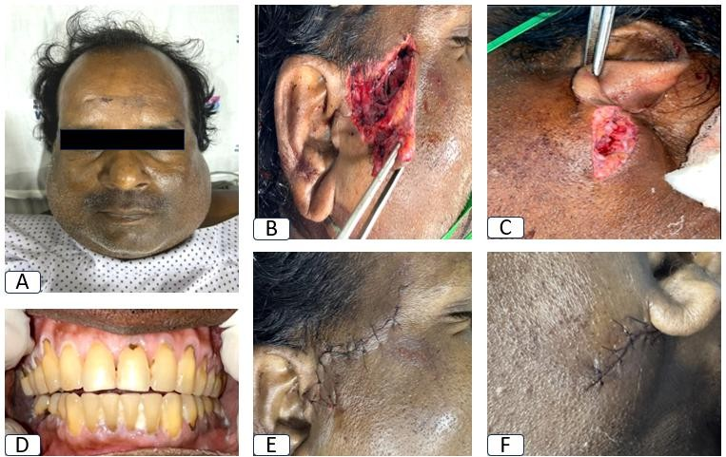
Figure 1: A) Preoperative extraoral image. B) Laceration in relation to right preauricular
region. C) Laceration in relation to left angle of mandible region. D) Preoperative occlusion.
E) Stay sutures placed in relation to right preauricular region. F) Stay sutures placed in relation to left angle of mandible region.

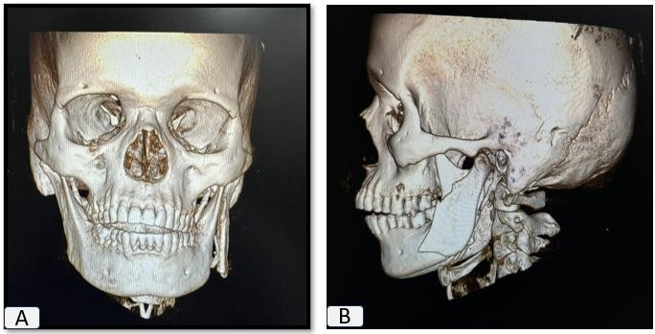
Figure 2: 3D CT images.

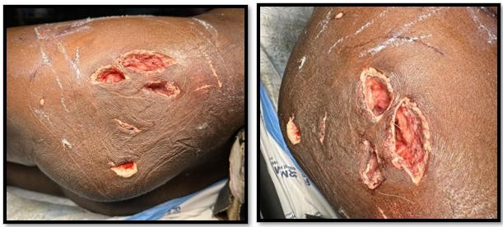
Figure 3: Animal bite injury in relation to gluteal region.

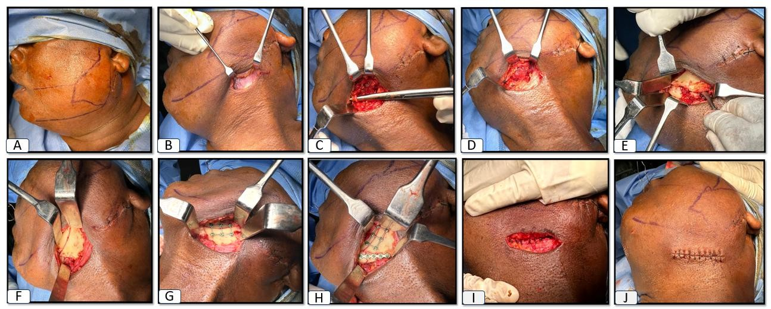
Figure 4: A) Skin marking done for submandibular incision. B) Platysma visualized. C) Facial artery visualized. D) Submandibular gland visualised. E) Fracture site visualised. F)
Fracture reduction done. G-H) Fracture fixation done with Titanium miniplates and screws. I-
J) Layerwise closure done.

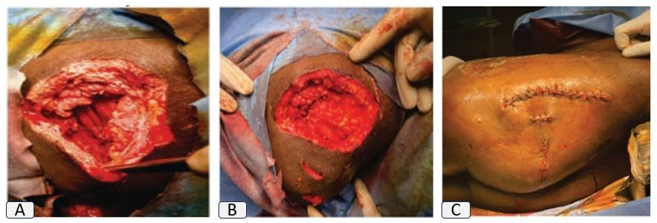
Figure 5: Gluteal wound explored and closure done.

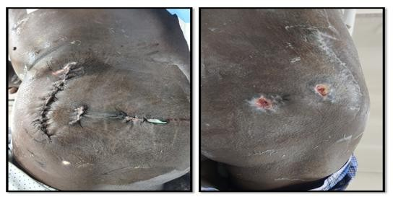
Figure 6: Post operative pictures.

