Original Research Article

Clinical and Procedural Outcomes of Left Main PCI in Indian Population: A Single-Center Observational Study

ABSTRACT
Introduction
Randomized trials and longer follow-up studies have demonstrated comparable outcomes between PCI and CABG in appropriately selected left main disease, particularly when contemporary techniques and stent platforms are used. The outcomes in this real-world cohort are broadly consistent with contemporary published evidence supporting unprotected left main PCI in appropriately selected patients.
Aim The present study evaluates the clinical, angiographic, and procedural characteristics and outcomes of left main (LM) percutaneous coronary intervention (PCI) in Indian population.
Study Design
Retrospective observational study.
Place and Duration of Study
Department of Cardiology, Apollo Speciality Hospitals, Vanagaram, Chennai, India; January 2025 to December 2025.
Methodology
A total of 100 consecutive patients undergoing unprotected LM PCI were included. baseline clinical data, angiographic characteristics, procedural strategies, and in-hospital as well as follow-up outcomes were collected. The primary endpoint was procedural success. Secondary endpoints included in-hospital, 30-day, and 1-year major adverse cardiovascular events (MACE), acute kidney injury (AKI), stent thrombosis, and restenosis.
Results
The mean age was 65.7 ± 12.4 years, and 50% of patients were female. Diabetes mellitus was present in 64%, and mean BMI was 28.4 ± 3.3 kg/m². Distal LM bifurcation disease was the predominant anatomical pattern (64%), with a mean SYNTAX score of 30.6 ± 7.5. Femoral access was used in 86% of procedures. Intravascular imaging was utilized in 40% (OCT 30%, IVUS 10%). A two-stent strategy was employed in 47% of cases, with proximal optimization technique performed in 78%. Procedural success was achieved in 88%. In-hospital MACE occurred in 5%, while 30-day and 1-year MACE rates were 11% and 16%, respectively. AKI was observed in 10%, stent thrombosis in 1%, and restenosis in 11%.
Conclusion
In this real-world Indian cohort with high clinical and anatomical complexity, unprotected LM PCI achieved high procedural success with acceptable short- and mid-term outcomes. Contemporary drug-eluting stents, selective intravascular imaging, and consistent stent optimization strategies supported favourable results in routine clinical practice.

Keywords
Left main coronary artery; Percutaneous coronary intervention; Diabetes mellitus; Coronary bifurcation; Drug-eluting stents; Intravascular imaging

1. INTRODUCTION

Left main coronary artery disease represents a critical subset of coronary artery disease due to the large myocardial territory involved. Traditionally managed surgically, the role of percutaneous coronary intervention (PCI) in left main disease has expanded with advances in drug-eluting stents, intravascular imaging, and bifurcation PCI techniques. Current guidelines support PCI as a reasonable alternative to coronary artery bypass grafting (CABG) in selected patients (Neumann et al., 2019; Lawton et al., 2022).

Randomized trials and longer follow-up studies have demonstrated comparable outcomes between PCI and CABG in appropriately selected left main disease, particularly when contemporary techniques and stent platforms are used (Stone et al., 2016; Mäkikallio et al., 2016; Ahn et al., 2021). However, patient comorbidities, lesion morphology, and real-world practice constraints can significantly influence procedural strategy and outcomes.

In India, left main disease often occurs in association with diabetes, obesity, diffuse coronary involvement, calcification, and reduced left ventricular systolic function, collectively contributing to a complex and high-risk indicated PCI (CHIP) phenotype. Distal left main bifurcation lesions remain particularly challenging and require systematic optimization strategies for durable outcomes (Lassen et al., 2018; Burzotta et al., 2021; Munde et al., 2024). Despite increasing adoption of left main PCI in India, real-world evidence describing procedural strategies and outcomes in high-risk Indian cohorts remains limited.

This study aimed to evaluate clinical, angiographic, and procedural characteristics and to report short- and mid-term outcomes of unprotected left main PCI performed at a tertiary care centre in Chennai.

2. MATERIALS AND METHODS

2.1 Study Design and Population

This was a retrospective, single-centre observational study conducted at Apollo Speciality Hospitals, Vanagaram, Chennai. Consecutive patients who underwent PCI for unprotected LM coronary artery disease during the study period were included. Patients with protected LM disease or incomplete clinical data were excluded.
Revascularization strategy (PCI) was selected based on institutional Heart Team decision where feasible, considering comorbidities, surgical risk, patient preference, and anatomical suitability for PCI. As this is a retrospective analysis of patients treated with LM PCI, no CABG comparison arm was included.

2.2 Data Collection

Demographic data, cardiovascular risk factors, prior cardiac history, and echocardiographic parameters were collected from hospital records. Angiographic variables included LM lesion location (ostial, mid-shaft, distal/bifurcation), SYNTAX score, Medina classification, severity of calcification, presence of chronic total occlusion in non-LM vessels, and reference LM vessel diameter.

Procedural data included vascular access site, use of intravascular imaging (IVUS or OCT), stent strategy (single- or two-stent), bifurcation technique, adjunctive plaque modification devices, hemodynamic support, type of drug-eluting stent, number of stents implanted, total stent length, use of proximal optimization technique (POT), and final kissing balloon (FKB) inflation.

2.3 Outcomes and Definitions

Procedural success was defined as residual stenosis <10% with TIMI 3 flow in the treated LM vessel without in-lab death or emergency surgery. MACE was defined as a composite of all-cause death, myocardial infarction, stroke, or target lesion revascularization. Bleeding was classified according to the Bleeding Academic Research Consortium (BARC) criteria. AKI was defined using standard creatinine-based definitions. Follow-up was obtained from outpatient records and/or telephonic contact at 30 days and 1 year. Repeat coronary angiography was performed only when clinically indicated. Restenosis was defined based on clinically driven angiographic assessment.

2.4 Statistical Analysis

Continuous variables are presented as mean ± standard deviation, and categorical variables as frequencies and percentages. Exploratory comparisons between categorical variables were performed using Chi-square test or Fisher’s exact test, as appropriate. Time-to-event outcomes were evaluated using Kaplan–Meier survival analysis where applicable. Missing data were minimal and were handled by complete-case analysis for the respective variables. A p value <0.05 was considered statistically significant. Owing to the retrospective nature and sample size, multivariable modelling was considered exploratory.

3. RESULTS

3.1 Baseline Characteristics
A total of 100 patients undergoing PCI for unprotected left main (LM) coronary artery disease were included. Baseline demographic and clinical characteristics are summarized in Table 1. The mean age of the cohort was 65.7 ± 12.4 years, and 50% of patients were female. The mean body mass index was 28.4 ± 3.3 kg/m². Hypertension and diabetes mellitus were present in 70% and 64% of patients, respectively. Dyslipidemia was observed in 61%, and 30% had a history of smoking. Chronic kidney disease was present in 26%. Prior myocardial infarction, prior PCI, and prior CABG were documented in 48%, 31%, and 15%, respectively. The mean left ventricular ejection fraction was 41.9 ± 10.6%, and 48% of patients had LVEF ≤40%.

Table 1. Baseline Clinical Characteristics of the Study Population (N = 100)

Variable | Value
Age (years) | 65.7 ± 12.4
Female sex | 50 (50%)
BMI (kg/m²) | 28.4 ± 3.3
Hypertension | 70 (70%)
Diabetes mellitus | 64 (64%)
Dyslipidemia | 61 (61%)
Smoking | 30 (30%)
Chronic kidney disease | 26 (26%)
Prior myocardial infarction | 48 (48%)
Prior PCI | 31 (31%)
Prior CABG | 15 (15%)
LVEF (%) | 41.9 ± 10.6
LVEF ≤40% | 48 (48%)

3.2 Angiographic Characteristics

Angiographic characteristics are detailed in Table 2. Distal LM bifurcation disease was the predominant anatomical pattern, observed in 64% of patients, while ostial and mid-shaft disease accounted for 20% and 16%, respectively. The mean SYNTAX score was 30.6 ± 7.5, indicating a high-complexity population. Medina classifications were distributed as follows: 1,1,0 in 28%, 1,0,1 in 25%, 1,1,1 in 24%, and 0,1,1 in 23%. Calcification was mild in 31%, moderate in 44%, and severe in 25%. Chronic total occlusion in a non-LM vessel was present in 26%. The mean reference LM diameter was 4.17 ± 0.31 mm (range 3.6–4.7 mm).

Table 2. Angiographic Characteristics

Variable | Value
LM lesion location
– Ostial | 20 (20%)
– Mid-shaft | 16 (16%)
– Distal/bifurcation | 64 (64%)
SYNTAX score | 30.6 ± 7.5
Medina classification
– 1,0,1 | 25 (25%)
– 1,1,0 | 28 (28%)
– 1,1,1 | 24 (24%)
– 0,1,1 | 23 (23%)
Calcification grade
– Mild | 31 (31%)
– Moderate | 44 (44%)
– Severe | 25 (25%)
CTO in other vessels | 26 (26%)
Reference LM diameter (mm) | 4.17 ± 0.31 (range 3.6–4.7)

3.3 Procedural Characteristics

Procedural characteristics are presented in Table 3. Femoral access was used in 86% of cases, while radial access was employed in 14%. Intravascular imaging was utilized in 40% of patients, predominantly with OCT (30%), whereas IVUS was used in 10%; the remaining 60% underwent angiography-guided PCI alone. A single-stent strategy was adopted in 53% of procedures, while a two-stent strategy was required in 47%. Among two-stent approaches, DK Crush and Culotte techniques were each used in 13%, TAP in 11%, and other techniques in 10% of all patients. Adjunctive devices were used selectively, with rotablation in 22%, cutting balloon angioplasty in 12%, and combined use in 9%, while 57% of cases did not require plaque modification. Hemodynamic support was required in 22%, predominantly with intra-aortic balloon pump (20%), while Impella use was limited (2%) and ECMO was not utilized. Contemporary drug-eluting stents were used in all patients, with Xience Xpedition and Orsiro being the most frequently deployed (each 19%). The mean number of stents used was 2.2 ± 1.0, and the mean total stent length was 61.2 ± 33.2 mm. Proximal optimization technique was performed in 78% of cases, and final kissing balloon inflation was performed in 40%.

Table 3. Procedural Characteristics

Variable | Value
Access site
– Femoral | 86 (86%)
– Radial | 14 (14%)
Intravascular imaging used
– None | 60 (60%)
– OCT | 30 (30%)
– IVUS | 10 (10%)
Stent strategy
– Single-stent | 53 (53%)
– Two-stent | 47 (47%)
Two-stent technique (among all patients)
– DK Crush | 13 (13%)
– Culotte | 13 (13%)
– TAP | 11 (11%)
– Other | 10 (10%)
Adjunctive devices
– None | 57 (57%)
– Rotablation | 22 (22%)
– Cutting balloon | 12 (12%)
– Both | 9 (9%)
Hemodynamic support
– None | 78 (78%)
– IABP | 20 (20%)
– Impella | 2 (2%)
– ECMO | 0 (0%)
DES platform used
– Xience Xpedition | 19 (19%)
– Ultimaster | 15 (15%)
– Megatron | 14 (14%)
– Orsiro | 19 (19%)
– Onyx | 16 (16%)
– Synergy | 17 (17%)
Number of stents used | 2.2 ± 1.0
Total stent length used (mm) | 61.2 ± 33.2
POT performed | 78 (78%)
Final kissing balloon performed | 40 (40%)

3.4 Clinical Outcomes

Clinical outcomes are summarized in Table 4. Procedural success was achieved in 88% of patients. In-hospital MACE occurred in 5% of cases. At 30 days, the MACE rate was 11%, while the 1-year MACE rate was 16%. Acute kidney injury was observed in 10% of patients. Angiographic restenosis occurred in 11%, and stent thrombosis was documented in 1% of the cohort.

Table 4. Clinical Outcomes

Outcome | Value
Procedural success | 88 (88%)
In-hospital MACE | 5 (5%)
30-day MACE | 11 (11%)
1-year MACE | 16 (16%)
Bleeding (BARC ≥3) | 25 (25%)
Acute kidney injury (AKI) | 10 (10%)
Stent thrombosis | 1 (1%)
Restenosis | 11 (11%)
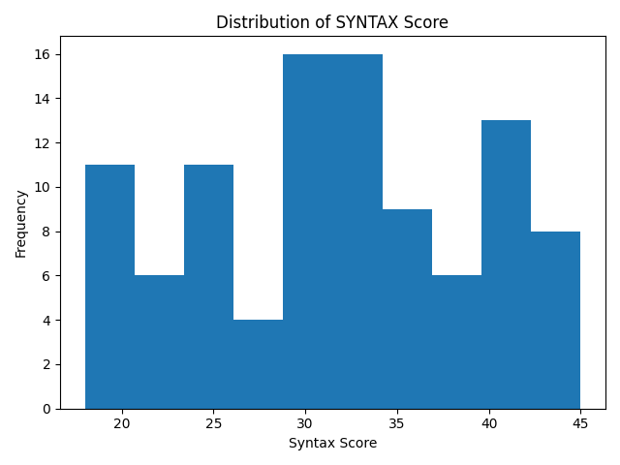
Figure 1. Distribution of SYNTAX Scores
Histogram showing the distribution of SYNTAX scores among patients undergoing left main PCI, demonstrating a predominance of high anatomical complexity.
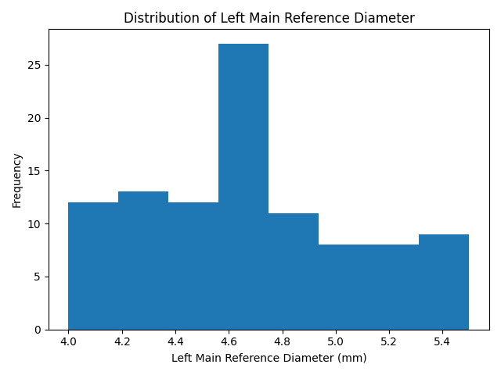
Figure 2. Distribution of Left Main Reference Vessel Diameter
Histogram depicting reference left main coronary artery diameters, reflecting smaller vessel dimensions typical of a diabetic Indian population.

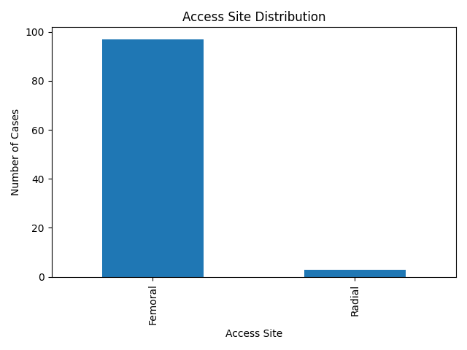
Figure 3. Vascular Access Site Distribution
Bar chart showing the predominance of femoral access for left main PCI.

4.DISCUSSION

This single-center retrospective study provides real-world insights into unprotected left main PCI in a high-risk Indian population. The present experience is clinically relevant because left main disease in India commonly occurs in patients with significant metabolic risk factors, reduced ventricular function, and complex bifurcation anatomy, all of which influence procedural strategy and outcomes.
Distal left main bifurcation involvement was a key feature of this cohort. Bifurcation left main PCI requires careful planning due to side-branch jeopardy and the need for durable long-term patency. Contemporary European Bifurcation Club consensus documents emphasize that outcomes are strongly linked to lesion preparation, appropriate strategy selection, and systematic stent optimization (Lassen et al., 2018; Burzotta et al., 2021). In this context, consistent use of proximal optimization technique in our practice reflects an important step toward achieving adequate proximal stent expansion and improving bifurcation geometry. Bench testing and computational simulation data support the role of POT and kissing balloon strategies in achieving better stent expansion and apposition in bifurcation lesions (Foin et al., 2015).
The procedural predominance of femoral access likely reflects the need for robust guide support in complex left main interventions, including bifurcation techniques, plaque modification, and longer or larger stent platforms. In addition, severely calcified anatomy and multivessel complexity often require adjunctive devices, which may further influence selection of access strategy in real-world CHIP PCI practice.
Intravascular imaging was used selectively in this cohort, reflecting routine practice in many centers where cost and logistics influence adoption. However, imaging guidance has been associated with improved stent expansion and outcomes in left main PCI, particularly with IVUS-guided implantation (Park et al., 2009; De la Torre Hernandez et al., 2014). OCT provides high-resolution assessment of stent expansion and edge pathology and can aid optimization in appropriately selected lesions (Ali et al., 2017). Selective utilization of imaging in complex or ambiguous cases may represent a pragmatic approach in resource-variable settings.
Overall, the outcomes observed in this cohort support the feasibility of unprotected left main PCI with contemporary drug-eluting stents and optimization strategies in carefully selected patients treated at experienced centers. These findings are in line with guideline-supported practice where left main PCI is an established alternative revascularization strategy in appropriate clinical contexts (Neumann et al., 2019; Lawton et al., 2022). Larger multicenter Indian datasets with long-term follow-up will help refine patient selection and procedural optimization strategies in the Indian context.
The outcomes in this real-world cohort are broadly consistent with contemporary published evidence supporting unprotected left main PCI in appropriately selected patients. These findings add to limited Indian real-world data and support further multicenter registries and prospective studies evaluating long-term outcomes and predictors in similar populations.

5. CONCLUSION

In this real-world, high-risk Indian cohort with a high burden of diabetes, reduced ventricular function, and predominantly distal left main bifurcation disease, unprotected left main PCI achieved a high procedural success rate with acceptable short- and mid-term outcomes. Contemporary drug-eluting stents, appropriate bifurcation strategies, and frequent use of stent optimization techniques supported favourable results. These findings reinforce the feasibility of left main PCI as an effective revascularization strategy in selected high-risk Indian patients when performed in experienced centers.

6. LIMITATIONS

This study has several limitations. First, it was a retrospective, single-center observational analysis, which may limit the generalizability of the findings. Second, the sample size was modest and may be underpowered for identifying predictors of adverse outcomes or supporting extensive subgroup analyses. Third, intravascular imaging was used selectively rather than routinely, which may have influenced optimization and outcomes. Fourth, follow-up was based on available clinical and angiographic data, and routine angiographic surveillance was not performed for all patients, which could underestimate restenosis. Finally, the study was not designed to compare PCI with CABG or to perform pre-specified subgroup analyses.

AUTHOR AFFILIATIONS

Department of Cardiology, Apollo Speciality Hospitals, Vanagaram, Chennai, India.

AUTHORS’ CONTRIBUTIONS

This work was carried out in collaboration among all authors. All authors read and approved the final manuscript.

ETHICAL APPROVAL

As per international standards or university standards written ethical approval has been collected and preserved by the author(s).

COMPETING INTERESTS

The authors declare that they have no competing interests.

Disclaimer (Artificial intelligence)

Author(s) hereby declare that NO generative AI technologies such as Large Language Models (ChatGPT, COPILOT, etc.) and text-to-image generators have been used during the writing or editing of this manuscript.

REFERENCES
- Neumann, F.J., Sousa-Uva, M., Ahlsson, A., Alfonso, F., Banning, A.P., Benedetto, U., et al. (2019). 2018 ESC/EACTS Guidelines on myocardial revascularization. Eur Heart J, 40(2), 87–165.
- Lawton, J.S., Tamis-Holland, J.E., Bangalore, S., Bates, E.R., Beckie, T.M., Bischoff, J.M., et al. (2022). 2021 ACC/AHA/SCAI Guideline for Coronary Artery Revascularization. J Am Coll Cardiol, 79(2), e21–e129.
- Stone, G.W., Sabik, J.F., Serruys, P.W., Simonton, C.A., Généreux, P., Puskas, J., et al. (2016). Everolimus-eluting stents or bypass surgery for left main coronary artery disease. N Engl J Med, 375(23), 2223–2235.
- Mäkikallio, T., Holm, N.R., Lindsay, M., Spence, M.S., Erglis, A., Menown, I.B.A., et al. (2016). Percutaneous coronary angioplasty versus coronary artery bypass grafting in treatment of unprotected left main stenosis (NOBLE): a randomised, non-inferiority trial. Lancet, 388(10061), 2743–2752.
- Serruys, P.W., Morice, M.C., Kappetein, A.P., Colombo, A., Holmes, D.R., Mack, M.J., et al. (2009). Percutaneous coronary intervention versus coronary-artery bypass grafting for severe coronary artery disease. N Engl J Med, 360(10), 961–972.
- Park, S.J., Kim, Y.H., Park, D.W., Yun, S.C., Ahn, J.M., Song, H.G., et al. (2011). Randomized trial of stents versus bypass surgery for left main coronary artery disease. N Engl J Med, 364(18), 1718–1727.
- Ahn, J.M., Roh, J.H., Kim, Y.H., Park, D.W., Yun, S.C., Lee, P.H., et al. (2021). Randomized trial of stents versus bypass surgery for left main coronary artery disease: PRECOMBAT 10-year follow-up. J Am Coll Cardiol, 77(5), 664–673.
- Valgimigli, M., Bueno, H., Byrne, R.A., Collet, J.P., Costa, F., Jeppsson, A., et al. (2018). 2017 ESC focused update on dual antiplatelet therapy in coronary artery disease. Eur Heart J, 39(3), 213–260.
- Mehran, R., Rao, S.V., Bhatt, D.L., Gibson, C.M., Caixeta, A., Eikelboom, J., et al. (2011). Standardized bleeding definitions for cardiovascular clinical trials: a consensus report from the Bleeding Academic Research Consortium. Circulation, 123(23), 2736–2747.
- Cutlip, D.E., Windecker, S., Mehran, R., Boam, A., Cohen, D.J., van Es, G.A., et al. (2007). Clinical end points in coronary stent trials: a case for standardized definitions. Circulation, 115(17), 2344–2351.
- Patel, M.R., Calhoon, J.H., Dehmer, G.J., Grantham, J.A., Maddox, T.M., Maron, D.J., et al. (2012). ACC/AATS/AHA/ASE/ASNC/SCAI/SCCT/STS 2012 appropriate use criteria for coronary revascularization. J Am Coll Cardiol, 59(9), 857–881.
- Lassen, J.F., Holm, N.R., Stankovic, G., Lefèvre, T., Chieffo, A., Hildick-Smith, D., et al. (2018). Percutaneous coronary intervention for coronary bifurcation disease: 14th consensus document from the European Bifurcation Club. EuroIntervention, 13(13), 1540–1553.
- Burzotta, F., Lassen, J.F., Lefèvre, T., Banning, A.P., Chatzizisis, Y.S., Johnson, T.W., et al. (2021). Percutaneous coronary intervention for bifurcation coronary lesions: the 15th consensus document from the European Bifurcation Club. EuroIntervention, 16(16), 1307–1317.
- Chen, S.L., Zhang, J.J., Han, Y., Kan, J., Chen, L., Qiu, C., et al. (2017). Double kissing crush versus provisional stenting for left main distal bifurcation lesions: DKCRUSH-V randomized trial. J Am Coll Cardiol, 70(21), 2605–2617.
- Zhang, J.J., Chen, S.L., Ye, F., Xu, Y.W., Kan, J., Santoso, T., et al. (2013). Clinical outcomes of DK crush versus culotte stenting for left main bifurcation lesions: DKCRUSH-III study. J Am Coll Cardiol, 61(14), 1482–1488.
- Foin, N., Torii, R., Mortier, P., De Beule, M., Viceconte, N., Chan, P.H., et al. (2015). Kissing balloon or proximal optimization technique for left main coronary bifurcation lesions: insights from bench testing and computational simulations. EuroIntervention, 11(7), e1–e8.
- Ali, Z.A., Karimi Galougahi, K., Maehara, A., Shlofmitz, R.A., Ben-Yehuda, O., Mintz, G.S., et al. (2017). Intracoronary optical coherence tomography: clinical and research applications. JACC Cardiovasc Interv, 10(24), 2473–2487.
- De la Torre Hernandez, J.M., Baz, J.A., Ojeda, S., Garcia Camarero, T., Martin-Reyes, R., Hernandez, F., et al. (2014). Clinical impact of intravascular ultrasound guidance in drug-eluting stent implantation for unprotected left main coronary artery disease. EuroIntervention, 10(3), 352–359.
- Park, S.J., Ahn, J.M., Kang, S.J., Yoon, S.H., Koo, B.K., Lee, P.H., et al. (2009). Intravascular ultrasound-guided drug-eluting stent implantation for left main coronary artery disease. J Am Coll Cardiol, 53(13), 1050–1057.
- Windecker, S., Stortecky, S., Stefanini, G.G., da Costa, B.R., Rutjes, A.W., Di Nisio, M., et al. (2014). Revascularisation versus medical treatment in patients with stable coronary artery disease. Lancet, 383(9915), 139–145.
- Munde, K. S., T S, A., Mutha, S., Niari, J., Paliwal, M., & Kolapkar, H. (2024). A Tale of Grumpy Neighbours: Angina from Left Main Coronary Artery Compression in Severe Pulmonary Hypertension with Large ASD. Cardiology and Angiology: An International Journal, 13(4), 54–63.

