Case report
PASCAL-Guided Closure of Patent Foramen Ovale After Cryptogenic Stroke in a Very Young Adult: A Case Report

Abstract

Patent foramen ovale (PFO) is frequently identified in young patients with cryptogenic stroke; however, establishing a causal relationship remains challenging. Contemporary management relies on probabilistic stratification integrating clinical profile and high-risk interatrial anatomy like the presence of a highly mobile atrial septal aneurysm. The PFO-associated stroke causal likelihood (PASCAL) classification provides a structured framework to guide therapeutic decision-making, including percutaneous closure.
Keynotes : Patent Foramen Ovale; Cryptogenic Stroke; Young Adult; Risk Assessment; Paradoxical Embolism; , Interventional, PASCAL classification

Case presentation:
A 23-year-old woman with no conventional cardiovascular risk factors, except active smoking and progestin-only contraception, presented with transient aphasia, frontal headache, and photophobia following physical exertion. Neurological symptoms resolved rapidly (NIHSS 0). Brain magnetic resonance imaging demonstrated a recent superficial left M3 middle cerebral artery infarction with an intraluminal thrombus. Intravenous thrombolysis was administered with favorable clinical and radiological evolution. Etiological assessment revealed a highly mobile atrial septal aneurysm on transthoracic echocardiography and a patent foramen ovale with a strongly positive right-to-left shunt on transesophageal contrast study. No alternative embolic source was identified on vascular imaging or prolonged rhythm monitoring.
Oral anticoagulation was initiated. Based on a high RoPE score combined with high-risk interatrial anatomy, the patient was classified as PROBABLE according to the PASCAL system, supporting a causal relationship between PFO and stroke. At five-month follow-up, successful percutaneous PFO closure was performed. Anticoagulation was discontinued and dual antiplatelet therapy initiated. Clinical follow-up remained uneventful, with no recurrent neurological events.
This case illustrates the clinical value of PASCAL-guided stratification in selecting very young patients with cryptogenic stroke for PFO closure and supports individualized secondary prevention strategies.

INRODUCTION
Patent foramen ovale (PFO) is a frequent interatrial communication, affecting 15–35% of the adult population and up to 50% of young patients with stroke.(1,2,5) Increasing evidence suggests that PFO may contribute to cryptogenic stroke, particularly in children and young adults who lack traditional atheroembolic risk factors(3). Cryptogenic stroke accounts for 25–40% of all ischemic strokes and remains challenging because no clear etiology is identified despite a comprehensive diagnostic evaluation (4) .In this context, PFO may act as a pathway for paradoxical embolism, although establishing a direct causal relationship is often difficult (6). After a complete diagnostic workup, the identification of a PFO can strongly support a thromboembolic mechanism. Management remains debated due to heterogeneous therapeutic strategies and procedure-related risks, even though long-term data suggest significant benefit from PFO closure in preventing recurrent events.(7,8)

This case underscores the challenge of managing ischemic stroke in an exceptionally young patient, in whom a high PASCAL classification—combining her very young age, low vascular risk profile, and high-risk interatrial anatomy—strongly supported a causal link with the PFO and guided the decision toward percutaneous closure despite the small anatomical size of the defect.

Case report
A 23-year-old woman, active smoker (5 pack-years) and on progestin-only contraception, with no other cardiovascular risk factors, presented to the emergency department with sudden-onset aphasia, frontal headache, and photophobia occurring after morning exertion. Symptoms had completely resolved upon arrival, and neurological examination was normal (NIHSS 0).

Emergency brain MRI revealed a very recent superficial left M3 middle cerebral artery ischemic stroke with a 6-mm intraluminal thrombus. ECG showed sinus rythm, and routine blood tests were unremarkable. The patient received intravenous thrombolysis with favorable clinical and radiologic evolution.

During neurological hospitalization, an etiological evaluation was performed. Transthoracic echocardiography showed a highly mobile atrial septal aneurysm (16 mm excursion). Cervical CT angiography revealed no carotid dissection or fibromuscular dysplasia, and venous Doppler ultrasound showed no deep vein thrombosis. A 72-hour Holter ECG demonstrated no arrhythmias.

Transesophageal echocardiography confirmed a large, highly mobile atrial septal aneurysm (22 mm excursion) and a patent foramen ovale (5 mm height). Color Doppler showed a small resting shunt, while contrast study after Valsalva revealed a strongly positive right-to-left shunt (>30 bubbles), establishing a cardioembolic mechanism.

The patient was discharged on dabigatran 150 mg twice daily. At 5-month follow-up, she underwent successful percutaneous PFO closure with an Amplatzer Talisman 30/25 device. Anticoagulation was discontinued and dual antiplatelet therapy initiated. Clinical follow-up remained favorable with no recurrent neurological events.

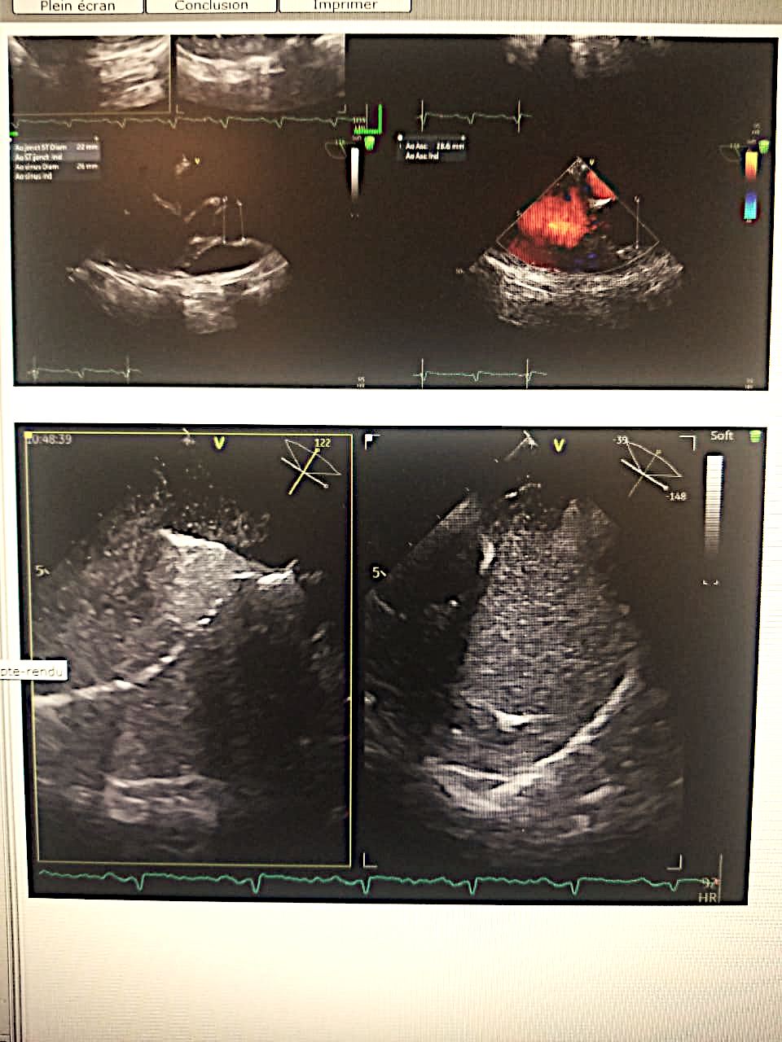
Figure 1bubble contrast TEE showing passage of microbubbles from right to left after valsalva maneuver
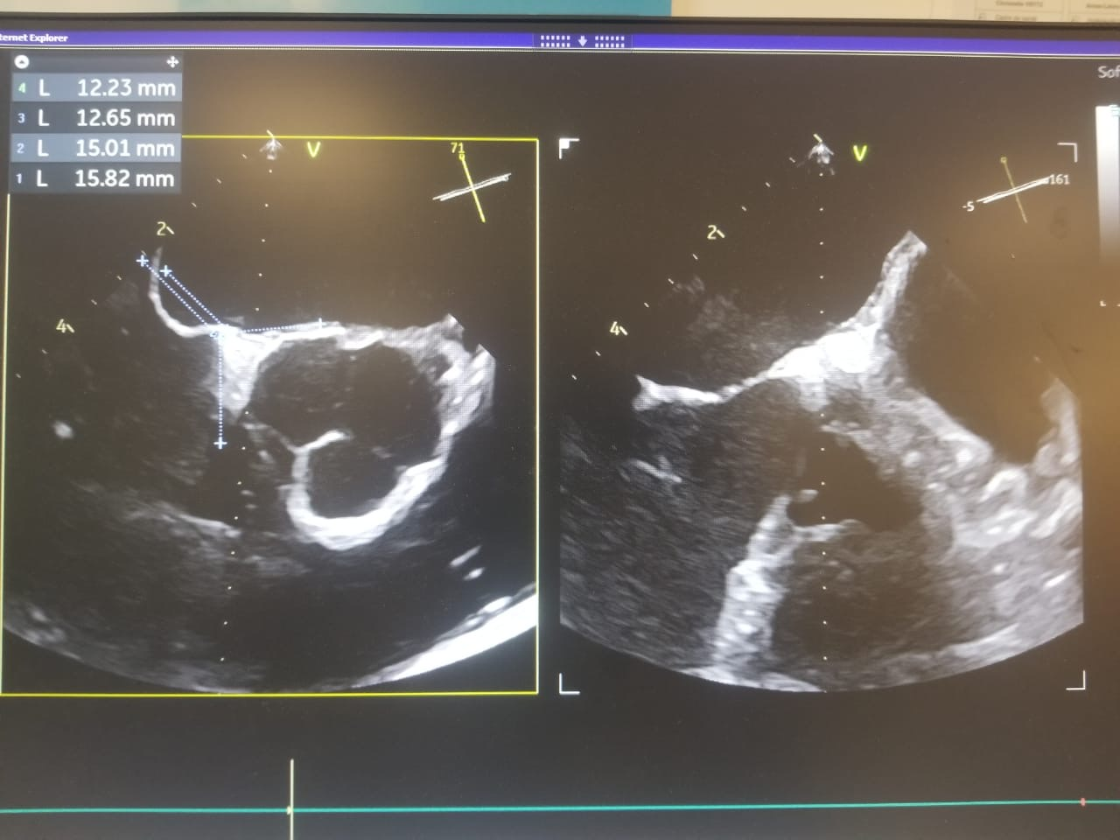
Figure 2TEE demonstrating measurements of the patent foramen tunnel length and surrounding septal rims, allowing anatomical characterization and selection of an appropriately sized occluder device
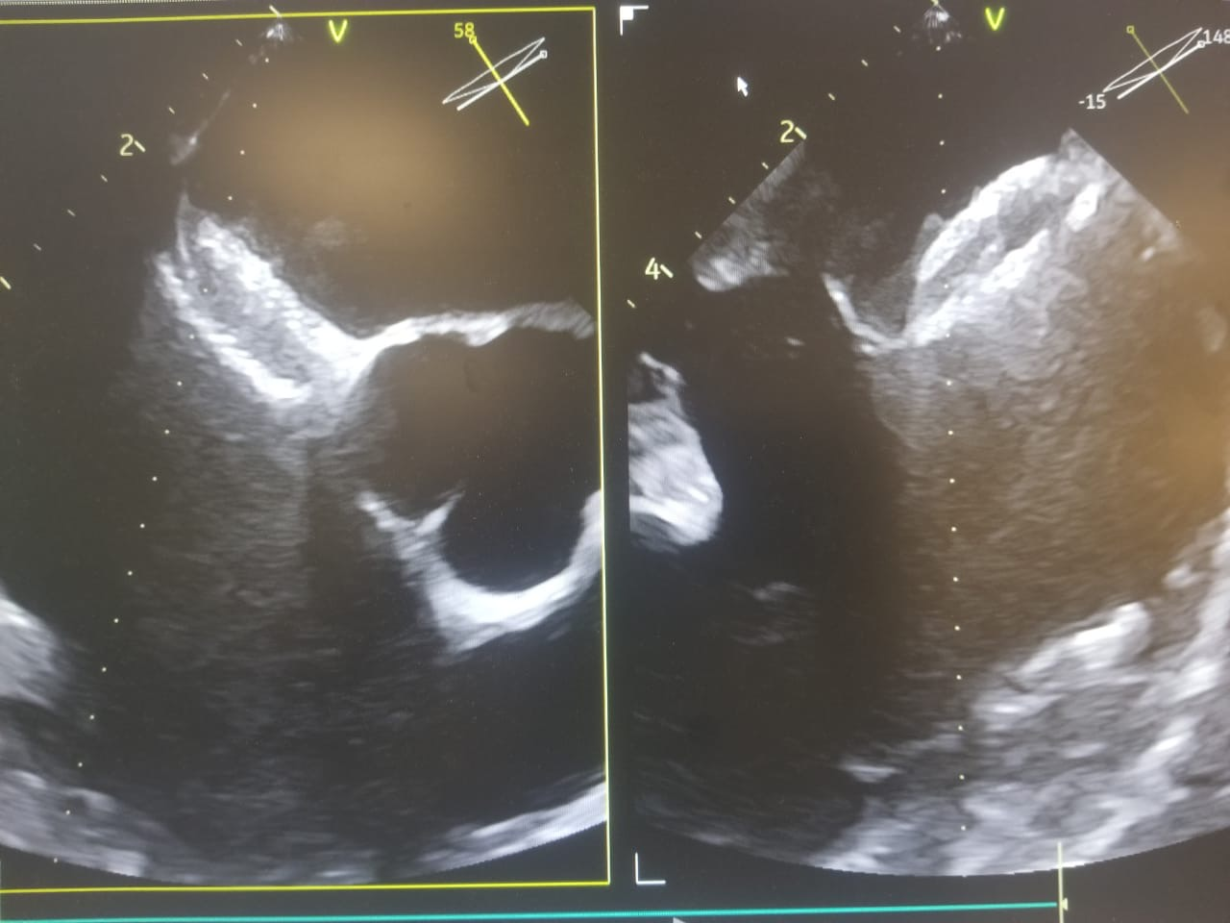
Figure 3Post-Procedural TEE demonstrating correct positionning and stable deployment of the patent foramen ovale occluder device with adequate septal apposition
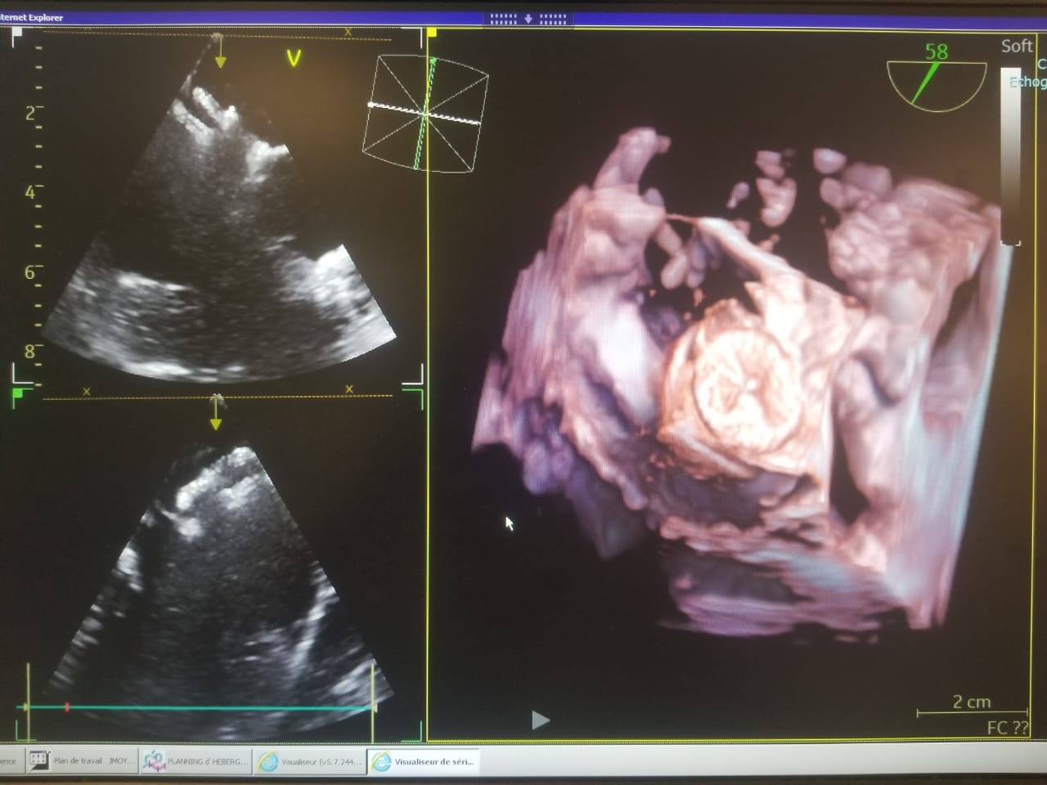
Figure 4 3D transoesophageal echocardiography showing the patent foramen ovale ocluder device correctly deployed across the interatrial septum , with optimal disc expansion and stable septal apposition
Discussion
This case describes a 23-year-old woman with no conventional vascular risk factors who presented with an acute superficial middle cerebral artery infarction and was subsequently found to have a patent foramen ovale (PFO) associated with a large and highly mobile atrial septal aneurysm (ASA). In young adults, PFO represents one of the most frequent causes of stroke, together with carotid dissection, and its prompt identification is essential to guide secondary prevention and reduce the risk of recurrence.(2,11)

PFO is a congenital remnant of the fetal interatrial communication and constitutes the most common cause of right-to-left shunting in adults. Epidemiologic data highlight its relevance in cerebrovascular disease: a meta-analysis reported a stroke odds ratio of 3.1 in patients under 55 years with PFO. (9 ;10)
Cryptogenic strokes account for 15% to 40% of all strokes, and PFO is found in 40% to 56% of young patients with cryptogenic stroke. The causal relationship between PFO and ischemic stroke has been best demonstrated in this population, with PFO prevalence reaching 40% to 50% in affected patients compared with 10% to 15% in controls.(2). In our case, the patient was quite young, aged 23 years.

Bayesian analyses have further shown that the likelihood of a causal implication of PFO is high in younger patients, with the probability of PFO involvement estimated at approximately two-thirds of cryptogenic strokes, and up to 80% in the youngest subgroup (12). In this context, identifying high-risk anatomical features is critical. Current evidence indicates that moderate or large PFOs and the presence of ASA are associated with higher recurrence risk and a greater benefit from PFO closure.(13)
A large PFO has been defined in clinical trials as the passage of more than 20 to 30 microbubbles into the left atrium within three cardiac cycles after right atrial opacification.(14) In this case, although the PFO height was modest, the patient demonstrated a strongly positive shunt on contrast study and a markedly mobile ASA, consistent with high-risk interatrial anatomy.

Additional cardiac morphological features, such as the Eustachian valve, have been associated with paradoxical embolism in some reports, although with less robust evidence than PFO size and ASA. The Eustachian valve-related increased risk of paradoxical embolism in patients having a PFO is possibly explained by the valve directing the blood jet coming from the inferior vena cava toward the fossa ovalis (15)
Screening for PFO has therefore become a central component of the etiologic evaluation of ischemic stroke in patients aged 60 years or younger, with transesophageal echocardiography and agitated saline contrast injection representing the diagnostic gold standard, with a sensitivity of 89%.(16,17)
The patient underwent both transthoracic and transoesophageal echocardiography with bubble study, which revealed a patent foramen ovale (PFO) with significant bubble passage. The examination also noted the presence of Eustachian valves, without any evidence of peripheral venous thrombosis on lower limb Doppler ultrasound, which rules out the hypothesis of a paradoxical stroke.
Diagnosis should be probabilistic and stratified using a validated scoring system to help guide therapeutic decisions.

Recent reviews highlight that management of cryptogenic stroke should rely on risk stratification models combining clinical and anatomical features to guide decisions between medical therapy and percutaneous PFO closure (18)

Risk stratification can be refined using the PFO-associated stroke causal likelihood (PASCAL) system, which integrates high-risk PFO characteristics—large shunt or ASA—and the RoPE score. Based on these two domains, patients are classified as PROBABLE, POSSIBLE, or UNLIKELY to have sustained a PFO-related stroke, guiding management decisions. PROBABLE patients derive a 90% reduction in recurrent stroke with closure, while POSSIBLE patients have a 62% reduction. In UNLIKELY patients, there is no significant difference between closure and medical therapy.(19)
With a ROPE score greater than 7 and classified as high risk according to the PASCAL system, our patient was considered to have a stroke probably related to the PFO and was therefore a candidate for PFO closure, with a 90% chance of reduction in recurrence following closure.

Recent case reports suggest that even small PFOs may be clinically relevant when associated with embolic stroke patterns and high-risk features, supporting closure in carefully selected young patients . (20)

This framework supports decision-making in patients such as the one described, whose very young age, embolic infarct pattern, high-risk septal morphology, and large provoked shunt strengthened the causal likelihood of a PFO-mediated event and provided a rationale for percutaneous closure as secondary prevention.

Conclusion
This case illustrates the importance of a comprehensive etiologic evaluation of ischemic stroke in very young adults, particularly when conventional vascular risk factors are absent. Although the stroke remained cryptogenic, the presence of a highly mobile atrial septal aneurysm, a significant right-to-left shunt on contrast study, and a small but functionally high-risk PFO considerably increased the likelihood of a PFO-related mechanism. The PASCAL classification—incorporating both high-risk interatrial anatomical features and a high RoPE score—positioned the patient in a category with a strong probabilistic association between the PFO and the stroke, supporting the decision for percutaneous closure as part of secondary prevention. The favorable clinical outcome highlights the value of combining anatomical, functional, and probabilistic tools to guide management in young patients with cryptogenic stroke.

Disclaimer (Artificial intelligence)

Author(s) hereby declare that NO generative AI technologies such as Large Language Models (ChatGPT, COPILOT, etc.) and text-to-image generators have been used during the writing or editing of this manuscript.
Références
- Romano V, Gallinoro CM, Mottola R, Serio A, Di Meglio F, Castaldo C, Sirico F, Nurzynska D. Patent foramen ovale: a not so innocuous atrial septal defect in adults. J Cardiovasc Dev Dis. 2021;8:60.
- Webster MW, Chancellor AM, Smith HJ, et al. Patent foramen ovale in young stroke patients. Lancet. 1988;2(8601):11–12. doi:10.1016/S0140-6736(88)92944-3.
- Khan R, Chan AK, Mondal TK, Paes BA; Thrombosis and Hemostasis in Newborns (THIN) Group. Patent foramen ovale and stroke in childhood: a systematic review of the literature. Eur J Paediatr Neurol. 2016;20:500–511.
- Yaghi S, Bernstein RA, Passman R, Okin PM, Furie KL. Cryptogenic stroke: research and practice. Circ Res. 2017;120:527–540.
- Yuan K, Kasner SE. Patent foramen ovale and cryptogenic stroke: diagnosis and updates in secondary stroke prevention. Stroke Vasc Neurol. 2018;3:84–91.
- Ioannidis SG, Mitsias PD. Patent foramen ovale in cryptogenic ischemic stroke: direct cause, risk factor, or incidental finding? Front Neurol. 2020;11:567.
- Šunde D, Ljevak J, Ozretić D, Perić I, Blažević N, Poljakovic Z. Young stroke patient with patent foramen ovale and intracranial stenosis: a case report. SAGE Open Med Case Rep. 2023;11. doi:10.1177/2050313X231187677.
- Agarwal S, Bajaj NS, Kumbhani DJ, Tuzcu EM, Kapadia SR. Meta-analysis of transcatheter closure versus medical therapy for patent foramen ovale in prevention of recurrent neurological events after presumed paradoxical embolism. JACC Cardiovasc Interv. 2012;5:777–789.
- GBD 2019 Stroke Collaborators. Global, regional, and national burden of stroke and its risk factors, 1990–2019: a systematic analysis for the Global Burden of Disease Study 2019. Lancet Neurol. 2021;20:795–820. doi:10.1016/S1474-4422(21)00252-0.
- Overell JR, Bone I, Lees KR. Interatrial septal abnormalities and stroke: a meta-analysis of case-control studies. Neurology. 2000;55:1172–1179.
- Larrue V, Berhoune N, Massabuau P, Calviere L, Raposo N, Viguier A, Nasr N. Etiologic investigation of ischemic stroke in young adults. Neurology. 2011;76:1983–1988. doi:10.1212/WNL.0b013e31821e5517.
- Katsanos AH, Bhole R, Frogoudaki A, et al. The value of transesophageal echocardiography for embolic strokes of undetermined source. Neurology. 2016;87:988–995. doi:10.1212/WNL.0000000000003063.
- Mas JL, Saver JL, Kasner SE, et al. Association of atrial septal aneurysm and shunt size with stroke recurrence and benefit from patent foramen ovale closure. JAMA Neurol. 2022;79:1175–1179. doi:10.1001/jamaneurol.2022.3248.
- Kent DM, Saver JL, Kasner SE, et al. Heterogeneity of treatment effects in pooled individual patient data from randomized trials of patent foramen ovale closure after stroke. JAMA. 2021;326:2277–2286. doi:10.1001/jama.2021.20956.
- Schuchlenz HW, Saurer G, Weihs W, Rehak P. Persisting Eustachian valve in adults: relation to patent foramen ovale and cerebrovascular events. J Am Soc Echocardiogr. 2004;17:231–233. doi:10.1016/j.echo.2003.12.003.
- Sposato LA, Albin CSW, Elkind MSV, Kamel H, Saver JL. Patent foramen ovale management for secondary stroke prevention: state-of-the-art appraisal of current evidence. Stroke. 2024;55:1–12. doi:10.1161/STROKEAHA.123.040546.
- Pristipino C, Sievert H, D’Ascenzo F, et al; Evidence Synthesis Team. European position paper on the management of patients with patent foramen ovale: general approach and left circulation thromboembolism. Eur Heart J. 2019;40:3182–3195. doi:10.1093/eurheartj/ehy649.
- Ibeh C, Elkind MS. Stroke prevention after cryptogenic stroke. Current Cardiology Reports. 2021 Dec;23(12):174.
- Elgendy AY, Saver JL, Amin Z, et al. Proposal for updated nomenclature and classification of potential causative mechanisms in patent foramen ovale–associated stroke. JAMA Neurol. 2020;77:878–886. doi:10.1001/jamaneurol.2020.0458.

- Munde, Kalyan, Sandip Ghoti, Samkit Mutha, Anant Munde, Jayakrishna Niari, Gaurav Kothari, Suvarna Thorat, et al. 2025. “Cryptogenic Stroke With Isolated Cranial Nerve Deficits Attributable to a Small PFO: Successful Management With Cocoon Occluder”. Cardiology and Angiology: An International Journal 14 (4):6-11. https://doi.org/10.9734/ca/2025/v14i4503.

