Case report

Parasinusal Atrial Tachycardia Mimicking Inappropriate Sinus Tachycardia: Successful ECG-Guided Ablation Without Three-Dimensional Mapping : A case report

Abstract
Background:
Parasinusal atrial tachycardia (AT) is an uncommon form of focal supraventricular tachycardia that may closely mimic inappropriate sinus tachycardia (IST), creating diagnostic and therapeutic challenges. Differentiating these entities is crucial, as IST is primarily managed medically, whereas focal AT is amenable to curative ablation. Although three-dimensional (3D) electroanatomical mapping facilitates precise localization, it is not universally available, making surface electrocardiography (ECG) analysis essential.

Case Summary:
We report the case of a 54-year-old woman presenting with recurrent palpitations and dizziness. Initial ECG demonstrated a narrow-complex tachycardia with a ventricular rate of approximately 130 bpm. Detailed P-wave analysis revealed biphasic P waves in leads V1 and aVL, suggesting a right atrial origin. Electrophysiological study induced a parasinusal atrial tachycardia with earliest activation near the sinus node region, reproducing the patient’s symptoms. No evidence of accessory pathway or sinus node dysfunction was found. Despite beta-blocker therapy, symptoms persisted. Radiofrequency ablation was successfully performed using fluoroscopic guidance and ECG-based localization, without 3D mapping, resulting in complete arrhythmia suppression.

Conclusion:
This case highlights the diagnostic value of meticulous P-wave morphology analysis in distinguishing parasinusal AT from IST. Even in the absence of advanced mapping technologies, systematic ECG-guided localization can enable accurate diagnosis and effective curative ablation, particularly in resource-limited settings.

Introduction
Supraventricular tachycardia (SVT) is a common clinical entity with a global prevalence estimated at 2.25 per 1000 individuals (1). Within this spectrum, focal atrial tachycardia (AT) accounts for a minority of cases but often poses significant diagnostic challenges. “Foci arising from the right atrial appendage (RAA) is uncommon”(2). Similarly, “AT originating from the upper portion of the crista terminalis (CT) can be difficult to distinguish from sinus tachycardia” (3). In cases of inappropriate sinus tachycardia (IST), the earliest endocardial activation (EA) site characteristically shifts superiorly as the heart rate increases (4).
“Inappropriate sinus tachycardia (IST), characterized by an inappropriately elevated sinus rate out of proportion to physiologic demand , shares overlapping clinical and ECG features with parasinusal AT” (4) .
Distinguishing these entities is essential because IST Is usually managed medically. While focal is amenable to curative ablation.
“Several mechanisms have been proposed for the development of AT, including enhanced automaticity, triggered activity , β2-adrenergic stimulation and microreentrant circuits” (5,6).
Despite its rarity. Focal AT is identified in up to 10%–15% of patients undergoing ablation for presumed SVT(7).
While 3D electroanatomical mapping facilitates localization , it is not universally available. In such settings, careful analysis of P-wave morphology remains a critical tool.
We present the case of a 54-year-old woman with a parasinusal AT mimicking IST, localization was achieved using surface ECG criteria , and radiofrequency ablation was successfully treated based on ECG localization without the use of three-dimensional mapping.
Case Presentation
A 54-year-old female with a past medical history of hypertension and hypothyroidism (on Levothyrox since 2003, with most recent TSH within the normal range) was admitted for recurrent palpitations and dizziness. Episodes lasted approximately five minutes, resolved spontaneously, and recurred with associated vertigo.
Initial ECG at the emergency department demonstrated a narrow complex tachycardia (so-called “Bouveret tachycardia”) with a ventricular rate between 115 and 130 bpm. The QRS complexes were narrow (94 ms), with normal axis, retrograde P-waves, and QTc of 462 ms. A persistent reduction of R-wave amplitude (“rabotage”) was noted in V1–V3, superimposable on a previous tracing from April 2023. The tachycardia terminated spontaneously during transportation by the emergency service (SAMU).
At hospital admission, the ECG showed sinus rhythm at 84 bpm, PR interval 180 ms, QRS duration 88 ms, no pre-excitation or delta waves, persistent R-wave reduction in V1–V3, and no repolarization abnormalities. Laboratory testing was unremarkable. Echocardiography demonstrated preserved systolic function (LVEF 67%) and no structural abnormalities.
The patient remained clinically stable and was discharged on bisoprolol 2.5 mg daily. She was subsequently scheduled for an electrophysiological study (EPS) and possible ablation on December 5–6, 2024.
EPS findings included: No dual AV nodal physiology
Retrograde, decremental AV nodal conduction without evidence of an accessory pathway
Induction of atrial tachycardia (interpreted as parasinusal AT / inappropriate sinus–like) at 133 bpm, with variable cycle length; earliest atrial activation localized to the sinus node region; tachycardia reproducibly induced symptoms and was suppressed by overdrive pacing
No AV conduction abnormalities at baseline Corrected sinus node recovery time <525 ms, excluding sinus node dysfunction
Programmed ventricular stimulation (RV apex and RV outflow tract) with up to three extrastimuli down to 200 ms did not induce ventricular arrhythmias
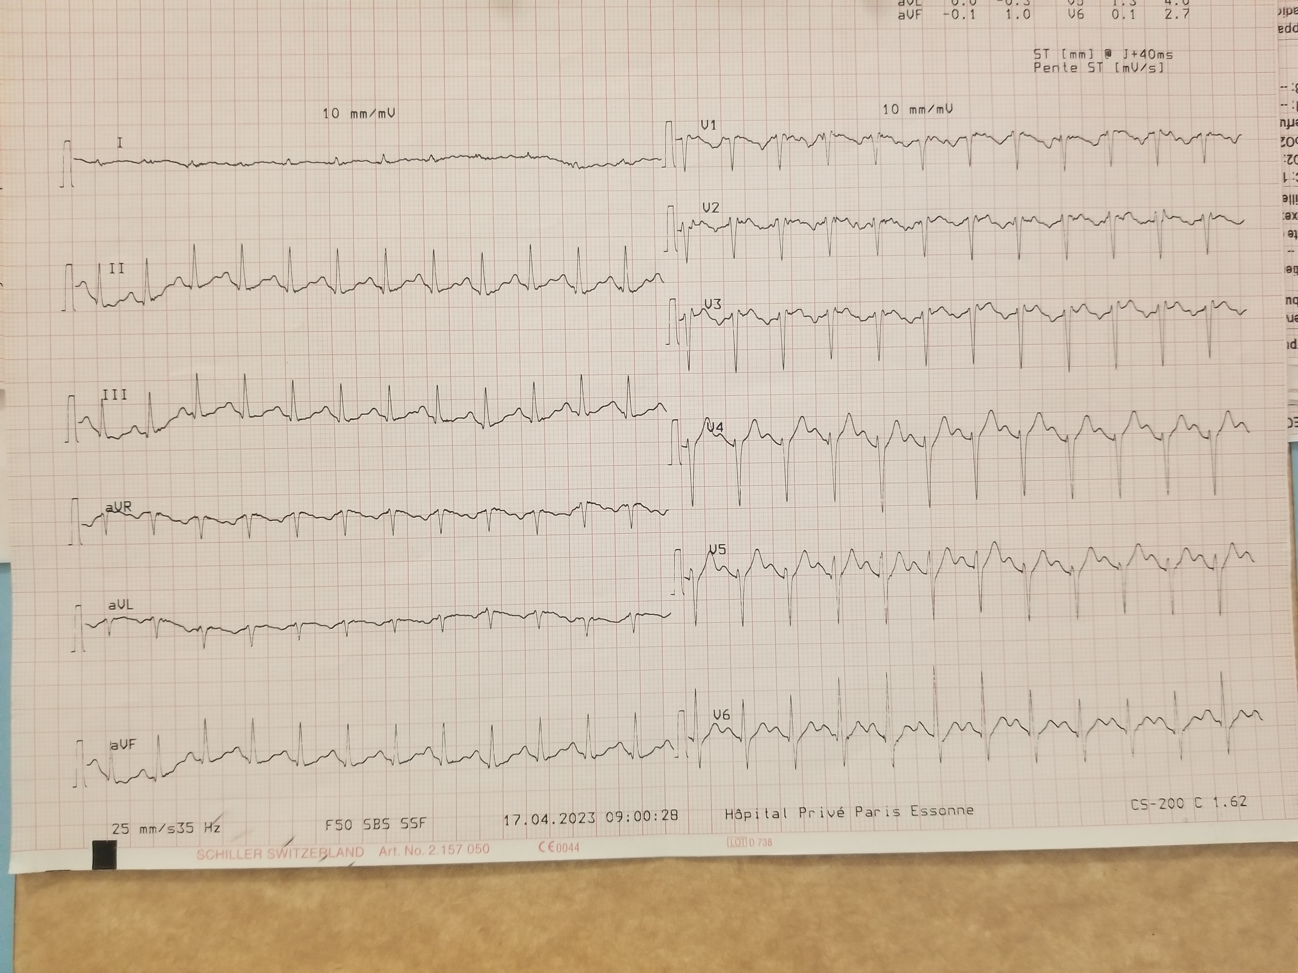
Figure 1Twelve-lead electrocardiogram with a heart rate of approximately 130 beats per minute. The P wave is biphasic in leads V1 and aVL

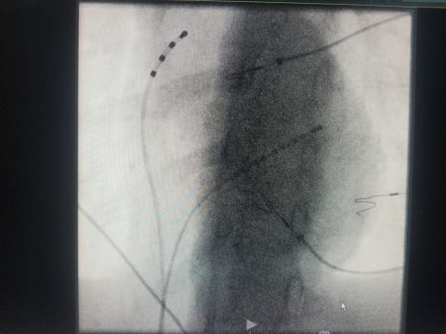
Figure 2 Fluoroscopic view during catheter ablation of tachycardia showing positioning of the mapping and ablation catheters within the cardiac chambers.

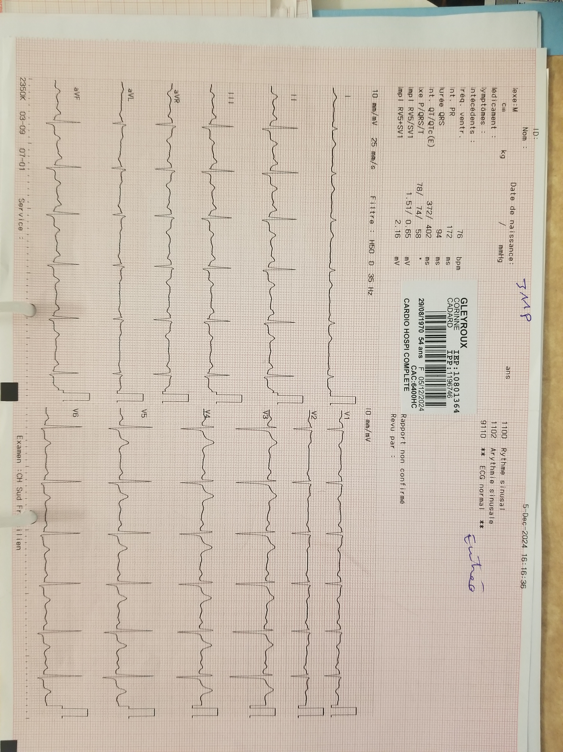
Figure 3 Twelve-lead electrocardiogram with a sinusal p wave , HR at 85 bpm after catheter ablation

Discussion
Although SVT is relatively common , Focal AT accounts for only a minority of cases, being identified in approximately 10-15% of patients referred for ablation (6). Most patients are asymptomatic or present with palpitations (5).
It is recognized that focal atrial tachycardias do not occur randomly throughout the atria but rather have a characteristic anatomic distribution In the right atrium they tend to cluster around the crista terminalis, coronary sinus, parahisian region, tricuspid annulus, and right atrial appendage (8)

Foci arising from the right atrial appendange (RAA ) or crista terminalis (CT) are particularly challenging because their ECG presentation may closely sinus tachycardia(2,3)
Electrocardiographic features vary widely. While focal AT often exceeds 150 bpm (5,9), lower rates have also been described, particularly during pregnancy. The hallmark finding is the presence of non-sinus P-waves, but morphology depends on the site of origin. The CT and RAA are among the most frequent right atrial foci (5).
Differentiating parasinusal AT from IST is essential. In IST, P-wave morphology during tachycardia is virtually identical to sinus rhythm, with mean daytime heart rate >95 bpm on Holter (3,4). Conversely, parasinusal AT typically exhibits distinct P-wave features. Tang et al. (10) demonstrated that P-wave polarity in V1 and aVL predicts atrial origin: a negative or biphasic V1 strongly suggests a right atrial focus. Kistler et al. (11) confirmed this, showing that a negative/biphasic P-wave in V1 had 100% specificity for right atrial origin.
In our patient, P-wave morphology varied with tachycardia rate:
At 133 bpm, P-waves were biphasic/negative in V1 and biphasic in aVL, consistent with an RAA focus.
At 112 bpm, P-waves were again biphasic in V1, favoring a CT origin.
In our patient , this overlap initially raised suspicion of IST but detailed ECG analysis revealed subtle differences in P-wave morphology , confirming the diagnosis of AT .
These findings demonstrate the value of systematic ECG analysis for localization, even in the absence of advanced mapping.
Three-dimensional electroanatomical mapping provides a precise means of localizing atrial tachycardia and may reduce recurrence rates while minimizing fluoroscopic exposure (4,12, 13). However mapping technology is not universally available.
Medical therapy is frequently ineffective in controlling focal AT (14).in our patient , symptoms persisted despite b-blocker therapy.
Radiofrequency ablation guided by ECG and mapping is considered curative, with low recurrence rates (5). In our case, ablation was performed without three-dimensional mapping, relying solely on ECG morphology, this reinforces the pratical value of surface ECG interpretation as a first line diagnostic approach

Conclusion
We report a rare case of parasinusal atrial tachycardia mimicking inappropriate sinus tachycardia in a middle-aged woman. Careful ECG-based analysis of P-wave morphology, according to validated algorithms, enabled accurate localization of the arrhythmic focus to the right atrial appendage and crista terminalis.
This case highlights that, even without the use of three-dimensional mapping, precise diagnosis and successful ablation can be achieved through a systematic ECG-guided approach. Early recognition of parasinusal AT is essential to distinguish it from IST, ensuring timely curative therapy with excellent prognosis.

Disclaimer (Artificial intelligence)

Author(s) hereby declare that NO generative AI technologies such as Large Language Models (ChatGPT, COPILOT, etc.) and text-to-image generators have been used during the writing or editing of this manuscript.

References
1. Kotadia ID, Williams SE, O’Neill M. Supraventricular tachycardia: an overview of diagnosis and management. Clin Med (Lond). 2020;20(1):43-7. doi:10.7861/clinmed.cme.20.1.3. PMID: 31941731.
2. Roberts-Thomson KC, Kistler PM, Haqqani HM, et al. Focal atrial tachycardias arising from the right atrial appendage: electrocardiographic and electrophysiologic characteristics and radiofrequency ablation. J Cardiovasc Electrophysiol. 2007;18(4):367-72. doi:10.1111/j.1540-8167.2007.00775.x.
3. Shen WK. How to manage patients with inappropriate sinus tachycardia. Heart Rhythm. 2005;2(9):1015-9. doi:10.1016/j.hrthm.2005.05.021.
4. Marrouche NF, Beheiry S, Tomassoni G, et al. Three-dimensional nonfluoroscopic mapping and ablation of inappropriate sinus tachycardia: procedural strategies and long-term outcome. J Am Coll Cardiol. 2002;39(6):1046-54. doi:10.1016/S0735-1097(02)01719-9.
5. Wang NC, Shen C, McLaughlin TJ, et al. Maternal focal atrial tachycardia during pregnancy: a systematic review. J Cardiovasc Electrophysiol. 2020;31(11):2982-97. doi:10.1111/jce.14738. PMID: 32897619.
6. . Roscani MG, Zanati SG, Magalhães CG, Borges VTM, Matsubara BB. Digitalis-like induced arrhythmia in a patient with rheumatic mitral regurgitation complicated by preeclampsia. Hypertens Pregnancy. 2010;29(2):148-52. doi:10.3109/10641950902928571. PMID: 19891530.
7. Steinbeck G, Hoffmann E. ‘True’ atrial tachycardia. Eur Heart J. 1998;19 Suppl E:E11-6. doi:10.1093/eurheartj/19.suppl_e.E11. PMID: 9717019.
8. Roberts-Thomson, K. C., Kistler, P. M., & Kalman, J. M. (2005). Atrial tachycardia: mechanisms, diagnosis, and management. Current problems in cardiology, 30(10), 529-573.

9. Sonsoz MR, Bilge AK, Elitok A. Left atrial appendage: the uncommon origin of focal atrial tachycardia in a pregnant woman. Anatol J Cardiol. 2019;22(6):E13-4. doi:10.14744/AnatolJCardiol.2019.17748. PMID: 31789606.
10. Tang CW, Scheinman MM, Van Hare GF, et al. Use of P-wave configuration during atrial tachycardia to predict site of origin. J Am Coll Cardiol. 1995;26(5):1315-24. doi:10.1016/0735-1097(95)00314-0. PMID: 7594080.
11. Kistler PM, Roberts-Thomson KC, Haqqani HM, et al. P-wave morphology in focal atrial tachycardia: development of an algorithm to predict the anatomic site of origin. J Am Coll Cardiol. 2006;48(5):1010-7. doi:10.1016/j.jacc.2006.03.054. PMID: 16949484.
12. Narita S, Miyamoto K, Tsuchiya T, et al. Radiofrequency catheter ablation of atrial tachycardia under navigation using the EnSite array. Circ J. 2010;74(1):59-65. doi:10.1253/circj.CJ-09-0412. PMID: 19966546.
13. Sane PS, Raja DC, Sarvanan S, Pandurangi U. Hybrid magneto-impedance based 3D electro-anatomical mapping in a complex case of incessant left atrial tachycardia. Indian Pacing Electrophysiol J. 2019;19(6):240-5. doi:10.1016/j.ipej.2019.09.002. PMID: 31518690.

14. Hubbard WN, Jenkins BA, Ward DE. Persistent atrial tachycardia in pregnancy. BMJ. 1983;287(6388):327-8. doi:10.1136/bmj.287.6388.327. PMID: 6409293.

