Case report

Acute Stanford Type A Aortic Dissection Revealed by Isolated Acute Confusion: A Case Report and Review of the Literature

Abstract

Background:
Acute Stanford type A aortic dissection is a life-threatening condition that classically presents with abrupt chest or back pain and requires immediate surgical management. However, atypical presentations are frequent and may complicate diagnosis. Neurological manifestations occur in up to 30% of cases and are associated with diagnostic delay and increased mortality. Among these, isolated acute confusion as the initial presentation is exceptionally rare and remains poorly recognized.

Case presentation:
We report the case of a 59-year-old woman with Hypertension who initially presented to the emergency department with retrosternal chest pain that resolved spontaneously and was followed five days later by isolated acute confusion. On readmission, she had no chest pain, focal neurological deficits, hypotension, shock, or signs of internal bleeding, but exhibited severe hypoxemia. Initial neurological investigations, including brain imaging, were unremarkable. Chest X-ray revealed mediastinal widening, and contrast-enhanced computed tomography confirmed an acute Stanford type A aortic dissection extending from the origin of the left subclavian artery to the celiac trunk, without involvement of the supra-aortic vessels. Emergency surgical replacement of the ascending aorta under cardiopulmonary bypass was promptly performed.

Results:
The postoperative course was overall favorable despite minor complications, with rapid hemodynamic stabilization and complete resolution of neurological symptoms. No postoperative delirium or neurological deficits were observed. The patient was discharged in good clinical condition and scheduled for outpatient cardiology follow-up.

Conclusion:
This case highlights that acute aortic dissection may present with isolated acute confusion in the absence of chest pain or focal neurological signs. Clinicians should maintain a high index of suspicion for aortic dissection in patients with unexplained acute confusional states, particularly when cardiovascular risk factors are present. Early thoracic imaging remains essential to prevent diagnostic delay and improve clinical outcomes.
Keywords: Acute aortic dissection; Stanford type A; Atypical presentation; Acute confusional state; Neurological manifestations; Diagnostic delay; Emergency surgery.

INTRODUCTION
Acute Stanford type A aortic dissection is a life-threatening emergency characterized by a tear of the intimal layer of the ascending aorta, resulting in the formation of a false lumen that may compromise perfusion of vital organs. Its incidence is estimated at 3 to 6 cases per million inhabitants per year, with a mortality rate increasing by 1–2% per hour in the absence of immediate surgical intervention. (1)
The typical initial presentation is a sudden onset of severe chest or back pain, often described as tearing or stabbing. However, atypical presentations frequently complicate diagnosis: approximately 30% of patients initially present with neurological manifestations such as ischemic stroke, syncope, or altered mental status. These so-called “painless” or “neurological-first” presentations are associated with significant diagnostic delays and increased mortality.(2)
Neurological manifestations may result from obstruction of the carotid or vertebral arteries, global cerebral hypoperfusion, or transient hypoxic encephalopathy. Among these presentations, isolated acute confusion is exceptionally rare and may misleadingly suggest a neuropsychiatric or metabolic disorder, thereby delaying recognition of this critical condition.(3)
We report the case of a 59-year-old woman in whom acute type A aortic dissection was revealed by isolated acute confusion, without chest pain or focal neurological deficit, highlighting the diagnostic value of early thoracic imaging in atypical neurological presentations among patients with cardiovascular risk factors.
Case Presentation
A 59-year-old woman with a history of hypertension managed with lifestyle and dietary measures, occasional smoking since the age of 13, anxiety–depressive disorder, asthma, and migraine headaches treated with undisclosed long-term therapy was admitted to our institution. Her surgical history was notable for bilateral knee prosthetic replacement performed five years earlier. No family history of cardiovascular disease or inherited connective tissue disorders was reported.

On June 30, 2023, she presented to the emergency department with persistent retrosternal chest pain, without radiation or associated syncope. Initial physical examination was unremarkable, and hemodynamic parameters were stable. The electrocardiogram showed no repolarization abnormalities, and initial laboratory tests were within normal limits, including cardiac troponin, complete blood count, D-dimer levels, and C-reactive protein. The chest pain resolved spontaneously, and the patient was discharged home.
Five days later (day +5), the patient was found at home in a state of disorientation and acute confusion, without fever or focal motor deficit. She was readmitted to the emergency department. On admission, vital signs revealed severe oxygen desaturation, while other parameters remained stable: blood pressure 130/86 mmHg, heart rate 100 beats per minute, respiratory rate 23 breaths per minute, oxygen saturation 44%, and body temperature 36.8°C.
Laboratory investigations demonstrated a markedly elevated C-reactive protein level of 300 mg/L, a borderline estimated glomerular filtration rate of 50 mL/min, hypokalemia at 2.9 mEq/L, and negative cardiac troponin levels. The electrocardiogram showed diffuse flattened T waves. Chest radiography revealed mediastinal widening.

Additional Investigations
Given the acute confusional syndrome, a neurological workup was initiated. Contrast-enhanced cerebral, thoracic, and abdominal computed tomography performed after admission revealed a Stanford type A aortic dissection extending from the origin of the left subclavian artery to the celiac trunk, associated with aneurysmal dilation of the ascending aorta. Both true and false lumens were patent, with a large fenestration at the level of the celiac trunk. No involvement of the supra-aortic vessels was identified.

Management and Surgical Intervention
The patient was urgently transferred to the cardiac surgery intensive care unit. Emergency surgical management was undertaken after achieving adequate hemodynamic control with intravenous labetalol.it’s consisting of prosthetic replacement of the ascending aorta with a tubular graft under cardiopulmonary bypass. The procedure was completed under satisfactory technical and hemodynamic conditions.
Postoperative Course and Follow-Up
The immediate postoperative course was notable for the following:
- successful extubation at 15 hours postoperatively;
- a right anterior pneumothorax requiring chest drainage on postoperative day 0;
- rapid weaning from vasopressor support on postoperative day 0;
- initiation of beta-blocker therapy and an angiotensin-converting enzyme inhibitor for blood pressure control;
- development of community-acquired pneumonia on postoperative day 3, treated with cefotaxime for six days;
- effective fluid and sodium depletion achieved with intravenous furosemide;
- no recurrence of confusion or postoperative hallucinations.
The patient was transferred to the surgical ward on postoperative day 7 and discharged home on postoperative day 16 in good general condition, with blood pressure of 150/75 mmHg, body weight of 67.7 kg, body temperature of 36.6°C, clean surgical incisions, and no neurological deficits.
Outpatient cardiology follow-up was scheduled.
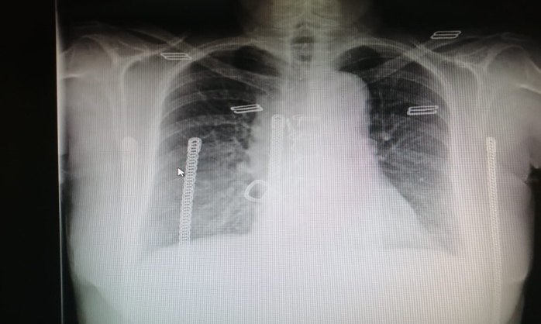
- Figure 1 Chest X-ray demonstrating mediastinal widening.

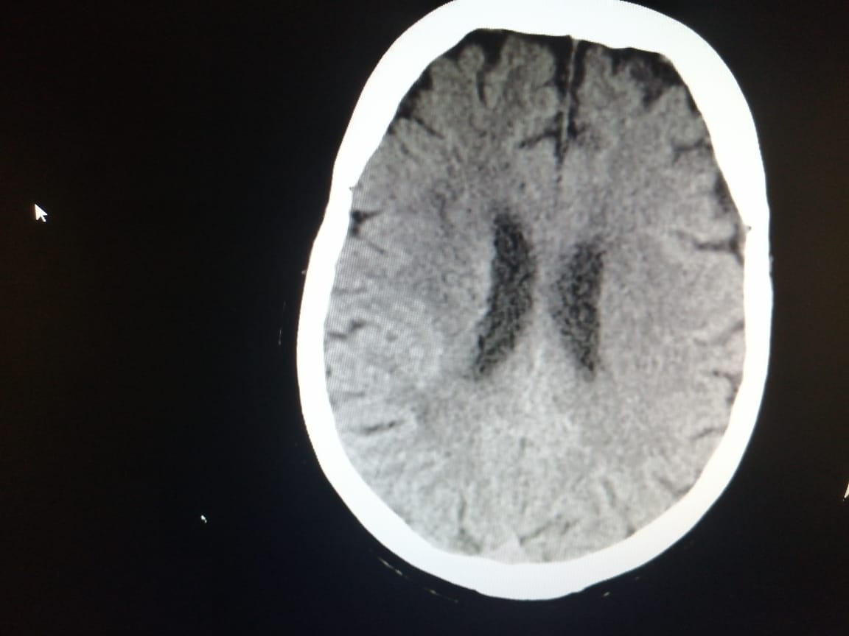

Figure 2 Brain CT scan without lesions explaining the clinical presentation.

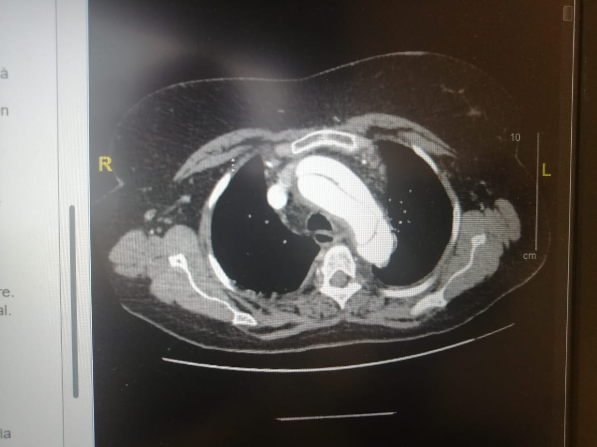
Figure 3 axial contrast-enhanced CT angiography shows an intimal flap within the aortic arch, separating true and false lumens xith extension to the origin of the left subclavian artery

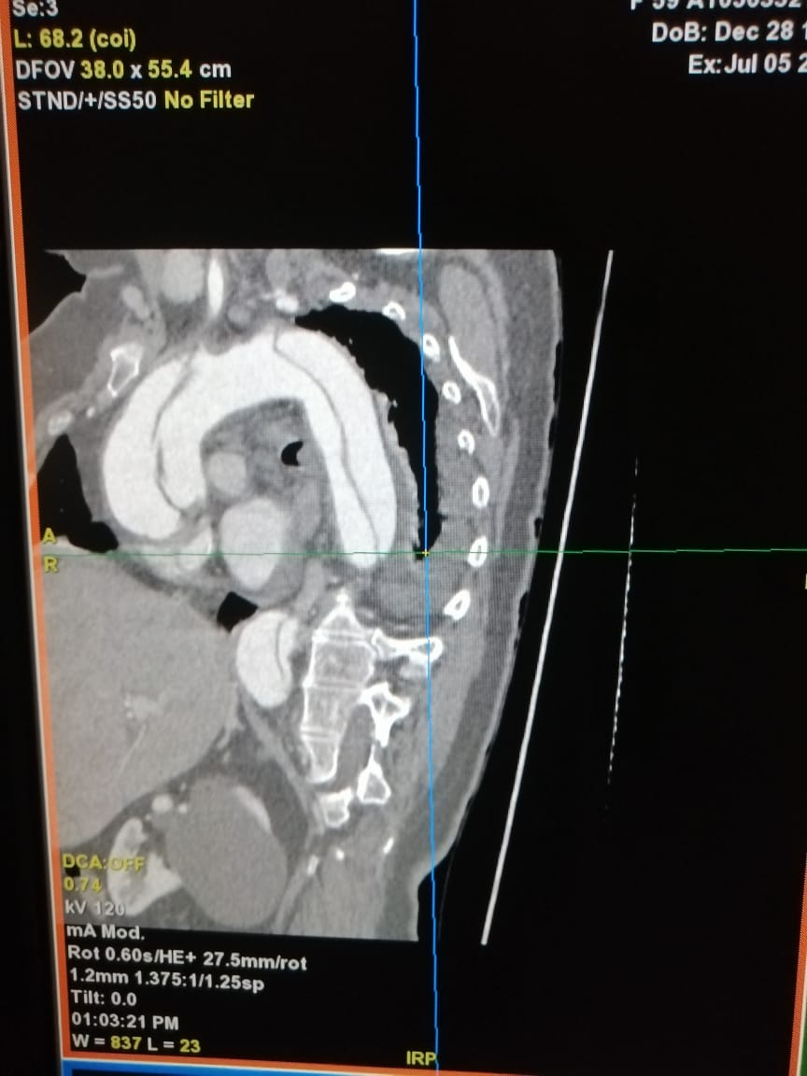
Figure 4 sa gittal contrast-enhanced CT angiography showing a clear intimal flap separating the true and false lumens of the thoracic aorta, involving the aortic arch and descending
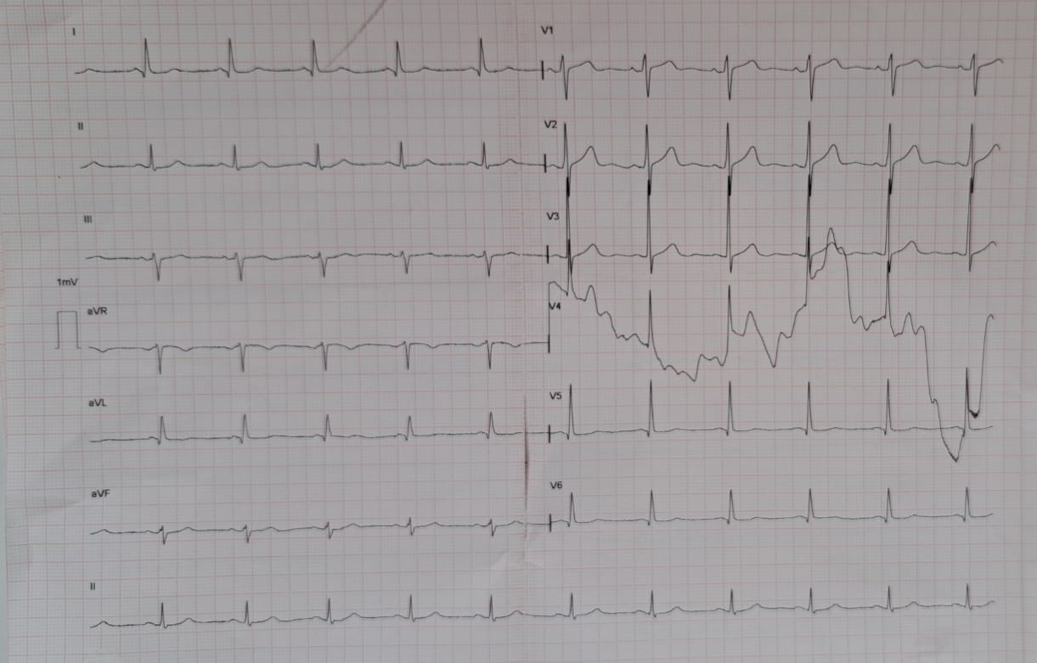
Figure 5 The electrocardiogram showed diffuse flattened T waves.

Discussion

Aortic dissection is a potentially fatal condition resulting from a tear in the intimal layer of the aorta or from hemorrhage within the aortic wall, leading to separation of the different layers of the aortic wall. Several risk factors have been identified, including advanced age, hypertension, dyslipidemia, and genetic connective tissue disorders.

Once aortic dissection is suspected, time becomes a critical determinant of outcome. In earlier series, the mortality rate of untreated aortic dissection was estimated at 1–2% per hour following initial presentation, reaching approximately 25% within the first 24 hours.⁽⁴˒⁵⁾
Acute Stanford type A aortic dissection carries a mortality risk of approximately 0.5% per hour, reaching 23.7% at 48 hours.⁽¹⁾ Rapid recognition and accurate diagnosis are therefore essential to initiate appropriate management.

The most common initial symptom of acute aortic dissection is chest or abdominal pain. Nevertheless, in a minority of cases, the clinical presentation may be atypical, complicating diagnosis from a clinical standpoint.⁽³⁾
Neurological manifestations associated with aortic dissection are often dramatic and may completely dominate the clinical picture. According to the classification proposed by Blanco et al.⁽⁶⁾, and based on the early reports of Weisman and Adams⁽⁷⁾ as well as Scott and Sancetta⁽⁸⁾, these manifestations can be categorized as persistent or transient ischemic stroke, spinal cord ischemia, ischemic neuropathy, and hypoxic encephalopathy.
Neurological presentations include syncope, seizures, spinal cord ischemia, ischemic neuropathy, and encephalopathy, with ischemic stroke being the most common manifestation, often occurring in the absence of pain.⁽⁶⁾

A retrospective review of medical records revealed that 29% of patients with aortic dissection primarily presented with neurological symptoms, and these patients were significantly less likely to report pain.⁽³⁾ In the same study, neurological manifestations were nearly twice as frequent in patients with dissection involving the supra-aortic vessels.

Neurological complications are common in the setting of Stanford type A aortic dissection. Indeed, nearly half of these dissections are associated with neurological involvement, most frequently affecting the carotid vascular system, which is involved in 81.2% of cases. However, it is noteworthy that in our patient, although neurological manifestations were present, they were not related to involvement of the carotid system, thereby distinguishing this clinical presentation from the majority of cases reported in the literature.⁽³⁾

Hagan et al. reported that most patients who developed ischemic stroke also had a history of pain.⁽⁹⁾ In another study, only two-thirds of patients presenting with neurological symptoms at the onset of dissection complained of pain, whereas the majority of patients without neurological symptoms (94.4%) experienced initial pain.⁽³⁾ Approximately half of all patients who did not report pain presented exclusively with neurological symptoms.⁽³⁾

In our case, retrospective assessment revealed that the patient had experienced chest pain five days prior to admission.

A wide spectrum of neurological symptoms has been documented in patients with aortic aneurysms, as observed in our patient. In a series of three cases, the neurological manifestations reported in patients with aortic dissection included dysarthria with mild left-sided paresis and a positive Babinski sign, aphasia with severe right-sided paresis, and, in a third case, aphasia associated with right-sided paresis.⁽¹⁰⁾
In our case, the neurological presentation was essentially limited to acute confusion.

While most neurological complications are attributed to propagation of the dissection into the supra-aortic vessels, a combination of focal and global cerebral ischemia leading to hypoxic encephalopathy may also result from sustained hypotension secondary to cardiac tamponade, exsanguination into the pleural or retroperitoneal spaces, or frank aortic rupture.⁽⁶⁾ In our case, the patient was normotensive and showed no evidence of internal hemorrhage.

The available literature has extensively reviewed neurological manifestations, their underlying pathophysiological mechanisms, and their prevalence as initial symptoms of acute Stanford type A aortic dissection.⁽⁶⁾

Our patient presented with severe oxygen desaturation to 44% at admission in the setting of acute confusion, without hypotension, shock, cardiac tamponade, or other internal bleeding, and with preserved supra-aortic vessels. No clear explanation could be identified for the hypoxemia leading to hypoxic encephalopathy responsible for the confusional state.

Furthermore, neurological manifestations, particularly delirium, are common postoperative complications following aortic dissection repair.⁽¹¹⁾ A history of cerebrovascular disease, duration of surgery and cardiopulmonary bypass, postoperative hypoxia, and duration of intubation have been independently associated with the development of delirium.⁽¹²⁾

In our reported case, the initial presentation was marked by acute confusion, whereas no neurological signs were observed during the postoperative period.

A case similar to ours was reported in 2017, describing a 55-year-old man with an acute Stanford type A ascending aortic dissection who initially presented with syncope and intermittent seizures.¹³ In addition, in 2023, another case was reported in which the diagnosis of aortic dissection in a female patient was established only after death, following clinical agitation and circulatory collapse, underscoring the critical importance of early detection and prompt management.¹

The diagnosis of aortic dissection can be confirmed by computed tomography, transthoracic or transesophageal echocardiography, magnetic resonance imaging, or aortography, either alone or in combination. In high-risk patients, all four diagnostic modalities demonstrate positive predictive values exceeding 85%. The choice of the initial imaging modality in most studies reflects availability rather than preference.⁽⁹⁾

In the present case, the diagnostic process incorporated the history of chest pain occurring five days prior to admission, associated with neurological manifestations in the form of acute confusion. This presentation initially prompted investigations for ischemic stroke, which were negative, before the diagnosis was ultimately established by thoracic computed tomography.

Several studies have reported conflicting evidence regarding whether neurological symptoms constitute an independent predictor of poor prognosis or in-hospital mortality in patients with acute Stanford type A aortic dissection. While some studies have failed to demonstrate such an association, others have identified preoperative neurological deficits as a significant predictor of in-hospital mortality.⁽²˒¹⁴–¹⁸⁾

Based on the most comprehensive analysis of 682 patients from the International Registry of Acute Aortic Dissection (IRAD), a multivariable risk prediction model was proposed. Independent preoperative predictors of mortality included age >70 years (odds ratio [OR] 1.98), previous cardiac surgery (OR 4.21), hypotension (systolic blood pressure <100 mmHg) or shock (OR 3.23), cardiac tamponade (OR 2.65), migrating pain (OR 2.42), any pulse deficit (OR 1.75), and signs of myocardial ischemia (OR 1.76).⁽¹⁴⁾ In our case, the patient presented with none of these adverse prognostic factors, which likely explains her favorable outcome.

Conclusion
This case highlights the importance of a systematic and comprehensive diagnostic approach, particularly in complex clinical situations where multiple symptoms and risk factors coexist. It emphasizes that even in the absence of typical features, clinicians should consider the possibility of aortic dissection in patients presenting with unusual neurological symptoms, such as acute confusion, especially when cardiovascular risk factors similar to those observed in our patient are present.

Limitations
- Lack of a clearly established pathophysiological mechanism :
Although several hypotheses were considered to explain the acute confusional state and hypoxemia, no definitive pathophysiological mechanism could be clearly demonstrated. This limits the ability to draw firm conclusions regarding the causal relationship between the aortic dissection and the neurological presentation.
- Absence of preoperative echocardiographic assessment :
Due to the extreme emergency context, neither transthoracic nor transesophageal echocardiography was performed prior to surgery. While this approach was justified to avoid delaying life-saving intervention, it limited the preoperative hemodynamic and functional cardiac assessment.
- Limited contemporary literature on similar atypical presentations :
The rarity of acute aortic dissection presenting with isolated neurological symptoms has resulted in a scarcity of recent published data. Consequently, some older references were required to contextualize this case, which may limit comparisons with contemporary cohorts.

CONSENT
As per international standards or university standards, patient(s) written consent has been
collected and preserved by the author(s).
ETHICAL APPROVAL

Ethical approval was not required for this case report. Written informed consent for publication was obtained from the patient, and all data were anonymized.
COMPETING INTERESTS
Authors have declared that no competing interests exist.

Disclaimer (Artificial intelligence)

Author(s) hereby declare that NO generative AI technologies such as Large Language Models (ChatGPT, COPILOT, etc.) and text-to-image generators have been used during the writing or editing of this manuscript.

Références

- Harris KM, Nienaber CA, Peterson MD, et al. Early mortality in type A acute aortic dissection: insights from the International Registry of Acute Aortic Dissection. JAMA Cardiol. 2022;7(10):1009–1015. doi:10.1001/jamacardio.2022.2718.
- Mohamed Azhar M, Rajesh M. A case of acute aortic dissection presenting with neurological symptoms. Cureus. 2023;15(7):e42318. doi:10.7759/cureus.42318.
- Gaul C, Dietrich W, Friedrich I, Sirch J, Erbguth FJ. Neurological symptoms in type A aortic dissections. Stroke. 2007;38(2):292–297. doi:10.1161/01.STR.0000254594.33408.b1.
- Khan IA, Nair CK. Clinical, diagnostic, and management perspectives of aortic dissection. Chest. 2002;122(1):311–328. doi:10.1378/chest.122.1.311.
- Hirst AE Jr, Johns VJ Jr, Kime SW Jr. Dissecting aneurysm of the aorta: a review of 505 cases. Medicine (Baltimore). 1958;37(3):217–279. doi:10.1097/00005792-195809000-00003.
- Blanco M, Díez-Tejedor E, Larrea JL, Ramírez U. Neurologic complications of type I aortic dissection. Acta Neurol Scand. 1999;99(4):232–235. doi:10.1111/j.1600-0404.1999.tb07352.x.
- Weisman AD, Adams RD. The neurological complications of dissecting aortic aneurysm. Brain. 1944;67(2):69–92. doi:10.1093/brain/67.2.69.
- Scott RW, Sancetta SM. Dissecting aneurysm of the aorta with hemorrhagic infarction of the spinal cord and complete paraplegia. Am Heart J. 1949;38:747–756.
- Hagan PG, Nienaber CA, Isselbacher EM, et al. The International Registry of Acute Aortic Dissection (IRAD): new insights into an old disease. JAMA. 2000;283(7):897–903. doi:10.1001/jama.283.7.897.
- Pastuszak Ż, Stępień A, Kordowska J, Rolewska A, Galbarczyk D. Brain strokes related to aortic aneurysm: analysis of three cases. Open Med (Wars). 2017;12:58–61. doi:10.1515/med-2017-0011.
- Shi Q, Mu X, Zhang C, Wang S, Hong L, Chen X. Risk factors for postoperative delirium in type A aortic dissection patients: a retrospective study. Med Sci Monit. 2019;25:3692–3699. doi:10.12659/MSM.913774.
- Flower L, Arrowsmith JE, Bewley J, et al. Management of acute aortic dissection in critical care. J Intensive Care Soc. 2023;24(4):409–418. doi:10.1177/17511437231162219.
- Chen CH, Liu KT. Painless type A aortic dissection with intermittent convulsive syncope as the initial presentation: a case report. Medicine (Baltimore). 2017;96(17):e6762. doi:10.1097/MD.0000000000006762.
- Rampoldi V, Trimarchi S, Eagle KA, et al. Simple risk models to predict surgical mortality in acute type A aortic dissection: the IRAD score. Ann Thorac Surg. 2007;83(1):55–61. doi:10.1016/j.athoracsur.2006.08.007.
- Fann JI, Smith JA, Miller DC, et al. Surgical management of aortic dissection during a 30-year period. Circulation. 1995;92(9 Suppl):II113–II121. doi:10.1161/01.CIR.92.9.113.
- Pansini S, Gagliardotto PV, Pompei E, et al. Early and late risk factors in surgical treatment of acute type A aortic dissection. Ann Thorac Surg. 1998;66(3):779–784. doi:10.1016/S0003-4975(98)00555-4.
- Ehrlich MP, Ergin MA, McCullough JN, et al. Results of immediate surgical treatment of all acute type A dissections. Circulation. 2000;102(19 Suppl 3):III248–III252. doi:10.1161/01.CIR.102.suppl_3.III-248.
- Chirillo F, Marchiori MC, Andriolo L, et al. Outcome of 290 patients with aortic dissection: a 12-year multicentre experience. Eur Heart J. 1990;11(4):311–319. doi:10.1093/eurheartj/11.4.311.

