Case report
A Giant Asymptomatic True Aneurysm Following Silent Myocardial Infarction: A Case Report in an Octogenarian

Abstract:

Background : Large ventricular aneurysms (LVA) are now rare as the result of the widespread availability of percutaneous coronary intervention. Yet it presents adverse events such as recurrent angina, reduced ventricular stroke volume with congestive heart failure, mitral regurgitation, thromboembolism, and ventricular arrhythmias.

Case Presentation : We report the case of an 84-year-old woman who presented with generalized weakness and was subsequently noted to have impressive findings of a chronic large LV true aneurysm with thrombus , which was managed conservatively with medical therapy in the absence of complications.

Conclusion : Left ventricular aneurysms can present with nonspecific symptoms yet carry a high risk of serious complications. This case highlights the importance of comprehensive multimodal imaging in addition to accurate clinical history for diagnosing ventricular aneurysms and guiding appropriate management strategies, particularly in elderly patients.

Keywords: Left ventricular aneurysm; Myocardial infarction; Cardiac magnetic resonance; Multimodality imaging.

Introduction

Left ventricular aneurysms (LVA) are typically a late consequence of transmural acute myocardial infarction (AMI). Like other post-AMI mechanical complications, the incidence of LVA has decreased in the era of early and intensive revascularization but remains associated with greater morbidity and mortality. Current European Society of Cardiology STEMI guidelines suggest incidence of LVAs to be <5%. [1]
LV aneurysm was first reported in 1951 by angiographic evidence. The natural progression begins with a full-thickness infarction, which had been replaced by scarred tissue. This can lead to a true ventricular aneurysm or a ventricular pseudo aneurysm. [2] In contrast to pseudo aneurysms, in which the risk for rupture is greater, surgical intervention typically is reserved for patients with heart failure not responding to guideline-directed medical therapy (GDMT) or persistent ventricular arrhythmias [3].
This case report highlights a clinically significant presentation of a giant true left ventricular aneurysm discovered following a silent myocardial infarction in an elderly patient. Although the incidence of left ventricular aneurysms has decreased in the era of early reperfusion therapy, this case demonstrates that they can still be detected incidentally and may present without typical ischemic symptoms. The case emphasizes the practical role of multimodality cardiac imaging in establishing the diagnosis and supporting management decisions, particularly in older patients with limited surgical options.

Case presentation
We report a case of 84-year-old female patient with cardiovascular risk factors, including arterial hypertension and type 2 diabetes. She attended a routine consultation for the management of her hypertension, she denied any history of ongoing chest pain, orthopnea or lower extremities edema. Cardiovascular examination revealed a double apex beat on palpation with no murmurs. Neurogical examination remained unremarkable.
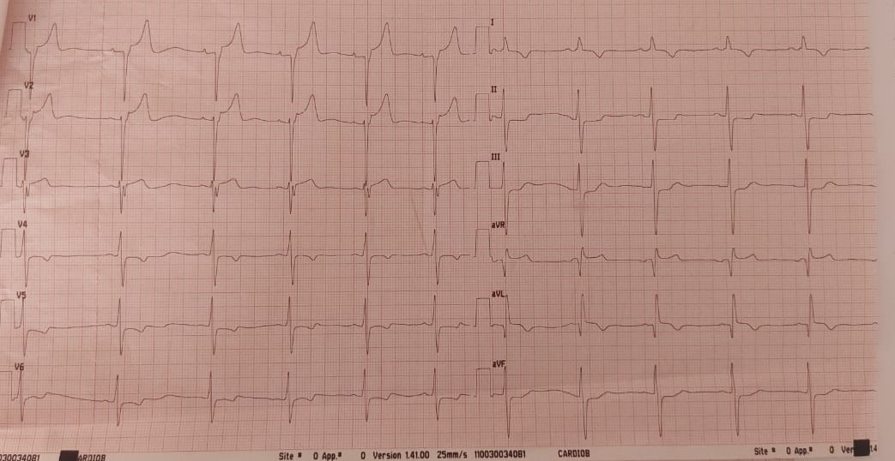
The electrocardiogram (EKG) showed ST-elevation and Q-waves in the septal and high lateral leads (V1, V2, aVR, aVL) with reciprocal ST-depression in the inferior leads (Figure 1).
Figure 1 EKG showed widespread ST depression with ST elevation in V1-V2 , aVR and aVL associated with deep Q waves and T wave inversion
Chest X-ray revealed significant cardiomegaly (cardiothoracic index: 0.65) and a well-circumscribed opacity projecting from the left middle cardiac contour, without evidence of venous congestion (Figure 2).

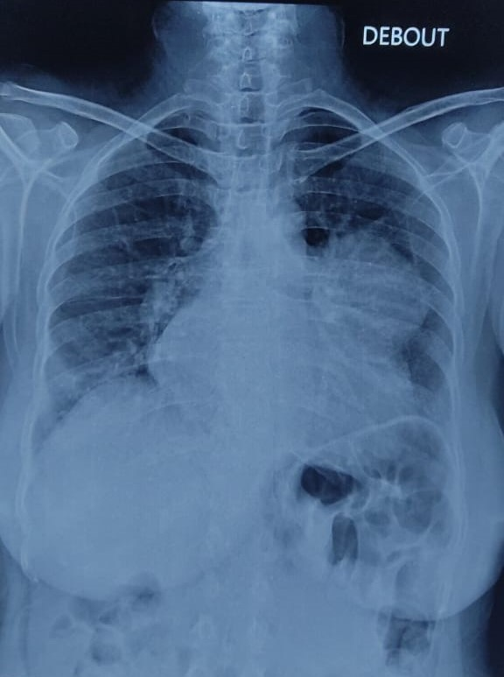
Figure 2 Chest X ray revealed well-circumscribed opacity arising from the left middle heart border
Biological assessments were unremarkable, with normal fasting blood glucose, negative troponin and normal thyroid function tests. She had stage IIIb chronic kidney disease (estimated glomerular filtration rate, GFR: 34 mL/min).

A transthoracic echocardiogram (TTE) was performed, revealing a large aneurysmal pouch at the apex and anterior wall, communicating with the ventricular cavity through a wide neck (30mm) and lined with organized thrombus (Figure 3 A, B and C) difficult to estimate, though it was evident that it was severely reduced due to the presence of the large aneurysm. Left ventricle was dilated (end-diastolic diameter of 62 mm, end-systolic diameter of 50 mm). Apical, midanterior and mid-septal segments were thinned and akinetic.

She subsequently had elective coronary angiography, which demonstrated a total chronic occlusion of ostial left anterior descending artery in keeping with prior STEMI with poor collateralization, along with severe multi-level stenotic lesions in the right coronary artery. Given evidence of completed infarction with resultant aneurysmal change, revascularization was deferred (Figure 4). Left ventriculography was not performed given presence of LV thrombus.

Although transthoracic echocardiography was essentially diagnostic, our patient underwent cardiovascular magnetic resonance imaging (CMR), which revealed a massive outpouching deformation of the anterior wall with a broad neck contained all the layers of the myocardium, leading to the diagnosis of an anterior true aneurysm partly filled by a large thrombus (Figure 5). The cardiovascular MRI was also performed to assess myocardial viability, which was found to be negative in the left anterior interventricular artery territory in our patient. No surgical interventions were considered necessary at the time she was deemed too high risk in view of her significant frailty and lack of complications, therefore conservative management with close follow-up was pursued.

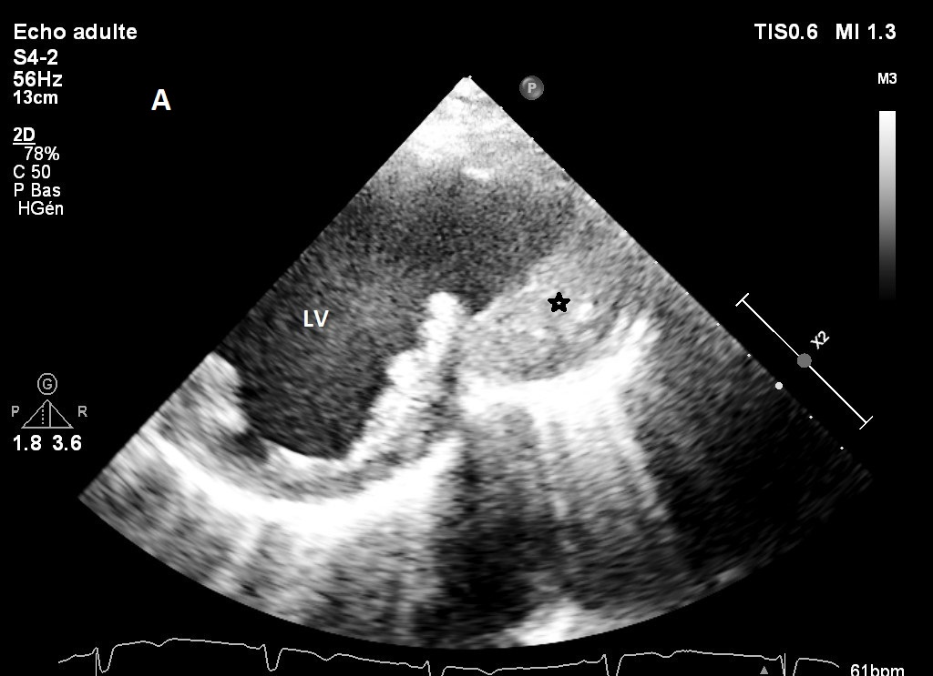

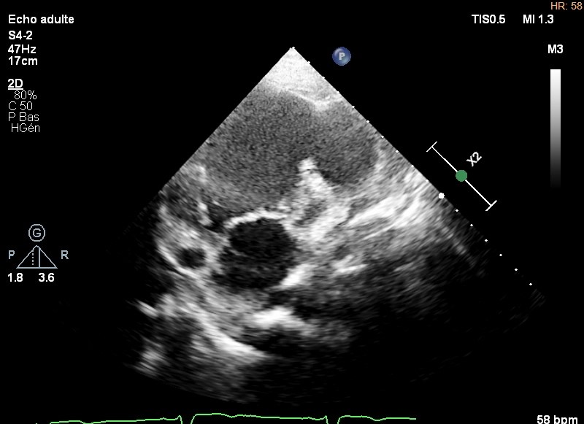
B
True Aneurysm

LV

LA

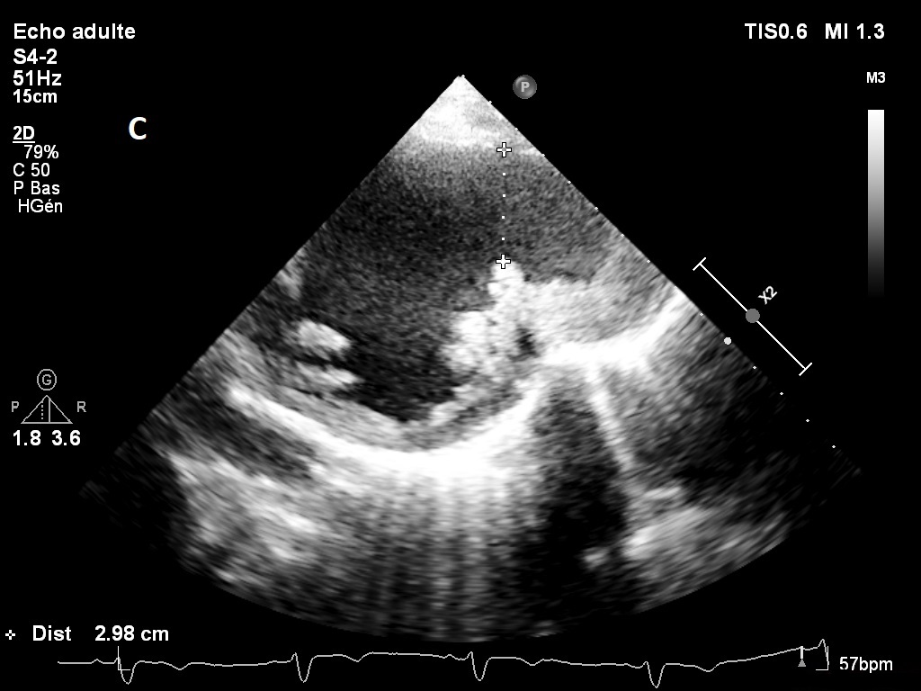
Figure 3 Transthoracic echocardiogram using parasternal short-axis (A) and apical two-chamber (B) views showing a thrombus (asterisk) covering the anterior wall of the aneurysm with a broad neck (yellow arrow) (C). LV, left ventricle; LA, left atrium.
Broad neck
Thrombus
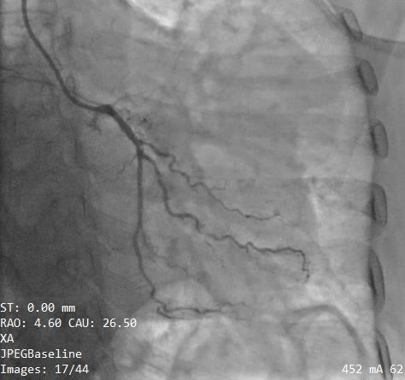
Figure 4 Left coronary angiography demonstrating ostial occlusion of left anterior descending artery.
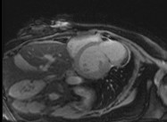
Thrombus
LVAneurysm
RV
LV
Figure 5 Cardiovascular MRI shows a large anterior ventricular aneurysm with a wide neck and myocardial continuity into the aneurysm, a hallmark of a true aneurysm, partly filled by a large thrombus. LV, left ventricle; RV, Right ventricle.
Discussion
Transmural myocardial infarction remains the most common cause of left ventricular aneurysm. The incidence of VA has changed over the last decades due to the improvement and diffusion of primary percutaneous revascularization. Less than 5% of patients after MI develop LV aneurysm. [1] The majority (75%–80%) occur in individuals with established risk factors, such as delayed or incomplete reperfusion, inadequate collateral circulation in the setting of total coronary artery occlusion as the case we present. [4]

As the occurrence of LVA declines, it is still crucial to maintain the ability to detect aneurysms. Assessment includes multimodal imaging techniques, such as CXR (which may reveal cardiomegaly, aneurysmal deformation, and occasionnally calcification) and TTE. CT and MRI imaging may be useful in the case of diagnostic doubt and for surgical planning. [5]

The differential diagnosis for left ventricular outpouchings consists of true aneurysms, pseudo aneurysms, and diverticulum.[6] Distinguishing between these conditions can be difficult but crucial, as it directly impacts prognosis and management decisions, since false aneurysms are usually associated with imminent risk of rupture. [7][8]

True aneurysms are defined as areas of thinner myocardium that are dyskinetic but contain
all wall layers. By contrast, pseudoaneurysms result from free wall rupture, often contained by thrombus and adherent pericardium. The latter thus present a greater risk than true aneurysms, spontaneous rupture being the most serious complication since this generally results in sudden
death.[9]

TTE is the first line modality used to diagnose left ventricular aneurysms. In this case, the myocardium can be seen enveloping the thrombus, indicating the presence of a left ventricle aneurysm. However, further imaging (MRI) plays a crucial role not only in diagnosis but also in assessing myocardial viability, identifying thrombus formation, morphological assessment and measuring LV volumes. [10]

Surgical intervention is aimed to eliminate fibrotic tissue substrate for ventricular arrhythmia, decrease myocardial demand, improve contractility, and reduce need for lifelong anticoagulation, thus decreasing complications and improving symptoms. [5] It may be indicated if the patient develops life-threatening tachyarrhythmia, systemic embolization despite appropriate anticoagulation therapy, and heart failure or when coronary artery disease (CAD) necessitating coronary artery bypass graft (CABG). [11] [12]

Medical treatments can improve survival rates: the median survival for patients on angiotensin-converting enzyme (ACE) inhibitors is 6.5 years, for those on beta-blockers it is 7.5 years, and for patients taking spironolactone, it is 8.5 years [13]. These insights highlight the importance of timely diagnosis and appropriate treatment options to improve patient survival. However, the STICH (Surgical Treatment for Ischemic Heart Failure) trial revealed a critical insight that ventricular reconstruction did not show any advantages in terms of survival, readmission, or symptom relief compared to revascularization alone. [14]

This finding underscores the potential benefits of a conservative management approach, which can lead to improved outcomes avoiding the risks of surgical interventions, particularly in elderly populations.

Our patient remained clinically stable and asymptomatic under medical treatment, and on serial imaging, no progression in the size of the aneurysm was noted. Therefore, she was treated conservatively, given the prohibitive surgical risk and lack of any absolute indications for surgery.

Conclusion
This case of a post-myocardial infarction left ventricular aneurysm (LVA) emphasizes the gradual and frequently asymptomatic progression of such cardiac remodeling. While the LVA remains asymptomatic, it carries risks for heart failure, arrhythmias, and thromboembolic events. It is important to recognize the appearance of a left ventricular aneurysm and distinguish it from a pseudo aneurysm as the treatment strategies if often different.

Abbreviations:
LVA : Left ventricular aneurysm; AMI : Acute myocardial infarction; GDMT : guideline-directed medical therapy ; EKG: Electrocardiogram; TTE: Thransthoracic echocardiogram; CMR: Cardiovascular Magnetic Resonance ; CAD : Coronary artery disease; CABG : Coronary artery bypass graft; ACE : angiotensin-converting enzyme; STICH : Surgical Treatment for Ischemic Heart Failure

Availability of Data and Materials:
Data sharing is not applicable to this article as no datasets were generated or analysed during the current study.

Ethical approval:
N/a

Disclaimer (Artificial intelligence)
Option 1:
Author(s) hereby declare that NO generative AI technologies such as Large Language Models (ChatGPT, COPILOT, etc.) and text-to-image generators have been used during the writing or editing of this manuscript.
Option 2:
Author(s) hereby declare that generative AI technologies such as Large Language Models, etc. have been used during the writing or editing of manuscripts. This explanation will include the name, version, model, and source of the generative AI technology and as well as all input prompts provided to the generative AI technology
Details of the AI usage are given below:
1.
2.
3.

References:

[1] Ibanez, B., James, S., Agewall, S., Antunes, M. J., et al & ESC Scientific Document Group. (2018). 2017 ESC Guidelines for the management of acute myocardial infarction in patients presenting with ST-segment elevation: The Task Force for the management of acute myocardial infarction in patients presenting with ST-segment elevation of the European Society of Cardiology (ESC). European Heart Journal, 39(2), 119-177. https://doi.org/10.1093/eurheartj/ehx393
[2] Sattar, Y., & Alraies, M. C. (2023). Ventricular Aneurysm. In StatPearls. StatPearls Publishing. https://www.ncbi.nlm.nih.gov/books/NBK555955/
[3] Gong, F. F., Vaitenas, I., Malaisrie, S. C., & Maganti, K. (2021). Mechanical complications of acute myocardial infarction: A review. JAMA Cardiology, 6(3), 341-349. https://doi.org/10.1001/jamacardio.2020.3690
[4] Gorlin, R., Klein, M. D., & Sullivan, J. M. (1967). Prospective correlative study of ventricular aneurysm. Mechanistic concept and clinical recognition. American Journal of Medicine, 42(4), 512-531. https://doi.org/10.1016/0002-9343(67)90051-4
[5] El Ouazzani, J., & Jandou, I. (2022). Aneurysm and pseudoaneurysm of the left ventricle. Annals of Medicine and Surgery, 75, 103405. https://doi.org/10.1016/j.amsu.2022.103405.
[6] Brown, S. L., Gropler, R. J., & Harris, K. M. (1997). Distinguishing left ventricular aneurysm from pseudoaneurysm: A review of the literature. Chest, 111, 1403-1409. https://doi.org/10.1378/chest.111.5.1403
[7] Antman EM . ST-elevation myocardial infarction: management. In: Zipes, et al., editors. Braunwalds heart disease: a textbook of cardiovascular medicine. 7th ed. Philadelphia: Elsevier Saunders; 2005. p. 1167–226 .
[8] Duvernoy, O., Wikstrom, G., Mannting, F., et al. (1992). Pre-and postoperative CT and MR in pseudoaneurysms of the heart. J Comput AssistTomogr, 16, 401-409. https://doi.org/10.1097/00004728-199205000-00011
[9] Frances, C., Romero, A., & Grady, D. (1998). Left ventricular pseudoaneurysm. J Am Coll Cardiol, 32, 557-561. https://doi.org/10.1016/s0735-1097(98)00290-3
[10] Kumbaser, B., Wu, K. C., Kamel, I. R., et al. (2002). Left ventricular true aneurysm: Diagnosis of myocardial viability on MR imaging. AJR Am J Roentgenol, 179, 472-474. https://doi.org/10.2214/ajr.179.2.1790472
[11] O'Gara, P. T., Kushner, F. G., Ascheim, D. D., et al. 2013 ACCF/AHA guideline for the management of ST-elevation myocardial infarction: A report of the American College of Cardiology Foundation/American Heart Association Task Force on Practice Guidelines. Journal of the American College of Cardiology, 61, e78–140. https://doi.org/10.1016/j.jacc.2012.11.019.
[12] Grisel, P., & Müller, H. (2011). Complications mécaniques de l’infarctus du myocarde.
Revue Médicale Suisse,7,1189-1192. https://doi.org/10.53738/revmed.2011.7.297.1189
[13] Restore Group – SAVER update meeting, Toronto 2004.
[14] Hosenpud, J. D., Bennett, L. E., Keck, B. M., Boucek, M. M., & Novick, R. J. (2001). The Registry of the International Society for Heart and Lung Transplantation: eighteenth Official Report-2001. Journal of Heart and Lung Transplantation, 20(8), 805-815. https://doi.org/10.1016/s1053-2498(01)00323-0.

