A Case Report on Primary Umbilical Endometriosis

Abstract
Background: Endometriosis is a benign gynecological condition characterized by ectopic endometrial glands and stroma, most commonly affecting pelvic organs. Umbilical endometriosis is a rare extra-pelvic manifestation, and primary (spontaneous) umbilical endometriosis associated with an umbilical hernia can pose a diagnostic challenge, as it may clinically mimic an obstructed hernia.
Case Report: A 38-year-old woman presented with a progressively enlarging nodular swelling at the umbilicus over two years, accompanied by severe cyclical pain during menstruation. Over the preceding six months, the lesion developed pigmentation and cyclical bleeding. Clinical examination revealed a firm, black umbilical nodule measuring approximately 2 × 1.5 cm, with no cough impulse or signs of intestinal obstruction. The clinical features raised suspicion of umbilical endometriosis, which was confirmed on histopathological examination following surgical excision.
Discussion: Umbilical endometriosis is uncommon and often misdiagnosed due to its resemblance to hernia and other umbilical lesions. Imaging modalities such as ultrasonography, computed tomography, and magnetic resonance imaging have limited diagnostic accuracy but can help delineate lesion characteristics and guide surgical planning. Definitive diagnosis is established histologically.
Conclusion: Primary umbilical endometriosis should be considered in women presenting with cyclical umbilical pain, swelling, or bleeding. A high index of clinical suspicion is crucial, and surgical excision remains the treatment of choice with histopathological confirmation.
Keywords: Endometriosis, primary, obstructed hernia, umbilicus, bleeding, umbilical nodule

Introduction
Endometriosis is a benign disorder defined by the presence of functional endometrial-like tissue outside the uterus, affecting about 5-10% of reproductive-aged women [1]. The most common location for endometriotic deposits is pelvic cavity. Umbilical endometriosis (UE) or Villar’s nodule is a rare form of endometriosis with a frequency of around 0.4–4% of extragenital lesions and around 0.5–1% of all cases of endometriosis [2].
UE is divided into primary and secondary types. Primary umbilical endometriosis occurs spontaneously with unknown etiology. This type accounts for around 70% of all cases of umbilical endometriosis. Secondary umbilical endometriosis is considered to develop iatrogenically in surgical scars following a cesarean section or a laparoscopy [3].
Most patients have cyclical worsening of symptoms during menstruation. Swelling, pain, and bleeding are most often seen in the affected area. The nodule is often pigmented and usually manifests in the 30s. The differential diagnosis includes benign and malignant tumours, metastatic deposits (Sister Mary Joseph nodule), polyps, granulomas, umbilical hernias, and keloids. Among complications, the risk of malignant transformation is minimal, around 3% [4].
Due to the low frequency of the condition, limited data are available on the prevalence of UE and its associated symptoms. This report describes one such rare case.

Case presentation
A 38-year-old woman presented to our General Surgery department with a small, nodular swelling in her navel, which had increased in size over two years and involved the entire umbilicus. Since 1 year, she experienced severe cyclical pain around the umbilicus during menstruation. The nodule turned black and began bleeding during menstruation over the last six months (Fig. 1).
Her past history included an uneventful per vaginal delivery 14 years ago, and she had no issues like menorrhagia, dysmenorrhea, dyspareunia, dysuria, dyschezia, or infertility.
On clinical examination, a black swollen umbilical nodule of 2cm x 1.5cm was observed. It was normal temperature, non-tender, and no discharge except for cyclical bleeding. It was firm on palpation with no visible or palpable cough reflex, no features of intestinal obstruction, and a negative straight leg raising test. The patient didn't present any features of upper or lower gastrointestinal or any form of malignancy thus reducing the chances of it being a metastatic umbilical nodule.
She underwent abdominal wall ultrasonography (USG), which revealed a swollen umbilicus with few blood vessels; and excluded any umbilical or paraumbilical hernia. To check the extent of the disease, she further underwent Magnetic Resonance Imaging (MRI), which revealed a lesion 23 x 12 x 11mm below the umbilicus in the subcutaneous fatty plane with no other anomaly elsewhere including pelvis. Transvaginal ultrasound showed an unremarkable uterus and normal ovaries bilaterally. The internal genitalia, bladder, and bowel were freely mobile and nontender on clinical examination.
The patient underwent excision of the umbilical nodule via a transverse elliptical incision under spinal anaesthesia. Superior and inferior skin flaps were raised, and the entire mass was excised, extending till the underlying muscle fascia. Furthermore, a neo-umbilicus was created (Fig. 2). Histopathological examination (HPE) of the nodule confirmed the diagnosis of UE (Fig. 3 A and B). She underwent an uneventful recovery and was on oral contraceptive pills (OCPs) which included a fixed drug combination of ethinyl estradiol (0.03mg) with desogestrel (0.15mg) for a span of 21 days with a gap of 7 days and 4 such cycles repeated. The OCPs were prescribed in consultation with the Obstetrics and Gynaecology Department of our Institute. The patient showed no problem in further follow-ups.

Fig. 1 – Blackish swollen bleeding umbilical nodule
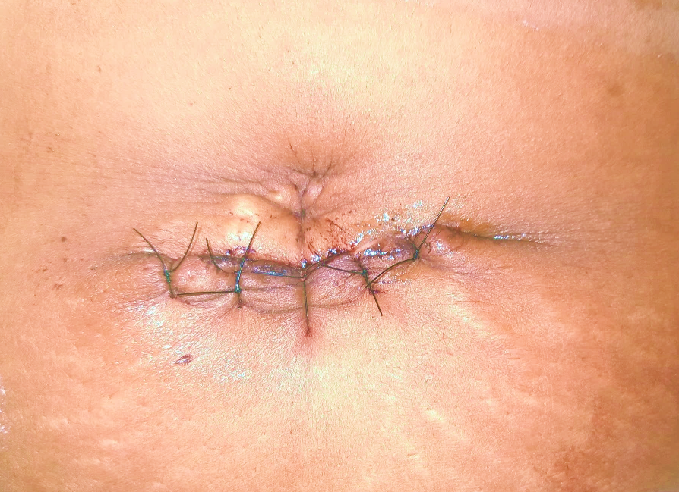
Fig. 2 – Post-operative period with neo-umbilicus formed
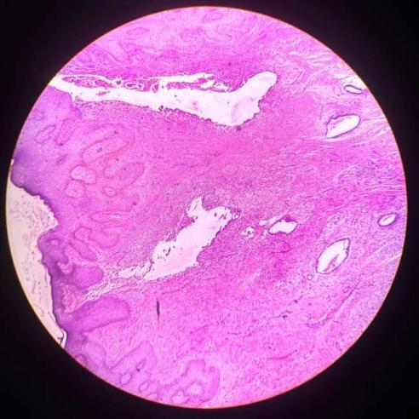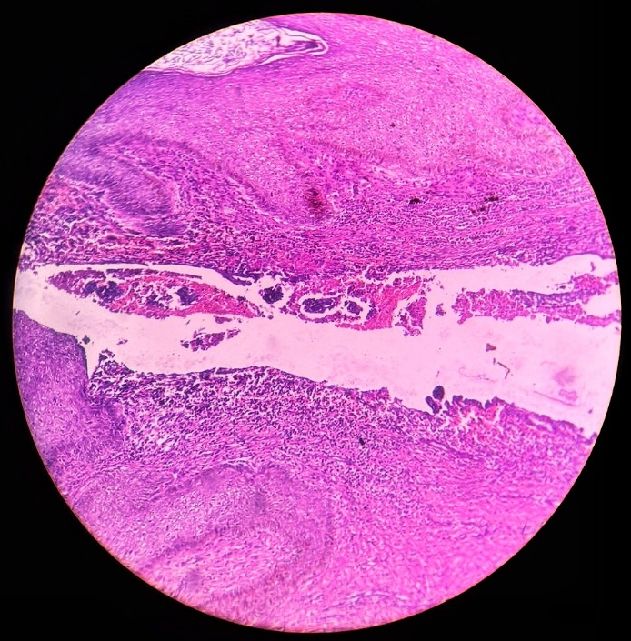
B
A
Fig. 3 –Photomicrographs of the endometriosis visible in the HPE of the umbilical nodule stained with Hematoxylin and Eosin and seen in 100x magnification. (A)Black arrow shows the skin with epidermis and dermis; Red arrow denotes the endometrial glands; White arrow denotes the endometrial stroma. (B) layers of skin visible with areas of hemorrhage, and a few hemosiderin-laden macrophages (arrowhead)
Discussion
Villar first described umbilical endometriosis (UE) in 1886. The etiopathogenesis of UE remains controversial, and several theories have been proposed, including Sampson’s theory of retrograde menstruation, coelomic metaplasia, direct extension, iatrogenic implantation, lymphatic or hematogenous dissemination, genetic susceptibility, and immunologic dysfunction [5]. Secondary UE is believed to occur following surgical procedures such as laparoscopy with umbilical port placement and cesarean section, leading to implantation of endometrial tissue at the umbilicus
The diagnosis is often based on clinical presentation. Victory et al. reported umbilical swelling in nearly 90% of cases, with less than 50% presenting with bleeding and approximately 80% experiencing pain [6]. Pain is thought to result from inflammation, tissue distension, and cyclical hormonal changes. Discoloration of the lesion occurs due to bleeding and hemosiderin deposition, which can also be demonstrated on histopathological examination [7]. The umbilical nodule is frequently pigmented and typically measures around 2 cm in diameter [8, 9]. Most cases are reported in women in their 30s [8, 10, 11], although cases in adolescents as young as 16 years have been documented [12], supporting the concept that endometriosis is an estrogen-dependent condition affecting women of reproductive age [13].
Imaging modalities can assist in assessing anatomical involvement, although definitive diagnosis is established by histopathology [9, 10]. Differential diagnoses include umbilical hernia, abscess, cyst, lipoma, granuloma, urachal fistula, sarcoma, malignant melanoma, and primary or metastatic carcinoma [10].
The sensitivity and specificity of ultrasonography, computed tomography, and magnetic resonance imaging (MRI) are limited for diagnosing UE. Ultrasonography mainly provides information on lesion size and adherence to adjacent tissues. It can evaluate the size of the lesion, its relationship with surrounding tissues, and associated pelvic pathology, thereby aiding surgical planning [14]. MRI may be used for preoperative evaluation in suspected cases and is particularly useful for assessing associated pelvic endometriosis and excluding other serious differential diagnoses such as malignancy, Sister Mary Joseph nodule, and granuloma. MRI findings of UE typically include a homogeneous hypointense lesion on T1-weighted images with low signal intensity on T2-weighted sequences [13, 15].
The umbilicus, being a physiological scar, is considered a preferential site for UE, as described by Yu et al. [16]. Proposed mechanisms include lymphatic or hematogenous spread to the umbilicus and direct extension of endometrial cells through the round ligament or omphalomesenteric remnants [17].
Due to the rarity of the condition, there is no standardized treatment protocol. Medical therapies such as progesterone, danazol, norethisterone, and gonadotropin-releasing hormone analogues have shown inconsistent efficacy. Hormonal therapy may be used preoperatively to relieve symptoms or reduce lesion size but is not curative and may be associated with adverse effects such as amenorrhea. In the review by Victory et al., approximately 70% of patients required surgical management [6]. Wide local excision or total umbilical resection with clear margins is recommended to prevent recurrence [8, 18]. Pelvic endometriosis is reported in about 35% of cases of UE [8]. However, the presence of UE alone does not justify routine laparoscopy, which should be reserved for patients with additional symptoms or clinical findings suggestive of pelvic disease [11]. Histopathological examination is mandatory to exclude malignant transformation, reported in 0.3–2.8% of cases [9, 11]. Recurrence following complete surgical excision is uncommon [11].
Umbilical endometriosis is a rare condition, particularly in spontaneous cases. The triad of umbilical swelling, cyclical pain, and occasional bleeding is highly suggestive of the diagnosis. Surgical excision remains the treatment of choice, and histopathological confirmation is essential.
Conclusion
Primary umbilical endometriosis is an extremely rare clinical entity that can mimic common umbilical pathologies such as hernia. A high index of clinical suspicion, supported by imaging and confirmed by histopathology, is essential for accurate diagnosis. Surgical excision with clear margins remains the definitive treatment, with an excellent prognosis and low recurrence rate.

Conflict of Interest – The authors declare no conflict of interest.

Acknowledgments – The authors are grateful to RG Kar Medical College and Hospital for the support. The authors would also like to thank Prof. Dr. G. Ghosh (HOD, Department of General Surgery, RGKMCH) and Prof. Dr. B. Ghosh (Department of General Surgery, RGKMCH) for the operative help and Prof. Dr. T.K. Das (HOD, Department of Pathology, RGKMCH) for smooth conduct from pathological point of view.

Contributions – Dr. Akash Panda evaluated the patient, made the primary manuscript, investigated and performed the surgery; Dr. Sourav Chakraborty helped in framing a provisional diagnosis, supervised the surgery, and reviewed the manuscript; Dr. Shrimonti Sen helped with the histopathological aspect of the disease and confirmation of the diagnosis; Dr. Mala Mistri checked the final manuscript and supervised the entire process.
Ethical Approval:
As per international standards or university standards written ethical approval has been collected and preserved by the author(s).
Consent
As per international standards or university standards, patient(s) written consent has been collected and preserved by the author(s).

Disclaimer (Artificial intelligence) - Author(s) hereby declare that NO generative AI technologies such as Large Language Models (ChatGPT, COPILOT, etc.) and text-to-image generators have been used during the writing or editing of this manuscript.

References
[1] Oral, S., Akpak, Y. K., Turan, G., Lafci, D., Kinci, M. F., & Usta, C. S. (2024). Efficacy of colchicine and melatonin in the treatment of rat endometriosis model: An animal study. Journal of Reproductive Immunology, 165, 104294.
[2] KINCI, M. F., ARSLANER, M. O., KINCI, Ö. Ş., PASKAL, E. K., ÜNÇEL, M., & SİVASLIOĞLU, A. A. (2021). Endometriosis in Abdominal Fascia Mesh. Turkiye Klinikleri Journal of Case Reports, 29(1), 20-23.
[3] Huang QF, Jiang B, Yang X, Yu B, Hu XP. Primary versus secondary cutaneous endometriosis: Literature review and case study. Heliyon. 2023 Sep 26;9(10):e20094. doi: 10.1016/j.heliyon.2023.e20094. PMID: 37867870; PMCID: PMC10585216.
[4] Al-Khalili AA, Billick R. Umbilical Endometriosis. Sultan Qaboos Univ Med J. 2017 Aug;17(3):e371-e372. doi: 10.18295/squmj.2017.17.03.023. Epub 2017 Oct 10. PMID: 29062568; PMCID: PMC5642375.
[5] Lamceva J, Uljanovs R, Strumfa I. The Main Theories on the Pathogenesis of Endometriosis. Int J Mol Sci. 2023 Feb 21;24(5):4254. doi: 10.3390/ijms24054254. PMID: 36901685; PMCID: PMC10001466.
[6] Victory R, Diamond MP, Johns DA. Villar's nodule: a case report and systematic literature review of endometriosis externa of the umbilicus. J Minim Invasive Gynecol 2007; 14: 23–32.
[7] Boesgaard-Kjer D, Boesgaard-Kjer D, Kjer JJ. Primary umbilical endometriosis (PUE). Eur J Obstet Gynecol Reprod Biol. 2017 Feb;209:44-45. doi: 10.1016/j.ejogrb.2016.05.030. Epub 2016 Jun 18. PMID: 27374811.
[8] Dridi D, Chiaffarino F, Parazzini F et al. Umbilical Endometriosis: A Systematic Literature Review and Pathogenic Theory Proposal. J Clin Med 2022; 11: 995.
[9] Calagna G, Perino A, Chianetta D et al. Primary umbilical endometrioma: Analyzing the pathogenesis of endometriosis from an unusual localization. Taiwan J Obstet Gynecol 2015; 54: 306–12.
[10] Ghosh A, Das S. Primary umbilical endometriosis: a case report and review of literature. Arch Gynecol Obstet 2014; 290: 807–9.
[11] Santos Filho PVD, Santos MPD, Castro S et al. Primary umbilical endometriosis. Rev Col Bras Cir 2018; 45: e1746.
[12] Nellihela L, Al-Adnani M, Kufeji D. Primary Umbilical Endometriosis in an Adolescent Girl: Unsuspected Pathology. European J Pediatr Surg Rep 2020; 8: e10–3.
[13] Shafrir AL, Farland LV, Shah DK, Harris HR, Kvaskoff M, Zondervan K, et al. Risk for and consequences of endometriosis: a critical epidemiologic review. Best Pract Res Clin Obstet Gynaecol. 2018;51:1–15.
[14] Genovese G, Passoni E, Veraldi S, Nazzaro G. Ultrasonographic findings in primary umbilical endometriosis. An Bras Dermatol. 2018;93(2):297–8.
[15] Hartigan C, Holloway B. MR imaging features of endometriosis at the umbilicus. Br J Radiol. 2005;78(932):755–7.
[16] Yu CY, Perez-Reyes M, Brown JJ, Borrello JA. MR appearance of umbilical endometriosis. J Comput Assist Tomogr. 1994;18(2):269–71.
[17] Ouedraogo NLM, Ilboudo S, Ouattara AK, Ouedraogo AS, Zida M, Zongo N, et al. A case report of Villar’s nodule in a woman without surgical history. Int J Surg Case Rep. 2018;53:186–8.
[18] Hirata T, Koga K, Osuga Y. Extra-pelvic endometriosis: A review. Reprod Med Biol 2020; 19: 323–33.

