Case report
Multiple Tumors in a Giant Bladder Diverticula: A Case Report

ABSTRACT
Background: Bladder diverticula are outpouchings of the bladder mucosa through the muscularis propria and are most commonly acquired in elderly men secondary to bladder outlet obstruction. Although often asymptomatic, diverticula may lead to significant complications, including recurrent urinary tract infections, stone formation, and malignancy. Tumors arising within bladder diverticula are uncommon but are associated with an unfavorable prognosis due to the absence of a muscular layer.
Case Presentation: We report the case of a 74-year-old male who presented with long-standing lower urinary tract symptoms, recurrent cystitis, and a sensation of incomplete bladder emptying. Imaging studies revealed multiple bladder diverticula, including a giant left-sided diverticulum measuring over 11 cm in diameter, with a nodular lesion suspicious for malignancy. Diagnostic cystoscopy demonstrated three papillary tumors located exclusively within the left-sided diverticulum, which were unsuitable for transurethral resection. The patient subsequently underwent open bladder diverticulectomy. Histopathological examination revealed high-grade invasive urothelial carcinoma arising within the diverticulum.
Conclusion: Carcinoma developing in bladder diverticula is rare but carries a high risk of early invasion due to the lack of a muscularis propria. This case highlights the importance of thorough evaluation of patients with large or symptomatic diverticula and recurrent urinary tract infections. While transurethral resection may be considered for selected intradiverticular tumors, open surgical management remains a definitive and appropriate option when endoscopic treatment is not feasible.
Keywords: Bladder diverticulum, diverticulectomy, intradiverticular tumor, recurrent urinary tract infection , urothelial carcinoma

1.INTRODUCTION
Bladder diverticula are protrusions of the bladder urothelium and mucosa via muscle fibers of the bladder wall, the muscularis propria, which results in a thin-walled structure connected to the bladder lumen and poorly empties during micturition.[1]. Diverticulas are classified as primary or secondary. Primary diverticula are due to a developmental weakness in the bladder mucosa, usually near the ureteral hiatus. Secondary bladder diverticulas are mostly the consequence of a bladder outlet obstruction. Although they are frequently small and asymptomatic and require no treatment, some bladder diverticula may cause significant morbidity, such as infection, stone formation and carcinoma[2]. In adults, they develop as a consequence of lower urinary tract obstruction and need surgical treatment (endoscopic, open surgery, laparoscopic or robotic) when complications appear (urinary tract infection, lithiasis and tumors)[3].
We report an unusual case of multipl tumours in a giant bladder diverticulum presenting with low urinary tract symptoms and reccurence urinary tract infection. We discuss the clinical aspects of diagnosis and management.

2.CASE REPORT
A 74-year-old male presented with a history of low urinary tract symptoms (LUTS) , reccurence cystitis and feeling of residual urine after micturition. One month ago the patient had been admitted to another instution’s urology department with LUTS . The patient did not describe any macroscopic hematuria and his urine sediment did not show any microhematuria. On ultrasonographic examination, the biggest one of diverticulum on left lateral wall size as 142x72 milimeter there is multipl diverticula. Prostat volume was: 27 cc . Serum PSA : 1.99 ng/ml , digital rectal extamination + fibroadenoma . On uroflowmetry: Qmax : 22 ml/sec , voided volume : 306 ml. Post-void residual urine volume (PVR) was measured as 300 ml in the first attempt and the patients was asked to empty the bladder again. The second PVR was 248 ml. On MR with contrast and MR urography : There is trabeculation on all bladder wall, left lateral wall of bladder there is size as 113 x 72 mm diverticulum connected with neck size as 4.5 mm diameter, right posterolateral wall of bladder there is size as 35x46 mm diverticulum connected with neck size as 5 mm diameter. On the anterior wall of the left-sided diverticula there was at T2A hyperintense, T1A hypointense noduler lesion.
The patient underwent diagnostic cystoscopy and two big divertuculas on right and left walls were noted. There was no pathological findings in right sided diverticula and in the true bladder cavity. There were three papiller tumours in left-sided diverticula unsuitable for endoscopic resection. We decided to perform a diverticulectomy.
In 1 March 2023 we operated the patient for open bladder diverticulectomy. Histopathological examination revealed high-grade invasive urothelial carcinoma.

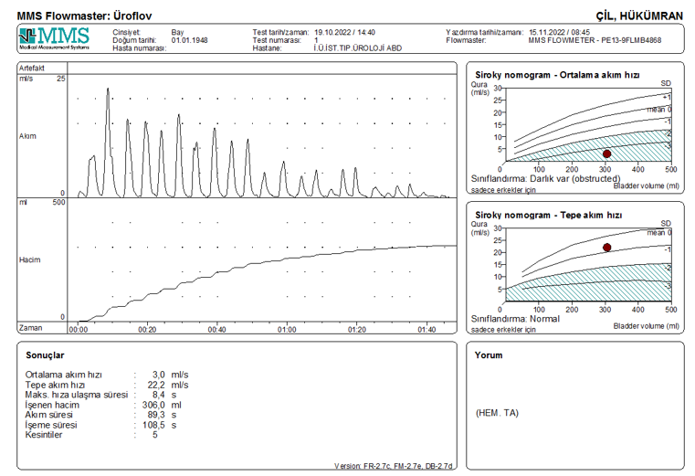
Graph 1: Uroflowmetry of this patient.

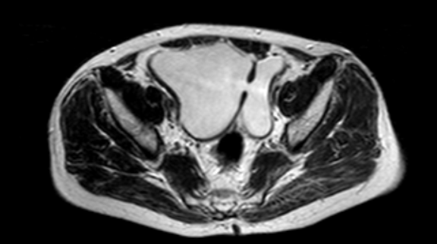
Fig 1: Abdominal MR (2015), Bladder diverticulum

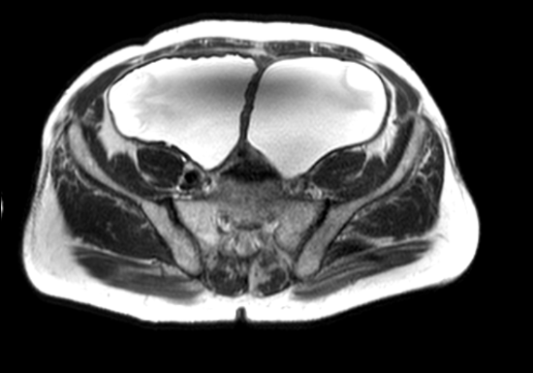
Fig 2: Abdominal MR (2018) , Bladder diverticulum

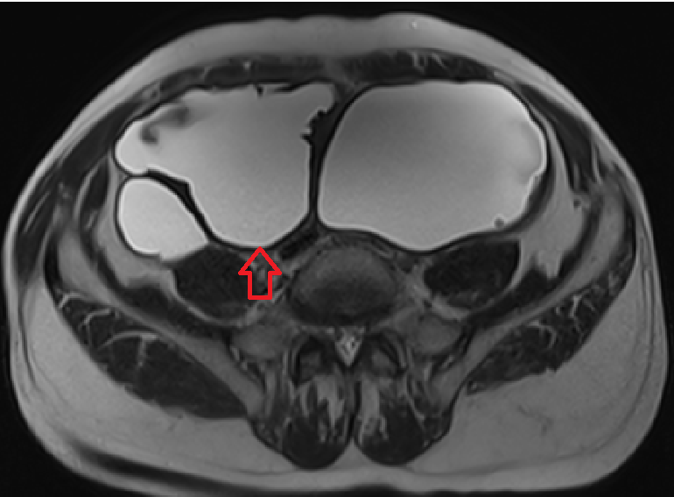
Fig 3: MR Urography (2022 ), The giant diverticula bladder (Red arrow is bladder)
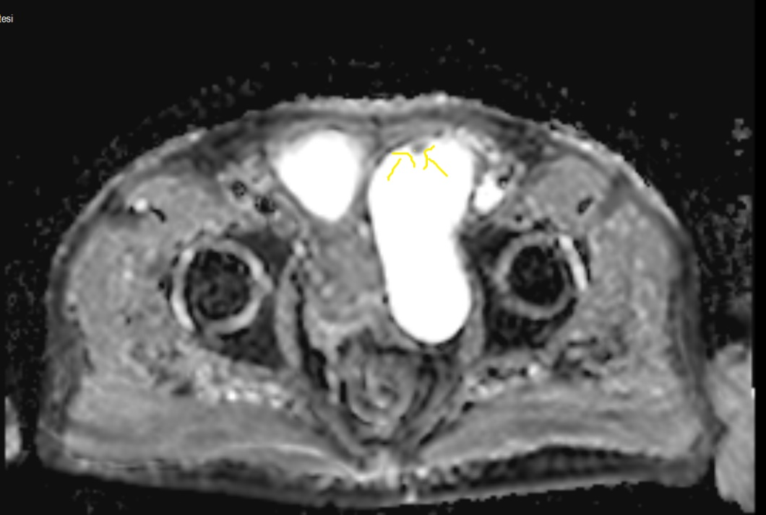

Fig 4: MR Urography (2022), In left diverticul on anterior wall there is papiller tumour. (Yellow arrow is tumour)
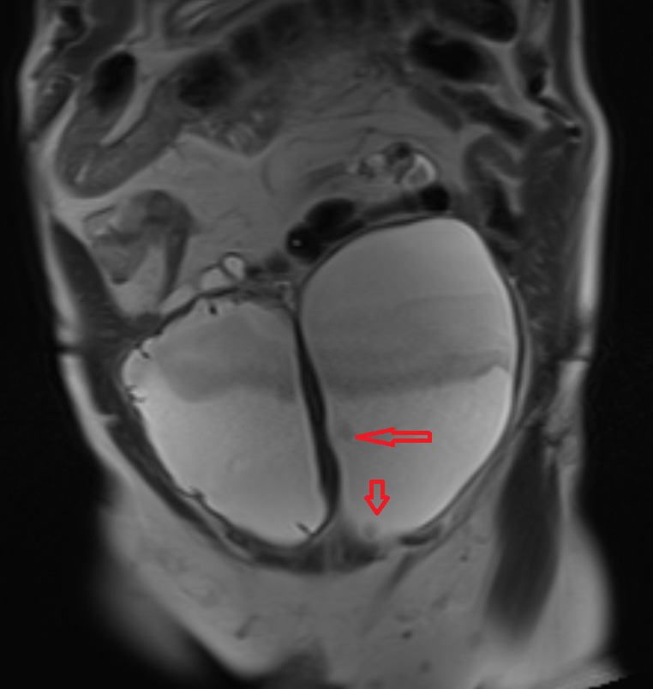
Fig 5: MR Urography (2022), In left diverticul on anterior and medial wall there are two papiller tumours. (Red arrows are tumours)
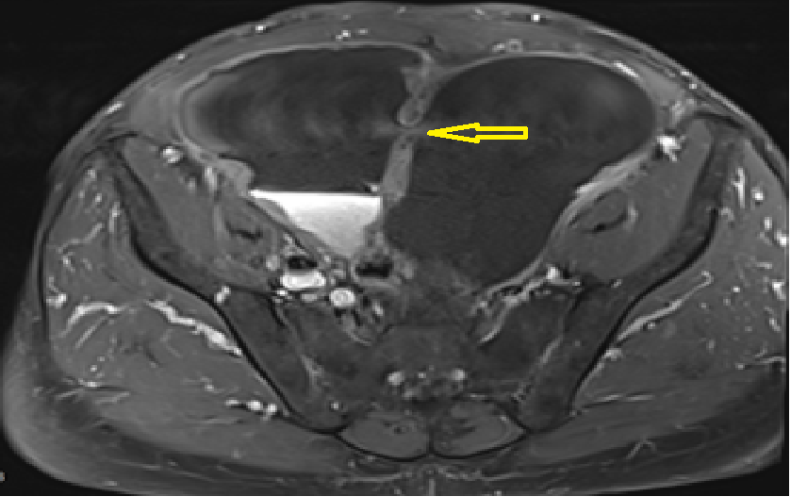
Fig 6: MR Urography (2022), Neck between bladder and diverticulum (Yellow arrow is diverticular neck)

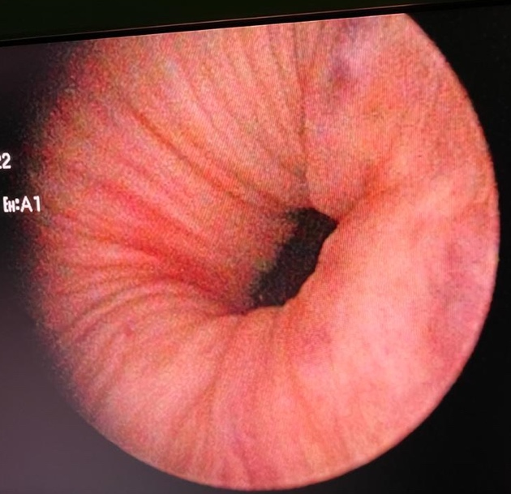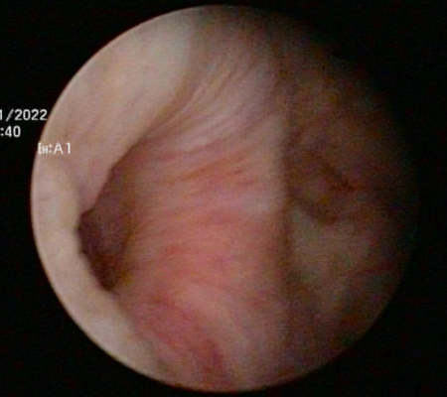

Fig 7: (a)Cystoscopy: Left divertikulum neck (b)Cystoscopy: Right divertikulum neck

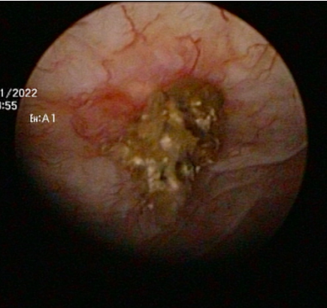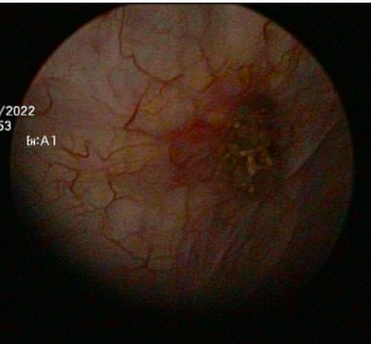,

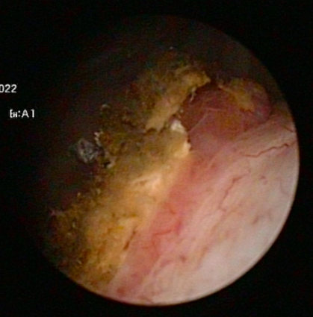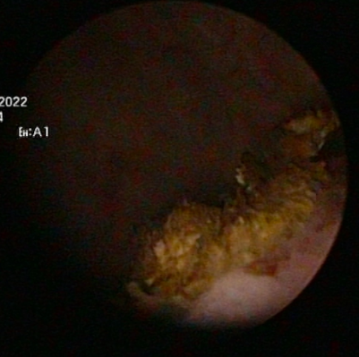

Fig 8: Cystoscopy: Tumours in left bladder diverticulum.

3. DİSCUSSİON AND CONCLUSİON
Bladder diverticula may be acquired or congenital and the incidence in children and adults is reported to be almost 1.7 and 1 to 6%, respectively [4]
Bladder diverticula in males usually occur more than 60 years of age and they are secondary to outflow obstruction such as benign prostatic hypertrophy , neurogenic bladder dysfunction, prostatic carcinomas, external sphincter dysynergia or posterior urethral.[4,5,6]
The most widespread presentation is recurrent UTIs secondary to urinary stasis in the diverticulum. Other presentations are acute urinary retention, bladder stones, enuresis and voiding dysfunction [7].
Bladder tumors within the bladder diverticulum are responsible for 2 to 10% of all tumors that arise in the bladder [8]. Carcinoma in urinary bladder diverticula has a worse prognosis than do neoplasms that originate within the main bladder lumen as a result of early transmural tumor infiltration [9].
The development of urothelial carcinoma within bladder diverticula is biologically distinct from tumors arising in the native bladder lumen. The absence or marked thinning of the muscularis propria in diverticular walls facilitates early transmural invasion, which partly explains the higher incidence of muscle-invasive or extravesical disease at diagnosis and the associated poorer prognosis reported in the literature [10]. Consequently, even superficially appearing tumors within diverticula should be approached with a high index of suspicion.
In adults, they develop as a consequence of lower urinary tract obstruction and need surgical treatment (endoscopic, open surgery, laparoscopic or robotic ) when complications appear (urinary tract infection, lithiasis, and tumors )[3].
The optimal management of bladder tumors arising within diverticula remains controversial and must be individualized. Transurethral resection may be feasible in selected cases with small, non-invasive lesions and wide diverticular necks; however, complete resection is often technically challenging and carries a risk of perforation [11].
Tumors arising within bladder diverticula represent a distinct clinical entity with unique diagnostic and therapeutic challenges. Intradiverticular bladder tumors account for approximately 1% of all bladder cancers and are thought to develop more frequently than intravesical tumors due to chronic urinary stasis and prolonged exposure of the urothelium to carcinogens . The absence of a well-defined muscularis propria layer not only increases the risk of early extravesical invasion but also complicates pathological staging, as a true T2 stage does not exist in diverticular tumors. Even limited invasion beyond the lamina propria may correspond to advanced disease. These anatomical and pathological characteristics support a more aggressive surgical approach in selected patients, particularly when endoscopic resection is not feasible or when high-grade disease is suspected [12].
Recent evidence suggests that malignancy within bladder diverticula is not uncommon. In a large institutional series, bladder cancer was identified in 13% of patients with bladder diverticula, with over one-third of tumors arising intradiverticularly, particularly in older male patients [13]. A small proportion of patients undergoing diverticulectomy for presumed benign disease were found to have incidental carcinoma, highlighting the diagnostic limitations of preoperative evaluation and the need for heightened clinical vigilance.
According to a systematic review , evidence guiding the management of intradiverticular bladder tumors is limited and largely based on small retrospective series . The authors emphasize that the lack of a muscularis propria complicates staging and increases the risk of clinical understaging, making treatment decisions highly individualized. Management strategies are generally extrapolated from conventional bladder cancer protocols rather than supported by robust, tumor-specific data [14].
In a recent study, a pooled analysis of 498 cases showed that intradiverticular bladder tumors occur predominantly in elderly men and are most often high-grade urothelial carcinomas diagnosed at pT1 stage . Cystoscopy and cross-sectional imaging were the main diagnostic tools, while radical cystectomy was the most common treatment choice due to the absence of a muscular layer and high recurrence rates [15]. However, selected patients with low-volume or low-grade tumors achieved acceptable outcomes after bladder-sparing approaches, supporting individualized surgical decision-making.
In conclusion, intradiverticular bladder tumors are rare but clinically relevant entities with a high risk of early invasion due to the absence of a muscularis propria. This case demonstrates that giant bladder diverticula may contain multifocal, high-grade urothelial carcinoma even in the absence of hematuria. Careful radiological and cystoscopic evaluation is essential in symptomatic patients. When transurethral resection is not feasible, open diverticulectomy remains a definitive and effective treatment option.

Disclaimer (Artificial intelligence)
I declare that no generative artificial intelligence technologies, including Large Language Models (such as ChatGPT, Copilot, etc.) or text-to-image generation systems, were used during the writing or editing of this manuscript.

REFERENCES

1. Halaseh, S. A., & Leslie, S. W. (2023). Bladder Diverticulum. In StatPearls. https://pubmed.ncbi.nlm.nih.gov/35593864/

2. Moreno Sierra, J., Galante-Romo, I., Ortiz-Oshiro, E., Castillon-Vela, I. T., Fernandez-Perez, C., & Silmi-Moyano, A. (2010). Bladder diverticulum robotic surgery: Systematic review of case reports. Urologia Internationalis, 85(4), 381-385. https://doi.org/10.1159/000319421

3. Shah, B., Rodriguez, R., Krasnokutsky, S., Shah, S. M., & Ali Khan, S. (1997). Tumour in a giant bladder diverticulum: a case report and review of literature. International Urology and Nephrology. https://doi.org/10.1007/BF02551338 .

4. Gerridzen, R. G., & Futter, N. G. (1982). Ten-year review of vesical diverticula. Urology, 20(1), 33–35. https://doi.org/10.1016/0090-4295(82)90532-5
5. London, R. L. (1984). Diverticulum of the urinary bladder. *American Family Physician*, *30*(4), 151–153. https://pubmed.ncbi.nlm.nih.gov/6437194/
6. Melekos, M. D., Asbach, H. W., & Barbalias, G. A. (1987). Vesical diverticula: etiology, diagnosis, tumorigenesis, and treatment. Analysis of 74 cases. Urology, 30(5), 453–457. https://doi.org/10.1016/0090-4295(87)90378-5
7. Garat, J. M., Angerri, O., Caffaratti, J., Moscatiello, P., & Villavicencio, H. (2007). Primary congenital bladder diverticula in children. Urology, 70(5), 984-988. https://doi.org/10.1016/j.urology.2007.06.1108

8. Halaseh, S. A., & Leslie, S. W. (2023). Bladder Diverticulum. In StatPearls. StatPearls Publishing. https://www.ncbi.nlm.nih.gov/books/NBK580557/

9. Tamas, E. F., Stephenson, A. J., Campbell, S. C., Montague, D. K., Trusty, D. C., & Hansel, D. E. (2009). Histopathologic features and clinical outcomes in 71 cases of bladder diverticula. Archives of Pathology & Laboratory Medicine, 133(5), 791-796. https://doi.org/10.5858/133.5.791

10. Baniel, J., & Vishna, T. (1997). Primary transitional cell carcinoma in vesical diverticula. Urology, 50(5), 697-699. https://doi.org/10.1016/S0090-4295(97)00319-1
11. Golijanin, D., Yossepowitch, O., Beck, S. D., Sogani, P., & Dalbagni, G. (2003). Carcinoma in a Bladder Diverticulum: Presentation and Treatment Outcome. Journal of Urology, 170(5), 1761–1764. https://doi.org/10.1097/01.ju.0000091800.15071.52
12. Walker, N. F., Gan, C., Olsburgh, J., & Khan, M. S. (2014). Diagnosis and management of intradiverticular bladder tumours. Nature Reviews Urology, 11(7), 383-390. https://doi.org/10.1038/nrurol.2014.131
13. DeWitt-Foy, M. E., Anele, U. A., Accioly, J. P. E., Sharpe, M. G., Michael, P., & Angermeier, K. W. (2023). Cancer risk in bladder diverticula: a large institutional analysis of risk and management. International Urology and Nephrology, 55(3), 541-546. https://doi.org/10.1007/s11255-022-03447-3
14. Poletajew, S., Krajewski, W., Adamowicz, J., Kołodziej, A., Zdrojowy, R., & Radziszewski, P. (2020). Management of Intradiverticular Bladder Tumours: A Systematic Review. Urologia Internationalis, 104(1-2), 42-47. https://doi.org/10.1159/000503868
15. Katsimperis, S., Tzelves, L., Bellos, T., Angelopoulos, P., Tsikopoulos, I., Mitsogiannis, I., & Papatsoris, A. (2022). Diagnosis and management of intradiverticular bladder tumours: A pooled analysis of 498 cases. Archivio Italiano di Urologia e Andrologia, 94(4), 486-491. https://doi.org/10.4081/aiua.2022.4.486

