Multimodality Imaging and Sclerotherapy Success in Pediatric Axillary Venous Malformation: A 6-Year-Old Case Report

Abstract: Venous vascular malformations are rare congenital anomalies of the venous system that may remain clinically silent until childhood. We report a 6-year-old girl who presented with acute onset swelling and fever in the left axilla. Clinical examination revealed a soft, compressible mass that decreased in size on pressure. Initial ultrasonography demonstrated conglomerate lobulated suppurative lymphadenopathy with liquefied components, raising the possibility of an abscess. High-resolution real-time ultrasonography further showed a well-defined multiloculated subcutaneous cystic mass with inter-muscular extension and absent internal flow on colour Doppler, suggesting a lymphatic or venous malformation. MRI using T1, T2, STIR and post-contrast sequences revealed a large hyperintense multiloculated lesion with fluid–fluid levels, internal septations and adjacent soft-tissue involvement, without invasion of surrounding muscles or chest wall, features highly suggestive of a venous vascular malformation with haemorrhagic components. Based on the imaging findings, the patient was treated with multiple sessions of sclerotherapy using sodium tetradecyl sulfate under general anaesthesia. Progressive reduction in lesion size and resolution of symptoms were observed on follow-up, with the child returning to normal activities. This case highlights the crucial role of multimodality imaging in accurate characterization of pediatric venous vascular malformations, guiding minimally invasive treatment, and preventing complications through early diagnosis and multidisciplinary management.
Keywords: Venous vascular malformation, pediatric case report, axillary swelling, ultrasonography, high-resolution real-time ultrasound, color Doppler, magnetic resonance imaging, fluid–fluid levels, sclerotherapy, sodium tetradecyl sulfate, minimally invasive treatment.
Introduction
Venous vascular malformations (VVMs) are slow-flow congenital vascular anomalies that arise from errors in venous morphogenesis and are present at birth, although they may not become clinically apparent until childhood or adulthood. They consist of ectatic, dysplastic venous channels that grow proportionally with the child and do not regress spontaneously, in contrast to infantile haemangiomas, which typically proliferate and then involute. VVMs can occur anywhere in the body, most commonly in the head, neck and extremities, and are characterized clinically by soft, compressible masses that may enlarge with dependency or Valsalva manoeuvre and are often associated with pain, swelling and functional limitation. In some patients, they present with fever, thrombotic episodes, bleeding or localized intravascular coagulopathy, which can significantly increase morbidity[1-5].
Accurate diagnosis and anatomical delineation are critical in children, because VVMs may mimic other vascular anomalies and soft-tissue tumours and require different therapeutic strategies. Imaging therefore plays a central role in evaluating venous vascular malformations in a 6-year-old child, helping to confirm the presence of a low-flow lesion, assess its extent and guide treatment planning. High-resolution ultrasonography with colour Doppler is usually the first-line modality; it demonstrates heterogeneous, compressible, hypoechoic spaces with slow or absent flow, phleboliths and possible fluid–fluid levels, while also permitting dynamic examination during compression and positional change. Magnetic resonance imaging (MRI) provides superior soft-tissue contrast and multiplanar capability, enabling precise evaluation of lesion size, location, depth and relationship to adjacent muscles, joints and neurovascular bundles, which is essential in anatomically complex regions such as the axilla[5-10]. Typical MRI features of VVMs include T2-weighted hyperintensity, septations, phleboliths and absence of arterial-type flow voids, findings that help differentiate them from arteriovenous malformations and lymphatic malformations.
Treatment is individualized and depends on symptoms, lesion extent and potential complications; options include observation, percutaneous sclerotherapy, surgical excision or combined approaches. Sclerotherapy using agents such as sodium tetradecyl sulfate, polidocanol or ethanol has emerged as a mainstay therapy, particularly in pediatric patients, because it allows targeted obliteration of abnormal venous channels with preservation of surrounding structures and generally favourable cosmetic and functional outcomes. Early diagnosis through appropriate imaging in a 6-year-old child not only permits timely initiation of such minimally invasive treatment but also reduces the risk of progressive pain, disfigurement and coagulopathic complications, underscoring the importance of multidisciplinary management involving paediatricians, interventional radiologists, anaesthesiologists and surgeons.
Case Presentation
A 6-year-old girl presented with a sudden onset swelling in the left axilla associated with high-grade fever, which progressively increased in size and clinically resembled a soft tissue lump. On inspection and palpation, the lesion appeared as a soft, compressible mass that decreased in size on manual pressure and enlarged again on release, a characteristic feature of low-flow venous malformations that helps distinguish them from solid tumours or high-flow arteriovenous lesions[11-14]. No overlying skin ulceration or bruit was noted, but the swelling caused discomfort and anxiety to the child’s parents because of its rapid enlargement. Given the acute presentation and associated pyrexia, an initial clinical differential diagnosis included suppurative lymphadenitis, abscess and vascular malformation.
Imaging evaluation was undertaken with conventional ultrasound, high-resolution real-time ultrasonography and magnetic resonance imaging (MRI) of the left axillary region. Grey-scale and Doppler ultrasound demonstrated a predominantly cystic, compressible mass with internal septations and sluggish flow, favouring a slow-flow vascular malformation over purely inflammatory lymphadenopathy. High-resolution ultrasonography further delineated the multiloculated nature of the lesion and its inter-muscular extension, while colour Doppler confirmed the absence of high-velocity arterial components, thereby excluding arteriovenous malformation. MRI provided superior soft-tissue contrast and revealed a well-defined multiloculated lesion with T2-hyperintense channels, fluid–fluid levels and internal septations, without invasion of adjacent muscles or chest wall, features highly suggestive of venous vascular malformation[12-14].
Correlation of clinical findings with the multimodality imaging appearances allowed a confident diagnosis of venous vascular malformation of the left axilla in this paediatric patient. The detailed mapping of lesion size, depth and relationship to the neurovascular bundle was crucial for planning minimally invasive therapy, and the case underscores the value of early imaging work-up to distinguish venous malformations from other causes of axillary swelling such as lymphadenitis, abscess, lymphatic malformation or neoplasm[15-16].
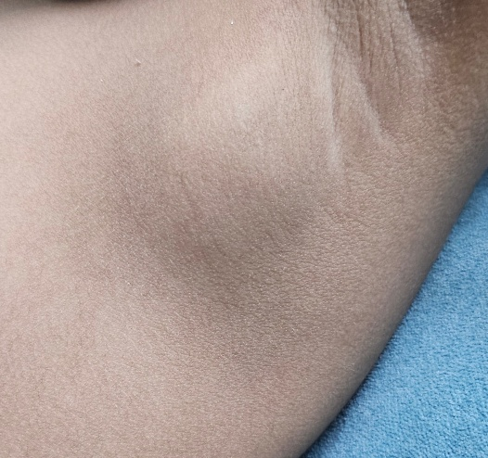
Fig 1: sudden swelling on the left axilla of 6 year old girl.
Image studies
Ultrasound
On initial grayscale ultrasound, the left axilla showed conglomerate lobulated lymph-node–like structures measuring approximately 36 × 26 × 40 mm, with a thin peripheral wall and a predominantly liquefied anechoic internal component. Fine mobile internal echoes and echogenic debris were noted within the cavity, and the surrounding soft tissues demonstrated mild inflammatory oedema, findings that were initially suggestive of suppurative lymphadenitis or a drainable abscess rather than a solid mass. These features are consistent with the reported sonographic spectrum of low-flow vascular malformations, in which cystic spaces, internal debris and occasional venous channels may mimic inflammatory collections. Importantly, no discrete solid mass lesion was identified, prompting further high-resolution assessment[17].
High-resolution real-time ultrasonography
High-frequency real-time ultrasonography of the axilla revealed a well-defined multiloculated subcutaneous cystic mass measuring 56 × 34 × 44 mm (calculated volume approximately 45 cc), with multiple inter-communicating locules extending between the muscle planes of the axillary fossa. The largest locule measured 33 × 21 × 29 mm (volume about 11 cc). On colour Doppler, there was no demonstrable high-velocity arterial flow within the lesion, and only minimal sluggish venous signals were detected, confirming a slow-flow lesion rather than an arteriovenous malformation. The right axilla was normal, excluding bilateral lymphadenopathy[18-20]. These ultrasound characteristics—compressible multiloculated cystic spaces with absent or very low flow—strongly favoured a diagnosis of venous vascular malformation over suppurative lymphadenitis or solid neoplasm.
Magnetic resonance imaging
Magnetic resonance imaging of the left axilla was performed using multiplanar T1-weighted, T2-weighted, STIR, T2 SPAIR and gradient-echo coronal sequences, axial T2 and T2 SPAIR images, followed by dynamic post-contrast T1 SPIR acquisitions in axial, coronal and sagittal planes. MRI demonstrated a well-marginated multiloculated lesion occupying the axillary subcutaneous tissue with inter-muscular extension, showing low signal intensity on T1-weighted images and marked hyperintensity on T2/STIR sequences, with internal septations and multiple fluid–fluid levels compatible with haemorrhagic or proteinaceous contents. After contrast administration, there was gradual, septal and peripheral enhancement without early arterial feeders or nidus, confirming a low-flow venous malformation and excluding arteriovenous malformation. The lesion displaced but did not infiltrate adjacent muscles, chest wall or neurovascular bundle, information that was crucial for planning percutaneous sclerotherapy[21].
Discussions
On MRI, the lesion in the left axilla appeared as a well-defined T1, T2 and STIR hyperintense mass composed of multiple cystic spaces with thick internal septations, measuring approximately 7.3 × 3.2 × 4.3 cm. These cystic components demonstrated fluid–fluid levels with blooming of the dependent hypointense layer on gradient-echo sequences, compatible with haemorrhagic or proteinaceous contents, while the non-dependent layer showed hyperintense signal, a recognised feature of venous malformations with intralesional thrombosis or haemorrhage. The lesion extended through the axillary fat with ill-defined interposed soft tissue but showed no infiltration of the surrounding muscles or chest wall; medially it abutted the rib cage, posteriorly the subscapularis muscle and superiorly displaced the neurovascular bundle without encasement or evidence of grossly dilated arterial structures. The adjacent bones, glenohumeral and acromioclavicular joints, and visualised muscles all demonstrated normal signal intensity, and no shoulder joint effusion was present, findings that support a primary venous vascular malformation rather than an aggressive neoplasm or inflammatory arthropathy.
Impressions
On initial ultrasound, the conglomerate lobulated hypoechoic lesion with predominantly liquefied, anechoic internal contents and echogenic debris was interpreted as suppurative lymphadenopathy with drainable abscess components, favouring an infectious aetiology. However, subsequent high-resolution ultrasonography revealed a well-defined multiloculated subcutaneous cystic mass in the left axilla with inter-muscular extension and absence of significant internal flow on colour Doppler, findings more suggestive of a slow-flow vascular malformation, with lymphangioma and venous malformation considered in the differential diagnosis. Correlation with MRI, which demonstrated characteristic T2-hyperintense cystic channels, fluid–fluid levels and gradual septal and peripheral enhancement without early arterial feeders, allowed a confident diagnosis of venous vascular malformation and excluded high-flow arteriovenous malformation or purely lymphatic malformation.
Treatment
The patient underwent multiple sessions of percutaneous sclerotherapy using sodium tetradecyl sulfate under general anaesthesia, following current recommendations that endorse sclerotherapy as first-line therapy for symptomatic venous malformations in children. Each session was uneventful, and the child was discharged on the same day after observation. Over subsequent follow-up visits, there was progressive reduction in the size of the axillary swelling, improvement in local discomfort and restoration of full upper-limb mobility, with no evidence of neurovascular compromise or major complications, in line with reported outcomes of sodium tetradecyl sulfate sclerotherapy in paediatric venous malformations. The patient was able to resume normal daily activities, and continued clinical and imaging surveillance has been planned to monitor for residual lesion or recurrence.
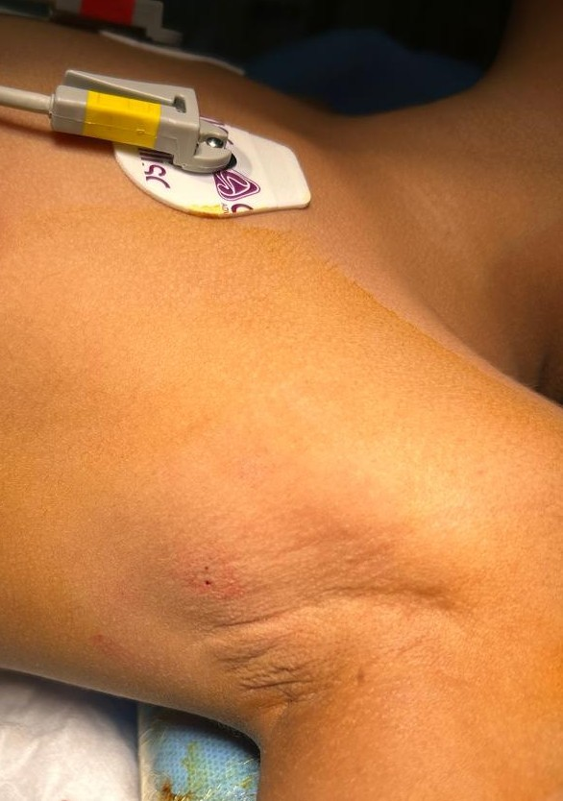
Fig 2: Sclerotherapy procedure injected on the left axilla of 6 year old girl patient.
After Treatment:
Sclerotherapy is usually performed in multiple sittings separated by several weeks, with the total number of sessions determined by the size, depth and extent of the malformation. In this patient, the procedure was well tolerated and the child showed a favourable clinical response to therapy. Mild, transient adverse effects such as local bruising, itching and irritation occurred at the injection site, consistent with the known safety profile of sodium tetradecyl sulfate sclerotherapy. Three treatment sessions administered at intervals of approximately 4–6 weeks resulted in a marked reduction of the left axillary swelling and improvement in symptoms, with significant overall clinical benefit documented on follow-up.
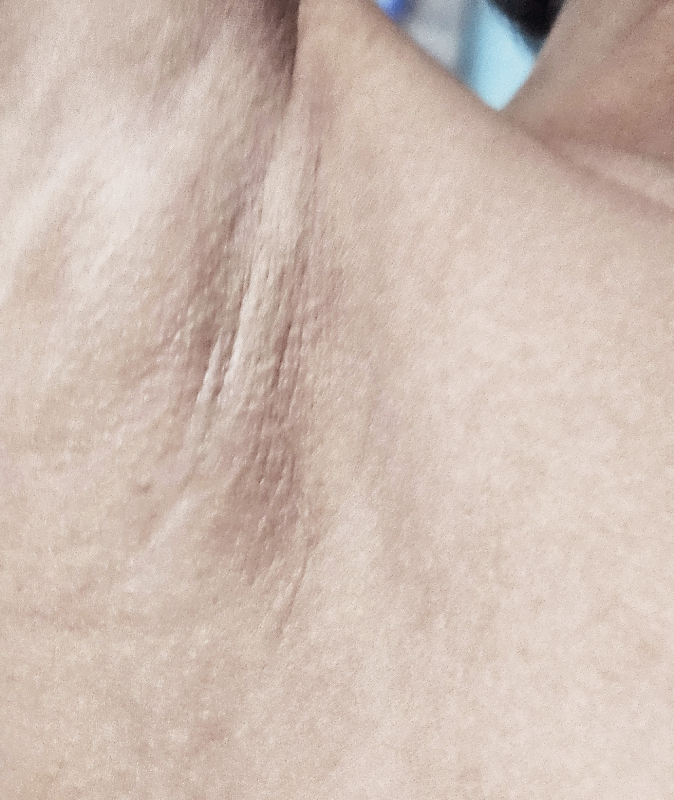
Fig 3: After three sittings of Sclerotherapy patient responded well with reduced swelling on the left axilla of the patient.
Venous vascular malformations are rare congenital anomalies of the venous system that are present at birth and may gradually become symptomatic during childhood. Early diagnosis is essential to prevent complications such as pain, functional limitation, bleeding, local intravascular coagulopathy and cosmetic deformity, which can significantly affect quality of life in paediatric patients. Optimal management requires a multidisciplinary approach that typically involves paediatricians, interventional radiologists, anaesthesiologists and surgeons to individualise treatment and long-term follow-up.
Sclerotherapy is currently regarded as a safe and effective first-line treatment for many symptomatic venous malformations in children, offering meaningful lesion reduction with acceptable morbidity when performed by experienced teams. In the present case, the child experienced only mild, self-limiting adverse effects—itching, discomfort, redness and local inflammation at the injection site—which are well-recognised reactions to sclerosant injection. Post-procedure care included elevation of the treated limb and use of compression bandages to minimise oedema and promote venous return, together with advice to avoid strenuous activity and to keep the area clean while monitoring for warning signs such as increasing pain, swelling or erythema. The patient was reviewed regularly to assess clinical improvement and to detect any evidence of recurrence, reflecting current recommendations for structured follow-up after sclerotherapy in paediatric venous malformations. Thus, early recognition combined with multidisciplinary, image-guided sclerotherapy and vigilant follow-up plays a crucial role in preventing long-term complications and optimising functional and cosmetic outcomes in children with venous vascular malformations.
Conclusion
Venous vascular malformations in children are uncommon but clinically significant lesions that can cause pain, functional limitation, cosmetic disfigurement and, in some cases, serious complications such as thrombosis or localized intravascular coagulopathy. The present case of a 6-year-old girl with an axillary venous vascular malformation illustrates how careful clinical assessment combined with appropriate imaging is essential for accurate diagnosis and safe management. High-resolution ultrasonography with colour Doppler provided the first objective evidence of a multiloculated slow-flow lesion, while magnetic resonance imaging offered comprehensive delineation of lesion size, depth, inter-muscular extension and relationship to the axillary neurovascular bundle, thereby distinguishing venous malformation from lymphatic malformation, suppurative lymphadenitis and arteriovenous malformation. This imaging-driven approach is consistent with contemporary guidelines that emphasise multimodality imaging as the cornerstone of evaluation for paediatric vascular anomalies.
The outcome of this case underscores the value of image-guided sclerotherapy as a first-line, organ-preserving treatment for symptomatic venous malformations in children. Use of sodium tetradecyl sulfate allowed targeted ablation of abnormal venous channels with progressive reduction in lesion volume, relief of symptoms and restoration of normal limb function, while only transient, mild local adverse effects were observed. These results mirror reports from paediatric series demonstrating that sclerotherapy can achieve substantial clinical improvement with low complication rates when performed by experienced multidisciplinary teams. In addition, structured post-procedure care—compression, limb elevation, limitation of strenuous activity and regular follow-up—helped to minimise recurrence risk and ensured early detection of any complications, reflecting best-practice recommendations for long-term surveillance of venous malformations.
More broadly, this case highlights several key messages for clinicians. First, any persistent or rapidly enlarging soft, compressible swelling in a child, particularly in anatomically complex regions such as the axilla, should prompt consideration of an underlying vascular malformation and early referral for specialised imaging. Second, integration of radiological findings with clinical features is critical to avoid misdiagnosis and inappropriate interventions such as unnecessary wide surgical excision. Third, optimal outcomes are achieved when children with venous vascular malformations are managed within a multidisciplinary framework that includes paediatricians, interventional radiologists, surgeons, anaesthesiologists and pain specialists, ensuring that both functional and psychosocial aspects of care are addressed. Finally, there remains a need for prospective, multicentre paediatric studies to standardise imaging-based classification, refine sclerosant selection and dosing, and evaluate long-term quality-of-life outcomes, so that evidence-based treatment algorithms can be further strengthened for this rare but impactful group of vascular anomalies.
Competing interests disclaimer
Authors have declared that they have no known competing financial interests OR non-financial interests OR personal relationships that could have appeared to influence the work reported in this paper
Consent
As per international standards or university standards, patient(s) written consent has been collected and preserved by the author(s).
Artificial intelligence disclaimer
This part is designed to comply with emerging journal policies on the use of generative AI in manuscript preparation. It offers two options:
Option 1 (no AI use): Authors declare that no generative AI tools (large language models, text-to-image tools, etc.) were used at any stage of writing or editing.
Sections where it was used (e.g., language polishing of Introduction and Conclusion).
References
- Behravesh Shervin, Yakes William, Gupta Neerav, Naidu Sailaja, Chong Brian W., Khadem Jaleh, Oklu Rahmi. Venous malformations: clinical diagnosis and treatment. Cardiovascular Diagnosis and Therapy. 2016;6(6):557–569.
- Dompmartin Anne, Vikkula Miikka, Boon Laurence M. Venous malformation: a benign congenital anomaly of the venous vasculature. Journal of Clinical Medicine. 2020;9(5):1414.
- Seront Eva, Van Damme Aurore, Boon Laurence M., Vikkula Miikka. Venous malformations: diagnosis, management and future perspectives. Journal of Clinical Medicine. 2024;13(1):135.
- Burrows Patricia E., Mulliken John B., Fellows Karen E., Strand Robin D. Childhood hemangiomas and vascular malformations: diagnostic imaging. Radiographics. 1989;9(2):195–214.
- Paltiel Harold J., Burrows Patricia E., Kozakewich Harry P., Mulliken John B. Soft-tissue vascular anomalies: utility of US for diagnosis. Radiology. 2000;214(3):747–754.
- Wassef Mounir, Blei Francine, Adams Dermot, Alomari Ahmad, Baselga Eulàlia, Berenstein Alejandro, Burrows Patricia, Frieden Ilona J., Garzon Maria C., Lopez-Gutierrez Juan Carlos, Lord David, et al. Vascular anomalies classification: recommendations from the International Society for the Study of Vascular Anomalies. Pediatric Radiology. 2015;45(4):549–554.
- Chandra Tarun, Srinivasan Ajit, Rao Vijay, Monroe Elizabeth J. Low-flow vascular malformation pitfalls: from clinical examination to practical imaging evaluation—Part 2, venous malformation mimickers. American Journal of Roentgenology. 2016;206(5):952–960.
- Adams Dermot M., Trenor Cameron C., Hammill Adrienne M., Vinks Alexander A., Patel Mohan N., Chaudry Gulraiz, Wentzel Megan S., Mobberley-Schuman Paige S., Campbell Joy M., Brookbank Carolyn, et al. Ultrasound evaluation of pediatric slow-flow vascular malformations: practical diagnostic reporting to guide interventional management. American Journal of Roentgenology. 2021;216(3):801–812.
- Kakadia Jaymin N., Lee Eunice Y., Eisenberg Robin L. Pediatric vascular malformations: imaging guidelines and recommendations. Pediatric Radiology. 2022;52(2):217–232.
- O’Donnell Thomas F., Iafrati Mark D., Eberhardt Robert T. Venous malformations. Vascular Medicine. 2020;25(6):573–585.​
- Eberson Sarah N., Bruckner Anna L. A basic introduction to pediatric vascular anomalies. Current Problems in Pediatric and Adolescent Health Care. 2019;49(5):100658.
- Cincinnati Children’s Hospital Medical Center. Venous Malformations: Symptoms, Diagnosis & Treatment. Updated 2025.
- CompVA Network. Clinical presentation — venous malformation. 2021. Available from:
- Mulliken John B., Glowacki Julie. Hemangiomas and vascular malformations in infants and children: a classification based on endothelial characteristics. Plastic and Reconstructive Surgery. 1982;69(3):412–422.
- Pérez Gutiérrez Juan Carlos López, et al. Vascular anomalies in childhood: review and update. Anales de Pediatría. 2024;101(2):120.e1–120.e14.
- Boston Children’s Hospital. Venous Malformation. Updated 2025. Available from:
- Gupta Ritu, Sodhi Karamjit Singh, Khandelwal Neelam. Pediatric vascular anomalies: a clinical and radiological update. Indian Journal of Radiology and Imaging. 2023;33(1):5–18.
- Bhat Venkatraman, Venkatesh M. Imaging spectrum of hemangioma and vascular malformations of the head and neck in children. Journal of Clinical Imaging Science. 2014;4:31.
- Mulligan Patrick R., Prajapati Hitendra, Martin Luther G., Patel Tushar H. Vascular anomalies: hemangiomas and malformations. Radiologic Clinics of North America. 2013;51(3):455–470.
- Lee Simon K., Chandra Tarun, Friedman Elizabeth R. Pediatric vascular malformations. In: Pediatric Vascular Malformations. Radiology Key; 2020.
- Bhatia Ankur, Prasad Anupama, Gupta Ritu. Imaging pediatric vascular lesions. Journal of Clinical and Aesthetic Dermatology. 2024;17(1):38–48.

