Infection-Induced Cardiac Decompensation in a Patient with Severe Mitral Stenosis and Multisystem Comorbidities: A Case Report

Abstract

Background: Multimorbidity involving respiratory infection, chronic lung disease, valvular heart disease, coronary artery disease, and chronic liver disease presents significant diagnostic and therapeutic challenges. Lower respiratory tract infections are known to precipitate acute cardiovascular events through systemic inflammation, hypoxia, and increased myocardial oxygen demand, particularly in patients with pre-existing cardiac disease.
Case Presentation: A 47-year-old male with bronchial asthma, chronic lung disease, severe mitral stenosis, prior coronary artery disease, and chronic liver disease who presented with symptoms of lower respiratory tract infection complicated by non–ST-elevation myocardial infarction.
Conclusion: This case highlights the complex interaction between infection and cardiac decompensation and emphasizes the importance of early recognition and multidisciplinary management in patients with significant comorbidities.
Keywords: multimorbidity; lower respiratory tract infection; bronchial asthma; mitral stenosis; acute coronary syndrome; chronic liver disease.

Introduction

- Lower respiratory tract infections (LRTIs) are a common cause of hospitalization and are recognized triggers for acute cardiovascular events, particularly in patients with underlying heart disease. Systemic inflammation, hypoxia, and increased myocardial oxygen demand during infection may lead to plaque instability and myocardial ischemia. According to Corrales-Medina, V. F., Musher, D. M., Wells, G. A., Chirinos, J. A., Chen, L., & Fine, M. J. (2012).encompasses infections of lower airways and lung parenchyma, including pneumonia, acute bronchitis, and influenza-related lower respiratory infections, with pneumonia representing the most clinically significant entity. Patients with coexisting bronchial asthma, chronic lung disease, valvular heart disease, coronary artery disease, and chronic liver disease constitute a particularly vulnerable population with increased morbidity and mortality. Occupational exposures may further compound respiratory risk; professions such as cobbling involve repeated exposure to dust and chemical fumes, which can predispose to or exacerbate bronchial asthma.
We present a case of a middle-aged male with significant cardiopulmonary and hepatic comorbidities who developed infection-related cardiac decompensation in the setting of LRTI, highlighting diagnostic challenges and the importance of coordinated multidisciplinary care.

Case Presentation

A 47-year-old male, a cobbler by occupation, presented with complaints of cough, progressive breathlessness, chest pain, and epigastric discomfort of acute onset. The symptoms began in the early hours of the morning and were associated with increased work of breathing.
He had a confirmed diagnosis of bronchial asthma and chronic lung disease, along with a history of coronary artery disease and a prior occurrence of non–ST-elevation myocardial infarction. In 2023, he received a diagnosis of significant mitral stenosis accompanied by mild mitral regurgitation and mild pulmonary arterial hypertension. He also suffered from chronic liver disease resulting from prolonged alcohol use and hepatitis C virus infection

There was a significant history of chronic alcohol use and active smoking. There was no history suggestive of active pulmonary tuberculosis.

Clinical Examination

On examination, the patient was conscious and oriented. He was tachypnoeic at presentation. Cardiovascular examination revealed a normal jugular venous pressure, a loud first heart sound, and a split second heart sound, with no audible murmurs. Respiratory system examination revealed bilateral rhonchi suggestive of an acute exacerbation of bronchial asthma. Abdominal examination revealed a soft, non-tender abdomen, and central nervous system examination was within normal limits.

Investigations

Laboratory investigations showed hemoglobin within normal limits and an elevated total leukocyte count suggestive of infection. Inflammatory markers, including C-reactive protein, were raised. Renal function tests were within normal limits. Liver function tests showed mild abnormalities consistent with chronic liver disease.
Serological testing was positive for hepatitis C virus infection, while hepatitis B surface antigen and human immunodeficiency virus testing were negative.
Chest radiography (Figure 1) demonstrated bilateral bronchitic changes with features suggestive of lower respiratory tract infection. Serial chest radiographs showed interval changes correlating with the patient’s clinical status.

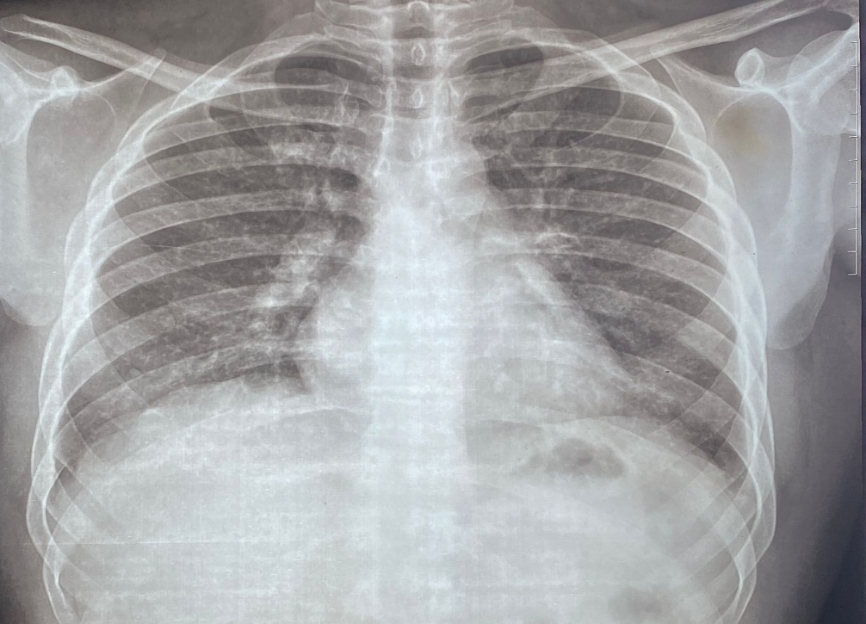
Figure 1: Chest radiograph showing bilateral increased bronchovascular markings with patchy perihilar and lower zone opacities, suggestive of bronchitic changes and lower respiratory tract infection.
Electrocardiography revealed sinus rhythm with ST-segment depression and T-wave inversions in the inferolateral leads, suggestive of myocardial ischemia. Serial electrocardiograms demonstrated persistent ischemic changes correlating with the clinical presentation.
Transthoracic echocardiography (Figure 2) demonstrated severe mitral stenosis with mild mitral regurgitation, mild pulmonary arterial hypertension, preserved left ventricular systolic function, and an ejection fraction of 67.5%.

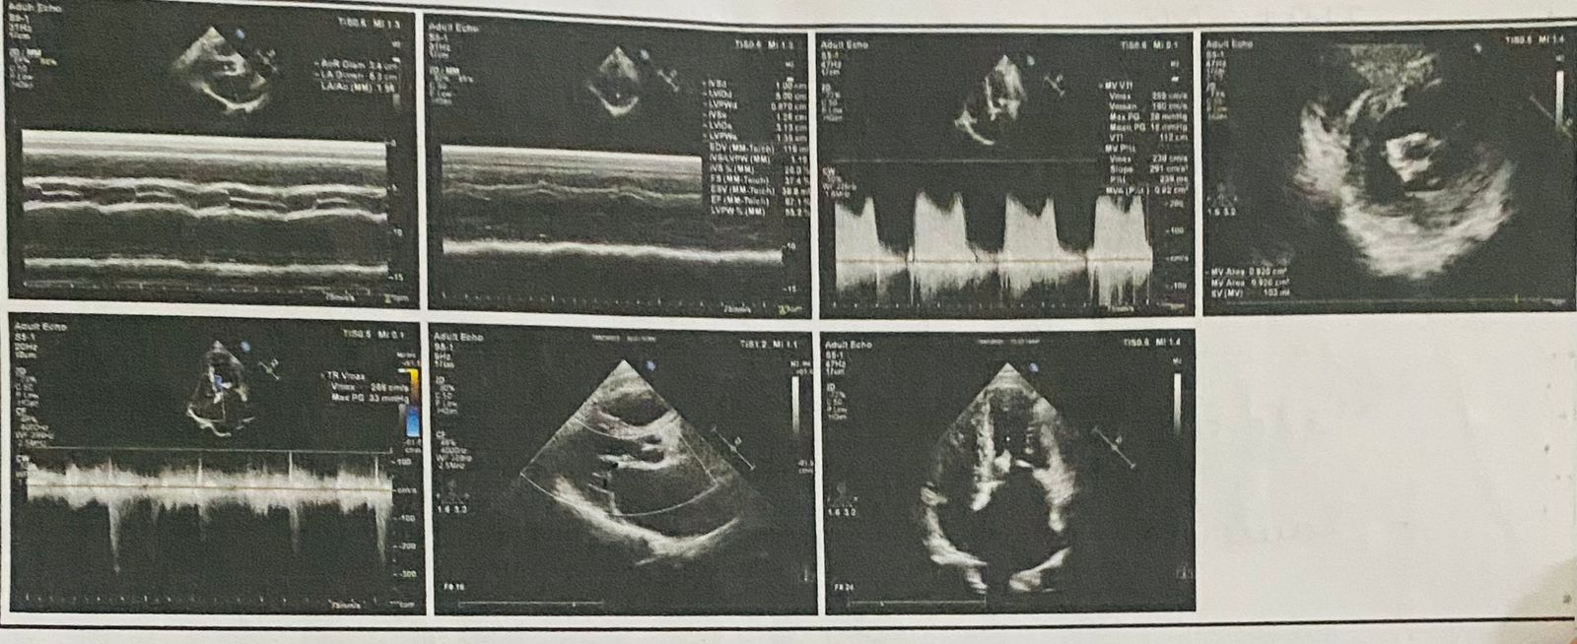
Figure 2: Transthoracic echocardiography demonstrating thickened mitral valve leaflets with restricted opening, elevated transmitral gradients on Doppler imaging, and preserved left ventricular systolic function, consistent with severe mitral stenosis.
Overall, the findings are consistent with severe mitral stenosis.
Ultrasonography of the abdomen revealed features consistent with chronic liver disease, including coarse hepatic echotexture, without focal lesions.

Treatment and Clinical Course

The patient was managed with a multidisciplinary approach addressing the underlying infection, cardiac condition, chronic lung disease, and hepatic comorbidities. Empirical intravenous antibiotic therapy was initiated with piperacillin–tazobactam (4.5 g) for the treatment of lower respiratory tract infection. Bronchodilator and anti-inflammatory therapy was administered in the form of nebulization with ipratropium bromide and budesonide to manage acute exacerbation of bronchial asthma.
Cardiac management included continuation of beta-blocker therapy with bisoprolol 2.5 mg once daily. The patient remained hemodynamically stable throughout the hospital stay, with blood pressure maintained at 128/80 mmHg, pulse rate of 90 beats per minute, and oxygen saturation of 98% on room air.
Given the background of chronic liver disease with hepatitis C virus infection, antiviral therapy with sofosbuvir 400 mg once daily and velpatasvir 100 mg once daily was continued. Hepatoprotective and supportive medications included ursodeoxycholic acid 300 mg twice daily and rifaximin 400 mg twice daily. Gastroprotection was provided with pantoprazole 40 mg once daily.
The patient exhibited steady clinical progress with the disappearance of respiratory symptoms and stabilization of cardiac condition. Throughout the treatment period, no instances of hemodynamic compromise or increased hypoxia were noted

Discussion

Respiratory infections are recognized triggers for acute coronary syndromes due to systemic inflammation, endothelial dysfunction, hypoxia, and increased sympathetic activity. In patients with pre-existing coronary artery disease and severe valvular heart disease, these factors may precipitate myocardial ischemia even in the absence of plaque rupture.
Severe mitral stenosis further limits the ability to augment cardiac output during periods of increased physiological stress. Concurrent chronic lung disease and bronchial asthma exacerbate hypoxia and increase right ventricular afterload. Additionally, chronic liver disease alters drug metabolism and coagulation status, complicating therapeutic decision-making in the setting of acute coronary syndrome.
Occupational exposure to dust and chemical fumes among cobblers is a recognized risk factor for occupational asthma, contributing to chronic airway inflammation and recurrent respiratory infections. This further increases the risk of infection-related cardiopulmonary decompensation.
Figure 1, showed bronchitic changes on chest radiography in this patient likely reflects chronic airway inflammation secondary to recurrent respiratory infections, predisposing to repeated lower respiratory tract infections and systemic inflammatory stress. According to this patient unhygienic occupational environment created a cornerstone for developing these diseases.

This case underscores the importance of a multidisciplinary approach involving pulmonology, cardiology, hepatology, and infectious disease teams to balance competing clinical priorities and optimize outcomes in patients with complex multimorbidity.

Conclusions

This case illustrates the complex interplay between lower respiratory tract infection and acute cardiac decompensation in a patient with significant cardiopulmonary and hepatic comorbidities. Early recognition of infection-related cardiac complications and timely, coordinated multidisciplinary management are essential to reduce morbidity and improve outcomes in patients with multimorbidity.
Consent
Consent was obtained from the patient for publication of this case report.
Conflicts of Interest
The authors declare that they have no competing interests.
Ethics Approval
Ethical approval was not required for this study as it is a single-patient case report.
Disclaimer (Artificial intelligence)
Option 1:
Author(s) hereby declare that NO generative AI technologies such as Large Language Models (ChatGPT, COPILOT, etc) and text-to-image generators have been used during writing or editing of manuscripts.

References

- Corrales-Medina, V. F., Musher, D. M., Wells, G. A., Chirinos, J. A., Chen, L., & Fine, M. J. (2012). Cardiac complications in patients with community-acquired pneumonia: Incidence, timing, risk factors, and association with short-term mortality. Circulation, 125(6), 773–781. https://doi.org/10.1161/CIRCULATIONAHA.111.040766.

- Kwong, J. C., Schwartz, K. L., Campitelli, M. A., Chung, H., Crowcroft, N. S., Karnauchow, T., Katz, K., Ko, D. T., McGeer, A. J., McNally, D., Richardson, D. C., Rosella, L. C., Simor, A., Smieja, M., Zahariadis, G., & Gubbay, J. B. (2018). Acute myocardial infarction after laboratory-confirmed influenza infection. *New England Journal of Medicine*, *378*(4), 345–353. https://doi.org/10.1056/NEJMoa1702090.

- Madjid, M., Vela, D., Khalili-Tabrizi, H., Casscells, S. W., & Litovsky, S. (2007). Systemic infections cause exaggerated local inflammation in atherosclerotic coronary arteries: clues to the triggering effect of acute infections on acute coronary syndromes. Tex Heart Inst J, 34(1), 11–18. https://www.ncbi.nlm.nih.gov/pmc/articles/PMC1847934/.

- Braunwald, E. (2019). Valvular heart disease. In D. P. Zipes, P. Libby, R. O. Bonow, D. L. Mann, & G. F. Tomaselli (Eds.), *Braunwald’s Heart Disease: A Textbook of Cardiovascular Medicine* (11th ed.). Elsevier. https://doi.org/10.1016/C2018-0-00779-6.

- Caraballo C, Desai NR, Mulder H, et al. Clinical implications of chronic liver disease in patients with acute coronary syndrome. J Am Heart Assoc. 2019;8(6):e011965.

- Global Initiative for Asthma. (2023). Global Strategy for Asthma Management and Prevention, 2023. https://ginasthma.org/2023-gina-report/.

- Blanc, P. D., & Torén, K. (2007). Occupation in chronic obstructive pulmonary disease and chronic bronchitis: An update. *International Journal of Tuberculosis and Lung Disease*, *11*(3), 251–257. https://doi.org/10.5588/ijtld.2007.11.3.251.

- Carapetis JR et al. (2016). Acute rheumatic fever and
    - rheumatic heart disease. Nature Reviews Disease Primers, 2,15084.
- Watkins DA et al. (2017). Global, regional, and national burden of
  - rheumatic heart disease (1990–2015). New England Journal of Medicine, 377(8), 713–722.
- Negi PC, Kanwar A, Chauhan R, et al. Epidemiological trend of RF/RHD in North India schoolchildren. India.

- Dima C, O’Brien TX. Mitral Stenosis. Medscape. 2021. eMedicine.

- Imran TF, Awtry EH. Severe Mitral Stenosis. N Engl J Med. 2018;379(3):e6. (as cited in StatPearls) NCBI.

- Ranjan R, Pressman G. Aetiology and epidemiology of mitral stenosis. Eur J Cardiol Pract. 2018. European Society of Cardiology.

- Ramakrishna CD, Kanattu PS. Echocardiographic and Clinical Review Form Created by: DR Checked by: PM Approved by: MBM Version: 3 (07-07-2024) Evaluation of Rheumatic Mitral Stenosis. IntJ Clin Med. 2017 ;8:128–135. Semantic Scholar.

- Sinha SK, Jha MJ, Aggarwal P, Mishra V. Critical Mitral Stenosis: A Blessing in Disguise. J Case Rep. 2020. (supports clinical features).

