Advanced Squamous Cell Carcinoma of Gall Bladder: A Case Report

ABSTRACT
Gallbladder carcinoma is the fifth most common gastro-intestinal neoplasm and the most common biliary tract malignancy in the world. Primary squamous cell carcinoma of the gallbladder is a rare entity comprising around 1%-3% of all primary gallbladder cancers. We report the case of a 72-year- old woman who was diagnosed with a locally invasive squamous cell carcinoma of the gallbladder. The tumor was unresectable and considered for palliative care in the form of endotherapy (SEMS) and chemotherapy.
Keywords: Squamous cell carcinoma, Gallbladder, biliary malignancy, Gastric Outlet Obstruction, Obstructive Jaundice.

INTRODUCTION
“Gallbladder carcinoma is the most common malignancy of biliary tract. Majority of gallbladder cancers are adenocarcinomas (80-95% of cases) “[1]. “Squamous cell carcinoma (SCC) and adenosquamous types are rare accounting for approximately 1-10% cases. There is geographic variation in incidence with higher prevalence reported from North India, South America and Eastern Asia” [1].
“SCC of gallbladder is thought to arise either de novo or through squamous metaplasia of gallbladder epithelium. In comparison to adenocarcinoma, SCC is more locally aggressive, with frequent invasion into adjacent hepatic, gastric, duodenal and colonic structures. Distant metastasis is relatively less common” [2].

Known risk factors for any GB carcinoma include chronic cholelithiasis, female gender (ratio approximately 3:1), porcelain gallbladder, adenomatous polyps of gallbladder, carcinogens (eg, radon), Salmonella typhi infection, and abnormal pancreaticobiliary duct junction [3]. “Only a minority of patients with cholelithiasis develop gallbladder cancer but gallstones are present in 70%-90% of patients diagnosed with GBC” [3]. Genetic factors like Lynche Syndrome and anomalous pancreatobiliary junction associated with adenocarcinoma; smoking & porcelain gall bladder are more associated with squamous cell carcinoma (SCC).
Presentation usually varies from remaining asymptomatic in the absence of advanced disease to symptoms such as anorexia, abdominal pain, nausea, and vomiting, which may mimic acute cholecystitis. More advanced disease presents with loss of weight, jaundice, ascites, palpable abdominal mass.
Because of the rarity of the gall bladder SCC and nonspecific clinical presentation, diagnosis is usually delayed and often diagnosed at advanced stages. Therefore, prognosis remains poor. This indicates the need for early diagnosis to facilitate the resection of tumor to improve the outcome.

CASE REPORT
A 72-year-old woman presented with dull right upper abdominal pain for the past few weeks. There was associated loss of appetite and early satiety, though no frank vomiting was reported. She had experienced unintentional weight loss over the preceding two months. There was no jaundice, abdominal pain or pruritus. On examination, she was hemodynamically stable with mild right hypochondrial tenderness, but without icterus, palpable mass, or ascites.
Baseline investigations revealed anemia, while liver function tests were within normal limits, Ca 19-9 was 19.80 U/ml. Ultrasonography of the abdomen revealed, heteroechoic area with calcification seen near gallbladder fossa but gall bladder could not be identified clearly. Contrast-enhanced CT (CECT) of the abdomen demonstrated a heterogeneously enhancing mass lesion arising from the gallbladder, with extensive local invasion into the adjacent liver parenchyma, pyloric antrum, first and second parts of the duodenum, and the hepatic flexure of the colon. No distant metastases were identified.

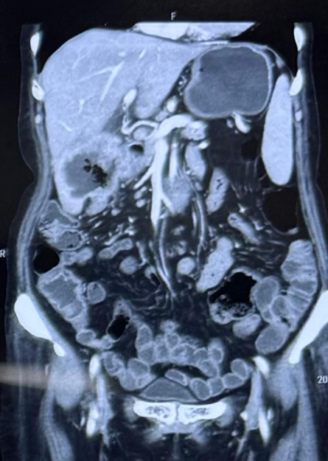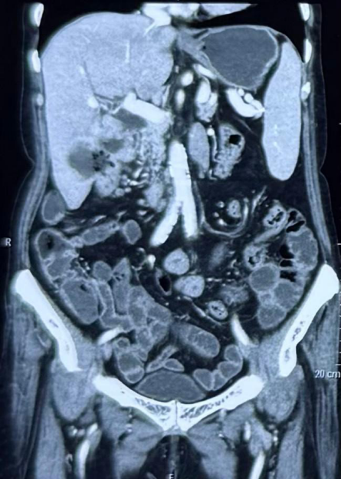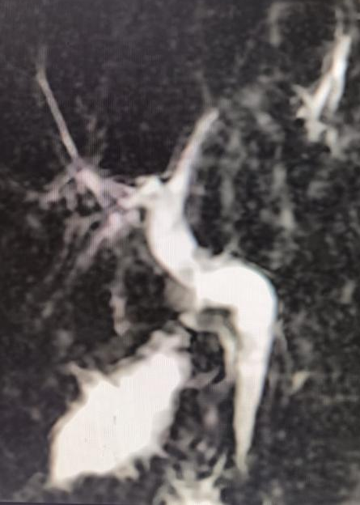
Fig 1: Sagittal section of computed tomography images reveal large lobulated hypo attenuating peripherally enhancing , centrally necrotic mass in sub hepatic region infiltrating and involving the liver, pyloric antrum, D1 and proximal D2 segment of duodenum and hepatic flexure of colon. MRCP showed non obstructed, minimally dilated CBD.

USG guided biopsy of the liver lesion was done. Histopathology revealed malignant squamous epithelial cells with keratinization. There were extensive areas of tumor necrosis. IHC was (P40 and CK19 positive and negative for CDX2 and CK7) suggestive of squamous cell carcinoma, probably primary from gallbladder.

Endoscopy revealed deformity of pyloro duodenal junction and an ulceroproliferative lesion with partial narrowing of D1-D2 junction suggestive of duodenal infiltration by the neoplastic lesion.

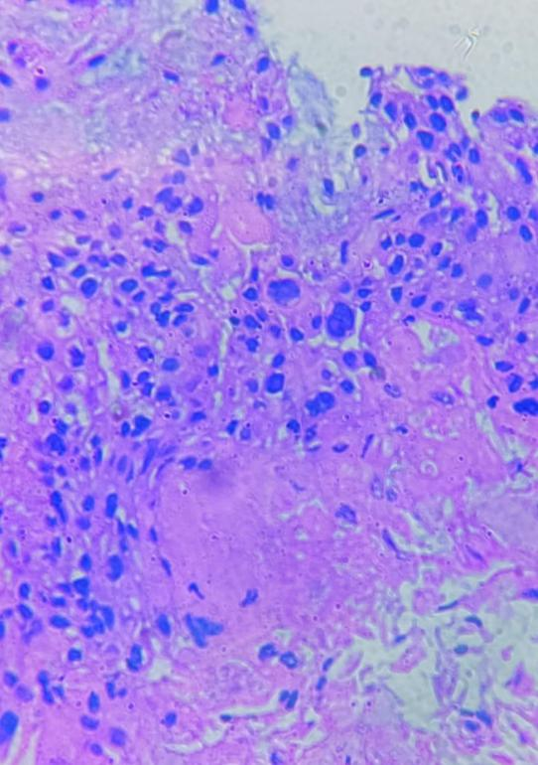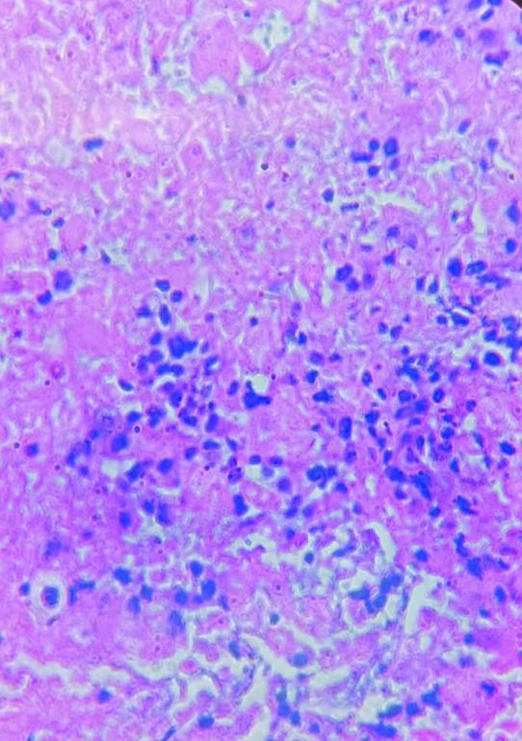
Fig 2a Fig 2b

Fig 2: a) Malignant squamous epithelium with keratinization.
b) Extensive areas of tumor necrosis with viable tumor cells in the edge. Individual cells show high N/C ratio with hyper chromatic , markedly pleomorphic nuclei, eosinophilic cytoplasm.
The tumour stage was T3, N0, M0 and ECOG performance scale was 3. Given the extent of local invasion, the lesion was deemed surgically inoperable. In view of early satiety, abdominal discomfort and impending gastric outlet obstruction, a self-expandable metal duodenal stent was placed endoscopically across the narrowed segment. Following the procedure, the patient tolerated oral feeds well and had symptomatic improvement.

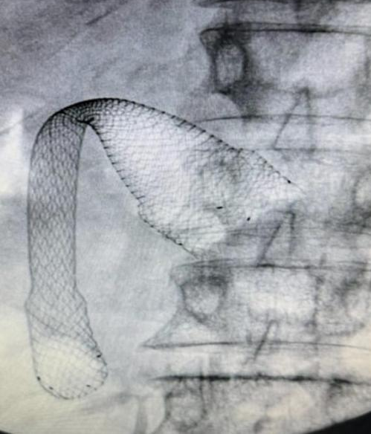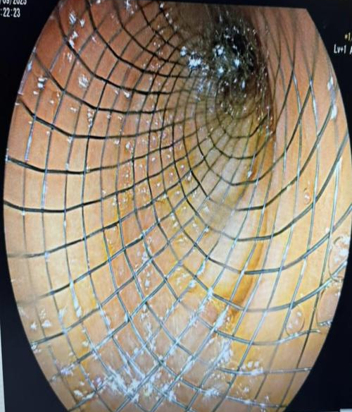
Fig 3: Self - expandable metal duodenal stent

Palliative chemotherapy with Gemcitabine and Carboplatin regimen was considered & initiated. She remained clinically stable on follow-up.
DISCUSSION
The incidence of gall bladder cancer (Ca GB) is high in India, 10-22 / 1,00,000 population, especially in northern India [4]. It is much lower in south India. There are various types of Ca GB, namely:

- Adenocarcinoma
- Papillary adenocarcinoma
- Squamous cell cancer
- Adenosquamous cancer
- Small cell cancer
- Sarcoma
- Neuroendocrine tumour
- Lymphoma
- Melanoma

Adenocarcinoma is the commonest type of gall bladder cancer and rest of the varieties are uncommon. Papillary type of adenocarcinoma tends to have a better prognosis. Squamous cell carcinoma accounts for only 1% of gall bladder cancers and arises from basal layers of epithelium [5]

The tumour staging is done as T1 (involving the wall of Gall Bladder), T2 (Perimuscular connective tissue), T3 (invading liver or other organs) T4 (invading biliary tree, portal vein or hepatic artery); N1 (involvement of nodes and cystic duct, CBD, Hepatic artery or portal vein) and N2 (involvement of aortic, caval, SMA or celiac nodes are affected); M1 (defined as distant metastasis).

“The common genetic mutations that may occur in gall bladder cancer include: TP 53, ARID 1 A, KRAS, PIK 3 CA, CTNNB 1, ERBB2 and microsatellite instability. There are no specific studies on genetic mutations in squamous cell carcinoma of gall bladder. Some mutations like PIK 3 CA may have therapeutic indications like targeted therapy” [6].

Primary squamous cell carcinoma (SCC) of gall bladder is a rare entity and carries poor prognosis compared to other forms of gallbladder cancer. While adenocarcinoma commonly causes distant metastases, SCC tends to be more locally aggressive, directly invading adjacent structures as seen in our patient where liver, pyloric antrum, duodenum (D1 and D2), hepatic flexure of colon were involved.
Clinical presentation is highly nonspecific ranging from asymptomatic , to symptoms like anorexia, abdominal pain , and even with sequelae of local invasion like gastric outlet obstruction or bowel obstruction.
“Diagnosis of gallbladder carcinoma requires imaging and histopathological confirmation. Ultrasound is usually the first-line imaging, demonstrating gallbladder wall thickening or intraluminal mass. Contrast enhanced CT abdomen plays a vital role in assessing the extent of local invasion, regional lymph node involvement, vascular invasion and also helps in determining the resectability of the tumor” [7]. “MRCP plays a role in assessing biliary anatomy.

On both CT and MR, intense irregular enhancement may occur at the periphery of the lesion on arterial phase with persistence in portal venous phase and delayed enhancement” [8]. The persistence of enhancement in portal venous and delayed phases can help to differentiate it from large hepatocellular carcinomas which have tendency to wash out. Endoscopic evaluation helps in assessing gastric, duodenal involvement and planning the management of obstructive cases.
“Histopathology is the gold standard in confirming the diagnosis. Classical features of SCC are sheets of squamous epithelial cells and keratin deposits” [9]. IHC aids in further confirming the diagnosis and excluding adenocarcinoma or adenosquamous carcinoma.

“In terms of treatment of gallbladder SCC, there is no standard treatment protocol other than a full R0 resection which results in the best outcome” [10,11]. “Our patient’s tumor was locally invasive and unresectable at the time of diagnosis. These tumors are locally aggressive, yet often clinically silent early on, and many patients present at a stage past that of full resectability” [12,13]. Treatment after full resection and of unresectable tumors both utilize systemic chemotherapy and radiation [10].

CONCLUSION
Squamous cell carcinoma of gall bladder is rare and usually presents with evidence of local invasion of surrounding structures. Early diagnosis is the key to treatment and resection followed by chemotherapy is the standard managment. Resection was not feasible in our patient and hence palliative stenting of the obstructed gastric outlet followed by chemotherapy was considered.

Consent
As per international standards or university standards, patient(s) written consent has been collected and preserved by the author(s).

Conference disclaimer:
Some part of this manuscript was previously presented and published in the conference: European Society of Cardiology (ESC) Congress 2020- The Digital Experience dated from 29th August to 01st September, 2020 in Paris, France, Web Link of the proceeding: https://www.escardio.org/Congresses-Events/World-cardio-agenda/esc-congress-2020
Disclaimer (Artificial intelligence)
Option 1:
Author(s) hereby declare that NO generative AI technologies such as Large Language Models (ChatGPT, COPILOT, etc) and text-to-image generators have been used during writing or editing of manuscripts.
Option 2:
Author(s) hereby declare that generative AI technologies such as Large Language Models, etc have been used during writing or editing of manuscripts. This explanation will include the name, version, model, and source of the generative AI technology and as well as all input prompts provided to the generative AI technology
Details of the AI usage are given below:
1.
2.
3
REFERENCES:

- Furlan A, Ferris JV, Hosseinzadeh K, Borhani AA. Gallbladder carcinoma update: multimodality imaging evaluation, staging, and treatment options. American Journal of Roentgenology. 2008 Nov;191(5):1440-7.
- Weatherall TJ, Fenton M, Munene G, Dickson PV, Deneve JL. Locally advanced, unresectable squamous cell carcinoma of the gallbladder. Case Reports in Surgery. 2015;2015(1):424650.

- Whang EE, Duxbury M, Rocha FG, Zinner MJ. Chapter 51. Cancer of the gallbladder and bile ducts. In: Zinner MJ, Ashley SW, editors. Maingot’s abdominal operations. 12th ed. New York (NY): McGraw-Hill; 2013.

- Dutta U, Bush N, Kalsi D, Popli P, Kapoor VK. Epidemiology of gallbladder cancer in India. Chinese clinical oncology. 2019 Aug;8(4):33-.

- Alpuerto AC, Mora ME, Robitsek RJ, Schubl SD. Primary pure squamous cell carcinoma of the gallbladder locally invading the liver, duodenum, and stomach: a case report and literature review. Case reports in surgery. 2017;2017(1):2534029.

- Roa JC, García P, Kapoor VK, Maithel SK, Javle M, Koshiol J. Gallbladder cancer. Nature reviews Disease primers. 2022 Oct 27;8(1):69.

- Somers I, Bipat S. Contrast-enhanced CT in determining resectability in patients with pancreatic carcinoma: a meta-analysis of the positive predictive values of CT. European radiology. 2017 Aug;27(8):3408-35.

- McKnight T, Patel A. Gallbladder masses: multimodality approach to differential diagnosis. Journal of the American Osteopathic College of Radiology. 2012 Oct 9;1(4):22-31.

- Sanchez-Danes A, Blanpain C. Deciphering the cells of origin of squamous cell carcinomas. Nature Reviews Cancer. 2018 Sep;18(9):549-61.

- Takahashi H, Irri A, Fenig Y, Byale A, Thung S, Gunasekaran G. Systematic review of squamous cell carcinoma of the gallbladder. The American Journal of Surgery. 2022 Sep 1;224(3):863-8.

- Ayabe RI, Wach MM, Ruff SM, Diggs LP, Martin SP, Wiemken T, Hinyard L, Davis JL, Luu C, Hernandez JM. Gallbladder squamous cell carcinoma: an analysis of 1084 cases from the National Cancer Database. Journal of surgical oncology. 2020 Sep;122(4):716-22.

- Samuel S, Mukherjee S, Ammannagari N, Pokuri VK, Kuvshinoff B, Groman A, LeVea CM, Iyer R. Clinicopathological characteristics and outcomes of rare histologic subtypes of gallbladder cancer over two decades: A population-based study. PLoS One. 2018 Jun 11;13(6):e0198809.

- Zhu C, Sun L, Wei Y, Xu D, Zhou Y. Characteristics and survival prognosis of patients with pure squamous cell carcinoma of the gallbladder. ANZ Journal of Surgery. 2021 Mar;91(3):E91-7

