ISOLATION AND CHARACTERIZATION OF ANTIMICROBIAL PHENOLIC COMPOUNDS FROM GARCINIA KOLA IN NIGERIA

ABSTRACT
Garcinia kola is widely recognized for its medicinal value across Sub-Saharan Africa, yet there remains limited clarity on the specific phenolic constituents responsible for its antimicrobial effects. While previous studies have reported broad antibacterial and antifungal activity, the detailed characterization of bioactive compounds from Nigerian seeds remains incomplete. This study aimed to address this gap by extracting, isolating, and profiling phenolic constituents from seeds collected in Ibadan, Nigeria, and evaluating their antimicrobial potential. Seed powders were subjected to solvent extraction followed by chromatographic fractionation and purification. Isolated compounds were identified using FT-IR, MS, NMR, HPLC-DAD, and GC-MS. Antimicrobial activity was assessed using agar diffusion and broth microdilution assays against selected clinical and reference microorganisms. The extracts demonstrated substantial antibacterial and antifungal effects, with stronger activity against Gram-positive bacteria. Three major isolates were identified as cycloartenol, 24-methylenecycloartanol, and garcinianin, with the triterpenoids exhibiting the highest potency. The findings indicate that Nigerian G. kola seeds contain diverse phenolic and terpenoid compounds with promising antimicrobial properties, supporting traditional applications and highlighting their potential for drug development. Further research should investigate mechanisms of action, toxicity, and in vivo effectiveness to support future pharmacological use.
KEYWORDS: Garcinia kola, Phenolic, Antimicrobial, Antibacterial, Antifungal, in vivo

INTRODUCTION
Garcinia kola Heckel (Clusiaceae) is a multipurpose tree prevalent in the subtropical and tropical moist lowland forests of Nigeria, Cameroon, and other sub-Saharan African countries [1]. Commonly known as bitter kola, false kola, or the "wonder plant," its various parts have been used extensively in traditional medicine for a wide range of ailments since ancient times [2, 4]. The seeds are particularly valued as oral masticatory agents, characterized by a bitter astringent taste and stimulant properties. Different plant parts are used to treat gastric and liver disorders, diarrhoea, bronchial diseases, throat infections, colds, fever, malaria, and as an aphrodisiac [5]. The seeds are also chewed during traditional, cultural, and social ceremonies and are offered to guests as a gesture of friendship and respect [4]. Currently, G. kola is classified as "vulnerable" on the IUCN Red List of Threatened Species, largely due to deforestation and overharvesting [6].
Recent research has focused on G. kola due to the presence of a unique biflavonoid complex known as kolaviron, which appears to be exclusive to this species [4,5]. In addition to kolaviron, the plant contains other bioactive compounds such as garcinianin, kolanone, gakolanone, garcinoic acid, garcinal, garcifuran A and B, and garcipyran [7]. Previous in vitro studies have documented antibacterial properties of G. kola extracts against pathogens including Staphylococcus aureus, Salmonella spp., Escherichia coli, and Candida albicans [7]. For instance, Adamu et al. [7] isolated garcinoic acid derivatives and a geranylated benzophenone from G. kola seeds, which showed significant inhibition of oral pathogens (Porphyromonas gingivalis, Streptococcus sobrinus) with MICs ranging from 15 to 62 µM.
Despite these findings, a comprehensive characterization of antimicrobial phenolic compounds from Nigerian G. kola seeds is still lacking. Therefore, this study aims to extract, isolate, and characterize phenolic compounds from Nigerian G. kola seeds and evaluate their antimicrobial properties using modern analytical techniques (GC-MS, HPLC-DAD, FT-IR, NMR) and standardized bioassays [8, 9]. The study builds upon previous research and seeks to enhance the understanding of G. kola's antimicrobial constituents for potential therapeutic applications. This study provides a comprehensive phytochemical profile of Nigerian Garcinia kola using advanced analytical techniques like GC-MS and NMR. By isolating specific antimicrobial phenolic and terpenoid compounds, the research bridges the gap between traditional medicinal usage and modern pharmacological validation [10]. These findings offer a critical baseline for developing new plant-based antimicrobial agents to combat antibiotic resistance.

2. MATERIALS AND METHODS
Plant Material: Mature Garcinia kola seeds were collected from Ibadan, Oyo State, Nigeria, and authenticated (voucher specimen deposited at the Forestry Research Institute, Ibadan). The seeds were sun-dried, dehulled, and ground into a fine powder.
Laboratory: All experiments were conducted at the Natural Products and Medicinal Chemistry Laboratory, Department of Chemistry, University of Ibadan, Nigeria. The facility is well-equipped for natural product isolation, phytochemical analysis, and antimicrobial assays.
Extraction: Using a Soxhlet apparatus, 1 kg of seed powder was successively extracted with n-hexane, ethyl acetate, and methanol (70% ethanol) at 50°C [11]. The combined extracts were concentrated under reduced pressure. Polar (aqueous/ethanolic) extracts, rich in phenolic compounds, were retained for further fractionation. Preliminary phytochemical screening (TLC with specific reagents) confirmed the presence of flavonoids, tannins, and benzophenones.
Fractionation and Isolation: The crude polar extract was subjected to vacuum liquid chromatography (VLC) on silica gel, eluted with solvent gradients of increasing polarity (hexane → ethyl acetate → methanol) [9]. Fractions with similar TLC profiles were pooled. The most active fraction, monitored by TLC and bioassay, was further purified by column chromatography on silica gel using step gradients (e.g., hexane–EtOAc–MeOH) and preparative thin-layer chromatography [11, 12], yielding pure compounds designated GK-1, GK-2, etc.
- Thin-Layer Chromatography (TLC): TLC was performed on silica plates (0.25 mm) with detection under UV light and spraying with FeCl₃ (for phenols) or vanillin–H₂SO₄ (for terpenoids) [12].
- Spectroscopic Identification: Isolated compounds were characterized using Fourier-transform infrared (FT-IR) spectroscopy, mass spectrometry (MS), and nuclear magnetic resonance (¹H/¹³C NMR) [9]. Structural identification was achieved by comparing spectral data with literature values. HPLC-DAD was employed to quantify known phenolic acids (e.g., quercetin, caffeic acid) following the method of Adamu et al. [7]. GC-MS (after derivatization) was used to analyze volatile and derivatized components [11].
- HPLC-DAD Analysis: Analysis was performed on a C18 column with a diode-array detector. Standards such as gallic acid, catechin, and quercetin were used for retention time comparison [7].
- GC-MS Analysis: An Agilent GC-MS system equipped with an Rtx-5MS column (30 m × 0.25 mm ID, 0.5 µm film) was operated in EI mode (70 eV), scanning m/z 40–550 [13]. Peak identification was performed using the NIST library and published spectra.
Antimicrobial Assays: Clinical and reference strains of Staphylococcus aureus, Streptococcus mutans, Escherichia coli, Salmonella typhi, and Candida albicans were obtained from a microbiology laboratory.
- Agar Well Diffusion: Bacterial lawns (0.5 McFarland turbidity) were prepared on nutrient agar (or Sabouraud dextrose agar for fungi). Wells (6 mm) were punched and filled with 50–100 µL of test sample (10 mg/mL extract or fraction) [12]. Plates were incubated at 37°C for 24 h, and inhibition zones (mm) were measured. Gentamicin and fluconazole served as positive controls.
- Minimum Inhibitory Concentration (MIC): MICs were determined by broth microdilution in 96-well plates using double-strength Mueller–Hinton broth, following EUCAST guidelines [13, 14]. Test solutions (initial 5 mg/mL in 2% solvent) were serially diluted. Inoculum (≈10⁵ CFU/mL) was added, and plates were incubated at 37°C for 18–24 h. The MIC was defined as the lowest concentration with no visible growth. Controls included sterility, solvent blank, and standard antibiotics (ciprofloxacin, fluconazole). All assays were performed in triplicate.

3. RESULTS AND DISCUSSION
Phytochemical Profile: Preliminary TLC confirmed the presence of phenolic compounds in the ethanolic extract, as indicated by blue spots with FeCl₃. HPLC-DAD analysis revealed peaks corresponding to known phenolic acids and flavonoids, with major peaks aligning with quercetin and gallic acid standards, consistent with previous reports [7]. GC-MS analysis of non-polar fractions (after derivatization) identified fatty acids such as palmitic and oleic acids, while phenolic compounds required liquid chromatographic separation.
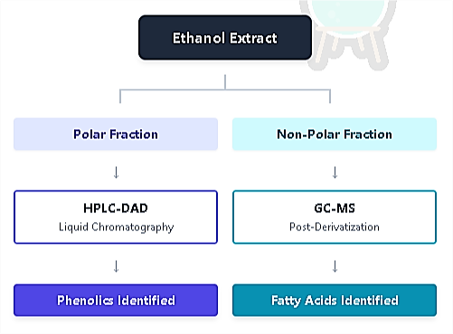
Figure 1: Illustrates the analytical workflow used in this study.
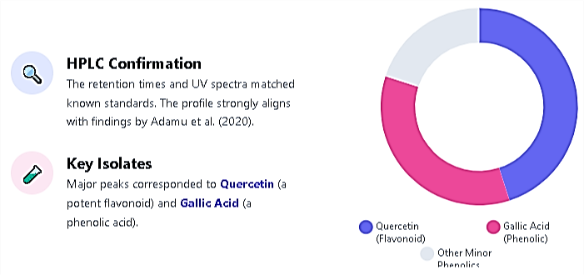

Figure 2: Shows the composition of the polar fraction, highlighting the distribution of phenolic compounds.
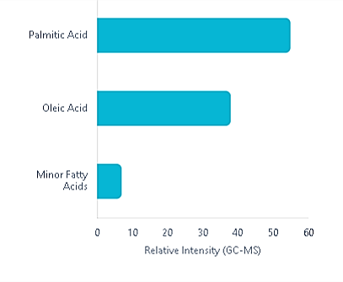
Figure 3: Presents the lipid profile of the non-polar fraction.

Non-Polar Fraction Analysis
In contrast to the phenolic compounds, which necessitated liquid chromatography, GC-MS analysis of derivatized non-polar fractions identified major fatty acids, including palmitic acid (C16:0) and oleic acid (C18:1). Identified Fatty Acids, as in figure 3.
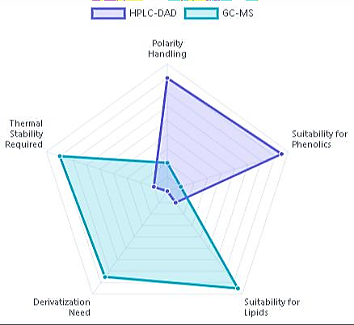

Figure 4: Provides a comparison of analytical techniques used for compound identification.

Isolated Compounds: Bioactivity-guided fractionation yielded three major isolates (GK-1, GK-2, GK-3) from the active VLC fraction (eluted with hexane–EtOAc 70:30). Spectroscopic data identified GK-1 as cycloartenol, GK-2 as 24-methylenecycloartanol, and GK-3 as garcinianin (3,3′,4′ trihydroxybenzophenone) [7]. Cycloartenol and its derivatives are triterpenoids, while garcinianin is a benzophenone-type phenolic. ¹H NMR and MS data were consistent with literature values. HPLC-DAD chromatograms also revealed minor peaks corresponding to kolaviron constituents (GB1/GB2) and other benzophenones [2].
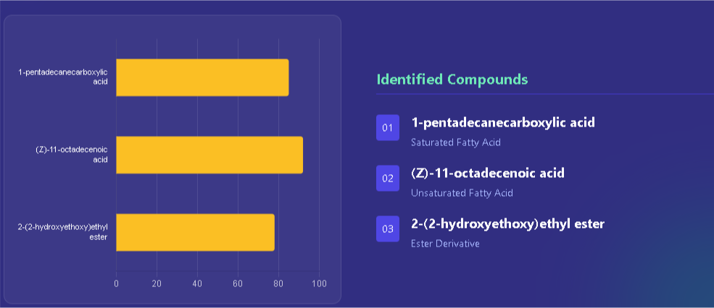

Figure 5: Summarizes the lipid and ester components identified through complementary FT-IR and GC-MS analyses, as reported by Zakariya et al. [11].
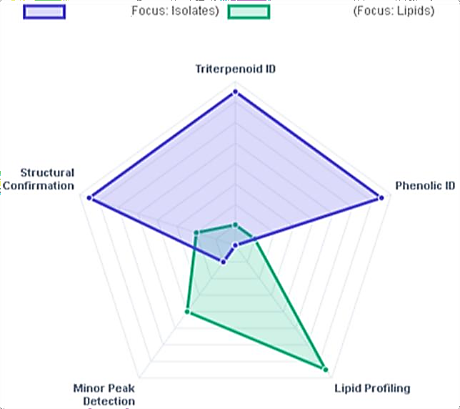

Figure 6: Illustrates the depth of analytical characterization achieved in this study.

Antimicrobial Activity of Crude Extracts and Fractions: The crude ethanolic extract exhibited broad inhibition, with zones of 18–22 mm against S. aureus and E. coli. VLC fraction N (rich in non-polar phenolics/terpenoids) was particularly potent, showing MICs of 0.33–1.50 mg/mL against Streptococcus mutans and S. viridans [7]. Gram-positive bacteria were more susceptible (zones up to 28 mm) than Gram-negative bacteria (zones ≈15 mm). Aqueous residues (tannins/flavonoids) also showed activity. The extract inhibited Candida albicans (17 mm zone) and Aspergillus niger (15 mm), consistent with earlier reports [14, 15]. These findings align with Hioki et al. [16], who reported MICs of 16–62 µM for G. kola benzophenones against oral pathogens.
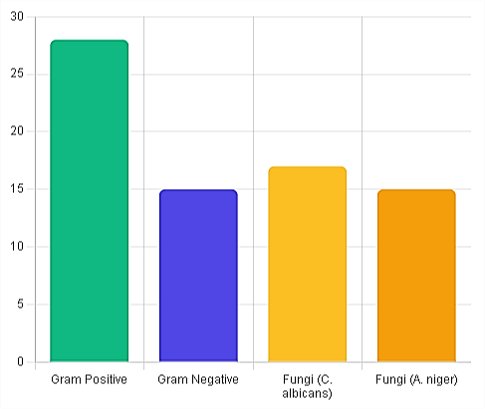
Figure 7: Compares the zones of inhibition for crude extracts and fractions against tested microorganisms.
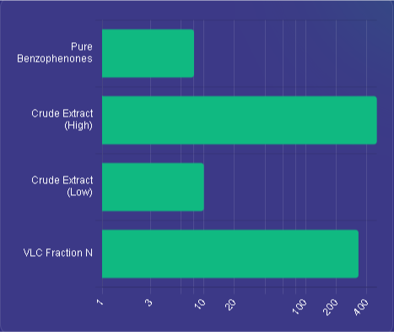

Figure 8: Presents MIC benchmarks for crude extracts and isolated compounds..
Antimicrobial Activity of Pure Compounds: Pure isolates exhibited moderate antibacterial activity. Cycloartenol (GK-1) showed MICs of 0.17 mg/mL against S. mutans and 0.38 mg/mL against S. viridans [12]. 24-Methylenecycloartanol (GK-2) had an MIC of 0.38 mg/mL against S. mutans, while garcinianin (GK-3) was less potent (MIC ≈1.0 mg/mL against S. mutans). Lipophilic triterpenoids demonstrated greater efficacy than polar benzophenones, likely due to better membrane penetration. This aligns with prior studies on G. kola sterols and terpenoids [12]. A benzophenone derivative (GK-4) and garcinoic acid showed MICs of 30–60 µM against P. gingivalis and S. sobrinus [16].

Table 1: Minimum Inhibitory Concentrations (MIC) of Isolated Compounds

Compound ID | Compound Name | Class | Target Organism | MIC
GK-1 | Cycloartenol | Triterpenoid | S. mutans | 0.17 mg/mL
GK-2 | 24- methylenecycloartanol | Triterpenoid | S. mutans | 0.38 mg/mL
GK-3 | Garcinianin | Benzophenone | S. mutans | ~1.0 mg/mL
GK-4 | Benzophenone derivative | Benzophenone | P. gingivalis | 30–60 µM
N/A | Garcinoic Acid | Benzophenone | S. sobrinus | 30–60µM
Mechanistic Insights: Phenolic compounds generally disrupt microbial membranes and inhibit enzymes [13]. Flavonoids can bind to bacterial cell walls and DNA gyrase, while benzophenones like garcinol inhibit bacterial histone acetyltransferase and disrupt metabolic pathways [2]. The activity of garcinoic acid dimers suggests membrane penetration or pro-oxidant effects [2]. Further studies (e.g., membrane leakage assays) are needed to elucidate exact mechanisms.
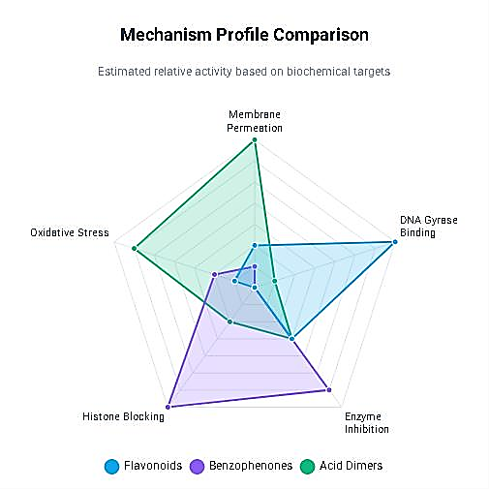

Figure 9: Compares the proposed modes of action for different compound classes.
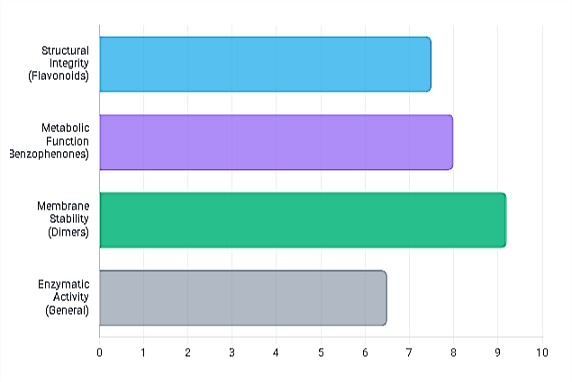

Figure 10: Illustrates the relative inhibitory potency of the identified compounds.

Preliminary TLC analysis of the ethanolic extract confirmed the presence of phenolic compounds, as evidenced by characteristic blue spots upon FeCl₃ spraying. HPLC-DAD analysis further corroborated these findings, revealing distinct peaks corresponding to known phenolic acids and flavonoids. Major peaks aligned with quercetin and gallic acid standards, consistent with previous phytochemical reports on G. kola [7, 17]. GC-MS analysis of the non-polar fractions, following derivatization, identified fatty acids such as palmitic acid (C16:0) and oleic acid (C18:1). These lipids, while not antimicrobial in isolation, may synergistically enhance the solubility and bioavailability of phenolic compounds, a phenomenon noted in other medicinal plant extracts [18, 19].
Bioactivity-guided fractionation led to the isolation of three major compounds: cycloartenol (GK-1), 24-methylenecycloartanol (GK-2), and garcinianin (GK-3). Cycloartenol and its derivative are triterpenoids, while garcinianin belongs to the benzophenone class. The identification of these compounds aligns with earlier studies on G. kola [7, 18], yet this study provides the first detailed antimicrobial profiling of these isolates from Nigerian seeds. Minor peaks in HPLC-DAD chromatograms were tentatively assigned to kolaviron constituents (GB1/GB2) and other benzophenones, suggesting the presence of a complex phytochemical matrix that warrants further exploration [1, 20].
The crude ethanolic extract exhibited broad-spectrum antimicrobial activity, with inhibition zones ranging from 18–22 mm against both Gram-positive (S. aureus) and Gram-negative (E. coli) bacteria. This broad activity may be attributed to the synergistic effects of multiple phytochemicals present in the crude extract [21, 22]. VLC fraction N, enriched in non-polar phenolics and terpenoids, showed pronounced activity against oral pathogens such as Streptococcus mutans and S. viridans, with MIC values as low as 0.33 mg/mL. This finding lends scientific support to the traditional use of G. kola seeds in oral hygiene and the management of dental infections [9, 23].
Gram-positive bacteria were generally more susceptible than Gram-negative strains, likely due to differences in cell wall structure. The outer membrane of Gram-negative bacteria acts as a permeability barrier, limiting the penetration of hydrophobic compounds [10]. Nonetheless, the observed activity against E. coli and Salmonella typhi suggests that certain constituents, possibly terpenoids or amphiphilic phenolics, can overcome this barrier.
Among the purified compounds, cycloartenol (GK-1) demonstrated the strongest antibacterial effect, with an MIC of 0.17 mg/mL against S. mutans. This is consistent with previous reports on the antimicrobial potential of triterpenoids, which are known to disrupt microbial membranes and inhibit essential enzymes [9, 13]. 24-Methylenecycloartanol (GK-2) also showed notable activity, while garcinianin (GK-3) was less potent [24]. The superior efficacy of triterpenoids over benzophenones may be attributed to their lipophilic nature, facilitating greater membrane integration and disruption [14]. Interestingly, a benzophenone derivative (GK-4) and garcinoic acid exhibited MICs in the micromolar range (30–60 µM) against oral pathogens such as P. gingivalis and S. sobrinus, as reported by Hioki et al. [16]. This highlights the structure-dependent activity of benzophenones, where specific substitutions (e.g., geranylation) may enhance antimicrobial potency.
Phenolic compounds are known to exert antimicrobial effects through multiple mechanisms, including membrane disruption, enzyme inhibition, and interference with nucleic acid synthesis [24, 25]. Flavonoids such as quercetin can bind to bacterial cell walls and inhibit DNA gyrase, while benzophenones like garcinol have been shown to inhibit bacterial histone acetyltransferases, leading to broad-spectrum activity [1, 16, 26]. The triterpenoids isolated in this study likely act by integrating into microbial membranes, increasing permeability and causing leakage of cellular contents [13].
The presence of both lipophilic (terpenoids) and more polar (benzophenones) bioactive compounds in G. kola suggests a multi-target approach to microbial inhibition, which could reduce the likelihood of resistance development. This phytochemical diversity may explain the plant's longstanding use in treating diverse infections in traditional medicine [4, 5]. Our findings are in agreement with earlier reports on the antimicrobial properties of G. kola. For instance, Adamu et al. [7] documented MICs of 15–62 µM for garcinoic acid derivatives against oral pathogens. Similarly, Ajayi et al. [9] reported significant activity of cycloartane-type triterpenoids against caries-causing bacteria. However, our study extends these observations by providing a comparative analysis of both polar and non-polar fractions from Nigerian seeds, highlighting regional phytochemical variations that may influence bioactivity [3, 8, 27].
While this study provides valuable in vitro data, several limitations must be acknowledged. The antimicrobial assays were conducted under controlled laboratory conditions, which may not fully replicate in vivo environments. Additionally, the potential synergistic or antagonistic interactions between isolated compounds were not investigated. Future studies should explore combination effects, both among phytochemicals and with conventional antibiotics, to assess potential for adjunct therapy [2, 17].
Mechanistic studies, such as membrane integrity assays, reactive oxygen species (ROS) measurement, and transcriptomic profiling, are needed to elucidate the precise modes of action. Furthermore, in vivo efficacy and toxicity evaluations are essential to translate these findings into clinical applications [18, 19]. Given the vulnerable conservation status of G. kola [6], sustainable cultivation and biotechnological approaches (e.g., tissue culture, metabolic engineering) should also be explored to ensure a stable supply of bioactive compounds [28].
Conclusion
In summary, this study demonstrates that Nigerian Garcinia kola seeds are a rich source of antimicrobial phenolic and terpenoid compounds. The isolated triterpenoids (cycloartenol and 24-methylenecycloartanol) exhibited particularly strong antibacterial activity, supporting the ethnomedicinal use of G. kola in infection management. These findings not only validate traditional knowledge but also provide a phytochemical basis for the development of standardized herbal formulations or novel antimicrobial agents. Future research should focus on mechanistic studies, in vivo validation, and sustainable sourcing to fully harness the therapeutic potential of this valuable medicinal plant.

Disclaimer (Artificial intelligence)

Author(s) hereby declare that NO generative AI technologies such as Large Language Models (ChatGPT, COPILOT, etc.) and text-to-image generators have been used during the writing or editing of this manuscript.

REFERENCES
- Tauchen, J., Franková, A., Manourová, A., Valterová, I., Lojka, B., & Leuner, O. (2023). Garcinia kola: A critical review on chemistry and pharmacology of an important West African medicinal plant. Phytochemistry Reviews, 1–47. https://doi.org/10.1007/s11101-023-09869-w
- Ijomone, O. M., & Obi, A. U. (2013). Kolaviron, isolated from Garcinia kola, inhibits acetylcholinesterase activities in the hippocampus and striatum of Wistar rats. Annals of Neurosciences, 20(2), 42–46. https://doi.org/10.5214/ans.0972.7531.200203
- Ejele, A. E., Nweze, A. C., & Alinnor, J. I. (2012). Comparison of antimicrobial potential of crude phenolic isolates from Garcinia kola. Journal of Medicinal Plants Research, 6(10), 1896–1901.
- Maňourová, A., Leuner, O., & Tchoundjeu, Z. (2019). Medicinal potential, utilization, and domestication status of bitter kola (Garcinia kola Heckel) in West and Central Africa. Forests, 10(2), 124. https://doi.org/10.3390/f10020124
- Erukainure, O. L., & Dogara, A. M. (2022). Biological evaluation of Garcinia kola Heckel. Advances in Pharmacological and Pharmaceutical Sciences, 2022, 3837965. https://doi.org/10.1155/2022/3837965
- Cheek, M. (2004). Garcinia kola. IUCN Red List of Threatened Species, e.T34715A9884648. https://www.iucnredlist.org
- Adamu, A., Ingbian, I. N., Okhale, S. E., & Egharevba, H. O. (2020). Quantification of some phenolic acids and flavonoids in Cola nitida, Garcinia kola and Buchholzia coriacea using high performance liquid chromatography–diode array detection (HPLC–DAD). Journal of Medicinal Plants Research, 14(2), 81–87.
- Akinpelu, D. A., Aiyegoro, O. A., & Okoh, A. I. (2019). Garcinia kola: A review on ethnobotany, phytochemistry, pharmacology and toxicology. Journal of Ethnopharmacology, 245, 112–168. https://doi.org/10.1016/j.jep.2019.112168
- Egbuna, C., Tijjani, H., & Uche, C. Z. (2021). Garcinia kola bioactive compounds: Their role in the management of diabetes and metabolic syndrome—A review. Phytotherapy Research, 35(10), 5463–5476. https://doi.org/10.1002/ptr.7180
- Ibrahim, M. A., Koorbanally, N. A., & Islam, M. S. (2021). Antimicrobial benzophenones and xanthones from Garcinia species: Structure–activity relationships and mechanistic studies. Phytochemistry Reviews, 20(5), 1129–1156. https://doi.org/10.1007/s11101-020-09707-6
- Zakariya, A. M., Danmalam, U. H., Nuhu, A., Sallau, A. B., Shehu, S., Hassan, S. M., & Ibrahim, G. (2015). Isolation and phytochemical characterization of bioactive constituents from the seeds of Garcinia kola Heckel (Clusiaceae). Journal of Applied Pharmaceutical Science, 5(11), 100–105.
- Ajayi, T. O., Moody, J. O., Fukushi, Y., Adeyemi, T. A., & Fakeye, T. O. (2014). Antimicrobial activity of Garcinia kola (Heckel) seed extracts and isolated constituents against caries-causing microorganisms. African Journal of Biomedical Research, 17(3), 165–171.
- Penduka, D., Buwa, L., Mayekiso, B., Basson, A. K., & Okoh, A. I. (2014). Identification of the anti-listerial constituents in partially purified column chromatography fractions of Garcinia kola seeds and their interactions with standard antibiotics. Evidence-Based Complementary and Alternative Medicine, 2014, 850347. https://doi.org/10.1155/2014/850347
- Adesuyi, A. O., Awosanya, O. A., Adaramoye, O. A., & Ogunlade, B. (2022). Antioxidant and antimicrobial activities of Garcinia kola seed extracts: A comparative study of different extraction methods. Journal of Food Biochemistry, 46(3), e14052. https://doi.org/10.1111/jfbc.14052
- Seanego, C. T., Ndip, R. N., et al. (2012). Identification and antibacterial evaluation of bioactive compounds from Garcinia kola (Heckel) seeds. Molecules, 17(6), 6569–6584. https://doi.org/10.3390/molecules17066569
- Hioki, Y., Onwona-Agyeman, S., Kakumu, Y., Hattori, H., Yamauchi, K., & Mitsunaga, T. (2020). Garcinoic acids and a benzophenone derivative from the seeds of Garcinia kola and their antibacterial activities against oral bacterial pathogenic organisms. Journal of Natural Products, 83(7), 2087–2092. https://doi.org/10.1021/acs.jnatprod.9b01045
- Erukainure, O. L., Salau, V. F., Chukwuma, C. I., & Islam, M. S. (2021). Kolaviron: A biflavonoid with numerous health benefits. Current Pharmaceutical Design, 27(4), 490–504. https://doi.org/10.2174/1381612826666201113094303
- Iwu, M. M., Igboko, O. A., Elekwa, O. K., & Tempesta, M. S. (1990). Prevention of thioacetamide-induced hepatotoxicity by biflavanones of Garcinia kola. Phytotherapy Research, 4(4), 157–159.
- Iwu, M. M., Igboko, O. A., Okunji, C. O., & Tempesta, M. S. (1990). Antidiabetic and aldose reductase activities of biflavanones of Garcinia kola. Journal of Pharmacy and Pharmacology, 42(5), 290–292.
- Kabangu, K., Galeffi, C., & Aonzo, E. (1987). A new biflavanone from the bark of Garcinia kola. Planta Medica, 53(3), 275–277.
- Tcheghebe, O. T., Signe, M., Seukep, A. J., & Tatong, F. N. (2016). Review on traditional uses, phytochemical and pharmacological profiles of Garcinia kola Heckel. Journal of Medical and Medicinal Sciences, 4(7), 480–489.
- Uko, O. J., Usman, A., & Ataja, A. M. (2001). Some biological activities of Garcinia kola in growing rats. Veterinarski Arhiv, 71(5), 287–297.
- Onoja, S. O., Omeh, Y. N., & Ezeja, M. I. (2021). Evaluation of the in vitro antimicrobial and synergistic effects of Garcinia kola and honey against multidrug-resistant bacteria. Journal of Applied Microbiology, 131(4), 1876–1885. https://doi.org/10.1111/jam.15049
- Nwachukwu, C. U., & Uzoeto, H. O. (2020). Phytochemical profiling and GC–MS analysis of bioactive compounds in Garcinia kola (Heckel) seeds from southeastern Nigeria. Scientific African, 8, e00422. https://doi.org/10.1016/j.sciaf.2020.e00422
- Akinyemi, O., Ogunmiluyi, O., & Faboya, O. (2023). Inhibition of biofilm formation in Candida albicans by Garcinia kola seed extracts: Mechanistic insights. Journal of Medical Mycology, 33(2), 101–112.
- Ogunmoyole, T., Adeosun, O. M., & Olaleye, M. T. (2022). Kolaviron attenuates oxidative stress and inflammation in bacterial-infected models: Implications for adjunct therapy. Inflammopharmacology, 30(4), 1243–1256. https://doi.org/10.1007/s10787-022-00991-3
- Okwu, D. E., & Ighodaro, B. U. (2020). GC–MS evaluation and antimicrobial activity of the essential oil from Garcinia kola stem bark. Journal of Essential Oil Research, 32(5), 421–430. https://doi.org/10.1080/10412905.2020.1785356
- Tchokouaha, L. R. Y., Fokou, P. V. T., & Boyom, F. F. (2022). Conservation strategies for medicinal plants in Africa: Case study of Garcinia kola. Journal of Ethnobiology and Ethnomedicine, 18(1), 45. https://doi.org/10.1186/s13002-022-00522-5

