Biocontrol potential of Trichoderma species against soil-born tomato pathogens (Fusarium oxysporum and Sclerotium rolfsii) in Senegal

ABSTRACT:
Soil-borne pathogens are major contributors to significant agricultural losses in developing countries. Trichoderma spp. are widely used as biocontrol agents for the management of fungal diseases of crops plants, due to their strong antagonistic activity and mycoparasitic abilities against a broad range of phytopathogens. The present study aims to evaluate the antagonistic potential of Trichoderma strains against two major tomato pathogens, Fusarium oxysporum and Sclerotium rolfsii. Seven Trichoderma asperellum strains and one Trichoderma virens strain collected from the Niayes tomato-growing zone in Senegal were characterized for their antagonistic activity against Fusarium oxysporum and Sclerotium rolfsii. Dual culture and the sealed Petri dish techniques were used to evaluate the percentage inhibition of pathogens by Trichoderma strains. All Trichoderma strains exhibited antagonistic activity and significantly inhibited the in vitro the mycelial growth of Sclerotium rolfsii and Fusarium oxysporum. In direct confrontation assays, strain TM1 showed the highest inhibition rate against F. oxysporum (73.49 %) while strain TN1 exhibited the highest performance against S. rolfsii (59.26 %). In indirect confrontation assays, strainTG4 showed the highest inhibition rate against Sclerotium (31.37 %), whereas TM1 showed the highest inhibition rate against Fusarium (39.11 %). Overall, inhibition rate observed in direct confrontation assays were higher than those recorded in indirect confrontation test. Furthermore, Fusarium oxysporum appeared to be more sensitive to the antagonistic activity of the Trichoderma than Sclerotium rolfsii.

Key Word: Trichoderma, biocontrol, Fusarium oxyporum, Sclerotium rolfsii, tomato

INTRODUCTION
Tomato is the second most consumed vegetable in Senegal after onion (ANSD, 2015; Camara et al., 2013). It plays an important socio-economic role by generating income and employment opportunities for farmers. Tomato production also contributes significantly to the national economy. Despite its importance, this sector is currently under serious threat, as local production does not meet national demand. The main constraints to increasing tomato production include poor seed quality used, low soil organic matter, limited access to organic fertilizers (PADEN, 2013), lack of storage facilities and the isolation of several production areas (Ndiaye, 2021). In addition, numerous problems related to pest pressure (Camara et al., 2013; Tendeng et al., 2022) particularly the rise in fungal diseases, which negatively affect yields.
These fungal diseases negatively affect tomato yields. Tomato crops are affected by two major Fusarium diseases: Fusarium wilt caused by Fusarium oxysporum f. sp. lycopersici (Snyder and Hansen) and Fusarium crown and root rot caused by Fusarium oxysporum f. sp. radicis-lycopersici Jarvis and Shoemaker (Katan et al., 1997). These diseases are among the most destructive tomato diseases worldwide (Hanaa et al., 2011). In addition, tomato sclerotiniosis caused by Sclerotium rolfsii Sacc. (Athelia rolfsii) induced seedling damping-off, root rot and crown rot (Abada, 2003, Bolou et al., 2015), leading to severe economic losses thant can reach up to 50% in some cases (Fidah, 1995).
These diseases are complex and difficult to control because they are often initiated by wounds that facilitate the entry and progression of pathogenic fungi (Caron et al., 2006) and persist in the soil in the form of sclerotia (Bolou et al.,2015). This situation leads to excessive use of synthetic pesticides by farmers with harmful effects on the environment, human health, and beneficial microorganisms.
In a context where societal expectations for sustainable agriculture aim to reduce pesticide use, it is necessary to develop new effective and environmentally friendly methods that rely on interactions between soil and microbiota. Biological control techniques based on the exploitation of the antagonistic potential of microorganisms could represent a real and eco-friendly alternative against fungal plant diseases (Karimi et al., 2016; Rabbee et al., 2019). Among biological control agents, Trichoderma spp. have shown promising antagonistic activity against phytopathogenic fungi (Hassan et al., 2017; Liu et al., 2022). Trichoderma species have been widely used in the biological control of various pathogenic fungi causing significant damage to fruits, vegetables, greenhouse crops and ornamentals (Hu et al., 2024; Sanchez et al., 2019). Although several bio fungicides based on Trichoderma formulations have been marketed over the decades, there remain an immense need to discover new Trichoderma species with potential antimicrobial activities against a wide range of pathogens (Martinez et al., 2023). In this context, the present study aims to evaluate the antagonistic potential of Trichoderma strains isolated from different sites in the Niayes area against two major tomato pathogens: Fusarium oxysporum and Sclerotium rolfsii.

MATERIALS AND METHODS
2.1. Isolation of Trichoderma
Trichoderma strains used in this study were isolated from rhizosphere soil samples collected from tomato fields in five different areas of Niaye zone, the main horticultural production in Senegal: UCAD, Sangalkam, Gorome, Notto Gouye Diama and Mboro. Identification of Trichoderma isolates was based on culture characteristics as well as microscopic parameters (branching of conidiophores, shape and position of phialides, spore size and shape) (Nagamani et al., 2006). Pure cultures were stored at 4°C in a refrigerator for further studies. The best producers of enzyme were identified by 18S rRNA sequencing (MACROGEN, SOUTH KOREA). These sequences were deposited in GeneBank (NCBI).
2.2 Isolation of Fusarium oxyporum and Sclerotium rolfsii
Fusarium and Sclerotium strains were isolated from infected tomato plants collected at the Sangalkam, experimental station of ISRA / CDH. The infected tissues were cut into pieces of approximatively 0.5 cm. The fragments were washed with tap water and then disinfected superficially by soaking in a sodium hypochlorite solution (10%) for 3 minutes. Then they were rinsed with sterile distilled water (3 times) and dried on sterile filter paper. Once dried, the fragments are placed on Potato Dextrose Agar (PDA) medium at the rate of 4 fragments per Petri dish (Davet and Rouxel, 1997). The PDA medium was supplemented with streptomycin sulfate (200 mg / l) to prevent bacterial growth. The dishes were then incubated in the dark at 25 ° C for 2 to 4 days. Successive subcultures performed after mycelial growth appeared in order to obtain pure isolates of Fusarium sp. and Sclerotium sp. Identification of the isolates was based on macroscopic and microscopic characteristics using the determination key of Nagamani et al., (2006).
2.3. In vitro antagonistic activities of Trichoderma on Fusarium oxysporum and Sclerotium rolfsii
Antagonistic interactions were evaluated using two methods: the dual culture technique and the sealed agar plate assay. A total of eight Trichoderma isolates were tested, consisting of seven Trichoderma asperellum strains (TS1–KF737410.1, TS2–KU896306.1, TB2–KU896306.1, TN1–KY225658.1, TU1–KF737411.1, TG4–JN108925.1, and TM1–KX620957.1) and one Trichoderma virens strain (TG1–KY225664.1), following Gueye (2019).
2.3.1. Direct confrontation tests
Two explants of 8 mm diameter from cultures of the two fungi were placed in Petri dishes containing 15 ml of PDA. Both pathogen and antagonist were first grown separately on sterilized PDA plates for 5 days. An 8 mm mycelial disk of the antagonist was excised from the edge of an actively growing 5 days old culture plate and inoculated opposite the pathogenic fungi in the same plate, 1 cm away from the edge. In the control plates, PDA plugs were placed opposite the pathogen instead of the antagonist. Each test was performed in triplicate. The dishes were incubated at 28 °C for 6 days.
2.3.2. Indirect confrontation tests
An explant of 8 mm in diameter taken from the colonies of Trichoderma and strains of pathogens (Fusarium or Sclerotium) was placed in the center of each Petri dish containing the PDA medium, following the method described by Dennis and Webster (1971). Trichoderma was inoculated in the center of the Petri plates containing solidified, sterilized PDA medium by placing 8 mm disc (5 days old culture) excised from the margin of the actively growing region of Trichoderma sp. and incubated for 2 days at 28 °C. Subsequently, the top lid of each Petri plate was replaced with the bottom part of another Petri plate of the same size containing PDA medium, inoculated with a 8 mm mycelial disc of the test pathogen. Each paired plate was sealed with parafilm and incubated at 28 °C. Control plates consisted of PDA medium without Trichoderma in the bottom part, with the respective test pathogen inoculated on the upper lid. Each treatment was performed in triplicates and incubated at 28 °C. After 6 days, the assemblies were opened and observations were recorded.

2.2.3. Measured parameters
The mycelial growth of pathogens was determined after 6 days of incubation by measuring the diameter of the pathogenic fungus colony with a graduated ruler.
In both antagonism tests, inhibition exerted by Trichoderma was calculated as the percentage inhibition of mycelial growth using the following formula (Hmouni et al., 1996):
I (%) = (1- Dn / Do) x 100
Dn: colony diameter of the pathogen in the presence of Trichoderma (mm)
Do: colony diameter of the pathogen in control plates (mm).
2.3.4. Statistical analysis
Statistical analyses were performed using Xlstat 2016 version 4.07 addinsoft. Data were submitted to an analysis of variance (ANOVA). Significantly different means were separated using the Newman Keuls test at the 5% probability level.
- RESULTS
  - Morphological aspects of Fusarium oxysporum and Sclerotium rolfsii
Fusarium oxysporum isolates develop a white aerial mycelium with a purple pigmentation, the colony reverse being an intense purple (Figure 1a). They produce spindle-shaped, slightly curved macroconidia with 3 septa, a basal pedicellate cell, and an apical hooked cell. Microconidia are ellipsoidal to oval, usually aseptate or with a single septum. Macroconidia are formed by phialides on branched conidiophores or within sporodochia.
Sclerotium rolfsii isolates exhibit a dense whitish mycelium. Sclerotia are smooth, nearly spherical structures (1 to 3 mm in diameter) that initially appear white, later turning light brown to reddish-brown resembling mustard seeds. They typically develop within the mycelium 5 to 7 days after transplanting (Figure 1b). Microscopically, hyphae measuring 5 to 9 microns in diameter are observed. The main hyphae are hyaline (colorless), thin-walled, with transverse septa and infrequent connections.
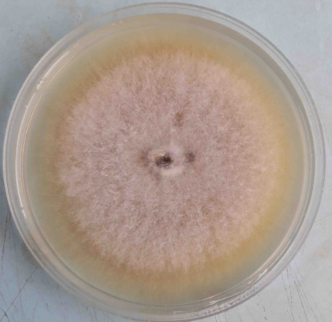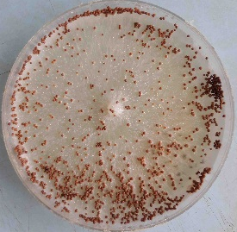
b
a
Figure 1: Aspect of Fusarium oxyporum (a) and Sclerotium rolfsii (b) on PDA medium
  - Direct confrontation tests
The results showed that the mycelial growth of the control strains was greater than that observed under the different confrontation treatments (Table 1). After 6 days of incubation, the various Trichoderma strains exerted a significant inhibitory effect on the mycelial growth of the pathogens.

- Direct confrontation between Trichoderma-Sclerotium
The direct confrontation test between S. rolfsii (SR1) and Trichoderma isolates revealed significant differences in mycelial growth among treatments. The control (SR1 alone) exhibited nearly twice the mycelial growth compared to the treatments combining Trichoderma and SR1. In confrontation with the Trichoderma strain TB2, SR1 showed relatively higher growth (4.13 cm) whereas the lowest growth was recorded with the TN1 strain (3.43 cm). The percentage inhibition ranged from 51.07% to 59.26%. The highest inhibition (59.26%) was observed with the TU1 isolates, followed by TG4 and TM1 respectively (Table 1). In contrast, the TG1, TB2 and TS2 strains exhibited the lowest inhibition percentages, not exceeding 55% with values ​​of 52.63%, 51.07% and 53.80% respectively.
- Direct confrontation between Trichoderma-Fusarium
The direct confrontation test between Trichoderma and F. oxysporum (FO1), also reveals a greater mycelial growth in the control (7.67 cm) which was nearly twice that observed in the confrontation treatments. In confrontation with the Trichoderma strain TS2, the FO1 isolate exhibited the highest mycelial growth (3.00 cm), whereas the lowest growth was recorded with the TM1 strain. The TM1 strain showed the strongest inhibition capacity (73.49%) followed by TS1 (70.45%) and TN1 (70.01%). These three isolates inhibited FO1 by more than 70%. In contrast, the TS2 and TB2 strains displayed the weakest inhibitory capacities. Overall, all Trichoderma isolates inhibited FO1 more than 60%.
Table 1: Direct confrontation between Trichoderma strains and pathogenic strains (Fusarium oxyporum and Sclerotium rolfsii)
Trichoderma strains | Pathogens
Trichoderma strains | Sclerotium rolfsii (SR1) |  | Fusarium oxysporum (FO1)
Trichoderma strains | Mycelial growth (cm) | Inhibition (%) | Mycelial growth (cm) | Inhibition (%)
TB2 | 4,13^{b} | 51,07^{c} | 2,97^{b} | 61,32^{b}
TG1 | 4,00^{bc} | 52,63^{bc} | 2,73^{bc} | 64,36^{ab}
TS2 | 3,90^{bc} | 53,80^{abc} | 3,00^{b} | 60,89^{b}
TS1 | 3,83^{cd} | 54,58^{abc} | 2,27^{bc} | 70,45^{ab}
TM1 | 3,60de | 57,31^{ab} | 2,03^{c} | 73,49ª
TG4 | 3,57de | 57,70^{ab} | 2,47^{bc} | 67,84^{ab}
TU1 | 3,53e | 58,09^{ab} | 2,53^{bc} | 66,97^{ab}
TN1 | 3,43e | 59,26ª | 2,30^{bc} | 70,01^{ab}
Control | 8,50ª | - | 7,67a | -
The means that share the same letters within a group in each column are not significantly by Fischer LSD test (P=.05).
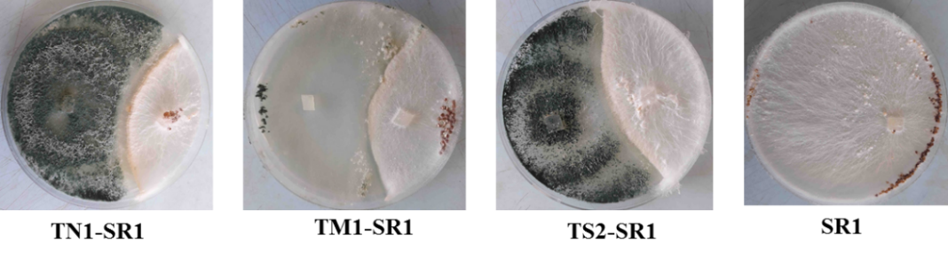
Plate 1 : direct confrontation test Trichoderma-S. rolfsii (SR1)

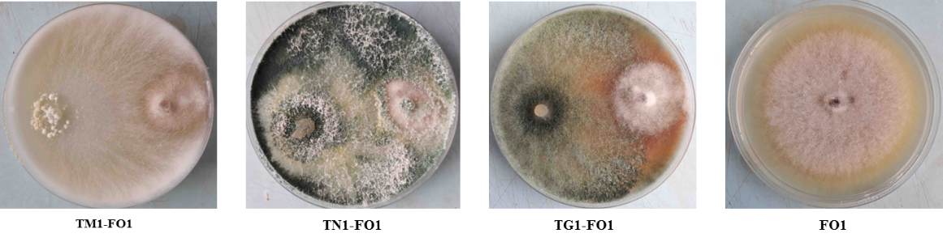
Plate 2 : direct confrontation test Trichoderma-F. oxysporum (FO1)

  - Indirect confrontation tests (distance)
The indirect confrontation test (Table 2) showed a reduction in the growth of Fusarium and Sclerotium strains caused by Trichoderma compared to the control. Unlike the direct confrontation test, the inhibition of the pathogens mycelial growth was less pronounced under indirect confrontation conditions.
- Indirect confrontation Trichoderma-Sclerotium
The mycelial growth of the control strains was greater than that observed in the presence of Trichoderma. In indirect confrontation, the FO1 isolate showed the weakest growth (4.57 cm) when paired with the TM1 strain. Regarding percentage inhibition, significant differences were noted among the treatments. The TM1 strain exhibited the highest inhibition (39.11%) followed by TN1 (30.67%) and TU1 (30.22%), with inhibition values around 30 % (Table 2). None of the Trichoderma strains inhibited FO1 by more than 50% during the indirect confrontation test.
- Indirect confrontation Trichoderma-Fusarium
In an indirect confrontation between Trichoderma isolates and F. oxysporum (FO1), the results showed that the mycelial growth of the control strains was greater than that in the presence of Trichoderma. In this test, the F01 isolate exhibited the weakest growth (4.57 cm) when paired with the TM1 strain. Regarding percentage inhibition, significant differences were noted among the treatments. The TM1 strain displayed the highest inhibition (39.11%) followed by the TN1 (30.67%) and TU1 (30.22%) with inhibition values around 30 % (Table 2). None of the Trichoderma strains inhibited FO1 strain by more than 50% during the indirect confrontation test.
Table 2: Distance comparison between Trichoderma strain and pathogens
Trichoderma strains | Pathogènes
Trichoderma strains | Sclerotium rolfsii (SR1) |  | Fusarium oxysporum (FO1)
Trichoderma strains | Mycelial growth (cm) | Inhibition (%) | Mycelial growth (cm) | Inhibition (%)
TN1 | 7,33^{b} | 13,73^{c} | 5,20^{cd} | 30,67^{b}
TG1 | 7,07^{b} | 16,86^{bc} | 5,93^{b} | 20,89^{d}
TS1 | 7,00^{b} | 17,65^{bc} | 5,50^{bc} | 26,67^{bc}
TB2 | 6,80^{b} | 20,00^{bc} | 5,77^{bc} | 23,11^{cd}
TS2 | 6,67^{b} | 21,57^{b} | 5,67^{bc} | 24,44^{cd}
TU1 | 6,63^{b} | 21,96^{b} | 5,23^{cd} | 30,22^{b}
TM1 | 5,97^{c} | 29,80ª | 4,57d | 39,11ª
TG4 | 5,83^{c} | 31,37ª | 5,40^{bc} | 28,00^{bc}
Témoin | 8,50ª | - | 7,50ª | -
The means that share the same letters within a group in each column are not significantly by Fischer LSD test (P=.05).
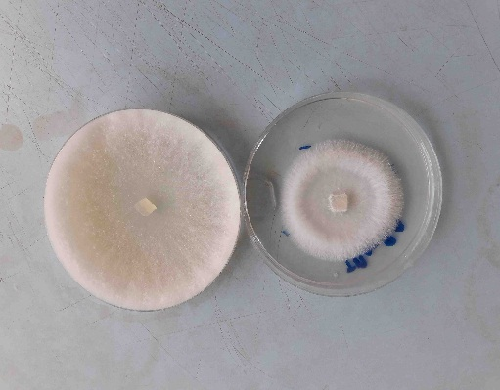
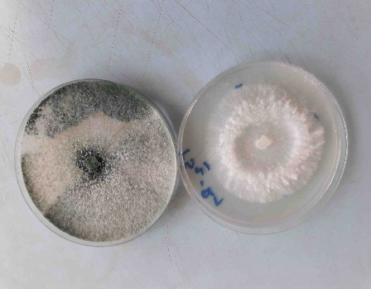
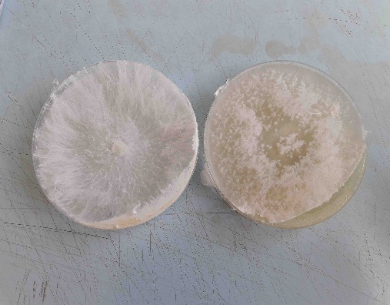
TM1-SR1
TS2-SR1
SR1

Plate 3 : indirect confrontation test Trichoderma- Sclerotium rolfsii (SR1)
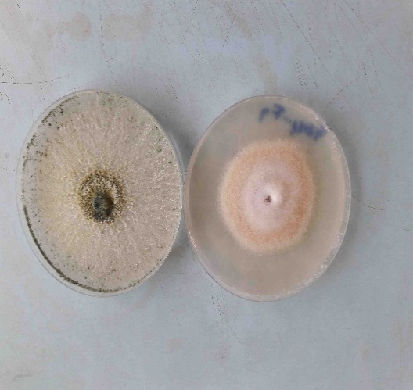
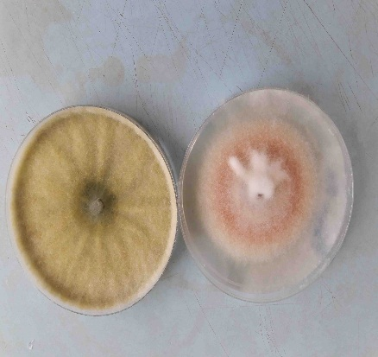
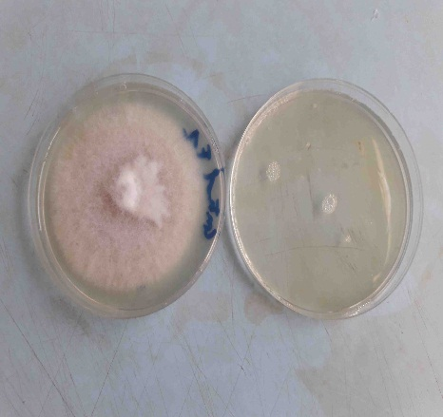
TN1-FO1
TG1-FO1
FO1

Plate 4 : indirecte confrontation test Trichoderma-Fusarium oxysporum (FO1)
Direct confrontation test allowed a greater inhibition of the mycelial growth of pathogens than the remote confrontation test. Trichoderma TM1, TN1, TS1, TG4 and TU1 strains performed best for both antagonist tests.
- DISCUSSION
The macroscopic and microscopic features observed in the present study confirmed the identification of Fusarium oxysporum, and Sclerotium rolfsii as reported by Roquebert (1998) and Nagamani et al. (2006), respectively. Appropriate morphological identification is still a prerequisite in phytopathology, as demonstrated by Khare et al. (2025) and clearly emphasize the role of morphological characteristics in differentiating such pathogenic fungi from various agro-climatic regions. Direct confrontation and indirect confrontation tests showed that Trichoderma strains had the capability to cause mycelial (in vitro) inhibition of F. oxysporum (FO1) and S. rolfsii (SR1). However, the inhibitory power depended on both Trichoderma strain and target pathogen. Altogether, F. oxysporum seems to be less resistant to Trichoderma’s antagonism than S. rolfsii irrespective of the mode of confrontation. Several authors have previously reported such strain-dependent differences of inhibition capacity (Sanchez et al., 2019; Chen et al., 2021; Zhang et al., 2022). These results are in accordance with those obtained by Khare et al. (2025) observed considerable variability in the levels of antagonism against Colletotrichum truncatum, the causal agent of soybean anthracnose, by the isolates of Trichoderma.
These observations further suggest that the antagonistic effectiveness of Trichoderma depends largely on the specific isolate–pathogen combination. Previous research has demonstrated that both the Trichoderma isolate and the target pathogen significantly influence biocontrol efficacy, thereby underlining the importance of isolate screening prior to field application. In this context, Pakkala and Harrison (2018) reported inhibition rates ranging from 45 to 70% in direct confrontation assays and from 30 to 50% in indirect assays between Trichoderma viride and Fusarium oxysporum, which closely aligns with the results obtained in the present study.
Using strains of Trichoderma asperellum, Hasan and Nada (2016) reported mycelial growth inhibition of up to 69.23% for Alternaria alternata and 64% for Fusarium semitectum. Similarly, Amin et al. (2010) observed inhibitory rates of 41.8% against F. oxysporum, 40.68% against Sclerotium rolfsii, and 30.58% against Rhizoctonia solani, highlighting the contribution of volatile compounds produced by Trichoderma spp. Moreover, studies by Rehman et al. (2013) and Cherkupally et al. (2017), which evaluated different isolates of Trichoderma harzianum and T. viride against F. oxysporum, reported markedly higher inhibition levels approaching 80%, further emphasizing the influence of isolate–pathogen specificity. In contrast, Bardia and Rai (2007) documented lower inhibition percentages, generally below 60%, reinforcing the idea that isolate diversity and experimental conditions can substantially affect antagonistic performance. A similar degree of variability has been reported in fungicide-based studies against Colletotrichum truncatum, where in vitro efficacy differed considerably among pathogen isolates (Khare et al., 2025). Collectively, these observations support the notion that pathogen sensitivity varies widely among isolates, regardless of the control strategy employed. Several mechanisms may contribute to the inhibition observed during antagonism assays, including mycoparasitism (Howell, 2003), competition for nutrients and space (Elad et al., 1999), antibiosis (Howell, 1998), inactivation of pathogen enzymes (Roco and Pérez, 2001), secretion of diffusible non-volatile antibiotics (Hajieghrari et al., 2008), and the production of cell wall-degrading enzymes (Harman et al., 2004).
Among these mechanisms, mycoparasitism represents a key mode of antagonism by Trichoderma. This process involves direct physical interactions with the phytopathogen, including hyphal coiling, penetration, and subsequent degradation of the host cell wall. Strong evidence of mycoparasitic activity was provided by ultrastructural studies conducted by Elad et al. (1983), which clearly illustrated the intimate interactions between Trichoderma spp. and plant pathogenic fungi. During this process, Trichoderma secretes a range of lytic enzymes, such as proteases, chitinases, and β-1,3-glucanases, which target the principal structural components of fungal cell walls (Haran et al., 1996; Carsolio et al., 1999). In addition to mycoparasitism, competition for nutrients and space plays a major role in pathogen suppression. The rapid growth and aggressive colonization ability of Trichoderma allow it to efficiently occupy available ecological niches and utilize nutrients more effectively than competing phytopathogens, thereby restricting their development (Davet, 1996). Furthermore, the inhibitory effects observed in indirect confrontation assays confirm the involvement of diffusible and volatile metabolites in pathogen suppression. Previous studies have shown that Trichoderma produces a wide range of volatile secondary metabolites, including ethylene, hydrogen cyanide, aldehydes, and ketones, which contribute significantly to the biological control of phytopathogenic fungi (Davet, 1983a, 1983b; Vey et al., 2001; Bhagat et al., 2014). Overall, the present findings demonstrate the strong antagonistic potential of Trichoderma strains against major soil-borne pathogens and highlight the importance of selecting highly efficient isolates for the development of sustainable and long-term disease management strategies.
- CONCLUSION
The present study clearly shows that Trichoderma isolates possess a strong antagonistic activity against Fusarium oxysporum and Sclerotium rolfsii. Both direct and indirect confrontation assays revealed a significant reduction in mycelial growth of the two pathogens. In direct interaction tests, inhibition rates ranged from 60.89% to 73.49% for F. oxysporum and from 51.07% to 59.26% for S. rolfsii, indicating a particularly high suppressive effect. Indirect confrontation assays resulted in comparatively lower inhibition levels, with values between 20.89% and 39.11% for F. oxysporum and 13.73% to 31.37% for S. rolfsii. Nevertheless, these results confirm that volatile and diffusible metabolites produced by Trichoderma still contribute meaningfully to pathogen suppression. Overall, these findings underline the remarkable in vitro antagonistic potential of the tested Trichoderma isolates, especially when direct contact with the pathogens occurs. However, since laboratory conditions do not fully reflect the complexity of natural environments, further evaluations under field conditions are required to confirm their biocontrol efficacy. Such studies will be essential to assess their persistence, adaptability, and performance under local agroecological conditions. Based on these findings, the promising antagonistic activity observed in this study suggests that these Trichoderma isolates could represent valuable biological control agents for managing fungal diseases in vegetable crops in Senegal., the promising antagonistic activity observed in this study suggests that these Trichoderma isolates could represent valuable biological control agents for managing fungal diseases in vegetable crops in Senegal. Their use could contribute to the development of more sustainable, environmentally friendly, and locally adapted plant protection strategies.
Disclaimer (Artificial intelligence)
Author(s) hereby declare that generative AI technologies such as Large Language Models, etc. have been used during the writing or editing of manuscripts. This explanation will include the name, version, model, and source of the generative AI technology and as well as all input prompts provided to the generative AI technology
Details of the AI usage are given below:
1. Microsoft Copilot
REFERENCES
- Abada, K. A. (1994). Fungi causing damping-off and root-rot on sugar-beet and their biological control with Trichoderma harzianum. Agriculture, Ecosystems & Environment.
- Agence Nationale de la Statistique et de la Démographie. (2015). *Bulletin Mensuel des Statistiques Economiques et Financières – Avril 2015*. Dakar, Senegal : Agence Nationale de la Statistique et de la Démographie. https://www.ansd.sn/publications/
- Amin, F., Razdan, V. K., Mohiddin, F. A., Bhatt, K. A., & Sheikh, P. A. (2010). Effect of volatile metabolites of Trichoderma species against seven fungal plant pathogens in-vitro. Journal of Phytology, 2(10), 34–37.
- Antoine, B. B. B., Hilaire, K. T., Koffi, K. G., Fernand, K., Seydou, T., Mamadou, C., Bomisso, L., & Daouda, K. (2015). Inhibition of Sclerotium rolfsii Sacc. (Corticiaceae), the causal agent of tomato (Solanaceae) stem collar rot, by Xylopia aethiopica (Dunal) A. Rich (Annonaceae) and Trichoderma sp. European Scientific Journal, 11(12), 61–85.
- Bardia, P. K., & Rai, P. K. (2007). In vitro and field evaluation of biocontrol agents and fungicides against wilt of cumin caused by Fusarium oxysporum f. sp. cumini. Journal of Spices and Aromatic Crops, 16(2), 88-92. https://updatepublishing.com/journal/index.php/josac/article/view/4877
- Bhagat, S. B. A., Kumar, R., Yadav, M. S., & Chattopadhyay, C. (2014). Plant disease management: Prospects of pesticides of plant origin. In D. Singh (Ed.), Advances in Plant Biopesticides (pp. 119-129). Springer India. https://doi.org/10.1007/978-81-322-2006-0_7
- Camara, M., Mbaye, A. A., Samba, S. A. N., Gueye, T., Noba, K., Diao, S., & Cilas, C. (2013). Etude de la productivité et de la sensibilité de diverses variétés de tomate (Lycopersicon esculentum Mill) à la virose du jaunissement et de l'enroulement en cuillère des feuilles au Sénégal. International Journal of Biological and Chemical Sciences, 7(6), 2504-2512.
- Caron J, Laverdière J, Venne J, Bélanger RR. (2006). Research and development of biopesticides and natural pesticides with low toxicity for non-target organisms and environmentally friendly – Final report – Phytopathology section. Québec, Canada : Ministère du Développement durable, de l’Environnement et des Parcs (MDDEP), Université Laval. 143 pages.
- Carsolio, C., Benhamou, N., Haran, S., Cortés, C., Gutiérrez, A., Chet, I., & Herrera-Estrella, A. (1999). Role of the Trichoderma harzianum endochitinase gene, ech42, in mycoparasitism. Applied and Environmental Microbiology, 65(3), 929-935. https://doi.org/10.1128/AEM.65.3.929-935.1999
- Chen, J., Zhou, L., Din, I. U., Arafat, Y., Li, Q., Wang, J., Wu, T., Wu, L., Wu, H., Qin, X., Pokhrel, G. R., Lin, S., & Lin, W. (2021). Antagonistic Activity of Trichoderma spp. Against Fusarium oxysporum in Rhizosphere of Radix pseudostellariae Triggers the Expression of Host Defense Genes and Improves Its Growth Under Long-Term Monoculture System. Frontiers in Microbiology, 12, 579920. https://doi.org/10.3389/fmicb.2021.579920
- Cherkupally, R., Amballa, H., & Reddy, B. N. (2017). In vitro antagonistic activity of Trichoderma species against Fusarium oxysporum f. sp. Melongenae. International Journal of Applied Agricultural Research, 12(1), 87-95. https://www.ripublication.com/ijaar17/ijaarv12n1_10.pdf
- Davet P. (1983a). Introduction and Persistence of Trichoderma in Soil. In : Microbial Antagonists – Mode of Action and Application in the Biological Control of Plant Diseases, ACTA, INRA-ENSAM Montpellier (France). 159–168
- Davet P. (1983b). Trichoderma as an example of fungal antagonists of pathogenic agents. In Faune et flore auxiliaire en agriculture. ACTA, INRA-ENSAM Montpellier (France). 193–204.
- Davet, P. (1996). Vie microbienne du sol et production végétale. INRA Editions. https://hal.inrae.fr/hal-02841361
- Davet, P., & Rouxel, F. (2000). Detection and Isolation of Soil Fungi. INRA Science Publishers.
- Dennis, C., & Webster, J. (1971). Antagonistic properties of species-groups of Trichoderma : I. Production of non-volatile antibiotics. Transactions of The British Mycological Society, 57, 25-30. https://doi.org/10.1016/S0007-1536(71)80077-3
- Elad, Y., Barak, R., Chet, I., & Henis, Y. (1983). Ultrastructural studies of the interaction between Trichoderma spp. and plant pathogenic fungi. Journal of Phytopathology, 107(2), 168-175. https://doi.org/10.1111/j.1439-0434.1983.tb00064.x
- Elad Y, David DR, Levi T, Kapat A, Kirshner B. (1999). Trichoderma harzianum T-39-mechanisms of biocontrol of foliar pathogens. In: Modern fungicides and antifungal compounds II. Eds. H. Lyr, P.E. Russell, H.W. Dehne, and H.D. Sisler). Andover, Hants, UK: Intercept. pp. 459-467.
- Fidah A. (1995). Sugar Beet Rot Caused by Sclerotium rolfsii in the Doukkala Region: Epidemiology and Control Trials. Third Cycle Thesis, Faculty of Sciences Semlalia, Marrakech, Morocco, p123.
- Guèye N. 2020. Caractérisation de Trichoderma spp. Indigènes et évaluation de leurs potentialités antagonistes sur deux agents pathogènes de la tomate (Solanum lycopersicum L.) au Sénégal : Fusarium oxysporum et Sclerotium rolfsii, Thèse de Doctorat Unique, UCAD, Faculté des Sciences et Techniques, p183.
- Hajieghrari, B., Torabi-Giglou, M., Mohammadi, M. R., & Davari, M. (2008). Biological potantial of some Iranian Trichoderma isolates in the control of soil borne plant pathogenic fungi. African Journal of Biotechnology, 7(8), 967-972. https://doi.org/10.5897/AJB07.709
- Hanaa, R. M. F., Abdou, Z. A., Salama, D. A., Ibrahim, M. A. R., & Sror, H. A. M. (2011). Effect of neem and willow aqueous extracts on fusarium wilt disease in tomato seedlings: Induction of antioxidant defensive enzymes. Annals of Agricultural Sciences, 56(1), 1–7. https://doi.org/10.1016/j.aoas.2011.05.007
- Haran, S., Schickler, H., & Chet, I. (1996). Molecular mechanisms of lytic enzymes involved in the biocontrol activity of Trichoderma harzianum. Microbiology, 142 (9), 2321-2331. https://doi.org/10.1099/00221287-142-9-2321
- Hassan AA, Kalboush ZA, Saleh MM. (2017). Efficacy of Trichoderma spp as Biocontrol Agents against Rice Brown Spot Disease and Biochemical Approaches. J. Plant Prot. and Path 8(12), 677–686. DOI: 10.21608/jppp.2017.46961
- Hassan GM, Nada HF. (2016). In vitro Assessment of Trichoderma asperellum Isolated from plant rhizosphere and evaluation of their potential activity against some pathogenic fungi. Egypt. J. Genet. Cytol., 45: 113-128. DOI: 10.21608/ejgc.2016.9701
- Hassan, A. A., Kalboush, Z. A., & Saleh, M. S. (2017). Efficacy of Trichoderma spp as Biocontrol Agents against Rice Brown Spot Disease and Biochemical Approaches. Journal of Plant Protection and Pathology, Mansoura University, 8(12), 677–686.
- Hmouni, A., Hajlaoui, M. R., & Mlaiki, A. (1996). Résistance de Botrytis cinerea aux benzimidazoles et aux dicarboximides dans les cultures abritées de tomate en Tunisie. OEPP/EPPO Bulletin, 26, 697-705. https://doi.org/10.1111/j.1365-2338.1996.tb01513.x
- Howell, C. R. (1998). The role of antibiosis in biocontrol. In G. E. Harman & C. P. Kubicek (Eds.), Trichoderma and Gliocladium: Enzymes, Biological Control and Commercial Applications* (Vol. 2, pp. 173–183). Taylor and Francis Ltd.
- Howell, C. R. (2003). Mechanisms employed by Trichoderma species in the biological control of plant diseases: The history and evolution of current concepts. Plant Disease, 87(1), 4–10. https://doi.org/10.1094/PDIS.2003.87.1.4
- Hu, X., Shi, H., Zhang, Z., & Bai, C. (2024). Antifungal effects of volatile organic compounds produced by Trichoderma hamatum against Neocosmospora solani. Letters in Applied Microbiology, 77(7). https://doi.org/10.1093/lambio/ovae063
- Karimi, E., Safaie, N., Shams-Baksh, M., & Mahmoudi, B. (2016). Bacillus amyloliquefaciens SB14 from rhizosphere alleviates Rhizoctonia damping-off disease on sugar beet. Microbiological Research, 192, 221-230. https://doi.org/10.1016/j.micres.2016.06.011
- Katan, T., Shlevin, E., & Katan, J. (1997). Sporulation of Fusarium oxysporum f. sp. lycopersici on stem surfaces of tomato plants and aerial dissemination of inoculum. Phytopathology, 87(7), 712-719. https://doi.org/10.1094/PHYTO.1997.87.7.712
- Khare, A. K., Kumar, A., Chouhan, A., Sharma, R., Namdeo, P., Dubey, R. K., … & Laha, D. (2025). Morphological Characterization of Colletotrichum truncatum from Diverse Agro-climatic Zones of Madhya Pradesh, India. Journal of Scientific Research and Reports, 31(10), 733–744. https://doi.org/10.9734/jsrr/2025/v31i103617
- Khare, A. K., Kumar, A., Chouhan, A., Sharma, S., Ramakrishnan, R. S., Sharma, R., Jhariya, R., & Dubey, A. (2025). In-Vitro Efficacy of Fungicides Against Colletotrichum truncatum Causing Anthracnose of Soybean. Journal of Advances in Biology & Biotechnology, 28(10), 1133–1141. https://doi.org/10.9734/jabb/2025/v28i103132
- Khare, A. K., Kumar, A., Sharma, S., Chouhan, A., Dubey, A. K., Mishra, N., … & Deshmukh, M. (2025). Evaluation of Trichoderma Isolates for Management of Soybean Anthracnose Caused by Colletotrichum truncatum. Journal of Experimental Agriculture International, 47(11), 369–377. https://doi.org/10.9734/jeai/2025/v47i113875
- Liu, Y., He, P., He, P., Munir, S., Ahmed, A., Wu, Y., Yang, Y., Lu, J., Wang, J., Yang, J., Pan, X., Tian, Y., & He, Y. (2022). Potential biocontrol efficiency of Trichoderma species against oomycete pathogens. Frontiers in Microbiology, 13. https://doi.org/10.3389/fmicb.2022.974024
- Lorito, M., Hayes, C. K., Di Pietro, A., Woo, S. L., & Harman, G. E. (1994). Purification, characterization, and synergistic activity of a glucan 1,3-beta-glucosidase and an N-acetyl-beta-glucosaminidase from Trichoderma harzianum. Phytopathology, 84, 398–405. https://doi.org/10.1094/Phyto-84-398
- Martínez, Y., Ribera, J., Schwarze, F. W. M. R., & De France, K. (2023). Biotechnological development of Trichoderma-based formulations for biological control. Applied Microbiology and Biotechnology, 107, 5595–5612. https://doi.org/10.1007/s00253-023-12687-x
- Nagamani, A., Kunwar, I. K., & Manoharachary, C. (2006). Handbook of soil fungi. I. K. International Private Limited. https://catalog.cnr.edu.bt/cgi-bin/koha/opac-detail.pl?biblionumber=4404
- Ndiaye, P. Y. (2021). *Diagnostic des contraintes du maraîchage dans la zone humide des Niayes : cas de la commune de Ndiébéne Gandiol* [Master's thesis, Université Assane Seck de Ziguinchor]. https://rivieresdusud.uasz.sn/handle/123456789/1366
- PADEN. (2013). Studies of Horticultural Value Chains, Final Report, Ministry of Agriculture and Rural Equipment, Niayes Economic Development and Planning Program, Soned-Afrique Report. 54 pages.
- Pakkala, A., & Harison, M. (2018). In vitro Antagonism of Trichoderma viride against Fusarium oxysporum strains. Journal of Pharmacognosy and Phytochemistry, 7(2), 2816-2819. https://www.phytojournal.com/archives/2018/vol7issue2/PartAN/7-2-407-792.pdf
- Rabbee, M. F., Ali, M. S., Choi, J., Hwang, B. S., Jeong, S. C., & Baek, K. H. (2019). Bacillus velezensis: A valuable member of bioactive molecules within plant microbiomes. Molecules, 24(6), 1046. https://doi.org/10.3390/molecules24061046
- Rehman, S. U., Dar, W. A., Ganie, S. A., Bhat, J. A., Mir, G. H., Lawrence, R., Narayan, S., & Singh, P. K. (2013). Comparative efficacy of Trichoderma viride and Trichoderma harzianum against Fusarium oxysporum f sp. ciceris causing wilt of chickpea. African Journal of Microbiology Research, 7(50), 5731-5736. https://doi.org/10.5897/AJMR2013.6442
- Roco, A., & Pérez, L. M. (2001). In vitro biocontrol activity of Trichoderma harzianum on Alternaria alternata in the presence of growth regulators. Electronic Journal of Biotechnology. https://doi.org/10.2225/vol4-issue2-fulltext-1
- Roquebert MF. (1998). Taxonomy of Molds : Culture Methods and Observation Techniques ; Identification. In : Molds in Low-Moisture Foods. Tec & Doc Edition. pp. 39–95.
- Sanchez, A. D., Ousset, M. J., & Sosa, M. C. (2019). Biological control of Phytophthora collar rot of pear using regional Trichoderma strains with multiple mechanisms. Biological Control. 135, 124-134. https://doi.org/10.1016/j.biocontrol.2019.05.012
- Tendeng, E., Labou, B., Sylla, E. H. S., Baldé, A., Diatte, M., Seydi, O., Ndiaye, I. A., Diop, P., Sène, S. O., Diarra, K., & Djiba, S. (2022). Diversité et Occurrence des Ravageurs dans les Agroécosystèmes Maraîchers en Basse Casamance, Sénégal. European Scientific Journal, ESJ, 18(27), 104. https://doi.org/10.19044/esj.2022.v18n27p104
- Vey, A., Hoagland, R. E., & Butt, T. M. (2001). Toxic metabolites of fungal biocontrol agents. In T. M. Butt, C. Jackson, & N. Magan (Eds.), Fungi as biocontrol agents: Progress, problems and potential (pp. 311-346). CABI. https://doi.org/10.1079/9780851993560.0000
- Zhang, S., Xiang, D., Sun, C., Han, K., Li, T., Zhou, J., Xu, B. (2022). Morphological and Molecular Identification of Peach Brown Rot Disease in Tibet and Exploration of the Biocontrol Efficiency of Trichoderma. Journal of Fungi, 8(11), 1174. https://doi.org/10.3390/jof8111174

