Water Quality and Consumer Perception: A Case Study of Alternative Water Supply (AWS) Sources in Dschang, Cameroon
Abstract
The difficulty to supply good quality drinking water is becoming very critical in urban communities of Sub-Saharan countries. In Cameroon, Dschang alternative water supply (AWS) sources (springs) are threatened by contamination because of the high cost of acquiring portable. The main objective of the study was to assess consumers' perception and its effects on water consumption in Dschang municipality, Cameroon, specifically on evaluating the physicochemical and microbiological quality of AWS sources with consumers' perception of water potability. Data for this study was obtained through structured questionnaires administered through simple random sampling techniquw to 150 respondents and an analysis of physicochemical and microbiological water samples was also conducted at key AWS points: Lefock, Madagascar, Gendarmerie camp, La Vallée, and University campus B. The parameters analyzed included pH, conductivity, turbidity, TDS, cations (Ca, Mg, K, Na), total coliforms, and faecal coliforms adapted from Temgoua (2011). The parameters studied included the hydrogen ion concentration or acidity level (pH) of the different AWS sources. The pH values ranged between 5.26 and 7.51. The pH value for good quality water should be between 6.9 and 9.2 (Temgoua, 2011). Results showed that water from AWS sources was not subjected to any home-based treatment. Lefock (pH value = 5.26), Madagascar (pH value = 5.50), Gendarmerie camp (pH value = 5.60), and La Vallee (pH value = 5.51) all did not meet the pH range for good quality water, except University of Dschang campus B (pH value = 7.51). About 75% of respondents perceived that AWS water is potable. Of the five supply sources studied, only the University of Dschang campus B source is acceptable for human consumption; the rest are unacceptable, with La Vallée source being the most contaminated with the lowest pH level. The study revealed that most Alternative Water Supply (AWS) sources in Dschang Urban Municipality have pH levels unsuitable for consumption, except University of Dschang campus B. Despite this, many respondents perceived the water as potable. Proper handling and control of AWS sources could boost water security and support economic growth

Key words: Alternative water source, Conventional water source, Perception, Drinking water

Introduction
Water has always played a great role in the history of humanity. Early civilisations are known to have taken off in most cases from areas where water could be easily obtained in constant supply for domestic consumption and agriculture. In many regions of the world, the demand for fresh water is progressively surpassing the existing sources especially in countries south of the Sahara (MINEE, 2005). Water is life for the people and for the entire planet. It is essential for the wellbeing of mankind and for the basic functioning of the entire world’s ecosystem. According to Cunningham et al., (2003), about 71% of the earth’s surface is covered with water, while 7% is blocked in glaciers, ice caps and snow cover and only 3% is found in rivers, lakes, wetlands, soils, aquifers and the atmosphere. Nowadays, the principal difficulty faced by developing countries is access to potable water. Sufficient water needs to be safe for drinking, cooking and personal hygiene. The United Nation Department of Economic Affairs Commission on Sustainable Development (2004) reported that, the global commitments made in the area of water and sanitation do not specifically address the equitable division of power, work, access to and control of sources between women and men. In 1996, the World Health Organization (WHO) recorded 4 billion diarrhoea cases in the World resulting to 3.1 million deaths (Ngnikam et al., 2004). The difficulty to supply good quality drinking water is becoming more and more critical in the urban communities in most African countries. The reason is that water reserves are not sufficiently exploited and are threatened by contamination (CRDI, 1990).
The high unemployment and poverty rate in Cameroon has resulted to a reduction in the purchasing power of most households (INS, 2008) and access to potable water. Faced with the high connection cost, alternative drinking water sources were sourced by the Dschang Council and autonomous institutions to meet the increasing demand for water. In Dschang with a population of over 70.000 inhabitants (BUCREP, 2010), only 3000 inhabitants are connected to Camerounaise des Eaux (CDE) (CDE, 2010). Unfortunately, the water network is not capable of supplying 1500 households, indicative of a constant water supply shortage. Consequently, the inhabitants resort to alternative sources for drinking water. The diversified manner with which households and consumers choose their alternative water supply sources, and the alarming rate of contamination observed means there is a need to investigation household and consumers’ perception of a good alternative water supply source and identify consumer’s preference source of water. Therefore, there is need to assess the effect and impact of these water supply sources on the health of the consumers and its contribution to the socio-economic development of the community. The broad objective of this study is to create awareness and better understanding of AWS sources. Specifically, the study aims at assessing household and consumer perception of alternative water supply sources; assess household and consumer preference of water supply source and to determine the physicochemical and bacteriological characteristics of these Alternative Water Supply (AWS) sources. The research findings will help the Municipal authorities, stake holders, actors, donors, and autonomous institutions involved in community development to review their general developmental strategies. The findings will help residents in construction of sanitary facilities. It will also enrich literature on household and community’s perception of alternative water supply sources and serve as reference material in the area of alternative water supply source management.
The World Water Forum (2000) observed that water and socio-economic development is mutually dependent. Water is a valuable but vulnerable natural asset. In Dschang, the conventional drinking water supply network is weak. The population use water from spring sources as an alternative water supply. Due to urbanization, groundwater sources in Dschang are being contaminated. Temgoua (2011) observed that 17 alternative water supply points out of the 22 created in 2008 by the Association International des Maires Francophones (AIMF) in partnership with Dschang Municipal Council are polluted. This result confirms studies by Lacmango (2010) that water borne diseases prevalence rate is 52.75% in Dschang. These results confirms studies by Katte et al., (2005), Temgoua et al., (2009) and Temgoua, (2011) which revealed turbidity and the presence of faecal coliforms. In addition to this is the low prevalence rate of 43% of households that subject their drinking water to home based treatment. The aim of this study is to determine; consumers’ perception of alternative drinking water supply sources, their preference of alternative drinking water sources and to investigate the effects of AWS sources on the health of consumers.
Methodology
The study was carried out in Dschang situated in Menoua Division of the West Region of Cameroon; it is situated between latitude 5º 25’N and 5º 30’N and Longitude 10º 0’E and 10º05’E. This town is bounded South-East by the Bambuotos Mountains, to the South-West by the River Menoua that flows towards the Mbo plain; to the East it is closed by the Bani massif. Dschang has an estimated population of about 70.000 inhabitants and an annual rainfall between 3000mm and 4000mm (BUCREP, 2010). Dschang is comprised of Tapale, Fiala-Foto, Minpeuh, Tsimbing, Fiankop,Melang, Tsinfem, Tchouale, Meka’a, Lefock, Madagascar Ngoua and Ndoungah villages. Lefock, Madagascar, Fiankop, Ngoua and La Vallée villages were purposively selected based on the relative abundance of springs. These springs included Lefock, Madagascar, Fiankop, Ngoua, Gendarm camp, La Vallée, UDs Campus B and CDE spring sources (Figure 1).The occupation of the people is commerce and farming. Figure 1 is the map of the study area.

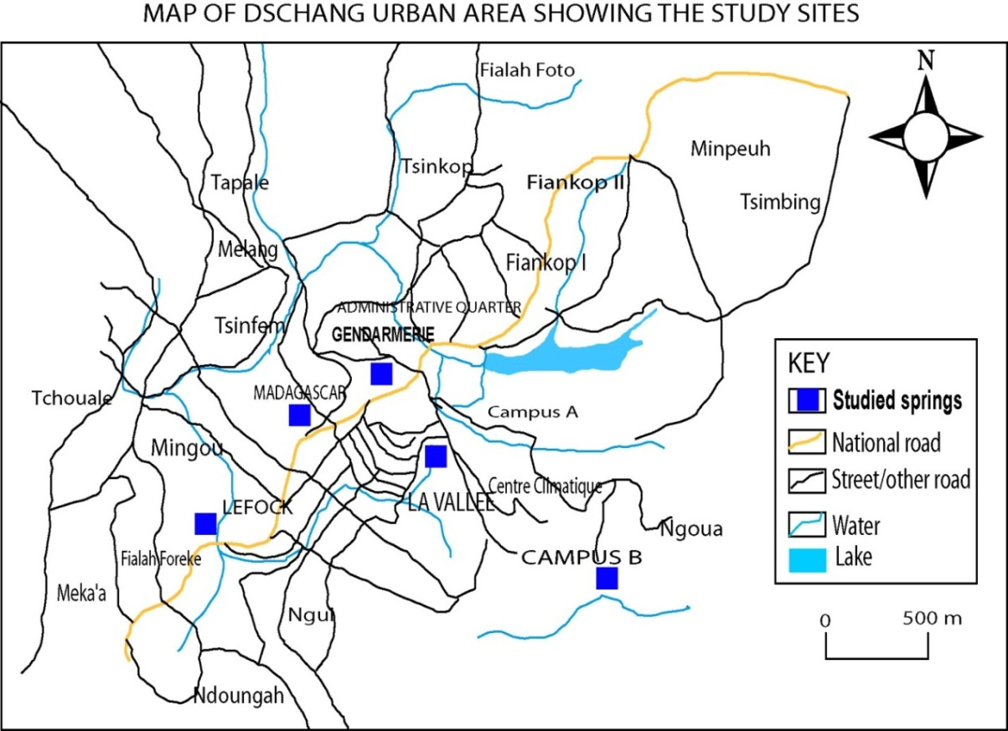
Figure 1: Map of Dschang showing the study area
Source: Services Techniques, Dschang Council.

A simple random sampling procedure was used to select respondents for the study. A list of households in the villages was obtained out of which 150 were selected in proportion to their population and served with structured questionnaires. A total of150 questionnaire were correctly filled returned and were used for analysis. Descriptive statistics such as frequency, percentage was used to describe the socioeconomic characteristics of the respondents. Friedman chi square test was used to determine the effect of water quality and proximity on household perception of alternate drinking water fetching source. Physicochemical and microbiological analyses were carried out on water samples from five key points: Lefock, Madagascar, Gendarmerie camp, La Vallee, and University campus B. The parameters analyzed included pH, conductivity, turbidity, TDS, cations (Ca, Mg, K, Na), total coliforms, and faecal coliforms. Data is adapted from Temgoua (2011)

Results and Discussions
The respondents were between 10 and 40 years old. This shows the age group that is involved in fetching water for domestic use. This finding ties with the practice of most typical African settings where water fetching is relegated to the younger ones.

Table 1 show that respondents were aware of an AWS source. From the table, 114 respondents had knowledge of what an AWS source is while 36 had no knowledge of what it is. About 116 respondents had knowledge on what a conventional water supply source is while 34 did not. Though aware of the conventional drinking water supply sources, respondents prefer the AWS source to the conventional as their principal source of drinking for domestic use. According to the Table below, 112 respondents fetch their water from springs while 38 principally fetch water from CDE. This implies that the respondents prefer water from AWS to water from conventional source (CDE). On use of water, 134 respondents use water for drinking while16 respondents use it for other purposes. This confirms the preference these consumers accord to AWS sources over CDE. The table also show that 77 respondents gave a quality rating of very good quality; while 65 respondents gave a quality rating of average good and 8 respondents (5.3%) gave quality rating of bad quality. About 128 respondents said the quality of water influenced their choice of fetching source while 22 respondents held to the fact that the quality of water did not influence their choice of water source. The 22 respondents represent those who are influenced by their proximity to the AWS source. The table shows the consumers of water from AWS sources believe that all water from springs are potable and consequently do not subject the water to any treatment. About 37 respondents confirmed that this water supply has a negative effect on them, while 113 did not agree to the assertion that the alternative water supply had any negative effect on their health. Table 1 indicates that if there is any negative effect, 4 respondents will buy bottle water for drinking, 37 will carry out home treatment of the water and 109 will not treat the water. No respondent will go for CDE or others sources. Paradoxically, respondents indicate that none of them will consume water from CDE, or from any other sources. This confirms that respondents will consume water from an AWS source even if the source is considered bad or contaminated. Table 1 also show that 37 respondents observed that AWS was good for washing only, 24 said the water was a contaminated source and 60 respondents said the source was too far away from their home. The above findings tie with assertions made by Cairncross (1987) that the main benefit of water supply is not only a reduction in water borne diseases due to improved water quality but to provide water closer to the homes. Thus the time and distance to fetch water affects the average quantity used in households.

Table 1.Perception of AWS sources
Response | Frequency | Percentage
Assessment of AWS sources
Yes | 114 | 76
No | 36 | 24
Knowledge of a conventional water supply source
Yes | 116 | 77
No | 34 | 23
Principal water fetching source
Spring | 112 | 75
CDE Water | 38 | 25
Use of water
Drinking | 134 | 89
Others | 16 | 11
Water quality rating
Very good | 77 | 51.3
Averagely good | 65 | 43.3
Bad | 8 | 5.3
Water quality rating
Yes | 128 | 85.33
No | 22 | 14.67
Influence water quality on choice of fetching source
Quality influences | 128 | 85.33
Quality does not influences | 22 | 14.67
Effects of AWS source on household and consumers
Yes | 37 | 25
No | 113 | 75
Why AWS source has not resolved the burden of portable water
Bad for drinking | 29 | 19.33
Good for washing only | 37 | 24.67
Contaminated source | 24 | 16
Source is too far from home | 60 | 40

Table 2 shows that 10%of the respondents indicated Diarrhoea as a common disease in their household, 20% respondents indicated Typhoid, 2% respondents indicated Amoebiasis, 8% respondents made mention of intestinal worm, 10% respondents made mention of Malaria, 6% respondents also indicated others and 44% respondents made mention of no disease. These results indicate that a total of 56% of the respondents are affected by one water linked disease or the other while 46% are not. This confirms studies carried out earlier by Lacmango (2010), which revealed that common diseases caused by bad water include: diarrhoea 61.7%, amoebiasis 23.0%, and typhoid fever 15.3%. His investigations also reveal that 80% of the inhabitants of Dschang and its peripheries believe that all spring water is potable. Also on table 2 about77.3% of the respondents preferred latrine than defecating in the bush to maintain hygiene and sanitation, 7.3% said to impress visitors, they use the latrine, about 6.67% said they use the latrine to preserve the quality of water and 5.3% said to protect the environment and avoid contamination while 3.3% said the use other methods. These results indicate that the respondents understanding the importance of latrines for hygiene and sanitation but very little on the importance to preserve the quality of water and the protection of the environment as a means to avoiding contamination. Table 2 shows that 33% of the respondents said livestock should be grazed around habitats while 67% said livestock should not be grazed around habitats. This shows that the respondents are aware of the implication of grazing around habitats on hygiene and sanitation.

Table 2: Diseases common to households
Distribution of common diseases in the household.
Respond | Frequency | Percentage
Diarrhoea | 17 | 10
Typhoid | 23 | 20
Amoebiasis | 4 | 2
Intestinal worm | 12 | 8
Malaria | 19 | 10
Other diseases | 9 | 6
No diseases | 66 | 44
Awareness of the necessity to use latrine to defecate
Hygiene and sanitation | 116 | 77.3
Impress visitors | 11 | 7.3
Preserve the quality of water | 10 | 6.67
Protect environment | 8 | 5.3
Others | 5 | 3.3
Awareness of whether livestock should graze around habitats
Yes | 49 | 33
No | 101 | 67

The physicochemical and microbiological parameters of the AWS sources under study presented in Table 3 are extracts from recent research publications of chemical and bacteriological analysis of drinking water from Alternative Sources in Dschang (Temgoua, 2011). The parameters that were studied included the hydrogen ion concentration or acidity level (pH) of the different AWS sources. The pH values range between 5.26 and 7.51. The pH value for good quality water must be between 6.9 and 9.2 (Temgoua, 2011). Thus, AWS sources under study were noted to be slightly acidic and therefore corrosive to the distribution pipes. Only the University of Dschang campus B met the WHO standard. Another indicator of water quality is the ability of a solution to support an electrical current (electrical conductivity). It can also be expressed as the quantity of dissolved matter which is called salinity. The value for the AWS source varies between 30 and 120 micros s/cm. the value for the studied water varies between 30 and 120 micros s/cm. this is the standard method for the examination of water (Temgoua, 2011). Thus the electrical conductivity of water sources studied fall within the acceptable range. Another factor is turbidity. It is the amount of material in suspension in a liquid. This turbidity in ranged from 0 to 4 FTU. A turbidity value of less than 5 FTU is acceptable by WHO standards (Temgoua, 2011). This implies that AWS sources studied are free from particles and do not require filtration before use.

Table 3: Physicochemical and microbiological parameter of studied AWS resources.
Water point | pH | Conductivity | Turbidity | TDS | Ca | Mg | K | Na | Total coliforms | Faecal  coliforms
Water point | pH | Micro S/cm | FTU | Mg/L |  |  |  |  | CFU/100ml | CFU/100ml
Lefock | 5.26 | 81 | 0 | 35 | 0.36 | 1.56 | 2.61 | 8.54 | 3.75x10⁶ | 0
Madagascar | 5.50 | 40 | 0 | 20 | 0.26 | 1.66 | 1.43 | 2.58 | 1.50x10⁴ | 1.15x10⁴
Gendarmerie camp | 5.60 | 120 | 4 | 45 | 0.54 | 1.08 | 1.50 | 2.5 | 3.40x10⁴ | 3x10³
La Vallee | 5.51 | 80 | 0 | 40 | 0.64 | 1.90 | 2.61 | 5.43 | 3x10³ | 1x10³
University campus B | 7.51 | 30 | <10 | 550 | 3 | 1 | 1 | 3 | 0 | 0
Source:Temgoua (2011).
- Total Dissolved Solids (TDS)
This parameter expresses the salt reaction in solution, or the organic level of pollution of water. The allowable values range between 500 and 1500mg/l. For analyzed water, the values of TDS were between 20 and 45with the exception of the UDs Campus B source that recorded 550mg/l indicating a low level of pollution.
- The cations Ca, Mg, K, Na
The presence of cations in water expresses the hardness of water. The limiting values according to WHO standards are: 75-200, 30-150, 50-60 mg/l respectively for Ca, Mg, K and Na. The values of these parameters in the studied water ranged between 0.1 and 0.6; 0.06 to 2.6; 1 to 2.6; 0.8 to 8 mg/l respectively for Ca, Mg, K, and Na. Generally, the water sources are reported to be very slightly mineral-bearing.
- The Anions in Studied Water
Investigation of the quantities of anions (Sulphate, Chlorides, Bicarbonates and Nitrates) present in the alternative water supply sources in Dschang urban revealed the presence of Sulphate and Nitrates in the water. This implies the presence of agricultural pollutants originating from agricultural activities such as chemical and organic inputs, free grazing of animals, urines and the effects of urbanization. For the alternative water supply sources studied in Dschang urban the values of sulphates were between 0.2 and 6 mg/l while Nitrates ranged from 0.9 and 3.5 mg/l. The WHO recommends 40 – 50mg/l. In almost all the cases, Sulphate and Nitrates were present in water of Dschang Urban Municipality.
- Microbiological Parameters
Investigations revealed that the studied water average microbiological density was as represented in table 3. The total coliforms are observed in all water except for the water of Campus B of the University of Dschang. The pathogenic bacteria here are faecal coliforms. This might be originating from contaminations by excreta and infiltration from open bottom pit toilets and septic tanks built not far from the water sources and dug to the ground water. The allowable value by WHO is 0 CFU for 100 ml of water.

Conclusion and Recommendations
Based on the findings of this study, it is observed that AWS sources in Dschang are a valuable natural asset. However, the Physicochemical and bacteriological characteristics of alternative water supply sources studied do not meet the acceptable norms for human consumption.In view of this conclusion, the following recommendations are proffered: the government should put in place specific regulations to monitor the construction of sanitary facilities such as toilets and waste dispositions facilities; water harvesting sources should be isolated by fencing; home based treatment of water from alternative sources should be practised by consumers; agricultural practices that encourage application of organic and chemical inputs, disposal of human and household waste around water catchments should be discouraged. The government should institute legislation on alternative water supply with emphasis on sanctions on those who pollute water sources.
Disclaimer (Artificial intelligence)
Option 1:
Author(s) hereby declare that NO generative AI technologies such as Large Language Models (ChatGPT, COPILOT, etc) and text-to-image generators have been used during writing or editing of manuscripts.

REFERENCE

- BUCREP, (2010). Résultat du 3e Recensement General de la Population et de l’habitat. Imprimerie National, Yaoundé, Cameroun.
- Cairncross, (1990). Health aspects of water and sanitation. Community health and Sanitation. Kerr, C (Ed) London: Intermediate Technology Publication Ltd
- CRDI, (1990). Centre de Recherches pour le développement international Canada villes assoiffées. Explore no 4, Volume 18, BP 8500. Ottawa, Canada
- Cunningham, W. (2003). Environmental Sciences: A Global Concern 7th Edition. McGraw-Hill, 476P
- INS, (2008). 3e Enquête Camerounaise de Ménages (ECAM 3). Imprimerie Nationale, Yaounde ; Cameroun.
- Katte, V., Fonteh, M. F., and Guemeh, G. N, (2005). “Effectiveness of Home Water treatment Methods in Dschang, Cameroon,” Cameroon Journal of Experimental Biology, vol. 1 No 2, pp 102-106.
- Katte, V., Fonteh, M. F., and Guemeh, G. N, (2005). Temporal domestic water quality in urban settings in Cameroon. Journal of Science, Technology and Environment. Vol 5 Nº 102,pp 58-65.
- Lacmango, N. (2010). Contribution des ouvrages hydrauliques autonomes à l’approvisionnement en eau potable dans la ville de Dschang. A dissertation submitted in partial fulfilment of the requirements for the diploma d’Ingénieur, Department of Agricultural engineering, FASA, Option Genie Rural, University of Dschang, Dschang, Cameroon.
- MINEE. (2005). Définition du Processus D’élaboration du plan D’action de Gestion Intégrée des Ressources en eau du Cameroun, Version Provisoire. 46P
- Ngnikam, E., Koudjou, T., Ndongson, L. (2004). Stratégie concertée d’accès a l’eau potable et de l’assainissement dans la ville de Dschang. Imprime au Centre multimédia de la Commune de Dschang, Dschang, Cameroun.
- Temgoua, E., Kueche, S. (2009). Analyse de la qualité des eaux des points aménagés en 2008 par l’AIMF dans la ville de Dschang : Commune de Dschang, Cameroon.
- Temgoua, E. (2011). Chemical and Bacteriological Analysis of Drinking Water from Alternative Sources in the Dschang Municipality, Cameroon. Journal of Environnemental Protection 2, 620-628, doi:10.4236/jep.2011.25071
- United Nations (1977). Report of the United Nations Water Conference; Mar del Plata, 14- 25 march 1977. New York, NY, USA, United Nations.
- WHO, (2008). “Guidelines for Drinking-Water Quality, Third Edition, incorporating the first and second Addenda. Volume 1: Recommendation.” Geneva.
- World Water Forum, (2000). The Africa Water Vision for 2005. Equitable and Sustainable Use of Water for Socio-economic Development. The Hague, The Netherlands.

