Assessing Structural Capacity and Performance of Two – Way Concrete Slabs Reinforced with Reused GFRP Bars for Sustainable Construction

ABSTRACT
The mechanical properties of reused Glass Fibre Reinforced Polymer (GFRP) bars retrieved from previously collapsed slabs were first measured before they were used to reinforce two-way concrete slabs. A total of six two-way reinforced concrete slabs measuring 100mm x 1200mm x 1200mm were cast. Three were reinforced with 8mm diameter reused GFRP bars, and the other three were reinforced with 12 mm reused GFRP bars. The mechanical test results revealed that the re-used bars exhibited a complete linear stress-strain relationship without yielding, but with reduced elongation and failure strain that were identical to the original GFRP bars. The Young’s modulus of elasticity was 50.02 N/mm² and 41.34 N/mm² for the 8mm and 12mm, respectively. Similarly, the ultimate tensile strength of the 8mm and 12mm reused bars averaged approximately 1079N/mm² and 800N/mm^{2,} respectively, which confirms the dependence of mechanical properties on bar size as observed in previous studies and in consonance with ACI 440.IR-15 code. Reused GFRP reinforced concrete slabs were tested under monotonic loading. The load-carrying capacity of these slabs maintained approximately similar load levels of 82kN for the 8mm and 76.67kN for the 12mm as the concrete slabs reinforced with the virgin GFRP bars for similar concrete grades. Overall, the experimental results indicate that using reused GFRP bars as reinforcement for two-way concrete slabs, sourced from demolished structures, is feasible and reliable, as they achieved nearly similar outcomes. Furthermore, there was good agreement between the experimental results and the theoretically predicted model.

Keywords: Re-used GFRP bars; two–way slab; structural deflection; punching shear; cracks; elongation.

1.0 INTRODUCTION
The rapid advancement of technology and growing environmental challenges have driven engineers to explore alternative materials as a replacement for conventional construction, such as standard carbon steel (Akintola, 2024). Iron, a key raw material in steel production, presents environmental issues such as corrosion and high maintenance costs (Apostolopoulos et al., 2006). Consequently, there has been a significant increase in interest in polymer reinforced materials over the past two decades, driven by ongoing research (CSA, 2002; 2010). One promising alternative is Glass Fibre Reinforced Polymer (GFRP) (Benmorhkrane et al., 2006; 2017). Research has shown that GFRP offers several advantages over steel, including: exceptional corrosion resistance, non-conductivity, electromagnetic resistivity, full recovery of strength upon load release (Kankam et al., 2025), lower cost, high strength-to-weight ratio, and durability.
Despite the advantages mentioned above GFRP bar does have some drawbacks compared to steel. Some significant disadvantages are a lack of yield point and ductility in the stress-strain relationship (Kankam and Adom-Asamoah, 2002), poor chemical adhesion to concrete and low compressive strength. GFRP bars are fully linearly elastic and do not undergo plastic deformation, meaning they can reach their load-bearing capacity suddenly without any visible warning signs (Boateng et al., 2024; Tackie, 2025). Furthermore, GFRP reinforcing bar is heterogeneous, anisotropic and its mechanical properties are size-dependent and inversely proportionally related, whereby smaller bars generally exhibit higher mechanical properties (Boateng et al., 2024). While GFRP bars offer several important benefits over steel, their lower modulus of elasticity can lead to excessive deflection and cracking in flexural concrete elements. They have poor resistance in compression, making them unsuitable for use in compression zones (ACI 440.1R-15; Bendure et al., 2023). GFRP bars were noted for poor bonding with concrete (Zhang et al., 2020; Xie et al., 2023), but surface treatment of GFRP bars by manufacturers significantly enhances their bonding properties with concrete (Abdulsalam, 2014; Ohene-Coffie et al., 2024).
Chang and Seo (2012), El- Zaroug et al. (2013) and Ashteyat et al.(2019) conducted experimental studies on the flexural behaviour of one-way solid slabs reinforced with GFRP bars, and observed their suitable structural behaviour in comparison with steel–reinforced one–way slabs, Chag and Seo (2012) observed that GFRP- reinforced slabs, along with their steel-reinforced counterparts, exhibited longer fatigue life. This advantage is attributed to the fact that the modulus of elasticity of GFRP reinforcement is closer to that of concrete than to steel.

2. EXPERIMENTAL METHDOLOGY:
2.1 Materials
Fine aggregate (sand) and crushed granitic rock (coarse aggregate) of 12mm maximum size used for the preparation of concrete complied with BS EN 1990-1 (2002) and BS 882:1992 standards, while ordinary Portland cement met the specifications of BS EN 1990-1 (2002). Re-used Glass Fibre Reinforced Polymer (GFRP) of Ghana bars originally obtained from a local manufacturer (VIVA Fibre Glass) were salvaged from previously laboratory-tested concrete slabs to failure. The reinforcing bars in the two-way concrete slabs comprised 8 mm and 12 mm GFRP bars.
2.1 PREPARATION OF TEST SPECIMENS
2.1.1 CONCRETE
Concrete was prepared from sand, gravel and ordinary Portland cement that were carefully mixed to ensure a consistent and homogeneous blend. The concrete was mechanically mixed in a 1:2:4 ratio (cement, sand, and gravel), and a water-cement ratio of 0.55. The dry constituents were first mixed thoroughly before water was gradually added to achieve the desired consistency of concrete. A slump of approximately 95mm was obtained (AS 1379:2007). The concrete mix was designed following the ACI 213R-03 (2003) guidelines. After casting, the concrete slabs were covered with moist hessian sacks in the open to ensure wet curing for 28days of continuous hydration in accordance with BS EN 12390-2 (2009)
2.2 GFRP reinforcing bars
The previously used GFRP bars were carefully cleaned of dirt and attached concrete particles after being removed from the collapsed concrete slabs in a previous test, as shown in Fig 1. To ensure an effective tensile test, a gripping mechanism was employed at both ends of the GFRP bars to prevent slippage and premature failure. Epoxy-filled pipes serving as grips were adopted to anchor the GFRP bars, which were embedded 150mm into the pipes, leaving a 300mm free length. The embedment length was crucial to prevent the bars from slipping, in accordance with the specified length of at least 15 times the bar diameter (ACI 440.1R-15). This gripping system addressed the shear and compression weakness of the GFRP bars, which could otherwise lead to crushing of the anchorage area in the testing machine. The epoxy used in the gripping mechanism required 24 hours to dry, and the specimens were allowed to cure for a minimum of three days before testing to ensure proper hardening.
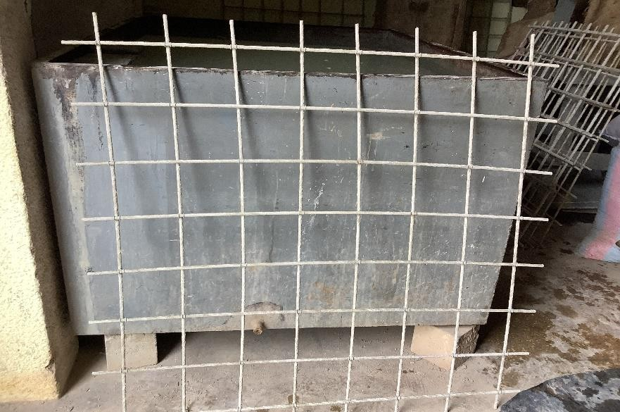
Figure 1: GFRP Removal from collapsed slab

2.3 Preparation of Reinforced Concrete Slabs
The skeletal GFRP rib cage was laid flat in a clean formwork to provide a concrete cover of 12mm. Once mixed, the concrete was poured directly into the formwork with a release agent to prevent sticking, and the concrete was subsequently compacted. Details of the two-way concrete test slabs are presented in Tables 1 and 2
Table 1: Details of concrete slabs
Slab ID | Dimesions  (mm³) | Comp. strength  (N/mm²) | Modulus of rupture  (N/mm²) | Effective span  (mm)
TWSA | 1200 x 1200 x 100 | 22.3 | 2.73 | 1050
TWSB | 1200 x 1200 x 100 | 22.3 | 2.73 | 1050
TWSC | 1200 x 1200 x 100 | 20.0 | 2.69 | 1050
TWSD | 1200 x1200 x 100 | 24.6 | 3.28 | 1050
TWSE | 1200 x 1200 x 100 | 28.6 | 3.24 | 1050
TWSF | 1200 x1002 x 100 | 22.5 | 3.24 | 1050

Table 2: Dimensions of two-way slabs reinforcement
Slab ID | Bar size  (mm) | Effective depth in X-direction  (mm) | Effective depth in the Y-direction  (mm) | Reinforcement  area |  | Reinforcement  area |  | Total reinforcement  area
 |  |  |  | A_{x1}  (mm²) | 100A_{x}/bh  (%) | A_{y1}  (mm²) | 100A_{y}/bh  (%) | Total reinforcement  area
TWSA | 8 | 83 | 73 | 402.1 | 0.40 | 402.1 | 0.72 | 0.86
TWSB | 8 | 83 | 73 | 402.1 | 0.40 | 402.1 | 0.72 | 0.86
TWSC | 8 | 83 | 73 | 402.1 | 0.40 | 402.1 | 0.72 | 0.86
TWSD | 12 | 82 | 70 | 904.78 | 0.92 | 628.31 | 1.08 | 2.0
TWSE | 12 | 82 | 70 | 904.78 | 0.92 | 628.31 | 1.08 | 2.0
TWSF | 12 | 82 | 70 | 904.78 | 0.92 | 628.31 | 1.08 | 2.0

2.4 Test Procedures
2.4.1 Control Concrete Specimens
The 7days and 28days compressive and 28days tensile strength of concrete were obtained from tests on cubes (150mm x 150mm x 150mm) and prisms (100mm x 100mm x500mm) respectively in accordance with the British Standard (BS EN 12390-3;2002),

2.4.3 Tensile strength of re-used bars
The re-used GFRP bars were prepared for tensile strength test in accordance with the requirements of ACI 440.1R-15 and subjected to a uniformly applied tensile force to failure. The average maximum tensile strength was 1079N/mm² and 800N/mm² for the 8mm and 12mm bars, respectively in comparison with the manufacturer’s guaranteed tensile strength of 758N/mm² in accordance with ACI 440.1R-15 specifications.
2.4.4 GFRP reinforced concrete slabs
The two–way concrete slab was simply supported on all four sides in a rigid steel frame and loading was centrally applied incrementally using a hydraulic loading jack attached with a load cell as shown in Fig 2. A digital mechanical dial gauge was mounted at the soffit of the slab to measure its central deflection. Loads were applied in 2 kN increments and cracks were marked on the sides and soffit as they developed, allowing for assessment of their type, width, and spacing. The crack patterns were recorded after the failure of each slab. During testing, the first crack and its corresponding load were carefully recorded, and the crack propagation and behaviour were monitored. This systematic approach provided detailed data for analyzing the material's behaviour under applied stress.
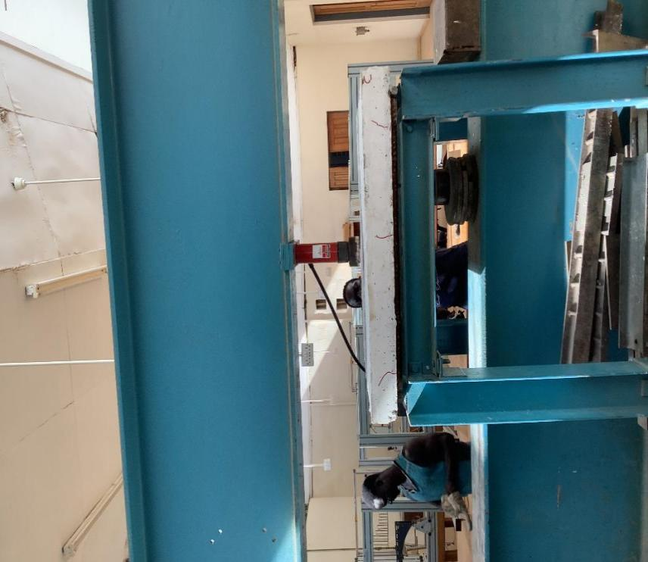
Fig 2: Two-way slab simply supported in a rigid steel frame

3.0 Results
3.1 Tensile Strength of reused GFRP Bars
Three specimens of each of the used GFRP bar, sizes 8mm and 12 mm were tested. The average tensile strength of the used GFRP bars sizes is in presented in Table 3,

Table 3: Tensile strength of new and re-used GFRP bars
Bar Size  (mm) | Tensile Strength (N/mm²) |  | Modulus of Elasticity (kN/mm²)
Bar Size  (mm) | Original GFRP (Tackie, 2025) | Re-used GFRP | Original GFRP | Re-used GFRP
8 | 1193.0 | 1079 | 54.40 | 50.02
12 | 829.0 | 800 | 41.7 | 41.34

The average tensile strength of 800N/mm² for the 12mm bar, as shown in Table 3, is 1.42% higher than the manufacturer’s (VIVA fibreglass) guaranteed strength of 758N/mm² (in accordance with ACI 440. IR – 15). For the 8mm size, the average tensile strength is 1079N/mm² and resonates with results of previous research (Pultrall, 2007; Sheilch and Johnson, 2007, Weber and Toitanji, 2007). Furthermore, the ultimate tensile strength values for the previously used bars closely align with the original bar tensile strength 1193N/mm² and 829N/mm² for the 8mm and 12mm bars, respectively (Tackie, 2025), whereby the slight differences could be attributed to the heterogeneity of GFRP bars (Boateng et al., 2024).

3.2 Analysis of Two-Way slabs
3.2.1 Theoretical analysis
Traditional reinforced concrete design relies on the regime of steel’s inelastic behavior to ensure ductility and safety beyond design loads. However, GFRP bars are fully elastic without any range of inelasticity and this property is expected to affect the GFRP reinforced concrete slabs ductile failure characteristics. Reused GFRP bars as tensile reinforcement may rupture suddenly under certain load conditions. In a two-way slab simply supported on all four edges and concentrically loaded, two types of failure mechanisms can occur when analyzed using the method of yield line theory: (a) Diagonal yield line pattern and (b) Circular fan pattern. The ultimate flexural load (P_{ul}t) for these two mechanisms is calculated differently:
For diagonal failure mode:
P_{ult} = 8 Mult / L
For circular failure mode:
P_{ult} = 2 𝜋 M_{ult} / L
Where,
M_{ult} is the ultimate moment per unit width of the slab,
L = effective length of the slab
3.2.1.1 Theoretical cracking moment of RC concrete slab
Using the concrete tensile strength, the cracking moment of reinforced concrete slab simply supported and loaded centrally with a point load is obtained from the expression of equation 1:
M_{cr} = f_{tc}bh² / 6…………………………………………………………………………......Eq 1
where
M_{cr} = cracking moment

f_{tc} = tensile strength of concrete

b = width of concrete slab (= 1.0m strip)
h = overall thickness of slab

3.2.1.2 Theoretical cracking load of RC slab
The two-way slab simply supported on all four edges and loaded at the centre could either follow (i) diagonal yield line pattern mode or (ii) a circular fan pattern mode. With a diagonal yield pattern failure mode, the slab is divided into four equal triangular panels with an angle of 45º yield line starting at the corners and symmetrically meeting at the centre. Whereas, in the circular fan pattern mode, a point load acts in the centre of the slab and the moment per unit length moves in circular yield mode. The analysis of the ultimate flexural failure load depending on the mode is obtained from equations 2 and 3 for circular mode and diagonal mode, respectively:
Circular mode: 𝑃_{𝑢𝑙𝑡} = 2𝜋𝑀_{𝑢𝑙𝑡} /L …………………………………………………………..,,,,Eq 2
Diagonal mode: 𝑃_{𝑢𝑙𝑡} = 8𝑀_{𝑢𝑙𝑡}/𝐿 ………………………………………………………………..Eq 3

3.2.1.3 Theoretical failure load of two-way GFRP reinforced concrete slab
Theoretical failure load on the assumption that the GFRP bars fail first:
X-Direction
The moment of resistance of a reinforced concrete slab, on the assumption that the tension GFRP bars fail first, is derived assuming a partial factor of safety of 1.52 for GFRP tension bar (Boateng et al, 2024; Kpo et al., 2024a):
M_{rp} = 0.66f_{p}A_{p} 0.775d Eq 4
where:

f_{p} = ultimate tensile strength of GFRP

d = effective depth of slab
A_{p} = area of GFRP reinforcement
M_{rp} = moment of resistance of GFRP bars.
Theoretical failure load on the assumption that concrete crushes first:
The moment resistance of the GFRP two-way reinforced concrete slab, on the assumption that the concrete crushes first in compression, is obtained from equation 5:
M_{cu} = 0.156f_{cu} bd² Eq 5

where:

f_{cu} = compressive strength of concrete
d = effective depth
b = slab width
M_{cu} = moment resistance based on concrete failure in compression:

Theoretical failure load on the assumption of shear failure first
Punching Shear Strength
Without shear reinforcement (stirrup), the maximum shear force (Vu) is obtained from using equation 7 which is based on the design concrete shear stress (v_{c}) in accordance with BS8110.
The British Standard BS 8110-1 estimates that the theoretical punching shear strength is comprised of the total of the concrete section and the tension reinforcement. Hence, the critical section is derived from the perimeter distance of 1.5h. Therefore, for the base of a loading hydraulic plate of 127mm diameter, the length of the critical perimeter from the boundary of the loaded area is given as:
L=2(1.5+φ/2)……………………………………………………………………………………………Eq 6

where
L = the length of the critical perimeter
h = overall slab thickness
φ = diameter of the hydraulic plate (= 127mm)
The value of the length of the perimeter L obtained in the equation is used as the effective width of the slab (b)
In the expression of equation 7
V_{u} = v_{c}bd………………………………………………………………………………………….Eq 7
b = the length of the critical perimeter
d = effective depth slab
P_{ult} = ultimate shear failure load
v_{c} = design concrete shear stress (BS 8110)

4.0 Discussion of test results
The mechanical properties of the reused Glass Fibre Reinforced Polymer (GFRP) were evaluated through experimental laboratory tests. The two-way slabs were reinforced with reused GFRP bars and subjected to tests to investigate their flexural performance. During the tests, the displacement at the centre of the slabs was recorded at various load levels. The test results are displayed as load-deflection curves, crack patterns, observed modes of failure, theoretical and experimental cracking loads and theoretical and experimental failure loads
4.1 Load-Deflection curves
The load - deflection curves of all the GFRP-reinforced concrete slabs are illustrated in Figures 3 and 4. The behaviour of the slabs under monotonic loading shows that all the specimens exhibit linear characteristics until the first crack develops, after which non-linear behaviour is observed (Abdalla, 2002; Kpo et al,. 2024a; Kankam et al., 2025). Each slab was gradually loaded in monotonic increments of 2 kN, and deflections were recorded at each load increment. The loading was continued until the first crack appeared, at which point the load value was recorded. Testing continued until the slab failed. Once the crack developed, a noticeable shift in the slope of the load-deflection curve occurred, although the behaviour remained relatively linear until failure (Tackie, 2025; Kpo et al., 2024). The sharp increase in observed deflections even before cracking and following crack initiation can be attributed to the lower modulus of elasticity of GFRP (54.4 kN/mm²) compared to that of steel (200 kN/mm²), (Boateng et al., 2024; Kpo et al,. 2024; Tackie 2025; Kankam and Adom-Asamoah, 2002).

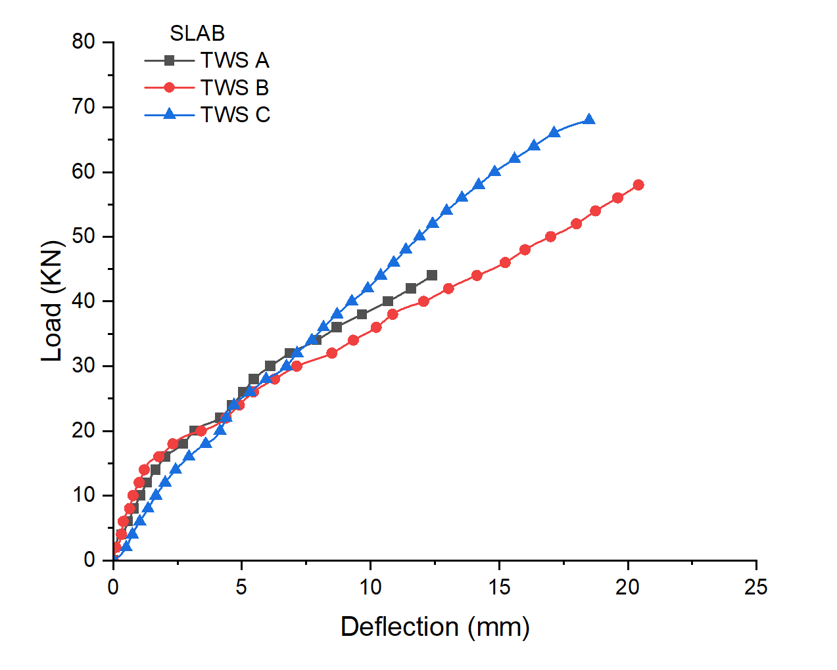
Figure 3: Load against Deflection Curves of Slabs under Monotonic loading (I).

Figure 4: Load against Deflection Curves of Slabs under Monotonic loading (II).

4.2 Cracking and failure loads
The cracking load is the critical load at which a flexural or tensile structural concrete member begins to develop cracks under external loads. Determining this load is essential for evaluating the structural integrity of materials. On the other hand, the failure load is the maximum load that the structural member can endure. Several factors influence the cracking and failure loads, including the material's inherent properties—such as strength, reinforcement toughness, and ductility—as well as the specimen's geometry (e.g., shape and size). Other considerations, like stress concentrations and the type of loading (rate, direction, and magnitude), also play a significant role. By accurately predicting and measuring the cracking and failure loads, engineers can better understand the material’s behavior under stress and use this data to design safer, more durable structures. This information is vital for ensuring that structures perform reliably under expected service conditions while minimizing the risk of premature failure (Akintola, 2024). Table 4 presents the theoretically predicted and experimentally measured cracking and failure loads of all the slabs.

Table 4: Cracking and Failure Loads of Slabs

Slab  ID | Theoretical cracking load, P_{cr}  (kN) | Experimental cracking  load, P’_{cr}  (kN) | Theoretical Failure Load  P_{ult} (kN) based on: |  |  | Experimental failure  load, P’_{ult}  (kN) | P’_{ult} /P’_{cr} | P’_{cr}/P_{cr} | P’_{ult}/P_{ult}
Slab  ID | Theoretical cracking load, P_{cr}  (kN) | Experimental cracking  load, P’_{cr}  (kN) | GFRP  rupturing | Concrete crushing | Shear failure
TWS A | 13.6 | 4.56 | 158.52 | 122.19 | 64.24* | 84 | 18.42 | 0.34 | 1.31
TWSB | 13.6 | 4.56 | 158.52 | 122.19 | 64.24* | 84 | 18.42 | 0.34 | 1.31
TWSC | 13.4 | 4.76 | 158.52 | 109.71 | 61.75* | 78 | 16.39 | 0.36 | 1.26
TWSD | 16.34 | 5.47 | 162.67 | 124.02 | 73.23* | 74 | 13.53 | 0.33 | 1.01
TWSE | 16.14 | 5.40 | 162.67 | 144.20 | 77.53* | 74 | 13.70 | 0.33 | 0.95
TWSF | 16.14 | 5.08 | 162.67 | 113.46 | 71.04* | 82 | 16.14 | 0.31 | 1.15
Average: |  |  |  |  |  |  | 1.61 | 0.34 | 1.17

*Governing failure load

4.2.1 Comparison between the theoretical and the experimental cracking and failure loads
The theoretical and experimental cracking loads, and theoretical and experimental failure loads are illustrated in Table 4. Theoretical analysis predicted failure of all slabs to be due to punching shear. The experimental results presented in Table 4 show that incorporating GFRP reinforcement leads to a significant structural integrity and stability of the slab after cracking. Initially, all slabs demonstrated high stiffness and strong resistance to loading, maintaining structural integrity until the formation of the first visible cracks. In every specimen, the first crack developed at the mid-span on the soffit of the slab, indicating this region as the critical tension zone. With further load application, these cracks extended progressively outward from the loading point, to the edges and marked the evolution of flexural behaviour under increasing stress. Ultimately, the slabs experienced flexural failure, consistent with the crack patterns and modes as illustrated in Figure 5. The observed crack progression provides important insight into the structural response and the governing failure mechanism of GFRP-reinforced slabs. The experimental failure loads (P’_{ult}) averaged 16.1 P’_{cr} (experimental cracking loads), indicating the significant contribution of reused GFRP reinforcement in the concrete slab. The contribution of reused GFRP bars in the two-way concrete slabs compares favorably with the result from the previously tested slabs for which the ratio (P’_{ult}/P’_{cr} ) averaged 10.75 (Tackie, 2025).
The ratio of experimental failure loads to theoretical failure loads predicted for the slabs (p’_{ult} / p_{ult}) averaged 1.17 and represents a value of 17 percent extra margin of safety of the reused GFRP reinforced against failure. It also confirms a close relationship between theoretical prediction and actual experimental failure loads, thereby affirming the reliability of the theoretical analysis.
4.2.2 Crack formation, propagation and patterns in slabs
The development of cracks in the GFRP reinforced slabs followed a consistent pattern. The first crack formed at mid-span and extended in two perpendicular directions parallel to the slab edges. At early load stages, hairline fractures appeared throughout the slab soffit, followed by the formation of nearly vertical flexural cracks along the slab edges as loading increased. Continued loading produced inclined shear cracks originating around mid-depth, often appearing in both shear spans at similar stress levels. These diagonal cracks extended from the initial flexural cracks toward the point load, and ultimately, some cracks progressed into the compression zone, leading to structural failure. The final crack patterns were similar across all slab specimens, as shown in Figure 5 (a-d)

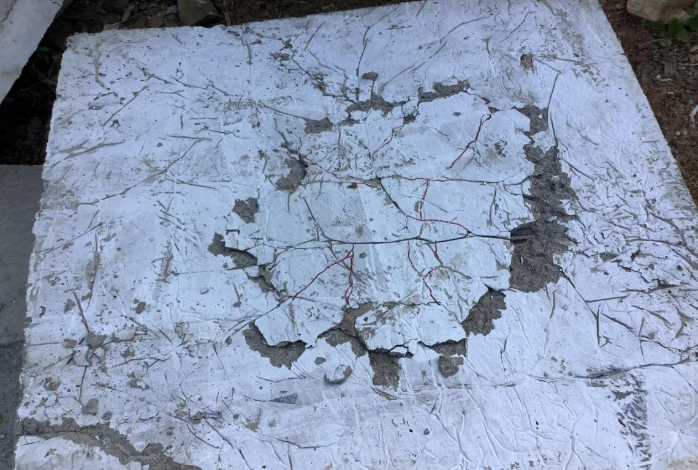
- Slab TWSA.
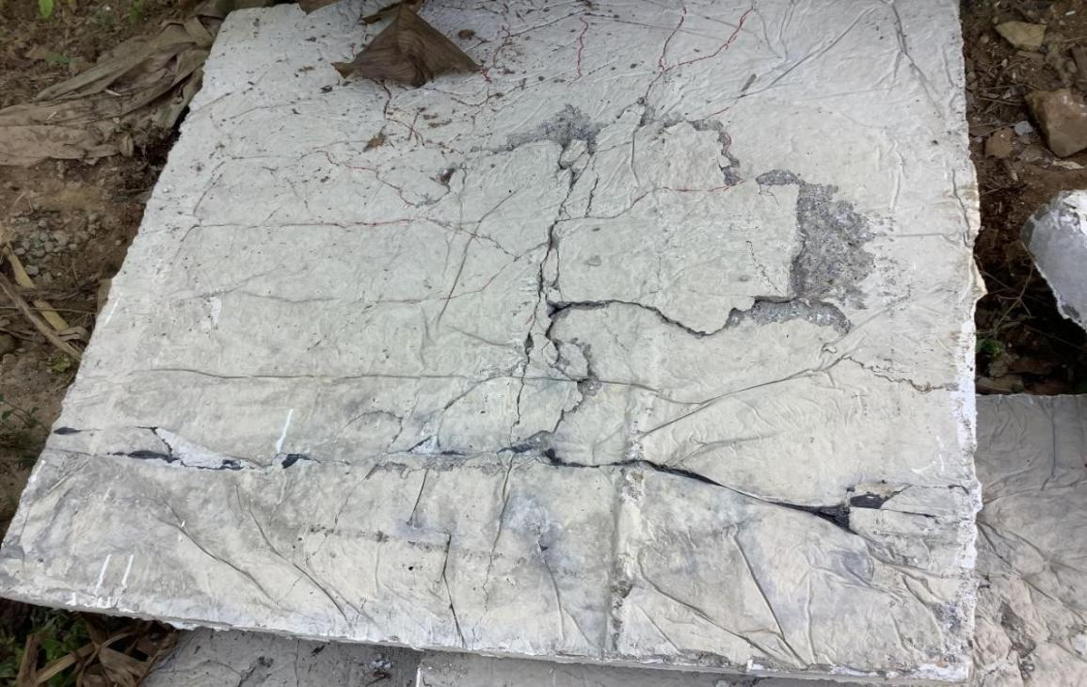

- Slab TWSB.

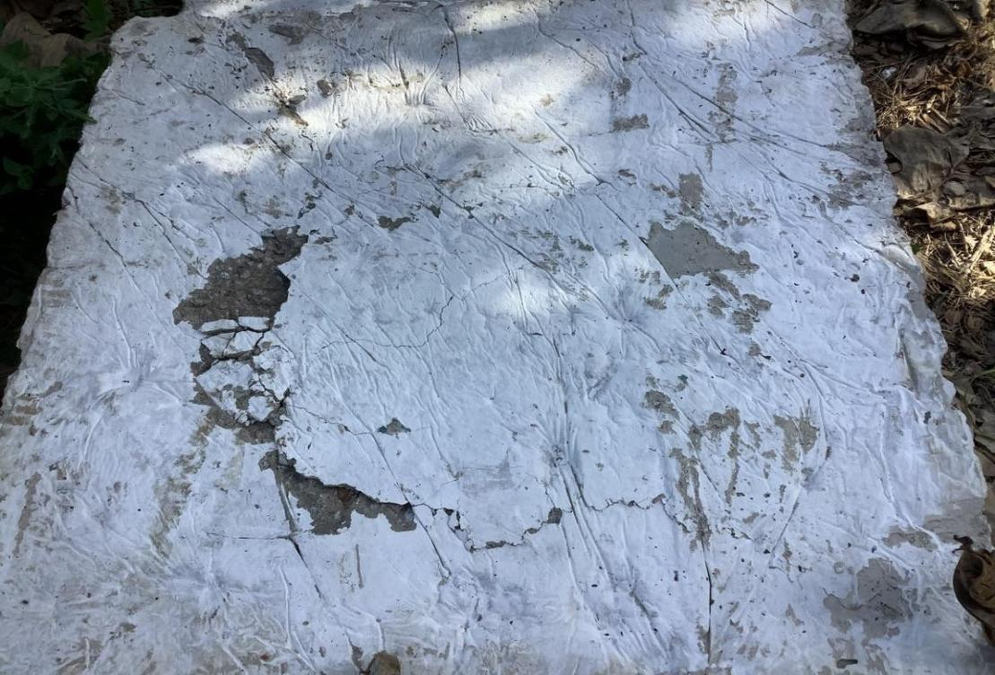

- Slab TWSC.

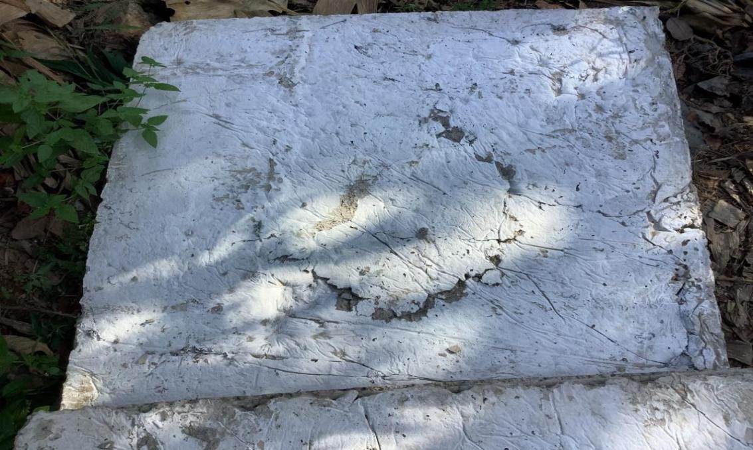

- Slab TWSD

Figure 5: Punching shear failure and patterns in slab
All the slabs initially behaved elastically under flexural loading, remaining uncracked and showing minimal deflection in the early stages. The first visible crack appeared near the point load at approximately 4 - 5 kN for every specimen, as shown in Table 4. As the load increased, fine vertical cracks developed and propagated upward from the tension zone across the spans, gradually widening and deepening, particularly beneath the point load (Figure 6). With further load increments, concrete crushing began in the compression zone, leading to a pronounced vertical crack on the right side of the slab that penetrated the compression concrete.
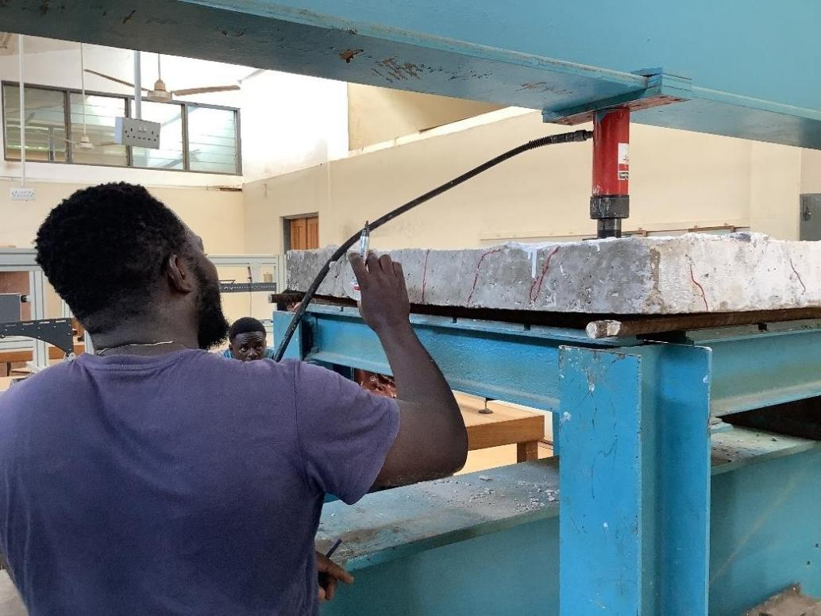
Shear cracks then formed beneath the loading point and extended diagonally toward the bottom face of the slab. Throughout testing, the reused GFRP reinforcement remained intact with no observation of rupture. Overall, failure was governed by progressive cracking, increased deflection, and crushing of concrete at multiple locations away from the supports, but near the load point (Figures 5, 7, 8), highlighting a flexure-dominated failure
Figure 6: Propagation of cracks

mechanism in punching shear.
For a typical slab TWSB reinforced with GFRP bar (total reinforcement ratio of 0.86), the cracking process followed a distinct progression under increasing load. Fine cracks first appeared at the bottom surface directly beneath the point load and continued to develop until the load reached about 72 kN. Beyond this stage, the cracks widened and extended upward toward the top layer of the concrete, as shown in Figures 7 and 8. With further loading, the vertical cracks near the point load became larger, while additional inclined cracks formed beneath the loading point due to shear stresses, propagating diagonally toward the supports. Eventually, crushing of the concrete began in the compression zone. The slab ultimately failed at a load of 84kN (as indicated in Table 4) through a sudden shear failure Kpo et al., 2024b), accompanied by a loud noise, indicating a brittle and rapid failure mode in punching (Ju et al., 2018; Tackie, 2025).

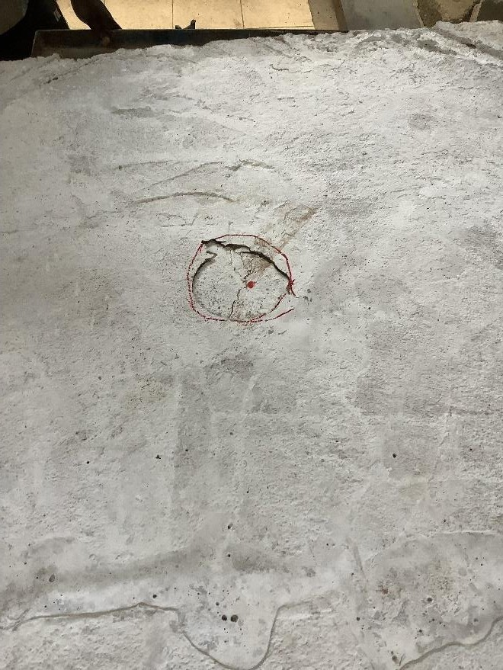

Figure 7: Crack distribution close to the point load (slab TWSB)

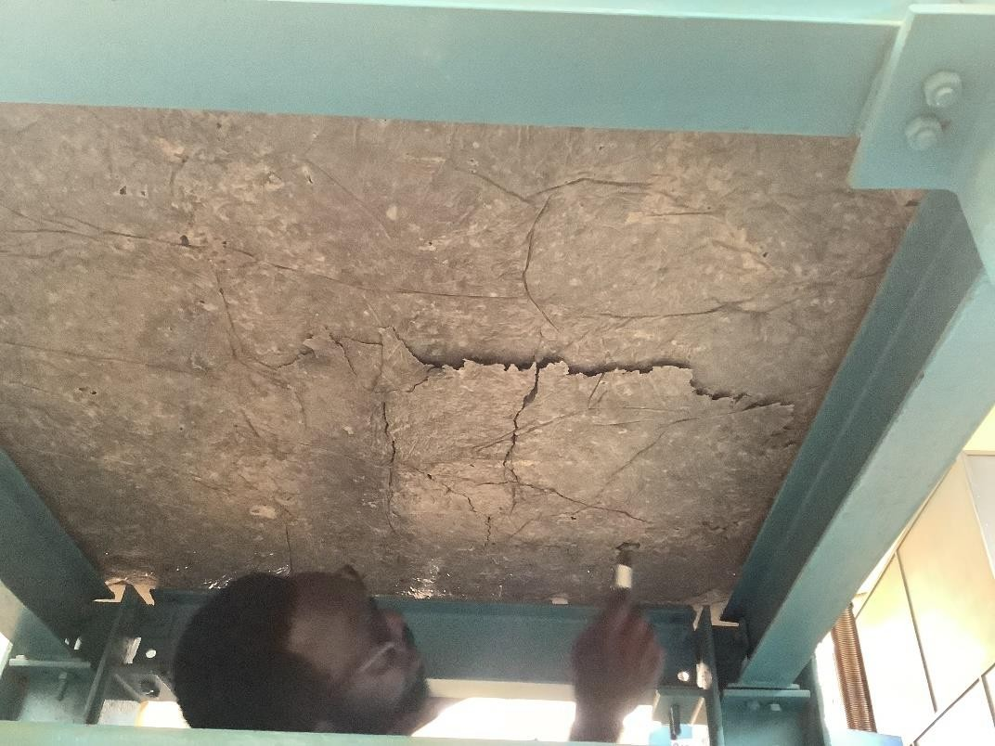
Figure 8: Cracks at slab soffit radiating from load point (slab TWSB)
4.2.3 Punching shear failure
In the two-way reinforced concrete slabs, the punching shear resistance was provided by the concrete under the circular loading head which tended to punch through the concrete against the shear strength of the concrete (V_{c}), acting over a critical perimeter and the effective depth (d). Experimental results from all six specimens indicated that the primary failure mode was due to punching shear, under the circular loading head, which punched through the concrete before the reinforcement reached its rupture point. In each case, punching cones formed in the slabs, with no evidence of rupture of the GFRP bars. This suggests that punching shear failure dominated the behaviour of the slabs (Adnan and Falah. 2022; Ju et al., 2018; Tackie, 2025). The failure mode was largely influenced by the concrete shear performance and slab design rather than the tensile strength of the reused GFRP reinforcement, which lacked the ductility to redistribute stress (Adom-Asamoah and Kankam, 2008). This was also the failure mode in the previously tested concrete slabs reinforced with the virgin GFRP bars (Tackie, 2025)
4.2.4 Flexural behavior
In general, slabs reinforced with GFRP bars exhibited a linear response until cracking occurred. After that, wide and deep cracks suddenly emerged, leading to substantial deflections. In a two-way slab with GFRP reinforcement, the initiation and propagation of cracks tended to be more gradual rather than an abrupt failure that is characteristic of plain concrete, and the slabs endured significant deformation due to the contribution of re-used GFRP bars as effective concrete reinforcement.
It is important to note that once the first crack initiated, the stiffness of the slab reinforced with GFRP bars decreased noticeably. Furthermore, all slabs reinforced with the reused GFRP displayed significantly wider and deeper cracks compared to steel reinforcement, as observed in past studies (Kankam et al., 2025; Tackie, 2025). The type, number, average spacing and width of cracks are presented in Table 4. The number and spacing of cracks in the slabs suggest good bond of the GFRP bars with concrete (Ohene-Coffie et al., 2024)
4.2.5 Cracking behaviour
Crack development in the tested slabs was closely monitored throughout loading. Initial cracks formed horizontally of the soffit and were soon followed by vertical cracks of the edge, with all six specimens displaying similar patterns. The first cracks appeared longitudinally on the bottom surface directly beneath the loaded area. As shown in Table 4. the theoretical cracking load based on circular mode for the 8mm GFRP reinforced slabs (TWSA and TWSB) was 13.6 kN—significantly higher than the experimental cracking load of 4.56kN. Cracking occurred whenever the tensile stresses exceeded the concrete’s modulus of rupture. The first crack initiated at mid-span and extended across the width of the slab parallel to the supports. With increasing load, additional flexural cracks formed and progressively propagated through the slab thickness. Failure in the GFRP reinforced slabs was triggered by punching shear as predicted by theoretical analysis of the slabs, and this failure behavior of the slabs reinforced with reused GFRP bars (Tackie, 2025) in both theoretical and experimental analysis.

4.2.6 Effects of failure types on punching shear
The two-way GFRP reinforced concrete slabs exhibited punching shear failure directly beneath the loading point at the ultimate state. This resulted in brittle failure, causing both the top and bottom surfaces to sink, as illustrated in Figures 5, 7 and 8. The shear resistance of the GFRP reinforcement through dowel action possibly prevented the concrete from disintegrating due to punching shear failure (Tackie, 2025). Figures 5 to 8 also present the cracking patterns associated with this type of failure, showing numerous radial cracks along with some longitudinal cracks. Table 5 presents the full crack characteristics of all the slabs. Although GFRP reinforcement enhances flexural stiffness, the reduced deformation capacity of the slabs that have reached their ultimate strength ultimately results in a reduced punching shear strength (Kurtoglu et al., 2022)
Table 5: Crack characteristics in slabs
Slab  ID | Final deflection (mm) | Maximum average crack width  (mm) | Maximum average crack spacing  (mm) | Types and number of cracks
 |  |  |  | shear cracks | No. of flexural -shear  cracks
 |  |  |  |  | Near loaded  zone | Outside loaded  zone
TWSA | 24.5 | 0.3 | 6.9 | 4 | 5 | 4
TWSB | 25.1 | 0.3 | 7.1 | 7 | 5  7 | 3
TWSC | 22.7 | 0.4 | 7.5 | 11 | 5 | 4
TWSD | 21.3 | 2.7 | 43.5 | 6 | 5 | 5
TWSE | 20.2 | 2.2 | 34.4 | 7 | 9 | 4
TWSF | 23.9 | 1.9 | 30.7 | `10 | 10 | 4

5.0 Conclusion
The average tensile strength of re-used 8mm and 12mm GFRP bars was approximately 1079 N/mm² and 800 N/mm^{2,} respectively. These values align well with those reported in existing literature evaluating the mechanical properties of glass fibre reinforced polymer bars (Boateng et al, 2024 Tackie, 2025), confirming the reliability of the reused material (Kankam et al., 2025). Test results revealed that the 8 mm bars demonstrated superior tensile strength and a higher Young’s modulus of 50.02N/mm² compared to the 41.34N/mm² for the 12mm bar. Based on the test results obtained from six two-way slabs reinforced with reused glass fibre-reinforced polymer (GFRP) bars, the following conclusions are drawn:
- Mechanical properties: The reused GFRP bars possessed mechanical properties that closely matched those of newly manufactured factory-grade GFRP bars, indicating virtually zero to minimal degradation in mechanical properties after first use, as long as they did not previously rupture.

- Punching Shear Consideration: From comparison of reused GFRP and the original GFRP bars as reinforcement in two-way slabs under similar flexural and concentrated loads, it is evident that punching shear resistance is a critical decision consideration for GFRP reinforced slabs, especially because punching is a potential source of failure.
- Failure modes: All slabs reinforced with re-used GFRP bars subjected to central point load produced flexural shear cracks and underwent brittle punching failure.

Disclaimer (Artificial intelligence)
Option 1:
Author(s) hereby declare that NO generative AI technologies such as Large Language Models (ChatGPT, COPILOT, etc.) and text-to-image generators have been used during the writing or editing of this manuscript.
Option 2:
Author(s) hereby declare that generative AI technologies such as Large Language Models, etc. have been used during the writing or editing of manuscripts. This explanation will include the name, version, model, and source of the generative AI technology and as well as all input prompts provided to the generative AI technology
Details of the AI usage are given below:
1.
2.
3.

References

Abdalla, H. (2002). Evaluation of deflection in concrete members reinforced with fibre- reinforced polymer (FRP) bars. Composite Structures, 56, 63-71. https://doi.org/10.1016/S0263-8223(01)00188-X
Abdulsalam B. (2014). Behaviour of shear critical FRP reinforced concrete one-way slabs. PhD thesis, University of Sherbrooke, Sherbrooke, Quebec, Canada, https://savoirs.usherbrooke.ca/handle/11143/4900
Achillides Z. & Pilakoutas K. (2004), “Bond Behavior of Fiber Reinforced Polymer Bars under Direct Pullout Conditions”, ASCE Journal of Composites for Construction, Vol. 8, No. 2, March-April 2004.
ACI 213R-03: Guide for Structural Lightweight-Aggregate Concrete. Farmington Hills, MI: American Concrete Institute, 2003. 38 pp. (ACI Manual of Concrete Practice). Semantic Scholar+1
American Concrete Institute. (2015). Guide for the design and construction of structural concrete reinforced with fiber-reinforced polymer (FRP) bars (ACI 440.1R-15). https://www.concrete.org/
Adnan, D., & Falah, H. (2022). Punching Shear Behavior of Fibrous High Strength Concrete Slabs Reinforced with BFRP Bars. Civil and Environmental Engineering. https://doi.org/10.2478/cee-2022-0054
Adom-Asamoah, M., & Kankam, C. K. (2008). Behaviour of reinforced concrete two-way slabs using steel bars milled from scrap metals. Materials & Design. https://doi.org/10.1016/j.matdes.2007.06.001
Akintola, S. O. (2024). Revolutionizing global infrastructure:Integrating sustainable construction practices and safety standards for a resilient future. Current Journal of Applied Science and Technology, 43(10):84-95. https://doi.org/10.9734/cjast/2024/v43i104438.
Apostolopoulos, C. A., Papadopoulos, M. P., & Pantelakis, S. G. (2006). Tensile behaviour of corroded reinforcing steel bars BSt 500s. Construction and Building Materials, 20, 782-789. https://doi.org/10.1016/j.conbuildmat.2005.01.065
Standards Australia. (2007). *AS 1379:2007 (R2017) Specification and supply of concrete*. https://www.standards.org.au/standards-store/as-1379-2007
Ashteyat, A. M., Al Rjoub, Y. S., Obaidat, A. T., & Dagamseh, H. (2019). Strengthening and repair of one-way and two-way self-compacted concrete slabs using near-surface-mounted carbon-fiber-reinforced polymers. Advances in Structural Engineering, 22(11), 2435-2448. https://doi.org/10.1177/1369433219843649
Benmokrane, B., Ali, A., Mohamed, H., Elsafty, A., & Manalo, A. (2017). Laboratory assessment and durability performance of vinyl-ester, polyester, and epoxy glass-FRP bars for concrete structures. Composites Part B: Engineering, 114, 163-174. https://doi.org/10.1016/j.compositesb.2017.02.002
Benmokrane, B., El-Salakawy, E., El-Ragaby, A., & Lackey, T. (2006). Designing and testing of concrete bridge decks reinforced with glass FRP bars. Journal of Bridge Engineering, 11(2), 217–229. https://doi.org/10.1061/(ASCE)1084-0702(2006)11:2(217)
Boateng, G. O., Kankam, C. K., Mansar, E. C., Afrifa, R. O., Kwarteng, F., Ohene-Coffie, F., & Kpo, S. A. K. (2024). Evaluating the Mechanical Properties of Fiberglass-Reinforced Polymer Bar. Journal of Engineering Research and Reports, 26(7), 150–160. https://doi.org/10.9734/jerr/2024/v26i71200
British Standards Institution. (1997). *BS 8110-1:1997 Structural use of concrete. Part 1: Code of practice for design and construction*. https://doi.org/10.3403/02573988
British Standards Institution. (2002). *BS EN 1990:2002+A1:2005 Eurocode — Basis of structural design*. https://www.bsigroup.com/en-GB/standards/bs-en-19902002a12005
BS 882:1992, Specification for aggregates from natural sources for concrete. British Standards Institution; 2002. BSI (2002) BS EN 1990:2002+A1:2005: Eurocode: Basis of structural design. BSI, London, UK.
British Standards Institution. (2009). *BS EN 12390-2:2009 Testing hardened concrete. Making and curing specimens for strength tests*. https://www.bsigroup.com/en-GB/standards/bs-en-12390-22009
British Standards Institution. (2002). BS EN 12390-3:2002: Testing hardened concrete. Part 3: Compressive strength of test specimens. British Standards Institution. https://doi.org/10.3403/30360097U
British Standards Institution. (2019). Testing hardened concrete. Part 4: Compressive strength — Specification for testing machines (BS EN 12390-4:2019). https://doi.org/10.3403/30480341
Canadian Standards Association. (2010). CAN/CSA S807-10: Specification for fibre-reinforced polymers. Canadian Standards Association. https://store.csagroup.org/ccrz__ProductDetails?sku=S807-10%20(R2015)
Chang, K., & Seo, D. (2012). Behavior of one-way concrete slabs reinforced with GFRP bars. Journal of Asian Architecture and Building Engineering, 11(2), 351–358. https://doi.org/10.3130/jaabe.11.351
Canadian Standards Association. (2002). *CSA S806-02, Design and construction of building components with fibre-reinforced polymers*. Canadian Standards Association International. https://www.csagroup.org/store/product/CAN/CSA-S806-02%20(R2007)/
Canadian Standards Association. (2002). *Design and construction of building components with fibre-reinforced polymers* (CAN/CSA-S806-02). Canadian Standards Association. https://store.csagroup.org/ccrz__ProductDetails?sku=2415292
Elzaroug, O., Forth, J., Ye, J., & Beeby, A. (2013). Flexural performance of concrete slabs reinforced with GFRP rebars. Civil and Environmental Research, 5, 6-11. http://www.iiste.org/Journals/index.php/CER/article/view/9969
Ohene-Coffie, F., Kankam, C. K., Kpo, S. A. K., Boateng, G. O., & Nanor, E. S. (2024). Anchorage Bond Strength of Glass Fibre Polymer Reinforced Concrete With Palm Kernel Shells As Partial Coarse Aggregate. Journal of Engineering Research and Reports. https://doi.org/10.9734/jerr/2024/v26i71189
Ibrahim MS, Sangi AJ, Hamza SM. 2022. Experimental Study on Bond Strength of Locally Manufactured GFRP Bar. Eng. Proc. 2022;22(4).
Ju, M., Park, K., & Park, C. (2018). Punching Shear Behavior of Two-Way Concrete Slabs Reinforced with Glass-Fiber-Reinforced Polymer (GFRP) Bars. Polymers https://doi.org/10.3390/polym10080893
Kankam, C. K., & Adom-Asamoah, M. (2002). Strength and ductility characteristics of reinforcing steel bars milled from scrap metals. Materials & Design, 23(6), 537–545. https://doi.org/10.1016/S0261-3069(02)00028-6
Kankam, C. K., Kpo, S. A. K., Afrifa, R. O., Banahene, J. O., Dwomo Boateng, J., Asamoah, J. E., Appiah-Kubi, M., Kwaako, T., Mansal, E. C., Boateng, G. O., Ati, D. K., & Tongyem, E. (2025). Structural performance of reused GFRP bars in reinforced concrete beams: A sustainable approach to concrete reinforcement. *Asian Journal of Advanced Research and Reports*, *19*(4), 331–348. https://doi.org/10.9734/ajarr/2025/v19i4987
Kpo, S. A. K., Kankam, C. K., Ohene-Coffie, F., Boateng, G. O., Nanor, E. S., Quarm Junior, J. K., & Mansal, E. C. (2024). Strength and deformation characteristics of concrete beams reinforced with Glass Fibre Reinforced Polymer bars. Asian Journal of Advanced Research and Reports, 18(9), 151-169. https://doi.org/10.9734/ajarr/2024/v18i9741
Kpo, S. A. K., Kankam, C. K., Ababio, C. O., & Tackie, D. T. (2025). Investigation on the shear performance of concrete beams reinforced with Glass Fibre Reinforced Polymer (GFRP) bars. Asian Journal of Advanced Research and Reports, 19(4), 119-137. https://doi.org/10.9734/ajarr/2025/v19i4969
Kurtoglu, A. E., Bilgehan, M., Gülşan, M. E., & Cevik, A. (2022). Experimental and theoretical investigation of the punching shear strength of GFRP-reinforced two-way slabs. Structural Engineering International, 33(3), 379–388. https://doi.org/10.1080/10168664.2022.2093689
Rizkalla, S., & Mufti, A. (2007). *Reinforcing Concrete Structures with Fibre Reinforced Polymers (FRPs) Design Manual No. 3*. ISIS Canada Research Network.
Robert M. & Benmokrane B. 2010. Effect of ageing on the bond of GFRP bars embedded in concrete. Cement and Concrete Composites, 32, 461-467.
Sheikh S. A. & Johnson M. K. (2007). “Reinforced Concrete Columns Confined by Fiber-Reinforced Polymers.” ACI Structural Journal, 104(4), 452–461.
Tackie D T. (2025). ‘’Flexural Behaviour of Two-Way Slab Reinforced With Glass Fibre Reinforced Polymer Bars (GFRP) Subjected to Monotonic and Cyclic Loading’’ MPhil Thesis, KNUST, Kumasi, Ghana
Xie, F., Tian, W., Diez, P., Zlotnik, S., & Gonzalez, A. G. (2023). Bonding Performance of Glass Fiber-Reinforced Polymer Bars under the Influence of Deformation Characteristics. Polymers, 15(12), 2604. https://doi.org/10.3390/polym15122604
Weber M. & Toutanji H. (2007). “Stress–Strain Behavior of FRP-Reinforced Concrete Members.” Construction and Building Materials, 21(6), 1301–1307.
Zhang, L., Zheng, Y., Hu, S., Yang, J., & Xia, L. (2020). Identification of bond-slip behavior of GFRP-ECC using smart aggregate transducers. Frontiers in Materials. https://doi.org/10.3389/fmats.2020.00165

