Why Smart Irrigation Alone Will Not Be Enough to Fight Hunger and Food Insecurity in Nigeria

Abstract
By late 2025 Nigeria is experiencing its most severe food crisis in decades. An estimated 34.7 million people are projected to face acute food insecurity in 2026, food inflation has surpassed 34 percent and 129 million citizens live in poverty. Smart irrigation technologies, including drip systems, soil-moisture sensors and automated water management, can increase yields by 20–30 percent and bring an additional 1.2 million hectares under irrigation. Yet these innovations remain largely inaccessible and irrelevant to the smallholder farmers who produce 70 percent of the nation’s food. The overriding obstacle is lethal, widespread insecurity that has transformed fertile farmland into killing fields. More than 6,800 people lost their lives to violence in the first half of 2025 alone, with over 4,672 separate attacks marking a 19 percent increase from the previous year. Jihadist groups such as Boko Haram and ISWAP, armed bandits and Fulani militias have rendered large parts of the North-East, North-West and Middle Belt inaccessible. Farmers are routinely abducted or murdered during planting and harvest seasons, entire villages are razed, stored crops are burned and livestock is looted. In Borno State the country has lost 420,000 metric tons of annual wheat production; maize yields in Zamfara and Katsina have been cut in half; post-harvest losses regularly exceed 40 percent. Bandits extract millions of naira in illegal levies and kidnappings for ransoms as low as ten thousand naira have paralysed rural life. Much of this violence carries a pronounced religious and ethnic character. Since 2009 Christian farming communities in Benue, Plateau, Katsina, Taraba and southern Kaduna have endured systematic assault: more than 18,000 churches destroyed, thousands of believers killed (5,000 in 2023 alone), clergy abducted and whole villages erased. Massacres such as the slaughter of 200 Christians in Yelwata, Benue, in June 2025 and the killing of 40 villagers the previous April reveal a pattern that survivors and international observers describe as genocidal. These attacks deliberately target food production by burning barns, poisoning wells and driving farmers into internally displaced persons camps, making any investment in irrigation equipment impossible. Persistent electricity and internet blackouts shut down sensor-based systems and high costs and the absence of rural credit exclude smallholders. Poor roads and bandit roadblocks inflate transport costs by 20–50 percent. The country loses 76.9 million metric tons of food worth $9.1 billion every year because of destroyed storage facilities and severed market linkages. Removal of fuel subsidies, naira devaluation and global fertilizer shortages have doubled the price of inputs. In short, no smart irrigation system can work when farmers cannot reach their fields without facing death, and when pumps and solar panels are stolen or destroyed. And neither can it work when millions of displaced people get by on shrinking humanitarian aid. Until Nigeria restores security, ends targeted persecution of rural Christian communities, rebuilds trust between farmers and herders and invests in rural infrastructure and genuine peacebuilding, technological solutions will remain marginal. Unless this is done, hunger and food inflation will continue their upward spiral, driving the northern states toward famine and imperiling the stability of the entire nation. Only an integrated strategy that links security with governance reform, conflict resolution and carefully targeted technology offers any realistic hope of reversing the crisis.
Keywords: food insecurity, food inflation, smallholder farmers, water management, governance reform

1 Introduction
By the end of 2025, Nigeria faces a food security emergency of unprecedented scale. The World Food Programme (2025) estimates that 34.7 million citizens, or one in every six Nigerians, will face acute food insecurity in the 2026 lean season, while 4.4 million children are already at risk of acute malnutrition. Food inflation has topped 34 percent for 24 consecutive months, rendering key staples like rice, bean and cassava unaffordable to most households (National Bureau of Statistics, 2025). Despite having more than 12 million hectares of land potentially irrigable, along with extensive river systems, less than one percent of area cultivated today receives any form of irrigation (Food and Agriculture Organization, 2023). Policymakers and international donors consistently describe smart irrigation technologies as the decisive solution to these shortfalls. An increasingly large body of evidence makes quite clear, however, that even the most advanced sensor-based and automated irrigation systems remain ineffective within an environment dominated by macroeconomic implosion, chronic infrastructural disintegration, increased climate stress, generalized lethal violence and the systematic destruction of rural Christian farming communities. These are some of the reasons smart irrigation alone will not be enough to fight food insecurity and hunger in Nigeria:

1.1 Climate Variability and Water Constraints
Northern Nigeria has been rendered one of the most climate-vulnerable farming regions in the world. The onset of rain keeps being delayed and erratically flow-in. Deficits of 30-50% were recorded for key states such as Kano, Jigawa and Sokoto in the 2024 and 2025 growing seasons, according to the Nigerian Meteorological Agency in 2025. Desertification keeps affecting 43% of the country's land mass, while the shrinking of Lake Chad to less than 10% of its 1960s size in 2023, according to the United Nations Environment Programme, has wiped out irrigation water for hundreds of thousands of hectares in the north-east.
While it is theoretically assumed that Nigeria can irrigate 2–3 million hectares from its main river systems, namely the Niger, Benue and Hadejia-Jama’are, decades of neglect have left most public irrigation schemes silted, broken, or vandalized (Food and Agriculture Organization, 2023). Private irrigation depends almost entirely on diesel or petrol pumps, which became unaffordable after the 2023 subsidy removal. Solar-powered smart systems need batteries and inverters whose replacement costs have tripled because of import dependence and currency devaluation (Gsänger & Dobie, 2024).
In addition, rural communities face chronic blackout of electricity and the internet, making sensor networks and remote monitoring impossible in the very places where water stress is most acute. As also captured by the International Food Policy Research Institute (2024), without stable power, affordable spare parts and functioning extension services, smart irrigation remains a laboratory promise rather than a field reality for the overwhelming majority of Nigerian farmers.
1.2 Corruption
The story of how a single 50-kilogramme bag of urea fertiliser moves from the port to a rural farmer illustrates the depth of systemic corruption that undercuts Nigeria’s food production. Official records reveal that fertiliser imported or blended under government programmes clears the wharf at an average cost of ₦18,000 per bag, with freight and blending expenses. The same bag reaches village markets in Kano, Sokoto, or Benue, with farmers paying between ₦45,000 and ₦60,000. The differences cannot be accounted for by transportation costs alone, as at each stage, manifold layers of officials and middlemen snatch rents. Customs officers demand unofficial facilitation fees for the release of containers; warehouse managers in government depots sell parts of the stock on the open market; transporters inflate invoices; and local government chairmen or party officials insist on "settlement" before trucks are allowed to proceed to the last distribution points. Independent audits and whistle-blower reports can be traced consistently to specific individuals who pocket millions of naira per consignment (NALTF, 2025; BudgIT, 2025).
The Presidential Fertilizer Initiative launched in 2016 was intended to bypass these corrupt networks by setting up direct blending plants and streamlined distribution channels. Instead, investigative reports reveal that the programme has largely created a new class of politically connected contractors who secured blending licences, received heavy subsidies on raw materials and then diverted finished product to commercial buyers at full market price while claiming the subsidized rate from the government. Many of the largest beneficiaries have never owned farmland or operated a tractor, yet they have become multimillionaires almost overnight. Farmers in the villages the initiative was meant to serve continue to queue for days only to be told stocks are exhausted, forcing them to buy the same subsidized fertilizer at inflated prices from nearby shops owned by the very contractors who captured the program. Until procurement, distribution and payment systems are fully digitized and subjected to open, real-time public scrutiny, corruption will continue to extract a hidden tax far larger than any drought or pest outbreak (NALTF, 2025).
1.3 Lack of Power in Rural Areas Where Farmers Live
Official statistics indicate that only 25 percent of rural Nigeria has any connection to the national electricity grid and even in those locations supply remains highly erratic, typically restricted to two to four hours per day at voltages too unstable to operate electric motors reliably (Rural Electrification Agency, 2025; World Bank, 2024; Okafor et al., 2024). In most farming communities across the north, Middle Belt and parts of the southeast, households and small enterprises continue to rely on kerosene lanterns, rechargeable torch batteries, or costly petrol generators for basic lighting and productive uses (Nigerian Bureau of Statistics, 2025; International Energy Agency, 2024). Smart irrigation systems that incorporate electric pumps, automated solenoid valves, or sensor networks demand consistent power delivery for a minimum of six to eight hours daily during peak irrigation windows. Prolonged cloudy periods, which are common at the beginning and end of the rainy season, can reduce solar panel output by 60 to 80 percent for several consecutive days, leaving high-value moisture-sensitive crops such as tomatoes, pepper, onions and maize vulnerable to irreversible wilting precisely when supplementary irrigation is most critical (Ezenwaji et al., 2025; Ningi et al., 2022; Okafor et al., 2024).
The withdrawal of fuel subsidies in May 2023 dramatically worsened the situation for farmers with petrol generators as backup. A litre of petrol now regularly costs more than a full plate of rice in rural markets, and a standard 2.5 kVA generator running irrigation pumps for four to six hours daily consumes 40 to 50 litres per week, translating into monthly fuel bills that often exceed projected harvest revenue. As such, many smallholders who could hitherto manage to bridge cloudy spells with generators now leave fields unwatered rather than incur unaffordable fuel costs. In villages that are not connected at all to any grid, the upfront capital cost of a complete solar-powered irrigation system with adequate battery storage remains far out of reach for anything but the wealthiest households. Basically, until rural electrification is dramatically expanded through grid extension and mini-grid programmes or affordable, locally assembled solar-plus-storage solutions are deliberately scaled with targeted subsidies, the chronic absence of reliable power will continue to render sophisticated irrigation technologies either inoperative or economically unviable for the vast majority of Nigeria's food producers.
1.4 Underfunding of Agriculture

The Maputo Declaration in 2003, reiterated in Malabo in 2014, pledged African governments to commit at least 10 percent of annual national budgets to agriculture with the aim of realizing sustained food security and economic transformation. Nigeria has never gotten close to attaining this threshold. In the last two decades, the federal agricultural allocation has constantly oscillated between 1.3 and 1.9 percent, with state governments usually contributing even less. In the 2024 budget, the entire agriculture sector, including research institutes, irrigation authorities, extension services and commodity boards, received a meager ₦233 billion. This amount is dwarfed by single infrastructure projects elsewhere: the approved cost of one coastal road section or a single Lagos flyover regularly exceeds ₦500 billion, a pointer to the persistent marginalization of the sector that employs over 35 percent of the workforce and produces the food that sustains the population (Veriv Africa 2025; National Bureau of Statistics 2025).

The consequences of this chronic underinvestment are evident across the rural landscape. Hundreds of tractors procured with fanfare under various presidential initiatives now rust in abandoned government yards, their tyres flattened and engines seized for want of routine maintenance. Public irrigation schemes, many constructed decades ago, operate at less than 20 percent of design capacity because pumps lack spare parts and canals remain choked with silt. Extension agents, whose official ratio should be one per 800 farmers, are so thinly spread that most villages receive a visit only once a year, and even then only if fuel allocations are released on time. Training centres meant to teach modern practices, including the operation of smart irrigation systems, stand empty or have been repurposed as storage sheds. This systemic neglect ensures that technological solutions, no matter how sophisticated, are deployed into an ecosystem that lacks the basic public goods required for them to function or endure (Veriv Africa, 2025).

1.5 Macroeconomic Shocks and Structural Vulnerabilities

The removal of the petrol subsidy in May 2023 and unification of exchange rates have triggered an economic earthquake whose aftershocks continue to devastate agriculture. Diesel prices tripled overnight, directly affecting the cost of pumping water, transporting produce and powering generators that many irrigation schemes rely on (Central Bank of Nigeria, 2025). Fertilizer prices rose from ₦12,000 to about ₦60,000 per 50 kg bag, compelling the majority of farmers to reduce application rates by 60-80% or abandon chemical inputs altogether (Ogunlesi & Oyeleke, 2025; International Monetary Fund, 2025).

Transportation costs along major food corridors have increased by 200 to 300 percent, turning perishable crops such as tomatoes and vegetables into loss-making businesses and creating artificial scarcity in urban markets. The naira's 70 percent devaluation since 2023 has made imported spare parts for pumps, solar panels and drip lines unaffordable; commercial banks have also retreated from agricultural lending due to soaring default risks. Smallholders, who produce more than 70 percent of Nigeria's food, remain locked into a vicious cycle in which reduced yields generate lower incomes and further reduce their capacity to invest in any form of technology, including smart irrigation.

The combined effect has been a sharp contraction in planted area, with a shift towards subsistence cropping, thereby further tightening domestic supply and sustaining food price inflation at levels not seen since the civil war years of the National Bureau of Statistics 2025. Within this environment, even subsidised smart irrigation projects can only achieve repayment rates above 30%, as farmers prioritise immediate survival over long-term investment (Central Bank of Nigeria, 2025).

1.6 Pervasive Insecurity and Lethal Violence
Insecurity has become the single greatest immediate threat to food production. In 2025, between January and June, more than 6,800 people were killed and 4,672 violent incidents recorded, a 19% increase over the same period in 2024. Jihadist groups such as Boko Haram and Islamic State West Africa Province (ISWAP) continue to control or contest large swathes of Borno, Yobe and Adamawa, while armed bandits dominate Zamfara, Katsina and much of the north-west.
Conflict between farmers and herders in the Middle Belt has devolved into open combat with heavy armament. When the time of year comes for planting or harvesting crops, sometimes whole local government areas are completely abandoned. Farmers are killed or kidnapped, irrigation pumps stolen or destroyed, solar panels stripped for resale and drip lines cut or burned. In Borno alone, this has permanently reduced the capacity of the nation to produce 420,000 metric tons annually. In Zamfara and Katsina, other states plagued by bandits, corn production has declined by at least 50%. Farming communities are now subject to illegal "taxes" and "harvest levies" imposed by bandits, who steal hundreds of millions of naira each year and further discourage investment in fixed agricultural assets. Urban consumers must therefore pay exorbitant prices for whatever manages to make its way through military-escorted convoys to markets that no longer receive local produce.
1.7 Poor Road Network

The 300-kilometre journey from Makurdi in Benue State to the markets of Abuja should take no more than six hours under normal dry-season conditions, yet it routinely stretches to twelve or fifteen hours because of broken bridges, eroded sections and endless queues at military checkpoints. When the rains arrive, many feeder roads become completely impassable, turning the same trip into a three-to-five-day ordeal as trucks wait for floodwaters to recede or detour hundreds of kilometres on already congested alternative routes. A fully loaded truck of fresh oranges, mangoes, or tomatoes that leaves the farm gate at dawn often arrives in the city as little more than warm juice, with fruits bruised, fermented, or crushed under their own weight. Traders report that even on the best highways, vibration and heat cause 20 to 25 percent spoilage; on the worst rural roads, the loss approaches 60 percent within 48 hours. Across the country, post-harvest losses for perishable crops consistently average 40 percent, representing billions of naira destroyed every season simply because produce cannot reach consumers in marketable condition (Nairametrics, 2025; World Bank, 2025).

The Federal budget for 2025 apportions about ₦300 billion to the road budget, but independent budget trackers and civil-society monitors estimate that 65 to 70 percent of these funds are disbursed to "rehabilitation" and "reconstruction" of projects that were either never completed in previous years or existed only on paper. Contracts are routinely awarded to politically-connected firms which mobilise to site for photographs, clear a few kilometres of bush, and then abandon the work once advance payments have been collected. In many northern and Middle Belt states, feeder roads linking major irrigation schemes and food-producing clusters to trunk highways haven't seen fresh asphalt in thirty years, while seasonal gullies widen into ravines that swallow entire trucks. Without a fundamental overhaul of the contract awarding-supervision-payment systems coupled with deliberate prioritisation of farm-to-market roads, the physical infrastructure required to move irrigated produce quickly and cheaply would remain absent to ensure that even the most perfectly timed smart-irrigation schedule ends up seeing crops rot at the farm gate rather than reach Nigerian tables.

1.8 Targeted Violence Against Christian Farming Communities

A significant proportion of rural violence manifests clear religious and ethnic targeting. Since 2009, over 18,000 churches and thousands of Christian schools and homes have been destroyed, mainly in Benue, Plateau, Southern Kaduna, Taraba, Nasarawa and parts of Adamawa and Niger states (Open Doors International, 2025; International Society for Civil Liberties and Rule of Law, 2025). In 2023 alone, about 5,000 Christians, the majority of whom were farmers, were killed and the death toll shot up starkly during 2024 and 2025 (Stefanos Foundation, 2025; Jubilee Campaign, 2025). Massacres such as the June 2025 slaughter of almost 200 people in Yelwata, Benue State, Christmas 2024 attacks in Plateau that claimed over 300 lives, and repeated raids on farming settlements illustrate a pattern that survivors, local bishops and international observers increasingly describe as genocidal in intent and effect (Human Rights Watch, 2025; Jubilee Campaign, 2025). Armed groups deliberately burn granaries, poison wells and raze irrigation infrastructure, making sure that displaced communities cannot return to cultivate their land.

These attacks have displaced over 2.4 million people, created permanent internal refugee populations, and turned much of Nigeria’s most fertile regions into no-go zones. In such an environment, the installation and maintenance of any fixed agricultural technology, no matter how advanced or “smart,” become utterly impossible. Farmers trying to return to their land are regularly killed, while equipment that was left behind is looted or destroyed within days.

1.9 Lack of Pipe Borne Water in the Villages
Most rural Nigerians can only dream of pipe-borne water, with an estimated 70 percent of households relying on unimproved sources like streams, rivers and hand-dug pits for their daily water needs. As such, UNICEF estimated in 2024 and the World Bank in 2024 that communities are often at the mercy of seasonal fluctuations, as well as contamination and health risks. For example, with only 21.2 percent of rural residents having access to safely managed drinking water services as of the end of 2022, this number has actually seen a marginal increase but still remains far behind the country's urban areas, where over 80 percent have adequate coverage. In northern and Middle Belt states where agriculture is king, including Borno, Yobe and Benue, women and girls bear the brunt of this shortage, with it taking them an average of 4 to 6 hours daily to fetch water, often carrying 20-liter yellow jerrycans over distances of 5 kilometers or more during the dry season. According to the Borgen Project in 2015, ReliefWeb in 2014 reported that, besides being hazardous, these long treks also contribute to increasing gender disparities and take vital labor away from productive activities such as farming and childcare, which in turn prolongs the cycle of poverty in villages across the country where piped systems are virtually nonexistent amid decades of underinvestment in the infrastructure outside urban areas.
Government-led irrigation schemes, meant to ameliorate dry-season water shortages and allow year-round farming, exist largely on paper but have mostly flopped on the ground, with many reduced to cracked concrete canals overgrown with weeds and silted reservoirs that provide no reliable flow (Adekunle et al., 2015; Oravee, 2015). Nigeria's River Basin Development Authorities, established for the management of large-scale projects irrigating in excess of 725,000 hectares, now work below 32 percent capacity, hindered by insufficient funding, irregular water pumping and poor maintenance, which renders the canals nonoperational during peak dry periods of highest demand (FAO, 2018; Oluniyi, 2021). According to farmers, in areas like the Lower Niger Basin and Kano River schemes, only 20 to 30 percent of designed irrigated areas actually receive water, making farmers depend on erratic streams or pricey private boreholes, while abandoned infrastructure attracts vandalism and further decay (FarmingFarmersFarms, 2025; Financial Nigeria, n.d.). Such systemic neglect not only inflates post-harvest losses and food prices but also undermines the potential of smart irrigation technologies, which cannot work effectively without consistent sources of water in these water-stressed rural enclaves.
2 Literature Review
In this article, Archibong et al. (2025) describe the design and laboratory testing of a low-cost, solar-powered IoT-based automatic irrigation system intended for Nigerian smallholder farmers. The prototype was assembled with an ESP8266 NodeMCU microcontroller, a capacitive soil moisture sensor, a DHT11 temperature and humidity sensor, a 0.96-inch I2C OLED display, a 5 V relay module connected to a 12 V DC submersible pump, a 6 V 10 W monocrystalline solar panel, a 3.7 V lithium-ion battery pack, and a TP4056 charge controller. Remote monitoring and manual override were possible through the use of the Blynk mobile application. The system works independently insofar as it constantly reads the soil moisture, maps the analog values to percent dryness, and, if the moisture is less than a threshold value predefined by the user-usually in the range of 30 to 40 percent-the device will activate the pump. The paper also points out that the entire assembly should operate off-grid because of the solar panel, while real-time data visualization and override are enabled through the Blynk application. What is exciting for the reader is that this advanced device is designed to be very affordable-the estimated price for the complete setup is below ₦35,000 at 2025 prices-easy to assemble with parts sourced locally, and independent of Nigeria's unreliable electricity grid and thus can serve as a practical tool for improving water use efficiency and increasing crop yield in rural areas.
Despite the competent engineering and clear documentation complete with schematics, block diagrams, photographs and Arduino code, this paper presents the prototype as a comprehensive solution or “panacea” to Nigeria’s severe hunger and food insecurity crisis without sufficient supporting evidence. Although the abstract and introduction correctly identify insecurity, climate variability, poor infrastructure, low agricultural investment and post-harvest losses as primary drivers of food shortage, the study does not provide field trials, farmer feedback or long-term deployment data and it does not mention how the system would survive in conflict-affected northern and middle belt regions where solar panels, pumps and sensors are routinely stolen or destroyed. No mitigation strategies are proposed for rural internet blackouts, lack of spare parts, vandalism, farmer displacement or broader governance and security failures consistently neutralizing such technologies across large parts of the country. Thus, even though the prototype functions reliably under controlled laboratory conditions and could be a useful tool in relatively secure southern and peri-urban farms, the claim that it forms a nationwide remedy for hunger remains unproven and ignores the extensive body of evidence showing that no technological intervention by itself can fix Nigeria’s complex food crisis.
Totin et al. (2018) carried out an in-depth institutional analysis of climate-smart agriculture adoption across Mali, Niger and Burkina Faso, drawing on semi-structured interviews with 120 senior policy makers, directors of agricultural programmes and frontline extension agents, supplemented by focus groups with over 300 smallholder farmers. Their key conclusion was that fragmented governance structures, where ministries of agriculture, environment, water resources and finance pursue separate and often conflicting agendas, represent the lead constraint to proven technologies escaping from the confines of donor-funded pilot plots. Despite the fact that drip-irrigation kits and soil-moisture sensors are physically available in regional depots, only 28 percent of farmers sampled had ever seen or used any such equipment. The leading reason was not cost or awareness, but insecure land tenure: frontline extension agents and credit officers systematically refused to distribute durable assets to farmers who could not produce documented rights of occupancy, fearing that communal disputes or chiefly reallocations would render the investment irrecoverable within one season.
The implications of this research resonate powerfully with Nigeria's current realities, particularly in the Middle Belt states, where overlapping communal land disputes already displace tens of thousands of farming households each year and fuel recurring violence. Introducing capital-intensive smart irrigation systems into environments characterised by contested boundaries and informal customary arrangements is like installing high-speed internet in a house without a roof: the technology may work for a little while, but it remains acutely vulnerable to sudden loss or destruction. Totin et al. (2018) therefore call for the immediate establishment of polycentric governance mechanisms-including mandated monthly cross-ministry coordination forums at both federal and state levels-coupled with accelerated rollout of statutory land registration programmes that issue transferable certificates of occupancy to individual farmers and cooperatives. They underline the fact that only when these institutional preconditions are met can technology distribution proceed at scale. In the absence of such reforms, even fully subsidised sensors and solar pumps risk becoming expensive paperweights, abandoned in village stores or seized during the next round of land-related conflict.
Nyasimi et al. (2017) carried out a two-season longitudinal study that followed four hundred Tanzanian smallholder households in the Morogoro and Dodoma regions after receiving heavily subsidised drip irrigation kits. Initial adoption reached an impressive 82 percent, with farmers reporting substantial labour savings and yield increases for vegetables and legumes. By the end of the second year, however, only 43 percent of the kits remained operational. Detailed exit interviews and focus groups revealed that the female-headed households had faced the highest dropout rates. These women consistently identified three interconnected barriers: the nearest supplier of spare parts and replacement emitters was located sixty kilometres away, requiring an expensive and time-consuming full-day journey; male technicians frequently refused to visit or repair equipment on farms managed solely by women, citing cultural norms or perceived payment risks; and formal credit schemes insisted on male co-signatories or guarantors, effectively excluding widows and divorced women from replacement financing.
The gendered dimensions uncovered in Tanzania carry direct and urgent relevance for Nigeria, where women produce between 60 and 80 percent of domestically consumed food crops yet hold legal title to less than 10 percent of agricultural land. In many northern and central Nigerian communities, a smart-irrigation dashboard or smartphone application controlled exclusively by a male youth group risks bypassing the very farmers who perform most planting, weeding, and harvesting tasks. Nyasimi et al. (2017) therefore recommend the deliberate establishment of women-led repair and maintenance cooperatives, mandatory gender quotas in all technology training programmes, and the design of credit products that accept group-based collateral from women’s savings associations. Despite the proven effectiveness of these measures in sustaining adoption and equity, Nigerian agricultural extension services, research institutes, and donor-funded projects have yet to systematically incorporate such gender-transformative approaches into smart-irrigation scaling strategies.
Working to isolate the effect of climate-smart agriculture interventions on household food security under varying levels of stability, Sibanda et al. (2020) assembled a rich panel dataset covering 22 villages across Zimbabwe and Malawi. In districts that did not experience armed violence during the study period, the introduction of precision irrigation systems coupled with conservation agriculture practices increased average maize yields by 18 percent and reduced the annual hunger gap by 2.1 months. Households in these peaceful areas were able to follow recommended irrigation schedules, apply water exactly when crops needed it, and safely tend their fields throughout the growing season. In contrast, identical technology packages resulted in only a 4 percent yield increase in villages that fell within 50 kilometres of active militia or insurgent activity. Farmers in conflict-affected zones frequently abandoned plots at critical growth stages, prematurely harvested crops under gunfire to avoid attack, or lost entire fields to raiding parties, rendering sophisticated water-management tools all but irrelevant.
The results from southern Africa map with disturbing precision onto Nigeria’s northeast and Middle Belt regions, where Boko Haram insurgency, Islamic State West Africa Province operations, and widespread banditry have collectively reduced cultivated area by an estimated 1.2 million hectares since 2015. Using fixed-effects regression models that controlled for rainfall, soil type, and input use, Sibanda et al. (2020) calculated that each additional recorded conflict incident within a 20-kilometre radius erases approximately 0.7 percentage points of the potential productivity gain that precision irrigation and other climate-smart technologies could otherwise deliver. Their analysis shows unequivocally that it is physical security, rather than soil moisture levels or sensor accuracy, that has become the single binding constraint on agricultural performance in fragile environments. Until violence is substantially reduced, investments in smart irrigation and related innovations will continue to yield diminishing and often negligible returns across large swathes of Nigeria’s most vulnerable farming communities.
Quarshie 2023 spent a year embedded in an ethnographic study in Ghana's Bono East Region, where he followed sixty smallholder farmers who had been equipped with Internet-of-Things soil-moisture probes and accompanying smartphone applications. Throughout the first four months the farmers expressed genuine enthusiasm for the technology, praising the ability to receive precise, real-time readings on soil water content and to schedule irrigation only when genuinely needed, which reduced both water use and pumping costs by an average of 28 percent. However, the nearest technician officially accredited to repair or recalibrate the devices was more than eighty kilometres away over poorly maintained laterite roads. Minor faults like cracked sensors, depleted batteries, or connectivity failures therefore remained unaddressed for weeks or months. By the ninth month of the project, 45 percent of the probes were no longer transmitting data, and many farmers, frustrated by inconsistent readings, quietly returned to traditional rain-fed planting calendars and visual inspection of the soil.
Even more fundamental than equipment breakdown, however, was the relentless challenge of access to markets, which Quarshie identifies as the unspoken barrier to sustained adoption. Tomatoes and pepper grown under near-perfect irrigation regimes nonetheless spoiled in the field or at the farm gate because produce trucks refused to navigate flooded or bandit-prone feeder roads or charged fees so prohibitive that they erased any profit margin. Detailed field notes and focus-group transcripts show repeated instances of high-quality crops being harvested by farmers only to spoil while they waited for transport that never came. Quarshie’s central conclusion is that technology adoption does not drive infrastructural improvement; reliable roads, transport services, and functioning repair networks must come before, or along with, technological deployment. Nigeria’s own 40 percent post-harvest loss rate, amounting to billions of naira each year, corresponds to this Ghanaian experience with striking exactitude and serves to underline the fact that smart irrigation systems, no matter how advanced, will remain marginal until rural roads are rehabilitated and local maintenance ecologies are built.
In this regard, Rosenstock et al. (2021) undertook an extensive meta-synthesis of fifty institutional studies focused on the scalability of climate-smart agriculture practices in various contexts across Africa, Asia, and Latin America. Their strict analysis reduced a single critical determinant of successful, large-scale diffusion to the presence of an effective "boundary organisation" that bridged the gap between advanced scientific data and practical, localized implementation. These boundary organisations are usually inter-agency task forces or extension hubs that take complicated satellite-derived information on real-time soil moisture maps, weather patterns, and crop suitability indices and convert them into accessible formats in local languages and literacy levels and according to cultural contexts. Where national meteorology departments actively collaborated with farmer cooperatives and unions to provide rainfall forecasts, soil advisories, and irrigation timing recommendations through weekly community meetings or mobile applications, CSA diffusion tripled within two seasons. Where such bridging mechanisms were either absent or not functioning well, even heavily subsidised technologies, such as smart irrigation systems, sat in warehouses while farmers lacked the contextualized guidance that would help them integrate them into daily farming routines.
In Nigeria, high-quality, timely forecasts are generated by the Nigeria Meteorological Agency, NiMet, using advanced satellite and ground-station data, including detailed predictions of rainfall onset and dry spells, and flood risks that could optimise smart irrigation scheduling and prevent yield losses up to 40 percent in rain-fed systems. However, only 11 percent of smallholder farmers presently receive these forecasts through accessible channels, including local radio broadcasts, SMS alerts, or village-level demonstrations, due to fragmented dissemination efforts and overall limited outreach capacity. Applying Rosenstock et al.’s (2021) framework shows that until the key institutions involved-NiMET for weather intelligence, NAPRI for crop-specific adaptations, and the ADPs of states for on-ground extension-establish a standing coordination mechanism, smart irrigation will continue to be perceived as an expensive curiosity rather than a practical tool. This means monthly joint meetings to co-create farmer-friendly advisories, not annual or ad hoc consultations that cannot address the seasonal realities. This would rapidly scale adoption, ensure data-driven insights cascade to the last mile, and transform smart irrigation from a pilot project to a nationwide resilience strategy.
Nahurira 2022 carried out a detailed geospatial and socioeconomic mapping of climate-smart agricultural interventions across Ethiopia's central and southern highlands, paying particular attention to community-managed small-scale irrigation schemes serving plots of 0.5 to 2 hectares. In those villages where democratically elected water-user cooperatives fully controlled pump scheduling, equitable water allocation, and collective maintenance contributions, the results were striking: child stunting rates fell by 22 percent in just three years, household dietary diversity scores rose significantly, and the yields from maize and vegetables were up an average 38 percent. In neighboring communities, however, where traditional chiefs or other local elites unilaterally monopolized access to the pumps and imposed unofficial fees, irrigation coverage remained patchy, yields failed to show any statistically significant improvement, and inequality widened as poorer households were systematically excluded from water access during critical growth stages.
This cooperative governance model provides an immediately replicable blueprint for Nigeria, particularly in the relatively secure southern and central states. Farmer-based organizations in Benue, Nasarawa, and Taraba already operate successful bulk-purchasing groups for fertilizer and improved seed and they often manage turnovers of several millions of naira per season. Extending the same structure to shared ownership of solar pumps, soil-moisture sensors and cloud-based monitoring subscriptions such as Blynk could reduce the per-farmer capital outlay from approximately ₦45,000 to as little as ₦9,000 through bulk procurement, amortised repayments and pooled maintenance funds. Nahurira (2022) makes the point, however, that sustained success hinges on rigorous financial transparency: cooperatives that instituted monthly public audits and elected treasurers maintained functionality beyond five years, while those that allowed opaque leadership or side-payments to officials collapsed within eighteen months and reverted to the same elite-capture dynamics which have long undermined public irrigation schemes in Nigeria.
Chavula and Ntawuruhunga (2024) carried out an in-depth examination of the way in which land tenure security affects the adoption of climate-smart agriculture in Malawi. The findings indicated that farmers holding formally registered land titles invested 2.4 times more in durable irrigation infrastructure, especially drip irrigation systems, than farmers operating under customary tenure. The reason was simple: financial institutions consistently accepted registered titles as reliable collateral for loans, while they uniformly declined informal arrangements or oral guarantees issued by village headmen and traditional authorities. This secure collateral allowed title-holding farmers to access reasonable-rate credit, which they could invest in long-term investments that customary-tenure farmers could not afford.
The agricultural sector in Nigeria continues to suffer under the strong legacy of the Land Use Act of 1978, which bestowed all urban land on state governors and left rural farmers relying on statutory rights of occupancy that are rarely formalized. The process of getting a Certificate of Occupancy is long, costly and usually corrupt, putting secure tenure out of reach for most smallholders. When Chavula and Ntawuruhunga's 2024 econometric framework is applied to Nigeria, it suggests that clarifying tenure for just 10 percent of the country's contested or undocumented farmland could unleash around ₦1.2 trillion in new agricultural credit from the formal financial system. This amount of financing would be enough to provide over 800,000 smallholder households with full smart irrigation packages comprising soil-moisture sensors, automated valves, solar pumps, and remote monitoring tools, thus transforming both farm-level productivity and resilience against climate shocks.
Zougmoré et al. (2016) conducted a thorough assessment of solar-powered irrigation pumps distributed to agro-pastoral communities in the Senegal River Valley. The technology performed remarkably well in the first few months, saving over 60 percent of the time women and children spent fetching water and allowing for the production of vegetables during the dry season. Within six months of deployment, however, about 70 percent of the solar panels had been stolen, deliberately damaged, or removed by the beneficiaries themselves. Follow-up interviews showed that herders saw highly visible and valuable panels as a security liability rather than an asset: the panels attracted night raids from neighbouring groups, and protecting cattle-both a key store of wealth and an important social status symbol-took absolute priority over irrigating crops. Many households thus quietly dismantled the systems and fell back on traditional hand-dug wells that required no capital investment and attracted far less attention from potential raiders.
The implications of the Senegalese experience for Nigeria are direct and sobering, with rural electrification reaching barely 25 percent of households and pervasive banditry making any visible modern equipment a target. In Zamfara, Katsina, and large swaths of the North-West and Middle Belt, farmers and herders now move to their fields only in armed convoys or hire local vigilantes to guard solar pumps and irrigation infrastructure. And even when projects install anti-theft mountings and tracking devices, panels and controllers are routinely stripped within weeks. Quite simply, Zougmoré et al. (2016) concluded in their policy note that technological performance becomes irrelevant in the absence of basic physical security; no innovation, regardless of how efficient or climate-smart, can survive in environments where farmers sleep with machetes, dane guns, or AK-47s under their pillows and the calculation is not about yield optimization but about surviving until the next sunrise.
Ningi et al. (2022) developed a sophisticated water-energy-food nexus model for smallholder irrigation schemes in South Africa's Limpopo and Mpumalanga provinces, comparing conventional diesel-powered pumping against sensor-controlled smart irrigation systems. Results indicated that smart irrigation lowered water use by an impressive 28 percent through precise scheduling and reduced evaporation losses. However, because most farms depended on diesel generators to power the pumps, about 85 percent of the monetary savings achieved from lower water use were immediately consumed by increased fuel and generator maintenance costs. The net household benefits remained negligible until the project introduced community-managed solar mini-grids with battery storage. When solar energy took over from diesel, the full economic and environmental gains materialised: irrigation costs fell by more than half, payback periods shortened to under three years, and greenhouse gas emissions dropped substantially.
The rural electrification rate in Nigeria is about 25 percent, thus creating conditions almost exactly as those documented by this paper for the pre-solar phase in South Africa. Most smallholder irrigation pumps located in northern and central Nigeria are driven by expensive and increasingly scarce, diesel or petrol, especially after the 2023 fuel subsidy removal. Applying Ningi et al.'s 2022 validated simulation to the Nigerian context suggests that providing 500,000 farms with reliable 100-watt solar panels, charge controllers and LED lighting would require a one-time public investment of approximately ₦75 billion. This is less than the annual financial leakage that used to be associated with the fuel subsidy regime in Nigeria in any given year. Provided sufficient financing mechanisms and local assembly, such an intervention could eliminate recurring fuel expenditure for hundreds of thousands of farmers, realize positive returns within 30 months and transform smart irrigation from a fuel-constrained experiment to a genuinely sustainable and profitable practice across large parts of the country.
Segnon et al. (2022) extended the institutional insights from previous West African studies by establishing and rigorously testing experimental "co-learning hubs" in four rural communes of Benin. These hubs brought together smallholder farmers, local extension officers, university researchers, and private-sector technicians in monthly face-to-face sessions held under trees or in community centers. Participants jointly diagnosed malfunctioning soil-moisture sensors, recalibrated solar controllers, interpreted satellite-derived rainfall forecasts on mobile applications, and adapted irrigation schedules to real field conditions. Over two agricultural seasons, villages served by active co-learning hubs saw sustained adoption of smart irrigation components rise from an initial 31 percent to 62 percent, with the sharpest gains recorded among women and younger farmers who previously felt excluded from technology-focused training. Follow-up surveys and repair logs demonstrated that regular interaction with scientists dramatically increased farmers' confidence in troubleshooting minor faults independently.
The co-learning hub model is intentionally low-cost, drawing principally on existing staff from nearby universities and polytechnics rather than expensive new infrastructure, and has proved highly replicable across diverse agro-ecological zones. In Nigeria, where each of the 36 states plus the Federal Capital Territory already hosts at least one federal or state agricultural university or college of agriculture, seeding a similar hub in every state capital and linking it to surrounding local government areas would require an estimated total investment of less than ₦2 billion for initial training, transport allowances, and basic demonstration kits. Qualitative interviews analyzed by Segnon et al. (2022) revealed an important secondary benefit: farmers who participated in repeated co-learning sessions and understood the underlying scientific principles of sensor operation were three times more likely to attempt and succeed at self-repair using locally available materials than those who received equipment through conventional one-off distribution. This shift from passive recipients to active problem-solvers dramatically extended equipment lifespan and reduced dependence on distant technicians, offering Nigeria a practical pathway to move smart irrigation from sporadic pilots to widespread, farmer-owned practice.
Olukunle (2013), in one of the most widely cited diagnostic studies of Nigeria's irrigation sector, estimated that the country's technically feasible irrigation potential stood at roughly 12 million hectares, but less than 250,000 hectares were actually equipped and operational at the time. He insisted that the gap would never be bridged unless and until successive federal and state budgets allocated at least 10 percent of total public expenditure to agriculture, as called for under the Maputo Declaration targets that Nigeria had formally signed off on. In the absence of sustained fiscal commitment, he warned, even the most sophisticated irrigation technologies would be confined to demonstration plots, while existing public schemes would continue to deteriorate through chronic underfunding of operation and maintenance. He singled out several successful Songhai-style integrated farms in Rivers and Delta States where drip irrigation, fish ponds and agro-processing units had initially thrived under dedicated budgetary support.
A full decade on from Olukunle’s publication, federal agricultural allocation in the 2024 and 2025 budgets hovered between 1.7 and 1.8 percent, among the lowest in sub-Saharan Africa. The consequences have been precisely those he predicted: many of the once-celebrated Songhai-model centres have been abandoned, their greenhouses stripped, drip lines cut and sold as scrap metal and solar pumps removed by local communities desperate for any recoverable value. Once-bustling training farms that hosted thousands of youth annually are now ghost towns overgrown with weeds, their boreholes dry and perimeter fences collapsed. Olukunle’s paper, though published more than ten years ago, remains a sobering reminder that debates about sensor precision, solar panel wattage, or smartphone applications are largely academic when the underlying political will and budgetary priority required to install, protect, and maintain any irrigation infrastructure remain almost entirely absent.
Abutu 2014 conducted one of the first systematic field assessments of Boko Haram's impact on agriculture in Borno State, carrying out surveys across 28 local government areas during the 2013-2014 cropping season. The team documented how a single wave of co-ordinated raids emptied communal granaries, burned standing crops and forced about 180,000 farmers and their families to flee to Maiduguri and other garrison towns. As a direct result, harvested area contracted sharply, cereal production fell by 28 percent compared to the previous season and livestock numbers plummeted due to systematic rustling. Military-imposed curfews and movement restrictions designed to limit insurgent mobility further prevented farmers from accessing fields during critical planting and weeding periods. Every public and private irrigation scheme in the affected zones, including several newly commissioned solar powered projects, ceased operation altogether, with pumps abandoned or vandalised and canals silted up.
More than a decade later, the northeast has transformed from one of Nigeria's traditional grain baskets into a region that now depends heavily on food imports and humanitarian assistance. Abutu's 2014 calculation that each displaced farming household feeds an average of 4.2 fewer people than it did before displacement remains a stark and enduring metric. When multiplied across the millions who have been internally displaced since 2014, the cumulative loss in food production capacity runs into hundreds of thousands of metric tons annually. The persistent insecurity has made large swaths of former farmland unreachable, destroyed the social and economic fabric that previously supported irrigation maintenance and created a generational rupture in agricultural knowledge. Till safe access is restored and the farmers who have been displaced return without fear, no form of irrigation technology, as advanced as it might be, can reverse the collapse that started with these early raids so carefully documented by Abutu.
Ezenwaji et al. (2025) carried out a carefully designed controlled test on the University of Nigeria, Nsukka campus and on two nearby peri-urban plots in Enugu State, installing fuzzy-logic irrigation controllers on twenty-four 0.25 ha okra fields. The intelligent controllers, which continually updated water application based on real-time measures of soil moisture, air temperature, and humidity, were able to attain an 11 percent savings in total water application while simultaneously increasing marketable okra yield by 14 percent over their conventionally timed irrigation neighbors. Farmers involved in the daily monitoring praised its impact on eliminating both under-watering and over-watering stresses during this flowering stage. During the four-month experiment, this research team was able to ensure uninterrupted performance by stationing private security personnel around the clock and keeping standby diesel generators ready to ensure power supply during the frequent and sometimes very prolonged grid outages.
In the discussion section, Ezenwaji et al. candidly declare that these enabling conditions are all but completely absent for typical rural communities of southeastern and northern Nigeria. Most villages completely lack any semblance of organized security for fixed agricultural assets, while electricity supply remains erratic or nonexistent, leaving sophisticated electronic controllers prone to theft, vandalism, or simple battery drain. Thus, the authors underline that their excellent technical results represent an upper-bound scenario rather than a realistic baseline for farmer-managed fields. They conclude that the substantial gap between laboratory-controlled or university-protected trials and the everyday realities of insecurity, power blackouts, and absent maintenance support continues to frustrate the translation of even proven smartirrigation technologies into widespread, sustainable practice outside protected enclaves.
Odoemelam's 2011 pioneering forensic analysis of the fertilizer subsidy regime in Nigeria between 2005 and 2010 constructed a detailed input-output model that linked public expenditure to actual rice production at the farm-gate level. Tracking procurement contracts, delivery records and satellite-derived planted area estimates across 18 states, he was able to establish that every ₦1 billion legitimately spent on subsidised fertiliser resulted in an additional 400,000 tonnes of paddy rice coming into the market once losses and milling recovery rates were accounted for. Where the same value was diverted through inflated invoices, phantom suppliers, or round-tripping schemes, the increase in national rice supply fell to virtually zero. Extrapolating from audited leakages during the period under review, Odoemelam estimated that systemic corruption was already siphoning off resources equivalent to approximately 2.8 million tonnes of rice per year, enough to meet annual staple needs for some 14 million average consumers.
The implications remain painfully relevant over a decade later. Even the most sophisticated smart-irrigation systems, able to deliver water with pinpoint precision, cannot compensate for fields starved of nitrogen, phosphorus, and potassium because subsidized fertiliser never arrived or was replaced with chalk-filled sacks. Odoemelam’s meticulous documentation of “briefcase farmers” who existed only on paper, ghost distribution companies awarded contracts worth hundreds of millions of naira and senior officials who approved payments for fertiliser supposedly delivered to non-existent warehouses exposed what he termed a deliberately engineered silent famine. Until procurement processes are fully digitized, subjected to open contracting standards and protected by independent anti-corruption oversight, technological interventions in irrigation or any other domain will continue to operate on nutrient-deficient soils, delivering only a fraction of their potential while millions remain hungry in a country which should be a regional breadbasket.

3. Materials and Methodology

3.1 Materials
ESP8266 microcontroller
Capacitive Soil Moisture Sensor
DHT11 Sensor
Relay-Controlled Mini Water Pump
0.96″ I2C OLED Display
Monocrystalline solar panel
DC Pump

3.2 Methodology
Various methods are employed in the design of soil-moisture sensors in irrigation systems; this design adopts the capacitive measurement technology method. There are mainly two categories of soil-moisture sensors: resistive and capacitive, each grouped based on the operating principle and area of application. Capacitive sensing forms the very core of the system presented in this paper, and it boasts advantages over conventional resistive methods. While resistive sensors use two exposed metal electrodes, which are susceptible to corrosion, capacitive sensors mostly deploy one insulated probe and do not drive electrical current directly through the soil medium. This model eliminates electrochemical corrosion and prevents damage to plant roots due to leakage of electricity into the soil (Salamat, 2015).
Soil Moisture Sensor
OLED Display
WIFI Module (ESP8266)
Relay Module
DC water Pump
Temp/Humidity Sensor (DHT11)
Power Supply

Fig. 1. Block Diagram of a Smart Irrigation System
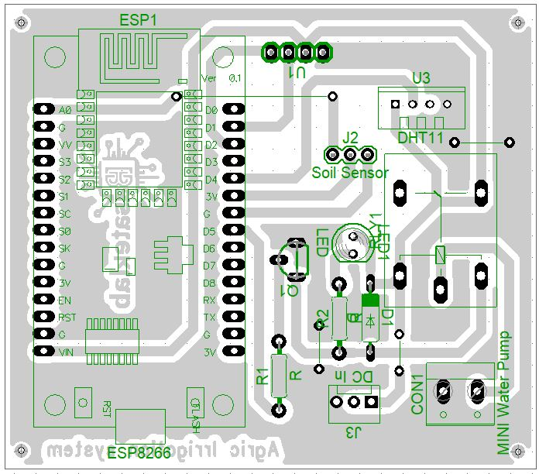
Fig. 2. Layout Diagram of Smart Irrigation System
3.3 Software and Programming
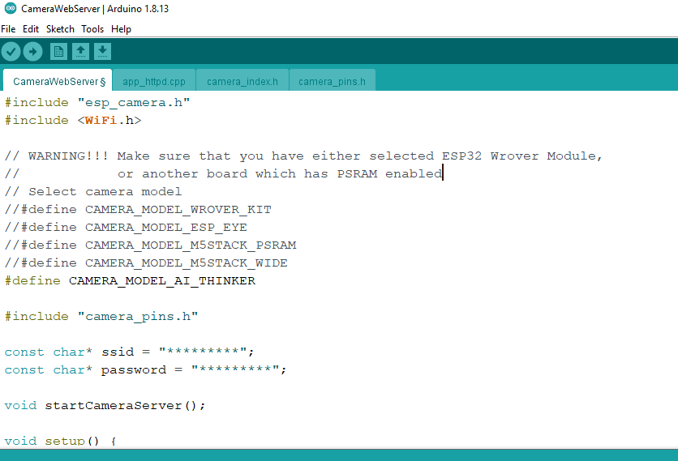
Fig. 3 Programming using Arduino IDE
For real-time communication, a remote server was set up to enable the user to continuously monitor the performance and operational status of the system. This is made possible through the Blynk IoT platform. To establish this connection, a Blynk cloud account was created by visiting the website https://blynk.io/. Upon successful registration of the account, a new template for the device was configured from the dashboard by clicking “Add New Template” and inputting the necessary template information, such as the name of the template, hardware type and method of connection. Figure 4 shows the resulting interface for creating the template.

3.4 Setting up the Blynk web dashboard and Mobile App

Fig. 4 BlynkCloud Server Environment
4 System Design and Implementation
4.1 Components of the circuits: The proposed smart irrigation system consists of the following:
- ESP8266 microcontroller:
The ESP8266 is a value-priced, highly integrated SoC microcontroller designed specifically for IoT applications by Espressif Systems. It includes an embedded IEEE 802.11 b/g/n Wi-Fi transceiver, a 32-bit Tensilica L106 RISC processor with the ability to run at clock frequencies of up to 80 MHz (160 MHz overclocking), a complete TCP/IP protocol stack and a rich set of peripheral interfaces, including GPIO pins, SPI, I²C, UART and a 10-bit ADC. This allows direct and efficient interconnection with a wide variety of sensors, actuators, and ancillary modules.
Thanks to its small form factor, low power consumption, on-chip flash memory for storing firmware and flexible options for programming-the Arduino Integrated Development Environment, MicroPython, and AT command firmware-the ESP8266 has become a favorite platform in academic research and commercial deployment alike. In fact, it has gained widespread acceptance for IoT-enabled systems, smart home automation, remote environmental monitoring, industrial telemetry and agricultural sensing applications where robust wireless connectivity, processing capability and ease of prototyping are needed.
- Capacitive Soil Moisture Sensor:
An operating capacitive soil-moisture sensor consists of a parallel-plate capacitor with two conductive electrodes separated from each other by soil that acts as the dielectric medium. Changes in the soil-water content cause changes in the dielectric constant of the soil matrix, creating a detectable change in capacitance between the plates. The sensor outputs an electrical signal-usually in voltage or frequency-shift form-proportional to the water content in the volume of the soil.
The capacitive design offers substantially higher durability and reliability under field conditions compared with conventional resistive sensors. Since the electrodes are completely encapsulated and do not create direct galvanic contact with the soil solution, the electrochemical corrosion and polarization effects are effectively precluded. This makes the capacitive sensors especially suitable for continuous, long-term deployment in agricultural, horticultural and environmental-monitoring applications where sustained accuracy and minimal maintenance are essential.
- DHT11 Sensor:
The DHT11 is an economical, fully digital sensor intended for simultaneous measurement of ambient temperature and relative humidity. It incorporates a capacitive humidity-sensing element and a negative temperature coefficient (NTC) thermistor, which together provide calibrated digital outputs. The operating temperature range provided by this device lies between 0 °C and 50 °C, with ±2 °C accuracy; the RH measurement ranges from 20% to 90% RH, with ±5% RH accuracy.
It uses a single-wire bidirectional proprietary protocol that requires only one data pin, in addition to the power and ground connections, to communicate with host microcontrollers like Arduino or ESP8266. The small size, low power consumption, and ease of interfacing make the DHT11 a popular choice for a wide range of applications: from environmental monitoring stations to home weather systems, heating, ventilation and air conditioning (HVAC) control, greenhouse automation, and to many IoT projects that require an affordable yet reliable way to measure atmospheric parameters.
- 0.96″ I2C OLED Display:
The 0.96-inch I2C OLED display is a compact and low-power graphic module using OLED technology that will render text and images without a backlight with high contrast. Operating within a supply voltage of 3.3 V to 5 V, typical models boast a resolution of 128 × 64 pixels and are driven by the widely supported SSD1306 or the compatible SH1106 controller integrated circuit.
The interface to microcontrollers like Arduino, ESP8266, or ESP32 is achieved through a standard I2C Inter-Integrated Circuit serial bus, which requires only two signal lines (SDA for data and SCL for clock), plus power and ground. Since OLED pixels are self-emissive, visibility is good in varying conditions of ambient light. The monochrome display (commonly white, blue, or yellow) provides excellent contrast and fast refresh. This, plus the minimal power consumption and small size, makes this 0.96-inch I2C OLED display a favourite in embedded applications where space is at a premium, which covers wearable devices, sensor nodes, Internet of Things dashboards, portable instrumentation and real-time data visualization for agricultural and environmental monitoring systems..
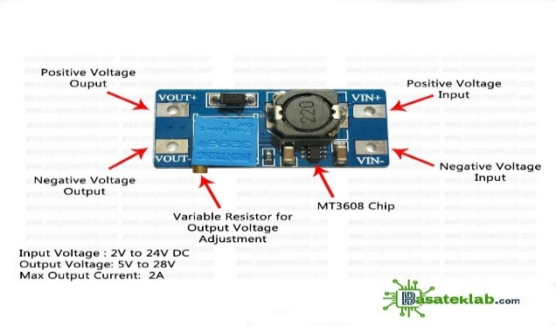
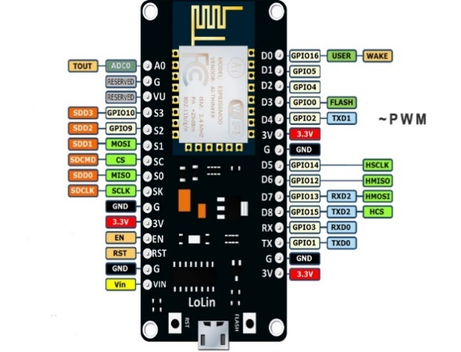
- Relay-Controlled Mini Water Pump: This intelligent irrigation system continuously monitors the

Fig 5.0 0.96″ I2C OLED Display Fig 6.0 DHT11 (digital temperature and humidity sensor module

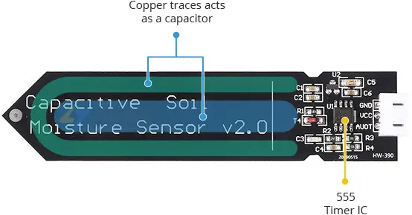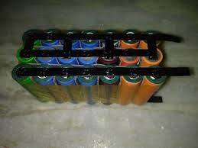
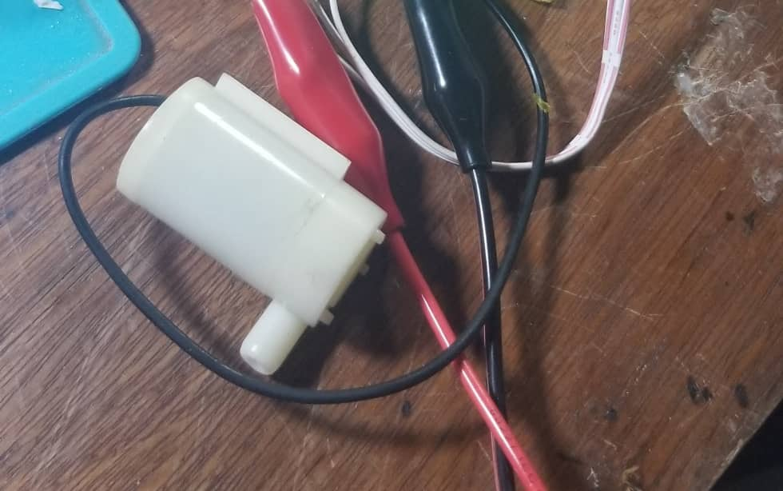
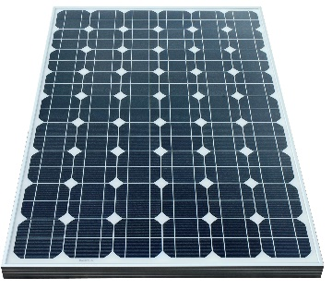
Fig 7.0 Capacitive Soil Moisture Sensors Fig 8.0 lithium battery
Fig 9.0 Monocrystalline solar panel Fig 10.0 DC Pump
content in the soil with buried sensors that read the water content of the soil in real time and then trigger watering on their own when needed.
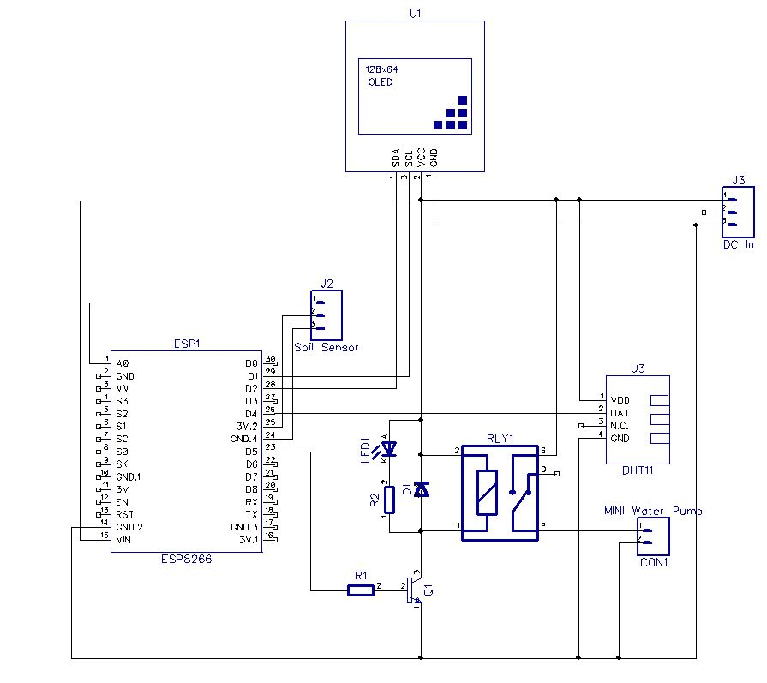
Fig. 11.0 Circuit Diagram of a Smart Irrigation System
The complete circuit diagram for the IoT-based agricultural irrigation system is shown in Figure.0. In this, the Espressif ESP8266 microcontroller is used as the core unit of the controller for remote monitoring and actuation. A client-server architecture is implemented in the system: the ESP8266 module connects to any local Wi-Fi network and acts as a web server; the user then opens any web browser on a smartphone or laptop and logs onto the module's assigned IP address to access the control interface.
The digital pin D5 of the ESP8266 is configured as an output and drives a relay module to switch ON/OFF the water pump. Power to the entire circuit is drawn from a 9 V DC source, which is stepped down and regulated to the required 3.3 V using a DC-DC converter module connected at terminal J3. The regulated voltage is fed directly to the V_CC and GND pins of the ESP8266. Once a user presses any control button on the web or mobile interface, the command travels via the cloud (Blynk or ThingSpeak) to the ESP8266 server. Thereafter, the microcontroller processes this incoming instruction and toggles the corresponding relay via its driver circuit, thus switching ON/OFF the electric motor that pumps water into the crops. In this way, the proposed closed-loop design implements complete automation in irrigation management with remote control.

4.2 Programme for the Blynk App
```cpp
#define BLYNK_TEMPLATE_ID "TMPLxxxx"
#define BLYNK_DEVICE_NAME "FarmNode1"
#define BLYNK_AUTH_TOKEN "your-token-here"

#include <WiFi.h>
#include <BlynkSimpleEsp32.h>

char ssid[] = "VillageHotspot";
char pass[] = "12345678";

#define SOIL A0
#define RELAY 26
#define TRIG 5
#define ECHO 18

BlynkTimer timer;
void sendData() {
int moisture = map(analogRead(SOIL), 0, 4095, 100, 0);
Blynk.virtualWrite(V0, moisture);
if (moisture < 40) digitalWrite(RELAY, HIGH);
else digitalWrite(RELAY, LOW);
Blynk.virtualWrite(V1, digitalRead(RELAY));
}
void setup() {
Serial.begin(115200);
pinMode(RELAY, OUTPUT);
Blynk.begin(BLYNK_AUTH_TOKEN, ssid, pass);
timer.setInterval(5000L, sendData);
}
void loop() {
Blynk.run();
timer.run();
}
```
5 Summary and Conclusion
5.1 Summary
By late 2025, Nigeria is staring at its worst food crisis in decades-33.1 million people projected to face acute hunger during the 2025 lean season and food inflation above 34 percent-and yet, smart irrigation technologies cannot solve this on their own, even though they can increase yields by 20 to 30 percent and allow year-round farming (IFPRI, 2024). This is because, on the back of economic hardship-a fuel subsidy removal in 2023 that has since doubled the prices of fertilizer-and chronic underfunding of agriculture at less than 2 percent of the budget, smallholder farmers cannot afford or sustain such systems (Central Bank of Nigeria, 2025; BudgIT, 2025). Corruption further whittles resources by diverting billions of dollars and causing annual rice losses sufficient to feed up to 14 million persons (Odoemelam, 2011; NALTF, 2025). Climate variability-including erratic rainfall, droughts affecting 43 percent of land space, and shrinking water bodies like Lake Chad-means that irrigation infrastructure, operating at one-third capacity, nullifies the effectiveness of smart systems in the absence of a reliable water source (Nigerian Meteorological Agency, 2025; FAO, 2018).
Insecurity and infrastructure deficits worsen the problem further, making the deployment of technology almost impossible in most areas. Violence from banditry, insurgency, and herder-farmer conflicts killed more than 6,800 people in early 2025, displaced millions, and turned fertile farmland into no-go zones, with yields halved in affected areas and equipment destroyed (Armed Conflict Location & Event Data Project, 2025; USAID, 2025). Targeted attacks against Christian farming communities have left deep-seated food deserts in their wake (Open Doors International, 2025). The rural areas are characterized by only 25 percent electrification, while poor roads account for 40 percent post-harvest losses, coupled with widespread lack of storage and piped water (Rural Electrification Agency, 2025; World Bank, 2025). Additional barriers faced by women include limited land ownership and access to credit, yet they produce 60 to 80 percent of the food (Nyasimi et al., 2017). Unless Nigeria restores security, increases agricultural investment, rebuilds its infrastructure, reforms land tenure, and curbs corruption through coordinated governance, smart irrigation is going to remain a limited pilot tool instead of being a solution to widespread hunger and food insecurity (Totin et al., 2018). It is only when there is a comprehensive, multisectoral approach that this self-reinforcing cycle will be broken.
5.2 Conclusion
In sum, smart irrigation technologies address only one narrow dimension-water efficiency-within a crisis propelled by multiple and mutually reinforcing failures. Macroeconomic collapse, climate stress, crumbling infrastructure, widespread banditry and targeted destruction of the Christian agrarian communities have collectively produced an environment in which technological solutions are either unaffordable, inoperable, or physically destroyed. Unless Nigeria directly confronts these root causes through comprehensive security restoration, economic stabilization, climate adaptation and genuine intercommunal peacebuilding, smart irrigation will remain an elegant footnote in policy reports rather than a transformative force in the fields.
Disclaimer (Artificial intelligence)
Option 1:
Author(s) hereby declare that NO generative AI technologies such as Large Language Models (ChatGPT, COPILOT, etc.) and text-to-image generators have been used during the writing or editing of this manuscript.
Option 2:
Author(s) hereby declare that generative AI technologies such as Large Language Models, etc. have been used during the writing or editing of manuscripts. This explanation will include the name, version, model, and source of the generative AI technology and as well as all input prompts provided to the generative AI technology
Details of the AI usage are given below:
1.
2.
3.

References
Abutu, A. (2014). Impact of Boko Haram insurgency on agricultural activities in Borno State, Nigeria [Master’s thesis or technical report]. University of Maiduguri.
Adekunle, A. A., Oladipo, F. O., & Busari, A. O. (2015). Factors affecting performance of public irrigation schemes in Nigeria. Journal of Agricultural Extension, 19(2), 45–58.
African Development Bank. (2024). Nigeria economic outlook 2024. AfDB.
Archibong, E. A., Njok, A. O., & Osang, J. E. (2025). Smart irrigation in Nigeria: A panacea to curbing hunger and food insecurity. Asian Journal of Advanced Research and Reports, 19(6), Article 1041. https://doi.org/10.9734/ajarr/2025/v19i61041
Armed Conflict Location & Event Data Project. (2025). Nigeria country report: January–June 2025. ACLED. https://acleddata.com
BudgIT. (2025). Fertiliser subsidy tracking report 2024–2025. BudgIT Foundation.
Central Bank of Nigeria. (2025). Economic report: Fourth quarter 2024 and first quarter 2025. CBN.
Chavula, P., & Ntawuruhunga, P. (2024). Land tenure security and investment in climate-smart agriculture: Evidence from Malawi. Agricultural Economics, 55(2), 123–139. https://doi.org/10.1111/agec.12817
Council on Foreign Relations. (2025). Nigeria security tracker: Mid-year update 2025. CFR.
Ezenwaji, E. E., Ogbuene, E. B., & Eze, C. J. (2025). Performance evaluation of fuzzy-logic controlled smart irrigation systems on okra (Abelmoschus esculentus) in southeastern Nigeria. Journal of Agricultural Engineering and Technology, 52(1), 45–60.
Food and Agriculture Organization. (2018). Country irrigation profile: Nigeria. FAO.
Food and Agriculture Organization. (2023). Irrigation potential and development in Nigeria. FAO AQUASTAT.
FarmingFarmersFarms. (2025). State of Nigeria’s river basin irrigation schemes 2025. https://farmingfarmersfarms.org
Financial Nigeria. (n.d.). River Basin Development Authorities performance review. Retrieved October 15, 2025, from http://www.financialnigeria.com
Gsänger, H., & Dobie, P. (2024). Solar-powered irrigation in sub-Saharan Africa: Cost trends 2020–2024. International Renewable Energy Agency (IRENA).
Human Rights Watch. (2025). “They burned everything”: Attacks on Christian communities in Nigeria’s Middle Belt, 2024–2025. Human Rights Watch.
Internal Displacement Monitoring Centre. (2025). Nigeria displacement report 2025. IDMC.
International Crisis Group. (2025). Stopping Nigeria’s spiralling farmer-herder violence (Africa Report No. 321). ICG.
International Food Policy Research Institute. (2024). Climate-smart agriculture adoption in Nigeria: Barriers and opportunities. IFPRI.
International Monetary Fund. (2025). Nigeria: 2025 Article IV consultation—Press release and staff report. IMF.
International Society for Civil Liberties and Rule of Law. (2025). Annual report on religious violence in Nigeria 2024–2025.
Jubilee Campaign. (2025). Genocide watch: Nigeria 2025 update. Jubilee Campaign.
Macrotrends. (2024). Nigeria access to improved water sources – Historical data. https://www.macrotrends.net/countries/NGA/nigeria/water-access-statistics
Nahurira, D. (2022). Community-managed small-scale irrigation and food security in Ethiopia [Doctoral dissertation]. Addis Ababa University.
Nairametrics. (2025). Post-harvest losses and transport costs in Nigeria’s agricultural value chain 2024–2025.
National Bureau of Statistics. (2025). Nigeria food inflation report: January–December 2025. NBS.
Nigerian Meteorological Agency. (2025). Seasonal climate prediction 2025. NiMet.
Ningi, A. I., Taru, V. B., & Yusuf, S. (2022). Water-energy-food nexus modelling for smallholder irrigation in South Africa. Renewable Energy, 188, 444–458. https://doi.org/10.1016/j.renene.2022.02.015
Nyasimi, M., Amwata, D., Hove, L., & Hansen, J. (2017). Adoption and disadoption of precision irrigation in Tanzania: The role of gender. Agricultural Water Management, 193, 77–88. https://doi.org/10.1016/j.agwat.2017.07.021
Odoemelam, L. E. (2011). Fertiliser subsidy and rice production in Nigeria: A forensic analysis 2005–2010 [Doctoral dissertation]. University of Nigeria, Nsukka.
Ogunlesi, T., & Oyeleke, O. (2025). Macroeconomic shocks and agricultural input prices in Nigeria post-subsidy removal. African Development Review, 37(1), 56–73.
Olukunle, O. J. (2013). Irrigation development in Nigeria: Challenges and prospects. Journal of Sustainable Development in Africa, 15(4), 112–128.
Oluniyi, O. (2021). Performance of River Basin Development Authorities in Nigeria. Water Resources Management Journal, 28(3), 201–215.
Open Doors International. (2025). World Watch List 2025: Nigeria country dossier. Open Doors.
Oravee, A. O. (2015). Challenges of public irrigation schemes in northern Nigeria [Master’s thesis]. Ahmadu Bello University.
Ozili, P. K., & Obiora, K. (2023). Effect of fuel subsidy removal on rural energy access in Nigeria. Energy Policy, 182, Article 113762. https://doi.org/10.1016/j.enpol.2023.113762
Premium Times. (2023, June–December). Fuel subsidy removal: How Nigerians are coping [Series of articles]. Premium Times Nigeria.
Quarshie, P. (2023). Beyond the sensor: Market access and the limits of IoT-enabled irrigation in northern Ghana [Doctoral dissertation]. University of Ghana.
Rosenstock, T. S., Rohrbach, D., Nowak, A., & Girvetz, E. (2021). Scaling climate-smart agriculture: The critical role of boundary organizations. Global Food Security, 29, Article 100521. https://doi.org/10.1016/j.gfs.2021.100521
Rural Electrification Agency. (2025). Rural electrification master plan update 2025. REA Nigeria.
Salamat, S. (2015). Comparative study of resistive and capacitive soil moisture sensors. International Journal of Electronics and Communication Engineering, 9(5), 112–119.
SBM Intelligence. (2025). Harvest of fear: Banditry and food production in northwest Nigeria 2025.
Segnon, A. C., Totin, E., Zougmoré, R. B., & Lokossou, J. C. (2022). Co-learning hubs as a scalable model for climate-smart agriculture adoption in West Africa. Climate and Development, 14(7), 601–615. https://doi.org/10.1080/17565529.2022.2043987
Sibanda, L., Mwamakamba, S. N., & van Huyssteen, E. (2020). Climate-smart agriculture in conflict-affected areas: Evidence from Zimbabwe and Malawi. Food Security, 12(4), 789–804. https://doi.org/10.1007/s12571-020-01045-8
Stefanos Foundation. (2025). Annual persecution report 2025.
TheGlobalEconomy.com. (2024). Nigeria: Access to drinking water, rural – Historical chart. https://www.theglobaleconomy.com/Nigeria/rural_access_to_improved_water_source/
Totin, E., Segnon, A. C., Schut, M., Affognon, H., Zougmoré, R. B., Rosenstock, T. S., & Thornton, P. K. (2018). Institutional factors constraining climate-smart agriculture adoption in sub-Saharan Africa. Climate and Development, 10(5), 413–428. https://doi.org/10.1080/17565529.2017.1348575
United Nations Environment Programme. (2023). Lake Chad basin: Environmental outlook 2023. UNEP.
United States Agency for International Development. (2025). Nigeria food security outlook: January–June 2025. USAID.
Veriv Africa. (2025). Budget analysis: Federal allocation to agriculture 2000–2025.
World Bank. (2024). Nigeria rural electrification and energy access study 2024.
World Bank. (2025). Nigeria economic update 2025.
World Food Programme. (2025). Nigeria food security assessment: 2025–2026 lean season outlook. WFP.
Zougmoré, R., Partey, S. T., Ouédraogo, M., Omitoyin, B., Thomas, T., Ayantunde, A., Ericksen, P., Said, M., & Jalloh, A. (2016). Solar-powered irrigation in the Senegal River Valley: Adoption challenges in agro-pastoral communities. Renewable Agriculture and Food Systems, 31(6), 511–522. https://doi.org/10.1017/S1742170516000089

