Circular Economy Approaches in Sustainable Horticultural Systems: Significance of Nutrient Standardisation and Soil-Less Cultivation

  - ABSTRACT
The agricultural community is witnessing a shift from traditional linear take, make, dispose patterns to the application of circular economy principles, which are more resource-efficient, minimize wastes, and environmentally sustainable. This paper conducts a critical evaluation of the global application of circular economy principles to horticultural practices, specifically on soil-less culture systems, nutrient standardization, and precision management systems. The analysis was conducted on peer-reviewed publications, policies, and technology developments from Indo-Dutch partnership ventures, Indian sustainable agricultural practices, and Dutch-European greenhouse vegetable production systems. The paper reveals the essential knowledge gaps that exist in regional implementation techniques, economic viability, and monitoring systems, and the important role that nutrient standardization plays within circular horticultural systems to promote environmentally sustainable horticultural practices. The implications from the paper suggest that, despite the enormous potential of circular horticulture for sustainable intensification, further advancements are required in the application of innovative technologies, policies, and regional adaptability of nutrient management systems.

Keywords: Circular economy, Horticulture, Nutrient standardisation, Sustainability, Resource efficiency

Introduction

Hydroponics and Soilless Cultivation Systems: An Introduction to Modern High-Tech Horticulture
The fast development of agricultural technology created modern food production systems which move beyond conventional soil-based farming practices. Soilless cultivation methods including hydroponics have established a new sustainable direction for horticulture through efficient technological practices. The innovative systems solve multiple worldwide problems by addressing water shortages and decreasing available farmland and climate effects and meeting rising food security needs in urbanizing areas. Soilless cultivation systems achieve sustainable horticulture status through circular economy integration and nutrient standardization which enables continuous production throughout the year with minimized environmental impact and optimized resource utilization and crop output.

Figure 1:Aeroponic vertical farming with nutrient misting in a controlled environment greenhouse.
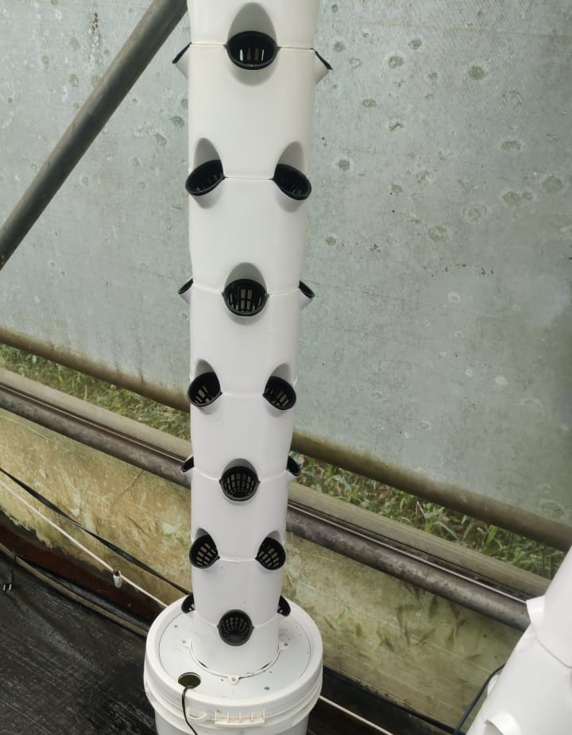
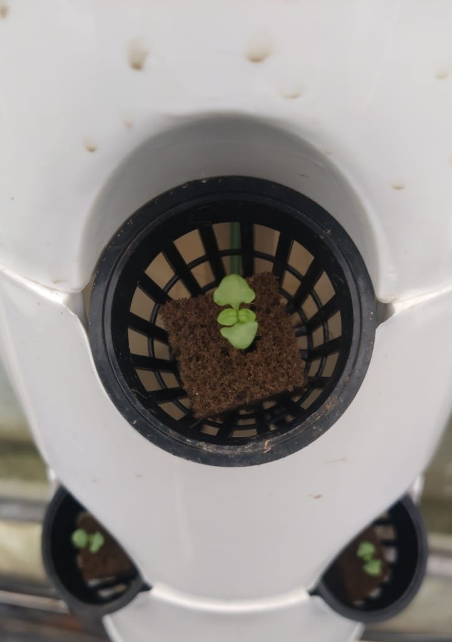

Historical Development and Conceptual Framework of Soilless Cultivation
Soilless cultivation has existed since ancient times because ancient civilizations built the Hanging Gardens of Babylon and floating gardens of the Aztecs and practiced soilless agriculture in China and Egypt. The scientific basis for contemporary hydroponics emerged from research conducted by scientists during the 17th and 19th centuries. During the 17th century Flemish botanist Jan van Helmont proved that plants could thrive without soil through his experimental work. The French scientists De Saussure and Boussingault established in 1800 that plants need carbon and hydrogen and oxygen and nitrogen to thrive before German scientists Sachs and Knop demonstrated plant cultivation in aqueous mineral salt solutions in 1860. (Pozníčková, n.d.; ‘Protected Cultivation : 9 Benefits of Controlled Environment Agriculture’, n.d.; ‘Vertical Farming | Urban Farming | Tower Farms | Aeroponics’, n.d.)
The term "hydroponics" comes from Greek roots where "hydro" means water and "ponos" means labor thus forming "water work". William Frederick Gericke established himself as a leading figure in modern hydroponics through his research which proved plants need specific water-based nutrient solutions to thrive. His scientific work created the foundation for current soilless farming practices and developed the principles which guide modern hydroponic cultivation systems. (Pozníčková, n.d.)
The scientific study of hydroponics became established as a formal discipline during the 20th century although Sir Francis Bacon first presented its core principles in 1627. The development of hydroponics evolved from traditional water-based farming techniques into modern high-tech systems which use exact nutrient control and automated environmental monitoring and precise management systems.(‘(30) Revolutionary Farming Method: Unveiling Our Aeroponic Vertical Farm - YouTube’, n.d.; ‘Hydroponics and protected cultivation: a practical guide | CABI Books’, n.d.)

Figure 2 : Classification and Evolution of Soilless Cultivation Systems in Modern Horticulture
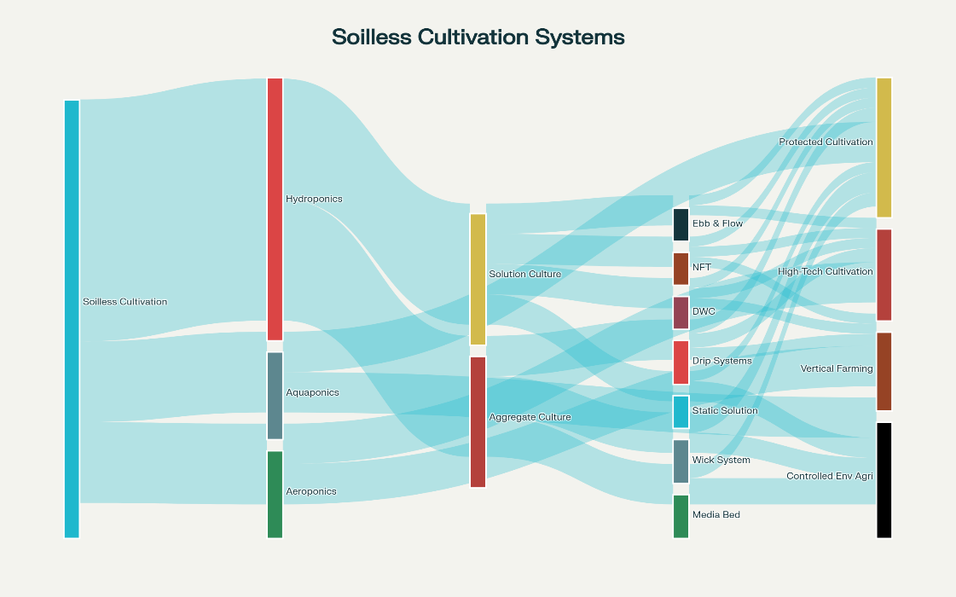

Fundamental Principles and Classification of Hydroponic Systems
The fundamental definition of hydroponics describes a plant cultivation method which uses water solutions containing nutrients to grow plants instead of traditional soil-based cultivation. The soilless system delivers nutrients to plant roots through specially designed solutions while using inert materials like rockwool and perlite and clay pellets and peat moss and vermiculite and coco coir for physical root support. The main purpose of these support media is to maintain root stability while ensuring proper oxygen availability.(Pozníčková, n.d.; ‘Protected Cultivation : 9 Benefits of Controlled Environment Agriculture’, n.d.; ‘Vertical Farming | Urban Farming | Tower Farms | Aeroponics’, n.d.)
The two main categories of hydroponic systems exist because they use different substrates: soilless-solution culture and granular-substrate culture. Solution culture systems allow roots to touch nutrient solutions directly but substrate culture systems use inert media to support plants while delivering nutrients through the medium. The two system types provide unique operational features which make them appropriate for specific crop types and environmental conditions and production objectives.(Pozníčková, n.d.)
All hydroponic systems operate based on three essential principles which optimize water availability and nutrient delivery and oxygen supply for plant development. Traditional soil-based farming systems face challenges because excessive water causes poor soil aeration yet insufficient water supply restricts nutrient delivery. The controlled management of water availability and nutrient delivery and oxygen supply in hydroponic systems enables plants to grow faster and produce more than traditional farming methods.(‘Frontiers | Editorial: Nutrients Recycling in Hydroponics: Opportunities and Challenges Toward Sustainable Crop Production Under Controlled Environment Agriculture’, n.d.; ‘Protected Cultivation : 9 Benefits of Controlled Environment Agriculture’, n.d.)
Modern hydroponic systems use multiple approaches to optimize their operations. The two main delivery methods for nutrients in hydroponics include sub-irrigation and top irrigation systems which match specific crop needs and environmental settings. The hydroponic systems use plastic containers and reservoirs as standard materials but researchers have tested concrete glass metal and organic substrates for alternative uses. All hydroponic containers need to block light because light exposure leads to algae and fungal development in the hydroponic growing medium.(‘Frontiers | Editorial: Nutrients Recycling in Hydroponics: Opportunities and Challenges Toward Sustainable Crop Production Under Controlled Environment Agriculture’, n.d.)
Table 1 : Hydroponic Systems Comparison Chart
System | Type | Water Eff | Complexity | Crops | Advantages | Disadvantages
NFT | Active/Recirc | V.High (90%) | Moderate | Leafy/Herbs | Water/Space Eff | Power/Clog Risk
Aeroponics | Active/Mist | Highest (95%) | High | Most Crops | Fast/High Yield | Complex/Expens
DWC | Passive/Static | High | Low | Leafy/Short | Simple/Fast | Temp/Algae
Ebb & Flow | Active/Inter | Mod-High | Moderate | Various | Versatile/Scale | Timer/Pump Fail
Drip System | Active/Cont | High | Low to Moderate | All Types | Precise Control | Clog/pH Issues
Wick System | Passive/Cap | Moderate | Very Low | Small/Herbs | No Power/Simple | Slow/Limited
Comparison of Major Hydroponic Systems: Characteristics, Efficiency, and Applications
Nutrient Film Technique (NFT): Precision Water and Nutrient Management
The Nutrient Film Technique emerged as a water-efficient hydroponic system which Allen Cooper developed at the Glasshouse Crops Research Institute in Littlehampton England during 1965. The NFT system functions through a process where plants in watertight channels receive a thin stream of nutrient-enriched water which flows past their bare roots. The system gets its name from the thin water layer which moves through channels to provide plants with both air exposure and continuous water and nutrient supply to their developing root mat at the channel base.(‘80 Plants You Can Grow with Vertical Towers and Hydroponic Garden Syst – SeedsNow.com’, n.d.; Reddy, n.d.)
NFT systems require specific design parameters to achieve their best performance through proper channel slope selection and appropriate flow rates and optimal channel dimensions. The recommended slope of 1:100 for NFT systems has given way to practical slopes between 1:30 and 1:40 because these slopes handle minor surface defects while maintaining consistent nutrient film flow and preventing waterlogging. The system delivers water and oxygen and nutrients to plants at the same time which other growing systems struggle to provide.(Reddy, n.d.)
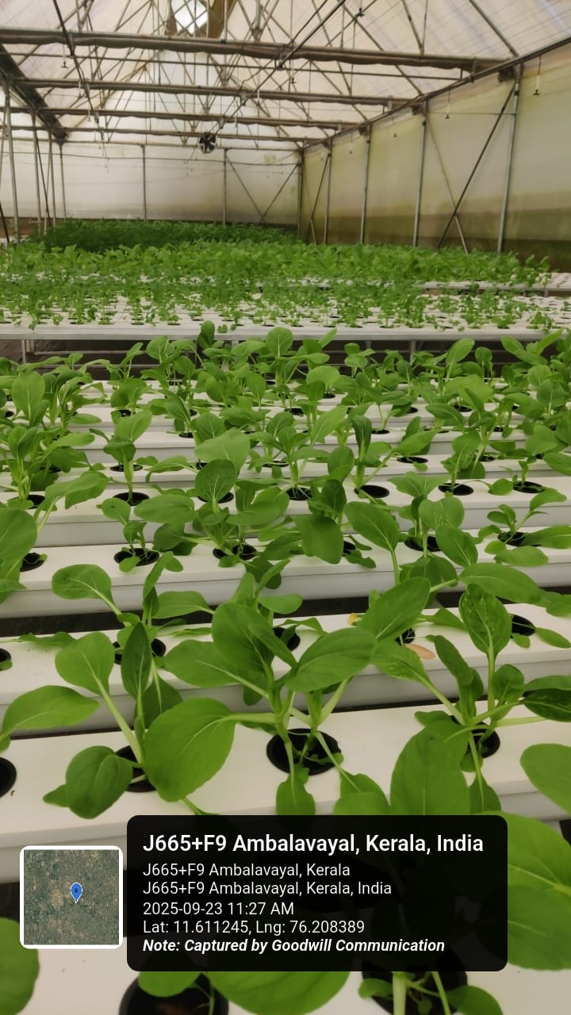
Figure 3 : NFT system

NFT systems are remarkably water-efficient, up to 90% more so than growing plants in soil. This is a more efficient system than other soil-based methods of farming, because it recirculates nutrient solutions in a closed loop, maximizing the amount of nutrients and reducing waste. The practice is excellent for growing short term crop types with shallow root systems like lettuces and herbs, strawberries, other leafy vegetables. The system's modularity allows either horizontal or vertical assembly, the latter of which can more than double crop density and yield potential per unit area.(‘80 Plants You Can Grow with Vertical Towers and Hydroponic Garden Syst – SeedsNow.com’, n.d.; ‘A Comprehensive Review on Protected Cultivation: Importance, Scope and Status | International Journal of Environment and Climate Change’, n.d.)
Practically, NFT has benefits in operational space saving (especially for vertical farming), but also much faster growth as it makes the most efficient use of nutrients. It is concerning that in many instances growth rates and yields can also be higher than can be achieved when using cuttings grown for possible soil-based production, with harvest time typically shortened by 30-50%. Nevertheless, the predominate weakness of the system is its susceptibility to power outages that can quickly cause plant stress or death as a result of lack of buffering capacity which exists with the thin nutrient film.(‘80 Plants You Can Grow with Vertical Towers and Hydroponic Garden Syst – SeedsNow.com’, n.d.; ‘A Comprehensive Review on Protected Cultivation: Importance, Scope and Status | International Journal of Environment and Climate Change’, n.d.; Reddy, n.d.)
Today, NFT systems can be used for city gardening (greenhouses), rooftop farms, or other controlled environment production activities. The addition of cutting-edge technology such as automated pH and nutrient monitoring, precision dosing systems, and environmental control has increased the performance and consistency of NFT. These advances help to solve common problems by removing nutrient imbalances, pH instability and the need for system surveillance.(‘80 Plants You Can Grow with Vertical Towers and Hydroponic Garden Syst – SeedsNow.com’, n.d.)
Deep Water Culture (DWC): Simplicity and Efficiency in Hydroponic Production
One of the most simple yet effective hydroponic methods, Deep Water Culture (DWC) involves suspending plant roots in a solution of nutrient-rich, oxygenated water. This method, referred to as Deep Flow Technique (DFT), Floating Raft Technology (FRT) or raceway systems utilize very shallow rectangular tanks less than a foot deep which are filled with nutrient saturated water and plants are supported on floating Styrofoam boards. The floating board design is a virtually friction free conveyor system.(Chowdhury & Asiabanpour, 2024; ‘Vertical Farming: Everything You Need to Know | Eden Green’, n.d.)
The basic concept behind DWC is to have the roots of your plant submerged in a slightly oxygenated nutrient solution, unlike other forms of hydroponic growth which use an intermittent watering system. The never ending submersion allows enough aeration courtesy of air pumps and air stones for plants to receive both nutrients and oxygen in unison all the way through-up to harvest. The high volume of water in the DWC system acts as a buffering medium, helping to absorb temperature and nutrient fluctuations and lowering maintenance.(Chowdhury & Asiabanpour, 2024; ‘Vertical Farming: Everything You Need to Know | Eden Green’, n.d.)
DWC systems are especially efficient in growing short cycle non-fruiting plants (lettuces, herbs.. etcetera.). The simplicity of the procedure allows its use for an inexperienced grower and for commercial purposes where limited technical knowledge is necessary obtaining consistent results. Since their introduction, growth in DWC systems has been found to be 30-50% faster than that of soil plants; lettuce for example can grow to maturity in about half the time as a traditional soil growing system (Harich, 1987).(Chowdhury & Asiabanpour, 2024; ‘Vertical Farming: Everything You Need to Know | Eden Green’, n.d.)
The flow of water in DWC systems presents a challenge, requiring attention to reservoir size and support due to the weight load associated with large volumes of water. There is no maximum reservoir size although keeping system separated into more tanks may help manage pinhole leaks and localize operational problems. Good surface coverage is important for three main reasons: reducing evaporation, preventing the growth of algae (which prefer to grow in light filled water), and those surfaces help shield light from contacting nutrient rich water and will protect whatever nutrients are delivered on that day-longer than open water under direct sunlight.(Chowdhury & Asiabanpour, 2024)

Aeration is by far the most significant factor when it comes to DWC; due to the low water flow and exchange you need to efficiently oxygenate or else roots will suffocate. This is commonly accomplished by constant aeration, such as air pumps and air stones serving in this capacity around the clock or involving ozone input systems for both oxygenation and pathogen removal. Optimal levels of dissolved oxygen should be maintained to support proper root function, while preventing anaerobic conditions that could result in rot and death of the plants.(Chowdhury & Asiabanpour, 2024)
Newer adaptations to the DWC system are Recirculating Deep Water Culture (RDWC) systems, in which nutrient solution is pumped from a reservoir through direct contact with the plants; it's essentially deep water culture but with improved nutrient circulation and oxygenation. The advanced systems overcome some of the disadvantages inherent to DWC techniques, yet still retain its simplicity and efficiency. Furthermore, DWC’s commercial applicability for large-scale operations has grown with the development and incorporation of automated monitoring systems, controlled environment agriculture technologies and precision nutrient management.(‘Vertical Farming: Everything You Need to Know | Eden Green’, n.d.)
Aeroponics: Advanced Root Zone Management and Maximum Efficiency
Aeroponics is the most high-tech type of hydroponic gardening. roots are suspended in air and periodically misted with a nutrient solution. This method dispenses with any growing support systems, roots grow in an air network and are precisely fed nutrient solution and water by fog application. With no substrate 100% of the carbon dioxide concentrations are available for photosynthesis and maximum oxygen availability to root systems.(Rufí-Salís, Calvo, Petit-Boix, Villalba, & Gabarrell, 2020) (‘(31) How To Build A Tower Garden & Tower Farm (FLEX) - YouTube’, n.d.; ‘Vertical Garden - Vertical Hydroponic Tower Manufacturer from Pune’, n.d.)
The basic idea of aeroponics is to feed nutrients in the form of micro-droplets that serve as water, nourishment and oxygen for the plant at the same time. This method promotes accelerated and more efficient plant growth than bulkier conventional methods, with crops around 35-50% higher in yeild than a traditional hydroponic solution. The technique's accuracy provides fine-tuned control of nutrient application timing, dose and frequency to meet the crop's needs/development stage.(‘(31) How To Build A Tower Garden & Tower Farm (FLEX) - YouTube’, n.d.; ‘Vertical Garden - Vertical Hydroponic Tower Manufacturer from Pune’, n.d.; Rufí-Salís et al., 2020)
Aeroponic systems are the most water-efficient method of growing, using approximately 95% less water than conventional or organic farm production. This efficiency is largely due to nutrients being delivered directly to plant roots with little waste or run-off. Closed-loop system design of the majority of aeroponic setups allows recycling a significant proportion of nutrient solution which improves resource efficiency and minimizes environmental impact.(‘(31) How To Build A Tower Garden & Tower Farm (FLEX) - YouTube’, n.d.; ‘Vertical Garden - Vertical Hydroponic Tower Manufacturer from Pune’, n.d.)
The technology is particularly suitable for towering growth applications such as vertical farming, where an aeroponic tower can house many plant locations in a small area. Commercial aeroponic towers are able to grow 50-52 plants per tower in less than one m2 of floor space. Aeroponics This level of vertical integration allows for production densities many times higher than traditional agriculture and is perfect for urban agriculture, greenhouse production and controlled environment growing facilities.(Kh S Al-Hamdani et al., 2021; ‘Vertical Garden - Vertical Hydroponic Tower Manufacturer from Pune’, n.d.)
The aeroponic systems are excellent in crops of high value (lettuce, greens, some herbs and fruit plants). The controlled environment and precise nutrient solution allow for crops to achieve a higher nutritive density, antioxidant ability, and phenolic values in comparison to conventionally grown produce. Studies have shown that A-growing vegetables usually only enhances their flavor, aroma and texture attributes with the products fetching premium in niche markets.(‘(31) How To Build A Tower Garden & Tower Farm (FLEX) - YouTube’, n.d.; Rufí-Salís et al., 2020)
Aeroponics, on the other hands, needs costly structures and the technical know-how for its use. The system is complex: it features high precision misting systems, automatic timing devices, nutrient injecting mechanisms and environmental controls. All this high-tech wizardry comes with a premium in terms of setup and upkeep expenses compared to simpler hydroponics. Also, its reliance on 24/7 operation makes it susceptible to the failure of equipment and thus the need for backup systems and technical personnel expertise.(Rufí-Salís et al., 2020; ‘Vertical Farming: Everything You Need to Know | Eden Green’, n.d.)
Notwithstanding these constraints, aeroponics provides several advantages for the cultivation of crops such as contamination-free plant materials and rapid growth rates as well crop quality. The year-round production capacity of the method within greenhouses in combination with other production methods (e.g., aquaponics) may be very attractive for areas with disadvantaged climatic conditions and limited land availability. As costs of technologies decrease and automation systems continue to advance, aeroponics is likely enhance the sustainability of food production systems.(‘(31) How To Build A Tower Garden & Tower Farm (FLEX) - YouTube’, n.d.)

Ebb and Flow Systems: Versatile Intermittent Irrigation Technology
An ebb and flow system, also called a flood and drain hydroponic system, is an easy to use, versatile method that's very popular among home growers as well as commercial agricultural operations.Ebb-Flow is the most extensively used form of hydroponics. This method replicates the natural irrigation process of filling grow trays with nutrient solutions, back-flowing all of the solution to reservoir systems. The pulsating supply of nutrients allows the plant to take up both nutrients when flooding and oxygen when draining.(Jia, Speck, Feng, & Lee, 2025; Kh S Al-Hamdani et al., 2021; Saaid, Yahya, Noor, & Ali, 2013)
How Ebb and Flow Systems Work In an Ebb and Flow system, submersible pumps triggered by timers flood the grow tray with nutrient solution (water + fertilizers) that contains your plant in its growing medium. The nutrient solutions flow the growing medium and feed directly to the root zones during flood cycles. When the pumps close, the solutions are then allowed to drain back into reservoirs through the delivery lines, causing air flow in to growing medium.(Kh S Al-Hamdani et al., 2021; Saaid et al., 2013)
This system is incredibly versatile accommodating multitude of growing media, such as fabric, clay pellets, Rockwool, coir and many others! The versatility in media choice enables growers to customise root zone conditions to suit their crops, while maintaining consistent nutrient feed schedules. The modular nature of the unit allows us to easily scale the system up or down from small home use all the way to commercial size operations.(Kh S Al-Hamdani et al., 2021; Saaid et al., 2013)
Ebb & Flow systems have a number of operational benefits such as optimal nutrient and oxygen capability, the ability to grow mission critical plants, and versatility in plant scheduling. The periodic flooding and draining cycles can be programmed to control growing medium moisture content for the purpose of managing plant health and lowering pest counts. Reducing flood depth or increasing drainage periods will dry surfaces and alleviate humidity related issues.(Kh S Al-Hamdani et al., 2021; Saaid et al., 2013)
Key to this system's success in encouraging healthy root growth is the wet-dry cycle produced which encourages roots downwards and stops waterlogging. During drain intervals, fresh air is drawn through the growth media to supply necessary oxygen to the root system and remove excess moisture from reaching levels where pathogenic conditions may occur. this natural aeration is not something that can be achieved with other forms of hydroponics.(Jia et al., 2025; Saaid et al., 2013)
Reliability of the timer is by far the most important part of an Ebb and Flow system because without a reliable Ebb and Flow system that floods and drains reliably you will quickly kill your plants! Equipment failure, such as pump failure or timer malfunction can rapidly result in plant stress or death. But the simplicity of the system, and its rugged design, means that there are few technical problems to be encountered compared with other hydroponics.(Kh S Al-Hamdani et al., 2021; Saaid et al., 2013)
Ebb and Flow systems are used today for greenhouse growing, nurseries and urban farming installations. Its modular design allows it to adapt to a variety of plant sizes and growth habits, catering from seedling production to mature plant growing. Integration with computerized environmental controls, nutrient dosing systems and fertigation have increased the economic viability of Ebb and Flow systems for commercial yields in horticulture.(Jia et al., 2025; Saaid et al., 2013)

Protected Cultivation and High-Tech Agricultural Integration
Protected crop production is an advanced technology where soilless culture management and controlled environment policies are combined in such a way that the quality of growth factors can be managed efficiently resulting in better yields. This is a system that includes different types of structure-systems such as greenhouses, polyhouses, polytunnels and shade houses designed to offer different levels of environmental control and crop protection. The use of hydroponic arrangements in these protected environments presents opportunities for synergy, where the sum of both resource efficiency and crop quality is greater than individual benefits alone.(Butcher, Laubscher, & Coetzee, 2017; Singh et al., 2023)
For instance, greenhouse production with hydroponic systems has shown impressive productivity benefits with vegetable yields that are often 20-25% higher than field-grown offerings because of the greater plant densities per square meter. The climatic systems make year round productionpossible irrespective of external climate conditions, and thus the seasonal-dependence is eliminated and the harvest can be continuous. This is especially useful for high value crops, such as coloured capsicum, cherry tomatoes, exotic vegetables and specialty herbs that offer premium market prices.(Butcher et al., 2017; Singh et al., 2023)
Modern protected cultivation’s technological advancements have evolved to include automated greenhouses with polycarbonate covering, and incorporated heating/cooling as well as computerized environmental regulation. These high-tech facilities allow for accurate control of temperature, humidity, carbon dioxide concentration and light level to maximise plant growth. The level of environmental control achievable in protected systems permits the cultivation of crops which would not otherwise be viable for local climatic conditions.(Butcher et al., 2017)
Hydroponic systems under controlled conditions are highly resource efficient especially in terms of water and nutrients use. Recirculating hydroponic production systems can use water 80-90% more efficiently than open-field crops but also allow for precise application of nutrient solutions which reduces losses and associated environmental impacts. Control environment conditions also result in a significant reduction of pesticide use since most pests and disease organisms are physically prevented from reaching crops.(Butcher et al., 2017; Singh et al., 2023)
The combination of renewable energy sources with a protected cultivation system helps to overcome one of the major concerns find in high energy-demanding growing scenarios. Climate control, lighting and system operations can be powered naturally by solar panels, geothermal systems, biomass heating and wind power. This closing of the loop is crucial for the financial and ecological sustainability of protected cultivation farms.(Singh et al., 2023)
Protected environment, in particular greenhouse system, has excellent potential for its use in urban and peri-urban agriculture where suitable soil may not always be available due to land unavailability; contaminated soils or spatial restrictions. Protected hydroponic systems are physically intensive and can be highly productive per unit of land producing food in urban areas where land is expensive as well as providing local food production capacity.(Butcher et al., 2017; Singh et al., 2023)
Vertical Farming and Space-Efficient Production Systems
Vertical farming is an innovative method of growing plants that maximizes the space whether it stacks hundreds or even thousands of cultivation layers vertically, and are usually fed with hydroponic, aeroponic or aquaponic. This spatially efficient farming can have such a high production density that some systems have been able to yield 10-15 times as much per unit area than traditional horizontal field farms. Insight: A new era of vertical farming is upon us - and it could help feed the planet The vertically 'integrated' growing systems solves crucial issues of insufficient fertile land as well as pressures caused by urbanization.(Ferrarezi et al., 2024; A. Kumar, Mehta, Yadav, & Kumari, 2024)
The basic idea of the vertical farm is to establish multiple growing floors within a controlled-environment building, each with its own lighting, irrigation and climate control. This building method provides for the year-round production with extremely accurate environmental control, without need for allowing variances that result from seasons and inclement weather. The controlled environment inside vertical farms are allowing us to grow crops that would otherwise not survive in the local climate.(Ferrarezi et al., 2024; A. Kumar et al., 2024)
Aeroponic towers are among the most efficient of vertical farming methods, as it is possible to produce 28-52 plants using a single tower while taking up very little floor space. Nutrient Misting Tower SystemsThese towers employ a nutrient misting technology that allows full feeding to aerial root systems by serving nourishment and hydration with precision. Commercial aeroponic tower installments can accomplish hundreds of plants per square meter, albeit not achievable with traditional agriculture.(Ferrarezi et al., 2024)
The resource efficiency of vertical farming systems is particularly remarkable in water preservation, with many system showing 95-98% water savings over traditional farming. This is achieved through closed-loop recirculation, exacting delivery of nutrients and doing away with agricultural runoff. The controlled environment can also allow for large reductions in pesticide use, as isolation physically prevents pests from reaching the plants and the growing conditions are optimal so that the plants become more resilient to disease pressures which increase with plant stress.(Ferrarezi et al., 2024; A. Kumar et al., 2024)
Lighting is the key element for the operation of vertical farming systems, and LED (Light Emitting Diode) systems as an energy-saving artificial light source to plant photosynthesis are widely used. Modern LED systems are easily adjustable to deliver the right light spectra for different crops and growth stages, which means you can produce year-round irrespective of access to sunlight. LED technology has become much more energy efficient in recent years and it is finally getting to the point where it makes economic sense for indoor growing.(Ferrarezi et al., 2024; A. Kumar et al., 2024)
Vertical farming systems offer special benefits when we are producing leafy greens, herbs or other high-value crops that grow quickly and can be priced at a premium. The well-controlled environment and the very good nutrition usually ensure that these crops have better nutritional value, longer shelf-life, enhanced sensory qualities compared with field grow produce. These quality advantages allow that produce to fetch higher prices which can in part compensate for the high costs of production.(Ferrarezi et al., 2024; A. Kumar et al., 2024)
Automation technologies, such as robotic harvesting systems, planting and transplanting equipment, computer mediated environmental controls are bringing vertical farming commercially nearer to practical reality. Such technology solves the problem of high labour cost and simultaneously enhances production consistency and working performance. As cost of automation technology continues to come down, vertical farming is anticipated to be a strong competitor to traditional farming techniques.(Ferrarezi et al., 2024; A. Kumar et al., 2024)
Circular Economy Integration and Nutrient Standardization
Adaptation of the principles of circular economy to systems under soilless cultivation means a turnabout in terms of sustainability and reduction of waste in horticultural production. It focuses primarily on reducing, reusing and recycling materials across production processes to produce closed-loop systems that are as resourceful as possible with minimal impact on the environment. The incorporation of circular economy principles in the hydroponic systems results in solutions to both major sustainability concerns and operations efficiency as well as economic profitability.(Mohd, Mirfat, Norma, Nurzahidah, & Faris, 2024; Singh Rawal, 2024)
Resource loop closure in hydroponic systems is mainly concerned with water recycle, nutrient regeneration and biomass utilization. State-of-the-art hydroponic operations utilize closed-loop water systems to recover, clean, and reuse drain water; achieving 90-95% water savings relative to traditional farming. Nutrient reclamation systems allow collection and reuse of worn-out fertilizers in leachate solutions, cutting input costs and limiting environmental release of farm chemicals.(Mohd et al., 2024; Singh Rawal, 2024)
Waste recovery can be an important opportunity through which to introduce the circular economy in hydroponic ecosystems. Organic waste from crop production, i.e. plant residues, root masses and growing media can be exploited leading to recovery of valuable products like biofertilizers, biochar and substrate amendments. This waste stream valorisation not only reduces the cost of disposal but also even transforms these material for disposal into revenue-yielding commodities.(Mohd et al., 2024)
The correct standardization of nutrient management procedures is the key to reaching the maxmum circular economy that hydroponic culture can stimulate. Standardization of those parameters in turn permits accurate regulation or control of nutrient inputs and outputs, which can be referred to for the purposes of designing closed-loop recycling schemes which avoid creation of waste. For instance, It is estimated that the use of fertilizers might be decreased by 20-30% without reduction in grain yield, or even increase (on a long-term), due to an improved N efficiency if optimized nutrient doses according to available protocols.(Mohd et al., 2024; Singh Rawal, 2024)
Industrial symbiosis provides great potential to improve CE in hydroponics. These methodologies include the combination of hydroponics operations with other manufacturing or processing works to harmonize the relationship between these resources. For instance, food processing waste has been used as a nutrient source, waste heat from some industrial processes has been used to heat greenhouses and hydroponic waste streams are processed into products for other industries.(Singh Rawal, 2024)
Figure 4 : Deep water culture hydroponic system with floating rafts growing leafy greens inside a controlled greenhouse environment.(‘Aquaponics | Description, History, System, Benefits, Examples, & Facts | Britannica’, n.d.)
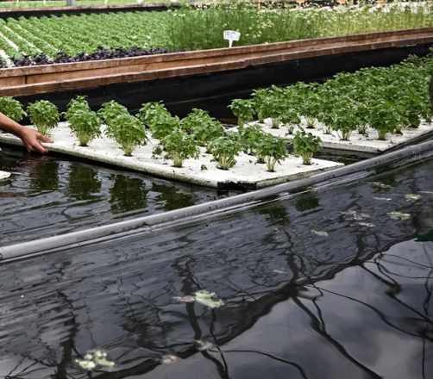

The inclusion of aquaponic systems is an even higher level of circular economy extension, where plant production (hydroponic) is combined with a fish culture. Fish waste serves as a source of organic nutrients for plant growth and the plants serve as natural filters to purify and clean water for fish production. This interdependent relationship results in a very efficient use of resources resulting in plant and animal protein from very little input.(Mohd et al., 2024)
A sustainable substrate is another key factor of circular economy in a hydroponic system. Studies aim to produce biodegradable and recyclable growing media able to replace conventional substrates such as rockwool and pebbles. Such sustainable alternatives for peat can be coconut coir, wood fiber, biochar as well as different types of organic waste-derived materials that can even be composted or recycled after being used.(Mohd et al., 2024)
Economic advantages of raising circular economy strategies in hydroponic / aquaponic systems can be considered under the below scenarios: cost savings on inputs development of novel income from waste utilization better selling positions for ecologically produce crops. Consumer demand for environmentally sustainable food production opens up premium markets for crops that have been grown according to the principles of the circular economy. These market benefits compensate implementation costs and bring a long-term sustainability advantage.(Mohd et al., 2024; Singh Rawal, 2024)
Technological Innovation and Future Development Pathways
The rapid development of power digital technology, automation and precision agriculture means that soilless culture is changing from the labor-intensive traditional way to intensive, modern digitized production mode. The systems are fitted with Internet of Things (IoT) sensors, AI and machine learning software that provide real-time control over growth and nutrient and environmental conditions. These are the types of tech integrations that are changing the game by improving hydroponic systems efficiency, consistency and scalability.(Subhashini et al., 2024; Verdoliva, Gwyn-Jones, Detheridge, & Robson, 2021)
Precision nutrition control systems incorporate sophisticated sensors and analytical instrumentation to continuously measure nutrient concentrations, pH, electrical conductivity, and dissolved oxygen levels. Computerized application systems use sensor feedback to modify fertilizer recipes and application timings, so as to resist optimal growth condition through different stages of crop development. This exacting attitude reduces nutrient waste and optimizes crop manufacture & superiority.(Subhashini et al., 2024; Verdoliva et al., 2021)
The use of AI in soil-less growing systems These are such as predictive models to predict yield, image analysis for pest and disease detection and optimization softwares that aid in resources allocation. Machine learning systems draw on information collected from numerous production cycles to pattern match and tailor growing recipes for types of crops under certain environmental circumstances. Such AI insights allow the system to optimize for higher and more consistent outputs in terms of crop quality, improve production efficiency and reduce waste.(Subhashini et al., 2024; Verdoliva et al., 2021)
Several nanotechnology applications have been developed for hydroponics such as nano-fertilizers with controlled physiological release, nano-sensors for ultra-precise monitoring and nano-materials for growing substrates. These are advanced materials and technologies that promote nutrient use efficiency, less harm to the environment and better crop performances. In line with its development, nanotechnological applications in hydroponics are expected to have a great impact.(Verdoliva et al., 2021)
The introduction of renewable energy based systems in hydroponic production is a sustainable response to this, both environmental and economical. Lighting, climate control and system operations can be powered with solar panels, wind turbines and geothermal. The ESS can maintain the term reliability in a system considering variable RE generation and ensure stable operation under various energy generation from REs, contributing to mitigation of power grid dependence on grid electricity.(Subhashini et al., 2024; Verdoliva et al., 2021)
In the field of hydroponics, whilst there are automation systems today that deal with issues such as automatic seeding and transplant systems, robotic harvesting devices, etc., robotics and automated technologies generally remain in their infancy. These technologies ensure Resolution of issues related to labor cost while enhancing operational stability and productivity. And as robotic systems continue to improve and fetch more competitive prices, it is projected that uptake in the commercial hydroponic space will increase.(Subhashini et al., 2024; Verdoliva et al., 2021)
Challenges and Limitations in Soilless Cultivation Systems
Although there are many benefits of soilless cultivation techniques, there are many barrier issues that should be overcome when using them to develop a sustainable food production system. Energy demand is one of the biggest barriers, especially when it comes to indoor systems with artificial lighting and temperature regulation. The energy consumption intensity of such systems may lead to higher carbon footprints compared with traditional agriculture except in cases where renewable energy is used.(Fitriyah, Budi, Maulana, & Setiawan, 2022; Janeczko & Timmons, 2019)
Advanced hydroponic systems would be easily adopted for use by the majority of growers, but technical complexity and skill requirements are limiting factors. Those who know how to run such systems tasty are betting on knowledge of plant nutrition, system mechanics, environmental control and problem- solving skills beyond the reach of a quotidian farmer. This techno-bureaucratic barrier requires extensive educational and training programs to create expert users that can work in sophisticated soilless systems.(Fitriyah et al., 2022; Janeczko & Timmons, 2019)
The start-up costs for hydroponics are generally higher but can be much higher than conventional farming, particularly if a high-tech systems such as integrated computer-controlled environments and equipment for precision monitoring and automation. These are high initial costs that can inhibit adoption, especially for smallholder farmers in the developing world with less available capital. But higher yields and a premium over field price for most hydro crops usually make such expenditures worthwhile in time.(Fitriyah et al., 2022; Janeczko & Timmons, 2019)
The main obstacle arises from crop limitations because hydroponic systems work best with leafy greens and herbs but struggle to support other types of plants. The production of fruiting crops and root vegetables and grains faces technical barriers because of support needs and harvest methods and market profitability. The expansion of hydroponic crop diversity needs ongoing research activities together with system improvements.(Fitriyah et al., 2022; Janeczko & Timmons, 2019)
Hydroponic systems need unique disease management strategies because they operate differently from traditional farming methods. The absence of soil in hydroponic systems reduces pathogen transmission but water-based diseases can quickly spread through the recirculating nutrient solution. The management of diseases in hydroponics needs specific monitoring systems and sanitizing protocols and treatment methods which work for hydroponic systems.(Fitriyah et al., 2022; Janeczko & Timmons, 2019)
The acceptance of hydroponic produce in markets together with how consumers view it remains an ongoing difficulty. The practice of growing crops without soil leads some consumers to doubt its natural origin and they might view hydroponic produce as less valuable than traditional farm products. The market needs educational programs and promotional activities to show hydroponic farming advantages and product safety thus creating customer trust and market growth.(Fitriyah et al., 2022; Janeczko & Timmons, 2019)

1. Overview: Essentials of the Circular Economy in Horticulture
By highlighting methods for resource conservation, waste reduction, and regeneration, the circular economy concept challenges us to reevaluate agricultural production systems. Its three main principles are restoring natural systems, cutting down on waste and pollution, and efficiently recycling goods or resources. These criteria are not met by traditional or older models, which are defined by the extraction, use, and disposal of resources. This entails creating horticultural production systems that maximize internal resource cycling and minimize external inputs through the use of precision management technology, integrated nutrient loops, and sustainable waste valorization techniques.(‘Circular Economy in Farming: A Sustainable Approach’, n.d.; ‘Concept of Circular Economy Principles Applied to Livestock & Agriculture: From Farm to Fork - Pashudhan Praharee | Pet Care Blog’, n.d.)
Adoption of the circular economy in horticulture is important for reasons other than environmental protection, such as the need for food security and economic resilience. By 2050, the world's food consumption is expected to rise significantly, and the agricultural industry will confront hitherto unheard-of difficulties due to growing demands on limited resources such fertilizers that include nitrogen and phosphate. Through greater economic sustainability, less environmental impact, and increased resource efficiency, circular horticulture provides a means of addressing these issues. In intensive production systems like greenhouse horticulture, where precise resource management and waste minimization are made possible by controlled settings, the idea becomes more pertinent.(‘CLOSING THE WATER AND NUTRIENT CYCLES IN SOILLESS CULTIVATION SYSTEMS | International Society for Horticultural Science’, n.d.; ‘Web App - Unavailable’, n.d.; Salinas-Velandia et al., 2022)
Recent work reveals that circular horticulture systems can offer striking resource efficiency gains; possible water savings of up to 30% and a decrease of 40% in the use of fertilizers have been reported compared to conventional linear systems. These systems utilize advanced closed-loop systems that reuse nutrient solutions, recycle organic waste streams and incorporate precision monitoring to ensure the viable use of these resources. Yet this needs adequate knowledge of nutrient dynamics, standardized procedures for resource recovery and monitoring strategies to guarantee system integrity and productivity.(‘Closed soilless growing systems: a sustainable solution for dutch greenhouse horticulture | Water Science & Technology | IWA Publishing’, n.d.)
2. Dutch and European leadership in circular horticulture: Global perspectives
2.1 Dutch Greenhouse Systems and Closed Systems
The Netherlands is leading the world in circular horticulture with high-tech greenhouses and stand-alone and closed-loop growing systems. Dutch soilless growing systems have become the practical example for the application of circular economy in intensive horticulture and now account for over 80% of the greenhouse area. While these systems can recycle nutrients with minimal discharge, an average annual discharge rate of 10% of OE at the nutrient-level due to sodium accumulation, the concern for pathogens, and nutrient imbalances are the challenges of these tech-niques at present..(Beerling, Blok, Van Der Maas, & Van Os, 2014; ‘CLOSING THE WATER AND NUTRIENT CYCLES IN SOILLESS CULTIVATION SYSTEMS | International Society for Horticultural Science’, n.d.) (Campana, Ciriello, Rouphael, & De Pascale, 2025)
In The Netherlands, large investments in research and pilots programmes aimed at closing water and nutrient cycles at the farm level and even at system level in soilless systems are being made due to enforcement of the Water Framework Directive 2000/60/EC. The goal of near-zero emissions by 2027 has spurred the development of nutrient recovery technologies, disinfection systems, and precision monitoring approaches. The current fresh water use in Dutch greenhouses amounts to about 6.5 million m3, meanwhile, 1,300 tons of nitrogen, 200 tons of phosphor, and huge amount of plant protection drugs are distributed in the production process, which indicates a great volume of circular system to be enhanced.(Beerling et al., 2014; ‘CLOSING THE WATER AND NUTRIENT CYCLES IN SOILLESS CULTIVATION SYSTEMS | International Society for Horticultural Science’, n.d.)
The more advanced Dutch greenhouse ecosystem allows for a combination of several circular economy technologies, such as slow sand filtration for pathogen control, precision fertigation systems, and automated monitoring procedures to assess nutrient status. These are the technologies that allow farmers to maintain very high levels of productivity with very impressive resource use efficiencies. Research shows removing leading discharge causes could save 2.6 million cubic meters of fresh water a year and cut nutrient pollution by 60%.(‘Closed soilless growing systems: a sustainable solution for dutch greenhouse horticulture | Water Science & Technology | IWA Publishing’, n.d.; ‘CLOSING THE WATER AND NUTRIENT CYCLES IN SOILLESS CULTIVATION SYSTEMS | International Society for Horticultural Science’, n.d.; Van Os, 1998) (Campana et al., 2025)
2.2 Policy Framework of European Union and Circular Economy Action Plan
In Europe, for example, the Circular Economy Action Plan, a key element of the European Green Deal, sets out ambitious roadmaps for the transformation of agriculture in line with circular economy principles. The strategy focuses on prudent management of resources; minimize wastage and adopt modern technology with eco-friendly practices in agriculture. UK is aiming for a 50% reduction in chemical pesticide/20% reduction in fertilizer use by 2030, in line with current EU initiatives, requiring significant uptake of circular horticulture practices.(Campana et al., 2025; ‘Circular Economy Action Plan - European Commission’, n.d.; ‘Circular Economy and Agriculture in the European Green Deal’, n.d.; ‘European Circular Economy policy overview - IEEP AISBL’, n.d.)
The European policy process increasingly understands that nutrient standardisation can help contribute to circular economy goals. The incoming EU Circular Economy Act (expected to be adopted in 2026) has a section on secondary material markets and critical raw material recovery including phosphorus recovery from agri wastes. These regulations provide economic incentives for the market uptake of circular technologies, as well as defining the quality requirements that are applied for recovered nutrients and organic matter. (‘European Sustainable Phosphorus Platform - Nutrient proposals for the new EU Circular Economy Act and the CAP’, n.d.)
Regional use varies significantly in the different European contexts, with the Southern countries such as Spain using selective circular policies in intensively growing hotspots such as Almería. The research is evidence that low adoption of nutrient and water recirculation technology in tomato and lettuce production mirrors scaling opportunities as well as circular technology's scaling challenges under diversified regional conditions. The strategy in Europe centers on stakeholder collaboration, joined-up policy development, and diffusion tools of technology in bringing circular measures in horticulture into broader application.(Salinas-Velandia et al., 2022) (Campana et al., 2025)

3. Indian Scenario: Incorporation of Sustainable Horticulture and Circular Economy
3.1 Traditional Techniques and Modern Incorporations
The Indian farming terrain provides a robust prospectus for the circular economy adoption, using poor men’s practices that are circular in nature. Historical systems such as integrated crop-livestock systems, organic waste composting and diverse cropping systems are also close to recent circular economy concepts. Since the 2000s there had been increased initiatives in India on nutrient recycling through organic farming with the focus on composting and utilizing agricultural waste as natural fertilizers sources.(‘Agricultural Waste Management in India - Corpseed’, n.d.; ‘Nutrient Recycling: A Key Solution for Sustainable Farming’, n.d.; ‘Nutrient recycling through agricultural and industrial wastes:potential and limitations | PPT | Agriculture | Industries’, n.d.; Barman, 2025)
Approximately 312.5 million tonnes of crop residues are produced yearly by modern Indian horticulture, which has the capacity to provide 1.13, 1.41, and 3.54 million tonnes of potassium, phosphorus, and nitrogen, respectively. An extra 17.77 million tonnes of plant nutrients are provided by animal excrement, and 1.72 million tonnes of NPK nutrients are provided each year by urban waste streams. With 8.0 million tonnes of poultry manure produced annually, almost 3.56 million hectares of agricultural land might be fertilised, showing significant promise for the use of circular nutrient management. (‘Nutrient recycling through agricultural and industrial wastes:potential and limitations | PPT | Agriculture | Industries’, n.d.)
Research from India shows that integrated agricultural systems that use nutrient budgeting techniques and residue recycling have a lot to offer. Research shows that rice-fish-poultry-cowpea systems produce around 10 tonnes of organic matter recycling per unit area and have positive effective nutrient budgets for nitrogen. Recycling allows for an internal nutrient supply of 55 kg of nitrogen, 17 kg of phosphorus, and 76 kg of potassium per hectare, which is comparable to a significant decrease in the cost of chemical fertilizer. (Paramesh et al., 2021)
3.2 Policy Initiatives and Sustainable Development
Through programs like the Lifestyles for Sustainable Development (LiFE) program and national waste management policies, Indian policy frameworks are placing a greater emphasis on the concepts of the circular economy. The potential of the circular economy is acknowledged by the government in relation to goals for job creation, economic expansion, and environmental preservation. Many Sustainable Development Goals are in line with current policy, including SDGs 2 (Zero Hunger), 6 (Clean Water and Sanitation), and 12 (Responsible Consumption and Production).(‘How can India Boost Circular Economy Potential for Sustainability?’, n.d.)
One important governmental initiative promoting the optimisation of nutrient management in Indian agriculture is the Soil Health Card program. In order to enhance nutrient usage efficiency and lessen environmental effect, this program offers farmers location-specific fertiliser recommendations and soil fertility tests. According to research, nutrient management using soil health cards can save up to 10% of nutrients while boosting grain yields by 5% to 15%.(S. Kumar, Hasanain, Kumar Singh, & Singh Rathore, 2025)
In order to optimise nutrient management in Indian agriculture, the Soil Health Card program is a major governmental initiative. By giving farmers location-specific fertiliser recommendations and soil fertility tests, this program helps to enhance nutrient usage efficiency and lessen its negative effects on the environment. Grain yields can be increased by 5–15% and nutrient savings of up to 10% can be achieved via the use of soil health cards.(Barman, 2025)

4.2 Standardisation Protocols and Quality Assurance
4.2.1 Concentration-Based Nutrient Standardisation
Nutrient standardisation through concentration aims to ensure optimal levels of nutrients are attained in soilless cultivation systems to enhance nutrient efficiency while preventing nutrient loss. Nutrient recycling in circular hydroponic systems is achieved by proper control of nutrient inputs and outputs, thereby preventing nutrient discharge into the environment as waste. Standard nutrient levels that help maintain optimal concentrations of nutrients such as nitrogen, phosphorus, potassium, calcium, magnesium, and sulfur are essential in preventing overuse of fertiliser nutrients while preventing spillage into the environment.(Mohd et al., 2024; Singh Rawal, 2024)
4.2.2 Crop-Specific Nutrient Formulation and Quality Assurance
Nutrient standardisation for specific crops recognises that various horticultural crops at different stages of growth have diverse nutrient requirements. The use of tailored nutrient formulations for specific crops at specific growth stages can optimise nutrient use efficiency without excesses. Quality assurance procedures play a significant role within circular horticultural practices to guarantee the safety as well as efficiency of the nutrient sources recycled from organic waste materials. The procedures take into account the possibilities of poisoning by contaminants such as heavy metals, microorganisms, and veterinary drugs, which are within the requirements for quality certification of recycled nutrient sources. The adoption of processing techniques, such as fermentation, has been demonstrated to optimise nutrient availability without increasing the risks of poisoning by contaminants, thus ensuring safe recycling of organic materials within circular horticultural practices.(Kazemi, 2025; Nazir et al., 2021; Salinas-Velandia et al., 2022)
4.2.3 System-Level Nutrient Delivery and Recycling Protocols
System-level nutrients standardisation deals with efficiency protocols related to nutrient flow, recovery, and recirculation in soil-less production systems. The system-level nutrient standards include nutrient flow and frequency of recirculation, as well as monitoring, to ensure equal nutrient distribution and optimise nutrients in the system. Closed-loop system approaches combining nutrient recovery and monitoring help to optimise system efficiency and mitigate resource and emissions use in horticultural production. Indeed, for practical and relevant application, nutrient standards at a higher system level would have to be area-adaptive to ensure adaptability in relation to climatic conditions and governance regulations in horticulture production at a national and international level.(Mohd et al., 2024; Singh Rawal, 2024)
5. Indo-Dutch Collaborations: Case Study of RARS Ambalavayal
5.1 Center of Excellence for Vegetables and Flowers
A premier Indo-Dutch partnership, the Regional Agricultural Research Station (RARS) Ambalavayal Centre of Excellence for Vegetables and Flowers was founded in 2020 with ₹13 crore in funding and technical support from the Dutch government. Situated 974 meters above sea level in Kerala's Wayanad region, this facility showcases advanced Dutch greenhouse technology and precision farming techniques tailored to Indian circumstances. The facility combines open precision farming displays, tissue culture labs, and polyhouse horticulture for the production of flowers and vegetables.(‘Inauguration of Center of Excellence on Vegetables and Flowers | Kerala Agricultural University’, n.d.; ‘Indo-Dutch centre of excellence for vegetables, flowers opens in Kerala’, n.d.; ‘Kerala CM launches CoE for vegetables, flowers | Kozhikode News - Times of India’, n.d.; ‘Potential | RARS, Ambalavayal’, n.d.)
With an emphasis on closed-loop nutrient management, sophisticated fertigation systems, and integrated pest management procedures, the Ambalavayal partnership serves as an example of the practical implementation of Dutch circular economy technology in tropical environments. High-value crops including tomatoes, cucumbers, capsicum, chrysanthemums, and gerbera are the focus of the first stages of deployment, which make use of advanced climate control systems and precision irrigation technology. In order to promote the expansion of sophisticated horticultural techniques, the center's polyhouse nurseries aim to produce one crore virus-free vegetable transplants year for regional distribution.^{[30][27]}
RARS Ambalavayal's research activities combine indigenous agricultural knowledge systems with Dutch technological know-how to solve the unique problems of tropical horticulture, such as soil management, insect pressure, and climatic fluctuation. Commercial planting material manufacturing, extension officer capacity building, farmer training, and technology demonstration are just a few of the many uses for the facility. Complete innovation ecosystems that facilitate technology adoption and transfer are produced through integration with the Kerala Agricultural University's current infrastructure, which includes Krishi Vigyan Kendra and College of Agriculture facilities.(‘Potential | RARS, Ambalavayal’, n.d.; ‘Regional Agricultural Research Station, Ambalavayal | Kerala Agricultural University’, n.d.)
5.2 Scaling Implications and Network Development
Beyond the execution of specific projects, Indo-Dutch agricultural cooperation includes the deliberate establishment of networks spanning 24 Centres of Excellence that focus on horticulture, animal husbandry, and related fields. Nine centres are now being funded by the Mission for Integrated Development of Horticulture (MIDH), seven of which are already up and running and teaching more than 25,000 farmers throughout India. Knowledge exchange, technological adaptability, and the methodical expansion of circular horticulture techniques are all made easier by this network approach.(‘India-Netherlands Partnership to Establish 24 Centers of Excellence in Agriculture’, n.d.)
The collaboration is centered on bilateral farm machinery development specific for Indian agricultural needs, showing an understanding for the necessity of proper technology for the sustainability of the circular system method. The integration of Dutch precision agriculture expertise and Indian manufacturing skills provides the possibility for an affordable technology breakthrough appropriate for the region. Co-research and development efforts aim at climate-proof varieties, sustainable agricultural models, and increased productivity models compatible with the circular economy system.(‘India-Netherlands Partnership to Establish 24 Centers of Excellence in Agriculture’, n.d.)
Indo-Dutch cooperation has long-term effects on market growth, institutional capacity building, and policy development for the implementation of circular horticulture. While preserving cultural sensitivity and the need for local adaptation, the partnership model shows promise for international technology transfer. Reduction of environmental impact, improvement of farmer income, and building institutional capacity for long-term innovation and adoption are examples of success measures.(‘India-Netherlands Partnership to Establish 24 Centers of Excellence in Agriculture’, n.d.)
6. Synthesis of Key Research Findings
6.1 Comparative Analysis of Circular System Performance
The performance of circular horticulture systems varies significantly depending on the technical method, the area, and the size of implementation, according to a synthesis of worldwide research. Although operational limitations sometimes prevent practical implementation from reaching theoretical potential, Dutch closed-loop greenhouse systems exhibit the best technical success in nutrient cycling, with up to 90% nutrient retention under ideal circumstances. When water and nutrient recycling technologies are used selectively, European Mediterranean systems have modest adoption rates, especially in areas with heavy agriculture. (Beerling et al., 2014; ‘CLOSING THE WATER AND NUTRIENT CYCLES IN SOILLESS CULTIVATION SYSTEMS | International Society for Horticultural Science’, n.d.; Salinas-Velandia et al., 2022)
In Indian integrated farming systems, efficient nutrient recycling is observed through traditional methods of nutrient management supplemented with modern technologies, with positive nutrient balances in diversified crop-livestock combinations and organic matter recycle in good amount. Yet, there are challenges associated with scaling arising from infrastructure limitations, investment needs, and technical expertise. Comparative study shows that the successful establishment of a circular system needs the coordination of technology, economy and institution.(Barman, 2025; Paramesh et al., 2021)
On the basis of research synthesis, we reveal potential success factors, such as stakeholders' involvement, policy support, technological suitability, and profit incentives for acceptance of circular system. The best performing facilities are ones that use a combination of (1) accurate monitoring, (2) automated controls and (3) complete waste recovery systems”. Economically proven circular business models tend to show that while they might entail increased initial costs, they result in cost savings in the long term through resource efficiency gains and access to high value markets.(Muzondo, Mashapure, & Masiiwa, n.d.; Prakash, Kumar, & Kishore, 2023; Yadav & Bhagat, 2018)
6.2 Technology Integration and System Optimization
According to recent studies, successful circular horticulture depends more on integrated technological methods than on the optimisation of individual components. In order to optimise resource management, effective systems integrate automated application equipment, IoT sensor networks, satellite-based monitoring, and artificial intelligence algorithms. Data compatibility, system interoperability, and user interface design for various stakeholder requirements are some of the integration problems.(Nelson et al., 2014; ‘Precision Agriculture Software and Digital Solutions For Farming’, n.d.; ‘Top Precision Ag Software & Tools Farmers Swear By’, n.d.)
Cloud-based analytics, ML (machine learning) algorithms and blockchain innovations are being increasingly used on the precision agriculture platforms to make it easier to scale monitoring and management of a wide range of crops. In order to do so, these solutions offer real-time crop health evaluation, predictive analysis to calculate resource requirements, and automated optimization algorithms for timing and rates of nutrient application. The literature reveals that when combined precision technologies are implemented, they perform better than when each technology is separately used, with their complementary relationship producing high resource efficiency and productivity gains.(Nelson et al., 2014; ‘Top Precision Ag Software & Tools Farmers Swear By’, n.d.)
Technology integration calls for careful consideration of user capacity, infrastructural requirements, and cost-effectiveness for differentiated implementation contexts. Efficient systems balance technological sophistication and practical usability such that the advanced functionalities are within the grasp of farmers with disparities of their technological competence and resources' limitations. Literature emphasizes the importance of participatory designing practices through incorporating user feedback and indigenous knowledge systems into technology development and implementation process.(Nelson et al., 2014; ‘Precision Agriculture Software and Digital Solutions For Farming’, n.d.)
7. Conclusion
There are still considerable research gaps in the development of region-specific nutrient standardisation techniques; moreover, notable advancements have been made in circular horticulture technologies. Numerous current nutrient management techniques rely on general guidelines that fail to adequately consider differences in crop genotypes, microbial activity, soil characteristics, and temperature. Flexible, regionally adaptive methods that satisfy quality and safety requirements for recovered nutrients should be given priority in future research. These agreements should be backed by long-term field validation and interdisciplinary cooperation.(Cordeiro & Sindhøj, 2024; Kazemi, 2025)
Another significant barrier to the widespread implementation of circular horticulture systems is economic viability. Few thorough economic evaluations consider lifecycle costs, financial risks, and market acceptability, despite the fact that technical studies predominate in the existing literature. To better understand the adoption hurdles across various production sizes and geographic settings, future research should include economic sustainability, business model innovation, and legislative incentives.(Campana et al., 2025; Prakash et al., 2023; Yadav & Bhagat, 2018)
(Campana et al., 2025)
Digitally based monitoring and decision support systems provide great potential for the improvement of circular horticulture but still present challenges such as the issue of scalability and accessibility. Research should then focus on frameworks of holistic monitoring, simplified decision support systems as well as the application of digital solutions adapted for the regions, especially in resource-limited environments. System performance and the behavioral effects of the adoption of the systems should be evaluated.(Nelson et al., 2014)
In conclusion, this book review emphasizes the importance of nutrient standardization in being one of the keystones of moving forward with Circular Horticultural Systems. Although there has been significant development in terms of technological advancement, legislation, and institution building, it is significant to note that scaling up would entail collective action to overcome regional adaptability, economic feasibility, and digitalization. Improved cooperation among research Make-A-Legacy Network scientists, policy officials, and stakeholders would play an extremely important role.

Disclaimer (Artificial intelligence)
Option 1:

Author(s) hereby declare that NO generative AI technologies such as Large Language Models (ChatGPT, COPILOT, etc.) and text-to-image generators have been used during the writing or editing of this manuscript.

References

- Revolutionary Farming Method: Unveiling Our Aeroponic Vertical Farm - YouTube. (n.d.). Retrieved 22 September 2025, from https://www.youtube.com/watch?v=7tcCzAY3w20
- How To Build A Tower Garden & Tower Farm (FLEX) - YouTube. (n.d.). Retrieved 22 September 2025, from https://www.youtube.com/watch?v=-NODswQ8bI0
- 80 Plants You Can Grow with Vertical Towers and Hydroponic Garden Syst – SeedsNow.com. (n.d.). Retrieved 22 September 2025, from https://www.seedsnow.com/blogs/news/80-varieties-for-tower-garden
- A Comprehensive Review on Protected Cultivation: Importance, Scope and Status | International Journal of Environment and Climate Change. (n.d.). Retrieved 22 September 2025, from https://journalijecc.com/index.php/IJECC/article/view/4250
- Agricultural Waste Management in India - Corpseed. (n.d.). Retrieved 22 September 2025, from https://www.corpseed.com/knowledge-centre/agricultural-waste-management-in-india
- Aquaponics | Description, History, System, Benefits, Examples, & Facts | Britannica. (n.d.). Retrieved 22 September 2025, from https://www.britannica.com/technology/aquaponics
- Barman, B. (2025). Circularity in Indian Agriculture A pathway to sustainability. Indian Farming, 75(2), 30–32. Retrieved from https://epubs.icar.org.in/index.php/IndFarm/article/view/153799
- Beerling, E. A. M., Blok, C., Van Der Maas, A. A., & Van Os, E. A. (2014). Closing the water and nutrient cycles in soilless cultivation systems. Acta Horticulturae, 1034, 49–55. doi:10.17660/ACTAHORTIC.2014.1034.4
- Butcher, J. D., Laubscher, C. P., & Coetzee, J. C. (2017). A Study of Oxygenation Techniques and the Chlorophyll Responses of Pelargonium tomentosum Grown in Deep Water Culture Hydroponics. HortScience, 52(7), 952–957. doi:10.21273/HORTSCI11707-16
- Campana, E., Ciriello, M., Rouphael, Y., & De Pascale, S. (2025). A new paradigm in greenhouse horticulture: integrating resource efficiency for sustainable intensification. Environment, Development and Sustainability 2025, 1–40. doi:10.1007/S10668-025-06861-6
- Chowdhury, H., & Asiabanpour, B. (2024). A circular economy integration approach into vertical farming with computer-based simulation model for resource optimization and waste reduction. Journal of Cleaner Production, 470, 143256. doi:10.1016/J.JCLEPRO.2024.143256
- Circular Economy Action Plan - European Commission. (n.d.). Retrieved 22 September 2025, from https://environment.ec.europa.eu/strategy/circular-economy-action-plan_en
- Circular Economy and Agriculture in the European Green Deal. (n.d.). Retrieved from https://www.seipasa.com/en/blog/circular-economy-and-agriculture-in-the-european-green-deal/
- Circular Economy in Farming: A Sustainable Approach. (n.d.). Retrieved 22 September 2025, from https://agrinextcon.com/circular-economy-in-farming-a-sustainable-approach/
- Closed soilless growing systems: a sustainable solution for dutch greenhouse horticulture | Water Science & Technology | IWA Publishing. (n.d.). Retrieved 22 September 2025, from https://iwaponline.com/wst/article-abstract/39/5/105/7119/Closed-soilless-growing-systems-a-sustainable?redirectedFrom=fulltext
- CLOSING THE WATER AND NUTRIENT CYCLES IN SOILLESS CULTIVATION SYSTEMS | International Society for Horticultural Science. (n.d.). Retrieved 22 September 2025, from https://www.ishs.org/ishs-article/1034_4
- Concept of Circular Economy Principles Applied to Livestock & Agriculture: From Farm to Fork - Pashudhan Praharee | Pet Care Blog. (n.d.). Retrieved 22 September 2025, from https://www.pashudhanpraharee.com/concept-of-circular-economy-principles-applied-to-livestock-agriculture-from-farm-to-fork/
- Cordeiro, C. M., & Sindhøj, E. (2024). Situating the discourse of recycled nutrient fertilizers in circular economy principles for sustainable agriculture. Frontiers in Sustainability, 5, 1465752. doi:10.3389/FRSUS.2024.1465752/BIBTEX
- European Circular Economy policy overview - IEEP AISBL. (n.d.). Retrieved 22 September 2025, from https://ieep.eu/publications/european-circular-economy-policy-overview/
- European Sustainable Phosphorus Platform - Nutrient proposals for the new EU Circular Economy Act and the CAP. (n.d.). Retrieved 22 September 2025, from https://www.phosphorusplatform.eu/scope-in-print/news/2598-nutrient-proposals-for-the-new-eu-circular-economy-act-and-the-cap
- Ferrarezi, R. S., Qin, K., Nguyen, L. X., Poole, S. D., Cardenas-Gallegos, J. S., Oliveira, H. F. E. de, & Housley, M. J. (2024). Multi-season Evaluation of Substrates for Optimized Arugula and Lettuce Production in Hydroponics. HortScience, 59(3), 403–411. doi:10.21273/HORTSCI17606-23
- Fitriyah, H., Budi, A. S., Maulana, R., & Setiawan, E. (2022). Controlling the Nutrition Water Level in the Non-Circulating Hydroponics based on the Top Projected Canopy Area. IJCCS (Indonesian Journal of Computing and Cybernetics Systems), 16(2), 181. doi:10.22146/ijccs.70556
- Frontiers | Editorial: Nutrients Recycling in Hydroponics: Opportunities and Challenges Toward Sustainable Crop Production Under Controlled Environment Agriculture. (n.d.). Retrieved 22 September 2025, from https://www.frontiersin.org/journals/plant-science/articles/10.3389/fpls.2022.845472/full
- How can India Boost Circular Economy Potential for Sustainability? (n.d.). Retrieved 22 September 2025, from https://www.ceew.in/publications/how-can-india-unlock-circular-economy-for-wastewater-and-agricultural-waste-management
- Hydroponics and protected cultivation: a practical guide | CABI Books. (n.d.). Retrieved 22 September 2025, from https://www.cabidigitallibrary.org/doi/book/10.1079/9781789244830.0000
- Inauguration of Center of Excellence on Vegetables and Flowers | Kerala Agricultural University. (n.d.). Retrieved 22 September 2025, from https://kau.in/photo-album/14186
- India-Netherlands Partnership to Establish 24 Centers of Excellence in Agriculture. (n.d.). Retrieved 22 September 2025, from https://www.global-agriculture.com/india-region/india-netherlands-partnership-to-establish-24-centers-of-excellence-in-agriculture/
- Indo-Dutch centre of excellence for vegetables, flowers opens in Kerala. (n.d.). Retrieved 22 September 2025, from https://www.deccanherald.com/india/indo-dutch-centre-of-excellence-for-vegetables-flowers-opens-in-kerala-912211.html#google_vignette
- Janeczko, D. B., & Timmons, M. B. (2019). Effects of seeding pattern and cultivar on productivity of baby spinach (Spinacia oleracea) grown hydroponically in deep-water culture. Horticulturae, 5(1). doi:10.3390/horticulturae5010020
- Jia, X., Speck, A., Feng, X., & Lee, C. W. (2025). Impact of Water pH and Cultivar on Lettuce Growth, Water Use Efficiency, and Nutrient Use Efficiency in Deep Water Culture Systems. Water 2025, Vol. 17, Page 2637, 17(17), 2637. doi:10.3390/W17172637
- Kazemi, M. (2025). Recycling Agricultural Waste: Sustainable Solutions for Enhancing Livestock Nutrition. Veterinary Medicine and Science, 11(3), e70321. doi:10.1002/VMS3.70321
- Kerala CM launches CoE for vegetables, flowers | Kozhikode News - Times of India. (n.d.). Retrieved 22 September 2025, from https://timesofindia.indiatimes.com/city/kozhikode/cm-launches-coe-for-vegetables-flowers/articleshow/79068405.cms
- Kh S Al-Hamdani, S. A., Muraif, G. Z., Dawood, M. S., Yu, C.-H., Lo, C.-C., Chen, K.-H., … Hasan, A. (2021). Analysis of Deep Water Culture (DWC) hydroponic nutrient solution level control systems. IOP Conference Series: Materials Science and Engineering, 1108(1), 012032. doi:10.1088/1757-899X/1108/1/012032
- Kumar, A., Mehta, A., Yadav, A., & Kumari, K. (2024). Advanced Horticultural Techniques: Hydroponics, Aquaponics and Aeroponics for Optimal Crop Production. International Journal of Plant & Soil Science, 36(8), 884–892. doi:10.9734/IJPSS/2024/V36I84919
- Kumar, S., Hasanain, M., Kumar Singh, R., & Singh Rathore, S. (2025). Precision nutrient management Innovative technology for enhancing income in farming system.
- Mohd, Y. S., Mirfat, A. H. S., Norma, H., Nurzahidah, Z. A. S., & Faris, M. R. M. (2024). Effects of Nitrogen Concentration in Nutrient Solution on Growth, Yield and Phytochemical and Aromatic Compounds of Persicaria minor Cultivated Using Hydroponics System. Journal of Experimental Agriculture International, 46(11), 103–111. doi:10.9734/JEAI/2024/V46I113034
- Muzondo, P. J., Mashapure, R., & Masiiwa, S. T. (n.d.). Barriers and Enablers in Adopting Circular Business Models in Horticulture SMEs: Insights from Zimbabwe. doi:10.55845/GYQR3716
- Nazir, S., Zaman, Q. U., Abbasi, A., Komal, N., Riaz, U., Ashraf, K., … Chen, Y. (2021). Bioresource Nutrient Recycling in the Rice–Wheat Cropping System: Cornerstone of Organic Agriculture. Plants, 10(11), 2323. doi:10.3390/PLANTS10112323
- Nelson, G. C., Valin, H., Sands, R. D., Havlík, P., Ahammad, H., Deryng, D., … Willenbockel, D. (2014). Climate change effects on agriculture: Economic responses to biophysical shocks. Proceedings of the National Academy of Sciences of the United States of America, 111(9), 3274–3279. doi:10.1073/PNAS.1222465110
- Nutrient Recycling: A Key Solution for Sustainable Farming. (n.d.). Retrieved 22 September 2025, from https://www.techsciresearch.com/blog/nutrient-recycling-a-key-solution-for-sustainable-farming/4566.html
- Nutrient recycling through agricultural and industrial wastes:potential and limitations | PPT | Agriculture | Industries. (n.d.). Retrieved 22 September 2025, from https://www.slideshare.net/slideshow/nutrient-recycling-through-agricultural-and-industrial-wastes-potential-and-limitations/38050413
- Paramesh, V., Chakurkar, E. B., Bhagat, T., Ekanth, G. B., Kumar, H. B. C., Rajkumar, S., … Ravisankar, N. (2021). Impact of integrated farming system on residue recycling, nutrient budgeting and soil health. The Indian Journal of Agricultural Sciences, 91(1), 44–48. doi:10.56093/IJAS.V91I1.110923
- Potential | RARS, Ambalavayal. (n.d.). Retrieved 22 September 2025, from https://rarsamb.kau.in/rarsamb/about/potential
- Pozníčková, D. (n.d.). Hydroponic Farming and Circular Economy-implementation of Circular Economy into Hydroponic Production. Retrieved from http://stud.epsilon.slu.se
- Prakash, P., Kumar, P., & Kishore, P. (2023). Economic feasibility of polyhouse establishment with and without government subsidy support: A case of bell pepper (capsicum annuum l.) cultivation in maharashtra, india. European Journal of Horticultural Science, 88(2), 1–7. doi:10.17660/EJHS.2023/015
- Precision Agriculture Software and Digital Solutions For Farming. (n.d.). Retrieved 22 September 2025, from https://eos.com/products/crop-monitoring/precision-agriculture-software/
- Protected Cultivation : 9 Benefits of Controlled Environment Agriculture. (n.d.). Retrieved 22 September 2025, from https://risehydroponics.in/9-benefits-of-protected-cultivation/
- Reddy, C. V. (n.d.). Protected Cultivation of Horticulture Crops.
- Regional Agricultural Research Station, Ambalavayal | Kerala Agricultural University. (n.d.). Retrieved 22 September 2025, from https://kau.in/institution/regional-agricultural-research-station-ambalavayal
- Rufí-Salís, M., Calvo, M. J., Petit-Boix, A., Villalba, G., & Gabarrell, X. (2020). Exploring nutrient recovery from hydroponics in urban agriculture: An environmental assessment. Resources, Conservation and Recycling, 155, 104683. doi:10.1016/J.RESCONREC.2020.104683
- Saaid, M. F., Yahya, N. A. M., Noor, M. Z. H., & Ali, M. S. A. M. (2013). A development of an automatic microcontroller system for Deep Water Culture (DWC). Proceedings - 2013 IEEE 9th International Colloquium on Signal Processing and Its Applications, CSPA 2013, 328–332. doi:10.1109/CSPA.2013.6530066
- Salinas-Velandia, D. A., Romero-Perdomo, F., Numa-Vergel, S., Villagrán, E., Donado-Godoy, P., & Galindo-Pacheco, J. R. (2022). Insights into Circular Horticulture: Knowledge Diffusion, Resource Circulation, One Health Approach, and Greenhouse Technologies. International Journal of Environmental Research and Public Health, 19(19), 12053. doi:10.3390/IJERPH191912053/S1
- Singh, B. V., Ashutosh, Janbandhu, M. S., Satapathy, S. N., Das, H., Yadav, B., … Singh, S. (2023). Hydroponics and Synergetic Technologies: A Deep Dive into Small and Medium-Scale Applications. International Journal of Plant & Soil Science, 35(21), 32–41. doi:10.9734/IJPSS/2023/V35I213943
- Singh Rawal, J. (2024). Integrating Aquaculture And Hydroponics: A Review Of Aquaponics Systems And Their Sustainability. Engineering Heritage Journal (GWK), 5(2), 79–87. doi:10.26480/gwk.02.2024.79.87
- Subhashini, N., Tharun, P., Vishnuram, P., Kesavan, R., Santhosh, S. S., & Muthulakshmi, S. (2024). Smart Hydroponics on a Budget: DIY Self-Hosted System for Growing Lettuce. 2024 International Conference on Communication, Computing, Smart Materials and Devices (ICCCSMD), 1–6. doi:10.1109/ICCCSMD63546.2024.11015122
- Top Precision Ag Software & Tools Farmers Swear By. (n.d.). Retrieved 22 September 2025, from https://farmonaut.com/precision-farming/precision-ag-software-7-tools-farmers-swear-by
- Van Os, E. A. (1998). Closed soilless growing systems in the netherlands: The finishing touch. Acta Horticulturae, 458, 279–291. doi:10.17660/ACTAHORTIC.1998.458.36
- Verdoliva, S. G., Gwyn-Jones, D., Detheridge, A., & Robson, P. (2021). Controlled comparisons between soil and hydroponic systems reveal increased water use efficiency and higher lycopene and β-carotene contents in hydroponically grown tomatoes. Scientia Horticulturae, 279, 109896. doi:10.1016/J.SCIENTA.2021.109896
- Vertical Farming | Urban Farming | Tower Farms | Aeroponics. (n.d.). Retrieved 22 September 2025, from https://agrotonomy.com/commercial/
- Vertical Farming: Everything You Need to Know | Eden Green. (n.d.). Retrieved 22 September 2025, from https://www.edengreen.com/blog-collection/what-is-vertical-farming
- Vertical Garden - Vertical Hydroponic Tower Manufacturer from Pune. (n.d.). Retrieved 22 September 2025, from https://www.indiamart.com/shivrajagrotech/vertical-garden.html
- Web App - Unavailable. (n.d.). Retrieved 22 September 2025, from https://research.chalmers.se/publication/504778/file/504778_Fulltext.pdf
- Yadav, B. K., & Bhagat, I. B. (2018). Economic Feasibility of Greenhouse Technology for Crop Production in Cold Desert Conditions. Int.J.Curr.Microbiol.App.Sci, 96–104. Retrieved from http://www.ijcmas.com

