Vegetative propagation of Jasminum officinale through cuttings with different types of media

ABSTRACT

J. officinale is commonly known as Saman pichcha in Sri Lanka. It belongs to family Oleaceae. It is a vigorous, twining deciduous climber with sharply pointed pinnate leaves. Jasminum officinale is a medicinally and commercially important plant, producing a diverse array of bioactive compounds including alkaloids, coumarins, flavonoids, tannins, terpenoides, emodine, steroids, essential oil and saponins. As an herbal medicine, it is used in dermatology as either an antiseptic or anti-inflammatory agent. Despite its economic and therapeutic importance, the propagation of Jasminum officinale through conventional cuttings is often constrained by slow sprouting and a relatively low success rate. Therefore, with the objective of developing a suitable cutting propagation technique for Jasminum officinale was carried-out at the University of Colombo Institute for Agro-Technology and Rural Sciences, Hambantota, Sri Lanka. Different types of stem cuttings of shoot apices, softwood, semi-hardwood and hardwood was tested in different potting media of pure sand, pure coir dust and sand with coir dust at the ratio of parts by volume 1:1(v/v) under controlled environmental conditions. The experiment was arranged in Complete Randomize Design (CRD) with two factor factorial arrangement having twelve treatment combinations and four replications. Each replication contained three experimental units. Survival, rooting, shoot length, number of roots and root weight were recorded and statistical analysis was done by SAS 9.1.3 package. The study demonstrated that Jasminum officinale shoot apices and hardwood cuttings exhibited the highest survival rates when planted in a mixture of sand with coir dust or in coir dust alone, whereas semi-hardwood cuttings in sand showed the lowest survival. Rooting was 100% in shoot apices planted in sand: coir dust (1:1) and coir dust media, with the highest root numbers observed in these treatments, while cuttings in sand alone generally produced fewer roots. These results indicate that a sand and coir dust (1:1) medium provides optimal conditions for survival, rooting, and growth, making it suitable for the mass propagation of J. officinale.

Keywords: Jasminum officinale, cutting, media, propagation

- INTRODUCTION

Plant propagation is essential for increasing the population of specific species or cultivars. Among the various methods, vegetative propagation is particularly valuable for plants that produce few or no seeds, ensuring the preservation of desirable genetic traits (George, 2008). It is particularly important for ornamental and medicinal plants where consistency in growth habit, flower quality, fragrance, and bioactive compounds is essential for market value (Farnood,2024). Among the different propagation approaches, vegetative propagation is especially valuable for species that produce few or non-viable seeds, exhibit long juvenile phases, or show high genetic variability when propagated sexually (Mahanta & Gantait 2024). This method allows the preservation of desirable genetic traits and ensures true-to-type plant production. Plants can be propagated through two main methods, sexual and asexual reproduction. Sexual reproduction, which involves the production of fertile seeds, is the most common method of plant multiplication in nature (Dorken and Eckert, 2001). However, seed propagation is often unsuitable for many ornamental species due to low germination rates, seed dormancy, seasonal seed availability, and genetic segregation that leads to non-uniform progeny (Farnood, 2024). Among vegetative propagation techniques, stem cuttings are widely used because, they are simple, cost-effective, and capable of producing true-to-type plants. Nevertheless, the success of propagation through cuttings in J. officinale is often constrained by slow root initiation, low rooting percentage, and poor early establishment, which can limit nursery efficiency. These challenges highlight the need to optimize propagation conditions to enhance rooting performance and plant vigor. Root initiation and subsequent growth of cuttings are strongly influenced by the physical and chemical properties of the rooting medium. An ideal propagation medium should provide adequate aeration, moisture retention, drainage, and mechanical support to facilitate root development and enhance cutting survival (Fonteno & Nelson, 1990). Variations in media composition can markedly affect oxygen diffusion, water availability, and nutrient uptake in the root zone, thereby influencing rooting success and early plant vigor (Pholo et al., 2013). Variations in growing media composition can significantly influence oxygen diffusion, water availability, bulk density, and nutrient dynamics within the rooting zone. Poor aeration may restrict oxygen supply to developing roots, while well-balanced media promote healthy root systems, improve nutrient uptake, and enhance early vegetative growth and overall plant vigor (Mahanta and Gantait 2024). Selecting and optimizing suitable rooting media is a critical step in improving the efficiency and reliability of vegetative propagation systems. Optimizing the rooting medium is therefore a critical factor in improving the efficiency of vegetative propagation systems for Jasminum officinale (Das et al., 2023). The present study aims to assess the effect of different growing media on the rooting and early growth performance of Jasminum officinale stem cuttings. The findings are expected to contribute to the development of efficient propagation protocols and provide practical recommendations for nurseries and commercial growers to enhance large-scale production of this economically valuable species.

2. MATERIALS AND METHODS
A series of propagation experiments was conducted at the University of Colombo Institute for Agro Technology and Rural Sciences at Waligattha in Hambantota located in the southern dry zone of Sri Lanka. Hambantota lies at approximately 6.12⁰N latitude and 81.11⁰E longitude. It belongs to the Agro-ecological region of DL5 with an annual rainfall of 1257 mm and an average daily temperature of 31 ⁰C (Chithranayana, and Punyawardena, 2008).

2.1 COLLECTION OF PLANTING MATERIALS

Stem cuttings were collected from mother plants (Jasminum officinale) growing in the field and they were considered as the material for evaluation. Branches of J. officinale were detached early in the morning from apparently healthy mother plants. Immediately after detaching, basal end of the branch was dipped in a bucket containing clean water to prevent branches from wilting during transportation.

2.2 PREPARATION OF PLANTING MATERIAL
Depending on the stage of growth, cuttings were classified as hardwood, semi hardwood, softwood and stem apices to be tested as different stem cutting types (Figure 01). They were cut under water to prevent from air being trapped in vascular systems which restrict root formation. These cuttings were taken as three nodal cuttings bearing 3 –4 leaves. A slant cut was made at the basal end using a sharp blade to create a larger surface area required for rooting. These cut surfaces were dipped in a Roocta hormone (Indole-3-butyric acid) just before planting in polybags to promote rooting.

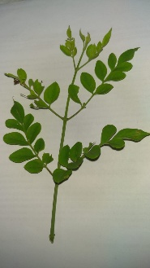
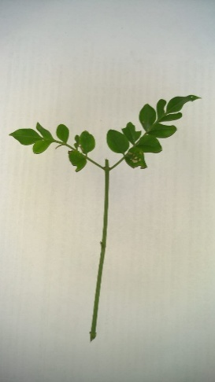
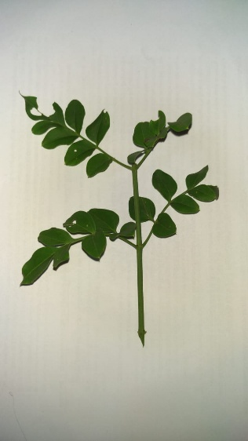
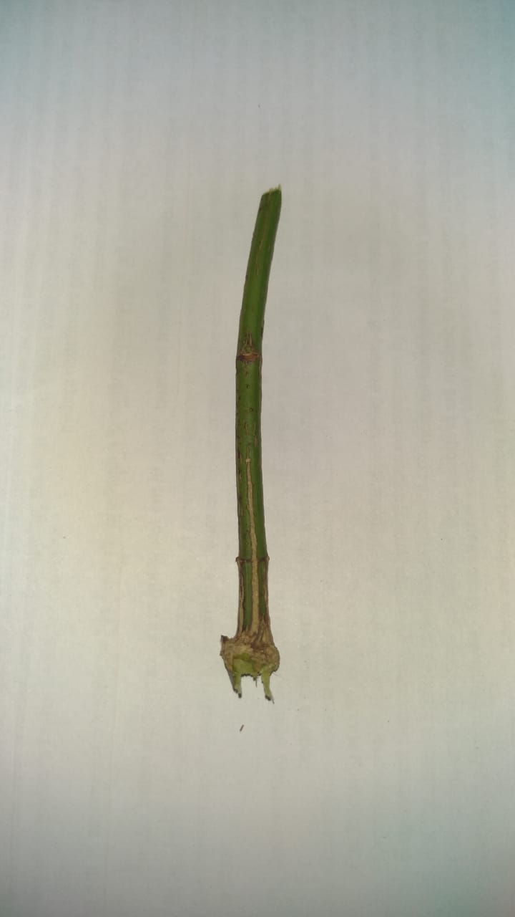
Shoot apices
Softwood
Semi hardwood
Hardwood
Figure 1: Stem cutting types

2.3 Treatment structure
The experiment was arranged in Complete Randomize Design (CRD) with two factor factorial arrangement having twelve treatment combinations and four replications. Each replication contained three experimental units.

Treatment combinations were as follows,
Table 1: Treatment combinations
Treatment combinations
TA1 | Sand+ Shoot apices
TA2 | Sand + Softwood
TA3 | Sand + Semi hardwood
TA4 | Sand + Hardwood
TB1 | Coir dust+ Stem apices
TB2 | Softwood + Coir dust
TB3 | Coir dust + Semi hardwood
TB4 | Coir dust+ Hardwood
TC1 | Stem apices + Sand, Coir dust mixture
TC2 | Softwood + Sand, Coir dust mixture
TC3 | Semi hardwood + Sand, Coir dust mixture
TC4 | Hardwood + Sand, Coir dust mixture

2.4 PREPARATION OF POTTING MEDIA
Grow bags made of 6 cm x 4 cm black polythene were filled with media of pure coir dust, pure sand and mixture of sand and coir dust 1:1 (v/v) treated with a fungicide as a precautionary measure to avoid fungal infections. The stem cuttings were planted in polybags (10 cm x 15 cm) by inserting one node within the media to get cover completely.

2.5 PLANTING OF CUTTINGS
These cuttings were taken as three nodal cuttings bearing 3 –4 leaves. A slant cut was made at the basal end using a sharp blade to create a larger surface area required for rooting. These cut surfaces were dipped in a Roocta hormone just before planting in polybags in order to promote rooting.

2.6 MAINTENANCE OF CUTTINGS
Planted cuttings were maintained under completely sealed propagator, covered using 500-gauge transparent polyethylene sheet. The structure was maintained under 50% shade condition throughout the period of four weeks. Watering of cuttings was not practiced during the period they were kept under the propagator.

2.7 DATA COLLECTION

In the fourth week after the establishment following data were collected.

2.8 SURVIVAL PERCENTAGE
Survival percentage was calculated using following equation;

Survival percentage = survival cuttings x 100
No of cuttings planted

Rooting percentage was calculated using following equation

Rooting percentage = Rooted cuttings x 100
No of cuttings survived

2.9 SHOOT LENGTH
Shoot length was measured in cm using a ruler after two weeks.

2.10 NUMBER OF ROOTS PER CUTTING
Newly emerged roots were counted manually and recorded.

2.11 ROOT WEIGHT
Roots were carefully separated and fresh weight was measured (g) using an analytical balance.

2.13 DATA ANALYSIS
Collected data were statistically analyzed using ANOVA procedures and the difference between the treatments means was compared using Duncan’s Multiple Range Test (DMRT) at 5% significance level by SAS 9.1.3 package.

3 RESULTS AND DISCUSSION
3.1 EFFECT OF CUTTING TYPE AND POTTING MEDIA ON SURVIVAL AND SHOOT LENGTH FOR J. OFFICINALE
The research results revealed the highest but not significant between the growth media and the type of cutting, impacting the percentage survival and shoot length of J. officinale cuttings. The readings were taken 4weeks after planting (Table 1). The highest survival rates were observed in shoot apices planted in a mixture of sand with coir dust media (TC1) and shoot apices planted in sand only media (TA1), hard wood cuttings planted in coir dust media (TB4) and hardwood cuttings planted in a mixture of sand with coir-dust media (TC4), surpassing other treatment combinations. On the other hand, the lowest survival percentage was observed in the case of semi hardwood cuttings planted in sand only media (TA3), when compared to all other treatment combinations except hard-wood cuttings planted in sand media (TA4). The significantly highest shoot length was observed in shoot apices planted in a mixture of sand with coir-dust media (TC1) with compared to all the treatment combinations.

Table 2: Performances of survival and shoot length on different types of stems of J. officinale in different potting media after 4 weeks of planting.
Treatments | Media Type (M) |  |  | Cutting type (C) |  | Survival (%) |  |  | Shoot Length (cm)
TA1 | Sand |  |  | Shoot apex |  | 95.42a |  |  | 3.10b
TA2 | Sand |  |  | Softwood |  | 60.33bc |  |  | 1.83b
TA3 | Sand |  |  | Semi-hardwood |  | 19.67d |  |  | 1.15b
TA4 | Sand |  |  | Hardwood |  | 36.33cd |  |  | 2.29b
TB1 | CD |  |  | Shoot apex |  | 78ab |  |  | 3.18b
TB2 | CD |  |  | Softwood |  | 78ab |  |  | 3.15b
TB3 | CD |  |  | Semi hardwood |  | 85.24ab |  |  | 3.15b
TB4 | CD |  |  | Hardwood |  | 95.42a |  |  | 3.13b
TC1 | Sand + CD |  |  | Shoot apex |  | 100a |  |  | 9.25a
TC2 | Sand + CD |  |  | Softwood |  | 69.67bc |  |  | 1.97b
TC3 | Sand + CD |  |  | Semi hardwood |  | 55bc |  |  | 2.53b
TC4 | Sand + CD |  |  | Hardwood |  | 95.42a |  |  | 2.99b
M × C |  |  | * |  |  |  | *
Treatment |  | M |  |  | * |  |  | *

3.2 EFFECT OF CUTTING TYPE AND POTTING MEDIA ON ROOTING OF SHOOTS, ROOT NUMBER AND ROOT WEIGHT FOR J. OFFICINALE
The research results revealed the highest but not significant between the growth media and the type of cutting, impacting the percentage of rooting of shoots, root number and root weight of J. officinale cuttings (Table 2). The 100% rooting percentage were observed in shoot apices planted in a mixture of sand: coir dust and coir dust only media (TC1 and TB1) but not significant different with TA1, with compared to all other treatment combinations. The lowest rooting percentages were observed in the case of softwood cuttings, semi-hard wood cuttings and hard wood cuttings planted in sand only media (TA2, TA3 and TA4), when compared to all other treatment combinations.
Table 3: Performances of rooting of shoots, root number and root weight different types of stems of J. officinale in different potting media after 4 weeks of planting

Treatments | Media (M) |  |  | Cutting type (C) |  | Percentage of rooting of shoots (%) |  | Root number |  |  | Root weight (g)
TA1 | Sand |  |  | Shoot apices |  | 95.42ab |  | 10.20b |  |  | 0.28c
TA2 | Sand |  |  | Softwood |  | 9.33d |  | 1.47e |  |  | 0.05d
TA3 | Sand |  |  | Semi-hardwood |  | 18.67d |  | 1.95e |  |  | 0.05d
TA4 | Sand |  |  | Hardwood |  | 13.11d |  | 1.95e |  |  | 0.07d
TB1 | CD |  |  | Shoot apices |  | 100a |  | 16.43a |  |  | 1.29b
TB2 | CD |  |  | Softwood |  | 69.67bc |  | 2.95de |  |  | 0.10cd
TB3 | CD |  |  | Semi hardwood |  | 85.34ab |  | 4.61d |  |  | 0.21cd
TB4 | CD |  |  | Hardwood |  | 95.42ab |  | 5.19d |  |  | 0.28cd
TC1 | Sand + CD |  |  | Shoot apices |  | 100a |  | 18.14a |  |  | 1.58a
TC2 | Sand + CD |  |  | Softwood |  | 73abc |  | 7.65c |  |  | 0.07d
TC3 | Sand + CD |  |  | Semi hardwood |  | 55c |  | 9.80b |  |  | 0.08cd
TC4 | Sand + CD |  |  | Hardwood |  | 85.34ab |  | 8.15bc |  |  | 0.22cd
M × C |  |  | * |  |  | * |  |  | *
Treatment |  | M |  |  | * |  | * |  |  | *

The highest but not significance root numbers were observed in shoot apices planted in a mixture of sand: coir-dust media (TC1) and coir dust only media (TB1) while the lowest root numbers were showed in soft wood, semi-hard wood and hard wood cuttings planted in sand media (TA2, TA3 and TA4) when compared to all other treatment combinations except soft wood cuttings planted coir dust media (TB2). The significantly highest root weight was showed in shoot apices planted in a mixture of sand: coir-dust media (TC1) followed by shoot apices planted in coir dust only media (TB1) and the significantly lower root weights was observed in soft wood, semi-hard wood and hard wood cuttings ,planted in a sand only media (TA2, TA3 and TA4) as well as soft-wood cuttings planted in a mixture of sand: coir dust media (TC2) than two treatment combinations which are shown the highest root weights (TC1 and TB1) and treatment combination of root apices planted in sand only media (TA1) .

3.3 DISCUSSION
Propagation techniques in flowering and ornamental plants were introduced to solve most of the problems that hinder effective propagation of significant economic flowering and ornamental plants (Hartmann et al., 2011). This investigation revealed that the cutting type with medium demonstrated substantial viability in shoot and root development (Leakey et al., 2004). In this study, shoot apices planted in the media contained sand mixed with coir dust media showed the significantly higher performance in most tested parameters. “This result might be due to the fact shoot tip cuttings generally produces a new plant faster since a well-developed shoot” is already present as reported by George. 2008. The presence of leaves on stem cuttings enhances root initiation and development by stimulating physiological and hormonal processes in the cutting (Lischweski et al., 2015). The better performances exhibited by the shoot apices could be due to the existence of active and young cells at the apices compared to the matured stem parts (Das et al., 2023). Also, there might be growth hormones available at the apices of stems compared to the mature parts. The media possessed with sand and coir dust might provide a porous rhizosphere which is favorable for emerging roots. Generally, root formation is promoted by the media having minimum of 50% porosity. “It appears likely that sand possesses that characteristic of an ideal medium, including a sufficient amount of gas-filled pore space and an oxygen diffusion rate for healthy respiration to maintain root uptake” (Fonteno and Nelson, 1990). “High aeration is a growth medium is especially crucial for improving root initiation and propagation media ensures that excess water can drain away, allowing air to fill the spaces between particles. oxygen is vital for root development as its facility’s cellular respiration, which provides energy for root growth. Since cuttings require sufficient moisture to initiate root formation, excessive water-retentive media can be harmful” (Eed et al., 2015). The coir dust along absorbs nine-fold of moisture in its weight hence, the retention of air might not be adequate to for root formation. The media of sand and coir dust in equal proportions probably provide a more favorable environment for root formation and development. Coir has successfully been used in cutting and seed propagation. Although coir dust has been reported to have a good buffering capacity. Others indicated that coir-dust increases medium pH over time (Scagel, 2003). “Enhance aeration potential and drainage capacity/porosity, which promote root development and spreading, are responsible for better toot growth”. (Beardsell et al, 1979). Abera and Sulaiman (2019) found that “increased aeration in rooting potential of cuttings can be greatly influenced by the type of rooting utilized”. The study done by Haile (2017) showed that “the potting medium had a substantial impact on the fresh weight of roots per cutting”. Also, the study done by Haile (2017) discovered that “the rooting media had a substantial impact on root fresh weight and showed that the least root mass was found in stem cuttings rooted in an agricultural soil”.

4.CONCLUSION
This study demonstrates that the propagation success of Jasminum officinale via stem cuttings is highly dependent on both the type of cutting and the rooting medium. Shoot apices planted in a 1:1 (v/v) mixture of sand and coir dust yielded the highest survival, rooting, shoot length, root number, and root fresh weight. This medium offers the ideal physical properties for root development. Therefore, for mass propagation and nursery production of J. officinale, it is recommended to use shoot apex cuttings in a sand and coir dust mixture. Future research could investigate the effects of different rooting hormone concentrations and alternative organic amendments to further optimize the protocol.

Disclaimer (Artificial intelligence)
Author(s) hereby declare that NO generative AI technologies such as Large Language Models (ChatGPT, COPILOT, etc.) and text-to-image generators have been used during the writing or editing of this manuscript.

REFERENCES
- Abera Jaleta, A., & Sulaiman, M. (2019). A review on the effect of rooting media on rooting and growth of cutting propagated grape (Vitis vinifera L). World Journal of Agriculture and Soil Science, 3(3), Article 000567. https://doi.org/10.33552/WJASS.2019.03.000567
- Beardsell, D. V., Nichols, D. G., & Jones, D. L. (1979). Water relations of nursery potting-media. Scientia Horticulturae, 11(1), 9–17. https://doi.org/10.1016/0304-4238(79)90049-9
- Chithranayana, R. D., & Punyawardena, B. V. R. (2008). Identification of drought-prone agro-ecological regions in Sri Lanka. Journal of the National Science Foundation of Sri Lanka, 36(2), 117–123. https://doi.org/10.4038/jnsfsl.v36i2.143
- Das, S., Mondal, T., & Sarkar, A. (2023). Effect of cutting types and rooting media on vegetative propagation of ornamental plants. Journal of Plant Growth Regulation, 42, 2141–2152. https://doi.org/10.1007/s00344-022-10715-4
- Dorken, M. E., & Eckert, C. G. (2001). Severely reduced sexual reproduction in northern populations of a clonal plant, Decodon verticillatus (Lythraceae). Journal of Ecology, 89(3), 339–350. https://doi.org/10.1046/j.1365-2745.2001.00558.x
- Eed, A. M., El-Sallami, I. H., & El-Shall, S. A. (2015). Effect of rooting media and auxins on rooting of ornamental cuttings. Journal of Horticultural Science & Biotechnology, 90(4), 443–449. https://doi.org/10.1080/14620316.2015.11513212
- Farnood, R. (2024). Generative and vegetative propagation in medicinal and aromatic plants. Advances in Crop Science and Technology, 13(1), 492. https://doi.org/10.35248/2167-0412.24.13.492
- Fonteno, W. C., & Nelson, P. V. (1990). Physical properties of container media and their ef fect on plant growth. HortScience, 25(1), 20–24. https://doi.org/10.21273/HORTSCI.25.1.20
- George, E. F., Hall, M. A., & De Klerk, G.-J. (2008). Plant propagation by tissue culture: Volume 1, The background (3rd ed.). Springer. https://doi.org/10.1007/978-1-4020-5005-3
- Haile, A. (2017). Influence of rooting media on root and shoot growth of stem cuttings. International Journal of Agricultural Research, 12(2), 55–62. https://doi.org/10.3923/ijar.2017.55.62
- Hartmann, H. T., Kester, D. E., Davies, F. T., & Geneve, R. L. (2011). Plant propagation: Principles and practices (8th ed.). Pearson Education. https://doi.org/10.1007/978-94-017-3321-6
- Leakey, R. R. B. (2004). Physiology of vegetative reproduction. In J. Evans (Ed.), Encyclopedia of forest sciences (pp. 1655–1668). Elsevier. https://doi.org/10.1016/B0-12-145160-7/00115-9
- Lischweski, S., Muchow, A., Guthörl, D., Hause, B., & Druege, U. (2015). Jasmonates act positively in adventitious root formation in petunia cuttings. BMC Plant Biology, 15, 229. https://doi.org/10.1186/s12870-015-0615-1
- Mahanta, S., & Gantait, S. (2024). Trends in plant tissue culture and genetic improvement of gerbera. Horticulture, Plant Journal, 10(3), 100–112. https://doi.org/10.1016/j.hpj.2024.03.003
- Pholo, M. S., Soundy, P., & Du Toit, E. S. (2013). Vegetative propagation of Pelargonium sidoides: Factors affecting rooting of leaf bud cuttings. Acta Horticulturae, 1007, 781–786. https://doi.org/10.17660/ActaHortic.2013.1007.92
- Scagel, C. F. (2003). Growth and nutrient use of ericaceous plants grown in media amended with sphagnum moss peat or coir dust. HortScience. https://doi.org/10.21273/HORTSCI.38.1.46

