Vegetative Compatibility Groups within Populations of Fusarium oxysporum f. sp. cubense Causing Banana Fusarium Wilt in Myanmar

.
ABSTRACT
Vegetative compatibility groups (VCGs) are used to study genetic relationships among asexually reproducing plant pathogenic fungi. VCGs are strongly associated with specific Fusarium oxysporum f. sp. cubense (Foc) races and often correlate with pathogenicity. In this study, 20 Foc isolates, the causal agent of banana Fusarium wilt, were analyzed using VCG analysis to identify strains and assess their diversity. The experiment was conducted from August 2024 to February 2025 at the Laboratory of the Department of Plant Pathology, Yezin Agricultural University, Myanmar. The 20 isolates tested were previously confirmed as virulent and identified as Foc race 1 through pathogenicity and PCR assays carried out in the same Laboratory. Nit-mutants of each isolate were firstly induced on KPS media (potato dextrose agar medium amended with 1.5% potassium chlorate, KClO₃) and generated on minimal media (MM). VCGs assay was performed on MM media by pairing the generated nit-mutants of each Foc isolate with nit-M mutants of 15 known Foc VCGs testers which were obtained from China. The ability of heterokaryon formation among isolates and VCGs testers was evaluated, and the corresponding physiological races were designated. Among the 20 isolates, 11 belonged to VCG 0124, eight to the VCG 0124/0125 complex, and one to VCG 0125, accounting for 55%, 40%, and 5% of the isolates, respectively. VCG analysis indicated that VCG 0124 was the most prevalent group, followed by the 0124/0125 complex and VCG 0125.The identification of these VCGs is consistent with earlier virulence and molecular studies, confirming that the isolates are pathogenic and belong to Fusarium oxysporum f. sp. cubense race 1. This study represents the first comprehensive investigation of Foc populations in Myanmar using VCG analysis.
Keywords: Banana Fusarium wilt, Fusarium oxysporum f. sp. cubense (Foc), Race 1, Strain, Vegetative compatibility groups (VCGs)
1. INTRODUCTION
Banana Fusarium wilt, widely known as Panama disease, is caused by a soil-borne ascomycete fungus, Fusarium oxysporum f.sp. cubense (Foc). The disease continues to be one of the most destructive constraints to banana production in the world (Pegg et al., 2019; D. N. Shukla et al., 2024) and occurs in all Asian countries (Molina, 2013). It is responsible for substantial yield losses and major restrictions to successful commercial cultivation (Daly et al., 2006; Ploetz, 2015). Fusarium wilt has become an increasingly serious problem in banana plantations across Myanmar. Bananas represent one of the most economically important perennial fruit crops in the country, cultivated for both domestic markets and cross-border trade. Recent assessments indicated a high disease incidence in the widely grown Hpi-gyan cultivar (Bluggoe subgroup; Ploetz et al., 2007), whereas a lower incidence has been recorded in Ya-khaing (Pisang Awak subgroup; Ploetz et al., 2007), suggesting variation in cultivar susceptibility or pathogen prevalence. In Hpi-gyan plantations, disease incidence ranges from 5–10% in newly established fields and increases to 15–30% in ratoon crops (Cho Cho San et al., 2024). Traditional practices, such as replanting infected suckers, further accelerate the spread of the pathogen. In addition, the pathogen’s survival structures, chlamydospores, enable long-term persistence in soil for decades (Dita et al., 2018).
The Foc exhibits high genetic and pathogenic diversity, comprising multiple races and strains that differ in population structure and levels of virulence, resulting in variable disease severity across susceptible banana genotypes (Ploetz and Pegg, 2000; Visser et al., 2010). This diversity is conventionally classified into four major pathogenic races namely Foc races 1, 2, 3, and 4 based on host range and cultivar susceptibility (Moore et al., 1993; Pegg et al., 1995). Beyond race classification, Foc isolates are further grouped into 24 vegetative compatibility groups (VCGs) distributed among the different races (Ploetz, 2006; Ploetz, 2015; Mostert et al., 2017). Vegetative compatibility grouping is a phenotypic system that distinguishes asexually reproducing fungal strains capable of hyphal fusion and heterokaryon formation. Because genetically similar isolates typically belong to the same VCG, this method provides a reliable means of identifying phenotypically related subpopulations. VCGs in Foc are determined when hyphae of complementary nitrate non-utilizing (nit) mutants, generated on chlorate medium, anastomose to form stable heterokaryons on minimal medium (MM) (Puhalla, 1985; Leslie, 1993). Isolates belonging to the same VCG possess identical alleles at all vic (vegetative incompatibility) loci, whereas isolates from different VCGs differ at one or more vic loci (Leslie, 1993). It is also highly useful for assessing banana resistance and for grouping Foc isolates according to their virulence profiles on different banana cultivars (races) (Correll et al., 1987; Leslie, 1990). Although VCG identity correlates strongly with race affiliation, it does not independently confirm pathogenicity; therefore, biological pathogenicity testing remains essential (Ploetz, 2006; Mostert et al., 2017).
Vegetative compatibility analyses have been successfully employed to determine the origin and global distribution of Fusarium oxysporum f. sp. cubense (Foc) (Bentley et al., 1998; Fourie et al., 2011). Of the 24 VCGs identified globally, 15 have been reported from Asia (Pegg et al., 1995; Katan, 1999; Riska et al., 2012; Czislowski et al., 2018). Two VCG complexes, 0124/0125 and 01213/01216, predominate in Asia (Mostert et al., 2017). Several VCGs within Foc, including VCGs 0124, 0125, 0128, 01212, 01220, and 01222, are among the most widely distributed worldwide and occur in all regions where bananas are cultivated (Ploetz, 2005; O’Donnell et al., 1998; Fourie et al., 2009; Fourie et al., 2011). Numerous studies have demonstrated the value of VCG analysis for population characterization, epidemiological investigations, and the differentiation of major Foc evolutionary groups, such as subtropical race 4 (SR4; VCGs 0120, 0129, 01211, and 01215) and tropical race 4 (TR4; VCGs 01213/01216) (Fourie et al., 2011). The first confirmed detection of Foc race 4 in Myanmar occurred in 2018 near the Myanmar–China border (Zheng et al., 2018), raising concern over the introduction of aggressive Cavendish-infecting genetic groups. Later studies confirmed that Foc race 1 is already widely distributed across major banana-producing regions, including some plantations of Ayeyarwady, Mandalay, and Naypyitaw (Cho Cho San et al., 2024). Race 1 is a major epidemic driver in many tropical countries and can cause yield losses of up to 60% in susceptible dessert bananas under favorable conditions (Tushemereirwe et al., 2000; Karangwa et al., 2016). Understanding the diversity and evolutionary history of Foc populations is crucial for developing effective disease management strategies.
Monitoring variations in isolates collected from different cultivars and geographic regions is essential for resistance breeding, especially because Foc is genetically dynamic and capable of overcoming host resistance (Ploetz, 1990; Moore, 1994). The conventional approaches to assess variation among the fungal isolates are morphological and virulence analysis. Whereas, vegetative compatibility group (VCG) analysis can be used to accurately characterize Foc isolates (Fourie et al., 2011). It provides a clearer assessment of phenotypic relatedness and continues to be one of the most reliable tools for differentiating and tracking Foc race populations due to strong race associations within this pathogen (Ploetz, 2006; Thangavelu and Mustaffa, 2010; Mostert et al., 2017). Although VCG diversity in Foc has been documented for strains collected from nearly all Asian countries, it has not yet been reported in Myanmar. Therefore, the present study aimed to identify VCGs within Myanmar Foc populations and to determine population relationships among field isolates in order to support epidemiological monitoring and banana resistance breeding programs.

2. material and methods
2.1. Fungal isolation
Total of 20 Foc isolates were used in this research and they were cultured and maintained in the Laboratory of Department of Plant Pathology, YAU. All isolates except two had been previously identified as Foc race 1 through PCR assay and confirmed as pathogenic ones via pathogenicity assay on susceptible Hpi-gyan cultivar (Bluggoe subgroup, ABB genome group). Both of these assays were conducted at the same department in 2024. All isolates were sub-cultured onto potato dextrose agar (PDA) modified with 0.1 g L⁻¹ of (0.01%) streptomycin, and incubated for 10 days at 28°C in a growth chamber (Leslie et al. 2006). After 10 days of incubation, colony were checked and compared to the characteristics of Fusarium spp. as described by Leslie and Summerell (2006). Then, single spore isolation was made for each isolate and the details of all isolates with respect to cultivars and locations were marked (Table 1).
Table 1. List of 20 Foc isolates used in this study and their source of collection
Sr. no. | Isolate name | Village | Township | Region
1. | Kyonpyaw-1 | Nyaungpinkwin | Kyonpyaw | Ayeyarwady
2. | Kyonpyaw-2 | Saintgyi | Kyonpyaw | Ayeyarwady
3. | Dadaroo-1 | Sakarinn | Dadaroo | Mandalay
4. | Patheingyi-1 | Nyaungpinthar | Patheingyi | Mandalay
5. | Kyaukse-1 | Thanywa (West) | Kyaukse | Mandalay
6. | Myitthar-1 | Yakhainggyi | Myitthar | Mandalay
7. | Myitthar-2 | Kume | Myitthar | Mandalay
8. | Nyaung-U-1 | Letpanchaypaw | Nyaung-U | Mandalay
9. | Kyaukpadaung-1 | Popa, Taungpawywa | Kyaukpadaung | Mandalay
10. | Pyinmana-1 | Thanatpinzeik | Pyinmana | Naypyitaw Union Territory
11. | Pyinmana-2 | Nyaungpingyi | Pyinmana | Naypyitaw Union Territory
12. | Pyinmana-3 | Thayagon | Pyinmana | Naypyitaw Union Territory
13. | Pyinmana-4 | Ywathitgyi | Pyinmana | Naypyitaw Union Territory
14. | Pyinmana-5 | Kyaukchet | Pyinmana | Naypyitaw Union Territory
15. | Lewe-1 | Kungyangon | Lewe | Naypyitaw Union Territory
16. | Lewe-2 | Ngapyawdaw | Lewe | Naypyitaw Union Territory
17. | Zeyarthiri-1 | Ywathit | Zeyarthiri | Naypyitaw Union Territory
18. | Zeyarthiri-2 | Laythar | Zeyarthiri | Naypyitaw Union Territory
19. | Zeyarthiri-3 | Thayettaw | Zeyarthiri | Naypyitaw Union Territory
20. | Pobbathiri-1 | Sintelgyi | Pobbathiri | Naypyitaw Union Territory

2.2. Induction and generation of nit Mutants
Seven-day old of purified fungal growth (Plate 1a-b) from the single spore culture was transferred onto KPS media (PDA amended with 1.5% potassium chlorate, KClO₃). The cultured plates were incubated at 28 °C for 7–14 days and then, checked for the fun-shaped colony sectors. Any unusual mycelium sectors were discarded. The chlorate-resistant fun-shaped colony sector (Plate 1c), which is growing on the KPS media, was cut into small size (5 mm in diameter), moved onto new minimal media (MM), and incubated at 28 °C for 7 days. Those sectors that produced very sparse growth with thin mycelia on MM media were considered as nitrate-non utilizing mutants (nit- mutant) and with thick mycelia, to be as wild type. If nit-mutant was not formed within 7-14 days, procedure was repeated until getting nit-mutant of all isolates. Then, the mutant colonies were collected and used for VCGs test.

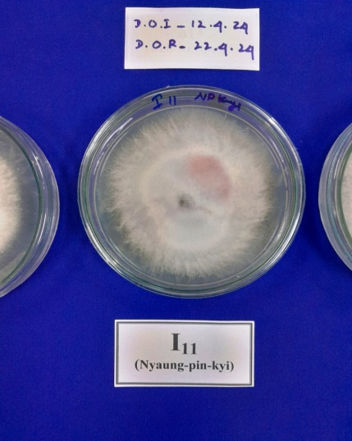  (a) | 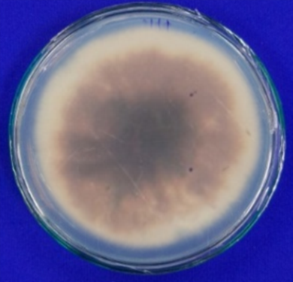  (b) | 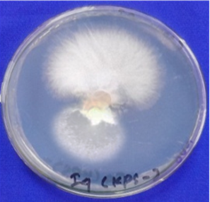  (c)
Plate 1. Seven-day old culture of Foc isolates: (a) surface and (b) reverse colony of Foc Pyinmana-2 isolate on PDA media; (c) fast growing, fun-shaped, chlorate-resistant sectors emerging from a restricted wild type colony of Foc Kyaukpadaung-1 isolate on KPS media.

2.3. Vegetative compatibility groups (VCGs) analysis
Vegetative compatibility groups (VCGs) analysis was conducted in the laboratory of the Department of Plant Pathology, Yezin Agricultural University, Naypyitaw from August 2024 to February 2025. Cultured medium used in the VCGs analysis was Minimal Media (MM). All nit-mutants generated from the 20 isolates of unknown VCG were paired on MM media with nit-M mutants of 15 known VCG according to the method described by Leslie and Summerell (Leslie et al., 2006). The 15 known Foc VCG tester strains used in this study, which were provided by Professor Dr. Fu Gang, Plant Protection Institute, Guangxi Academy of Agricultural Science, China, and included: VCG 0120, VCG 0121, VCG 0122, VCG 0123, VCG 0124, VCG 0125, VCG 0126, VCG 0128, VCG 01213, VCG 01216, VCG 01217, VCG 01218, VCG 01219, VCG 01220, VCG 01221. They were re-cultured on MM media for rejuvenation, and labeled similar to tester’s code. VCG was determined using the technique by Puhala (1985). The test was conducted by placing mycelial disc (5mm in diameter) of nit-mutants generated from each isolate onto the center of Petridish including MM media. Meanwhile, three pieces of respective mycelial discs of the known VCG testers were put surrounding 10-15 mm apart from to the center one by triangle formation (Plate 2c). The paired cultures on MM media were done by 3 repeats for each mutant and incubated at 28˚C. VCG testing was conducted at least twice for the same isolate to confirm vegetative compatibility. Some exceptions need to be repeated multiple times to obtain results.

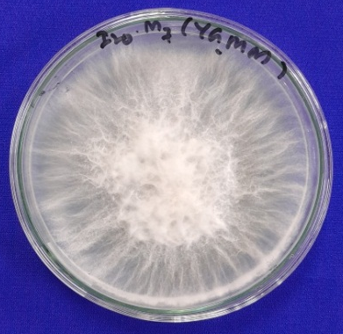  (a) | 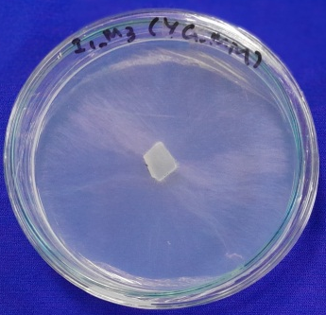  (b) | 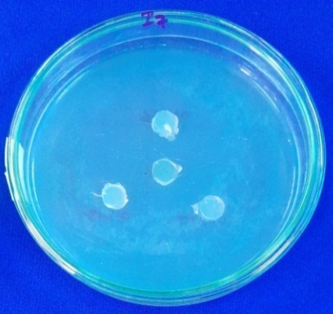  (c)
Plate 2 Seven-day old cultures of Foc on MM media: (a) thick mycelial growth of wild type colony of Foc Pobbathiri-1 isolate; (c) a very sparse and thin mycelial growth of nit mutant type colony of Foc Kyonpyaw-1 isolate (c) compatibility assays between known VCG tester strains and nit mutant generated from Myitthar-2 isolate.

2.4. Data recording and race designation
From 7 days after incubation, cultures were checked for heterokaryon development. It can be easily scored by the line of dense, nutrient sufficient heterokaryon growth which develops between the mycelium of generated mutants and the advancing margin of the tester nit-M mutant (Correl et al., 1987; Leslie, 1990). If no heterokaryon growth developed after 21 days, the paired strains were designated as vegetatively incompatible (vic). If the heterokaryon formation occurred between a new strain and a tester nit-M mutant (usually within 10 days), the strain was assigned to the same VCG as the tester strain. Then, race structure was comfirmed as described in Table 3 according to Ploetz (1990), Boehm et al. (1994), Thangavelu et al. (2003), Fourie et al. (2009), Mostert et al. (2017) and Czislowski et al. (2018).

3. RESULTS AND DISCUSSION
The VCGs assay is used as phenotypic markers to determine genetic diversity and polymorphism (Puhalla, 1985). Leslie (1996) stated that VCG test gave rapid isogenization of fungal strains within a population. According to the outcome by VCGs analysis, low diversity of VCG 0124 (Plate 4a-e), VCG 0125 (Plate 4f) and VCG 0124/0125 (Plate 4g-i) and was discovered among the isolates collected from three main regions; Ayarwaddy (lower parts of Myanmar), Mandalay (upper parts of Myanmar), Naypyitaw Union Territory (central Myanmar) as described in Table 2.
There was found to be variation in the degree of heterokaryon formation (Plate 3): some showed a line of slight mycelial growth formation (weak heterokaryon), some showed moderate (moderate heterokaryon) and other showed very thick growth (strong heterokaryons). VCG 0124 strain is mostly common and the largest Foc strain in the study areas of Myanmar, followed by VCG 0124-0125 and VCG 0125 strains. Out of the 20 tested isolates, 11 belonged to VCG 0124 and one isolate belonged to VCG 0125 and 8 belonged VCG 0124/0125 complex (Table 3). VCG 0124 represented the predominant population with 55% of total 20 collected Foc isolates as well as the cross compatible population was VCG 0124/0125 with a proportion of 40%. Foc identified as VCG 0125, had the lowest proportion with 5% of the total population (Table 2). No isolate was incompatible with known VCGs nit-M testers.
Table 2 Population frequency of respective VCG strains of 20 Foc isolates corresponding regions of different banana fields
Sr.  no. | Source of collection | Number  of Foc isolates | No. of observed VCGs |  |  | vic.
Sr.  no. | Source of collection | Number  of Foc isolates | 0124 | 0125 | 0124/  0125 | vic.
1 | Ayeyarwady | 2 | 0 | 0 | 2 | 0
2. | Mandalay | 7 | 4 | 0 | 3 | 0
3. | Naypyitaw | 11 | 7 | 1 | 3 | 0
Total number of tested Foc isolates |  | 20 | 11 | 1 | 8 | 0
Population frequency (%) of respective VCGs |  |  | 55 % | 5 % | 40% | 0 %
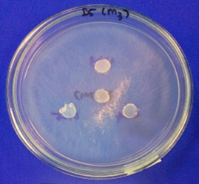  (a) | 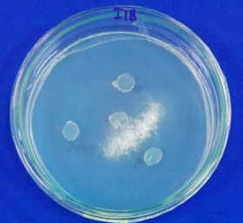  (b) | 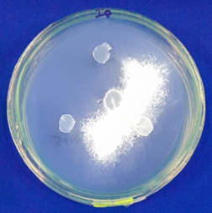  (c)
vic = vegetatively incompatibility
Plate 3 Variation in the degree of heterokaryon formation among corresponding isolates: (a) slight mycelial growth (a weak heterokaryon) in Kyaukse-1, (b) moderate mycelial growth (a moderate heterokaryon) in Zeyarthiri-2, and (c) very dense mycelial growth (a strong heterokaryon) in Nyaung-U-1. Cultures were 10 days old.

Therefore, the results of this study revealed that VCG 0124 and the VCG 0124/0125 complex constituted the largest Foc populations based on population frequency in the surveyed areas of Myanmar. These findings are consistent with those of Fourie et al. (2009, 2011) and Mostert et al. (2017), who reported that VCGs 0124 and 0125 are among the most widely distributed groups worldwide. In addition, the present results are supported by Mostert et al. (2017), who reported that the VCG 0124/0125 complex is a dominant Foc strain in countries where isolates were collected from non-Cavendish banana cultivars. In this study, the predominance of these two strains of Foc race 1 observed in Myanmar may be attributed to limited sampling, as all isolates were obtained from a single, frequently infected cultivar, Hpi-gyan. Notably, isolates were not collected from major banana-growing areas such as Kachin State and Taungoo Township (Bago Region), where Cavendish cultivars and other genome groups are widely grown. Therefore, further sampling of infected cultivars across major banana-growing regions is recommended to better characterize the diversity of Foc in Myanmar.

Table 3 Strain diversity of 20 Foc isolates classified by VCG analysis and their associated races
Sr  no. | Isolates | VCGs strains |  |  | vic. | Associated race
Sr  no. | Isolates | 0124 | 0125 | 0124/0125 | vic. | Associated race
1 | Kyonpyaw-1 | - | - | ++ | - | Race 1
2 | Kyonpyaw-2 | - | - | + | - | Race 1
3 | Dadaroo-1 | - | - | + | - | Race 1
4 | Patheingyi-1 | - | - | + | - | Race 1
5 | Kyaukse-1 | + | - | - | - | Race 1
6 | Myitthar-1 | ++ | - | - | - | Race 1
7 | Myitthar-2 | - | - | + | - | Race 1
8 | Nyaung-U-1 | +++ | - | - | - | Race 1
9 | Kyaukpadaung-1 | + | - | - | - | Race 1
10 | Pyinmana-1 | +++ | - | - | - | Race 1
11 | Pyinmana-2 | + | - | - | - | Race 1
12 | Pyinmana-3 | +++ | - | - | - | Race 1
13 | Pyinmana-4 | - | ++ | - | - | Race 1
14 | Pyinmana-5 | ++ | - | - | - | Race 1
15 | Lewe-1 | +++ | - | - | - | Race 1
16 | Lewe-2 | - | - | + | - | Race 1
17 | Zeyarthiri-1 | - | - | + | - | Race 1
18 | Zeyarthiri-2 | ++ | - |  | - | Race 1
19 | Zeyarthiri-3 | +++ | - |  | - | Race 1
20 | Pobbathiri-1 | - | - | +++ | - | Race 1
 | *No. of isolates | 11 | 1 | 8 | 0
“+” indicates that appearance of heterokaryon formation:
(+ weak heterokaryon; ++ moderate heterokaryon; +++ strong heterokaryon formation)
“-” indicates that no appearance of heterokaryon formation
“vic” vegetative incompatibility that mean not belonged to any of known VCG testers
* Number of isolates belonging to respective Foc VCG strains
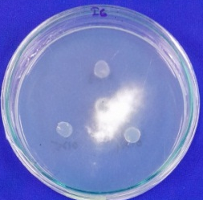  (a) | 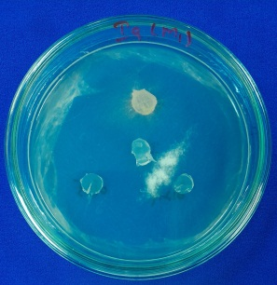  (b) | 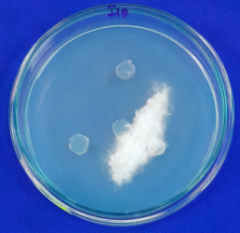  (c)
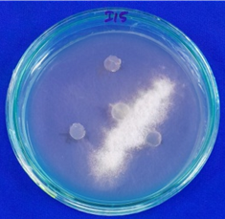  (d) | 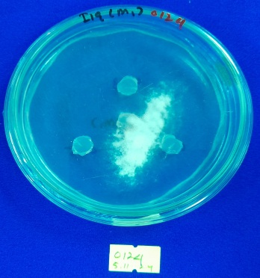  (e) | 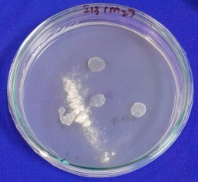  (f)
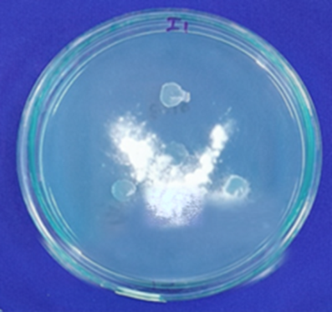  (g) | 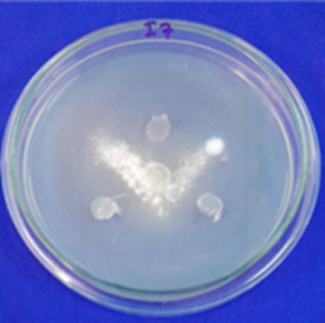  (h) | 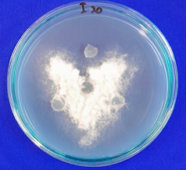  (i)
Plate 4 Heterokaryon development (a line of dense mycelial growth) between nit-mutants of vegetatively compatible strains of respective Foc isolates belonging to: (a-e) VCGs 0124 in (a) Myitthar-1, (b) Kyaukpadaung-1, (c) Pyinmana-1, (d) Lewe-1, (e) Zeyarthiri-3; (f) VCGs 0125 in Pyinmana-4; (g-i) VCGs 0124/0125 complex in (g) Kyonpyaw-1, (h) Myitthar-2, (i) Pobbathiri-1. Cultures are 10 days old.

The relationship between vegetative compatibility groups (VCGs) and races of Fusarium oxysporum f. sp. cubense (Foc) has been well documented, with race 1 primarily associated with VCGs 0124 and 0125 (Ploetz, 1990). Based on established race classifications (Boehm et al., 1994; Koenig et al., 1997; Bentley et al., 1998; Groenewald et al., 2006; Fourie et al., 2009; Fraser-Smith et al., 2014), all isolates examined in the present study were identified as belonging to VCGs 0124, 0125 and the 0124/0125 complex, which are globally recognized as race 1–associated lineages (Ploetz, 1990; Mostert et al., 2017). These results indicate that race 1–related strains predominate in the surveyed banana-growing regions of Myanmar. This uniform VCG profile is consistent with reports from other Asian countries, where race 1 isolates are predominantly associated with VCGs 0124 and 0125 and frequently exhibit cross-compatibility between these groups (Brake et al., 1990; Thangavelu et al., 2003; Mostert et al., 2017). Previous PCR-based analyses confirmed that 18 of the 20 isolates belonged to race 1, while in the present study the remaining two isolates formed heterokaryons with the race 1 tester strain (VCG 0124), indicating close genetic relatedness. Collectively, the molecular and VCG data confirm that all isolates examined are associated with Foc race 1.
Although VCGs generally correlate with genetic lineages, they do not strictly define pathogenic behavior, as isolates within the same VCG may differ in virulence. Consequently, race classification in Foc is based on pathogenicity to specific banana cultivars (Waite and Stover, 1960). Foc race 1 is epidemiologically associated with the Gros Michel subgroup (AAA) (Dita et al., 2018) and infects a wide range of cultivars belonging to the ABB, AAB, and AAA genome groups (Stover, 1962). In the present study, all isolates recovered from diseased Hpi-gyan plants (Bluggoe subgroup; Ploetz et al., 2007) were identified as race 1–related. This finding contrasted with earlier reports that traditionally regarded Bluggoe cultivars as susceptible to race 2, but supports previous observations that isolates within the same VCG can infect both race 1– and race 2–susceptible cultivars, indicating overlap in host specificity (Ploetz and Correll, 1988; Ploetz, 1990; Moore, 1995). Similar observations were also reported by Zhan et al. (2022), who demonstrated that the Bluggoe subgroup can be infected by both Foc races 1 and 2. The absence of race 2–associated VCG 0128 (Ploetz and Correll, 1988), and race 4–associated VCGs 01213 and 01216 (Fourie et al., 2011) in the present collections suggests that Fusarium wilt epidemics in Myanmar are currently driven predominantly by race 1 populations.

4. CONCLUSION
This study revealed a highly uniform VCG structure among Foc isolates from Myanmar, with most isolates belonging to VCGs 0124, 0125, or the 0124/0125 complex. The identification of these VCGs supports previous virulence assessments and molecular analyses, confirming that all tested isolates are pathogenic and belong to Fusarium oxysporum f. sp. cubense race 1. The dominance of race 1–associated VCGs has important implications for banana production, particularly for the continued cultivation of ABB genomes and the selection of resistant cultivars. Ongoing surveillance using VCG and molecular tools will be essential to detect potential incursions of race 4 and to guide sustainable disease management strategies for Myanmar’s banana industry. While VCG diversity has been extensively studied in other ASEAN countries, this represents the first report of VCG characterization of Foc populations in Myanmar. However, the collections for these 20 isolates tested in this study were geographically limited and subject to sampling bias, providing only a partial representation of Foc diversity in the surveyed regions. Consequently, future studies should incorporate broader geographic coverage and a wider range of banana cultivars to develop a complete understanding of the population structure and diversity of this pathogen in Myanmar.
Disclaimer (Artificial intelligence)
Option 1:
Author(s) hereby declare that NO generative AI technologies such as Large Language Models (ChatGPT, COPILOT, etc.) and text-to-image generators have been used during the writing or editing of this manuscript.

REFERENCES

- Bentley, S., Pegg, K. G., Moore, N. Y., Davis, R. D., & Buddenhagen, I. W. (1998). Genetic variation among vegetative compatibility groups of Fusarium oxysporum f. sp. cubense analyzed by DNA fingerprinting. Phytopathology, 88(12), 1283–1293. https://doi.org/10.1094/PHYTO.1998.88.12.1283
- Boehm, E. W. A., Ploetz, R. C., & Kistler, H. C. (1994). Statistical analysis of vegetative compatibility groups in Fusarium oxysporum f. sp. cubense. Phytopathology, 84(2), 167–172.
- Brake, V. M., Pegg, K. G., Irwin, J. A. G., & Langdon, P. W. (1990). Vegetative compatibility groups within Australian populations of Fusarium oxysporum f.sp. cubense, the cause of Fusarium wilt of bananas. Australian Journal of Agricultural Research, 41(5), 863–870. https://doi.org/10.1071/AR9900863
- Cho Cho San , Myo Zaw, Chaw Su Su Htwe, Nang Kyu Kyu Win and Tin Aye Aye Naing. (2024). Characterization of Fusarium oxysporum f. sp. cubense Causing Banana Fusarium Wilt Disease. Proceedings of the Centennial Research Conference of Yezin Agricultural University, 7-8 October 2024: 204-216.
- Correll, J. C., Klittich, C. J. R., & Leslie, J. F. (1987). Nitrate nonutilizing mutants of Fusarium oxysporum and their use in vegetative compatibility tests. Phytopathology, 77(12), 1640–1646. https://doi.org/10.1094/Phyto-77-1640
- Czislowski, E., Fraser-Smith, S., Zander, M., O'Neill, W. T., Meldrum, R. A., Tran-Nguyen, L. T. T., Batley, J., & Aitken, E. A. B. (2018). Investigation of the diversity of effector genes in the banana pathogen, Fusarium oxysporum f. sp. cubense, reveals evidence of horizontal gene transfer. Molecular Plant Pathology. https://doi.org/10.1111/mpp.12594
- Daly, A., Pegg, K. G., & Gibas, C. F. C. (2006). Fusarium wilt of banana. In R. Barkai-Golan & N. Paster (Eds.), Diseases of fruits and vegetables (Vol. 1, pp. 143–159). Springer.
- Dita, M., Barquero, M., Heck, D., Mizubuti, E. S. G., & Staver, C. P. (2018). Fusarium wilt of banana: Current knowledge on epidemiology and research needs toward sustainable disease management. Frontiers in Plant Science, 9, Article 1468. https://doi.org/10.3389/fpls.2018.01468
- Fourie, G., Steenkamp, E. T., Gordon, T. R., & Viljoen, A. (2009). Evolutionary relationships among the Fusarium oxysporum f. sp. cubense vegetative compatibility groups. Applied and Environmental Microbiology, 75(14), 4770–4781. https://doi.org/10.1128/AEM.00370-09
- Fourie, G., Steenkamp, E. T., Ploetz, R. C., Gordon, T. R., & Viljoen, A. (2011). Current status of the taxonomic position of Fusarium oxysporum formae specialis cubense within the Fusarium oxysporum complex. Infection, Genetics and Evolution, 11(3), 533–542. https://doi.org/10.1016/j.meegid.2011.01.012
- Fraser-Smith, S., Czislowski, E., Meldrum, R. A., Zander, M., O’Neill, W., Balali, G. R., et al. (2014). Sequence variation in the putative effector gene SIX8 facilitates molecular differentiation of Fusarium oxysporum f. sp. cubense. Plant Pathology, 63(5), 1044–1052.
- Groenewald, S., van den Berg, N., Marasas, W. F. O., & Viljoen, A. (2006). Biological, physiological and pathogenic variation in a genetically homogeneous population of Fusarium oxysporum f. sp. cubense. Australasian Plant Pathology, 35(4), 401–409.
- Hwang, S. C., & Ko, W. H. (2004). Cavendish banana cultivars resistant to Fusarium wilt acquired through somaclonal variation in Taiwan. Plant Disease, 88(6), 580–588. https://doi.org/10.1094/PDIS.2004.88.6.580
- Koenig, R. L., Ploetz, R. C., & Kistler, H. C. (1997). Fusarium oxysporum f. sp. cubense consists of a small number of divergent and globally distributed clonal lineages. Phytopathology, 87(9), 915–923.
- Karangwa, P., Mostert, D., Ndayihanzamaso, P., Dubois, T., Niere, B., Zum Felde, A., Schouten, A., Blomme, G., Beed, F., & Viljoen, A. (2018). Genetic diversity of Fusarium oxysporum f. sp. cubense in East and Central Africa. Plant Disease, 102(3), 552–560. https://doi.org/10.1094/PDIS-02-17-0282-RE
- Katan, T. (2001). Vegetative compatibility group diversity in Fusarium. In B. A. Summerell, J. F. Leslie, D. Backhouse, W. L. Bryden, & L. W. Burgess (Eds.), *Fusarium: Paul E. Nelson memorial symposium* (pp. 165–182). APS Press.
- https://www.apsnet.org/publications/apsnetbooks/Pages/FusariumPaulENelson.aspx
- Leslie, J. F. (1990). Genetic analysis of vegetative compatibility in Fusarium moniliforme. Phytopathology, 80(12), 1340–1344.
- Leslie, J. F. (1993). Fungal vegetative compatibility. Annual Review of Phytopathology, 31, 127–150. https://doi.org/10.1146/annurev.py.31.090193.001015
- Leslie, J. F. (1993). Fungal vegetative compatibility. Annual Review of Phytopathology, 31, 127–150. https://doi.org/10.1146/annurev.py.31.090193.001015
- Leslie, J. F., & Summerell, B. A. (2006). The Fusarium laboratory manual. Blackwell Publishing. https://doi.org/10.1002/9780470278376
- Molina, A. B. (2013). Managing Fusarium wilt of banana: A global perspective. Acta Horticulturae, 986, 33–42.
- Moore, N. Y. (1995). Fusarium wilt of banana: pathogen variability and host-pathogen interaction. Ph.D. thesis, The University of Queensland, Australia.
- Moore, N. Y. (1994). Vegetative compatibility and molecular variation in Fusarium oxysporum f. sp. cubense (Doctoral dissertation). University of Queensland.
- Moore, N. Y., Pegg, K. G., Allen, R. N., & Irwin, J. A. G. (1993). Vegetative compatibility and distribution of Fusarium oxysporum f.sp. cubense in Australia. Australian Journal of Experimental Agriculture, 33(6), 797–802. https://doi.org/10.1071/EA9930797
- Mostert, D., Molina, A. B., Daniells, J., Fourie, G., Hermanto, C., Chao, C. P., Fabregar, E., & Viljoen, A. (2017). The distribution and host range of the banana Fusarium wilt fungus, Fusarium oxysporum f. sp. cubense, in Asia. PLOS ONE, 12(7), e0181630 https://doi.org/10.1371/journal.pone.0181630
- Nelson, P. E., Toussoun, T. A., & Marasas, W. F. O. (1983). Fusarium species: An illustrated manual for identification. Pennsylvania State University Press. https://ciat.cgiar.org/library/catalog/details/fusearch/fusarium-species-an-illustrated-manual-for-identification/
- O’Donnell, K., Kistler, H. C., Cigelnik, E., & Ploetz, R. C. (1998). Multiple evolutionary origins of the fungus causing Panama disease of banana: concordant evidence from nuclear and mitochondrial gene genealogies. Proceedings of the National Academy of Sciences of the United States of America, 95(5), 2044–2049. https://doi.org/10.1073/pnas.95.5.2044
- Pegg, K. G., Moore, N. Y., & Sorensen, S. (1995). Vegetative compatibility and pathogenic variation in Fusarium oxysporum f. sp. cubense. Plant Pathology, 44(4), 722–733.
- Pegg, K. G., Coates, L. M., O’Neill, W. T., & Turner, D. W. (2019). The epidemiology of Fusarium wilt of banana. Frontiers in Plant Science. https://doi.org/10.3389/fpls.2019.01395
- Ploetz, R. C. & Correll, J. C. (1988). Vegetative compatibility among races of Fusarium oxysporum f. sp. cubense. Plant Disease, 72: 325–328.
- Ploetz, R. C. (1990). Population biology of Fusarium oxysporum f. sp. cubense. In R. C. Ploetz (Ed.), Fusarium wilt of banana (pp. 63–67). The American Phytopathological Society.
- Ploetz, R. C. (2006). Panama Disease: An Old Nemesis Rears its Ugly Head Part 2. The Cavendish Era and Beyond. Plant Health Progress, 7(1). https://doi.org/10.1094/PHP-2006-0308-01-RV
- Ploetz, R. C. (2006). Fusarium wilt of banana is caused by several pathogens referred to as Fusarium oxysporum f. sp. cubense. Phytopathology, 96(6), 653–656. https://doi.org/10.1094/PHYTO-96-0653
- Ploetz, R. C., Kepler, A. K., Daniells, J., & Nelson, S. C. (2007). Banana and plantain: an overview with emphasis on Pacific Island cultivars. Species Profiles for Pacific Island Agroforestry.
- Ploetz, R. C. (2015). Management of Fusarium wilt of banana: A review with special reference to tropical race 4. Crop Protection, 73, 7–15. https://doi.org/10.1016/j.cropro.2015.01.007
- Puhalla, J. E. (1985). Classification of strains of Fusarium oxysporum on the basis of vegetative compatibility. Canadian Journal of Botany, 63(2), 179–183. https://doi.org/10.1139/b85-020
- Riska, M., Thangavelu, R., & Mustaffa, M. M. (2012). Vegetative compatibility grouping of Fusarium oxysporum f. sp. cubense isolates from India. Journal of Phytopathology, 160(11–12), 654–660.
- Stover, R. H. (1962). Fusarial Wilt (Panama Disease) of Bananas and Other Musa Species. Commonwealth Mycological Institute, Kew, UK.
- Thangavelu, R., & Mustaffa, M. M. (2010). Vegetative compatibility groups and pathogenicity of Fusarium oxysporum f. sp. cubense isolates. Journal of Phytopathology, 158(7–8), 538–546.
- Thangavelu, R., Palaniswami, A., & Velazhahan, R. (2003). Vegetative compatibility grouping of Fusarium oxysporum f. sp. cubense isolates from India. Plant Disease, 87(3), 258–262.
- Tushemereirwe, W. K., Kangire, A., Smith, J. J., Ssekiwoko, F., Nakyanzi, M., Kataama, D., & Karamura, E. B. (2000). An outbreak of Fusarium wilt on Cavendish bananas in Uganda. Infomusa, 9(1), 14–16. https://hdl.handle.net/10568/105221
- Visser, M., Gordon, T., Fourie, G., & Viljoen, A. (2010). Characterization of South African isolates of Fusarium oxysporum f.sp cubense from Cavendish banana. South African Journal of Science. https://doi.org/10.4102/sajs.v106i3/4.154
- Waite, B.H. & Stover, R.H. (1960). Studies on Fusarium wilt of bananas: VI. Variability and cultivar concept in Fusarium oxysporum f. sp. cubense. Canadian Journal of Botany 38, 985–994.
- Zheng, S. J., García-Bastidas, F. A., Li, X., Zeng, L., Bai, T., Xu, S., Yin, K., Li, H., Fu, G., Yu, Y., Yang, L., Nguyen, H. C., Douangboupha, B., Khaing, A. A., Drenth, A., Seidl, M. F., Meijer, H. J. G., & Kema, G. H. J. (2018). New geographical insights of the latest expansion of Fusarium oxysporum f.sp. cubense Tropical Race 4 into the Greater Mekong Subregion. Frontiers in Plant Science, 9, Article 457. https://doi.org/10.3389/fpls.2018.00457
- D. N. Shukla, Pankaj Tiwari, S. K. Singh & Rohit Tiwari. (2024). Efficacy of Novel Fungicides against the Fusarium oxysporum f.sp. cubense Causing Panama wilt of Banana. International Journal of Plant & Soil Science, 36(1), 188–198. https://doi.org/10.9734/ijpss/2024/v36i14349

