Evaluation of the crude protein content of three forage species: Super Napier (Pakchong), Alfalfa (Medicago sativa) and Boma Rhodes (Chloris gayana)
Abstract
Protein is an extremely important component in animal feeds. It is required on daily basis for body condition maintenance, lactation, growth and reproduction. It can contribute to 10-20 percent of the total energy content of an animal diet. The aim of this study was to investigate and compare the percentage composition of protein content for the three important pasture grass samples within the University of Eldoret Farm. A purposive sampling method was used to collect Lucerne, Super Napier and Boma Rhodes from the University of Eldoret farm. Grass samples were digested using concentrated sulfuric acid in the presence of copper sulfate and potassium sulfate as a catalyst. Sample analysis was done using UV-VIS spectrophotometer and the data analyzed using one-way ANOVA for test of significance. The protein content values obtained were; Lucerne 21.9585 %, Super Napier 15.2 %, Boma Rhodes 6.79 %. The results indicated that there was a significance difference (p<0.05) in the levels of protein content between the three selected green pastures at 95 % confidence limits. Therefore, farmers should consider integrating Lucerne and super Napier in their animal feeds as Lucerne acts as a supplement while Super Napier provides the necessary nutrients required.
Keywords: Pastures, protein content, Lucerne, super napier, Boma Rhodes
Introduction
Agriculture forms the backbone of the Kenyan economy, contributing significantly to the Gross Domestic Product (GDP) and providing livelihoods for a majority of the population (Kenya National Bureau of Statistics, 2024). Within this vital sector, crop and livestock production play intertwined roles in ensuring food security, generating income, and sustaining rural economies. It is projected that the country’s population will continue to grow, and may reach around 96 million by 2050, with nearly 50 percent residing in urban areas by then compared with 27 percent in 2019 (FAO 2019; MacMillan 2019). Demand for animal-source foods is expected to grow substantially with this population growth and as higher numbers of affluent and more urban consumers seek nutrient-rich foods and more diversified diets (FAO 2019). This change in demand could potentially drive exponential growth in the livestock sector bringing with it many challenges and opportunities. One of the challenges frequently faced by Kenyan livestock producers is related to feed scarcity and poor nutritional quality, especially during dry seasons. This severely impacts animal productivity, reproductive efficiency and overall profitability. Ensuring optimal livestock productivity is paramount for meeting this demand and improving the welfare of both animals and humans (Ndathi et al., 2011).
A critical factor influencing livestock performance is the quality of their feed, particularly its protein content. Protein is essential for growth, reproduction, milk production, and overall animal health. In Kenya, most forages contributing to animal diets include tropical grasses supplemented by legumes and crop residues. Most common fodder species used by dairy farmers especially in a zero grazing system include napier grass (33%), Rhodes grass (21%), maize 17% and lucerne (8%) (Creemers and Aranguiz, 2019). These fodders are recognized for their potential to provide essential nutrients, including proteins, carbohydrates, fats, vitamins and minerals but their exact protein content can vary significantly depending on factors such as soil type, climate, maturity at harvest, and agricultural practices. Adequate protein intake is essential for various physiological functions in livestock including enzyme synthesis, tissue repair and immune system function (McDonald et al., 2011). Variations in protein content among different forage species and even within the same species grown under different environmental conditions can significantly impact their nutritional value for livestock. Understanding these variations is critical for farmers and livestock managers to make informed choices regarding forage selection pasture management and supplementation strategies to optimize animal performance and economic returns. This study focuses on three forages species commonly used in Livestock systems and each of these possesses unique characteristics that contribute to their suitability in different agro-ecological zones and livestock production systems.
Lucerne or alfalfa is a green leafy legume with narrow, upright stems and trifoliate leaves made up of three small oval leaflets, and serrated edges. It is a good source of slow release carbohydrates, proteins, minerals and vitamins (Tharanathan and Mahadevamma, 2003; Hao et al., 2008; G. Álvarez et al., 2024). Lucerne has been cultivated for around 2000 years. It is a perennial plant and may supply green fodder continuously for 3-4 years from the same sowing and grows in a wide range of climatic conditions. Lucerne’s high palatability and good digestibility make it readily accepted forage by livestock. It produces green fodder yield on regular basis and performs better than other forages during the dry season (Patra and Paul, 2022).
Super Napier is a high yielding perennial grass that can be grown round the year under assured irrigation, and contains around 19.48% crude protein. It is very fast-growing and high yielding (Mohamad et al., 2022). While generally recognized for its high dry matter yield, the protein content can vary depending on stage of maturity at harvest (Meel et al., 2025; Ramya et al., 2017) and nitrogen fertilization (Sirichaiwetchakul et al., 2016). It also provides significant amount of digestible fiber, contributing to rumen function in ruminant animals. Its efficient utilization of resources and high productivity makes it an important forage option, majorly in regions where land availability might be difficult.
Boma Rhodes grass (Chloris gayana) is an improved variety of Rhodes grass. It is a tropical perennial grass originally native to East and Southern Africa, where it evolved naturally in semi-arid and moderate-rainfall zones. It is a Kenyan-developed cultivar selected for its superior leafiness, quick establishment, and strong regrowth ability. Its development aimed to provide farmers with a high-yielding, drought-tolerant fodder grass suitable for hay production and year-round livestock feeding (https://www.beyondforest.org/post/boma-rhodes-grass-price-in-kenya).
Traditional grazing lands in Kenya are often characterized by low pasture productivity and nutrient content, particularly crude protein, due to factors such as overgrazing, soil degradation, and erratic rainfall patterns. This necessitates the exploration and promotion of alternative, high-quality fodder crops that can be cultivated to supplement conventional grazing and provide a consistent supply of nutritious feed. These will offer a sustainable solution to address feed deficits and enhance livestock productivity by providing a more reliable and nutritionally superior feed source (Manyeki et al., 2023).
Despite the widespread use of these fodder crops, there is a continued need for up-to-date and localized data on their nutritional composition, particularly their protein content. Previous studies on fodder quality in Kenya may not fully reflect current agricultural practices, environmental conditions, or the genetic variations of modern crop varieties. Accurate assessment of protein content in Lucerne, Super Napier, and Boma Rhodes is crucial for farmers and livestock producers to formulate balanced rations, optimize feed utilization, reduce feed costs, and ultimately enhance animal productivity and profitability. This study aims to provide current data on the protein content of these key fodder crops, contributing to more informed decision-making in livestock nutrition and sustainable agricultural development in Kenya.
This research was conducted because of the need to determine the protein content of Lucerne, Super Napier and Boma Rhodes which are essential for understanding their nutritional value. Evaluating and comparing the protein content of these forages enables informed decision making regarding pasture selection and feed formulation. However, the protein content of the pastures can vary depending on the type of grass, maturity stage, management practices and environmental conditions. By quantifying and comparing the protein levels of these three forages using UV-Vis spectrophotometry; the study aims to provide evidence based recommendations for optimized animal nutrition. The findings can guide livestock producers and farmers in selecting the most nutritionally beneficial pasture, ultimately contributing to enhanced livestock productivity.
Materials and Method
Chemicals and Reagents
All the reagents were of Analar grade. Concentrated Sulfuric acid, potassium sulfate, copper sulfate, distilled water, N1(contains sodium salicylate, sodium citrate, sodium tartrate, and sodium nitroprusside), N2 (Contains sodium hydroxide and sodium hypochlorite (bleach)), ammonium sulphate
Apparatus and Equipement
Conical flasks, test tubes, volumetric flasks, measuring cylinders, separating funnel, stirring rod, UV-Vis spectrophotometer (NOVASPEC 4049) manufactured by BIOCHROM CAMBRIDGE, ENGLAND.

Sample collection
A purposive sampling technique was employed to select representative samples of each grass species, within University of Eldoret farm Uasin Gishu County, Kenya. The representative samples of each grass species were collected at a certain growth stage. Lucerne and Super Napier were picked at early vegetative stage, and late vegetative stage (Super Napier at both stages) respectively. Boma Rhodes were collected at maturity stage where it had already shifted from leafy growth to more stem production. The samples were collected in clean bags separately, and taken to the Herbaceous Laboratory of the institution UOE, where they were identified and later preserved in the Chemistry Laboratory within the institution.

Sample preparation
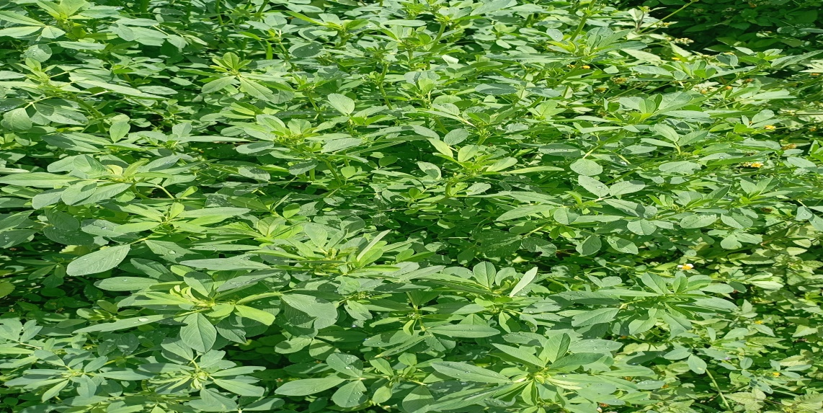
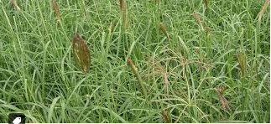
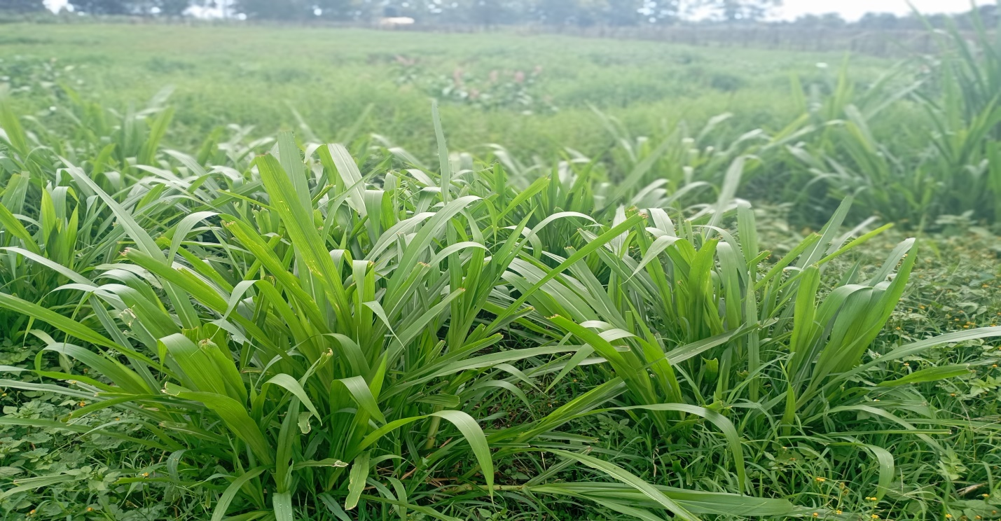
Upon arrival at the laboratory, the collected grass samples were thoroughly washed with distilled water to remove any soil, dust or other contaminants. The washed samples were then air dried to remove excess moisture and left for two weeks to ensure complete removal of moisture.
A
B
C

Figure 1: The collected pastures (A) Lucerne (B) Boma Rhodes (C) Super Napier (Pakchong)

Digestion of samples
The dried samples were ground into fine powder using mortar and pestle and the powdered samples stored in air tight containers at room temperatures. The dried powdered samples were digested separately; 0.3 g of each sample was weighed using a weighing balance and placed on a beaker. 12 mL of concentrated sulfuric acid was measured using a measuring cylinder and added to beakers containing the samples. A mixture of 0.8 g copper sulfate and 7.0 g potassium sulfate were also added. The beakers were then placed in a heating mantle in an open air, heated gently at first and were left to heat until the solution boiled. The digestion continued until the solution became light green and was later removed from the heating mantle.
The beakers were allowed to cool to room temperature, after cooling they were transferred to a 50 mL volumetric flask and were diluted with distilled water up to the mark. Filtration was then performed in each solution containing different samples and later stored in air tight containers.

Sample analysis
The samples were analyzed using UV-Vis spectrometry. 0.1 mL of each sample digest was taken using a micropipette to clearly labeled test tubes. 5.0 mL of the reagent N1 was added to each test tube and was left for 15 minutes. 5.0 mL reagent N2, vortex was added immediately fifteen minutes elapsed and was allowed to stand for 1 hour. The absorbance was then measured at 650 nm and a calibration curve drawn which showed the concentration of N in the solution.
Results and Discussion
A UV-Vis spectrophotometer was used to measure the concentration of nitrogen standards. A series of standards were prepared, and their absorbance was measured. The calibration curve linear equation (y=0.0136x−0.0042) which was used to calculate the nitrogen concentration in the samples as shown in table 1.
Table 1: Raw nitrogen concentration values and their average for each pasture (ppm)
 | Boma Rhodes | Lucerne | Super Napier (Pakchong)
Sample 1(ppm) | 64.21 | 229.72 | 165.01
Sample 2(ppm) | 66.19 | 192.07 | 126.78
Average(ppm) | 65.20 | 210.895 | 145.895

According to Table 1, the average nitrogen concentrations were determined to be 65.20 for Boma Rhodes, 210.895 for Lucerne, and 145.895 for Super Napier (Pakchong). These values indicate varying levels of nitrogen content across the different plant samples, which can be attributed to differences in their genetic makeup, growth conditions, and nutrient uptake efficiency (Engels and Marschner, 1995). For instance, legumes like Lucerne are known for their ability to fix atmospheric nitrogen through symbiotic relationships with bacteria, which often leads to higher nitrogen content compared to non-leguminous plants (Graham & Vance, 2003).
The Nitrogen content in the samples was calculated using the formula:$$\% N=\frac{Concentration X 0.005}{0.3}$$
This formula suggests a conversion factor to relate the measured concentration to the percentage of nitrogen.
Conversion of % Nitrogen to protein concentration
The percentage of nitrogen was converted to protein content using the formula:
=%N×6.25
The factor 6.25 is commonly used to convert nitrogen content to protein content in many agricultural and food analyses, assuming that protein generally contains about 16 % nitrogen (AOAC International, 2005).

Table 2 presents the calculated protein concentrations percentages, along with the average and standard deviation for each pasture.
Table 2: Protein content of the three selected pastures in percentage
 | Boma Rhodes | Lucerne | Super Napier (Pakchong)
Sample 1 (% ) | 6.69 | 23.91 | 17.19
Sample 2 (%) | 6.89 | 20.007 | 13.21
Average (%) | 6.79±0.14 | 21.9585±2.75 | 15.2 ± 2.81
Standard deviation | 0.14 | 2.75 | 2.81

The calculated protein concentrations, along with their standard deviations, are presented in Table 2. Lucerne exhibits the highest average protein content (21.96 %), followed by Super Napier (15.2%) and Boma Rhodes (6.79 %). The standard deviation values indicate the variability within the samples for each plant type. The higher protein content in Lucerne is consistent with its well-known nutritional profile as a highly proteinaceous forage crop with about 16-25 % crude protein, with 72 % digestibility (Patra and Paul, 2022).
Super Napier showed a mean crude protein content of 15.2 % ± 2.81 (Table 2). The crude protein content of super napier depends on the time of harvest of the pant (Manyawu et al., 2003; Khaled et al., 2005; Peiretti et al., 2015), soil profile and climatic condition (Singh et al, 2000). A study by Jagadeesh et al., (2017) recorded crude protein content for hybrid napier fodder grass ranging between 11.43 to 15.72 %. Wangchuck et al. (2015) determined the crude protein content of the leaf, stem and whole plant of super napier. The study recorded values of 17.2 (leaf), 3.6 (stem) and 10.4 % (whole plant). Another study by Meel et al. (2025) evaluated the chemical composition of super napier grass harvested at three different growth stages 40, 60, and 80 days. The crude protein content at the three growth stages was found to be 14.08, 12.08 and 10.11 % respectively. The crude protein content of super napier reported in this study is therefore within the range reported by other studies. Its hybrid vigor and enhanced biomass production makes it a valuable option for farmers aiming to meet both quantity and quality forage demands.
Boma Rhodes had the lowest average protein content (6.79 % ±0.14) as shown in Table 2 above, which is in the range of results from other studies. For instance, a study by Oktoto et al., (2024) found the crude protein content of Boma Rhodes to range between 4.06 to 4.63 %. The low crude protein content could be because it is a grass fodder whose chemical profile may be lower compared to leguminous fodders. https://www.beyondforest.org/post/boma-rhodes-grass-price-in-kenya reports crude protein content of Boma Rhodes as 8 to 12 %. The crude protein content varies depending on management and regional conditions (Oktoto et al., 2024).
The differences in protein content among these forages highlight their potential for various animal feed applications, with higher protein content being desirable for livestock growth and production.
Test of significant difference
The calculated p-value (0.01585) which is less than 0.05 (p<0.05) according. Additionally, the calculated F-statistic (22.27235) is greater than the critical F-value (9.552099). Both of these indicated that there is a statistically significant difference in protein content between the different pasture types (Lucerne, Super Napier and Boma Rhodes). This suggests that the type of pasture has a significant effect on its protein concentration.

Conclusion
The study established Lucerne as the superior protein source among the three forages, followed by Super Napier and then Boma Rhodes. The protein content for Lucerne and Super Napier analyzed, aligns with FAO & ICAR reported range of (15-25 %) and (12-18%), respectively. However, the observed protein content for Boma Rhodes was slightly below the KALRO expected range of (7-12 %). The observed differences in protein content are attributed by several factors inherent to each species. Lucerne is well known for their ability to fix atmospheric nitrogen through symbiotic relationships with rhizobia bacteria in the soil which naturally enhanced its nitrogen availability, a key component of protein synthesis. Grasses like Super Napier and Boma Rhodes rely on soil nitrogen uptake, which can be influenced by soil fertility and management practices. Lucerne’s high protein content is beneficial but Super Napier offers a more sustainable and affordable option for most farmers and a combination of these pastures, tailored to the specific needs of the livestock and the farms conditions would yield the best results. The objective of the experiment has been achieved, protein content of the three greener pastures was determined successfully.
Disclaimer (Artificial intelligence):
Author(s) hereby declare that NO generative AI technologies such as Large Language Models (ChatGPT, COPILOT, etc.) and text-to-image generators have been used during the writing or editing of this manuscript.
Reference
- AOAC International. (2005). Official Methods of Analysis of AOAC International. AOAC International. https://academic.oup.com/aoac-publications .
- Creemers, J. J. H. M., & Aranguiz, A. A. (2019). Quick Scan of Kenya’s Forage Sub-Sector: Netherlands East African Dairy Partnership (NEADAP) Working Paper . Netherlands East African Dairy Partnership (NEADAP). https://edepot.wur.nl/504126.
- Engels, C., & Marschner, H. (1995). Plant uptake and utilization of nitrogen. Bacon P. (Ed), Nitrogen fertilization in the environment, Marcel Dekker Inc. 41-81.https://books.google.co.ke/books?hl=en&lr=&id=PfjxThK1MDUC&oi=fnd&pg=PA41&dq=Engels,+C.,+%26+Marschner,+H.+(1995).+Plant+uptake+and+utilization+of+nitrogen.+Bacon+P.+(Ed),+Nitrogen+fertilization+in+the+environment,+41-81.&ots=lDekuNR5oB&sig=1xt62plBKs82LCTjEN0qx4JvE78&redir_esc=y#v=onepage&q&f=false
- FAO (Food and Agriculture Organization of the United Nations). (2019). The Future of Livestock in Kenya: Opportunities and Challenges in the Face of Uncertainty. Rome.https://openknowledge.fao.org/items/3350f895-a35e-429a-b71a-9ad595c50f44
- Graham, P. H., & Vance, C. P. (2003). Legumes: Importance and Constraints to Greater Use. Plant physiology, 131(3), 872-877. https://doi.org/10.1104/pp.017004 .
- Hao, C-c., Wang, L-j., Dong, L., O¨ zkan, N., Wang, D-c., & Mao, Z-h. (2008), “Influence of alfalfa powder concentration and granularity on rheological properties of alfalfa-wheat dough”, Journal of Food Engineering, 89, 137-41. https://doi.org/10.1016/j.jfoodeng.2008.04.011
- Jagadeesh, C. H., Reddy, Y.R., Nagalakshmi, D., Mahender, M., Kumari, N. N., Sridhar, K., & Devi, K.B. (2017). Effect of stage of harvest on the yield, chemical composition, in vitro and in sacco digestibility of hybrid Napier (Pennisetum purpureum) variety APB N1. Indian Journal of Animal Research, 51(1), 116-120. DOI: 10.18805/ijar.v0iOF.6994https://www.beyondforest.org/post/boma-rhodes-grass-price-in-kenya. Accessed on 20/12/2025.
- Kenya National Bureau of Statistics. (2024). Economic survey 2024.https://www.knbs.or.ke/economic-surveys/
- Khaled, R. A. H., Duru, M., & Cruz, P. (2005) June Are leaf traits suitable for assessing the feeding value of native grass species?. In XX International Grassland Conference: Offered papers: Offered Papers (p. 266). Wageningen Academic Publishers.https://doi.org/10.3920/978-90-8686-552-9_200
- MacMillan, S. (2019). “Kenyan Livestock Sector to Grow ‘Exponentially’—Kenya National Bureau of Statistics.” ILRI News Clipping, July 31. https://www.ilri.org/news/kenyan-livestocksector-grow-exponentially-kenya-national-bureau-statistics
- Manyawu, G. J., Chakoma, C., Sibanda, S., Mutis,i C., & Chakoma, I.C. (2003). The effect of harvesting interval on herbage yield and nutritive value of Napier grass and hybrid Pennisetums. Asian-Australasian Journal of Animal Sciences, 16(7), 996- 1002.https://doi.org/10.5713/ajas.2003.996
- Manyeki, J. K., Kuria, S., Kidake, B., Maweu, A., & Mulei, B. (2023). Fodder farming in the arid and semi-arid lands of Kenya: A Potential Profitable Venture. IOSR Journal of Economics and Finance (IOSR-JEF), 14(3), 18-24. DOI: 10.9790/5933-1403041824.
- McDonald, P., Edwards, R. A., Greenhalgh, J. F. D., Morgan, C. A., Sinclair, L. A., & Wilkinson, R. G. (2011). Animal nutrition (7th ed.). Prentice Hall.https://blackwells.co.uk/bookshop/product/Animal-Nutrition-by-Peter-McDonald-author-Dr-C-A-Morgan-author-R-A-Edwards-author-L-A-Sinclair-author-Liam-Sinclair-author-Robert-Wilkinson-author/9781408204238
- Meel, M. S., Gautam, L., & Garg, S. (2025). Growth-Stage dependent nutritional dynamics of super Napier grass. International Journal of Agriculture and Food Science. 7(5): 262-266. DOI: https://www.doi.org/10.33545/2664844X.2025.v7.i5d.406
- Mohamad, S. S. S., Kamaruddin, N. A., & Ting, J. Y. (2022). Study on Chemical Composition of Napier Pak Chong (Pennisetum purpureum x Pennisetum glaucum) Harvested at Different Growth Stages. Journal of Agrobiotechnology, 13(1S), 24-30.https://doi.org/10.37231/jab.2022.13.1S.315
- Ndathi, A. J., Nyangito, M. M., Musimba, N. K., & Mitaru, B. N. (2011). Climate variability and dry season ruminant livestock feeding strategies in Southeastern Kenya. Livestock Research for Rural Development, 23(9). https://lrrd.cipav.org.co/lrrd23/9/ndat23199.htm
- Oktoto, C., Ondiek, J. O., & Ndambi, O. A. (2024). Nutritional Value and Chemical Composition of Selected Fodders; Feed Intervention in Smallholder Dairy Farms in Kenya. Research Square 1-23. DOI: https://doi.org/10.21203/rs.3.rs-4005662/v1
- Patra, P. S., & Paul, T. A. R. U. N. (2022). Lucerne (alfalfa). Forage Crops of the World", Md. Hedayetullah and P. Zaman (Eds.), 231-243.https://5dportal.net/archive/library/food/forage_crops_of_the_world_volume_i.pdf#page=258
- Peiretti, P. G., Gai, F., & Tassone, S. (2015). Nutritional value and fatty acid profile of Niger (Guizotia abyssinica) plant during its growth cycle. Livestock Research for Rural Development 27(1), 1-10. http://www.lrrd.org/lrrd27/1/peir27018.htm
- Ramya, S., Ramesh, V., Muralidharan, J., & Purushothaman, M.R. (2017). Fodder yield and chemical composition of hybrid Napier and multi-cut sorghum fodder at different stages of cutting. Indian Journal of Small Ruminants (The), 23(2), 181- 185. DOI: 10.5958/0973-9718.2017.00046.0.
- Singh, D., Singh, V., & Joshi, Y.P. (2000). Effect of nitrogen fertilization and cutting intervals on yield and quality of Napier Bajra hybrid. Range Management and Agroforestry, 21, 128-134. https://www.researchgate.net/profile/Digvijay-Singh-8/publication/354381787_Effect_of_nitrogen_fertilisation_cutting_intervals_on_yield_of_Hybrid_Napier/links/6135fd802b40ec7d8beae4bb/Effect-of-nitrogen-fertilisation-cutting-intervals-on-yield-of-Hybrid-Napier.pdf
- Sirichaiwetchakul, S., Paengkoum, S., & Nabhadalung, N. (2016). Effects of arbuscular mycorrhizal fungi on yield and nutritive values of Napier Pak Chong 1 (Pennisetum purpureum cv. Pakchong 1). International Journal of Agricultural Technology, 12(7.2), 2123-2130. http://www.ijat-aatsea.com
- Tharanathan, R.N., & Mahadevamma, S. (2003), “Grain legumes – a boon to human nutrition”, Trends in Food Science and Technology, 14, 507-18https://doi.org/10.1016/j.tifs.2003.07.002

Wangchuk, K., Rai, K., Nirola, H., Dendup, C., & Mongar, D. (2015). Forage growth, yield and quality responses of Napier hybrid grass cultivars to three cutting intervals in the Himalayan foothills. Tropical Grasslands-Forrajes Tropicales, 3(3), 142-150.DOI: https://doi.org/10.17138/tgft(3)142-150.

G. Álvarez Fuentes, J. C. García López, J. A. Rendón Huerta, H. A. Lee Rangel, L. O. Negrete Sánchez & R. López Ortiz. (2024). Agronomic Yield, Digestibility, and Protein Content of Nine Alfalfa (Medicago sativa L.) Varieties in Central Valley Oaxaca Mexico. Journal of Applied Life Sciences International, 27(3), 74–82. https://doi.org/10.9734/jalsi/2024/v27i3648

