Effectiveness of Digital Language Laboratory Intervention on Writing Skills of Undergraduate Students from Regional-Medium Schools

ABSTRACT
Aims: To study the effectiveness of the Digital Language laboratory intervention on the expressive skills, particularly writing skills, of undergraduate students from regional medium schools and to examine the learning outcomes
Study design: Pre-intervention and post-intervention assessment study with a paired diagnostic test.
Place and duration of the study: This study involved 65 first-year agriculture and horticulture students from regional-medium schools, primarily from rural backgrounds and first-generation graduates. They were systematically and periodically trained in the language laboratory located at Anbil Dharmalingam Agricultural College and Research Institute, Tiruchirappalli, after their class hours, utilising relevant software viz. Cambridge English in mind, Business vocabulary in use, Face2face, Learn to speak English – Lessons & workshops etc. Over a period of six months, all participants received the same pedagogical intervention.
Methodology: The pre-evaluation test was designed to measure both micro- and macro-writing skills. Micro skills included spelling, syntax, and word usage, whereas macro skills focused on purpose and audience awareness, cohesion, and coherent writing. For practical and structured assessment, these skills were categorised into five major areas: content knowledge, vocabulary, grammar, sentence structure, and mechanics of writing. The same methodology as practised for the pre-evaluation was adopted for the post-evaluation, to ensure consistency and accuracy. A Paired t-test was used to determine statistical significance of changes between pre and post-evaluation scores.
Results: Pre-evaluation revealed that 38-89% of students required improvement in all areas. The post-intervention results prove improvement, with an average drop of 68.2% in the "Needs Improvement" category. Complete elimination of deficiencies was achieved in Content Knowledge from 38% to 0%, and 89% to 0% in Mechanics & Convention (89% to 0%). Combined Fair and Good proficiency increased significantly from 31.4% to 97%. Grammar demonstrated extraordinary progress of 87% improvement, while Vocabulary and Sentence Structure showed substantial gains of 60% and 67%, respectively. Paired t-test analysis confirmed highly statistically significant differences between pre and post-evaluation scores (p < 0.001), validating the intervention's effectiveness.
Conclusion: The structured intervention in the Digital Language Laboratory supported students from regional medium schools in developing their writing proficiency from foundational to intermediate levels. The intervention showed a remarkable impact in resolving fundamental writing difficulties, and continued instruction is recommended to achieve advanced mastery over the written competencies.
Keywords: Expressive Skills, Writing Skills, Digital Language Laboratory, Language Intervention, Paired t-test

- INTRODUCTION
The disparity in communication proficiency between students from regional-medium schools and those from English-medium schools remains a significant challenge in higher education, mainly in professional education due to their lack of practice and inadequate grammatical knowledge. To overcome this, it is essential to establish supportive learning practices that foster the self-esteem of students through technology-enabled interventions.
Writing is the foundation of all academic skills, as it promotes learning, critical thinking, and effective communication. Writing is the foundation of all academic skills, as it promotes learning, critical thinking, and the effective communication of ideas in a logical sequence. It helps students to arrange the basic concepts, evaluate data, and articulate arguments clearly and concisely, which enhances their academic performance and readiness for the workforce (Cottrell, 2019). Writing acts as a communicative and cognitive device throughout the learning process of a second language, supporting the development of vocabulary, grammar, and higher-order thinking skills, including argumentation and analysis (Khazrouni, 2019). Writing also increases the application of micro-linguistic information, such as morphology, syntax, and semantics, resulting in more coherent and correct texts (Menggo et al., 2019). Yet, it continues to be a most challenging task for second language learners due to the variations between the first and target languages, which often impact coherence, structure, and correctness (Monica, 2010). Writing skills are particularly essential for agricultural students, who must produce research reports, proposals, and extension materials, as well as communicate complex concepts to diverse audiences.
- LITERATURE REVIEW
  - Automated Tools in Skill Assessment
Digital technologies are powerful tools for assessing the expressive skills of students, providing fast and real-time feedback. In the twenty-first century, innovative technologies have the potential to deliver better-quality educational evaluations that are more valuable for teachers and that more readily benefit student learning (Koomen and Zoanetti, 2018). Evaluating the expressive skills of students in a digital language laboratory with appropriate software is crucial for identifying the weak areas of individual students and preparing them for improvement.
Karabulut, Halil & Karadağ, Engin. (2024) confirmed that digital learning environments have a positive impact on academic writing across different educational contexts. The studies by Nguyen and Lee (2023) demonstrate that the practical tools available in digital language laboratories are highly effective in enhancing students' writing skills. The research findings of Dey SK, Dey A (2020), Krishna, D. (2021), Lai Wah, L., & Hashim, H. (2021), Ndahayo, J., & Ndayambaje, I. (2024) and Tondeur, J.et al. (2020) confirmed the positive effectiveness of the digital language laboratory.
The majority of the researchers believe that unless students are academically matched with clear assessment criteria, language laboratories alone cannot assure the improvement of writing skills. According to Richards and Rodgers (2014), technology must be integrated into effective instructional and evaluation systems to have a significant impact on language outcomes. The relevance of technology-enabled assessment in improving the quality of writing is increasingly apparent in research on evaluating writing skills. Assessment of writing, as stated by Weigle (2002), is a systematic process of assessing written performance against predefined standards, such as content, organisation, vocabulary, and precision.
Attali and Burstein (2006) believe that automated tools play an influential role in enhancing writing skills by providing prompt feedback on areas such as grammar, coherence, and vocabulary use. These tools are valuable additional resources for thinking critically about the writing and revising it more effectively and should not be substituted for human evaluation. Hyland (2003) asserts that practical writing assessment emphasises feedback and change over one-off assessment. In a language lab, students can revise drafts, receive automated or teacher-generated feedback, and track their progress over time (Chapelle and Douglas 2006).
  - Language Laboratories and Skill Assessment
Assessments become more formative, ongoing, and learner-centred when they are integrated into digital environments, such as language laboratories. Hyland (2003) asserts that practical writing assessments place more emphasis on revision over one-time evaluation. Language laboratories facilitate this process more easily by allowing students to revise drafts, receive automated or teacher-generated feedback, and track their progress over time.
A language laboratory is a technology-supported environment equipped with computers and software designed to promote second language learning through structured practice and exposure. (Warschauer, 2000). A language laboratory is traditionally associated with improving listening and speaking skills. It has gradually evolved into a multimedia space that incorporates reading and writing exercises through digital platforms and online assessment modules. It provides a structured, technology-driven learning environments, which offer a wide range of interactive resources to support the development of speaking and writing skills. In contrast to traditional classrooms, digital language laboratories enable students to practise on their own and repeatedly, which reduces the fear of making mistakes that may lead to embarrassment in front of peers or teachers. This special feature is highly beneficial for the students from regional-medium schools, who commonly experience lower levels of confidence in expressing complex ideas in English due to their limited exposure.
Nagaraj (2010) suggests that a language laboratory fosters learner autonomy by enabling students to practice all four basic skills of language acquisition independently while getting instant feedback. Research by Padmapriya (2014) indicates that students often perceive language laboratories as motivating and relaxed settings that foster experimentation with language, such as writing. Along with tutoring, motivation is closely linked to active involvement in writing activities and better performance (Dörnyei, 2001). This privilege is particularly relevant for the writing component, where multiple drafts and revisions are necessary for developing writing skills.
Language laboratories enable students to practice sentence formation, create paragraphs, and use grammar properly in a controlled setting. Nevertheless, certain studies suggest that there is an insignificant improvement in writing when language laboratory activities mainly rely on mechanical drills instead of significant writing assignments (Ramesh & Krishnan, 2017), underlining the need to create writing evaluations that prioritise communicative intent, coherence, and audience awareness.
  - Language Laboratories and Writing Assessment
Assessment of writing skills focuses on evaluating the ability of students to communicate ideas clearly, coherently, and accurately, with supporting evidence, appropriate vocabulary, proper grammatical structure, and other writing mechanics, including correct spelling, punctuation, and capitalisation of letters. The evaluation of writing skills involves several steps, although it is a point of contention among educators. The widely accepted five-step process, popularly known as POWER, involves prewriting, organising ideas, writing with supporting evidence, evaluating with critical thinking, and revising and editing. Each step has its own subsets and strategies.
However, specific challenges involve grading subjectivity, ensuring evaluator homogeneity, and managing huge classrooms, which limit opportunities for in-depth, customised input. Other challenges include the diverse linguistic backgrounds of the students and their varying levels of previous exposure to writing skills. Time constraints of teachers also lead to creative approaches, such as technology-enabled solutions like language laboratories, to enhance student writing abilities.
Attali and Burstein (2006) believe that automated tools play an influential role in enhancing writing skills by providing prompt feedback on areas such as grammar, coherence, and vocabulary use. These tools are valuable additional resources for thinking critically about the writing and revising it more effectively and should not be substituted for human evaluation. Hyland (2003) asserts that practical writing assessment emphasises feedback and change over one-off assessment. In a language lab, students can revise drafts, receive automated or teacher-generated feedback, and track their progress over time (Chapelle and Douglas 2006).
Recognising this need, a study was undertaken to assess the writing proficiency of the undergraduate agricultural students of Anbil Dharmalingam Agricultural College and Research Institute (ADAC&RI), and Horticultural College and Research Institute for Women (HC&RI W), Tiruchirappalli, the constituent college of Tamil Nadu Agricultural University (TNAU), Coimbatore, India. By assessing the progress of students, this study intends to add to ongoing efforts to address written competency gaps in professional education by demonstrating the effectiveness of digital language laboratories as an instructional intervention.
MATERIALS AND METHODS
This study included 65 first-year agriculture and horticulture students who had their schooling at a regional medium. They were systematically and periodically trained in the language laboratory located at ADAC&RI, Trichy, after their class hours, utilising relevant software to improve their writing skills. Over a period of six months, all participants received the same pedagogical intervention. A pre- and post-testing design was employed to evaluate the impact of language laboratory–based training on the writing skills of students.
The pre-evaluation test was designed to measure both micro- and macro-writing skills. Micro skills included spelling, syntax, and word usage, whereas macro skills focused on purpose and audience awareness, cohesion, and coherent writing. For practical and structured assessment, these skills were categorised into five major areas: content knowledge, vocabulary, grammar, sentence structure, and mechanics of writing. The same methodology as practised for the pre-evaluation was adopted for the post-evaluation, to ensure consistency and accuracy.. The design limitation of this study is the absence of a control or comparison group, which restricts our ability to make definitive causal inferences, as it focused solely on the experimental group to evaluate the effects of the intervention at digital language laboratory.
The participants received structured training in the language laboratory with the following recommended instructional software.
TABLE 1. SOFTWARE USED FOR ASSESSING SKILLS

S. No. | Skills assessed | Software Used
 | Vocabulary | Cambridge English in mind 2 &3  Business vocabulary in use – Intermediate  Cambridge Vocabulary in Use
 | Content Knowledge | Cambridge English in mind – Module 1  Learn to speak English – Lessons & workshops
 | Grammar | Active Grammar Level -2  Interchange- 3
 | Sentence Structure | Cambridge Complete IELTS – Bands 6.5-7.5  English in Mind
 | Mechanics of Writing | Active Grammar Level -2  Cambridge Complete IELTS – Bands 6.5-7.5  Face2face - Intermediate

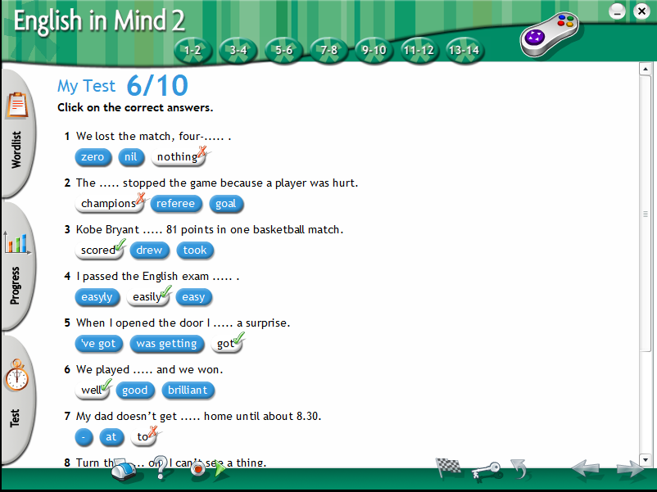 | 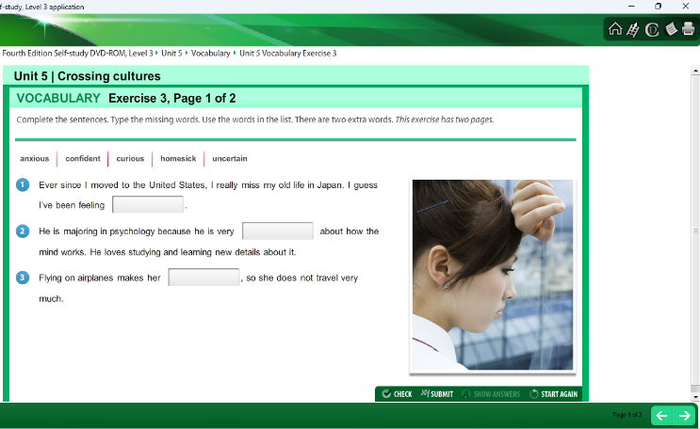
Vocabulary Enrichment Activities
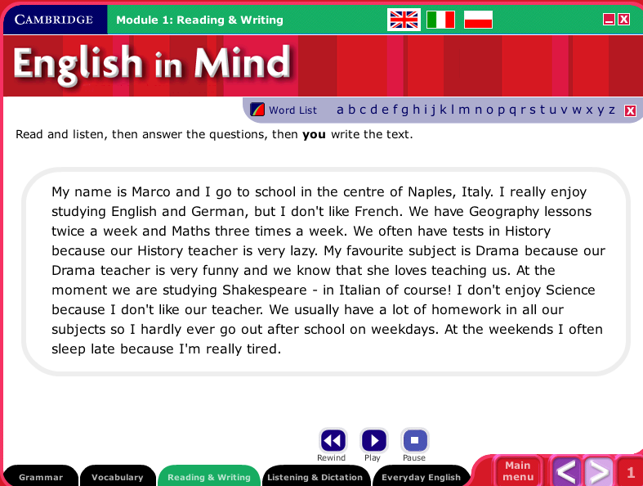 | 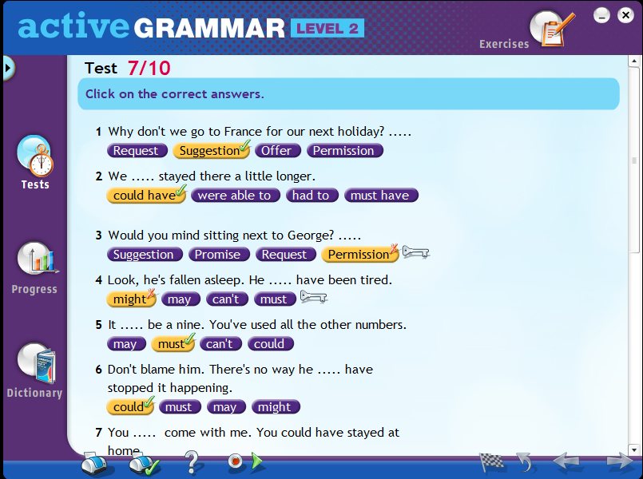
Sentence Structure Evaluation | Grammar Exercises
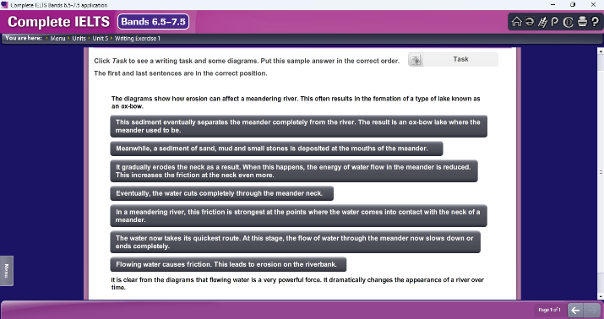 | 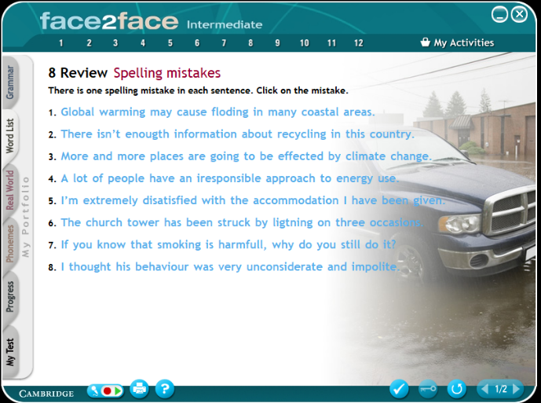
Activities to Assess the Mechanics of Writing
FIGURE 1. DIFFERENT ACTIVITIES DESIGNED TO EVALUATE THE WRITING SKILL OF THE STUDENTS

In addition to language laboratory teaching, a Google Group has been created to monitor the progress of students remotely and to facilitate ongoing interaction. Weekly assignments were given, and based on performance evaluation, customised remedial instruction was offered in the language lab, focusing on individual students' strengths and weaknesses.
DATA COLLECTION AND ANALYSIS
After six months of intervention, a post-evaluation test was conducted using the same assessment methodology as the pre-test. The obtained data were quantitatively analysed to compare pre- and post-test results to examine changes in the writing performance of students across the five assessment categories. The findings were systematically analysed to determine the effectiveness of the language laboratory intervention in enhancing students' writing skills.
RESULTS AND DISCUSSION:
During the intervention, the selected participants were systematically trained in the language laboratory on various written activities that assessed their writing skills, including IELTS and TOEFL examination preparation, grammar instruction modules, vocabulary enhancement sessions, and sentence construction exercises.
Throughout the intervention, students practiced under the guidance of the teacher, completing varied writing assignments comprising speaking and writing skills, including grammar practice exercises, vocabulary building activities, short story writing, describing a picture, narrating the best moments of the students, sentence construction drills, jumbled sentence activities, paragraph writing, and essay writing activities. The software available in the language laboratory provided students with digital writing assistance, automated grammar and vocabulary checking systems, vocabulary enrichment games and activities, grammar drills and interactive educational modules that supported individualised learning pathways and provided immediate performance feedback to the students. The writing proficiency of the students was measured by four classification levels: Needs Improvement, Fair, Good, and Excellent. The objective of this research was to assess the impact of the language laboratory intervention and to identify areas for improvement in the written communication of students. The collected data is given in the following tables.

TABLE 2. PRE-EVALUATION
Writing Dimension | Needs Improvement | Fair | Good | Excellent
Content Knowledge | 38% | 60% | 2% | 0%
Vocabulary | 68% | 32% | 0% | 0%
Grammar | 89% | 11% | 0% | 0%
Sentence Structure | 69% | 31% | 0% | 0%
Mechanics & Convention | 89% | 11% | 0% | 0%
The initial pre-evaluation suggested substantial writing challenges among the students from regional-medium schools. During the pre-evaluation, 89% of students fell into the "need to improve" category in both Grammar and Mechanics and Convention, representing the highest percentage of students requiring intervention. A notable shortfall was noticed in vocabulary and sentence structure, with 68% and 69% of students, respectively, needing improvement. Though content knowledge, showing a lower percentage relatively, still required intervention for 38% of students. At the "Fair" level, a notable number of students exhibited basic competence, with content knowledge documenting the highest percentage at 60%. The other skills proposed remarkably a lower percentage.
Notably, the pre-evaluation indicated minimal accomplishment at higher proficiency levels. Only 2% of students reached "Good" proficiency in content knowledge, whereas all other writing proportions documented 0% in this group. None of the students earned "Excellent" proficiency in any one of the categories. This distribution pattern strongly suggested the importance of comprehensive intervention with digital tools in the language laboratory to uplift students beyond foundational proficiency levels.

TABLE 3. POST-EVALUATION
Writing Dimension | Needs Improvement | Fair | Good | Excellent
Content Knowledge | 0% | 85% | 15% | 0%
Vocabulary | 8% | 83% | 9% | 0%
Grammar | 2% | 87% | 11% | 0%
Sentence Structure | 2% | 95% | 3% | 0%
Mechanics & Convention | 0% | 94% | 6% | 0%
The results of the post-evaluation performance of regional medium school students in five areas of writing skills indicate a significant decrease in the number of students who require improvement. There was a remarkable improvement in content knowledge and mechanics and convention, with the percentage of students in need of improvement dropping from 38% to 0% and 89% to 0%, respectively. Furthermore, in the areas of content knowledge, mechanics, and convention, 15% and 6% of students achieved a “Good” rating, respectively.
There was a remarkable decline in Grammar, from the “Needs Improvement” classification, where it was 89%, to 2%. This resulted in 87% of students advancing to the “Fair” category and 11% achieving the “Good” level. Similarly, in the vocabulary unit, there was a substantial decline in the “Needs Improvement” category from 68% to 8%, with 83% of students progressing to the “Fair” level and 9% of students acquiring the “Good” level. In Sentence Structure, the performance of students showed considerable progress, reducing the “Needs Improvement” category from 69% to 2%, with 95% of students achieving “Fair” proficiency and 3% rated as “Good.”
However, it is noteworthy that none of the students achieved the “Excellent” rank in any category, implying that the intervention has been effective in elevating students to an intermediate level, rather than to an advanced level.
TABLE 4 . COMPARATIVE ANALYSIS - COMPARISON TABLE:
Writing Dimension | Pre-Evaluation  (Needs Improvement) | Post-Evaluation  (Needs Improvement) | Reduction
Content Knowledge | 38% | 0% | -38%
Vocabulary | 68% | 8% | -60%
Grammar | 89% | 2% | -87%
Sentence Structure | 69% | 2% | -67%
Mechanics & Convention | 89% | 0% | -89%

The intervention achieved an average 68.2% reduction in students requiring improvement, with 100% effectiveness in eliminating deficiencies in Content Knowledge and mechanics/convention. Students achieving “Fair” and “Good” proficiency combined increased by an average of 65.6 percentage points. Specifically, students in the “Fair” category increased by an average of 57 percentage points, while those achieving “Good” proficiency increased by an average of 8.6 percentage points.

TABLE 5. SUMMARY TABLE:
Performance measure | Performance Data
Intervention Effectiveness | 68.2% average reduction in students requiring improvement; 97% achieving acceptable proficiency
Complete Success Areas | Content Knowledge and Mechanics and Convention: 100% of students moved beyond "Needs Improvement"
Highest Impact | 87% improvement in Grammar and Mechanics and 89% improvement in Convention
Overall Proficiency Shift | Combined Fair + Good proficiency increased by 65.6 % from 31.4% to 97%
Development Gap | No students achieved Excellent level, indicating a need for extended advanced training
Statistical Significance | Highly significant intervention impact with p < 0.001

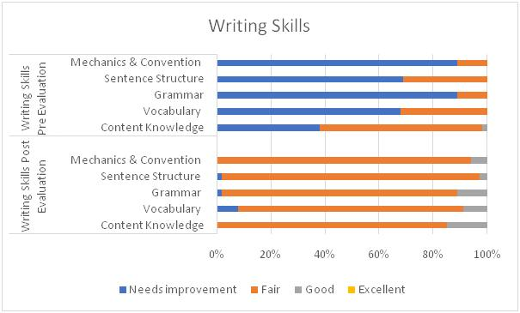
FIGURE 2. WRITING SKILLS
Statistical Analysis of Paired t-test
A paired t-test was conducted to determine whether the digital language laboratory intervention significantly improved the writing skills of students from Tamil-medium schools. The null hypothesis H₀ stated that there would be no significant difference between pre-evaluation and post-evaluation scores, while the alternative hypothesis H₁ predicted that the intervention would produce significant improvement in students' writing skills.
TABLE 6. STATISTICAL DATA ON THE PERFORMANCE OF WRITING SKILLS
Sample | Sample size N | Range |  | Mean | Standard Deviation | Standard Error Mean
Sample | Sample size N | Min | Max | Mean | Standard Deviation | Standard Error Mean
Pre evaluation | 65 | 5 | 10 | 6.492 | 1.276 | 0.158
Post evaluation | 65 | 9 | 14 | 10.338 | 1.050 | 0.130

TABLE 7. PAIRED DIFFERENCE AND PAIRED t-TEST RESULTS
Mean | Standard Deviation | SE Mean | 95% Confidence level for difference | t value | p-value
3.846 | 1.523 | 0.189 | (4.224,3.469) | 20.36 | <0.001***(Highly significant)

The value of p < 0.001 confirms that the differences between pre-evaluation and post-evaluation scores are highly statistically significant, rejecting the null hypothesis that there is no difference between the pre- and post-evaluation scores.
FIGURE 3.

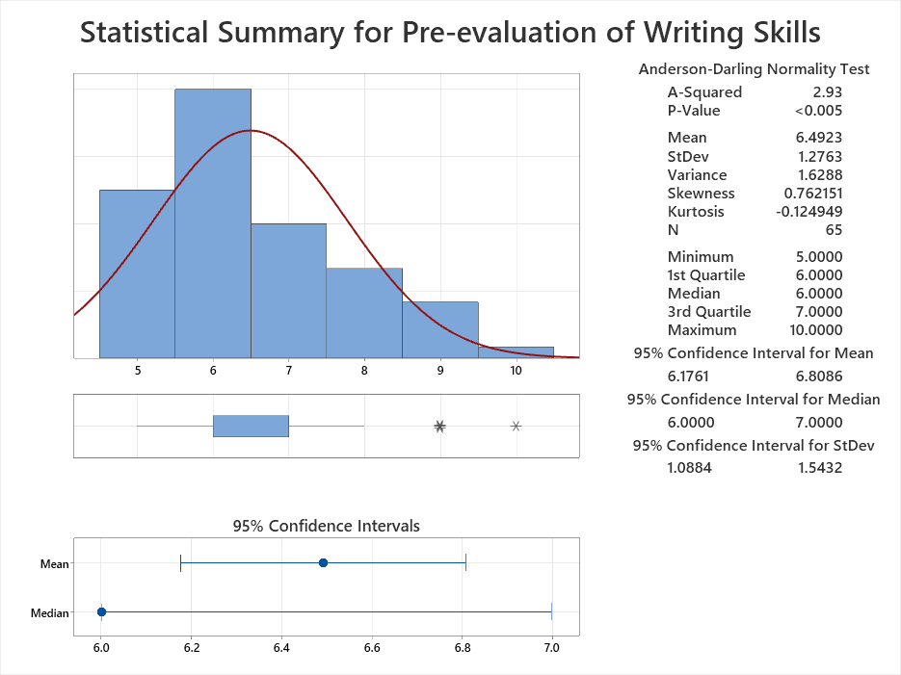

FIGURE 4.
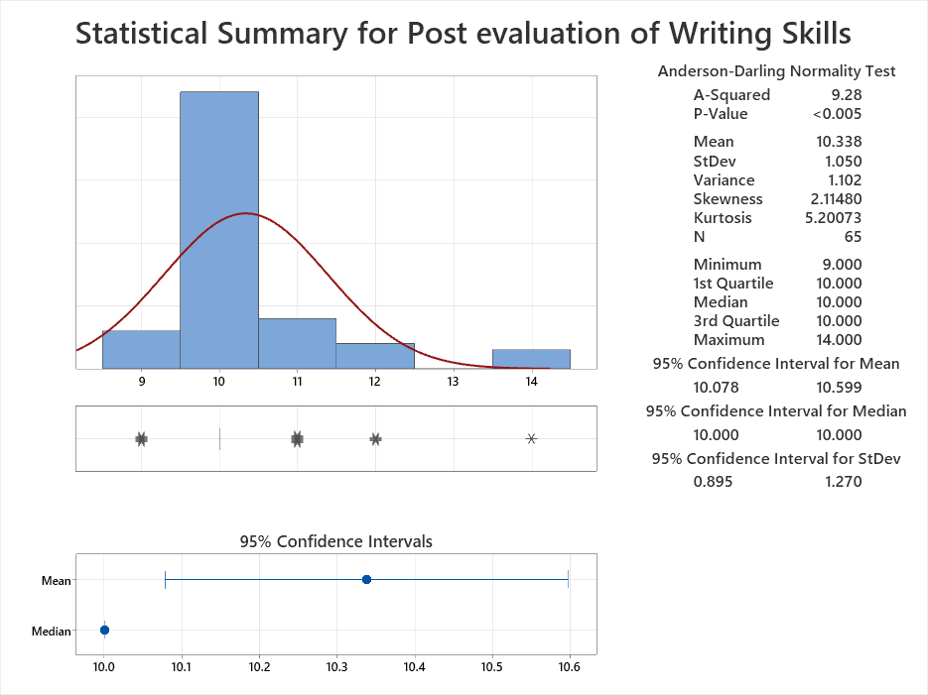
INTERPRETATION:
The calculated t-value for the writing skill is very large in magnitude, indicating a substantial difference between the pre-evaluation and post-evaluation scores. The p-value is extremely small, far less than the typical significance level of 0.05, indicating that the observed difference in means is highly statistically significant. At the 95% confidence interval for the mean difference, the result confirms a substantial difference in the performance of students in writing skills before and after the intervention. The paired t-test results strongly suggest that the intervention using the language laboratory led to a significant improvement in the overall writing skills of regional-medium students.

CONCLUSION:
This study presents strong evidence of significant improvement in the writing skills of students studied in regional medium schools. The comparative analysis between pre-evaluation and post-evaluation results shows improvements across all five key areas of writing proficiency. There has been a marked decrease in the number of students requiring improvement in all writing skill categories, with Content Knowledge and Mechanics and Convention showing complete elimination of students from the "Needs Improvement" level, emphasising the effectiveness of the instructional intervention.
Noteworthy progress was observed in Grammar and Mechanics and Convention, with students showing reductions of 87 and 89 percentage points in the lowest proficiency category, emphasising the effectiveness of targeted instruction in fundamental writing skills for regional-medium students. This research aligns with the studies of Jacques et.al (2024), who confirmed that students using digital language laboratories demonstrate better writing accuracy and fluency than those in traditional classrooms. Further, this study highlights the importance of continuous, long-term intervention with digital tools in the language laboratory to train students to achieve advanced mastery of the written competencies.

COMPETING INTERESTS DISCLAIMER:
Authors have declared that they have no known competing financial interests OR non-financial interests OR personal relationships that could have appeared to influence the work reported in this paper.

Disclaimer (Artificial intelligence)

Author(s) hereby declare that NO generative AI technologies such as Large Language Models (ChatGPT, COPILOT, etc.) and text-to-image generators have been used during the writing or editing of this manuscript.

REFERENCES
- Angel-Urdinola, D. F., Chinen, M. H., & Rodon Casarramona, G. (2025). Digital skills development: Competence frameworks, assessment tools, and pedagogical approaches (Education Working Paper Series No. 14). World Bank. https://doi.org/10.1596/43601
- Attali, Y., & Burstein, J. (2006). Automated essay scoring with e-rater® V.2. Journal of Technology, Learning and Assessment, 4(3). https://ejournals.bc.edu/index.php/jtla/article/view/1650
- Chapelle, C. A., & Douglas, D. (2006). Assessing language through computer technology. Cambridge University Press. https://doi.org/10.1017/CBO9780511733116
- Cottrell, S. (2019). The study skills handbook. Macmillan International. https://www.bloomsbury.com/uk/the-study-skills-handbook-9781137610874/
- Crusan, D., Plakans, L., & Gebril, A. (2016). Writing assessment literacy: Surveying second language teachers’ knowledge, beliefs, and practices. Assessing Writing, 28, 43–56. https://doi.org/10.1016/j.asw.2016.03.001
- Dey, S. K., & Dey, A. (2020). Digital pedagogical paradigm in language lab-based English teaching for higher technical education. In Computational intelligence in digital pedagogy (pp. 251–275). Springer Singapore. https://doi.org/10.1007/978-981-15-3172-9_14
- Dörnyei, Z. (2001). Motivational strategies in the language classroom. Cambridge University Press.
- Gultom, U. A. (2025). Assessing EFL undergraduate students’ needs for the development of writing learning materials. LETS: Journal of Linguistics and English Teaching Studies. https://doi.org/10.46870/lets.v6i2.1516
- Hyland, K. (2003). Second language writing. Cambridge University Press. https://doi.org/10.1017/CBO9780511667251
- International Test Commission, & Association of Test Publishers. (2022). Guidelines for technology-based assessment. Association of Test Publishers. https://www.intestcom.org/upload/media-library/guidelines-for-technology-based-assessment-v20221108-16684036687NAG8.pdf
- Islam, A. K. M. M. (2021). Major phonemic problems of Bangladeshi learners of English: Reasons behind and solutions. ELT Forum: Journal of English Language Teaching, 10(1). https://doi.org/10.15294/elt.v10i1.45061
- Karabulut, H., & Karadağ, E. (2024). The effectiveness of technology-enhanced language teaching methods on achievement in English: A meta-analysis. Bartın University Journal of Faculty of Education, 13, 802–822. https://doi.org/10.14686/buefad.1196993
- Khazrouni, M. (2019). Assessment for improving ESL learners’ writing skills among undergraduate students: A case study of Skyline University College. International Journal of English Language Teaching, 7(1), 30–44.
- Koomen, M., & Zoanetti, N. (2018). Strategic planning tools for large-scale technology-based assessments. Assessment in Education: Principles, Policy & Practice, 25(2), 200–223. https://doi.org/10.1080/0969594X.2016.1173013
- Krishna, D. (2021). Importance of language laboratory in developing language skills. Jurnal Arbitrer, 8(1), 101–106. https://doi.org/10.25077/ar.8.1.101-106.2021
- Lai Wah, L., & Hashim, H. (2021). Determining pre-service teachers’ intention of using technology for teaching English as a second language (ESL). Sustainability, 13(14), 7568. https://doi.org/10.3390/su13147568
- Lee, I. (2017). Classroom writing assessment and feedback in L2 school contexts. Springer. https://doi.org/10.1007/978-981-10-3924-9
- Menggo, S., Suastra, I. M., Budiarsa, M., & Padmadewi, N. N. (2019). Speaking for academic purposes course: An analysis of language functions. E-Journal of Linguistics, 13(2), 308–326. https://doi.org/10.24843/e-JL.2019.v13.i02.p10
- Nagaraj, G. (2010). English language teaching: Approaches, methods, and techniques. Orient BlackSwan.
- Ndahayo, J., & Ndayambaje, I. (2024). Computer assisted language learning in English teaching: Availability of teaching and learning resources to enhance students’ performance in English as subject in technical secondary schools, Nyanza District. African Journal of Empirical Research, 5(1), 84–91. https://doi.org/10.51867/ajernet.5.1.9
- Neumann, M. M., Anthony, J. L., Erazo, N. A., & Neumann, D. L. (2019). Assessment and technology: Mapping future directions in the early childhood classroom. Frontiers in Education, 4, Article 116. https://doi.org/10.3389/feduc.2019.00116
- Nguyen, T. H., & Lee, S. Y. (2023). Computer-assisted language learning tools and writing achievement in secondary education: Systematic review and implications. Educational Technology Research and Development, 71(5), 1245–1268. https://doi.org/10.1007/s11423-023-12789-4
- Padmapriya, P. V. (2014). Effectiveness of language laboratory in improving the communicative skills of engineering students. International Journal of English Language Teaching, 1(1), 1–6.
- Ramesh, P., & Krishnan, R. (2017). Role of language laboratories in enhancing writing skills of ESL learners. Journal of English Language and Literature, 4(2), 312–316.
- Richards, J. C., & Rodgers, T. S. (2014). Approaches and methods in language teaching (3rd ed.). Cambridge University Press. https://doi.org/10.1017/9781009024532
- Sim, M. A. (2010). Some thoughts on writing skills. Annals of the University of Oradea: Economic Science, 1(1), 127–133.
- Smith, A., McConnell, L., Iyer, P., Allman-Farinelli, M., & Chen, J. (2024). Co-designing assessment tasks with students in tertiary education: A scoping review of the literature. Assessment & Evaluation in Higher Education, 50(2), 199–218. https://doi.org/10.1080/02602938.2024.2376648
- Suastra, I. M., & Menggo, S. (2020). Empowering students’ writing skill through performance assessment. International Journal of Language Education, 4(3), 432–441. https://doi.org/10.26858/ijole.v4i3.15060
- Thangaraj, K., & Anandhi, S. (2024). An impact study on the oral proficiency of students from Tamil medium schools tutored in digital language laboratory. International Journal of Social Sciences. https://doi.org/10.46852/2249-6637.02.2024.3
- Timmis, S., Broadfoot, P., Sutherland, R., & Oldfield, A. (2016). Rethinking assessment in a digital age: Opportunities, challenges and risks. British Educational Research Journal. https://doi.org/10.1002/berj.3215
- Tondeur, J., Scherer, R., Siddiq, F., & Baran, E. (2020). Enhancing pre-service teachers’ technological pedagogical content knowledge (TPACK): A mixed-method study. Educational Technology Research and Development, 68, 319–343. https://doi.org/10.1007/s11423-019-09692-1
- Warschauer, M. (2000). The changing global economy and the future of English teaching. TESOL Quarterly, 34(3), 511–535. https://doi.org/10.2307/3587741
- Weigle, S. C. (2002). Assessing writing. Cambridge University Press. https://doi.org/10.1017/CBO9780511732997

