Green Materials and Their Applications for Dye Removal from Wastewater: A Review

Abstract
Wastewater discharge contaminated with dyes pollutants from various industries as textile, paper, leather etc., caused a serious risk to the aquatic system and human health because of the toxicity, persistence, and aesthetic influence of artificial dyes. Conventional treatment processes frequently agonize costly, produce secondary pollution, or poor effectiveness, inspiring the pursuit for suitable alternatives. Green materials have developed as auspicious resolutions for the removal of dye from contaminated water due to their atmospheric compatibility, economic, renewability, and much adsorption potential. This review summarises current advances in the expansion and application of green materials for dye elimination. Several types of eco-friendly substances, with chitosan, cellulose, and alginate biopolymers, agricultural wastes, biochar, clay-based materials, and green-synthesized nanomaterials, are discussed. Their removal mechanisms of dye form wastewater involved adsorption, ion exchange, electrostatic interaction, and photocatalytic degradation, which are critically analyzed. Factors influencing the performance of dye removal like pH, contact time, dye structure, and material alteration, are also studied. Furthermore, the reusability, and flexibility of green materials are focused to evaluate their practical pertinency. The review concludes by identifying recent contests and future research guidelines, emphasizing the need for optimization of material and real wastewater studies to ease the conversion of green materials from laboratory research to the application of manufacturing wastewater treatment.
Keywords: Agricultural waste, biopolymer, eco-friendly, green materials, green nanomaterials
1. Introduction
Increasing population growth increases human needs, which has accelerated the development of various industries such as textile (Gawate, Dr. K.N. 2024) leather, paper (Khorshidi, K. et.al.,2025), plastic (Vadera, S. 2021), cosmetic (Tolnay, A. et.al. 2018), and food-processing industries (Ncube, L.K. et.al., 2020). The products of these industries require dyes for staining to provide color, shine, and durability; therefore, synthetic dyes are extensively used (Hassan, M.N. et.al. 2024). Industrial effluents from such sectors are often discharged into water bodies in untreated or partially treated forms. These dyes exhibit high chemical stability and strong resistance to degradation, making them persistent environmental pollutants (Ashokan, J. et.al., 2025). Their complex aromatic structures, high solubility, and resistance to heat, light, and microbial attack present substantial challenges for conventional wastewater treatment methods (Kumari, S. et.al., 2024; Nath, A. 2025).
Even at very low concentrations, dyes impart an intense color to water systems, which reduces light penetration, disrupts photosynthetic processes, and alters dissolved oxygen levels, thereby affecting aquatic biodiversity (Thakur, S. et.al.2025). Many synthetic dyes and their secondary degradation products are also associated with toxicity, mutagenicity, and carcinogenicity, posing hazards to both the ecosystem and human health (Thakur, S. et.al.2025). Traditional treatment systems—such as chemical oxidation, coagulation–flocculation, adsorption using activated carbon, membrane filtration, and biological degradation—have several limitations, including high operational costs, generation of secondary pollutants, poor selectivity, and low efficiency for treating recalcitrant dyes (Zinicovscaia, I. 2016).
In recent years, the demand for sustainable, eco-friendly, and economical treatment alternatives has increased due to stricter environmental regulations and a global shift toward green chemistry and circular economy principles. To mitigate the environmental impacts of synthetic dyes, researchers are increasingly focusing on green materials, which are environmentally friendly and highly compatible with sustainable wastewater management (Kurul, F. et.al.2025; Nath, A. 2025).
Green materials, derived from natural, renewable, biodegradable, or waste resources, have emerged as promising candidates for the removal of pollutant dyes from wastewater (Sah, M.K. et.al.2025). This group of materials includes agricultural waste biomass, biopolymers (Vishwakarma, D. et.al., 2024) such as chitosan, cellulose, and alginate, biochar, clay minerals, natural fibers, plant-based coagulants, and microbial or enzymatic systems (Baee, M. et.al., 2021). These materials offer several advantages, including abundant availability, low toxicity, reduced carbon footprint, modifiable surface characteristics, and high adsorption capacity for various dyes (Mohanrasu, K. et.al. 2025). Furthermore, advancements in material modification, nanostructuring, and composite fabrication have significantly enhanced the dye-removal performance of green materials (Thayanithi, S. et.al.2025).
In this review author emphasised the current improvement in the advancement and application of green materials for the elimination of dyes from contaminated water and gave an outline of stain pollution and its atmospheric influences, conversed about the limitations of conservative treatment technologies and also studied the several categories of green materials, their processes for dye removal and their relative efficiencies. It is also emphasized about the challenges, research gaps, and forthcoming perspectives for grading up green materials-based technologies for sustainable remediation of wastewater.
2. Categories of Dyes in Wastewater
On the basis of the availability in wastewater are mainly categorized into:
2.1 Azo dyes:
These dyes are extensively applied in the staining processes of food, pharmaceutical, cosmetic, textile, and leather industries. Azo dyes are a class of synthetic dyes given in Scheme 1 containing at least one azo (-N=N-) group (Mohanrasu, K. et.al. 2025). When azo dyes are systematically absorbed, they can be metabolized by azoreductase enzymes present in the intestinal microflora, liver cells, and skin-surface bacteria (Nath, A. 2025).
Azo dyes consist of aromatic amines; therefore, during their metabolism, they produce aromatic amine by-products that can be hazardous to living beings. It has been observed that certain azo dyes, such as 4-dimethylaminoazobenzene and o-aminoazotoluene, are carcinogenic substances that directly affect the liver and bladder. Other examples, such as methyl orange and Congo red, exhibit high chemical stability and resistance to biodegradation, allowing them to persist in the environment (Nath, A. 2025; Negi, A. 2025).
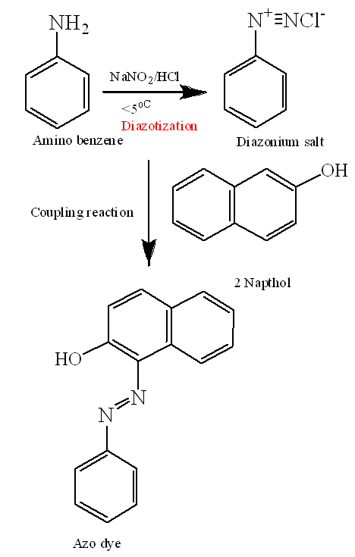
Scheme 1. Synthetic routs of Azo dyes (Kofie, W. et.al., 2019)
  - Triphenylmethane dyes
Triphenylmethane dyes are a group of synthetic organic dyes known for their brilliant and intense colors, which arise from their characteristic chemical structure given in Figure 1(Gaur, B. et.al., 2025). These dyes are widely used in printing inks (van Bommel, R.M. et.al., 2025), biological staining like Crystal Violet and
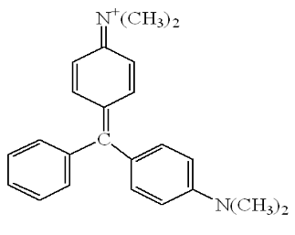
Figure 1: Structure of triphenylmethane dye
Malachite Green and textile coloration (Nagraj et.al., 2025). However, they exhibit poor lightfastness, which limits their long-term applications. The synthesis of triphenylmethane dyes typically involves a condensation reaction that produces a leuco base, which is then subjected to an oxidation process to generate the final-colored compound (van Bommel, R.M. et.al., 2025).
  - Anthraquinone dyes
After that azo dyes Anthraquinone dyes are a second huge and significant class of colorants, that comprise the anthraquinone structure (Negi A. et.al.,2025) shown in Figure 2. These dyes are also recognised for their vibrant and stable colors, mainly in the red, blue, and green ranges, and are applied in staining for textiles, cosmetics, and food. Though numerous synthetic anthraquinones exist, factually, red dyes were also derived from natural sources as insects (cochineal) and plants, that contain anthraquinone compounds (Krishnaraj, G. et. al, 2025). These dyes show good stability towards light and solubility. For examples: Reactive blue, Disperse blue.
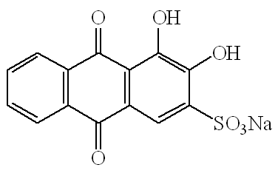
Figure 2: Structure of Anthraquinone dye (Negi A. et.al.,2025)
  - Reactive dyes
Reactive dyes are also a group of synthetic dyes (Kushwaha, R. et.al., 2025) represented in Figure 3. During the staining it permanently formed covalent bonds in specific condition as in alkaline condition with textile fibres that make them itself a part of fabric. Such chemical linkage results in brilliant colourfastness to washing and light making them a very prevalent choice for staining cellulosic fibers like cotton, along with protein fibers like as wool and silk. Because of its poor fixation capability with fibers hence, more quantity of dyes passed with wastewater that cause high amounts of dye present in water (Thakur, S. et.al.2025; Nath, A. 2025).
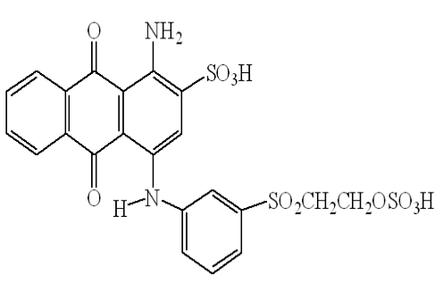
Figure 3: Structure of Reactive dye
  - Basic, Acid, and Disperse dyes
The dyes which show anionic, cationic and non-ionic nature called acidic, basic and disperse dyes respectively shown if Figure 4A.B and C, these are a distinct group of colorants that differ in their chem-
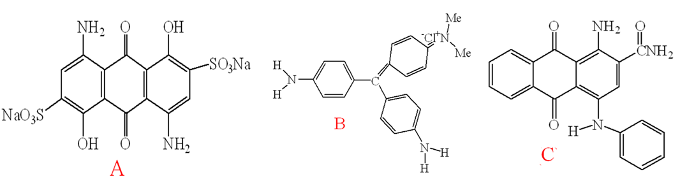
Figure 4: Structure of A. Acidic dye, B. Basic dye and C Disperse dyes

-ical nature as well as fiber affinity (Riaz, S. et.al., 2024). The basic or cationic dyes are bright which extensively applied for staining of acrylic, wool and silk, acidic or anionic dyes which are freely soluble in water that bind to protein and nylon fibers while disperse dye have non-ionic nature which are ideal stains for hydrophobic synthetics as polyester stains through diffusion process somewhat strong bonds (Anik, H.R. et.al., 2025; Nath, A. 2025). These dyes are applied for the dying in leather tanning, food, cosmetics and textile industries.
3. Environmental Impacts of Dye Pollution: Poorly bonded dye components easily pass into the water reservoir and contaminate pure water so that it causes adverse effects on atmosphere as;
3.1. Impacts on Aquatic Ecosystems
3.1.1. Reduced Light & Photosynthesis
Very low concentration of dyes produces intense color which blocks the penetration of sunlight in water bodies that alter the photosynthetic activity so that killing algae and aquatic plants occurs in aquatic system and damages the food chain (Soni, V. et.al., 2025), as shown in Figure 5.
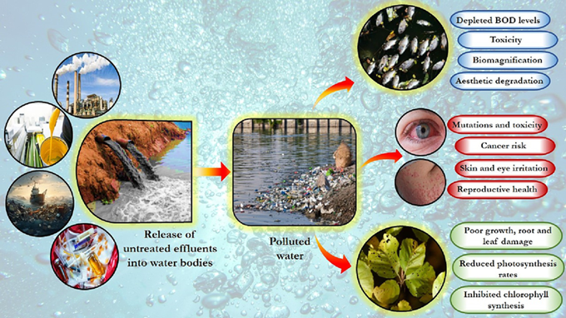
Figure 5: Dye reduce light and effects on aquatic system
3.1.2. Oxygen Depletion
Mostly dyes are constituents of organic compounds so that dyes contaminants produce high organic high
organic load which increases Chemical Oxygen Demands (COD) and Biological Oxygen Demand (BOD) that create hypoxic (low oxygen) level that harmful to fish and aquatic organisms (Kumari, U. 2024) given in Figure 6.

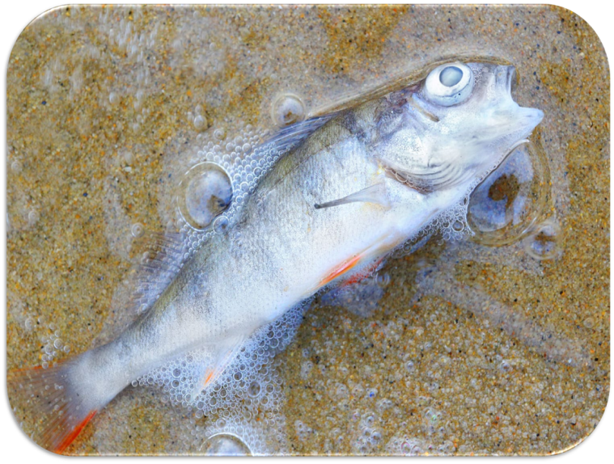
Figure 6: Depletion of oxygen caused death of Fish
3.1.3. Heavy metal contamination
Some dyes contain toxic metals ions hence their effluent loaded with heavy metal ions as lead, mercury, Chromium, these metals easily accumulate in bio-organism which show neurotoxicity and genetic issues given in Figure 7 (Kolya, W. et.al., 2024; Thakur, S. et.al.2025).

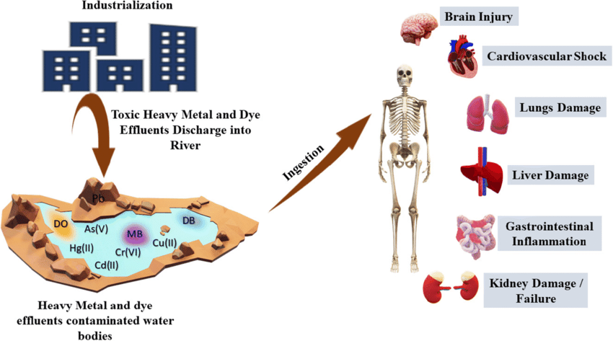
Figure 7: Effect of dye with heavy metals of human
3.1.4. pH & Osmotic Imbalance
Untreated or partially treated dye effluents discharged into aquatic systems that altered the pH, which are depends on the nature of the dyes. Dyes may be acidic, basic, or available in salt form. The degradation of acidic dyes makes the system acidic (pH < 7.0), while basic dyes make it alkaline (pH > 7.0). Dyes in salt form, after degradation, release excess salts into the water, disrupting the internal balance of aquatic life (Swaminathan, P. et al., 2024).
3.2. Impacts on Soil & Terrestrial Life
- Impedes Water and Air Flow: When wastewater with dyes passed into the soil by irrigation and other process, dyes make hydrophobic layers on soil that hinder water infiltration and air circulation so that it damages aquifers (Liu, Y. et.al., 2024).
- Inhibits Plant Growth: the dyes contaminated water reaches into the soil; it retards the uptake which inhibits the development of plants (Periyasamy, A. P. 2024; Periyasamy, A. P. 2025).
- Bioaccumulation: Dyes contaminated soil also loads some toxic products that are produced by degradation of dyes that can easily accumulate in biological tissues, these products easily enter the herbivorous animals which move into the food chain, affecting the terrestrial animals and humans (Periyasamy, A. P. 2024; Periyasamy, A. P. 2025).
3.3. Human Health Risks
- Carcinogenic/Mutagenic Effects: Several dyes derived from aromatic amines that produces aromatic amines after degradation which show carcinogenic behaviour which also cause oxidative stress and potential cancers (Periyasamy, A. P. 2025).
- Worker Exposure: Workers of dye factory faced respiratory problems, skin allergies and probable cancers from long term exposure of contaminated air (Mustafa, B. M. et.al., 2024).
- Contaminated Food/Water: Dyes pollutants resist towards degradation so that it easily accumulates in biological systems which cause adverse effects on fish or other aquatic animals (Kolya, W. et.al., 2024; Thakur, S. et.al.2025).
4. Green Materials Used for Dye Removal
Mitigation of effects caused by living being as well as aquatic systems, it is necessary for removal of pollutants from environments. For this purpose, choice of the materials is very important that show eco-friendly behaviour and no production of hazardous materials as secondary products therefore natural products also called green materials (Ren, Y. S. et.al., 2025) are key choice of researchers as:
4.1 Natural Polymers: - This class of polymer derived from living beings some polymeric materials are as;
4.1.1 Chitosan
This polymeric material derived from chitin (crustacean shells, insects, etc) having -NH₂ (amino
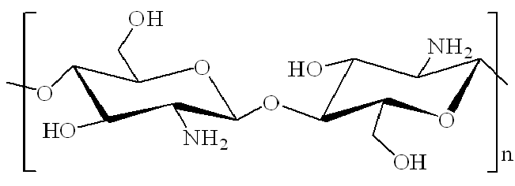
Figure 8: Structure of chitosan
group) functional groups in their structure given in Figure 8. These groups facilitate to the binding of dyes molecules that effective for the removal of acidic and reactive dyes (Baee, M. et.al., 2021; Ren, Y. S. et.al., 2025).
4.1.2 Cellulose and modified cellulose:
Cellulose is most abundant bio polymer on the earth these are structural plants component which made up of glucose chains, whereas modified cellulose chemically altered by etherification, esterification, oxidation, etc. that increase specific properties of cellulose as water solubility, binding of making film, produce sustainable derivatives as methylcellulose, CMC, cellulose acetate that vital for industries shown in Figure 9 A and B (Baee, M. et.al., 2021& Yadav, M. et.al., 2024).
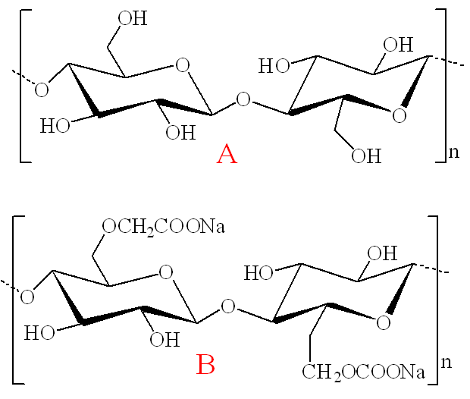
Figure 9: Structure of A. Cellulose, B. Derivatives of Cellulose
4.1.3 Alginate
Alginate is a negatively charged hydrophilic polysaccharide, it is the most significant biosynthesized natural substance which are primarily obtained from two sources as: marine plants as brown seaweed of Ascophyllum, Durvillaea, Ecklonia, Laminaria, Lessonia, Macrocystis, Sargassum and Turbinaria species and bacteria. It is constituted from linear groups of (1→4)- linked β-D-mannuronic acid (M) and α-l- guluronic acid(G) monomers. These polymeric materials show gel forms that applied in bead as well as composite form the structure is shown in Figure 10 (Baee, M. et.al., 2021; Hassan, M. N. et.al., 2024).
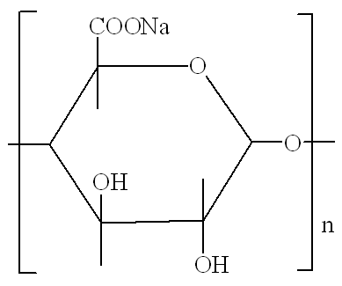
Figure 10: Structure of Alginate
4.2 Agricultural Waste and Biomass
Various agricultural waste materials like rice husk, coconut husk and coir, sugarcane bagasse, banana peels, orange peels and saw dust are used as adsorbent which are cost effective adsorbents having porous structures (Singh, S. et.al., 2024). These materials can be applied as in raw, activated of chemically alter form.
4.3 Biochar and Activated Carbon from Biomass
These materials porous carbon substances that derived from biomass through pyrolysis while it shows difference in their processing and applications as biochar is an important substance which directly take part in enhancing of soil health and it also play an important role in capturing of carbon. Though activated carbon go through additional activation to produces more surface area porosity that makes it better for water, air purification, energy storage, and industrial filtering in which activated carbon containing micro pores while biochar contains macro or meso
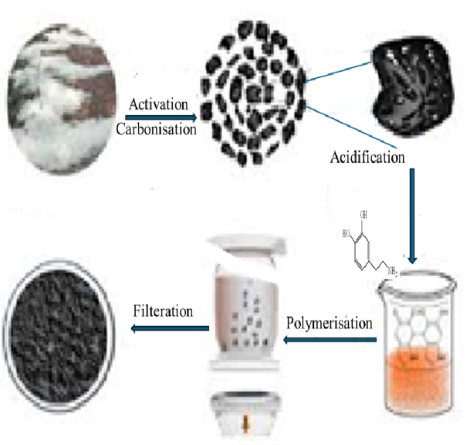
Figure 11: Synthesis of biochar and activated charcoal from biomass
pores shown in Figure 11. These materials are economical as well as ecofriendly and can be commercially used in place of activated carbon (Akpomie, K. G. et.al.,2024).
4.4 Clay–Biomaterial Composites
Bentonite and montmorillonite are composites material convert into hybrid materials by the blending with chitosan, starch and silk biopolymers that improved their properties which can be used in drug delivery, tissue engineering, packaging and agriculture. These composite materials also provide more mechanical strength, biocompatibility, controlled release and fence possessions by mixing clay’s produce vast surface area and biodegradability of polymer (Krajišnik, D., et.al.,2024; Mihai, S. et.al.,2024) represented by Figure 13.
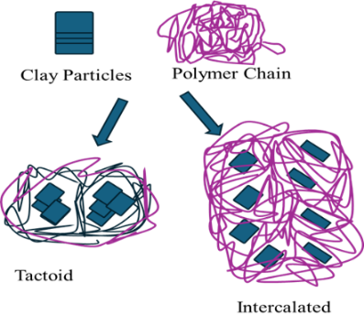
Figure 12: Clay biomaterials composite
4.5 Green Nanomaterials
    - Metal-free nanoparticles
Nanoparticles (NPs) free from metal ions are materials that not derived from common metals as gold, silver or copper, concentrating in its place on carbon-based compounds like fullerenes, graphene, carbon nano tubes, polymeric, ceramic, or some other metal oxide as TiO₂, ZnO and MgO materials. These nanomaterials are economical and also show lower toxicity, unique catalytic properties as well as biological activity and atmospheric remediation. During the treatment of dyes contaminated water with nanomaterials it functional group strongly attached with dyes molecule making it easy to remove dyes from wastewater (Baee, M. et.al., 2021; Soman, K. et.al., 2025).
4.5.2 Bio-synthesized nanoparticles
Biosynthesized nanoparticles (NPs) are eco-friendly nanomaterials derived from biological sources as plants, microbes, or fungi that have reducing and capping properties and avoid severe chemicals. Such "green" nanoparticles as Gold, Silver, Copper, Zinc Oxide provide auspicious applications in medicine, agriculture and atmospheric remediation. Due to their biocompatibility, exclusive properties that mitigate toxicity as compared to chemically synthesized NPs. These materials also frequently used in dye removal from wastewater (Verma, N. et.al., 2025; Sreelekshmi, P. B. et.al., 2024)
4.6 Microbial Biomass and Enzyme-based Systems
These systems are operative, economical, and eco-friendly. The process used for treating wastewater with dye-contaminant by using micro-organisms as bacteria, fungi, algae, yeast and their enzymes can decolorize and degrade the complex molecules of dye into simpler, non-toxic products, e.g. laccase enzyme degrades the aromatic dyes (Dey, S. et.al.,2025).
5. Mechanisms of Dye Removal Using Green Materials
5.1. Adsorption:
The methods involved that the dyes molecules adsorbed on the surface of adsorbents as green materials as agricultural waste or biomass (Nath, A.et.al.,2021).During the treatment of water using adsorbents that contains a wide area of free surface, dyes easily adsorbed by formation electrostatic bond with free surface valency on the free surface which can easily eliminate from the water (Ali, N. S. et.al.,2024; Meskel, A. G. et.al., 2024; Nath, A. 2025) given in Figure 13.
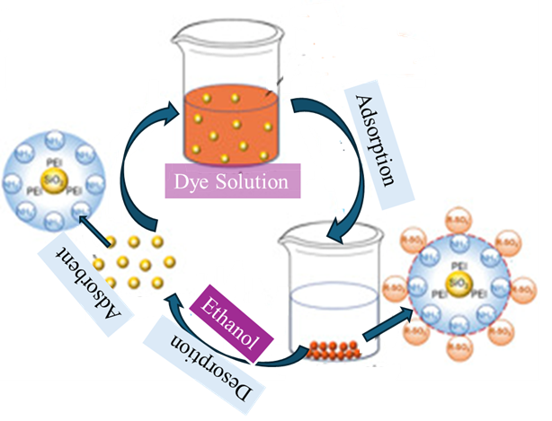
Figure 13: Adsorption mechanism for dye removal

5.2. Ion exchange:
Such types of dye-removal processes are based on the surface charge of the adsorbent. In this system, green materials can be modified into an activated form; in other words, the adsorbent surface becomes charged. These adsorbents are packed into a column, and contaminated water is passed through it. The charged dye molecules are captured by the packed adsorbents, resulting in dye-free water. In this process, dye molecules are retained on the adsorbent surface through electrostatic interactions, hydrogen bonding, and π–π stacking shown in Figure 13.

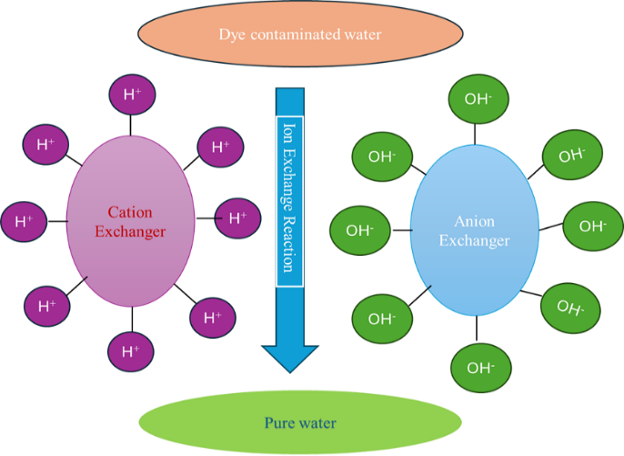
Figure 14: Ion exchange process in dye removal from contaminated water

Some other economical and highly efficient substitutes for synthetic resins used in textile wastewater treatment—such as chitosan composites or activated carbon derived from agro-waste—also act as ion-exchange resins. They can effectively remove both cationic and anionic dyes, offer good reusability, and have strong regeneration potential (Ghzal, Q. et.al.,2025; Nath, A. et.al.,2021; Nath, A. 2025; Yanardağ, D. et.al.,2024).
5.3. Complexation:
The presence of hydroxide, ammine and acidic (–OH, –NH₂, –COOH) functional groups into the dye’s molecules can formed primarily complex with using green substances that derived from natural materials as plants, biomass, agricultural waste and certain microorganisms and nanoparticles obtained from green synthesis. These processes play an important role of functional groups exist in adsorbent materials that bind dyes molecules by several interaction as well as surface complexation (Urooj, T. et.al., 2024). shown in Scheme 2.
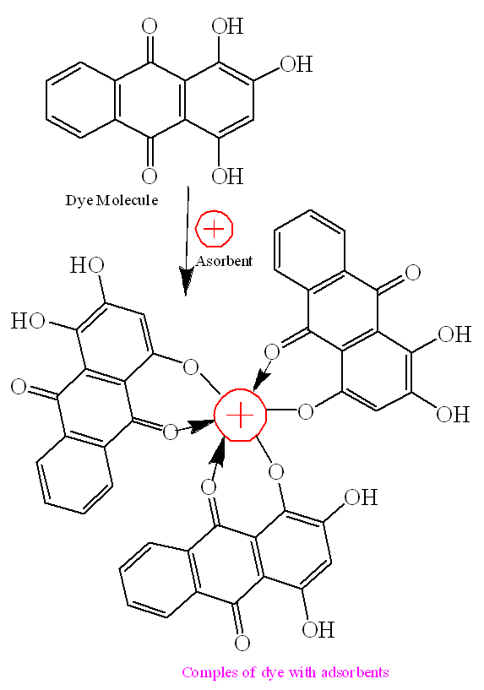
Scheme 2: Complexes process for dye removal from contaminated water

5.4. Biodegradation
The biodegradation process involves the removal of dyes using various microorganisms such as bacteria, fungi and algae, or their enzymes, which break down complex dye molecules into simpler, non-toxic forms. This method is eco-friendly, economical and serves as an effective alternative to conventional chemical treatments for textile wastewater (Phan, K. H. et.al., 2024)

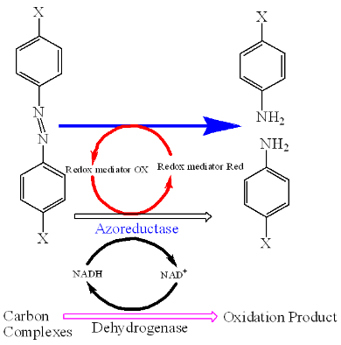

Scheme 3: Biodegradation of dye for removal of dye from wastewater

Microorganisms release oxidoreductase enzymes that cleave azo bonds and other structural components of dyes, resulting in their decolorization and detoxification. Promising results have been reported with bacterial species such as Pseudomonas aeruginosa and fungal species like Fusarium oxysporum.( Sharma, M. et.al.,2024)
This mechanism is particularly effective for recalcitrant dyes, converting toxic compounds into harmless end products such as carbon dioxide and water (Cui, C. et.al.,2024) given in Scheme 3.

5.5. Photocatalysis.
This process removes dyes from effluents by applying UV/visible light along with semiconductors that

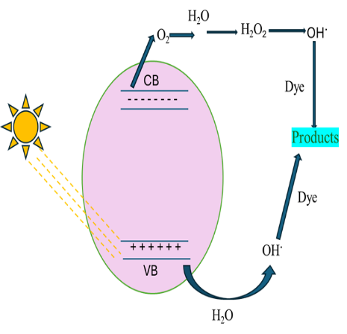
Scheme 4: Photocatalysis of dye for wastewater Treatments

act as catalysts, such as titanium oxide and zinc oxide. These catalysts generate highly reactive hydroxyl radicals that break down harmful dye molecules into non-toxic end products like carbon dioxide and water, making the method environmentally friendly. This is an efficient process with advantages such as the absence of secondary waste, mild operating conditions and the ability to be reused given in Scheme 4 (Ashokan, J. et.al., 2025; Khan, S. et.al.,2024).

6. Factors Affecting Dye Removal Efficiency
  - pH of wastewater:
The pH of the contaminated medium play and important role for the elimination of dyes that involved a number of processes as:
    - Adsorption methods: in this method adsorbent’s surface paly significant role for the removal of pollutants that depends on the pH, the lower pH protonates surface of adsorbents that attracts anionic dyes, whereas higher pH protonates positively charged dyes hence it alters the binding of dyes with surface of adsorbents (Bellaj, M. et.al., 2024)
    - Chemical process (Fenton Oxidations):
At lower pH at about 3.0 favours the generation of hydroxyl radicals (•OH) for oxidative breakdown, making acidic conditions ideal for Fenton reactions as:
Fenton reactions for degradation involved following mechanism as (Omar, B.M. et,al,,2024)
- Initiation of Radical: At lower pH Ferrous ion (𝐹𝑒²⁺) catalyses hydrogen peroxide (𝐻₂𝑂₂) to generates hydroxyl radicals (⋅𝑂𝐻) and ferric ion $(Fe^{3+}$), the chemical reactions shown in equation 1.

$Fe^{2+}+H_{2}O_{2}→Fe^{3+}+⋅OH+OH^{-}$ 1
- Oxidation of Dye: The produced hydroxyl (⋅𝑂H) radicals then attack on the structure of the complex organic dyes as azo dyes which rapidly oxidize shown in following equation 2.

Dye + $⋅OH→$ Degradation Products (CO₂, H₂O, etc.) 2
- Regeneration of Radical (Photo-Fenton): UV or visible light facilitate the revive 𝐹𝑒²⁺from $Fe^{3+}$, consenting the cycle to continue and enhancing to the degradation of dyes represents in equation 3.
$Fe^{3+}+H_{2}O_{2}(Light)→Fe^{2+}+⋅OOH+H^{+}$ 3
    - Biological Treatments:
In these process various microorganisms are use that can survive at certain pH hence suitable pH required for the dye degradation by microbes that show significant activity at neutral to alkaline medium as 6.0 to 10.0 pH which are depends of microbes and dye (Wadhawan, G. et.al.,2025).
    - Coagulation:
The alkaline medium or high pH encourages the creation of insoluble hydroxides as flocs of metal as Al (OH)₃, that easily trap dyes which facilitate the effectiveness for certain dyes as reactive Red 120 (Getahun, M. et.al., 2024; Lucas, M.S. et.al., 2025; Nath, A. 2025).
    - Examples of pH Dependence dye:
Cationic dyes (Methylene Blue) have better removal efficiency in acidic medium or at low pH. Anionic dyes (Disperse Red 73/Acid Blue 25) have high removal efficiency in alkaline medium or at high pH.
Acid Green Dye show maximum removal at around neutral pH (7.0) wherever an equilibrium of protonation and repulsion obtained (Li, D. et.al., 2024).
On the basis of above facts that in intrinsic nature, the electrostatic interaction and chemical environment can be controls by the pH of medium which provide critical aspect to optimize for active removal of dye there are no single pH parameters for all treatments (Li, D. et.al., (2024).
    - Initial dye concentration:
Increases the initial concentration of dyes facilitates the amount of dye adsorption since a better driving force derived in molecules to reach the surface, but it reduces the removal percentage effectiveness because of the active site of adsorbents become saturated, ultimately removal efficiency drips. Hence greater number of dye molecules show greater chances to bind to the adsorbents but once free sites become binds with dye’s molecules then rest dyes are stays in solution (Umejuru, E. C. et.al.,2024)
    - Temperature:
Temperature plays an important role for dye removal, commonly increasing efficiency through enhancing molecular energy and diffusion that facilitate to dye-adsorbent interactions more favourable at endothermic reactions, while extreme heat can occasionally hinder removal via producing degradation of dye involved hydrolysis reaction or minimise binding. Most of the researchers show better removal occurs at higher temperatures that indicate an endothermic adsorption mechanism, but this also depends on the precise dye, adsorbent, and temperature range (Moheb, M. et.al., 2025).
    - Contact time:
This is an important factor affecting dye removal. A short contact time of 15–60 minutes is often sufficient for rapid initial adsorption using natural adsorbents such as fruit peels or activated carbon. In contrast, processes such as photocatalysis generally require longer reaction times, for example up to 6 hours, to achieve higher removal efficiencies. Ultimately, the system reaches equilibrium, beyond which further increases in contact time result in minimal improvement in dye removal. This behavior strongly depends on the nature of the adsorbent (e.g., cassava, chitosan, rice husk), as well as dye type, initial dye concentration, pH, and temperature (Mutalib, N. et.al., 2025).
    - Surface area and porosity of adsorbent:
Significant dye removal requires adsorbents with high specific surface areas, typically ranging from hundreds to thousands of m²/g, and well-developed porous structures consisting of micro- and mesopores. These features provide abundant active sites for dye molecules, with pore sizes suitable for accommodating a wide variety of dye structures, thereby ensuring better accessibility, faster uptake, and higher adsorption capacity. Adsorbents such as activated carbon, graphene, and porous polymers outperform others due to their advanced pore architectures. In particular, mesopores facilitate the adsorption of larger dye molecules, while micropores contribute to rapid adsorption kinetics, collectively determining the overall performance of the adsorbent (Verma, N. et.al., 2025; Sreelekshmi, P. B. et.al., 2024).
7. Advantages of Green Materials
These materials are renewable, biodegradable, and non-toxic, abundant, inexpensive that produce very minimum secondary pollution, after modification that materials show high adsorption efficiency which are suitable for decentralized water treatment.

8. Limitations and Challenges
Some green materials as bio polymers have lower mechanical strength, these have limited regeneration and reuseable properties, its adsorption performance are variable for different dyes and also show limitation on use of industrial scale.
9. Future Perspectives: there are some challenges occurs that can be improved properties of the green materials as:
- Development of hybrid green composites that shows better stability.
- Used biochar–nanomaterial combinations.
- Large-scale continuous systems as fixed-bed reactors can be applied.
- Integrating green materials with photocatalysis and bioreactors.
- Tailored in surface chemical modification for higher adsorption efficiency.

10. Conclusion
Green materials an eco-friendly material the offer a sustainable and effective approach for removal of dye from contaminated water equated to conventional technologies that applied in wastewater treatment. Their economic value, renewability, and more adsorption capacity represents them promising choices for industrial wastewater treatment. Future research should focus on improving material’s stability, developing flexible treatment systems, and exploring multifunctional green composites to achieve efficient and eco-friendly dye removal.
Disclaimer (Artificial intelligence)
Author hereby declares that No generative AI technologies such as Large Language Models (ChatGPT, COPILOT, etc) and text-to-image generators have been used during the writing or editing of the manuscript.

References:
- Akpomie, K. G., Adegoke, K. A., Oyedotun, K. O., Ighalo, J. O., Amaku, J. F., Olisah, C. et.al. (2022). Removal of bromophenol blue dye from water onto biomass, activated carbon, biochar, polymer, nanoparticle, and composite adsorbents. Biomass Conversion and Biorefinery, 14(13), 13629-13657.Doi: https://doi.org/10.1007/s13399-022-03592-w
- Ali, N. S., Albayati, T. M. & Salih, I. K. (2024). Studying the kinetics and removal mechanism of the methylene blue dye in a continuous adsorption process using prepared mesoporous materials. Water Practice & Technology, 19(7), 2799-2815.Doi: https://doi.org/10.2166/wpt.2024.162
- Anik, H.R. & Akter, M. (2025). Advancements in Textile Printing from Conventional to Modern Practices. In: Shahid, M., Maiti, S., Khan, S.A., Adivarekar, R.V. (eds) Advancements in Textile Coloration. Springer, Singapore. https://doi.org/10.1007/978-981-96-5091-0_12
- Asokan, J., Kumar, P., Arjunan, G. et al. (2025). Photocatalytic Performance of Spinel Ferrites and their Carbon-Based Composites for Environmental Pollutant Degradation. Journal of Cluster Science 36, 42.Doi: https://doi.org/10.1007/s10876-024-02754-2
- Baee, M.,Sajjadi, M.,Iravani, S.& Varma, R. (2021). Starch, cellulose, pectin, gum, alginate, chitin and chitosan derived (nano)materials for sustainable water treatment: A review. Carbohydrate Polymers. 251.Doi: https://doi.org/10.1016/j.carbpol.2020.116986
- Bellaj, M., Aziz, K., El Achaby, M., El Haddad, M., Gebrati, L., Kurniawan, T. A. et.al. (2024). Cationic and anionic dyes adsorption from wastewater by clay-chitosan composite: an integrated experimental and modeling study. Chemical Engineering Science, 285, 119615.doi. https://doi.org/10.1016/j.ces.2023.119615
- Chin, W. H. (2024). Greywater treatment by Fenton, Photo-Fenton and UVC/H2O2 processes (Doctoral dissertation, RMIT University). Doi:10.25439/rmt.27576621
- Cui, C., Li, D., Wang, L. J. & Wang, Y. (2024). Curdlan/sodium carboxymethylcellulose composite adsorbents: A biodegradable solution for organic dye removal from water. Carbohydrate Polymers, 328, 121737. https://doi.org/10.1016/j.carbpol.2023.121737
- Dey, S.& Mandal, B. (2025). Progress and perspectives on microbial dye remediation: enzymatic pathways, microbial diversity, and hybrid microbial-based technologies. Arch Microbiol 207, 282.Doi: https://doi.org/10.1007/s00203-025-04477-y
- Gaur, B., Mittal, J., Meena, L., Mittal, A., & Baker, R. T. (2025). Adsorptive removal of a triphenylmethane dye from its aqueous solutions using a biosorbent. International Journal of Phytoremediation, 1–14.Doi: https://doi.org/10.1080/15226514.2025.2581818
- Gawate, Dr.K.N. (2024). Growing Population Pressure on Employment Opportunities and Sustainable Development in India. Educational Administration: Theory and Practice. 30. 10.53555/kuey. v30i5.11118. https://doi.org/10.53555/kuey.v30i5.11118
- Getahun, M., Befekadu, A. & Alemayehu, E. (2024). Coagulation process for the removal of color and turbidity from wet coffee processing industry wastewater using bio-coagulant: Optimization through central composite design. Heliyon, 10(7).Doi: https://doi.org/10.1016/j.heliyon.2024.e27584
- Ghzal, Q., Javed, T., Zghair, A. N., Haider, M. N., Abed, M. J., Jasim, L. S., & Iftikhar, R. (2025). Sustainable dye wastewater treatment: A review of effective strategies and future directions. Physical Chemistry Research, 13(3), 479-509.Doi: https://doi.org/10.22036/pcr.2025.501339.2633
- Hassan, M. N. Fariha, F.T., Zayee, Z. & Hasan, M. (2024). Analyzing different functional and dyeing performance of natural blended fabric utilizing natural dyes and quality prediction by fuzzy logic. Heliyon, 10(22), e40399. Doi: https://doi.org/10.1016/j.heliyon.2024.e40399
- Hussain, S., Salman, M., Al-Ahmary, K. M. & Ahmed, M. (2025). Synthesis of potential adsorbent for removal of malachite green dye using alginate hydrogel nanocomposites. International Journal of Biological Macromolecules, 289, 138816.doi. https://doi.org/10.1016/j.ijbiomac.2024.138816
- Khan, S., Noor, T., Iqbal, N. & Yaqoob, L. (2024). Photocatalytic dye degradation from textile wastewater: a review. ACS omega, 9(20), 21751-21767.Doi: https://doi.org/10.1021/acsomega.4c00887
- Khorshidi, K., Choukolaei, H.A.& Ghasemi, P. (2025). Sustainable solutions for the wood and paper industry: A comprehensive assessment of the rural environment impact. Journal of Engineering Research.13(2), 652-665, doi.org/10.1016/j.jer.2023.11.018.
- Kofie, W., Adosraku, R, & Amengor, C. (2019). Synthesis and evaluation of antimicrobial properties of azo dyes Original Article. International Journal of Pharmacy and Pharmaceutical Sciences. 7. 398-401. https://www.researchgate.net/publication/335990000_SYNTHESIS_AND_EVALUATION_OF_ANTIMICROBIAL_PROPERTIES_OF_AZO_DYES_Original_Article
- Kolya, H., & Kang, C.-W. (2024). Toxicity of Metal Oxides, Dyes, and Dissolved Organic Matter in Water: Implications for the Environment and Human Health. Toxics, 12(2), 111.Doi https://doi.org/10.3390/toxics12020111
- Krajišnik, D., Uskoković-Marković, S., & Daković, A. (2024). Chitosan–clay mineral nanocomposites with antibacterial activity for biomedical application: advantages and future perspectives. International Journal of Molecular Sciences, 25(19), 10377.doi.org/10.3390/ijms251910377
- Krishnaraj, G., Gokarneshan, N., Jothimanikandan, A., Periyasamy, P., Ponmaniselvam, M., et. al. (2025). Advances in Natural Dyeing of Hemp – An approach Towards. Sustainability. Journal of Environmental Science and Agricultural Research, 2025. 3(2), 1-14. Doi: https://doi.org/10.61440/JESAR.2025.v3.54
- Kumari, S., Singh, R., Jahangeer, J. et al. (2024). Innovative Strategies for Dye Removal from Textile Wastewater: A Comprehensive Review of Treatment Approaches and Challenges. Water Air Soil Pollution, 235, 720. https://doi.org/10.1007/s11270-024-07532-4
- Kumari, U. (2024). Textile Dyes and Their Impact on the Natural Environment. In: Singh, P. (eds) Dye Pollution from Textile Industry. SDGs and Textiles. Springer, Singapore. Doi: https://doi.org/10.1007/978-981-97-5341-3_2
- Kurul, F., Doruk, B. & Topkaya, S.N. Principles of green chemistry: building a sustainable future. Discov. Chem. 2, 68 (2025). https://doi.org/10.1007/s44371-025-00152-9
- Kushwaha, R. Kesarwani, P. & Kushwaha, A. (2025) A comprehensive review on reactive dye and its chemical components. Industrial Engineering Journa, 54, (1-2).
- Liu, Y., Sun, Y., Qi, Y., Niu, W., Ma, W., Wu, S.,Zhang, S. et.al. (2024). Water-Rewritable Structural Color Textiles with Fast Response Speed and Antispreading Capability. ACS applied materials & interfaces, 16(41), 55945-55954.Doi: https://doi.org/10.1021/acsami.4c10978
- Lucas, M. S., Teixeira, A. R., Jorge, N., & Peres, J. A. (2025). Industrial Wastewater Treatment by Coagulation–Flocculation and Advanced Oxidation Processes: A Review. Water, 17(13), 1934.Doi: https://doi.org/10.3390/w17131934
- Meskel, A. G., Kwikima, M. M., Meshesha, B. T., Habtu, N. G., Naik, S. C. S. & Vellanki, B. P. (2024). Malachite green and methylene blue dye removal using modified bagasse fly ash: Adsorption optimization studies. Environmental Challenges, 14, 100829.Doi: 10.1016/j.envc.2023.100829
- Mihai, S., Bondarev, A., Călin, C. & Sȋrbu, E. E. (2024). Adsorbent biomaterials based on natural clays and orange peel waste for the removal of anionic dyes from water. Processes, 12(5), 1032.Doi: https://doi.org/10.3390/pr12051032
- Mohanrasu, K., Manivannan, A.C., Rengarajan, H.J.R. et al. (2025). Eco-friendly biopolymers and composites: a sustainable development of adsorbents for the removal of pollutants from wastewater. npj Mater. Sustain. 3, 13.Doi: https://doi.org/10.1038/s44296-025-00057-9
- Moheb, M., El-Wakil, A. M., Waly, S. M., & Awad, F. S. (2025). Eco-friendly tassel-derived activated carbon for efficient dye removal in wastewater treatment. Scientific Reports.doi. https://doi.org/10.1038/s41598-025-28825-6
- Mustafa, B. M. & Hassan, N. E. (2024). Water contamination and its effects on human health: A review. Journal of Geography, Environment and Earth Science International, 28(1), 38-49. https://doi.org/10.9734/jgeesi/2024/v28i1743
- Mutalib, N, Azat, S., Othman, M B.H.,Ramle, A. Q., Mohd Salleh, N., Othman, M. H. et. al. (2025). Revolutionizing Dye Removal in Wastewater: An Optimization Study of Curcumin-Functionalized Zeolite Beads for Methylene Blue Adsorption. 72, Surfaces and Interfaces 107434. Doi. 10.1016/j.surfin.2025.107434
- Nagraj, Chaurasia, P. K., Bharati, S. L., Sharma, N., Kumar, J., & Sivalingam, A. M. (2025). Degradation of dyes by fungi: An overview on recent updates. The Microbe, 6, 100232. doi.org/10.1016/j.microb.2024.100232
- Nath, A., Mishra, A., & Pande, P. P. (2021). A review natural polymeric coagulants in wastewater treatment. Materials Today: Proceedings, 46, 6113-6117.Doi: https://doi.org/10.1016/j.matpr.2020.03.551
- Nath, A. (2025). Monosaccharides Xanthates and TheirApplication in the Removal of Toxic Metal Ions from Contaminated Water: A Review. International Journal on Science and Technology (IJSAT),16(4), 1-8.Doi: https://doi.org/10.71097/IJSAT.v16.i4.8981

- Nath, A. (2025). Types of Dyes and Their Effects on the Environment and Their Removal: A Review. Journal of Materials Science Research and Reviews 8 (4):1019–1034.Doi: https://journaljmsrr.com/current-issue
- Ncube, L.K., Ude, A.U., Ogunmuyiwa, E.N., Zulkifli, R., Beas, I.N. (2020). Environmental Impact of Food Packaging Materials: A Review of Contemporary Development from Conventional Plastics to Polylactic Acid Based Materials. Materials (Basel). 13(21),4994.Doi: https://doi.org/10.3390/ma13214994
- Negi A. (2025). Environmental Impact of Textile Materials: Challenges in Fiber-Dye Chemistry and Implication of Microbial Biodegradation. Polymers (Basel).17(7), 871.Doi: https://doi.org/10.3390/polym17070871
- Negi, A., Toukola, P.& Räisänen, R. (2025). Chemical profiling and characterisation of anthraquinone-based polyphenols as biocolourants from Cortinarius semisanguineus. Coloration Tecnnology,Doi: https://doi.org/10.1111/cote.12810
- Omar, B.M., Zyadah, M.A., Ali, M.Y. et al.(2024). Pre-treatment of composite industrial wastewater by Fenton and electro-Fenton oxidation processes. Sci Rep 14, 27906. Doi.org/10.1038/s41598-024-78846-w.
- Periyasamy, A. P. (2024). Recent Advances in the Remediation of Textile-Dye-Containing Wastewater: Prioritizing Human Health and Sustainable Wastewater Treatment. Sustainability, 16(2), 495.Doi: https://doi.org/10.3390/su16020495
- Periyasamy, A.P. (2025). Textile Dyes in Wastewater and its Impact on Human and Environment: Focus on Bioremediation. Water Air Soil Pollution, 236, 562.Doi: https://doi.org/10.1007/s11270-025-08204-7
- Phan, K. H., Le, L. T., Tran, T. D., Vo, T. K. Q., Nguyen, T. T., Tra, V. T., et.al. (2024). Anaerobic biodegradation of mixed azo dyes in thermophilic and mesophilic conditions. Case Studies in Chemical and Environmental Engineering, 9, 100667.Doi: https://doi.org/10.1016/j.cscee.2024.100667
- Ren, Y. S., Tynybekov, B., Nurmahanova, A., Ibragimov, T., Kurmanbay, U., Nazarbekova, S.et.al. (2025). Eucalyptus wood waste biochar: a green solution for fluoranthene contamination in wastewater. International Journal of Environmental Health Research, 35(11), 3309–3322. Doi.10.1080/09603123.2025.2483976
- Riaz, S., Jabbar, A., Siddiqui, H. et al. (2024). A sustainable process for cotton and polyester/cotton blend dyeing with nucleophilic disperse dyes through chemical modification. Cellulose 31, 3981–3992. https://doi.org/10.1007/s10570-024-05820-0
- Sah, M.K., Ettarhouni, O.Z., Pathak,R., Gawad,J., Bonde,C., Arya,S.P. & Bhattarai, A. (2025). Green Chemistry: Strategies and Sustainable Approaches for Bridging UN SDGS, 10(25), e00847.Doi: https://doi.org/10.1002/slct.202500847
- Sharma, M., Sharma, S., Akhtar, M. S., Kumar, R., Umar, A., Alkhanjaf, A. A. M., & Baskoutas, S. (2024). Microorganisms-assisted degradation of Acid Orange 7 dye: a review. International Journal of Environmental Science and Technology, 21, 6133-6166.Doi: https://doi.org/10.1007/s13762-023-05438-y
- Singh, S. and Kumar, N. (2024). Removal of Dyes from Waste Water Using Low‐Cost Adsorbents. Macromolecular Symposia, 413(5). https://doi.org/10.1002/masy.202400156
- Soman, K., Kanagaraj, K., Senthilkumar, N., Rajendran, S., Faraj, T. K., Alrefaei, A. F. et.al., (2025). Nitrogen-doped carbon dots from Brahmi (Bacopa monnieri): Metal-free probe for efficient detection of metal pollutants and methylene blue dye degradation. Green Processing and Synthesis, 14(1), 20240182.doi.org/10.1515/gps-2024-0182.
- Soni, V., Bhatt, U., Tailor, P. et al. (2025). Impact of synthetic and herbal dyes on photosynthesis and ROS scavenging enzyme activities in Spirodela polyrhiza. Sci Rep 15, 24775. https://doi.org/10.1515/gps-2024-0182
- Sreelekshmi, P. B., Pillai, R. R., Unnimaya, S., Anju, A. L. & Meera, A. P. (2024). Biofabrication of novel ZnO nanoparticles for efficient photodegradation of industrial dyes. Clean Technologies and Environmental Policy, 26(11), 3805-3818. https://doi.org/10.1038/s41598-025-02038-3
- Swaminaathan, P., Shaji, A., Saravanan, A. et al. (2024). Innovative Approaches in Extremophile-Mediated Remediation of Toxic Pollutants: A Comprehensive Review. Water Conservation Science and Engineering, 9, 39.Doi: https://doi.org/10.1007/s41101-024-00274-8
- Thakur, S., Chandra, A., Kumar, V. & Bharti, S. (2025). Environmental Pollutants: Endocrine Disruptors/Pesticides/Reactive Dyes and Inorganic Toxic Compounds Metals, Radionuclides, and Metalloids and Their Impact on the Ecosystem. In: Verma, P. (eds) Biotechnology for Environmental Sustainability. Interdisciplinary Biotechnological Advances. Springer, Singapore. https://doi.org/10.1007/978-981-97-7221-6_3
- Thayanithi, S., Kumar J., Sridhar, A., Abilesh R., Renugadevi, B., Gracesuganthi, J. & Vaidevi, S.(2025). Effect of Biopolymer and Polymeric Nanoparticles for Dye Degradation. In: Jeyaseelan, A., Murugasen, K. (eds) Sustainable Environmental Remediation: Avenues in Nano and Biotechnology. Environmental Science and Engineering. Springer, Cham, 197-218,Doi: https://doi.org/10.1007/978-3-031-78483-5_10
- Tolnay, A., Koris, A.& Magda, R. (2018). Sustainable Development of Cosmetic Products in the Frame of the Laboratory Market. Visegrad Journal on Bioeconomy and Sustainable Development. 7. 62-66 https://doi.org/10.2478/vjbsd-2018-0012
- Umejuru, E. C., Street, R. & Edokpayi, J. N. (2024). The application of synthesized geopolymer for the removal of cationic dye from industrial wastewater. Results in Materials, 22, 100572.Doi: https://doi.org/10.1016/j.rinma.2024.100572
- Urooj, T., Mishra, M. & Pandey, S. (2024). Unlocking environmental solutions: a review of cyclodextrins in pollutant removal. Discov Environ 2, 65 (2024). https://doi.org/10.1007/s44274-024-00090-w
- Vadera, S. (2021). A Critical Analysis of Rising Global Demand of Plastics and its Adverse impact on Environment Sustainability. Journal of Environmental Pollution and Management. 3 https://doi.org/10.18875/2639-7269.3.105
- van Bommel, R.M.& de Keijzer, M. (2025). A Colour Boom: The Tri-Arylmethane Dyes. In: Bright Colours from the Past. Cultural Heritage Science. Springer, Cham. https://doi.org/10.1007/978-3-031-88664-5_13
- Verma, N.& Nigam, A.K. (2025). Microbial Nanomaterials in Water Purification. In: Srivastava, N., Kumar, M. (eds) Biomedical Applications of Microbial Nanomaterials. Materials Horizons: From Nature to Nanomaterials. Springer, Singapore. https://doi.org/10.1007/978-981-96-8923-1_13
- Vishwakarma, D. & Shikha. (2022). Biopolymer-based materials for sustainable water treatment: A Review.Journal of Applied Science, Innovation & Technology (JASIT), 1(10), 10-14. https://prakritimitrango.com/documents-reports-and-publications/journal/
- Wadhawan, G. & Gupta, A. (2024). Biological treatment of methyl orange dye and textile wastewater using halo-alkaliphilic bacteria under highly alkaline conditions. Extremophiles 29, 6Doi: https://doi.org/10.1007/s00792-024-01369-9
- Yadav, M., Singh, N., Annu, Khan, S. A., Raorane, C. J. & Shin, D. K. (2024). Recent advances in utilizing lignocellulosic biomass materials as adsorbents for textile dye removal: a comprehensive review. Polymers, 16(17), 2417. https://doi.org/10.3390/polym16172417
- Yanardağ, D.& Edebali, S. (2024). Adsorptive removal of malachite green dye from aqueous solution by ion exchange resins. Biomass Conv. Bioref. 14, 5699–5710.doi. https://doi.org/10.1007/s13399-023-04839-w
- Zinicovscaia, I. (2016). Conventional Methods of Wastewater Treatment.Doi: https://doi.org/10.1007/978-3-319-26751-7_3

