POTENTIAL OF ACTIVATED GROUNDNUT SHELLS AS A NATURAL ADSORBENT FOR REMOVAL OF LEAD (II) IONS METALS FROM AQUEOUS SOLUTION

ABSTRACT
Lead (Pb) present in water at high levels causes a serious problem in many places all over the world. Activated carbon (AC) is employed as a low- cost alternative adsorbent in wastewater treatment for removal of heavy metals, acid dyes and even odour. The objective of this study was to assess the potential of activated groundnut shell as an adsorbent for removal of Lead from aqueous Lead (II) Chloride solutions using batch experiments. The groundnut shells were impregnated with activating reagents and subsequently heated to obtain activated groundnut shells. From the results the adsorption of Lead was optimal at contact time of 65 minutes, pH of 5, an adsorbent dose of 0.6 g, initial metal ion concentration of 50 ppm, and temperature of 65ºC with an adsorption removal of 18.425%. Langmuir isotherm is the best adsorption isotherm with R²= 0.9601. From FTIR experiment, there was a participation of –OH, and –NH groups in the uptake of metals. The Gibbs free energy value of –13,391.800 J·mol⁻¹ confirms that the adsorption process is spontaneous. Furthermore, analysis of the Dubinin–Radushkevich (D–R) isotherm revealed mean free energy values (E < 8 kJ·mol⁻¹), which are characteristic of physisorption, thereby indicating that the adsorption mechanism proceeds predominantly through physical interactions rather than chemical bonding. This study advances a simple and low-cost alternative adsorbent for removal of lead from waste waters.

KEYWORDS: Activated groundnut shells, Lead, natural adsorbent, FTIR analysis, heavy metal

1.0 INTRODUCTION
Water is an essential natural resource for humans, animals, plant and aquatic life and thus clean and safe is crucial for all forms of life and environmental sustainability []. Heavy metal pollution is one of the most serious situations being faced today []. For instance, heavy metals such as Ni, Cu, Pb or Cr are among most important pollutants in surface and ground water. Many industries such as the electroplating, mining and leather industries release various concentrations of heavy metals into water bodies such as rivers and lakes []. Untreated or ineffectively treated waste materials from industrial units possess risks to aquatic life since potentially toxic elements are persistent. One of the most important problems is their incorporation into the food chain which eventually reaches humans, posing multiple risks to their health [].
A heavy metal is a metallic chemical element that has a comparatively high atomic number, high density and is toxic or poisonous when permissible concentration levels are exceeded []. They include the transition metals and some metalloids, lanthanides, and actinides []. Some are essential micronutrients as they maintain the metabolism of the human body but can become toxic at high concentrations such as copper, manganese, iron, and zinc []. Copper toxicity for example can result from chronic or long- term exposure to high levels of copper through contaminated food and water sources and may cause liver failure and death. Other heavy metals such as Cadmium, mercury and lead have so far unknown role in living organism and are toxic even at low concentration. As reported by the World Health Organization (WHO) in 1992, the metals identified as most toxic include aluminium, chromium, magnesium, iron, cobalt, nickel, copper, zinc, cadmium, mercury, and lead []. Their metal ions have been recognized as ecotoxicological hazardous substances because they have accumulation abilities that cause chronic toxicities in the living organism. Among them are high blood pressure and damage to the reproductive organs. They may also affect the lungs, kidneys, brain, and skin []
With rapid industrialization a lot of water resources are polluted. Removing heavy metals from water and wastewater is key to protecting public health and wildlife. Current technologies used in removal of heavy metals from wastewater include chemical precipitation [], coagulation-flocculation [] reverse osmosis, ultra-filtration, electro-dialysis and ion exchange membrane filtration []. The main drawback of these methods is high cost. The adsorption process has emerged as one of the most efficient methods for removing heavy metals due to its simplicity, low energy consumption, ease of operation, high removal efficiency, availability of various adsorbents, and ability to remove heavy metals even in trace concentrations []. For example, a most recent study has shown that activated charcoal adsorbent derived from oak efficiently removed methylene blue from water []. This has led to an increased interest in the use of ground nut shells for the adsorption of heavy metals. Groundnut shells are an abundant and cost-effective waste product, therefore an attractive alternative to more expensive adsorbents. Activated carbons are used in adsorption technology because of their large surface area, which provides more specific adsorption sites. They also contain various surface functional groups, such as carboxylic, carbonyl, phenolic, quinolinic, lactonic, and other groups bound to the graphite-like layers. []. For these reasons, activated carbons are used as optimum adsorbent materials in various applications, including water purification, air filtration, and industrial processes. Their efficiency, versatility, and availability make them a vital component in modern adsorption technologies. Groundnut is a healthy leguminous crop which is grown for seed and oil worldwide []. The groundnut shells have several bioactive and functional elements that are advantageous to people. For commercial purposes, it serves as animal feed, food, fertilizer filler, and even a carrier for bio-filters. However, most abandoned ground nut shells are burned or buried, which causes environmental damage []. Therefore, new methods must be created to achieve zero waste generation and to employ this very waste product in the food, feed, paper, and bioenergy industries.
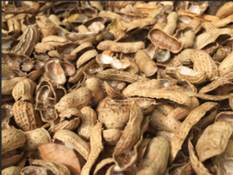
Figure 1: Groundnut shells.
Ground nut shells are rich in many functional compounds and composed of cellulose, hemicellulose, lignin, proteins, lipids and starch having a variety of functional groups []. Other uses for groundnut shells include composting wet materials, wastewater treatment, plastic, wardrobes, insulation board, metal casting, and as a pesticide and activated carbon delivery medium. Therefore, herein we describe the potential of ground nut shells in heavy metal adsorption.

2.0 MATERIALS AND METHODS.
2.1 Sample collection and preliminary preparation. The groundnuts were collected from the local market near Egerton University. The nuts were then removed from the pods to obtain the groundnut shells. The shells were washed several times with tap water to remove the dirt and left-over night to dry. They were then rinsed with distilled water repeatedly to remove any contaminant present. Phosphoric acid, KOH, and ZnCl₂ were used in succession to activate the groundnut shell biomass, each of which provided distinct advantages. Phosphoric acid (H₃PO₄) adds phosphate groups, increases polarity and acidity for improved metal binding while potassium hydroxide (KOH) increases surface area and produces hydroxyl groups, Finally, the Lewis acid zinc chloride (ZnCl₂) leads to increased pore structure.as reported in a most recent study where sequential activation of H₃PO₄ then ZnCl₂ showed to destruct P-O-C bonds to create additional micropores [].
After activation, the residue was dried in an oven at 60 °C for three days, powdered using a hammer mill, and sieved through a 250 µm mesh to obtain uniform particle size. The resulting powdered sample was then employed in subsequent adsorption experiments.
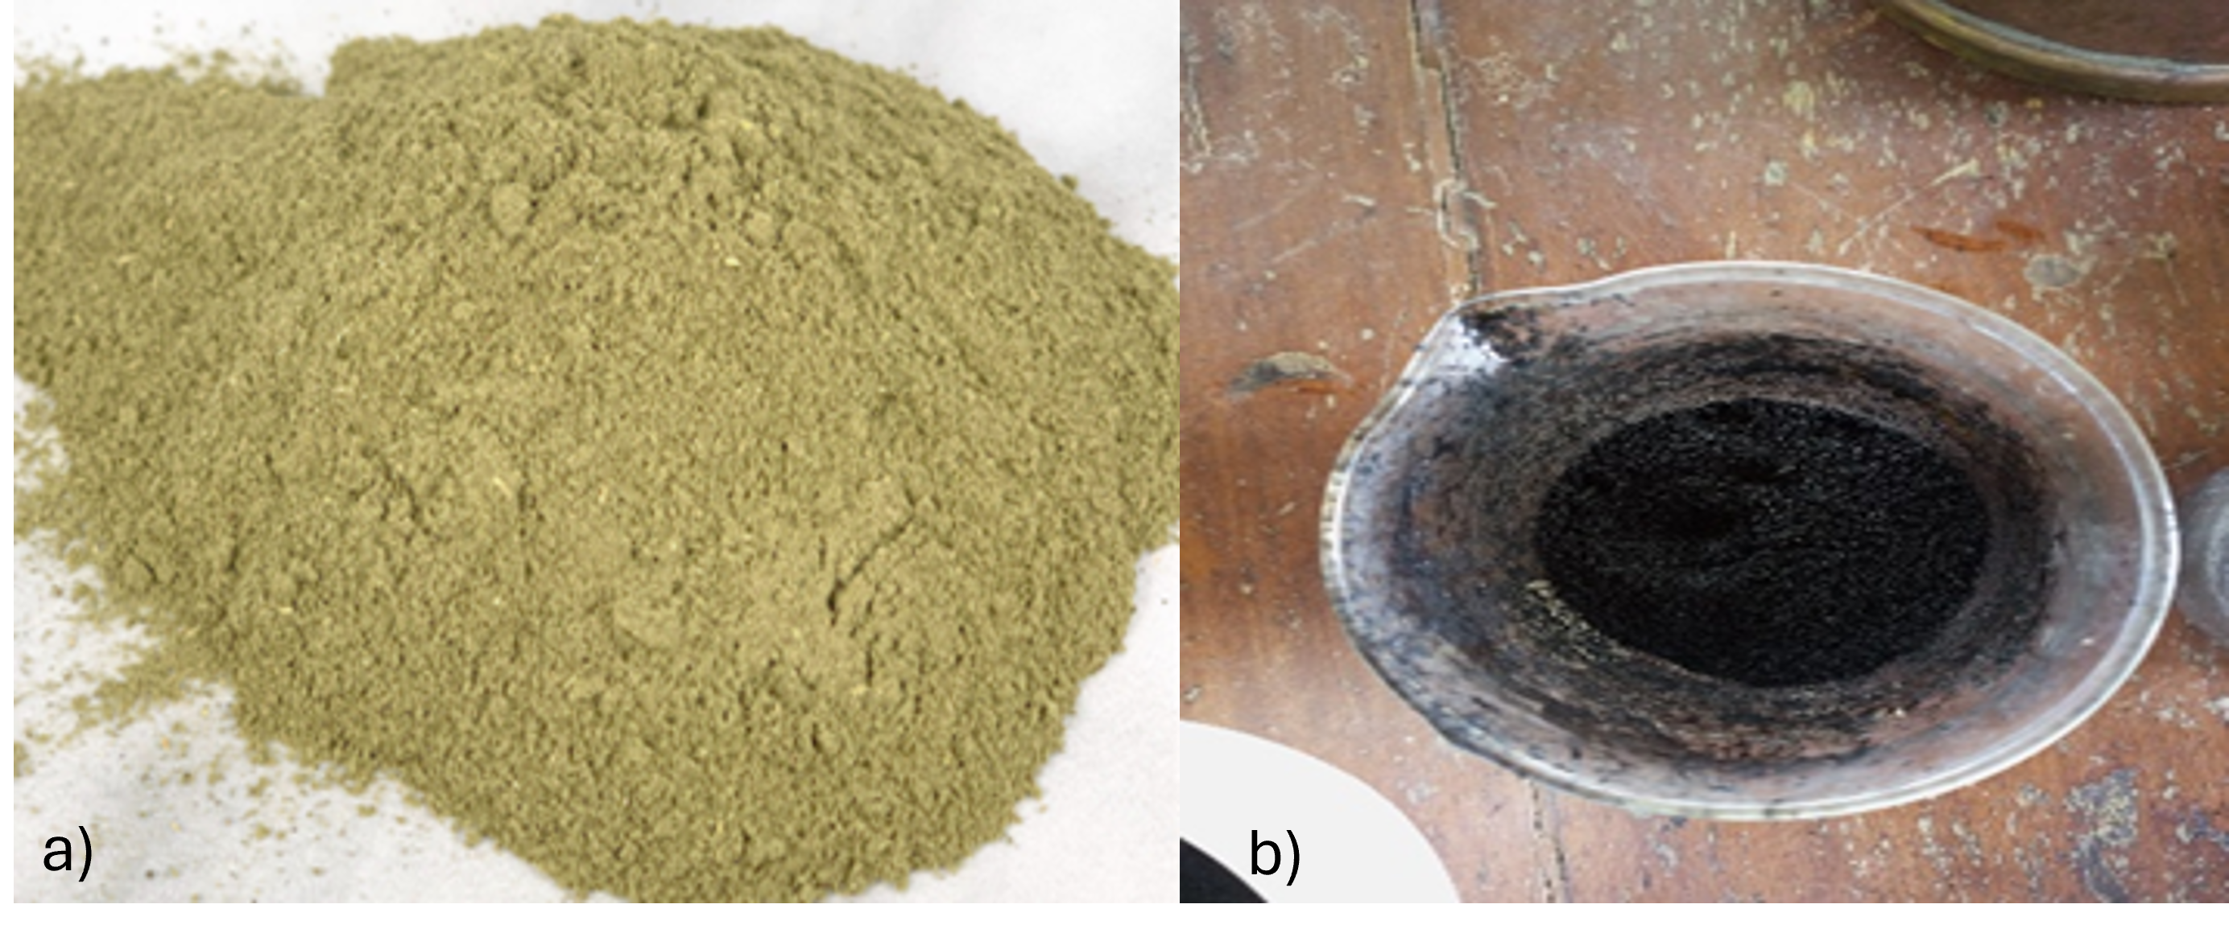
Figure 2a Powdered groundnut shells 2b: Activated groundnut shells (AGS).

2.2 Preparation of stock solution of lead. A stock solution of (1000 mg/L) lead was prepared by dissolving 1.342 g lead (II) Chloride in 1000 ml of distilled water. And a further standard solution of desired concentration was prepared from a stock solution. All glassware was cleaned with distilled water before use.
Amount of Pb (II) ions in PbCl₂ $=\frac{Molecular mass of Pb}{Molecular Mass of PbCl2 }$ (1)
= $\frac{207.2}{278.10 }x100$
= 0.745 of Pb (II) ions in PbCl₂

Amount of PbCl₂ required to make 1000ppm Pb (II) solution$=\frac{1000mg}{0.745}$= 1,342 mg/L = 1.342g/L
From this solution the other working solutions were prepared by serial dilution.
2.3 Batch adsorption. An experimental study was conducted in five separate batches, with each adsorption experiment performed in duplicates. The average values obtained were presented as experimental points in charts. Initially, the effect of pH was determined in batch mode under fixed conditions. Subsequently, each experimental sample was prepared by adjusting the desired lead concentration and adding a measured dose of 0.1 g of adsorbent to a 100 ml volumetric flask containing the lead solution. The test mixture was agitated using an orbital shaker at 40 rpm for one hour. Following agitation, the adsorbent suspension was separated from the solution by filtration using Whatman No. 42 filter paper. The concentration of adsorbed metal ions was analysed using an atomic absorption spectrophotometer (AAS). The same procedure was applied to additional batches to study the effects of adsorbent dose, contact time, temperature, and concentration on adsorption. The optimal conditions for each parameter were determined in these batch experiments.
Heavy metal removal percentage was determined using the following Equation: -
Metal ion removal (%) = $\left[\frac{Co-Ce}{Co }\right]$ x 100 (2)
Where, C_{o}: the initial metal ion concentration of test solution, mg/l.
C_{e}: final equilibrium concentration of test solution, mg/l.
2.4 Effect of contact time on the adsorption process. Experiments to investigate the effect of contact time on adsorption were carried out at room temperature. An initial concentration of 25 mg/L (ppm) of Lead (II) solution was prepared from a 1000 ppm stock solution. 100 ml of the 25 ppm Lead (II) solution was placed into 120 ml bottles, to which 0.1 g of the adsorbent was added. These solutions were agitated using an orbital shaker at 40 rpm for various time intervals (5, 25, 45, and 65 minutes) at ambient temperature. After the designated contact times, the adsorbent was separated from the solution by filtration using Whatman No. 42 filter paper. The concentration of absorbed metal ions was then analysed using an atomic absorption spectrophotometer.
2.5 Effect of Adsorbent Dose on the Adsorption Process. A 25-ppm lead (II) solution was precisely prepared from a stock solution using appropriate dilution factors. 100 ml of this prepared solution was then transferred into 120 ml bottles. Varying doses of adsorbent (0.1, 0.2, 0.4, and 0.6 g) were added to each bottle. The solutions were equilibrated by agitating them on an orbital shaker for one hour. After equilibrium was reached, the suspension was separated from the solution by filtration using Whatman No. 42 filter paper. The concentration of adsorbed metal ions was then analysed using an atomic absorption spectrophotometer.
2.6 Effect of pH on Adsorption Process. The pH of the solution in each flask was adjusted to 2, 3, 4, 5, 6, 8, and 10 through micro-additions of 0.1 M HCl or 0.1 M NaOH. Subsequently, 0.1 g of the adsorbent was introduced to 100 ml of a 25 ppm Pb (II) solution. The mixture was then agitated at 40 rpm on an orbital shaker at a controlled temperature of 25°C for one hour.
2.7 Effect on initial lead concentration on the adsorption process. Exactly 100 ml solutions of lead at varying known concentrations (50, 100, 150, and 200 ppm) were prepared. To each of these prepared solutions, 0.1 g of activated groundnut shell adsorbent was added. This procedure was carried out in duplicate to ensure accuracy. After allowing the mixtures to interact, the adsorbent was separated from the solution by filtration using Whatman No. 42 filter paper. The concentration of adsorbed lead ions in the filtrate was then analysed using an atomic absorption spectrophotometer.
2.8 Effect of Temperature on the adsorption process. A volume of 100 ml of Pb (II) with an initial of 25 ppm was prepared from a serial dilution of stock solution (1000 mg/L). Temperature varied from (25°C, 35°C, 40°C, 65°C). 0.1 g of the adsorbent was added to each bottle and placed in a water bath varying the temperatures for one hour. The adsorbent suspension with the solution was then separated from the solution by filtration using Whatman no.42 filter paper. Observation of absorbed metal ion was analysed by atomic absorption spectrophotometer.
2.9 FTIR analysis. Activated groundnut shell powder was dried at 105°C in an oven for 7 hours to remove moisture and then allowed to cool to room temperature in a desiccator. Another portion of modified groundnut shell powder was soaked in a 100 ppm Pb (II) solution, filtered, and then dried at 105°C in an oven for 7 hours to remove moisture. It was also allowed to cool to room temperature in a desiccator. The activated groundnut shell was characterized using a Fourier Transform Infrared Spectrometer (ATR FTIR JASCO 4700 with ATR PRO ONE head), with 40 scans per second, covering a range of 500-4000 cm⁻¹, a resolution of 4.0 cm⁻¹, and a TGS detector. This analysis was performed to determine the functional groups on the surface of the groundnut shell, both before and after the adsorption of Pb (II) metal ions.
2.10 Adsorption isotherms. In this study, the ability of groundnut shells to adsorb Pb (II) ions from an aqueous solution was analysed. Several adsorption isotherm models were applied to the experimental data to evaluate their fit and determine which model best describes the adsorption process. The models that were used include:
Langmuir adsorption isotherm $\frac{C_{e}}{q_{e}}=\frac{1}{q_{m}K_{L}} + \frac{C_{e}}{q_{m}}$ (3) Freundlich adsorption isotherm Log q_{e} = log K_{F} + $\frac{1}{n}$ log C_{e} (4) Dubinin- radushchevich (D-R) adsorption isotherm ln q_{e} = ln q_{s}- K_{DR} ℇ² (5)
Tempkin adsorption isotherm qe = $\frac{RT}{b}$ ln A + $\frac{RT}{b}$ lnC_{e} (6)
Adsorption isotherms are critical for understanding how an adsorption system functions. They provide insight into the interactions between an adsorbent and an adsorbate and help to determine the capacity and efficiency of the adsorption process
2.11 Adsorption Kinetics. A 100 ml solution of Pb (II) with an initial concentration of 25 ppm was prepared through a serial dilution of a 1000 mg/L stock solution. To each prepared solution, 0.1 g of the adsorbent was added, and the mixture was placed in a water bath for various time intervals: 5, 25, 45, and 65 minutes. Kinetic parameters for the adsorption process were studied at these intervals, and the obtained data were analysed using the Lagergren pseudo-first-order kinetic equation, the pseudo-second-order kinetic equation, and the Elovich model. The Elovich model assumes that the adsorption process follows second-order kinetics and that the surface of the adsorbent is energetically heterogeneous.

pseudo first order equation $\log{(}q_{e}- q_{t})=log⁡ q_{e}- \frac{K_{1}t}{2.303}$ (7)
pseudo second order $\frac{t}{q_{t}}=\frac{1}{{k_{2}q}_{e}^{2}} + \frac{1 }{q_{e}}t$ (8)
$Elovich model q_{t}=\frac{\ln{(αβ)}}{β} + \frac{lnt }{β}$ (9)
2.12 Adsorption diffusion. To study intraparticle diffusion, a 100 ml solution of Pb (II) with an initial concentration of 25 ppm was prepared through serial dilution of a 1000 mg/L stock solution. A 0.1 g amount of the adsorbent was added to each bottle, which were then placed in a water bath and agitated at different time intervals: 5, 25, 45, and 65 minutes. The data obtained were plotted as qt (amount of adsorbate per unit mass of adsorbent at time t) against the square root of time (t^{1/2}). The linearized form of the intraparticle diffusion model is given by Webber morris intraparticle diffusion equation’.

Qt = K_{IPD.}t^{1/2} + C (10)

Where; K_{IPD} = Intraparticle diffusion constant (mg.g⁻min^{1/2} )
C = intercept (Thickness of boundary layer)
2.13 Thermodynamic parameters. Thermodynamic parameters were investigated by varying the temperature at four different levels: 25°C, 35°C, 40°C, and 65°C. A 100 ml solution of Pb (II) with an initial concentration of 25 ppm was prepared through serial dilution of a 1000 mg/L stock solution. To each prepared solution, 0.1 g of the adsorbent was added. The bottles containing these mixtures were then placed in a water bath and maintained at the respective temperatures for one hour.
Thermodynamic parameters ΔG, ΔS, and ΔH were estimated using Vant hoffs equation
Vant hoff’s equation $ln K_{c} = -(\frac{ΔH }{R}$)$\frac{1}{T}$ + $\frac{ΔS}{R}$ (11)
Gibbs free energy ΔG = ΔH – TΔS (12)
A plot of ln $K_{c}$ vs was plotted to obtain the thermodynamic parameters.

∆H (Jmol⁻¹K⁻¹) | ∆S (Jmol⁻¹K⁻¹) | ∆G (Jmol⁻¹)
∆H = -(Slope) x R | ∆S = intercept x R | ∆Gº = ∆H-T∆S

2.14 Determination of heavy metal concentration in river Ndarugu water. To process the water sample, 10 ml of the sample was placed in a volumetric flask. Next, 20 ml of a hydrochloric acid and distilled water mixture (in a 1:4 ratio) was added to the flask. This was followed by the addition of 10 ml of a mixture of nitric acid and distilled water (in a 1:1 ratio). The sample was digested using a hot plate for 30 minutes at 300°C. After cooling to room temperature for 5 minutes, the mixture was filtered into a 100 ml conical flask and topped up to the mark with distilled water. The concentration of adsorbed metal ions was then analysed using an atomic absorption spectrophotometer (AAS). A 100 ml sample of river water was measured, and 0.1 g of adsorbent was added. The mixture was then agitated using an orbital shaker for one hour. After shaking, the mixture was filtered, and the concentration of lead ions was measured using an atomic absorption spectrophotometer (AAS).

2.15 Data analysis. Data analysis was done by using the equations below.
$Percentage removal \left(\%\right)=\frac{Co-Ce}{Co }X100$ (13)
${ Amount adsobed q}_{t}=\frac{C_{o}-C_{t}}{m}xV$ (14)
${ Amount adsorbed q}_{e}=\frac{C_{o}-C_{e}}{m}xV$ (15)
Whereby C_{o} is the initial metal ion concentration (mg/L), C_{t} is the metal ion concentration at time t (mg/L), C_{e} is the equilibrium concentration (mg/L), V is the volume of solution and m is the mass of adsorbent (g).
3.0 RESULTS & DISCUSSION
3.1 Effect of Adsorbent Dose on the Adsorption Process. The results illustrating the impact of adsorbent dosage on lead adsorption and the effect of contact time on adsorption are presented in Figure 3a and Figure 3b, respectively. Figure 3a shows the percentage of lead adsorption at various adsorbent dosages, ranging from 0.1 to 0.6 g. From the results it is observed that the optimal removal percentage was achieved at an adsorbent dose of 0.6 g, with a removal efficiency of 98.296%. At lower adsorbent dosages, the metal ions compete for the limited available adsorption sites. As the dosage of adsorbent is increased, both the rate of adsorption and the adsorption capacity are enhanced. A higher adsorbent dosage provides more active sites, thereby improving the efficiency of adsorption as more adsorptive material can adhere to these sites []. However, there is a point beyond which adding more adsorbent does not further enhance the adsorption efficiency. This is because all the available adsorption sites have become occupied by lead ions, leading to a saturation point. At this stage, any additional adsorbent does not contribute to further removal of lead from the solution, causing the adsorption curve to level off. This finding is consistent with observations made by other researchers. They have also reported that, regardless of the type of adsorbent used, increasing the adsorbent dosage improves efficiency up to a certain point (e.g., 0.6 g). Beyond this optimal dosage, further increases do not significantly impact the adsorption efficiency of Pb (II) ions from aqueous solutions. This phenomenon is likely due to the limited availability of adsorption sites and the competition among adsorbent particles for the metal ions [].
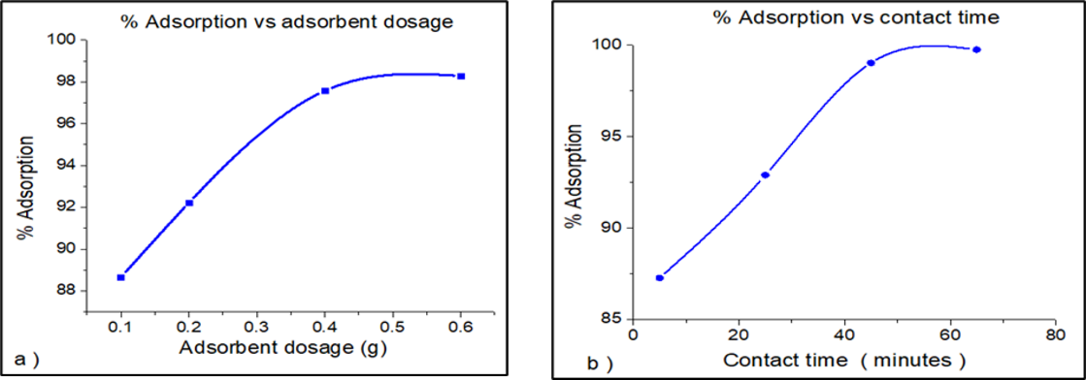

Figure 3a. Effect of adsorbent dose on adsorption of lead, 3b. Effect of contact time on adsorption of lead
3.2 Effect of contact time on the adsorption process. The adsorption of lead was examined at an initial concentration of 25 ppm, with contact times ranging from 5 to 65 minutes. Figure 3b above shows the percentage of lead adsorbed at various contact times, while keeping other parameters constant. The figure indicates that the lead removal percentage increases with longer contact times. The contact time parameter was studied within the range of 5 to 65 minutes using a biosorbent dosage of 0.1 g. The lead removal percentage increased with contact time up to 65 minutes, reaching a maximum removal of 99.75% at 65 minutes. Beyond this point, there was no further change in adsorption. The initial high rate of adsorption can be attributed to the availability of vacant adsorbent sites and a high solute concentration gradient, which facilitated rapid adsorption []. At 60 minutes, the lead uptake by the adsorbent plateaued due to a reduction in available adsorption sites and lead concentration. This saturation indicates that equilibrium had been reached.
3.3 Effect of initial lead concentration on the adsorption process. Figure 4 illustrates the effects of different initial lead concentrations on the adsorption process by the bio-adsorbent. It can be observed that the highest lead uptake occurs at 90.07635% with an initial lead concentration of 50 ppm, under constant time and dose conditions. At the initial stage, there are sufficient exchangeable sites available between the adsorbent and adsorbate, leading to higher uptake of Pb²⁺ ions. However, as the Pb²⁺ concentration increases, competition between the adsorbate ions and the adsorbent intensifies, which may result in a lower removal percentage []. Additionally, the concentration is inversely proportional to adsorption, which is influenced by the saturation of binding sites []. The relationship proves that as the concentration of lead increases, the adsorption efficiency decreases due to the limited number of available binding sites on the adsorbent becoming saturated.
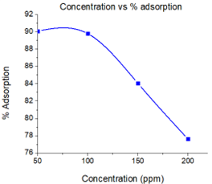
Figure 4: Effect of initial ion concentration on adsorption of lead
The results presented in Table 1 below illustrate the impact of the initial concentration of lead solution on the removal efficiency using activated ground nut shells, compared to other adsorbents studied.
Table 1: Comparison between adsorption capacities and percentages
Biomass | q_{m} (mg/g) | Removal % | Activation | Source
Orange peels | 495.98 | 99.20% | CaCl₂ | []
Plantain peel | 3.06 (Pb²⁺, Mn ²⁺) | 91.68% | WA | []
Almond tree peel | 1.99 (Pb²⁺) | 99.56% | AC | []
Corn cob | 208.92 | 85.00% | WA | []
Ground nut shells | 175.44 (Pb²⁺) | 99.75% | phosphoric acid, KOH, and ZnCl₂ | Present study
WA: Without activation AC: activated charcoal
3.4 Effect of pH values on the adsorption process. Figure 5a illustrates the effect of pH on the adsorption process. The results show that at lower pH levels, the adsorption of lead is reduced. This is attributed to the overall positive charge on the surface of the adsorbent, caused by the protonation of the surface (H^{+/}H3O⁺), which creates repulsive forces that hinder the metal ions access to the adsorbent's ligands []. In addition, the competition between hydrogen ions and metal ions for the same adsorption sites dimishes adsorption efficiency. The optimal pH range for adsorption was observed to be around 4.2 to 5.5. Within this range, the adsorbent exhibits a higher negative charge compared to the solution, which enhances the attraction and adsorption of the positively charged metal ions from the solution. As the pH increases further beyond 6, the metal ions start to precipitate out of the solution. This is due to the formation of metal hydroxide species, such as the soluble Pb (OH)²⁺ and the insoluble precipitate Pb (OH)₂. These precipitated species reduce the availability of free metal ions in the solution, thereby decreasing the adsorption efficiency [].
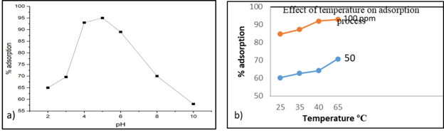
Figure 5a: Effect of pH on the adsorption process; 5b: Effect of temperature on adsorption of lead
3.5 Effect of temperature on adsorption process. Figure 5b illustrates the effect of temperature on the adsorption process at lead concentrations of 50 ppm and 100 ppm, with temperatures ranging from 25°C to 65°C. Temperature plays a significant role in influencing the adsorption rate by modifying molecular interactions and the solubility of the adsorbate. The data shows that both the removal efficiency and adsorption capacity for lead ions increase with rising temperature, indicating that the adsorption process is endothermic. In endothermic adsorption, higher temperatures enhance the efficiency of adsorption by increasing the mobility of the molecules toward the active sites of the adsorbent []. This effect is characteristic of a chemical reaction or bond formation occurring during the adsorption process.
3.6 Adsorption isotherms. In the study, equilibrium isotherm data obtained were applied to four two-parameter adsorption models (Figure 6) and the results of their linear regressions were used to find the model with the best fit.
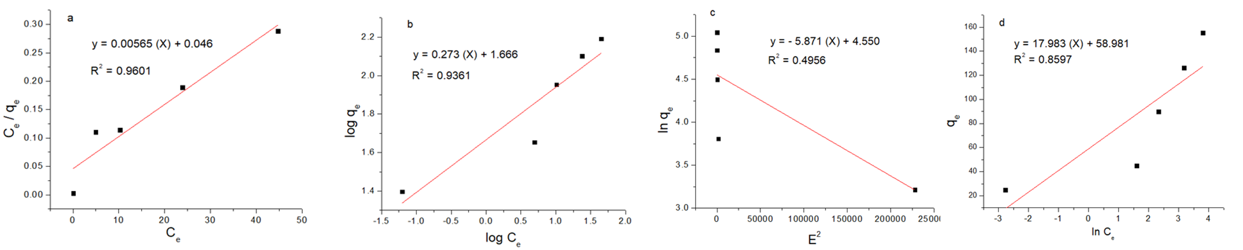Figure 6a: Langmuir isotherm, 6b: Freundlich isotherm, 6c: Dubinin- Radushchevich isotherm and 6d: Tempkin isotherm.
The experimental results, indicate that the Langmuir isotherm model has a higher R² value compared to other isotherm models. This higher R² value suggests that the Langmuir isotherm provides a better fit for the experimental data, meaning it more accurately describes the adsorption process of Pb²⁺ onto the adsorbent. Furthermore, similar findings have been reported by other researchers. For instance, Rahim et al conducted a study using coconut waste as an adsorbent and found that the adsorptive uptake of Pb²⁺ also followed the Langmuir isotherm model. This consistency in results across different studies reinforces the validity of the Langmuir isotherm model in explaining the adsorption behaviour of Pb²⁺ on various adsorbents []. Table 2 shows the experimental computed parameters of adsorption isotherms. The mean free energy as calculated from D-R isotherm show energy lower than 8 kJ/mol (i.e E < 8kJ/mol) meaning the adsorption mechanism is physiosorption which is associated with low energy.

Table 2: Calculated parameters of adsorption isotherms
 | Langmuir isotherm |  |  |  | Freundlich isotherm
Groundnut shell | Q_{max} (mg/g) | K_{L} (L/mg) | R_{L} | R² | n | K_{F} (L/mg) | R²
Pb²⁺ | 175.492 | 0.1239 | 5.0978 | 0.9216 | 3.658 | 46.355 | 0.9361
Dubinin- Radushchevich parameters
Groundnut shell | Q_{max} (mg/g) | β (mol²/J²) |  | E (kJ/mol)
Pb²⁺ | 94.56 | 2.64 × 10⁻⁸ |  | 4.35

3.7 Kinetics of adsorption. Table 3 shows the calculated parameters related to the adsorption kinetics of Pb²⁺. The pseudo second order kinetic model is one of the commonly used models to describe the adsorption process. The model assumes that the rate-limiting step involves chemical adsorption, where valence forces are formed through sharing or exchange of electrons between adsorbent and adsorbate.

Table 3: Calculated parameters of adsorption kinetics
 | pseudo-first-order model |  |  |  | pseudo-second-order model
Groundnuts shells | k₁ (minute^{–1}) | Q_{e} (mg/g) |  | R² |  | k₂ (g/mg minute) |  | Q_{e} (mg/g) |  | R²
Pb²⁺ | 0.0713 | 2.667 | 0.899 |  | 2.843 × 10⁻² |  | 25.38 |  | 0.999
From experimental results, the R² value for the pseudo second order plot is higher compared to other kinetic models as displayed in Figure 7. The R² value, or coefficient of determination, indicates how well the experimental data fits the chosen model. A higher R² value signifies a better fit, implying that the pseudo second order model accurately represents the adsorption process. This finding suggests that the removal of lead ions from the solution predominantly follows pseudo second order kinetics. This means that the adsorption rate is likely controlled by chemical interactions between lead ions and the active sites on the adsorbent. The higher R² value reinforces the conclusion that the pseudo second order model is the most suitable for describing the kinetic behaviour of lead adsorption in this case.
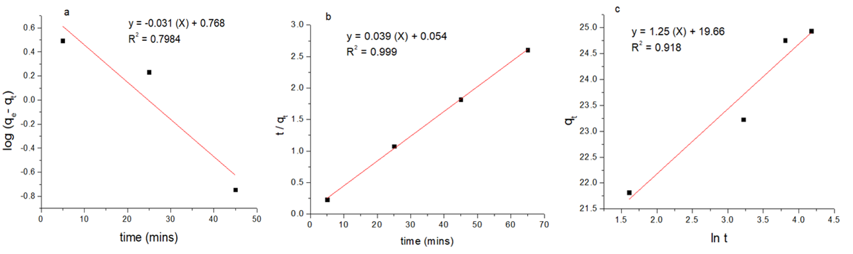

Fig 7 a Pseudo first order kinetics, 7b: Pseudo second order kinetics and 7c: Elovich model
3.8 Adsorption diffusion. The experimental data for adsorption diffusion was plotted in Figure 8 and resulted in a linear plot that did not pass through the origin. This confirmed that intraparticle diffusion occurred, but it was not the rate-limiting step, indicating that other processes were also involved [].
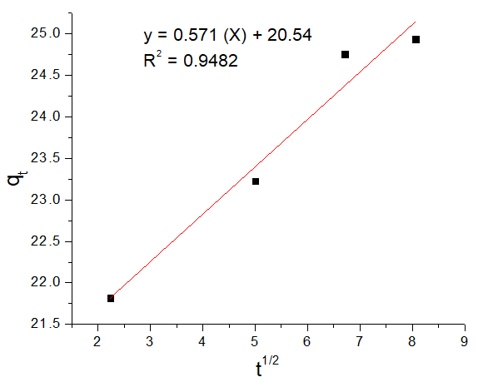
Figure 8: Intraparticle diffusion plot
Table 4: Calculated parameters for intraparticle diffusion
Intraparticle diffusion constant, K_{IPD} ( mg.g⁻¹.min^{-1/2}) | Thickness of boundary layer, C (mg/g)
0.573 | 20.54

A linear plot confirmed that intraparticle diffusion took place and the intercept indicated that film diffusion also took place. This means that the adsorption process involved two steps involving the migration of adsorbates from solution to the adsorbent surface and then intra-particle and film diffusion of metal ions into the adsorbent pores [].
3.9 Thermodynamics. Figure 9 illustrates a graphical representation showing the temperature dependence of equilibrium constants on the adsorption reaction. The equation shows how each of these thermodynamic quantities relates to the Van't Hoff plot

$ln K_{c} = -\frac{ΔH }{RT}$ + $\frac{ΔS}{R}$ (16)
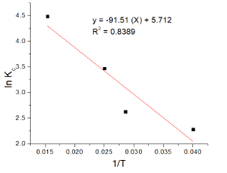
Fig 9: Vant Hoff’s plot

∆H (Jmol⁻¹K⁻¹) | ∆S (Jmol⁻¹K⁻¹) | ∆G (Jmol⁻¹)
760.831 | 47.492 | -13,391.800 Jmol⁻¹

3.10 FTIR analysis of groundnut shell adsorbent. Figure 10 shows FTIR analysis of activated ground nuts shells before and after adsorption. Before adsorption a strong broad peak at 3200-3500 cm⁻¹ indicated the presence of hydroxyl group of a carboxylic acid. []. Peak at 1693cm⁻¹ can be attributed to C=O stretch. Peak at 1132 cm⁻¹ is indicative of C-O stretch for alcohol and carboxylic acids. A peak at 1565 cm⁻¹ can be associated to C=C in aromatics. The FTIR spectrum of activated groundnut shells after exposure to lead shows a significant decrease in peak intensity within the 3000–3500 cm⁻¹ region. This reduction suggests that adsorption primarily took place at these locations, indicating the participation of –OH and –NH functional groups in metal uptake. The lone pairs of electrons on oxygen and nitrogen atoms enable the formation of coordinate bonds with Pb²⁺ ions, which explains the reduced spectral intensity seen in this area. Additionally, the enhanced peaks seen in the 600–2000 cm⁻¹ range clearly show that new metal–ligand interactions are happening. This means that functional groups like C=C, C=O stretching, N–H bending, and other specific vibrations are actively involved in forming chemical bonds with the adsorbate. These changes in the spectrum confirm that lead has been successfully adsorbed onto the activated groundnut shells.
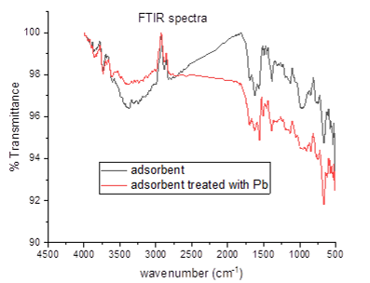
Fig 10 Groundnut shell biosorbent without Pb²⁺ ions and after being treated with Pb²⁺ ions
3.11 Efficacy of Groundnut shell adsorbent in removal of Pb²⁺ in a water sample. After digesting the water sample and analysing it with AAS, the concentration was determined to be 6 ppm. Following the addition of the adsorbent directly to the wastewater and subsequent analysis with AAS, the concentration was reduced to 4.8945 ppm. This decrease in concentration indicates that the metals present in the river have been effectively adsorbed, demonstrating that groundnut shells serve as an excellent adsorbent. The percentage adsorption in River Ndarugu water was computed as follows
Metal ion removal (%) = $\left[\frac{Co-Ce}{Co }\right]$ x 100 ; C_{o}=6ppm, C_{e}= 4.8945 ppm
=$\frac{6.00-4.8945}{6.00}×100\%$
=18.425%

4.0 CONCLUSION
In summary the modified groundnut shells exhibit pollutant binding properties that are highly beneficial for water treatment. Efficient lead adsorption depended on the adsorbent dosage, pH, concentration, and contact time. Higher adsorbent dosages led to increased Pb²⁺ ion adsorption. Groundnut shells were most effective at adsorbing Pb²⁺ ions at pH 5, with the optimal contact time for complete adsorption being 60 minutes. The higher temperature facilitated greater Pb²⁺ ion uptake, indicating an endothermic process. When the results were fitted to two-parameter adsorption isotherms, the Langmuir isotherm provided the best fit for the experimental data (R² = 0.9218), compared to other adsorption isotherms. Analysis of the data using first order and second-order kinetics revealed that the adsorption process followed pseudo-second-order kinetics. Thermodynamic studies showed that ΔH was 760.831 Jmol⁻¹K⁻¹, confirming the endothermic nature of the process. The entropy change, ΔS, was found to be 47.492 Jmol⁻¹K⁻¹. The Gibbs free energy change was -13.391 KJmol⁻¹, with the negative value indicating a spontaneous process. Applying the optimum conditions to a water sample from the River Ndarugu resulted in an 18.425% removal of lead. This study demonstrates that groundnut shells can be effectively used as a low-cost raw material for preparing activated carbon for lead adsorption from water effluent.
DISCLAIMER (ARTIFICIAL INTELLIGENCE)
Author(s) hereby declare that NO generative AI technologies such as Large Language Models (ChatGPT, COPILOT, etc.) and text-to-image generators have been used during the writing or editing of this manuscript.
ACKNOWLEDGEMENT
The authors would like to acknowledge Egerton University for providing laboratory space and equipment to enable this research.

REFERENCES

. Jamrah, A., Al-Jawaldeh, H., Al-Zghoul, T. M., Hamaideh, A., Darwish, M. M., & Al-Karablieh, E. OLIVE PITS ACTIVATED CARBON AS AN EFFECTIVE ADSORBENT FOR WATER TREATMENT USING H₃PO₄ AND H2SO4 ACTIVATING AGENTS. https://doi.org/10.26480/wcm.04.2024.415.419
. Mishra, S., Bharagava, R. N., More, N., Yadav, A., Zainith, S., Mani, S., & Chowdhary, P. (2019). Heavy metal contamination: an alarming threat to environment and human health. Environmental biotechnology: For sustainable future, 103-125. https://doi.org/10.1007/978-981-10-7284-0_5
. Saravanan, P., Saravanan, V., Rajeshkannan, R., Arnica, G., Rajasimman, M., Gurunathan, B., & Pugazhendhi, A. (2024). Comprehensive review on toxic heavy metals in the aquatic system: sources, identification, treatment strategies, and health risk assessment. Environmental Research, 119440. https://doi.org/10.1016/j.envres.2024.119440
. Ali, H., Khan, E., & Ilahi, I. (2019). Environmental chemistry and ecotoxicology of hazardous heavy metals: environmental persistence, toxicity, and bioaccumulation. Journal of chemistry, 2019. https://doi.org/10.1155/2019/6730305
. Izah, S. C., Inyang, I. R., Angaye, T. C., & Okowa, I. P. (2016). A review of heavy metal concentration and potential health implications of beverages consumed in Nigeria. Toxics, 5(1), 1. https://doi.org/10.3390/toxics5010001
. Saleh, H. M., & Hassan, A. I. (2023). 13 Innovative techniques utilized for bioremediation of rare earth elements to attain a sustainable world. Rare Earth Elements: Processing, Catalytic Applications and Environmental Impact, 241. https://doi.org/10.1515/9783110788082
. Singh, N., Shah, K., & Pramanik, B. K. (2023). Synthesis and application of manganese-doped zinc oxide as a potential adsorbent for removal of Congo red dye from wastewater. Environmental Research, 233, 116484. https://doi.org/10.1016/j.envres.2023.116484
8. Engwa, G. A., Ferdinand, P. U., Nwalo, F. N., & Unachukwu, M. N. (2019). Mechanism and health effects of heavy metal toxicity in humans. Poisoning in the modern world-new tricks for an old dog, 10, 70-90. https://doi.org/10.5772/intechopen.82511
9. Pratush, A., Kumar, A., & Hu, Z. (2018). Adverse effect of heavy metals (As, Pb, Hg, and Cr) on health and their bioremediation strategies: a review. International Microbiology, 21(3), 97-106. https://doi.org/10.1007/s10123-018-0012-3
10. Aziz, K. H. H., Mustafa, F. S., Omer, K. M., Hama, S., Hamarawf, R. F., & Rahman, K. O. (2023). Heavy metal pollution in the aquatic environment: efficient and low-cost removal approaches to eliminate their toxicity: a review. RSC advances, 13(26), 17595-17610. https://doi.org/10.1007/s10123-018-0012-3
11. Jabbar, K. Q., Barzinjy, A. A., & Hamad, S. M. (2022). Iron oxide nanoparticles: Preparation methods, functions, adsorption and coagulation/flocculation in wastewater treatment. Environmental Nanotechnology, Monitoring & Management, 17, 100661. https://doi.org/10.1016/j.enmm.2022.100661
. Jabbar, K. Q., Barzinjy, A. A., & Hamad, S. M. (2022). Iron oxide nanoparticles: Preparation methods, functions, adsorption and coagulation/flocculation in wastewater treatment. Environmental Nanotechnology, Monitoring & Management, 17, 100661. https://doi.org/10.1016/j.enmm.2022.100661
. Chakraborty, R., Asthana, A., Singh, A. K., Jain, B., & Susan, A. B. H. (2022). Adsorption of heavy metal ions by various low-cost adsorbents: a review. International Journal of Environmental Analytical Chemistry, 102(2), 342-379. https://doi.org/10.1080/03067319.2020.1722811
. Bülbül, A., Delibaş, A., & Coşkun, R. (2025). Development and characterization of activated charcoal adsorbent derived from oak for efficient removal of methylene blue: functionality vs surface area. Biomass Conversion and Biorefinery, 1-16. https://doi.org/10.1007/s13399-025-06752-w
. Srivastava, A., Gupta, B., Majumder, A., Gupta, A. K., & Nimbhorkar, S. K. (2021). A comprehensive review on the synthesis, performance, modifications, and regeneration of activated carbon for the adsorptive removal of various water pollutants. Journal of Environmental Chemical Engineering, 9(5), 106177. https://doi.org/10.1016/j.jece.2021.106177
. Akram, N. A., Shafiq, F., & Ashraf, M. (2018). Peanut (Arachis hypogaea L.): A prospective legume crop to offer multiple health benefits under changing climate. Comprehensive reviews in food science and food safety, 17(5), 1325-1338. https://doi.org/10.1111/1541-4337.12383
. Ajayi, V. A., & Lateef, A. (2023). Biotechnological valorization of agrowastes for circular bioeconomy: Melon seed shell, groundnut shell and groundnut peel. Cleaner and Circular Bioeconomy, 4, 100039. https://doi.org/10.1016/j.clcb.2023.100039
. Orooji, Y., Han, N., Nezafat, Z., Shafiei, N., Shen, Z., Nasrollahzadeh, M., ... & Klemeš, J. J. (2022). Valorisation of nuts biowaste: Prospects in sustainable bio (nano) catalysts and environmental applications. Journal of Cleaner Production, 347, 131220. https://doi.org/10.1016/j.jclepro.2022.131220
. Liang, J., Li, C., Zhang, S., Wang, S., & Hu, X. (2024). Sequential activation of willow wood with ZnCl2 and H3PO4 drastically impacts pore structure of activated carbon. Industrial Crops and Products, 221, 119387. https://doi.org/10.1016/j.indcrop.2024.119387
. Dev, V. V., Nair, K. K., Baburaj, G., & Krishnan, K. A. (2022). Pushing the boundaries of heavy metal adsorption: A commentary on strategies to improve adsorption efficiency and modulate process mechanisms. Colloid and Interface Science Communications, 49, 100626. https://doi.org/10.1016/j.colcom.2022.100626
. Elkhaleefa, A., Ali, I. H., Brima, E. I., Shigidi, I., Elhag, A. B., & Karama, B. (2021). Evaluation of the adsorption efficiency on the removal of lead (II) ions from aqueous solutions using Azadirachta indica leaves as an adsorbent. Processes, 9(3), 559. https://doi.org/10.3390/pr9030559
. Li, H., Budarin, V. L., Clark, J. H., North, M., & Wu, X. (2022). Rapid and efficient adsorption of methylene blue dye from aqueous solution by hierarchically porous, activated starbons®: Mechanism and porosity dependence. Journal of hazardous materials, 436, 129174. https://doi.org/10.1016/j.jhazmat.2022.129174
. Wadhawan, S., Jain, A., Nayyar, J., & Mehta, S. K. (2020). Role of nanomaterials as adsorbents in heavy metal ion removal from wastewater: A review. Journal of Water Process Engineering, 33, 101038. https://doi.org/10.1016/j.jwpe.2019.101038
. Shrestha, R., Ban, S., Devkota, S., Sharma, S., Joshi, R., Tiwari, A. P., ... & Joshi, M. K. (2021). Technological trends in heavy metals removal from industrial wastewater: A review. Journal of Environmental Chemical Engineering, 9(4), 105688. https://doi.org/10.1016/j.jece.2021.105688
. Tejada-Tovar, C., González-Delgado, Á., & Villabona-Ortíz, Á. (2018). Adsorption kinetics of orange peel biosorbents for Cr (VI) uptake from water. Contemporary Engineering Sciences, 11(24), 1185-1193. https://doi.org/10.12988/ces.2018.83105
. Leizou, E. K., Ashraf, M. A., Chowdhury, J. A., & Rashid, H. (2018). Adsorption studies of Pb2+ and Mn2+ ions on low-cost ddsorbent: Unripe Plantain (Musa Paradisiaca) peel biomass. Acta Chemica Malaysia (ACMY), 2(1), 11-15. https://doi.org/10.26480/acmy.01.2018.11.15
. Ayed, S., Ghorbel, A., Comite, A., & Boubaker, T. (2019). Analysis of the behavior of almond shells biomass in the biosorption of lead (II) and nickel (II) cations in aqueous solution. Desalination and Water Treatment, 148, 238-247. https://doi.org/10.5004/dwt.2019.23826
. Villabona-Ortíz, Á., Tejada-Tovar, C., Herrera-Barros, A., González-Delgado, Á., & Núñez-Zarur, J. (2018). Preparation of biosorbents from corn residual biomass and its application for Cr (VI) uptake. Contemporary Eng Sci, 11, 1401-1409. https://doi.org/10.12988/ces.2018.83130
. Ai, Y., Zhao, C., Sun, L., Wang, X., & Liang, L. (2020). Coagulation mechanisms of humic acid in metal ions solution under different pH conditions: A molecular dynamics simulation. Science of the Total Environment, 702, 135072. https://doi.org/10.1016/j.scitotenv.2019.135072
. Chen, Q., Yao, Y., Li, X., Lu, J., Zhou, J., & Huang, Z. (2018). Comparison of heavy metal removals from aqueous solutions by chemical precipitation and characteristics of precipitates. Journal of water process engineering, 26, 289-300. https://doi.org/10.1016/j.jwpe.2018.11.003
. Soliman, N. K., & Moustafa, A. F. (2020). Industrial solid waste for heavy metals adsorption features and challenges; a review. Journal of Materials Research and Technology, 9(5), 10235-10253. https://doi.org/10.1016/j.jmrt.2020.07.045
. Rahim, A. R. A., Mohsin, H. M., Thanabalan, M., Rabat, N. E., Saman, N., Mat, H., & Johari, K. (2020). Effective carbonaceous desiccated coconut waste adsorbent for application of heavy metal uptakes by adsorption: Equilibrium, kinetic and thermodynamics analysis. Biomass and Bioenergy, 142, 105805. https://doi.org/10.1016/j.biombioe.2020.105805
. Rahim, A. R. A., Johari, K., Shehzad, N., Saman, N., & Mat, H. (2021). Conversion of coconut waste into cost effective adsorbent for Cu (II) and Ni (II) removal from aqueous solutions. Environmental Engineering Research, 26(4). https://doi.org/10.4491/eer.2020.250
. Azizpourian, M., Kouchakzadeh, G., & Derikvand, Z. (2023). Removal of pharmaceutical compounds from aqueous solution by clay-based synthesized adsorbents: adsorption kinetics and isotherms studies. Chemical Papers, 77(8), 4245-4264. https://doi.org/10.1007/s11696-023-02774-8
. Jessima, S. H. M., Subhashini, S., Berisha, A., Mehmeti, V., & Srikandan, S. S. (2023). Experimental and Theoretical Approach of Evaluating Chitosan Ferulic Acid Amide as an Effective Corrosion Inhibitor. Journal of Bio-and Tribo-Corrosion, 9(4), 80. https://doi.org/10.1007/s40735-023-00796-z

