Method Article

Design, Implementation and Didactic Applications of an Online Biostatistical Assistant for Higher Education Students

ABSTRACT
Learning scientific methodology is a fundamental skill in modern higher education; however, many students face significant barriers in transitioning from theoretical concepts to the practical analysis of data. This article presents AEDES (Statistical Assistant for Higher Education Students), a web-based tool developed to overcome this gap. AEDES offers a smooth learning curve interface for data entry, automatic selection of statistical tests, and clear, publication-ready visualizations. Unlike classic software focused on statistics itself (and not biostatistics) that often overwhelm beginners with complex menus and extensive functionalities, AEDES prioritizes clear didactics, offering alerts and objective interpretations of results. This article describes the general principles of the system, its comprehensive methodological structure, including the use of inferential biostatistical strategies such as Welch's t-test for comparisons between two groups, ANOVA explored with Holm-Bonferroni post-hoc analyses for multiple groups, and robust measures for association and sample size determination, and its potential impact on increasing research productivity and statistical understanding among undergraduate students in life sciences-related fields.
Keywords: ANOVA, biostatistics, Welch's t-test, Holm-Bonferroni post-hoc

1. INTRODUCTION

The growing reliance on data-driven decision-making across life science disciplines has established biostatistics as a fundamental competency in higher education (Huang; Huang 2025; Nowacki et al., 2024). The ability to collect, analyze, and interpret data is no longer elective; it is a prerequisite for rigorous research and the advancement of scientific knowledge(Lee et al., 2025).

However, the pedagogical delivery of these skills faces a significant paradox: while the demand for statistical literacy increases, the complexity of the tools used to teach it often hinders the learning process. Traditional software, ranging from syntax-heavy environments like R to complex interface-driven packages such as IBM SPSS and SAS, presents a steep learning curve that can alienate students in biological and health sciences (Masuadi et al., 2021; Mavrevski et al., 2018).

This technical barrier often results in a hard approach to data analysis. When students are overwhelmed by software operation, they tend to apply statistical procedures mechanically, prioritizing computational execution over a conceptual understanding of methodological assumptions and limitations. As noted by Shortreed and Moodie (2020), excessive automation without a didactic foundation can decouple the researcher from the scientific process, shifting the focus from inferential reasoning to the mere generation of p-values. Consequently, this gap in statistical literacy compromises research integrity and discourages undergraduate engagement with quantitative methods (Kjelvik&Schultheis, 2019).

Despite the critical need for accessible biostatistics training, current analytical tools remain primarily designed for professional experts, prioritizing technical flexibility and raw power over pedagogical guidance(AbbasnasabSardareh et al., 2025). There is a distinct lack of platforms that explicitly support the novice user's methodological reasoning or facilitate the contextual interpretation of results within a didactic framework(Ouyang et al., 2025). This gap highlights the need for an environment where the complexity of the interface does not supersede the logic of the science(Bakri et al., 2025).

To address this challenge, we developed the Statistical Assistant for Higher Education Students (AEDES). AEDES is a web-based platform designed to shift the focus from software syntax to conceptual mastery and critical evaluation. By providing a simplified and intuitive interface, the tool allows students to perform robust analyses, generate publication-quality visualizations, and receive guided interpretations of their findings. This article details the design principles and methodological framework of AEDES, demonstrating its role in bridging the gap between statistical theory and practical application in the health and life sciences

2. THE SYSTEM'S ARCHITECTURE AND FUNCTIONALITIES
AEDES is a lightweight web application, running both client-side and server-side, developed with classic web technologies including PHP, HTML5, CSS3, and JavaScript, with its chart generation engine powered by the Chart.js library.
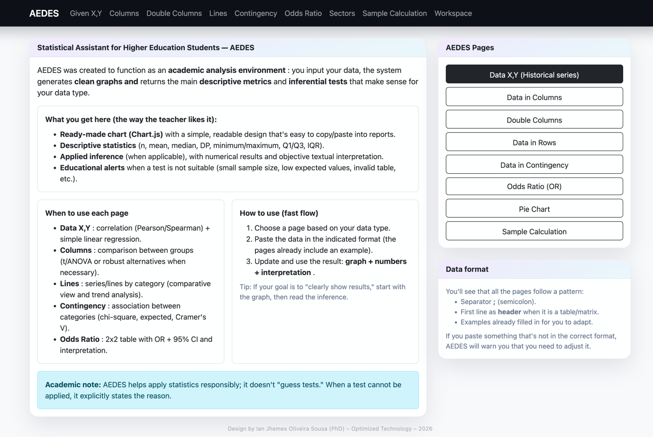
Fig. 1. AEDES homepage

Source: the author
This architecture allows students and researchers in the health and life sciences fields to access the system from any internet-connected device, such as desktop computers, laptops, or tablets, without the need for local software installation or specific operating system configurations. Consequently, AEDES can be easily incorporated into teaching activities, practical classes, and exploratory data analysis with minimal technical barriers. The system is organized into independent analytical modules, each corresponding to a specific statistical approach or analytical scenario commonly found in academic research. This modular structure aids learning by guiding users towards included analytical choices, reducing the necessary complexity, and providing a clearer understanding of how data structure relates to applied statistical methods.

2.1 User Interface and Data Input
The AEDES user interface follows a minimalist philosophy, prioritizing intuitiveness and ease of interaction. The primary and most direct mode of data entry is facilitated by a simple yet highly functional CSV-style text area, configured to accept semicolon-separated values. This standardized data format was used due to its broad compatibility with common spreadsheet applications (e.g., Microsoft Excel, Google Sheets, LibreOffice Calc).

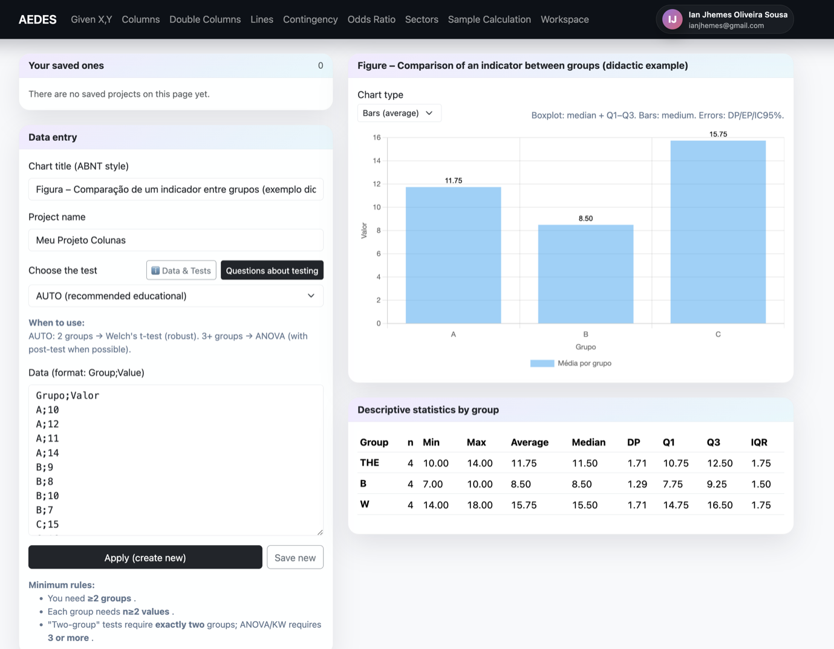
Fig. 2. Example of a data entry interface

Source: the author

This allows users to effortlessly copy and collect their raw (formatted) data directly from these familiar environments into AEDES. This approach allows students to quickly enter, process, and analyze their datasets, thus promoting an iterative, exploratory, and efficient approach to data analysis. Fundamentally, each analytical module of AEDES is carefully populated with illustrative example data. The immediate provision of context and a clear model serve as an invaluable guide for new users, allowing them to quickly understand the expected data structure and adapt their own diverse datasets accordingly, thus accelerating their learning and application process. It is worth noting that ecological studies, which are often neglected by major software programs, have a special place in this tool.

2.2 Visualization Engine

The AEDES system was carefully designed to automatically produce a wide range of visualizations that are not only aesthetically pleasing and clear, but also rigorously conform to classically established academic presentation standards. This includes adherence to specific institutional guidelines, such as those of ABNT (Brazilian Association of Technical Standards), commonly used in Brazilian academic contexts. The main types of visualizations dynamically generated by AEDES include:

Scatter plots with fitted regression lines: These graphs are particularly useful for visually representing the relationship between two continuous variables, as shown in the "X,YData" module. They clearly show the strength and direction of the specification and the visually fitted linear model, aiding in the interpretation of regression analyses.
Box plots and bar charts with error bars: These visualizations are widely used to compare distributions or means between different independent groups, as exemplified in the "Columns" module. Box plots illustrate central tendency (median), dispersion (interquartile range), and possible outliers, while bar charts with error bars (representing standard deviation, standard error, or confidence intervals) provide clear information about group means and their variability, facilitating robust comparisons between groups.
Stacked bar charts: These charts are strategically crafted to represent frequencies and visually analyze associations in contingency tables, as found in the "Contingency" module.

Figure 3- Example of a data output
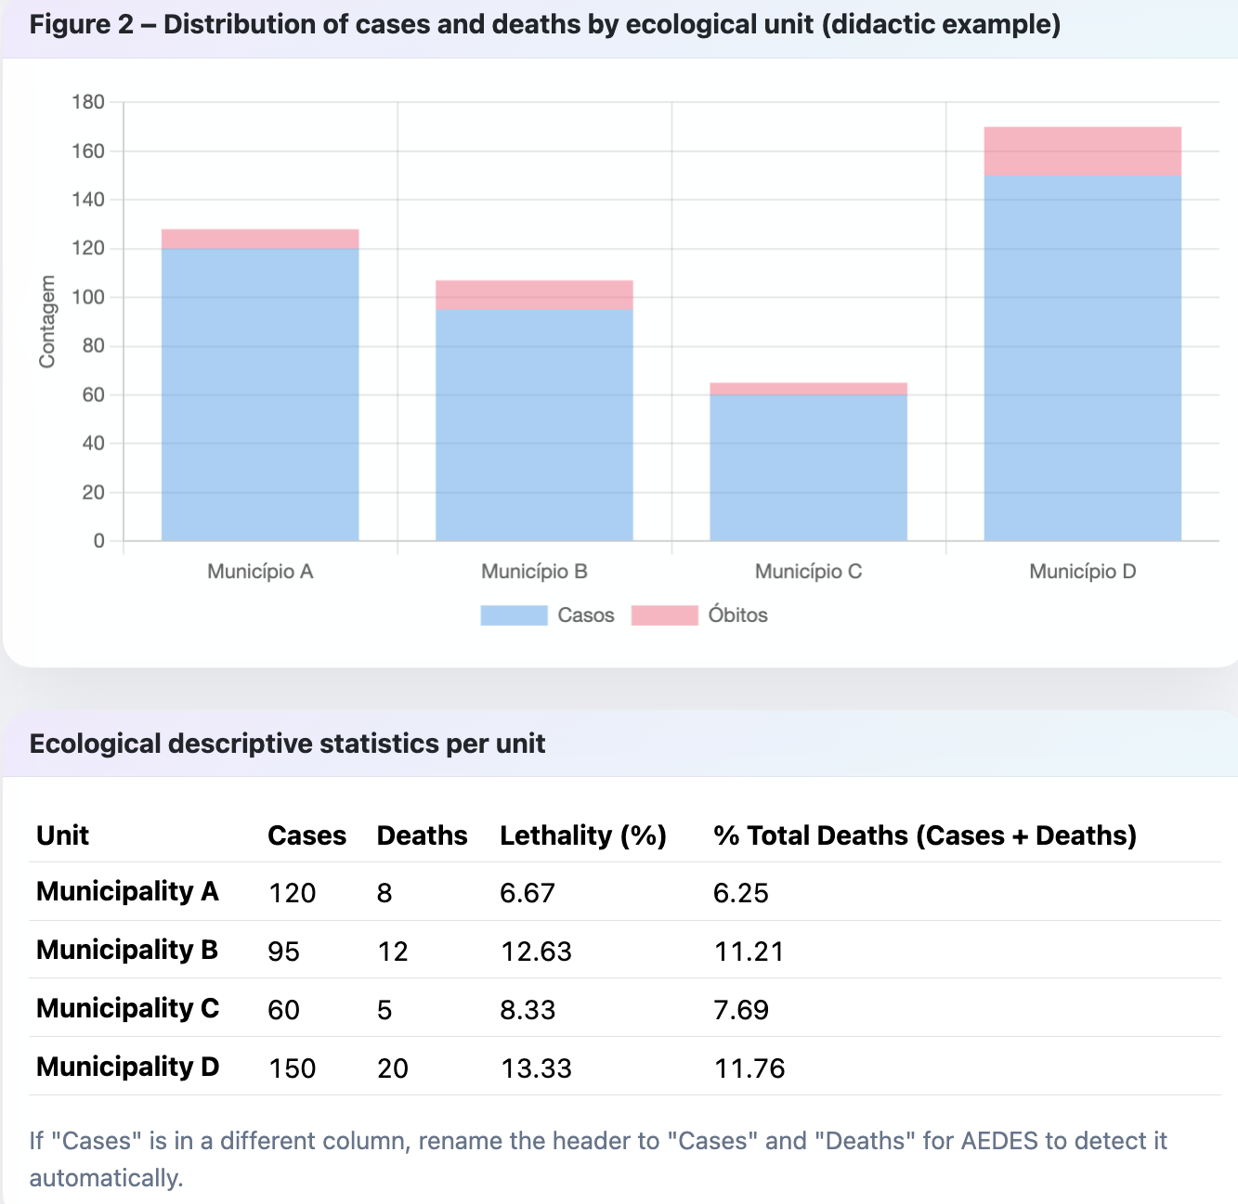
Fig. 3. Example of a data output

Source: the author

These automatically generated visualizations are designed to be easily exported in various formats, thus facilitating their seamless inclusion in lecture reports, academic presentations, and scientific publications, significantly improving the quality of students' research work.

3. METHODOLOGICAL FRAMEWORK
The core functionality of AEDES resides in a sophisticated yet intuitive framework for statistical testing. Its calculations in PHP and Javascript were reviewed by LLA AI models and cross-checked with control results compared to GraphPad Prism 8.0 (Intuitive Software for Science) for each analytical module, ensuring numerical consistency within expected rounding tolerances.
AEDES was developed with the goal of supporting students and researchers in the correct application of basic and intermediate statistical methods, especially in biostatistical contexts. One of its main features is the incorporation of automated statistical decision-making mechanisms, designed to reduce common methodological errors and, at the same time, stimulate conceptual understanding of the tests used.

3.1 Comparative Analysis (Independent Groups)
For scenarios involving the comparison of independent groups, AEDES incorporates an intelligent "AUTO" mode. This mode dynamically evaluates the number of groups present in the user's data and recommends the most statistically sound test:
Two Groups: When comparing two independent groups, the system defaults to Welch's t-test. This choice is deliberate and pedagogically significant. Unlike Student's t-test, Welch's t-test does not assume equal variances between groups, making it considerably more robust and reliable in real-world student-led research, where violations of assumptions are common. This prevents students from inadvertently misapplying a less appropriate test and drawing incorrect conclusions.
Three or More Groups: For comparisons involving three or more independent groups, Analysis of Variance (ANOVA) is automatically applied. If the ANOVA yields a statistically significant result, indicating an overall difference among group means, AEDES proceeds to perform automated post-hoc comparisons.
The system employs the Holm-Bonferroni method for these post-hoc tests. The Holm-Bonferroni method is a sequential multiple testing procedure that provides stronger control over the family-wise error rate (FWER) compared to simpler methods like Bonferroni, while maintaining higher statistical power. This ensures that students can identify specific group differences with appropriate statistical rigor, avoiding inflated Type I error rates that can arise from multiple comparisons.

3.2 Association and Correlation
AEDES also offers modules focused on analyzing the association between variables, encompassing both continuous and categorical variables.
In the “X,Y” module, the system calculates Pearson's correlation coefficient (r), used to quantify the strength and direction of the linear association between two continuous variables (Pearson, 1896). AEDES presents the r value along with its 95% confidence interval, allowing for a more precise assessment of the uncertainty associated with the estimate.
In addition to correlation, the system fits a simple linear regression model using the Ordinary Least Squares (OLS) method.
$Y=b_{0}+b_{1}X$,
The model is expressed as where the intercept ($b_{0}$) represents the expected value of $Y$when $X$equals zero, and the slope coefficient ($b_{1}$) reflects the average change in $Y$associated with a one-unit increase in $X$. AEDES also computes the 95% confidence intervals for these coefficients, which supports both inferential and predictive interpretations of the model (Montgomery et al., 2012).
For the analysis of the association between categorical variables, the AEDES “Contingency” module uses the chi-square test of independence (χ²). This test compares the frequencies observed in the table cells with the frequencies expected under the hypothesis of independence between the variables (Agresti, 2019). In addition to the χ² statistic, degrees of freedom, and p-value, AEDES calculates Cramer's V, a measure of effect size that allows for the evaluation of the magnitude of the association independently of the sample size.

An important aspect of this module is the inclusion of a specific alert for ecological data. When the data structure suggests aggregated information, the system alerts the user to the risk of ecological fallacy. This is very important because students, especially undergraduates, naturally tend to inflate or overestimate their findings, often speculating on aggregated data for individual groups, which constitutes an inadequate (and even dangerous) inference of associations at the individual level from group data (Morgenstern, 1995).
This functionality reinforces the pedagogical character of AEDES, encouraging a more critical and conceptually correct interpretation of statistical results.

3.3 Sample Size Determination
Recognizing that the statistical validity of a study begins with its planning, AEDES has a specific module for calculating sample size based on proportions. This feature is highly relevant for students developing population surveys, cross-sectional studies, or epidemiological research where the primary outcome is expressed as prevalence, proportion, or relative frequency.
The module guides the user in defining the main parameters necessary for sample size calculation, including the size of the reference population, the desired confidence level (e.g., 95%), the acceptable margin of error (such as ±5%), and, when available, the expected proportion of the event of interest. When this proportion is unknown, a common situation in exploratory studies or in contexts with scarce prior data, AEDES recommends using the value of 50%, which corresponds to the most conservative estimate and results in the largest possible sample size for the defined parameters. This approach is widely accepted in the methodological literature because it ensures greater statistical security in the absence of prior information (Lwanga &Lemeshow, 1991; Daniel & Cross, 2018).
The calculation adopted by the system is based on the classic formula for estimating proportions in finite populations, considering the normal distribution as an approximation of the binomial distribution when the conditions are met. At the end of the process, AEDES presents the minimum sample size required to achieve the established level of precision and confidence, accompanied by an explanatory summary in accessible language, which describes the practical meaning of each parameter used in the calculation.

4. CONCLUSION
AEDES represents an important step toward the democratization of statistical analysis in higher education. By automating the technical complexities of test selection and data visualization, it empowers students to engage more deeply with their data and to produce higher-quality research. The system’s didactic approach, combined with its accessibility and structured design, positions it as a powerful tool for fostering the development of knowledge, skills, attitudes, values, and ethics (K.S.A.V.E.) among life sciences students, thereby promoting good scientific practice in the next generation of researchers.

Disclaimer (Artificial intelligence)

During the preparation of this manuscript, the authors used Google-based translate assistance tools and OpenAI language models for language optimization and grammar improvement of the English text. After its use, the author thoroughly reviewed, verified, and revised all AI-assisted content to ensure accuracy and originality. The author(s) take full responsibility for the integrity and final content of the published article.

REFERENCES
AbbasnasabSardareh, Sedigheh, Gavin T. L. Brown, and Paul Denny. “Statistical Software Usability for Novice Research Students in the Social Sciences: An Eye-Tracking Study.” Journal of Statistics and Data Science Education, June, 2025, 1–15. doi:10.1080/26939169.2025.2497550.

Agresti, A. (2019). An introduction to categorical data analysis 3ed. 2019.

Bakri R, Del Val EB, Bado B, Ahmar AS. LOSARI: A novel R-based statistical software to facilitate students' self-regulated learning in statistics courses. MethodsX. 2025;15:103739. Published 2025 Nov 26. doi:10.1016/j.mex.2025.103739

Daniel, W. W., & Cross, C. L. . Biostatistics: A foundation for analysis in the health sciences.11ed. 2018.

Huang, Alexander A, and Samuel Y Huang. Enhancing Medical Education Through Statistics: Bridging Quantitative Literacy and Sports Supplementation Research for Improved Clinical Practice. Nutrients vol. 17,15 2463. 28 Jul. 2025, doi:10.3390/nu17152463

Kjelvik MK, Schultheis EH. Getting Messy with Authentic Data: Exploring the Potential of Using Data from Scientific Research to Support Student Data Literacy. CBE Life Sci Educ. 2019;18(2):es2. doi:10.1187/cbe.18-02-0023

Lwanga, S. K., &Lemeshow, S. Sample size determination in health studies: A practical manual. World Health Organization. 1991.

Masuadi E, Mohamud M, Almutairi M, Alsunaidi A, Alswayed AK, Aldhafeeri OF. Trends in the Usage of Statistical Software and Their Associated Study Designs in Health Sciences Research: A Bibliometric Analysis. Cureus. 2021;13(1):e12639. Published 2021 Jan 11. doi:10.7759/cureus.12639
Mavrevski, R. et al. “Approaches to Modeling of Biological Experimental Data with GraphPad Prism Software.” WSEAS Transactions on Systems and Control archive 13, 2018 https://www.wseas.org/multimedia/journals/control/2018/a625903-711.pdf

Montgomery, D. C., Peck, E. A., & Vining, G. G. Introduction to linear regression analysis 5ed. 2012

Morgenstern H. Ecologic studies in epidemiology: concepts, principles, and methods. Annu Rev Public Health. 1995;16:61-81. doi: 10.1146/annurev.pu.16.050195.000425. PMID: 7639884.

Nowacki AS, Brearley AM, Oster RA, et al. Diagnosing Statistical Education Needs of Health Science Learners. J Stat Data Sci Educ. 2025;33(2):199-209. doi:10.1080/26939169.2024.2333731
Ouyang H, Wang S, Huang L. Survey on the current status of statistical cognition and teaching needs of Chinese medical students. Front Public Health. 2025;13:1621667. Published 2025 Jul 9. doi:10.3389/fpubh.2025.1621667

Pearson, K. (1896) VII. Mathematical Contributions to the Theory of Evolution.-III. Regression, Heredity, and Panmixia. Philosophical Transactions of the Royal Society A, 187, 253-318.https://doi.org/10.1098/rsta.1896.0007

Shortreed SM, Moodie EEM. Automated analyses: Because we can, does it mean we should?. Stat Sci. 2020;35(3):499-502. doi:10.1214/20-sts773

