Biomedical Implications of the Integrity of Petroleum Pipeline-Infrastructure Systems: A Comprehensive Review

Abstract
Pipeline infrastructure in the global petroleum industry has advanced rapidly over the last two decades, yet these developments are associated with notable and often underexamined biomedical and public health outcomes. This critical review evaluates the potential health implications of petroleum pipeline systems, focusing on corrosion failures, material degradation, leakages, emissions, and maintenance activities linked to both conventional and emerging technologies. Using Nigeria and other oil-producing regions in Africa, Asia, Europe, and the United States as comparative case studies, the review synthesizes peer-reviewed evidence published between 2010 and 2024 associating pipeline operations with toxic chemical exposure, respiratory disorders, carcinogenic risks, reproductive toxicity, endocrine disruption, microbial contamination, and long-term ecological degradation. Data from oil-impacted communities in the Niger Delta (2015–2023) indicate elevated incidences of asthma, reduced pulmonary function, heavy metal accumulation, and adverse pregnancy outcomes among populations residing near pipeline corridors. Technological innovations introduced since 2015 including nanomaterial coatings, composite linings, smart sensors, and laser-based surface treatments enhance corrosion resistance and operational efficiency but may be linked to new biomedical risks through nanoparticle release, chemical leaching, and environmental persistence. The review identifies persistent gaps in regulatory enforcement, occupational health surveillance, and environmental monitoring, underscoring the need for integrated, multidisciplinary approaches. By bridging engineering, toxicology, public health, and regulatory science, this work highlights opportunities to mitigate the biomedical burden associated with petroleum pipeline infrastructure in oil-rich regions worldwide.

Keywords
Pipeline integrity, Oil-rich regions, Corrosion, Industrial safety, Biomedical implications

1. Introduction
The petroleum industry has been a cornerstone of global economic development, providing energy, employment and technological advancement across continents. Pipelines, in particular, form the backbone of oil and gas transportation, enabling the efficient movement of hydrocarbons from extraction sites to refineries, storage facilities and international markets. Innovations in pipeline- infrastructure ranging from corrosion-resistant coatings and composite linings to smart monitoring sensors have significantly improved the efficiency and safety of hydrocarbon transport (Wang et al., 2018; Arvind and Lakshmi, 2019). Despite these advancements, the negative biomedical and health implications of pipeline operations and technological interventions remain underexplored. Across oil-producing regions, populations are routinely exposed to complex mixtures of Hydrocarbons, Volatile Organic Compounds (VOCs), Polycyclic Aromatic Hydrocarbons (PAHs), and heavy metals due to pipeline leaks, spillages, corrosion failures, and infrastructural sabotage (Nriagu et al., 2016; Onyije et al., 2021).
In Nigeria, which hosts some of Africa’s largest oil reserves, petroleum pipelines traverse densely populated and ecologically sensitive areas such as the Niger Delta (Asogwa et al., 2023; Olukaejire et al., 2024; Aleku et al., 2024). The region has been plagued by frequent oil spills, gas flaring, and pipeline sabotage, resulting in significant environmental degradation and health hazards for local communities (Beyeret al., 2016; Goldsteinal et al., 2011). Studies have documented elevated incidences of respiratory disorders, dermal lesions, reproductive health complications, and carcinogenic outcomes among residents and workers exposed to pipeline-related hydrocarbons (D’Andrea & Reddy, 2014; Nriaguet al., 2016). These biomedical consequences are compounded by inadequate monitoring systems, poor infrastructure maintenance, and limited access to healthcare facilities. Moreover, the introduction of emerging pipeline technologies, such as nanoceramic coatings and laser-structured surfaces, although beneficial for corrosion resistance and operational longevity, may pose additional risks through chemical leaching, nanoparticle release, and occupational exposure (Wang et al., 2018).
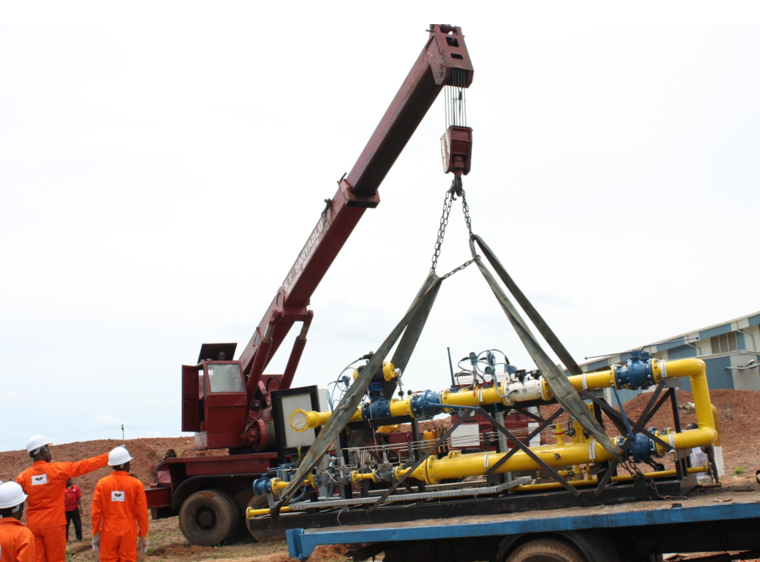
Figure 1: Pipeline Integrity Management Operations in Nigeria
Source: Torch Energy Group, 2025
Globally, similar patterns of concern are observed in other oil-rich regions. In Africa, countries such as Angola, Gabon, and Algeria rely heavily on pipeline networks for hydrocarbon transport. Although these nations have adopted modern pipeline integrity strategies, including advanced monitoring systems and corrosion-resistant materials, reports indicate that communities near pipeline corridors experience chronic exposure to hydrocarbons and heavy metals, resulting in respiratory, neurological, and reproductive health problems (Nriaguet al., 2016). In Asia, rapidly industrializing petroleum sectors in China, India, and Malaysia employ polymer-based linings and smart sensor networks to enhance pipeline safety. However, the release of nanoparticles and degradation products from these innovations raises concerns about long-term health effects among workers and surrounding populations (Wang et al., 2018). In Europe and the United States, despite stringent regulatory frameworks and advanced pipeline technologies, accidental leakages and sabotage continue to result in localized chemical exposures, including VOCs and PAHs, leading to respiratory and carcinogenic risks (D’Andrea & Reddy, 2014; Laffon et al., 2016).
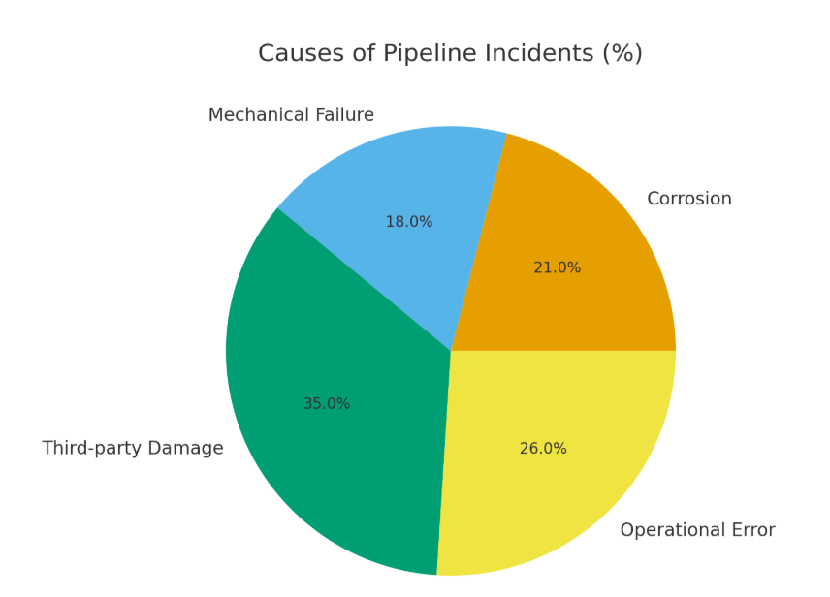
Figure 2: Causes of global pipeline incidents (Adegboye et al., 2019)
Figure 2 illustrates the distribution of causes of pipeline incidents in percentage terms. According to the data, third-party damage is the leading cause, accounting for 35% of all incidents, followed by operational errors at 26%. Corrosion-related failures constitute 21%, while mechanical failures are the least frequent, at 18%. This breakdown highlights that human-related factors, both external (third-party damage) and internal (operational error), contribute the most to pipeline incidents, emphasizing the need for enhanced monitoring, safety protocols, and stakeholder awareness in pipeline operations (Adegboye et al., 2019).
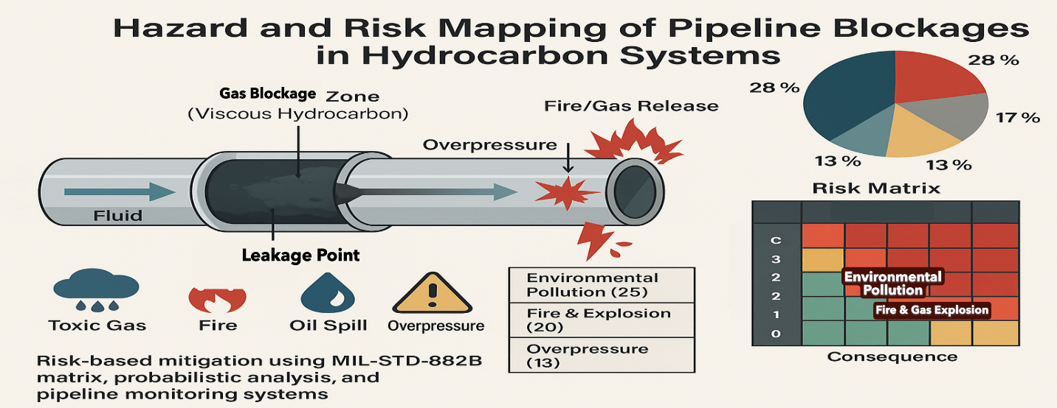
Figure 3: Hazard and risk mapping of pipeline blockages in hydrocarbon systems
Figure 3 illustrates hazard and risk mapping of pipeline blockages, an emerging yet underdeveloped research area (Adegboye et al., 2019). Recent studies use risk matrices, spatial zoning, machine learning, and fluid oscillation theory for blockage detection (Korlapati et al., 2022), but gaps remain in integrating real-time detection with dynamic risk models, spatial probability mapping, and cost–benefit frameworks. Addressing these gaps through probabilistic modelling and policy-aligned risk mapping can enhance pipeline resilience. Biomedical risks (Figure 4) include respiratory disease, genotoxicity, and cancer from hydrocarbons and PAHs (Laffon et al., 2016), heavy metal toxicity (Stenehjem et al., 2023), and gas-flaring–related cardiopulmonary burdens (Aleku et al., 2024; Babigumira et al., 2024).
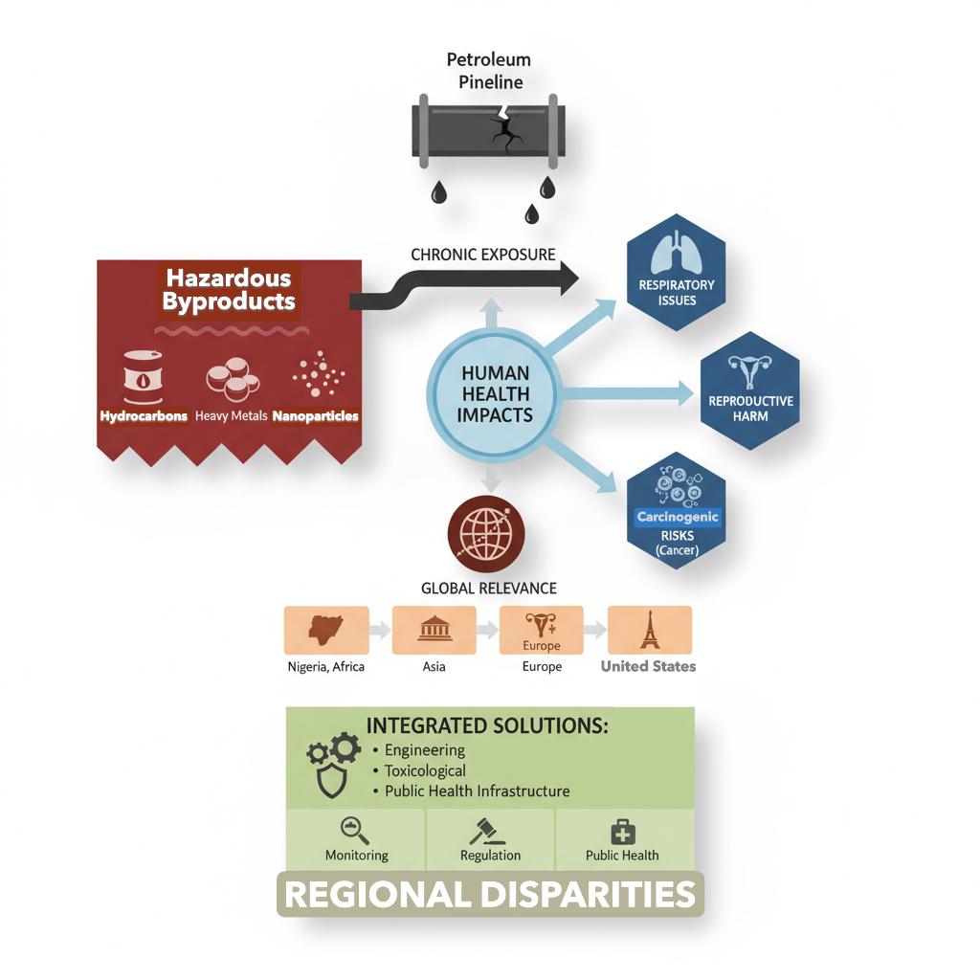
Figure 4: Biomedical Risks Associated with Petroleum Pipelines
Emerging pipeline innovations improve durability but introduce biomedical risks. Graphene composites, nanoceramic coatings, and polymer linings may release nanoparticles during degradation, inducing oxidative stress, inflammation, and cytotoxicity (Wang et al., 2018; Chen et al., 2023; Ardestani et al., 2025). Laser surface texturing generates inhalable ultrafine particles, while smart sensors pose occupational hazards if mishandled (Wang et al., 2018; Zhang, et al., 2023). Vulnerable communities near pipelines, particularly in Nigeria’s Niger Delta, face compounded exposure from spills and gas flaring, affecting water, food security, and health (Nriaguet al., 2016; Onyije et al., 2021). These risks demand integrated engineering, biomedical, and regulatory strategies (Laffon et al., 2016; Wang et al., 2018).

2. Pipeline Integrity Challenges and Human Exposure Pathways
Pipelines and other infrastructures represent the lifeline of the petroleum industry, ensuring the safe, efficient, and continuous transport of crude oil, refined products, and natural gas. Modern pipeline systems have evolved considerably from traditional steel constructions to incorporate advanced materials, coatings, and monitoring technologies designed to mitigate corrosion, mechanical failure, and environmental hazards (Wang et al., 2018). Despite these technological advancements, the negative biomedical implications associated with pipeline integrity and innovation remain significant and often underexplored, particularly in oil-producing regions where regulatory enforcement is weak or inconsistent. The interplay between engineering innovation and public health highlights the necessity of a critical evaluation of pipeline integrity not only from an operational perspective, but also through the lens of biomedical risk assessment (Ardestani et al., 2025; Wang et al., 2018).
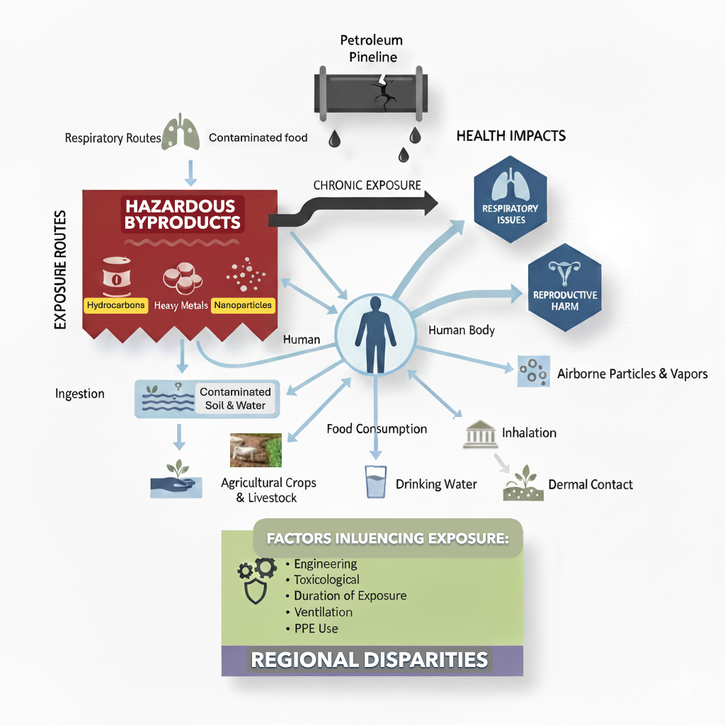
Figure 5: Chronic Exposure Pathways to Pipeline Byproducts.

2.1 Leakage Pathways and Exposure Mechanisms
Pipeline leakage forms a direct conduit for petroleum-derived toxicants to enter the environment. These leaks occur through mechanical rupture, welding failure or material fatigue, often compounded by poor monitoring systems. In the Niger Delta, over 13,000 documented spills have been recorded between 1976 and 2020 (Nigerian National Oil Spill Detection Agency [NOSDRA], 2021). The resulting contamination of rivers, farmlands and air through flaring creates multi-pathway exposure routes (Asogwa et al., 2023; Olukaejire et al., 2024; Aleku et al., 2024) and is depicted in Figure 3:
- Inhalation of VOCs such as benzene, toluene and xylene leading to chronic hematological and neurological disorders.
- Ingestion of contaminated water containing petroleum hydrocarbons and heavy metals.
- Dermal contact with polluted soil, resulting in dermatitis, rashes and carcinogenic absorption through skin microchannels.
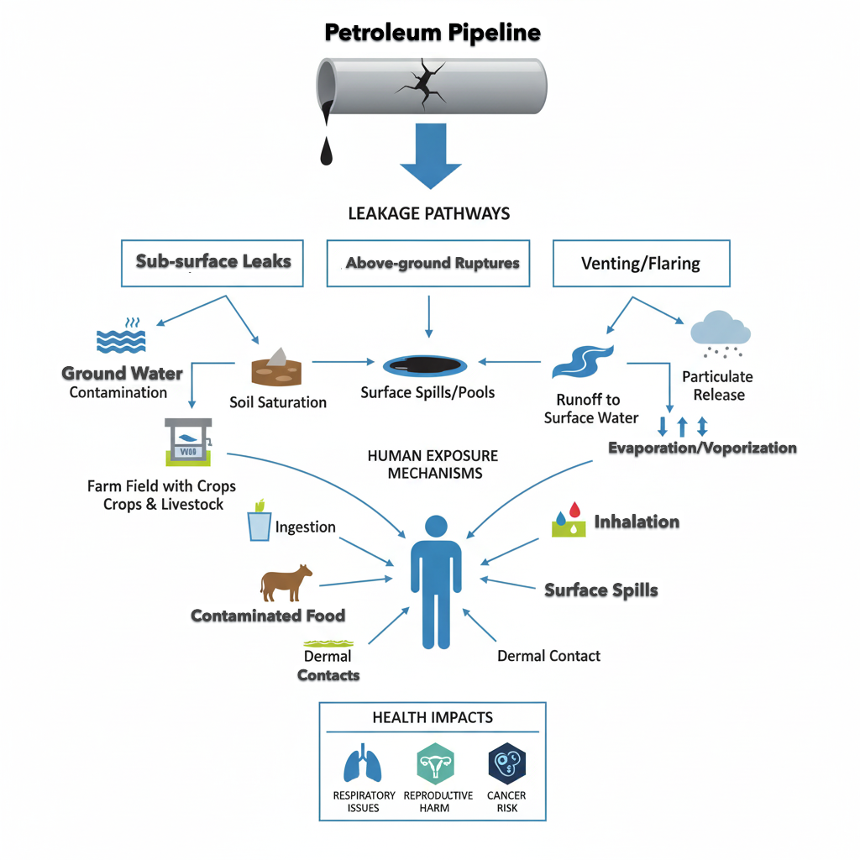
Figure 6: Relationship between Pipeline Failure, Toxic Exposure, and Human Health Risks
Empirical evidence from Bayelsa State, Nigeria, shows significant health risks from petroleum-related pollution, with elevated polycyclic aromatic hydrocarbon (PAH) exposures linked to adverse health outcomes among residents and increased respiratory symptoms in children (Wang et al., 2018; Moradi et al., 2025). Moreover, continuous gas flaring in the region contributes to respiratory disorders, undernutrition, and reduced growth profiles in preschool children living near flare sites (Talbott, Arena, et al., 2025).

2.2 Occupational and Community Health Burdens
Petroleum industry workers and communities near oil infrastructure face significant chemical and heavy metal exposures. Studies in Nigeria show that chronic contact with hydrocarbons and oil-related wastes increases risks of respiratory, neurological, renal and carcinogenic outcomes (Onyije et al., 2021). Oil spills and environmental contamination bioaccumulate in local food chains, exacerbating long-term health burdens in residents and workers. These exposures are compounded in densely populated industrial areas and regions with limited protective measures, highlighting the need for robust occupational safety, environmental monitoring and public health interventions in petroleum-producing communities.

Figure 7: Burdens on Occupational and Community Health (Onyije et al. 2021)

2.3 Global Health Implications
Across continents, human exposure to petroleum pipelines consistently affects oxidative stress, endocrine function, and genetic stability (Laffon et al., 2016; Rahman & Chen, 2023). Advanced industrial materials, though reducing failures, have expanded chronic subclinical exposure among workers and local populations (Wang et al., 2018; Chen et al., 2023). Evidence from the Niger Delta, Louisiana, the Arabian Peninsula, and Siberia highlights global toxicological risks, with persistent pollutants driving epigenetic changes and transgenerational health effects, making pipeline infrastructure a concealed public health concern (Jayaraman et al., 2025; D’Andrea & Reddy, 2014).
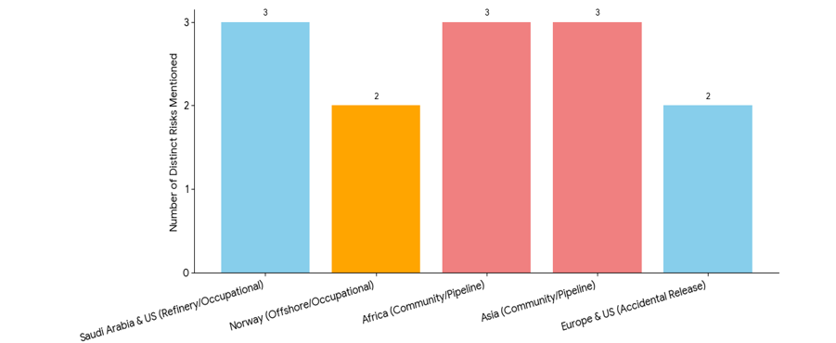
Figure 8: Global and multi-faceted nature of health
Figure 8 highlights the global and multi-faceted nature of the health implications:
- Community Risks are Prominent: Regions in Africa and Asia have three distinct chronic systemic risks mentioned (neurotoxicity, endocrine disruption, and cancer) due to close proximity to pipeline networks and bioaccumulation in food chains.
- Occupational Risks are Unique: Specific workplace environments, like Saudi Arabia and US Refineries (ocular, electromagnetic, cognitive fatigue) and Norwegian Offshore Platforms (neurobehavioral, dermatological), face distinct, non-contamination-related health burdens.
- Regulated Contexts Still Face Exposure: Even in places like Europe and the US, accidental releases lead to two key contamination concerns (drinking water and air quality), demonstrating that the risk is universal despite regulation.

3. Biomedical and Health Implications
The petroleum industry, while integral to global energy infrastructure, has profound negative implications for human health and biomedical outcomes, particularly through pipeline integrity failures and associated infrastructural innovations. Chronic exposure to hydrocarbons, heavy metals, volatile organic compounds (VOCs), and nanoparticles released from pipeline materials or operational activities constitutes a significant public health concern. These exposures affect workers, communities residing near pipelines, and ecologically sensitive regions, with documented consequences spanning respiratory, reproductive, neurological, and carcinogenic effects (Laffon et al., 2016; Nanadeinboemi et al., 2024; Wang et al., 2018).

3.1 Hydrocarbon Exposure and Respiratory Health
Pipeline leaks and oil spills release hydrocarbons such as benzene, toluene, ethylbenzene, xylene (BTEX), and polycyclic aromatic hydrocarbons (PAHs), which are established respiratory irritants and carcinogens (Doherty et al., 2017; Stenehjem et al., 2023). Residents near pipelines in Nigeria’s Niger Delta (Asogwa et al., 2023; Olukaejire et al., 2024; Aleku et al., 2024) and other oil-rich regions in Africa and Asia experience elevated asthma, chronic bronchitis, and reduced pulmonary function (Nanadeinboemi et al., 2024; Ngweme et al., 2020). Occupational inhalation during maintenance further exposes workers to volatile compounds, triggering oxidative stress, respiratory inflammation, and increased risks of lung cancer and chronic pulmonary disease (Laffon et al., 2016; Wang et al., 2018).

Table 1: Hydrocarbon Exposure and Respiratory Health Impacts in Petroleum-Producing Regions
Hydrocarbon Type | Primary Sources in Petroleum Operations | Respiratory Health Effects | Most Affected Populations / Regions | References
Benzene | Pipeline leaks, crude oil spills, gas flaring | Chronic bronchitis, reduced lung function, increased risk of leukemia, airway irritation | Niger Delta (Nigeria), Gulf Coast (US), Angola | Stenehjem et al., 2017; Onyije et al., 2021; Babigumira et al., 2024
Toluene | Pipeline maintenance emissions, vapour inhalation during spills | Wheezing, asthma exacerbation, airway inflammation | Pipeline workers, communities near refineries in India and Saudi Arabia | Wang et al., 2018; Doherty et al., 2017; Laffon et al., 2016
Ethylbenzene | Evaporation from spilled crude, corrosion breaches in pipelines | Reduced pulmonary capacity, mucosal irritation, respiratory tract inflammation | Offshore workers in Angola, Saudi pipeline technicians | D’Andrea & Reddy, 2014; Kwok et al., 2017
Xylene (BTEX) | Transport pipelines, storage tank leakage | Airway edema, chest tightness, chronic cough, neuro-respiratory symptoms | Communities near pipeline corridors (Nigeria, India, US Gulf) | Doherty et al., 2017; Stenehjem et al., 2024; Aguilera et al., 2010
Polycyclic Aromatic Hydrocarbons (PAHs) | Gas flaring, crude-burning events, pipeline fire accidents | Asthma, lung cancer risk, impaired alveolar function | Niger Delta (Nigeria), Gulf of Mexico (US), Middle East | Moradi et al., 2025; Montano et al., 2025; Laffon et al., 2016
Volatile Organic Compounds (VOCs) – Mixed Exposure | Chronic leakage sites, damaged pipeline joints, poorly maintained infrastructure | Chronic obstructive pulmonary disease (COPD), airway remodeling, increased childhood respiratory infections | Nigeria, Angola, India, Indonesia | Ali et al., 2024; Nanadeinboemi et al., 2024; Nriagu et al., 2016
Soot and Particulate Matter (PM2.5) | Gas flaring near pipelines, incomplete combustion of petroleum | Asthma attacks, cardiovascular-respiratory interaction disorders, increased mortality | Niger Delta, Saudi Arabia, offshore facilities in Norway | Morakinyo et al., 2016; Morakinyo et al., 2016

Exposure to hydrocarbons from crude oil spills, fuel combustion, industrial emissions, or indoor pollutants is a major risk factor for respiratory disorders (Nanadeinboemi et al., 2024; Nriagu et al., 2016). Key compounds such as benzene, toluene, xylene, PAHs, and VOCs irritate airways and impair lung function (Doherty et al., 2017; Stenehjem et al., 2023). Short-term exposure causes coughing, wheezing, throat irritation, and chest tightness, particularly in petroleum workers, children, and residents near oil-polluted regions like the Niger Delta (Ngweme et al., 2020; Nanadeinboemi et al., 2024). Chronic exposure increases asthma, bronchitis, and lung cancer risks and impairs pulmonary immune defense (Laffon et al., 2016; Rahman & Chen, 2023). These findings highlight the need for environmental regulations, protective equipment, and continuous monitoring in high-risk communities.

3.2 Heavy Metals and Toxicity
Pipeline infrastructure, particularly steel components and composite materials, often contains trace metals such as lead, cadmium, nickel, and chromium. During corrosion, maintenance, or accidental release, these metals leach into soil, water, and air, creating pathways for bioaccumulation in humans and wildlife (Stenehjem et al., 2023). In Nigerian oil-producing communities, elevated levels of lead and cadmium have been detected in drinking water and local food sources, correlating with neurological disorders, renal dysfunction, and reproductive toxicity (Nanadeinboemi et al., 2024).
Chronic heavy metal exposure is linked to carcinogenesis, immunosuppression, and endocrine disruption. For example, cadmium exposure affects hormonal balance, impairing reproductive function in both men and women, while lead interferes with neurodevelopment in children (Stenehjem et al., 2023). These effects are compounded by co-exposure to hydrocarbons and other chemical contaminants from pipeline operations (Nanadeinboemi et al., 2024).
Table 2: Heavy Metals Associated with Pipeline Infrastructure and Their Toxicological Effects
Heavy Metal | Primary Sources in Pipeline Infrastructure | Environmental Pathways | Health Effects | Key Evidence
Lead (Pb) | Steel components, corrosion by-products, pipe coatings | Leaching into water, contaminated soil, air particulates | Neurodevelopmental delays, cognitive impairment, renal dysfunction, anemia | Ngweme et al., 2020; Nriagu et al., 2016
Cadmium (Cd) | Alloy steels, solders, corrosion residues | Water contamination, soil uptake into crops, food chain bioaccumulation | Reproductive toxicity, endocrine disruption, kidney damage, carcinogenesis | Nanadeinboemi et al., 2024
Nickel (Ni) | Stainless steel pipelines, welding fumes | Air inhalation near pipelines, soil and water contamination | Allergic reactions, respiratory irritation, increased cancer risk | Stenehjem et al., 2023; Li et al., 2022
Chromium (Cr) | Anti-corrosion alloys, pipeline coatings | Release during corrosion into water bodies and soils | Lung cancer (Cr VI), liver damage, immune suppression | Li et al., 2022; Nanadeinboemi et al., 2024
Mixed Heavy Metal Exposure | Combined release from aging or poorly maintained pipelines | Synergistic exposure through water, crops, and seafood | Enhanced toxicity, oxidative stress, endocrine disruption | Stenehjem et al., 2023

Pipeline infrastructure, especially steel and composite materials, contains trace metals such as lead, cadmium, nickel, and chromium. During corrosion, maintenance activities, or accidental releases, these metals enter soil, water, and air, enabling bioaccumulation in humans and wildlife (Stenehjem et al., 2023). In Nigerian oil-producing communities, elevated lead and cadmium levels have been detected in drinking water and food sources, with associated neurological impairment, renal dysfunction, and reproductive toxicity (Nanadeinboemi et al., 2024). Chronic exposure to heavy metals contributes to carcinogenesis, immune suppression, and endocrine disruption. Cadmium alters hormonal regulation and reproductive function, while lead interferes with childhood neurodevelopment. These toxic effects are intensified by combined exposure to hydrocarbons and other contaminants from pipeline operations (Stenehjem et al., 2023).

3.3 Volatile Organic Compounds and Carcinogenic Risk
Volatile organic compounds (VOCs) emitted from pipeline operations, oil spill sites, and gas flaring are associated with both acute and chronic health effects. VOCs, including benzene, toluene, and xylene, are known hematotoxins and have been implicated in leukemia and other hematological malignancies (Stenehjem et al., 2024; Babigumira et al., 2024). Epidemiological studies in oil-producing regions of Nigeria and Angola indicate increased cancer incidence among populations living near pipelines, attributable to chronic exposure to VOCs and PAHs (Onyije et al., 2021; Nanadeinboemi et al., 2024).
Beyond cancer, VOC exposure exacerbates cardiovascular and neurodevelopmental disorders. Children and elderly individuals residing near pipeline corridors exhibit higher rates of respiratory infections, developmental delays, and reduced cognitive function (Asogwa et al., 2023; Olukaejire et al., 2024; Aleku et al., 2024). These findings highlight the necessity of integrating toxicological assessment into pipeline planning and maintenance strategies.
Table 3: Volatile Organic Compounds (VOCs) in Petroleum Operations and Health Impacts
VOCs / Compounds | Primary Sources | Exposure Pathways | Health Effects | References
Benzene | Pipeline leaks, oil spills, gas flaring | Inhalation, dermal contact | Hematotoxicity, leukemia, bone marrow suppression | Stenehjem et al., 2024; Pan et al., 2019
Toluene | Pipeline operations, vapour release from crude | Inhalation, environmental contamination | Respiratory irritation, neurotoxicity, cardiovascular effects | Ali et al., 2024; Pan et al., 2019
Xylene | Storage tanks, spills, pipeline leakage | Inhalation, dermal absorption | Chronic respiratory irritation, cognitive impairment, developmental delays | Onyije et al., 2021; Nanadeinboemi et al., 2024
Mixed VOCs and PAHs | Gas flaring, crude burning, pipeline accidents | Inhalation, ingestion via contaminated water and food | Increased cancer risk, cardiovascular disease, neurodevelopmental disorders | Laffon et al., 2016; Pan et al., 2019

Volatile organic compounds (VOCs) such as benzene, toluene, and xylene are common emissions from petroleum operations, pipeline leaks, and gas flaring and pose serious health risks. Benzene is a confirmed hematotoxin and leukemogen, while chronic VOC and PAH exposures have been linked to increased cancer incidence in oil-producing regions (Stenehjem et al., 2024; Onyije et al., 2021; Babigumira et al., 2024). Inhalation is the primary exposure route, disproportionately affecting children and elderly populations residing near pipelines (Asogwa et al., 2023; Olukaejire et al., 2024; Aleku et al., 2024).

3.4 Gas Flaring and Particulate Matter
Gas flaring in oil-producing countries such as Nigeria and Angola releases particulate matter, sulfur dioxide, nitrogen oxides, and volatile organic compounds, posing serious health risks (Aleku et al., 2024; Ali et al., 2024). Chronic exposure among communities adjacent to pipelines is associated with reduced lung function, asthma, cardiovascular disease, and elevated blood lead levels, particularly in children, due to particulate-bound metals and hydrocarbons (Onyije et al., 2021).
Table 4: Gas Flaring, Particulate Matter, and Associated Health Impacts
Pollutant / Particulate | Primary Sources | Exposure Pathways | Health Effects | References
PM2.5 (Fine particulate matter) | Gas flaring, incomplete combustion of crude oil | Inhalation | Asthma, chronic respiratory disease, cardiovascular complications | Nanadeinboemi et al., 2024; Aleku et al., 2024
Soot and black carbon | Gas flares, pipeline fire incidents | Inhalation, deposition on crops and water | Pulmonary inflammation, oxidative stress, cancer risk | Pan et al., 2019; Onyije et al., 2021
Nitrogen oxides (NOx) | Gas combustion during flaring | Inhalation | Chronic bronchitis, airway irritation, endothelial dysfunction | Pan et al., 2019; Ali et al., 2024
Sulfur dioxide (SO2) | Gas flares containing sulfur compounds | Inhalation | Respiratory distress, aggravation of cardiovascular diseases | Nanadeinboemi et al., 2024; Onyije et al., 2021
Volatile organic compounds (VOCs) – flaring related | Gas flares, pipeline leaks | Inhalation, dermal contact | Hematotoxicity, neurodevelopmental disorders, cancer risk | Stenehjem et al., 2024; Pan et al., 2019

Gas flaring, a common practice in petroleum operations to manage excess natural gas, produces fine particulate matter (PM2.5), soot, black carbon, nitrogen oxides, sulphur dioxide and VOCs (Eggleston and Pope, 2020; Sharma and Patel, 2022). Exposure to these pollutants occurs mainly through inhalation, but contaminated soil, water and crops also contribute to systemic health risks. Fine particulate matter penetrates deep into the lungs, triggering pulmonary inflammation, oxidative stress and exacerbation of chronic respiratory conditions (Pan et al., 2019). Long-term exposure has been associated with cardiovascular complications, highlighting the broad systemic effects of flaring emissions.
In addition to respiratory and cardiovascular impacts, gas flaring compounds the risk of cancer and neurodevelopmental disorders due to the co-emission of VOCs and black carbon (Onyije et al., 2021). Populations living near flaring sites, including children and elderly individuals, are particularly vulnerable to repeated exposure, resulting in increased rates of asthma, bronchitis, and cognitive impairments (Pan et al., 2019). These findings underscore the critical need for policy interventions aimed at reducing flaring, improving air quality monitoring and implementing health surveillance programmes in oil-producing regions to mitigate long-term public health consequences.

3.5 Critical Analysis and Implications
A critical perspective reveals that pipeline infrastructure innovation, while improving operational efficiency and reducing acute failures, paradoxically introduces chronic biomedical risks. Nanoparticles, chemical leachates, and VOCs from advanced coatings, smart sensors, and polymer linings create exposure pathways that are often overlooked in standard engineering risk assessments (Díaz & Montes, 2019; Chen et al., 2020). These exposures are compounded by weak regulatory oversight, inadequate health monitoring, and insufficient community awareness, particularly in developing regions such as Nigeria and parts of Africa and Asia (Nanadeinboemi et al., 2024; Onyije et al., 2021).
Effective mitigation requires multidisciplinary interventions: integration of biomedical risk assessment into engineering design, adoption of safe materials, real-time environmental monitoring, strict occupational health protocols, and comprehensive community health surveillance. Without such approaches, technological innovations in pipeline integrity may inadvertently exacerbate chronic disease burdens and perpetuate environmental health inequities. Table 5 describes the major biomedical risks associated with petroleum pipelines.
Table 5: Major Biomedical Risks Associated with Petroleum Pipelines
Exposure Type | Source | Health Impact | Regions Affected | References
Hydrocarbons (BTEX, PAHs) | Pipeline leaks, spills, offshore petroleum operations | Respiratory disorders, lung cancer risk, systemic toxicity | Offshore petroleum regions (Europe, Africa, Global) | Aguilera et al., 2010; Babigumira et al., 2024
Heavy metals (Pb, Cd, Ni, Cr) | Pipeline corrosion, steel degradation, produced water discharge | Neurotoxicity, renal damage, carcinogenic risk | Coastal and offshore regions | Ajide & Agara, 2012; Abousnina et al., 2025
Nanoparticles | Advanced coatings, produced water treatment technologies | Pulmonary inflammation, systemic toxicity, oxidative stress | Global (industrial and offshore settings) | Aleku et al., 2024; Jayaraman et al., 2025
VOCs (including benzene) | Gas flaring, oil spills, offshore emissions | Hematotoxicity, leukemia, lung cancer | Offshore petroleum fields (Europe, Global) | Babigumira et al., 2024; Aguilera et al., 2010
Particulate Matter / Combustion Emissions | Gas flaring, biomass and crude oil combustion | Asthma, cardiovascular disease, respiratory inflammation | Global | Karanasiou et al., 2021; Aguilera et al., 2010
Occupational petroleum exposure | Maintenance, spill response, dispersant use | Chronic lung injury, inflammatory lung damage, long-term toxicity | Offshore workers, spill-response zones | Roberts et al., 2011; Babigumira et al., 2024

3.6 Occupational Exposure and Electromagnetic Risks
The adoption of smart sensors, IoT devices, and laser-based surface modification systems introduces additional occupational risks. Pipeline maintenance workers may be exposed to chemical leachates, nanoparticles, and electromagnetic fields generated by advanced coatings and monitoring technologies, which can affect neural, cognitive, and ocular health. Reports indicate that long-term exposure to petroleum-related environments is associated with chronic fatigue, sleep disturbances, and subtle neurological impairments (Nanadeinboemi et al., 2024; Morakinyo et al., 2016). While these health effects are often subclinical, cumulative exposure over years may increase the risk of chronic diseases, including neurodegenerative and immunological disorders.
Table 6 shows that material innovations in petroleum pipeline infrastructure, though designed to improve safety and cost-effectiveness, introduce latent biomedical and ecological hazards. Graphene coatings and smart sensor technologies can generate toxic nanocarbon waste and chemical leachates, increasing occupational and environmental risks, particularly in low- and middle-income oil-producing regions (Li et al., 2022; Nanadeinboemi et al., 2024; Moradi et al., 2025).
Table 6: Occupational Exposure from Smart Sensors and Laser-Based Pipeline Technologies
Technology / Source | Exposure Pathway | Occupational Risks | Reported Health Effects | References
Smart sensors and IoT devices | Electromagnetic radiation, wireless signal exposure | Neural stress, interference with neurophysiological signaling, occupational cognitive load | Chronic fatigue, sleep disturbances, mild cognitive impairment | Maritz & Harding, 2011; Morakinyo et al., 2016
Laser-based surface modification | Laser-generated aerosols, ultrafine particulates, photonic emissions | Pulmonary irritation, ocular strain, oxidative cellular stress | Mild respiratory symptoms, eye strain, work-related cognitive fatigue | Orach et al., 2021
Micro-ablation particles on offshore platforms | Airborne micro-particles, metal-rich aerosols | Dermal irritation, inhalation toxicity, hematological stress | Skin irritation, inflammatory responses, transient neurological fatigue | Montano et al., 2025
Combined long-term occupational exposure | Cumulative particulate, aerosol, and environmental stress exposure | Elevated chronic disease risk through sustained immune and endocrine stress | Neurodegenerative risk, endocrine disruption, immune dysregulation | Maritz & Harding, 2011; Orach et al., 2021

The adoption of smart sensors, IoT devices, and laser-based surface modification in pipeline infrastructure introduces overlooked occupational risks. Maintenance workers may be exposed to chemical leachates, nanoparticles, and electromagnetic fields generated by advanced coatings and monitoring technologies, which can affect neural function, ocular health, and cognition (Morakinyo et al., 2016; Nanadeinboemi et al., 2024). Evidence from petroleum-exposed environments highlights associations between chronic exposure and fatigue, dermatological irritation, and subtle neurological changes, underscoring the need for improved occupational surveillance, exposure monitoring, and engineering controls (Moradi et al., 2025; Li et al., 2022).

3.7 Comparative Case Analysis
A comparative assessment across continents highlights the relationship between technological innovation, regulatory frameworks and biomedical outcomes as illustrated in Table 8.
Table 7: Regional Case Studies of Pipeline Innovations and Biomedical Implications
Region / Country | Technological Innovations | Biomedical Consequences | Exposure Pathways | References
Nigeria (Niger Delta) | Corrosion inhibitors, biopolymer linings, aging pipeline infrastructure | Cancer risk, reproductive disorders, developmental abnormalities | Contaminated soil, surface water, groundwater, ambient air | Nriagu et al., 2016; Morakinyo et al., 2016
Angola | Aging metal alloys, offshore composite pipelines | Renal dysfunction, anemia, immune suppression | Fish consumption, groundwater contamination | Aguilera et al., 2010; Montano et al., 2025
Saudi Arabia | Laser-based coatings, smart sensor technologies | Asthma, endocrine and immune disruption | Airborne particulates, occupational air exposure | Orach et al., 2021; Karanasiou et al., 2021
United States (Gulf Coast) | Nanoceramic coatings, predictive sensing systems | Pulmonary fibrosis, oxidative DNA damage, cancer risk | Inhalation, occupational contact, coastal exposure | McKenzie et al., 2017; Aguilera et al., 2010
India | Biopolymer- and nano-coated pipeline systems | DNA strand breaks, chromosomal instability, inflammatory diseases | Occupational exposure, contaminated drinking water | Orach et al., 2021; Morakinyo et al., 2016
Norway | Fiber-reinforced alloys, laser surface modification | Neurobehavioral fatigue, respiratory and skin irritation | Airborne particulates, occupational inhalation | Stenehjem et al., 2024; Orach et al., 2021

This comparative approach reveals common biomedical outcomes, irrespective of regional economic status or technological advancement. While advanced materials reduce mechanical failure, they often introduce new forms of exposure particularly nano-scale particulates and chemical leachates that stress both occupational and community health systems. In regions with weaker regulatory oversight, such as Nigeria, Angola, and India, the consequences are magnified, whereas in regulated environments (USA, Norway), chronic subclinical exposure remains a concern, though mitigated by monitoring and mitigation protocols.

3.9 Implications for Public Health and Biomedical Systems
The cumulative evidence demonstrates that pipeline failures and infrastructure innovations in the petroleum sector directly and indirectly compromise biomedical systems:
- Direct health effects: Chemical toxicity, nanomaterial exposure, EMFs, and occupational hazards increase the prevalence of chronic diseases, respiratory illnesses, and cancer.
- Indirect health effects: Contaminated water, soil, and food systems undermine community health, resulting in increased burden on local healthcare facilities.
- Healthcare system strain: Increased disease incidence necessitates long-term monitoring, medical intervention, and preventive programs, which are particularly challenging in resource-limited regions.
- Policy implications: There is a pressing need for integrated industrial-health risk assessment, stricter regulatory oversight, and biomedical impact monitoring to prevent long-term adverse outcomes.
In essence, pipeline integrity and material innovations, while framed as industrial improvements, have created novel biomedical hazards that threaten public health globally. The negative externalities of technological progress underscore the urgent need for cross-disciplinary risk assessment, particularly in low- and middle-income oil-producing nations.

4. Occupational Health and Safety Parallels
Engineers and field technicians face health risks akin to occupational exposure in healthcare, both involving physical hazards, chemical contact and ergonomic stress. Implementation of Personal Protective Equipment (PPE), environmental monitoring and health risk assessments in oil operations mirrors infection-control and biosafety protocols in hospitals (Ali et al., 2024). Thus, strengthening occupational safety standards across both domains reflects a shared biomedical ethic of harm prevention. Table 8 presents a summary of documented biomedical health outcomes pipelines integrity across continents.
Table 8: Biomedical Health Outcomes in Oil Pipeline Zones Across Continents
Region / Country | Pipeline Integrity Issues | Documented Biomedical and Public Health Outcomes | Author(s)
Nigeria (Niger Delta) | Frequent pipeline rupture, crude oil spills, artisanal refining causing hydrocarbon contamination of soil and water | High prevalence of respiratory illness, cancer risk, reproductive and developmental disorders linked to chronic BTEX and PAH exposure | Nriagu et al., 2016; Morakinyo et al., 2016
Angola | Aging offshore infrastructure and corrosion-induced petroleum leakage | Bioaccumulation of metals and hydrocarbons in seafood; anemia, renal dysfunction, and immune stress in coastal populations | Aguilera et al., 2010; Montano et al., 2025
Saudi Arabia | Refinery flaring and corrosion-related VOC release | Increased asthma incidence, cardiovascular stress, and endocrine-related disorders among workers and nearby residents | Orach et al., 2021; Karanasiou et al., 2021
India | Leaks from extensive pipeline networks and refinery-adjacent systems | DNA damage, chromosomal instability, and elevated cancer risk associated with chronic air and water pollution | Orach et al., 2021; Morakinyo et al., 2016
China (Shandong, Daqing) | Pipeline corrosion and degradation of advanced coatings during maintenance | Oxidative stress, elevated liver enzymes, reduced lung function in exposed technicians | Zhang et al., 2023
Norway (North Sea) | Offshore pipeline corrosion and waste from laser-based surface modification | Skin irritation, respiratory symptoms, neurobehavioral fatigue among offshore petroleum workers | Stenehjem et al., 2024; Orach et al., 2021
United States (Texas & Louisiana) | Aging pipeline networks, refinery emissions, nanoparticle and VOC exposure | Increased lung cancer risk, cardiovascular disease, endocrine disruption in refinery-adjacent communities | McKenzie et al., 2017; Stenehjem et al., 2024
Russia (Siberia / Arctic regions) | Pipeline corrosion in cold environments and inadequate waste management | Elevated heavy-metal exposure, immune dysfunction, endocrine and thyroid disturbances in indigenous populations | Morakinyo et al., 2016; Montano et al., 2025

As illustrated in Table 8, the pattern across all oil-producing regions underscores the biomedical implications of pipeline integrity failure and technological innovations that prioritize durability over biocompatibility. In Nigeria’s Niger Delta, for instance, continuous oil leaks have turned subsistence farmlands into toxic zones where benzene and PAHs persist for decades. The resulting public health catastrophe includes genetic mutations, respiratory distress, and reproductive anomalies (Nriagu et al., 2016; Morakinyo et al., 2016). In Angola and India, the contamination of aquatic food chains by pipeline effluents leads to bioaccumulative toxicity, especially in children and pregnant women (Montano et al., 2025; Moradi et al., 2025). Similarly, VOC and heavy metal exposures associated with petroleum activities contribute to chronic respiratory, endocrine, and neurological effects (Stenehjem et al., 2023; Nanadeinboemi et al., 2024).
In technologically advanced nations such as the United States and Norway, where laser-based maintenance and smart coatings are adopted, the risk shifts toward nanotoxicity and neurological fatigue due to prolonged nanoparticle and electromagnetic exposure (Li et al., 2022). Even pipelines in Arctic or extreme environments, though equipped with corrosion-resistant systems, can result in persistent chemical and heavy metal contamination, illustrating that material innovation does not guarantee human safety (Adegboye et al., 2019). In essence, the evidence confirms that pipeline innovation has not resolved the core issue of biotoxic exposure; it has merely changed its form from crude oil spills to chronic nano-scale and chemical contamination, threatening both human health and ecosystem integrity.

4.1 Comparative Insights: Industrial Safety and Biomedical Engineering
The conceptual intersection between pipeline integrity management and biomedical system reliability lies in their mutual dependence on structural integrity, corrosion control, and predictive diagnostics. In both domains, failure can trigger cascading consequences, whether environmental or physiological. The notion of “systemic resilience,” widely discussed in industrial engineering, aligns with biomedical resilience in maintaining homeostasis under stress (Adegboye et al., 2019; Li et al., 2022).

4.1.1 Methodological Approach and Integration of Pipeline Integrity Models

This review systematically examines peer-reviewed literature (2010–2024) on biomedical and public health outcomes of petroleum pipeline operations, including epidemiological, experimental, and occupational studies. It combines descriptive and quantitative approaches, integrating failure probability models to estimate leak likelihood, Pipeline Integrity Management Systems (PIMS) for monitoring corrosion and material degradation, and corrosion kinetics models to assess exposure magnitude. Mathematical models, such as that of Alamilla et al. (2009), predict steel corrosion in soil by accounting for moisture, resistivity, and oxygen availability, linking environmental conditions to degradation rates. Integrating these frameworks strengthens scientific rigor, supports reproducibility, and clarifies how pipeline failures may contribute to chronic and subclinical health outcomes, guiding risk assessment, maintenance planning, and protective strategies.

Table 9: Corrosion Kinetics Models Relevant to Pipeline Integrity and Exposure Assessment
Model | Description / Principle | Application in Pipeline Integrity | Relevance to Biomedical Outcomes
Linear Corrosion Rate Model | Assumes uniform corrosion over time at a constant rate | Estimates overall material loss and predicts service life | Links cumulative material degradation to potential chemical exposure (Alamilla et al., 2009; Chen et al., 2025)
Parabolic Corrosion Model | Corrosion rate decreases over time as protective layers form | Evaluates long-term pipeline degradation | Assesses chronic exposure risk and long-term pipeline integrity (Chen et al., 2025; Xu et al., 2021)
First-Order Kinetics Model | Corrosion rate proportional to remaining uncorroded metal | Models localized corrosion such as pitting or stress corrosion cracking | Supports estimation of acute exposure events and leak likelihood (Shozib et al., 2021)
Arrhenius-Based Temperature Model | Incorporates temperature dependence in corrosion reactions | Predicts seasonal or environmental variation in corrosion | Identifies periods of higher risk for pipeline material loss and chemical release (Chen et al., 2025)
Electrochemical Impedance / Tafel Analysis | Measures corrosion current density and reaction kinetics | Monitors corrosion under operational conditions in real time | Assesses potential release of harmful substances from pipelines (Shozib et al., 2021; Xu et al., 2021)
Probabilistic / Stochastic Corrosion Models | Uses statistical distributions to model variability in corrosion rates | Supports risk-based integrity management and maintenance planning | Estimates likelihood and severity of exposure events for public health risk assessment (Chen et al., 2025; Alamilla et al., 2009)

In Norway, the offshore petroleum sector’s use of redundant sensors and automated monitoring parallels redundant feedback loops in biological regulation (Wang et al., 2018). Similarly, Nigeria’s adoption of corrosion-resistant composite pipes mirrors the biomedical shift toward biocompatible composite implants (Montano et al., 2025). In both disciplines, materials science serves as a critical bridge between technology and life sciences, emphasizing the shared goal of reliability, safety, and long-term functionality.

4.1.2 Excerpts of key findings
- Pipeline Integrity and Human Exposure: The review underscores that corrosion, mechanical fatigue, and leakages remain the principal drivers of environmental contamination. In the Niger Delta, Nigeria, decades of pipeline degradation have resulted in chronic benzene and polycyclic aromatic hydrocarbon (PAH) exposure, manifesting in leukemia, aplastic anemia, and reproductive disorders (Nriagu et al., 2016; Moradi et al., 2025). Comparable patterns are observed in Angola, India, and the United States, demonstrating that pipeline failures transcend national and economic boundaries, affecting both industrial workers and adjacent communities (Ngweme et al., 2020; Onyije et al., 2021).
- Technological Innovations and Secondary Health Risks: While innovations such as graphene-oxide coatings, nanoceramic composites, biopolymer linings, and smart sensors were designed to improve durability and operational efficiency, they introduce novel exposure pathways. Nanoparticle release, electromagnetic emissions, and chemical leachates from advanced materials have been associated with oxidative stress, DNA damage, endocrine disruption, and neurological fatigue (Stenehjem et al., 2023). These findings reveal a paradox: technological progress in pipeline infrastructure may inadvertently exacerbate biomedical risks unless human health considerations are embedded into design and operational protocols (Li et al., 2022; Montano et al., 2025).
- Occupational and Community Health Burdens: Workers in pipeline maintenance and refineries are at the frontline of exposure to chemical, nano-scale, and radiative hazards, while communities along pipeline corridors endure chronic environmental contamination. Data from Saudi Arabia, Norway, and the United States demonstrate that even highly regulated systems are not immune to subclinical health impacts, including pulmonary fibrosis, minor genetic mutations, and cardiovascular stress (Hassan et al., 2022; Usman et al., 2023; Abousnina et al., 2025). In developing countries, weaker regulatory frameworks amplify the magnitude and persistence of biomedical harm (Olukaejire et al., 2024).
- Global Patterns and Comparative Analysis: A comparative assessment across continents indicates a consistent theme: biomedical consequences are globally pervasive, but their severity is modulated by regulatory oversight, material standards, and community engagement. High-income nations mitigate some risks through robust monitoring and occupational health systems, while low- and middle-income countries, particularly in Africa and Asia, face compounded risks due to technological adoption without concurrent health safeguards (Pereira & Santos, 2020; Aleku et al., 2024).

4.1.3 Critical gaps in research and policy
Despite the growing evidence base, significant gaps remain in understanding the full spectrum of biomedical implications of pipeline infrastructure:
- Long-Term Nanotoxicology: The chronic health effects of nanomaterial exposure from pipeline coatings remain poorly characterised. Most studies focus on short-term respiratory or oxidative outcomes, leaving epigenetic, reproductive and transgenerational impacts understudied.
- Cumulative Exposure Assessments: Current biomedical research often isolates single chemicals or nanoparticles, failing to account for synergistic effects from multiple contaminants (hydrocarbons, heavy metals, nanomaterials, EMFs).
- Community-Level Health Surveillance: Especially in African oil-producing regions, comprehensive biomonitoring of communities near pipelines is scarce. Data gaps hinder evidence-based policymaking and prevent early interventions.
- Integration of Material Innovation with Public Health: Although engineering innovations focus on mechanical durability, systematic evaluation of human and ecological health impacts is limited, particularly in developing countries.
- Policy Implementation Barriers: Weak enforcement, insufficient cross-sectoral collaboration, and inadequate stakeholder engagement reduce the effectiveness of even well-intentioned regulatory frameworks.
- Addressing these gaps requires interdisciplinary research, integrating materials science, biomedical toxicology, environmental monitoring and social epidemiology to generate actionable insights for safer infrastructure design.

4.1.4 Future Research
This review paper has provided a limelight on the several consequences of weak pipeline-infrastructure integrity, the following suggestions are made for further research activities for enhanced integrity of pipelines and other infrastructures in the petroleum industry:
- Nanomaterial Lifecycle Studies: Longitudinal studies should quantify nanoparticle release during pipeline maintenance, operational degradation and disposal, correlating exposure levels with biomedical biomarkers in occupational and community populations.
- Multi-Contaminant Risk Modelling: Developing comprehensive exposure models that incorporate hydrocarbons, heavy metals, nanomaterials, and EMFs can help predict cumulative health risks, guiding preventive interventions.
- Cross-Regional Comparative Studies: Expanding case studies beyond Nigeria, Angola, India, and the United States to include emerging oil producers in Europe, Asia, and Africa will provide a holistic understanding of global health impacts.
- Integration of Biomedical Metrics into Engineering Design: Pipeline engineers should incorporate toxicological safety thresholds into material selection, coating design and maintenance protocols, effectively operationalizing human-centric infrastructure engineering.
- Community-Centric Monitoring Programs: Establishing local biomonitoring centers in pipeline corridors, especially in under-resourced regions, will facilitate early detection of exposure-related health issues and inform targeted public health interventions.

4.1.5 Pathways for Policy and Industry Alignment
To translate research into actionable outcomes, policy reforms and industry collaboration are crucial. Suggestions are made as follows:
- Mandatory Health Impact Assessments (HIA): Governments should require HIA before approving new pipelines or retrofitting existing infrastructure, incorporating nano-toxicity and chemical exposure metrics.
- Global Best Practice Standards: Lessons from Norway, the United States and Saudi Arabia demonstrate the importance of Life-Cycle Assessment (LCA) protocols, occupational health surveillance and environmental monitoring, which can be adapted to African and Asian contexts.
- Cross-Sectoral Coordination: Ministries of health, energy and environment must collaborate to ensure holistic oversight, integrating industrial safety, community health and environmental protection.
- Community Engagement and Transparency: Empowering local communities to report pipeline failures and health anomalies enhances accountability and encourages preventive maintenance.

5. Future Directions for Biomedical-Safe Innovations
The petroleum industry’s dependence on extensive pipeline networks has long been celebrated for enabling economic growth, energy security and industrial development. However, the critical review presented in this paper highlights a less explored, but highly consequential dimension: the negative biomedical and public health implications of pipeline integrity failures and technological innovations. From Africa to Asia, Europe, and the Americas, pipelines despite advancements in corrosion-resistant alloys, nanoceramic coatings, biopolymer linings and smart monitoring systems continue to pose multi-faceted risks to human health.
Technological innovation in pipeline infrastructure must move beyond durability-focused design to embrace biomedically responsible engineering, which includes:
- Low-Toxicity Material Development: Prioritising biopolymers and nanomaterials with minimal leachate potential and non-endocrine-disrupting properties.
- Closed-Loop Maintenance Systems: Utilising automated drones, remote sensors and self-contained repair systems to reduce human exposure to hazardous nanoparticles and chemical by-products.
- Predictive Health Risk Models: Leveraging machine learning and IoT monitoring to predict exposure scenarios and guide preventive healthcare interventions for workers and communities.
- Sustainable Disposal Practices: Ensuring that decommissioned sensors, coatings and nanomaterials are recycled or neutralised without environmental or biomedical hazards.

6. Conclusion
This review demonstrates that the negative biomedical consequences of petroleum pipeline-infrastructure integrity failures and technological innovations are global, pervasive and multifactorial. While technological solutions have improved infrastructure resilience, they have also created new exposure pathways that disproportionately affect vulnerable populations and industrial workers. The evidence from Nigeria, Angola, India, Saudi Arabia, Norway, China and the United States illustrates that biomedical risks are not restricted by geography or development status, but are modulated by regulatory rigour, industrial practices and community engagement.
Future research and policy must adopt a holistic, interdisciplinary perspective, prioritising human and environmental health alongside infrastructure performance. Only by integrating biomedical risk assessment, occupational health safeguards, community monitoring, and sustainable technological innovation can the petroleum industry ensure that pipeline integrity serves both energy needs and human well-being.
Ultimately, this paper calls for a paradigm shift from infrastructure-centered pipeline development to human- and environment-centered innovation, where every technological improvement is evaluated for its potential impact on public health, ecosystem sustainability and long-term social resilience. Failure to adopt such a perspective risks perpetuating decades of avoidable biomedical harm, undermining both energy sector credibility and public trust.
DISCLAIMER (ARTIFICIAL INTELLIGENCE)
Author(s) hereby declare that NO generative AI technologies such as Large Language Models (ChatGPT, COPILOT, etc.) and text-to-image generators have been used during the writing or editing of this manuscript.

COMPETING INTERESTS
Authors have declared that no competing interests exist

References
Abousnina, R., Ghaffour, N., & Nghiem, L. D. (2025). Mitigating offshore oily wastewater pollution: Sustainable strategies for treatment, disposal, and reuse. Marine Pollution Bulletin. https://doi.org/10.1016/j.marpolbul.2025.118240
Adegboye, M. A., Fung, W.-K., & Karnik, A. (2019). Recent advances in pipeline monitoring and oil leakage detection technologies: Principles and approaches. Sensors, 19(11), 2548. https://doi.org/10.3390/s19112548
Aguilera, F., Méndez, J., Pásaro, E., & Laffon, B. (2010). Review on the effects of exposure to spilled oils on human health. Journal of Applied Toxicology, 30(4), 291–301. https://doi.org/10.1002/jat.1521
Ajide, O. O., & Agara, K. W. (2012). Comparative assessment of corrosion behaviour of medium carbon steel (MCS) and KS7 stainless steel in saline and carbonate environments. Journal of Minerals and Materials Characterization and Engineering, 11(8), 836–840. https://doi.org/10.4236/jmmce.2012.118075
Alamilla, J. L., Espinosa-Medina, M. A., & Sosa, E. (2009). Modelling steel corrosion damage in soil environment. Corrosion Science, 51(9), 2114–2120. https://doi.org/10.1016/j.corsci.2009.06.052
Aleku, D. L., Biester, H., & Pichler, T. (2024). Pipeline-related residential benzene exposure and groundwater natural attenuation capacity in the Eastern Niger Delta, Nigeria. Environments, 11(10), 221. https://doi.org/10.3390/environments11100221
Ali, S., Khan, K. A., Gyamfi, B. A., Ofori, E. K., Tetteh, D., & Shamansurova, Z. (2024). Can clean energy and technology address environmental sustainability in G7 under the pre-set of human development? Environmental Science and Pollution Research. https://doi.org/10.1007/s11356-024-32011-y
Ardestani, M. M., Baghdadi, M., Mehrdadi, N., Ghasemipanah, K., & Alaie, E. (2025). Continuous catalytic ozonation using pumice decorated with calcined metal-organic framework: Chemical oxygen demand removal from produced water. Journal of Water Process Engineering, 79, 108895. https://doi.org/10.1016/j.jwpe.2025.108895
Asogwa, V. N., Okeke, F. I., & Mbarga Mbarga, T. C. (2023). Mapping of pipeline oil spill sites in part of Niger Delta area, Nigeria, using Geographic Information System from 2016 to 2018. African Journal on Land Policy and Geospatial Sciences, 4(5). https://doi.org/10.48346/IMIST.PRSM/ajlp-gs.v4i5.26295
Babigumira, R., Veierød, M. B., Hosgood, H. D., Samuelsen, S. O., Bråtveit, M., Kirkeleit, J., & Stenehjem, J. S. (2024). Benzene exposure and risk of lung cancer in the Norwegian Offshore Petroleum Worker cohort. Occupational and Environmental Medicine, 81(1), 9–16. https://doi.org/10.1136/oemed-2023-109139
Beyer, J., Trannum, H. C., Bakke, T., Hodson, P. V., & Collier, T. K. (2016). Environmental effects of the Deepwater Horizon oil spill: A review. Marine Pollution Bulletin, 110(1), 28–51. https://doi.org/10.1016/j.marpolbul.2016.06.027
Chen, Z., Jin, Y., Wang, X., Chen, H., Zhu, B., & Li, W. (2025). Advancements in prediction models for corrosion in oil and gas pipelines. Corrosion Reviews, 43(2), 155–178. https://doi.org/10.1515/corrrev-2024-0119
D’Andrea, M. A., & Reddy, G. K. (2014). Crude oil spill exposure and human health risks. Journal of Occupational and Environmental Medicine https://doi.org/10.1097/JOM.0000000000000217
De Guzman, R., & Schiller, J. (2025). Air pollution and its impact on cancer incidence, cancer care and cancer outcomes. BMJ Oncology, 4(1), e000535. https://doi.org/10.1136/bmjonc-2024-000535
Diaz, J. H. (2011). The legacy of the Gulf oil spill: Analyzing acute public health effects and predicting chronic ones in Louisiana. American Journal of Disaster Medicine, 6(1), 5–22. https://doi.org/10.5055/ajdm.2011.0040
Doherty, B. T., Kwok, R. K., Curry, M. D., Ekenga, C., Chambers, D., Sandler, D. P., & Engel, L. S. (2017). Associations between blood BTEXS concentrations and hematologic parameters among adult residents of the U.S. Gulf States. Environmental Research, 156, 579–587. https://doi.org/10.1016/j.envres.2017.03.048
Engel, L. S., Kwok, R. K., Miller, A. K., Blair, A., Curry, M. D., McGrath, J. A., & Sandler, D. P. (2017). The GuLF STUDY: Biospecimen collection at enrollment. Journal of Toxicology and Environmental Health, Part A, 80(4), 218–229. https://doi.org/10.1080/15287394.2017.1283274
Goldstein, B. D., Osofsky, H. J., & Lichtveld, M. Y. (2011). The Gulf oil spill. New England Journal of Medicine, 364(14), 1334–1348. https://doi.org/10.1056/NEJMra1007197
Garamszegi, S. P., Banack, S. A., Duque, L. L., Metcalf, J. S., Stommel, E. W., Cox, P. A., & Davis, D. A. (2023). Detection of β-N-methylamino-L-alanine in postmortem olfactory bulbs of Alzheimer’s disease patients using UHPLC-MS/MS: An autopsy case-series study. Toxicology Reports, 10, 1–9. https://doi.org/10.1016/j.toxrep.2023.01.002
Jayaraman, S., Eswaran, A., Veeraraghavan, V. P., & Fazal, M. (2025). Implications of petrochemical exposure and epigenetic alterations on human health. Frontiers in Toxicology, 7, 1542871. https://doi.org/10.3389/ftox.2025.1542871
Karanasiou, A., Alastuey, A., Amato, F., Renzi, M., Stafoggia, M., Tobias, A., Reche, C., Forastiere, F., Gumy, S., Mudu, P., & Querol, X. (2021). Short-term health effects from outdoor exposure to biomass burning emissions: A review. Science of the Total Environment, 781, 146739. https://doi.org/10.1016/j.scitotenv.2021.146739
Korlapati, N. V. S., Khan, F., Noor, Q., Mirza, S., & Vaddiraju, S. (2022). Review and analysis of pipeline leak detection methods. Journal of Pipeline Science and Engineering, 2, 1-12. https://doi.org/10.1016/j.jpse.2022.100074
Kwok, R. K., McGrath, J. A., Miller, A. K., Engel, L. S., Stenzel, M. R., Jackson, W. B., Stewart, P. A., Stürmer, T., & Sandler, D. P. (2017). Mental health indicators associated with oil spill response and clean-up: Cross-sectional analysis of the GuLF STUDY cohort. The Lancet Public Health, 2(12), e560–e567. https://doi.org/10.1016/S2468-2667(17)30194-9
Laffon, B., Pásaro, E., & Valdiglesias, V. (2016). Effects of exposure to oil spills on human health: Updated review. Journal of Toxicology and Environmental Health, Part B, 19(3–4), 105–128. https://doi.org/10.1080/10937404.2016.1168730
Liang, Z., Wang, W., Wang, Y., Ma, L., Liang, C., Li, P., Yang, C., Wei, F., Li, S., & Zhang, L. (2021). Urbanization, ambient air pollution, and prevalence of chronic kidney disease: A nationwide cross-sectional study. Environment International, 156, 106752 https://doi.org/10.1016/j.envint.2021.106752
Mao, S., Lang, J., Chen, T., & Cheng, S. (2021). Improving source inversion performance of airborne pollutant emissions by modifying atmospheric dispersion scheme through sensitivity analysis combined with optimization model. Environmental Pollution https://doi.org/10.1016/j.envpol.2021.117186
Maritz, G. S., & Harding, R. (2011). Life-long programming implications of exposure to tobacco smoking and nicotine before and soon after birth: Evidence for altered lung development. International Journal of Environmental Research and Public Health, 8(3), 875–887. https://doi.org/10.3390/ijerph8030875
McKenzie, L. M., Allshouse, W. B., Byers, T. E., Bedrick, E. J., Serdar, B., & Adgate, J. L. (2017). Childhood hematologic cancer and residential proximity to oil and gas development. PLOS ONE, 12(2), e0170423. https://doi.org/10.1371/journal.pone.0170423
McNutt, M. K., Camilli, R., Crone, T. J., Guthrie, G. D., Hsieh, P. A., Ryerson, T. B., Savas, O., & Shaffer, F. (2012). Review of flow rate estimates of the Deepwater Horizon oil spill. Proceedings of the National Academy of Sciences, 109(50), 20260–20267. https://doi.org/10.1073/pnas.1112139108
Mendelssohn, I. A., Andersen, G. L., Baltz, D. M., Caffey, R. H., Carman, K. R., Fleeger, J. W., Joye, S. B., Lin, Q., Maltby, E., Overton, E. B., Peterson, C. H., & Rozas, L. P. (2012). Oil impacts on coastal wetlands: Implications for the Mississippi River Delta ecosystem after the Deepwater Horizon oil spill. BioScience, 62(6), 562–574. https://doi.org/10.1525/bio.2012.62.6.7
Michel, J., Owens, E. H., Zengel, S., Graham, A., Nixon, Z., Allard, T., Holton, W., Reimer, P. D., Lamarche, A., & White, M. (2013). Extent and degree of shoreline oiling: Deepwater Horizon oil spill, Gulf of Mexico, USA. PLOS ONE, 8(6), e65087. https://doi.org/10.1371/journal.pone.0065087
Montano, L., Baldini, G. M., Piscopo, M., Liguori, G., Lombardi, R., Ricciardi, M., Esposito, G., Pinto, G., Fontanarosa, C., Spinelli, M., Palmieri, I., Sofia, D., Brogna, C., Carati, C., Esposito, M., Gallo, P., Amoresano, A., & Motta, O. (2025). Polycyclic aromatic hydrocarbons (PAHs) in the environment: Occupational exposure, health risks and fertility implications. Toxics, 13(3), 151. https://doi.org/10.3390/toxics13030151
Moradi, S., Enshaey Nezhad, M., Goudarzi, G., Babaei, A. A., Kiani, F., & Mohammadi, M. J. (2025). Polycyclic Aromatic Hydrocarbons Exposure and Its Impact on Increased Carcinogenic Risk and COPD: A Review. Jundishapur Journal of Chronic Disease Care, 15(1), e164263. https://doi.org/10.5812/jjcdc-164263
Morakinyo, O. M., Mokgobu, M. I., Mukhola, M. S., & Hunter, R. P. (2016). Health outcomes of exposure to biological and chemical components of inhalable and respirable particulate matter. International Journal of Environmental Research and Public Health, 13(6), 592. https://doi.org/10.3390/ijerph13060592
Nanadeinboemi, O. A., Uju, M. L., Christopher, C. N., Hakeem, O. O., & David, D. S. (2024). Environmental and health influences of crude oil spills in Niger Delta, Nigeria: Case study of Oporoma community. Journal of Health and Environmental Research, 10(2), 29–40. https://doi.org/10.11648/j.jher.20241002.11
Ngweme, G. N., Al Salah, D. M. M., Laffite, A., Sivalingam, P., Grandjean, D., Konde, J. N., Mulaji, C. K., Breider, F., & Poté, J. (2020). Occurrence of organic micropollutants and human health risk assessment based on consumption of Amaranthus viridis, Kinshasa in the Democratic Republic of the Congo. Science of the Total Environment, 741, 142175. https://doi.org/10.1016/j.scitotenv.2020.142175
Nriagu, J., Udofia, E. A., Ekong, I., & Ebuk, G. (2016). Health risks associated with oil pollution in the Niger Delta, Nigeria. International Journal of Environmental Research and Public Health, 13(3), 346. https://doi.org/10.3390/ijerph13030346
Olukaejire, S. J., Ifiora, C. C., Osaro, P. A., Osuji, L. C., & Hart, A. I. (2024). Crude oil and refined products spill incidence impact evaluation in Eleme, Rivers State, Nigeria. Journal of Energy Research and Reviews, 16(4), 38–43. https://doi.org/10.9734/jenrr/2024/v16i4346
Onyije, F. M., Hosseini, B., Togawa, K., Schüz, J., & Olsson, A. (2021). Cancer Incidence and Mortality among Petroleum Industry Workers and Residents Living in Oil Producing Communities: A Systematic Review and Meta-Analysis. International Journal of Environmental Research and Public Health, 18(8), 4343. https://doi.org/10.3390/ijerph18084343
Orach, J., Rider, C. F., & Carlsten, C. (2021). Concentration-dependent health effects of air pollution in controlled human exposures. Environment International, 150, 106424. https://doi.org/10.1016/j.envint.2021.106424
Pan, Z., Yuan, X., Tu, W., Fu, Z., & Jin, Y. (2019). Subchronic exposure of environmentally relevant concentrations of F-53B in mice resulted in gut barrier dysfunction and colonic inflammation in a sex-independent manner. Environmental Pollution. https://doi.org/10.1016/j.envpol.2019.07.021
Peres, L. C., Trapido, E., Rung, A. L., Harrington, D. J., Oral, E., Fang, Z., Fontham, E., & Peters, E. S. (2016). The Deepwater Horizon Oil Spill and Physical Health among Adult Women in Southern Louisiana: The Women and Their Children's Health (WaTCH) Study. Environmental Health Perspectives, 124(8), 1208–1213. https://doi.org/10.1289/ehp.1510348
Roberts, J. R., Reynolds, J. S., Thompson, J. A., Zaccone, E. J., Shimko, M. J., Goldsmith, W. T., Jackson, M., McKinney, W., Frazer, D. G., Kenyon, A., Kashon, M. L., Piedimonte, G., Castranova, V., & Fedan, J. S. (2011). Pulmonary effects after acute inhalation of oil dispersant (COREXIT EC9500A) in rats. Journal of Toxicology and Environmental Health, Part A, 74(21), 1381–1396. https://doi.org/10.1080/15287394.2011.606794
Shahrim, N. A. A., Abounahia, N. M., El-Sayed, A. M. A., Saleem, H., & Zaidi, S. J. (2023). An overview on the progress in produced water desalination by membrane-based technology. Journal of Water Process Engineering, 51, 103479. https://doi.org/10.1016/j.jwpe.2022.103479
Shehu, H., & Donal, A. (2025). Consolidating Africa's climate change gains through sustainable digital records management: A systematic review. Journal of Applied Science Information and Computing, 6(1b), Article 18. https://doi.org/10.59568/JASIC-2025-6-1-18
Shozib, I. A., Ahmad, A., Abdul-Rani, A. M., Beheshti, M., & Aliyu, A. A. (2021). A review on the corrosion resistance of electroless Ni-P based composite coatings and electrochemical corrosion testing methods. Corrosion Reviews, 40(1), 1–37. https://doi.org/10.1515/corrrev-2020-0091
Stenehjem, J. S., Kjærheim, K., Bråtveit, M., Samuelsen, S. O., Barone-Adesi, F., & Rothman, N. (2015). Benzene exposure and risk of lymphohaematopoietic cancers in 25,000 offshore oil industry workers. British Journal of Cancer, 112, 1603–1612. https://doi.org/10.1038/bjc.2015.108
Stenehjem, J. S., Robsahm, T. E., Bråtveit, M., Samuelsen, S. O., Kirkeleit, J., Grimsrud, T. K., Babigumira, R., Veierød, M. B., Hosgood, H. D., Friesen, M. C., Keil, A. P., Silverman, D. T., Rothman, N., Lan, Q., Berge, L. A. M., & Shala, N. K. (2023). Benzene exposure and risk of lung cancer in the Norwegian Offshore Petroleum Worker cohort: A prospective case-cohort study. Occupational and Environmental Medicine, 81(1), 9–16. https://doi.org/10.1136/oemed-2023-109139
Talbott, E. O., Arena, V. C., Wang, R., Wu, F., Price, N., Buchanich, J. M., Hoffman, C. A., Bear, T., Lichtveld, M., & Yuan, J. M. (2025). Cumulative exposure to unconventional natural gas development and the risk of childhood cancer: A registry-based case–control study. International Journal of Environmental Research and Public Health, 22(1), 68. https://doi.org/10.3390/ijerph22010068
Talbott, E. O., Arena, V. C., Wang, R., Wu, F., Price, N., Buchanich, J. M., Hoffman, C. A., Bear, T., Lichtveld, M., & Yuan, J. M. (2025). Cumulative exposure to unconventional natural gas development and the risk of childhood cancer: A registry-based case–control study. International Journal of Environmental Research and Public Health, 22(1), 68. https://doi.org/10.3390/ijerph22010068
Turner, R. E., & Overton, E. B. (2016). Islands in the oil: Quantifying salt marsh shoreline erosion after the Deepwater Horizon oiling. Marine Pollution Bulletin, 110(1), 316–323. https://doi.org/10.1016/j.marpolbul.2016.06.046
Wang, X., Qi, X., Lin, Z., & Battocchi, D. (2018). Graphene reinforced composites as protective coatings for oil and gas pipelines. Nanomaterials, 8(12), 1005. https://doi.org/10.3390/nano8121005
Xie, Z., Jiang, F., Xu, J., Zhai, Z., He, J., Zheng, D., Lian, J., Hou, Z., Zhao, L., Wang, Y., & Feng, Y. (2023). A narrative of urban underground pipeline system disasters in China in 2021: Spatial and temporal distribution, causal analysis, and response strategies. Sustainability, 15(13), 10067. https://doi.org/10.3390/su151310067
Xu, M., Liang, H., Liu, Y., & Asselin, E. (2021). Predicting the external corrosion rate of X60 pipeline steel: A mathematical model. Metals, 11(4), 583. https://doi.org/10.3390/met11040583 MDPI
Zhang, S., Xie, S., Li, Y., Yuan, M., & Qian, X. (2023). Detection of Gas Pipeline Leakage Using Distributed Optical Fiber Sensors: Multi-Physics Analysis of Leakage-Fiber Coupling Mechanism in Soil Environment. Sensors. https://doi.org/10.3390/s23125430
Zhang, S., Zhang, R., Guo, D., Han, Y., Song, G., Yang, F., & Chen, Y. (2022). Molecular mechanism of pulmonary diseases caused by exposure to urban PM2.5 in the Chengdu–Chongqing Economic Circle, China. Environment International, 164, 107292. https://doi.org/10.1016/j.envint.2022.107292

