Original Research Article

Analysis of the Influence of Blast-Induced Free Surface on Rock Fragmentation Characteristics in Deep-Hole Blasting with Numerical Analysis

Abstract:
To thoroughly investigate the influence of blast-induced free surfaces on rock fragmentation characteristics, a three-dimensional blasting model was established using ANSYS/LS-DYNA software. The ALE fluid-structure coupling algorithm and the RHT rock constitutive model were employed to simulate the blasting process under different blast-induced free surface conditions. The study analyzed the impact of free surfaces generated from previous blast holes on subsequent blast hole rock failure. Simulation results demonstrate that: 1) With the increase in the number of blast-induced free surfaces, the damage range of the rock mass progressively increases; 2) The damage proportion reaches 15.1% with a single free surface, 20.3% with two free surfaces, and 32% with three free surfaces. The data clearly indicate that as the free surfaces increases, the rock damage range expands, and the fragmentation effect becomes more pronounced. This research on rock damage range under varying free surface conditions provides a theoretical basis for optimizing blast design and controlling rock fracture propagation.
Keywords: Blasting;Blast-induced free surface; Rock fragmentation characteristics; Damage range; Numerical simulation

INTRODUCTION
In deep-hole blasting, the free surface plays a crucial role in the rational release of explosive energy, improvement of rock fragmentation, enhancement of blasting effects, promotion of better rock fragmentation, and increase of broken rock volume. (Guo et al., 2025). Research has shown that during the rock-breaking process of blasting, only a small portion of the energy released by explosives is utilized for rock fragmentation, while the majority dissipates in the form of adverse effects such as blast vibration and flying rocks. (Jia et al., 2021). Different free surfaces lead to varying degrees of rock fragmentation, with multiple free surfaces making the rock mass more prone to fragmentation. (Min et al., 2023). Therefore, how to rationally utilize the generated free surface has always been an important aspect of blasting design and a research focus in fine-controlled blasting technology.
During the blasting process, rock blasting follows damage patterns where there exists a linear relationship between depth and blasting rock fragmentation effectiveness - the greater the depth, the more pronounced the fragmentation effect. (Li et al., 2025). Liu et al. combined tunnel blasting to propose a blasting parameter prediction formula considering free surfaces. (Liu et al., 2021). Lu et al. through computational analysis concluded that the rock damage between the blast hole and the initial free surface is more severe, with an increased damaged zone near the free surface, enhancing the surrounding rock fragmentation. (Lu et al., 2018). Wu et al. through field measurements of blast vibration found that the free surfaces affects vibration energy distribution - the more free surfaces, the less total energy in the blast vibration signal. (Wu et al., 2017). Qi et al. studied the influence of the ratio between the major and minor axes on the rock damaged zone.(Qi et al., 2021). Shi et al. through field blasting experiments analyzed that explosive energy is primarily used for rock fragmentation, while the generated free surface affects the peak vibration induced by blasting, thereby influencing rock fragmentation. (Shi et al., 2022). Existing research has fully revealed the impact of free surfaces on blasting rock fragmentation and damage, providing a theoretical basis for optimizing blasting design.
However, most existing research has focused on the impact of free surfaces on peak particle velocity (PPV), with relatively fewer studies on the generated free surfaces and rock fragmentation. In millisecond-delay blasting, the initially detonated blast holes create a temporary free surface for subsequent detonations, known as the generated free surface. He Li et al. through field experimental schemes and blast monitoring data demonstrated that the generated free surface has a significant impact on rock damage. (He et al., 2020). Lu Wenbo et al. further verified the impact of the generated free surface on blast vibration peak using SPH numerical simulation methods. (Lu et al., 2018). Su et al. through numerical simulation methods revealed the rock fragmentation mechanism and proposed a predictive model for blasting rock fragmentation. (Su et al., 2022). Tirresi et al. through analysis of open-pit rock throw blasting mechanics concluded that blast gases promote crack propagation and form fragmentation sizes. (Tirresi et al., 2022). Wang et al. using the Favreau model considered the effects of tensile waves and blast gases at various free surfaces, ultimately using rock fragmentation as the criterion for judgment. (Wang et al., 2022). Wu et al. based on electronic detonator technology studied the formation time of the second free surface in tunnel blasting and conducted blasting parameter design. (Wu et al., 2021).
This confirms the irreplaceability of inter-row initiation technology under specific conditions, highlights the unique advantages of the collaborative energy-release mechanism between rows during inter-row initiation, and also verifies the inherent drawbacks of the rock-breaking mechanism in single-hole sequential initiation, where explosive energy tends to be preferentially released toward lateral free surfaces. (Wu et al., 2017).Using ANSYS/LS-DYNA for numerical simulation, the implementation of hole-by-hole initiation can increase blast-induced free surfaces, resulting in more extensive rock fragmentation and effective blasting outcomes. Furthermore, optimizing the timing of hole-by-hole initiation can effectively reduce blasting vibrations. (Zeng., 2023) Deep-hole blasting with hole-by-hole initiation technology can effectively reduce blasting hazards, improve blasting outcomes, lower the surface boulder rate, significantly enhance excavation and loading efficiency, and contribute to the protection of slope safety. (Zhang., 2025) Current research on the generated free surfaces from sequential-hole initiation in deep-hole blasting remains relatively insufficient. Therefore, it is necessary to conduct research on the rock fragmentation and damage caused by sequential-hole initiation in deep-hole blasting.
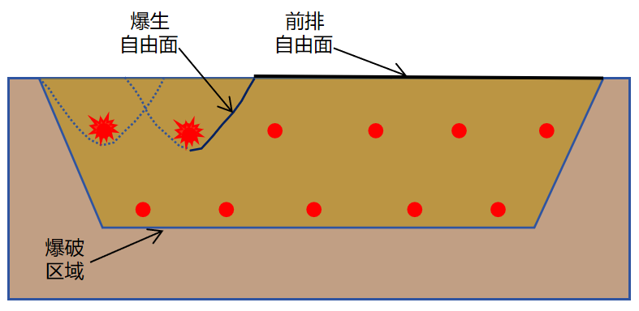
Fig.1 Blast-induced free surface

Numerical Simulation of Deep Hole Blasting
2.1 Blasting Model Parameters
A deep-hole blasting model was established using the finite element software ANSYS/LSDYNA, as shown in Figure 2. The model dimensions are 6 m × 3 m × 18 m (length × width × height), with a charge length of 12 m and a stemming length of 4 m in the borehole.Six blast holes were arranged in the model. The rock material in the model was simulated using the RHT material model, which is widely employed to characterize the dynamic response of brittle materials, such as rock, under explosive and impact loading. The fluid-structure interaction (ALE) algorithm of LS-DYNA was utilized to simulate the dynamic shock effects of the explosive, coupled with the JWL equation of state to describe the pressure-volume relationship during the explosive detonation process. The expression is given by Equation (1):
（1）
In the equation,P is the pressure determined by the JWL equation of state,V is the relative volume,E₀ is the initial specific internal energy,A, B, R₁, R₂, and ω are independent constants defining the JWL equation,with the values of each parameter listed in Table 1.
Table.1 Explosive Numerical Simulation Parameters
Density  /(kg·m-3) | A  /(GPa) | B  /(GPa) | R₁  /(m) | R₂  /(m) | ω  /(rad·s⁻¹)
1000 | 220 | 0.2 | 5.2 | 2.1 | 0.5
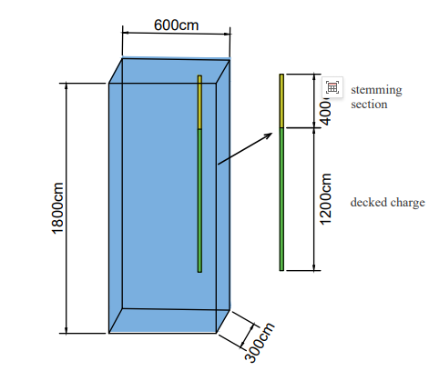
Fig.2 Blasting model

2.2 RHT Rock Constitutive Model
The rock material in this model adopts the RHT material model. The RHT rock constitutive model is widely used to simulate the dynamic response of rock under blasting, with its key features encompassing multi-mechanism failure and the evolution of damage. The constitutive equations of the RHT model consist of three stages: the elastic stage, strain hardening stage, and damage softening stage. The RHT model requires the definition of five equations, namely the elastic limit surface equation, linear hardening stage equation, failure surface equation, damage softening stage equation, and residual strength surface equation.Equation of state is as follows:
The application advantages of the RHT material model lie in:Accurately reflecting the propagation of blast stress waves.Predicting fracture zones and crack propagation by visualizing the extent of rock fragmentation through damage variables.Analyzing free surface effects, enabling the simulation of radial cracks at free surfaces.
elastic limit surface equation:
The linear hardening stage equation:
failure surface equation
damage softening stage equation
residual strength surface equation
The figure below presents the parameters of the RHT constitutive model,which meet the calculation requirements of LS-DYNA.
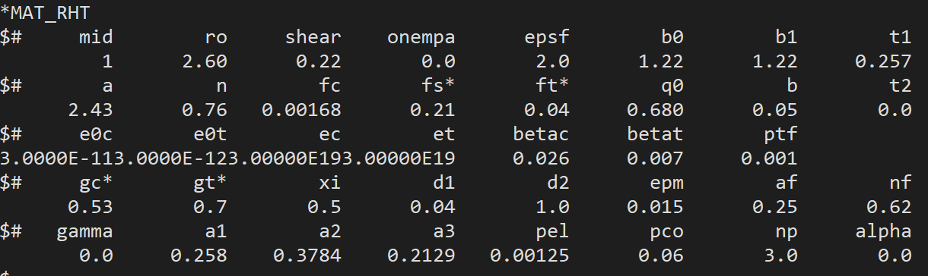
Fig 3Parameters of the RHT Constitutive Model

Numerical Simulation Results and Analysis
3.1 Blasting Numerical Simulation Scheme
A two-row blast hole model was established using ANSYS-LSDYNA. The rock mass was modeled with the RHT material, and the ALE fluid-structure interaction algorithm was employed. And extract the calculation result model diagrams using Lsprepost. In the model, Part1 represents the rock, Part2 the air, Part3 the explosive, and Part4 the stemming. Non-reflective boundaries were applied to the surrounding and bottom surfaces of the rock mass to simulate an infinite rock medium, while the top surface was set as a free boundary. The charging parameters and rock parameters remained consistent across all models to comparatively analyze the effects of different blast-generated free surface conditions on rock fragmentation.
To further investigate the influence mechanism of blast-generated free surfaces on rock fragmentation and damage during blasting, after the detonation of I.1, I.2 is initiated. The rock mass of I.1 is excavated to dimensions of 200 cm × 150 cm × 1600 cm, with the free surfaces indicated in yellow and the blast-induced free surfaces shown in green. This process is repeated accordingly. Both the first and second rows of blast holes are detonated from the middle.The detonation sequence is illustrated in Fig 3.

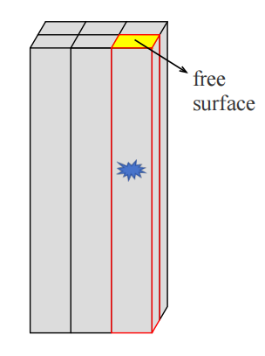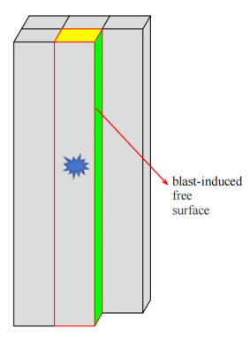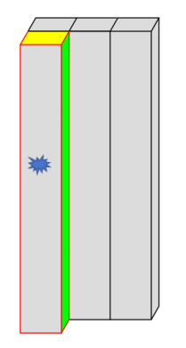
I.1 I.2 I.3

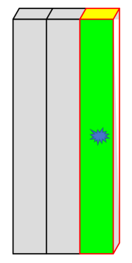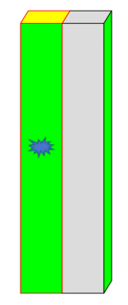
II.1 II.2 II.3
Fig 4 Schematic diagram of hole-by-hole detonation and free surface conditions
3.2 Analysis of Numerical Simulation Results
Figure 4 presents the blasting damage patterns of blast holes I.1, I.2, I.3, II.1, II.2, and II.3. During the blasting process, explosive energy propagates through the surrounding rock mass in the form of blast stress waves. Upon encountering a free surface, these waves undergo reflection and transform into tensile waves, which facilitate tensile fracturing of the rock mass adjacent to the free surface.For blast hole I.1, which features a single free surface at the top, the blast stress waves propagate radially around the borehole and attenuate rapidly, resulting in a relatively limited blasting damage zone. In this context, explosive energy is primarily transmitted in the form of seismic waves, thereby inducing blasting vibrations. Subsequent to the detonation of I.1, a blast-induced free surface is generated at the interface in contact with I.2, indicating that previously detonated blast holes exert a non-negligible influence on subsequent blasting events.With an increase in the number of blast-induced free surfaces, the damage range in the direction perpendicular to the free surfaces expands significantly. The extent of stress wave reflection at the free surfaces is further enhanced, leading to a corresponding enlargement of the blasting damage zone. Additionally, the density of cracks surrounding the blast holes is further increased. A schematic illustration of the numerical models under different free surface conditions is provided in Figure 4.

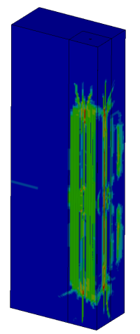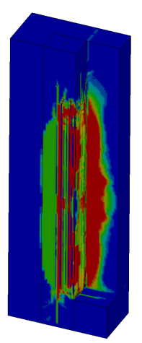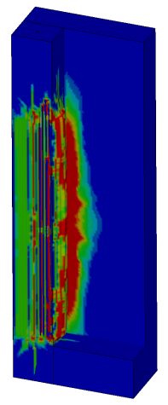
I.1 I.2 I.3
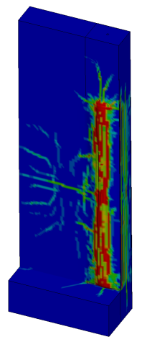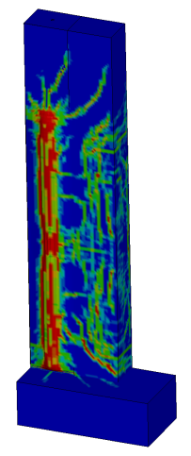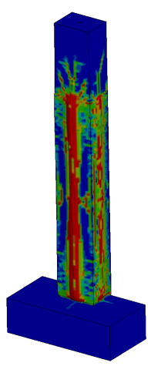
II.1 II.2 II.3

Fig 5 Schematic diagram of numerical models under different free surface conditions.
By comparing the percentage of the fragmented area (red zone) on the interface, the rock fragmentation under varying numbers of free surfaces can be assessed. When blast hole I.1 detonates, the top surface serves as the free surface while the other surfaces are non-reflective boundaries. Under these conditions, the red zone occupies a relatively small area, and the extent of rock fragmentation is limited. When blast hole I.2 detonates, the blast-generated free surface created by I.1 leads to an increase in the red zone area around I.2. Cracks gradually propagate and extend outward in all directions. Upon detonation of I.4, the blast-induced free surface produced by I.1 causes cracks to progressively spread toward the vicinity of the free surface. When II.2 detonates with two blast-induced free surfaces, crack propagation becomes more pronounced, and rock fragmentation damage is greater compared to the scenario with only one free surface. During the detonation of II.3, which has blast-induced free surfaces on three sides, the rock mass extrudes outward, and the internal damage zone expands further.
When I.1 is detonated, due to the presence of non-reflective boundaries, the explosive stress waves can only propagate infinitely along the borehole direction and rapidly attenuate. Under these conditions, the damage range of I.1 is relatively small, and crack propagation is limited. Since the explosive is initiated in the middle of the model, the blast pressure waves from I.2 and I.3 quickly spread outward in all directions. The red damage zone expands into the surrounding rock mass, resulting in rock fragmentation. When the number of blast-induced free surface increases for II.2, and the explosive is initiated in the middle of the model, cracks rapidly propagate outward in all directions, covering a larger area and showing a higher density compared to II.1. In the case of II.3, which has three blast-induced free surface, cracks quickly extend toward the surrounding free surfaces, leading to a more extensive damage range within the rock mass.

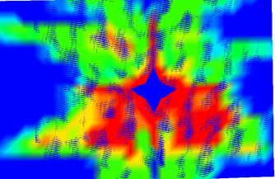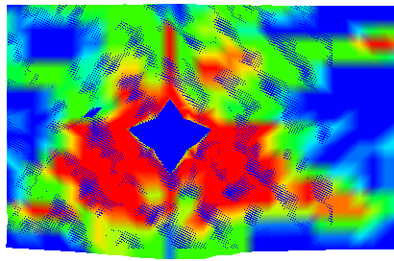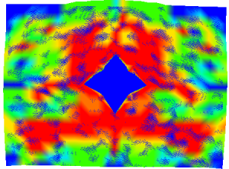
II-1 II-2 II-3
Fig 6 Cross section of the second row blast hole model
To better observe the influence of different blast-induced free surfaces on the damage range of rock mass, an analysis was conducted on the damage range of the second-row borehole models. As shown in Fig 5, when borehole II.1 has one blast-induced free surface, the damage range accounts for 15.1%; when borehole II-2 has two blast-induced free surfaces, the damage range is 20.3 %; and when borehole II.3 has three blast-induced free surfaces, the damage range is 32 %.The Damage Scope Proportion Map is shown in Fig 6‌. The data clearly indicate that as the number of blast-induced free surfaces increases, the damage range of the rock mass also continuously expands, and the fragmentation effect of the rock mass becomes more pronounced. Numerical simulation analysis conducted using ANSYS/LS-DYNA demonstrates that the application of hole-by-hole initiation technology can effectively increase the free surfaces during the blasting process, thereby significantly optimizing the distribution of explosive energy and the propagation paths of stress waves.Therefore, the number of blast-induced free surfaces is one of the significant factors affecting rock mass fragmentation.
The validated numerical simulations demonstrate that the initial blast from borehole I.1 generates a relatively confined damage zone with limited crack propagation. As subsequent blasts increase the free surfaces, both the damage range and the extent of crack propagation become significantly more pronounced (see Figures II.2 and II.3). Consequently, the free surfaces created by preceding blasts exert a substantial influence on the rock damage and crack propagation induced by subsequent boreholes.
From a practical engineering perspective, deep-hole blasting in mines often involves knowledge related to blast-induced free surfaces. These surfaces frequently affect rock fragmentation, leading to the generation of oversize rock fragments, and pose threats to the safety of surrounding structures. Therefore, this paper adopts a numerical simulation approach to investigate the influence of blast-induced free surfaces on rock fragmentation. Furthermore, it emphasizes the hazards of an increased number of blast-induced free surfaces in deep-hole blasting, thereby providing a theoretical basis for subsequent engineering projects to reduce the count of blast-induced free surfaces and mitigate the damage risks caused by blasting operations
.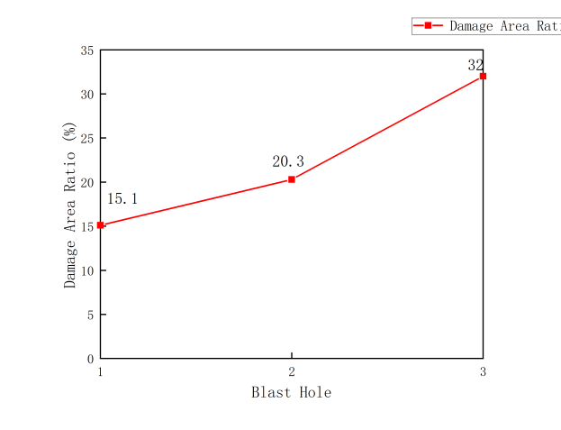
Fig 7 ‌Damage Coverage Percentage Chart‌

Conclusion
1.Blast-induced free surfaces significantly influence the extent of blasting damage: Simulation results demonstrate that as the number of blast-induced free surfaces increases, the reflection of blast stress waves at the free surfaces intensifies, leading to a notable expansion in the range of tensile failure. When the free surfaces increases from one to three, both the blasting damage area and the degree of rock fragmentation show a progressive upward trend.
2.Free surface orientation controls crack propagation patterns: Under conditions of a single free surface (Blast Holes I.1), explosive energy primarily propagates along the axial direction of the borehole and attenuates rapidly, resulting in a limited damage range. However, with the formation of lateral blast-induced free surfaces (Blast Holes II.2 and II.3), cracks significantly extend toward the free surfaces, exhibiting multidirectional propagation characteristics, along with increased crack density and connectivity.
3.Multiple free surfaces promote rock fragmentation and damage: A comparison of the damage percentages under varying numbers of free surfaces reveals that a greater number of free surfaces corresponds to a larger proportion of the fragmented interface area (red zone). This indicates that blasting energy is more effectively converted into rock fragmentation work rather than being dissipated solely as vibrations. Particularly under conditions with three free surfaces, the rock mass exhibits noticeable outward extrusion, and the internal damage range expands further.
4.Engineering implications: In practical blasting engineering, the blast-induced free surfaces can be actively created and utilized through rational design of initiation sequences and blast hole layouts. This approach can enhance rock fragmentation efficiency, reduce blasting vibrations, and optimize blasting outcomes. The simulation results provide theoretical reference for parameter design in engineering applications such as bench blasting and smooth blasting in tunnels.
5.However, this model lacks engineering practicality, and the implementation of numerical simulation needs to be appropriately adjusted based on the rock and explosive parameters obtained from field tests.
Disclaimer (Artificial intelligence)
Option 1:
Author(s) hereby declare that NO generative AI technologies such as Large Language Models (ChatGPT, COPILOT, etc.) and text-to-image generators have been used during the writing or editing of this manuscript.
Option 2:
Author(s) hereby declare that generative AI technologies such as Large Language Models, etc. have been used during the writing or editing of manuscripts. This explanation will include the name, version, model, and source of the generative AI technology and as well as all input prompts provided to the generative AI technology
Details of the AI usage are given below:
1.
2.
3.

Reference
- Guo, J., Fei, H., & Yan, Y. (2025). Research and Advances in the Characteristics of Blast-Induced Vibration Frequencies. Buildings, 15, 892. https://doi.org/10.3390/buildings15030892

- Gou, Y. G., Ye, M. Z., Chen, Y. M., Li, C. C., & Han, Y. (2025). Effects of Charge Length on Single Long-Hole Blasting Vibration Characteristics with Consideration of the Free Surface. Rock Mechanics and Rock Engineering, 58, 745–765. https://doi.org/10.1007/s00603-024-04187-9

- He, L., Zhong, D. W., Li, P., Song, K., & Si, J. F. (2020). Vibration prediction and energy analysis of slope under blasting load in underpass tunnel. Explosion And Shock Waves. https://doi.org/10.11883/bzycj-2019-0255

- Jia, B., Zhou, L., Cui, J., et al. (2021). Attenuation model of tunnel blast vibration velocity based on the influence of free surface. Scientific Reports, 11, 21077. https://doi.org/10.1038/s41598-021-00640-9

- Li, Y., Lu, W., Wang, Y., Chen, M., & Yan, P. (2025). Research of rock blasting seismic energy radiation and its dependence on blasting source and free surfaces. Chinese Journal of Rock Mechanics and Engineering, 44(06), 1585-1595. https://doi.org/10.3724/1000-6915.jrme.2024.0862
- Li, C. X., Yang, R. S., Zuo J. J., Zhu, Y., & Xie, P. (2025). Influence of delay time on the blasting effect of multiple charging forms in single free face rock mass. International Journal of Minerals, Metallurgy and Materials. https://doi.org/10.1007/s12613-025-3228-1

- Liu, X. Y., Gong, M., WU, H. J., & AN, D. (2021). Determination method of tunnel blasting parameters using electronic detonator under changing condition of free surface. Explosion and Shock Waves, 41(10), 105202. https://doi.org/10.11883/bzycj-2020-0428

- Lu, W., Leng, Z., Hu, H., Chen, M., & Wang, G. (2018). Experimental and numerical investigation of the effect of blast-generated free surfaces on blasting vibration. European Journal of Environmental and Civil Engineering, 22(11), 1374-1398. https://doi.org/10.1080/19648189.2016.1262285.

- Min, P., Xie, J., Shen, Y. S., Chang, M. Y., Dong, J., & Chen, K. F. (2023). Optimization of prediction formula for blasting vibration velocity of subway tunnels considering effects of free surface parameters. Journal of Vibration and Shock, 42(21), 245-253. https://doi.org/10.13465/j.cnki.jvs.2023.21.029

- Qi, Y. J., Dou, L. M., Dong, Z. X., Jiang, Z., Meng, B., & Zhang, J. Z. (2021). Numerical Study on the Mechanism and Application of Artificial Free Surfaces in Bedrock Blasting of Shield Tunnels. Geofluids, 2021, 9988120. https://doi.org/10.1155/2021/9988120

- Shi, J., Miao, X., Meng, H., An, H., & Zhang, W. (2022). Study on Critical Damage Width of Parallel Double-Free Surface Blasting. Frontiers in Earth Science, 10, 884558. https://doi.org/10.3389/feart.2022.884558

- Su, H., & Ma, S. (2022). Study on the stability of high and steep slopes under deep bench blasting vibration in open-pit mines. Frontiers in Earth Science, 10, 990012. https://doi.org/10.3389/feart.2022.990012

- Torres, V. F. N., Castro, C., Valencia, M. E., Figueiredo, J. R., & Silveira, L. G. C. (2022). Numerical Modelling of Blasting Fragmentation Optimization in a Copper Mine. Mining, 2(4), 654-669. https://doi.org/10.3390/mining2040035

- Wang, W. H., Liu, Y., Zhang, L. W., et al. (2022). Numerical Simulation of Homogeneous Rock Mass Damage Caused by Two-hole Simultaneous Blasting Based on RHT Model. Gold Science and Technology, 30(3), 414-426. https://doi.org/10.11872/j.issn.1005-2518.2022.03.130

- Wu, H., Gong, M., Zhao, Q., Ww, X., & Liu, X. (2022). Vibration Energy Comparison Helps Identify Formation Time of New Free Surface in Urban TunnelBlasting. Applied Sciences, 12(19), 10061. https://doi.org/10.3390/app121910061

- Wu, C. S., Xu, R. W., & Zhang, Q. B. (2017). Influence of free surface on energy distribution characteristics of blast vibration. Explosion and Shock Waves, 37(06), 907-914. https://doi.org/10.11883/1001-1455(2017)06-0907-08.

- Zeng, X., Zhang, X., Zhou, X., Duan, Y., & Chen, J. (2023). Prediction of Tunnel Blasting Vibration Velocity Considering the Influence of Free Surface. Applied Sciences, 13(3), 1373. https://doi.org/10.3390/app13031373

- Zhang, S. A., Shi, X. Z., Qiu, X. G., Zong, C. Y., & Yu, Z. Y. (2025). Influence of free surface width on blasting damage in open stope mining in narrow vein orebodies. International Journal of Rock Mechanics and Mining Sciences, 194, 106194. https://doi.org/10.1016/j.ijrmms.2025.106194

