Application of Environmental Scanning Electron Microscopy in Concrete Hydration

Abstract: The hydration mechanism has always been a hot and difficult research topic in cement chemistry. The application of modern analytical instruments has greatly developed people's understanding of the cement hydration process. At present, people have a relatively consistent understanding of the main characteristics of hydration, but there are still significant differences in the interpretation of details, especially the explanation of the reactions that occur in the first few hours of hydration. The practical significance of studying early hydration of cement lies in understanding the formation law of cement microstructure, and the changes in microstructure are of great significance for controlling the development of early strength of cement, and will ultimately affect the various properties of Portland cement and the concrete mixed with it. The early hydration process of Portland cement was continuously observed using environmental scanning electron microscopy. Describe the early hydration process of Portland cement into four stages: pre induction period, induction period, acceleration period, deceleration period, and stabilization period.

Key words:Coagulation scanning electron microscopy; Hydration mechanism; Pre induction period; Induction period; Acceleration period; Deceleration period; Stable period;

INTRODUCTION

The environmental scanning electron microscope (ESEM) is a direct descendant of the conventional SEM, but also permits wet and insulating samples to be imaged without prior specimen preparation (Donald, 2003). Concrete is the most important construction material used by mankind and, at the same time, one of the most complex substances known in materials science. Since this mineral compound is highly porous, a better understanding of its surface chemistry, and in particular the reaction with water, is urgently required to understand and avoid corrosion of infrastructure like buildings and bridges (Thissen et al., 2018). Scanning electron microscopy (SEM) is an important electron microscopy technique that is capable of achieving a detailed visual image of a particle with high-quality and spatial resolution. SEM is a multipurpose state-of-the-art instrument which is largely employed to observe the surface phenomena of the materials (Akhtar et al., 2018) .

1.Basic principles of environmental scanning electron microscopy and sample preparation
1.1 Basic principles of environmental scanning electron microscopy
In a conventional scanning electron microscope with high vacuum, a standard Everhart Thornley detector is used to accept the signal current (secondary electrons and partial backscattered electrons) of a sample excited by high-energy incident electrons, and the image is magnified to form an image.
In low-vacuum and ring scan mode, a high-energy incident electron beam emitted by an electron gun enters the sample chamber through a differential pressure diaphragm and is directed at the sample to be measured, exciting signal electrons from the sample surface: secondary electrons-SE and backscatter electrons-BSE. Due to the presence of gas in the sample chamber, the incident electrons and signaling electrons collide with the gas molecules, causing them to ionize to produce electrons and ions. If we add a stable electric field between the sample and the electrode plate, the electrons and ions generated by ionization will be directed in the opposite direction of the electrode to their respective polarities, respectively, and the negative charge accumulated on the surface of the non-conductor will be neutralized with the ionized positive charge and the charge will be eliminated.
When electrons are accelerated to a sufficiently high energy by the electric field on the way, they ionize more gas molecules, resulting in more electrons, and so on repeatedly. ESEM detectors use this principle to enhance the signal, also known as the gas amplification principle (Figure 1). LFD (detector used in low vacuum mode) and GSED (detector used in ring scan mode) probes receive these signals and transmit them directly to an electronic amplifier, amplifying them into electrical signals to modulate the picture tube or other imaging system.
ESEM maintains a low vacuum in the sample chamber by continuously replenishing the sample chamber with gas, while also providing the working gas for the gas secondary electron detector GSED, with water vapor being the most commonly used working gas. However, the presence of gas molecules in the sample chamber also has side effects on SEM imaging, because the scattering of incident electrons by gas molecules causes some electrons to change direction and do not fall on the focus point, resulting in the background noise of the image. At the same time, the incident electrons ionize the gas molecules, producing electrons and ions, which will also increase the background noise of the image. Therefore, the voltage and direction of the bias electric field, the shape of the electrode plate, the gas state (type, pressure, etc.) and the path of the incident electron will affect the resolution of the image, and the appropriate parameters must be selected to keep the resolution to a minimum. Different detectors should have different operating parameters.
1.2Sample preparation
Uses Phillips Electronscan ESEM2020 ESEM instrument. The operating conditions of the instrument are: 20 keV, 100 mA, working distance of about 9 mm, pressure of 640 Pa, temperature of 5 °C, and the corresponding relative humidity of about 90%.
After adding water to cement [water-cement ratio m (w) /m (c) =0.27], it was stirred by hand for about 3 min, and then immediately loaded into a small stainless steel crucible specially designed for ESEM and placed on the ESEM sample stage for continuous observation at fixed points.

2.Application of environmental scanning electron microscopy in cement hydration
The application of environmental scanning electron microscopy in cement hydration research is mainly reflected in the following aspects: Real-time observation: ESEM can operate in a certain humidity environment, so it can observe the hydration reaction of cement particles in real time after contact with water, which is very helpful for understanding the kinetics and mechanism of the hydration process. High-resolution imaging: ESEM can provide high-resolution images, allowing researchers to clearly see the microstructure and morphological changes of hydration products, which is important for analyzing the formation and development process of hydration products. Non-destructive analysis: The non-destructive nature of ESEM allows for multiple imaging on the same specimen, allowing samples to be observed at different stages of hydration without damaging the structure of the sample. Multi-element analysis: Combined with accessories such as energy spectrometers (EDS), ESEM can also analyze the elemental composition of hydration products to help understand the transformation and distribution of elements during hydration. Environmental simulation: By adjusting the humidity and temperature inside the ESEM, different environmental conditions can be simulated to study the effects of these conditions on cement hydration. Using environmental scanning electron microscopy to study cement hydration can help researchers and engineers better understand the properties and behavior of cement-based materials, thereby optimizing the design of concrete and improving the durability and service life of concrete structures. This is of positive significance for promoting scientific and technological progress and sustainable development of building materials. Environmental Scanning Electron Microscopy (ESEM) is a scanning electron microscopy technique that allows you to observe samples in a natural or near-natural state. This technique allows the observation of samples under certain humidity and temperature conditions, and therefore has unique advantages in the process of studying cement hydration.

3.Discussion and analysis of the results of each stage of hydration by environmental scanning electron microscopy
Figure 1 is a photograph of the morphological characteristics of the same cement slurry at different hydration ages taken from continuous records. After about 15 min of hydration, needle-like or hollow tubular hydration products were formed between the cement clinker particles and on the clinker surface (Fig. 1b and Fig. 1c), and a low molar ratio n (Ca) / n (Si) layer appeared on the surface of the tricalcium silicate particles. Since the ESEM system was not equipped with an energy spectrometer during the experiment, it was not possible to analyze the composition of the hollow needle hydration products, but these hollow needles contained Ca, Si, Al and S, which were presumed to be calcarelite. In addition, it has been reported that these hydration products may appear earlier, and calcite can appear after 5 minutes of hydration of silicate cement in the presence of gypsum.
As the hydration reaction continued, a gel-like overlay hydration product appeared on the surface of the clinker particles and gradually grew and spread over time, eventually covering the entire clinker particles (see Fig. 1D, Fig. 1E, Fig. 1F, Fig. 1G). After 20 min of hydration, the hydration product membrane was detected on the surface of C₃S. The results of calorimetry showed that the protective film may have formed after 20 min of hydration and disappeared after about 4 h. This membrane leads to a slowdown in the hydration reaction, i.e., the onset of the induction phase. Due to the entry of water, the hydration product membrane is separated from the anhydrous, and the solution inside the film is called the internal solution, and the other solution is called the external solution. Because the concentration of the internal solution is higher than that of the outer solution, there is a difference in osmotic pressure, and the water is drawn in, so that the film continues to push outward. Calcium ions can pass through the film smoothly, while silicate ions are quite difficult. When the concentration of calcium ions in the outer solution and silicate ions in the internal solution is high enough, the action of osmotic pressure leads to the rupture of the protective film.
Entering the acceleration period, CSH begins to nucleate and grow at high speed. After hydration for about 3 h and 50 min, a large number of branch-like CSHs (Fig. 1h and Fig. 1i) appeared on the periphery of the clinker particles, which crossed and climbed each other in a reticulated structure. A large amount of CSH gel (see Fig. 1j) appeared from 15 min to 5.5 h after hydration for 5 h, filling the gaps between the clinker particles. These hydration products first form a wheat bundle structure, and finally form a near-spherical morphology. During the acceleration period, the hydration rate is exponentially related to time. The hydration process is thought to be associated with the nucleation and growth of a product phase. The experimental results showed that the growth of CSH in the accelerated stage was a factor in the control of hydration reaction rate.
As the hydration products change from amorphous water-rich gels to amorphous granulars, cement enters the final solidification state. Most of the surface and inter-particle voids of the cement clinker after 18.5 h of hydration have been covered and filled by granular hydration products (see Fig. 1k). With the extension of hydration time, from 18.5 h to 65.5 h (Fig. 1k), the number of particles in the hydration product remained almost unchanged, but the individual particles gradually grew larger and larger (the particles were equal-granular), making the microstructure denser and denser.

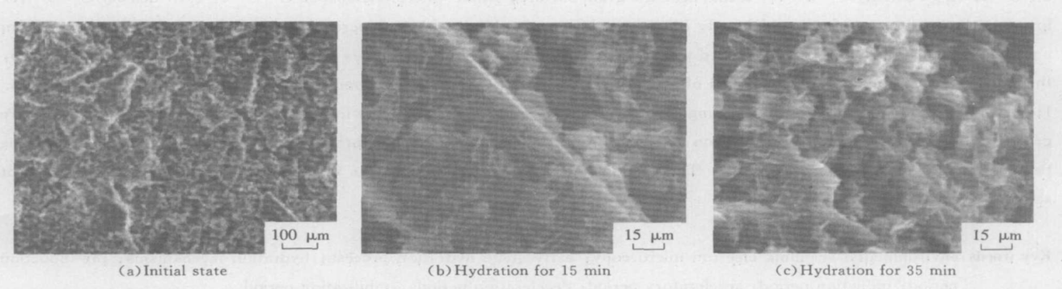
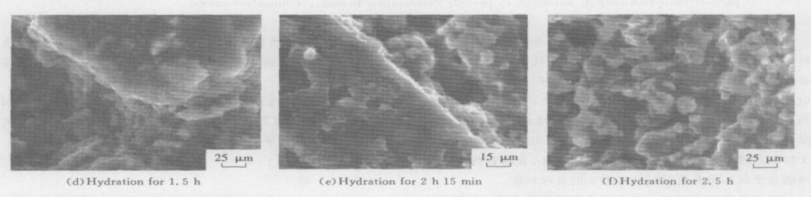
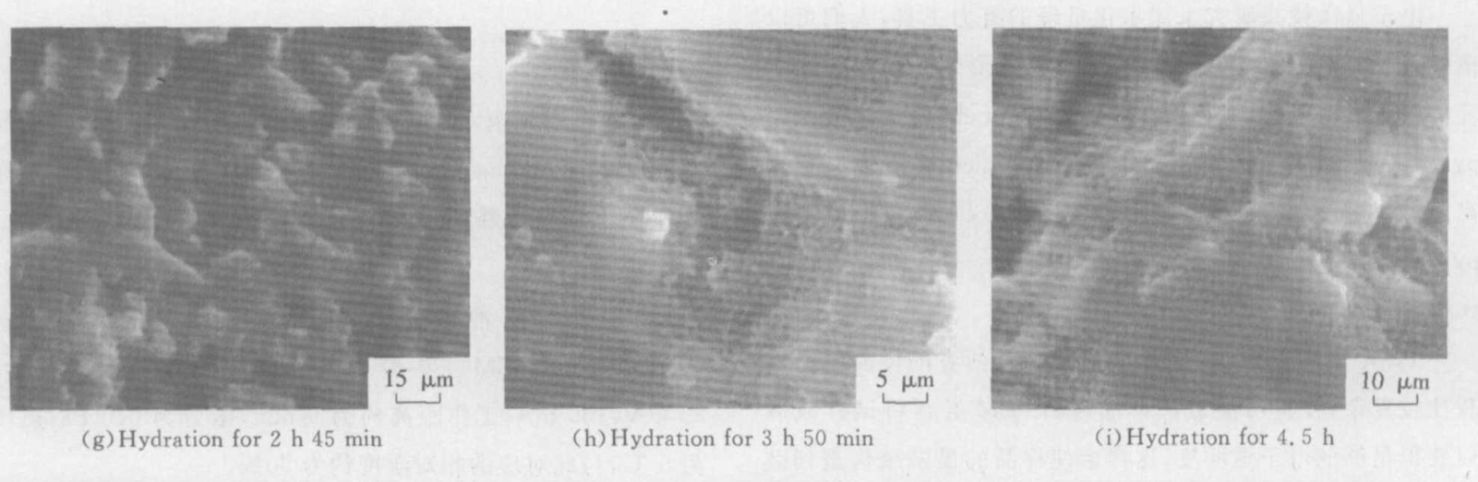
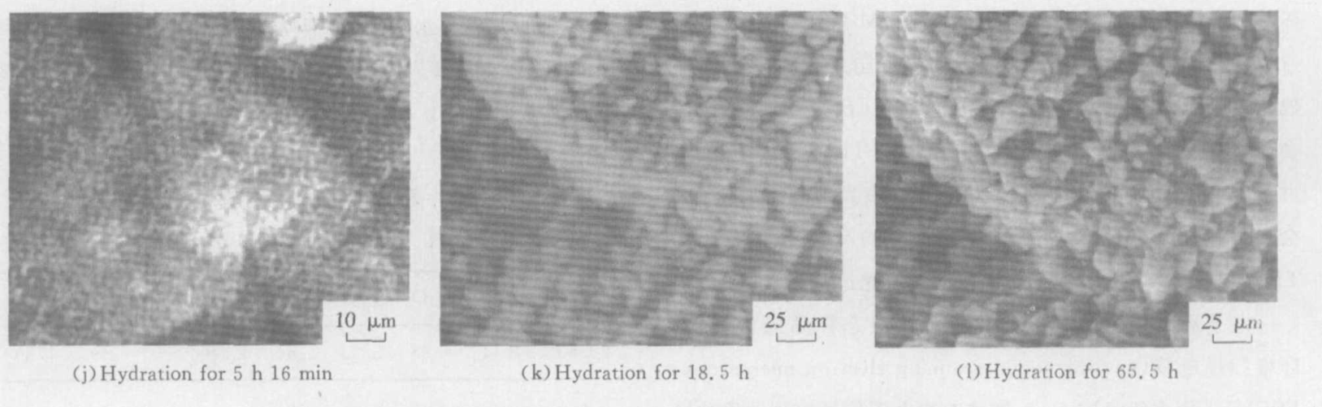
Fig. 1 ESEM photograph of continuous observation of the hydration products and structure formation process of the early stage of cement slurry
3.1Pre-induction period
Hydration occurs immediately after the cement particles come into contact with water, and the exchange of substances in the form of ions begins between the solid and liquid phases. In order to maintain the equilibrium of electricity price, calcium ions enter the solution, and due to the decrease of H⁺ concentration in the solution, the OH⁻ concentration increases, and the original C₃S surface structure is destroyed, transforming into an amorphous surface layer, which contains calcium ions, silicate anions and water molecules, which is a solid-liquid mixed phase. Because Ca²⁺ in clinker is dissolved by some components with high solubility, especially Ca2+ and Al(OH)₄⁻ released by C₃A, and after the release of Ca²⁺ and SO₄²⁻ from gypsum, the concentrations of Ca²⁺, OH⁻, SO₄²⁻, Al(OH)₄⁻, K⁺ and Na⁺ in the liquid phase increase rapidly, and the first batch of hollow needle-like hydration products (possibly calcarelite) begin to appear within a few minutes, and a protective film of CSH hydrate is formed. This corresponds to a weak peak on the DTA curve of early hydration. The formation of protective film separates the anhydrous matter from the liquid phase, hindering the diffusion of silicate ions and greatly slowing down the hydration reaction. The depletion of soluble reactants on the surface of C3S particles is the direct cause of the pre-induction phase.
3.2Induction period
The semi-liquid protective film layer formed at the end of the pre-induction period is composed of a flowing hydrogen bond network composed of highly protonated silicate ions and water molecules. The results of the ESEM observations showed that the protective film was gradually advanced until it covered the entire surface of the particles. The protective film is a semi-permeable membrane, through which calcium ions can diffuse outward, but some of them will be adsorbed on the surface of the protective film by excessive negative charges, forming a diffusion double layer. The silicate ions formed after the dissolution of the unhydrated substance below the film cannot pass through the permeable membrane, causing the osmotic pressure to increase. When the osmotic pressure is strong enough to rupture the film at the weak point, the calcium-deficient silicate ions are extruded into the liquid phase and combined with the calcium ions to form various amorphous CSHs, which will grow according to the pattern of the "silica garden". The rupture of the protective membrane marks the acceleration phase of hydration.
The induction stage ranged from about 20 min to 4 h, which was mainly controlled by diffusion and the reaction speed was slow. The rupture of the protective membrane leads to the end of the induction phase and the beginning of the accelerated phase.
3.3 acceleration period
In the accelerated period, the concentration of calcium ions and silicates reached supersaturation compared with CSH, and a large number of branch-like CSH grew at high speed, forming products similar to the reticulum morphology near the surface of the particles, and near-spherical products in the original water-filled space between the particles. Due to diffusion, the silicate ions form a concentration gradient from the solid phase to the liquid phase, resulting in the formation of silicon-rich calcium-rich high-density CSH near the perimeter of the raw clinker particles, and the formation of calcium-rich and silicon-rich low-density CSH in the liquid phase between the particles. The nucleation process is divided into two methods: heterogeneous nucleation (on an existing surface) and homogeneous nucleation (in solution), the former of which requires a lower surface energy barrier. The concentration of silicate ions in solution is low, and heterogeneous nucleation is more likely to occur than homogeneous nucleation, so CSH is first formed on the surface of the particles. CSH generally grows into curved, twisted flakes or bands, and new growth points mainly appear at the edges of the flakes or at both ends of the bands. Growing in this way, CSH grows into a network-like morphology with a low n(Ca)/n(Si) ratio. The interparticle product is generated in a manner similar to that of tiny silicon particles growing in a supersaturated Ca(OH)₂, away from the silicon source, and the product has a high n(Ca)/n(Si) ratio. In this case, the morphology of the product is similar to the central bundle and the end untied band, and its growth rate is affected by the speed of silicon ion diffusion to the growth front, and tends to produce a near-spherical morphology.
The accelerated stage is about 4 h to 10 h, which is mainly controlled by chemical reactions, and the reaction speed is fast. During the acceleration period, the growth rate of hydration products increases exponentially before the spatial growth is significantly hindered. The growth rate of CSH was the main factor in the control of hydration reaction rate during the accelerated stage.
3.4 Deceleration period
With the increase of hydrate thickness around clinker particles, the dissolution and crystallization rate slows down, which corresponds to the deceleration section of the exothermic curve. The hydrate layer continues to thicken, and continues to expand into the space between the particles and fill the gaps in the hydration product layer. In this way, the hydrate body becomes denser and denser, the penetration of water becomes more and more difficult, and the hydration enters a stage of slow and stable development, a stable period.
The deceleration phase is about 10 h to 1 day, which is mainly controlled by chemistry and diffusion, and the reaction speed is moderate.
3.5 Stabilization period
After 1 day, the number of hydration product particles remained almost unchanged, but the individual particles gradually grew and enlarged, and the microstructure gradually became dense. This stage of hydration is primarily achieved by the movement and rearrangement of ions in a solid. The stabilization period begins after 1 day, and this stage is mainly controlled by diffusion, and the reaction speed is very slow.

4.Conclusions and prospects
Combined with the observation results of ESEM experiments, the early hydration process of silicate cement was divided into five stages: pre-induction stage, induction stage, acceleration stage, deceleration stage and stabilization stage. The pre-induction stage (within 1 h) is controlled by chemical reactions, and the reaction speed is very fast. The hydration process that occurs in this stage is as follows: the cement begins to hydrolyze, releases ions, forms a low n (Ca) /n (Si) layer on the surface of C₃S, the first hydration products are produced, and a protective film of CSH hydrate is formed. The induction stage (2~4 h) is controlled by diffusion, and the reaction speed is slow. When the osmotic pressure is large enough to break the membrane at the weak point, the calcium-deficient silicate ions are extruded into the liquid phase and combined with the calcium ions to form various amorphous CSHs. The acceleration stage (4~10 h) is controlled by chemical reactions, and the reaction speed is very fast. The hydration process that occurs in this stage is that the concentrations of Ca²⁺ and HnSiO₄ ^{(n-2)} reach supersaturation compared with CSH, and a large number of branches and branches grow at high speed, forming products similar to the reticulation morphology near the surface of the particles, and forming products with near-spherical morphology in the original water-filled space between the particles. The deceleration stage (10 h~1 d) is controlled by chemistry and diffusion, and the reaction speed is moderate. The hydration process that occurs at this stage is as follows: the hydration products continue to grow, change from amorphous water-rich gel to amorphous granular, and the microstructure continues to develop. The stable phase (1 d~) is controlled by diffusion, and the reaction speed is very slow. The hydration process that occurs at this stage is as follows: the number of hydration product particles remains almost unchanged, but the individual particles gradually grow and become larger, and the microstructure gradually becomes denser. The formation of the protective film leads to the end of the pre-induction period and the beginning of the induction period, while the rupture of the protective film leads to the end of the induction period and the beginning of the accelerated period.
When observed by ESEM, the damage of temperature, humidity and vacuum to the original morphology is avoided, and the microscopic original morphology of cement-based composites is accurately and truly reflected, so ESEM will strongly promote the progress of cement-based composite research. Environmental scanning electron microscopy (ESEM) has shown significant application prospects in the field of cement hydration. Since water is an intrinsic component of the microstructure of cement slurry, techniques are needed to help study wet specimens. The evolution of ESEM technology from standard microscopic methods to in-situ analysis using ESEM has provided new perspectives and approaches to the study of cementitious materials. In the study of cementitious composites, ESEM is used to observe hydration products, polymer emulsions and membranes, interfaces and microcracks. The features and benefits of ESEM make it a unique addition to cement hydration research compared to traditional scanning electron microscopy (SEM). In the future, ESEM may develop in several directions in the study of cement hydration. Firstly, with the advancement of technology, the resolution and sensitivity of ESEM are expected to further improve, which will allow for more refined and accurate observation of the cement hydration process. Secondly, combined with advanced image processing and analysis techniques, ESEM can help researchers gain a deeper understanding of the structure and properties of hydration products. In addition, the range of applications of ESEM can be further expanded by combining with other analytical techniques, such as energy spectroscopy (EDS) and X-ray diffraction (XRD), thereby providing more comprehensive information for the study of cementitious materials.
In general, environmental scanning electron microscopy has broad application prospects in the study of cement hydration, which not only helps us better understand the basic process of cement hydration, but also provides an important scientific basis for optimizing the design and performance of cement-based materials.

Disclaimer (Artificial intelligence)

Option 1:

Author(s) hereby declare that NO generative AI technologies such as Large Language Models (ChatGPT, COPILOT, etc.) and text-to-image generators have been used during the writing or editing of this manuscript.

Option 2:

Author(s) hereby declare that generative AI technologies such as Large Language Models, etc. have been used during the writing or editing of manuscripts. This explanation will include the name, version, model, and source of the generative AI technology and as well as all input prompts provided to the generative AI technology

Details of the AI usage are given below:
1.
2.
3.

References
[1]Lü Peng, Zhai Jianping, Nie Rong, et al. Environmental scanning electron microscopy is used for the study of early hydration of silicate cement Journal of Silicate Society,2004(04):530-536.
[2]Zhang Yunsheng, Sun Wei, Lin Wei, Zheng Keren, Sha Jianfang, Liu Sifeng. In-situ quantitative study of the hydration process of K-PS geopolymer cement by environmental scanning electron microscopy[J]. Journal of Southeast University(Natural Science Edition), 2015, (03): 351-354.
[3]Zuo Min, Lu Lingchao, Chang Jun, Ye Zhengmao, Cheng Xin. Journal of Jinan University(Natural Science Edition),2007(01):151-155
[4]Wei Sun, Yun-sheng Zhang, Wei Lin, Zhi-yong Liu,In situ monitoring of the hydration process of K-PS geopolymer cement with ESEM,(2004)935-940
[5]SAKALLI, Y.; TRETTIN, R. (2015). Investigation of C S hydration by environmental scanning electron microscope. Journal of Microscopy, 259(1), 53–58.
[6]Xiao-Yong Wang, Ki-Bong Park,Analysis of the compressive strength development of concrete considering the interactions between hydration and drying,(2017), 1-15.
[7]Ping-Kun Chang, Wei-Ming Hou,A study on the hydration properties of high performance slag concrete analyzed by SRA,(2003), 183-189.
[8]Maciej Zajac, Linda Irbe, Frank Bullerjahn, Harald Hilbig, Mohsen Ben Haha,Mechanisms of carbonation hydration hardening in Portland cements,
(2022),106687,
[9] Donald, A. M. (2003). The use of environmental scanning electron microscopy for imaging wet and insulating materials. Nature materials, 2(8), 511-516.
[10] Thissen, P., Natzeck, C., Giraudo, N., Weidler, P., & Wöll, C. (2018). Hydration of concrete: The first steps. Chemistry–A European Journal, 24(34), 8603-8608.
[11] Akhtar, K., Khan, S. A., Khan, S. B., & Asiri, A. M. (2018). Scanning electron microscopy: Principle and applications in nanomaterials characterization. In Handbook of materials characterization (pp. 113-145). Cham: Springer International Publishing.

