Original Research Article

Storage stability and quality changes of extruded whole wheat snacks enriched with chicken egg and its fractions

.
ABSTRACT

The aim of the study was to produce and evaluate the storage stability of extruded snacks from chicken egg and whole wheat flour. The whole wheat flour (WWF) and raw whole egg (WE) or raw egg yolk (EY) or raw egg white (EW) were mixed in different proportions (100 % WWF; 85 % WWF and 15 % raw WE; 80 % WWF and 20 % raw WE; 85 % WWF and 15 % raw EY; 80 % WWF and 20 % raw EY; 85 % WWF and 15 % raw EW; 80 % WWF and 20 % raw EW). Extrusion of the samples was done in a twin screw extruder. The extrusion parameters were constant for all the samples. After production, the extrudates were divided into three portions. One portion was used for initial quality evaluation: Moisture content, water activity; microbial quality (total viable count (TVC), mould count (MC), thiobarbituric acid (TBA) value. The second (2nd) and third (3rd) portions were stored at ambient room conditions (25-30°C) and at 37 ºC respectively, for 12 weeks and evaluated for quality changes at two weeks interval. Results show that in month 3, the MC were within permissible limits. The moulds identified in samples may have resulted from contaminants during handling after extrusion. The moisture content (6.5 – 9.0 %) of the samples were stable during the period of storage. The water activity of the samples slightly increased with storage time both for samples stored at ambient temperature (0.69 – 0.76) and for those stored at 37 ºC (0.61 – 0.74). The TBA Values (0.01 - 0.06 mg Malondialdehyde/ kg sample) were very low and far below the required minimum for rancidity to be detectable throughout the storage period.

Keywords: Shelf-life, microbial quality, water activity, TBA value

1. INTRODUCTION

One major challenge faced by food processors is to ensure the stability of foods during storage. The time between food processing and consumption of the product by the consumer is crucial because the food must be wholesome and at the same time retain the desirable characteristics. Storage stability of food means the keeping quality or shelf-life of food over time under specific storage conditions. The shelf-life of a food may be regarded as the period of time the food is safe and suitable for consumption which means the consumer has no reason to consider it unacceptable ¹. The microbiological quality, physical and chemical properties are usually monitored to ascertain the stability of the food during storage. There is always a link between food quality and storage stability.
A low moisture content and water activity prevents microbial growth, hence water activity, moisture content and fat content determines the storage stability of extruded foods. Nkubana & Dusabumuremyi ² reported that dry foods may have a low water activity which may prevent microbial growth however deterioration may arise from chemical and enzymatic reactions which can also be controlled through means such as packaging. There are key conditions which affect shelf-life of food such as antioxidant-rich extrudates which could improve shelf stability ³. Other factors which influence shelf-life include lipid content, moisture content, packaging conditions, water activity, pH, and storage conditions ⁴.
Lipid oxidation is accelerated by free radical formation in foods which leads to a decline in food quality thereby decreasing consumer acceptability ⁵. To maintain food quality throughout its shelf-life depend on packaging such as proper sealing of the packaging material especially around the seal ⁶. Some indicators of lipid oxidation include hydroperoxides, aldehydes, ketones and volatile substances which signals flavour change.
In a review, Boukid et al. ⁷ reported that enzyme inactivation prolonged storage stability after microwave radiation was used to inactivate lipase in wheat germ. Sawhney et al. ⁸ and Correia et al. ⁹ reported that water activity determines deterioration in food systems and suggested modification in water activity for better storage stability.
The factors affecting storage stability may be inherent (intrinsic: water activity, available oxygen, nutrients, biochemical products (type and amount of enzymes present), moisture content, biological structures, natural microflora and surviving microbial counts, pH (total acidity and type of acid), preservative (such as sugar and salt), antimicrobial components, nutrient content, oxidation-reduction potential) or environmental (extrinsic: cultural practices in production, time-temperature profile during processing, temperature and relative humidity control during storage and distribution, exposure to light ((UV and IR) during processing, storage and distribution), microbial environment, environment in packaging (composition of atmosphere within packaging), heat treatment (subsequent heat treatment, e.g reheating or cooking before consumption), mechanical handling in distribution, consumer handling) ^{10;11}. Storage stability of foods may be improved by proper storage conditions and food processing techniques, suitable packaging materials and the use of safe food additives. All the above factors culminate into having a stable product, hence, the need to ascertain the storage stability of foods. This research investigates the storage characteristics of egg-based wheat snack products.

2. material and methods

Materials
Four bags of 50 kg each of whole-wheat flour were purchased from Supreme Flour Mills, 6, President Burgers Street, Pretoria West 0183, Pretoria, South Africa. Thirty-two crates of thirty eggs each of freshly laid eggs were purchased from Northwest University farm, Mmabatho Unit 5, Mafikeng 2790, Mafikeng, South Africa.
Methods
The samples were prepared using the method of Nwadi et al. ¹². Egg whites were separated from the egg yolk for samples requiring either egg yolk or egg white using an egg separator. The whole-wheat flour and raw whole egg or raw egg yolk or raw egg white were mixed using a 50-litre paddle mixer constructed by Centre for Advanced Manufacturing (CFAM), Potchefstroom, South Africa, in different proportions (Table 1). After mixing, extrusion of the samples was done in TX-32 Laboratory Scale (300 kg/h maximum) twin screw extruder made by CFAM. The extrusion was done in a batch size of 20 kg (using a Platform Scale, Model: Micro A12E in CFAM) per run for each of the samples and the extrusion parameters were constant for all the samples at a screw speed of 700 rpm, feed rate of 53.6 – 78.9 kg/h (50 – 60 %) driven by a 6 – 9.7 kW motor, 20.8 – 24.1 AMP, 50 – 55 % Torque, temperature of 139 – 153 ºC and 20 % feed moisture content. Each run lasted 14.22 – 15.02 minutes. A spaghetti die of 1.8 mm (2 rings) with a 40 – 60 % cutter was used in each run.
After production, the extrudates were divided into three portions. One portion was used for initial quality evaluation for moisture content, water activity, microbial quality (total viable count (TVC), mould count (MC), thiobarbituric acid (TBA) value using standard methods. The second portion was stored at ambient room condition and the third portion was stored at 37 ºC in a thermostatically controlled oven. The extrudates were stored for 12 weeks. Ambient room relative humidity and temperature were monitored throughout the period of storage.
The following quality parameters were evaluated on samples stored at both ambient room conditions and 37 ºC at two weeks interval for 10 weeks: moisture content, lipid oxidation (TBA value), water activity at two weeks interval. Microbial changes (total viable count and fungal count) were carried out at monthly intervals for 12 weeks (3 months).

Table 1: Ingredient combinations for products
Sample | Ratio (percentage of whole wheat flour to chicken egg) | Quantity of whole wheat flour (kg) | Quantity of chicken egg (kg) | Total quantity  (kg)
RI (Whole wheat flour) | 100:0 | 20 | 0 (no egg) | 20
R2 (Whole wheat flour and raw whole egg) | 85:15 | 17 | 3 (60 whole eggs) | 20
R3 (Whole wheat flour and raw whole egg) | 80:20 | 16 | 4 (80 whole eggs) | 20
R4 (Whole wheat flour and raw egg yolk) | 85:15 | 17 | 3 (187.5 egg yolks) | 20
R5 (Whole wheat flour and raw egg yolk) | 80:20 | 16 | 4 (250 egg yolks) | 20
R6 (Whole wheat flour and raw egg white) | 85:15 | 17 | 3 (81 egg whites) | 20
R7 (Whole wheat flour and raw egg white) | 80:20 | 16 | 4 (108 egg whites) | 20
One whole egg = 50 g, one egg white = 37 g, one egg yolk =16 g, 1000 g = 1 kg
Determination of Moisture content
The moisture content was determined by the method described in AOAC ¹³. An aluminium dish was washed, dried in hot oven, cooled in dessicator and weighed (W₁). Two gram (2 g) of sample was weighed into an aluminum dish with cover (W₂) and placed in an oven previously regulated to 135±2 ºC and dried for 2 hours. The cover was placed on dishes and transferred to a dessicator to cool and then weighed (W₃). This was repeated several times until constant weight was obtained. The percentage moisture content of the samples was calculated using the formula:
Moisture content (%) =
W₂ – W₃ x 100
W₂ – W₁
Where W₁ = weight of aluminium dish
W₂ = weight of aluminium dish + sample before drying
W₃ = weight of aluminium dish + sample after drying
Determination of Thiobarbituric Acid (TBA) Value
The Thiobarbituric acid value was determined using the method described by Kirk & Sawyer ¹⁴. The sample (10 g) was macerated with 50 ml of water for 2 minutes and washed into a distillation flask with 47.5 ml water. 2.5 ml of 4 M HCl was used to bring the pH to 1.5 followed by anti-foaming preparation. The flask was heated by means of an electric mantle so that 50 ml distillate is collected in 10 minutes from the time boiling commenced. The distillate (5 ml) was pipetted into a glass-stoppered tube and 5 ml of TBA reagent (0.2883g/100ml of 90% glacial acetic acid) added, stoppered, shaken and heated in boiling water for 35 minutes. The blank was prepared similarly using 5 ml of water for 10 minutes and absorbance measured against the blank at 538 nm using 1 cm cell. TBA value was calculated as:
TBA value = 7.8 x Absorbance
Determination of water activity (a_{w})
The water activity of the extrudates were determined using a (Lab Start Novasina, serial number 1710010, NEUTEC Company) Water Activity Meter in Department of Food Science and Technology, University of Nigeria, Nsukka. The procedure used was that written in the instrument manual:
The water activity meter was switched on and the sensor allowed sometime (2 minutes) to heat up. Display of measurement mode showed the device was ready.
The milled sample (5 g) was put into the sample cup (the water activity is not mass dependent) without compressing or pinching out the sample so as not to reduce the surface area (the larger the surface area, the faster the water activity value detection).
The sample cup containing the sample was placed in the measurement chamber after which the chamber was closed by pushing the upper part of the instrument down.
As soon as the measured value was ready for display, the machine beeped and the value was recorded. The sample cup was removed and cleaned for the next measurement
Total Viable count
Spread plate method as described by Boczek et al. ¹⁵ was used to determine the total viable count. One (1) g of each sample was suspended in test tubes containing 10 ml sterile normal saline water and homogenized by vortexing. Ten – fold serial dilutions were then carried by transferring 1 ml into test tubes of 9 ml saline water to achieve 10⁻², 10⁻³, 10⁻⁴, and 10⁻⁵ dilutions of the sample. Nutrient agar (L : S – BIOTECH San Diego, USA) culture media were prepared (28 g/L) and sterilized by autoclaving at 121 ºC. After dispensing the agar on sterile Petri dishes and allowed to solidify, 0.1 ml of the dilutions was transferred onto the plates and spread the entire surface with sterile bent glass rods. The inoculated plates were then incubated at 37 ºC for 24 hours. Total viable organisms (cfu/g) was counted and recorded. The total viable count of the samples were expressed in cfu/g, and calculated as follows:
CFU/g =
Mould count
Total moulds contaminating the samples were enumerated on potato dextrose agar following the method reported by Katase & Tsumura ¹⁶. The samples were prepared based on the procedures already described above. The sterilized potato dextrose agar (40 g/L, Hi media, India) was supplemented with chloramphenicol (0.05 g/L) to minimize bacterial contamination. After inoculation with 0.1 ml of the various dilutions of the sample, the agar plates were incubated at 37 ºC for 72 hours, and the resulting fungal colonies were subsequently counted. The mould count of the samples was expressed in cfu/g, and calculated as follows:
CFU/g =
Measurement of room temperature and relative humidity
The relative humidity of the room where the extrudates were stored at ambient temperature condition was determined for a period of three months by recording the wet bulb and dry bulb thermometer readings. The dry bulb thermometer was suspended in air while the bulb of the wet bulb thermometer was wrapped around with a cotton wool and the tip of the cotton wool dipped in water at ambient temperature such that the bulb is moist at any point in time with the help of the moist cotton wool. At the end of the three months storage period, an average of the wet bulb and dry bulb was determined. The average of the wet bulb thermometer reading which was expected to be lower was subtracted from the average of the dry bulb thermometer reading to get a difference. The relative humidity was extrapolated from a conversion table ¹⁷ using the difference.
Data Analysis
Data analysis was carried out using one-way analysis of variance (ANOVA) in a completely randomized design (CRD); mean separation was by Duncan’s New Multiple Range Test¹⁸. Significance was accepted at p<0.05

3. results and discussion

Moisture changes during storage
The samples were basically dry samples with moisture content between 6.5 and 9.0 % (Figure 1). Therefore, they would be expected to be stable. Awolu ¹⁹ reported that for shelf stability purposes, the moisture content should be equal to or below 10 %. The moisture content of the samples decreased during storage at ambient temperature (A) and 37 ºC (B). The loss of moisture during storage is attributable to reduction in water holding capacity caused by protein insolubility. From Figure 1, it was observed that moisture reduction at ambient conditions was slow and steady than at 37 ºC because of greater rate of insolubility at 37 ºC. The increase from 6th week of storage in moisture content in Figure 1 (storage at 37 ºC) could mean that cross linkage has started to breakdown, leading to production of hygroscopic end products. The relative humidity was 92 %.
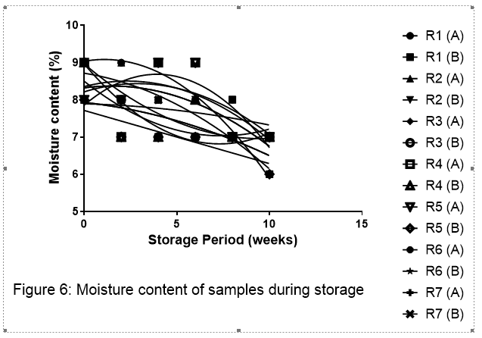
Figure 1: Moisture content of samples during storage
Source: Nwadi and Okonkwo ²⁰
Water Activity of egg-based extruded wheat products
The water activity of the extruded products are shown in Table 2 to be low (0.682 – 0.703) probably due to low moisture content. The low water activity of the products supports the findings on moisture content that the products are dry. Very dry food products are expected to be microbiologically and chemically stable during handling and storage. This is because water requirement for microbiological activities and chemical reactions are expressed in terms of water activity. With the low water activities, the potential microbial hazards (spoilage and food poisoning) of these products are low because the lowest water activity limit for growth of most bacteria is put at about 0.95 and fungi put at about 0.85 ^{21,22}. However, if storage abuse occurs and the products absorb moisture, fungi will be more apt to grow on the surface because the surface of the products will be the first to start absorbing water and oxygen is also plentiful at the surface of the products. These extruded products are also expected to be resistant to, physicochemical deteriorative reactions because, at these water activities, the solid components are more concentrated and viscous, thereby causing resistance to diffusion/mobility of reactants and consequently reducing rate of physicochemical deteriorative changes. It is also seen from Table 2 that products were extruded to similar moisture contents but extruded products containing only whole wheat (R1) had slightly the highest water activity (0.703) compared to those containing egg (R2 - R7) probably due to additional solid contents of egg in egg containing products. Among those containing egg, products containing egg yolk (R4 and R5) had lower water activity compared to their corresponding products containing egg white (R6 and R7) and those containing whole egg (R2 and R3). This is attributed to the fact that egg yolk contains more solids which can bring more water than egg white. Similarly, those containing higher quantity of egg (R3, R5 and R7) were lower in water activity than their corresponding products (R2, R4 and R6 respectively) containing lower quantity (15 %) of egg due to higher solids in those containing 20 % egg.
Table 2: Water Activity of Samples
Sample | Water activity
R1 | 0.703
R2 | 0.702
R3 | 0.700
R4 | 0.695
R5 | 0.682
R6 | 0.697
R7 | 0.692
R1 - 100:0 (100 % Whole wheat flour), R2 - 85:15 (85 % Whole wheat flour and 15 % raw whole egg), R3 - 80:20 (80 % Whole wheat flour and 20 % raw whole egg), R4 - 85:15 (85 % Whole wheat flour and 15 % raw egg yolk), R5 - 80:20 (80 % Whole wheat flour and 20 % raw egg yolk), R6 - 85:15 (85 % Whole wheat flour and 15 % raw egg white), R7 - 80:20 (80 % Whole wheat flour and 20 % raw egg white).
Thiobarbituric acid value
The TBA values (mg malondialdehyde equivalents/ kg sample (MDA mg/kg) of the samples during storage at ambient room temperature (A) and 37 ºC (B) are as shown in Figure 2. The TBA values (0.01 – 0.06 mg/ kg) were however very well below the required minimum in comparison with the results (0.09, 0.112 mg/ kg) reported by Reitznerová et al. ²³ which were acceptable. The antioxidant properties of egg and wheat in addition to low moisture content of the products may account for the low TBA values. However, Okolie et al. ²⁴ reported that there appears to be no lethal dose from literature for humans and experimental animals. The low water activity depicted low lipid oxidation in the samples, this is in agreement with Oparaku et al. ²⁵. The low TBA may also indicate that the products would not possess detectable rancidity. Both differences in quantity of eggs incorporated as substitutes and storage conditions (ambient room temperature and 37 ºC) did not influence the TBA values.

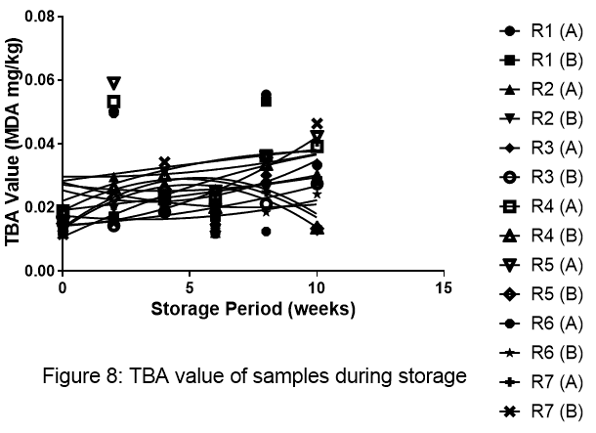
Figure 2: TBA value of samples during storage
Source: Nwadi and Okonkwo ²⁰
Microbiological stability of extrudates
Figure 3 and 4 show the total viable aerobic microorganisms and mould respectively in the egg-based extruded wheat products after extrusion and during storage. Initial total aerobic count was low in all products. This has been attributed to destruction of many cells by heat accompanying hot extrusion which must have killed most of the organisms. Akpe et al. ²⁶ observed that minimal microbial load is expected in industrially milled flour and these would reduce further during extrusion. Bulut et al. ²⁷ proposed that shear in the screw and the physical forces in the die of the extruder may effectively reduce microorganisms in the extrudates compared with heat. Obaroakpo et al. ²⁸ reported decrease in microbial flora after extrusion cooking. It is also possible that many of the spores would have been injured during extrusion to the extent that the cultural method applied could not detect their presence. Whatever, their origin, during storage at ambient temperature and at 37 ºC, total viable organisms increased in numbers, peaking at 8th week of storage. The favorable temperature of storage and pH of the products as well as high nutrient contents of the products must have stimulated the initial increases. The subsequent decline after the 8th week of storage is presumed to be as a result of unfavourable conditions of storage occasioned by low water activity, reducing moisture content and reducing protein solubility.
The presence of low numbers from the 4th week of storage suggest post production contamination, especially as the products were loosely packaged in polyethylene bags. It is also possible that injured cells and spores regained viability due to favourable temperature and high nutrient content. This is in line with the report of Likimani & Sofos ²⁹ that there may be small number of viable spores that may survive the extrusion cooking, and that some microorganisms with spore injury may repair their damage and grow to cause spoilage and health hazard. Post production contamination would not be ruled out in contributing to the total number of viable organisms. The subsequent decline after the 8th week of storage is assumed to be due to reducing moisture content, low water activity and reducing protein solubility, each of which can contribute to the environment being unsuitable for continuous growth.
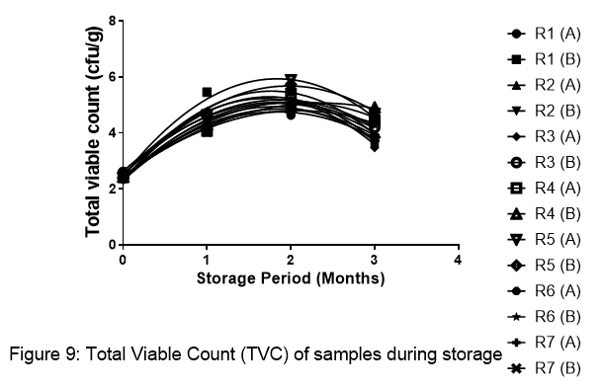
Figure 3: Total viable count of samples during storage
Source: Nwadi and Okonkwo ¹⁶
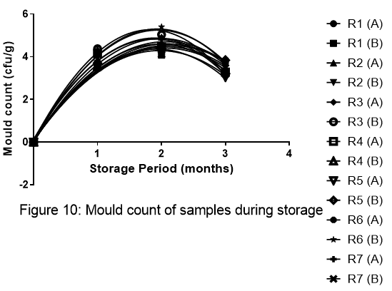
Figure 4: Mould count of samples during storage
Source: Nwadi and Okonkwo ²⁰

4. Conclusion

The extruded snack were generally stable during storage probably as a result of the microbial stability (total viable and mould count) of the extruded snacks which had a very low moisture content and water activity. The low TBA may also indicate that the products would not possess detectable rancidity. These attributes were observed irrespective of the part of the egg (whole egg, egg white or egg yolk) used or the storage temperature (ambient storage conditions of 25-30 ºC or the samples stored at 37 º C).The extruded snack can therefore be said to be safe for consumption across all age ranges. The maintenance of the storage stability of food is a necessary step in retaining the quality of food thereby preserving the integrity of the food, which will necessitate acceptability by the consumer who is often regarded as the ultimate arbiter of food quality through the purchase or non-purchase of the product.

ACKNOWLEDGEMENT

This research received partial funding from the National Economic Empowerment Development Strategy (NEEDS) Fund of the Federal Government of Nigeria through the University of Nigeria, Nsukka in May 2018.

COMPETING INTERESTS DISCLAIMER:
Authors have declared that they have no known competing financial interests OR non-financial interests OR personal relationships that could have appeared to influence the work reported in this paper.
Authors’ Contributions

Okonkwo designed the study, performed the statistical analysis, wrote the protocol. Nwadi wrote the first draft of the manuscript. Nwadi and Okonkwo managed the analyses of the study. Nwadi and Okonkwo managed the literature searches. Nwadi and Okonkwo read and approved the final manuscript.

DISCLAIMER (ARTIFICIAL INTELLIGENCE)

Author(s) hereby declare that no generative ai technologies such as large language models (ChatGPT, COPILOT, etc.) and text-to-image generators have been used during the writing or editing of this manuscript.

References

- Awulachew, M. T. (2021). Understanding to the shelf-life and product stability of foods. J Journal of Food Technology and Preservation, 5(8):1-5. https://www.alliedacademies.org/articles/understanding-to-the-shelf-life-and-product-stability-of-foods.html
- Nkubana, A., & Dusabumuremyi, J. C. (2019). Storage Stability Assessment of Extruded Rice and Maize Based Snacks Enriched with Fish. American Journal of Food Science and Technology, 7(5), 152–156. https://doi.org/10.2139/ssrn.3424024
- Le, T. H. (2025). Antioxidant Enriched into Extruded Food: Strategies for Stability, Functionality, and Application. Food and Bioprocess Technology, 18(11), 9170–9193. Springer. https://doi.org/10.1007/s11947-025-04025-y
- da Silva, I. C., dos Santos, P. D. S., dos Santos Júnior, O. O., Rocha, M., Janeiro, V., Volpato, J. A., Lazzari, A., & Vasconcellos, R. S. (2024). Influence of mineral source and inclusion levels of iron, copper, and zinc on the oxidative stability of extruded cat food. Animal Feed Science and Technology, 315, 115997. https://doi.org/10.1016/j.anifeedsci.2024.115997
- Gülçin, İ., Elias, R., Gepdiremen, A., Boyer, L., & Köksal, E. (2006). Antioxidant activity of lignans from fringe tree (Chionanthus virginicus L.). European Food Research and Technology, 223(6), 759–767. https://doi.org/10.1007/s00217-006-0265-5
- Fellows, P. J. (2009). Food processing technology: Principles and practice: Third edition. In Food Processing Technology: Principles and Practice: Third Edition. Woodhead Publishing. https://doi.org/10.1533/9781845696344
- Boukid, F., Folloni, S., Ranieri, R., & Vittadini, E. (2018). A compendium of wheat germ: Separation, stabilization and food applications. Trends in Food Science and Technology, 78, 120–133. https://doi.org/10.1016/j.tifs.2018.06.001
- Sawhney, I. K., Sarkar, B. C., & Patil, G. R. (2011). Moisture sorption characteristics of dried acid casein from buffalo skim milk. LWT - Food Science and Technology, 44(2), 502–510. https://doi.org/10.1016/j.lwt.2010.07.009
- Correia, R., Grace, M. H., Esposito, D., & Lila, M. A. (2017). Wild blueberry polyphenol-protein food ingredients produced by three drying methods: Comparative physico-chemical properties, phytochemical content, and stability during storage. Food Chemistry, 235, 76–85. https://doi.org/https://doi.org/10.1016/j.foodchem.2017.05.042
- Singh, R. P. (2012). Shelf Life of Foods (Including Food Losses) By R . Paul Singh Distinguished Professor of Food Engineering Department of Biological and Agricultural Engineering Department of Food Science and Technology University of California. Department of Food Science and Technology, University of California, 1–8. https://iufost.org/iufostftp/Module1_Chapter1_Shelf_Life_of_Foods.pdf
- Nemes, S. A., Szabo, K., & Vodnar, D. C. (2020). Applicability of agro-industrial by-products in intelligent food packaging. Coatings, 10(6), 1–25. https://doi.org/10.3390/COATINGS10060550
- Nwadi, O. M. M., Fagbemi, S. A., & Okonkwo, T. M. (2025). Proximate composition and sensory properties of whole-wheat flour and chicken egg-based extruded snacks. Science World Journal, 20(3), 1278–1282. https://doi.org/10.4314/swj.v20i3.52
- AOAC. (2010). Official methods of analysis. Association of official Analytical chemists. 18th Edition. AOAC International. https://www.worldcat.org/title/official-methods-of-analysis-of-aoac-international/oclc/649275444
- Kirk, R. S., & Sawyer, R. (1991). Pearson’s composition and analysis of foods 9th Edition. Longman Scientific Publisher, London, 537. https://www.cabidigitallibrary.org/doi/10.1079/CABICOMPENDIUM_19931459518
- Boczek, L. A., Rice, E. W., & Johnson, C. H. (2014). Total Viable Counts: Spread Plate Technique. In Encyclopedia of Food Microbiology: Second Edition (Second Edi, Vol. 3, Issue 2005). Elsevier. https://doi.org/10.1016/B978-0-12-384730-0.00331-1
- Katase, M., & Tsumura, K. (2011). Enumeration of micro-organisms in processed soy products with an automated most probable number method compared with standard plate method. Letters in Applied Microbiology, 53(5), 539–545. https://doi.org/10.1111/j.1472-765X.2011.03143.x
- Huang, Y., Zhang, K., Yang, S., & Jin, Y. (2013). A method to measure humidity based on dry-bulb and wet-bulb temperatures. Research Journal of Applied Sciences, Engineering and Technology, 6(16), 2984–2987. https://doi.org/10.19026/rjaset.6.3682
- Steel, G. D. and Torrie, J. H. (1980). Principles and Procedures of Statistics: A Biometrical Approach 2nd Edition. McGraw-Hill Book Company Inc. New York.
- Awolu, O. O. (2018). Rheological Evaluation of Cocoyam-Bambara Groundnut-Xanthan Gum Composite Flour Obtained from the Optimization of Its Chemical Composition and Functional Properties. Rheology, 2(1), 2–9. https://www.omicsonline.org/open-access/rheological-evaluation-of-cocoyambambara-groundnutxanthangum-composite-flour-obtained-from-the-optimization-of-its-chemicalcomposi.pdf
- Nwadi, O. M. M., & Okonkwo, T. M. (2021). Production, evaluation of quality characteristics and storage stability of extruded snacks from blends of whole wheat flour and chicken egg. https://doi.org/10.13140/RG.2.2.23390.36163
- Leistner, L., & Rodel, W. (1975). The significance of water activity for microorganisms in meats. In R. B. Duckworth (Ed.), Water Relations of Foods (pp. 309–323). Academic Press, London. https://doi.org/10.1016/B978-0-12-223150-6.50022-5
- Pitt, J. I. (1975). Xerophilic fungi and spoilage of foods of plant origin. In R. B. Duckworth (Ed.), Water Relations of Foods (pp. 273–308). Academic Press, New York. https://doi.org/10.1016/b978-0-12-223150-6.50021-3
- Reitznerová, A., Šuleková, M., Nagy, J., Marcinčák, S., Semjon, B., Čertík, M., & Klempová, T. (2017). Lipid peroxidation process in meat and meat products: A comparison study of malondialdehyde determination between modified 2-thiobarbituric acid spectrophotometric method and reverse-phase high-performance liquid chromatography. Molecules, 22(11), 1988. https://doi.org/10.3390/molecules22111988
- Okolie, N. P., Akioyamen, M. O., Okpoba, N., & Okonkwo, C. (2009). Malondialdehyde levels of frozen fish, chicken and turkey on sale in Benin City markets. African Journal of Biotechnology, 8(23), 6638–6640. https://doi.org/10.5897/AJB2009.000-9504
- Oparaku, N. F., Mgbenka, B. O., & Eyo, J. E. (2010). Proximate and Organoleptic Characteristics of Sun and Solar Dried Fish. Animal Research International, 7(2), 1169 – 1175. https://www.zoo-unn.org
- Akpe, A. R., Usuoge, P. O. A., Enabulele, O. I., Esumeh, F. I., Obiazi, H. A., Amhanre, I. N., & Omoigberale, O. M. (2010). Bacteriological and physico-chemical quality of wheaten white bread flour made for Nigerian market. Pakistan Journal of Nutrition, 9(11), 1078–1083. https://doi.org/10.3923/pjn.2010.1078.1083
- Bulut, S., Waites, W. M., & Mitchell, J. R. (1999). Effects of combined shear and thermal forces on destruction of Microbacterium lacticum. Applied and Environmental Microbiology https://doi.org/10.1128/AEM.65.10.4464-4469.1999
- Obaroakpo, J., Iwanegbe, I., & Ojokoh, A. (2017). The Effect of Fermentation and Extrusion on the Microbiological Composition of Millet and Defatted Soybean Blends. Journal of Advances in Microbiology, 2(3), 1–10. https://doi.org/10.9734/jamb/2017/30966
- Likimani, T. A., & Sofos, J. N. (1990). Bacterial spore injury during extrusion cooking of corn/soybean mixtures. International Journal of Food Microbiology, 11(3), 243–249. https://doi.org/https://doi.org/10.1016/0168-1605(90)90017-Y

