Digital Accounting Systems Adoption and Barriers: Impacts on SME Performance and Sustainability in Nigeria

Abstract
The paper examined digital accounting system (DAS) and the performance and sustainability of SMEs in Nigeria. The paper highlighted the importance of DAS to SMES’ performance and sustainability Digital accounting system has helped some SMEs from financial collapse such as reducing errors, have a straight record and to have a clear financial picture for easy decision making. Three research were questions guided the study and three hypotheses were tested at 0.05significance level. The study considered 200 samples from estimated population of entire population of SMEs business that cut across manufacturing sector, service sectors, agricultural sector, trading sector and other sectors that are using digital accounting systems. Out of 200 questionnaires distributed, 106 were returned, yielding a response rate of 53%. Two key metrics, Composite reliability and average variance extracted (AVE) were investigated to examine the reliability and validity of the study’s constructs. Based on the Cronbach’s alpha, shows that all constructs demonstrate Composite reliability values well above the 0.7. the result of the study reveal that awareness and usage of Digital Accounting System (DAS) have positive and direct solid relationship with Sustainable and Performance of SMEs in Nigeria. The path coefficient was 0.119, the T-statistic was 2.780, and the p-value was 0.037. the study further revealed that perceived benefit of adopting digital accounting system has positive and direct solid relationship with Sustainability and Performance of SMEs in Nigeria. The path coefficient was 0.140, the T-statistic was 2.991, and the p-value was 0.027 confirms a positive and significant impact of DAS awareness and usage on SMEs performance. it was recommended among others that practical insights for policymakers and SME owners, reinforcing the role of digital transformation in Nigeria’s economic development.
Keywords: Digital accounting, performance, sustainability, Small and medium Enterprises.

Introduction
One of the pivotal roles played by Small and medium sized enterprises (SMEs) in developing economies is by fostering employment generation, innovation, and poverty reduction. In Nigeria, according to NBS (2022); SMEDAN (2022), Approximately 84% of the country production that makes the economic resilience and growth is from the SME. Notwithstanding, their importance economically SMEs remain in facing structural constraints which impede the performance and long-term sustainability includes, low levels of digital literacy, limited access to finance, weak financial management system, and infrastructure deficiencies Olowe and Ojo (2022).
In order to have a sound and accounting and financial reporting system Nigerian SMEs should embrace DAS so as to have organizational efficiency, transparency, and strategic decision-making. Nevertheless, a substantial portion of SMEs still rely on manual bookkeeping or rudimentary spreadsheet-based accounting practices, which results in errors frequently, loss of data and delay in reporting. Such deficiencies will restrict managerial effectiveness, weak internal control and limit SMEs compliance to regulatory requirements entice external financing. In order to overcome those challenges, SMEs use DAS as a mechanism for enhancing financial management quality and organizational outcomes. (Al hatammi, 2025).
Financial record keeping, reporting accuracy and complete transformation compliances are potential workable answer of DAS. Furthermore, cloud-based accounting software, automated invoicing systems, and mobile bookkeeping application apps empower SMEs to produce accurate, timely and real time financial information (Al Okaily et al., 2024). Theoretically, those assist in explaining Resource based View (RBV) which posit effective deployment of valuable, rare, inimitable and non-substitutable (VRIN) resources firms can achieve superior performance and sustainable competitive advantages. For the enhancement of SMEs information processing capabilities and financial transparency, in that context DAS constituted a strategic organizational resource.
Empirical evidence linking DAS adoption to both sustainability and performance of SMEs remain limited, particularly in the developing economies such as Nigeria, notwithstanding the growing relevance of digital accounting technologies. The insufficient attention given to outcome of sustainability related activities like regulatory compliance, long term business continuity, adaptive capacity and resilience, exertive in an existing study focused on technology adoption decision or short-term financial outcome (Olowe and Ojo, 2022).
Against this backdrop, this study examines the application of digital accounting systems and their effects on SMEs’ performance and sustainability in Nigeria, drawing explicitly on the Technology Organizational Environment (TOE) framework, and Technology Acceptance Model Theory (TAM). By empirically evaluating both performance and sustainability outcomes and identifying the technological, organizational, environmental, and behavioral factors that facilitate or hinder DAS implementation, this study contributes to the digital accounting and SME sustainability literature.

Literature Review and Hypothesis Development
Theoretical Underpinning
This research work is based on theory developed by Davis (1989), TAM and theory proposed by Rogers (1995), Diffusion of Innovation (DOI). The technology acceptance model states that perceived utility and perceived ease of use encouragement an individual’s craving to embrace new technology. In line with the current research conducted by (Sulaiman and Usman, 2025), where SMEs’ awareness of DAS benefits and ease of use of inspire their level of adoption. Diffusion of Innovation (DOI) theory complements TAM through stressing factors like relative advantage, complexity in explaining adoption behavior, and compatibility. Both theories give a foundation for examining how perceived benefits, awareness and challenges affect DAS adoption and SMEs performance.

Awareness and Usage of DAS with Sustainability and Performance of SMEs in Nigeria.
Awareness and usage of DAS make SMEs owners and managers to understand digital accounting tools and make use of them in their day-to-day financial activities. The prerequisite for adoption is awareness, owners of the business would not adopt or make use of unfamiliar with (sulaiman & Usman, 2025). Consistently empirical studies reported that, low to moderate levels of awareness of DAS within the SMEs, specifically micro and small enterprises. According to Olayem et al. (2025) most of the SMEs owner are aware of the accounting software, but lack practical knowledge of its functions and benefits. Financial accuracy and decision making affected negatively due to a limited awareness resulting to a low rate and continue reliance on manual accounting system.

DAS usage has a strong linked with improved SME performance indicators like efficiency, compliance and profitability. In a study conducted by Mohammed et al., (2024) indicated SMEs that are using DAS experienced enhanced budgeting accuracy, improved cash flow management and faster preparation of financial statements. That improvements rendered to an increased business survival rates and better operational performance. Additionally, DAS usage supports a long-term business continuity by accountability, promoting financial transparency and informed planning. SMEs improve their organizational sustainability with consistent DAS usage which lead to better positioned to manage resources efficiency, monitor costs and meet regulatory requirements. Further, a positive relationship between awareness and usage of DAS and SMEs performance and sustainability, increased awareness and consistent application of digital accounting tools lead to improved business outcome. Hence, the following hypothesis is developed:
H1: Sustainability and performance of SMEs have a positive connection with awareness use of digital accounting system
Perceived Benefits of DAS with Sustainability and Performance of SMEs in Nigeria
Perceived benefits to SME owners are the advantages resulting from adopting DAS, while perceived usefulness is a serious determinant of both adoption and continued usage of digital systems (Sharma & Singh, 2022). According to Ejike, Nnamani & Ugwu, (2025), SMEs perceive many benefits from DAS adoption, which consist of reduced operational cost, improved internal controls, enhanced accuracy of financial records and better decision making in organization. Those benefits motivate SMEs to integrate DAS into financial operations. Consequently, Automation of routine accounting tasks and enhanced access to real-time financial data can only be achieved by SMEs that perceived DAS as beneficial recorded higher levels of financial performance (Mohammed et al. 2024). Similarly, Ajape et al. (2024) observed that perceived benefits of digital accounting systems influenced SMEs commitment to sustainability practice positively, as specific data facilitated long term plan and accountable resource management. To enhanced access to credit and external funding, SMEs that uses DAS are better prepare standardized financial statements that banks and investors required (Sulaiman & Usman, 2025). Consequently, the following hypothesis is proposed:

H2: A confident and direct influence on sustainability and performance of SMEs having through perceived benefits of adopting digital accounting system

Challenges of DAS Adoption with Sustainability and Performance of SMEs in Nigeria
Notwithstanding the benefits, there are many challenges hinder DAS adoption in Nigerian SMEs which lead to limit its impact on sustainability and performance. First, Financial constraints: high cost of acquiring accounting software, subscription fees and training workers is perceived high cost for micro or small businesses with little or no capacity (Okoye & Mensah, 2024). As a result of that, many SMEs delay or discontinue usage after implementation. Second, Low Digital Accounting Literacy. According to Ejike et al (2025), lack of technical skills to operate DAS effectively, lead to misuse or underutilization of the systems by many SMEs owner and managers and fear of technology and resistance to changes aggravate the problem. Finally, technical and infrastructural constraints: poor internet connectivity and unstable electricity supply are major challenges in adopting DAS to Nigerian SMEs owners, Halidu & Aliyu (2025) observed that weak broadband infrastructure disrupt the use of cloud-based accounting system, and frequent power outages discouraging SMEs from sustained adoption.

Even though there are significant challenges face by the SMEs in adopting digital accounting system like technical skills storages, limited digital readiness and infrastructural constraints tackling these challenges can contributes significantly in improving financial performance and sustainability. For example, research show that SMEs with a higher digital readiness can grasp a substantial improvement in cost efficiency and profitability from cloud-based accounting systems (Inayah & Suslivanti, 2025). Furthermore, research on digital transformation in SMEs shows by overpowering adoption barriers ultimately can leads improvement of financial outcomes strengthening DAS usage (Accounting and Financial Journal, 2025). Thus, the hypothesis below is developed:
H3: Adoption of DAS encounter some challenges which lead to a substantial relationship with SME performance and sustainability
Methodology
The paper adopted a survey research design approach and data were generated from operators/owners of SMEs in the North earthen, Nigeria through a structured questionnaire. The population of the study was 356 companies comprise of all SMEs in the Region. However, since the population cut across manufacturing sector, service sectors, agricultural sector, trading sector and other sectors that are using digital accounting systems, this study employed purposive sampling technique to pick the required sample. Sample size of 200 registered SMEs was selected. The study adopts a primary source of data collection. This achieved through the administration of designed questionnaires to obtain and collate data required for this study. Finally, the study, hypotheses previously formulated were tested using PLS-SEM.
Data presentation and analysis
This study considered 200 samples from estimated population of entire population of SMEs business that cut across manufacturing sector, service sectors, agricultural sector, trading sector and other sectors that are using digital accounting systems. Out of 200 questionnaires distributed, 106 were returned, yielding a response rate of 53%. After screening, 93 valid responses were retained for analysis. The survey instrument was designed following the guidelines of Churchill (1979), who proposed a systematic, iterative process for instrument development. Meanwhile, the Harman’s one-factor test argues that common method bias is likely if the total variance that a single factor shows exceeds 50%. The first factor explained 43.858% of the variance below the 50% threshold. Therefore, this study showed no significant standard method bias (Fuller, Simmering, & Atinc, 2015).

With regards to the demographical information of target respondents, the result of the eight demographical factors revealed as follows: the result of the gender shows that the majority of SMEs business using DAS owned and manage by men, whereas only 18(19.4%) were female. Based on the age of the respondents, the result revealed that majority of the SMEs ages were with 25years to 54years. The outcome of the study also indicates that majority of SMEs attained that level of education from BSc/HND to PhD level. This indicate that adoption of DAS was easy due to their level of exposure. Concerning the position of the respondents, the result show (67.8%) majority as SME business owners and manager who acquitted to the usage of DAS in their region. Furthermore, the result show that SMEs business owners and manager have above 3years experience in using DAS on their businesses. Similarly, the result also shows that 78.5% of the respondents cut across trading, servicing and agricultural sector who are also value the adoption of DAS to enhance their businesses. Also, the outcome further show that small and medium businesses majorly indicate their interest in the adoption of digital accounting system, most especially, businesses that general less that N50m annual incomes. See appendix I

Estimation Results
The sustainability and performance of SMEs in Nigeria are positively associated with awareness and effective utilization of DAS. Prior empirical studies indicate that increased awareness and consistent use of DAS enhance financial performance and support efficient managerial decision-making (Olayemi et al., 2025). Similarly, Nwankwo, Igwe, and Nnamani (2025) document that DAS adoption improves the accuracy and timeliness of financial information, thereby strengthening firms’ operational transparency and market attractiveness. Consistent with this evidence, the findings of the present study confirm a positive and statistically significant effect of DAS awareness and usage on SME performance and sustainability (β = 0.119, t = 2.780, p = 0.037). Greater awareness facilitates improved understanding and application of DAS tools, while accurate record-keeping, enhanced reporting quality, and sustained system usage reinforce financial discipline and contribute to long-term sustainability.

Moreover, the results reveal a strong and direct influence of the perceived benefits of adopting DAS on SME sustainability and performance. SME owners and managers who recognize the advantages of DAS such as improved accuracy, efficiency, transparency, and cost reduction—are more inclined to integrate these systems into their financial operations. This finding is consistent with prior empirical evidence (Ajape, Okpala, & Salawu, 2024; Ejike, Nnamani, & Ugwu, 2025), which demonstrates that perceived technological benefits significantly shape adoption decisions among SMEs. In particular, cloud-based accounting solutions have been shown to improve cash flow management and budgetary control among Nigerian SMEs. The results of the current study corroborate these insights, revealing a positive and statistically significant relationship between perceived benefits and SME performance and sustainability (β = 0.140, t = 2.991, p = 0.027). Perceived benefits thus function both as a catalyst for adoption and as a mechanism for strengthening decision-making quality and financial stability.
In contrast, the findings indicate that challenges associated with DAS adoption exert a negative and significant effect on SME sustainability and performance. The negative path coefficient (β = −0.165, t = 3.901, p = 0.002) suggests that barriers such as high software acquisition and maintenance costs, limited digital literacy, inadequate ICT infrastructure, and heightened cybersecurity concerns constrain the effective utilization of DAS (Usman, Halidu, & Aliyu, 2025). Furthermore, many Nigerian SMEs lack sufficient technical expertise and reliable internet connectivity, which reduces the operational effectiveness of digital accounting systems (Olayemi et al., 2025). Organizational resistance to change and financial constraints further complicate implementation and limit sustained adoption (Okoye & Mensah, 2024). Collectively, these challenges inhibit SMEs’ ability to fully realize the benefits of digital transformation, thereby constraining productivity growth and long-term sustainability.

Variance inflation factor (VIF) and Factor Analysis in SmartPLS
Another way to evaluate the presence of standard method bias is by examining VIF values. Common method bias may be present when values exceed 3.33, indicating multicollinearity issues. As seen in Table 4, the VIF values for all constructs (awareness and usage, perceived benefits, challenges in DAS adoption and Sustainable Performance) do not exceed 3.33. All the VIF values are below the threshold. In this regard, (Kock, 2015) offers some assurance regarding c method bias. Therefore, according to Harman’s single factor test and the VIF analysis done in SmartPLS, this study does measure common method bias in a significant manner.

Furthermore, this research sought to determine how the factor loadings of each item relate to each other. The analysis suggested that almost all test items demonstrated factor loadings that go well above the generally accepted level of 0.7, which indicates that the items reliably measure what they are supposed to measure. Table 2 outlines the factor loadings of the various constructs captured in the awareness and usage, perceived benefits, challenges in DAS adoption and Sustainable and Performance constructs, which ranged from 0.634 to 0.954, respectively. Despite this, some indicator which is supposed to be under the construct, performed poorly with a low factor load. As a result, some items were excluded from the model to enhance the reliability and validity of the measurement model. The exclusion of some indicator helps ensure that the remaining items accurately reflect the latent construct, contributing to a more robust and reliable subsequent analysis model. The summary of the measurement model is indicated in the Table 2 below:
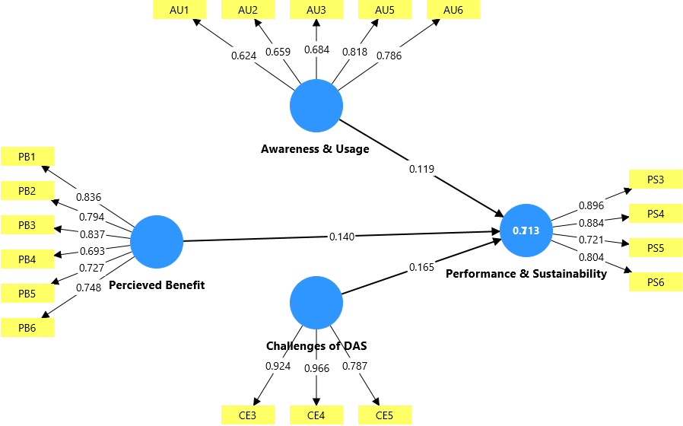

FIG 1: Structural model

Table 1: Summary of Measurement Model (Reliability and Validity Test)
Constructs | Items | Loadings | Cronbach Alpha | CR | AVE
Awareness and believe | AU1 | 0.624 | 0.784 | 0.841 | 0.516
 | AU2 | 0.659
 | AU3 | 0.684
 | AU5 | 0.818
 | AU6 | 0.786
Challenge in DAS Adoption | CE3 | 0.924 | 0.887 | 0.923 | 0.802
 | CE4 | 0.966
 | CE5 | 0.787
Perceived Benefit | PB1 | 0.836 | 0.866 | 0.900 | 0.600
 | PB2 | 0.794
 | PB3 | 0.837
 | PB4 | 0.693
 | PB5 | 0.727
 | PB6 | 0.748
Performance & Sustainability | PS3 | 0.896 | 0.849 | 0.897 | 0.688
 | PS4 | 0.884
 | PS5 | 0.721
 | PS6 | 0.804
Source: SmartPLS output version 4.0

Reliability and Convergent Validity Assessment
In line with PLS-SEM guidelines, the measurement model’s reliability and convergent validity were assessed using composite reliability (CR) and average variance extracted (AVE). As shown in Table 2, all constructs exhibit CR values above the recommended threshold of 0.70 (Hair et al., 2021), ranging from 0.841 to 0.923, indicating satisfactory internal consistency. Convergent validity was evaluated using AVE. The results reported show that all constructs achieve AVE values exceeding the minimum criterion of 0.50, with estimates ranging from 0.516 to 0.802, confirming that the constructs explain a substantial proportion of variance in their indicators. Items with low outer loadings were eliminated to improve measurement quality, resulting in a well-specified and robust measurement model. Overall, the findings confirm that the constructs demonstrate adequate reliability and convergent validity, justifying their use in subsequent structural model analysis.

Discriminant validity assessment
The Heterotrait-Monotrait Ratio (HTMT) was utilized in this research for heterotrait correlation validity for all model constructs. Such values are adequate to show discriminant validity, as the distance or separation between each construct, in this case, is demonstrated by these cross-correlations featuring scores below the threshold value of 0.85. Table 3 shows that HTMT values for most construct pairs were below the 0.85 threshold, confirming that the constructs were sufficiently distinct. For example, the HTMT value between awareness and usage (AU) and perceived benefit (PB) was 0.820, indicating a close but acceptable association. The interaction terms, perceived benefit and performance (PB x PS) also had acceptable HTMT values as indicated in the table below.

Table 2: Discriminant Validity (HTMT Criterion)
 | Constructs |  | AU |  | CE |  | PB |  | PS
 | Awareness & Usage (AU)
 | Challenges of DAS (CE) |  | 0.309
 | Perceived Benefit (PB) |  | 0.82 |  | 0.382
 | Performance & Sustainability (PS) |  | 0.29 |  | 0.238 |  | 0.32
Source:SmartPLS Output Version 4.0
Structural Model and Hypothesis testing
The study tested several hypotheses to understand the application of digital accounting system on SMEs performance and sustainability in Nigeria. With the analysis of structural model of response of 93 SMEs in Nigeria, Table 4 and figure 2 illustrates the path coefficients and their statistical significance to support each hypothesis.

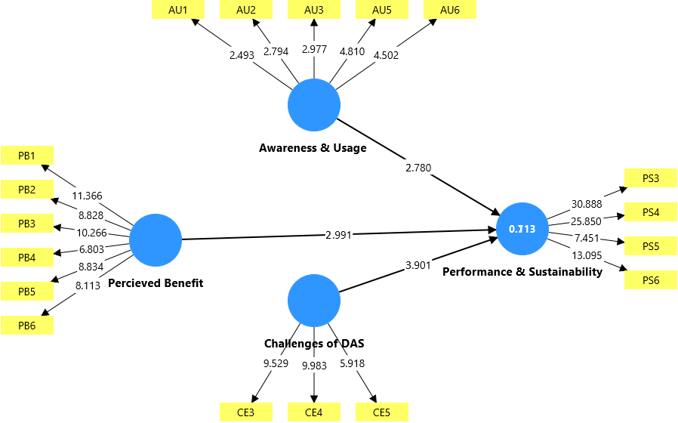
Figure 2: Structural Model (Bootstrapping @5000)

Table 3: Structural Model and Hypotheses Testing
Hypotheses |  | Coef. |  | se |  | T-value | P values |  | Decisions |  | 2.50% |  | 97.50%
Awareness and Usage Sustainable & Performance |  | 0.119 |  | 0.152 |  | 2.780 | 0.036 |  | Supported |  | 0.199 |  | 0.344
Perceived Benefit of DAS Sustainable & Performance |  | 0.140 |  | 0.141 |  | 2.991 | 0.027 |  | Supported |  | 0.366 |  | 0.732
Challenges of DAS adopt Sustainable & Performance |  | -0.165 |  | 0.087 |  | 3.901 | 0.002 |  | Supported |  | 0.117 |  | 0.378
 | Source:SmartPLS Version 4.0

Discussion of Findings
The findings provide empirical support for H1, indicating that awareness and usage of DAS exert a positive and significant influence on the sustainability and performance of SMEs in Nigeria. This result suggests that SMEs with greater familiarity and consistent use of DAS are better positioned to enhance operational efficiency and achieve sustainable performance outcomes. From the perspective of the Resource-Based View DAS adoption constitutes a strategic organizational resource that is valuable, difficult to imitate, and capable of generating competitive advantage. The widespread adoption observed where a substantial proportion of respondents reported using platforms such as QuickBooks, Sage, Xero, Zoho Books, Tally ERP, and Wave highlights the growing integration of digital accounting tools among Nigerian SMEs. Furthermore, the sustained use of DAS over several years reflects its effectiveness in supporting long-term business sustainability.

Support is also established for H2, which posits that the perceived benefits of adopting DAS positively affect SMEs’ sustainability and performance. The results indicate that SMEs acknowledge DAS as instrumental in improving the accuracy of financial records, reducing transaction processing time, enhancing managerial decision-making, facilitating tax compliance, strengthening cash flow monitoring, and lowering operational costs. The high level of agreement among respondents underscores the importance of perceived value in driving effective technology utilization and translating digital adoption into measurable performance improvements.

In contrast, the findings related to H3 reveal that challenges associated with DAS adoption negatively affect the sustainability and performance of SMEs. Key constraints include limited financial capacity to acquire and maintain software, poor internet connectivity, inadequate technical expertise, concerns over data security, and insufficient staff training. These barriers restrict the effective use of digital accounting technologies and weaken their potential contribution to firm performance. Although DAS adoption overall enhances SME performance and accounting efficiency, the persistence of these challenges highlights critical structural and capability-related gaps that must be addressed to fully realize the benefits of digital transformation.

Conclusion
This study provides comprehensive empirical evidence on the role of DAS in enhancing the sustainability and performance of SMEs in Nigeria. The findings demonstrate that both awareness and effective usage of DAS contribute meaningfully to improved operational efficiency, financial transparency, and long-term business viability. SMEs that have integrated digital accounting tools into their core operations are better equipped to manage financial information, support timely and informed decision-making, and maintain consistent performance in a dynamic and competitive business environment.

Furthermore, the study establishes that the perceived benefits of DAS adoption such as improved accuracy of financial records, enhanced cash flow monitoring, reduced processing time, lower operational costs, and improved tax compliance play a pivotal role in translating digital adoption into tangible performance outcomes. These benefits reinforce the strategic value of DAS, not merely as a technological upgrade, but as a critical managerial tool that strengthens internal controls and supports sustainable growth.

However, the study also highlights that the performance-enhancing potential of DAS is constrained by several adoption-related challenges. Financial limitations, inadequate digital infrastructure, limited technical expertise, concerns over data security, and insufficient employee training continue to impede the effective utilization of digital accounting technologies among SMEs. These constraints underscore the uneven nature of digital transformation in emerging economies and suggest that technology adoption alone is insufficient without complementary investments in human capital and institutional support.

Anchored in the Resource-Based View, the study concludes that DAS represents a strategic organizational resource capable of generating competitive advantage when appropriately deployed and supported. For Nigerian SMEs, the ability to leverage digital accounting systems effectively depends not only on access to technology but also on the development of internal capabilities and an enabling external environment. Consequently, policymakers, SME support agencies, and professional bodies should prioritize digital capacity-building initiatives, infrastructure development, and targeted training programs to enhance SMEs’ readiness for digital accounting adoption. Addressing these systemic challenges will be essential for maximizing the contribution of DAS to SME sustainability, competitiveness, and long-term economic development in Nigeria.

Suggestions for Future Research
Future research could adopt a longitudinal approach to examine how sustained DAS usage influences SME performance over time. Sector-specific investigations may also provide deeper insights into variations in adoption outcomes across industries. Additionally, examining the mediating or moderating roles of digital literacy, managerial capability, and organizational size could further enrich understanding of the DAS performance relationship. Qualitative studies may also be useful in capturing contextual and behavioural factors shaping DAS adoption in SMEs within emerging economies.
Disclaimer (Artificial intelligence)

Author(s) hereby declare that NO generative AI technologies such as Large Language Models (ChatGPT, COPILOT, etc.) and text-to-image generators have been used during the writing or editing of this manuscript.

References
Accounting and Financial Analysis Journal. (2025). Financial performance implications of digital
transformation in accounting practices: An empirical study of SMEs. Accounting and Financial Analysis Journal. afaaj.com

Al-Hattami, H. M. (2023). What determines digital accounting systems' continuance among
SMEs? Humanities and Social Sciences Communications, 10(1), 1–12. https://doi.org/10.1038/s41599-023-02332-3
Ejike, C., Nnamani, P., & Ugwu, J. (2025). Cloud accounting adoption among SMEs in Enugu
North LGA: Exploring key drivers and challenges. International Journal of Finance and Economic Analysis, 13(1), 88–102.
Fuller, C. M., Simmering, M. J., Atinc, G., Atinc, Y., & Babin, B. J. (2016). Common methods variance detection in business research. Journal of business research, 69(8), 3192-3198.
Hair, J. F., Astrachan, C. B., Moisescu, O. I., Radomir, L., Sarstedt, M., Vaithilingam, S., & Ringle, C. M. (2021). Executing and interpreting applications of PLS-SEM: Updates for family business researchers. Journal of Family Business Strategy, 12(3), 100392.
Inayah, I., & Susliyanti, E. D. (2025). The impact of cloud-based accounting systems on SME
financial performance in the digital era. Atestasi: Jurnal Ilmiah Akuntansi, 8(2), 138–145. https://doi.org/10.57178/atestasi.v8i2.1486 Jurnal Fakultas Ekonomi & Bisnis UMI

Kock, N. (2015). Common method bias in PLS-SEM: A full collinearity assessment approach. International Journal of e-Collaboration (ijec), 11(4), 1-10.
Mohammed, A., Inuwa, H., & Enemali, S. (2024). Digital accounting systems and SME
performance in Plateau State, Nigeria. International Journal of Innovative Development, 8(3), 119–130.

Nwankwo, B., Igwe, O., & Nnamani, K. (2025). Effect of automated accounting software on the efficiency of Nigerian SMEs’ financial operations. Global Journal of Accounting and
Finance, 12(2), 101–118.
Okoye, J., & Mensah, K. (2024). Challenges of technology adoption by SMEs in Rivers State, Nigeria. African Economic Journal, 7(2), 87–100.
Olayemi, A., Adebiyi, T., & Ibrahim, M. (2025). Exploring the level of awareness and usage of
accounting software among small businesses in Nigeria. African Journal of Accounting and Financial Research, 8(1), 52–66.

Sharma, R., & Singh, M. (2022). Adoption of accounting automation and SME performance: Evidence from Indian manufacturing sector. Journal of Technological Innovation and Business Development, 10(2), 95–110.

Sulaiman, M., & Usman, H. (2025). A narrative review of SME adoption of accounting information systems in Nigeria. African Journal of Accounting and Financial Research, 8(3), 77–90.

Usman, H., Halidu, S., & Aliyu, U. (2025). Barriers to cloud accounting adoption in Nigerian SMEs beyond cost and infrastructure constraints. International Journal of Pharmaceutical and Business Management Studies, 8(5), 244–259.

Van, H., Afifa, M., Nguyen, N., & Bui, D. (2025). Cloud accounting: A systematic literature review. Global Knowledge, Memory, and Communication. https://doi.org/10.1108/gkmc- 04-2024-0246

Appendix I
Demographic Information of the Respondents
Details | Frequency | Percentage
 | Gender
- Male | 75 | 80.6
- Female | 18 | 19.4
 | Age
- Below 25 years | 1 | 1.1
- 25 – 34 years | 26 | 28
- 35 – 44 years | 26 | 28
- 45 – 54 years | 30 | 32.3
- 55 years and above | 10 | 10.8
 | Educational Qualification
- Secondary school Level | 3 | 3.2
- OND/NCE | 3 | 3.2
- BSc/HND | 28 | 30.1
- MSc/MBA | 33 | 35.5
- PhD and others | 26 | 28
 | Position in Business
- Owner | 45 | 48.4
- Manager | 18 | 19.4
- Accountant/Finance Officer | 8 | 8.6
- Others | 22 | 23.7
 | Years of Operation
- Less than 1 year | 9 | 9.7
- 1 – 3 years | 23 | 24.7
- 4 – 6 years | 20 | 21.5
- 7 – 10 years | 16 | 17.2
- Over 10 years | 25 | 26.9
 | Industrial Sector
- Manufacturing | 7 | 7.5
- Trading sector | 25 | 26.9
- Service sector | 28 | 30.1
- Agricultural sector | 20 | 21.5
- Others | 13 | 14
 | Business Size
- Micro | 20 | 21.5
- Small | 41 | 44.1
- Medium | 32 | 34.4
 | Annual Turnover
- Less than N5m | 67 | 72
- N5m – N50m | 20 | 21.5
- Over N50m | 6 | 6.5

