Case report

Management of corneal opacity associated with bovine trypanosomosis using placental extract: A case report

Abstract
A six years old female cross bred Jersey cow was presented to the veterinary clinical complex, BVC,BASU, Patna, Bihar with the history of inappetance, bilateral ocular changes and lacrimal discharges, apparent blindness and drop in milk production. Clinical examination revealed body temperature of 103.2 ⁰ F, pale conjunctival mucus membranes, bilateral corneal opacity with hyphema and lacrimation, stamping of feet and salivation. Based on the clinical history, the animal was suspected for haemoprotzoal infection. The blood was collected for blood smear examination and haemato-biochemical estimations. Microscopic examination (oil immersion objective) of Giemsa stained blood smear revealed characteristic haemoflagellates, the Trypanosoma spp. Hematological examination revealed anemia, and serum bilirubin was elevated. Based on clinical and blood smear examination, the case was diagnosed for corneal opacity associated with trypanosomosis. Treatment was started with Inj. Triquin (Quinopyramine sulphate and chloride) @ 5 mg /kg, SC (single dose) after infusion of 2.0 litre of Dextrose saline solution. Day after initial therapy, Inj Placentrex (Human placental extract) 1ml was administered sub-conjunctively as a single dose in both eyes. Further, eye drop Prednisolone acetate two drops TID was prescribed for two week as follow-up treatment. Clinical recovery with complete resolution of corneal opacity was observed after 3 week treatment, and the post therapeutic blood sample was also found negative for any haemoparasites.
Keywords: Cattle; Corneal opacity; Placentrex; Trypanosomosis.

1. INTRODUCTION
Bovine trypanosomosis is the primary cause of livestock and agricultural productivity losses, resulting in negative socioeconomic effects (Mulat et al., 2024). It is a wasting disease of domestic livestock including cattle, caused by several species of Salivarian groups of trypanosomes (T. vivax, T. congolense and T. brucei spp.), and transmitted through the bite of blood sucking insects (Giordani et al., 2016). Among these insects, Glossina species are responsible for cyclical transmission, while other biting flies like Tabanus, Hematopota, and Stomoxys are responsible for mechanical transmission of trypanosomosis in domestic and wild animals (Fesseha et al., 2022). In India, T. evansi is the primary cause of trypanosomosis, also known as 'Surra'. In the absence of treatment, this can cause acute and/or chronic wasting disease, resulting in high morbidity, mortality, and infertility. The clinical manifestations of the disease are nonspecific and lack sufficient pathognomonic characteristics. However, the disease varies from acute to chronic forms. Clinically, the acute disease in bovine is characterized by high fever, emaciation, lacrimation, reduced milk yield, ocular opacity, nervous signs and death may occur within 24 hours of onset of clinical signs (Rani et al., 2015). Chronic form can lead to loss of body condition with impaired reproductive performance (Radostits et al., 2007). Ocular lesions including corneal opacity have been associated with Trypanosoma spp. infection in many animal species that may compromise the animal welfare and productivity.
The present communication reports on use of Placentrax (Human placental extract) in successful management of corneal opacity associated with trypanosomosis in a cross bred cow.

2. PRESENTATION OF CASE
A six years old female cross bred Jersey cow was presented to the veterinary clinical complex, BVC,BASU, Patna, Bihar with the history of inappetance, bilateral ocular changes and lacrimal discharges, apparent blindness and drop in milk production. Clinical examination revealed body temperature of 103.2 ⁰ F, pale conjunctival mucus membranes, salivation, bilateral corneal opacity with hyphema, lacrimation (Fig. 1) and stamping of feet. Based on the clinical history, the animal was suspected for haemoprotzoal infection. The blood was collected for blood smear examination and haemato-biochemical estimations. Microscopic examination (oil immersion objective) of Giemsa stained blood smear revealed characteristic haemo flagellates, the Trypanosoma spp. (Fig.2). The haematological examination showed low level of haemoglobin and total erythrocyte count, while the biochemical estimation revealed normal level of total serum protein, albumin and blood glucose, but the high values of total serum bilirubin was observed (Table 1). Based on clinical and blood smear examination, the case was diagnosed for corneal opacity associated with Bovine trypanosomosis.
3. DISCUSSION
After diagnosis, a single dose of Inj. Triquin (Quinopyramine sulphate and chloride) @ 5 mg /kg, SC was given after infusion of 2.0 litre of Intalyte solution. Day after initial therapy, Inj Placentrex (Human placental extract) 1ml was administered sub-conjunctively as a single dose in both eyes, and eye drop Prednisolone acetate two drops three times in a day for two week was advised as follow-up treatment. Clinical recovery with complete reversion of corneal opacity was observed after 3 week post treatment (Fig. 3), and the post therapeutic blood sample was found negative for hemoparasites. Currently, very few compounds (Diminazene aceturate, Homidium bromide/ Homidium chloride, Isometamidium chloride, Quinapyramine sulphate Quinapyramine sulphate:chloride, Suramin sodium, Melarsomine dihydrochloride) are available to treat trypanosome infection in animals. The cattle in the present case was treated with trypanocidal drug Triquin (quinapyramine sulphate and chloride) (Giordani et al., 2016). The infected cattle revealed low level of haemoglobin and total erythrocyte count indicate a state of anaemia which might be due to haemolysis induced by the trypanosomes (Dagnachew et al., 2015) or erythrophagocytosis by mononuclear phagocytic system of the hosts (Sivajothi et al., 2014), and or enhanced erythrocytic oxidation (Mishra et al., 2017). The total bilirubin of the infected cattle was increased as a result of enhanced erythrocytic destruction which is commonly reported due to hemolytic crisis and membrane injury during the period of infection and also supported by decrease in haemoglobin (Kumar et al., 2012). In cattle and buffalo, corneal opacity is a clinical sign of a number of infectious and parasitic diseases including Trypanosama spp. The cornea is a highly sensitive component of the eye. The sensory nerves are highly innervated and placed superficially, with fibers connecting to the ocular division of the trigeminal nerve. The corneal opacity occurs due to stromal inflammation, tissue fibrosis, corneal epithelial thickening, and vascularization (Sharun et al., 2020). During the disease process, organisms descend from the brain along with the optic artery, causing immune complexes to develop in the aqueous humour, and this leads to cloudiness of cornea by accumulation of the granular deposits within the aqueous humour (Sudhakara & Sivajothi, 2017). Placentrex, a human placental extract with reported regenerative and anti-inflammatory properties has good effect on ocular therapy in human patients (Ali et al., 2020). It is too widely used in healing process of corneal ulcers, corneal opacity and iris prolapse in animals. The healing property might be owing to tissue regeneration power through unique process of protein synthesis (Arunachalam et al., 2001). To treat the eye with hyphema, however, empirical therapy with topical corticosteroids and mydriatics are frequently initiated promptly. The use of corticosteroids prevent corneal opacification by inhibiting fibroplasia, decreasing vascularization, and reducing melanosis (Preena & Arvind, 2017). Furthermore, topical corticosteroids prevent recurrent bleeding by decreasing fibrinolysis and restoring the blood-ocular barrier. The most often used topical corticosteroids are dexamethasone sodium phosphate and prednisolone acetate, both of which can penetrate the intact cornea and act directly on the anterior segment of the eye (Telle & Betbeze, 2015).
Table 1: Hemato-biochemical parameters of cattle infected with trypanosomosis
Parameters | Day 0 | Reference*
Hemoglobin (g/dl) | 8.4 | 8.0-15.0
TEC (X10 ⁶/μl) | 4.78 | 5.0-10.0
Total Protein (gm/dL) | 7.46 | 5.7-8.1
Albumin (gm/dL) | 3.32 | 2.1-3.6
Blood Glucose (mg/dL) | 63.32 | 45-75
Serum Bilirubin (mg/dL) | 0.92 | 0. 01-0.5
*Source: Radostits et al., 2007
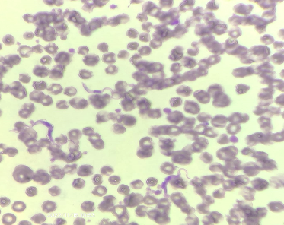

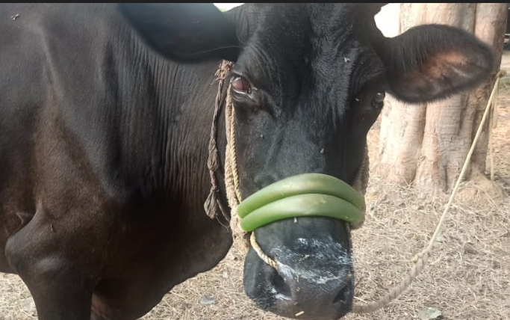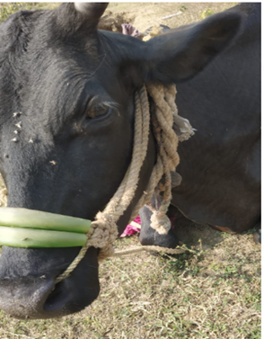
Fig. 1. Showing corneal opacity with hyphema
Fig. 3. Showing complete reversion of corneal opacity
Fig. 2. Arrow showing the extracellular Trypanosoma spp. in blood smear

Conclusion:
The present case demonstrates that Placentrex, when used as an adjunct therapeutic agent along with trypanocidal drugs and Steroid therapy can be beneficial in the treatment of corneal opacity caused by bovine trypanosomosis. Veterinary practitioners should consider Bovine trypanosomosis in the differential diagnosis when assessing the ocular lesions in cattle in field condition.

COMPETING INTERESTS DISCLAIMER:
Authors have declared that they have no known competing financial interests OR non-financial interests OR personal relationships that could have appeared to influence the work reported in this paper.
Disclaimer:
Author(s) hereby declare that NO generative AI technologies such as Large Language Models (ChatGPT, COPILOT, etc.) and text-to-image generators have been used during the writing or editing of this manuscript.
REFERENCES
- Ali, Samshul., Choudhury, B., Basumatary, P. & Ashraf, N.V.K. (2020). Chemical restraint and clinical management of corneal opacity in a free ranging wild water buffalo (bubalus arnee) in Assam, north-eastern India. Veterinary Practitioner, 21 (1), 120-122.
- https://cabidigitallibrary.org by 117.250.71.98

- Arunachalam, K., Karunanithi, K., Thiruvenkadan, A.K. & Karunakaran, P. (2001). Efficacy of placentrex drug against corneal defects in Mecheri Sheep. Indian Journal of Small Ruminants, 7(2), 88-88.
- Dagnachew, S., Bezie, M., Terefe, G., Abebe, G., Barry, J. D. & Goddeeris, B. M. (2015). Comparative clinico-haematological analysis in young Zebu cattle experimentally infected with Trypanosoma vivax isolates from tsetse infested and non-tsetse infested areas of Northwest Ethiopia. Acta Veterinaria Scandinavica (2015) 57:24. DOI 10.1186/s13028-015-0114-2

- Fesseha, H., Eshetu, E., Mathewos, M. & Tilante, T. (2022). Study on Bovine Trypanosomiasis and Associated Risk Factors in Benatsemay District, Southern Ethiopia. Environmental Health Insights Volume, 16: 1–10. DOI: 10.1177/11786302221101833

- Giordani, F., Morrison, L.J., Rowan, T.G., de Koning, H.P., & Barrett, M.P. (2016). The animal trypanosomiases and their chemotherapy: a review. Parasitology, 143, 1862–1889. https://doi.org/10.1017/S0031182016001268

- Kumar, H., Mohinder, P.G., Pritam, K.S., Mahajan, V., Mandeep, S.B., Kaur, K., Verma, S., & Singla, L.D. (2012). An outbreak of acute Trypanosoma evansi infection in crossbred cattle in Punjab, India. Journal of Applied Animal Research, 40(3), 256-259. https://doi.org/10.1080/09712119.2012.9707179

- Mishra, Rashmi R., Senapati, S.K., Sahoo, Sudam, C., Das, M. R., Sahoo, G., & Patra, R.C. (2017). Trypanosomiasis induced oxidative stress and hemato-biochemical alteration in cattle. Journal of Entomology and Zoology Studies, 5(6), 721-727.

- Mulat, G., Maru, M., Tarekegn, Z.S. & Dejene, H. A. (2024). systematic review and meta-analysis on prevalence of bovine trypanosomosis in East Africa. Parasite Epidemiol Control, 29, 26:e00371. doi: 10.1016/j.parepi.2024.e00371.

- Preena, P., & Aravind, B. (2017). Case report on the medical management of corneal opacity in a captive elephant tusker. Adv. Anim. Vet. Sci., 5(8), 342-345. https://doi.org/10.17582/journal.aavs/2017/5.8.342.345

- Radostits, O. M., Gay, C. C., Hinchcliff, K. W., & Constable, P. D. (2007). *Veterinary Medicine: A Textbook of the Diseases of Cattle, Sheep, Pigs, Goats, and Horses* (10th ed.). Saunders Elsevier. https://www.elsevier.com/books/veterinary-medicine-e-book/radostits/978-0-7020-2777-2

- Rani, N. L., Suresh, K., & Rajesh, K. (2015). A retrospective study on clinico-epidemiological aspects of trypanosomiasis in buffaloes. International Journal of Veterinary Science. https://www.ijvets.com/

- Sharun, K., Manjusha, K. M., Gopinathan A., Singh, K., Lakshmanan, B., Verma, N. K., Dhama K., & Pawde, A. M. (2020). Microfilaraemia induced corneal opacity in a water buffalo (Bubalus bubalis): a case report and review of literature. Journal of Experimental Biology and Agricultural Sciences, 8(1), 9 – 14.

- Sivajothi, S., Reddy, B. S., Kumari, K. N., & Rayulu, V. C. (2014). Haematological changes in Trypanosoma evansi infected cattle. International Journal of Scientific World, 2(1), 27-30. https://doi.org/10.14419/ijsw.v2i1.2275

- Sudhakara, R. B., & Sivajothi, S. (2017). Corneal opacity due to trypanosomosis in buffaloes-need of topical medication. Open Access J Sci., 1(6), 155–156. https://doi.org/10.15406/oajs.2017.01.00031

- Telle, M.R. & Betbeze, C. (2015). Hyphema: Considerations in the Small Animal Patient. Top Companion Anim Med., 3, 97-106. doi: 10.1053/j.tcam.2015.07.008.

