Ergonomic Evaluation of Direct Paddy Seeder with Two-Row and Three-Row Rice Transplanting in Peddapalli District of Telangana State

ABSTRACT
Rice is the most important staple food crop of India. In Telangana, during 2022-23, rice is grown in gross area of 1.72 million hectares with a productivity of 3.82 tonnes per hectare. Several attempts have been taken by Indian researchers to mechanize rice transplanting by introducing various transplanter. Krishi Vigyan Kendra assessed suitability of operating three and two row transplanter for the farmers of Peddapalli district and to compare them with direct seeded rice. The study was conducted during Rabi and Kharif 2023, 2024 with ten respondents. The results showed that, BMI value of the respondents ranged from 21.7 to 25.6 kg/m², with a mean BMI of 23.69 kg/m². The results also found that there was a significant difference in heart rate during work, with the highest rate recorded during operation of the OUAT 3-row transplanter (129.8 bpm), followed by the OUAT 2-row transplanter (123.7 bpm), and the direct paddy seeder (113.5 bpm). Work pulse was notably higher for both 2-row and 3-row transplanters (66.6 bpm and 59.4 bpm, respectively) compared to the direct paddy seeder (42.0 bpm). While, oxygen consumption (VO₂) during work was highest for the 3-row transplanter (1.04 L/min), slightly greater than that of the 2-row transplanter (1.00 L/min), and markedly higher than the direct seeder (0.80 L/min). Corresponding energy expenditures followed a similar trend, with the OUAT 3-row transplanter requiring the most energy (22.60 kJ/min), followed by the 2-row transplanter (21.90 kJ/min), and the direct seeder (19.05 kJ/min). The overall findings suggest that mechanized transplanters particularly the 3-row model are associated with increased physiological workload compared to the direct paddy seeder. The study also showed that direct seeding, transplanting procedures—particularly those utilizing two- and three-row machines are linked to higher degrees of bodily discomfort.
Key words: Rice transplanter, Direct seeder, Manual transplanting, OUAT and Krishi Vigyan Kendra
- INTRODUCTION:
India is one of the world's leading producers and consumers of rice. Rice is cultivated on 41.92 million hectares in India, the largest rice area of any country. India produces approximately 89.09 million tonnes of rice annually and has a productivity of 2125 kg per hectaree. In Telangana, rice is a prominent food crop (Chaudhary et al. 2022). In 2022–2023, 1.72 million hectarees of gross area were used to grow rice, yielding 3.82 tons of output per hectaree (Director of Economics and Statistics, 2025, Kamendra et al. 2022).
Generally, rice grown under wetland conditions. It may be grown in direct seeded or in transplanted condition. Transplanting of rice seedlings in the traditional way is laborious, time consuming and causes drudgery. The non-availability of laborers for transplanting at the appropriate time leads to late planting, which results in poor yields. In paddy cultivation, the planting methods have an impact on the growth and yield besides cost of cultivation and labour requirement. (Yadav et al. 2007)
Further, in manual transplanting usually less number of hills are planted per unit area than recommended to complete the planting quickly resulting in reduced plant population and thus decreased in yields. In such situations, farmers prefer direct seeding by using drum seeder
which is helpful due to less labour and time requirement, low cost of cultivation due to skipping of nursery raising and transplanting, maintaining recommended plant population and also due to early crop maturity by 7 to 12 days (Goel,et al., 2008).
In India several attempts have been taken to mechanize this transplanting operation by introducing various transplanters. At OUAT two and three row transplanters have been developed for agriculture workersto reduce their drudgery and to improve the efficiency during transplanting time.(Ojha and Kwatra, 2017 and Samal et al. 2020.)
This study is conducted to compare the ergo-economical suitability among two row and three row transplanter with traditional manual transplanting and direct seeding. In order to engage the farmers of Peddapalli district in mechanical rice transplanting, Krishi Vigyan Kendra, Ramagirikhilla, has attempted in this paper to examine the suitability of operating three and two row transplanters and compare them with direct seeding.
MATERIALS AND METHODS:
This study was carried out in the KVK, Ramagirkhilla adopted village Kalwacherla village, Ramagiri Mandal, Peddapalli district in Rabi 2023 and Kharif 2024. Ten subjects were selected in the age of 25-45 and their body weight varies from 55-75 KGs. The transplanting operation was performed from 10:30 A.M. to 2.00 P.M. and 3.00 P.M. to 5.00 P.M. Before going to field their Heart rate (HR), rest, Body Mass Index (BMI), oxygen uptakes (VO₂) and energy expenditure were measured. The operation was done in continuous transplanting for 30 minutes and taking 10 minutes of break.
2.1 Selection of subject and field:
The selected ten subjects aged 25-45 years because at this age maximum strength can be utilized. The soil of the testing plot was sandy soil with a size of plot 10 x 20 m² and the test was conducted at about 41 to 44⁰ C temperature and 83-88 % humidity. The details of physical parameters are placed in Table 1. The detail specifications direct seeder, 2 row and 3 row transplanter were placed in Table 2
Tables 1: Physical parameters of samples
 | Range | Mean | Std. Deviation (SD)
Age, years | 25-45 | 37.90 | 6.13
Weight, Kg | 55-74 | 63.54 | 6.63
Height, cm | 155-173 | 163.54 | 6.17
BMI, kg/m² | 21.7-25.6 | 23.69 | 1.19
Table 2: Comparisons between specifications of rice transplanter
Details | Specifications
Name | Direct paddy seeder | OUAT 2-row transplanter | OUAT 3 row transplanter
Type | Manual | Manual using mat type seedling | Manual using mat type seedling
Dimension (mm) | 2000 x 1500 x 640 | 630×600×400 | 600×600×940
Number of rows | 08 | 02 | 03
Row spacing | 20 | 24 | 24
Planting depth | - | 3-4 | 3-4
Cost of transplanting (Rupees) | 4000/- | 13000/- | 15000/-

2.2 Instruments Used
Heart rate and oxygen consumption was measured using a smart watch and energy expenditure was derived from VO₂ data. A stop watch was used to record task duration, and Borg’s CR-10 scale was used for assessing body discomfort.

2.3 Procedure of Measurement
Each participant performed transplanting continuously for 30 minutes with a 10-minute rest interval. Heart rate (HR) was recorded at rest and during work. VO₂ was measured, and energy expenditure was calculated.
Total Energy Expenditure (kJ/min) = kilojoules per litre O₂ consumed×VO₂, where kilojoules per litre of O₂ consumed is calculated from the thermal equivalents of oxygen for nonprotein respiratory quotient (RQ).
Discomfort ratings were recorded immediately after the operation for each body part using Borg’s CR-10 scale as shown in Fig 1.

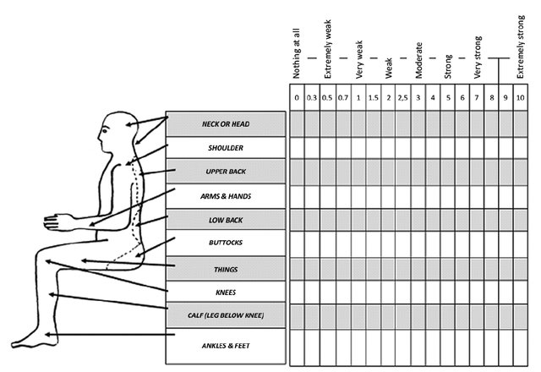
Fig 1: The body chart discomfort categories using Borg’s CR-10 scale (karuppiah et al.2012)

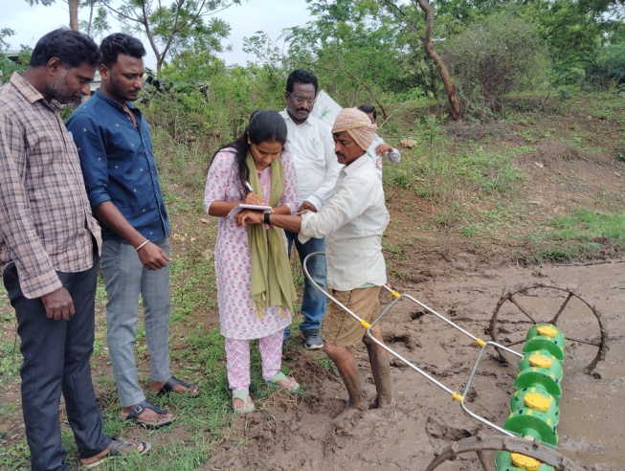 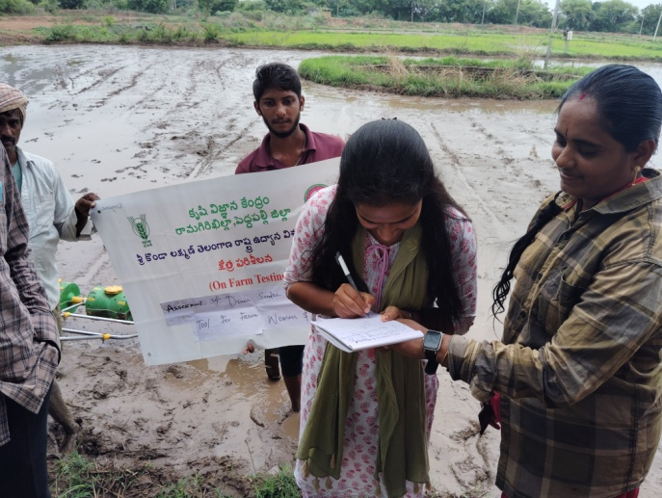Image 1: Data collection during Drum seeder in paddy
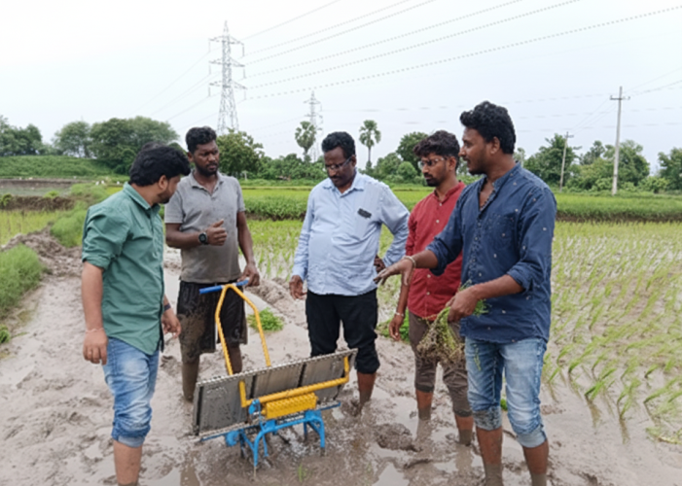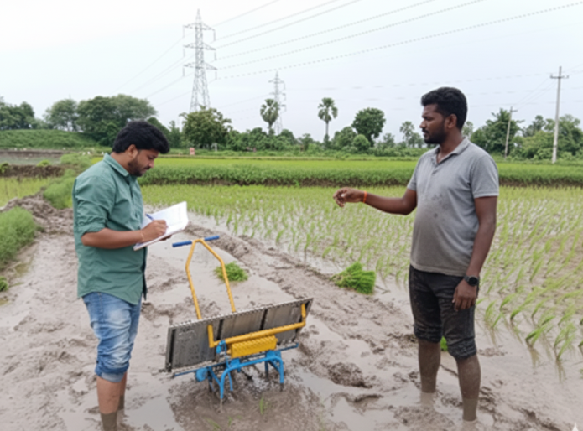 Image 2: Data collection during Two row & Three row transplanters in paddy
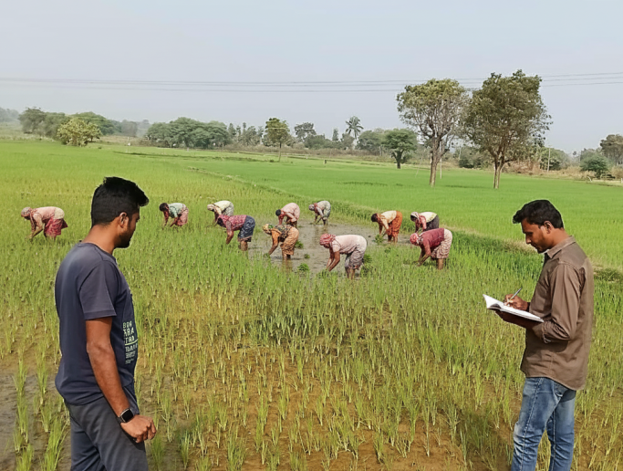 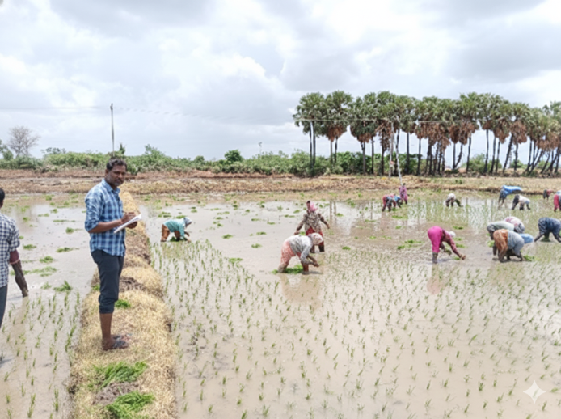 Image 3: Data collection during manual transplanting in paddy
- RESULTS AND DISCUSSION:
The results obtained from the present investigation as well as relevant discussion have been summarized under following heads:
3.1 Physical parameters of samples
Table 1 presents the descriptive statistics for the demographic and anthropometric characteristics of the study participants. The age of the participants ranged from 25 to 45 years, with a mean age of 37.90 years (Standard Deviation = 6.13), indicating that the sample primarily consisted of mid-aged adults. The body weight ranged from 55 to 74 kg, with a mean of 63.54 kg (SD = 6.63), while height ranged from 155 to 173 cm, with an average of 163.54 cm (SD = 6.17).
The Body Mass Index (BMI) of the participants was calculated based on measured height and weight values. BMI values ranged from 21.7 to 25.6 kg/m², with a mean BMI of 23.69 kg/m² (SD = 1.19), placing the majority of individuals within the normal weight category according to World Health Organization (WHO) classifications. The relatively low standard deviation of BMI indicates a homogeneous sample with respect to body composition. The results were in line with Bhuyan and Mohanty (2017)
3.2 Ergonomically evaluation of different transplanters with direct paddy seeder:
Table 3 summarizes the physiological responses of operators using three different paddy transplanting implements: the direct paddy seeder, the 2-row transplanter, and the 3-row transplanter. The parameters assessed include heart rate (HR) at rest and during work, work pulse, oxygen consumption (VO₂) at rest and during work, and energy expenditure.
Fig 2 showed that resting heart rates were relatively consistent across all treatments, ranging from 70.2 to 70.6 beats per minute (bpm), indicating similar baseline cardiovascular conditions among participants. However, significant differences were observed in heart rate during work, with the highest rate recorded during operation of the 3-row transplanter (129.8 bpm), followed by the 2-row transplanter (123.7 bpm), and the direct paddy seeder (113.5 bpm). Consequently, work pulse (i.e., the difference between working and resting HR) in Fig 3 showed that there was notably higher work pulse for the 2-row and 3-row transplanters (66.6 bpm and 59.4 bpm, respectively) compared to the direct paddy seeder (42.0 bpm).

Fig 2: Heart rate (Rest and work) for three transplanters
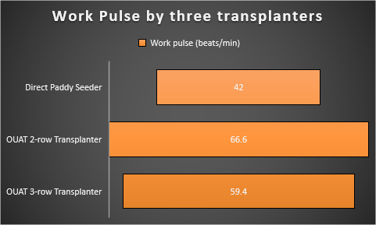
Fig 3: Work Pulse by three transplanters
Fig 4 depicted that oxygen consumption (VO₂) during work was highest for the 3-row transplanter (1.04 L/min), slightly greater than that of the 2-row transplanter (1.00 L/min), and markedly higher than the direct seeder (0.80 L/min). Corresponding energy expenditures followed a similar trend was showed in Fig 5, with the 3-row transplanter requiring the most energy (22.60 kJ/min), followed by the 2-row transplanter (21.90 kJ/min), and the direct seeder (19.05 kJ/min).

Fig 4: Oxygen consumption by using three transplanters

Fig 5: Energy consumption during usage of three transplanters
Overall, the findings suggest that mechanized transplanters—particularly the 3-row model—are associated with increased physiological workload compared to the direct paddy seeder. The significantly higher heart rate, oxygen consumption and energy expenditure recorded during transplanter operations reflect increased muscular effort under muddy field condition. The high temperature and humidity during field operations likely exacerbated thermal strain, contributing to elevated heart rate and oxygen uptake. The results were also seen in Venkat et al. (2024) study.
3.3 Body parts discomfort across different paddy establishment methods using Borg’s CR-10 scale
The mean discomfort scores and standard deviations for various body regions associated with the use of Direct Paddy Seeder, Two-Row Transplanter, and Three-Row Transplanter are presented in Table 3.
Table 3: Body parts discomfort of operators Borg’s CR-10 scale

Body Parts | Direct paddy seeder |  | Two row transplanter |  | Three row transplanter
Body Parts | Mean | SD | Mean | SD | Mean | SD
Neck and Head | 2.35 | 0.41 | 4.5 | 0.53 | 5.60 | 0.49
Shoulder | 6.3 | 0.95 | 8.6 | 0.97 | 8.7 | 0.97
Upper back | 3.8 | 0.63 | 8.2 | 0.79 | 8.4 | 0.78
Arms and Hands | 8.4 | 0.52 | 9.3 | 0.95 | 9.0 | 0.86
Low back | 5 | 0.82 | 6.5 | 0.53 | 7.0 | 0.67
Buttocks | 4.1 | 0.74 | 6.4 | 0.52 | 6.7 | 0.52
Thighs | 7 | 0.67 | 8.4 | 0.70 | 8.6 | 0.52
Knees | 8.2 | 0.79 | 8.6 | 0.52 | 8.8 | 0.63
Calf (leg below knee) | 7.1 | 0.57 | 7.5 | 0.53 | 8.0 | 0.80
Ankles and joints | 8.8 | 0.63 | 9.1 | 0.74 | 9.7 | 0.72
Total body parts | 6.105 | 2.2 | 7.71 | 1.50 | 8.05 | 1.24

3.3.1 Neck and Head
Discomfort in the neck and head region was reported to be lowest during the operation of the Direct Paddy Seeder (Mean = 2.35, SD = 0.41), while it increased significantly in the Two-Row Transplanter (Mean = 4.50, SD = 0.53) and Three-Row Transplanter (Mean = 5.60, SD = 0.49). This suggests that transplanting activities, especially in semi-mechanized forms, may impose sustained forward head postures, increasing cervical load and discomfort.

3.3.2 Shoulders and Upper Back

The shoulder region demonstrated a notable increase in discomfort levels, from a mean of 6.30 (SD = 0.95) in direct seeding to 8.60 (SD = 0.97) and 8.70 (SD = 0.97) in two- and three-row transplanting, respectively. Similarly, discomfort in the upper back rose from 3.80 (SD = 0.63) in direct seeding to 8.40 (SD = 0.78) in the three-row transplanter. These increases can be attributed to repetitive arm movements and static muscle exertion required in manual and semi-mechanized transplanting, which place significant strain on the deltoid and trapezius muscle groups.

3.3.3 Arms and Hands

Discomfort in the arms and hands was consistently high across all methods, with the Two-Row Transplanter showing the highest mean score of 9.30 (SD = 0.95). This reflects the high frequency of manual handling and gripping movements in seedling placement, especially in transplanting operations, which result in cumulative muscular fatigue in the upper extremities.

3.3.4 Lower Back and Buttocks

Discomfort in the lower back increased from 5.00 (SD = 0.82) in the direct seeder to 6.50 and 7.00 in the two- and three-row transplanters, respectively. This rise is indicative of greater lumbar stress, likely due to prolonged stooping and trunk flexion postures in transplanting tasks. Similarly, discomfort in the buttocks rose from 4.10 (SD = 0.74) to 6.70 (SD = 0.52), further highlighting the physical burden associated with semi-static or awkward sitting/kneeling postures during transplanting.

3.3.5 Lower Limbs: Thighs, Knees, Calves, and Ankles

Workers reported substantial discomfort in the lower extremities, particularly the knees and ankles, across all three methods. The Three-Row Transplanter showed the highest discomfort levels in the ankles and joints (Mean = 9.70, SD = 0.72), followed by the knees (Mean = 8.80, SD = 0.63) and thighs (Mean = 8.60, SD = 0.52). This pattern suggests that transplanting methods require more time in semi-squatting and kneeling postures, thereby increasing static and dynamic muscular strain in the lower limbs.

3.3.6 Total Body Discomfort

The overall average body discomfort score was 6.11 (SD = 2.20) for the Direct Paddy Seeder, 7.71 (SD = 1.50) for the Two-Row Transplanter, and 8.05 (SD = 1.24) for the Three-Row Transplanter. The trend reflects a clear increase in perceived physical strain with the use of more complex transplanting machinery, despite the assumption that mechanization might reduce physical workload. The higher discomfort in mechanized transplanting may result from insufficient ergonomic design, inadequate operator adjustment, or extended postural constraints during operation.

The usage of two- and three-row transplanters included prolonged stooping, forward bending, and semi-squatting postures, according to discomfort ratings for both the upper and lower bodies. The constant pushing and pulling of the transplanter handles causes static loading of the deltoid and trapezius muscles, which explains the tension on the shoulder and upper back. These outcomes are consistent with those of Inthiyaz et al. (2021), who observed that limited mobility and uncomfortable hand posture during transplantation led to higher shoulder and back discomfort.

The greater discomfort in the lower back and buttocks is attributed to prolonged trunk flexion and insufficient body support while maneuvering in muddy fields. In a same vein, frequent semi-squatting, kneeling, and uneven ground pressure—all prevalent ergonomic risks in transplanting tasks—are the cause of high knee and ankle discomfort scores. Compared to direct seeding, which permits a more erect working posture, semi-mechanized transplanting increases static strain on the lower limbs, according to studies by Bhuyan and Mohanty (2017).

3.4 Implications for Ergonomics Strategy
The findings underscore the need for ergonomic redesign of transplanting machinery to minimize musculoskeletal stress, particularly in the lower back, upper limbs, and lower extremities. While mechanization aims to improve productivity and reduce labor demand, it must also consider the operator’s physical well-being. The results suggest that direct seeding is ergonomically superior, imposing relatively lower discomfort across all body parts. Transplanting methods, particularly multi-row machines, may benefit from improved seating support, adjustable working angles, and integrated rest periods to mitigate the cumulative effects of prolonged strain.
- CONCLUSION:
In summary, this study reveals that transplanting operations, especially those involving two- and three-row machines, are associated with higher body discomfort levels compared to direct seeding. Targeted ergonomic interventions and worker-centric machinery modifications are essential to promote occupational health, enhance work efficiency, and ensure sustainable mechanized paddy cultivation.
AUTHORS’ CONTRIBUTION
Author 1: Field study as part of On Farm Testing in Krishi Vigyan Kendra, Writing and Analysis of data
Author 2: Field study as part of On Farm Testing in Krishi Vigyan Kendra
Author 3: Writing-Draft Preparation
Author 4: Writing-Draft Preparation
Author 5: Review and Editing
Author 6: Formal analysis and reviewing
CONFLICT OF INTEREST
The authors declare no conflict of interest
DATA AVAILABILITY STATEMENT
The authors do not have permission to share data

Disclaimer (Artificial intelligence)
Option 1:
Author(s) hereby declare that NO generative AI technologies such as Large Language Models (ChatGPT, COPILOT, etc.) and text-to-image generators have been used during the writing or editing of this manuscript.
Option 2:
Author(s) hereby declare that generative AI technologies such as Large Language Models, etc. have been used during the writing or editing of manuscripts. This explanation will include the name, version, model, and source of the generative AI technology and as well as all input prompts provided to the generative AI technology
Details of the AI usage are given below:
1.
2.
3.

References:
- Bhuyan, J. and Mohanty, D. K. (2017). Assessment of manual paddy transplanters for drudgery reduction of farm women in Mayurbhanj district of Odisha. Asian Journal of Home Science, 12(2): 373–377.
- Chaudhary, D, Sharma, S, and Sharma, M.K. 2022. Effect of water soaking on Physical and Engineering Properties of Paddy (Basmati 370). International Journal of Plant Soil Science. Volume 34, Issue 24. DOI: 10.9734/IJPSS/2022/v34i242673.
- Chaudhary, D., Sharma, S., Khar, S., and Srivastava, R. K. (2025). Internet of Things (IoT) and Big Data: Future of Farming. Agricultural Engineering Today.
- Directorate of Economics and Statistics (2025). Third Advance Estimates of Production of Foodgrains, Oilseeds and other Commercial Crops for the 2024–25. Government of India.https://desagri.gov.in/
- Goel, A.K., Swain, S., and Debaraj, B. (2008). Effect of seedling age on performance of rice transplanter. Journal of Agricultural Mechanics, 40(3): 41–46.
- Inthiyaz, M., Mishra, J., Mohanty, S. K., Pradhan, P. L., and Behera, D. (2021). Ergonomics of manual transplanting operations with female workers in eastern India. Journal of Ergonomics, 11(3): 1–6.
- Kamendra, D. C., Singh, S.,and Kumar, M. 2022. Ergonomic Evaluation of a Walking Type Power Operated Maize Stalk Harvester. Asian Journal of Dairy and Food Research.
- Karuppiah, K., Salit, M.S., Ismail, M. Y., Ismail, N. and Tamrin, S.B.M. 2012. Evaluation of Motorcyclist’s Discomfort during Prolonged RidingProcess with and without Lumbar Support. Anais da Academia Brasileira de Ciências. 84(4): 1169-1188
- Mohanty, S. K. and Ghosal, M. K. (2016). Ergonomical evaluation of manually operated paddy transplanters for female agricultural workers in Odisha. International Journal of Tropical Agriculture, 34(5): 1305–1310.
- Ojha, P. and Kwatra, S. (2017). Comparative ergonomic assessment of male and female farm workers involved in rice cultivation. International Journal of Current Microbiology and Applied Sciences, 6(9): 3439–3446.
- Samal, S. K., Mishra, J. N., Pradhan, R. R., Pradhan, P. L. and Mohanty, S. K. 2020. Comparison of Field Performance of Different Paddy Transplanters Available in Odisha, India.Int.J.Curr.Microbiol.App.Sci. 9(3): 992-1000
- Venkat, R., Mohan, S.S., Rahaman, S., Vinayak, M., Haribabu, B. and Reddy, K. V. S. 2024. Energy Assessment of Manual Transplanting Rice and Dry Direct Seeding Rice Production Systems in Combined Nalgonda District, Telangana. Indian Journal of Agricultural Research. 58 (1): 95-100.
- Yadav, R., Patel, M., Shukla, S. P., and Pund, S. (2007). Ergonomic evaluation of manually operated six-row paddy transplanter. International Agricultural Engineering, 16(3-4): 147–157

