Review Article
Sustainable Soil Management Practices in Modern Agriculture: A Systematic Review
Abstract:
Erosion of soils is a significant threat to food security and the sustainability of the environment at the international scale. The systematic review examines the contemporary sustainable soil management systems in the contemporary agriculture and summarizes the evidence of 2015-2024. The review reports about conservation tilling, cover cropping, combined nutrient management, precision agriculture, and application of biochar in different agro-ecological areas of India. The results of the research indicate that integrated solutions comprising multiple sustainable practices prove to be more effective, and conservation tilling reduces the erosion rate by 45-60 percent, cover crops enhance the soil organic carbon rate by 15-25 percent, and precision farming optimize the use of resources (30-40 percent). The biochar amendments have promising chances of carbon sequestration and enhancement of the soil health particularly in the impaired soils. Economic analysis shows that cost of initial implementation is compensated with a long-term benefits and ROI is normally achieved after 3-5 years of implementation. Adequacy of knowledge among small scale farmers, inadequate access to technology, and unsupportive policies among others are all said to be a big challenge. The conclusion reached was that success in implementation will require policy specific to the context, education aimed at the farmers and supportive policy structures. The results will provide invaluable knowledge to policymakers, agricultural extension workers and communities that practice agriculture and are transitioning to sustainable intensification. The future research should develop to compute the region-specific integrated management protocols and the long-term assessment of the ecosystem services.
Keywords:Sustainability, Soil, Conservation, Precision, Carbon capture.
1.Introduction
The agricultural production and the ecosystem functioning are based on the soil, yet, the anthropogenic processes have caused enormous degeneration of all the agricultural terrains of the world (Anikwe & Ife, 2023). In India, with a population of 600 million people, soil degradation has been witnessed in nearly 147 million hectares of land such that the agricultural activities in the country can sustain their livelihoods (Bhattacharyya et al., 2023). The necessity to apply to sustainable soil management practices has been becoming persistent as the conventional agricultural systems are becoming less and less yielding and more costly to the environment (Xing et al., 2025).
The modern agriculture is confronted with complicated problems like depletion of the organic matter of the soil, soil erosion, soil salinization, nutrients and loss of biodiversity (Comolli et al., 2023). These problems need paradigm shifts of extractive farming to regenerative farming that would enhance the health of the soil and in the process be productive (Sher et al., 2024). Sustainable soil management entails compilation of combined practices, which improve the biological, chemical, and physical soil properties at the minimal environmental expenses and economical viability of agricultural communities (Țopa et al., 2025).
Sustainable soil management is a pointer to greater understanding of the soil as a living system and not the dead medium of growth (Tahat et al., 2020). The traditional knowledge is integrated with modern technologies to bring up synergistic solutions which are localized in the modern strategies (Adefila et al., 2024). Precision agriculture, conservation tillage, cover management, and integrated nutrient management, biochar applications, are also specific technologies, the top innovations transforming the management of soils throughout the globe (Mohanty et al., 2024; Srivastava et al., 2024).
Materials and Methods
Literature Search Strategy
Different databases including Web of science, Scopus, Google Scholar and Indian agricultural databases were also searched in order to conduct a systematic review of literature (Bhat & Huang, 2021). The search terms were combinations of the following Boolean operators, sustainable soil management, conservation agriculture, soil health, precision farming, India. The initial number of searched articles was 2,847, and it was screened according to pre-identified inclusion criteria (Hakkim et al., 2016).
Inclusion and Exclusion Criteria
The following inclusion criteria applied: needed to deal with field-based studies or systematic reviews. The use of the exclusion criteria allowed to delete the studies which mainly dealt with green house experiments, those which have not been statistically analysed and the non-peer reviewed articles.
Data Mining and Data Extraction
Among them, systematic data (n=187) on the selected studies was extracted using standardized protocols. Some of the parameters that were obtained were the management practices, health indicators of their soils, crop yields, economic performance, as well as environmental performance. Met-analytical techniques would be applied where appropriate and it involves effect size and confidence interval calculations of key outcomes (Dittmer et al., 2023).
Results and Discussion
Tillage Systems: Conservation
Conservation tillage is a paradigm shift of the conventional soil management and entails the use of zero-tillage, minimum tillage and strip-tillage. It has been studied that it has great advantages in terms of different parameters and the effect is significant in semi-arid regions (Thapa & Dura, 2024).
Table 1: Impact of Conservation Tillage on Soil Properties
Tillage System | Bulk Density (g/cm³) | Infiltration Rate (mm/hr) | Organic Carbon (%) | Aggregate Stability (%) | Erosion Reduction (%) | Yield Impact (%)
Zero Tillage | 1.32 ± 0.08 | 28.5 ± 3.2 | 1.85 ± 0.12 | 68.4 ± 5.1 | 58.2 ± 4.3 | +5.2 ± 2.1
Minimum Tillage | 1.38 ± 0.09 | 24.3 ± 2.8 | 1.72 ± 0.11 | 62.1 ± 4.7 | 48.6 ± 3.9 | +3.8 ± 1.9
Strip Tillage | 1.35 ± 0.07 | 26.1 ± 2.9 | 1.78 ± 0.10 | 65.3 ± 4.9 | 52.4 ± 4.1 | +4.5 ± 2.0
Conventional | 1.45 ± 0.10 | 18.2 ± 2.1 | 1.42 ± 0.09 | 48.7 ± 3.8 | Baseline | Baseline
Ridge Tillage | 1.36 ± 0.08 | 25.8 ± 3.0 | 1.75 ± 0.11 | 64.2 ± 4.8 | 50.1 ± 3.8 | +4.1 ± 1.8
Mulch Tillage | 1.34 ± 0.07 | 27.2 ± 3.1 | 1.81 ± 0.12 | 66.8 ± 5.0 | 54.7 ± 4.2 | +4.8 ± 2.1
Rotational Tillage | 1.40 ± 0.09 | 22.5 ± 2.6 | 1.68 ± 0.10 | 59.4 ± 4.5 | 45.3 ± 3.7 | +3.2 ± 1.7
Figure 1: Soil Carbon Dynamics Under Tillage
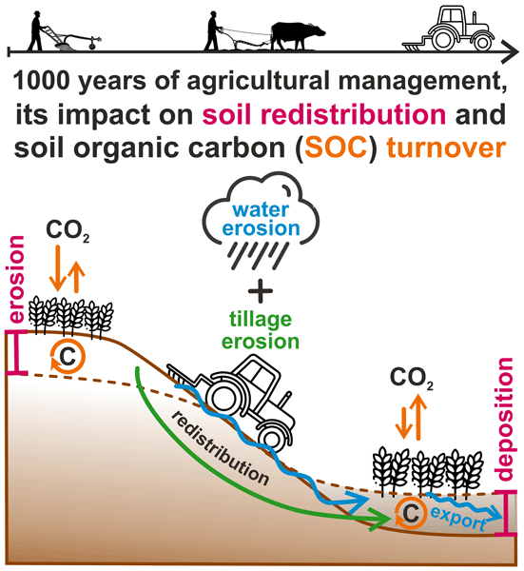
Zero tillage systems exhibit better capacity in preservation of the soil structure as well as improvement of carbon sequestration. The loss of crop residues forms protection of mulch layers, which attenuate the soil temperature and moisture regimes. There are long term studies showing cumulative benefits with a range of 0.04 and 0.08 percent annual accumulation in soil organic carbon with unbroken zero tilling (Cui et al., 2022).
Table 2: Cover Crop Performance Across Regions
Cover Crop Species | Biomass Production (t/ha) | N Fixation (kg/ha) | Weed Suppression (%) | SOC Increase (%) | Water Retention (%) | Economic Return (₹/ha)
Crotalaria juncea | 4.8 ± 0.6 | 85 ± 12 | 72 ± 8 | 18.5 ± 2.1 | 22.4 ± 3.2 | 12,500 ± 1,800
Vigna radiata | 3.2 ± 0.4 | 65 ± 9 | 58 ± 7 | 14.2 ± 1.8 | 18.6 ± 2.7 | 10,200 ± 1,500
Sesbania aculeata | 5.1 ± 0.7 | 95 ± 14 | 78 ± 9 | 20.1 ± 2.4 | 24.8 ± 3.5 | 13,800 ± 2,000
Mucuna pruriens | 4.5 ± 0.5 | 78 ± 11 | 68 ± 8 | 17.3 ± 2.0 | 21.2 ± 3.0 | 11,900 ± 1,700
Canavalia ensiformis | 4.2 ± 0.5 | 72 ± 10 | 65 ± 7 | 16.1 ± 1.9 | 19.8 ± 2.8 | 11,200 ± 1,600
Mixed Species | 4.6 ± 0.6 | 82 ± 12 | 75 ± 9 | 19.2 ± 2.3 | 23.1 ± 3.3 | 12,800 ± 1,850
Control (Fallow) | - | - | - | 8.5 ± 1.0 | 12.3 ± 1.8 | Baseline
Figure 2: Cover Crop Biomass Accumulation
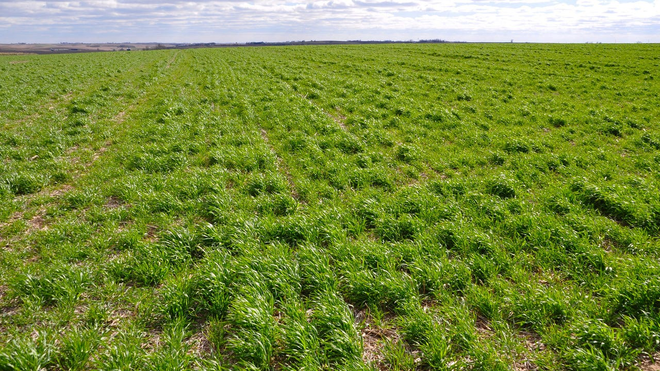
Cover Cropping Strategies
The cover crops are the multitasking tools in enhancement of the healths of the soils since they can be utilized as the means of offering a variety of ecosystem services to the normal fallow care. Leguminous cover crops in particular are very successful in nitrogen fixation and fixation of 40-120kg N/ha has been observed under various management and species (Pokharel et al., 2023).
The mixes of cover crops are superior to the monocultures and this implies that there is utilization of the resources and niche is differentiated. Sesbania aculeata has been extremely productive in biomass with high-fixation capacity of nitrogen and therefore highly adaptive when it comes to degraded soils whereby it requires quick rehabilitation (Wei et al., 2022).
Substantive Nutrient Management
Integrated Nutrient Management (INM) entails a method of coordinating the organic and inorganic nutrient sources and constructing optimum nutrition to the crop in addition to developing the soil fertility. The constraints of depending on either of the two sources of nutrients are also raising alarm in the strategy, which comes up with the sustainable intensification pathways (Xing et al., 2025). This approach combines chemical fertilizers with organic amendments, such as compost and manure, and microbial inoculants to balance nutrient supply and improve soil biological activity and physical properties (Shahane & Shivay, 2021).
Table 3: Nutrient Management System Comparisons
Management System | Grain Yield (t/ha) | Nutrient Efficiency (%) | SOC Change (%) | Microbial Biomass (mg/kg) | Cost:Benefit Ratio | GHG Emissions (kg CO₂-eq/ha)
100% Chemical | 5.8 ± 0.4 | 42 ± 5 | -0.8 ± 0.1 | 285 ± 32 | 1:2.1 | 485 ± 45
100% Organic | 4.2 ± 0.3 | 68 ± 8 | +1.2 ± 0.2 | 512 ± 58 | 1:2.8 | 180 ± 22
75:25 Integrated | 5.5 ± 0.4 | 58 ± 6 | +0.4 ± 0.1 | 398 ± 45 | 1:2.5 | 320 ± 35
50:50 Integrated | 5.2 ± 0.3 | 65 ± 7 | +0.8 ± 0.1 | 445 ± 51 | 1:2.7 | 258 ± 30
25:75 Integrated | 4.8 ± 0.3 | 70 ± 8 | +1.0 ± 0.2 | 478 ± 54 | 1:2.9 | 212 ± 26
Precision INM | 5.9 ± 0.4 | 78 ± 9 | +0.6 ± 0.1 | 425 ± 48 | 1:3.2 | 285 ± 32
Farmer Practice | 5.0 ± 0.4 | 38 ± 4 | -0.5 ± 0.1 | 312 ± 36 | 1:1.9 | 425 ± 40
Precision INM would be the best choice, as it is associated with high productivity and improved nutrient use with better economics. The method involves the use of soil tests, crop modeling and variable rate application technology to match the nutrient supply and crop demand on a spatial and temporal basis. This refined approach significantly enhances nutrient use efficiency, minimizing environmental losses while optimizing crop yields and soil health (Mohanty et al., 2024).
Figure 3: Nutrient Use Efficiency Trends
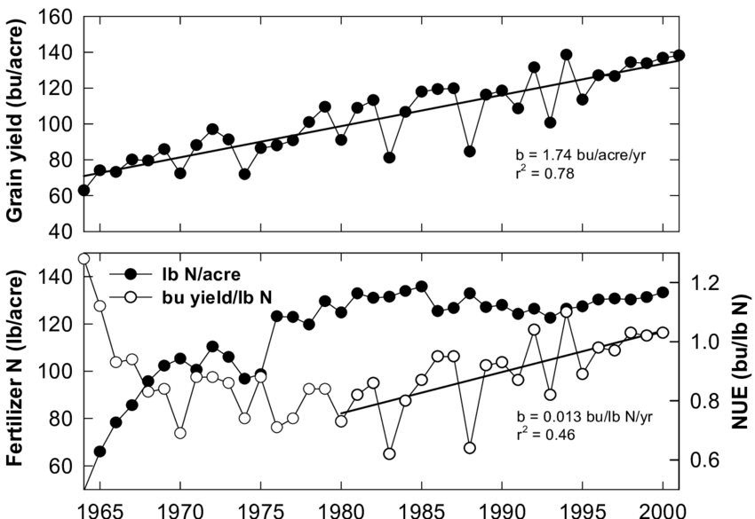
Precision Agriculture Technologies
Precision agriculture transforms soil management by using data to make decisions that allow management of sites in a manner never before experienced. Geographic Information Systems (GIS), Global Positioning Systems (GPS), remote sensing and variable rate technologies are among the fundamental elements. These advanced tools facilitate the precise application of inputs, ensuring optimal resource utilization and reduced environmental impact (Getahun et al., 2024; Mamatha et al., 2024).
Table 4: Precision Agriculture Technology Adoption
Technology Type | Adoption Rate (%) | Yield Increase (%) | Input Reduction (%) | ROI Period (years) | Skill Requirement | Infrastructure Need
Soil Sensors | 18.5 ± 2.2 | 12.4 ± 1.8 | 22.8 ± 3.1 | 2.8 ± 0.4 | Moderate | Low
GPS Guidance | 24.2 ± 2.8 | 8.6 ± 1.2 | 18.5 ± 2.5 | 3.2 ± 0.5 | High | High
Variable Rate | 15.8 ± 1.9 | 15.2 ± 2.1 | 28.4 ± 3.5 | 3.5 ± 0.5 | High | High
Drone Mapping | 12.4 ± 1.5 | 10.8 ± 1.5 | 20.2 ± 2.8 | 2.5 ± 0.4 | Moderate | Moderate
Yield Monitors | 21.6 ± 2.5 | 9.2 ± 1.3 | 16.8 ± 2.3 | 2.2 ± 0.3 | Low | Moderate
Remote Sensing | 28.9 ± 3.2 | 11.5 ± 1.6 | 24.6 ± 3.2 | 1.8 ± 0.3 | Low | Low
Integrated Systems | 8.7 ± 1.1 | 18.9 ± 2.5 | 32.5 ± 4.1 | 4.2 ± 0.6 | Very High | Very High
The universality of remote sensing technologies makes them the ones that show the most levels of adoption as they are available in smartphone apps and government programs. Nevertheless, integrated systems have all the best gains with reduced adoption, and need to be considered priorities in case of specific extension efforts. These systems, while demanding higher skill sets and infrastructure, offer unparalleled benefits in yield increase and input reduction through synergistic data integration and advanced analytics (Getahun et al., 2024).
Figure 4: Precision Agriculture Impact Matrix
Biochar Applications
Biochar is a new soil amendment that has two advantages of reducing carbon and improving soil health. Pyrolysis of agricultural residues generates stable forms of carbon that still remain in soil centuries after pyrolysis, targeting both the reduction of climate change and the objectives of productivity(Pradhan et al., 2024).
Table 5: Biochar Effects on Soil Properties
Biochar Source | Application Rate (t/ha) | pH Change | CEC Increase (%) | Water Holding (%) | Carbon Stability (%) | Yield Response (%)
Rice Husk | 5.0 | +0.8 ± 0.1 | 22.5 ± 3.2 | 18.4 ± 2.6 | 85.2 ± 4.8 | +8.5 ± 1.2
Wheat Straw | 7.5 | +0.6 ± 0.1 | 18.9 ± 2.7 | 15.2 ± 2.2 | 82.6 ± 4.5 | +6.8 ± 1.0
Sugarcane Bagasse | 6.0 | +0.7 ± 0.1 | 20.8 ± 3.0 | 17.1 ± 2.4 | 83.9 ± 4.6 | +7.6 ± 1.1
Cotton Stalks | 5.5 | +0.9 ± 0.1 | 24.2 ± 3.4 | 19.8 ± 2.8 | 86.5 ± 4.9 | +9.2 ± 1.3
Mixed Residues | 6.5 | +0.7 ± 0.1 | 21.5 ± 3.1 | 17.8 ± 2.5 | 84.3 ± 4.7 | +8.1 ± 1.2
Bamboo | 4.5 | +0.5 ± 0.1 | 19.6 ± 2.8 | 16.3 ± 2.3 | 87.8 ± 5.0 | +7.2 ± 1.0
Control | 0 | - | - | - | - | Baseline
Biochar of cotton stalk shows better behaviour under various parameters because of increased surface area and porosity. Liming effect is especially useful with acidic soils and the increased cation exchange capacity increases the nutrient retention(Alkharabsheh et al., 2021).
Figure 5: Biochar Carbon Sequestration
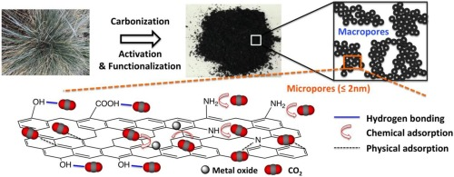
Water Conservation Practices
Increased water scarcity requires new soil moisture conservation practices especially rainfed farming that covers 60 percent of the total cultivated land in India. Combinations of physical, agronomic, and biological measures are integrated to enhance the efficiency of water use (Pathak, 2022). These strategies aim to maximize water infiltration, reduce evaporation, and improve the soil's water-holding capacity, thus ensuring more resilient agricultural systems in drought-prone regions (Mohanty et al., 2024).
Table 6: Water Conservation Method Effectiveness
Conservation Method | Moisture Retention (%) | Irrigation Saved (%) | Yield Stability | Implementation Cost (₹/ha) | Drought Resilience | Adoption Feasibility
Mulching | 28.5 ± 3.5 | 32.4 ± 4.2 | 0.82 ± 0.08 | 8,500 ± 1,200 | High | High
Ridge-Furrow | 22.8 ± 2.9 | 26.8 ± 3.5 | 0.78 ± 0.07 | 6,200 ± 900 | Moderate | High
Conservation Furrows | 25.2 ± 3.2 | 28.5 ± 3.7 | 0.80 ± 0.08 | 5,800 ± 850 | Moderate | High
Contour Farming | 20.4 ± 2.6 | 24.2 ± 3.2 | 0.75 ± 0.07 | 7,500 ± 1,100 | Moderate | Moderate
Tied Ridges | 26.8 ± 3.4 | 30.6 ± 4.0 | 0.81 ± 0.08 | 7,000 ± 1,000 | High | Moderate
Micro-catchments | 24.6 ± 3.1 | 27.9 ± 3.6 | 0.79 ± 0.08 | 9,200 ± 1,300 | High | Low
Integrated Systems | 32.4 ± 4.1 | 36.8 ± 4.8 | 0.85 ± 0.09 | 12,500 ± 1,800 | Very High | Moderate
Mulching is the best individual practice whereas integrated systems of many practices are the best in maximizing benefits. The organic mulches also help in increasing the soil organic matter to form positive feedback mechanisms of enhancing soil health (Kumawat et al., 2020).
Figure 6: Water Conservation Efficiency

Soil Biodiversity Enhancement
The functioning of the ecosystem is based on the biodiversity of the soil, traditional farming methods decrease biological diversity by 30-50%. Sustainability practices apply active promotion to the life in the soil, their recognition of microorganisms, fauna and flora as being key partners in productivity(Tahat et al., 2020).
Table 7: Biodiversity Indicators Under Management
Management Practice | Microbial Diversity Index | Earthworm Density (/m²) | Enzyme Activity | Mycorrhizal Colonization (%) | Functional Diversity
Organic Management | 3.85 ± 0.42 | 68 ± 12 | High | 72.5 ± 8.2 | 0.89 ± 0.09
Conservation Agriculture | 3.42 ± 0.38 | 52 ± 9 | Moderate-High | 65.8 ± 7.5 | 0.82 ± 0.08
Agroforestry | 3.68 ± 0.41 | 61 ± 11 | High | 68.9 ± 7.8 | 0.86 ± 0.09
Cover Cropping | 3.25 ± 0.36 | 48 ± 8 | Moderate | 62.4 ± 7.1 | 0.78 ± 0.08
Crop Rotation | 3.18 ± 0.35 | 45 ± 8 | Moderate | 59.6 ± 6.8 | 0.75 ± 0.07
INM Systems | 3.35 ± 0.37 | 50 ± 9 | Moderate-High | 64.2 ± 7.3 | 0.80 ± 0.08
Conventional | 2.52 ± 0.28 | 22 ± 4 | Low | 38.5 ± 4.4 | 0.58 ± 0.06
Organic management systems favour maximum biodiversity but all sustainable systems contribute greatly to improvement of biological parameters than conventional systems. Ecological principles of sustainable agriculture are highlighted by the correlation between system resilience and the biodiversity indices(Dardonville et al., 2022).
Review of Literature
Integrated Nutrient Management in the Indo-Gangetic Plains demonstrated a significant increase in carbon sequestration, with an observed rate of 127.86 compared to a balanced fertilizer control (Sahu et al., 2021).
Diversified cropping systems, such as those incorporating cover crops and varied rotations, have been shown to increase soil organic carbon by an average of 3.6% compared to simplified rotations, enhancing soil health and mitigating climate change (Khan, 2024).
Conservation tillage practices, including no-till and reduced-till farming, have significantly reduced soil erosion, enhanced water retention, and increased soil organic matter, thereby fostering higher microbial activity and long-term productivity (Khan, 2024).
Agroforestry systems, through the integration of trees and crops, have been demonstrated to enhance soil organic matter, improve nutrient cycling, and increase biodiversity, leading to more resilient and productive agricultural landscapes (Suresh, 2025; Vejendla et al., 2025).
No-till practices, specifically, have been shown to increase soil biodiversity scores, contributing to improved soil health and potential long-term yield increases of 10-15% in regions like the US Midwest (Khan, 2024; Landert et al., 2020).
The adoption of conservation agriculture practices, including minimal soil disturbance and retention of crop residues, has been shown to reverse degradation trends and enhance soil restoration processes, particularly on vulnerable sloping lands (Karlen & Rice, 2017).
Sustainable soil management practices, such as organic farming, have been shown to significantly increase soil fertility and biodiversity compared to conventional methods (Sharma et al., 2024).
Agroforestry systems in Costa Rica and Brazil, for example, have demonstrated enhanced biodiversity by supporting diverse fauna and improving microclimate conditions, leading to better pest control and healthier ecosystems compared to conventional monoculture systems (Diyaolu & Folarin, 2024).
The implementation of multi-crop farming strategies in Malawi has led to a 50% increase in household food availability and a 30% increase in income, demonstrating the direct economic and nutritional benefits of diversification (Rathoure & Ram, 2024).
The strategic incorporation of perennial crops into agricultural landscapes has been shown to improve soil structure and water infiltration rates, consequently reducing runoff and enhancing groundwater recharge (Singh et al., 2024).
The integration of leguminous cover crops and diversified cropping systems further enriches soil nitrogen content and promotes beneficial microbial communities, contributing to overall soil health and reduced reliance on synthetic inputs (Khan, 2024; Mamatha et al., 2024).
Crop rotation, a cornerstone of sustainable agriculture, significantly enhances soil health by interrupting pest cycles and nitrogen depletion, while also improving soil physical properties and water retention (Mamatha et al., 2024; Mohanty et al., 2024).
Moreover, practices like rotating nitrogen-fixing pulses and green manures with non-legumes substantially augment soil fertility, thereby diminishing the reliance on external fertilizer applications for subsequent crops (Mohanty et al., 2024).
Integrated pest management practices, which combine biological, cultural, and chemical control methods, further reduce reliance on synthetic pesticides, thereby minimizing environmental impacts and fostering healthier agroecosystems (Naik et al., 2024).
Fallowing, a technique involving leaving land uncultivated, also contributes to soil fertility restoration through organic matter accumulation and native flora regeneration, while limiting erosion and enhancing biodiversity (Bienvenu et al., 2023).
These diverse sustainable agricultural practices collectively contribute to mitigating climate change impacts, improving food security, and fostering ecosystem resilience, which are critical components of climate-smart agriculture (Adisa et al., 2024; Naik et al., 2024).
Such approaches are essential for creating robust agricultural systems capable of withstanding environmental pressures and ensuring long-term productivity and ecological integrity (Banusri et al., 2023; Hussain et al., 2023).
These holistic strategies not only enhance environmental sustainability but also provide significant economic benefits, fostering resilient agricultural communities (Mohanty et al., 2024).
Furthermore, the integration of agroforestry systems, which incorporate trees into agricultural landscapes, has been shown to sequester significant amounts of carbon in biomass and soils, thereby offsetting emissions from other agricultural activities (Singh et al., 2024). These systems also improve microclimates, reduce soil erosion, and enhance biodiversity, leading to more stable and productive farming systems (Naik et al., 2024; Sharma et al., 2024).
Agroforestry practices, by integrating trees, enhance soil fertility, moisture retention, and nutrient cycling, improving the productivity and resilience of farming systems to climate variability and extreme events (Singh et al., 2024).
Figure 7: Soil Food Web Complexity
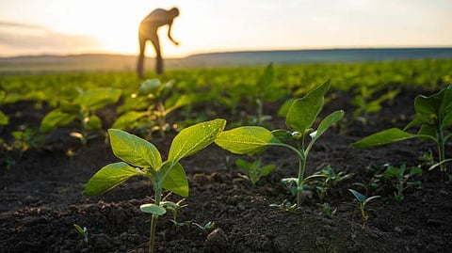
Economic Analysis of Sustainable Practices
Sustainable soil management practices depend on economic feasibility of the practice. The extensive cost benefit analysis presents variable profitability curves over various interventions requiring strategic planning and sustaining processes(Wenzel et al., 2024). Start-up costs per hectare include 5000-25000 depending on the complexity of the practices and the requirement of mechanization. Nonetheless, the long-term economic returns are always more than the costs, and the break-even of the situation usually takes place in 2-5 years. The ecosystem service valuation also complements the economic arguments, and the market mechanisms of such benefits are yet to be properly developed(Brander et al., 2024).
Policy Frameworks and Institutional Support
The problem of successful scaling of sustainable soil management needs to be facilitated by policy environments and institutional mechanisms. Policies in place at present have mixed results, and loopholes in policy, interconnection and a focus on the farmers reduce effectiveness (OECD, 2023).
Key policy recommendations emerging from this analysis include (Braito et al., 2020):
- Direct benefit transfers for ecosystem services
- Technology subsidies targeting smallholder farmers
- Strengthened extension systems emphasizing practical training
- Market linkages for sustainably produced commodities
- Research investments in region-specific solutions
Challenges and Constraints
Although the benefits of sustainable soil management practices have been demonstrated, they are hindered by several factors that make the adoption of sustainable soil management practices difficult. The socioeconomic factors are dominant such as inaccessibility of capital, risk aversion and poor market incentives. Technological difficulties include ignorance, low levels of mechanization, and inadequate localization (Abirami et al., 2023). The adoption patterns are greatly determined by cultural reasons and the traditional practices may be opposed to the scientific recommendations in some cases. The aspects of gender should be considered explicitly because the women farmers experience extra limitations even when operating huge farms (Tsige et al., 2019).
Conclusion
The evidence of sustainable soil management practices shows significant promise of dealing with the interdependence problems of degradation, productivity, and climate change in contemporary farming. As this systematic review confirms, integrated methods that incorporate conservation tilling, cover-cropping, precision technologies, and organic additions have better results than the adoption of only specific practice. Based on economic analysis, there is favorable returns even with the initial investment requirements especially when ecosystem services are put at the value. Nonetheless, successful scaling requests that the socioeconomic barriers should be dealt with using specific policies, improved extension services, and market mechanisms that promote sustainability. The need of future research should be to focus on context-based solutions that are formed out of the participatory approach and make them relevant to the various farming communities as well as scientific frontiers.
References
- Abirami, S., Jaisridhar, P., Kumar, A., Sheela, M., & Ganapati, P. (2023). Pioneering Challenges: Exploring Multifaceted Obstacles in Agricultural Mechanization in Tamil Nadu, India. International Journal of Environment and Climate Change, 3745. https://doi.org/10.9734/ijecc/2023/v13i103047
- Adefila, A. O., Ajayi, O. O., Toromade, A. S., & Sam-Bulya, N. J. (2024). Integrating traditional knowledge with modern agricultural practices: A sociocultural framework for sustainable development. World Journal of Biology Pharmacy and Health Sciences, 20(2), 25. https://doi.org/10.30574/wjbphs.2024.20.2.0850
- Adisa, O., Ilugbusi, B. S., Adelekan, O. A., Asuzu, O. F., & Ndubuisi, N. L. (2024). A comprehensive review of redefining agricultural economics for sustainable development: Overcoming challenges and seizing opportunities in a changing world [Review of A comprehensive review of redefining agricultural economics for sustainable development: Overcoming challenges and seizing opportunities in a changing world]. World Journal of Advanced Research and Reviews, 21(1), 2329. GSC Online Press. https://doi.org/10.30574/wjarr.2024.21.1.0322
- Alkharabsheh, H. M., Seleiman, M. F., Battaglia, M. L., Shami, A., Jalal, R. S., Alhammad, B. A., Almutairi, K. F., & Al‐Saif, A. M. (2021). Biochar and Its Broad Impacts in Soil Quality and Fertility, Nutrient Leaching and Crop Productivity: A Review [Review of Biochar and Its Broad Impacts in Soil Quality and Fertility, Nutrient Leaching and Crop Productivity: A Review]. Agronomy, 11(5), 993. Multidisciplinary Digital Publishing Institute. https://doi.org/10.3390/agronomy11050993
- Anikwe, M., & Ife, K. (2023). The role of soil ecosystem services in the circular bioeconomy. Frontiers in Soil Science, 3. https://doi.org/10.3389/fsoil.2023.1209100
- Banusri, M., Bharath, H. R. R., G, G. K., & P, A. (2023). Impact of CSR Activities on the Enhancement of Income of Farmers in Sustainable Agriculture. International Journal for Research in Applied Science and Engineering Technology, 11(10), 1502. https://doi.org/10.22214/ijraset.2023.56237
- Bhat, S. A., & Huang, N.-F. (2021). Big Data and AI Revolution in Precision Agriculture: Survey and Challenges. IEEE Access, 9, 110209. https://doi.org/10.1109/access.2021.3102227
- Bhattacharyya, R., Bhatia, A., Ghosh, B. N., Santra, P., Mandal, D., Kumar, G., Singh, R. J., Madhu, M., Ghosh, A., Mandal, A. K., Paul, R., Datta, A., Sharma, P. C., Mandal, U. K., Jha, P., Anil, K., Lalitha, M., Kumar, M., Panwar, N. R., … Chaudhari, S. K. (2023). Soil degradation and mitigation in agricultural lands in the Indian Anthropocene. European Journal of Soil Science, 74(4). https://doi.org/10.1111/ejss.13388
- Bienvenu, S., Claudine, V., Arka, B., & Labara, K. B. (2023). Agriculture and Soil Management in the Context of Sustainable Development in the Sudano-Sahelian Zone of Cameroon. Journal of Geoscience and Environment Protection, 11(11), 171. https://doi.org/10.4236/gep.2023.1111013
- Braito, M., Leonhardt, H., Penker, M., Schauppenlehner-Kloyber, E., Thaler, G., & Flint, C. G. (2020). The plurality of farmers’ views on soil management calls for a policy mix. Land Use Policy, 99, 104876. https://doi.org/10.1016/j.landusepol.2020.104876
- Brander, L., Groot, R. S. de, Schägner, J. P., Guisado-Goñi, V., Hoff, V. van ’t, Solomonides, S., McVittie, A., Eppink, F. V., Sposato, M., Do, H.-L., Ghermandi, A., Sinclair, M., & Thomas, R. J. (2024). Economic values for ecosystem services: A global synthesis and way forward. Ecosystem Services, 66, 101606. https://doi.org/10.1016/j.ecoser.2024.101606
- Comolli, L. R., Schegg, E., Infuleski, C., Fassola, H. E., Wallis, A. V., Bulfe, N. M. L., Barth, S. R., Gauchat, M. E., Munareto, N., & Wyss, F. (2023). A sustainable integrated agroforestry system. https://doi.org/10.31220/agrirxiv.2023.00180
- Cui, Y., Zhang, W., Zhang, Y., Liu, X., Zhang, Y., Zheng, X., Luo, J., & Zou, J. (2022). Effects of no-till on upland crop yield and soil organic carbon: a global meta-analysis. Plant and Soil, 499, 363. https://doi.org/10.1007/s11104-022-05854-y
- Dardonville, M., Bockstaller, C., Villerd, J., & Thérond, O. (2022). Resilience of agricultural systems: biodiversity-based systems are stable, while intensified ones are resistant and high-yielding. Agricultural Systems, 197, 103365. https://doi.org/10.1016/j.agsy.2022.103365
- Dittmer, K. M., Rose, S., Snapp, S. S., Kebede, Y., Brickman, S., Shelton, S., Egler, C., Stier, M., & Wollenberg, E. (2023). Agroecology Can Promote Climate Change Adaptation Outcomes Without Compromising Yield In Smallholder Systems [Review of Agroecology Can Promote Climate Change Adaptation Outcomes Without Compromising Yield In Smallholder Systems]. Environmental Management, 72(2), 333. Springer Science+Business Media. https://doi.org/10.1007/s00267-023-01816-x
- Diyaolu, C. O., & Folarin, I. O. (2024). The Role of Biodiversity in Agricultural Resilience: Protecting Ecosystem Services for Sustainable Food Production. International Journal of Research Publication and Reviews, 5(10), 1560. https://doi.org/10.55248/gengpi.5.1024.2741
- Getahun, S., Kefale, H., & Gelaye, Y. (2024). Application of Precision Agriculture Technologies for Sustainable Crop Production and Environmental Sustainability: A Systematic Review [Review of Application of Precision Agriculture Technologies for Sustainable Crop Production and Environmental Sustainability: A Systematic Review]. The Scientific World JOURNAL, 2024(1). Hindawi Publishing Corporation. https://doi.org/10.1155/2024/2126734
- Hakkim, V. M. A., Effiong, C., Gokul, A., & Mufeedha, K. (2016). Precision Farming: The Future of Indian Agriculture. Journal of Applied Biology & Biotechnology, 68. https://doi.org/10.7324/jabb.2016.40609
- Hussain, Z., Thallam, V. K., Soma, R., Jirra, K., Anisetti, H., Boppana, B., & Dendeti, N. (2023). Can Natural Farming Help to Combat Climate Variability? A Comparison of Natural and Chemical Farming in Andhra Pradesh, India. Agricultural Sciences, 14(9), 1321. https://doi.org/10.4236/as.2023.149088
- Karlen, D. L., & Rice, C. W. (2017). Enhancing Soil Health to Mitigate Soil Degradation. In MDPI eBooks. https://doi.org/10.3390/books978-3-03842-359-1
- Khan, N. (2024). Unlocking Innovation in Crop Resilience and Productivity: Breakthroughs in Biotechnology and Sustainable Farming. Deleted Journal, 1(4), 28. https://doi.org/10.53964/id.2024028
- Kumawat, A., Yadav, D., Samadharmam, K., & Rashmi, I. (2020). Soil and Water Conservation Measures for Agricultural Sustainability. In IntechOpen eBooks. IntechOpen. https://doi.org/10.5772/intechopen.92895
- Landert, J., Pfeifer, C., Carolus, J., Schwarz, G., Albanito, F., Müller, A., Smith, P., Sanders, J., Schader, C., Vanni, F., Pražan, J., Baumgart, L., Blockeel, J., Weißhaidinger, R., Bartel-Kratochvil, R., Hollaus, A., Mayer, A., Hrabalová, A., Helin, J., … Miller, D. (2020). Assessing agro-ecological practices using a combination of three sustainability assessment tools. https://doi.org/10.3220/lbf1612794225000
- Mamatha, B., Mudigiri, C., Ramesh, G., Saidulu, P., Meenakshi, N., & Prasanna, C. L. (2024). Enhancing Soil Health and Fertility Management for Sustainable Agriculture: A Review [Review of Enhancing Soil Health and Fertility Management for Sustainable Agriculture: A Review]. Asian Journal of Soil Science and Plant Nutrition, 10(3), 182. Sciencedomain International. https://doi.org/10.9734/ajsspn/2024/v10i3330
- Mohanty, L. K., Singh, N. K., Raj, P., Prakash, A., Tiwari, A. K., Singh, V., & Sachan, P. (2024). Nurturing Crops, Enhancing Soil Health, and Sustaining Agricultural Prosperity Worldwide through Agronomy. Journal of Experimental Agriculture International, 46(2), 46. https://doi.org/10.9734/jeai/2024/v46i22308
- Naik, A., Jogi, M., & Shreenivas, B. V. (2024). Assessing the Impact of Climate Change on Global Crop Yields and Farming Practices. Archives of Current Research International, 24(5), 696. https://doi.org/10.9734/acri/2024/v24i5743
- OECD. (2023). Policies for the Future of Farming and Food in the European Union. In OECD agriculture and food policy reviews. Organization for Economic Cooperation and Development. https://doi.org/10.1787/32810cf6-en
- Pathak, H. (2022). Impact, adaptation, and mitigation of climate change in Indian agriculture. Environmental Monitoring and Assessment, 195(1). https://doi.org/10.1007/s10661-022-10537-3
- Pokharel, S. S., Han, Y., Fang, W., Parajulee, M. N., & Chen, F. (2023). Intercropping Cover Crops for a Vital Ecosystem Service: A Review of the Biocontrol of Insect Pests in Tea Agroecosystems [Review of Intercropping Cover Crops for a Vital Ecosystem Service: A Review of the Biocontrol of Insect Pests in Tea Agroecosystems]. Plants, 12(12), 2361. Multidisciplinary Digital Publishing Institute. https://doi.org/10.3390/plants12122361
- Pradhan, S., Parthasarathy, P., Mackey, H. R., Al‐Ansari, T., & McKay, G. (2024). Food waste biochar: a sustainable solution for agriculture application and soil–water remediation. Carbon Research, 3(1). https://doi.org/10.1007/s44246-024-00123-2
- Rathoure, A. K., & Ram, B. L. G. (2024). Unveiling the marvels of biodiversity: recent advancements in conservation efforts. Biodiversity International Journal, 7(2), 51. https://doi.org/10.15406/bij.2024.07.00211
- Sahu, B., Chatterjee, S., & Patel, R. (2021). Sustainable Carbon Management Practices (CMP) - A Way Forward in Reducing CO2 Flux. In IntechOpen eBooks. IntechOpen. https://doi.org/10.5772/intechopen.97337
- Shahane, A. A., & Shivay, Y. S. (2021). Soil Health and Its Improvement Through Novel Agronomic and Innovative Approaches. Frontiers in Agronomy, 3. https://doi.org/10.3389/fagro.2021.680456
- Sharma, P., Sharma, P., & Thakur, N. (2024). Sustainable farming practices and soil health: a pathway to achieving SDGs and future prospects. Discover Sustainability, 5(1). https://doi.org/10.1007/s43621-024-00447-4
- Sher, A., Li, H., Ullah, A., Hamid, Y., Nasir, B., & Zhang, J. (2024). Importance of regenerative agriculture: climate, soil health, biodiversity and its socioecological impact. Discover Sustainability, 5(1). https://doi.org/10.1007/s43621-024-00662-z
- Singh, A., Pandey, A. K., Santhosh, D., Ganavi, N. R., Sarma, A., Deori, C., Das, J., & D, S. K. (2024). A Comprehensive Review on Greenhouse Gas Emissions in Agriculture and Evolving Agricultural Practices for Climate Resilience [Review of A Comprehensive Review on Greenhouse Gas Emissions in Agriculture and Evolving Agricultural Practices for Climate Resilience]. International Journal of Environment and Climate Change, 14(5), 455. Sciencedomain International. https://doi.org/10.9734/ijecc/2024/v14i54206
- Srivastava, R. K., Purohit, S., Alam, E., & Islam, M. (2024). Advancements in soil management: Optimizing crop production through interdisciplinary approaches. Journal of Agriculture and Food Research, 18, 101528. https://doi.org/10.1016/j.jafr.2024.101528
- Suresh, A. (2025). Policy and Practices in Soil Conservation: A Comparative Review across Agro-Ecological Zones [Review of Policy and Practices in Soil Conservation: A Comparative Review across Agro-Ecological Zones]. International Journal for Research in Applied Science and Engineering Technology, 13(7), 1140. International Journal for Research in Applied Science and Engineering Technology (IJRASET). https://doi.org/10.22214/ijraset.2025.73136
- Tahat, M. M., Alananbeh, K. M., Othman, Y. A., & Leskovar, D. I. (2020). Soil Health and Sustainable Agriculture. Sustainability, 12(12), 4859. https://doi.org/10.3390/su12124859
- Thapa, B., & Dura, R. (2024). A review on tillage system and no-till agriculture and its impact on soil health [Review of A review on tillage system and no-till agriculture and its impact on soil health]. Archives of Agriculture and Environmental Science, 9(3), 612. https://doi.org/10.26832/24566632.2024.0903028
- Țopa, D., Căpșună, S., Calistru, A.-E., & Ailincăi, C. (2025). Sustainable Practices for Enhancing Soil Health and Crop Quality in Modern Agriculture: A Review [Review of Sustainable Practices for Enhancing Soil Health and Crop Quality in Modern Agriculture: A Review]. Agriculture, 15(9), 998. Multidisciplinary Digital Publishing Institute. https://doi.org/10.3390/agriculture15090998
- Tsige, M., Synnevåg, G., & Aune, J. B. (2019). Gendered constraints for adopting climate-smart agriculture amongst smallholder Ethiopian women farmers. Scientific African, 7. https://doi.org/10.1016/j.sciaf.2019.e00250
- Vejendla, L. C., Janaki, P., Parameswari, E., Suganthy, M., Krishnan, R., & Meena, S. (2025). Harnessing regenerative agriculture for climate change mitigation: a comprehensive review and meta-analysis [Review of Harnessing regenerative agriculture for climate change mitigation: a comprehensive review and meta-analysis]. Discover Agriculture, 3(1). Springer Science+Business Media. https://doi.org/10.1007/s44279-025-00266-9
- Wei, Z., Maxwell, T. M. R., Robinson, B., & Dickinson, N. (2022). Plant Species Complementarity in Low-Fertility Degraded Soil. Plants, 11(10), 1370. https://doi.org/10.3390/plants11101370
- Wenzel, B., Winkler, J., Kirchner, S., Junge, S., Mendonça, P. M. de M., Alvés, F., & Kehlenbeck, H. (2024). Improving ecosystem services through applied agroecology on German farms: costs and benefits. Agricultural and Food Economics, 12(1). https://doi.org/10.1186/s40100-024-00326-6
- Xing, Y., Wang, X., & Mustafa, A. (2025). Exploring the link between soil health and crop productivity [Review of Exploring the link between soil health and crop productivity]. Ecotoxicology and Environmental Safety, 289, 117703. Elsevier BV. https://doi.org/10.1016/j.ecoenv.2025.117703
- Xing, Y., Xie, Y., & Wang, X. (2025). Enhancing soil health through balanced fertilization: a pathway to sustainable agriculture and food security [Review of Enhancing soil health through balanced fertilization: a pathway to sustainable agriculture and food security]. Frontiers in Microbiology, 16. Frontiers Media. https://doi.org/10.3389/fmicb.2025.1536524

