Review Article
The Evolution of Agricultural Extension: A Comprehensive Review of Historical Developments and Modern Practices

Abstract:
Since the beginning of agricultural extension in the 19 th century, agricultural extension has gone through extraordinary changes as being a mere transfer mechanism of knowledge has been refined into complex participatory methods. In this exhaustive review, the historical path of agricultural extension services is explored in analysis of major paradigms of technology transfer to farmer-first paradigms. The paper examines contemporary extension practices such as digital platforms, farmer field schools and innovation systems and also deals with the current issues concerning climate change adaptation, market linkages and sustainable intensification. This review centers on the most important success factors such as participation of farmers, institutional backing and integration of technology through the analysis of global case studies and Indian experiences. These results indicate that successful extension systems involve pluralistic methods comprising of the society, the business and the civil society. Future paths stipulate the necessity of the demand-driven nature of services, gender-based approach and integration of climate-smart agriculture.
Keywords: Agricultural Extension, Transfer Of Technology, Involvement Of Farmers, Digital Agriculture, Sustainable Development.
Introduction
This is due to the fact as an institution, the agricultural extension is the most important point of contact in the linking of the research institutions and the farming communities and it is the most important channel through which agricultural innovations can reach out to and rural livelihood improved. The problem of climatic change, erosion of resources and fluctuation in the markets have complicated the food security problem in the world agricultural environment, thereby making the extension services significant. The evolution of agricultural extension since the introduction of the first agricultural extension systems of the 19 th century in Europe and North America to the versions of a complex and multi stakeholder system represent the broader changes of the agricultural development paradigm shifts and the rural change processes (Hains & Hains, 2025).
Demand-based and more participatory models have superseded the classical model of agricultural extension that was characterized by top-down transfer of technology between the researchers and the farmers via government agents. In this transformation, farmers do not receive information passively but rather they are also participants in the process of creating knowledge and innovating (Kajobe et al., 2025).
Historical Evolution of Agricultural Extension
The history of agricultural extension dates back to the late 18th and early 19th centuries, with the German Raiffeisen movement and other European cooperative movements laying the foundation for farmer-based extension strategies (Khan et al., 2024; Boberg‐Fazlić et al., 2023). The institutionalization of extension services began in the early 20th century, with the Smith-Lever Act of 1914 forming the Cooperative Extension Service in the U.S. (Ramos & Herrera, 2024, p. 209). This model influenced global extension efforts, even in colonial regions. The period after WWII marked the technology transfer era, with India’s 1952 Community Development Programme being one of the largest rural development initiatives, incorporating extension into broader development goals (Bereir et al., 2024, p. 2).
Table 1: Evolution of Extension Paradigms
Period | Dominant Paradigm | Key Features | Primary Actors | Farmer Role
1850-1920 | Agricultural Societies | Demonstration plots | Progressive farmers | Observer
1920-1950 | Institutional Extension | Formal organizations | Government agencies | Recipient
1950-1980 | Technology Transfer | T&V system approach | Extension agents | Adopter
1980-2000 | Participatory Extension | Farmer involvement | Multiple stakeholders | Collaborator
2000-2010 | Pluralistic Systems | Market integration | Public-private mix | Decision maker
2010-Present | Digital Extension | ICT platforms | Tech companies | Co-creator
Future | Innovation Systems | Knowledge networks | Innovation brokers | Innovator
Modern Extension Approaches
Farmer Field Schools (FFS) emerged in Indonesia in the 1980s as a participatory learning method focused on experiential training, where farmers conduct comparative experiments. Research indicates that FFS members exhibit better technical knowledge, reduced pesticide use, and improved problem-solving abilities (“What Have We Learned from Trees? Three Decades of Farmer Field Schools on Agroforestry and Forestry,” 2022). The Agricultural Innovation Systems (AIS) approach views extension as part of broader innovation networks, connecting actors like researchers, farmers, and financial institutions (Ouerghemmi et al., 2024; Isgren et al., 2023). The Indian Agricultural Technology Management Agency (ATMA) model exemplifies this systems approach (Rao et al., 2023). Additionally, ICTs, through mobile apps, video learning, and remote sensing, have transformed extension services, enabling scalable, cost-effective information delivery (Beerge et al., 2025).
Table 2: Comparison of Extension Approaches
Approach | Coverage Scale | Cost Efficiency | Farmer Engagement
Traditional Visit | Limited | Low | Passive
Group Methods | Moderate | Medium | Active
Mass Media | Extensive | High | Minimal
Farmer Field School | Small scale | Low | Very high
Digital Platforms | Unlimited | Very high | Interactive
Innovation Systems | Network-based | Variable | Collaborative
Private Extension | Market-driven | Self-sustaining | Customer-focused
Contemporary Challenges and Opportunities
Climate change presents a significant challenge for extension services, requiring location-specific guidance for farmers on weather conditions, crop selection, and adaptation strategies (Habanyati & Paramasivam, 2025, p. 5; Makamane et al., 2025). Modern extension services increasingly focus on market integration, providing farmers with not only production technologies but also information on market prices, quality standards, and post-harvest practices (Ma et al., 2024). Despite women comprising 43% of the global agricultural workforce, extension services have traditionally been gender-neutral (Sahu et al., 2024, p. 7). Recent initiatives emphasize gender-responsive programming, with women extension workers and efforts to address the unique challenges faced by female farmers (“Women as Agents of Change for Greening Agriculture and Reducing Gender Inequality,” 2023).
Table 3: Gender Dimensions in Extension
Aspect | Traditional Approach | Gender-Responsive Approach | Impact Indicators
Targeting | Male household heads | Women farmers directly | Participation rates
Timing | Regular working hours | Flexible scheduling | Attendance levels
Content | Cash crop focus | Nutrition gardens | Adoption rates
Delivery | Male extensionists | Women agents preferred | Knowledge retention
Technology | Complex machinery | Appropriate tools | Labor reduction
Groups | Mixed gatherings | Women-only spaces | Group dynamics
Leadership | Male-dominated | Women representatives | Decision influence
Figure 1: Gender-Responsive Extension Framework
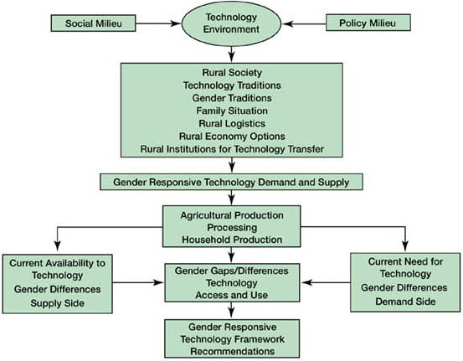
Digital Transformation in Extension
Mobile-Based Advisory Services
The Indian government has suggested an mKisan portal that provides guidance to the registered farmers of more than 3 million through the use of texts message, voice call as well as smartphone apps which provides the customer with a timely update on the weather, pests management and market rates (Balkrishna et al., 2024, p. 11).
Exact Agriculture Technologies.
The accessibility is increasing even though the adoption is still limited to the progressive farmers, there are demonstration effects and cost reduction (Parra-López et al., 2024).
Machine Learning and Artificial Intelligence
Technology in image recognition can be used to conduct pest and disease diagnosis using smartphone cameras in a very fast manner (Wu et al., 2025).
Figure 2: Digital Extension Ecosystem
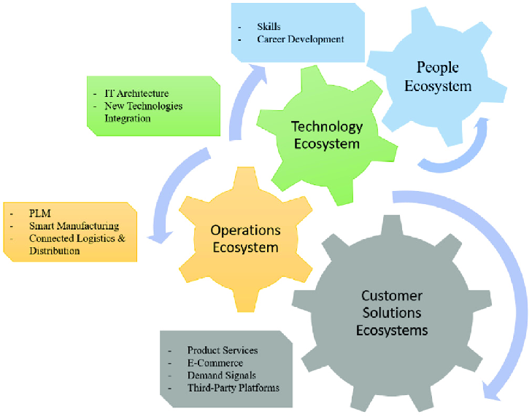
Institutional Arrangements and Governance
Public extension systems in developing countries are primarily government-driven, with agriculture advisory services provided by various government departments at national, state, and local levels, such as India’s Department of Agriculture, Krishi Vigyan Kendras (Farm Science Centres), and ATMA (Tetteh et al., 2025, p. 13). The private sector also plays a significant role, with input companies, agribusiness firms, and contract farming companies offering embedded extension services. However, the involvement of the private sector raises concerns about bias in business goods, highlighting the need for stronger regulatory frameworks to ensure fairness (Venkattakumar et al., 2024, p. 1020; Ma et al., 2024). Civil society organizations, often informal, also contribute to extension efforts, though they remain marginal compared to official systems (Byaruhanga, 2024; Zarnegar & 1958-, 2025).

Table 4: Extension Service Providers
Provider Type | Coverage Focus | Funding Source | Service Quality | Accountability
Government | Universal mandate | Public budget | Variable | Political system
Private Companies | Customer base | Business revenue | Product-focused | Market forces
NGOs | Marginalized groups | Donor funding | Community-oriented | Donor requirements
Farmer Organizations | Member services | Membership fees | Demand-driven | Member control
Research Institutes | Technology testing | Research grants | Science-based | Academic standards
Media Organizations | Mass audience | Advertising | Information-only | Audience ratings
Digital Platforms | Tech-savvy farmers | Venture capital | Data-driven | User metrics
Impact Assessment and Effectiveness
Evaluating the efficacy of diverse extension approaches is essential for optimizing resource allocation and improving agricultural productivity, particularly when considering the socio-economic and environmental contexts of various farming communities (Siankwilimba, 2021, p. 873). Measurement challenges in evaluating extension impact include issues like attribution, time lag, and spillovers. To overcome these challenges, integrating advanced econometric models and quasi-experimental designs is critical. These methods help address problems of endogeneity and selection bias, thereby improving the causal inference of extension program effectiveness (Baul et al., 2024).
Figure 3: Pluralistic Extension System
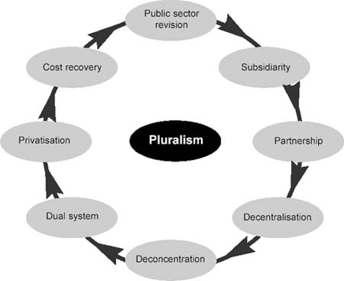
Evidence of Impact
Extension programs show positive, but varied, impacts. Investment returns range from 15% to over 50%, influenced by program design, implementation quality, and context (Amghani et al., 2023; Kalogiannidis & Syndoukas, 2024). Effectiveness depends on socio-economic conditions, farming systems, and institutional frameworks (Sahu et al., 2024). Successful programs often feature demand-driven approaches, participatory methods, and farmer capacity building (“Agricultural Innovation Systems,” 2012; Harder, 2015).
Success Factors
Successful programs include farmer participation, adequate funding, trained staff, relevant content, proper delivery, and strong research-extension linkages.

Table 5: Extension Impact Indicators
Domain | Traditional Indicators | Modern Indicators | Measurement Methods
Knowledge | Awareness levels | Skill application | Tests/surveys
Adoption | Technology uptake | Innovation adaptation | Field observations
Productivity | Yield increase | Resource efficiency | Crop cutting
Economic | Gross returns | Net profitability | Cost-benefit analysis
Environmental | Input reduction | Ecosystem services | Soil/water testing
Social | Group formation | Social capital | Network analysis
Institutional | Service delivery | System performance | Program evaluation
Figure 4: Extension Impact Pathway
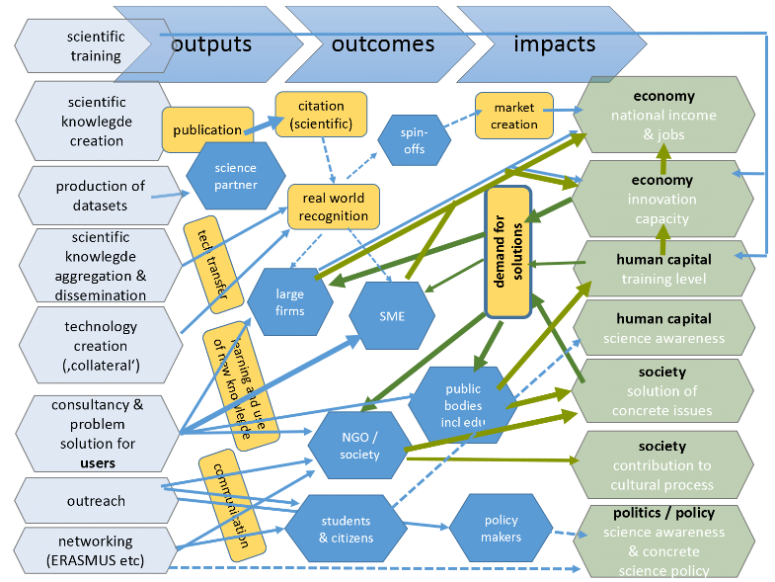
Case Studies from India
e-NAM (National Agriculture Market)
The electronic National Agriculture Market has unified the agricultural markets in India via the digital platform (Siankwilimba, 2021, p. 873; Venkattakumar et al., 2024, p. 1026). The extension services assist in registration of farmers, quality grading and on-line trading (Kumari et al., 2024, p. 657).
Figure 5: Indian Extension Innovations
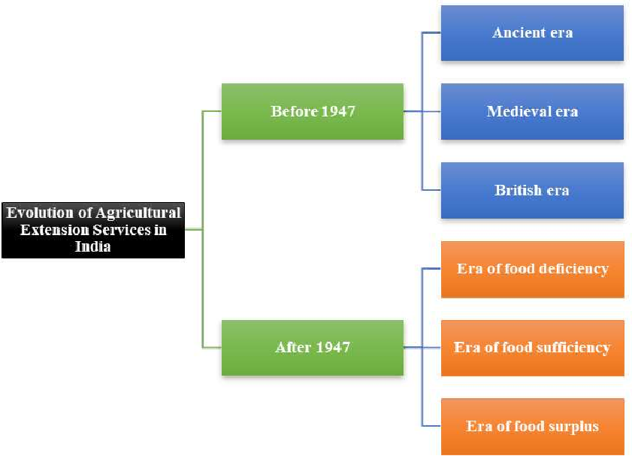
Soil Health Card Scheme
This program provides farmers with soil nutrient status and fertilizer recommendations, aiming to improve fertilizer use efficiency and promote sustainable agricultural practices (Balkrishna et al., 2024; Mohanty et al., 2024).
Zero Budget Natural Farming
The Andhra Pradesh natural farming initiative uses farmer-to-farmer extension, led by community resource persons, often women, to encourage chemical-free farming. This approach, supported by credit access and education, enhances welfare and promotes sustainable practices (Berger et al., 2025; Habanyati & Paramasivam, 2025; Kumar et al., 2024; Mamatha et al., 2024).
Future Directions and Emerging Trends
The future of agricultural extension involves digital tools using AI and machine learning for personalized recommendations, optimizing farm management and enhancing crop resilience (Seevers, 2012; Kumar, 2024). Integrated platforms will offer services like credit, insurance, and market access, reducing transaction costs and improving economic resilience (Tran & Touch, 2024; Sen et al., 2025).
Youth Engagement
Attracting educated youth to agriculture requires integrating entrepreneurship, technology, and value addition into extension services, with agri-startups and incubation centers as key drivers (Oluwatayo & Ojo, 2024; Chirinda et al., 2024; Kuśka et al., 2024).
Big Data and AI
The use of predictive analytics, automated advisory systems, and precision recommendations will revolutionize extension services, though concerns around equitable access and data privacy must be addressed (Parra-López et al., 2024; Venkattakumar et al., 2024; Adewusi et al., 2024).
Policy Recommendations
A coordinated system among extension providers requires proper regulation, quality monitoring, and capacity building for extension personnel (Zafar et al., 2024; Timsina et al., 2023). Financial sustainability can be achieved through diversified funding sources and cost-effective delivery mechanisms (Carrard et al., 2024).

Important Facts
- Digital agriculture, encompassing technologies like big data, IoT and robotics, is transforming food production and agricultural resource management, though its adoption faces challenges due to a shortage of qualified personnel and financial resources in some regions (Gamage et al., 2024, p. 100429).
- The global population is projected to reach 9.8 billion by 2050, necessitating advanced agricultural solutions and smart technologies to ensure sustained food security (Siankwilimba et al., 2023, p. 17).
- Digital twins, for example, could significantly enhance agricultural production by enabling predictive modeling for disease and pest outbreaks, allowing for proactive and preventative strategies that reduce reliance on pesticides (Finger, 2025, p. 104518).
- Although high costs, regulatory hurdles, data requirements and limited monitoring capabilities currently restrict the widespread use of these sophisticated approaches, their potential for future adoption remains substantial (Finger, 2025, p. 104518).
- Mobile technologies have proven particularly effective in disseminating agricultural information, contributing to a 4% increase in yields within sub-Saharan Africa and India (Gamage et al., 2024, p. 100427).
- Digitalization plays an essential role in supporting precision agriculture, integrating solutions with machinery, sensors and drones to achieve scalable impact (“Leveraging Automation and Digitalization for Precision Agriculture: Evidence from the Case Studies,” 2022, p. 50).
- National policies, including data protection and privacy regulations, along with investments in national data infrastructures, connectivity and rural electricity, are critical enablers for the widespread adoption of such digital and automation solutions (“Leveraging Automation and Digitalization for Precision Agriculture: Evidence from the Case Studies,” 2022, p. 12).
- Digital agriculture significantly contributes to climate resilience by enabling farmers to adapt practices through real-time monitoring of weather and soil conditions (Sultan, 2021, p. 68).
- Moreover, integrating digital technologies in agricultural extension services promotes climate-smart practices, thereby enhancing the resilience and sustainability of farming communities (Xu et al., 2024).
- Such advancements are crucial given that digital agriculture is essential for sustainable agricultural activities and can effectively address challenges like rising temperatures, changing seasons and decreased soil fertility (Abashidze, 2023, p. 18).
- These digital tools, by enabling continuous monitoring and data-driven decision-making, significantly reduce waste and boost overall productivity, contributing to a more sustainable agricultural ecosystem (Taha et al., 2025, p. 5).
- Advanced digital agriculture applications, such as yield monitoring, smart irrigation and supply chain management, further optimize resource allocation and minimize post-harvest losses, enhancing overall efficiency and sustainability (Fuentes-Peñailillo et al., 2024, p. 56).
- Furthermore, the integration of these digital tools facilitates better environmental stewardship by optimizing input usage and mitigating agricultural runoff, contributing to broader ecological health (Shamshiri et al., 2024, p. 26).
- The application of precision planting and irrigation systems, alongside GPS-guided machinery and drones, allows farmers to optimize nutrient and water delivery, manage land efficiently and control pests, leading to increased crop yields and improved agricultural productivity, particularly evident in regions such as Africa (Nwokolo et al., 2023, p. 105).
- The broad adoption of digital agricultural solutions is constrained by high costs, regulatory complexities, data requirements and limited monitoring capabilities, necessitating collaborative efforts from policymakers, researchers and farmers to ensure sustainable and equitable benefits (Balasundram et al., 2023; Mansoor et al., 2025, p. 17; Parra-López et al., 2024).
- Digital agriculture, employing advanced technological solutions like sensors, robotics and data analytics, is critical for enhancing the ecological and economic viability of agricultural operations while simultaneously boosting crop output and quality (Shamshiri et al., 2024).
- These innovations enable more efficient farming practices, such as precision planting and variable rate application technologies, which optimize seed and fertilizer placement while minimizing waste (Sultan, 2021, p. 67).
- The integration of IoT sensors in autonomous agricultural machinery further refines these processes, allowing for real-time adjustments and precise resource allocation that significantly improve crop establishment and yield (Khan, 2024, p. 35).
- Moreover, digital technologies enhance farm agility, enabling rapid responses to environmental changes through real-time surveillance and forecasting, which helps in crop preservation (Singh et al., 2022, p. 444).
Table 6: Strategic Recommendations
Area | Current Gaps | Recommended Actions | Implementation Timeline
Coordination | Fragmentation | Platform creation | 1-2 years
Capacity | Skill deficits | Training programs | Continuous
Technology | Digital divide | Infrastructure | 3-5 years
Participation | Top-down approach | Farmer committees | 1-3 years
Sustainability | Donor dependence | Revenue models | 2-4 years
Innovation | Rigid systems | Experimentation | Ongoing
Monitoring | Weak M&E | Digital tracking | 1-2 years

10. Synthesis, Limitations and Future Research
Synthesis of Findings
A comprehensive understanding of sustainable agricultural practices is essential for addressing global challenges and ensuring food security (Hussein et al., 2024). The bibliometric analysis emphasizes the need to adapt precision agriculture, smart farming, machine learning, and IoT technologies for developing regions, which is critical for mitigating climate change and enhancing food security (Gamage et al., 2024; Hassim et al., 2024; Ngongolo & Gayo, 2024). However, significant barriers such as high initial costs, limited rural connectivity, and lack of technical expertise hinder widespread adoption (Issa et al., 2024; Khan, 2024). Overcoming these challenges requires strategies including government subsidies, infrastructure development, and training programs for farmers (Fuentes-Peñailillo et al., 2024; Issa et al., 2024).
Methodological and Contextual Limitations
Future research should focus on comparative assessments of regional and international policies to identify the most effective frameworks for promoting sustainability (Contreras et al., 2025). Additionally, exploring the integration of explainable AI in precision agriculture decision-support systems can address stakeholder skepticism and improve trust in AI-driven recommendations (Luque-Reyes et al., 2025; Ugwu et al., 2025; Alazzai et al., 2024). These efforts will help advance digital technology adoption in agriculture and ensure long-term sustainability.

Figure 6: Sustainable Extension Model
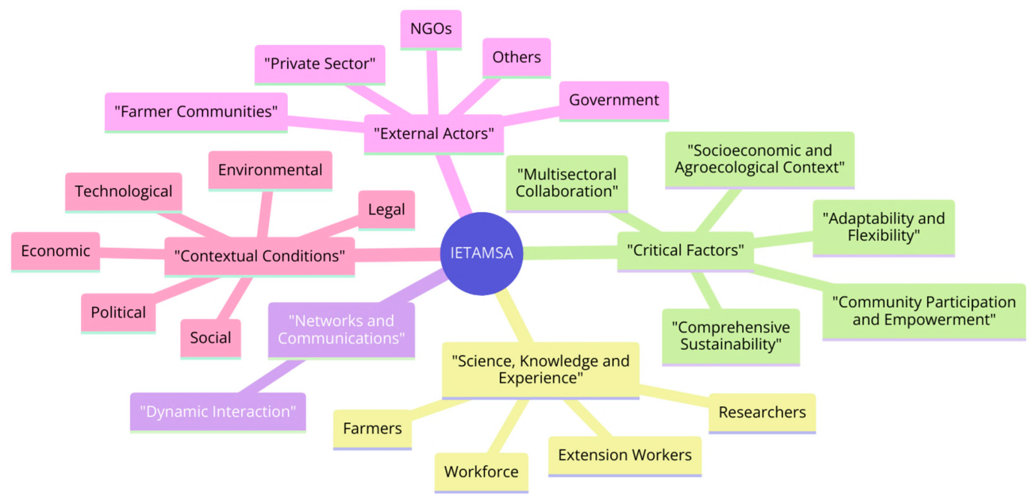

Agenda for Future Research
Future research should also prioritize the development of affordable, accessible and user-friendly precision agriculture solutions, particularly for smallholder farmers in resource-limited settings (Getahun et al., 2024, p. 8; Polwaththa et al., 2024, p. 57).

Conclusion
The change in the technological transfer of agricultural extension to modern pluralistic transfers is indicative of the wider changes in the agricultural development paradigm. The contemporary extension services are forced to overcome intricate issues such as climate change, integration in the market and digitalization with the aim to deliver inclusive and sustainable results. The adaptive institutional arrangements, long-term commitment to the human resources and the farmer-focused approach that acknowledges the role of agricultural communities in the innovation processes are the keys to success.

Disclaimer (Artificial intelligence)
Option 1:
Author(s) hereby declare that NO generative AI technologies such as Large Language Models (ChatGPT, COPILOT, etc.) and text-to-image generators have been used during the writing or editing of this manuscript.
Option 2:
Author(s) hereby declare that generative AI technologies such as Large Language Models, etc. have been used during the writing or editing of manuscripts. This explanation will include the name, version, model, and source of the generative AI technology and as well as all input prompts provided to the generative AI technology
Details of the AI usage are given below:
1.
2.
3.

References
Abashidze, G. (2023). Digital agriculture - technological means and possibilities of digital transformation of agriculture. Proceedings of the International Scientific Conference “Economic Science for Rural Development”/Economic Science for Rural Development, 57, 13. https://doi.org/10.22616/esrd.2023.57.001
Adewusi, A. O., Asuzu, O. F., Olorunsogo, T., Olorunsogo, T., Adaga, E. M., & Daraojimba, D. O. (2024). AI in precision agriculture: A review of technologies for sustainable farming practices [Review of AI in precision agriculture: A review of technologies for sustainable farming practices]. World Journal of Advanced Research and Reviews, 1, 2276. GSC Online Press. https://doi.org/10.30574/wjarr.2024.21.1.0314
Agricultural Innovation Systems. (2012). In The World Bank eBooks. https://doi.org/10.1596/978-0-8213-8684-2
Alazzai, W. K., Abood, B. Sh. Z., Al–Jawahry, H. M., & Obaid, M. K. (2024). Precision Farming: The Power of AI and IoT Technologies. E3S Web of Conferences, 491, 4006. https://doi.org/10.1051/e3sconf/202449104006
Amghani, M. S., Mojtahedi, M., & Savari, M. (2023). An economic effect assessment of extension services of Agricultural Extension Model Sites for the irrigated wheat production in Iran. Scientific Reports, 13(1). https://doi.org/10.1038/s41598-023-44290-5
Balasundram, S. K., Shamshiri, R. R., Sridhara, S., & Rizan, N. (2023). The Role of Digital Agriculture in Mitigating Climate Change and Ensuring Food Security: An Overview. Sustainability, 15(6), 5325. https://doi.org/10.3390/su15065325
Balkrishna, A., Singh, S. K., Pathak, R., & Arya, V. (2024). E-governance paradigm in the Indian agricultural sector. Discover Agriculture, 2(1). https://doi.org/10.1007/s44279-024-00012-7
Baul, T., Karlan, D., Toyama, K., & Vasilaky, K. (2024). Improving smallholder agriculture via video-based group extension. Journal of Development Economics, 169, 103267. https://doi.org/10.1016/j.jdeveco.2024.103267
Beerge, R., Devarmani, S., & Kumbar, D. (2025). Scope and challenges of farm digitization in India. Proceedings of the Indian National Science Academy. https://doi.org/10.1007/s43538-025-00651-4
Bereir, A., Elfaki, M., & Khalifa, E. H. (2024). Evaluating Selected Agricultural Extension Approaches in Rural Sudan. In IntechOpen eBooks. IntechOpen. https://doi.org/10.5772/intechopen.114130
Berger, I., Kamble, A. K., Morton, O., Raj, V., Nair, S. S., Edwards, D. P., Wauchope, H. S., Joshi, V., Basu, P., Smith, B., & Dicks, L. V. (2025). India’s agroecology programme, ‘Zero Budget Natural Farming’, delivers biodiversity and economic benefits without lowering yields. Nature Ecology & Evolution. https://doi.org/10.1038/s41559-025-02849-7
Boberg‐Fazlić, N., Jensen, P. S., Lampe, M., Sharp, P., & Skovsgaard, C. V. (2023). ‘Getting to Denmark’: the role of agricultural elites for development. Journal of Economic Growth, 28(4), 525. https://doi.org/10.1007/s10887-023-09226-8
Byaruhanga, R. (2024). NGOisation and food sovereignty: unearthing the intricacies of NGO-driven food sovereignty efforts. Insights from Uganda. Agriculture and Human Values, 42(2), 905. https://doi.org/10.1007/s10460-024-10645-5
Carrard, N., Willetts, J., Kome, A., & Munankami, R. (2024). Sustainable cost recovery principles can drive equitable, ongoing funding of critical urban sanitation services. Npj Clean Water, 7(1). https://doi.org/10.1038/s41545-024-00399-2
Chirinda, N., Abdulkader, B., Hjortsø, C. N., Aitelkadi, K., Salako, K. V., Taarji, N., Mhada, M., Lamdaghri, Z., Romanova, G. P., Assogbadjo, A. E., Chadaré, F. J., Saidi, M., Sassi, M., Mugonola, B., Gogo, E. O., Ssekandi, J., Okalany, E., Egeru, A., Mshenga, P. M., & Chfadi, T. (2024). Perspectives on the integration of agri-entrepreneurship in tertiary agricultural education in Africa: insights from the AgriENGAGE project. Frontiers in Sustainable Food Systems, 8. https://doi.org/10.3389/fsufs.2024.1348167
Contreras, R. L. G., Puertas, R., & Martínez-Gómez, V. (2025). Bibliometric analysis of emerging trends and future prospects in sustainable agriculture. Discover Sustainability, 6(1). https://doi.org/10.1007/s43621-025-01901-7
Finger, R. (2025). Sustainable crop protection and the role of digital agriculture. Agricultural Systems, 231, 104516. https://doi.org/10.1016/j.agsy.2025.104516
Fuentes-Peñailillo, F., Gutter, K., Vega, R., & Carrasco, G. (2024). Transformative Technologies in Digital Agriculture: Leveraging Internet of Things, Remote Sensing and Artificial Intelligence for Smart Crop Management. Journal of Sensor and Actuator Networks, 13(4), 39. https://doi.org/10.3390/jsan13040039
Gamage, A., Gangahagedara, R., Subasinghe, S., Gamage, J., Guruge, C., Senaratne, S., Randika, T., Rathnayake, C., Hameed, Z., Madhujith, T., & Merah, O. (2024). Advancing Sustainability: The Impact of Emerging Technologies in Agriculture. Current Plant Biology, 100420. https://doi.org/10.1016/j.cpb.2024.100420
Getahun, S., Kefale, H., & Gelaye, Y. (2024). Application of Precision Agriculture Technologies for Sustainable Crop Production and Environmental Sustainability: A Systematic Review [Review of Application of Precision Agriculture Technologies for Sustainable Crop Production and Environmental Sustainability: A Systematic Review]. The Scientific World JOURNAL, 2024(1). Hindawi Publishing Corporation. https://doi.org/10.1155/2024/2126734
Habanyati, E. J., & Paramasivam, S. (2025). Extension models in sustainable agriculture adoption in South Asia and sub-Saharan Africa. South African Journal of Science, 121. https://doi.org/10.17159/sajs.2025/20578
Hains, B. J., & Hains, K. D. (2025). Pondering Theory within Extension & Community Education: An Exploration of New Frontiers & Frameworks. Journal of International Agricultural and Extension Education, 32(1). https://doi.org/10.4148/2831-5960.1500
Harder, A. (2015). Introduction and Table of Contents. Journal of International Agricultural and Extension Education, 22(3), 1. https://doi.org/10.4148/2831-5960.1269
Harnessing dividends from drylands: innovative scaling up with soil nutrients. (2016). In CABI eBooks. https://doi.org/10.1079/9781780648156.0000
Hassim, O. A., Osman, I., Awal, A., & Amin, F. M. (2024). Navigating the Path to Equitable and Sustainable Digital Agriculture among Small Farmers in Malaysia: A Comprehensive Review [Review of Navigating the Path to Equitable and Sustainable Digital Agriculture among Small Farmers in Malaysia: A Comprehensive Review]. Information Management and Business Review, 16, 173. International Foundation for Research and Development. https://doi.org/10.22610/imbr.v16i2(i)s.3795
Hussein, A. H. A., Jabbar, K. A., Mohammed, A., & Jasim, L. (2024). Harvesting the Future: AI and IoT in Agriculture. E3S Web of Conferences, 477, 90. https://doi.org/10.1051/e3sconf/202447700090
Isgren, E., Clough, Y., Murage, A. W., & Andersson, E. (2023). Are agricultural extension systems ready to scale up ecological intensification in East Africa? A literature review with particular attention to the Push-Pull Technology (PPT) [Review of Are agricultural extension systems ready to scale up ecological intensification in East Africa? A literature review with particular attention to the Push-Pull Technology (PPT)]. Food Security, 15(5), 1399. Springer Science+Business Media. https://doi.org/10.1007/s12571-023-01387-z
Issa, A. A., Majed, S., Ameer, S., & Al–Jawahry, H. M. (2024). Farming in the Digital Age: Smart Agriculture with AI and IoT. E3S Web of Conferences, 477, 81. https://doi.org/10.1051/e3sconf/202447700081
Kajobe, R., Kabuga, E. M., Dricile, R., Wadri, V., Malingumu, R., & Yumbya, P. (2025). Pioneering the use of embedded research translation methodology for potential increased income and livelihoods of smallholder farmers. Frontiers in Sustainable Food Systems, 9. https://doi.org/10.3389/fsufs.2025.1508040
Kalogiannidis, S., & Syndoukas, D. (2024). The Impact of Agricultural Extension Services on Farm Output: A Worldwide Viewpoint. Research on World Agricultural Economy, 5(1), 96. https://doi.org/10.36956/rwae.v5i1.999
Khan, R. P., Gupta, S., Daum, T., Birner, R., & Ringler, C. (2024). Levelling the field: A review of the ICT revolution and agricultural extension in the Global South [Review of Levelling the field: A review of the ICT revolution and agricultural extension in the Global South]. Journal of International Development, 37(1), 1. Wiley. https://doi.org/10.1002/jid.3949
Korinek, A., & Stiglitz, J. E. (2021). Artificial Intelligence, Globalization and Strategies for Economic Development. https://doi.org/10.3386/w28453
Kumar, A., Mishra, A. K., Singh, A., Saroj, S., M., M. M., & Joshi, P. (2024). Impact of India’s farm science centers (Krishi Vigyan Kendras) on farm households’ economic welfare: An evidence from a national farmers’ survey. The Indian Journal of Agricultural Sciences, 94, 63. https://doi.org/10.56093/ijas.v94i3.148771
Kumar, R. (2024). Transforming Agriculture: Exploring Diverse Practices and Technological Innovations. arXiv (Cornell University). https://doi.org/10.48550/arxiv.2411.00643
Kumari, S. S., Singh, K. M., & Ahmad, N. (2024). Cashless Economy: The Impact of Digital Innovation in India. Current Science, 126(6), 650. https://doi.org/10.18520/cs/v126/i6/650-661
Kuśka, M. T., Wahabzada, M., & Paulus, S. (2024). AI for crop production – Where can large language models (LLMs) provide substantial value? Computers and Electronics in Agriculture, 221, 108924. https://doi.org/10.1016/j.compag.2024.108924
Leveraging automation and digitalization for precision agriculture: Evidence from the case studies. (2022). In FAO eBooks. https://doi.org/10.4060/cc2912en
Luque-Reyes, J. R., Zidi, A., Peña, A., & Gallardo‐Cobos, R. (2025). Assessing Agri-Food Digitalization: Insights from Bibliometric and Survey Analysis in Andalusia. World, 6(2), 57. https://doi.org/10.3390/world6020057
Ma, W., Rahut, D. B., Sonobe, T., & Gong, B. (2024). Linking farmers to markets: Barriers, solutions and policy options. Economic Analysis and Policy, 82, 1102. https://doi.org/10.1016/j.eap.2024.05.005
Makamane, A., Loki, O., Swanepoel, J. W., Zenda, M., & Niekerk, J. V. (2025). Farmers’ perceptions on the capacity of extension practitioners on climate change in the Eastern Cape Province of South Africa. Frontiers in Climate, 7. https://doi.org/10.3389/fclim.2025.1534254
Mamatha, B., Mudigiri, C., Ramesh, G., Saidulu, P., Meenakshi, N., & Prasanna, C. L. (2024). Enhancing Soil Health and Fertility Management for Sustainable Agriculture: A Review [Review of Enhancing Soil Health and Fertility Management for Sustainable Agriculture: A Review]. Asian Journal of Soil Science and Plant Nutrition, 10(3), 182. Sciencedomain International. https://doi.org/10.9734/ajsspn/2024/v10i3330
Mansoor, S., Iqbal, S., Popescu, S. M., Kim, S. L., Mansoor, S., & Baek, J. (2025). Integration of smart sensors and IOT in precision agriculture: trends, challenges and future prospectives [Review of Integration of smart sensors and IOT in precision agriculture: trends, challenges and future prospectives]. Frontiers in Plant Science, 16. Frontiers Media. https://doi.org/10.3389/fpls.2025.1587869
Manzoor, F., Wei, L., Siraj, M., Lu, X., & Qiyang, G. (2025). Digital agriculture technology adoption in low and middle-income countries—a review of contemporary literature. Frontiers in Sustainable Food Systems, 9. https://doi.org/10.3389/fsufs.2025.1621851
Mohanty, L. K., Singh, N. K., Raj, P., Prakash, A., Tiwari, A. K., Singh, V., & Sachan, P. (2024). Nurturing Crops, Enhancing Soil Health and Sustaining Agricultural Prosperity Worldwide through Agronomy. Journal of Experimental Agriculture International, 46(2), 46. https://doi.org/10.9734/jeai/2024/v46i22308
Mukherjee, S., & Modak, S. (2022). A BRIEF DISCUSSION ON PARADIGMS OF AGRICULTURAL EXTENSION IN INDIA: A REVIEW [Review of A BRIEF DISCUSSION ON PARADIGMS OF AGRICULTURAL EXTENSION IN INDIA: A REVIEW]. PLANT ARCHIVES, 22(2), 304. Dr. R.S. Yadav. https://doi.org/10.51470/plantarchives.2022.v22.no2.052
Naik, A., Jogi, M., & Shreenivas, B. V. (2024). Assessing the Impact of Climate Change on Global Crop Yields and Farming Practices. Archives of Current Research International, 24(5), 696. https://doi.org/10.9734/acri/2024/v24i5743
Ngongolo, K., & Gayo, L. (2024). Synergistic impact of COVID-19 and climate change on agricultural resilience and food security in Sub-Saharan Africa. Discover Agriculture, 2(1). https://doi.org/10.1007/s44279-024-00056-9
Nwokolo, S. C., Eyime, E., Obiwulu, A., & Ogbulezie, J. C. (2023). Africa’s Path to Sustainability: Harnessing Technology, Policy and Collaboration. Trends in Renewable Energy, 10(1), 98. https://doi.org/10.17737/tre.2024.10.1.00166
Oluwatayo, I. B., & Ojo, A. O. (2024). Agriculture and the youth population in Africa: An under-tapped resource for inclusive development. African Journal of Food Agriculture Nutrition and Development, 24(10), 24774. https://doi.org/10.18697/ajfand.135.24235
Ouerghemmi, H., Frija, A., Souissi, A., Carpentier, I., Shiri, Z., Dhehibi, B., & Rejeb, H. (2024). Are farmer organizations effective intermediaries and facilitators of agricultural innovations processes? Evidence from Tunisia. Frontiers in Sustainable Food Systems, 8. https://doi.org/10.3389/fsufs.2024.1440086
Parra-López, C., Abdallah, S. B., Garcia‐Garcia, G., Hassoun, A., Sánchez‐Zamora, P., Trollman, H., Jagtap, S., & Carmona‐Torres, C. (2024). Integrating digital technologies in agriculture for climate change adaptation and mitigation: State of the art and future perspectives. Computers and Electronics in Agriculture, 226, 109412. https://doi.org/10.1016/j.compag.2024.109412
Polwaththa, K. P. G. D. M., Amarasinghe, S., Amarasinghe, A. A. Y., & Amarasinghe, A. A. Y. (2024). Exploring Artificial Intelligence and Machine Learning in Precision Agriculture: A Pathway to Improved Efficiency and Economic Outcomes in Crop Production. American Journal of Agricultural Science Engineering and Technology, 8(3), 50. https://doi.org/10.54536/ajaset.v8i3.3843
Prajapati, C. S., Priya, N. K., Bishnoi, S. K., Vishwakarma, S., Buvaneswari, K., Shastri, S., Tripathi, S., & Jadhav, A. (2025). The Role of Participatory Approaches in Modern Agricultural Extension: Bridging Knowledge Gaps for Sustainable Farming Practices. Journal of Experimental Agriculture International, 47(2), 204. https://doi.org/10.9734/jeai/2025/v47i23281
Ramos, F. S., & Herrera, K. M. (2024). How to build an agribusiness giant: the role of rural extension services in Brazil during the 20th Century. Historia Agraria Revista de Agricultura e Historia Rural, 203. https://doi.org/10.26882/histagrar.094e04f
Rao, P. S., Subbanna, Y. B., Rathore, S., Kumar, V. V. S., Kumar, S., Vinayagam, S. S., Rakesh, S., Balasani, R., Raju, D. T., Kumar, A., Rao, N. S., Krishnan, P., Marwaha, S., Agrawal, A., Rao, C. S., & Agrawal, R. (2023). Academia-Industry Linkages for Sustainable Innovation in Agriculture Higher Education in India. Sustainability, 15(23), 16450. https://doi.org/10.3390/su152316450
Sahu, S., Bishnoi, S., Sharma, Ph. R., Satyapriya, Mahra, G. S., Burman, R. R., Barua, S., Madhavan, M. M., Sangeetha, V., Sinha, S., Singh, R., Wason, M., Joshi, P., & Sharma, J. P. (2024). Exploring popular information sources and determinants of farmers’ access to agricultural extension services in the Indo-Gangetic plains. Frontiers in Sustainable Food Systems, 8. https://doi.org/10.3389/fsufs.2024.1339243
Saikanth, D. R. K., Ragini, M., Tripathi, G., Kumar, R., Giri, A., Pandey, S. K., & Verma, L. (2024). The Impact of Emerging Technologies on Sustainable Agriculture and Rural Development. International Journal of Environment and Climate Change, 14(1), 253. https://doi.org/10.9734/ijecc/2024/v14i13830
Seevers, B. S. (2012). Introduction and Table of Contents. Journal of International Agricultural and Extension Education, 19(2). https://doi.org/10.4148/2831-5960.1222
Sen, L. T. H., Phương, L. T., Chou, P., Dacuyan, F. B., Nyberg, Y., & Wetterlind, J. (2025). The Opportunities and Barriers in Developing Interactive Digital Extension Services for Smallholder Farmers as a Pathway to Sustainable Agriculture: A Systematic Review [Review of The Opportunities and Barriers in Developing Interactive Digital Extension Services for Smallholder Farmers as a Pathway to Sustainable Agriculture: A Systematic Review]. Sustainability, 17(7), 3007. Multidisciplinary Digital Publishing Institute. https://doi.org/10.3390/su17073007
Shamshiri, R. R., Sturm, B., Weltzien, C., Fulton, J. P., Khosla, R., Schirrmann, M., Raut, S., Basavegowda, D. H., Yamin, M., & Hameed, I. A. (2024). Digitalization of agriculture for sustainable crop production: a use-case review [Review of Digitalization of agriculture for sustainable crop production: a use-case review]. Frontiers in Environmental Science, 12. Frontiers Media. https://doi.org/10.3389/fenvs.2024.1375193
Siankwilimba, E. (2021). Effective Extension Sustainability in the face of COVID-19 Pandemic in Smallholder Agricultural Markets. International Journal for Research in Applied Science and Engineering Technology, 9(12), 865. https://doi.org/10.22214/ijraset.2021.39403
Siankwilimba, E., Hiddlestone‐Mumford, J., Hoque, M. E., Hang’ombe, B. M., Mumba, C., Hasimuna, O. J., Maulu, S., Mphande, J., Chibesa, M., Moono, M. B., Muhala, V., Cavaliere, L. P. L., Faccia, A., & Prayitno, G. (2023). Sustainability of agriculture extension services in the face of COVID-19: A study on gender-specific market systems. Cogent Food & Agriculture, 9(2). https://doi.org/10.1080/23311932.2023.2284231
Singh, G., Kalra, N., Yadav, N., Sharma, A. K., & Saini, M. (2022). SMART AGRICULTURE: A REVIEW [Review of SMART AGRICULTURE: A REVIEW]. Siberian Journal of Life Sciences and Agriculture, 14(6), 423. Naučno-innovacionnyj Centr. https://doi.org/10.12731/2658-6649-2022-14-6-423-454
Sultan, Dr. A. E. – Q. S. (2021). Future prospects for sustainable agricultural development. Deleted Journal, 1(2), 54. https://doi.org/10.21608/ijmae.2023.215952.1012
Taha, M. F., Mao, H., Zhang, Z., Elmasry, G., Awad, M. A., Abdalla, A., Mousa, S., Elwakeel, A. E., & Elsherbiny, O. (2025). Emerging Technologies for Precision Crop Management Towards Agriculture 5.0: A Comprehensive Overview.
Tetteh, S., Amoabeng-Nimako, S., Leeuwis, C., Freeman, C., Maat, H., Macnaghten, P., Doukkali, R., Bindraban, P. S., Ingenbleek, P. T. M., Dittoh, S., & Gouzaye, A. (2025). Nourishing the nexus: system analysis of the enablers and barriers in the Ghanaian soil health system. Nutrient Cycling in Agroecosystems. https://doi.org/10.1007/s10705-025-10439-z
Timsina, K. P., Subedi, S., Pandey, S., Devkota, D., Aryal, A., & Lamichhane, J. (2023). Reforming Agricultural Extension System in Nepal: What can we adopt from selected Agriculture Led Countries? Journal of Nepal Agricultural Research Council, 1. https://doi.org/10.3126/jnarc.v9i1.61513
Tran, T. A., & Touch, V. (2024). How agricultural extension responds to amplified agrarian transitions in mainland Southeast Asia: experts’ reflections. Agriculture and Human Values. https://doi.org/10.1007/s10460-024-10577-0
Ugwu, O. P.-C., Ogenyi, F. C., Alum, E. U., Eze, V. H. U., Basajja, M., Ugwu, J. N., Ugwu, C. N., Ejemot-Nwadiaro, R. I., Okon, M. B., Egba, S. I., & Ejim, U. D. (2025). Implementing artificial intelligence and machine learning algorithms for optimized crop management: a systematic review on data-driven approach to enhancing resource use and agricultural sustainability [Review of Implementing artificial intelligence and machine learning algorithms for optimized crop management: a systematic review on data-driven approach to enhancing resource use and agricultural sustainability]. Cogent Food & Agriculture, 11(1). Cogent OA. https://doi.org/10.1080/23311932.2025.2569982
Venkattakumar, R., Venkatesan, P., Avinashilingam, N. V., Rathore, S., Shirur, M., Rao, Ch. S., Challa, L. N., & Dori, B. (2024). Challenges and strategies for farmer-centric extension system in India. Current Science, 127(9), 1019. https://doi.org/10.18520/cs/v127/i9/1019-1028
Wang, H., Zhang, L., & An, Z. (2025). Digital transformation in agricultural circulation: enhancing rural modernization and sustainability through technological innovation. Frontiers in Sustainable Food Systems, 9. https://doi.org/10.3389/fsufs.2025.1538024
What have we learned from trees? Three decades of farmer field schools on agroforestry and forestry. (2022). In FAO eBooks. https://doi.org/10.4060/cc2258en
Women as Agents of Change for Greening Agriculture and Reducing Gender Inequality. (2023). In UNDP’s development futures series briefs and working papers. https://doi.org/10.18356/30053307-58
Wu, Y., Chen, L., Yang, N., & Sun, Z. (2025). Research Progress of Deep Learning-Based Artificial Intelligence Technology in Pest and Disease Detection and Control. Agriculture, 15(19), 2077. https://doi.org/10.3390/agriculture15192077
Xu, J., Li, Y., Mei-ping, Z., & Zhang, S. (2024). Sustainable agriculture in the digital era: Past, present and future trends by bibliometric analysis [Review of Sustainable agriculture in the digital era: Past, present and future trends by bibliometric analysis]. Heliyon, 10(14). Elsevier BV. https://doi.org/10.1016/j.heliyon.2024.e34612
Zafar, O., Gonzalez, R. S., Wilkins, G. A., Rodríguez‐Morales, A. J., & Ayday, E. (2024). Privacy-Preserving Data Linkage Across Private and Public Datasets for Collaborative Agriculture Research. arXiv (Cornell University). https://doi.org/10.48550/arxiv.2409.06069
Zarnegar, D., Maryam, & 1958-, Q., Sigrid. (2025). A Relational Approach to NGOs in Global Politics. https://doi.org/10.1093/9780198942757.001.0001

