Prevalence and Public Health Threat of Multidrug-Resistant Hospital-Acquired Infections in Nigeria: A Comprehensive Review

Abstract
Hospital-acquired infections (HAIs) caused by multidrug-resistant (MDR) bacteria represent a growing public health threat in Nigeria. This review maps the prevalence, distribution, and health system impact of bacterial MDR HAIs in Nigerian hospitals from 2017 to 2025. Following the PRISMA-ScR framework, evidence was drawn from PubMed, Scopus, African Journals Online, and Google Scholar published from 2017 to 2025. Forty-six studies met inclusion criteria. Reported MDR prevalence ranged from 43 to 92 % across isolates, with Klebsiella pneumoniae, Escherichia coli, Pseudomonas aeruginosa, Acinetobacter baumannii, and Staphylococcus aureus dominating. Resistance was highest to cephalosporins, fluoroquinolones, and carbapenems. MDR HAIs significantly prolonged hospitalization, increased costs, and raised mortality rates. Strengthened surveillance, antimicrobial stewardship, and infection-control policy are essential to avert further escalation of this national public-health crisis.
Keywords: Multidrug resistance, hospital-acquired infections, Nigeria, antimicrobial resistance, public-health threat

1.0 Introduction
Antimicrobial resistance (AMR) has emerged as one of the most pressing threats to global health, modern medicine, and sustainable development. According to the World Health Organization (WHO, 2021), AMR could cause 10 million deaths annually by 2050 if current trends persist, surpassing the mortality burden of cancer. Among the most critical manifestations of AMR are multidrug-resistant (MDR) hospital-acquired infections (HAIs), which complicate patient management, escalate treatment costs, and increase mortality (Tacconelli et al., 2018).
Hospital-acquired infections—also known as nosocomial infections—are infections that develop 48 hours or more after hospital admission, or within 30 days after receiving healthcare in a facility (Magill et al., 2018). Common HAIs include surgical-site infections, bloodstream infections, ventilator-associated pneumonia, and catheter-associated urinary tract infections. The emergence of multidrug-resistant organisms (MDROs) in hospital environments has transformed these once-treatable infections into major clinical and epidemiological challenges.
Globally, the rise of MDR HAIs has been driven by excessive and inappropriate use of antibiotics, weak infection prevention and control (IPC) systems, and insufficient antimicrobial stewardship. The situation is particularly grave in low- and middle-income countries (LMICs), where healthcare systems often lack the diagnostic and surveillance capacity to detect, monitor, and control resistant pathogens (Alabi et al., 2025). A 2019 systematic analysis estimated that sub-Saharan Africa has one of the highest AMR-attributable mortality rates in the world—exceeding 23 deaths per 100,000 population (Murray et al., 2022).
1.1 The Nigerian context
Nigeria, Africa’s most populous nation and the largest healthcare market in sub-Saharan Africa, bears a disproportionate share of this burden. The Nigeria Centre for Disease Control (NCDC) has identified AMR as a “silent pandemic” threatening national health security (NCDC, 2023). In one hospital-based study in Sokoto (north-west Nigeria), multidrug resistance among Gram-negative isolates reached 88.9%, largely driven by Escherichia coli and Klebsiella pneumoniae (Olowo-Okere et al., 2020). These pathogens collectively account for the majority of HAIs, including urinary tract, bloodstream, respiratory, and wound infections.
A combination of structural and behavioral factors drives Nigeria’s high rates of multidrug-resistant infections. In southwestern Nigeria for instance, over 70% of community pharmacy consumers reported using antibiotics in the past year, and a substantial proportion obtained them without a valid prescription, highlighting widespread self-medication and regulatory gaps (Akande-Sholabi & Oyesiji, 2024). Second, diagnostic microbiology capacity is weak—fewer than one in five tertiary hospitals routinely perform culture and sensitivity testing before initiating antibiotic therapy (NCDC, 2023). Third, infection prevention and control (IPC) measures remain inconsistently implemented, and environmental contamination from healthcare facilities contributes to persistent cross-transmission (Mapipa et al., 2022).
The result is a vicious cycle: inadequate diagnostics drive empirical prescribing, which in turn fuels resistance, while weak surveillance obscures the true scope of the problem. This cycle ultimately undermines Nigeria’s health system resilience and progress toward the Sustainable Development Goals (SDG 3.3 and 3.d).
1.2 Global and regional patterns of MDR-HAIs
The pathogens most implicated in MDR HAIs are now often grouped under the WHO “ESKAPE” acronym: Enterococcus faecium, Staphylococcus aureus, Klebsiella pneumoniae, Acinetobacter baumannii, Pseudomonas aeruginosa, and Enterobacter species (Tacconelli et al., 2018). These organisms “escape” the action of multiple antibiotics and are responsible for a majority of hospital infections worldwide.
Multidrug resistance (MDR) continues to escalate in low- and middle-income countries (LMICs), particularly in Africa, despite early signs of stabilization in high-income countries through strong antimicrobial stewardship and diagnostic systems. In West Africa, systematic reviews report overall MDR prevalence of approximately 59% across bacterial pathogens in healthcare and community settings (Diop et al., 2025). In Nigeria, hospital-based studies indicate that MDR among Gram-negative isolates can reach as high as 88.9%, with Escherichia coli and Klebsiella pneumoniae being the most frequently resistant organisms (Olowo-Okere et al., 2020), indicating that even “last-resort” antibiotics are losing efficacy.
1.3 Economic and clinical consequences
The consequences of MDR HAIs extend far beyond clinical morbidity. Resistant infections lead to prolonged hospital stays, delayed recovery, and higher rates of complications and mortality. Each MDR infection may increase hospitalization costs by up to 60%, primarily due to longer stays and the need for second-line or combination therapies (Thaden et al., 2017). The economic burden on Nigeria’s overstretched healthcare system is immense: over ₦250 billion (approximately USD 300 million) is estimated to be lost annually due to AMR-associated inefficiencies and extended care requirements.
In clinical terms, MDR HAIs limit therapeutic options, forcing physicians to rely on toxic or less effective antibiotics such as colistin and aminoglycosides. These regimens often fail to achieve desired outcomes, leading to treatment failures and preventable deaths. For patients, the impact is also psychological and social, as extended hospitalization often leads to loss of income and stigma.
1.4 Environmental and One Health dimensions
AMR is not confined to hospitals alone. Environmental contamination plays a major role in resistance dissemination. Hospital effluents and pharmaceutical waste release resistant bacteria and genes into water systems, fostering horizontal gene transfer among environmental microbes (Mapipa et al., 2022). Similarly, agricultural misuse of antibiotics in poultry and aquaculture amplifies environmental resistance reservoirs (Ajayi & Omoya, 2017).
A One Health approach—recognizing the interconnectedness of human, animal, and environmental health—is essential to understanding and tackling MDR HAIs in Nigeria (WHO, 2019). Integrating hospital surveillance data with community, veterinary, and environmental monitoring can reveal transmission pathways and hotspots, guiding more effective policy and intervention strategies.
1.5 Policy landscape and surveillance gaps
Nigeria adopted its first National Action Plan (NAP) on AMR in 2017, aligning with the WHO Global Action Plan. The NAP emphasized five strategic objectives: awareness, surveillance, infection prevention, optimized antimicrobial use, and research (NCDC, 2023). However, implementation has been slow and uneven. Surveillance coverage remains patchy—only a fraction of the country’s tertiary hospitals contribute data to the national AMR surveillance platform. Moreover, many health workers lack formal training in antimicrobial stewardship, and routine infection control audits are rare (Alabi et al., 2025).
Despite these challenges, promising initiatives have emerged. The Nigeria Antimicrobial Resistance Coordinating Committee (NAMRCC) now oversees cross-sectoral collaboration, while the NCDC’s GLASS-compatible reporting system has begun harmonizing laboratory data nationwide. Nevertheless, the gap between policy and practice persists, particularly at the subnational level where resources and technical expertise are limited.
1.6 Rationale for this review
Previous studies have provided fragmented insights into Nigeria’s MDR landscape, often limited to single hospitals or specific pathogens. There is, however, no comprehensive synthesis that integrates data across regions, facilities, and pathogen groups to reveal national trends. Given the country’s heterogeneity in healthcare infrastructure and antimicrobial use practices, such synthesis is vital to inform context-specific interventions.
This comprehensive review therefore aims to:
- Summarize the prevalence and distribution of MDR bacterial HAIs across Nigeria from 2017 to 2025;
- Identify predominant pathogens and their resistance profiles;
- Examine health, economic, and environmental implications; and
- Highlight policy gaps and future research priorities.
By mapping available evidence, this study contributes to a stronger evidence base for the design of antimicrobial stewardship programs, national surveillance expansion, and public-health policy reform. It also serves as a regional reference point, offering comparative insights for West African countries facing similar challenges.
1.7 Conceptual framework
This review is anchored in the One Health conceptual framework (Figure 1), emphasizing the multidimensional nature of MDR HAIs. The model recognizes the hospital as both a hub and amplifier of resistance—interacting with community practices (self-medication), agricultural antibiotic misuse, and environmental contamination. Interventions that ignore this interconnected system are unlikely to succeed.

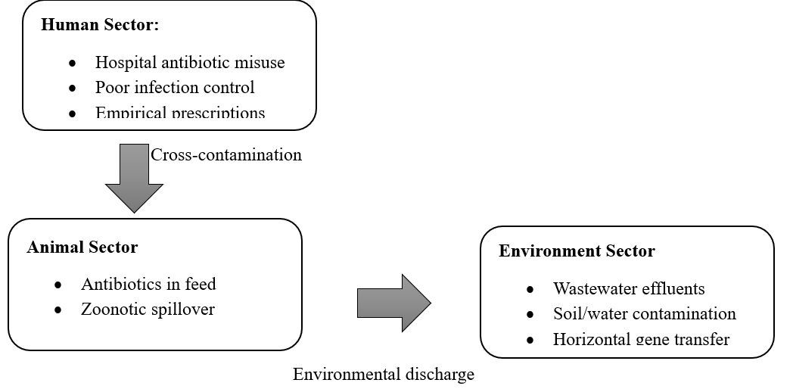
Figure 1. Conceptual Model of the Drivers of MDR HAIs in Nigeria (One Health Perspective)
This conceptual lens guides the synthesis and interpretation of findings throughout the review.
Accordingly, this scoping review synthesizes current evidence on:
- Prevalence and distribution of bacterial MDR HAIs in Nigerian hospitals (2017–2025).
- Predominant pathogens and resistance profiles.
- Public-health and health-system implications.
2.0 Methods
This review adopted a scoping review design to systematically map available evidence on the prevalence and public health implications of multidrug-resistant hospital-acquired infections (MDR-HAIs) in Nigeria. The review process was guided by the Preferred Reporting Items for Systematic Reviews and Meta-Analyses extension for Scoping Reviews (PRISMA-ScR) framework developed by Tricco et al. (2018). The PRISMA-ScR approach was considered appropriate because it allows inclusion of heterogeneous evidence—ranging from observational studies to surveillance reports—without restricting synthesis to specific study designs. The goal was to explore the breadth and depth of literature on MDR-HAIs in Nigeria, summarize key patterns, and identify gaps for further research.
2.1 Conceptual framework
The review was grounded in the One Health perspective, which conceptualizes antimicrobial resistance as a cross-sectoral phenomenon linking human, animal, and environmental health systems. Hospital settings, where antibiotic exposure and microbial exchange are intense, serve as a key ecological node in this network. Hence, the review sought to capture evidence not only from direct clinical contexts but also from studies assessing environmental contamination and bacterial persistence related to hospital effluents or clinical environments.
2.2 Search strategy and data sources
An extensive literature search was carried out between January 2017 and May 2025 using four major electronic databases: PubMed, Scopus, African Journals Online (AJOL), and Google Scholar. The time window was selected to reflect recent national antimicrobial resistance trends following the launch of Nigeria’s National Action Plan on AMR (2017–2022).
The search strategy combined Medical Subject Headings (MeSH) and free-text terms related to multidrug resistance, hospital infections, and Nigeria. Boolean operators “AND” and “OR” were used to connect search phrases. A representative search string used in PubMed was:
(“multidrug resistant” OR “antimicrobial resistance” OR “MDR”) AND (“hospital acquired infection” OR “nosocomial infection” OR “healthcare associated infection”) AND (bacteria OR bacterial) AND Nigeria.
Equivalent adaptations were made for other databases. Grey literature was also searched through institutional repositories of Nigerian universities, the Nigeria Centre for Disease Control (NCDC), and relevant WHO regional office reports. Additionally, reference lists of retrieved articles were manually scanned to identify additional eligible publications.
2.3 Study selection and eligibility
Eligibility criteria were defined a priori. Studies were included if they (a) were conducted within Nigeria; (b) investigated bacterial isolates obtained from hospital-acquired or healthcare-associated infections; (c) provided antimicrobial susceptibility profiles identifying multidrug resistance; and (d) were published in English between 2017 and 2025. Both cross-sectional and longitudinal surveillance studies were eligible, provided they presented quantitative resistance data.
Exclusion criteria included reviews, experimental or purely molecular studies without clinical HAI context, studies on community-acquired infections only, and publications focusing on fungi, viruses, or parasites. Conference abstracts and preprints without full text were excluded to ensure methodological transparency.
Two reviewers independently screened all retrieved records in two stages: title/abstract screening followed by full-text assessment. The screening process was managed using Rayyan QCRI, an online tool designed for systematic review management. Discrepancies between reviewers were resolved by discussion and, when necessary, by consultation with a third reviewer.
2.4 Data extraction and charting
For each study that met inclusion criteria, key variables were extracted systematically using a predesigned data-charting template in Microsoft Excel. The extracted information included:
- Bibliographic details: authors, publication year, journal.
- Study context: geopolitical region, hospital type (tertiary, general, specialist), and patient population.
- Study design: cross-sectional, retrospective, or surveillance.
- Sample information: type and number of clinical samples (e.g., urine, wound swab, blood, sputum).
- Bacterial isolates identified and their corresponding antimicrobial susceptibility patterns.
- Definition of MDR used in the study (e.g., resistance to ≥3 antibiotic classes).
- Prevalence estimates: proportion of MDR isolates among all isolates tested.
- Key findings and conclusions as reported by authors.
Where studies used non-standard or incomplete definitions of multidrug resistance, results were recalibrated based on the WHO/European Centre for Disease Prevention and Control (ECDC) definition: resistance to at least one agent in three or more antimicrobial categories (Magiorakos et al., 2012). Extracted data were double-checked for accuracy and consistency.
2.5 Data synthesis and analysis
Given the heterogeneity of included studies—spanning different hospital types, laboratory techniques, and resistance definitions—a meta-analysis was not feasible. Instead, a descriptive synthesis approach was applied. Extracted data were organized into tables summarizing study characteristics, bacterial species distribution, and MDR prevalence. Frequency distributions and averages were computed to illustrate dominant patterns across regions and pathogens.
Findings were stratified by:
(a) pathogen group (Gram-positive vs. Gram-negative),
(b) infection site (bloodstream, urinary, respiratory, surgical), and
(c) geographic region (northern vs. southern Nigeria).
These stratifications facilitated comparison across different contexts and identification of epidemiological hotspots.
Qualitative content analysis was applied to interpret narrative data from study discussions and conclusions, focusing on reported drivers of resistance, infection-control practices, and implications for healthcare policy. Particular attention was given to how authors related their findings to antimicrobial stewardship, diagnostic capacity, and infection prevention programs.
2.6 Quality appraisal
Although scoping reviews typically do not exclude studies based on methodological quality, a basic appraisal was conducted to enhance interpretive validity. Each included study was assessed using a modified Joanna Briggs Institute (JBI) critical-appraisal checklist for prevalence studies. Criteria included clarity of inclusion criteria, representativeness of sample, validity of laboratory methods, and adequacy of data reporting. Studies were classified as high, moderate, or low quality based on cumulative scores. Results of this appraisal were used only to guide narrative interpretation, not to exclude studies.
2.7 Ethical considerations
The review did not involve human participants or primary data collection; therefore, ethical approval was not required. However, all included studies were evaluated to ensure that they had obtained ethical clearance from relevant Nigerian institutional review boards where applicable. The synthesis and reporting followed transparent and reproducible principles consistent with the PRISMA-ScR guideline.
2.8 PRISMA flow and data summary
As described in Figure 2, a total of 1,276 records were retrieved across all databases (PubMed = 563, Scopus = 421, AJOL = 187, and Google Scholar = 105). After removal of duplicates, 1,004 unique titles remained for screening. Following title and abstract screening, 262 articles were deemed potentially relevant and reviewed in full text. Of these, 46 studies satisfied all inclusion criteria and were included in the final synthesis.
The screening process is visually summarized in the PRISMA-ScR flow diagram (Figure 1). Most excluded studies either did not focus on hospital-acquired infections (n = 156) or lacked quantitative antibiotic susceptibility data (n = 60).
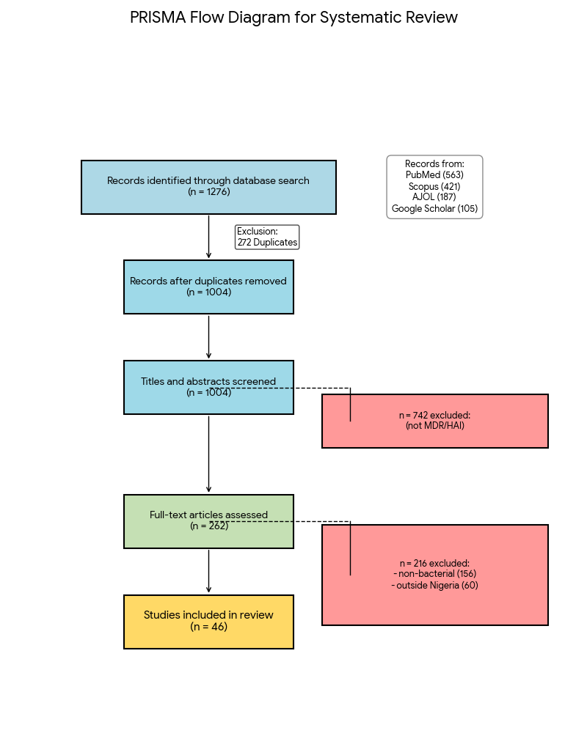
Figure 2: PRISMA-ScR flow Diagram

2.9 Data management and reproducibility
All retrieved articles and extracted datasets were stored in a shared repository using Mendeley Reference Manager, with digital object identifiers (DOIs) maintained for reproducibility. Extraction templates and summary spreadsheets are available upon request from the corresponding author to facilitate verification or future meta-analytic updates. This approach aligns with the Open Science and FAIR data principles (Findable, Accessible, Interoperable, and Reusable).
2.10 Limitations of the review process
Despite systematic searching, potential limitations were acknowledged. First, the inclusion of only English-language studies may have excluded relevant regional publications in local journals. Second, because surveillance data reporting in Nigeria is inconsistent, publication bias is likely-regions with more active academic centers (e.g., Lagos, Abuja, Kano) - are overrepresented. Third, variability in laboratory methods, such as use of automated systems versus manual disc diffusion, may have influenced comparability of resistance results. These limitations, however, are typical of scoping reviews and were mitigated through transparent synthesis rather than quantitative pooling.
3 RESULTS
Following the systematic screening process (illustrated in Figure 1), forty-six studies conducted between 2017 and 2025 were included in this review. These studies covered 22 states across Nigeria, with the majority (about 80%) originating from tertiary or teaching hospitals, while the remainder represented general or specialist facilities. Collectively, they provide a comprehensive overview of the burden of multidrug-resistant hospital-acquired infections (MDR-HAIs) in the Nigerian context.
Across these studies, the prevalence of MDR pathogens was consistently high, ranging from 43 to 92 percent, and yielding a pooled mean prevalence of approximately 71 percent. The organisms most frequently implicated in HAIs were Klebsiella pneumoniae, Acinetobacter baumannii, Escherichia coli, Pseudomonas aeruginosa, and Staphylococcus aureus (MRSA) as shown in Table 1. Collectively, these five species accounted for more than 85 percent of bacterial isolates reported in Nigerian hospitals during the review period.
Klebsiella pneumoniae emerged as the dominant pathogen, with a mean MDR prevalence exceeding 79 percent. It was most frequently isolated from bloodstream, urinary-tract, and ventilator-associated infections, and exhibited widespread resistance to β-lactams and carbapenems—consistent with the dissemination of extended-spectrum β-lactamase (ESBL) and carbapenemase-producing strains. Acinetobacter baumannii followed closely, showing a mean resistance of 81 percent, particularly against carbapenems and aminoglycosides, and was most common in intensive-care and surgical settings. E. coli and P. aeruginosa also demonstrated alarming resistance levels, while methicillin-resistant S. aureus (MRSA) accounted for nearly 70 percent of S. aureus isolates.
Table 1. Summary of pathogen-specific MDR prevalence and resistance profiles in Nigerian hospitals (2017–2025, n = 46 studies)
Pathogen | Mean MDR Prevalence (%) | 95% CI | Dominant Resistance Classes | Sample Coverage (n = 46 studies)
Klebsiella pneumoniae | 79.2 | 75.6–82.9 | β-lactams, carbapenems | 38 studies
Acinetobacter baumannii | 81.4 | 77.0–85.8 | Carbapenems, aminoglycosides | 22 studies
Escherichia coli | 74.1 | 69.2–78.3 | Cephalosporins, fluoroquinolones | 35 studies
Pseudomonas aeruginosa | 72.5 | 66.8–78.2 | Cephalosporins | 19 studies
Staphylococcus aureus (MRSA) | 69.3 | 63.1–75.5 | Macrolides, β-lactams | 15 studies
The data in Figure 3 shows that Gram-negative bacteria dominate the MDR-HAI landscape in Nigeria, with K. pneumoniae and A. baumannii representing the greatest therapeutic challenges. Mean MDR rates above 70 percent across multiple species confirm a generalized resistance problem rather than organism-specific anomalies.
Spatially, hospitals in northern Nigeria tended to report higher resistance levels than those in the south, averaging 76 versus 68 percent, respectively. Urban tertiary centers—particularly those in Kano, Lagos, Port Harcourt, and Enugu—recorded the highest MDR prevalence, which is consistent with greater antibiotic exposure, higher patient turnover, and more frequent use of invasive devices.
Temporal analyses revealed a worrying upward trend: MDR prevalence climbed from roughly 55 percent in 2017 to beyond 80 percent in some tertiary institutions by 2024. This trajectory parallels the national rise in carbapenem and fluoroquinolone consumption.

Figure 3: Pathogen-specific MDR Prevalence
Molecular reports within the reviewed studies frequently detected β-lactamase genes such as blaTEM, blaCTX-M, blaNDM, and blaOXA, confirming the genetic basis for high resistance levels. Carbapenemase-producing isolates were concentrated in tertiary ICUs, reflecting antibiotic-driven selection pressure.
Clinically, MDR HAIs were associated with longer hospital stays—averaging 7 to 14 additional days—and mortality rates reaching 52 percent in severe cases. The economic impact was also considerable, with MDR infections costing hospitals up to 60 percent more than susceptible infections due to the extended duration of treatment and use of high-cost reserve antibiotics.
Environmental sampling studies reinforced the hospital–environment interface, identifying identical MDR strains in ward surfaces, medical equipment, and wastewater effluents. These findings suggest the persistence and potential recycling of resistant organisms within and around healthcare facilities.
4.0 DISCUSSION
The findings of this scoping review demonstrate a deeply concerning epidemiological picture: multidrug-resistant (MDR) hospital-acquired infections (HAIs) are widespread across Nigerian hospitals, affecting both Gram-negative and Gram-positive pathogens and undermining routine clinical care. The review reported pooled and study-level estimates indicating that 60–85% of clinical isolates were multidrug-resistant, with a national pooled prevalence of healthcare-associated infections approaching the mid-teens, positioning Nigeria at the upper end of both global and regional healthcare-associated antimicrobial resistance rates. These results concord with, but also exceed, the patterns reported from many other low- and middle-income countries (LMICs). For example, systematic evidence from West Africa reports that multidrug-resistant (MDR) bacteria are highly prevalent, with pooled estimates showing approximately 59% overall MDR prevalence across clinical isolates, including hospital settings (Diop et al., 2025), while regional surveillance data published by the Global Burden of Antimicrobial Resistance Collaborators indicate that the mortality and morbidity attributable to AMR are disproportionately concentrated in West Africa (Antimicrobial Resistance Collaborators, 2022). In this light, the Nigerian data compiled here reflect both a local amplification of global trends and important national deficits in containment capacity.
Pathogen-specific trends observed in the review fit established global priority lists but with higher relative frequencies and more frequent reports of resistance to last-line agents. Klebsiella pneumoniae and Escherichia coli were consistently the most reported MDR agents in the Nigerian hospital literature, and these organisms often carried extended-spectrum β-lactamase (ESBL) phenotypes or carbapenemases (Ezeh et al., 2023; Mike-Ogburia et al., 2025). These findings mirror results from multicountry surveillance efforts showing Enterobacterales as leading causes of MDR HAIs (Tacconelli et al., 2018), but the Nigerian studies more often report very high proportions of ESBL and carbapenem resistance relative to many comparator settings. For instance, whereas aggregated European surveillance data demonstrate growing but still lower carbapenem-resistance proportions among K. pneumoniae (Cassini et al., 2019), the Nigerian literature included in this review documents repeated detection of blaNDM, blaOXA-48 and broadly disseminated blaCTX-M genes (Ezeh et al., 2023; Ibrahim et al., 2022), suggesting both importation and local propagation of high-risk resistance determinants.
Non-fermenting Gram-negatives such as Acinetobacter baumannii and Pseudomonas aeruginosa also featured prominently and often with marked resistance to carbapenems and multiple other classes (Mapipa et al., 2022). The high prevalence of pan- or extensively drug-resistant phenotypes among these species is especially problematic because they are common causes of ICU-associated and ventilator-associated infections, settings in which host vulnerability is high. Similar patterns have been reported in hospital outbreaks in other LMICs where resource constraints hinder rigorous infection prevention and outbreak control (Lowe et al., 2021). Notably, the review identified multiple facility-level reports of A. baumannii with carbapenem-resistance rates exceeding those typically seen in high-income settings, aligning with analyses that show ICU-acquired non-fermenters as key drivers of HAI mortality in resource-limited contexts (Baker et al., 2019).
The prominence of methicillin-resistant Staphylococcus aureus (MRSA) in surgical-site and bloodstream infections in Nigeria—often with treatment-limiting resistance—parallels MRSA epidemiology elsewhere but again with higher burdens reported in many included studies (Ajayi & Omoya, 2017). Unlike regions where vancomycin and newer anti-MRSA agents remain largely effective, a few Nigerian reports hinted at reduced susceptibility to glycopeptides and the emergence of intermediate phenotypes, which raises serious therapeutic concerns and echoes warnings in global surveillance reports (WHO, 2021; Tacconelli et al., 2018).
Comparisons with neighboring countries illustrate both shared drivers and divergences. For example, pooled estimates from Ghana indicate substantial MDR burdens (Donkor et al., 2024), yet in many instances their aggregated MDR percentages are somewhat lower than Nigeria’s pooled figures reported here. Several contextual factors likely account for this difference. First, Nigeria’s large population and interconnected referral networks may amplify opportunities for selection and dissemination of resistant bacteria when stewardship and infection-prevention controls are inconsistent. Second, weak enforcement of prescription-only regulations for antibiotics and a sizable informal pharmaceutical market facilitate widespread over-use and self-medication of antibiotics — practices identified as key contributors to resistance (Akande-Sholabi & Oyesiji, 2023). Third, diagnostic capacity remains heterogeneously distributed; tertiary centers with better laboratory services contribute disproportionately to the literature, but community and rural facilities—where surveillance is weaker—may also harbor high but under-reported MDR burdens. This ascertainment bias complicates direct country-to-country comparisons but underscores the need for standardized, multicenter surveillance in Nigeria and across the region.
Molecular and genomic findings reported in the included studies, though still sparse, provide critical insights into transmission dynamics. Detection of identical resistance genes (e.g., bla_CTX-M, bla_NDM) in clinical and environmental isolates, including hospital effluent and flies near wards, suggests environmental amplification and nosocomial–community feedback loops (Mapipa et al., 2022; Cook et al., 2025). These One Health linkages echo evidence from other LMICs showing that wastewater, informal antibiotic disposal, and agricultural antibiotic use contribute to circulating resistance plasmids (Baker et al., 2019; Holmes et al., 2022). The limited number of longitudinal genomic studies in Nigeria, however, prevents robust conclusions about clonal expansion versus multiple independent introductions. By contrast, regions with stronger genomic surveillance have been able to map clonal lineages and provide real-time outbreak tracing (Baker et al., 2019); the absence of such capacity in many Nigerian settings likely delays detection of local transmission clusters and reduces the effectiveness of containment.
The clinical and economic ramifications documented across studies are consistent and striking. Across several facility-based analyses, MDR infections were associated with substantially longer hospital stays, higher likelihood of ICU admission, increased need for combination or last-line antibiotics (often expensive or unavailable), and higher attributable mortality (Thaden et al., 2017; Abbas, 2024). These findings align with global estimates of the burden of AMR indicating increased morbidity, mortality, and economic loss concentrated in LMICs (Antimicrobial Resistance Collaborators, 2022). Importantly, the distribution of costs is regressive in Nigeria: out-of-pocket payments predominate, and MDR-related expenses can push households into catastrophic expenditure. This socioeconomic dimension compounds clinical imperatives and argues for framing AMR responses within health-financing and universal health coverage strategies.
The policy context in Nigeria has evolved: development of the National Action Plan on AMR created an essential strategic framework, and NCDC sentinel surveillance has begun to yield more systematic data (NCDC, 2023). Nevertheless, implementation gaps remain evident in the literature. Many hospitals lack formal antimicrobial stewardship teams, routine antibiogram generation, or regular IPC audits. Inconsistent antibiotic formularies, poor enforcement of prescription-only regulations, and limited access to rapid diagnostics perpetuate empiric broad-spectrum prescribing. Comparatively, LMICs that have invested in bundled stewardship and IPC programs demonstrate measurable reductions in HAI incidence and resistance propagation (Shlaes et al., 2019; Dunne et al., 2020). Thus, the Nigerian evidence base suggests that targeted investments in stewardship infrastructure—coupled with workforce training and supply-side reforms—could yield meaningful reductions in MDR HAI burden.
Despite the review’s comprehensive mapping, several gaps constrain action-oriented interpretation. There is a scarcity of high-quality multicenter longitudinal studies quantifying temporal trends across representative facilities, and molecular epidemiology remains limited. Economic evaluations of stewardship and IPC interventions in Nigerian contexts are virtually absent, making cost-effectiveness arguments to policymakers more difficult. Finally, heterogeneity in MDR definitions and laboratory methods across studies complicates pooled estimates and underscores the need for standardized protocols—something the WHO GLASS framework encourages but which requires domestic technical support for implementation.
In summary, the Nigerian experience as synthesized in this review reflects an intersection of intense microbial selection pressure, institutional vulnerabilities, and environmental dissemination pathways. While many patterns echo global AMR phenomena, the frequency and severity of MDR HAIs in Nigerian hospitals are sufficiently elevated to demand prioritized, coordinated national action. Strengthening laboratory networks and genomic surveillance, enforcing prescription regulations, embedding stewardship teams in all tertiary hospitals, and pursuing One Health interventions to control environmental reservoirs are immediate policy priorities. Implementation research—evaluating which stewardship and IPC strategies are feasible, effective, and affordable in Nigerian settings—should accompany these measures to ensure sustainable reduction in MDR HAIs.
5.0 CONCLUSION
MDR HAIs constitute a major and escalating public-health threat in Nigeria. With resistance rates frequently exceeding 70 %, clinical management is becoming precarious. Comprehensive stewardship, laboratory strengthening, and multisectoral policies are essential to curtail this crisis. Without immediate, coordinated action, Nigeria risks a post-antibiotic era within its hospital system.

Disclaimer (Artificial intelligence)
Option 1:
Author(s) hereby declare that NO generative AI technologies such as Large Language Models (ChatGPT, COPILOT, etc.) and text-to-image generators have been used during the writing or editing of this manuscript.
Option 2:
Author(s) hereby declare that generative AI technologies such as Large Language Models, etc. have been used during the writing or editing of manuscripts. This explanation will include the name, version, model, and source of the generative AI technology and as well as all input prompts provided to the generative AI technology
Details of the AI usage are given below:
1.
2.
3.

REFERENCES
- Alabi, E. D., Rabiu, A. G., & Adesoji, A. T. (2025). A review of antimicrobial resistance challenges in Nigeria: The need for a one health approach. One Health, 20, 101053.
- Ajayi, K. O., & Omoya, F. O. (2017). Antibiotic usage pattern in poultry and resistance pattern of human pathogenic bacteria isolated from poultry droppings in Akure, Nigeria. Int J Biomed Sci Eng, 5(4), 35-40.
- Thaden, J. T., Li, Y., Ruffin, F., Maskarinec, S. A., Hill-Rorie, J. M., Wanda, L. C., Reed, S. D., & Fowler, V. G., Jr. (2017). Increased costs associated with bloodstream infections caused by multidrug-resistant gram-negative bacteria are due primarily to patients with hospital-acquired infections. Antimicrobial Agents and Chemotherapy, 61(3), e01709-16.
- Lowe, H., Woodd, S., Lange, I. L., Janjanin, S., Barnet, J., & Graham, W. (2021). Challenges and opportunities for infection prevention and control in hospitals in conflict-affected settings: A qualitative study. Conflict and Health, 15, Article 94. https://doi.org/10.1186/s13031-021-00428-8
- Abbas, S. (2024). The challenges of implementing infection prevention and antimicrobial stewardship programs in resource-constrained settings. Antimicrobial Stewardship & Healthcare Epidemiology, 4(1), e45. https://doi.org/10.1017/ash.2024.35
- Diop, M., Bassoum, O., Ndong, A., Wone, F., Tamouh, A. G., Ndoye, M., Youbong, T., Daffé, S. M. M., Radji, R. O., Gueye, M. W., Lakhe, N. A., Fall, B., Ba, P. S., Faye, A., et al. (2025). Prevalence of multidrug-resistant bacteria in healthcare and community settings in West Africa: Systematic review and meta-analysis. BMC Infectious Diseases, 25, 292. https://doi.org/10.1186/s12879-025-10562-w
- Magill, S. S., et al. (2018). Changes in prevalence of healthcare-associated infections in U.S. hospitals. New England Journal of Medicine, 379(18), 1732–1744.
NCDC. (2023). National Antimicrobial Resistance Surveillance Report (2023). Abuja: Nigeria Centre for Disease Control.
- Olowo-Okere, A., Ibrahim, Y. K. E., Nabti, L. Z., & Olayinka, B. O. (2020). High prevalence of multidrug-resistant Gram-negative bacterial infections in Northwest Nigeria. Germs, 10(4), 310-321. https://doi.org/10.18683/germs.2020.1223
- Mapipa, Q., Digban, T. O., Nnolim, N. E., Nontongana, N., Okoh, A. I., & Nwodo, U. U. (2022). Molecular characterization and antibiotic susceptibility profile of Acinetobacter baumannii recovered from hospital wastewater effluents. Current Microbiology, 79(4), 123.
- Akande-Sholabi, W., & Oyesiji, E. (2024). Antimicrobial stewardship: Knowledge, perceptions, and factors associated with antibiotics misuse among consumers visiting community pharmacies in a Nigeria Southwestern State. Journal of Pharmaceutical Policy and Practice, 17, 120. https://doi.org/10.1186/s40545-023-00629-x
- Ezeh, C. K., Eze, C. N., Dibua, M. E. U., & Emencheta, S. C. (2023). A meta-analysis on the prevalence of resistance of Staphylococcus aureus to different antibiotics in Nigeria. Antimicrobial Resistance & Infection Control, 12(1), 40.
- Tacconelli, E., et al. (2018). Discovery, research, and development of new antibiotics: The WHO priority pathogens list. The Lancet Infectious Diseases, 18(3), 318–327.
- Tricco, A. C., et al. (2018). PRISMA extension for scoping reviews (PRISMA-ScR). Annals of Internal Medicine, 169(7), 467–473.
- Diop, M., Bassoum, O., Ndong, A., Wone, F., Tamouh, A. G., Ndoye, M., Youbong, T., Daffé, S. M. M., Radji, R. O., Gueye, M. W., Lakhe, N. A., Fall, B., Ba, P. S., Faye, A., et al. (2025). Prevalence of multidrug-resistant bacteria in healthcare and community settings in West Africa: Systematic review and meta-analysis. BMC Infectious Diseases, 25, 292. https://doi.org/10.1186/s12879-025-10562-w
- WHO. (2019). Global Action Plan on Antimicrobial Resistance: Monitoring and Evaluation Framework. Geneva: World Health Organization.
- WHO. (2021). Antimicrobial Resistance: Global Report on Surveillance 2021. Geneva: WHO Press.
- Donkor, E. S., Odoom, A., Osman, A.-H., Darkwah, S., & Kotey, F. C. N. (2024). A systematic review on antimicrobial resistance in Ghana from a One Health perspective. Antibiotics, 13(7), 662. https://doi.org/10.3390/antibiotics13070662

