Symphoxanthone and Celibixanthone as COVID Spike Protein inhibitors using Molecular Docking, MM GBSA, and Molecular Dynamics Studies

.
ABSTRACT

The COVID-19 pandemic posed an unprecedented global health challenge, leading to the rapid development of vaccines and antiviral drugs that substantially reduced disease-related mortality. Nevertheless, conventional synthetic drug discovery remains time-consuming and is often associated with adverse effects, prompting interest in alternative therapeutic strategies based on natural products. One viable antiviral approach involves inhibiting angiotensin-converting enzyme 2 (ACE2), the primary host receptor that mediates SARS-CoV-2 entry through interaction with the receptor-binding domain (RBD) of the viral spike protein. In this study, we aimed to identify potential phytochemical inhibitors of ACE2 that could serve as pre-COVID antiviral candidates. Molecular docking was performed using standard precision (SP) and extra precision (XP) protocols, with nelfinavir, hydroxychloroquine, nirmatrelvir, and Paxlovid employed as reference drugs approved by the United States Food and Drug Administration. The binding free energy was estimated using MM-GBSA calculations. The ACE2 structure was extracted from the ACE2-RBD complex (PDB ID: 6M0J) by removing the viral RBD before docking. The most promising ligand-receptor complexes were further evaluated through 100 ns molecular dynamics simulations. Structural stability and conformational behavior were assessed using root-mean-square deviation (RMSD), root-mean-square fluctuation (RMSF), and radius of gyration (Rg) analyses. The results indicated that the phytochemicals NP#0158 (Symphoxanthone) and NP#0157 (Celibixanthone) exhibited favorable docking scores, binding free energies, and stable interaction profiles comparable to hydroxychloroquine. These findings suggest that Symphoxanthone and Celibixanthone may serve as promising natural-product-based ACE2 inhibitors and warrant further experimental validation as potential antiviral agents against SARS-CoV-2.

Keywords: COVID-19, ACE2 inhibition, Phytochemicals, antiviral drug discovery, Symphoxanthone, Celibixanthone

1. INTRODUCTION
Coronavirus disease 2019 (COVID-19), caused by the severe acute respiratory syndrome coronavirus 2 (SARS-CoV-2), was first reported in Wuhan, China, in December 2019 and rapidly evolved into a global pandemic within a few years¹. According to global epidemiological reports, more than 760 million confirmed cases and approximately 6.8 million deaths were recorded worldwide, highlighting the unprecedented impact of this outbreak. The emergence of multiple variants of concern, including Alpha (UK), Beta (South African), Gamma (Brazilian), Delta (Indian), and Omicron, significantly altered the transmissibility, virulence, and clinical outcomes of the disease. SARS-CoV-2 infection primarily affects the respiratory tract, leading to symptoms ranging from mild respiratory distress to acute respiratory failure. Severe cases are frequently associated with multiorgan dysfunction, including cardiovascular complications, renal impairment, and exacerbation of non-communicable diseases^{2,3}.

1.1. SARS-CoV-2 Spike Protein
SARS-CoV-2 is an enveloped, positive-sense single-stranded RNA virus whose genome encodes four major structural proteins: spike (S), membrane (M), envelope (E), and nucleocapsid (N)⁴. Among these, the spike glycoprotein plays a pivotal role in viral infectivity by mediating host cell recognition, attachment, and membrane fusion. The spike protein is a trimeric class I fusion protein composed of two functional subunits, S1 and S2. The S1 subunit is primarily responsible for receptor recognition, whereas the S2 subunit facilitates membrane fusion following receptor engagement⁴.
The S1 subunit spans residues 14-685 and consists of the N-terminal domain (NTD; residues 14-305) and the receptor-binding domain (RBD; residues 319-541)⁵. The RBD is the key region that binds to the host angiotensin-converting enzyme 2 (ACE2) receptor. Structurally, the SARS-CoV-2 RBD comprises a twisted, five-stranded antiparallel β-sheet. Within the RBD, a specific region, the receptor-binding motif (RBM), encompassing residues 438-506, directly mediates most interactions with ACE2⁵.

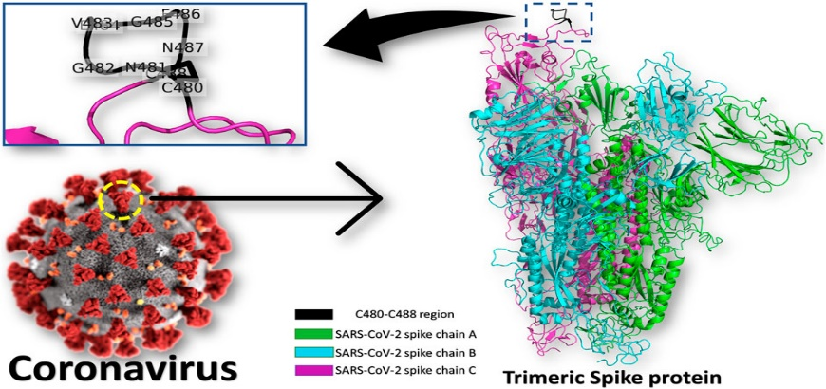
Fig. 1: The COVID-19 virus and trimeric spike protein⁶

Although the RBD is a critical determinant of viral entry and an attractive target for therapeutic intervention, its high mutation rate across emerging variants presents challenges for the development of broad-spectrum antiviral agents. Nevertheless, the spike protein remains a central focus of antiviral drug discovery efforts due to its indispensable role in viral attachment and entry. While the RBD within the S1 subunit governs host recognition, the S2 subunit contains the heptad repeat regions HR1 and HR2, which drive membrane fusion and enable viral genome release into the host cell⁷.

1.2. Angiotensin-Converting Enzyme 2 (ACE2)
Angiotensin-converting enzyme 2 (ACE2) is a key regulatory component of the renin-angiotensin-aldosterone system (RAAS), which plays a critical role in blood pressure regulation, cardiovascular homeostasis, and fluid balance. ACE2 is widely expressed in multiple organs, including the lungs, heart, kidneys, and gastrointestinal tract, thereby explaining the systemic manifestations observed in severe COVID-19 cases⁸. Beyond its physiological functions, ACE2 serves as the primary cellular receptor for SARS-CoV-2, facilitating viral attachment and entry.

1.3. Interaction Between ACE2 and SARS-CoV-2 RBD
The interaction between the SARS-CoV-2 RBD and the ACE2 receptor is a crucial initial step in viral infection. The RBD predominantly interacts with the N-terminal peptidase domain of ACE2 via a network of intermolecular interactions. Structural studies have identified approximately 13 hydrogen bonds and one salt bridge stabilizing the ACE2-RBD complex, underscoring the high binding affinity between the viral spike protein and its host receptor⁹. Disruption of this interaction is therefore considered a promising strategy to prevent viral entry and subsequent infection.

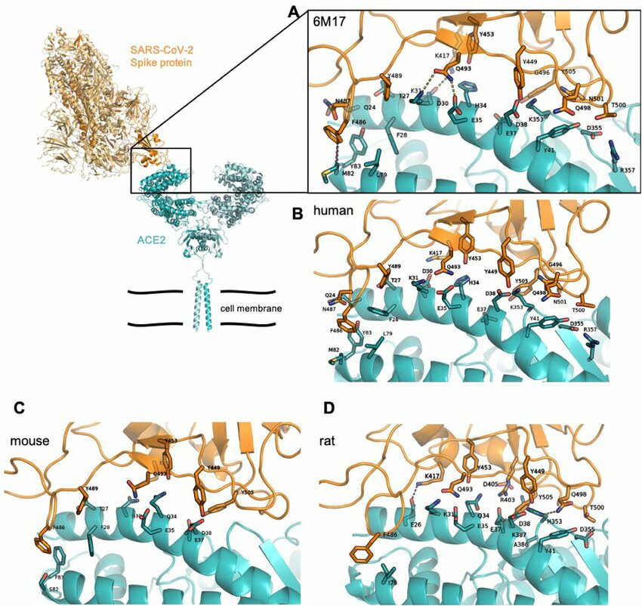
Fig. 2: The Interactions between Ace-2 enzyme and SARS-CoV-2 RBD¹⁰

1.4. Natural Products as Antiviral Inhibitors
Natural products and phytochemicals have long been recognized as valuable sources of antiviral agents due to their structural diversity and favorable safety profiles. Several SARS-CoV-2 targets, including the spike protein and viral polymerases, have been explored using plant-derived compounds.¹¹Repurposed drugs such as hydroxychloroquine have been reported to interfere with viral binding to ACE2. At the same time, other agents, including remdesivir, nirmatrelvir, Paxlovid, and ivermectin, have demonstrated inhibitory effects against different stages of the viral life cycle¹². These findings highlight the potential of natural and repurposed compounds as alternative therapeutic strategies for COVID-19 and warrant further investigation through structure-based computational approaches.

2. Methodology

2.1. Ligand Preparation
The X-ray crystal structure of the SARS-CoV-2 spike protein complexed with the human angiotensin-converting enzyme 2 (ACE2) receptor (PDB ID: 6M0J) was retrieved from the Protein Data Bank¹³. The original structure contains both the ACE2 receptor and the viral receptor-binding domain (RBD). Before docking, all crystallographic water molecules, heteroatoms, ligands, and non-protein residues, including N-acetylglucosamine (NAG), were removed using UCSF Chimera to obtain a clean protein structure suitable for molecular modeling.
A library of phytochemicals was compiled from the Sri Lankan Flora database (https://science.cmb.ac.lk/tools/slflora/), which comprises approximately 200 natural compounds native to or endemic to Sri Lanka. The two-dimensional structures of these compounds were retrieved and subsequently geometry-optimized using Gaussian 09W employing the CBS-QB3 composite method¹⁴. The optimized structures were converted into Protein Data Bank (PDB) format using Avogadro and imported into the Schrödinger Maestro 12.5 molecular modeling environment for further processing.
Ligand preparation was carried out using the LigPrep module in Maestro, which included energy minimization, generation of possible stereoisomers, assignment of appropriate protonation states, and optimization of molecular geometries. In addition, physicochemical and pharmacokinetic properties of the ligands were evaluated using the QikProp module to assess their drug-likeness and suitability as potential inhibitors.

2.2. Protein Preparation
Protein preparation was performed using the Protein Preparation Wizard (PrepWizard) in the Schrödinger Maestro suite. The cleaned 6M0J structure was imported into Maestro, and the ACE2 receptor was isolated for docking studies by removing the SARS-CoV-2 RBD where required. During preparation, hydrogen atoms were added, bond orders were assigned, disulfide bonds were created, and missing side chains and loops were repaired using the Prime module.
Crystallographic water molecules beyond 5.0 Å from the protein surface were removed, and the protein structure was optimized at physiological pH (7.0 ± 2.0). Steric clashes and unfavorable hydrogen-bonding networks were resolved through restrained energy minimization, resulting in a properly optimized receptor structure suitable for molecular docking studies.

2.3. Molecular Docking
Molecular docking was performed using the Glide module of Schrödinger. Before docking, the binding site of the ACE2 receptor was identified based on reported interaction residues involved in ACE2-RBD recognition, as described in previous structural studies. A receptor grid was generated around the active binding region using defined Cartesian coordinates (x, y, z), large enough to accommodate ligand flexibility during docking.
Docking simulations were conducted hierarchically: High-Throughput Virtual Screening (HTVS) for initial screening, followed by Standard Precision (SP) and Extra Precision (XP) docking for refined binding analysis. Docking scores were used to rank ligand binding affinities, where more negative scores indicated stronger predicted interactions between the ligand and the receptor¹⁵.

2.4. Molecular Dynamics Simulation
Molecular dynamics (MD) simulations were performed using GROMACS version 4.5.6. The GROMOS53a6 united-atom force field was applied to the ACE2 protein, while force field parameters for the selected ligands were obtained from the Automated Topology Builder (ATB) server. Before simulation, ionizable residues were assigned appropriate protonation states: lysine, arginine, and histidine residues were protonated, whereas aspartic acid and glutamic acid residues were deprotonated.¹⁶
The ACE2-ligand complex was placed at the center of a cubic simulation box with dimensions of 9.0 × 9.0 × 9.0 nm³, and the system was solvated with approximately 37,000 SPC/E water molecules. System neutrality was achieved by adding Na⁺ counterions to compensate for the net negative charge arising from protonation states of residues.
Electrostatic interactions were treated using the particle mesh Ewald (PME) method, with a short-range cutoff of 1.2 nm for both electrostatic and van der Waals interactions. Energy minimization was performed in three stages (em01, em02, and em03) using the steepest descent algorithm, followed by 100 ps of equilibration under NVT and NPT ensembles. Temperature and pressure were maintained at 300 K and 1 bar, respectively.¹⁴
Production MD simulations were carried out for 100 ns using the leap-frog integration algorithm with a time step of 1 fs. Trajectories were saved at 1 ps intervals for subsequent analysis, including structural stability and conformational dynamics of the ACE2-ligand complexes.

3. Results and Discussion

3.1. ADMET Profile Analysis
A library of 200 phytochemicals derived from the Sri Lankan Flora database was subjected to virtual screening against the ACE2 enzyme using the Glide workflow. Before docking, all compounds were evaluated for their absorption, distribution, metabolism, excretion, and toxicity (ADMET) properties using the QikProp module. QikProp generates 44 physicochemical descriptors, among which key parameters associated with Lipinski’s rule of five and the rule of three were considered to assess drug-likeness¹⁶.
Only compounds satisfying these criteria without violations were retained for further analysis, as compliance with these rules is generally associated with favorable oral bioavailability and pharmacokinetic profiles. Based on ADMET screening, a subset of phytochemicals demonstrated acceptable molecular weight, lipophilicity (QPlogP), hydrogen bond donor and acceptor counts, aqueous solubility (QPlogS), and Caco-2 cell permeability (QPPCaco). Among these, NP#0157 (Celibixanthone) and NP#0158 (Symphoxanthone) exhibited physicochemical properties consistent with drug-like behavior and were therefore prioritized for subsequent docking and simulation studies.

Table 1. Drug-like properties and their scores of the best candidates
ID | mol_MW | QPlog | Donor | Accpt | N+O | QPlogS | QPPCaco
ID | mol_MW | Po/w | HB | HB | N+O | QPlogS | QPPCaco
NP#0157 | 358.47 | 0.47 | 4 | 10.2 | 6 | -1.02 | 698.02
NP#0158 | 344.44 | -0.28 | 5 | 10.2 | 6 | -1.41 | 154.13

(a) (b)
Fig. 3: Structure of (a) Celibixanthone (NP#0157), and (b) Symphoxanthone (NP#0158)

3.2. Molecular Docking and MM-GBSA Binding Free Energy Analysis
The shortlisted compounds were prepared using the LigPrep module, and their protonation states were optimized within a physiological pH range (7.0 ± 2.0). Initial molecular docking was performed using the standard precision (SP) protocol, and the top-ranking compounds were subsequently subjected to extra precision (XP) docking for refined binding evaluation. From the XP docking results, approximately 25-30 top-scoring ligands were selected for MM-GBSA binding free energy calculations¹⁷.

Table 2. SP Docking scores of the top ligands with reference compounds
Title | Docking score | Glide score | E_{vdw} | E_{coul} | E_{model} | Energy  (kJ/mol)
NP#0155 | -3.35 | -3.35 | -16.52 | -10.00 | -31.77 | -26.53
NP#0157 | -2.88 | -2.88 | -17.44 | -5.62 | -23.61 | -23.06
NP#0158 | -3.30 | -3.30 | -13.24 | -10.81 | -29.29 | -24.05
hydroxychloroquine | -2.68 | -2.68 | -18.48 | -7.65 | -28.47 | -26.13
nelfinavir | -3.62 | -3.62 | -22.77 | -11.50 | -39.27 | -34.27
Nirmatrelvir (Paxlovid) | -3.09 | -3.09 | -18.31 | -9.83 | -27.77 | -28.14

While docking scores provide a preliminary estimate of binding affinity, they do not fully capture the thermodynamic stability of the protein-ligand complex. Therefore, MM-GBSA calculations were employed to estimate the binding Gibbs free energy, with more negative values indicating stronger, more stable interactions. The XP docking scores of the selected ligands ranged from approximately −5.3 to −3.5 as per the table 3 with reference inhibitors such as nelfinavir, hydroxychloroquine, and nirmatrelvir showing comparable binding scores. Notably, NP#0157 (Celibixanthone) and NP#0158 (Symphoxanthone) demonstrated XP docking scores superior to or comparable with those of the reference drugs.

Table 3. XP Docking scores of the top ligands with reference compounds
Title | Docking score | Glide score | E_{vdw} | E_{coul} | E_{mode}l | Energy  (kJ/mol)
NP#0155 | -4.24 | -4.24 | -11.92 | -13.76 | -33.25 | -25.68
NP#0157 | -5.34 | -5.34 | -15.97 | -9.04 | -31.47 | -25.01
NP#0158 | -4.37 | -4.37 | -14.01 | -7.64 | -25.79 | -21.64
hydroxychloroquine | -2.28 | -2.28 | -18.51 | -8.15 | -29.87 | -26.66
Nelfinavir | -4.24 | -4.24 | -30.24 | -6.74 | -50.96 | -36.98
Nirmatrelvir (Paxlovid) | -3.55 | -3.55 | -10.38 | -21.88 | -30.43 | -32.26

MM-GBSA analysis further supported these findings, with binding free energies ranging from −29.18 to −6.04 kcal mol⁻¹ among the top-ranked ligands as per the table 4. NP#0157 exhibited the most favorable binding free energy, followed by NP#0158, suggesting a stable, energetically favorable interaction with the ACE2 receptor. These results indicate that the selected phytochemicals exhibit binding affinities comparable to those of FDA-approved reference inhibitors.

Table 4. MMGBSA scores of the top ligands with reference compounds
Title | Glide Score | E_{lipo} | E h_{bond} | E_{model} | glide energy | Prime Solv | Prime H bond | MM-GBSA
NP#0155o | -4.24 | -0.29 | 0 | -33.24 | -25.68 | -4765.38 | -467.18 | -20.35
NP#0157o | -5.34 | -0.50 | 0 | -31.47 | -25.01 | -4740.00 | -466.10 | -29.18
NP#0158o | -4.37 | -0.11 | 0 | -25.79 | -21.64 | -4761.45 | -467.28 | -22.89
hydroxychloroquine | -2.28 | -0.21 | -0.46 | -29.87 | -26.66 | -4753.96 | -466.48 | -18.74
nelfinavir | -4.24 | -0.79 | -0.44 | -50.96 | -36.98 | -474.31 | -466.68 | -27.86
Nirmatrelvir (Paxlovid) | -3.55 | -0.31 | -0.53 | -30.42 | -32.26 | -4751.07 | -468.42 | -22.22

3.3. Molecular Dynamics Simulation Analysis
Molecular dynamics (MD) simulations were performed to evaluate further the dynamic stability and conformational behavior of the ACE2-ligand complexes. The top-performing phytochemicals, NP#0157 and NP#0158, were compared with hydroxychloroquine as a reference compound. Several structural parameters, including root mean square deviation (RMSD), root mean square fluctuation (RMSF), and radius of gyration (Rg), were analyzed over a 100 ns simulation period.

3.3.1 Root Mean Square Deviation (RMSD)
RMSD analysis of the protein backbone was conducted to assess the overall structural stability of the ACE2-ligand complexes relative to their initial conformations. All simulated systems displayed a similar RMSD profile, characterized by an initial equilibration phase followed by stable trajectories throughout the remainder of the simulation. Minor fluctuations were observed during the early stages (approximately 5-35 ns), after which the RMSD values stabilized, indicating convergence of the systems¹⁶.

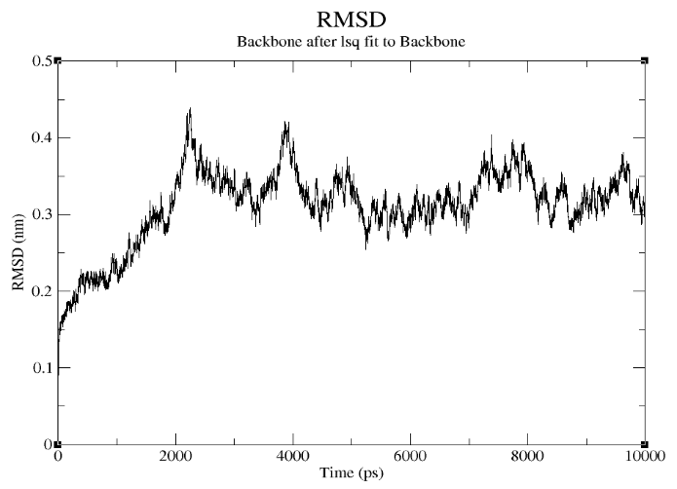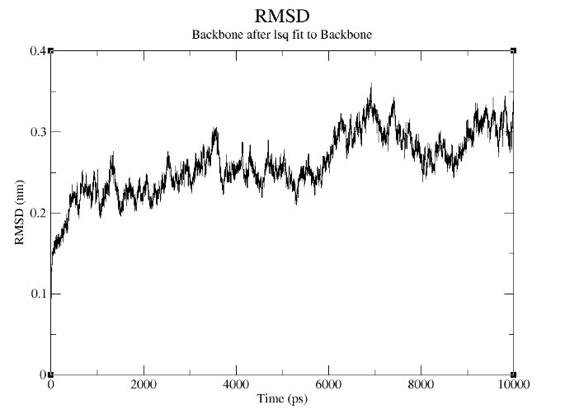
(a) (b)
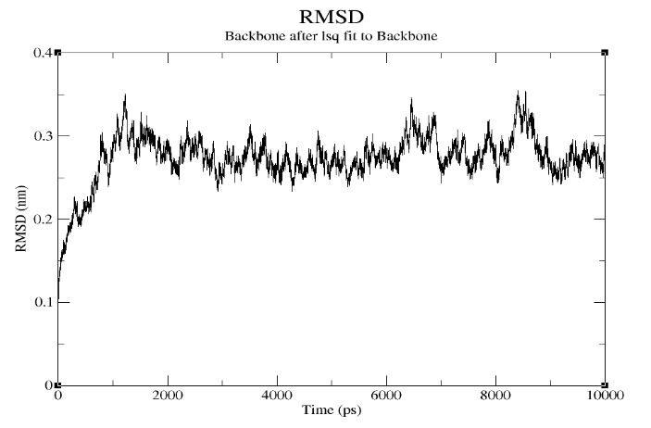
(c)
Fig. 4: Backbone RMSD of ACE2 with (a) Celibixanthone, (b) Symphoxanthone, and (c) Hydroxychloroquine

The comparable RMSD trends observed for the Celibixanthone-, Symphoxanthone-, and hydroxychloroquine-bound complexes suggest that the phytochemical ligands do not induce significant structural perturbations in the ACE2 receptor and can form stable complexes under physiological conditions.

4.3.2 Root Mean Square Fluctuation (RMSF)
RMSF analysis was performed to examine residue-level flexibility of the ACE2 protein in the presence of different ligands¹⁸. Over the 100 ns simulation period, fluctuations were primarily localized to loop regions and terminal residues, which is consistent with typical protein dynamics. Among the total residues of the ACE2 structure, approximately 130-150 residues exhibited higher fluctuations, while the remaining regions remained relatively stable.
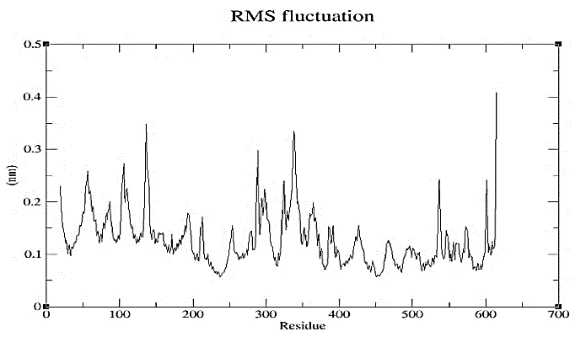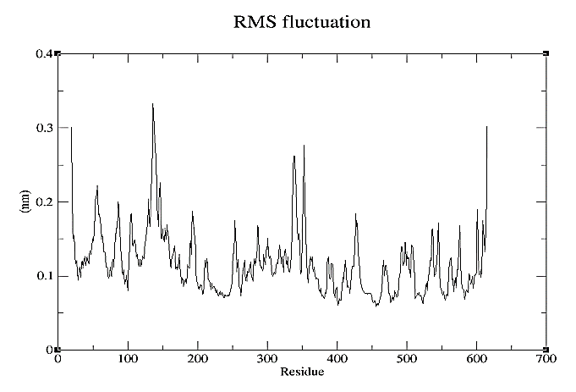
(a) (b)
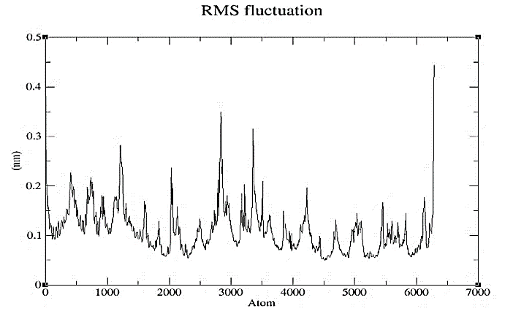
(c)
Fig. 5: Backbone RMSF of amino acids present in ACE2 with (a) Celibixanthone, (b) Symphoxanthone, and (c) Hydroxychloroquine

Importantly, the key residues involved in ligand binding showed limited fluctuations, indicating stable interactions between the receptor and the phytochemical ligands. The RMSF profiles of the Celibixanthone- and Symphoxanthone-bound complexes closely resembled that of the hydroxychloroquine-bound system, further supporting their comparable dynamic behavior.

4.3.3 Radius of Gyration (Rg)
The radius of gyration (Rg) was calculated to assess the overall compactness and conformational stability of the ACE2-ligand complexes during the simulation¹⁶. Across all systems, the Rg values remained relatively constant throughout the 100 ns trajectory, indicating that the ACE2 protein maintained a compact and stable fold in the presence of the bound ligands.

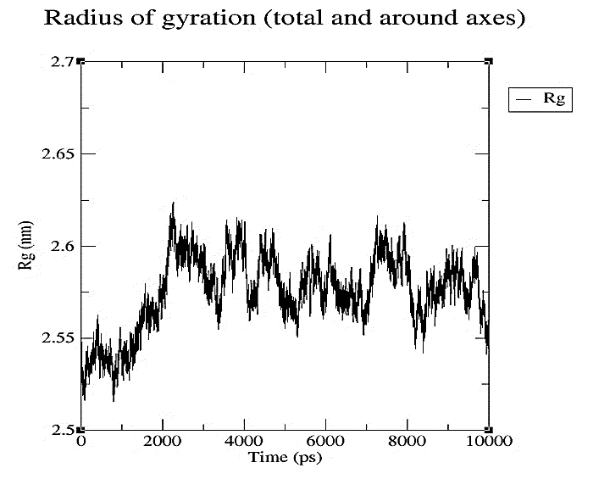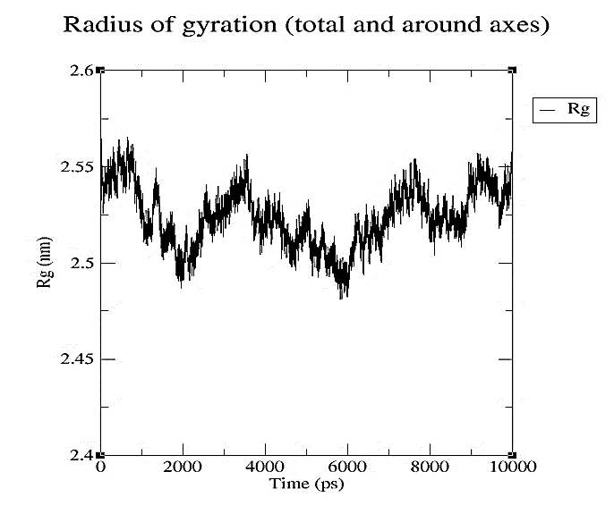
(a) (b)
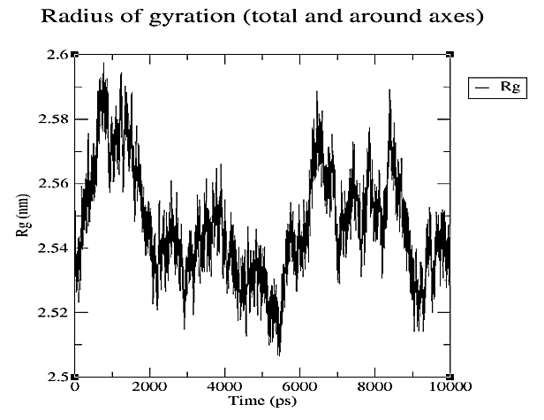
(c)
Fig. 6: The radius of gyration of ACE2 with (a) Celibixanthone, (b) Symphoxanthone, and (c) Hydroxychloroquine

Stable Rg profiles suggest that ligand binding did not induce significant receptor unfolding or structural destabilization. Taken together, the Rg results corroborate the RMSD and RMSF findings and confirm the structural integrity of the ACE2-ligand complexes during the simulation period.

The combined results from ADMET screening, molecular docking, MM-GBSA binding free energy calculations, and molecular dynamics simulations indicate that NP#0157 (Celibixanthone) and NP#0158 (Symphoxanthone) exhibit favorable drug-like properties, strong binding affinity, and stable dynamic behavior when complexed with the ACE2 receptor. Their performance was comparable to that of hydroxychloroquine and other reference inhibitors, highlighting their potential as promising natural-product-based ACE2 inhibitors. These findings warrant further experimental validation to confirm their antiviral efficacy against SARS-CoV-2.

5. Conclusion
In this study, a structure-based computational approach was employed to identify phytochemical inhibitors of the human angiotensin-converting enzyme 2 (ACE2) receptor, a key mediator of SARS-CoV-2 entry into host cells. FDA-approved antiviral agents, including hydroxychloroquine, nelfinavir, and nirmatrelvir (Paxlovid), were used as reference compounds to benchmark the performance of the selected phytochemicals. The overarching objective was to explore natural-product-based candidates that could potentially serve as prophylactic or pre-treatment agents against COVID-19 by disrupting ACE2-mediated viral entry.
Virtual screening, followed by SP and XP molecular docking and MM-GBSA binding free energy calculations, identified several phytochemicals with favorable binding affinities toward ACE2. Among these, NP#0157 (Celibixanthone) and NP#0158 (Symphoxanthone) demonstrated docking scores and binding free energies comparable to, or exceeding, those of the reference drugs. Molecular dynamics simulations further substantiated these findings, as the ACE2-ligand complexes exhibited stable structural behavior over 100 ns, with consistent RMSD, RMSF, and radius of gyration profiles, indicating robust and sustained interactions.
Collectively, the results suggest that Celibixanthone and Symphoxanthone possess favorable drug-like characteristics, stable binding interactions, and dynamic stability within the ACE2 binding site. These phytochemicals, derived from Cratoxylon celibicum and Symphonia globulifera, respectively, represent promising natural-product scaffolds for further investigation as potential ACE2 inhibitors. Although the present findings are based on in silico analyses, they provide a strong theoretical foundation for subsequent in vitro and in vivo validation studies to assess their efficacy and safety as potential prophylactic or therapeutic agents against SARS-CoV-2.

6. References
(1) Ohashi, H.; Watashi, K.; Saso, W.; Shionoya, K.; Iwanami, S.; Hirokawa, T.; Shirai, T.; Kanaya, S.; Ito, Y.; Kim, K. S.; Nomura, T.; Suzuki, T.; Nishioka, K.; Ando, S.; Ejima, K.; Koizumi, Y.; Tanaka, T.; Aoki, S.; Kuramochi, K.; Suzuki, T.; Hashiguchi, T.; Maenaka, K.; Matano, T.; Muramatsu, M.; Saijo, M.; Aihara, K.; Iwami, S.; Takeda, M.; McKeating, J. A.; Wakita, T. Potential Anti-COVID-19 Agents, Cepharanthine and Nelfinavir, and Their Usage for Combination Treatment. iScience 2021, 24 (4), 102367. https://doi.org/10.1016/j.isci.2021.102367.
(2) Singh, P.; Chauhan, S. S.; Pandit, S.; Sinha, M.; Gupta, S.; Gupta, A.; Parthasarathi, R. The Dual Role of Phytochemicals on SARS-CoV-2 Inhibition by Targeting Host and Viral Proteins. J. Tradit. Complement. Med. 2022, 12 (1), 90–99. https://doi.org/10.1016/j.jtcme.2021.09.001.
(3) Arthur, D. E.; Elegbe, B. O.; Aroh, A. O.; Soliman, M. Computational Drug Design of Novel COVID-19 Inhibitor. Bull. Natl. Res. Cent. 2022, 46 (1), 210. https://doi.org/10.1186/s42269-022-00892-z.
(4) Adhikari, P.; Li, N.; Shin, M.; Steinmetz, N. F.; Twarock, R.; Podgornik, R.; Ching, W.-Y. Intra- and Intermolecular Atomic-Scale Interactions in the Receptor Binding Domain of SARS-CoV-2 Spike Protein: Implication for ACE2 Receptor Binding. Phys. Chem. Chem. Phys. 2020, 22 (33), 18272–18283. https://doi.org/10.1039/D0CP03145C.
(5) Huang, Y.; Yang, C.; Xu, X.; Xu, W.; Liu, S. Structural and Functional Properties of SARS-CoV-2 Spike Protein: Potential Antivirus Drug Development for COVID-19. Acta Pharmacol. Sin. 2020, 41 (9), 1141–1149. https://doi.org/10.1038/s41401-020-0485-4.
(6) Elfiky, A. A. SARS-CoV-2 Spike-Heat Shock Protein A5 (GRP78) Recognition May Be Related to the Immersed Human Coronaviruses. Front. Pharmacol. 2020, 11, 577467. https://doi.org/10.3389/fphar.2020.577467.
(7) Eweas, A. F.; Alhossary, A. A.; Abdel-Moneim, A. S. Molecular Docking Reveals Ivermectin and Remdesivir as Potential Repurposed Drugs Against SARS-CoV-2. Front. Microbiol. 2021, 11, 592908. https://doi.org/10.3389/fmicb.2020.592908.
(8) Suvarnapathaki, S.; Chauhan, D.; Nguyen, A.; Ramalingam, M.; Camci-Unal, G. Advances in Targeting ACE2 for Developing COVID-19 Therapeutics. Ann. Biomed. Eng. 2022, 50 (12), 1734–1749. https://doi.org/10.1007/s10439-022-03094-w.
(9) Borkotoky, S.; Dey, D.; Hazarika, Z. Interactions of Angiotensin-Converting Enzyme-2 (ACE2) and SARS-CoV-2 Spike Receptor-Binding Domain (RBD): A Structural Perspective. Mol. Biol. Rep. 2023, 50 (3), 2713–2721. https://doi.org/10.1007/s11033-022-08193-4.
(10) Brooke, G. N.; Prischi, F. Structural and Functional Modelling of SARS-CoV-2 Entry in Animal Models. Sci. Rep. 2020, 10 (1), 15917. https://doi.org/10.1038/s41598-020-72528-z.
(11) Hennekens, C. H.; Rane, M.; Solano, J.; Alter, S.; Johnson, H.; Krishnaswamy, S.; Shih, R.; Maki, D.; DeMets, D. L. Updates on Hydroxychloroquine in Prevention and Treatment of COVID-19. Am. J. Med. 2022, 135 (1), 7–9. https://doi.org/10.1016/j.amjmed.2021.07.035.
(12) Eweas, A. F.; Alhossary, A. A.; Abdel-Moneim, A. S. Molecular Docking Reveals Ivermectin and Remdesivir as Potential Repurposed Drugs Against SARS-CoV-2. Front. Microbiol. 2021, 11, 592908. https://doi.org/10.3389/fmicb.2020.592908.
(13) Aslam, M.; Nawaz, M. S.; Fournier-Viger, P.; Li, W. Comparative Analysis and Classification of SARS-CoV-2 Spike Protein Structures in PDB. COVID 2023, 3 (4), 452–471. https://doi.org/10.3390/covid3040034.
(14) Parthiban, G.; Dushanan, R.; Weerasinghe, S.; Dissanayake, D.; Senthilnithy, R. Exploration of Novel Mono Hydroxamic Acid Derivatives as Inhibitors for Histone Deacetylase Like Protein (HDLP) by Molecular Dynamics Studies. Indones. J. Chem. 2022, 22 (6), 1534. https://doi.org/10.22146/ijc.74167.
(15) Negru, P. A.; Miculas, D. C.; Behl, T.; Bungau, A. F.; Marin, R.-C.; Bungau, S. G. Virtual Screening of Substances Used in the Treatment of SARS-CoV-2 Infection and Analysis of Compounds with Known Action on Structurally Similar Proteins from Other Viruses. Biomed. Pharmacother. 2022, 153, 113432. https://doi.org/10.1016/j.biopha.2022.113432.
(16) Parthiban, G.; Dushanan, R.; Weerasinghe, S.; Dissanayake, D.; Senthilnithy, R. Exploration of Novel Mono Hydroxamic Acid Derivatives as Inhibitors for Histone Deacetylase Like Protein (HDLP) by Molecular Dynamics Studies. Indones. J. Chem. 2022, 22 (6), 1534. https://doi.org/10.22146/ijc.74167.
(17) Hassanzadeganroudsari, M.; Ahmadi, A.; Rashidi, N.; Hossain, M.; Habib, A.; Apostolopoulos, V. Computational Chemistry to Repurposing Drugs for the Control of COVID-19. Biologics 2021, 1 (2), 111–128. https://doi.org/10.3390/biologics1020007.
(18) Ali, A.; Vijayan, R. Dynamics of the ACE2–SARS-CoV-2/SARS-CoV Spike Protein Interface Reveal Unique Mechanisms. Sci. Rep. 2020, 10 (1), 14214. https://doi.org/10.1038/s41598-020-71188-3.

