Green Growth and Sustainable Finance: A Narrative Review of Economic Evidence and Policy Pathways

Abstract
The search for economic growth that is still viable environmentally has reignited the applicability of the concepts of green growth and sustainable finance. Both have been prominently featured in policy debates, but their economic bases and their effectiveness are still questioned. This narrative review summarizes the literature of environmental and financial economics to assess how environmental policy, innovation, and financial mechanisms together influence growth outcomes and transition pathways. The review is structured around four themes, the conceptualization and measurement of green growth; the relationship between environmental policy, innovation, and economic performance, the role of sustainable finance in reallocating capital; and the implications of climate, related financial risks for governance and stability. Green growth, according to the evidence, hinges on measurement frameworks that are based on wealth and well, designed environmental policies that redirect technological change without causing a decline in productivity. Sustainable finance may play a role in these developments by reducing the financing costs and making the risk pricing more efficient, yet its effect is still very limited in the absence of policy signals, disclosure, and governance. The financial risks associated with climate change reinforce the argument for embedding sustainable finance operations within macro, financial oversight. The review, in general, conveys that green growth is a real option but it will not happen automatically. It calls for a coordinated policy pathway that aligns regulation, innovation, and finance while at the same time managing trade-offs and systemic risks.
Keywords: Green growth; sustainable finance; environmental policy; climate-related financial risk; technological innovation; policy governance

- Introduction
Maintaining long-term economic growth in a world where we have to deal with climate change and environmental degradation is the major challenge that policymakers all over the globe are facing now. The idea of green growth is the way out this problem, suggesting that economic growth can be in harmony with environmental sustainability if we use the right policies, technology and institutional structures. Also, the concept of the sustainable finance has been put forward as a way of attracting private capital to investments that are good for the environment, thus, creating the hope that financial markets can be the main driver of the transition to a low, carbon economy.
While green growth has been a popular topic of discussion in the policy world, the economic background of green growth and sustainable finance is still debatable. On one hand, empirical evidence is inconclusive on the question of whether environmental policies put a brake on or drive productivity, while on the other hand, the question of the effectiveness of sustainable finance instruments in redirecting capital towards truly green activities remains unresolved. Besides, the growing awareness of the risks of climate change to the financial sector has led to a shift of the debate from issues of growth and investment to those of financial stability, disclosure, and regulatory governance. The problems are, thus, very real and immediate in contexts of developing economies where climate impacts are entangled with livelihoods and economic vulnerability, deepening the call for the need of growth strategies that not only focus on the social and distributional aspects of sustainability but also explicitly incorporate them (Shamim & Faishal, 2019). The two sets of literatures have been separately explored, thus, the interaction between real economic activity, financial markets, and policy in practice is not fully understood.
This narrative review seeks to bring together these pieces of evidence by combining leading ideas from environmental economics and financial economics. Instead of questioning if green growth can be possible in principle, the paper concentrates on the ways political design, innovation dynamics, and financial mechanisms together influence growth results and transition routes. The work is structured around four topics: the understanding and quantifying of green growth; the impact of environmental policy, innovation, and economic performance; the contribution of green finance to capital allocation; and, finally, the consequences of climate, related financial risks for regulation and security.
To back up this integration, Table 1 lays out the fundamental economic, Core green growth ideas, measurement methods, and policy innovation linkages. Table 2 aggregates sustainable finance instruments, risk pricing, and regulatory responses insights. Figure 1 shows a conceptual framework connecting green growth, sustainable finance, and policy, and Figure 2 depicts policy transmission pathways, tradeoffs, and risks. In the Core framework linking green growth, sustainable finance, and policy, Trade-offs, risks, and policy transmission pathways. These components combined describe a structured account of knowledge, Conceptual framework connecting green growth, sustainable finance, and policy. Policy transmission pathways, trade- offs, and risks known as well as the areas where the proof is lacking and the policy routes are most likely to be. This review, by providing a brief, policy, oriented synthesis, is a Structured account of knowledge, known as well as areas where proof is lacking and policy routes are most likely. Brief, policy, oriented synthesis contributing to ongoing debates on sustainable development and signaling key areas for future research and coordinated policy action. debate surrounding sustainable development, to which it makes a key contribution by pinpointing the major areas for future research and coordinated policy action.

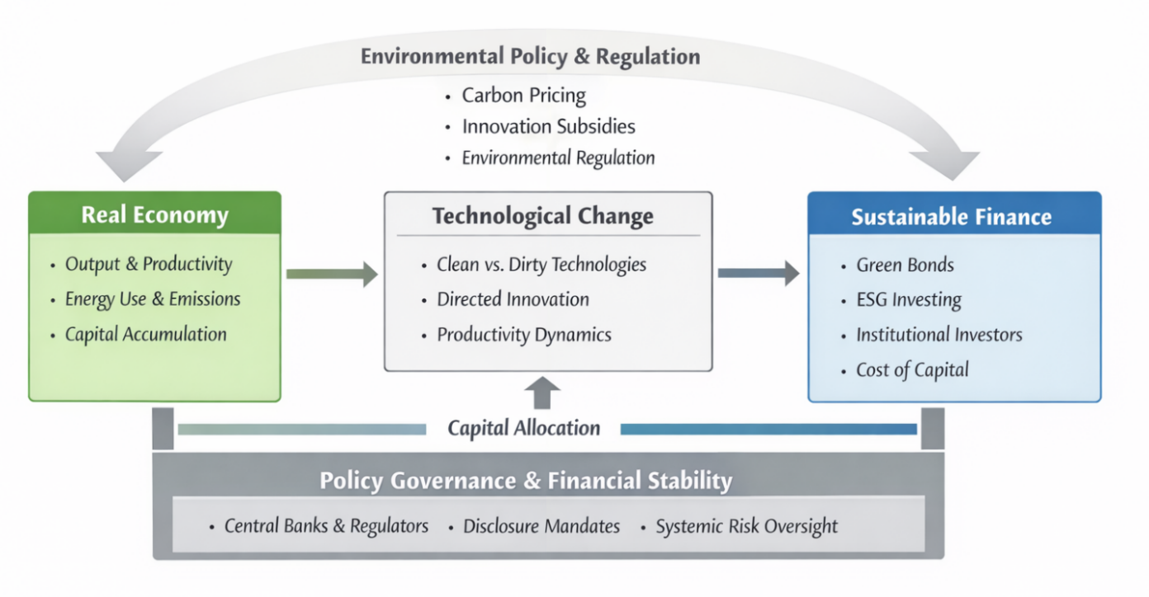
Figure 1: Conceptual Linkages Between Green Growth, Sustainable Finance, and Policy

- Methodology
This study uses a narrative review to combine economic evidence related to green growth and sustainable finance. A narrative design is suitable here because the literature is conceptually diverse, methodologically heterogeneous, and interdiscipdisciplinary in nature, spanning environmental economics, macroeconomics, and financial economics. Instead of aiming for an exhaustive coverage, the review focuses on theoretical coherence, empirical credibility, and policy relevance. The literature selection involved a targeted screening of peer, reviewed journals indexed in Scopus and Web of Science, with a particular focus on the leading outlets in economics and finance. The weighting was turned towards papers that (i) offer empirical evidence on the growth, environment relationship, (ii) study the role of environmental policy and innovation, (iii) investigate sustainable finance instruments and capital allocation, or (iv) evaluate climate, related financial risks and governance mechanisms. The inclusion of influential theoretical contributions was limited to the framing of empirical findings.
The studies selected for examination were grouped into four thematic areas: (1) conceptualization and measurement of green growth, (2) environmental policy, innovation, and economic performance, (3) sustainable finance and capital reallocation, and (4) financial stability, climate risk, and policy governance. Tables 1 and 2 summarize the major empirical findings and policy directions for these themes, whereas Figures 1 and 2 illustrate the conceptual frameworks that link economic mechanisms, financial channels, and policy pathways. Being a narrative review, this paper does not assert exhaustiveness. Its primary intention is to provide a structured, policy, oriented synthesis that maps out solid findings, unresolved debates, and the research and policymaking implications.

- Green Growth: Concepts and Economic Evidence
The green growth concept is an attempt to harmonize economic expansion with environmental sustainability by mostly focusing on changes in the composition and the direction of growth, rather than the growth rates themselves. Initial economic contributions pointed out that conventional measures of income, like GDP, do not reflect the depletion of natural capital and the occurrence of environmental externalities. Consequently, green growth frameworks turn to indicators that are based on wealth and adjusted for productivity, thus reflecting environmental constraints and long, run welfare (Table 1).
One of the main ideas emerging from the research is that sustainability is conditional on economies still holding or even increasing their total capital stock, which is a broad concept including produced, human, and natural capital. The concepts of genuine savings and comprehensive wealth, among others, were created to make this idea more operational, i. e. provide measurable indicators of weak sustainability. The real, world data shows that countries with consistently negative genuine savings are the ones that lower their future consumption growth, thus wealth, based metrics become the most relevant for the assessment of long, run development paths. However, at the same time, the outcomes are still dependent on valuation assumptions, which indicate that there are still substantial difficulties in the precise measurement of natural capital and environmental degradation.
Besides a core measurement, the main debate still revolves around the effect of environmental policies on productivity and innovation. Traditional economic theories argued that there may be trade-offs between regulation and growth, but a major part of empirical literature nowadays is arguing against such trade-offs. Some studies that test the weak Porter hypothesis reveal that firms can innovate to meet environmental regulations without a decrease in their productivity level. Table 1 summarizes the findings that firm, and industry, level data reveal to us. These data suggest that policy stringency, if it is predictable and market, based, may lead to a clean, tech innovation drive with a positive net economic performance effect. The pace of technological change is a very important aspect of green growth. Innovation is a non-neutral process, policies determine whether firms invest in carbon, intensive or low, carbon technologies. The empirical studies of energy prices, carbon markets, and regulatory regimes indicate that environmental policies can be a major driver of directed technological change which in turn can lead to clean technology becoming more widely used and emissions intensity getting lower over time. Such effects are crucial for the environmental objectives to be compatible with economic growth as they determine the productivity trajectories for the long run rather than the adjustment costs for the short run.
These findings are presented by figure 1 within a wider economic framework, showing how environmental policy impacts the real economy through innovation and structural change. The figure emphasizes that green growth results depend not only on policy ambition but also on policy design, credibility, and the way it interacts with financial markets. Although environmental regulation can change incentives alone, its effectiveness is increased if it is complemented by financial mechanisms that facilitate the reallocation of capital toward innovative and low, carbon activities. In sum, economic evidence points to the fact that green growth is not an automatic process, nor is it impossible to achieve. It needs suitable measurement frameworks, properly designed environmental policies, and a structural change driven by innovation. These revelations form the basis for studying the role of sustainable finance in amplifying or limiting green growth paths, which is the subject of the following sections.

Table 1: Concepts, Measurement, and Economic Evidence on Green Growth
Dimension | Key Concept / Indicator | Main Empirical Findings | Representative Studies | Policy Implications
Conceptual foundations | Weak vs. strong sustainability | Income growth alone is insufficient to assess sustainability | Pearce & Atkinson (1993); Arrow et al. (2012) | Growth metrics must account for natural capital depletion
Measurement approaches | Genuine savings / comprehensive wealth | Positive genuine savings predicts future consumption | Hamilton & Clemens (1999); Ferreira & Vincent (2005) | Wealth-based metrics outperform GDP in policy evaluation
Measurement challenges | Valuation of natural resources | Results sensitive to accounting assumptions | Neumayer (2000); Atkinson & Hamilton (2007) | Transparency in valuation methods is critical
Policy-innovation link | Environmental regulation & innovation | Regulation can stimulate innovation (weak Porter hypothesis) | Jaffe & Palmer (1997); Lanoie et al. (2011) | Well-designed regulation supports productivity
Productivity effects | Policy stringency & firm productivity | No systematic evidence of long-run productivity losses | Albrizio et al. (2017); Calel & Dechezleprêtre (2016) | Stringent policies can coexist with growth
Technological direction | Directed technical change | Policies shift innovation toward clean technologies | Popp (2002); Dechezleprêtre et al. (2017) | Policy design affects long-term growth paths

- Sustainable Finance and Policy Pathways
Sustainable finance is the main source of green growth strategies and this is the reflection of the expectation that financial markets can be the tools to resend capital toward environmentally sustainable activities. Such instruments as green bonds, ESG integration, and climate, focused investment mandates are being used more and more as the ways by which the private climate, friendly investment can be aligned with public climate objectives. Nevertheless, the economic evidence shows that the sustainable finance promotion has to be accompanied with the green growth policy, information quality, and governance framework (Table 2). On the one hand, empirical studies reveal that the use of sustainable finance instruments may condition the firms financing to some extent. Worldwide green bond markets attest to the fact that the issuance is generally linked with relatively small reductions in the cost of capital and positive market reactions, thus, investors seem to 'value environmental commitments which are credible. On the other hand, the scope of these effects is still very small, and the way they influence real investment in different firms and sectors varies. It points to the significant limitation: financial markets usually have the ability to 'amplify existing incentives' rather than 'create them independently'. As shown in Figure 1, the main impact of the sustainable finance is when they are combined with the environmental policies which lead to the establishment of prices and regulations.
A related question is whether ESG, oriented investment leads to improved corporate performance or just reflects investor preferences. Meta, analytical evidence indicates a generally positive, but not consistent, relationship between ESG indicators and financial outcomes. Research at the firm level also implies that markets reward genuine, long, term commitments to non, financial goals, but punish those that are secretive or merely symbolic. These results highlight significance of standardization, disclosure, and verification in stopping greenwashing and allowing sustainable finance to be a means of real capital reallocation rather than reputational arbitrage. The scope of sustainable finance has been extended from capital allocation to financial stability due to the increasing acknowledgement of climate, related financial risks. Both physical risks resulting from climate change and transition risks resulting from policy changes can influence asset prices, firm valuations, and systemic risk. The empirical evidence indicates that investors are increasingly considering the carbon footprint and climate risk of their investments, while the stress, testing exercises reveal that a disorderly transition could exacerbate financial instability. As given in Table 2, this has led the central banks and regulators to incorporate climate considerations in prudential supervision and macro, financial oversight.
Figure 2 shows the journey of policy tools leading to economic and financial results through price signals, information channels, and risk reallocation, thus, revealing the key trade-offs. Any ambitious climate policies may cause temporary adjustment costs, distributional effects, and the risk of stranded assets in case of a bad sequence of activities. Sustainable finance can alleviate some of these problems by enabling investment and risk, sharing, but it cannot replace a properly designed policy. Hence, good governance, including disclosure standards, taxonomies, and regulatory coordination, is indispensable to align financial incentives with the goals of long, term growth and stability.

In general, the evidence is in favor of sustainable finance as a side mechanism, not a standalone solution. Its role in the green growth is conditional on the existence of credible environmental policies, strong information frameworks, and governance structures that can handle trade-offs and systemic risks. These revelations emphasize the necessity of integrated policy pathways that simultaneously tackle growth, finance, and the stability issues.
Table 2: Sustainable Finance, Climate Risk, and Policy Pathways
Dimension | Financial Channel | Core Evidence | Representative Studies | Policy Relevance
Capital allocation | Green bonds | Lower cost of capital for issuers | Flammer (2021); Tang & Zhang (2020) | Supports scaling of green investment
Pricing mechanisms | Green premia (“greenium”) | Small but significant bond pricing effects | Zerbib (2019) | Market incentives exist but are limited
ESG integration | Firm valuation & performance | Mixed but generally positive associations | Friede et al. (2015); Edmans (2011) | ESG signals matter but require standardisation
Investor behaviour | Institutional investor climate concern | Investors actively price climate risk | Krueger et al. (2020); Bolton & Kacperczyk (2021) | Disclosure enhances market discipline
Financial stability | Climate stress-testing | Transition risks can amplify systemic risk | Battiston et al. (2017); Bansal et al. (2021) | Climate risk is macro-financial risk
Governance & regulation | Central banks & regulators | Climate mandates reshape financial oversight | Campiglio et al. (2018); Bolton et al. (2021) | Regulatory coordination is essential

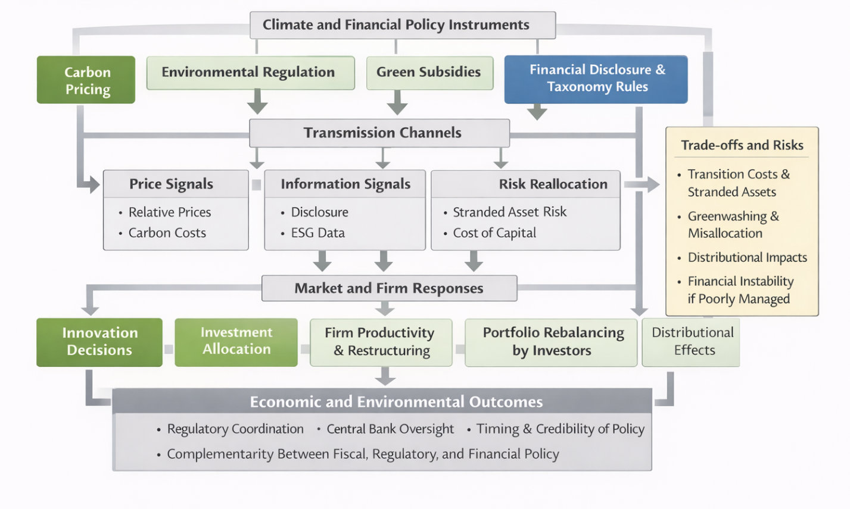
Figure 2. Policy Transmission Pathways, Trade-offs and Risks in Green Growth

- Conclusion and Policy Implications
This narrative review has investigated the economic evidence regarding green growth and sustainable finance, with a focus on the interaction of environmental policy, innovation, and financial mechanisms to long, run growth and stability. The literature examined in this review points to green growth as being neither automatic nor inconsistent- economic development can be harmonized with environmental goals if growth is backed by proper measurement frameworks, credible policy signals, and innovation-driven structural change.
Environmental economics have provided evidence that wealth, based and productivity, adjusted indicators offer a more accurate evaluation of sustainability than income, based measures by themselves. Additionally, empirical studies are gradually refuting the argument that environmental regulation always has a negative impact on economic performance. In the case of well, designed, predictable, and market, based policies, they can therefore encourage innovation and make technological change cleaner without lowering productivity. Consequently, these results emphasize significance of policy design and institutional trust in determining the results of green growth.
Sustainable finance essentially helps the policy to work by making loud the signals of the policy and by making it easy for the capital to move from one place to another. In fact, on their own green bonds and ESG integration might be able to lower the cost of the financing and to sway investment decisions, but their impacts remain very limited and differ much from case to case. Generally, financial markets tend to react to incentives and information rather than to come up with them on their own. Hence, sustainable finance yields the best results when it is part of a comprehensive policy programme which deals with environmental externalities and guarantees openness. Furthermore, the increasing awareness of climate, related financial risks has brought sustainable finance in the centre of issues related to macro, financial stability, thus calling for combined regulatory and supervisory responses. Considering policies, the main message for the governments is that a green economy is not achievable by single policies, but rather by integrated policies pathways. The environment regulation, the innovation policy, and the financial governance should be at the same time aligned and sequenced so as to be capable of managing trade-offs, controlling the distributional effects and preventing financial instability. Incomplete or uncoordinated measures may result in the destruction of the two sides the economy and the environment at the same time.
Further studies ought to concentrate on determining the situations when sustainable finance truly results in real additionality, refining the measurement of natural capital and transition risks, and evaluating the distributional effects of green growth strategies. It is vital to resolve these issues to create market interventions that are environmentally efficient, viable in terms of the economy and politics as well.

References
- Albrizio, S., Kozluk, T., & Zipperer, V. (2017). Environmental policies and productivity growth: Evidence across industries and firms. Journal of Environmental Economics and Management, 81, 209–226. https://doi.org/10.1016/j.jeem.2016.06.002
- Andersson, M., Bolton, P., & Samama, F. (2016). Hedging climate risk. Financial Analysts Journal, 72(3), 13–32. https://doi.org/10.2469/faj.v72.n3.4
- Arrow, K. J., Dasgupta, P., Goulder, L. H., Mumford, K. J., & Oleson, K. (2012). Sustainability and the measurement of wealth. Environment and Development Economics https://doi.org/10.1017/S1355770X12000137
- Atkinson, G., & Hamilton, K. (2007). Progress along the path: Evolving issues in the measurement of genuine saving. Environmental and Resource Economics, 37(1), 43–61. https://doi.org/10.1007/s10640-007-9114-7
- Bansal, R., Kiku, D., & Ochoa, M. (2021). Climate change risk. The Journal of Finance, 76(6), 2873–2921. https://doi.org/10.1111/jofi.13079
- Battiston, S., Mandel, A., Monasterolo, I., Schütze, F., & Visentin, G. (2017). A climate stress-test of the financial system. Nature Climate Change, 7(4), 283–288. https://doi.org/10.1038/nclimate3255
- Bolton, P., & Kacperczyk, M. (2021). Do investors care about carbon risk? Journal of Financial Economics, 142(2), 517–549. https://doi.org/10.1016/j.jfineco.2021.05.008
- Bolton, P., Despres, M., Pereira da Silva, L. A., Samama, F., & Svartzman, R. (2020). The green swan: Central banking and financial stability in the age of climate change. Bank for International Settlements. https://www.bis.org/publ/othp31.pdf
- Calel, R., & Dechezleprêtre, A. (2016). Environmental policy and directed technological change: Evidence from the European carbon market. Review of Economics and Statistics, 98(1), 173–191. https://doi.org/10.1162/REST_a_00538
- Campiglio, E., Dafermos, Y., Monnin, P., Ryan-Collins, J., Schotten, G., & Tanaka, M. (2018). Climate change challenges for central banks and financial regulators. Nature Climate Change. https://doi.org/10.1038/s41558-018-0175-0
- Dechezleprêtre, A., Martin, R., & Mohnen, M. (2017). Knowledge spillovers from clean and dirty technologies: A patent citation analysis (Grantham Research Institute on Climate Change and the Environment Working Paper No. 135). London School of Economics and Political Science. http://www.lse.ac.uk/GranthamInstitute/wp-content/uploads/2013/10/Working-Paper-135-Dechezlepretre-et-al_updateOct2017.pdf
- Edmans, A. (2011). Does the Stock Market Fully Value Intangibles? Employee Satisfaction and Equity Prices. Journal of Financial Economics. https://doi.org/10.1016/j.jfineco.2011.03.021
- Ferreira, S., & Vincent, J. R. (2005). Genuine savings: Leading indicator of sustainable development? Economic Development and Cultural Change, 53(3), 737–754. https://doi.org/10.1086/426834
- Flammer, C. (2021). Corporate green bonds. Journal of Financial Economics, 142(2), 499–516. https://doi.org/10.1016/j.jfineco.2021.01.010
- Friede, G., Busch, T., & Bassen, A. (2015). ESG and financial performance: Aggregated evidence from more than 2000 empirical studies. Journal of Sustainable Finance & Investment, 5(4), 210–233. https://doi.org/10.1080/20430795.2015.1118917
- Hamilton, K. (2003). Sustaining economic welfare: Estimating changes in total and per capita wealth. Environment, Development and Sustainability, 5, 419–436. https://doi.org/10.1023/A:1025716711086
- Hamilton, K., & Clemens, M. (1999). Genuine savings rates in developing countries. The World Bank Economic Review, 13(2), 333–356. https://doi.org/10.1093/wber/13.2.333
- Hong, H., Karolyi, G. A., & Scheinkman, J. A. (2020). Climate Finance. The Review of Financial Studies. https://doi.org/10.1093/rfs/hhz146
- Jaffe, A. B., & Palmer, K. (1997). Environmental regulation and innovation: A panel data study. The Review of Economics and Statistics, 79(4), 610–619. https://doi.org/10.1162/003465397557196
- Johnstone, N., Haščič, I., & Popp, D. (2010). Renewable energy policies and technological innovation: Evidence based on patent counts. Environmental and Resource Economics, 45(1), 133–155. https://doi.org/10.1007/s10640-009-9309-1
- Kahn, M. E., Mohaddes, K., Ng, R. N. C., Pesaran, M. H., Raissi, M., & Yang, J.-C. (2021). Long-term macroeconomic effects of climate change: A cross-country analysis. Energy Economics, 104, 105624. https://doi.org/10.1016/j.eneco.2021.105624
- Krueger, P., Sautner, Z., & Starks, L. T. (2020). The importance of climate risks for institutional investors. Review of Financial Studies, 33(3), 1067–1111. https://doi.org/10.1093/rfs/hhz137
- Lanoie, P., Laurent-Lucchetti, J., Johnstone, N., & Ambec, S. (2011). Environmental policy, innovation and performance: New insights on the Porter hypothesis. Journal of Economics & Management Strategy, 20(3), 803–842. https://doi.org/10.1111/j.1530-9134.2011.00301.x
- Neumayer, E. (2000). Resource accounting in measures of unsustainability: Challenging the World Bank’s conclusions. Environmental and Resource Economics, 15(3), 257–278. https://doi.org/10.1023/A:1008304812545
- Pearce, D. W., & Atkinson, G. D. (1993). Capital theory and the measurement of sustainable development: An indicator of “weak” sustainability. Ecological Economics, 8(2), 103–108. https://doi.org/10.1016/0921-8009(93)90039-9
- Popp, D. (2002). Induced innovation and energy prices. American Economic Review, 92(1), 160–180. https://doi.org/10.1257/000282802760015658
- Shamim, J., & Faishal, M. (2019). An overview of inevitable linkage between climate change and agriculture with livelihood security in rural India. IMPACT: International Journal of Research in Humanities, Arts and Literature, 7(4), 71-87. https://www.impactjournals.us/journals/impact-international-journal-of-research-in-humanities-arts-and-literature
- Tang, D. Y., & Zhang, Y. (2020). Do shareholders benefit from green bonds? Journal of Corporate Finance, 61, 101427. https://doi.org/10.1016/j.jcorpfin.2018.12.001
- Zerbib, O. D. (2019). The effect of pro-environmental preferences on bond prices: Evidence from green bonds. Journal of Banking & Finance, 98, 39–60. https://doi.org/10.1016/j.jbankfin.2018.10.012

