Original Research Article
Post-Natal Growth Trends: Evaluating the Correspondence Between Body Measurements and Weight in Surti Goat Kids

ABSTRACT
The present study was carried out on 115 apparently healthy Surti goats maintained at Livestock Research Station (LRS), Kamdhenu University, Navsari. Various body measurements viz. height at wither, height at hipbone, height at pinbone, hock height, chest height, ground to stomach height, humerus height, femur height, body length, heart girth, bicostal girth, paunch girth, fore cannon bone girth, rump length, ilium width of the rump, medium width of the rump and ischium width of the rump were taken. Live body weight of all animals was recorded on the day their body morphometry was done and body weight of animals at different age was studied from growth/body weight register maintained at the farm. These animals were classified into 2 different groups based on their age viz. group 1 (0 to 3 months) and group 2 (3 to 6 months). For groups 1 and 2, the corresponding mean and standard error of live body weight were 05.03 ± 00.29 and 10.20 ± 00.44 kg, respectively. The live body weight was highly correlated (P<0.001) with bicostal girth with r value of 0.942 in group 1 (0 to 3 months). In group 2, live body weight was positively and significantly (P<0.001) correlated with heart girth with r of value 0.917.
KEY WORDS
Surti Goats, Body Morphometry, Corelation, Body Weight

- INTRODUCTION
Goats represent a vital component of livestock systems in many tropical and subtropical regions, providing essential sources of meat, milk, and income for smallholder farmers. In India, which maintains one of the world's largest goat populations, indigenous breeds play a key role in sustaining rural livelihoods due to their adaptability to local conditions and relatively low management requirements. Among these, the Surti goat—a medium-sized breed primarily distributed in southern Gujarat and parts of Maharashtra—stands out for its compact body conformation, predominantly white coat with short, shiny hair, and suitability for stall-fed or semi-intensive rearing systems (Deshpande et al., 2010).
Smallholder farmers practiced estimation of the body weight by looking on the animal body size, leading to inaccuracies in decision making. Proper measurement of live body weight, which is often hard in villages due to lack of weighing scale (Berhe, 2017). Weighing scale, although accurate, is less preferred because it is cumbersome, time consuming, costly to implement, difficult for notorious/aggressive animal and stressful to the herd (Kesang et al., 2018). Linear morphometric traits offer practical, non-invasive indicators that reflect overall body development and mass accumulation during the critical pre-weaning and early post-weaning phases. Body measurements like body length and paunch girth may be considered best for prediction of body weight of Assam Hill goat (Khargharia et al., 2015). Highly significant, (P<0.001) moderate to high correlation of live weight with the body length, wither height and chest girth was observed in all the four age groups studied (Karna et al., 2020). Body length and heart girth were highly positive significant correlated to body weight of female and male yearling Boer goats, respectively (Mathapo and Tyasi, 2021).
The present study therefore aimed to examine the phenotypic correlations between a range of body morphometric measurements and live body weight in Surti goat kids aged below six months. By documenting these associations, the research seeks to highlight the practical relevance of linear body traits as indicators of weight in young Surti goats, offering implications for field-based monitoring, breeding decisions and overall herd improvement in similar production systems.
- MATERIALS AND METHODS
2.1 Description of study animals and management
The study was conducted on Surti goats maintain at Livestock Research Station, Kamdhenu University, Navsari. All experimental animals were maintained under loose housing system. Animals were kept in concrete (pakka) shed with concrete floor. All the animals were housed under same managemental conditions and subjected to standard routine management practices followed at Livestock Research Station.
2.2 Sampling technique and sample size determination
One hundred fifteen apparently healthy Surti goat kids aged below 6 months were included in this study. These animals were classified in 2 different groups based on their age as mentioned below
List 1 : Distribution of animals by age group
Sr. No. | Group | Age | No. of Animals
1 | Group 1 | 0 to 3 months | 58
2 | Group 2 | > 3 to 6 months | 57
Total |  |  | 115
Available body weight of animals at different age was studied from growth/body weight register maintained at this farm. Further, live body weight of all animals under this study was recorded on the day their body morphometry was done. The constant weight was considered for recording. The weight of animals was measured in kilogram unit.
2.3 Data collections
Body measurements of these animals were recorded with utmost precision to the nearest centimetre scale with the help of measuring tape. Measurements were taken when animal stands comfortably and evenly on its feet on hard plain ground with its neck elevated to a position level with back for maximum precision. The various body measurements which were recorded in this study are; Height at Wither (HaW): The vertical distance from ground to the highest point of the withers; Height at Hip bone (HaH): The vertical distance from ground to highest point of hip bone; Height at Pin bone (HaP): The vertical distance from ground to highest point of pin bone; Hock Height (HoH): The vertical distance from ground to point of hock joint; Chest Height (CH): The vertical distance from ground to portion between two fore limbs just behind the point of elbow; Ground to Stomach Height (GtSH): The vertical distance from ground to point on the lower side of the belly; Humerus height (HS): The vertical distance from ground to head of humorous bone; Femur Height (FH): The vertical distance from ground to head of femur bone; Body Length (BDL): The oblique distance between tip of the shoulder to the tip of the pin bone; Heart Girth (HG): The circumference of chest just behind the point of elbow; Bicostal Girth (BG): The circumference around the abdomen region; Paunch Girth (PG): The circumference around the abdomen ahead of the udder; Fore Cannon Bone Girth (FCBG): The circumference of left cannon bone in the middle area; Rump Length (RL): The distance between the tip of the ilium and the tip of the ischium; Ilium Width of the Rump (ILWR): Measured between the two tips of the ilium bone; Medium width of the Rump (MDR): Measured between the trochanter (coxofemoral articulation) and Ischium Width of the Rump (ISWR): Measured between the two tips of the ischium bone.
2.4 Data analysis
The obtained data were first tabulated using descriptive statistics and analyzed by One-way ANOVA and mean within the group was compared using Duncan multiple range test (DMRT). Duncan multiple range test (DMRT) was used for mean separation at 5% and 1% level of significance. Correlation test was also performed for correlation coefficients between live body weight and body measurements using SPSS software.
- RESULTS AND DISCUSSION
3.1 Body morphometric measurements of Surti goats
The overall mean and standard error for body weight of Surti goats at birth (BW), 3 months and 6 months of age were 02.45 ± 00.03, 09.02 ± 00.17 and 13.89 ± 00.29 kg, respectively. The mean and standard error for live body weight of groups 1 and 2 were found to be 05.03 ± 00.29 and 10.20 ± 00.44 kg, respectively. The overall mean and standard error of body measurements of both age groups of Surti goats are shown in table 1.
Table 1: Means and standard error (Mean ± SE) of various body morphometric traits of Surti goats.
Body Morphometric Traits | Group 1 | Group 2
BL | 36.58 ± 0.95 | 47.05 ± 0.64
HG | 38.65 ± 0.82 | 48.95 ± 0.70
BG | 40.45 ± 1.04 | 55.46 ± 0.86
PG | 40.50 ± 0.92 | 53.96 ± 0.77
FCBG | 5.73 ± 0.08 | 6.14 ± 0.1
RL | 11.38 ± 0.28 | 14.05 ± 0.28
ILWoR | 04.85 ± 0.16 | 06.28 ± 0.15
MWoR | 11.31 ± 0.28 | 13.53 ± 0.20
IWoR | 02.49 ± 0.07 | 03.21 ± 0.10
HaW | 39.29 ± 0.77 | 47.76 ± 0.65
HaH | 40.18 ± 0.77 | 49.01 ± 0.65
Hap | 34.58 ± 0.72 | 41.42 ± 0.68
HoH | 16.59 ± 0.28 | 19.69 ± 0.24
CH | 23.80 ± 0.57 | 28.59 ± 0.4
GtSH | 24.97 ± 0.49 | 29.07 ± 0.37
HS | 28.73 ± 0.69 | 35.68 ± 0.44
FH | 32.62 ± 0.85 | 41.42 ± 0.56
(All measurements are in centimetres (cm))
All body measurements of Surti goats showed a slow and gradual increasing trend in body mass from both groups, i.e., from 0 to 3 months to 6 months of age. The increase can be attributed to the overall growth and maturation of the skeletal system with age.
3.2 Relationship between Live Body Weight and Body Measurements in Group 1 Surti Goats
A positive and significant (P<0.001) correlation was found between live body weight and height at wither, height at hipbone, height at pinbone, hock height, chest height, ground to stomach height, humerus height, femur height, body length, heart girth, bicostal girth, paunch girth, rump length, ilium width of the rump, medial width of the rump and ischium width of the rump with r value 0.83, 0.853, 0.666, 0.805, 0.69, 0.769, 0.842, 0.861, 0.713, 0.915, 0.942, 0.910, 0.633, 0.577, 0.844 and 0.586, respectively, in group 1 of Surti goats. Highest correlation was for bicostal girth with an r value of 0.942 and the lowest correlation for fore cannon bone girth with an r value of 0.332 with live body weight. There was a positive and significant (P<0.05) correlation between fore cannon bone girth and live body weight.
Table 2: Correlation coefficients between body weight and height at wither (HaW), height at hipbone (HaH), height at pinbone (HaP), hock height (HoH), chest height (CH), ground to stomach height (GtSH), humerus height (HS) and femur height (FH) in group 1 Surti goats.
 | Live weight | Sex | HaW | HaH | HaP | HoH | CH | GtSH | HS | FH
Live weight | 1 | -0.236 | 0.830** | 0.853** | 0.666** | 0.805** | 0.690** | 0.769** | 0.842** | 0.861**
Sex |  | 1 | -0.170 | -0.216 | -0.175 | -0.234 | -0.201 | -0.138 | -0.091 | -0.116
HaW |  |  | 1 | 0.969** | 0.867** | 0.878** | 0.817** | 0.920** | 0.903** | 0.894**
HaH |  |  |  | 1 | 0.868** | 0.889** | 0.843** | 0.925** | 0.916** | 0.930**
HaP |  |  |  |  | 1 | 0.792** | 0.791** | 0.826** | 0.779** | 0.741**
HoH |  |  |  |  |  | 1 | 0.757** | 0.830** | 0.833** | 0.810**
CH |  |  |  |  |  |  | 1 | 0.876** | 0.836** | 0.783**
GtSH |  |  |  |  |  |  |  | 1 | 0.930** | 0.908**
HH |  |  |  |  |  |  |  |  | 1 | 0.950**
FH |  |  |  |  |  |  |  |  |  | 1
(** Correlation is significant at 0.01 level; * Correlation is significant at 0.05 level)

Table 3: Correlation coefficients between body weight and body length (BL), heart girth (HG), bicostal girth (BG), paunch girth (PG), fore cannon bone girth (FCBG), rump length (RL), ilium width of the rump (ILWoR), medial width of the rump (MWoR) and ischium width of the rump (IWoR) in group 1 Surti goats.
 | BL | HG | BG | PG | FCBG | RL | ILWoR | MWoR | IWoR
Live weight | 0.713** | 0.915** | 0.942** | 0.910** | 0.332* | 0.633** | 0.577** | 0.844** | 0.586**
Sex | -0.180 | -0.165 | -0.151 | -0.173 | -0.262* | -0.042 | -0.105 | -0.100 | 0.223
HaW | 0.737** | 0.876** | 0.837** | 0.876** | 0.451** | 0.761** | 0.723** | 0.787** | 0.552**
HaH | 0.767** | 0.893** | 0.866** | 0.895** | 0.440** | 0.768** | 0.686** | 0.822** | 0.511**
HaP | 0.678** | 0.712** | 0.673** | 0.751** | 0.501** | 0.821** | 0.763** | 0.601** | 0.426**
HoH | 0.678** | 0.813** | 0.778** | 0.810** | 0.367** | 0.693** | 0.697** | 0.764** | 0.580**
CH | 0.645** | 0.736** | 0.690** | 0.713** | 0.476** | 0.693** | 0.589** | 0.655** | 0.367**
GtSH | 0.687** | 0.873** | 0.795** | 0.806** | 0.365** | 0.726** | 0.714** | 0.79** | 0.527**
HS | 0.759** | 0.922** | 0.882** | 0.869** | 0.354** | 0.710** | 0.708** | 0.871** | 0.537**
FH | 0.755** | 0.937** | 0.908** | 0.895** | 0.285* | 0.693** | 0.644** | 0.900** | 0.552**
BL | 1 | 0.779** | 0.788** | 0.784** | 0.259* | 0.605** | 0.524** | 0.695** | 0.330*
HG |  | 1 | 0.956** | 0.910** | 0.223 | 0.657** | 0.681** | 0.904** | 0.602**
BG |  |  | 1 | 0.943** | 0.282* | 0.653** | 0.620** | 0.879** | 0.594**
PG |  |  |  | 1 | 0.404** | 0.708** | 0.651** | 0.862** | 0.557**
FCBG |  |  |  |  | 1 | 0.534** | 0.268* | 0.200 | -0.018
RL |  |  |  |  |  | 1 | 0.735** | 0.583** | 0.398**
ILWoR |  |  |  |  |  |  | 1 | 0.624** | 0.467**
MWoR |  |  |  |  |  |  |  | 1 | 0.580**
IWoR |  |  |  |  |  |  |  |  | 1
(** Correlation is significant at 0.01 level; * Correlation is significant at 0.05 level)

3.3 Relationship between Live Body Weight and Body Measurements in Group 2 Surti Goats
Live body weight was positively and significantly (P<0.001) correlated with height at wither, height at hipbone, height at pinbone, hock height, chest height, ground to stomach height, humerus height, femur height, body length, heart girth, bicostal girth, paunch girth, fore cannon bone girth, rump length, ilium width of the rump and medial width of the rump with r values of 0.866, 0.889, 0.513, 0.739, 0.664, 0.716, 0.727, 0.878, 0.876, 0.917, 0.779, 0.683, 0.636, 0.57, 0.578 and 0.69, respectively. The highest correlation was for heart girth with an r value of 0.917 and the lowest correlation for ischium width of the rump with an r value of 0.215 with live body weight.
Table 4: Correlation coefficients between body weight and height at wither (HaW), height at hipbone (HaH), height at pinbone (HaP), hock height (HoH), chest height (CH), ground to stomach height (GtSH), humerus height (HS) and femur height (FH) in group 2 Surti goats.
 | Live weight | Sex | HaW | HaH | HaP | HoH | CH | GtSH | HS | FH
Live weight | 1 | -0.402** | 0.866** | 0.889** | 0.513** | 0.739** | 0.664** | 0.716** | 0.727** | 0.878**
Sex |  | 1 | -0.437** | -0.403** | -0.194 | -0.362** | -0.272* | -0.301* | -0.328* | -0.402**
HaW |  |  | 1 | 0.941** | 0.632** | 0.770** | 0.837** | 0.843** | 0.815** | 0.888**
HaH |  |  |  | 1 | 0.678** | 0.796** | 0.783** | 0.809** | 0.854** | 0.898**
HaP |  |  |  |  | 1 | 0.687** | 0.612** | 0.591** | 0.789** | 0.592**
HoH |  |  |  |  |  | 1 | 0.603** | 0.646** | 0.764** | 0.742**
CH |  |  |  |  |  |  | 1 | 0.896** | 0.780** | 0.737**
GtSH |  |  |  |  |  |  |  | 1 | 0.775** | 0.766**
HS |  |  |  |  |  |  |  |  | 1 | 0.798**
FH |  |  |  |  |  |  |  |  |  | 1
(** Correlation is significant at 0.01 level; * Correlation is significant at 0.05 level)

Table 5: Correlation coefficients between weight and body length (BL), heart girth (HG), bicostal girth (BG), paunch girth (PG), fore cannon bone girth (FCBG), rump length (RL), ilium width of the rump (ILWoR), medial width of the rump (MWoR) and ischium width of the rump (IWoR) in group 2 Surti goats.
 | BL | HG | BG | PG | FCBG | RL | ILWoR | MWoR | IWoR
Live weight | 0.876** | 0.917** | 0.779** | 0.683** | 0.636** | 0.570** | 0.578** | 0.690** | 0.215
Sex | -0.307* | -0.451** | -0.333* | -0.435** | -0.385** | -0.244 | -0.288* | -0.160 | 0.401**
HaW | 0.839** | 0.852** | 0.733** | 0.676** | 0.625** | 0.559** | 0.643** | 0.640** | 0.187
HaH | 0.831** | 0.892** | 0.791** | 0.744** | 0.679** | 0.618** | 0.665** | 0.721** | 0.263*
HaP | 0.579** | 0.576** | 0.426** | 0.651** | 0.657** | 0.751** | 0.706** | 0.444** | 0.361**
HoH | 0.772** | 0.780** | 0.658** | 0.722** | 0.666** | 0.634** | 0.738** | 0.503** | 0.243
CH | 0.668** | 0.603** | 0.556** | 0.504** | 0.495** | 0.504** | 0.609** | 0.442** | 0.269*
GtSH | 0.691** | 0.649** | 0.437** | 0.452** | 0.538** | 0.555** | 0.705** | 0.480** | 0.312*
HS | 0.736** | 0.790** | 0.649** | 0.711** | 0.720** | 0.683** | 0.702** | 0.562** | 0.370**
FH | 0.762** | 0.839** | 0.732** | 0.647** | 0.583** | 0.474** | 0.528** | 0.663** | 0.185
BL | 1 | 0.804** | 0.680** | 0.618** | 0.613** | 0.598** | 0.661** | 0.617** | 0.346**
HG |  | 1 | 0.846** | 0.812** | 0.751** | 0.596** | 0.608** | 0.716** | 0.133
BG |  |  | 1 | 0.783** | 0.498** | 0.353** | 0.360** | 0.662** | 0.058
PG |  |  |  | 1 | 0.726** | 0.581** | 0.587** | 0.555** | 0.025
FCBG |  |  |  |  | 1 | 0.728** | 0.646** | 0.440** | 0.143
RL |  |  |  |  |  | 1 | 0.748** | 0.367** | 0.403**
ILWoR |  |  |  |  |  |  | 1 | 0.419** | 0.377**
MWoR |  |  |  |  |  |  |  | 1 | 0.159
IWoR |  |  |  |  |  |  |  |  | 1
(** Correlation is significant at 0.01 level; * Correlation is significant at 0.05 level)
The results of the present study are similar to Slippers et al. (2000) report that body weight was highly correlated (P < 0.01) with heart girth measurement. A positive and highly significant (P < 0.001) relationship was found between body weight and body measurements of two commercial meat-type chickens (Ajayi et al., 2007). Alade et al. (2008) also reported high correlation coefficients between body weight and body measurements (heart girth, height at wither and body length) at all ages of kids. For Malabari goats, the correlation between body weight and body measurements at different ages was positive and strongly correlated (Alex et al., 2010). Cam et al. (2010) investigated the possibilities of morphometric characteristics for body weight prediction in Turkish Hair goats (Kilkeci) and found the highest correlations between body weight and heart girth (0.847) and chest depth (0.775).
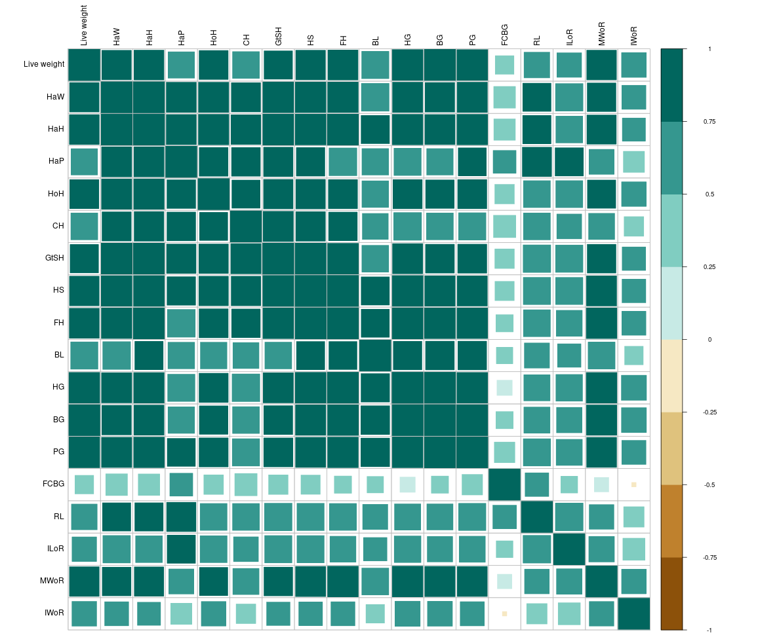
Figure 1: Correlation Plot of morphometric measurements of group 1
Fahim et al. (2013) conducted an experiment on goats and found a positive and significant correlation (P < 0.01) at the time of birth between birth weight and chest girth, body length, height at withers, and pelvic width, which were 0.579, 0.357, 0.682 and 0.361, respectively. They also found a positive and significant (P<0.01) correlation between mature body weight and chest girth, body length, height at withers, neck length, and pelvic width, and it was 0.615, 0.319, 0.439, 0.430 and 0.614, respectively. A study carried out on goats (n = 230) falling in the age group of 13–18 months found significant and positive correlation coefficients between live weight and other body characteristics: body length, height at withers, heart girth, rump and forehead were 0.805, 0.766, 0.767, 0.088 and 0.229, respectively (Iqbal et al., 2013).
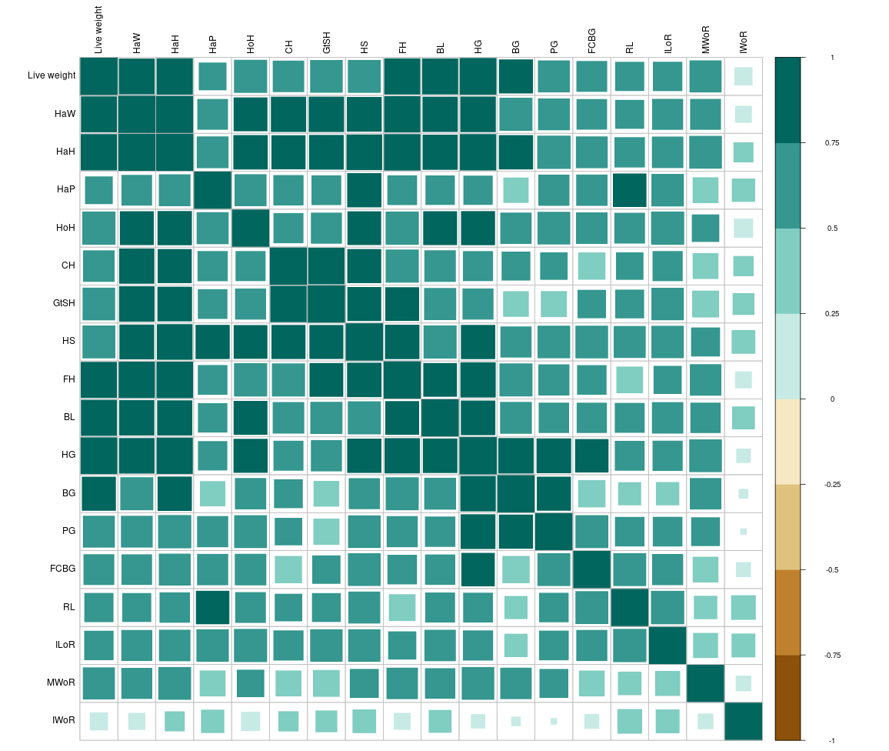
Figure 2: Correlation Plot of morphometric measurements of group 2
In male lambs, the highest correlation was observed between body weight and heart girth at 0-3 (0.86) and 4-6 (0.91) months of age, while in females, the highest relationships with r values of 0.79 and 0.80 were observed between body weight and heart girth at 0-3 months and body weight & body length at 4-6 months of age, respectively (Iqbal et al., 2014). Mule et al. (2014) reported a highly positively (P < 0.01) correlated mean body weight with mean body length, height at wither and chest girth. Zergaw et al. (2017) conducted a study to differentiate the Woyto-Guji and Central Highland goat breeds of Ethiopia and observed positive and highly significant (P<0.001) correlations between body weight and most independent body measurement variables in both breeds.
Bedada et al. (2019) observed that most of the parameters considered (chest girth, body length, wither height, pelvic width, body condition score and ear length) had a positive and significant correlation with live body weight. Adhianto et al. (2020) reported the highest and most positive correlation coefficient value (0.85) between BW and HG in goats. Mathapo and Tyasi (2021) carried out a study to investigate the relationship between body weight and morphometric traits and found BW of female goats was highly positive and significant (P<0.01) with HG (r =0.828) and BL (r = 0.621) and consistently positively correlated (P<0.05) with RH (r = 0.558) and HW (r = 0.512), while BW of male goats was highly positive and significant (P<0.01) with BL (r = 0.727), CC (r = 0.642), HG (r = 0.564), RW (r = 0.361) and EL (r = 0.340) and consistently positively significant (P<0.05) correlated with RH (r = 0.317).
Ouchene-Khelifi and Ouchene (2021) found positive and highly significant (P<0.001) correlations between BW and independent variables (chest girth, abdominal circumference and spiral circumference, height at withers and body length). The highest relationship was illustrated between CG and BW (r = 0.922). Chest girth, body length and shoulder height positively and significantly correlated with BW, with correlation values of 0.90, 0.85 and 0.79, respectively, while combination of chest girth, body length, and shoulder height produced the highest correlation value (r = 0.92) in an experiment carried out by Shoimah et al. (2021).
- CONCLUSION
The various body measurements showed an increasing trend with age and body weight advancement. It indicates that the age has a positive association with body measurements; as age advances, there is an increase in all body measurements simultaneously with the growth of body mass and size. While hock height, ground to stomach height, fore cannon bone girth, ilium width of the rump, and ischium width of the rump showed a slow and steady increase from 0 to 6 months of age. Live body weight was highly correlated (P < 0.001) with bicostal girth (r = 0.942) in 0 to 3 months of age group and heart girth (r = 0.917) in 3 to 6 months age group.
REFERENCE
Adhianto, K., Harris, I., Nugroho, P., & Putra, W. P. B. (2020). Prediction of body weight through body measurements in Boerawa (Boer×Etawah crossbred) bucks at Tanggamus regency of Indonesia. Bulg. J. Agric. Sci., 20(6), 1273-1279.
Ajayi, F. O., Ejiofor, O., & Ironkwe, M. O. (2008). Estimation of body weight from linear body measurements in two commercial meat-type chicken. Global Journal of Agricultural Sciences, 7(1), 57-59.
Alade, N. K., Raji, A. O., & Atiku, M. A. (2008). Determination of appropriate model for the estimation of body weight in goats. J. Agric. Biol. Sci, 3(4), 52-57.
Alex, R., Raghavan, K. C., & Mercey, K. A. (2010). Prediction of body weight of malabari goats from body measurements under field conditions. J. Vet. Anim. Sci., 41, 21-27.
Bedada, Z. E., Gilo, B. N., & Debela, G. T. (2019). Morphometric and physical characterization of Borana indigenous goats in Southern Oromia, Ethiopia. Univers. J. Agric. Res., 7(1), 25-31.
Berhe, W. G. (2017). Relationship and prediction of body weight from morphometric traits in Maefur goat population in Tigray, Northern Ethiopia. Journal of Biometrics and Biostatistics, 8(5), 1-6.
Cam, M. A., Olfaz, M., & Soydan, E. (2010). Possibilities of using morphometrics characteristics as a tool for body weight prediction in Turkish Hair goats (Kilkeci). Asian J. Anim. Vet. Adv., 5(1), 52-59.
Deshpande, S. B., Sabapara, G. P., Malik, P. K., Sadana, D. K., Singh, P. K., Singh, G., & Joshi, B. K. (2010). Morpho-metric characteristics of Surti goats and socio-economic status of Surti goat keepers. Indian Journal of Animal Sciences, 80(6), 575.
Fahim, A., Patel, B. H. M., & Rijasnaz, V. V. (2013). Relationship of body weight with linear body measurements in Rohilkhand local goats. Indian J. Anim. Res., 47(6), 521-526.
Iqbal, M., Javed, K., & Ahmad, N. (2013). Prediction of body weight through body measurements in Beetal goats. Pak. J. Sci., 65(4), 458.
Iqbal, Z. M., Javed, K., Abdullah, M., Ahmad, N., Ali, A., Khalique, A., & Younas, U. (2014). Estimation of body weight from different morphometric measurements in Kajli lambs. J. Anim. Plant Sci., 24, 700-703.
Karna, D. K., Acharya, A. P., Das, B. C., Nayak, G., & Dibyadarshini, M. R. (2020). Adult body weights and morphometric traits of Ganjam goats of Odisha and prediction of body weights from body measurements. J. Anim. Res., 10(6), 1029-1036.
Kesang, W., Jigme, W., & Mindu, M. (2018). Comparison and reliability of techniques to estimate live cattle body weight. J. Appl. Anim. Res., 46(1), 349-352.
Khargharia, G., Kadirvel, G., Kumar, S., Doley, S., Bharti, P. K., & Das, M. (2015). Principal component analysis of morphological traits of Assam Hill goat in Eastern Himalayan India. J. Anim. Plant Sci., 25(5), 1251-1258.
Mathapo, M. C., & Tyasi, T. L. (2021). Prediction of Body Weight of Yearling Boer Goats from Morphometric Traits using Classification and Regression Tree. Am. J. Anim. Vet. Sci., 16(2), 130-135.
Mule, M. R., Barbind, R. P., & Korake, R. L. (2014). Relationship of body weight with linear body measurement in Osmanabadi goats. Indian J. Anim. Res., 48(2), 155-158. http://dx.doi.org/10.5958/j.0976-0555.48.2.033.
Ouchene-Khelifi, N. A., & Ouchene, N. (2021). Statistical models based on morphometric traits for live body weight estimation in goats. Agricultural Science & Technology, 13(2), 1313-8820.
Shoimah, U. S., Dakhlan, A., & Hamdani, M. D. I. (2021). Use of body measurements to predict live body weight of Simmental bull in Lembang Artificial Insemination Center, West Java. In IOP Conference Series: Earth and Environmental Science, 888, 012030. doi:10.1088/1755-1315/888/1/012030
Slippers, S. C., Letty, B. A., & De Villiers, J. F. (2000). Prediction of the body weight of Nguni goats. S. Afr. J. Anim. Sci., 30(1-1), 127-128.
Zergaw, N., Dessie, T., & Kebede, K. (2017). Using morphometric traits for live body weight estimation and multivariate analysis in Central Highland and Woyto-Guji Goat Breeds, Ethiopia. Afr. J. Agric. Res., 12(15), 1326-1331.

