Original Research Article
Development and Characterization of Herbal Sandesh Fortified with Beetroot (Beta vulgaris) and Rosemary (Salvia rosmarinus): A Study on Physicochemical Properties and Shelf-Life Extension

ABSTRACT:
The present study aims to evaluate the value addition of Sandesh by incorporating the beetroot and rosemary @ 1%, 2%, and 3% of the weight of Chhana. The Sandesh samples were analyzed to determine their chemical composition (moisture, total solids, fat, protein, ash, and carbohydrate). The results showed that fat, total solids, protein, and carbohydrate were high in the control and low in optimized sample BRS2, except for ash content, which was high in BRS2. Moisture and ash content were higher in BRS2 (28.71%, 1.60%) than control (27.14%, 1.50%). Total solid, fat, protein, and carbohydrate levels were lower in BRS2 (72.19%, 17.7%,17.13%, and 23.28%) than control (72.60%,18.4%,18.35%, and 26.16%). Cow milk was used to manufacture herbal Sandesh. Changes in physicochemical traits (acidity, pH, and free fatty acid) and microbial quality attributes (total plate count, coliform count, and yeast and mould count) during storage at refrigerated temperature (6±1℃). The analysis was carried out on the 0th, 7th, and 15th days of storage. During storage, the pH of BRS2 was increased than control, whereas titratable acidity and free fatty acid content were decreased from 0.424, 0.466, and 0.563 and 0.024, 0.039, and 0.074, respectively, at 0th, 7^{th,} and 15th days of refrigerated storage. Titratable acidity and free fatty acid content steadily increased towards the end. The microbial analysis revealed that both yeast and mould count and total plate count decreased with the increased incorporation of beetroot and rosemary. During storage, however, both the counts increased. The standard plate count and yeast and mould were 3.5 and 2.4 log cfu/g and 4.1 and 3.1, respectively, at the 7th and 15th day of refrigerated storage.

Keywords: Chhana, Antioxidant activity, Beetroot, Rosemary, Herbal Sandesh, Shelf-Life, Physicochemical Properties

Introduction
According to FSSAI, Chhana or Paneer refers to a product derived from any type of milk, with or without the addition of milk solids, through the process of precipitation using allowed acidulants and heating. Primarily made from cow's milk, chhana is utilized in the preparation of numerous Bengali confections. Approximately 4 to 4.5 percent of India's overall milk output is used to produce chhana. Various sweets, such as Sandesh, rasogolla, chamcham, rasomalai, pantooa, and chhana murki, as well as others, are created using chhana as a key ingredient. (Ranganadham et al., 2016). It is often known that the most effective and suitable way to provide the nutritional and functional health benefits of many herbs and spices is through milk and milk products. (Maji soma et al., 2023). In addition to being used in functional food production, adding phenolic compounds to milk and dairy products may help decrease oxidation, providing an alternative to synthetic antioxidants often used in industry that are linked to negative health impacts. (Katerina Tzima et al., 2020).
The trend of milk production in India shows that approximately 6 percent of the milk generated is processed to create Chhana. Sandesh is a traditional sweet made from chhana that enjoys great popularity (Tanmay Sarkar et al.,2023 ). This sweet dairy delicacy is made from milk that has been coagulated through the use of acid and heat. It is particularly favored in eastern India, especially in West Bengal. Estimates suggest that the yearly output of sandesh in West Bengal is around 30,000 tons. Recent research indicates that roughly 80% of the chhana produced in Kolkata is transformed into Sandesh (Saini et al.,2018). Sandesh is rich in animal protein, fats, minerals, and vitamins. This sweet is renowned for its delightful taste and aroma (Mian Anjum Murtaza et al., 2017).
Sandesh is made using cow milk chhana, as it provides a soft consistency and a smooth texture with fine and uniform grains. Chhana, derived from buffalo milk, is not preferred because it results in a hard body and coarse texture for Sandesh (Bandyopadhyay et al., 2008). Nolen gurer Sandesh is regarded as one of the most eagerly awaited winter desserts among Bengalis. This sweet, based on chhana, has its roots in Bengal.
The food industry is very concerned with oxidative degradation since it is a major contributor to the short shelf life of foods that contain lipids (Gad and Sayd, 2015). Antioxidants play a vital role in promoting good health. They consist of various plant-based compounds that safeguard cells from damage inflicted by free radicals, which are harmful molecules generated during typical metabolic processes. Customers are more conscious of the connection between their nutritional state and eating habits. As such, people seek out foods that include natural ingredients instead of artificial chemicals (Daniel Granato et al., 2018). Dairy products that are enriched with herbs can serve as a great source of antioxidants, provided that the antioxidant potential of both the dairy and the herbs remains intact during the mixing and storage process. (Skrede et al., 2004)
The addition of different flavors to milk and dairy products has made them more palatable in recent years (Amit Ashok Gajarmal et al., 2024). Flavors and colors in the preparation of Sandesh were enhanced by the use of spices like clove, small cardamom, and saffron. Incorporating beet extracts into Sandesh not only enhanced its capacity to inhibit lipid peroxidation but also added hues to the final product. (Bandyopadhyay et al., 2007). The medicinal qualities of dairy products, which are widely used in therapeutic, preventive, and dietetic nutrition, can be used to support the selection of dairy ingredients for functional foods (Stanislav A. Sukhikh et al., 2019). Bioactive substances that include fibers, phytosterols, carotenoids, polyphenols, and antioxidants have been utilized as sources of functional components. (Aikaterini Kandyliari et al., 2023)
2. Materials and methods
Cow milk, jaggery, beetroot, and rosemary were the raw materials used for the production of herbal Sandesh. Jaggery, beetroot, and rosemary were purchased at the local market of Varanasi( Uttar Pradesh).
Preparation of herb extract
Beetroot was washed thoroughly; roots and peel were removed, then cut into slices about 2-3 mm thick by using a sharp knife and air dried at 40°C for 8 hrs in a tray drier. Dried beetroot and rosemary leaves were ground by the grinder, sieved, and made into powder. The extraction was performed using a 60% aqueous ethanol solution. The ethanolic extract of beetroot and rosemary was mixed for 30 min with the help of a vortex shaker. The supernatant obtained by centrifugation of the extract at 6000 rpm for 10 mins was filtered by Whatman filter paper ( grade no. 42). For evaporation of ethanol Soxhlet method was used (130-140⁰C for 10-14 hrs) and stored at 4⁰C.

2.1 Manufacturing of Herbal Sandesh
To prepare Herbal Sandesh, fresh Chhana was made using cow milk with 4% fat and 8.5% SNF, which was then kneaded until it became a smooth dough. About 40% of the total weight of the Chhana was sweetened with Date Jaggery and combined with herbal extract. This mixture was heated in an iron pan, continuously scraped, until it achieved the right consistency and flavor. Afterward, it was poured into a shallow tray to cool and solidify. The final product was shaped using various molds and cut into different sizes with a sharp knife. The moisture content of the Chhana, along with the cooking time and temperature of the Chhana-jaggery mixture, affected the final texture of the Sandesh. A control version of Sandesh was made using the same procedure but without incorporating any herbs.

Rosemary (1, 2, 3%)

Beetroot (1, 2, 3%)

Fig. 1: Flow Chart for Manufacturing of Herbal Sandesh

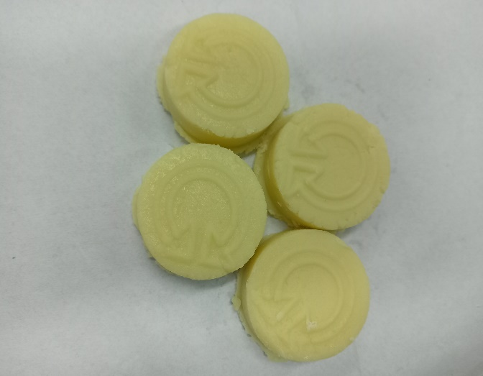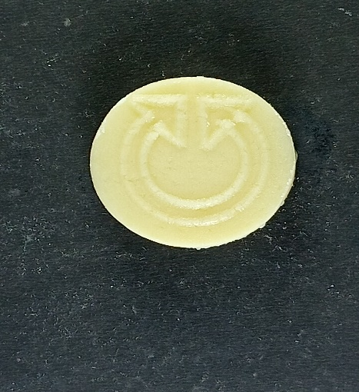
Picture 1 : Rosemary Sandesh 1, 2, 3% Picture 2 :Control Sandeh

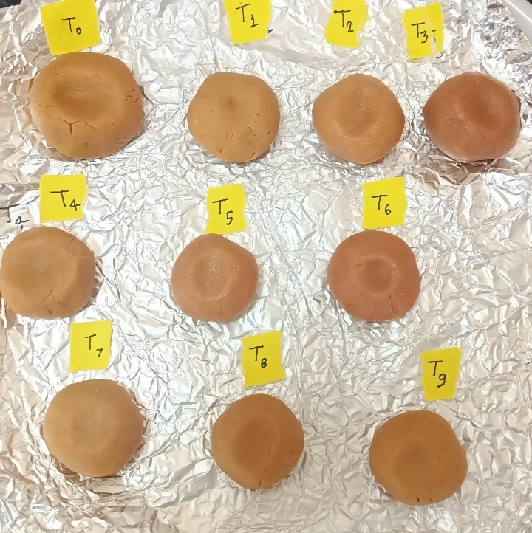

Picture 3 : Experimental Sandesh

Table 1: Experimental Design for Optimization of Product
S. No. | Treatment | Treatment | Chhana (gm) | Beetroot Extract (ml) | Rosemary Extract (ml) | Jaggery (gm)
1 | T₀ | CS | 28.5 | 0 | 0 | 0
2 | T₁ | BS1 | 28.5 | 0.285 | 0 | 11.4
3 | T₂ | BS2 | 28.5 | 0.57 | 0 | 11.4
4 | T₃ | BS3 | 28.5 | 0.855 | 0 | 11.4
5 | T₄ | RS1 | 28.5 | 0 | 0.285 | 11.4
6 | T₅ | RS2 | 28.5 | 0 | 0.57 | 11.4
7 | T₆ | RS3 | 28.5 | 0 | 0.855 | 11.4
8 | T₇ | BRS1 | 28.5 | 0.285 | 0.285 | 11.4
9 | T₈ | BRS2 | 28.5 | 0.57 | 0.57 | 11.4
10 | T₉ | BRS3 | 28.5 | 0.855 | 0.855 | 11.4

Note: Jaggery use for all Treatment excluding control: 40% by wt. of chhana
Rosemary extract: 1, 2 & 3%
Beetroot extract: 1, 2 & 3%
CS: Control Sandesh,
BS: Beetroot Sandesh
RS: Rosemary Sandesh,
BRS: Beetroot-Rosemary Sandesh

Chemical properties of Sandesh

The physicochemical properties of Sandesh made with added rosemary and beetroot extract were analyzed using established methods. Chemical evaluations of samples, including cow milk, Chhana, and Sandesh, were conducted based on each treatment as described below.

Total solids and moisture
Moisture content of the sample was estimated by the oven drying method (A.O.A.C., 2005).
Fat
The fat content was determined by using the standard Gerber method as described by Choudhari (1959) with modification in the strength of sulphuric acid.
Protein
The protein content of Sandesh was determined by the Micro-Kjeldahl method as prescribed in A.O.A.C. (1970).
Acidity :
Titratable acidity of the sample was determined as per the method described in BIS (SP: 18 (Part-XI), 1981).
pH
The method prescribed by Deeth (1975) was used to estimate the pH content of sandesh.
Microbiological Analysis
Standard plate count, coliform count and yeast and mould count were obtained with the help of the standard procedure given by Indian Standards (IS: SP-18, 1981).
Statistical analysis
The findings from the physicochemical analysis conducted in this investigation were analyzed using the ANOVA technique (one-way ANOVA) in Microsoft Excel 2019 to determine if there were any notable differences among the treatments.

RESULTS AND DISCUSSION
The present investigation was undertaken to evaluate the chemical and sensory quality of Sandesh by incorporating different levels of mango pulp. The results of the present research work are the average of six time-repeated data tabulated, presented, and discussed along with Statistical analysis under the following main heads.
This study was conducted to assess the chemical and sensory quality of Sandesh by adding varying amounts of beetroot and rosemary. The findings from this research are based on the average data collected from three, which have been organized, presented, and discussed along with statistical analysis.
Chemical analysis of Sandesh
The proximate analysis of Sandesh prepared by using different levels of rosemary and beetroot was carried out for Moisture, Total solids, Fat, Protein, Ash, and Carbohydrate. The results and statistical analysis are mentioned below in Table 2.

Table 2 Proximate composition (% w/w WM) of sandesh samples
Treatments | Moisture (%) | Total Solid(%) | Fat (%) | Protein (%) | Ash (%)
CS | 27.14 ± 0.44ª | 72.60 ± 0.44ª | 18.4 `± 0.37ª | 18.35 ± 0.07ª | 1.50 ± 0.08ª
BS1 | 27.73 ± 0.39^{b} | 72.30 ± 0.35ª | 17.5 ± 0.13^{b} | 17.52 ± 0.03^{b} | 1.54 ± 0.06ª
BS2 | 28.06 ±0.53^{c} | 71.94 ± 0.53ª | 17.9 ± 0.20^{c} | 17.44 ± 0.11^{c} | 1.57 ± 0.03ª
BS3 | 28.34 ± 0.52^{d} | 72.66 ± 0.52ª | 17.5 ± 0.74^{d} | 17.03 ± 0.03^{d} | 1.54 ± 0.05ª
RS1 | 28.78 ± 0.12e | 72.22 ± 0.12ª | 17.6 ± 0.17e | 17.56 ± 0.71e | 1.56 ± 0.06ª
RS2 | 28.28 ± 0.71^{f} | 71.86 ± 0.71ª | 17.5 ± 0.37^{f} | 17.26 ± 0.28^{f} | 1.58 ± 0.06ª
RS3 | 28.30 ± 0.57^{g} | 72.72 ± 0.57ª | 17.1 ± 0.01^{g} | 17.06 ± 0.01^{g} | 1.59 ± 0.05ª
BRS1 | 28.42 ± 0.81^{h} | 72.58 ± 0.81ª | 17.4 ± 0.21^{h} | 17.41 ± 0.28^{h} | 1.59 ± 0.03ª
BRS2 | 28.71 ± 0.52^{i} | 72.19 ± 0.52ª | 17.7 ± 0.25^{i} | 17.13 ± 0.33^{i} | 1.60 ± 0.09ª
BRS3 | 28.82 ± 0.23^{j} | 71.98 ± 0.23ª | 17.5 ± 0.09^{j} | 17.03 ± 0.03^{j} | 1.72 ± 0.03ª
Values are expressed as Mean & Standard deviation (Mean ± SD) n=3.
Values with different superscripts have p<0.05 and are significantly different, and values with the same superscript have p>0.05 and are not significantly different

Fig. 2 Graphical Representation of Moisture Content in Herbal Sandesh

Moisture
Table 2 presents the chemical composition of both the herbal and control Sandesh. The moisture levels in chhana samples varied from 48 to 52 percent. The moisture content in sandesh samples ranged between 27.14 and 28.82 percent. The data indicates that cooking resulted in moisture loss in the samples. The cooking temperature was responsible for this moisture reduction. The moisture level in the control Sandesh was lower compared to all the herbal Sandesh, as one-tenth of the herbal Sandesh was derived from herbal sources in aqueous form, which contained higher moisture than the control Sandesh. There was no significant difference (P<0.05) in moisture content among the herbal Sandesh samples. Among the various herbal Sandesh combinations, BRS3 had the highest moisture content, while BS1 had the lowest. The lower moisture content may be attributed to the beetroot extract (86%) compared to the rosemary extract (87–89%). The moisture content in herbal Sandesh is greater than what was reported by (Bandyopadhyay et al., 2007) for traditional Sandesh, likely due to the use of the aqueous extracts from beetroot, rosemary, and jaggery in the herbal Sandesh preparation. The fat, protein, and ash content were consistent with the results of (Bandyopadhyay et al., 2007).

Fig. 3: Graphical Representation of Total Solid Content in Herbal Sandesh

Fig. 4 Graphical Representation of Fat & Protein Content in Herbal Sandesh

Fat :
The data about the protein content in Sandesh with the addition of beetroot and rosemary at different levels are presented in Table 2 and Fig. 4.
The data related to the fat content in Sandesh incorporating varying levels of beetroot and rosemary are shown in Table 2 and Fig. 6. Upon review of the data, it is evident that the differences in fat and protein content of Sandesh resulting from different amounts of beetroot and rosemary were statistically significant.

The fat content in the CS was the lowest and showed significant differences compared to all other treatments. Chhana has a high fat content, while the herbs do not contribute any fat. This explains why CS has a higher fat content compared to the other samples. The fat levels in herbal Sandesh did not differ significantly (P>0.05) and were observed to decrease in the following order: CS>BS2>BRS2>RS1>BS3>RS2>BS1>BRS3>BRS1>RS3.

Protein
The protein levels in CS were higher compared to herbal Sandesh, but the difference was not statistically significant (P>0.05) except for BS3, BRS3, and RS3. The lower protein concentrations in BS3, BRS3, and RS3 can be attributed to the greater moisture present in the beet. The ash content in BRS3 and BRS2 is higher than that of other herbal Sandesh due to the increased mineral presence in beetroot and rosemary. There was no significant variation in the ash content of CS and herbal Sandesh (P>0.05), which followed the decreasing order of: BRS3>BRS2>RS3>BRS1>RS2>BS2>RS1>BS1>BS3>CS.

pH
The Sandesh samples fortified with herbs exhibited a significantly (p< 0.05) reduced acidity in comparison to the control samples over the 15-day storage period at 6 ± 1 °C. This reduction may be attributed to the alkaline properties of the herbs.
Treatments | 0th day | 7th day | 15th day
CS | 6.51ª | 5.79ª | 5.60ª
BS2 | 6.51ª | 6.48^{b} | 5.34^{b}
BS3 | 6.53^{b} | 6.49^{c} | 5.45^{c}
RS1 | 6.63^{c} | 6.51^{d} | 5.71^{d}
RS2 | 6.65^{d} | 6.52e | 5.96e
RS3 | 6.66e | 6.63^{f} | 6.52^{f}
BRS1 | 6.50^{f} | 6.49^{g} | 6.43^{g}
BRS2 | 6.52^{g} | 6.50^{h} | 6.45^{h}
BRS3 | 6.67^{h} | 6.59^{i} | 6.49^{i}
Table 3: Changes in pH of During Storage at Refrigerated Temperature (6±2⁰C)
Values are represented as Mean and Standard deviation (Mean ± SD) with n=3.
Values that have different superscripts indicate a significance level of p <0.05, while values sharing the same superscript indicate a non-significant difference with p >0.05.

Fig 5: Graphical Representation of Changes in pH
From table 3 and figure 5, it was noted that the pH level of the control Sandesh is lower than that of the herbal Sandesh, with the control measuring 6.51 on the 0th day, while sample BRS3 records a pH of 6.65, which is higher than the other samples. The pH of the control Sandesh decreased from 5.86 at the start to 5.6 after 15 days of storage. Conversely, in the optimized herbal Sandesh BRS2, the pH fell from 6.52 to 6.50 by the 7th day. By the 15th day, the pH of BRS2 was recorded at 6.45. There was a significant reduction in the pH of the products (p<0.05) as the storage duration increased. The decline in pH for both the control Sandesh and herbal Sandesh could be attributed to the rise in free fatty acid and lactic acid levels, which may have resulted from elevated bacterial metabolic activity consuming lactose and producing lactic acid and galactose.

Acidity
Table 4: Changes in acidity during Storage at refrigerated temperature (6±2⁰C)
Treatments | 0th day | 7th day | 15th day
CS | 0.481ª | 0.512ª | 0.661ª
BS1 | 0.463^{b} | 0.471^{b} | 0.651^{b}
BS2 | 0.464^{c} | 0.473^{c} | 0.642^{c}
BS3 | 0.475^{d} | 0.483^{d} | 0.571^{d}
RS1 | 0.463e | 0.470e | 0.552e
RS2 | 0.461^{f} | 0.477^{f} | 0.576^{f}
RS3 | 0.439^{g} | 0.471^{g} | 0.541^{g}
BRS1 | 0.428^{h} | 0.469^{h} | 0.542^{h}
BRS2 | 0.424^{i} | 0.466^{i} | 0.563^{i}
BRS3 | 0.421^{j} | 0.468^{j} | 0.561^{j}

.
Fig 6: Graphical Representation of Changes in acidity
Values are presented as Mean and Standard deviation (Mean ± SD) with n=3.
Values that have different superscripts indicate p <0.05 and are significantly different, while values with the same superscript indicate p >0.05 and are not significantly different.
The acidity of the control Sandesh increased from 0.481 to 0.512 by day 7, and by day 15, it rose further to 0.661. In comparison, the acidity of the optimized herbal Sandesh (BRS2) started at 0.424 on day 0, climbed to 0.466 on day 7, and reached 0.563 on day 15. By the end of the storage period on day 15, the acidity levels of the Sandesh samples showed significant differences (p<0.05) when compared to the initial measurements. The increase in acidity was more pronounced in the control Sandesh than in the herbal variant. The escalation in titratable acidity in Sandesh is likely due to jaggery, which has inherent acidity, and the growth of lactic acid bacteria that generate lactic acid. The rise in titratable acidity for the beetroot and rosemary-treated samples was slower than that of the control, probably because of the antimicrobial effects of beetroot and rosemary. Khatkar et al., (2017) documented similar observations regarding the storage of fresh paneer.
Free Fatty Acid Content (% Oleic Acid)
The percentage of free fatty acid content, specifically oleic acid, was assessed to determine the effects of incorporating beetroot and rosemary extract on the free fatty acid values of Sandesh during storage, as shown in Table 5 and Figure 7. The free fatty acid levels in all samples significantly (P<0.05) increased with longer storage periods. In the control sample, the free fatty acid content rose considerably (P<0.05) from an initial value of 0.175 to 0.542 after 7 days, and reached 1.254 after 15 days, primarily due to lipolysis. The data indicates that the addition of beetroot and rosemary, alongside jaggery, led to a slight decrease in the FFA content of Sandesh. This effect may be linked to the alkaline properties of the herbs. The observed increase in FFA levels in Sandesh samples was consistent with findings reported by Khatkar et al., (2017) and remained within a desirable range.
Table 5: Changes in FFA (% oleic acid) During Storage at Refrigerated Temperature (6±2⁰C)
Treatments | 0th day | 7th day | 15th day
CS | 0.025 ± 0.1ª | 0.043 ± 0.2ª | 0.085 ± 0.21ª
BRS2 | 0.024 ± 0.12ª | 0.039 ± 0.2^{b} | 0.074 ± 0.13^{b}
Values are presented as Mean and Standard Deviation (Mean ± SD), with n=3. Values marked with different superscripts indicate a significant difference (p < 0.05), while values sharing the same superscript indicate no significant difference (p > 0.05).

Fig 7: Changes in FFA During Storage at Refrigerated Temperature (6±2⁰C)
Fig. 9 shows the free fatty acid of control sample and optimized sample (BRS2) containing 2% beetroot and 2% rosemary sample, increased from an initial 0.024 to 0.039 in 7 days and to 0.074 in 15 days of storage, while CS from an initial 0.025 to 0.043 in 7 days and to 0.085 in 15 days of storage respectively.
Table 6: Changes in FFA (% oleic acid) During Storage at Refrigerated Temperature (6±2⁰C)
Treatments | 0th day | 7th day | 15th day
CS | 0.025 ± 0.1ª | 0.043 ± 0.2ª | 0.085 ± 0.21ª
BRS2 | 0.024 ± 0.12ª | 0.039 ± 0.2^{b} | 0.074 ± 0.13^{b}
Values are expressed as Mean & Standard deviation (Mean ± SD) n=3. Values with different superscripts have p <0.05 and are significantly different, and values with the same superscript have p >0.05 and are not significantly different.

Fig 8: Changes in FFA During Storage at Refrigerated Temperature (6±2⁰C)
Fig. 8 shows the free fatty acid of control sample and optimized sample (BRS2) containing 2% beetroot and 2% rosemary sample, increased from an initial 0.024 to 0.039 in 7 days and to 0.074 in 15 days of storage, while CS from an initial 0.025 to 0.043 in 7 days and to 0.085 in 15 days of storage respectively.

Microbiological Analysis of Control and Optimized Herbal Sandesh
Table 7: Changes in microbial quality (counts in log cfu/g) in control and optimized samples during storage at refrigerated conditions (6±1℃)
Storage period (days) | SPC |  | Yeast and mould |  | Coliform
 | Control | BRS2 | Control | BRS2 | Control | BRS2
0 | 0 | 0 | 0 | 0 | 0 | 0
7 | 4.5 | 3.5 | 3.2 | 2.4 | 0 | 0
15 | 5.1 | 4.1 | 3.6 | 3.1 | 0 | 0
Each observation is the Mean ± SD of 3 replications
Table 7 displays the data collected for variations in SPC, yeast and mold count, and coliform count. According to the table, on the seventh day of storage, the Standard Plate Count (SPC) in the control samples noticeably increased. Nevertheless, the number of samples that contained 2% beetroot and 2% rosemary dropped. Control samples showed more visible mold growth than BRS2 up until the fifteenth day of storage, and their SPC was also higher than that of the optimized sample. On days 0th, 7th, and 15th during storage, the coliform count was zero. In comparison to the control Sandesh, Buch et al., (2014) discovered that the SPC was lower at 3.5 log cfu/g at 7th days, 4.1 log cfu/g at 15th days of storage.
Conclusion
The development and characterization of herbal Sandesh fortified with beetroot and rosemary demonstrated significant improvements in both nutritional and sensory qualities. The incorporation of beetroot contributed to enhanced antioxidant properties, vivid coloration, and increased mineral content, while rosemary infusion added natural preservative effects due to its antimicrobial and antioxidant properties. Physicochemical analysis revealed that the fortified Sandesh maintained desirable moisture, total solids, fat, texture, and pH levels, which are critical for product stability and consumer acceptance. Shelf-life studies indicated that the herbal Sandesh exhibited extended freshness and reduced microbial growth compared to the control, highlighting its potential as a functional dairy-based confectionery with added health benefits and prolonged market viability. These findings suggest that herbal fortification not only enriches the nutritional profile of traditional dairy products but also provides a natural means of shelf-life extension, aligning with consumer demands for healthier and preservative-free food options. Further research could explore scaling up production and evaluating consumer acceptance across diverse demographics.

Declaration of competing interest
The authors have declared no conflicts of interest in the above research
REFERENCES

- Ashok, G. A., Sandipkumar, B., Santosh, M., & Sudipt, R. (2024). A comprehensive review of herbs utilized in milk products of dairy industry: Insights from Ayurveda. Pharmacological Research-Natural Products, 100074.
- Bandyopadhyay, M., Chakraborty, R., & Raychaudhuri, U. (2007). Incorporation of herbs into sandesh, an Indian sweet dairy product, as a source of natural antioxidants. International journal of dairy technology, 60(3), 228-233.
- Bandyopadhyay, M., Chakraborty, R., & Raychaudhuri, U. (2008). Antioxidant activity of natural plant sources in dairy dessert (Sandesh) under thermal treatment. LWT-Food Science and Technology, 41(5), 816-825.
- Eilers, H., Saal, R. N. J., & Van der Waarden, M. (1947). Chemical and physical investigations on dairy products.
- Gad, A. S., & Sayd, A. F. (2015). Antioxidant properties of rosemary and its potential uses as natural antioxidant in dairy products—A review. Food and Nutrition Sciences, 6(1), 179-193.
- Granato, D., Santos, J. S., Salem, R. D., Mortazavian, A. M., Rocha, R. S., & Cruz, A. G. (2018). Effects of herbal extracts on quality traits of yogurts, cheeses, fermented milks, and ice creams: a technological perspective. Current Opinion in Food Science, 19, 1-7.
- Kandyliari, A., Potsaki, P., Bousdouni, P., Kaloteraki, C., Christofilea, M., Almpounioti, K., ... & Koutelidakis, A. E. (2023). Development of dairy products fortified with plant extracts: antioxidant and phenolic content characterization. Antioxidants, 12(2), 500.
- Khatkar, A. B., Ray, A., & Kaur, A. (2017). Studies on shelf-life extension of paneer with the addition of plant essential oil and different packaging materials. International Journal of Current Microbiology and Applied Sciences, 6, 376-89.
- Maji, S., Bumbadiya, M., & Sao, K. (2023). Value addition of traditional Indian dairy products using herbs and spices-An overview. International Journal of Bio-resource and Stress Management, 14(3), 400-406.
- Murtaza, M. A., Pandya, A. J., Haenlein, G. F., & Khan, M. M. H. (2017). Traditional Indian dairy products. Handbook of Milk of Non‐Bovine Mammals, 343-367.
- Ranganadham, M., MH, S. K., Devraja, H. C., & Garg, F. C. (2016). Traditional dairy products.
- Saini, A., Pandey, A., Sharma, S., Suradkar, U. S., Ambedkar, Y. R., Meena, P., ... & Gurjar, A. S. (2020). Assessment of antioxidant activity of rosemary (Rosmarinus officinalis) leaves extract. Journal of Pharmacognosy and Phytochemistry, 9, 14-17.
- Sarkar, T., Salauddin, M., Paul, A., Choudhury, T., Chakraborty, R., & Imran, F. (2023). The essence of Bengal’s ethnic sweetmeats: an exploratory journey through history, tradition, and culture. Journal of Food Quality, 2023(1), 5008420.
- Skrede, G., Larsen, V. B., Aaby, K., Jørgensen, A. S., & Birkeland, S. E. (2004). Antioxidative properties of commercial fruit preparations and stability of bilberry and black currant extracts in milk products. Journal of food science, 69(9), S351-S356.
- Sukhikh, S., Astakhova, L., Golubcova, Y., Lukin, A., Prosekova, E., Milenteva, I., ... & Rasshchepkin, A. (2019). Functional dairy products enriched with plant ingredients. Foods and Raw materials, 7(2), 428-438.
- Tzima, K., Brunton, N. P., Choudhary, A., & Rai, D. K. (2020). Potential applications of polyphenols from Herbs and spices in dairy products as natural antioxidants. Herbs, Spices and Medicinal Plants: Processing, Health Benefits and Safety, 283-299.

