PERFORMAMCE EVALUATION OF DEVELOPED TRACTOR OPERATED GROUNDNUT COMBINE FOR THRESHED CROP

Abstract
Groundnut(Arachis hypogaea)is an important oil seed crop in India cultivated in an area of 6.7 million hectares with a production of 7.0 million tonnes annually. The crop can be grown successfully in areas receiving the rainfall ranging from 600 to 1250 mm. Present practice of manual harvesting and threshing consumes huge amount of labour to a magnitude of about 175 to 200 women h ha⁻¹. It is very tedious and time consuming operation and is being adoptable for small scale farming. Since it is a labour intensive operation, scarcity of labour is often experienced during the peak harvesting season. Several efficient independent machines are available for harvesting and threshing separately by manual feeding, but collecting harvested crop and feeding in to thresher is again a labour intensive operation. Moreover, the harvesting requires maximum energy and combining may not be feasible with commonly available tractor. Hence the combine was developed by designing collecting, conveying and threshing systems for harvested groundnut crop. The effective field capacity was 0.122 ha h⁻¹ with an average fuel consumption of about 4.67 lt h⁻¹. It was also observed that output capacity of the thresher was 21.66kg h⁻¹ and the broken pod loss was 0.15 kg h⁻¹. The threshing capacity was 83.58% and the cleaning efficiency was 81.68%.
Keywords: Groundnut harvesting, threshing, field efficiency, cleaning efficiency and threshing efficiency

Introduction:
Groundnut is an important oil seed crop in India cultivated in an area of 6.7 million hectares with a production of 7.0 million tonnes annually (Reddy et al., 2013). Andhra Pradesh state shares about 1/3rd of groundnut area of the country and occupies 3rd place in production contributing 18.81 percent of production in the country. Groundnut is cultivated as a major oilseed crop in Andhra Pradesh. In Andhra Pradesh, chittoor district ranks second in the area and production of groundnut with 1,89,000 hectares and 1,31,000 tonnes respectively. The crop can be grown successfully in areas receiving the rainfall ranging from 600 to 1250 mm. The best soils for groundnut crop are sandy loam, loam and medium black with good drainage system.
Acute shortage of labour is experienced now a days during field operations due to increased industrialization and other opportunities for labour like migration of labour to urban areas for better paid employment coupled with policy changes like implementation of MGNREGA (Mahatma Gandhi National Rural Employment Guarantee Act) has made a profound impact on labour availability in the rural areas (Gupta and Sidhartha, 2011). Mechanical method, i.e. the use of machines for harvesting and threshing of groundnuts is only the way to reduce labour requirements and timely harvest. This method is best used for commercial or large scale farming. Harvesting is the digging of the plants along with the pods and the threshing is removal of pods from the plant roots, whereas the combine harvester indicates both the operations.The major reasons for the demand for groundnut machinery are to reduce drudgery, to improve timeliness, and to increase productivity and income. The most desirable machines indicated by farmers are stripper, digger, and planter for irrigated area; planter, stripper, and weeder for rainfed area; and stripper, weeder, and seed shelter for area using residual soil moisture.
. The available digger-shaker-windrower is used to uproot the plants and rid them of soil. They are also equipped to lay the plants in windrows (lifter-shaker-windrowers). Indicatively, mechanized pulling and windrowing of the plants requires about 4 - 6 working hours per hectare. Picker-threshers usually finish the work of the above machines by gathering up the windrows for threshing (De Lucia and Assennato, 1994). It digs deep enough to prevent cutting pegs. Windrow-inverting attachments orient plants as they leave the shaker so that pods are primarily on the top of windrows to permit greater air circulation. But this windrowed crop need to be collected by manual labour and to be fed to the thresher. This process is also labour intensive and cumbersome.
There are also two types of threshers; wet pod thresher and dry pod thresher which are used to thresh the crop after harvesting, which can be done by keeping the harvested crop in the thresher by manually. In wet pod thresher the crop can be fed in to the hopper immediately after the harvest, where as in dry pod thresher the harvested crop can be fed in to the hopper after 3-5 days of drying the crop. Even though efficient harvesters and threshers are available, their adoption level is very low due to varying power requirements and huge investment cost. Moreover individual operation leads to the requirement of operator and labour. In present day, farmer prefer the machine which should do all the operations and requires very less operators and also prefer to strip the pods immediately after harvest so as to prevent crop damage from unexpected rains and other field losses. Hence, groundnut combine is the present day requirement, i.e., digging, collecting and threshing of groundnut crop on single pass.
To develop combine harvester, the machine should harvest and after which the crop material need to be collected, conveyed and threshed. Since all the three operation are energy intensive, all together may require around 75hp. Availability of high power 75hp tractors are very limited and majority of Indian farmers are small and marginal having 40-45 hp tractor. Keeping in view and to make it also available to the small farmer it was aimed to design separately i.e., a machine for collecting, conveying and threshing of already harvested crop. Furthermore to make results more pragmatic and to concentrate on the required components in the proposed design, the existing evaluated thresher (wet pod thresher) was selected as threshing unit and the evaluated digger shaker formed windrows were aimed for collecting, conveying and threshing. Accordingly design and development of a tractor operated groundnut combine for harvested crop was contemplated.
Materials and methods:
The present study was conducted at College of Agricultural Engineering, Madakasira, which is located in Anantapur district of Andhra Pradesh. The geographical location of the experimental site is 13º56’58’’ N and 77º 18’42’’ E with an elevation of 641.6 metres above mean sea level.Madakasira region is considered as one of the arid areas with low precipitation of 532 mm and the maximum temperature is 35ºC, whereas the minimum temperature of 23ºC. The average temperature is 25.7ºC. The average relative humidity is 53% and average wind speed is 10.3 km h⁻¹.The relative proportions of sand, silt and clay in a soil mass determine the texture of soil. Most of the Madakasira region is characterized by sandy loam soils with gravel. Field area of 2700 m² was used for study. Field was sown with K6 variety of groundnut in the kharif season (July –October) during the south-west monsoon.
To develop a tractor operated groundnut combine for harvested crop, survey was conducted to select efficient machinery for harvesting and as well as threshing. Best machines were considered for study and utilized in proposed machine development process. From the study and review it was evident that maximum number of labour (200 man-hours) for collecting and threshing, to mechanize these two operations, the concept of the machine was to gather or collect harvested crop from windrows formed on field by manual or machine harvesting and convey it to the feeding trough of the thresher through suitable elevators. In this process the collecting unit, conveying unit, elevating unit and feeding units were designed and fabricated. These designed units were attached to the existing selected stationary wet pod thresher and synchronized through various tests. To make the unit mobile and be operated by some prime mover (tractor) the hitching system was developed and power transmission was done through P.T.O connected telescopic universal joint.
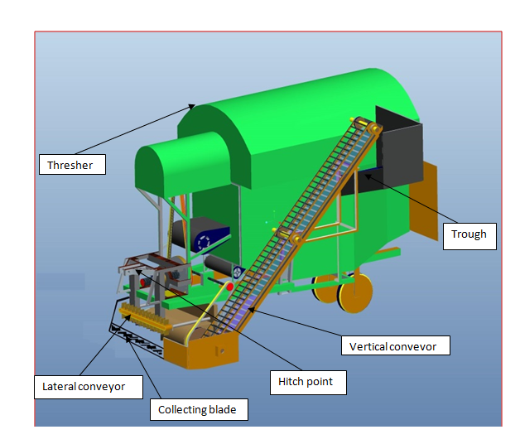
Fig.1 Conceptual drawing of tractor operated groundnut combine for harvested crop

To operate the machine, power was transmitted from the prime mover (tractor)PTO through universal shaft connected to main input shaft. From the input shaft of thresher the power is tapped through V – pulley and belt to two different input shafts for operating lateral conveying system and vertical elevating system. Shafts and pulleys were designed independently to meet the requirement of application. Overall power train was depicted in the Fig: 2. and optimized speed ratio 1:3 was transmitted to the horizontal conveyor and flight elevator by 'V' belt transmission system. When the tractor moves forward the blade arranged in front of the collecting unit lifts the crops and convey to the lateral belt conveyor. The crops spread on the tray are conveyed to a side by using the flaps fitted on the flat belt. When the crop moves a side to the elevator tray, the slat elevator spikes picks crop and convey it to the top end. The crop was dropped into the collecting trough in turn conveyed to thresher through chute. The threshing of material starts and the pods get separated from haulm and collected in the bottom tray. Where the pods further cleaned by blower and reaches bottom spout. Then separated haulms were pushed by spider wheel through trash opening.

Fig 2.Front view and top view of power transmission to the developed combine
The performance of the groundnut combine was evaluated in terms of the following parameters.
Conveying efficiency:
Conveying efficiency of equipment was calculated using the following expression
$ηcc = \frac{Wp1}{Wp1 +Wp2}$× 100
Where,
η_{cc}= Conveying efficiency
Wp₁ = Weight of conveyed crops collected at the collecting chamber, g
Wp₂ = Weight of conveyed crops missed from the collecting chamber, g
Theoretical field capacity
Theoretical field capacity (TFC) is rate of field coverage of the implement based on 100 percent of time at the rated speed and covering 100 percent of its rated width. For calculating theoretical field capacity, first the speed and width of the implement was measured. The speed was calculated by recording the time required to travel 20 m distance. It is calculated by using below equation given by Patange et al. (2015).
Where,
S = Forward speed, km h⁻¹
W = Width of the implement, m
Effective field capacity
Effective field capacity (EFC) is the actual average rate of coverage by the machine, based upon the total field time. It is a function of the rated width of the machine, the percentage of rated width actually utilized, speed of the travel and the amount of field time lost during the operation. Effective field capacity is usually expressed as hectare per hour. It is calculated by using below equation given by Manjunatha et al. (2014).
Where,
A = Area of coverage, ha
T_{P} = Productive time, h
T_{NP} = Non-productive time, h
Field efficiency
Field efficiency (F_{e}) is the ratio of effective field capacity to the theoretical field capacity, expressed as percentage. It was calculated using below equation given by Nagesh et al. (2014).
Where,
E.F.C = Effective field capacity, ha h⁻¹ and
T.F.C = Theoretical field capacity, ha h⁻¹.

Fuel consumption
Fuel consumption (F_{t}) was measured by top fill method. The fuel tank was filled to full capacity before the testing at levelled surface. After completion of test operation, amount of fuel required again to top fill is the fuel consumption for the test duration. It was expressed in litre per hour. Fuel consumption is calculated by below equation given by Raghavendra et al. (2013).
Where,
V = Volume of fuel consumed, L
t = Total operating time, h
Results & discussion
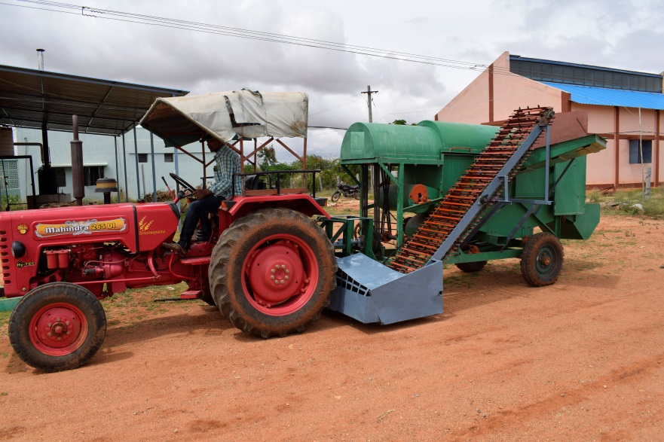
The present study was conducted at Madakasira, which is located in Anantapur district of Andhra Pradesh. The relative proportion of soil at experimental site was sand 68.0%, silt 14.5% and clay 17.5%. Most of the Madakasira region is characterized by sandy loam soils with gravel (sand 68.0%, silt 14.5% and clay 17.5%).

FIG 3. Tractor operated groundnut combine
The prototype machine was developed and fabricated with optimized designed parameters obtained from various laboratory experiments. The machine was tested in the field, where the windrows were formed by harvesting two rows. The machine was operated for 10 m length at optimized speed of 1.59 km h⁻¹. The threshed pods, refractions and bhusa were collected.
The performance of the developed machine was evaluated and compared with manual collecting conveying and threshing method. The cylinder and blower speeds were measured by using a digital non –contact type tachometer and the feed rate was measured by using a platform balance. A stop watch was used to note the time of operation. All tests were replicated thrice. The output capacity and man-h ha⁻¹ for threshing was noted.
The results revealed that the average plant height at the time of harvest was recorded as 35.68 cm and the average plant width at the time of harvest was recorded as 17.53 cm and the root length at the time of harvest was recorded as 25.27 cm and the number of plants during harvest was recorded as 26 and average number of pods per plant at the time of harvest was recorded as 27.12 and number of filled and unfilled pods at time of harvest was 20.04 and 7.08 respectively. The haulm yield of the windrows formed for a distance of 10 m was 2.93 kg for single row, 6.3 kg for two rows and 8.67 kg for three rows. Results revealed that at the feed rate of 870 kg h⁻¹, the thresher output was 227.25 kg h⁻¹. The orientation of the blade was evaluated among 3 angles with the ground vis-a-vis 450, 600 and 750. The best collecting percentage was 95.28% obtained at 600 rake angle whereas least percentage of 75.23% with 750 rake angle.
Trials were conducted for optimizing the speed of the lateral conveyor pulley with three combinations of reduction ratio 1:1, 1:2 and 1:3 rpm. From the results it was found that the speed ratio of 1:3 was able to give maximum percentage of conveying efficiency of 88.23%. The least (62.85%) was observed in 1:1 rpm reduction ratio due to more speed of the conveying unit. The results revealed that the lateral conveyor works efficiently with single and double row at forward speed of 1.57 km h-1 but compared to single row (277.81kg h-1), double row (690.83 kg h-1) was more efficient because single row makes the conveyer less efficient . In triple row the amount of haulm collected was more which was difficult to thresh by the thresher. Hence, double row was selected during study of performance of groundnut combine. Similarly, the spacing of the flaps out of 5, 10 and 15 cm, the 10 cm spaced flaps was found efficient with respective conveying of collected crop mass. The highest lateral conveying efficiency of 92.40% was obtained at combination of 1.19 m s-1 peripheral velocity of picker conveyor, forward speed of 1.59 km h-1 and 10 cm spacing of flaps which confirmed for designed collecting mechanism.
Trials were conducted for optimizing the speed of the vertical slat elevator pulley with three combinations of reduction ratio 1:1, 1:2 and 1:3 rpm. From the results it was found that the speed ratio of 1:3 was able to give maximum percentage of conveying efficiency. The least was observed in 1:1 rpm reduction ratio. Due to more speed of the conveying unit the elevator was unable to pick the crops while running so the efficiency was less when the speed was more. The combination of 100 mm slat spacing, 120⁰ peg end projection angle, 1.19 ms-1 of peripheral velocity of slat elevator had achieved the maximum conveying efficiency of 92.56%.
The performance of the developed groundnut combine was evaluated in the field. During field trail it was observed that the effective field capacity of the combine was 0.122 ha h⁻¹ with an average fuel consumption of 4.67 l h⁻¹. It was also observed that output capacity of the thresher was 3.61 kg min⁻¹ and the percentage of pod loss was 0.15 kg. The threshing efficiency was 83.58% and the cleaning efficiency was 81.68%. It was observed that even after the threshing and cleaning, some of the pods were attached to the plant, which may be due to uneven falling of crop material in to thresher and the crop factors.
Conclusions:
Groundnut combine resulted in 74.92 % saving in cost when compared to conventional method of manual collecting and hand stripping. It was also concluded that number of hours required for operating the developed combine harvester was 6.67 machine hours + 16 man hours for hectare which was least compared to conventional method of collecting and threshing (200 h).
References:
- Ling, J., Shen, H., Gu, M., Hu, Z., Zhao, S., Wu, F., Xu, H., Gu, F., & Zhang, P. (2024). Design and optimization of a peanut-picking system for a fresh-peanut-picking crawler combine harvester. Agriculture, 14(8), 1332.
- Pan, L., Yang, H., Yu, Z., Shen, H., Gu, M., Luo, W., Wu, F., Gu, F., Ren, G., & Hu, Z. (2025). Development and test of a self-propelled peanut combine harvester for hilly and mountainous regions. Agriculture, 15(5), 457.
- Gu, M., Shen, H., Ling, J., Yu, Z., Luo, W., Wu, F., Gu, F., & Hu, Z. (2025). Current status and development strategies of the research on half-feed peanut combine harvester. Sustainability, 17(4), 1708.

- Vennela Er. B., C. Ramana, M. V. Ramana, S. Joseph Reddy, S. Kalleemullah and Lavanya Kumari K. 2018. Study on Selected Physiological Parameters of Groundnut in Relation to Design of Groundnut Combine for Threshed Crop. Int.J.Curr.Microbiol.App.Sci. 7(11): 3608-3611.
- Vennela, B., C. Ramana, M.V. Ramana, S. Joseph Reddy, S. Kalleemullah and K. Lavanya Kumari. 2018. Studies on Harvesting and Threshing Parameters of Available Tractor Operated Groundnut Digger-Shaker and Fresh Pod Thresher. Int.J.Curr.Microbiol.App.Sci. 7(11): 3517 -3525.
- De Lucia, M., and Assennato, D. 1994. Agricultural engineering in development. Post harvest operations and management of food grains.FAO Agricultural Services Bulletin.No. 93. Rome.
- Gupta, S. and Sidhartha .2011. Farm wages increase by 43 % rising labour costs drive up prices of agri products. Times of India (Ahmedabad edition), 30 May
- Manjunatha, K., Sunil, S.S. and Vijaya, K.J. 2014. Development and evaluation of manually operated sprocket weeder. International Journal of Agricultural Engineering. 7(1): 156-159.
- Moneium, A., Dafalla, M.A., Dawelbeit, M. and Abouda, S.E.K. 1992. Effect of some machine and crop factors on mechanical groundnut threshing. Agricultural Mechanization in Asia, Africa and Latin America. 23(3): 43-46.
- Nagesh, K.T., Sujay, K.A., Madhusudhan, N. and Ramya, V. 2014. Performance evaluation of weeders. International Journal of Science, Environment. 3(6): 2160-2165.
- Patang, G.S., Thokale, P.J. and Deshmukh, V.D. 2015. Performance evaluation of self- propelled rotary weeder. International Journal of Agricultural Engineering. 8(1): 70-74.
- Raghavendra, Veerangounda, M., Prakash, K.V., Vijay, K.P., Sharan, K.H. and Devanand, M. 2013. Development and evaluation of rigid planter for cotton. Karnataka Journal of Agricultural Science. 26(1): 88-91.

