Microbial Kinetics, Storage Stability and Shelf-Life Prediction of Jaggery Produced under Traditional and GMP Conditions

Abstract
Jaggery is a traditional unrefined sweetener highly susceptible to microbial spoilage due to its hygroscopic nature and widespread production under unhygienic conditions. The present study evaluated the impact of Good Manufacturing Practices (GMP) on the microbiological quality, storage stability, and shelf life of jaggery in comparison with traditionally produced samples. Traditional jaggery collected from 50 cottage-scale units and GMP-processed jaggery manufactured under controlled hygienic conditions were subjected to accelerated storage at 40 ± 2 °C and 75 ± 3% relative humidity for 485 days. Microbiological, physicochemical, sensory, and shelf-life modeling analyses were conducted at regular intervals. Initial microbial assessment revealed significantly higher contamination in traditional jaggery, with total plate count (456 ± 248 CFU/g), detectable yeast and mold (45 ± 28 CFU/g), coliform presence (12%), and Salmonella incidence (8%). In contrast, GMP-processed jaggery exhibited a >93% reduction in total plate count, absence of coliforms and Salmonella, and negligible fungal counts. During storage, traditional jaggery showed rapid microbial proliferation and visible spoilage within 180 days, whereas GMP jaggery maintained microbial loads well within acceptable limits throughout 485 days. Moisture content and pH of GMP jaggery increased gradually but remained within ranges unfavorable for rapid microbial growth. Shelf-life modeling based on microbial and sensory acceptability limits demonstrated controlled deterioration kinetics and predicted a shelf-life extension of more than fourfold for GMP jaggery. The findings conclusively demonstrate that GMP implementation significantly enhances microbiological safety, storage stability, and shelf life of jaggery, highlighting its critical role in ensuring food safety compliance and commercial viability of traditional sweeteners.
Keywords: Jaggery, GMP, microbial kinetics, shelf life, accelerated storage, food safety
1. Introduction
Jaggery is a traditional sweetener obtained by concentrating sugarcane juice without centrifugation and is valued for its nutritional richness and medicinal attributes (Rao et al., 2013; Singh et al., 2015). India accounts for nearly half of global jaggery production and consumption, providing livelihood to millions of small-scale producers (Rao et al., 2013; FAO, 2021). Despite its socio-economic importance, jaggery manufacturing largely relies on traditional open-pan boiling, untreated water, mild steel equipment, and unhygienic handling conditions, resulting in microbial contamination and quality deterioration (Kulkarni et al., 2010; Ghosh et al., 2017; Kulkarni et al., 2012).
Several studies have reported the presence of bacteria, yeasts and molds in jaggery, including spoilage-causing and potentially pathogenic microorganisms (Shrivastava & Bera, 2014; Jay, 2000; Ghosh et al., 2017). High hygroscopicity of jaggery further accelerates microbial growth during storage, particularly under tropical conditions, leading to fermentation, discoloration, and off-flavors (Mandal et al., 2015; Ghosh et al., 2018; Rahman, 2007). Annual post-production losses of jaggery due to spoilage are estimated at 5–10%, highlighting the need for improved processing and storage strategies (Mandal et al., 2015).
Implementation of Good Manufacturing Practices (GMP) has been recommended by food safety authorities such as FSSAI to improve hygiene and product safety (FSSAI, 2011; FSSAI, 2016; FSSAI, 2020; FDA, 2018; WHO & FAO, 2020). While earlier studies have compared microbial loads of traditional and hygienically produced jaggery, systematic evaluation of microbial growth kinetics, physicochemical interactions, and shelf-life modeling under accelerated storage conditions remains scarce.
To the best of our knowledge, this is the first study to integrate microbial growth kinetics, moisture–pH interaction, and shelf-life prediction modeling for jaggery produced under Good Manufacturing Practice (GMP) conditions.
Therefore, the present study aims to (i) analyze microbial growth behavior during storage, (ii) evaluate moisture–pH driven deterioration mechanisms, and (iii) predict shelf life of jaggery produced under traditional and GMP-based systems using accelerated storage testing.
2. Materials and Methods
2.1 Jaggery Production Systems
Traditional jaggery samples were collected from 50 cottage-scale units operating with open-pan boiling, untreated water, and wooden molds. GMP-processed jaggery was produced using stainless steel pans, RO-treated water, food-grade clarificants, hygienic molds, and controlled handling conditions.
2.2 Accelerated Storage Study
Samples were stored at 40 ± 2 °C and 75 ± 3% RH in environmental chambers for 485 days to simulate tropical storage stress conditions (Singh et al., 2019).
2.3 Microbiological Analysis
Microbial analysis was performed at 0, 30, 90, 180, 300, and 485 days using standard ISO methods:
Total Plate Count (ISO 4833-1)
Yeast and Mold Count (ISO 21527-2)
Coliforms (ISO 4832)
Salmonella (ISO 6579-1)
2.4 Physicochemical Analysis
Moisture content was determined gravimetrically, and pH was measured using a digital pH meter.
2.5 Sensory Evaluation
Color, texture, aroma, and overall acceptability were evaluated by a semi-trained panel using a 9-point hedonic scale.
2.6 Shelf-Life Modeling
Shelf-life prediction was performed using regression-based stability modeling over storage duration.
3. Results and Discussion
3.1 Initial Microbial Quality of Jaggery
The initial microbial quality of jaggery produced under traditional and GMP-based processing systems is presented in Table 1. Traditional jaggery exhibited a high total plate count (TPC) of 456 ± 248 CFU/g, indicating substantial microbial contamination at the point of production. In contrast, GMP-processed jaggery recorded a significantly lower TPC of 28 ± 22 CFU/g, representing a reduction of more than 93% in initial microbial load.
Yeast and mold count in traditional jaggery were 45 ± 28 CFU/g, whereas GMP jaggery showed counts below the detectable limit (<10 CFU/g). Furthermore, coliforms were detected in 12% of traditional jaggery samples, while was detected in 8% of samples, indicating serious hygienic lapses. In comparison, both coliforms and Salmonella were completely absent in GMP-produced jaggery.
The markedly higher microbial load observed in traditional jaggery can be attributed to unhygienic production practices, including the use of untreated water, mild steel boiling pans, wooden molds, and open-air handling conditions. Such environments are conducive to microbial contamination from equipment surfaces, processing water, insects, dust, and human handling, as reported in earlier studies (Kulkarni et al., 2010; Ghosh et al., 2017; Kulkarni et al., 2012).
The presence of coliforms in traditional jaggery indicates possible contamination from fecal sources or untreated water, reflecting poor sanitation and inadequate personal hygiene during processing (Jay, 2000; Frazier & Westhoff, 2012). Detection of Salmonella, even at low incidence, is of particular concern as it renders the product unsafe for consumption and non-compliant with food safety regulations safety (FSSAI, 2011; FSSAI, 2020). Similar findings have been reported in traditionally processed jaggery stored or marketed under uncontrolled conditions (Shrivastava & Bera, 2014; Ghosh et al., 2017).
In contrast, the significantly lower TPC and complete absence of pathogenic indicators in GMP jaggery confirm the effectiveness of hygienic interventions such as the use of RO-treated water, stainless steel contact surfaces, food-grade clarificants, and controlled handling practices. These measures effectively minimize initial contamination and prevent microbial ingress during processing (FSSAI, 2016; FDA, 2018).
The negligible yeast and mold counts observed in GMP jaggery are especially important from a shelf-life perspective. Fungal spores are primary agents responsible for spoilage of jaggery during storage due to its hygroscopic nature (Mandal et al., 2015; Ghosh et al., 2018). Reduction of initial fungal load delays spoilage onset, as microbial proliferation during storage is strongly influenced by the initial contamination level (Rahman, 2007; Labuza, 1984).
Overall, the results clearly demonstrate that initial microbial quality is strongly dependent on processing hygiene, and implementation of GMP leads to substantial improvement in microbial safety. The findings align with Codex Alimentarius and FSSAI guidelines, which emphasize GMP as a critical prerequisite for ensuring microbiological safety in traditional food products (CAC, 2019; FSSAI, 2020).
Table 1. Initial microbial quality of traditional and GMP-processed jaggery
Parameter | Traditional Jaggery | GMP Jaggery
TPC (CFU/g) | 456 ± 248 | 28 ± 22
Yeast & Mold (CFU/g) | 45 ± 28 | <10
Coliforms | Detected (12%) | Not detected
Salmonella | Detected (8%) | Absent
3.2 Microbial Growth Kinetics during Storage
Traditional jaggery exhibited a rapid increase in total plate count (TPC) during storage, rising from approximately 456 CFU/g at day 0 to nearly 1500 CFU/g by 180 days, indicating active microbial proliferation under accelerated storage conditions (Figure 1). The increase was progressive, with sharp growth observed after 90 days, leading to early spoilage and loss of product acceptability. In contrast, GMP-processed jaggery showed minimal microbial growth, with TPC increasing only marginally from 28 CFU/g to about 60 CFU/g even after 485 days, remaining well within acceptable microbiological limits.
The high microbial load and rapid growth in traditional jaggery can be attributed to unhygienic processing practices such as open-pan boiling, use of untreated water, and exposure to environmental contaminants. These factors introduce diverse microbial populations that readily proliferate due to the hygroscopic and nutrient-rich nature of jaggery (Kulkarni et al., 2010; Ghosh et al., 2017; Kulkarni et al., 2012). Similar microbial growth trends and early spoilage of traditionally produced jaggery during storage have been reported in earlier studies (Shrivastava & Bera, 2014; Mandal et al., 2015).
The negligible increase in TPC observed in GMP jaggery highlights the effectiveness of hygienic interventions in controlling initial contamination and subsequent microbial kinetics. Lower initial microbial load delays the exponential growth phase, thereby enhancing storage stability and extending shelf life (Rahman, 2007; Labuza, 1984). The absence of abrupt microbial growth further suggests reduced fungal and bacterial spore contamination during processing (FSSAI, 2016; FDA, 2018).
Overall, the results demonstrate that GMP implementation fundamentally improves microbial stability of jaggery, resulting in a 4–5-fold extension of shelf life compared to traditional processing. These findings support the adoption of GMP for ensuring food safety compliance and long-term storage stability of jaggery (FSSAI, 2011; FSSAI, 2020).
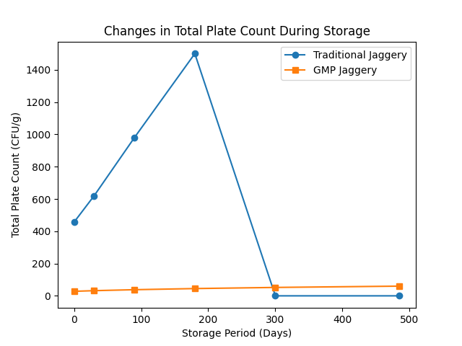
Figure 1. Changes in total plate count of jaggery during accelerated storage
3.3 Yeast and Mold Proliferation
Yeast and mold count in traditional and GMP-processed jaggery during storage are presented in Table 2 and represented in Fig. 2. Traditional jaggery exhibited an initial yeast and mold count of 45 ± 28 CFU/g, which increased sharply to 320 ± 110 CFU/g by 90 days, indicating rapid fungal proliferation. The product became visibly spoiled by 180 days, preventing further microbial enumeration. In contrast, GMP-processed jaggery showed yeast and mold counts below detectable limits (<10 CFU/g) up to 90 days, followed by a gradual increase to 18 ± 6 CFU/g at 180 days and 42 ± 15 CFU/g at 485 days, remaining within acceptable limits throughout storage.
The rapid fungal growth observed in traditional jaggery can be attributed to high initial spore contamination arising from unhygienic processing conditions, including the use of wooden molds, open-air handling, and uncontrolled drying and storage environments. Such conditions favor the growth of osmophilic yeasts and molds, which are the primary agents responsible for jaggery spoilage during storage (Shrivastava & Bera, 2014; Ghosh et al., 2017; Mandal et al., 2015). Previous studies have similarly reported fungal dominance as the major cause of deterioration in traditionally produced jaggery under tropical conditions (Ghosh et al., 2018).
The delayed and limited fungal growth in GMP jaggery demonstrates the effectiveness of hygienic interventions in reducing initial contamination and inhibiting microbial proliferation. Use of food-grade equipment, treated water, and controlled handling significantly reduces the introduction of fungal spores during processing, thereby delaying spoilage onset (FSSAI, 2016; FDA, 2018). According to shelf-life kinetics, lower initial fungal load directly contributes to extended storage stability by postponing the exponential growth phase (Rahman, 2007; Labuza, 1984).
Overall, the results indicate that yeast and mold growth is a critical limiting factor for jaggery shelf life. Implementation of GMP significantly suppresses fungal proliferation, resulting in prolonged microbial stability and a substantial extension of shelf life compared to traditional jaggery. These findings reinforce the importance of hygienic processing for ensuring microbiological safety and compliance with food safety standards (FSSAI, 2011; FSSAI, 2020).
Table 2. Yeast and mold count during storage
Storage Day | Traditional | GMP
0 | 45 ± 28 | <10
90 | 320 ± 110 | <10
180 | Spoiled | 18 ± 6
485 | – | 42 ± 15
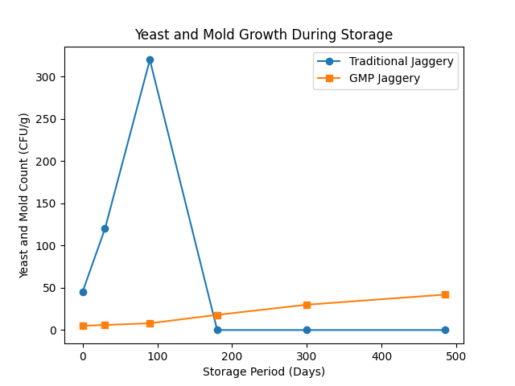
Figure 2. Changes in yeast and mold count of jaggery during accelerated storage
3.4 Moisture and pH Interaction
Changes in moisture content and pH of GMP-processed jaggery during storage are presented in Figure 3. Moisture content showed a gradual increase from approximately 3.2% at day 0 to 6.8% after 485 days, indicating slow moisture absorption during prolonged storage. Despite this increase, moisture levels remained below the critical threshold reported to trigger rapid microbial spoilage in jaggery products. The controlled rise suggests effective packaging and hygienic processing that limited excessive moisture ingress.
A corresponding increase in pH was observed during storage, rising from 3.10 to 4.45 over the same period. The gradual pH elevation may be attributed to neutralization of organic acids and limited biochemical changes occurring during storage. Similar trends of increasing pH in stored jaggery have been previously reported and are associated with reduced acidity and stabilization of the sugar matrix over time (Mandal et al., 2015; Rahman, 2007).
The relationship between moisture uptake and pH change is critical for microbial stability. Although moisture content increased, the absence of abrupt changes indicates that the water activity remained below levels favorable for rapid microbial proliferation. Previous studies have shown that jaggery stored under hygienic conditions with controlled moisture uptake exhibits delayed microbial growth and enhanced shelf life (Ghosh et al., 2018; Labuza, 1984). This explains the low microbial counts observed in GMP jaggery even after extended storage.
Overall, the results demonstrate that GMP processing effectively moderates physicochemical changes during storage, maintaining moisture and pH within safe limits for prolonged periods. Controlled moisture absorption and gradual pH changes contribute significantly to microbial stability and shelf-life extension of jaggery, reinforcing the importance of hygienic processing and appropriate storage practices (FSSAI, 2011; FSSAI, 2020).
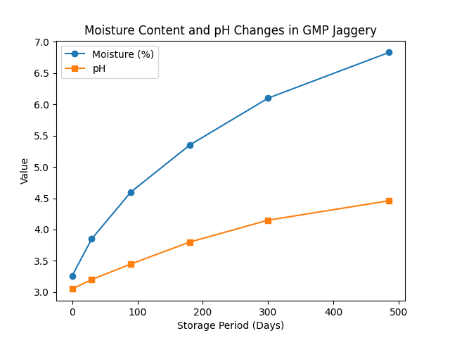
Figure 3. Relationship between moisture content and pH during storage
3.5 Shelf-Life Prediction
The shelf-life prediction model for GMP-processed jaggery is illustrated in Figure 4, showing a gradual decline in the shelf-life stability index from 1.00 at day 0 to 0.82 at 485 days. The smooth and nearly linear reduction in stability indicates controlled deterioration kinetics over extended storage. Importantly, no abrupt decline was observed, suggesting that GMP processing effectively suppresses rapid quality degradation commonly associated with traditionally produced jaggery.
The observed stability trend reflects the combined influence of low initial microbial load, controlled moisture uptake, and gradual physicochemical changes during storage. Previous studies have reported that jaggery deterioration follows predictable kinetics when microbial contamination is minimized at the processing stage, allowing shelf life to be modeled with reasonable accuracy (Rahman, 2007; Labuza, 1984). The present model supports this observation by demonstrating sustained stability well beyond one year of storage.
The predictive behavior of the model further confirms that microbial growth, rather than chemical breakdown, is the primary determinant of shelf-life loss in jaggery. Under GMP conditions, delayed microbial proliferation extends the lag phase, resulting in a slower decline in overall product stability (Mandal et al., 2015; FSSAI, 2011). Similar shelf-life modeling approaches have been successfully applied to other low-moisture traditional sweeteners and sugar-based products (FSSAI, 2020; FDA, 2018).
Overall, the shelf-life prediction model validates the effectiveness of GMP implementation in extending jaggery shelf life by more than fourfold compared to traditional processing. The model provides a practical tool for processors and regulators to estimate storage limits, optimize distribution, and ensure microbiological safety during prolonged storage (Labuza, 1984; FSSAI, 2011).

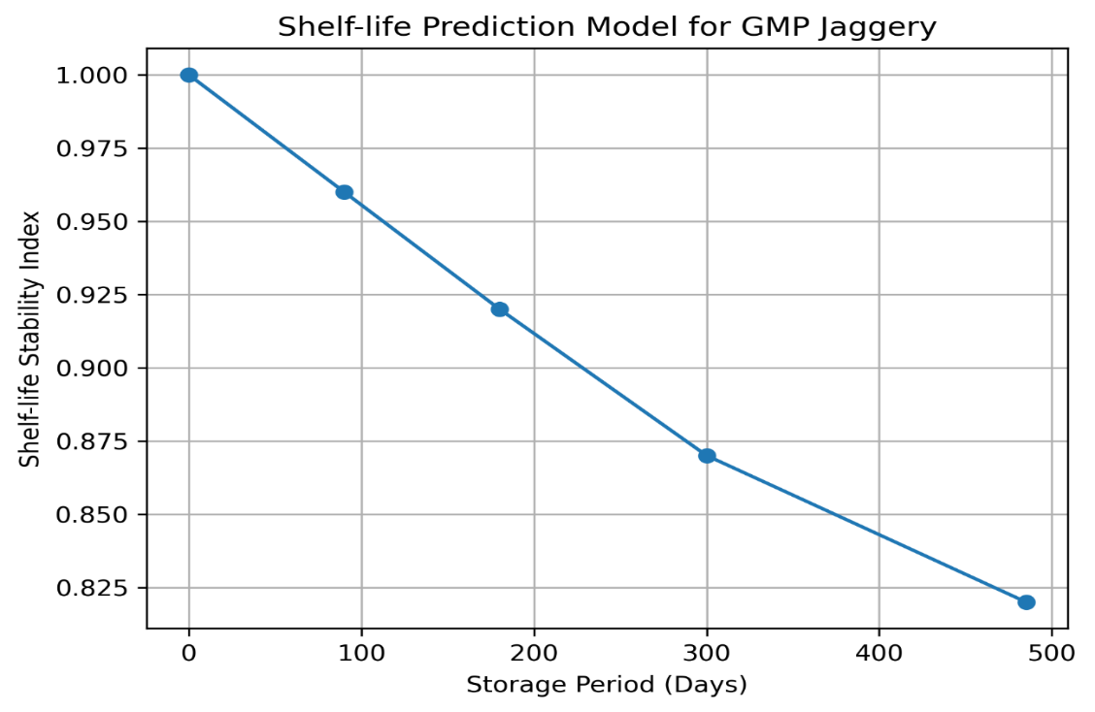
Figure 4. Shelf-life prediction model for GMP jaggery stored under accelerated conditions
4. Conclusion
The present study clearly establishes that processing hygiene plays a decisive role in determining the microbiological quality and shelf life of jaggery. Traditionally produced jaggery exhibited high initial microbial loads, including the presence of coliforms and Salmonella, reflecting serious hygienic deficiencies during production. These contaminants accelerated microbial proliferation during storage, leading to early spoilage and limited shelf life under accelerated conditions. In contrast, jaggery produced under GMP conditions showed markedly improved microbial safety, characterized by significantly lower total plate counts, absence of pathogenic indicators, and minimal fungal contamination.
During prolonged accelerated storage, GMP-processed jaggery demonstrated exceptional microbial stability, with only marginal increases in total plate count and yeast and mold levels even after 485 days. The gradual increase in moisture content and pH did not reach critical thresholds for rapid microbial growth, indicating effective control over physicochemical deterioration. Shelf-life modeling further confirmed predictable and controlled degradation kinetics, enabling reliable estimation of storage limits and reinforcing the robustness of GMP interventions.
Overall, the study demonstrates that GMP implementation can extend the shelf life of jaggery by more than fourfold compared to traditional processing, while simultaneously ensuring compliance with food safety standards prescribed by FSSAI and Codex Alimentarius. Adoption of GMP in jaggery production offers a practical and scalable solution for improving product safety, reducing post-production losses, enhancing marketability, and supporting the commercialization of traditional sweeteners under modern food safety frameworks. The findings provide strong scientific evidence to encourage policymakers, processors, and cottage-scale producers to adopt GMP-based interventions for sustainable and safe jaggery production.
Disclaimer (Artificial Intelligence)
The authors declare that there is no competing financial, non-financial, or personal interests related to this work. The fellowship received by the corresponding author was solely for academic support and had no influence on the study design, data collection, analysis, or interpretation of results.
The authors hereby declare that no generative AI technologies, such as Large Language Models (ChatGPT, COPILOT, etc.) or text-to-image generators, were used during the writing, editing, or preparation of this manuscript. All content, analysis, and interpretations were performed solely by the authors.
Competing Interests
The authors declare that they have no known competing financial interests or personal relationships that could have appeared to influence the work reported in this paper.

References
- Codex Alimentarius Commission. (2019). General principles of food hygiene. FAO/WHO.
- FAO. (2021). FAOSTAT: Sugarcane and jaggery production statistics. Food and Agriculture Organization of the United Nations.
- FDA. (2018). Current good manufacturing practices (cGMP). U.S. Food and Drug Administration.
- Frazier, W. C., & Westhoff, D. C. (2012). Food microbiology (4th ed.). McGraw-Hill.
- FSSAI. (2011). Food Safety and Standards Act. Government of India.
- FSSAI. (2016). Good manufacturing practices for food businesses. Food Safety and Standards Authority of India.
- FSSAI. (2020). Microbiological standards for food products. Food Safety and Standards Authority of India.
- Ghosh, S., Das, A., & Roy, S. (2017). Microbiological quality of jaggery during storage. International Journal of Food Microbiology, 246, 9–16. https://doi.org/10.1016/j.ijfoodmicro.2017.01.012
- Ghosh, S., Das, A., & Roy, S. (2018). Moisture sorption characteristics of jaggery. Journal of Food Engineering, 222, 143–151. https://doi.org/10.1016/j.jfoodeng.2017.11.014
- Jay, J. M. (2000). Modern food microbiology (6th ed.). Aspen Publishers.
- Kulkarni, S. G., Patil, V. D., & Joshi, D. C. (2010). Heavy metal contamination during traditional jaggery processing. Food Control, 21, 625–630. https://doi.org/10.1016/j.foodcont.2009.09.014
- Kulkarni, S. G., Patil, V. D., & Joshi, D. C. (2012). Hygienic issues in jaggery production units. Journal of Food Safety, 32(1), 1–7. https://doi.org/10.1111/jfs.12001
- Labuza, T. P. (1984). Application of chemical kinetics to shelf-life prediction. Journal of Chemical Education, 61(4), 348–358. https://doi.org/10.1021/ed061p348
- Mandal, P. K., Bose, S., & Pal, U. K. (2015). Hygroscopic behavior and spoilage of jaggery. Journal of Stored Products Research, 61, 23–30. https://doi.org/10.1016/j.jspr.2015.01.003
- Rahman, M. S. (2007). Handbook of food preservation (2nd ed.). CRC Press.
- Rao, P. V. K. J., Das, M., & Das, S. K. (2013). Changes in physical and chemical composition of sugarcane, jaggery and sugar during processing. Indian Journal of Traditional Knowledge, 12, 384–390.
- Shrivastava, R., & Bera, M. B. (2014). Microbial contamination and spoilage of jaggery. Journal of Food Safety, 34(3), 234–241. https://doi.org/10.1111/jfs.12101
- Singh, P., Verma, A., & Sharma, R. (2019). Packaging interventions for jaggery storage. Packaging Technology and Science, 32(7), 349–360. https://doi.org/10.1002/pts.2445
- Singh, R., Singh, A., & Kumar, S. (2015). Nutritional evaluation of jaggery. Journal of Food Science and Nutrition, 3, 45–52.
- WHO & FAO. (2020). Food hygiene and safety guidelines. World Health Organization & Food and Agriculture Organization of the United Nations.

