Original Research Article

Mycelial compatibility groups among Sclerotium rolfsii isolates associated with collar rot of chickpea in Telangana

ABSTRACT

Chickpea (Cicer arietinum L.) is one of the most important pulse crops cultivated extensively in India. Despite its immense potential and superior nutritional value, chickpea productivity remains low due to several biotic stress factors. Among the various diseases, collar rot caused by Sclerotium rolfsii (Sacc.) is the most destructive and leads to plant mortality ranging from 10% to complete crop loss. Considering the importance of the crop and the highly destructive nature of the pathogen, mycelial compatibility studies were undertaken. Thirteen S. rolfsii isolates isolated from collar rot–infected chickpea fields of Telangana were used in the present investigation. Mycelial compatibility among the isolates was assessed by dual culture and classified based on an aversion scale (0–4). Out of 78 isolate combinations, 44 showed complete mycelial compatibility (scale 0). All isolates were self-compatible, indicating the absence of self-incompatibility. Among the isolates, CSR-2, CSR-10 and CSR-12 showed incompatibility with seven other isolates (38.46%) indicating the highest level of incompatibility, whereas CSR-7 and CSR-13 were the most compatible (84.62%) each showing incompatibility with only one isolate. Despite the presence of several incompatible pairings (aversion levels 1–4), all isolates were interconnected through at least one fully compatible interaction. The results identified a single mycelial compatibility group (MCG) among the chickpea isolates, indicating low genetic variability and suggesting that control measures evaluated against a representative isolate may be effective across the region.
Keywords: Chickpea, Sclerotium rolfsii, Collar rot, Mycelial compatibility group, Genetic variability, Disease management.

INTRODUCTION
Chickpea is the predominant pulse crop grown in India and accounts for nearly three-fourths of the total pulse production in the country [1]. Chickpea cultivation also improves soil fertility by fixing atmospheric nitrogen through its association with beneficial bacteria, which supports subsequent crops in crop rotation [2]. However, chickpea yield is greatly affected by several soil-borne diseases, particularly collar rot caused by Sclerotium rolfsii. This pathogen is common in warm and humid regions and can cause severe seedling loss, ranging from 10% to almost complete crop failure, depending on environmental conditions and varietal susceptibility [3].
The disease causes collapse of infected seedlings with rotting at the collar region. As it progresses, leaves turn brown, dry, and remain attached to the dead stem. White mycelial growth and mustard

seed–like sclerotia ranging from light to dark brown are formed on infected plant parts and surrounding soil [4].
Sclerotium rolfsii exhibits rapid growth and produces abundant sclerotia capable of surviving in the soil for multiple years [5]. Considering the importance of crop and highly destructive nature of S. rolfsii, the current research work was designed to assess the virulence S. rolfsii isolates infecting chickpea in Telangana by mycelial compatibility.

Materials and Methods
  - Isolation and maintenance of S. rolfsii isolates
In the present investigation chickpea infecting 14 S. rolfsii isolates were obtained from the Department of Plant Pathology, Agricultural College, Jagtial, which were collected from diseased chickpea samples representing three agricultural zones of Telangana viz., Northern Telangana region (Adilabad, Nirmal, Nizamabad and Jagtial districts), Southern Telangana region (Jogulamba Gadwal and Vikarabad districts) and Central Telangana region (Warangal district). The sclerotial bodies of 14
S. rolfsii isolates were surface sterilized with 1% sodium hypochlorite solution for 30 seconds then rinsed thoroughly in sterile distilled water thrice to remove traces of sodium hypochlorite, if any and then aseptically transferred to sterilized potato dextrose agar (PDA) plates. They were incubated at 27±2°C for 48 hours. Then the isolates were purified by transferring hyphal tips from the margins of the resulting colonies to the centre of Petri dish containing PDA medium and then the plates were incubated at 27 ± 2°C temperature for seven days.
These 13 S. rolfsii isolates were indicated with two part code CSR 1, CSR 2, CSR 3 and so on. The first (part) alphabet of the name indicates crop and remaining two alphabets indicates genus and species of pathogen (C - Chickpea; S - Sclerotium; R - rolfsii) and second part (numerical number) indicates the serial number of the isolate.

Mycelial compatibility
Fresh mycelial plugs (5 mm in diameter) from 3 to 4 day old actively growing fungal colonies were paired on PDA plates and incubated at 30°C. Each pairing involved three plugs on a 90-mm plate: two plugs from one isolate and one plug from a different isolate with plugs spaced 25 to 30 mm apart. Self-compatibility was confirmed by pairing plugs from the same isolate. Pairings were examined macroscopically after 10 days of incubation for the presence of an antagonism zone in the region of mycelial contact [6].
The degree of aversion between different isolates was measured according to the following scales [7].
0 = No aversion
1 = Slight aversion (antagonism zone up to 1.0 mm)
2 = Moderate aversion (antagonism zone up to 1.1 to 2.0 mm)
3 = High aversion (antagonism zone up to 2.1 to 3.0 mm)

4 = Strong aversion (antagonism zone more than 3.0 mm)
Isolates forming a barrage zone were assigned to different MCGs, while those without a barrage and with intermingled mycelia were considered compatible and grouped within the same MCG.

Results and Discussion

Mycelial compatibility
Mycelial compatibility test was conducted using 13 S. rolfsii isolates of three agricultural zones of Telangana to identify the compatibility and incompatibility reaction among the isolates. Total 78 possible pairwise combinations were analysed to observe the compatibility and incompatibility/aversion reaction between S. rolfsii isolates at the point of mycelial contact (Figure 1a, 1b and 1c). Each interaction was classified based on the degree of aversion observed at the mycelial contact zone. All isolates demonstrated compatibility with themselves, confirming the absence of self-incompatibility.
Based on the degree of aversion (0-4 rating scale) S. rolfsii isolates were grouped into five categories given in (Table 1.). Among the 78 pairwise combinations, 44 pairwise combinations exhibited complete fusion mycelia and were grouped under no aversion category (0 score on 0-4 scale). This was followed by 15 pair wise combinations among S. rolfsii isolates that showed moderate aversion reaction with aversion zone 1.1 to 2.0 mm (Score 2 on 0-4 aversion scale). Nine Pairwise combinations grouped under slight aversion category with aversion zone up to 1 mm (Score 1 on 0-4 scale). High aversion category (Score 3 on 0-4 scale) with aversion zone between 2.1 to 3.0 mm was shown in eight pair wise combinations. Two pair wise combinations among S. rolfsii isolates viz., CSR 1 collected from Nirmal district of Telangana with CSR 4 collected from Adilabad district of Telangana showed aversion zone
5.0 mm and CSR 5 collected from Vikarabad district of Telangana with CSR 8 from Jogulamba Gadwal district of Telangana showed aversion zone 4.0 mm and categorised under strong aversion zone (score 4 on 0-4 scale).
The results presented in the (Table 2.) indicated that among the 13 S. rolfsii isolates CSR 2, CRS 10 and CRS 12 isolates exhibited highest level of incompatibility (61.54%) with eight S. rolfsii isolates indicating the minimum level of compatibility (38.46%) followed by S. rolfsii isolates CSR 4 and CSR 11 each showed incompatibility (53.85%) with seven S. rolfsii isolates and compatibility (46.15%) with only six S. rolfsii isolates. Whereas the three S. rolfsii isolates (CSR 1, CSR 3 and CSR 5) and two S. rolfsii isolates (CSR 6 and CSR 8) showed compatibility of 53.85 per cent and 61.54 per cent (7 S. rolfsii isolates) respectively. The S. rolfsii isolate CSR 9 demonstrated incompatibility (69.23%) with only three isolates. The most compatible (84.62%) isolates CSR 7 and CSR 13 each, showing incompatibility (15.38%) with CSR 10 and CSR 12 respectively.

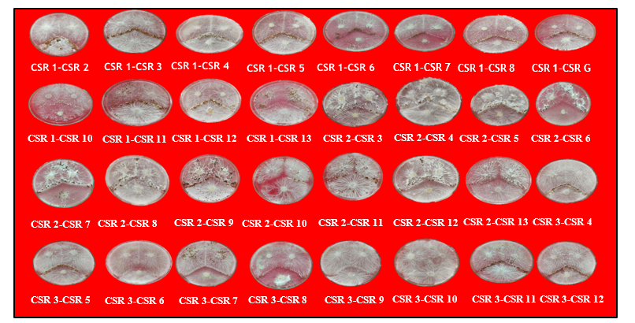

Figure 1a. Mycelial compatibility of different S. rolfsii isolates on Potato dextrose agar medium

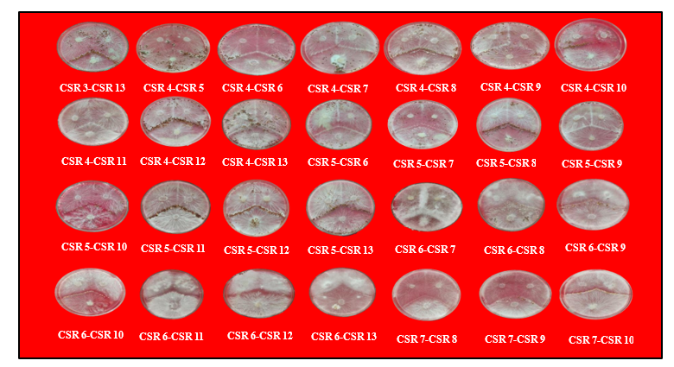

Figure 1b. Mycelial compatibility of different S. rolfsii isolates on Potato dextrose agar medium

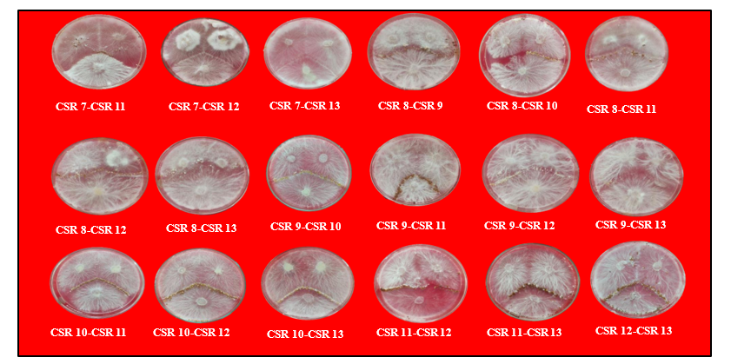

Figure 1c. Mycelial compatibility of different S. rolfsii isolates on Potato dextrose agar medium

Table 1. Degree of aversion between the isolates of S. rolfsii based on the aversion scale (0-4)

Isolates | CSR 1 | CSR 2 | CSR 3 | CSR 4 | CSR 5 | CSR 6 | CSR 7 | CSR 8 | CSR 9 | CSR 10 | CSR 11 | CSR 12 | CSR 13
CSR 1 | 0
CSR 2 | 0 | 0
CSR 3 | 0 | 2 | 0
CSR 4 | 4 | 0 | 3 | 0
CSR 5 | 3 | 3 | 2 | 0 | 0
CSR 6 | 0 | 0 | 0 | 0 | 0 | 0
CSR 7 | 0 | 0 | 0 | 0 | 0 | 0 | 0
CSR 8 | 0 | 2 | 0 | 3 | 4 | 1 | 0 | 0
CSR 9 | 0 | 2 | 2 | 0 | 0 | 0 | 0 | 0 | 0
CSR 10 | 2 | 2 | 0 | 2 | 3 | 2 | 1 | 3 | 2 | 0
CSR 11 | 1 | 1 | 2 | 0 | 0 | 1 | 0 | 0 | 0 | 3 | 0
CSR 12 | 2 | 1 | 2 | 1 | 0 | 3 | 0 | 0 | 0 | 3 | 1 | 0
CSR 13 | 1 | 0 | 0 | 0 | 0 | 0 | 0 | 0 | 0 | 0 | 0 | 3 | 0

0=No aversion, 1= Slight aversion (antagonism zone up to 1.0 mm), 2 = Moderate aversion (antagonism zone up to 1.1 to 2.0 mm), 3= High aversion (antagonism zone up to 2.1 to 3.0 mm), 4 = Strong aversion (antagonism zone more than 3.0 mm)

Table 2. Mycelial compatibility of different S. rolfsii isolates with other isolates and their mycelial compatibility percentage

S.No. | District | Mandal | Village | No. of Mycelial compatible isolates | MCC % | Incompatible  %
CSR 1 | Nirmal | Kubeer | Bakot | 7 | 53.85 | 46.15
CSR 2 | Nirmal | Kubeer | Godisera | 5 | 38.46 | 61.54
CSR 3 | Adilabad | Boadh | Pochera | 7 | 53.85 | 46.15
CSR 4 | Adilabad | Adilabad | ARS | 6 | 46.15 | 53.85
CSR 5 | Vikarabad | Basheerabad | Navalga | 7 | 53.85 | 46.15
CSR 6 | Nizamabad | Ranjal | Boregaon | 8 | 61.54 | 38.46
CSR 7 | Nizamabad | Bodhan | Chinnamavandi | 11 | 84.62 | 15.38
CSR 8 | Gadwal | Undavelli | Bhairapur | 8 | 6154 | 38.46
CSR 9 | Adilabad | Neredigonda | Neredigonda | 9 | 69.23 | 30.77
CSR 10 | Nirmal | Kubeer | Elegoan | 5 | 38.46 | 61.54
CSR 11 | Jagtial | Jagtiyal | RARS Jagtial | 6 | 46.15 | 53.85
CSR 12 | Adilabad | Jainath | Jainath | 5 | 38.46 | 61.54
CSR 13 | Warangal | Hasanparthy | Siddapur | 11 | 84.62 | 15.38

MCC%- Mycelial compatibility percentage

To better understand the relatedness among isolates, similarity matrix of Jaccard coefficient was used (Table 3.) wherein compatible interactions were scored as 1 and incompatible ones as 0 (zero). This binary matrix provide a visual representation of the clustering pattern and overall mycelial compatibility relationship among the isolates. When two isolates were placed in dual culture, the presence of a barrage zone at the point of contact indicated vegetative incompatibility, placing those isolates into different mycelial compatibility groups (MCGs). In the present investigation despite of the presence of several incompatible pairings (aversion levels 0-4), all isolates were interconnected/compatible with any of the isolate and these results identified only one MCG among chickpea S. rolfsii isolates. This result suggests a high degree of vegetative compatibility within the S. rolfsii population of Telangana state affecting chickpea.
The Results are similar to the findings of Yasar and Mert (2019), who reported that even though some isolate pairs within the same group exhibited partial incompatibility, they were included in the same MCG if they were linked through compatible interactions with other members. This indirect grouping method supports the present study, where isolates were assigned to a single MCG based on their direct or indirect compatibility via aversion-0 reactions.
The present study's binary matrix to generate jaccard similarity index was supported by [8].

Similarly, [9] reported that all 32 Sclerotium rolfsii isolates collected from turfgrass across multiple provinces in Turkey belonged to a single mycelial compatibility group (MCG), based on visual fusion in dual culture. Their findings align with the present study, where 13 chickpea isolates were similarly placed into one MCG through direct and indirect aversion-0 interactions. This supports the conclusion that populations of S. rolfsii may exhibit high levels of vegetative compatibility even across diverse sources.

CONCLUSION

The present study revealed that all Sclerotium rolfsii isolates associated with collar rot of chickpea in Telangana belong to a single mycelial compatibility group, indicating low genetic variability within the pathogen population. Although varying degrees of incompatibility were observed among isolate pairings complete interconnection through compatible interactions suggested a common genetic background. This uniformity supports the use of a representative isolate for pathogenicity and management studies. The findings imply that disease control strategies, including biocontrol agents and fungicides evaluated against a single isolate are likely to be effective across the region aiding in the development of region-specific management practices for collar rot of chickpea.

Disclaimer (Artificial intelligence)
Author(s) hereby declare that NO generative AI technologies such as Large Language Models (ChatGPT, COPILOT, etc.) and text-to-image generators have been used during the writing or editing of this manuscript.

Table 3. Jaccards coefficient similarity binary matrix of different S. rolfsii isolates with other isolates

Isolates | CSR 1 | CSR 2 | CSR 3 | CSR 4 | CSR 5 | CSR 6 | CSR 7 | CSR 8 | CSR 9 | CSR 10 | CSR 11 | CSR 12 | CSR 13
CSR 1 | 1
CSR 2 | 0.27 | 1
CSR 3 | 0.55 | 0.5 | 1
CSR 4 | 0.6 | 0.27 | 0.4 | 1
CSR 5 | 0.4 | 0.5 | 0.33 | 0.55 | 1
CSR 6 | 0.54 | 0.36 | 0.36 | 0.54 | 0.36 | 1
CSR 7 | 0.53 | 0.38 | 0.38 | 0.53 | 0.38 | 0.61 | 1
CSR 8 | 0.36 | 0.44 | 0.3 | 0.36 | 0.44 | 0.45 | 0.46 | 1
CSR 9 | 0.30 | 0.66 | 0.5 | 0.41 | 0.5 | 0.38 | 0.61 | 0.45 | 1
CSR 10 | 0.4 | 0.71 | 0.5 | 0.27 | 0.5 | 0.5 | 0.38 | 0.44 | 0.5 | 1
CSR 11 | 0.5 | 0.11 | 0.25 | 033 | 0.25 | 0.3 | 0.23 | 0.22 | 0.18 | 0.11 | 1
CSR 12 | 0.3 | 0.22 | 0.22 | 0.3 | 0.37 | 0.4 | 0.30 | 0.2 | 0.4 | 0.22 | 0.5 | 1
CSR 13 | 0.63 | 0.33 | 0.45 | 0.5 | 0.33 | 0.72 | 0.69 | 0.30 | 0.46 | 0.45 | 0.4 | 0.5 | 1

REFERENCES
- Dinesh, K, Sinha, B. and Savan, AK. 2021. Morphological variability and mycelial compatibility of Sclerotium rolfsii. Indian Journal of Plant Protection, 49(3): 182–189.
- Hasna MK, Kashem MA and Ahmed F. 2020. Use of Trichoderma in biological control of collar rot of soybean and chickpea. International Journal of Biochemistry Research and Review, 29(9): 25–31.
- Kashiwagi J, Krishnamurthy L, Upadhyaya HD, Krishna H, Chandra S, Vadez V and Serraj R. 2005. Genetic variability of drought-avoidance root traits in the mini-core germplasm collection of chickpea (Cicer arietinum L.). Euphytica, 146: 213–222.
- Keote GA, Prakash Reddy MS, Kapgate OY, Wasnikar AR and Bhoyar SD. 2019. Effect of bio-inoculants for the management of collar rot of chickpea. International Journal of Chemical Studies, 7: 1857–1861.
- Punja ZK and Sun LJ. 2001. Genetic diversity among mycelial compatibility groups of Sclerotium rolfsii (teleomorph Athelia rolfsii) and S. delphinii. Mycological Research, 105(5): 537–546.
- Rajput RS, Singh P, Singh J, Vaishnav A, Ray S and Singh HB. 2019. Trichoderma-mediated seed biopriming augments antioxidant and phenylpropanoid activities in tomato plant against Sclerotium rolfsii. Journal of Pharmacognosy and Phytochemistry, 8(3): 2641–2647.
- Singh SR, Singh SK and Pandey RK. 2012. Integrated management of collar rot of lentil caused by Sclerotium rolfsii. (Journal details to be added).
- Ünal F, Aşkın A and Koca E. 2019. Mycelial compatibility groups, pathogenic diversity and biological control of Sclerotium rolfsii on turfgrass. Egyptian Journal of Biological Pest Control, 29: 44.
- Yasar I and Mert F. 2019. Mycelial compatibility groups of Sclerotium rolfsii isolates and comparison of morphological and pathogenic characters. The Journal of Turkish Phytopathology, 48(1): 1–7.
.

