Original Research Article

Design and Development of a UV Reactor Integrated with a Microfiltration Module for Removal of Somatic Cells and Inactivation of Bacteria in Raw Milk

.
ABSTRACT

This study focuses on the design, development, and evaluation of a hybrid ultraviolet–microfiltration (UV–MF) module for improving the microbial quality of raw milk while maintaining its overall quality. The system was developed by integrating a 3 µm microfiltration unit with two custom-fabricated UV-C reactors arranged in series to overcome the limitations of low UV transmittance in milk. Reactor 1 was designed with a 28 W UV lamp and a 3.5 mm annular flow gap, while Reactor 2 incorporated a higher-power 62 W lamp with a reduced 2.0 mm flow gap to enhance UV exposure under continuous flow conditions. Both reactors were fabricated using food-grade stainless steel and quartz sleeves to ensure hygienic operation, leak-proof performance and ease of maintenance. The microfiltration stage acted as a critical pre-treatment by reducing turbidity and somatic cell load, thereby improving UV treatment efficiency. Limited performance evaluation indicated effective bacterial reduction, unchanged milk composition, delayed acidity development and acceptable sensory quality, demonstrating the suitability of the developed UV–MF system as a compact and non-thermal processing approach for dairy and food applications.

Keywords: Raw milk, Microfiltration, UV-C treatment, UV Reactor, Bacterial inactivation, Non-thermal processing

1. INTRODUCTION

Raw milk is highly susceptible to microbial contamination and deterioration, posing significant risks to food safety. Pathogenic microorganisms such as Escherichia coli, Salmonella, Staphylococcus aureus and Listeria monocytogenes have been frequently reported in raw milk, with contamination levels increasing during handling and transportation (Gume et al., 2023). In addition to microbial load, somatic cell count (SCC) is a key indicator of milk quality, as elevated SCC adversely affects shelf life, processing efficiency and product quality (Alhussien and Dang, 2018).
Thermal processing is effective for microbial reduction but often compromises the nutritional and sensory attributes of milk. As a result, non-thermal technologies such as microfiltration (MF) and ultraviolet (UV-C) treatment have gained attention. Microfiltration removes somatic cells and bacteria through membrane separation without altering milk composition, while UV-C treatment inactivates microorganisms by damaging microbial DNA (Wang et al., 2019; Bandla, 2012).
UV technology has also been applied successfully to various dairy products. Significant microbial reductions have been reported in raw milk, goat milk, donkey milk, soymilk and UHT milk using continuous, and LED-based UV systems (Krishnamurthy et al., 2007; Lu et al., 2011; Bandla, 2012; Kasahara et al., 2015; Martinez-Garcia et al., 2019; Papademas et al., 2020). Additionally, UV treatment has been applied to cheese varieties such as Fiordilatte, fresh cheese, white American cheese, Ricotta, Cheddar and processed cheese, achieving microbial reductions ranging from 1 to over 5 log cycles depending on UV dose, exposure time and packaging material (Can et al., 2014; Lacivita et al., 2016; Lacivita et al., 2018; Ricciardi et al., 2020; Ha et al., 2016; Proulx et al., 2015).

The integration of microfiltration with UV treatment offers an efficient approach to enhance microbial safety while preserving milk quality. Microfiltration reduces the initial microbial and somatic cell load, enabling improved UV treatment efficiency and overall bacterial inactivation (Patel et al., 2023). The microfiltration module used in the present study was originally developed and reported by Patel et al. (2023). The system consists of hygienic stainless-steel filter housings for 5 µm and 3 µm (or 1 µm) cartridges, equipped with silicon gaskets, tri-clamp fittings, ball valves and sample cocks to ensure leak-proof operation and aseptic sampling. Building upon this established microfiltration setup, the current research focuses on further integration of custom-fabricated UV reactors with the microfiltration module to enhance microbial inactivation and overall milk safety.

2. material and methods
2.1 UV Module
The UV module was developed using the following components:
- UV lamps: Low-pressure mercury lamps emitting at 254 nm with power ratings of 28 W and 62 W
- Quartz glass tubes: UV-transmitting sleeves for isolating lamps from milk
- Sealing elements: Food-grade EPDM gaskets and O-rings
- Reactor housing: SS-304 outer pipe
- End caps and flanges: For lamp installation and maintenance
- Electrical components: Lamp holders, ballasts, wiring and power supply unit
2.2 Peristaltic Pump
A peristaltic pump was used to transfer raw milk from the collection tank to the filtration and UV modules. The pump enabled gentle handling of milk and precise control of flow rate by adjusting the impeller speed.
2.3 software Used
AutoCAD-2021 was used to prepare the Process and Instrumentation Diagram (P&ID) and line diagrams of the experimental setup. SOLIDWORKS-2025 was employed for developing 2-D and 3-D fabrication drawings of the UV reactor components.
2.4 Materials for UV Reactor Housing
The reactor housing and piping system were fabricated using SS-304 components, including pipe nipples, ball valves and sample cocks. Food-grade silicone tubing was used for milk transfer between the tank and treatment modules.
2.5 Selection of UV Reactor
The UV reactor was designed considering UV dose, lamp intensity, exposure time, flow pattern and physical properties of milk such as turbidity and opacity. The germicidal efficacy of UV radiation was governed by UV dose, calculated as the product of UV intensity and exposure time. Higher intensity, longer exposure time and reduced distance between the lamp and milk enhanced microbial inactivation.
2.6 Preparation of P&ID
The P&ID for the integrated UV-microfiltration system was developed using AutoCAD-2021, following standard process engineering practices to ensure proper integration of all components.
2.7 Experimental Design
Raw milk was pumped through the system using a peristaltic pump. The milk first passed through a 5 µm microfilter followed by a 3 µm or 1 µm microfilter to remove somatic cells and reduce microbial load. The microfiltered milk was collected as Sample 1.
The milk was then treated in UV Reactor 1 at a UV dose of 134.5 mJ/cm² (1 L/min) and collected as Sample 2. Subsequently, the milk passed through UV Reactor 2 at a higher UV dose of 204.8 mJ/cm² (1 L/min) to achieve further microbial inactivation and Samples 3 and 4 were collected. Finally, the treated milk was cooled to 4 °C using a sterile eutectic cooling system and stored for quality evaluation.
2.8 Design and Fabrication of UV Reactors
Fabrication drawings were prepared using SOLIDWORKS-2025 and used as references during manufacturing. Reactor 1 was fabricated with a 28 W UV lamp and a 3.5 mm flow gap, while Reactor 2 used a 62 W lamp with a reduced flow gap of 2.0 mm to enhance UV exposure. Both reactors were fabricated from SS-304 and assembled with quartz sleeves to ensure uniform irradiation.
2.9 Fabrication Procedure
The fabrication process included material selection, cutting and shaping of SS pipes, TIG welding using argon shielding, surface grinding and polishing to sanitary finish, assembly of quartz sleeves and UV lamps, electrical wiring and leak testing of the complete unit.

3. results and discussion
3.1. Development of Process and Instrumentation Diagram (P&ID) for the Integration of a UV Ray Reactor with Microfiltration Module
To achieve effective synchronization of UV ray treatment with microfiltration for raw milk processing, a Process and Instrumentation Diagram (P&ID) was developed, as illustrated in Figure 1. This P&ID serves as the foundational layout for the fabrication, assembly and operation of the hybrid treatment system, ensuring clarity of the process flow, control points and instrumentation involved in the integration.
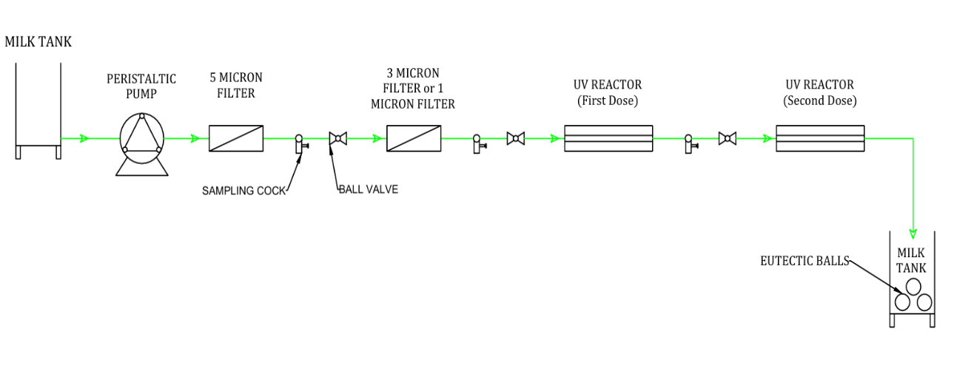

Fig 1. P&ID of Developed Hybrid UV-Microfiltration Module

3.2 Selection and Synchronization of the UV-Ray Reactor with the Microfiltration Module
The integration of the UV-ray reactor with the microfiltration module was essential to achieve effective microbial reduction while preserving the physicochemical quality of raw milk. Due to the low UV transmittance and opaque nature of milk, careful attention was given to reactor selection, fabrication and operational synchronization. The integration process was carried out in three stages: selection of the UV reactor, fabrication of the reactor and synchronization with the microfiltration module.
3.2.1 Selection of the UV-Ray Reactor
Direct UV treatment of raw milk is challenging because of its high turbidity and complex colloidal structure. Therefore, a suitable UV reactor design and component selection were necessary to ensure effective microbial inactivation. Water disinfection-type UV lamps emitting at 254 nm were selected for their proven germicidal efficiency. Low-pressure mercury lamps with quartz glass sleeves (Alfa Ecostream ECS15L and ECS25L) were used, with the outer reactor shell modified to suit the experimental setup. The quartz sleeves ensured maximum UV transmission while preventing direct contact between the lamp and milk.
Parameter | Water UV Reactor | Milk UV Reactor
Lamp Type | Low-pressure mercury UV lamps emitting at 254 nm | Same
Lamp Wattage | Depending Upon Capacity and targeted Microbes | Same
Quartz Sleeves | Standard quartz sleeves with gaskets | Same
Outer Shell | Standard design | Requires custom-designed shell for compatibility with milk processing setup
Availability | Commercially available | Not commercially available
Table No. 1 Comparison between Water UV Reactor and Milk UV Reactor
The findings of this study are consistent with the principles reported by Koutchma (2009), who highlighted the importance of UV absorbance in the treatment of opaque liquids such as milk. Low UV transmittance and the presence of suspended particles can limit microbial exposure and reduce inactivation efficiency. To overcome this challenge, a staged UV treatment approach was applied in the present work by integrating two UV reactors in series, which enhanced microbial exposure to UV radiation and improved overall disinfection efficiency.
3.2.2 Fabrication of UV-Ray Reactor 1
UV-Ray Reactor 1 was fabricated to ensure hygienic milk contact, leak-proof operation and uniform UV exposure. The housing was designed for safe integration with the microfiltration module and ease of cleaning and maintenance.
The reactor was custom-fabricated using AISI-304 stainless steel based on a 3D model developed in SolidWorks (Fig. 2). The design enabled secure placement of the quartz sleeve and UV lamp, quick lamp replacement and effective flow control to achieve uniform UV irradiation.
The fabricated reactor showed robust construction, reliable sealing and safe electrical insulation, contributing to stable and continuous operation during milk processing.

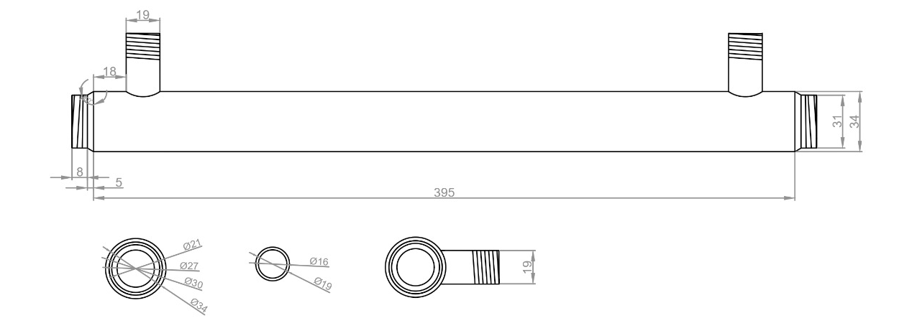
Fig.2: 2-D Design drawing of Reactor 1
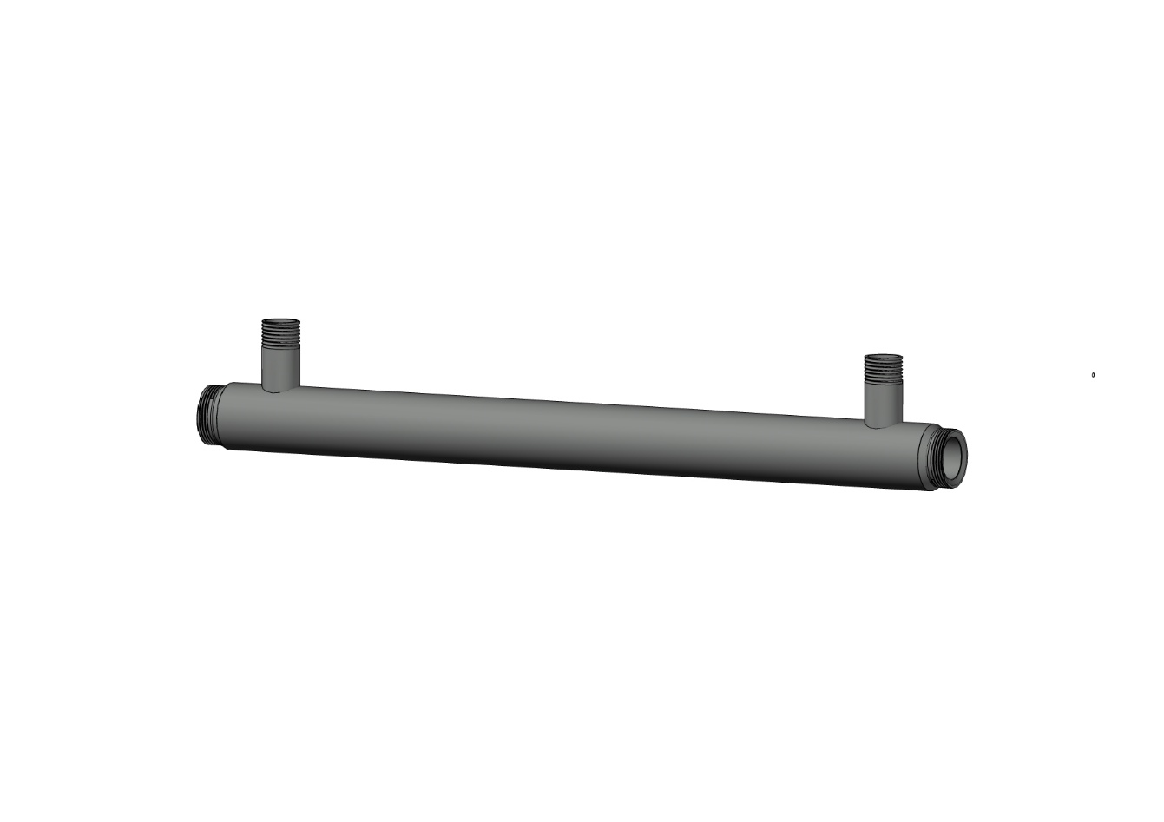
Fig.3: 3-D Design drawing of Reactor 1

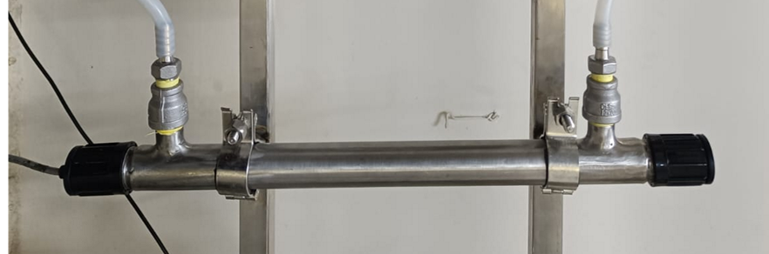
Fig.4: Fabricated UV Reactor 1
Component | Specification
Material of Construction | AISI-304 Stainless Steel
Reactor Outer Diameter | 33 mm
Reactor Inner Diameter | 27 mm
Reactor Housing Length | 420 mm
Quartz Sleeve Outer Diameter | 20 mm
Quartz Sleeve Length | 430 mm
UV Lamp Power - Reactor 1 | 28 W
Flow Gap - Reactor 1 | 3.5 mm
Type of UV Lamp | Low-pressure mercury lamp
UV Wavelength | 254 nm
Welding Type Used | TIG welding
O ring/Gaskets | Food-grade EPDM
Table 2. Specifications of Custom-Fabricated UV Reactor 1

Dhahir et al. (2021) reported a continuous UV-C reactor for camel milk with a 3.5 mm flow gap to ensure uniform UV exposure and minimize shadowing effects. Similarly, the present reactor design adopted a narrow 3.5 mm flow gap; however, the custom-fabricated reactor provides additional advantages such as compact design, higher lamp wattage, food-grade construction, and ease of assembly and operation.

3.2.3 Fabrication of UV-Ray Reactor 2
UV-Ray Reactor 2 was fabricated to ensure hygienic operation, safe integration with the microfiltration module and enhanced UV exposure. The reactor housing was custom-developed based on a 3D SolidWorks model (Fig. 3) and fabricated using AISI-304 stainless steel due to its corrosion resistance and suitability for dairy applications.
The design enabled secure positioning of the quartz sleeve and UV lamp, quick lamp replacement and uniform milk flow around the UV source. The reactor assembly consisted of an outer housing shell and an internal lamp–quartz sleeve arrangement, with provisions for leak-proof sealing, electrical insulation and easy disassembly for cleaning and maintenance.
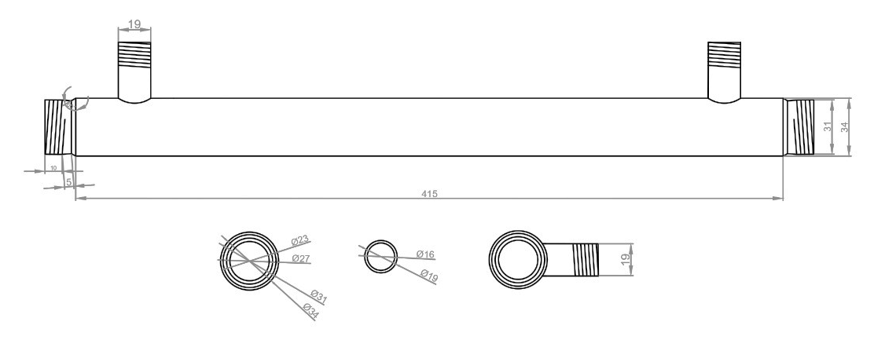
Fig.5 : 2-D Design drawing of Reactor 2

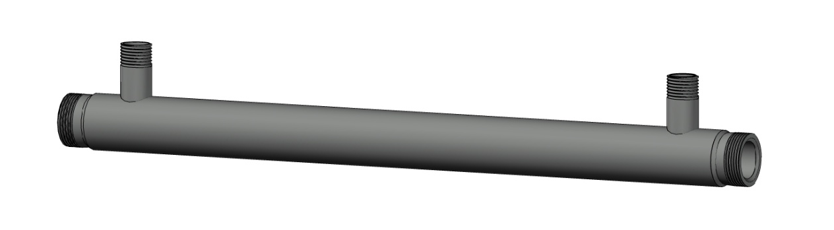
Fig.6: 3-D Design drawing of Reactor 2
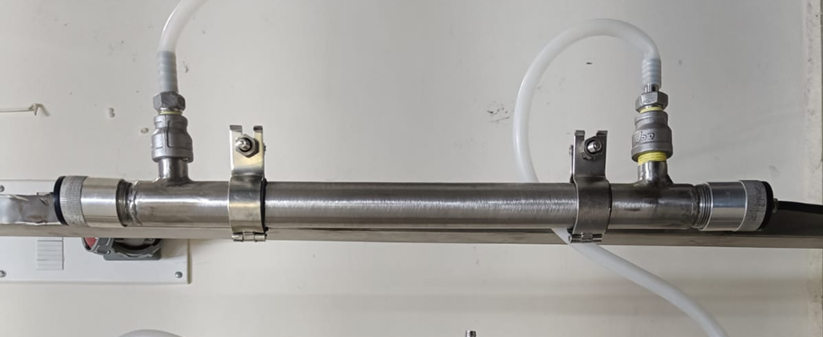
Fig.7: Fabricated UV Reactor 2
This robust and user-friendly fabrication approach reduced maintenance requirements, ensured operational safety and improved system reliability during continuous milk processing. Two UV reactors with different lamp powers and flow gap dimensions were developed to evaluate microbial inactivation under varying exposure conditions. Reactor 1 was fitted with a 28 W UV lamp and a 3.5 mm milk flow gap, while Reactor 2 was equipped with a 62 W UV lamp and a reduced flow gap of 2.0 mm.
Component | Specification
Material of Construction | AISI-304 Stainless Steel
Reactor Shell Outer Diameter | 33 mm
Reactor Shell Inner Diameter | 27 mm
Reactor Housing Length | 450 mm
Quartz Sleeve Outer Diameter | 25 mm
Quartz Sleeve Length | 465 mm
UV Lamp Power - Reactor 2 | 62 W
Flow Gap - Reactor 2 | 2.0 mm
Type of UV Lamp | Low-pressure mercury lamp
UV Wavelength | 254 nm
Welding Type Used | TIG welding
O ring/Gaskets | Food-grade EPDM
Table 3. Specifications of Custom-Fabricated UV Reactor 2

These configurations ensured adequate UV energy delivery to milk flowing through the annular region surrounding the quartz sleeve, despite limited UV penetration depth in milk. The smaller flow gap in the higher-power reactor enhanced light exposure to all milk fractions. In addition, the reactor design minimized dead zones and promoted uniform flow, resulting in consistent and effective UV treatment.

When compared with the thin-film UV-C system reported by Makarapong et al. (2020), which used lamp powers of 39 W and 48 W with a 1.9 mm flow gap, Reactor 2 offers certain advantages. The higher lamp power (62 W) and similar narrow gap (2.0 mm) suggest improved dose delivery, especially important for milk’s low UV transmittance.

3.2.4 Synchronization with Microfiltration Module
The synchronization of the UV-ray reactors with the microfiltration (MF) module was an important step in developing a combined treatment system for raw milk. The main aim was to ensure smooth operation of both units in a continuous process without affecting milk quality or hygienic conditions.
After fabrication and preliminary trials, the UV reactors were installed after the MF module. This arrangement was chosen because microfiltration removes a major portion of suspended solids, somatic cells and microorganisms from raw milk. As a result, the milk entering the UV reactors had lower turbidity, which allowed better penetration of UV light and improved the effectiveness of microbial inactivation.

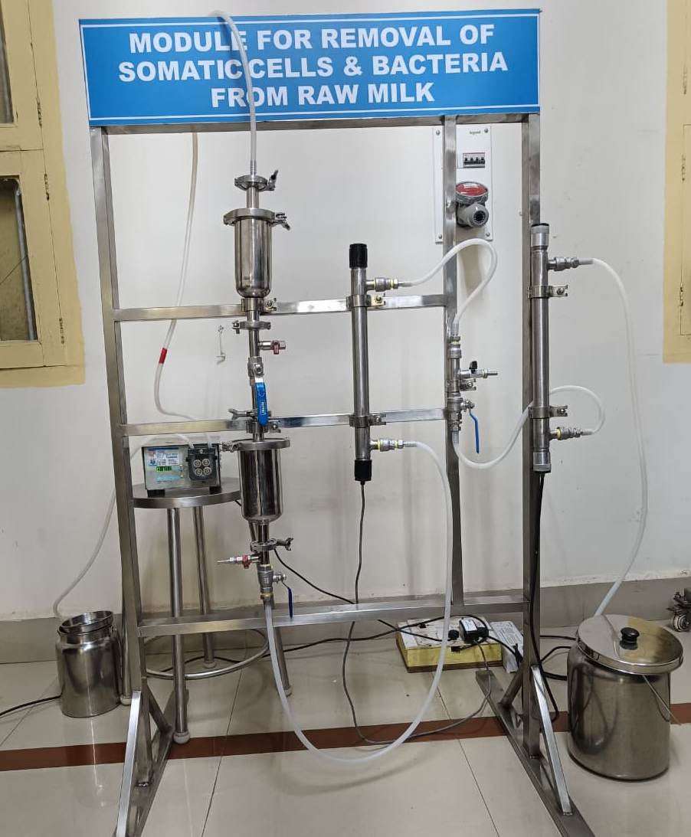
Fig 8: Developed Functional UV ray-Microfiltration module

3.3 Performance Evaluation of the Developed Hybrid UV-MF Module
The hybrid UV–microfiltration (UV–MF) system was evaluated using raw milk samples with varying somatic cell count (SCC) and total bacterial count (TBC). Milk was first microfiltered through a 3 µm filter, followed by UV treatment using two reactors connected in series. SCC was analyzed using an automatic somatic cell counter, while TBC was determined by the standard plate count method.
Microfiltration alone reduced TBC from 5.82–5.87 to 5.41–5.46 log₁₀ cfu/mL (0.39–0.41 log reduction) and SCC by 28–29%. UV-C Reactor 1 achieved bacterial reductions of 0.68–0.96 log units, with the highest reduction at 1 L/min due to higher UV dose. UV-C Reactor 2 showed improved performance, achieving reductions of 0.82–1.20 log units, again highest at the lowest flow rate.
The combined operation of Reactor 1 and Reactor 2 resulted in the maximum microbial reduction. At 1 L/min and a combined UV dose of 339.3 mJ/cm², a reduction of 1.81 log units was achieved. Overall, lower flow rates and higher UV doses significantly enhanced bacterial inactivation, demonstrating the effectiveness of the integrated UV–MF system.
Chemical composition:
The chemical composition of milk remained unchanged after microfiltration and UV treatment. Fat (4.1%), SNF (8.6%) and total solids (12.7%) showed no variation across raw, microfiltered and UV-treated samples (TC–T4), indicating that the treatments did not affect milk composition.
Titratable acidity:
Initial titratable acidity (0.135% lactic acid) was identical for all treatments. The control and microfiltered milk spoiled by day 3, indicating limited shelf-life improvement with microfiltration alone. UV-treated samples showed delayed acidity development, with spoilage occurring on day 4 (low dose), day 5 (high dose) and day 7 for the combined UV treatment, demonstrating a clear shelf-life extension with increasing UV dose.
Sensory evaluation:
Raw milk received the highest sensory scores across all attributes. Microfiltered and low-dose UV-treated milk showed sensory quality comparable to raw milk. Higher UV doses caused a slight reduction in flavour and overall acceptability, with the combined UV treatment showing the most noticeable decline, though samples remained acceptable.
4.CONCLUSION
The present study successfully demonstrated the design, development and performance of a hybrid ultraviolet–microfiltration (UV–MF) module for improving the microbial quality of raw milk. Microfiltration effectively reduced somatic cell count and initial bacterial load, while subsequent UV-C treatment further enhanced microbial inactivation. The use of two UV reactors with different lamp powers and flow gap configurations allowed effective UV exposure under continuous flow conditions, with higher UV doses and lower flow rates resulting in greater bacterial reduction.
Importantly, the integrated UV–MF system did not alter the chemical composition of milk, as fat, SNF and total solids remained unchanged across all treatments. UV treatment also delayed acidity development during refrigerated storage, leading to a significant extension of shelf life compared to untreated and microfiltered milk. Sensory quality was well preserved at lower UV doses, with only minor changes observed at higher cumulative doses.
Overall, the developed hybrid UV–MF module proved to be an efficient non-thermal alternative for enhancing the safety and shelf life of raw milk while maintaining its physicochemical and sensory properties. The system shows strong potential for application in dairy processing, particularly where minimal heat treatment and quality retention are desired.

References
Gume, B., Berhanu, L., Kassa, T., Bediru, H., Fikre, A.G., Dadi, L.S., & Mereta, S.T. (2023). Bacterial hazard identification and exposure assessment of raw milk consumption in Jimma zone, South West Ethiopia. BMC Microbiology, 23(1), 166. https://doi.org/10.1186/s12866-023-02910-0
Alhussien, M. N., & Dang, A. K. (2018). Milk somatic cells, factors influencing their release, future prospects, and practical utility in dairy animals: An overview. Veterinary World, 11(5), 562-577. https://doi.org/10.14202/vetworld.2018.562-577
Wang, D., Fritsch, J., & Moraru, C. I. (2019). Shelf life and quality of skim milk processed by cold microfiltration with a 1.4-μm pore size membrane, with or without heat treatment. Journal of Dairy Science, 102(10), 8798-8806. https://doi.org/10.3168/jds.2018-16050
Bandla, S., Choudhary, R., Watson, D. G., & Haddock, J. (2012). UV-C treatment of soymilk in coiled tube UV reactors for inactivation of Escherichia coli W1485 and Bacillus cereus endospores. LWT - Food Science and Technology, 46(1), 71-76. https://doi.org/10.1016/j.lwt.2011.10.024
Krishnamurthy, K., Demirci, A., & Irudayaraj, J.M. (2007). Inactivation of Staphylococcus aureus in milk using flow-through pulsed UV-light treatment system. Journal of Food Science, 72(7), M233-M239. https://doi.org/10.1111/j.1750-3841.2007.00438.x
Lu, G., Li, C., & Liu, P. (2011). UV inactivation of milk-related microorganisms with a novel electrodeless lamp apparatus. European Food Research and Technology, 233(1), 79-87. https://doi.org/10.1007/s00217-011-1498-5
Kasahara, I., Carrasco, V., & Aguilar, L. (2015). Inactivation of Escherichia coli in goat milk using pulsed ultraviolet light. *Journal of Food Engineering*, *152*, 43-49. https://doi.org/10.1016/j.jfoodeng.2014.11.012
Martinez-Garcia, M., Sauceda-Gálvez, J. N., Codina-Torrella, I., Hernández-Herrero, M. M., Gervilla, R., & Roig-Sagués, A. X. (2019). Evaluation of continuous UVC treatments and its combination with UHPH on spores of Bacillus subtilis in whole and skim milk. Foods, 8(11), 539. https://doi.org/10.3390/foods8110539
Papademas, P., Mousikos, P., & Aspri, M. (2020). Optimization of UV-C processing of donkey milk: An alternative to pasteurization? Animals, 11(1), 42. https://doi.org/10.3390/ani11010042
Can, F. O., Demirci, A., Puri, V. M., & Gourama, H. (2014). Decontamination of Hard Cheeses by Pulsed UV Light. Journal of Food Protection. https://doi.org/10.4315/0362-028X.JFP-13-559
Lacivita, V., Conte, A., Lyng, J.G., Arroyo, C., Zambrini, V.A., & Del Nobile, M.A. (2018). High intensity light pulses to reduce microbial load in fresh cheese. Journal of Dairy Research, 85(2), 232-237. https://doi.org/10.1017/S0022029918000134
Lacivita, V., Conte, A., Manzocco, L., Plazzotta, S., Zambrini, V. A., Del Nobile, M. A., & Nicoli, M. C. (2016). Surface UV-C light treatments to prolong the shelf-life of Fiordilatte cheese. Innovative Food Science & Emerging Technologies, 36, 150-155. https://doi.org/10.1016/j.ifset.2016.06.010
Ha, J. W., Back, K. H., Kim, Y. H., & Kang, D. H. (2016). Efficacy of UV-C irradiation for inactivation of food-borne pathogens on sliced cheese packaged with different types and thicknesses of plastic films. Food Microbiology, 57, 172-177. https://doi.org/10.1016/j.fm.2016.02.007
Proulx, J., Hsu, L.C., Miller, B.M., Sullivan, G., Paradis, K., & Moraru, C.I. (2015). Pulsed-light inactivation of pathogenic and spoilage bacteria on cheese surface. Journal of Dairy Science, 98(9), 5890-5898. https://doi.org/10.3168/jds.2015-9410
Patel, S. H., Kumar, M. G., Rajunaik, B., Prashantakumar, B. S. G., Shilpashree, B. G., & Ramachandra, C. T. (2023). Design and development of microfiltration module for removal of somatic cells and bacteria from raw milk. The Pharma Innovation Journal, 12(9S), 1310-1317. https://www.thepharmajournal.com/
Koutchma, T. (2009). Advances in ultraviolet light technology for non-thermal processing of liquid foods. Food and Bioprocess Technology, 2, 138-155. https://doi.org/10.1007/s11947-008-0178-3
Dhahir, N., Feugang, J., Witrick, K., Park, S., White, S., & AbuGhazaleh, A. (2021). The effect of different ultraviolet-C light doses on microbial reduction and the components of camel milk. Food Science and Technology International, 27(2), 99-111. https://doi.org/10.1177/1082013220935230
Makarapong, D., Tantayanon, S., Gowanit, C., & Inchaisri, C. (2020). Development of an innovative apparatus using UV‐C for controlling the number of microorganisms in raw milk after milking. International Journal of Dairy Technology, 73(1), 301-305. https://doi.org/10.1111/1471-0307.12654.

