Efficacy of Biofertilizers on Growth, Quality and Yield of Tomato
[Solanum lycopersicum (L.) cv. Anagha]

.
ABSTRACT

Aims: To evaluate the growth, yield, and quality response of tomato to biofertilizers applied alone and in combination with chemical fertilizers.
Study design: Randomized block design
Place and Duration of Study: A one-year experiment was conducted at the Department of Vegetable Science, College of Agriculture, Vellanikkara, Thrissur, under Kerala Agricultural University
Methodology: The bacterial wilt- and crack-resistant tomato variety Anagha, developed by Kerala Agricultural University, was used for the study. Three biofertilizers-Azospirillum, Arbuscular Mycorrhizal Fungi (AMF), and Frateuria aurantia-were evaluated in different combinations with farmyard manure (FYM), with or without inorganic fertilizers. Treatments included single biofertilizer inoculation with FYM (T₁: Azospirillum + FYM, T₂: AMF + FYM, T₃: Frateuria + FYM), combinations of two biofertilizers with FYM (T₄: Azospirillum + AMF + FYM, T₅: Azospirillum + Frateuria + FYM, T₆: AMF + Frateuria + FYM), all three biofertilizers with FYM (T₇), and all three biofertilizers with FYM and inorganic fertilizers at half (T₈) and full (T₉) recommended doses. A control (T₁₀) was maintained as per the Kerala Agricultural University Package of Practices. The experiment was laid out with three replications.
Results: Integrated application of FYM, full recommended dose of inorganic fertilizers, and biofertilizers (T₉) significantly improved vegetative growth and yield of tomato. Treatment T₉ recorded the highest plant height, number of leaves, number of fruits per plant (28.16), fruit yield per plant (814.70 g), total fruit yield (20.81 t ha⁻¹), and total soluble solids. Superior fruit physical traits, including fruit weight (34.15 g), fruit volume (38.20 cm³), and fruit girth (15.31 cm), were observed in T₇. The highest vitamin C content (24.66 mg 100 g⁻¹) was also recorded in T₇.
Conclusion: Biofertilizer application improved growth, yield, and quality of tomato. FYM combined with biofertilizers and full recommended NPK was most effective, while FYM and biofertilizers with 50% NPK indicated the possibility of reducing chemical fertilizer use without yield loss.

Keywords: Tomato, biofertilizer, integrated nutrient management, Azospirillum, AMF and Frateuria

1. INTRODUCTION

Vegetables play a vital role in ensuring nutritional security by providing essential vitamins, minerals, dietary fibre, and antioxidants required for human health. In India, vegetable cultivation contributes significantly to food security, income generation, and employment, particularly for small and marginal farmers. Tomato (Solanum lycopersicum L.) is one of the most important vegetable crops grown throughout the country due to its wide adaptability, high productivity, and diverse uses in fresh consumption as well as in processing industries. It is an unavoidable vegetable in Indian kitchens and nutrition gardens, owing to its regular use in daily cooking and its nutritional richness. Tomato is a rich source of vitamins A and C, lycopene, and minerals, and occupies an important place in the daily diet of the Indian population (Kalloo and Banerjee, 2013).
Farmers often rely heavily on chemical fertilizers to maximize the tomato yield for meeting the increased demand for. Although chemical fertilizers have played a key role in enhancing crop productivity, their indiscriminate and continuous use has led to several adverse effects, including a decline in soil organic matter, nutrient imbalance, reduced soil microbial activity, and environmental pollution. Under the present agricultural scenario, there is a growing need for an evergreen revolution that ensures sustained productivity without degrading natural resources. Integrated Nutrient Management (INM), which involves the combined use of organic manures, biofertilizers, and inorganic fertilizers, has emerged as a sustainable approach to address these challenges. The judicious integration of these components, along with reduced or recommended doses of chemical fertilizers, can improve nutrient use efficiency and sustain crop yields.
Biofertilizers such as Azospirillum, Arbuscular Mycorrhizal Fungi (AMF), and Frateuria aurantia play distinct and complementary roles in plant nutrition. Azospirillum fixes atmospheric nitrogen and promotes root growth, AMF enhances the uptake of phosphorus and micronutrients, and Frateuria solubilizes potassium in the soil. Their combined application has the potential to improve growth, yield, and quality of tomato while reducing dependence on chemical fertilizers. The integrated use of organic manures and biofertilizers with chemical fertilizers has been reported to improve soil fertility and crop productivity. Studies have shown that the combined application of FYM, biofertilizers, and inorganic fertilizers results in higher yields and better quality attributes in tomato compared to the sole application of chemical fertilizers (Mahanty et al., 2017).
However, the response of tomato to different combinations of biofertilizers and fertilizer levels varies with location, soil type, and management practices, highlighting the need for location-specific studies. In this context, the present study evaluates the effect of individual and combined application of Azospirillum, AMF, and Frateuria aurantia along with FYM, with and without inorganic fertilizers, on the growth, yield, and quality of tomato. The study aims to generate scientific data on the effectiveness of these biofertilizers under Kerala conditions and to assess the possibility of reducing chemical fertilizer inputs without compromising crop performance.

2. material and methods

The experiment was conducted at the research farm of Department of vegetable science, College of Agriculture under Kerala Agricultural University located at Vellanikkara, Thrissur. The research field is located at an altitude of 22.25 m above MSL at 10⁰ 32’N latitude and 76⁰ 16’E longitude. The soil at this location is classified as a well-drained laterite. Anagha, a bacterial wilt and crack resistant variety of tomato developed by Kerala Agricultural University was selected for the study. Three biofertilizers, viz. Azospirillum, AMF and Frateuria were used at different combinations along with farm yard manure (FYM) and with or without chemical fertilizers constituted different treatments. Commercial talc formulation of Azospirillum and soil based formulation of AMF were purchased from College of Agriculture, Vellayani. Liquid formulation of potassium mobilizer, Frateuria aurantia commercially known as Symbion-K was obtained from T. Stanes and Company, Coimatore. Farm yard manure containing N, P₂O₅ and K₂O at
1:0.5:1 percentage was used. Urea (46 %), Factamphos (20 % N and 20 % P₂O₅) and Muriate of Potash (60 % K₂O) were used as sources of chemical fertilizers.
The experimental area was ploughed twice, weeds were removed and the land was levelled before the layout of treatments. The experiment was laid out in Randomised Block Design (RBD) with three replications. The size of plot was 3.0 m x 3.0 m. There were 25 plants in a plot with 5 rows of 5 plants each. Spacing adopted was 60 x 60 cm. The manurial and fertilizer doses were based on the Package of Practices recommendations (KAU, 2011) for tomato. Accordingly, FYM at 25 tonnes and N: P₂O₅: K₂O at 75: 40: 25 kg ha⁻¹ were applied.
The treatments are
T₁ - FYM +Azospirillum @ 2 kg ha ⁻¹
T₂ - FYM + AMF @ 2 kg ha ⁻¹
T₃ - FYM + Frateuria @ 2 kg ha ⁻¹
T₄ - FYM + Azospirillum + AMF each @ 2 kg ha ⁻¹
T₅ - FYM + Azospirillum + Frateuria each @ 2 kg ha ⁻¹
T₆ - FYM + AMF + Frateuria each @ 2 kg ha ⁻¹
T₇ - FYM + Azospirillum + AMF + Frateuria each @ 2 kg ha ⁻¹
T₈ - FYM + ½ (NPK) + Azospirillum + AMF + Frateuria each @ 2 kg ha ⁻¹
T₉- POP + Azospirillum + AMF + Frateuria each @ 2 kg ha⁻¹
T₁₀ - Manures and fertilizers as per POP recommendation (control)
The nursery was raised in pots of 5 kg capacity, and filled with soil, sand and FYM at the ratio 1:1:1. One third of the recommended rate of biofertilizers were applied in nursery as per treatment. Seeds were sprayed with rice gruel and then coated with Azospirillum and Frateuria. The seeds were shade dried for 20 minutes and sown in pots. AMF was applied in the pots after mixing with FYM at a ratio of 1:25 (KAU, 2011). Two third of the biofertilizers were applied at the time of transplanting. Root dipping of the seedlings (30 days old) was followed for inoculation of Azospirillum and Frateuria. AMF was mixed with FYM in the ratio 1:25 and placed in small pits into which seedlings were transplanted. Mulching was provided in all the treatments. Seven days of gap was maintained between chemical fertilizer and biofertilizer application. Hand weeding was done regularly to keep the field free of weeds. Light earthing up was done along with top dressing of fertilizers. Irrigation was done at alternate days. Staking was given to the plants. Fruits were harvested at turning stage.
Observations were taken at periodic intervals. The plant height was recorded at 15, 30, 45 and 60 Days After Transplanting (DAT) as the average of observations from five tagged plants. The measurement was done from the base of the stem to the growing tip of the plants. Number of leaves and branches of five plants per plot was counted at 30, 45 and 60 DAT. Earliness is calculated based on the number of days taken from transplanting to opening of the first flower in each plot and number of days taken from transplanting to first harvest of the fruits in each plot. Data relating to each character was analysed by applying the Analysis of Variance (ANOVA) and the means were compared using Duncan’s Multiple Range Test (DMRT). MSTATC was used for computation and analysis of data.

3. results and discussion
3.1. Days to germination
The days to germination varied from 4 to 4.6 days but were found to be non-significant between treatments.
3.2 Response of biofertilizers on growth parameters
Significant difference in plant height, number of leaves and number of branches due to treatments was noticed.
3.2.1 Height (cm)
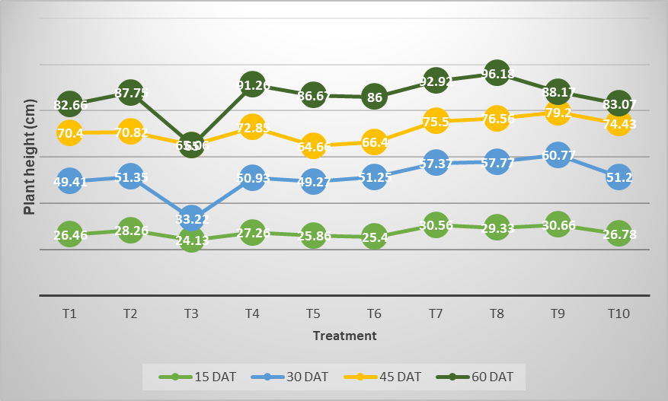
The plant height, considered to be an important factor to judge the vigour was found increased to a significant level with the application of biofertilizers (Fig.1). Plant height differed significantly among treatments at 15, 30, 45, and 60 days after transplanting (DAT) (Fig. 1). At 15 DAT, the maximum plant height was recorded in T₉ (all three biofertilizers + FYM + full NPK; 30.66 cm), which was statistically comparable to T₇ (all three biofertilizers + FYM; 30.56 cm). At 30 and 45 DAT, T₉ continued to record the tallest plants, with heights of 60.77 cm and 79.20 cm, respectively. At the final stage (60 DAT), the maximum plant height (96.18 cm) was observed in T₈ (all three biofertilizers + FYM + 50% recommended NPK), indicating the sustained influence of biofertilizers even under reduced chemical fertilizer application.
Fig.1. Response of biofertilizers on height of plant at various growth stages
The significant improvement in plant height with biofertilizer application may be attributed to enhanced nutrient availability and the synthesis of growth-promoting substances, resulting in increased cell division and elongation (Sreenivasa, 1994). Similar responses have been reported in tomato (Premsekhar and Rajasree, 2009), onion (Prusty M., et al., 2019), and okra (Anisa, 2011), where reduced nitrogen levels supplemented with biofertilizers significantly enhanced plant growth.
The superior performance of T₈ at 60 DAT could be associated with the higher and sustained population of biofertilizers under this treatment leading to prolonged nutrient availability. Growth enhancement due to Azospirillum has been attributed to its nitrogen-fixing ability, increased nitrogenase activity, and production of phytohormones such as IAA, gibberellins, and cytokinin-like substances (Veeraraghavathatham et al., 1988; Govindarajan and Thangaraju, 2001).
3.2.2 Number of leaves
The number of leaves differed significantly among treatments at 30, 45 and 60 DAT (Fig.2). At all stages, T₉ recorded the highest number of leaves. At 30 DAT, T₉ was superior, though it was on par with T₁, T₂, T₇ and T₈. At 45 DAT, T₉ remained significantly superior, followed by T₇, while T₄ and T₁₀ were on par with T₈. At 60 DAT, T9 recorded the maximum number of leaves (52.58), followed by T₇ and T₈, and control plants were on par with these treatments.
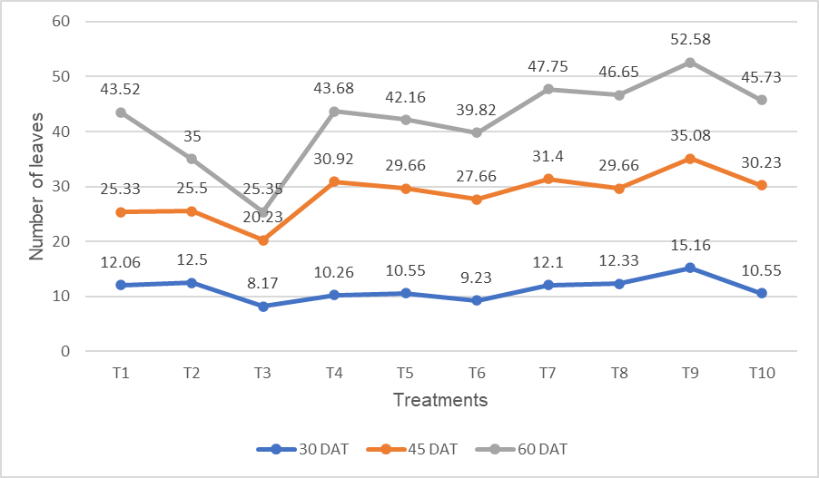
Among the morphological traits associated with yield, the maintenance of functional leaves is of primary importance, as leaves constitute the main site of photosynthesis and assimilate production. The significant variation in leaf number observed at 30, 45, and 60 DAT reflects the strong influence of nutrient management on canopy development. The consistently higher leaf production under T₉ (combined application of all three biofertilizers with FYM and the full recommended dose of NPK) can be attributed to improved rhizosphere conditions that favored enhanced water and nutrient uptake. Biofertilizers improve nutrient availability and root activity, thereby promoting sustained leaf initiation and expansion. In particular, improved nitrogen availability enhances chlorophyll synthesis and leaf development, resulting in a larger photosynthetic surface area and improved vegetative growth, which ultimately contributes to higher yield potential.
Fig.2. Response of biofertilizers on number of leaves at various growth stages
3.2.3 Number of branches
The number of branches varied significantly among treatments at 30, 45, and 60 DAT (Fig. 3). At 30 DAT, T₇ (all three biofertilizers + FYM) recorded the highest number of branches (5.08), which was statistically on par with T₉, while the control was comparable with T₈ and T₆. At 45 DAT, T₇ remained superior (8.78 branches), followed by T₄, whereas T₃ recorded the minimum number of branches. A similar trend was observed at 60 DAT, where T₇ produced the maximum number of branches (12.00), followed by T₄, while T₆, T₁₀, T₈, and T₉ were statistically on par.
Branch number is an important yield-contributing trait, as increased branching enhances canopy spread and potential sink strength. The significant increase in branch number with biofertilizer application, particularly under T₇, suggests improved regulation of plant growth and hormonal balance. Biofertilizers are known to influence endogenous phytohormone levels, especially by reducing apical dominance through modulation of auxin activity, thereby promoting axillary bud break and branch initiation (Rademacher, 1991). Similar observations were reported by Hinson and Hanson (1962), who demonstrated that partial suppression of apical dominance accelerates the development of axillary buds into lateral branches. The superior branching response under T₇ may also be attributed to improved nutrient availability and root activity in the rhizosphere, resulting in sustained vegetative growth. Enhanced nitrogen availability and balanced nutrient uptake support meristematic activity and lateral shoot development, ultimately leading to an increased number of branches and improved yield potential.
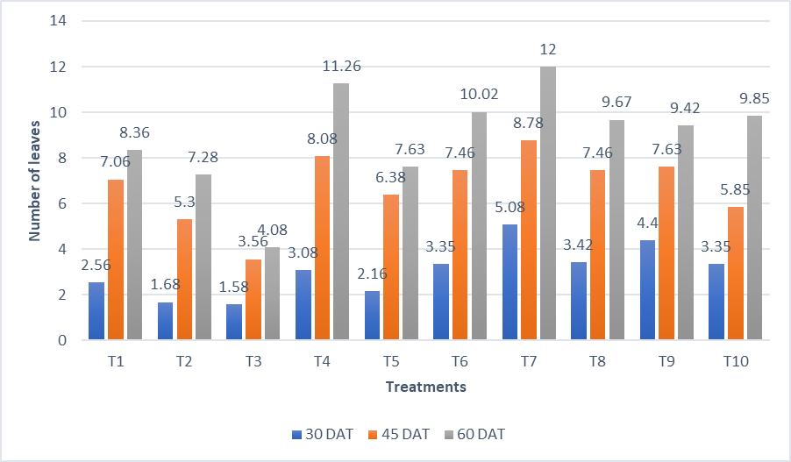

Fig.3. Response of biofertilizers on number of branches at various growth stages

3.3 Earliness of the crop
Data pertaining to earliness-related traits are presented in Table 1.

Table 1. Response of biofertilizers on earliness of the crop

3.3.1 Days to first flower opening
Treatments differed significantly with respect to days to first flower opening. Early flowering was observed in T₇ which recorded the minimum number of days to first flower opening (28.50 and 28.88 days, respectively). Delayed flowering was recorded in T₁ and T₃, while the control exhibited intermediate flowering duration.
3.3.1 Days to first harvest
Significant variation was also observed for days to first harvest. Early harvest was recorded in T₇, T₂, and T₉, with harvest occurring at approximately 60 days, whereas T₃ and T₆ recorded the maximum number of days to first harvest, indicating delayed maturity.
Earliness in flowering and fruit maturity is influenced by environmental, nutritional, and hormonal factors, including light, temperature, nutrient availability, and growth regulator activity (Kinet and Peet, 1997). The earlier flowering observed under T₇ and T₂ indicates the beneficial role of biofertilizers, particularly AMF, in accelerating reproductive development.
Among major nutrients, phosphorus plays a critical role in promoting earliness by enhancing energy transfer and reproductive differentiation. Increased phosphorus uptake facilitated by AMF, along with the secretion of growth-regulating substances, may have promoted early development of reproductive organs (Anburani and Manivannan, 2002). Enhanced uptake of nutrients under combined biofertilizer application may also have stimulated the synthesis of bioactive compounds such as cytokinins, leading to increased photosynthate production and their translocation to axillary buds. Accumulation of these assimilates and hormones may have favored early transition from the vegetative to reproductive phase, thereby inducing early flower bud initiation (Amritalingam and Balakrishnan, 1988).
Similar responses have been reported earlier, where AMF inoculation resulted in early flowering in chilli (Oyetunji and Osonubi, 2005) and early curd initiation in cauliflower (Chaurasia et al., 2008). Early fruit maturity observed under biofertilizer treatments may further be attributed to enhanced nutrient uptake and photosynthetic efficiency, leading to increased carbohydrate synthesis and improved hormonal activity. Accelerated photosynthesis and rapid translocation of assimilates may have strengthened source–sink relationships, thereby promoting early fruit development and harvest.
3.4 Biometric characteristics of fruit
Statistical analysis revealed significant differences among treatments for fruit weight, fruit girth, fruit volume and flesh thickness per fruit. Mean values of these biometric characteristics are presented in Table 2.
3.4.1 Fruit weight (g)
Average fruit weight differed significantly among treatments. The maximum fruit weight was recorded in T₇ (34.15 g), followed by T₉ and the control, while T₃ recorded the minimum fruit weight.
Table 2. Response of biofertilizers on biometric characteristics of fruits

3.4.2 Fruit girth (cm)
Significant variation was observed in fruit girth among treatments. The highest fruit girth (15.31 cm) was recorded in T₇, followed by T₉, which was statistically on par with T₁₀, T₄, T₆, and T₅. The minimum fruit girth was recorded in T₃.
3.4.3 Fruit volume (cm³)
Fruit volume varied significantly across treatments. T₇ recorded the maximum fruit volume (38.20 cm³), followed by T₉, which was on par with T₁₀, while T₃ recorded the lowest fruit volume.
3.4.4 Flesh thickness (mm)
Flesh thickness showed significant differences among treatments. The maximum flesh thickness was recorded in T₂ (3.43 mm), followed by T₇ (3.27 mm), which was statistically on par with T₆, T₈, T₉, and T₄. The minimum flesh thickness (2.72 mm) was observed in T₃.
Fruit biometric characters such as weight, girth, volume and flesh thickness are important quality and yield determining traits in tomato. The superior performance of T₇ (combined application of FYM with Azospirillum, AMF, and Frateuria aurantia) for most fruit attributes indicates the beneficial synergistic effect of organic manures and biofertilizers.
Enhanced fruit size and weight under T₇ may be attributed to increased photosynthetic efficiency and greater accumulation of carbohydrates, leading to the development of larger and heavier fruits (Sharma, 1995). Improved soil fertility, microbial activity, and nutrient availability under FYM application likely enhanced nutrient uptake and metabolic activity, resulting in improved fruit biochemical characteristics. Similar improvements in fruit weight and girth with combined biofertilizer application have been reported in okra (Anisa, 2011).
Farmyard manure also improves soil physical, chemical, and biological properties, including water-holding capacity and humus content, thereby creating a favorable environment for the establishment and activity of inoculated microorganisms (Hayworth et al., 1996). Growth-promoting substances such as cytokinins produced by biofertilizers may have enhanced enzymatic activity and cell metabolism, leading to increased fruit size and flesh thickness (Subbaiah, 1991).
The higher flesh thickness observed under T₂ and T₇ suggests a positive influence of AMF on nutrient uptake, particularly phosphorus, which plays a key role in fruit tissue development.
3.5 Yield characteristics
Yield represents the integrated outcome of morphological, physiological, and biochemical processes, reflecting the efficiency with which plants intercept solar radiation and convert nutrients into economic yield (Humphries, 1969). Yield improvement can be achieved either by enhancing the growth performance of existing cultivars under given environmental conditions or by modifying assimilate partitioning towards economically important plant parts.
3.5.1 number of fruits per plant
In the present study, the number of fruits per plant varied significantly among treatments (Table 3). The combined application of all biofertilizers with the full recommended dose of NPK (T9) recorded the highest number of fruits per plant (28.16), representing a 20.60% increase over the control. Similar increases in fruit number due to combined application of biofertilizers and 100% recommended fertilizer dose have been reported in tomato (Sendur et al., 1998) and in brinjal (Anburani and Manivannan, 2002; Kiran, 2006). The increase in fruit number under T9 may be attributed to enhanced uptake of N, P, and K, leading to improved
photosynthetic efficiency and greater assimilate availability. In addition, growth regulators
produced by inoculated microorganisms may have stimulated reproductive development and increased truss formation.
3.5.2 Fruit yield per plant
Significant differences were also observed in fruit yield per plant. The treatment, T₉ recorded the highest yield (814.70 g per plant), followed by T₈ (664.90 g per plant) and the control (629.50 g per plant). The yield under T₉ was 29.40% higher than the control.
3.5.3 Yield per hectare
Total fruit yield per hectare was maximum under T₉ (20.81 t ha⁻¹), representing a 22.84% increase over the control, followed by T₈ (16.95 t ha⁻¹) and the control (16.06 t ha⁻¹). Comparable improvements in yield due to integrated application of biofertilizers and inorganic fertilizers have been reported in brinjal (Anburani and Manivannan, 2002; Kiran, 2006) and chilli (Talukder and Jana, 2009).

Table 3. Response of biofertilizers on yield characteristics
The superior yield performance under T₉ may be attributed to enhanced synthesis of metabolites and improved nutrient uptake resulting from the combined application of inorganic fertilizers, biofertilizers, and FYM. This integrated nutrient management approach promoted improved plant growth in terms of plant height, leaf number, branching, and inflorescence development, all of which showed positive associations with yield. Application of FYM likely improved soil physical, chemical, and biological properties, facilitating rapid multiplication of

inoculated microorganisms, enhanced mobilization of bound nutrients, and improved soil aggregation (Nirmala and Vadivel, 1999). FYM also supplies both macro- and micronutrients, increases water-holding capacity, and improves soil aeration, thereby supporting better root development and nutrient absorption (Kirad et al., 2010). Collectively, these factors enhanced photosynthetic rate and assimilate translocation, ultimately resulting in higher fruit yield.
4. CONCLUSION
The present study clearly demonstrates that integrated nutrient management involving biofertilizers, organic manure, and inorganic fertilizers significantly influences growth, earliness, yield, and fruit quality of tomato. Combined application of Azospirillum, AMF, and Frateuria aurantia along with FYM and the full recommended dose of NPK (T₉) proved most effective in enhancing yield attributes, fruit yield per plant, and total yield per hectare, primarily through improved nutrient uptake, enhanced photosynthetic efficiency, and better assimilate partitioning. Notably, treatments involving biofertilizers with reduced chemical fertilizer inputs also performed comparably for several growth and yield parameters, indicating the potential for partial substitution of inorganic fertilizers.
Improved vegetative growth, increased branching, early flowering, enhanced fruit biometric traits, and number of fruits per plant under biofertilizer-based treatments highlight the role of beneficial microorganisms in regulating physiological and hormonal processes essential for productivity. The synergistic effect of FYM and biofertilizers further improved soil fertility, microbial activity, and nutrient-use efficiency, contributing to sustained crop performance.
Overall, the findings emphasize that the integration of biofertilizers with organic and inorganic nutrient sources is a viable and sustainable strategy for improving tomato productivity while reducing dependency on chemical fertilizers. Adoption of such integrated nutrient management practices can enhance yield, maintain soil health, and support environmentally sustainable vegetable production systems.

DISCLAIMER (ARTIFICIAL INTELLIGENCE)
Artificial intelligence tools (Chat GPT) were used only for language editing and improving readability. All scientific content and interpretations are the sole responsibility of the author.
COMPETING INTERESTS
Authors have declared that no competing interests exist.

References
Amirthalingam, S. and Balakrishnan, R. 1988. Studies on the effect of Azospirillum, nitrogen and NAA on growth and yield of chilli (Capsicum annuum L.) cv. K.1. South Indian Hort., 36 : 218.
Anburani, A. and Manivannan, K. 2002. Effect of integrated nutrient management on growth in brinjal (Solanum melongena L.) cv. Annamalai. S. Indian Hortic. 50(4/6):377-386.
Anisa, N. A. 2011. Response of okra (Abelmoschus esculentus (L.) Moench) to biofertilizers. M. Sc. (Hort.) thesis, Kerala Agricultural University, Vellanikkara, Thrissur, 98p.
Chaurasia, S. N. S., Singh, A. K., Singh, K. P., Rai, A. J., Singh, C. P. N., and Rai, M. 2008. Effect of integrated nutrient management on yield and quality of cauliflower (Brassica oleraceae var. botrytis) variety Pusa Snowball K-1. Veg. Sci. 35(1):41-44.
Latham, M. C. (1997). Human nutrition in the developing world (FAO Food and Nutrition Series No. 29). Food and Agriculture Organization of the United Nations. https://digitallibrary.un.org/record/234000?ln=en
Govindarajan, K. and Thangaraju, M. 2001. Azospirillum- a potential inoculants for horticultural crops. S. Indian Hortic. 49:233-235.
Hayworth, F., Cleawer, T. J., and Bran, J. M. 1996. The effects of different manurial treatments on the yield and mineral composition of early potato. J. Hortic Sci. 41(3):225-241.
Hinson, K., & Hanson, W. D. (1962). Competition studies in soybean. Crop Science, 2, 117-123. https://doi.org/10.2135/cropsci1962.0011183X000200020010x
Singh, P. K., Dasgupta, S. K., & Tripathi, S. K. (Eds.). (2004). Hybrid vegetable development. CRC Press. https://doi.org/10.1201/9781482282863
Kerala Agricultural University. (2011). Package of practices recommendations: Crops (14th ed.). Kerala Agricultural University. https://www.kau.in/documents/package-practices-crops
Kinet, J. M., & Peet, M. M. (1997). Tomato. In H. C. Wien (Ed.), The physiology of vegetable crops (pp. 207-258). CAB International. https://www.cabi.org/cabebooks/book/20053000007
Kirad, K. S., Barche, S., and Singh, D. B. 2010. Integrated nutrient management on growth, yield and quality of carrot. Karnataka J. Agric. Sci. 23(3):542-543.
Kiran, J. 2006. Effect of fertilizer, biofertilizer and micronutrients on seed yield and quality of brinjal (solanum molongena l.). M. Sc. (Ag) thesis, University of Agricultural Sciences, Dharwad, 78p.
Mahanty, T., Bhattacharjee, S., Goswami, M., Bhattacharyya, P., Das, B., Ghosh, A., & Tribedi, P. (2017). Biofertilizers: a potential approach for sustainable agriculture development. Environmental Science and Pollution Research, 24, 3315-3335. https://doi.org/10.1007/s11356-016-8104-0
Nirmala, R. and Vadivel, E. 1999. Effect of combined application of organic manures and biofertilizers on growth and productivity of cucumber. S. Indian Hortic. 47(1-6):252-254.
Oyetunji, O. J., & Osonubi, O. (2005). Influence of arbuscular mycorrhizae on the performance of chilli (Bell) pepper (Capsicum annuum L.). Journal of Applied Horticulture, 7(2), 133-136. https://doi.org/10.37855/jah.2005.v07i02.34
Premsekhar, M. and Rajashree, V. 2009. Influence of biofertilizers on the growth characters, yield and quality of tomato. Am.-Eur. J. Sustain. Agric. 3(1):68-70.
Prusty, M., Mishra, N., Kar, D.S., & Pal, S. (2019). Effect of Integrated Nutrient Management on Growth and Yield of Onion (Allium cepa L.) cv. Bhima Super. International Journal of Agriculture Sciences, 11(4), 7910-7912. https://www.bioinfopublication.org/viewarticle.php?id=29900
Rademacher, W. 1991. Biochemical effects of plant growth retardants. In: Harold, and Gausman, W. (eds.), Plant Biochemical Regulations. Marcel Dekker Inc. New York, pp. 169-200.
Sendur, K. S., Natarajan, S., and Thamburaj, S. 1998. Effect of organics and inorganic fertilizers on growth, yield and quality of tomato. S. Indian Hortic. 46(3-4):203-205.
Sharma, S. K. 1995. Response of triacontanol application on certain morphological characters, fruit and seed yield and quality of tomato seed. Ann. Agric. Res. 16: 128-130.
Sreenivasa, M. N. 1994. VA mycorrhizal in conjunction with organic amendments improves growth and yield of chilli. Environ. Ecol. 12(2):312-314.
Subbiah, K. 1991. Studies on the effect of nitrogen and Azospirillum on okra. S. Indian Hortic. 39(1):37-44.
Talukder, B., & Jana, J. C. (2009). Integrated nutrient management for better growth, yield and quality of green chilli (Capsicum annuum) in terai region of West Bengal. *Indian Journal of Agricultural Sciences*, *79*(8), 600–603. https://epubs.icar.org.in/ejournal/index.php/IJAgS/issue/archive (Navigate to Volume 79, Issue 8, 2009)
Veeraraghavathatham, D., Sunderarajan, S., Jayashankar, S., Vadivel, E., and Shanmugavelu, K. G. 1988. Effect of N and P application and Azospirillum inoculation on chilli (Capsicum annuum L.), In: Proceedings of National Seminar on Chillies, Turmeric and Ginger, 11-12 Jan. 1988, Hyderabad, pp. 65-70.

