How Integrated Are India’s Coarse Cereal Markets? Evidence from Jowar Price Linkages

Abstract
In this paper, spatial price linkages and market integration were studied for jowar markets in India. Monthly wholesale price and arrival data for five major markets i.e. Kekri, Burhanpur, Barshi, Sindhanur and Visnagar over 2009–10 to 2023–24 were used. Unit-root testing (ADF), Bai–Perron structural-break detection, Johansen co-integration, Granger causality, Vector Error Correction Models (VECM) and Impulse Response Functions (IRF) were used. It was observed that all price series are stationary at first difference and the five markets are co-integrated, indicating a stable long-run relationship despite short-run frictions. Kekri Granger-causes Sindhanur and Visnagar and Barshi Granger-causes Sindhanur. VECM estimates reveal heterogeneous error-correction speeds — Kekri adjusted at speed of 134.1 per cent, followed by Barshi (57.87 per cent) indicating an uneven responsiveness across regions. IRF analysis confirms asymmetric shock transmission: Kekri and Visnagar act as important transmitters while Burhanpur behaves more self-contained. Price growth is generally positive across markets, but arrivals are highly variable with significant seasonality and occasional structural breaks linked to climatic events. The need for targeted infrastructure, improved market information, and region-specific policy interventions to strengthen spatial price efficiency, stabilize farmer incomes, and improve market coordination for jowar were emphasized.
Keywords: Jowar, Coarse cereals, Market integration, Price linkages, Spatial analysis
Introduction
Coarse cereals play a pivotal role to provide nutritional security, income diversification and resilience in Indian agriculture. These are commonly referred to as nutri cereals. They are rich in nutritional fibre, protein, and micronutrients. It renders them critical towards solving the issue of malnutrition and advancing climate-resilient agriculture. Coarse cereals account for nearly one-fifth of India’s total cereal area. They have been increasing in demand because of the growing health awareness, promoting value addition and exports in the policies. Nevertheless, the markets for coarse cereals often remain fragmented, with limited infrastructure, uneven price transmission, and high regional variability, highlighting the need for stronger market integration and coordination.
One of the coarse cereal is jowar (Sorghum bicolor). It grew mostly in arid and semi-arid areas during kharif season. It is especially the most important in sustainable rainfed agriculture as it has the capacity to survive in drought and heat stress. Jowar is also a staple food among the rural diets. It is also employed as livestock food and raw material in biofuel industries and food process industries. India is the fifth largest jowar producer encompassing approximately 4.08 million hectares producing 4.74 million tons of production in 2023-24 (GOI, 2023). Maharashtra, Karnataka and Rajasthan combine produce more than 65 per cent of the national output (GOI, 2023). In 2019-20, 13.54 lakh tons of jowar were exported, which shows its increasing commercial and agribusiness value.
Despite its economic and nutritional significance, the markets of jowar are still characterized by a huge price fluctuation. It comes as a result of production swings, imbalances of supply-demand in the region and imperfect market connections. The presence of surplus and deficit regions, poor transport and storage facilities limits the efficiency of price transmission. Consequently, the markets continue to have spatial differences. It causes suppression of incentives of farmers and prevents the achievement of stable and fair prices. The level of market integration is thus important to understand how the market can be integrated to make a better price discovery and to make the market run more efficiently.
In this context, the present study examined the behavior of jowar prices and arrivals across key markets in India. The specific objectives are:
• To assess the behavior in prices and arrivals of jowar.
• To study the extent of market integration among jowar markets.
• To estimate the speed of price adjustment toward equilibrium and analyze the impulse response function.
The study provides empirical insights into the structure and dynamics of India’s jowar market. It also contributes to a better understanding of coarse cereal market efficiency.
Methodology
The data
The present study is based on monthly wholesale jowar price data for a 15-year period, from 2009–10 to 2023–24. Five major jowar markets were selected based on data availability, regional representation and trade volume. Markets were Kekri (Rajasthan), Burhanpur (Madhya Pradesh), Sindhanur (Karnataka), Barshi (Maharashtra), and Visnagar (Gujarat). These markets are among the principal jowar arrival centers in their respective regions and play a key role in state-level price formation. Data were collected primarily from AGMARKNET, Agricultural Prices in India (published by the Directorate of Economics and Statistics), Agricultural Statistics at a Glance (2023), the Economic Survey of India. Supplementary information was also obtained from government and industry reports to contextualize market trends.
The analytical framework
The analysis followed a systematic, multi-step econometric approach to assess the degree of market integration and identify potential price leadership patterns among selected jowar markets.

Testing for Stationarity:
The Augmented Dickey-Fuller (ADF) Test (Dickey & Fuller, 1979) was employed to examine the stationarity of the jowar price series. The ADF test determines whether a series contains a unit root, thereby identifying the order of integration. The model is expressed as:
$$ΔY_{t}=β_{1}+β_{2}t+δY_{t-1}+\sum_{i=1}^{m}{}α_{i}ΔY_{t-i}+ε_{t}$$where $Y_{t}$denotes the price at time $t$, $ΔY_{t}$is the first difference, $m$is the optimal lag length selected using Akaike Information Criterion (AIC) and Schwarz Information Criterion (SIC) and $ε_{t}$represents the error term.
  - H₀: δ = 0 (the series is non-stationary)
  - H₁: δ < 0 (the series is stationary)
Identification of Structural Breaks:
The Bai-Perron Multiple Structural Break Test (Bai & Perron, 2003) was used to detect significant regime shifts in the price series. This method was preferred over traditional Chow tests as it allows for identifying multiple, unknown breakpoints caused by policy interventions, macroeconomic shocks, or climatic events. The model is specified as:
$$y_{t}=α+x_{t}β+z_{t}δ_{j}+u_{t}\text{for}t=T_{j-1}+1,…,T_{j}$$where $y_{t}$is the dependent variable, $x_{t}$and $z_{t}$are vectors of covariates, $β$and $δ_{j}$are coefficients and $u_{t}$is the disturbance term.
  - H₀: Structural stability exists.
  - H₁: Structural breaks are present.
Accounting for such breaks improves the reliability of subsequent cointegration and causality analyses.
Co-integration Analysis:
To determine the existence of long-run relationships among jowar markets, the Johansen and Juselius (1990) multivariate co-integration approach was employed. This method is suitable for analyzing multiple markets simultaneously and identifies the number of co-integrating vectors using both Trace and Maximum Eigenvalue statistics. The presence of co-integration implies that jowar prices across markets move together over time, maintaining long-run equilibrium despite short-term fluctuations.
Granger Causality Analysis:
The Granger Causality Test (Granger, 1969) was applied to identify the direction of price influence between markets. Conducted within a Vector Autoregressive (VAR) framework, this test evaluates whether past prices in one market can predict future prices in another. Unidirectional causality suggests market leadership, while bidirectional causality indicates mutual interdependence. Understanding these linkages helps in identifying dominant price-setting centers and dependent follower markets.
Vector Error Correction Model (VECM):
Once co-integration was established, the VECM was estimated to capture both long-run and short-run dynamics. The model incorporates an error correction term (ECT) representing the speed at which short-run deviations adjust toward long-run equilibrium (Engle & Granger, 1987). This framework is particularly suited to agricultural markets where price transmission is influenced by transport costs, information delays and market frictions.
Result and Discussion
Price and Arrival Behavior of Jowar in Selected Markets for Overall Period
The analysis of jowar arrivals and prices across the selected markets reveals substantial inter-market differences in both volume and price dynamics. Kekri emerged as the most significant market in terms of arrivals, recording the highest mean arrival volume of 2,162 quintals. In contrast, Burhanpur had the lowest average arrival of only 208 quintals, indicating its comparatively smaller role in the jowar supply chain. When analyzing price levels, Visnagar recorded the highest average wholesale price at Rs. 29.66 per kg, while Burhanpur exhibited the lowest at Rs. 13.18 per kg. This wide disparity in prices across markets may be attributed to regional supply-demand conditions, local consumption preferences, and transportation factors.
Price volatility was notable in Visnagar and Barshi, as indicated by relatively high standard deviations. In contrast, Kekri showed the highest volatility in arrivals, suggesting significant fluctuation in supply volume, possibly due to seasonal production patterns or variations in local procurement behavior.
Skewness and kurtosis measures further enrich the interpretation. The arrival distributions in markets like Kekri and Burhanpur displayed high positive skewness and leptokurtic characteristics, indicating the presence of extreme outliers, likely associated with peak harvest periods or sudden market inflows. Price distributions were more symmetric but showed moderate positive skewness, reflecting occasional price spikes, especially in markets such as Barshi and Burhanpur.
Additionally, extremely low minimum arrival values in several markets, particularly Burhanpur and Visnagar, point to months of negligible or no supply, underscoring the seasonal and erratic nature of market arrivals. Price ranges across markets also varied substantially, with the maximum recorded price reaching Rs. 58.41 per kg in Visnagar, suggesting potential instances of acute supply shortages or high urban demand. The summary statistics for arrival and price of jowar are presented in Table 1.
The compound annual growth rate (CAGR) estimates further reflect the heterogeneity in market performance over the study period. As seen in Table 4.2, Kekri and Barshi demonstrated strong positive growth in both arrivals and prices, indicating growing market importance and increasing demand. In contrast, Burhanpur, Sindhanur, and Visnagar markets displayed consistent declines in arrivals but moderate to steady price increases, possibly due to supply shortages, local consumption shifts, or reduced production incentives.
Table 1. Summary statistics of market arrival and price of jowar in selected markets (2009-10 to 2022-23)
 | Kekri |  | Burhanpur |  | Barshi |  | Sindhanur |  | Visnagar
 | A | P | A | P | A | P | A | P | A | P
Mean | 2162.00 | 18.12 | 207.98 | 13.18 | 900.51 | 25.31 | 694.31 | 16.49 | 414.19 | 29.66
SD | 4067.56 | 6.12 | 425.54 | 4.05 | 1052.27 | 8.93 | 1184.14 | 5.85 | 708.13 | 10.78
Kurtosis | 11.43 | 1.04 | 45.89 | 2.34 | 3.06 | 0.11 | 26.35 | 0.86 | 2.96 | -0.29
Skewness | 3.20 | 0.98 | 5.74 | 1.37 | 1.84 | 0.63 | 4.49 | 0.82 | 1.95 | 0.49
Minimum | 3.90 | 7.92 | 0.10 | 6.77 | 0.20 | 9.67 | 2.00 | 7.02 | 0.10 | 10.41
Maximum | 23448.00 | 41.26 | 4216.00 | 29.52 | 5451.00 | 54.23 | 9984.00 | 36.96 | 2962.10 | 58.41
CV (%) | 146.37 | 33.13 | 144.80 | 30.35 | 116.78 | 34.62 | 113.04 | 35.00 | 131.51 | 35.90
CDVI | 142.76 | 16.39 | 135.11 | 20.68 | 89.64 | 23.20 | 113.03 | 23.96 | 128.38 | 27.15
Note: A – Arrival in Quintal, P- Price in Rs. /kg, SD – Standard deviation
Table 2. CAGR of market arrival and price of jowar in selected market (2009-10 to 2022-23)
(at 5 per cent significance)
 | Kekri |  | Burhanpur |  | Barshi |  | Sindhanur |  | Visnagar
 | A | P | A | P | A | P | A | P | A | P
January | 1.153 | 1.077 | 0.807 | 1.046 | 1.152 | 1.080 | 1.094 | 1.078 | 1.098 | 1.070
February | 1.030 | 1.079 | 0.843 | 1.050 | 1.246 | 1.076 | 0.980 | 1.076 | 0.923 | 1.062
March | 0.955 | 1.069 | 0.815 | 1.044 | 1.165 | 1.069 | 0.950 | 1.070 | 0.977 | 1.066
April | 1.076 | 1.071 | 0.717 | 1.040 | 1.156 | 1.057 | 0.862 | 1.065 | 1.291 | 1.070
May | 1.083 | 1.059 | 0.856 | 1.045 | 1.169 | 1.058 | 0.885 | 1.071 | 1.061 | 1.045
June | 1.127 | 1.068 | 0.860 | 1.044 | 1.150 | 1.054 | 0.888 | 1.068 | 0.935 | 1.046
July | 1.095 | 1.064 | 0.838 | 1.048 | 1.190 | 1.062 | 0.889 | 1.065 | 1.001 | 1.040
August | 1.156 | 1.064 | 0.863 | 1.050 | 1.146 | 1.060 | 0.907 | 1.058 | 1.031 | 1.030
September | 1.147 | 1.058 | 0.836 | 1.055 | 1.187 | 1.062 | 1.006 | 1.059 | 1.197 | 1.056
October | 1.150 | 1.072 | 0.916 | 1.068 | 1.263 | 1.065 | 0.933 | 1.053 | 1.049 | 1.074
November | 1.107 | 1.069 | 0.822 | 1.059 | 1.209 | 1.069 | 0.905 | 1.059 | 0.941 | 1.061
December | 1.104 | 1.073 | 0.782 | 1.062 | 1.197 | 1.065 | 0.913 | 1.058 | 1.042 | 1.080
Note: A - Arrival, P- Price
The jowar market landscape is marked by considerable heterogeneity across regions, with Kekri and Barshi showing market strength through robust arrival growth and relatively stable prices. Meanwhile, declining arrival trends in Burhanpur, Sindhanur, and Visnagar raise concerns over local production or supply chain constraints. Price stability appears moderate across all markets, but the presence of outliers and arrival irregularities underscores the need for improved forecasting, supply management, and infrastructure support.
Determination of Structural Break
The Bai and Perron L+1 method provides insights about structural break for jowar price series (Table 3). In Kekri market, one structural breakpoint was detected in December, 2016. The unseasonal rainfall and hailstorms in early 2016 adversely affected standing crops across several states, including Rajasthan that led to decrease in production. These weather anomalies led to delays in harvest and reduced crop yields, thereby tightening the supply of jowar in the market and raising prices to upper side. In Barshi market, structural break point was found in October, 2018. Maharashtra faced severe drought conditions in 2018, leading to a sharp decline in the production of kharif and rabi crops, including jowar. As a result of the reduced production and supply constraints, the average wholesale price of jowar in Maharashtra rose to Rs.2,987.05 per quintal, exceeding the Minimum Support Price (MSP) of Rs.2450 per quintal for maldandi and Rs.2430 per quintal for hybrid jowar. This marked a 14.68 per cent increase in prices since December 2018. Another structural break point was found in Burhanpur, Sindhanur and Visnagar market for jowar during 2012, 2011 and 2014, respectively.
Period-wise growth performance, trend, variability of prices and arrival in selected jowar markets
The descriptive statistics of jowar prices and arrivals in the major markets is presented in Table 4. The mean price of jowar in the selected markets ranged from 55-70 per cent from period I to II. The highest jowar price was recorded in Visnagar market with Rs.21.19 per kg and Rs.34.22 per kg during period I and II, respectively, suggesting limited production and increased importation from other zones, while Other markets such as Sindhanur and Burhanpur exhibited the lowest price i.e. Rs.8.65 per kg in period-I and Rs.14.40 per kg in period -II. The highest arrival of jowar was found in Kekri with 1221.65 qtl and 3236.68 qtl in successive periods. In contrast, the lowest arrival was noted in Visnagar and Burhanpur markets for period I & II, respectively. The period II showed higher mean arrivals than Period I, particularly in Kekri and Barshi, indicating increased market activity in the later period. The Burhanpur market showed a decrease in mean arrivals from Period I to Period II, but a price increase from period I to period II indicating a potential supply-demand dynamic where lower supply leads to higher prices.
Higher standard deviations in jowar arrivals indicated a significant variability in market arrivals, specifically in Kekri, Burhanpur, and Barshi markets. However, standard deviations of price were found relatively lower, suggesting more stable price levels compared to the variability in arrivals. In arrivals, high kurtosis values were observed for most markets, which suggests that arrivals have heavier tails and sharper peaks than a normal distribution, indicating occasional extreme arrival values. However, the kurtosis values are generally lower for the price of jowar, indicating a more normal distribution. Market arrivals of jowar were found to be positively skewed, indicating that the distribution is skewed to the right, with a long tail of higher arrival values. In the case of jowar prices across the five selected markets, the distribution exhibited positive skewness, indicating a tendency for prices to skew toward higher values. However, this skewness was less pronounced compared to that observed in market arrivals, suggesting relatively more stability in price movements than in arrival volumes.

Table 3. Structural break points of jowar in selected markets
Market | Break Point – I
Kekri | December, 2016
Burhanpur | August, 2012
Barshi | October, 2018
Sindhanur | March, 2011
Visnagar | April, 2014
Note: Breaks are given in Month, Year

Figure 1. Structural Break Points of jowar in selected markets
Kekri | Burhanpur
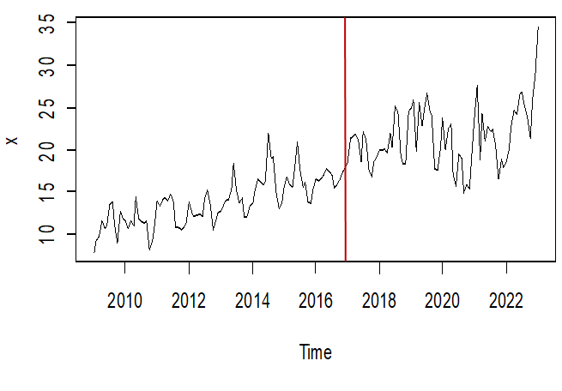 | 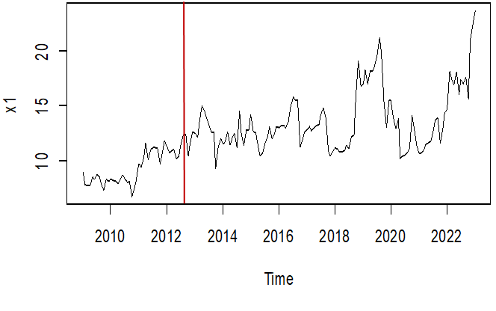
Barshi | Sindhanur
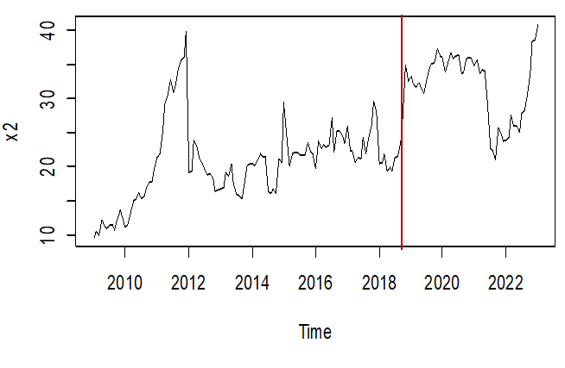 | 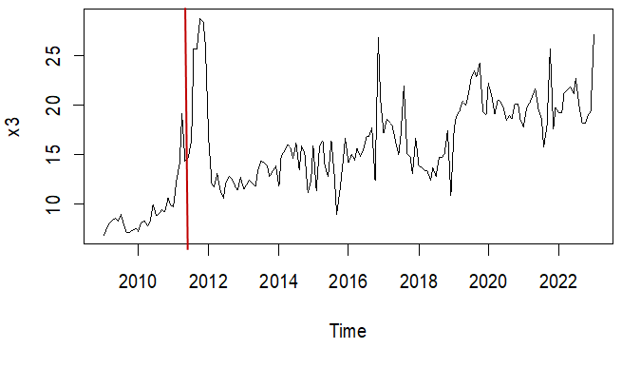
Visnagar
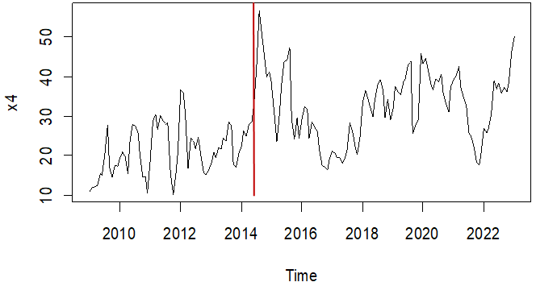

Table 4 presents the Compound Annual Growth Rate (CAGR) of market arrivals (A) and prices (P) of jowar across five major markets for the period 2009–10 to 2022–23, segmented into Period I and Period II. All values were found to be significant at the 5 per cent level. The data revealed a general trend of positive price growth across all markets and months in both periods, with CAGRs typically ranging between 1.02 and 1.13, indicating modest yet consistent increases in jowar prices over time. The highest price growth was observed in markets like Burhanpur and Sindhanur during several months, reflecting localized demand or supply-side pressures. In contrast, market arrivals exhibited greater variability, with several markets such as Barshi and Sindhanur showing declining or stagnant growth in Period I, often with CAGR values well below 1.0, particularly in months like May, July, and August. This may reflect production challenges, shifting cropping patterns, or market disincentives. However, some markets like Kekri and Visnagar showed more stable or improving arrival trends in Period II. The data suggest that while prices have remained steadily upward, arrival trends are mixed, potentially highlighting production volatility, climatic stress, or regional disparities in market access and procurement systems.
From the Table 4, it was observed that high CV and CDVI values were found for arrivals across most markets and periods indicating substantial variability in jowar arrivals. Kekri, Burhanpur, Sindhanur, and Visnagar show particularly high variability. However, in Burhanpur market, the highest CV (136.54 per cent) and CDVI (127.39) values for market arrival in period I, suggests very high variability in market arrivals, which decreases in period II.
Table 4. Summary statistics of market arrival and price of jowar in selected market (2009-10 to 2022-23)
 | PERIOD – I |  |  |  |  |  |  |  |  |  | PERIOD - II
 | Kekri |  | Burhanpur |  | Barshi |  | Sindhanur |  | Visnagar |  | Kekri |  | Burhanpur |  | Barshi |  | Sindhanur |  | Visnagar
 | A | P | A | P | A | P | A | P | A | P | A | P | A | P | A | P | A | P | A | P
Mean | 1221.65 | 13.83 | 322.35 | 9.29 | 426.36 | 20.59 | 632.22 | 8.65 | 372.75 | 21.19 | 3236.68 | 22.90 | 170.98 | 14.40 | 1802.90 | 34.08 | 705.27 | 17.81 | 437.06 | 34.22
SD | 2345.73 | 2.74 | 669.69 | 1.45 | 541.22 | 5.73 | 647.59 | 1.25 | 762.01 | 6.18 | 5214.59 | 5.24 | 302.67 | 3.83 | 1193.65 | 6.98 | 1256.47 | 5.25 | 678.91 | 9.95
Kurtosis | 9.59 | 0.06 | 27.57 | -1.37 | 23.83 | 1.07 | 1.91 | 2.12 | 4.47 | -0.46 | 6.06 | 1.29 | 14.29 | 2.53 | 0.08 | 0.78 | 24.21 | 1.43 | 2.05 | -0.35
Skewness | 2.99 | 0.31 | 4.90 | 0.30 | 4.14 | 0.60 | 1.61 | 1.22 | 2.34 | 0.33 | 2.50 | 1.13 | 3.42 | 1.60 | 0.84 | 0.53 | 4.38 | 1.16 | 1.70 | 0.31
Minimum | 3.90 | 7.92 | 2.00 | 6.77 | 0.20 | 9.67 | 69.00 | 7.02 | 0.20 | 10.41 | 9.90 | 14.95 | 0.10 | 9.36 | 272.00 | 21.08 | 2.00 | 9.00 | 0.10 | 16.53
Maximum | 12085.00 | 21.92 | 4216.00 | 11.86 | 4257.67 | 39.95 | 2386.00 | 12.47 | 2962.10 | 36.66 | 23448.00 | 41.26 | 1968.82 | 29.52 | 5451.00 | 54.23 | 9984.00 | 36.96 | 2749.50 | 58.41
CV | 128.93 | 19.79 | 136.54 | 15.58 | 103.30 | 27.82 | 84.84 | 14.42 | 112.97 | 29.18 | 116.03 | 22.88 | 104.19 | 26.62 | 65.78 | 20.47 | 116.71 | 29.48 | 132.63 | 29.08
CDVI | 128.42 | 13.08 | 127.39 | 9.54 | 100.92 | 25.55 | 75.20 | 9.92 | 112.46 | 27.84 | 102.77 | 18.65 | 99.44 | 21.83 | 59.27 | 19.26 | 116.65 | 23.95 | 129.50 | 27.45
Note: A – Arrival in Quintal, P- Price in Rs. /kg, SD – Standard deviation
Table 5. CAGR of market arrival and price of jowar in selected market (2009-10 to 2022-23)
(at 5per cent significance)
 | PERIOD – I |  |  |  |  |  |  |  |  |  | PERIOD - II
 | Kekri |  | Burhanpur |  | Barshi |  | Sindhanur |  | Visnagar |  | Kekri |  | Burhanpur |  | Barshi |  | Sindhanur |  | Visnagar
 | A | P | A | P | A | P | A | P | A | P | A | P | A | P | A | P | A | P | A | P
January | 1.415 | 1.079 | 0.405 | 1.089 | 0.823 | 1.087 | 1.543 | 1.179 | 0.944 | 1.120 | 0.830 | 1.061 | 0.810 | 1.036 | 1.438 | 1.000 | 1.104 | 1.053 | 1.368 | 1.039
February | 1.512 | 1.081 | 1.456 | 1.114 | 0.951 | 1.075 | 1.318 | 1.289 | 0.882 | 1.126 | 0.626 | 1.058 | 0.878 | 1.036 | 1.196 | 1.015 | 0.958 | 1.068 | 1.215 | 1.058
March | 1.237 | 1.073 | 0.907 | 1.136 | 0.923 | 1.060 | 0.714 | 1.323 | 0.990 | 1.107 | 0.521 | 1.065 | 0.828 | 1.024 | 1.276 | 1.026 | 0.924 | 1.063 | 1.380 | 1.082
April | 1.032 | 1.060 | 0.457 | 1.153 | 0.831 | 1.032 | 0.147 | 0.930 | 1.033 | 1.142 | 0.756 | 1.052 | 0.655 | 1.022 | 1.521 | 1.003 | 0.835 | 1.043 | 1.162 | 1.061
May | 1.062 | 1.063 | 0.614 | 1.078 | 0.946 | 1.039 | 0.173 | 0.957 | 0.890 | 1.076 | 0.719 | 1.049 | 0.956 | 1.031 | 1.347 | 1.019 | 0.869 | 1.060 | 0.957 | 1.034
June | 1.148 | 1.084 | 0.791 | 1.095 | 1.043 | 1.035 | 0.147 | 1.198 | 1.144 | 1.083 | 0.746 | 1.108 | 0.877 | 1.031 | 1.441 | 1.018 | 0.907 | 1.061 | 0.876 | 1.029
July | 1.219 | 1.063 | 0.636 | 1.115 | 0.995 | 1.053 | 0.261 | 0.994 | 1.105 | 1.005 | 0.539 | 1.046 | 0.822 | 1.043 | 1.308 | 1.035 | 0.864 | 1.050 | 0.970 | 1.015
August | 1.201 | 1.049 | 1.174 | 1.154 | 1.006 | 1.041 | 0.213 | 1.163 | 1.683 | 1.002 | 0.594 | 1.037 | 0.832 | 1.035 | 1.408 | 1.027 | 0.847 | 1.034 | 0.911 | 1.000
September | 1.276 | 1.073 | 0.769 | 1.187 | 1.057 | 1.052 | 0.404 | 1.309 | 2.799 | 1.098 | 0.645 | 1.058 | 0.777 | 1.041 | 1.077 | 1.051 | 1.019 | 1.036 | 1.137 | 1.025
October | 1.168 | 1.101 | 0.786 | 1.153 | 1.055 | 1.055 | 0.694 | 1.283 | 2.855 | 1.047 | 0.688 | 1.069 | 0.774 | 1.063 | 1.317 | 1.055 | 0.948 | 1.028 | 1.015 | 1.031
November | 1.388 | 1.059 | 1.204 | 1.142 | 0.900 | 1.057 | 0.298 | 1.423 | 1.178 | 0.996 | 0.595 | 1.088 | 0.686 | 1.053 | 1.231 | 1.056 | 0.896 | 1.039 | 1.105 | 1.027
December | 1.277 | 1.065 | 1.072 | 1.207 | 0.787 | 1.048 | 0.759 | 1.304 | 0.778 | 1.081 | 0.652 | 1.069 | 0.679 | 1.058 | 1.132 | 1.065 | 0.958 | 1.036 | 1.335 | 1.055
Note: A - Arrival, P- Price
Seasonality of arrival and price in the jowar markets
The analysis of monthly seasonal indices for price (Figure 3) highlighted distinct seasonal price variations across different jowar markets in India. The Visnagar market exhibited the highest index in August (120.72), while the lowest was in October (82.95). Notably, the indices across markets peaked during the months leading up to the harvest (primarily January and October) as shown in figure 3, attributed to the scarcity of jowar supply. The highest (508.58) and lowest (2.11) arrival indices were observed in Visnagar market during June and December respectively.
The analysis of average de-seasonalized values for each month indicated that prices of jowar were highest in the Vinagar market and lowest in Burhanpur, influenced by the volume of jowar arriving in the market and its impact on local prices (Table 6). Moreover, the average de-seasonalized prices across months displayed consistency within the respective markets.
The Intra-year Price Rise (IPR) and Average Seasonal Price Variation (ASPV) were most pronounced in the Vinagar market and least in the Burhanpur market (Table 7). The IPR ranged from 12.45 per cent to 45.53 per cent, while the ASPV varied from 11.72 per cent to 37.09 per cent.
Table 6. Average de-seasonalized monthly prices in jowar (2009-10 to 2022-23)
 | Kekri | Burhanpur | Barshi | Sindhanur | Visnagar
January | 18.22 | 13.09 | 25.43 | 16.35 | 29.67
February | 18.31 | 13.11 | 25.32 | 16.47 | 29.60
March | 18.15 | 13.05 | 25.21 | 16.38 | 29.58
April | 18.08 | 12.98 | 25.01 | 16.43 | 29.76
May | 17.91 | 13.14 | 25.08 | 16.41 | 29.05
June | 18.22 | 13.15 | 25.14 | 16.40 | 29.28
July | 18.05 | 13.21 | 25.38 | 16.43 | 29.39
August | 17.99 | 13.20 | 25.39 | 16.58 | 29.25
September | 17.90 | 13.27 | 25.51 | 16.64 | 29.89
October | 18.20 | 13.35 | 25.42 | 16.43 | 30.44
November | 18.16 | 13.18 | 25.38 | 16.64 | 30.05
December | 18.23 | 13.34 | 25.42 | 16.69 | 30.36
Table 7. IPR & ASPV in seasonal price index of jowar
Market | IPR (per cent) | ASPV (per cent)
Kekri | 31.10 | 26.92
Burhanpur | 12.45 | 11.72
Barshi | 18.91 | 17.28
Sindhanur | 13.68 | 12.81
Visnagar | 45.53 | 37.09
Figure 2. Seasonal indices of market arrival of jowar in selected markets
Figure 3. Seasonal indices of market price of jowar in selected markets
Empirical Analysis of Market Integration in Selected Jowar Markets
Stationarity Check
As presented in Table 8, the ADF test statistics at level for all five markets were found to be non-significant at both the 5 per cent and 1 per cent levels. This confirms the presence of unit roots and indicates that the series are non-stationary in levels. However, upon first differencing, the ADF test statistics became significant for all markets, thereby establishing that the series are stationary at the first difference and integrated of order one, I(1). These results confirm that the data meet the precondition for applying Johansen’s co-integration method to assess long-run relationships among the selected jowar markets.
Table 8. ADF Test for Unit Root in the Prices of jowar
Market center | Level | First-difference
Kekri | -2.181 | -7.0187**
Burhanpur | -1.2051 | -6.1992**
Barshi | -2.5977 | -5.696**
Sindhanur | -2.9043 | -6.294**
Visnagar | -2.6916 | -7.2378**
N.B. * for 10 per cent, ** for 5 per cent and *** for 1 per cent level of significance.
Johansen co-integration
To assess the presence of long-run equilibrium relationships among the selected jowar markets, the Johansen Co-integration Test was applied. The test results, summarised in Table 9, are based on both the trace statistic and the maximum eigen value statistic. The trace test rejected the null hypothesis of no co-integration (r = 0) and continued to reject successive null hypotheses up to r ≤ 4 at the 5 per cent level of significance. The maximum eigenvalue test corroborated these findings by identifying significant co-integrating vectors across the market pairs. These results provided strong statistical evidence that the jowar markets under study were co-integrated, implying that prices in these geographically dispersed markets are linked by a stable long-term relationship. Despite potential short-run fluctuations, these markets tend to adjust toward a common equilibrium over time. This long-run co-movement supported the notion of spatial price efficiency and effective transmission of price signals within the Indian jowar market network.
Table 9. Co-integration Results for Inter-State Spatial Integration of jowar Markets (at 5 per cent level of significance)
Eigen  Value (λi) | Trace test |  |  | Maximum eigen value test
Eigen  Value (λi) | Null | Test value | λ-trace | Null | Test value | λ-max
0.50 | r=0 | 516.56 | 76.07** | r=0 | 152.36 | 34.40**
0.41 | r <=1 | 364.19 | 53.12** | r <=1 | 125.32 | 28.14**
0.37 | r <=2 | 238.87 | 34.91** | r <=2 | 87.60 | 22.00**
0.30 | r <=3 | 151.27 | 19.96** | r <=3 | 80.51 | 15.67**
0.28 | r <=4 | 70.77 | 9.24** | r <=4 | 70.77 | 9.24**
N.B. * for 10 per cent, ** for 5 per cent and *** for 1 per cent level of significance. k= Optimal lag selected by the AIC. k=2 for the pre- and post-reform periods. The estimated VAR includes a constant and a trend. The market centres considered are: Kekri, Burhanpur, Barshi, Sindhanur and Visnagar.
Granger Causality Test
To explore the short-run dynamic relationships among jowar markets, the Granger Causality Test was conducted using pairwise market comparisons. The test results, presented in Table 10, reveal limited but meaningful causality among the selected jowar markets. Barshi was found to Granger-cause Sindhanur at the 1 per cent level of significance, indicating a unidirectional influence wherein price changes in Barshi have predictive power over Sindhanur. However, Barshi did not exhibit statistically significant causality with the other markets in the study.
Kekri demonstrated unidirectional causality toward both Sindhanur and Visnagar, suggesting that price information originating from Kekri contributes to short-term price formation in these markets. On the other hand, Burhanpur, Sindhanur, and Visnagar did not exhibit statistically significant causal influence over any of the other markets. This lack of outgoing causality may suggest that these markets’ function more as price receivers rather than price leaders within the inter-market network.
Table 10. Granger Causality Test Results for major jowar Markets of India
Markets Pairs | F-Statistic | p-value | Decision of null hypothesis | Remarks
Kekri – Burhanpur | 1.616 | 0.2017 | Reject | No causality
Burhanpur - Kekri | 0.5852 | 0.5581 | Reject | No causality
Kekri -Barshi | 0.4657 | 0.6285 | Reject | No causality
Barshi – Kekri | 2.3261 | 0.1007 | Reject | No causality
Kekri – Sindhanur | 4.1854* | 0.01679* | Do not reject | Unidirectional
Sindhanur – Kekri | 0.2332 | 0.7922 | Reject | No causality
Kekri – Visnagar | 3.641** | 0.028** | Do not reject | Unidirectional
Visnagar - Kekri | 0.0848 | 0.9187 | Reject | No causality
Burhanpur – Barshi | 0.5891 | 0.5559 | Reject | No causality
Barshi – Burhanpur | 0.0024 | 0.9976 | Reject | No causality
Burhanpur – Sindhanur | 0.7558 | 0.4712 | Reject | No causality
Sindhanur – Burhanpur | 0.5243 | 0.5929 | Reject | No causality
Burhanpur – Visnagar | 0.0136 | 0.9865 | Reject | No causality
Visnagar – Burhanpur | 0.0944 | 0.91 | Reject | No causality
Barshi - Sindhanur | 5.1381*** | 0.006*** | Do not reject | Unidirectional
Sindhanur – Barshi | 0.0345 | 0.9661 | Reject | No causality
Barshi – Visnagar | 0.527 | 0.5913 | Reject | No causality
Visnagar – Barshi | 0.0858 | 0.9178 | Reject | No causality
Sindhanur - Visnagar | 0.7692 | 0.465 | Reject | No causality
Visnagar - Sindhanur | 1.2952 | 0.2765 | Reject | No causality
N.B. * for 10 per cent, ** for 5 per cent and *** for 1 per cent level of significance

Estimate the speed of adjustment of price for equilibrium and analyse the impulse response function.
The Vector Error Correction Model (VECM) was applied to examine both the long-run equilibrium restoration and short-run interactions among five major jowar markets. The estimated error correction terms (ECTs) indicated that four of the five markets exhibit statistically significant long-run adjustment. Kekri showed the strongest adjustment Kekri speed 134.1 per cent, followed by Barshi (57.87 per cent). These values suggest that deviations from the long-run price equilibrium are corrected at varying speeds across markets, with Kekri responding most promptly to disequilibria (Table 11).
Short-run dynamics revealed rich inter-market price linkages. In Kekri, prices were negatively influenced by one-period lagged prices from Burhanpur, Sindhanur, and Visnagar, with respective speeds of adjustment at 31.79 per cent, 39.38 per cent, and 25.89 per cent. Barshi, on the other hand, exerted a strong positive effect on Kekri, with one- and two-period lagged effects of 46.60 per cent and 19.05 per cent. Kekri also continues to be affected negatively by Sindhanur and Visnagar at the two-period lag, with adjustments of 22.01 per cent and 14.59 per cent, respectively. These results suggested that Kekri was strongly influenced by price movements in both southern and western markets, with a mix of reinforcing and offsetting effects over time (Table 11).
Burhanpur’s pricing was dominated by its own lagged values. The first lag of Burhanpur had a negative impact of 64.62 per cent, while the second lag added a further 25.56 per cent decline. Additionally, prices in Burhanpur responded negatively to the second lag of Kekri, with an effect size of 21.61 per cent, suggesting a delayed influence from the northern market. Overall, Burhanpur behaved largely as an autoregressive system with modest external sensitivity (Table 11).
Barshi responded negatively to its own past prices at both the first (65.81 per cent) and second (32.45 per cent) lags but also shows meaningful responses to external price signals. The market was negatively influenced by Burhanpur (6.89 per cent) and Sindhanur (14.43 per cent) at the first lag, while showing strong positive reactions to Kekri at both the first (40.56 per cent) and second (19.30 per cent) lags. This highlighted Barshi’s position as a semi-integrated market that balances strong internal correction with meaningful inter-market dependencies (Table 11).
Sindhanur exhibited a complex network of short-run influences. Its current prices were negatively affected by its own lag (50.31 per cent) as well as by Kekri (49.10 per cent) and Barshi (27.17 per cent). In contrast, Burhanpur and Visnagar exerted positive influences, with adjustment magnitudes of 34.67 per cent and 21.77 per cent, respectively. In the second lag, Sindhanur was further affected negatively by its own price and by Kekri. These relationships suggested that Sindhanur was highly sensitive to both local and external price conditions and may serve as a key node in southern price transmission (Table 11).
Visnagar displayed a strong internal correction, with its own first and second lags contributing to current price reductions of 41.12 per cent and 21.06 per cent, respectively. In addition, Visnagar’s prices were negatively influenced by Kekri (57.73 per cent) and Barshi (25.84 per cent), while positively affected by Sindhanur (23.24 per cent). These results confirmed Visnagar’s strong long-run responsiveness and suggest that it integrates signals from both the central and southern zones of the jowar network (Table 11).
Table 11. VECM coefficient value of jowar Market Integration
 | Kekri | Burhanpur | Barshi | Sindhanur | Visnagar
ECT | -1.3415  (0.173)*** | 0.2041  (0.1619) | -0.5787  (0.1761)** | 1.5507  (0.2488)*** | 0.9673  (0.2628)***
D(Kekri)-1 | 0.1804  (0.1413) | -0.2072  (0.1320) | 0.4056  (0.1435)** | -0.9454  (0.2029)*** | -0.5773  (0.2142)**
D(Burhanpur)-1 | -0.3179  (0.092)*** | -0.6462  (0.0863)*** | -0.0689  (0.0939) | 0.3467  (0.1327)** | 0.1712  (0.1402)
D(Barshi)-1 | 0.4660  (0.0791)*** | -0.0593  (0.0739) | -0.6581  (0.0803)*** | -0.2717  (0.1135)* | -0.2584  (0.1199)*
D(Sindhanur)-1 | -0.3938  (0.058)*** | 0.0669  (0.0541) | -0.1443  (0.0589)* | -0.5031  (0.0832)*** | 0.2324  (0.0879)**
D(Visnagar)-1 | -0.2589  (0.056)*** | 0.0279  (0.0523) | -0.0956  (0.0569). | 0.2177  (0.0804)** | -0.4112  (0.0850)***
D(Kekri)-2 | 0.0835  (0.0889) | -0.2161  (0.0831)* | 0.1930  (0.0903)* | -0.4910  (0.1277)*** | -0.1882  (0.1348)
D(Burhanpur)-2 | -0.1552  (0.0884). | -0.2556  (0.0826)** | -0.0607  (0.0898) | 0.2297  (0.1269). | 0.1748  (0.1340)
D(Barshi)-2 | 0.1905  (0.0742)* | -0.0185  (0.0693) | -0.3245  (0.0754)*** | 0.0598  (0.1065) | -0.3618  (0.1125)**
D(Sindhanur)-2 | -0.2201  (0.048)*** | -0.0077  (0.0457) | -0.0591  (0.0497) | -0.3543  (0.0702)*** | 0.0319  (0.0742)
D(Visnagar)-2 | -0.1459  (0.0489)** | 0.0352  (0.0457) | -0.0863  (0.0497). | 0.0959  (0.0702) | -0.2106  (0.0742)**
Notes: ECT=Error Correction Term; D= first difference operator; [ ] t-statistic
*** Significant at level 1 per cent, ** Significant at level 5 per cent; * significant at level 10 per cent
To assess the dynamic and directional influence of inter-market price shocks among the selected jowar markets, Impulse Response Function (IRF) analysis was undertaken. This technique traces the impact of a one-standard-deviation shock in the price of one market on other related markets over time, revealing both the magnitude and persistence of price transmission and helping to evaluate the strength of spatial integration.
A price shock originating in the Kekri market generates varied responses across the other markets. In Burhanpur, the response remained relatively stable with minimal fluctuations throughout the time horizon. The confidence interval suggested that the impact is not statistically strong. In contrast, Barshi showed a gradually rising response, indicative of a long-run positive effect of Kekri’s price movements. The widerg confidence interval over time reflected increasing uncertainty in the persistence of this effect. Sindhanur initially experienced a sharp increase in response, followed by a stabilization phase, implying a significant but time-limited adjustment. The confidence interval remained within a reasonable range, supporting the statistical reliability of the effect. Visnagar showed a consistent and gradually increasing positive response, with the upper confidence bound suggesting that Kekri’s price shock transmits more strongly to Visnagar than to the other markets. Overall, Barshi, Sindhanur, and Visnagar exhibited stronger price transmission from Kekri, while Burhanpur appears relatively insulated (Figure 4).
Figure 4. Response graph of Burhanpur, Barshi, Sindhanur and Visnagar market to one standard deviation shock in Kekri market on jowar
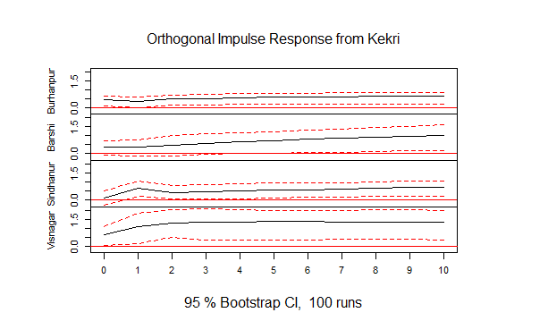
Following a price shock in the Burhanpur market, both Kekri and Sindhanur displayed positive but differently paced responses. Kekri responded quickly with an upward trend that stabilizes within a few periods. The narrow confidence interval showed a stable and statistically significant relationship. Sindhanur also reacted positively, but its adjustment was more gradual and modest. Over time, the response strengthens and stabilizes, suggesting that Sindhanur does respond to Burhanpur’s price signals, albeit with a slight lag. Together, the results suggested strong price transmission to both markets, with Kekri adjusting more promptly and Sindhanur exhibiting delayed responsiveness (Figure 5).
Figure 5. Response graph of Kekri and Sindhnur market to one standard deviation shock in Burhanpur market on jowar
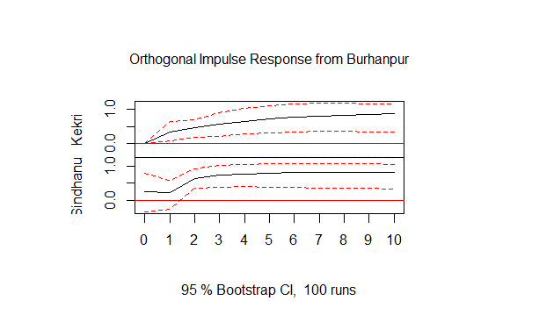
In response to a shock in Barshi, Kekri displayed a mild and short-lived reaction. The response started from zero and rises only slightly before stabilizing, suggesting limited influence from Barshi. The confidence interval remained tight, reinforcing the weak and statistically insignificant transmission. Sindhanur reflected a small initial positive movement, but the response flattens quickly and slightly declines thereafter. The wider confidence interval here suggested more variability in the effect. Visnagar’s response began slightly negatively and then trended upward steadily, eventually reaching a modest positive value. The confidence interval remained stable, suggesting a consistent if delayed transmission effect. These patterns indicated that Barshi’s influence on Kekri and Sindhanur was weak, while Visnagar experienced a more gradual and long-term impact (Figure 6).
Figure 6. Response graph of Kekri, Sindhanur and Visnagar market to one standard deviation shock in Barshi market on jowar
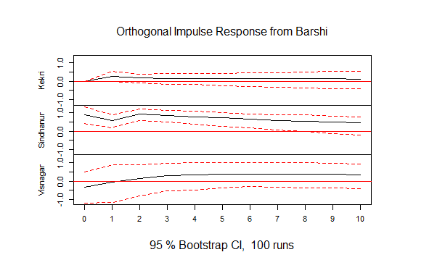
A shock from Sindhanur resulted in limited transmission to other markets. Kekri’s response remained close to zero with little variation. The narrow confidence interval reinforced the interpretation of weak or statistically insignificant influence. In Burhanpur, the response was almost flat, indicating that price changes in Sindhanur had negligible effect on this market. Barshi exhibited a small initial increase in response, which quickly levels off. Although this suggested some sensitivity to Sindhanur’s price movements, the overall magnitude of the response was low. Visnagar initially showed a minor negative response, which remained close to zero throughout the time horizon. A wider confidence band for Visnagar reflected greater uncertainty in the transmission. Collectively, the results showed that Sindhanur had weak linkages with Kekri, Burhanpur, and Visnagar, and only a marginal connection with Barshi (Figure 7).
Figure 7. Response graph of Kekri, Burhanpur, Barshi and Visnagar market to one standard deviation shock in Sindhanur market on jowar
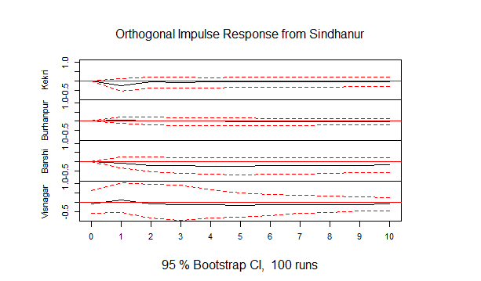
When Visnagar experienced a price shock, Kekri reacted strongly and positively. There was a sharp increase in response in the initial periods, which then stabilized at a positive level. The narrow confidence interval confirmed that the transmission is both consistent and statistically significant. This suggested a high degree of integration between Visnagar and Kekri. Sindhanur, in contrast, showed an initial negative response, reaching its lowest point around the first period. Over time, the response gradually eventually turned positive. The wider confidence interval for Sindhanur indicated greater uncertainty and weaker price transmission. These results suggested that Visnagar’s influence was strong and immediate in the Kekri market but weaker and delayed in Sindhanur (Figure 8).

Figure 8. Response graph of Kekri and Sindhanur market to one standard deviation shock in Visnagar market on jowar
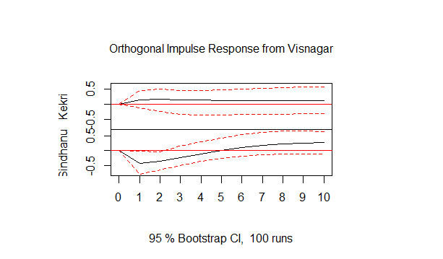
Overall, the IRF analysis confirmed asymmetric and market-specific patterns of price transmission across jowar markets. Kekri consistently emerged as both a source and recipient of statistically meaningful price shocks, especially in its relationships with Visnagar and Burhanpur. Barshi and Sindhanur demonstrate limited outward influence but respond modestly to shocks from key nodes. Visnagar proved to be an influential transmitter, particularly to Kekri, while Burhanpur was more self-contained. These insights highlighted the need for targeted policy and infrastructural interventions to enhance spatial price efficiency and improve market integration in the jowar supply chain.
Conclusion
The Johansen co-integration results established a strong long-run equilibrium relationship among the five markets, suggesting that prices in different regions tend to move together over time. However, short-run relationships were weaker and asymmetric, as shown by limited Granger causality between market pairs. Markets such as Kekri and Visnagar played leading roles in transmitting price information to others, while Burhanpur appeared relatively isolated from the overall network. The VECM results indicated differing speeds of adjustment toward long-run equilibrium, with Visnagar responding fastest to price deviations, followed by Barshi, whereas Sindhanur and Kekri adjusted more slowly. Impulse response analysis further confirmed that the impact of price shocks in one market gradually spread to others, although with varying intensity and duration.
Overall, the study confirms that India’s jowar markets are integrated in the long run but experience short-run inefficiencies due to infrastructural limitations, information gaps, and regional market heterogeneity. Strengthening transport and storage facilities, improving access to real-time market information through digital platforms like e-NAM, and enhancing inter-state trade linkages would promote faster and more uniform price transmission. Developing processing industries and promoting jowar-based value chains in major producing states such as Maharashtra, Karnataka, and Rajasthan can also help reduce market volatility and create stable demand. In addition, region-specific policies aimed at improving climate resilience and supporting market connectivity will be crucial for stabilizing prices, ensuring fair returns to farmers, and strengthening the overall efficiency of India’s coarse cereal economy.
Reference
Bai, J., & Perron, P. (2003). Computation and analysis of multiple structural change models. Journal of Applied Econometrics, 18(1), 1–22. https://doi.org/10.1002/jae.659
Department of Agriculture and Farmers Welfare. (2024). Agricultural Statistics at a Glance, 2023. DAFW, Ministry of Agriculture and Farmers Welfare, Government of India. https://agriwelfare.gov.in/
Dickey, D. A., & Fuller, W. A. (1979). Distribution of the estimators for autoregressive time series with a unit root. Journal of the American Statistical Association, 74(366), 427-431. https://doi.org/10.1080/01621459.1979.10482531
Engle, R. F., & Granger, C. W. J. (1987). Co-Integration and Error Correction: Representation, Estimation, and Testing. *Econometrica*, *55*(2), 251–276. https://doi.org/10.2307/1913236
Granger, C. W. J. (1969). Investigating Causal Relations by Econometric Models and Cross-spectral Methods. Econometrica, 37(3), 424-438. https://doi.org/10.2307/1912791
Johansen, S., & Juselius, K. (1990). Maximum likelihood estimation and inference on cointegration—With applications to the demand for money. Oxford Bulletin of Economics and Statistics, 52(2), 169–210. https://doi.org/10.1111/j.1468-0084.1990.mp52002003.x
Kumar, P., & Sonnad, J. (2023). Study on the market integration between the major markets of pearl millet in Karnataka. International Journal of Statistics and Applied Mathematics. https://doi.org/10.22271/maths.2023.v8.i6Si.1448
Kumare, S. T., Perke, D. S., & Rede, G. D. (2022). Economic Analysis of Arrivals and Prices of Paddy in Gadchiroli District of Maharashtra. Agro Economist - An International Journal, 9(02), 161-165. https://doi.org/10.30954/2394-8159.02.2022.10
Paul, R. K., & Karak, T. (2022). Asymmetric Price Transmission: A Case of Wheat in India. Agriculture, 12(3), 410. https://doi.org/10.3390/agriculture12030410
Sendhil, R., Arti, T., Lal, P., Gururaj, B. M., Jamaludheen, A., Chaudhary, U., & Rathore, R. (2019). Price Dynamics and Extent of Integration in Indian Wholesale and Retail Wheat Markets. J. Agr. Sci. Tech. 21(3): 517-530.
Zalkuwi, J. W., & Joshua, T. (2024). Analysis of integration in the wholesale maize and rice markets in Northeast, Nigeria. Dutse Journal of Pure and Applied Sciences. https://doi.org/10.4314/dujopas.v10i3b.23

