Effect of Arbuscular Mycorrhizal Fungi and Phosphate Solubilizing Bacteria on Growth and Yield of Soybean

.
ABSTRACT

Soybean (Glycine max L.) is a vital legume crop with significant nutritional and economic value. Sustainable nutrient management is essential to enhance its productivity while maintaining soil health. A field experiment titled “Effect of Arbuscular Mycorrhizal Fungi and Phosphate Solubilizing Bacteria on Growth and Yield of Soybean” was conducted during Kharif 2024–25 at Shri Vaishnav Institute of Agriculture, Indore (M.P.), using a Randomized Block Design with ten treatments and three replications. Treatments involved various combinations of 50% and 100% recommended dose of fertilizers (RDF), phosphate solubilizing bacteria (PSB), arbuscular mycorrhizal fungi (AMF), and farmyard manure (FYM). Among all treatments, T10 (50% RDF + PSB + AMF + FYM) showed significant improvement in plant height, dry matter, number of leaves and branches, resulting in the highest grain (12.99 q ha⁻¹) and straw yield (20.23 q ha⁻¹). T10 was statistically at par with T9 (50% RDF + AMF + FYM) and T2 (100% RDF). Soil pH and EC remained largely unaffected, but organic carbon (0.53%) and available N and P increased under integrated treatments. Thus, integrated use of AMF, PSB, FYM with 50% RDF (T10) emerges as a sustainable option, enhancing crop performance and soil health while reducing chemical fertilizer dependency.

Keywords: AMF, PSB, FYM, integrated nutrient management, soybean, sustainability

1. INTRODUCTION

Soybean (Glycine max L.) is a vital oilseed crop in India, known for its high protein (40-42%) and oil (20-22%) content. India ranks fifth globally in soybean production and third among its oilseed crops, contributing 3% to world production. Over the last three decades, soybean yield has improved due to genetic and management advances. Besides its industrial importance and potential as an alternative to rice, soybean is often called the “poor man’s meat” because of its rich protein, playing a crucial role in vegetarian diets (Suryawanshi et al., 2006).
Despite its significance, soybean productivity is challenged by nutrient depletion in soils (Sikka et al., 2016). Heavy use of chemical fertilizers has led to soil fertility decline and environmental issues (Bisht et al., 2021). Soybean’s high demand for nitrogen and phosphorus results in stagnant or declining yields, even with liberal fertilizer application. This has increased interest in biological approaches like bio-fertilizers to sustain soil fertility, especially given the rising costs and limited supply of chemical fertilizers. An integrated nutrient management approach combining chemical fertilizers and bio-fertilizers offers an eco-friendly and sustainable solution.
Bio-fertilizers, such as phosphorus solubilizing bacteria (PSB), arbuscular mycorrhizal fungi (AMF), and azotobacter, enhance soil fertility by improving nutrient availability and crop yield (Ravikumar et al., 2012). These microbes fix atmospheric nitrogen and solubilize otherwise unavailable nutrients like phosphorus (Geetha et al., 2017). Studies show microbial inoculants can meet 20–25% of plants’ phosphorus needs (Sandhya et al., 2013). PSB species such as Bacillus megaterium and Pseudomonas striata solubilize phosphate by secreting organic acids, making phosphorus available for plants. Since natural phosphorus-solubilizing microbes are scarce in soil, inoculation is necessary to improve nutrient uptake and yield (Perez et al., 2007).
AMF also play a critical role in nutrient uptake, especially phosphorus and micronutrients, by extending the root system’s absorption area through fungal hyphae (Jayashree and Umesha, 2021). They enhance nutrient uptake, improve tolerance to stresses, and increase crop yield and quality (Hijri, 2016). AMF form symbiotic associations with many crops, including soybean, benefiting nutrient acquisition and soil health (Hodge and Storer, 2015).
Organic manures like farmyard manure (FYM) improve soil physical, chemical, and biological properties and nutrient availability. FYM combined with chemical fertilizers like urea can reduce nitrogen loss and improve nitrogen use efficiency. However, limited information exists on the combined effects of organic, inorganic, and bio-fertilizers on soybean growth and yield. Keeping in this view this study aims to evaluate the effect of arbuscular mycorrhizal fungi and phosphate solubilizing bacteria on the growth, yield, and soil chemical properties of soybean (Glycine max L.).

2. material and methods

The present experiment entitled “Effect of arbuscular mycorrhizal fungi and phosphate solubilizing bacteria on growth and yield of soybean” was conducted during Kharif 2024 at the experimental farm of SVIAg, SVVV, Indore. The soil was medium black clay with clayey loam texture, belonging to the Vertisol order. Initial soil analysis showed pH 7.31 (Piper, 1950), electrical conductivity (EC) 0.70 dS m⁻¹ (Piper, 1950), organic carbon 0.50% (Walkley and Black, 1934), available nitrogen 230 kg ha⁻¹ (Subbiah and Asija, 1956), available phosphorus 13.10 kg ha⁻¹ (Watanabe and Olsen, 1965), and available potassium 367 kg ha⁻¹ (Jackson, 1973).
The experiment was laid out in a randomized block design (RBD) with 10 treatments and three replications, resulting in 30 plots. The treatments included: T1- Absolute control, T2-100% RDF, T3-50% RDF, T4- 50% RDF + PSB, T5- 50% RDF + AMF, T6- 50% RDF + FYM, T7- 50% RDF + PSB + AMF, T8- 50% RDF + PSB + FYM, T9- 50% RDF + AMF + FYM, T10- 50% RDF + PSB + AMF + FYM
Soybean variety JS 9560 was sown on 3rd July 2024 at a spacing of 30 cm × 10 cm with a seed rate of 75 kg ha⁻¹. The gross plot size was 3.60 m × 4.50 m, and the net plot size was 3.00 m × 4.30 m. The recommended dose of fertilizer was applied in split doses, with half the nitrogen and the full phosphorus and potassium at sowing, and the remaining half nitrogen at 30 days after sowing (DAS) in the 100% RDF treatment. Organic manures, FYM, was applied 15 days before sowing on a dry weight basis after nutrient analysis, which showed nutrient contents as follows: FYM (N 0.52%, P 0.25%, K 0.50%).
Seeds were treated with Rhizobium japonicum, PSB and Mycorrhiza before sowing to promote nodulation and phosphorus availability. Growth parameters including plant height, dry matter per plant, number of leaves and branches per plant were recorded at 30, 45, 60, and 75 DAS and at harvest, with measurements taken from five randomly selected plants per plot. Root nodules were counted on two randomly selected flowering plants per plot after careful washing of roots.
Yield attributes such as number of pods per plant, pod yield per plant, seed yield per plant, and 1000-seed weight were recorded at harvest. Seed yield and straw yield per hectare were computed from the net plot data, and biological yield was calculated as the sum of seed and straw yields.
Economic analysis was performed by estimating the total cost of cultivation including all inputs and labour charges. Gross monetary returns were calculated based on the prevailing market price of soybean seeds, and net returns were obtained by subtracting the cost of cultivation from gross returns. The benefit-cost (B:C) ratio was computed by dividing the gross returns by the cost of cultivation.

3. results and discussion

3.1 Plant Height
Effect of different sources of nutrients available on growth parameters is presented in fig 1 A. At 30 DAS and at harvest, plant height differences among treatments were not statistically significant. At 45, 60, 75 DAS plant height showed significant variation. T2 (100% RDF) exhibited a 39.1%, 43.3%, 29.1% increase, while T10 (50% RDF + PSB + AMF + FYM) showed a 37.7%, 34.7% and 27.8% increase, respectively over control. Both treatments were statistically superior to the control and other treatments. The increase in plant height with 50% RDF + PSB + AMF + FYM is due to FYM enhancing nutrient supply via mineralization, AMF extending root absorption through hyphae networks, and PSB improving soil phosphorus availability by solubilizing insoluble phosphates. Organic fertilization further promotes AMF growth, collectively supporting better growth and biomass accumulation (Abdurrahman et al., 2023, Akbar et al., 2023 and Yilmaz et al., 2025).

3.2 Dry Matter Accumulation
Effect of different sources of nutrients available on growth parameters is presented in fig 1 B. At 30 DAS, dry matter accumulation showed non-significant variation among treatments. At 45, 60, 75 DAS and at harvest, dry matter accumulation varied significantly. T2 (100%) showed a 50%, 52.8%, 76.6% and 72.7% increase, while T10 (50% RDF + PSB + AMF + FYM) demonstrated a comparable 49%, 51.7%, 76.1% and 72% increase, over control. Both treatments significantly outperformed the control and the other treatments. The effectiveness of T10 is due to continuous, balanced phosphorus from mineral and biological sources, enhancing carbohydrate metabolism, starch and cellulose synthesis, and dry matter accumulation. Phosphorus, as part of ATP, boosts photosynthesis, vegetative growth, and assimilate distribution (Igiehon et al., 2020, Jayshree & Umesha, 2021).

3.3 Number of Leaves Plant⁻¹
Effect of different sources of nutrients available on growth parameters is presented on fig 1 C. At 30 DAS and at harvest, the number of leaves per plant showed no significant difference among treatments. At 45, 60, 75 DAS application of T2 (100% RDF) recorded the highest average leaf count 33.6%, 34.1%, 37.4% followed closely by T10 (50% RDF + PSB + AMF + FYM) with 32.3%, 33.6% and 36.3% leaves, while control had the lowest at 12.06 leaves, indicating limited growth without nutrient supplementation. FYM gradually supplies nutrients through mineralization, enhances nutrient uptake via humic substances, and stimulates AMF colonization, improving nutrient absorption. Both FYM and AMF also enhance soil structure, promoting root growth. Increased N from FYM boosts protein synthesis in chloroplasts, leading to leaf expansion and new leaf production.

3.4 Number of Branches Plant⁻¹
At 45, 60, 75 DAS and at harvest T2 (100% RDF) showed an 80.6%, 110.7%, 89.3% and 87.2% increase over control, while T10 (50% RDF + PSB + AMF + FYM) had a 79.7%, 110.3%, 89.1% and 86.3% increase. Higher branch numbers from 50% RDF + PSB + AMF + FYM treatments are attributed to improved P nutrition, enhanced root development, and better N and P availability, which increased photosynthate production and branch growth (Mulambula et al., 2019, Jayshree & Umesha, 2021).

Treatment | A | B | C | D etc…
Mean
P value
LSD0.05
CV%

FIG 1. Effect of different nutrient sources on growth parameters of soybean Line graphs are not the best to present these results, l suggest you use bar graphs or put everything in one Table.
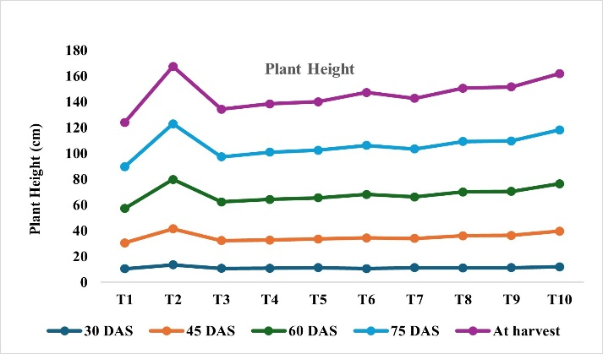 | 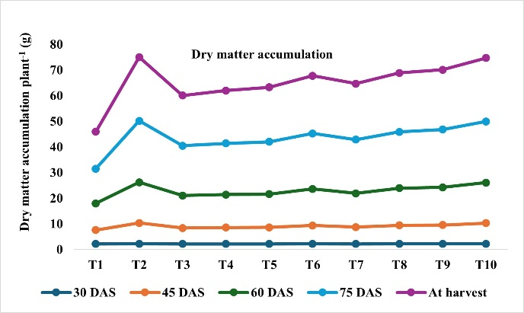
Fig. 1A | Fig. 1B
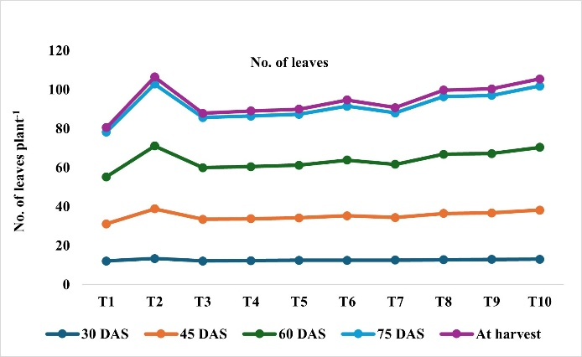 | 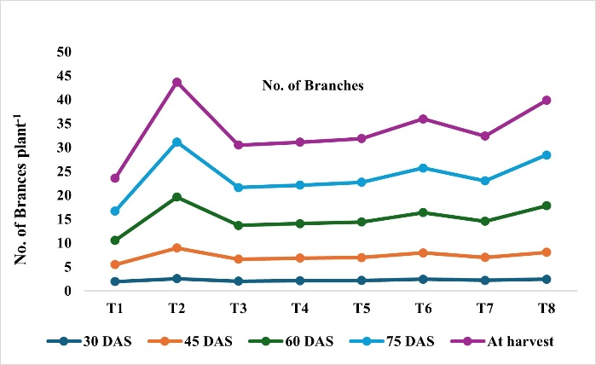
Fig. 1C | Fig. 1D
T1- Absolute control, T2-100% RDF, T3-50% RDF, T4- 50% RDF + PSB, T5- 50% RDF + AMF, T6- 50% RDF + FYM, T7- 50% RDF + PSB + AMF, T8- 50% RDF + PSB + FYM, T9- 50% RDF + AMF + FYM, T10- 50% RDF + PSB + AMF + FYM

3.5 Yield
The yield data revealed substantial improvements in both grain and straw production under different nutrient management practices (Table 1). For grain yield, treatment T₂ (100% RDF) recorded the highest numerical value followed closely by T₁₀ (50% RDF + PSB + AMF + FYM) and both treatments were statistically at par but significantly higher than the control (6.94 q ha⁻¹), representing 87.2% and 83.9% increases, respectively. Similarly, straw yield was markedly enhanced under these treatments, with T₂ yielding 20.23 q ha⁻¹ and T₁₀ producing 18.74 q ha⁻¹, again both at par with each other and superior to the control (assumed 12.00 q ha⁻¹), corresponding to 68.6% and 56.2% increases, respectively. These results clearly demonstrate that integrated and balanced nutrient management not only boosts reproductive yield but also promotes vegetative growth and biomass accumulation, thereby improving overall crop productivity. Higher phosphorus in FYM + AMF treatments is due to FYM-driven solubilization and AMF hyphae enhancing nutrient uptake, extending beyond root zones, and improving P and other immobile nutrient availability compared to FYM alone (Tagore et al., 2013 and Yassen et al., 2017).

3.5 Economics
Economic analysis showed significant variation among treatments (Table 1). T₂ (100% RDF) gave the highest gross return (₹64,950 ha⁻¹) and B:C ratio (2.32), but at a higher cultivation cost (₹37,019 ha⁻¹). T₁₀ (50% RDF + PSB + AMF + FYM) closely followed in gross return (₹63,800 ha⁻¹) with a moderate cost (₹29,372 ha⁻¹), high net return (₹34,428 ha⁻¹), and B:C ratio of 1.85, offering a sustainable and profitable alternative that maintains soil health while ensuring good yield. Control had the lowest returns and profitability.

Table 1. Effect of combination of different sources of nutrients on yield and economics of soybean

Treatments | Grain yield  (q ha⁻¹) | Straw yield  (q ha⁻¹) | Gross monetary returns  (₹ ha⁻¹) | Cost of cultivation  (₹ ha⁻¹) | Net monetary returns  (₹ ha⁻¹) | B:C Ratio
T1 | 6.94 | 10.67 | 21,300 | 13,400 | 34,700 | 1.62
T2 | 12.99 | 20.23 | 27,931 | 37019 | 64,950 | 2.32
T3 | 7.83 | 12.00 | 23,978 | 15172 | 39,150 | 1.63
T4 | 8.09 | 13.58 | 23,978 | 16472 | 40,450 | 1.68
T5 | 8.35 | 13.98 | 25,703 | 16047 | 41,750 | 1.62
T6 | 10.08 | 15.73 | 35,703 | 14697 | 50,400 | 1.41
T7 | 9.07 | 14.23 | 25,253 | 20097 | 45,350 | 1.79
T8 | 11.09 | 16.04 | 34,428 | 21022 | 55,450 | 1.61
T9 | 11.30 | 16.18 | 33,978 | 22522 | 56,500 | 1.66
T10 | 12.76 | 18.74 | 34,428 | 29372 | 63,800 | 1.85
S. Em ± | 0.45 | 0.83
CD at 5% | 1.33 | 2.46
T1- Absolute control, T2-100% RDF, T3-50% RDF, T4- 50% RDF + PSB, T5- 50% RDF + AMF, T6- 50% RDF + FYM, T7- 50% RDF + PSB + AMF, T8- 50% RDF + PSB + FYM, T9- 50% RDF + AMF + FYM, T10- 50% RDF + PSB + AMF + FYM
3.6 Soil Chemical Properties
Data presented in table 2 showed the effect of combination of different nutrients sources on soil chemical properties. Soil pH ranged from 7.29 to 7.31 (neutral). Lowest pH occurred with organic manure due to acid release during decomposition. EC ranged 0.68–0.72 dS m⁻¹. Highest EC was in T₁₀ (50% RDF + PSB + AMF + FYM) treatments without organics had lower EC. EC slightly increased in PSB, FYM, AMF, and 50% RDF treatments due to enhanced nutrient mineralization and release of soluble salts. OC varied 0.51–0.53%. Highest OC (0.53%) was in treatments with organic amendments (T₆, T₈, T₉, T₁₀); control and treatments without organics had 0.51%. The higher soil organic carbon in plots receiving FYM with NPK compared to those getting only inorganic fertilizer, might be due to an increase in microbial activity and abundance, as well as better soil regulation by the dynamics of organic carbon clear therefore that the treatment regimen RDF + FYM + bio-fertilizers generated the maximum level of organic carbon. Available N ranged from 179.82 to 199.43 kg ha⁻¹. The highest N was in 50% RDF + 5 t FYM, indicating that combining organic amendments with reduced chemical fertilizer enhances N availability. The lowest N was in 50% RDF + PSB + AMF + FYM, suggesting possible N immobilization. . AMF and PSB boost nutrient uptake and root growth. Together, they reduce nitrogen loss and improve availability in the root zone. Available P ranged from 11.07 to 13.62 kg ha⁻¹. The highest P was in 100% RDF, while the lowest was in 50% RDF + PSB + AMF + FYM, indicating reduced P availability in this combination. Available P seems to improve with a combined application of 50% RDF, PSB, AMF, and FYM may be due to the release of organic acids during the organic decomposition which in turn improve the P availability by its solubilising action of native P in soil. K ranged from 352.21 to 373.02 kg ha⁻¹. The highest K was in 50% RDF + 5 t FYM, and the lowest in 50% RDF + PSB + AMF + FYM, showing similar trends of nutrient availability as N and P. Combining 50% of the recommended fertilizer with PSB, AMF, and FYM could result in increased plant height due to the release of some organic acids during soil decomposition and the supply of additional K through FYM both increased the soil’s ability to maintain K in the accessible form.

Table 2. Effect of combination of different nutrients on soil chemical properties

Treatments | pH | EC  (dS m⁻¹) | OC  (%) | Available N  (kg ha⁻¹) | Available P  (kg ha⁻¹) | Available K  (kg ha⁻¹)
T1 | 7.31 | 0.68 | 0.51 | 187.27 | 9.86 | 341.13
T2 | 7.29 | 0.69 | 0.51 | 161.95 | 13.62 | 355.26
T3 | 7.30 | 0.69 | 0.51 | 191.11 | 12.72 | 353.89
T4 | 7.30 | 0.69 | 0.51 | 189.40 | 12.49 | 354.11
T5 | 7.30 | 0.70 | 0.51 | 188.60 | 12.37 | 353.12
T6 | 7.29 | 0.71 | 0.53 | 199.43 | 12.17 | 373.02
T7 | 7.30 | 0.69 | 0.51 | 181.85 | 12.13 | 352.21
T8 | 7.29 | 0.71 | 0.53 | 192.41 | 11.84 | 371.15
T9 | 7.29 | 0.71 | 0.53 | 191.31 | 11.76 | 370.30
T10 | 7.29 | 0.72 | 0.53 | 179.82 | 11.07 | 364.11
S. Em ± | 0.01 | 0.01 | 0.01 | 0.63 | 0.36 | 2.03
CD at 5% | NS | NS | NS | 1.88 | 1.07 | 6.02
T1- Absolute control, T2-100% RDF, T3-50% RDF, T4- 50% RDF + PSB, T5- 50% RDF + AMF, T6- 50% RDF + FYM, T7- 50% RDF + PSB + AMF, T8- 50% RDF + PSB + FYM, T9- 50% RDF + AMF + FYM, T10- 50% RDF + PSB + AMF + FYM
4. Conclusion

Integrated nutrient management enhances plant growth, biomass accumulation, nutrient uptake, and soil fertility more sustainably than inorganic fertilizers alone. 50% RDF + PSB + AMF + FYM (T₁₀) is a highly effective, eco-friendly, and economically viable alternative to 100% RDF, capable of maintaining comparable yields while improving soil quality. T₁₀ offers a promising strategy for long-term soil health, reduced dependence on chemical fertilizers, and improved profitability for soybean farmers.

References

Abdurrahman, I., & Abubakar, M. M. (2025). Machine learning model for predicting rice crop yield: A case study in Hadejia and Auyo, Nigeria. Umaru Musa Yar'adua University Scientifica, 4(1), 239–249. https://doi.org/10.56919/usci.2541.024
Akbar, K., Yaseen, T., Abbasi, B. A., Iqbal, J., Ullah, Z., Ijaz, S., Mustafa, A. E. M. A., Elshikh, M. S., Ercisli, S., Harsonowati, W., & Iqbal, R. (2025). Role and genetic diversity of arbuscular mycorrhizal fungi in improving the productivity and enhancing nutrients absorption in chickpea (Cicer arietinum L.) genotypes. Genetic Resources and Crop Evolution. https://doi.org/10.1007/s10722-024-02132-x
Bisht, A., & Garg, N. (2022). AMF species improve yielding potential of Cd stressed pigeon pea plants by modulating sucrose-starch metabolism, nutrients acquisition and soil microbial enzymatic activities. Plant Growth Regulation, 96(3), 409–430. https://doi.org/10.1007/s10725-021-00791-9
Geetha, P. A. S., Tayade, C. A., Chandrasekar, T., Selvan, T., & Kumar, R. (2018). Agronomic response, weed smothering efficiency and economic feasibility of sugarcane and legume intercropping system in tropical India. Sugar Tech, 21(5), 838–842. https://doi.org/10.1007/s12355-018-0689-9
Hijri, M. (2016). Analysis of a large dataset of mycorrhiza inoculation field trials on potato shows highly significant increases in yield. Mycorrhiza, 26(3), 209–214. https://doi.org/10.1007/s00572-015-0661-4
Hodge, A., & Storer, K. (2015). Arbuscular mycorrhiza and nitrogen: Implications for individual plants through to ecosystems. Plant and Soil, 386(1-2), 1–19. https://doi.org/10.1007/s11104-014-2162-1
Igiehon, N. O., & Olubukola, O. B. (2017). Bio-fertilizers and sustainable agriculture: Exploring arbuscular mycorrhizal fungi. Applied Microbiology and Biotechnology. https://doi.org/10.1007/s00253-017-8344-z
Jackson, M. L. (1973). Soil chemical analysis. Prentice Hall of India Private Limited.
Jayshree, K., & Umesha, C. (2021). Effect of biofertilizers and phosphorus on growth parameters and yield of Cowpea (Vigna unguiculata (L.) Walp.) in sandy loam soil of Prayagraj. Environment Conservation Journal, 22(1&2), 137–141. https://doi.org/10.36953/ECJ.2021.221218
Olsen, S. R., Cole, C. V., Watanabe, F. S., & Dean, L. A. (1954). Estimation of available phosphorus in soils by extraction with sodium bicarbonate. Circular 939. US Department of Agriculture.
Pérez, E., Sulbarán, M., Ball, M. M., & Yarzábal, L. A. (2007). Isolation and characterization of mineral phosphate-solubilizing bacteria naturally colonizing a limonitic crust in the south-eastern Venezuelan region. Soil Biology and Biochemistry. https://doi.org/10.1016/j.soilbio.2007.06.017
Piper, C. S. (1950). Soil and plant analysis: A laboratory manual of methods for the examination of soils and the determination of the inorganic constituents of plants. Interscience Publishers, Inc. https://hdl.handle.net/2027/mdp.39015000444000
Ravikumar, R. L., Chaitra, G. N., Anil Kumar, M., Choukimath, & Soregaon, C. D. (2013). Gametophytic selection for wilt resistance and its impact on the segregation of wilt resistance alleles in chickpea (Cicer arietinum L.). Euphytica, 189, 173–181. https://doi.org/10.1007/s10681-012-0745-6
Sandhya, V., Shrivastava, M., Ali, S. Z., & Sai Shiva Krishna Prasad, V. (2017). Endophytes from maize with plant growth promotion and biocontrol activity under drought stress. Russian Agricultural Sciences, 43(1), 22–34. https://doi.org/10.3103/S1068367417010165
Sikka, R. R., Kaur, S. S., & Gupta, R. K. (2022). Effect of phosphorous application on yield and its uptake by soybean (Glycine max L.) in different cropping systems. Indian Journal of Agricultural Research, 56(3), 308–312. https://doi.org/10.18805/IJARe.A-5742
Subbiah, B. V., & Asija, G. L. (1956). A rapid procedure for the estimation of available nitrogen in soils. Current Science, 25, 259–260. https://doi.org/10.1079/PA20061000000
Tagore, G. S., Namdeo, S. L., Sharma, S. K., & Kumar, N. (2013). Effect of Rhizobium and Phosphate Solubilizing Bacterial Inoculants on Symbiotic Traits, Nodule Leghemoglobin, and Yield of Chickpea Genotypes. International Journal of Agronomy. https://doi.org/10.1155/2013/581627
Walkley, A., & Black, I. A. (1934). An examination of the Degtjareff method for determining soil organic matter, and a proposed modification of the chromic acid titration method. Soil Science, 37(1), 29–38. https://doi.org/10.1097/00010694-193401000-00003
Yaseen, M., Aziz, M. Z., Komal, A., & Naveed, M. (2017). Management of textile wastewater for improving growth and yield of field mustard (Brassica campestris L.). International Journal of Phytoremediation. https://doi.org/10.1080/15226514.2017.1284757
Suryawanshi, S. B., Lad, N. G., Suryawanshi, V. P., Shaikh, A. K., & Abdul, P. B. (2006). Combined effect of organic and inorganic fertilization of yield attributes and yield of soybean (Glycine max (L.) Merrill). Soils and Crops, 16(1), 45–47.

