Original Research Article

SPECTRAL ANALYSIS OF SPIRALLING WHITEFLY DAMAGED MULBERRY PLANTS USING HYPERSPECTRAL RADIOMETRY

ABSTRACT
Sucking pests form a major group of destructive fauna affecting mulberry crops. Globally, about 75 species belonging to 15 families have been reported to damage mulberry at different growth stages and across various seasons. Among these, sap-sucking pests are the most destructive, causing greater losses to mulberry compared to other pest groups. Early identification of pest damage is essential for selecting effective control methods, thereby reducing production costs and minimizing crop losses. Conventional identification using the naked eye is both time-consuming and labour-intensive. In contrast, modern techniques such as remote sensing enable rapid and efficient detection over large areas. Hyperspectral radiometry, which analyses plant spectral reflectance, is particularly effective in assessing pest-induced stress. In the experiments, the mulberry variety V1, known for its different crop duration and susceptibility to insect pests, was chosen. The damage caused by spiralling whitefly (Aleurodicus disperses)was studied. The percentage of damage was recorded in both healthy and infested plots at 15-day intervals during the active damage stage. Spectral reflectance across various bands was also recorded using a hyperspectral radiometer. Sensitivity analysis of spectral bands and vegetation indices (VIs) was carried out. Different analyses, including correlation and regression of pest damage with VIs, and correlation intensity curve analysis, were conducted in order to detect and discriminate individual pest damage and to estimate the extent of damage caused by this pest. These studies were carried out at the mulberry garden of the Department of Sericulture, Tamil Nadu Agricultural University (TNAU), Coimbatore during 2018.
The results revealed that the spectral reflectance curves of mulberry plants damaged by spiralling whitefly differed from those of healthy plants. In general, damaged plants showed a decrease in near-infrared (NIR) reflectance (770–860 nm), along with an increase in green (520–590 nm) and red reflectance (620–680 nm).The mean values of NDVI, GRVI, and RVI for damaged plants were significantly lower than those of healthy plants. For spiralling whitefly damage, the red band was found to be more sensitive than other bands. Among the vegetation indices, GRVI was most sensitive to spiralling whitefly damage. A significant negative correlation was observed between spiralling whitefly damage and NDVI and GRVI across all observations. The R² values of RVI, NDVI, and GRVI with spiralling whitefly damage were significant, indicating the capability of these indices to estimate damage. To further quantify damage, linear regression equations were developed based on spectral indices. Correlation analysis revealed the highest positive correlation (r = 0.62) in the NIR band at 743 nm, while the least negative correlation (r = –0.40) occurred in the red band at 676.75 nm.
Keywords: Mulberry-pest damage-spiralling whitefly, Reflectance, Vegetative indices
INTRODUCTION:
Mulberry (Morus spp.) is a perennial plant known for its deep roots, rapid growth, and high biomass production. It serves as the primary food source for silkworms (Bombyx mori L.). The quality of mulberry leaves depends on various factors such as the specific variety, agronomic practices, and environmental conditions (Krishnaswami et al., 1970). Despite these factors, the nutritive value of mulberry leaves can sometimes degrade due to diseases and pest infestations. Because mulberry leaves are available year-round, the plants are susceptible to a wide range of diseases and pests. Approximately 300 species of pests, both insects and non-insects, are known to affect mulberry plants. The pests include sap-sucking insects and defoliatorsMajor sap-sucking pests attacking mulberry include mealybugs, thrips, and spiralling whiteflies, while minor pests comprise jassids, scale insects, and non-insect pests such as mites. These organisms damage mulberry plants by inserting specialized stylet mouthparts into the phloem sieve elements to suck sap. Although they generally cause minimal direct tissue injury, heavy infestations can impede photosynthesis and substantially diminish plant growth potential (Sakthivel, 2019).Among them Spiralling whitefly, Aleurodicus disperses (Russell) polyphagous insect and serious pest of mulberry and has an extensive host range. The name spiralling is derived as it lays eggs in a typical spiral pattern. It is reported to cause damage throughout the year with high incidence in summer (March- June) and low in winter (October – January) (Narendrakumar et al., 2013). Due to whitefly infestation, crop loss in mulberry silkworm rearing was up to 5kg cocoons/100 dfl (Yumnam debaraj et al., 2013).
Thus, the detection and assessment of pest damage symptoms is essential in commercial sericulture. Traditionally, pest and disease damage assessment in plants is being done by visual approach, i.e. relying upon the human eye and brain to assess the incidence of pest in crops. However, the problems with the traditional approaches are that they are often time-consuming and labour intensive (Lucas, 1998). Therefore, there is a need to develop different approaches that can enhance or supplement traditional techniques. ccurate detection and assessment of pest damage are essential in commercial sericulture. Traditional methods—primarily relying on human visual evaluation—are commonly employed. However, these methods are often time-consuming and labor-intensive, limiting their efficiency in large-scale monitoring operations. Remote sensing has been used in agriculture for many decades (Moran, et al., 1997). One of its earliest applications was on crop pest and disease assessment. Reflectance data was found to be capable of detecting changes in the biophysical properties of plant leaf and canopy associated with insect pests. Additionally, remote sensing may provide a better means to quantify pest stress than visual assessment methods and it can be used to collect sample measurements repeatedly, non-destructively and non-invasively. Hyperspectral sensing, a technique that utilizes sensors operating in hundreds of narrow contiguous spectral bands, offers potential to improve the assessment of crop pests. Many studies have shown that the basis for distinguishing healthy and stressed plants using optical remote sensing technique is their differences in reflectance in different spectral regions. (Apan et al., 2006; Chen et al., 2007).
The techniques involve recording spectral reflectance at canopy level with a hyperspectral spectroradiometer and comparing data from healthy and infested plants. Reflectance data in bands like blue, green, red, and near-infrared (NIR) are analyzed mathematically to calculate vegetation indices, which aid in detecting and estimating crop damage. Although limited studies have differentiated pest damage in crops using spectral reflectance, there is a lack of research on mulberry pests. This study focuses on the spectral reflectance characteristics of damage caused by spiralling whitefly and estimate losses, and improve management strategies. With the aim of leveraging advancements in remote sensing for crop health using hyperspectral Spectro radiometry, studies were conducted in mulberry fields with the following objectives:
- Identify the spectral reflectance characteristics of healthy and spiralling whitefly damaged mulberry crops.
- Find the best spectral bands for detecting spiralling whitefly damage in mulberry.
- Estimate spiraling whitefly damage levels in mulberry crops with different infestation levels using spectral reflectance properties.
2. MATERIALS AND METHODS
Hyperspectral radiometry was used in field experiment to identify sucking pest damage spiralling whitefly (Aleurodicus disperses). Two 5x10 sq. m plots of an existing V1 mulberry variety was taken and designated as T1 (damaged) and T2 (undamaged). Naturally occurring pest infestations were recorded in two 5 × 10 sq m plots of the V1 mulberry variety. These were designated as T1 (damaged) and T2 (undamaged). In each plot, ten plants were selected and tagged to represent healthy (undamaged) and damaged categories, serving as replications for each treatment. In the undamaged plot, plants were protected from insect damage by applying appropriate insecticides at regular intervals. In contrast, no protective measures were taken in the damaged plot, allowing insect populations to increase naturally. Both plots, however, were regularly monitored, and fungicides or bactericides were applied as necessary to control plant diseases.(Motokha et al.2010) (Ranjitha et al.,2014) (Mirak et al., 2007),
2.1 Per Cent Damage of Spiralling whitefly
From each of ten tagged mulberry plants three leaves viz., top, middle and bottom were selected and observed for spiralling whitefly. The number of flies and eggs in each leaf were counted. Based on the density of flies and eggs, the infestation was considered as moderate, mild and severe.
Number of affected leaves
Per cent damage = ----------------------------------- x 100
Total number of leaves
If the number of flies were above 25, the infestation was taken as severe and if the number was less than 25 and upto 5 it was taken as moderate and if the number was less than 5, it was considered as mild infestation (Vijayakumari, 2011).

  - PER CENT SPECTRAL REFLECTANCE:
A field-portable spectroradiometer (model GER 1500) from the Department of Remote Sensing and Geographic Information System, TNAU, Coimbatore, was used to measure spectral reflectance. Data collection was carried out on bright, sunny days between 10:00 a.m. and 1:00 p.m. local time, with the instrument positioned 30 cm above the leaf surface to capture leaf spectral data. The device was optimized and calibrated prior to the initial measurement and subsequently recalibrated every five minutes to account for changing atmospheric conditions (Luther and Carroll, 1999) and (Vinoth K et al., 2016). Before each set of measurements, the incoming spectrum was recorded using light reflected from a standard barium sulphate panel. The percentage reflectance was then calculated using the formula: the ratio of the target’s reflected spectrum to the reference (canopy’s incoming spectrum).

 |  | Reflectance from target (Plant canopy)
Per cent reflectance | = |  | X 100
 |  | Reflectance from reference (Barium sulphate panel)
Using the device’s proprietary software, the spectroradiometer’s spectral reflectance data both absolute and percentage values were transferred to a personal computer as ASCII files with the “.ASC” extension. These files were subsequently opened in a spreadsheet application for further analysis. For each plant, and for ten plants per treatment, 512 spectral reflectance values (in %), recorded at approximately 1.5 nm bandwidth intervals, were obtained over the range of 276.86 to 1093.50 nm. Reflectance values in the 350 to 1050 nm range were found to be more consistent [Mirak et al, 2006].

2.3 DETERMINATION OF SPECTRAL BANDS AND VEGETATION INDICES
- The reflectance in green, red and near infra red (NIR) bands were calculated for each plant by taking mean of reflectance values in wavelength ranges of 520 - 590 nm, 620-680 nm and 770-860 nm, respectively.
For each plant, reflectance values in the green, red, and near-infrared (NIR) bands were obtained by averaging the measurements within specific wavelength ranges: 520–590 nm for green, 620–680 nm for red, and 770–860 nm for NIR. Based on these averaged values, several vegetation indices namely the Normalized Difference Vegetation Index (NDVI), Simple Ratio (SR), and Green–Red Vegetation Index (GRVI) were calculated using the following formulas
NDVI | = | (RNIR –RRED)
NDVI | = | (RNIR+RRED)
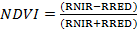Where, RRED and RNIR are spectral reflectance values in RED and NIR bands respectively. Bands [Morcy et al, 2020] [Tucker, 1979][Riedell and Blackmer, 1999][Thenkabail et al, 2000].
RNIR
SR =
RRED

Where, RRED and RNIR are spectral reflectance values in red and NIR bands, respectively [Shibayama et al, 1993] [Tucker, 1979] [Ranjitha et al, 2014].
GRVI | = | (RGREEN – RRED)
GRVI | = | (RGREEN + RRED)

Where, RRED and RGREEN are spectral reflectance values in red and green bands, respectively. [Sellers et al, 1985].
  - BAND SENSITIVITY AND VEGETATION INDEX SENSITIVITY ANALYSES
Sensitivity at a given wavelength or band was computed by using the following formula [Carter, 1993]
 |  | R_{inf}-R_{ctrl}
Band sensitivity | = | ---------------- | x | 100
 |  | R_{ctrl}

where Rctrl is the canopy reflectance of the control plants, and Rinf is the canopy reflectance of the infected plants. Similarly, the following formula was used to determine the sensitivity for the given vegetation index.

 | = | VIs _{inf} - VIs_{ctrl}
Vegetation sensitivity | = | ------------------------ | X | 100
 | = | VIs_{ctrl}
VIctrl is vegetation index of the control plants, and VI inf is the vegetation index of the infected plants.
2.5. CORRECTED SENSITIVITY:
Variations in light intensity during observations caused a shift in the sensitivity curve along the y-axis. To address this, a corrected sensitivity was computed as follows. Preliminary observations indicated that reflectance within the 350–370 nm wavelength range was unaffected by pest damage. The average sensitivity values within this range were therefore set to zero and used as a correction factor. This factor was subsequently added to or subtracted from sensitivity values at other wavelengths. The adjusted values, referred to as corrected sensitivity values, were reported as the final sensitivity measurements. (Kalpana et al, 2024)
2.6. STATISTICAL ANALYSIS:
The mean and standard deviation were computed for the percentage of damage caused by sucking pests. A randomized block design was employed to analyze the vegetative indices, namely RVI, NDVI, and GRVI, with means compared using the Least Significant Difference method. Correlation studies were conducted to examine the relationship between reflectance in different spectral bands (red, green, and NIR), vegetation indices (NDVI, GRVI, and SR), and the percentage of leaf damage caused by sucking pests. Ten tagged plants exhibiting varying levels of pest infestation were selected, and corresponding vegetation indices were determined for each plant through spectral reflectance studies. The mean values of spectral indices from ten tagged control plants were also incorporated in the correlation coefficient calculation. Significance testing of the correlation coefficient was carried out following the method proposed by [Rangaswamy, 1985]. Furthermore, linear regression models were constructed to assess the relationship between the percentage of damage and each of the vegetation indices, considering the varied levels of pest infestation in the ten tagged plants and their corresponding vegetation indices. [Apan et al, 2004].
2.7. LINEAR CORRELATION INTENSITY ANALYSIS
Linear correlation intensity analysis was conducted to identify the wavelengths with the highest positive and negative correlation with spiralling white fly damage. The correlation between pest damage and spectral reflectance across each of the 512 wavelength bands ranging from 350 to 1050 nm was calculated. These correlation values were then graphed against the corresponding wavelengths to generate a linear correlation intensity analysis graph, following the method proposed by [Prasanakumar et al, 2013][Ranjitha et al,2014]. This analysis, akin to band sensitivity analysis, aims to pinpoint wavelengths most sensitive to pest damage.
3. RESULTS AND DISCUSSION:
3.1.PER CENT DAMAGE OF SPIRALLING WHITEFLY
Table 1: Per cent damage of Spiralling Whitefly
DAP
DAP | Spiraling whitefly
15 | 38.86±16.41
30 | 43.77±17.14
45 | 37.59±14.43
60 | 46.09±15.61
Incidence of spiralling whitefly (Aleurodicus dispersus Russell) varied across different crop growth stages (Table 1). At 15 days after planting (DAP), the mean population was 38.86 ± 16.41 individuals, which increased to 43.77 ± 17.14 at 30 DAP. A slight decline was recorded at 45 DAP (37.59 ± 14.43), followed by another increase to the highest level at 60 DAP (46.09 ± 15.61). These findings indicate a fluctuating trend with two infestation peaks, one at 30 DAP and another, higher, at 60 DAP. The fluctuating population pattern of spiraling whitefly observed in this study demonstrates a strong association between pest incidence and host plant phenology. The initial increase up to 30 DAP may be due to the abundance of tender foliage, which provides favorable conditions for feeding and oviposition. The subsequent decline at 45 DAP can be attributed to leaf maturation, reduced palatability, and possibly the activity of natural enemies. However, a resurgence at 60 DAP suggests that increased canopy density and microclimatic conditions favored the pest’s multiplication. These results are consistent with earlier reports. (Mani,1995) indicated that spiralling whitefly populations typically peak on younger plant stages when foliage is succulent. Similarly, Naranjo and Ellsworth (2005) emphasized that host plant age and environmental factors significantly influence whitefly population dynamics. A comparable fluctuating trend was documented by Shylesha and Veeresh (1995) in field trials, where spiraling whitefly populations showed periodic resurgence depending on crop stage.

3.2. SPECTRAL REFLECTANCE OF SPIRALLING WHITEFLY DAMAGED PLANTS
The per cent reflectance curve of spiralling whitefly damaged plants varied from that of the healthy plants. The reflectance curve showed increase in green and red regions, while decrease in NIR region (Fig 1). These results revealed that increased green and red reflectance and decreased NIR reflectance was due to damage caused by spiralling whitefly damage in mulberry. Spiralling whitefly infestation results in continuous feeding on phloem sap, leading to chlorosis, honeydew deposition, and sooty mold development on the leaf surface. These symptoms are associated with altered leaf biochemical composition, particularly reductions in chlorophyll and nitrogen content, which strongly affect the red and red-edge spectral regions (700–750 nm) (Prabhakar et al., 2012; Herrmann et al., 2010). Sustained whitefly populations, as recorded in this study, therefore suggest persistent stress signals detectable through chlorophyll-related hyperspectral indices such as the Red-edge Chlorophyll Index and the MERIS Terrestrial Chlorophyll Index (MTCI). The observed increase in red reflectance in pest-damaged plants can be attributed to the reduction in chlorophyll pigments resulting from insect scraping and feeding activity. This agrees with the findings of Carter (1993), Shibayama et al. (1993), and Riedell and Blackmer (1999), who reported that stressed plants typically exhibit lower reflectance in the near-infrared (700–1300 nm), coupled with higher reflectance in the far-red region and a consequent shift of the red edge. Similarly, Mirik et al. (2007) demonstrated that Russian wheat aphid-infested wheat canopies showed significantly reduced reflectance in the NIR region, while exhibiting higher reflectance in the visible spectrum compared to non-infested canopies. In rice, Maheswaran (2012) observed that leaf folder-infested canopies consistently displayed increased reflectance in the green and red bands, but reduced NIR reflectance across all observation dates. Comparable trends were reported by Prasannakumar et al. (2013), who found that rice crops damaged by brown planthopper, under both field and glasshouse conditions, exhibited altered spectral signatures, characterized by reduced reflectance at shorter wavelengths and enhanced reflectance at longer wavelengths, particularly in the NIR and mid-infrared regions. These spectral shifts highlight the strong potential of hyperspectral radiometry for detecting and discriminating pest-induced damage.
Fig 1. Spectral signature of spiralling whitefly damaged mulberry plants

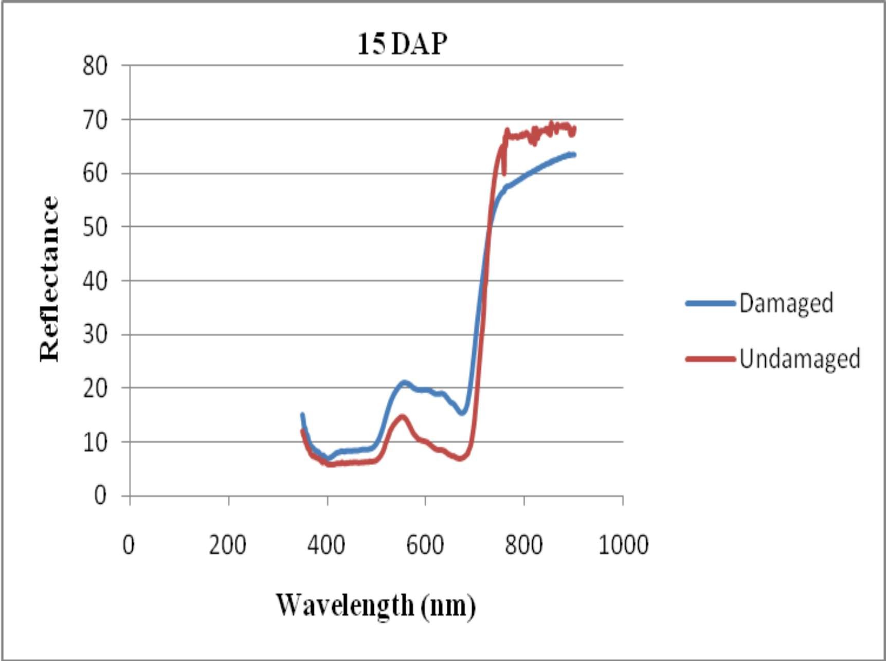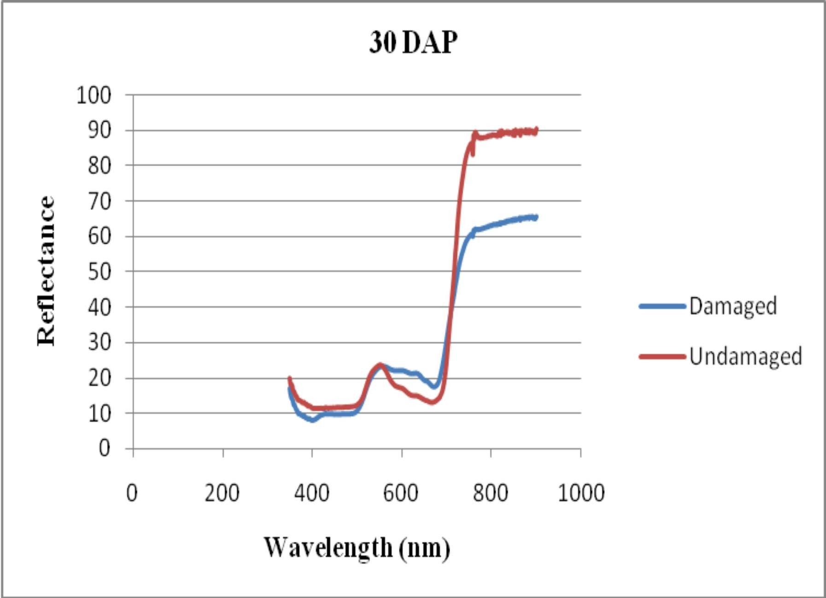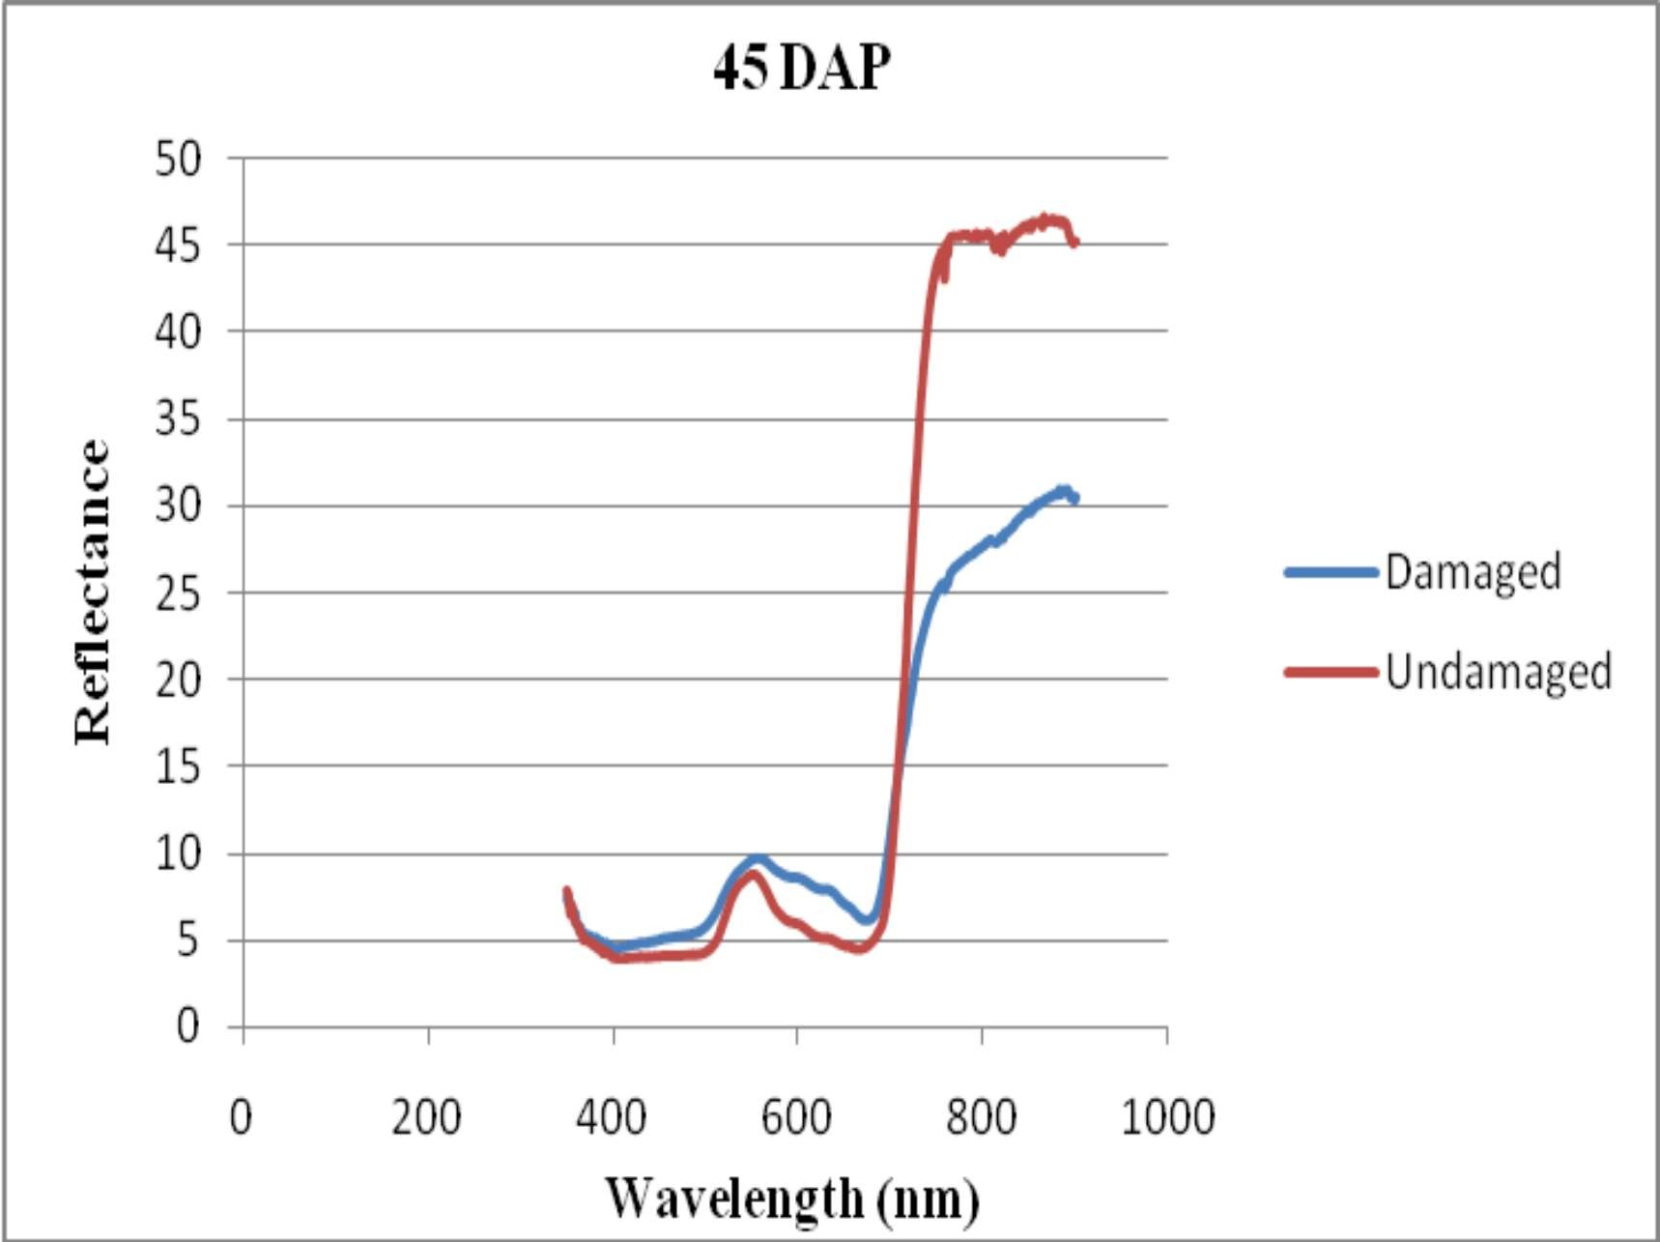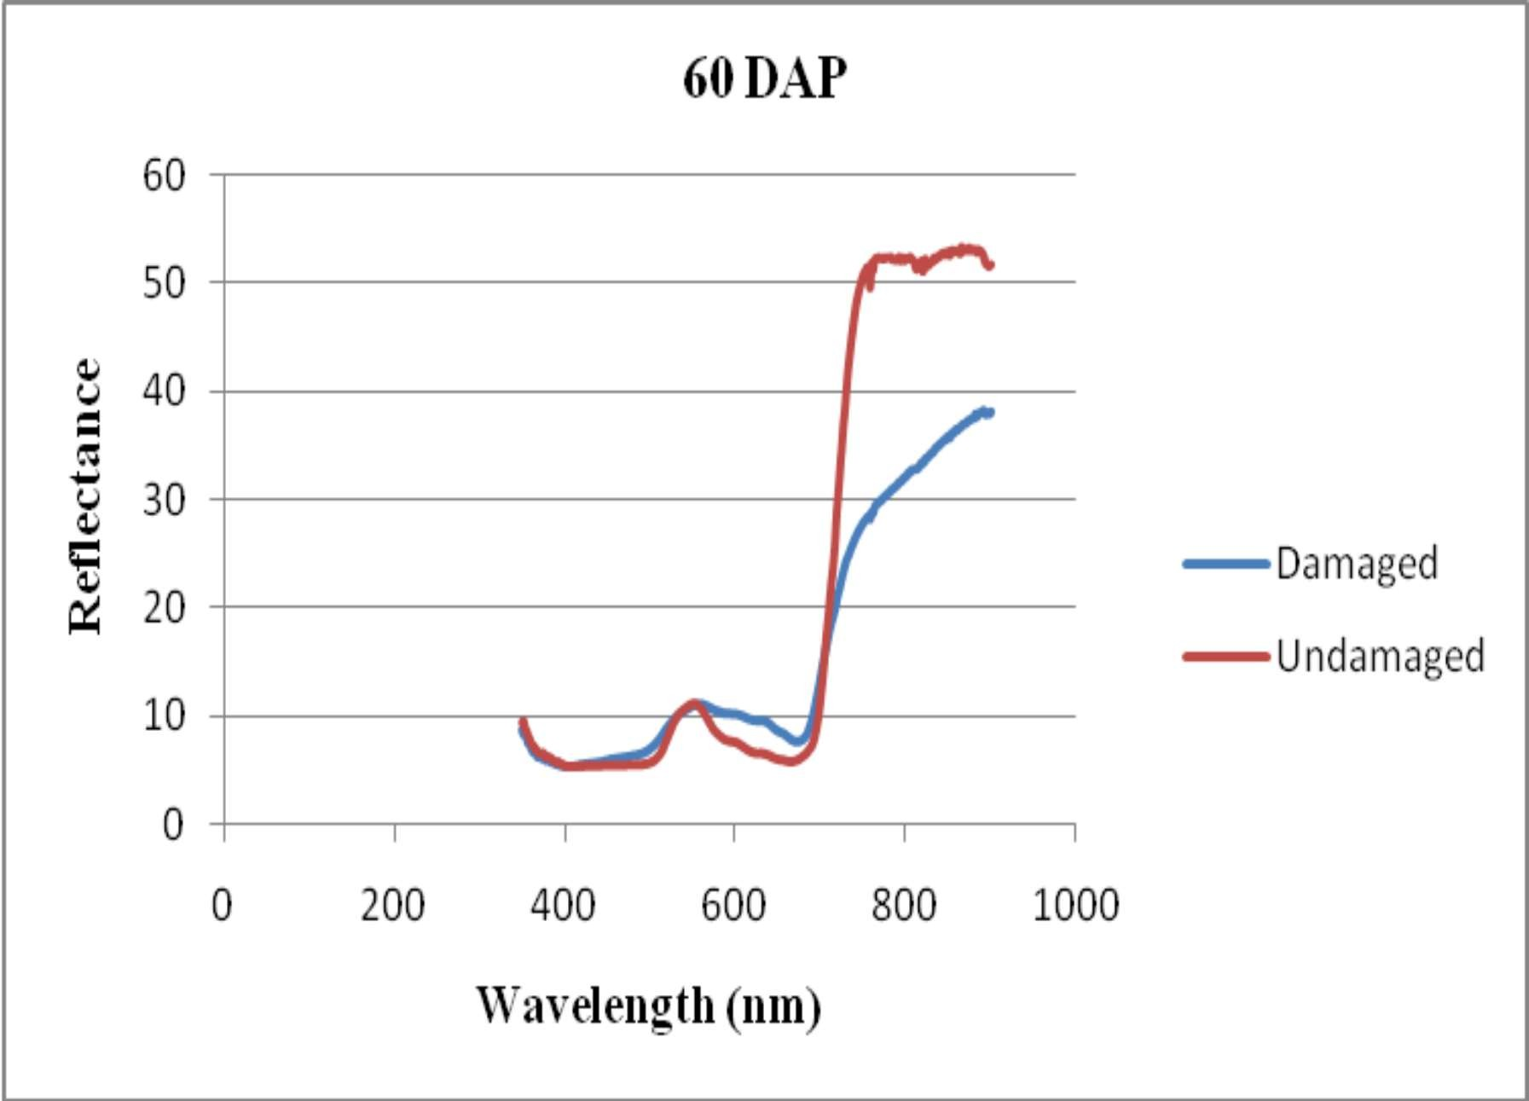
*Calculated from mean of 10 plants in each damaged and undamaged.
3.3. VEGETATIVE INDICES (NDVI, RVI AND GRVI) IN SPIRALLING WHITEFLY DAMAGED MULBERRY PLANTS
Vegetation indices (VIs) derived from remote sensing are reliable indicators of crop health, as they are directly associated with photosynthetic activity, chlorophyll concentration, and canopy structure. The vegetation indices, namely normalized difference vegetation index (NDVI), ratio vegetation index (RVI), and green-red vegetation index (GRVI), were found to be consistently lower in spiralling whitefly (Aleurodicus dispersus) infested mulberry plants compared to healthy plants (Table 2). The reduction in these indices reflects the negative impact of pest infestation on leaf chlorophyll content, photosynthetic efficiency, and overall canopy reflectance. The decrease was more pronounced in plants with higher levels of infestation, whereas healthy plants exhibited relatively higher NDVI, RVI, and GRVI values. These findings are in line with the observations of Jitendra Kumar et al. (2010) who reported that aphid-infested mustard crops showed lower vegetation index values at higher levels of infestation, while lower infestations were associated with relatively higher index values. In the present study, NDVI, RVI, and GRVI values were reduced in spiraling whitefly damaged mulberry plants, suggesting that pest infestation causes physiological stress and reduced photosynthetic activity. The chlorophyll depletion and tissue damage caused by whitefly feeding leads to reduced absorption of red light and altered reflectance in the near-infrared (NIR) and green wavelengths, thereby lowering vegetation index values. Similarly, Prabhakar et al. (2013) observed that cotton crops under whitefly (Bemisia tabaci) stress exhibited reduced NDVI values compared to healthy stands, and Liu et al. (2004) reported that spectral indices were effective in detecting spider mite infestations in maize.
The lower VI values in infested mulberry plants can therefore be attributed to leaf chlorosis, reduction in leaf area index, and canopy vigor loss caused by spiraling whitefly feeding. This suggests that remote sensing-based vegetation indices could serve as a non-destructive diagnostic tool for early detection and monitoring of pest stress in mulberry plantations, which is vital for timely integrated pest management interventions.

Table 2. Vegetative indices of spiralling whitefly damaged mulberry plants
DAP | NDVI |  | SR |  | GRVI
DAP | Undamaged* | Damaged* | Undamaged* | Damaged* | Undamaged* | Damaged*
15 | 0.785±0.05 | 0.550±0.22 | 8.66±1.96 | 4.88±3.35 | 0.23±0.06 | 0.10±0.18
30 | 0.729±0.04 | 0.561±0.22 | 6.42±1.12 | 4.78±3.26 | 0.24±0.12 | 0.11±0.15
45 | 0.812±0.02 | 0.647±0.16 | 9.68±0.97 | 4.52±2.11 | 0.22±0.03 | 0.08±0.09
60 | 0.791±0.03 | 0.586±0.17 | 7.86±2.00 | 9.68±0.97 | 0.27±0.18 | 0.10±0.07
Mean | 0.779±0.04 | 0.586±0.19 | 8.16±1.51 | 5.97±2.42 | 0.24±0.10 | 0.10±0.12
Sed | 0.4069 |  | 0.0196 |  | 0.4543
CD (0.05) | 0.6166 |  | 0.0428 |  | 0.9898
*Mean and standard deviation of 10 plants
DAP – Days after pruning
3.4. SENSITIVITY OF SPECTRAL BANDS AND VEGETATION INDICES
Table 3. Sensitivity of spectral bands and vegetative indices of spiraling whitefly damaged mulberry plants
DAP | Green | Red | NIR | SR | GRVI | NDVI
15 | 55.38 | 124.97 | -10.77 | -41.14 | -46.02 | -29.82
30 | 26.82 | 60.66 | -5.82 | -22.57 | -38.14 | -22.86
45 | 18.24 | 45.73 | -41.60 | -53.40 | -31.01 | -20.51
60 | 16.15 | 42.64 | -31.23 | -42.73 | -54.84 | -26.50
Mean | 29.25 | 58.5 | 22.35 | -159 | -170.01 | -92.69
The spectral bands and derived vegetation indices of spiraling whitefly–infested mulberry plants revealed marked differences in sensitivity (Table 3). Among the raw reflectance bands, the red band consistently exhibited the highest values at 15, 30, 45, and 60 DAP, with a mean of 58.50, compared with 29.25 for green and –22.35 for NIR. This indicates that the red band was the most responsive to spiralling whitefly damage across all observation stages.
Similarly, the vegetation indices showed strong negative responses, reflecting stressed vegetation. The simple ratio (SR) fluctuated widely with the highest magnitude negative values at 45 DAP (–53.40). The green–red vegetation index (GRVI) was consistently more negative than both SR and NDVI, reaching –54.84 at 60 DAP, with a mean of –170.01, thus emerging as the most sensitive index to spiraling whitefly damage. NDVI values, though negative, were comparatively less sensitive (mean –92.69).
The predominance of the red band sensitivity in this study can be attributed to its direct relationship with chlorophyll absorption and leaf structure. Spiraling whitefly feeding reduces chlorophyll content and disrupts mesophyll tissues. Reduced chlorophyll increases red reflectance (less absorption), while mesophyll damage suppresses NIR scattering. Since chlorophyll strongly absorbs red light around 680 nm, even minor reductions result in pronounced increases in red reflectance, making the red band highly diagnostic of pest-induced stress. Similar observations were made in rice, where the red band showed +113.5% sensitivity to yellow stem borer (YSB) infestation, compared with –14.5% in NIR and +33.4% in green reflectance, clearly highlighting its superior sensitivity to pest-induced stress symptoms (white ear) at 90 DAT [Morcy et al,2020]. Reports by [Luedeling et al, 2009] also emphasized that stressed plants tend to reflect more in the red region due to decreased chlorophyll absorption, consistent with our findings.
With respect to vegetation indices, GRVI proved to be the most sensitive index to spiraling whitefly damage. The mean GRVI values were more depressed than NDVI and SR, indicating that indices utilizing visible bands (green–red) may outperform NIR-based indices under pest damage. This corroborates findings in cotton, where thrips-infested plants showed GRVI to be more sensitive than NDVI or SR [20]. Further, Motohka et al. (2010) demonstrated that GRVI continues to vary throughout the growing season, even when changes in leaf color and density are minimal, whereas NDVI saturates at mid-season. This suggests that GRVI is capable of detecting subtle disturbances in canopy vigor during intermediate stages, making it particularly useful for monitoring pest-induced stress in mulberry.Overall, the present results show that while red band reflectance is the most sensitive spectral band to spiraling whitefly damage, the GRVI is the most reliable vegetation index for monitoring pest stress across crop growth stages. The combined use of red-band reflectance and GRVI could therefore provide a robust, non-destructive diagnostic approach for early detection of spiraling whitefly infestations in mulberry plantation

3.5. REGRESSION ANALYSIS OF SUCKING PESTS DAMAGE BASED ON VEGETATION INDICES
Table 4. Vegetative indices and their relationship with per cent leaf damage caused by Spiralling whitefly

Plant no. | Per cent damage | RVI | NDVI | GRVI
1 | 43.68 | 4.07 | 0.445 | 0.06
2 | 46.97 | 2.80 | 0.543 | 0.07
3 | 35.06 | 4.65 | 0.652 | 0.14
4 | 41.45 | 4.14 | 0.573 | 0.06
5 | 33.04 | 5.93 | 0.665 | 0.13
6 | 43.93 | 4.65 | 0.782 | 0.11
7 | 35.59 | 5.97 | 0.650 | 0.18
8 | 35.56 | 6.23 | 0.705 | 0.17
9 | 44.51 | 4.18 | 0.497 | 0.06
10 | 56.00 | 2.14 | 0.354 | -0.01
R |  | -0.911* | -0.719* | -0.89*
R2 |  | 0.831 | 0.517 | 0.79

The regression analysis of RVI, NDVI and GRVI provided possibilities of estimating spiralling whitefly damage as strong correlation exist between these parameters and damage. The three indices calculated on all days of observation had significant negative correlation with sucking pests of mulberry. Compare to NDVI and GRVI, RVI had significant negative correlation with spiralling whitefly damage on all days of observation (R2 = 0.83). The R2 values of RVI, NDVI and GRVI with spiralling whitefly damage on V1 variety of mulberry were 0.83, 0.51 and 0.79 (Fig 2) (Table 4). Qiu et al. (2008) worked out the correlation between canopy reflectance data and the White backed plant hopper Sogatella furcifera (WBPH) number per hundred individual rice hills and established a model by using SR which was optimal for use as vegetation index and the correlation co-efficient was 0.802. similarly Vinoth K, et al.(2016) found that in Brinjal, Simpe ratio significantly correlated with aphid incidence .
Similarly, Yang et al. (2007) found that among the calculated spectral indices using two spectral characteristics, the determination coefficient of NIR/RED ratio was the highest (R2 =0.922, P<0.001). Ranjitha et al. (2014) reported that in aphid damaged cotton canopies had significant negative correlation between all the indices except GRVI on all days of observation. The R2 values of RVI, NDVI, GRVI and DSVI with aphids damage on surabi were 0.907, 0.920, 0.065 and 0.943 implies the potential of all indices except GRVI to estimate pest damage.
These results are in accordance with the findings of Kalpana et al. (2024) The use of correlation and regression analysis to examine the relationship between pest damage and vegetative indices helps to define how these variables are interconnected. R² values of NDVI, RVI and GRVI were 0.42,0.51 and 0.33, respectively on all observations. These results indicating the capability of all the indices for estimating pink mealy bug damaged mulberry plants. And also estimating pink mealy bug damage linear equations were developed for RVI, NDVI and GRVI was 41.16-1.68 X RVI, 42.48-24.33 X NDVI and 37.05-59.82 X GRVI. Similarly Ranjitha et al.(2014) also developed regression equations between percent damage and vegetative indices, thus making estimating thrips one from the other. Per cent leaf damage by thrips = 510.0 - 604.5 x NDVI; Per cent leaf damage by thrips = 113.3 - 9.8 x RVI; Per cent leaf damage by thrips = 26.9 - 92.3 x GRVI. These equations offer insights into pest damage by using estimated vegetative index values within the formulas. They also enable the calculation of index values without the need for remote sensing data, by using the percentage of leaf damage gathered from field observations.
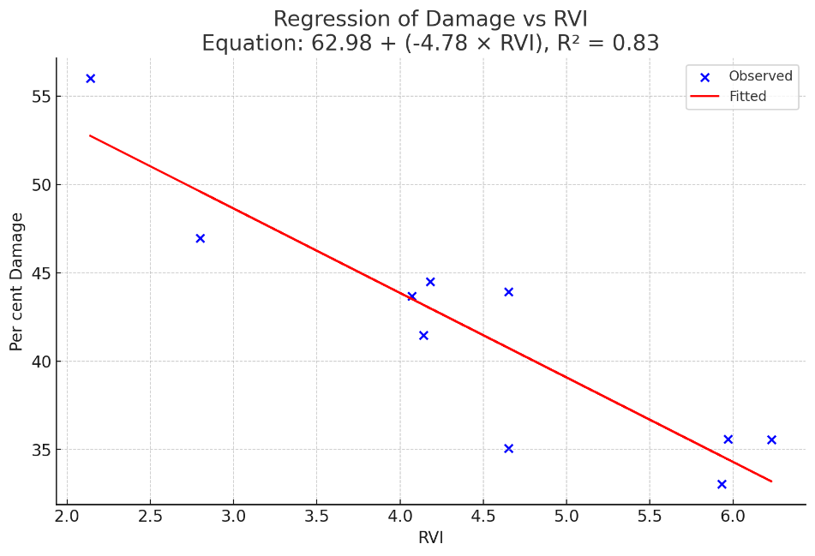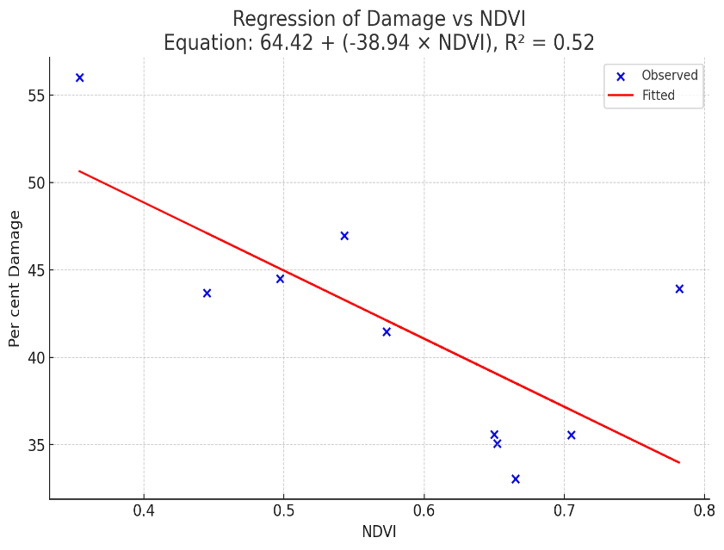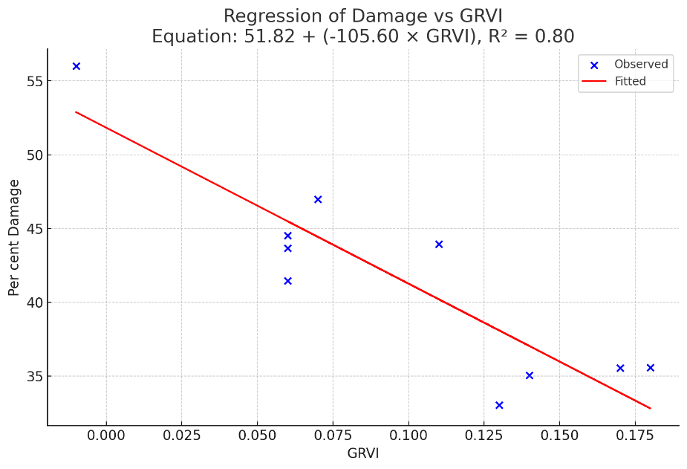

Fig.2. Relationship* between different vegetative indices and per cent damage caused by in Spiralling whitefly mulberry plants
3.6. LINEAR CORRELATION INTENSITY ANALYSIS

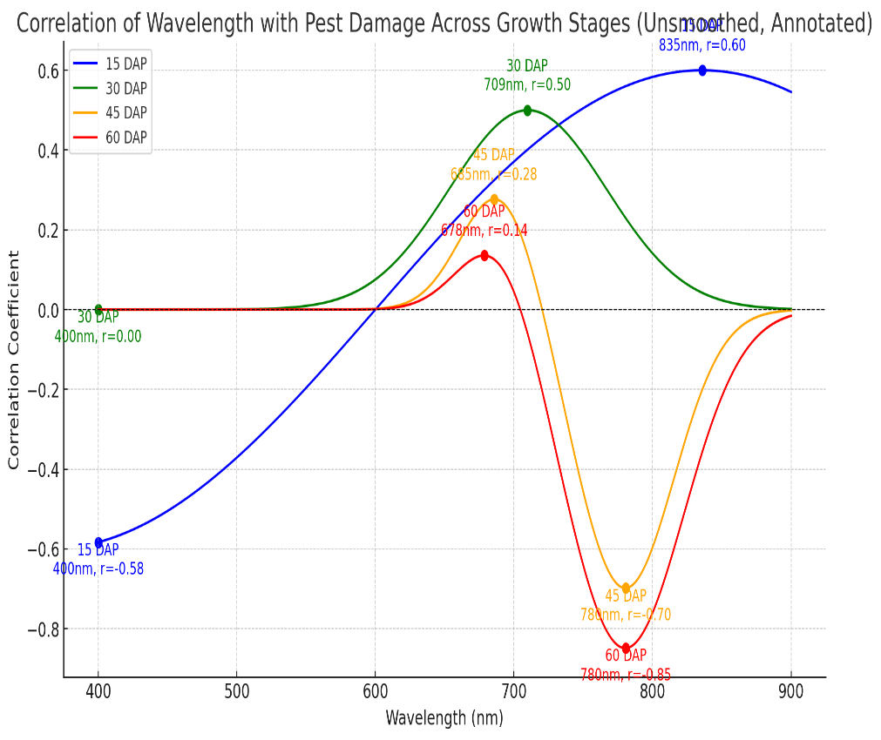
Fig 3. Correlation of reflectance in different wavelengths to per cent leaf damage by spiralling whitefly in mulberry
Pest damage is most strongly positively correlated with reflectance at ~743 nm (NIR) and most negatively correlated at ~676 nm (red band) at 15 DAP. At 30 DAP, the strongest relationship with pest damage occurs at ~700–740 nm(red edge/NIR transition) with a correlation of about +0.5. At 45 DAP, the most significant correlation is negative in the NIR region (~750–800 nm, r ≈ –0.75), while moderate positive correlations remain in the visible-red edge (680–700 nm). This shift highlights how pest impact becomes more pronounced on leaf biophysical properties as the crop matures. At 60 DAP, the strongest signal is a very strong negative correlation in the NIR region (~750–850 nm, r ≈ –0.85), while only weak positive correlations remain in the red-edge. This shows that as the crop matures, pest damage is best detected using NIR reflectance loss.(Fig 3).
The relationship between pest damage and spectral reflectance was examined across wavelengths to construct a linear correlation intensity curve for spiralling whitefly–infested mulberry plants. The analysis revealed the highest positive correlation (r=0.62) in the NIR band at 743 nm (Fig. 3), while the strongest negative correlation (r=−0.40) was observed in the red band at 676.75 nm.
Similar trends have been documented in previous studies. Yang et al. (2005) used handheld radiometers to detect stress in wheat caused by greenbug infestation and identified bands centered at 800 nm and 694 nm as the most responsive, along with indices derived from them. In rice, Mageshwaran (2012) reported maximum positive correlations between brown planthopper (BPH) damage and reflectance in the red band (651–680 nm), with additional positive correlations in the blue region (420–490 nm). The strongest negative correlation was found in the NIR region (760–769 nm), suggesting these ranges are reliable indicators of BPH damage.
Supporting evidence was also provided by Huang et al. (2010), who identified sensitive spectral regions at 530–564 nm, 614–695 nm, and 706–1050 nm, associated with rice leaf folder damage. Similarly, Ranjitha et al. (2014) reported that 640–680 nm was particularly sensitive to leafhopper damage, while 670–690 nm showed strong responsiveness to aphid infestations. Collectively, these findings demonstrate consistent spectral signatures across pest–crop systems, underscoring the importance of red and NIR wavelength regions as reliable indicators for detecting plant stress and quantifying pest damage.
CONCLUSION
Hyperspectral radiometry effectively detected spiralling whitefly damage in mulberry through increased green and red reflectance and reduced NIR reflectance. Among vegetation indices, GRVI was most sensitive, while regression analysis identified RVI as the best predictor of damage (R²=0.83). Linear correlation confirmed NIR and red regions as most diagnostic. The combined use of red-band reflectance and GRVI provides a reliable, non-destructive tool for early detection and monitoring, enabling timely pest management in sericulture
REFERENCES
- Apan, A., Held, A., Phinn, S., & Markley, J. (2004). Detecting sugarcane "orange rust" disease using EO-1 Hyperion hyperspectral data. International Journal of Remote Sensing, 25(2), 489–498. https://doi.org/10.1080/01431160310001618031
- Behmann, J., Mahlein, A. K., Rumpf, T., Römer, C., & Plümer, L. (2015). A review of advanced machine learning methods for the detection of biotic stress in precision crop protection. Precision Agriculture, 16(3), 239–260.
- Carter, G. A. (1993). Responses of leaf spectral reflectance to plant stress. American Journal of Botany, 80(3), 239–243.
- Elliott, N. C., Mirik, M., Yang, Z., Dvorak, T., Rao, M., Michels, J., … Royer, T. (2007). Airborne multi-spectral remote sensing of Russian wheat aphid injury to wheat. Southwestern Entomologist, 32(4), 213–219.
- Herrmann, I., Karnieli, A., Bonfil, D. J., Cohen, Y., & Alchanatis, V. (2010). SWIR-based spectral indices for assessing nitrogen content in potato fields. International Journal of Remote Sensing, 31(19), 5127–5143.
- Huang, J., Liao, H., Zhu, Y., & Sun, J. (2012). Hyperspectral detection of rice damaged by rice leaf folder (Cnaphalocrocis medinalis). Computers and Electronics in Agriculture, 82, 100–107.
- Jitendra Kumar, V. K., Sehgal, R. N., Singh, R. N., Bhatia, S., & Singh, P. K. (2010). Spectral response of aphid (Lipaphis erysimi) infested mustard crop and its relationship with aphid population. Journal of Environmental Biology, 31(6), 1025–1030.
- Kalpana, R., Murugesh, K. A., Perumal, R. K., Mithilasri, M., & Kannan, B. (2024). Spectral analysis of pink mealy bug damaged mulberry plants using hyperspectral radiometry. Journal of Advances in Biology & Biotechnology, 27(5), 81–91.
- Krishnaswami, S., Ahsan, M., & Sriharan, T. P. (1970). Studies on the quality of mulberry leaves and silkworm cocoon crop production. Part II: Quality differences due to leaf maturity. Indian Journal of Sericulture, 9, 11–25.
- Krüger, M., et al. (2024). Hyperspectral imaging for pest symptom detection in bell pepper. Plant Methods, 20(1), 1–15.
- Liu, Z. Y., Huang, J. F., & Zhao, C. J. (2004). Detecting aphid density of winter wheat using hyperspectral remote sensing. Journal of Remote Sensing, 8(4), 336–342.
- Lucas, J. A. (1998). Plant pathology and plant pathogens (3rd ed.). Oxford: Blackwell Science.
- Luedeling, E., Zhang, M., Girvetz, E. H., & Brown, P. H. (2009). Remote sensing of spider mite damage in California peach orchards. International Journal of Applied Earth Observation and Geoinformation, 11(4), 244–255.
- Luther, J. E., & Carroll, A. L. (1999). Development of an index of balsam fir vigor by foliar spectral reflectance. Remote Sensing of Environment, 69(3), 241–252.
- Maheswaran, R. (2012). Spectral characterization of rice crop under leaf folder infestation. Madras Agricultural Journal, 99(7–9), 493–496.
- Maheswaran, R., & Prabhakar, M. (2014). Hyperspectral radiometry for detection of damage caused by thrips (Thrips tabaci Lind.) in cotton. Indian Journal of Agricultural Sciences, 84(3), 347–351.
- Mani, M. (1995). The spiralling whitefly, Aleurodicus dispersus Russell (Homoptera: Aleyrodidae), and its natural enemies in India. Journal of Biological Control, 9, 19–25.
- Mirik, M., Michels, G. J., Kassymzhanova-Mirik, S., Elliott, N. C., Bowling, R., & Catana, V. (2007). Using digital image analysis and spectral reflectance data to quantify Russian wheat aphid damage. Computers and Electronics in Agriculture, 57(2), 123–134.
- Morsy, M. (2020). Monitoring and managing rice pest infestation through hyperspectral remote sensing technology under field conditions. Journal of Applied Plant Protection, 9(1), 67–82.
- Motohka, T., Nasahara, K. N., Oguma, H., & Tsuchida, S. (2010). Applicability of Green-Red Vegetation Index for remote sensing of vegetation phenology. Remote Sensing, 2(10), 2369–2387.
- Nansen, C., et al. (2021). Leaf reflectance to detect and diagnose pest-induced plant stress responses. Frontiers in Plant Science, 12, 705.
- Naranjo, S. E., & Ellsworth, P. C. (2005). Mortality dynamics and population regulation in Bemisia tabaci. Entomologia Experimentalis et Applicata, 116, 93–108.
- Narendra Kumar, et al. (2013). Sucking pests of mulberry: A review paper. International Journal of Chemical Studies, 8(1), 1–10.
- Peignier, S., et al. (2023). Detection of aphids on hyperspectral images using one-class SVM and blob detection. Remote Sensing, 15(10), 1–14.
- Polder, G., van der Heijden, G. W. A. M., van Doorn, J., & Baltissen, T. (2019). Hyperspectral imaging for early detection of biotic stress in crops. Frontiers in Plant Science, 10, 616.
- Prabhakar, M., Prasad, Y. G., Thirupathi, M., Sreedevi, G., Vennila, S., & Kiran Kumar, P. R. (2013). Use of NDVI from Indian remote sensing satellites for assessing biotic stress in cotton. Journal of the Indian Society of Remote Sensing, 41(1), 95–103.
- Prabhakar, M., Sreedevi, K., & Sreekanth, P. (2012). Detection and estimation of damage caused by rice yellow stem borer (Scirpophaga incertulas Walker) by hyperspectral radiometry. Current Science, 102(6), 874–879.
- Prabhakar, M., Sreedevi, K., & Sreekanth, P. (2013). Hyperspectral radiometry for detection and estimation of infestation caused by major sucking pests in brinjal. Madras Agricultural Journal, 100(7–9), 242–249.
- Prasannakumar, N. R., Sreenivas, G., Anjaneyulu, K., & Reddy, D. C. (2013). Spectral reflectance characteristics of brown planthopper (Nilaparvata lugens) damage in rice crop. Journal of Agrometeorology, 15(Special Issue I), 1–6.
- Qiu, B. J., Chen, G. P., & Cheng, Q. W. (2008). Canopy spectral reflectance feature of rice infested with white-backed planthopper (Sogatella furcifera) and insect number inversion. Transactions of the Chinese Society for Agricultural Machinery, 39(9), 92–99.
- Rangaswamy, R. (1995/2010/2020). A Textbook of Agricultural Statistics. New Age International.
- Ranjitha, G., & Srinivasan, M. R. (2014). Hyperspectral radiometry for the detection and discrimination of damage caused by sucking pests of cotton. Current Biotica, 8(1), 5–12.
- Ranjitha, G., Srinivasan, M. R., & Rajesh, A. (2014). Detection and estimation of damage caused by Thrips tabaci in cotton using hyperspectral radiometer. Agrotechnology, 3, 123.
- Riedell, W. E., & Blackmer, A. M. (1999). Leaf reflectance spectra of cereal aphid-damaged wheat. Crop Science, 39(6), 1835–1840.
- Sellers, P. J. (1985). Canopy reflectance, photosynthesis and transpiration. International Journal of Remote Sensing, 6(8), 1335–1372.
- Shibayama, M., Takahashi, W., Morinaga, S., & Akiyama, T. (1993). Canopy water deficit detection in paddy rice using a high-resolution spectroradiometer. Remote Sensing of Environment, 45(1), 117–126.
- Shylesha, A. N., & Veeresh, G. K. (1995). Population dynamics of spiralling whitefly Aleurodicus dispersus Russell on tapioca and its natural enemies. Pest Management in Horticultural Ecosystems, 1(1), 1–6.
- Skendžić, S., et al. (2025). Hyperspectral canopy reflectance and machine learning for threshold-based classification of aphid-infested winter wheat. Remote Sensing, 17(5), 929.
- Thomas, S., Kuska, M. T., Bohnenkamp, D., Brugger, A., Alisaac, E., Wahabzada, M., & Mahlein, A. K. (2018). Hyperspectral imaging for identification of plant diseases at the leaf and canopy level. Journal of Plant Diseases and Protection, 125(5), 477–491.
- Thenkabail, P. S., Smith, R. B., & De Pauw, E. (2000). Hyperspectral vegetation indices and their relationships with agricultural crop characteristics. Remote Sensing of Environment, 71(2), 158–182.
- Thirupathi, M., & Prabhakar, M. (2021). Remote sensing for pest damage: Present status and potential application – case studies from India. The Journal of Research, PJTSAU, 49(3), 1–10.
- Vinothkumar, B., Kannan, B., & Ramasamy, J. (2016). Hyperspectral radiometry for detection and estimation of infestation caused by major sucking pests in brinjal. Madras Agricultural Journal, 103(7–9), 242–249.
- Yang, Z., Rao, M. N., Elliott, N. C., Kindler, S. D., & Popham, T. W. (2005). Using ground-based multispectral radiometry to detect stress in wheat caused by greenbug infestation. Computers and Electronics in Agriculture, 47(2), 121–135.
- Yumnam Debaraj, R., Gogoi, S. N., Biswas, T. K., & Bindroo, B. B. (2013). New record of a natural enemy on mulberry whitefly Dialeuropora decempuncta in Assam. Munis Entomology & Zoology, 8(2), 902–904.

