Impact of Shade on Cocoa Swollen Shoot Virus Disease Hotspots in the Fresco Department (Southern Côte d’Ivoire)

ABSTRACT
Cocoa Swollen Shoot Virus (CSSV) threatens the main cocoa production basins of Côte d'Ivoire, to the point that the fight against this disease represents a priority for all stakeholders in the cocoa sector. To contribute to the fight against the Cocoa Swollen Shoot Virus disease, this study was initiated with the general objective of evaluating the impact of trees associated with cocoa trees on the prevalence and configuration of CSSV disease outbreaks in cocoa farms in the department of Fresco. To do this, the characterization of the infection of plantations by the disease of swollen shoot were carried out, followed by botanical inventories of shade trees were carried out in and around the foci and determine the projection on the ground of the crown of these trees. Measurement of shade tree densities showed that there were more trees around the foci than in the foci, suggesting an effect of shade on symptom intensity. From the determination of this projection, it was found that shading did not influence the spread and development of CSSV symptoms in cocoa farms. Agroforestry systems with appropriate shade trees appear to limit the spread of swollen shoot symptoms and may therefore offer a potential adaptation strategy to mitigate the severity of CSSV symptoms.

Keywords: landscape configuration, Cocoa Swollen Shoot Virus, cocoa plantation, Fresco area, shading.

Introduction
Côte d’Ivoire supplies approximately 43% of the global cocoa bean market (ICCO, 2021) and has ranked first among nearly fifty cocoa-producing countries for more than three decades. This major production contributes over 15% to the national Gross Domestic Product and constitutes the primary source of income for thousands of smallholder farmers. Cocoa alone accounts for nearly 50% of Ivorian export products, thereby providing essential economic support to the State.
However, these socio-economic achievements should not obscure the numerous constraints that may lead to a substantial decline in production and exacerbate rural poverty. In general, the constraints affecting cocoa farming in Côte d’Ivoire can be grouped into two main categories. Abiotic constraints include, in particular, fluctuations in market prices and the progressive depletion of forest resources (Freud et al., 2000). Biotic constraints are predominantly driven by diseases and insect pests. Among these bioagressors, black pod disease caused by Phytophthora spp. and mirid bugs (Sahlbergella singularis and Distantiella theobroma) are the most destructive (Coulibaly et al., 2013). In addition, Cocoa Swollen Shoot Virus (CSSV), the causal agent of swollen shoot disease, represents a particularly damaging threat. Notably, N’Guessan (2013) reported that more than 30% of cocoa plantations in the Fresco Department were affected.
In response to this threat, agroforestry has emerged as a promising approach to limit the spread of CSSV. As an agricultural system that integrates trees with crops (and sometimes livestock), agroforestry is widely recognized as both environmentally sustainable and economically viable (Nair, 2007; Valentini, 2007).
Accordingly, the overall objective of this study is to assess the impact of shade trees associated with cocoa on the prevalence of CSSV disease hotspots in plantations of the Fresco Department.

Study area
The Fresco Department, located in southern Côte d’Ivoire, covers an area of 325.5 km² and belongs to the Gbôklè Region (Figure 1). The climate is of the subequatorial type (Avenard, 1971), with mean monthly temperatures ranging from 24 °C to 28 °C. Annual rainfall varies between 15 and 247 mm, with June being the wettest month, recording an average rainfall of 247 mm.
The local economy is primarily based on agricultural activities. The coffee–cocoa system remains dominant, alongside food crops such as rice, plantain banana, maize, and yam. More recently, cashew (Anacardium occidentale) cultivation has been introduced in the area (N’Drin et al., 2019), providing a valuable economic complement to traditional agricultural productions (Coulibaly et al., 2019).
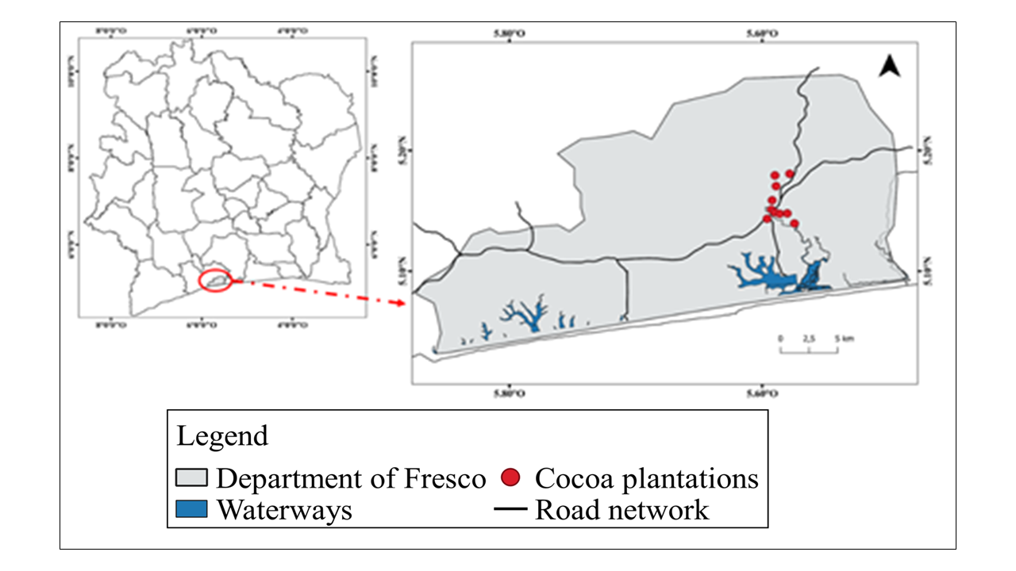
Figure 1. Location of the department of Fresco and the cocoa plantations in the study

- Methodology
  - Sampling design
The present study was conducted across a network of ten (10) cocoa plantations. Observations focused on both cocoa trees and associated shade trees within each plantation. The selection of plantations was based on a typology defined using three main criteria: plantation age, yield level, and the density of associated trees per hectare. All studied sites exhibited a high incidence of cocoa swollen shoot disease. The detailed characteristics of these plantations are presented in Table 1.
Table 1. Characterisation of selected cocoa farms
N° | Planting code | Age (years) | Productivity (kg) / ha | Tree density (threshold 20 / ha)
1 | Fresco_1 | 16 | 700 | < 20 trees/ha
2 | Fresco_2 | 20 | 250 | > 20 trees/ha
3 | Fresco_3 | 13 | 500 | > 20 trees/ha
4 | Fresco_4 | 7 | 900 | < 20 trees/ha
5 | Fresco_5 | 20 | 1000 | < 20 trees/ha
6 | Fresco_6 | 17 | 1500 | > 20 trees/ha
7 | Fresco_7 | 20 | 250 | < 20 trees/ha
8 | Fresco_8 | 70 | 2000 | > 20 trees/ha
9 | Fresco_9 | 16 | 1500 | < 20 trees/ha
10 | Fresco_10 | 10 | 600 | > 20 trees/ha

  - Inventory of trees associated with cocoa
The inventory involved the identification, measurement of circumference, and geolocation of trees located within disease hotspots and in the surrounding areas within a 20 m radius of cocoa swollen shoot disease foci. Only trees with a diameter at breast height (dbh) greater than 10 cm were included in the study (Vroh et al., 2010). For buttressed species, circumference measurements were taken 30 cm above the buttress zone.
For each tree meeting the dimensional criteria, GPS coordinates were recorded, and the tree was marked using biodegradable paint to facilitate identification during subsequent verification.

  - Estimation of shade
Shade within CSSV disease hotspots was estimated based on the ground projection of the area covered by the crowns of shade trees. To this end, each crown was approximated as a circular shape, for which two perpendicular diameters (D1 and D2) were measured on the ground using a measuring tape (Figure 2). The mean of these two diameters was then squared and multiplied by π (3.14) to obtain the projected crown area.
These measurements made it possible to quantify shade by calculating the proportion of shaded area within each hotspot, defined as the ratio between the total area occupied by crown projections and the total area of the CSSV hotspot. This proportion theoretically ranges from 0% (absence of shade) to 100% (complete shade).
Shade estimation was conducted in six plantations selected according to their agroecological characteristics. Selection was based on two criteria: plantation age (< 20 years and > 20 years) and the intensity of swollen shoot infection (low, moderate, high), with two plantations selected per infection level. The resulting values were subsequently grouped into three shade classes: 0–30% (low), 30–60% (moderate), and 60–100% (high).

Figure 2. Measuring the ground projection of the crown of shade trees across two diameters
Source : (Alian & François, 2020)

  - Data analysis
Mean comparison tests were used to compare selected calculated parameters, with the objective of determining whether the means of different treatments differed significantly. In this study, a one-way analysis of variance (one-way ANOVA) was applied. The significance level was set at 5% (p = 0.05). When significant differences were detected, Tukey’s post hoc test was performed to identify which groups differed from each other.

Results
  - Tree species richness in infection hotspots
A total of 50 tree species were recorded within and around the CSSV infection hotspots, belonging to 36 genera and 23 families. The most represented families were Moraceae (12%), Sterculiaceae (11%), Rutaceae (11%), Apocynaceae (8%), and Anacardiaceae (6%). (Figure 3). Tree density within and around CSSV hotspots ranged from 0 to 56 trees per hectare, with a mean of 17 trees per hectare. Around the hotspots, the average density was 22 trees per hectare, while the mean density within the hotspots was 13 trees per hectare.

Figure 3. Tree species families

  - Spatial distribution of shade trees
Figure 4 illustrates the distribution of shade trees within and around the different CSSV hotspots, as well as the ground projection of their crowns. Overall, the results reveal substantial variability between plantations.
The hotspots in the Fresco 10 plot were the most shaded, featuring a mix of forest and fruit trees. The density of associated trees was relatively low, with 20 trees per hectare in the surveyed area. The total crown cover amounted to approximately 925 m². A large proportion of the associated trees belonged to the families Moraceae (Ficus exasperata, Antiaris toxicaria, and Milicia excelsa) and Sterculiaceae (Sterculia tragacantha). Fruit trees were mainly represented by Persea americana (Lauraceae) and Mangifera indica (Anacardiaceae), whose crown areas were generally small (Table 2). Shade tree distribution within the hotspots was highly heterogeneous.
In contrast, the hotspots of the Fresco 1 plot were the least shaded. These contained only forest trees, namely Antiaris toxicaria (Moraceae), Acacia mangium, Albizia adianthifolia (Mimosaceae), and Afzelia africana (Caesalpiniaceae), planted at an average density of approximately 12 trees per hectare. The crown area in this plot was relatively low, about 216 m² within the surveyed area.

Table 2. List of species in the plantations
N° | Specices | Families | Biological types | Within hotspots | Proximity to hotspotss
01 | Afzelia africana Smith ex Pers. | Caesalpiniaceae | mP | 5 | 2
02 | Albizia adianthifolia (Schumach.) W.F. | Mimosaceae | mP | 10 | 0
03 | Albizia ferruginea (Guill. & Perr.) Benth. | Mimosaceae | mP | 0 | 0
04 | Alstonia boonei De Wild. LC. | Apocynaceae | MP | 3 | 4
05 | Anacardium occidentalis L. | Anacardiaceae | mp | 2 | 6
06 | Anthonotha crassifolia (Baill.) J.Léonard | Caesalpiniaceae | mp | 1 | 0
07 | Antiaris toxicaria Lesch. | Moraceae | mP | 4 | 3
08 | Artocarpus altilis (Parkinson) Fosberg | Mimosaceae | mP | 2 | 2
09 | Baphia nitida Lodd. | Fabaceae | mp | 2 | 0
10 | Blighia sapida K. D. Koenig | Sapindaceae | mP | 2 | 1
11 | Blighia welwitschii (Hiern) Radlk. | Sapindaceae | mP | 0 | 0
12 | Bridelia ferruginea Benth. | Euphorbiaceae | mp | 2 | 1
13 | Carica papaya L. | Caricaceae | mp | 1 | 1
14 | Ceiba pentandra (Linn.) Gaerth. | Bombacaceae | MP | 1 | 2
15 | Celtis zenkeri EngI. | Ulmaceae | mP | 1 | 1
16 | Citrus latipes (Swingle) Tanaka | Rutaceae | mp | 1 | 0
17 | Citrus reticulata Blanco | Rutaceae | mp | 2 | 1
18 | Citrus sinensis (L.) Osbeck | Rutaceae | mp | 2 | 1
19 | Cola nitida (Vent.) Schott & Endl. | Sterculiaceae | mP | 4 | 2
20 | Diospyros mespiIiformis Hochst. | Ebenaceae | mp | 1 | 0
21 | Entandrophragma angolense (Welw.) C. DC. | Meliaceae | MP | 0 | 1
22 | Ficus exasperata Vahl | Moraceae | mp | 1 | 1
23 | Ficus recurvata De Wild. | Moraceae | mp (Ep) | 1 | 0
24 | Ficus sur Forsk. | Moraceae | mp | 4 | 1
25 | Funtumia africana (Benth.) Stapf | Apocynaceae | mP | 2 | 1
26 | Harungana madagascariensis Lam. | Hypericaceae | mp | 2 | 3
27 | Holarrhena floribunda (G. Don) Dur. & Schinz | Apocynaceae | mP | 1 | 0
28 | Kigelia africana (Lam.) Benth. | Bignoniaceae | mp | 0 | 0
29 | Lophira alata Banks ex Gaertn.f. | Ochnaceae | MP | 1 | 1
30 | Mangifera indica Linn. | Anacardiaceae | mP | 4 | 3
31 | Milicia excelsa (Welw.) Benth. | Moraceae | MP | 4 | 4
32 | Millettia zechiana Harms | Fabaceae | mp | 10 | 0
33 | Morinda lucida Benth. | Rubiaceae | mp | 9 | 8
34 | Morus mesozygia Stapf ex A. Chev. | Moraceae | mp | 0 | 0
35 | Musanga cecropioides R. Br. | Musaceae | G | 2 | 0
36 | Myrianthus arboreus P. Beauv. | Cecropiaceae | mP | 3 | 5
37 | Nesogordonia papaverifera (A. Chev.) R. Capuron | Cecropiaceae | mp | 3 | 1
38 | Newbouldia laevis (P. Beauv.) Seemann | Sterculiaceae | MP | 6 | 0
39 | Parkia biglobosa (Jacq.) Benth. | Bignoniaceae | mp | 0 | 0
40 | Persea americana Mill. | Mimosaceae | mi | 7 | 3
41 | Piptadeniastrum africanum (Hook.f.) | Mimosaceae | MP | 0 | 0
42 | Pycnanthus angolensis (Welw.) Warb | Myristicaceae | mP | 3 | 3
43 | Rauvolfia vomitoria Afzel. | Apocynaceae | mp | 10 | 7
44 | Ricinodendron heudelotii (Baill.) Pierre | Euphorbiaceae | mP | 0 | 0
45 | Spondias mombin Linn. | Anacardiaceae | mp | 7 | 9
46 | Sterculia tragacantha Lindl. | Sterculiaceae | mP | 3 | 2
47 | Terminalia ivorensis A. Chev. | Combretaceae | MP | 2 | 0
48 | Terminalia superba EngI. & Diels | Combretaceae | MP | 0 | 0
49 | Triplochiton scleroxylon K. Schum. | Sterculiaceae | MP | 1 | 0
50 | Zanthoxylum Zanthoxyloides (Lam.) | Rutaceae | mp | 1 | 0
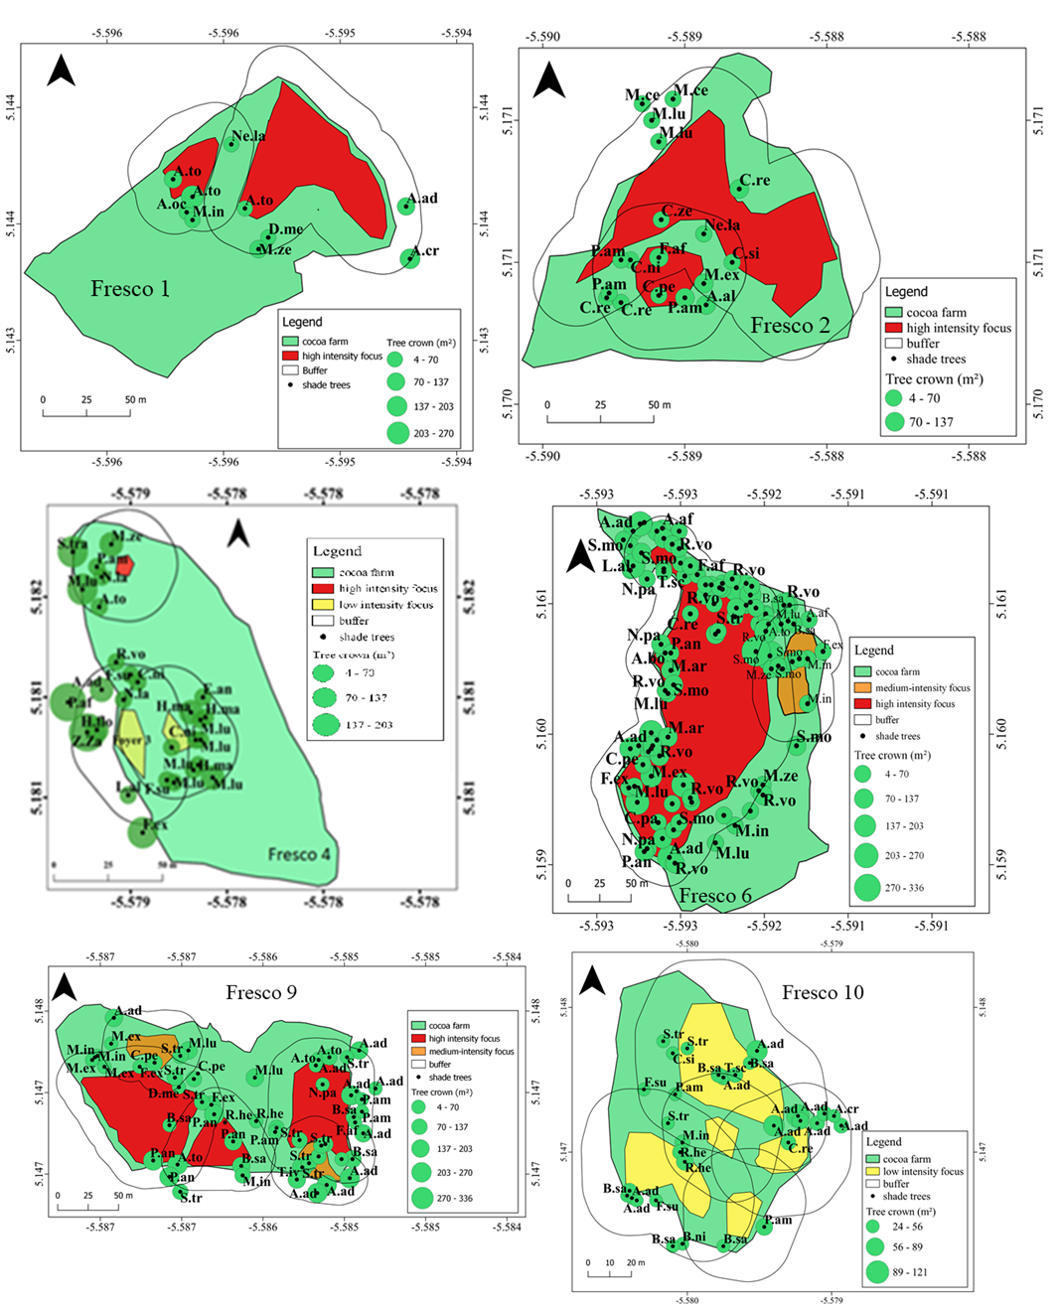
Figure 4. Spatial distribution of shade trees and tree crown area in and around swollen shoot foci (the areas around the foci)
a
b

5.3 Effet de l’ombrage sur l’intensité de swollen shoot
La proportion de surface ombragée dans et autour des foyers de swollen shoot varie de 0 à 69% avec une moyenne de 16% (Figure 5). Autour des foyers, la proportion de surface ombragée est de 17% tandis que la proportion de surface ombragée dans les foyers est de 15%. Le test de Wilcoxon a montré qu’il n’y a pas de différence significative (p = 0.12) entre les proportions des surfaces ombragées si l’on compare les foyers avec les surfaces autour des foyers (buffers). Ceci semble indiquer que la proportion de surface ombragée n’a pas d’effet sur la présence des foyers d’infection par le CSSV.
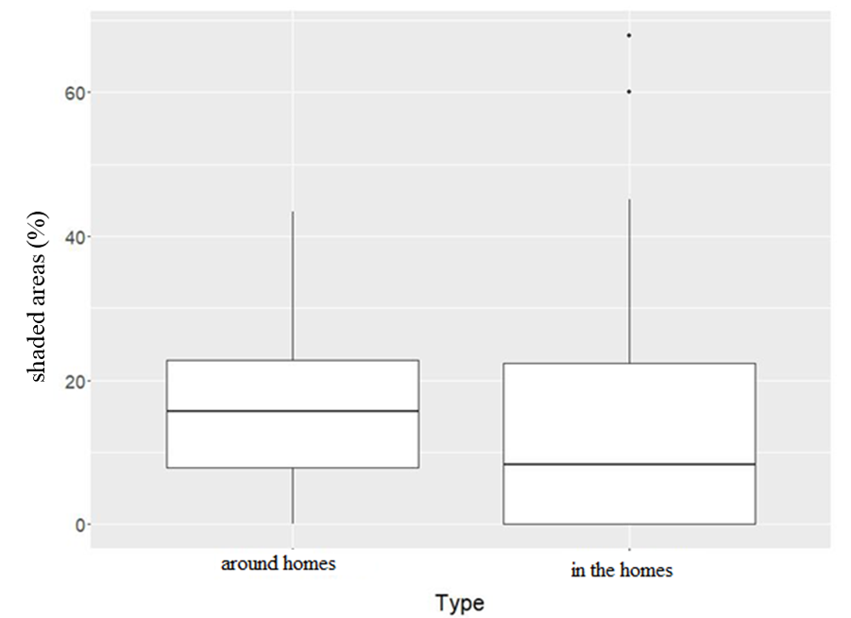
b
a
Figure 5. Comparative boxplots of the proportion of shaded area in and around swollen shoot foci

Discussion
The flora in and around the CSSV outbreaks is rich with 41 species divided into 36 genera and 23 families. Among the families recorded, five (5) are the most important in terms of species. These are Moraceae (12%), Sterculiaceae (11%), Rutaceae (11%), Apocynaceae (8%) and Anacadiaceae (6%). These families have been cited as dominant in Doboua agrosystems (Boko et al., 2020). The presence of many trees from the Moraceae, Sterculiaceae and Rutaceae families, known to contain alternative host plants for CSSV. These include Ficus exasperata, Citrus sinensis and Cola nitida etc. These species could also explain the high number of outbreaks of swollen shoot in cocoa plots. Eight (8) cocoa plots had a high number of high intensity swollen shoot outbreaks.
Furthermore, the number of high species in our study has an effect on the prevalence of the disease. The CNRA in 2011 showed that some species are alternative hosts for the virus. These species are therefore likely to host the virus and the mealybugs. These species, known as alternative host plants, could possibly influence the evolution of the disease, insofar as they are denser in a cocoa farm. As our study does not take into account the total number of each woody species, but rather the total number of all woody plants present in and around CSSV outbreaks, it is very likely that this number does not influence the prevalence rate. Especially since around and within CSSV foci, there may be a single species that is denser than the others, but is not an alternative host species for the virus.
The results of the Wilcoxon Test showed that there was no significant difference between the proportions of shaded areas in and around CSSV foci and the prevalence of swollen shoot. This indicates that the proportion of shaded area has no effect on the presence of CSSV foci. The density of shade trees was higher around the foci than in the swollen shoot foci. This suggests that symptoms are less visible when the associated trees are more densely planted. Our results seem to be in line with those of Jeger & Thresh (1993), who showed that agroforestry systems are a potential coping strategy to reduce the severity of CSSV symptoms, but they may not be able to prevent its spread.
Also, when shading is not controlled, it greatly affects production. The strong increase in the rate of parasitic attacks in relation to the increase in the density of host species associated with cocoa trees is confirmed by authors such as Besse (1972), who report this fact but do not specify the dynamics of this increase. A similar result was found by Nyassé et al, (1999) and Ndoumbe-Nkeng & Sache (2003) who showed that excessive shading can increase the severity of diseases, such as black pod rot, caused by Phytophthora megakarya, which is responsible for considerable production losses in Cameroon. According to Babin et al. (2009), shade management could reduce attacks by the cocoa mirid Sahlbergella singularis Hagl. (Hemiptera: Miridae) in traditional cocoa agroforests in Cameroon. Thus, shading in itself is not a disadvantage for cocoa farms. This is what led Braudeau (1969) to state that shading is a hindrance to production only under non-limiting conditions. In fact, shading is only a limiting factor for production if all other factors are favorable. This is what Boffa (2000) concluded when he said that the factors must be considered as a whole, and shading is the lever by which the farmer can act on the environmental conditions.
Although this result does not allow for a general conclusion, it does tend to remove some of the ambiguity about the real impact of shading in the field. This could help in the choice of associations in areas where new cocoa farms are being established, where the emphasis could be placed on the intensity of shade to be provided and also on the added value of the associated species.

Conclusion
The objective of this study was to assess the impact of trees associated with cocoa trees on the prevalence of CSSV disease outbreaks in cocoa farms in Fresco department. Measurement of shade tree densities showed that there were more trees around the outbreaks than in the outbreaks, suggesting an effect of shading on the intensity of CSSV symptoms around low intensity outbreaks. Our analysis of the impact of shading on CSSV outbreaks gave conflicting results, but the trend was that a higher density of associated trees could limit the expression of CSSV disease symptoms. In order to assess an effect of shading on the spread of the virus, the presence of the virus in cocoa trees would have to be verified by molecular analysis. The choice of tree species is probably the main difficulty in avoiding associations that may present health risks, especially with species known to be alternative hosts or reservoirs of pests or pathogens.
The development of agroforestry systems for cocoa cultivation in this area should be recommended to reduce the impact of CSSV damage.

References
Avenard J. M. (1971). Aspects of geomorphology. In: The natural environment of Côte d'Ivoire. ORSTOM Memoir, 50, Paris (France): 9-72.
Babin R., Gerben M., Hoopen T., Cilas C., Enjalric F., Yede, Gendre P. & Lumare J.P. (2009). Impact of shade on the spatial distribution of Sahlbergella singularis in traditional cocoa agroforests. Agricultural and Forest Entomology, 12(1): 69-79.
BAD (2020). Country Diagnostic Report on Long Term Financing (LTF) for Côte d'Ivoire. 56 p. Besse J. (1972). Comparison of two methods of establishing cocoa plantations. Café, Cacao, Thé, 26 (4): 317-332.
Boffa J.M. (2000). Agroforestry parks in West Africa: keys to conservation and sustainable management. Unasylva, 51: 11-17.
Boko B. B., Koulibaly A., Amon A. D. E., Dramane K. B., M'Bo K.A.A., & Porembski S. (2020). Farmers' Influence on Plant Diversity Conservation in Traditional Cocoa Agroforestry Systems of Côte d'Ivoire. International Journal of Research Studies in Agricultural Sciences, 6(12): 1-11
Braudeau J. (1969). The cocoa tree. Techniques Agricoles et Productions Tropicales. Maisonneuve et Larose, Paris (France), 304 p.
CNRA. (2011). Effectively combating cocoa swollen shoot disease in Côte d'Ivoire, Cocoa technical sheet No. 6 cocoa (Theobroma cacao L.): a review. Expert Agriculture. 47, 653-676. Coulibaly B., Krouba D.I., Kouakou A.A.C., Ouattara A.A., Berté D., Ta Bi T.D., Rayaisse J-P., Jamonneau V., Solano Ph., Koffi Y.J.J., Kaba D., Courtin F., Assi Kaudjhis J-P. & Anoh K.P. (2019). Health consequences of rural landscape dynamics in the human African trypanosomiasis (HAT) outbreak of Fresco (Côte d'Ivoire) between 2002 and 2015. Revue Espace, Territoires, Sociétés et Santé, 1(2): 19-36.
Coulibaly K., Kébé I.B., Koffi N.K., Mpika J. & Koné D. (2013). Characterisation of Phytophthora sp isolates from the cocoa orchard of Côte d'Ivoire. Journal of Applied Biosciences, 70: 5567-5579.
Dago A.G.B. (2014). Petrogenesis of the Lauzoua Manganesiferous deposit in the Guitry department (Southern Ivory Coast). Master's thesis in Petrology-Metallogeny, Université Félix Houphouët Boigny, Cocody (Côte d'Ivoire), 94 p.
Freud E.H., Petithuguenin P. & Richard J. (2000). Cocoa fields: a challenge of competitiveness between Africa and Asia. Editions Karthala and CIRAD, Paris (France), 207 p.
ICCO. (2021). Annual report 2019/2020. International Cocoa Organization, 76 p.
Jeger M.J. & Thresh J.M. (1993). Modelling reinfection of replanted cocoa by swollen shoot virus in pandemically diseased areas. Journal of Applied Ecology, 30: 187-196.
N'drin O.J.A., Konan-Waidhet A.B. & Kienon-Kaboré T.H. (2019). Analysis of the Determinants of Climate Change Resilience of Farmers in the Department of Fresco, Côte d’Ivoire. European Scientific Journal, 15(18): 288-314.
Nair P.K.R. (2007). The Coming of Age of Agroforestry. Journal of Science of Food & Agriculture, 87: 1613-1619.
Ndoumbe-Nkeng M. & Sache I. (2003) Fight against brown rot of cocoa pods in Cameroon. Phytoma-La Défense des Végétaux, (562): 10-12.
Nyasse S., Grivet L., Risterucci A.M., Blaha G., Berry D., Lanaud C. & Despreaux D. (1999). Diversity of' Phytophthora megakarya in Central and west Africa revealed by isozyme and RAPD markers. Mycological Research, 103: 1225-1234.
Valentini G.S. (2007). Evaluation of carbon sequestration in agroforestry plantations and fallow lands resulting from migratory agriculture in the indigenous territories of Talamanca, Costa Rica. Master's thesis, Faculty of Agricultural and Food Sciences, University of Laval, Quebec (Canada), 88 p.
Vroh B. T. A., Adou Yao C. Y., Kouamé D., N'Da D. H. & N'Guessan K. E., 2010. Floristic and structural diversity on the site of a voluntary nature reserve in Azaguié, south-east Côte d'Ivoire. European Journal of Scientific Research, 45 (3): 411 - 421.

