Relationship between ish Fauna and Plant communities in the Djiri River (Brazzaville, Republic of Congo)

Abstract

The study of flora-fauna relationships is, of course, extremely complex, as it should consider all organisms living in the environment and incorporate fundamental knowledge of vegetation, species biology, ecological niches, diets, reproduction, and population dynamics. The disappearance of certain animals or the decline in their abundance due to poaching or habitat degradation impacts the survival of some plant species. Indeed, certain animals play a crucial role in either plant fertilization or dispersal. The overall objective of this study is to contribute to our understanding of the relationship between the surrounding flora and the fish fauna of the Djiri River. Specifically, the study focuses on (i) characterizing plant communities, (ii) cataloging the fish fauna, and (iii) assessing the relationships between plant communities and the distribution of fish fauna. The biological material consists of fish and tracheophytes recorded in the Djiri River's main channel and bed. For the flora, the classification adopted is based on APG IV (2016) for spermatophytes and PPG I (2016) for pteridophytes. The taxonomic nomenclature is in accordance with Lebrun and Stork (1991-2015). Data collection was carried out within a sampling design consisting of three contiguous stations of varying sizes, located on the lower reaches of the Djiri River (Figure 1). The stations were delineated according to vegetation type. The floristic inventory followed a qualitative method in which only the presence of a species at each site was recorded. The choice of environmental descriptors is based on existing knowledge of the relationship between the environment and fish populations. The biological spectrum of the vascular flora of the Djiri River (Figure 4) highlights a relative dominance of phanerophytes (39.68%) in the study area. Phanerophytes are followed by geophytes (19.05%), hemicryptophytes (14.29%), hydrophytes and therophytes (9.52% each), and chamaephytes (7.94%). Analysis of the dendrogram based on Jaccard dissimilarity (Figure 8) revealed a strong floristic dissimilarity among the different surveyed sites. This indicates a diversity of plant communities within the study area. The study of the ichthyofauna showed that biodiversity is very high with 99 species of fish recorded, the ratio of the number of species to the number of families. the significant occurrence of spore-bearing Tracheophytes suggests a particular microclimate linked to the site's humidity. The strong floristic dissimilarity of the inventoried sites confirms the diversity of the original vegetation types. The presence of hydrophytes offers ideal living conditions for thousands of species, providing nurseries and camouflage, thus attracting numerous predators and leading to silent competition and predation in this aquatic environment

Keywords : flora-fauna relationship, aquatic environment, hydrophytes, ecological niches

1. INTRODUCTION

The numerous inventories of freshwater fish fauna in the right-bank tributaries of the Congo River carried out in recent years now allow for a better understanding of the specific characteristics of this region within the Congo Basin (Mady-Goma Dirat et al., 2016). The latest estimates on the state of the Congo Basin's fish fauna indicate nearly 700 fish species. While inventories of fauna and flora form the basis of any study, these data only partially meet management needs in the face of the many external constraints on the watercourse that threaten population dynamics or ecological balance. It is therefore necessary to assess this balance in order to identify points where a disruption would have a negative impact on its sustainability. To do this, it is essential to understand the relationships between fauna and flora (Chatelain et al., 2001). However, the scattered nature of information on flora-fauna interactions in the scientific literature does not facilitate ecosystem management. The study of flora-fauna relationships is, of course, extremely complex, as it should consider all organisms living in the environment and incorporate fundamental knowledge of vegetation, species biology, ecological niches, diets, reproduction, and population dynamics. The disappearance of certain animals or the decline in their abundance due to poaching or habitat degradation impacts the survival of some plant species. Indeed, certain animals play a crucial role in either plant fertilization or dispersal. The propagation of some plants may depend on migratory fish. It appears that such a study requires knowledge of the fish's diet, followed by knowledge of the biology of the plants they consume, including their reproductive methods. Furthermore, the dispersal methods and types of fruits of the species they consume are also necessary. This allows us to determine if certain plants are consumed and thus dispersed solely by a single animal, and if so, whether these species are abundant or uncommon. Similarly, changes in the abundance of certain plants can influence the long-term survival of some animal species. Indeed, the survival of typical forest animals is, of course, linked to the long-term survival of the forest. However, an animal can live in an open environment and require a primary forest environment for certain biological parameters, such as reproduction (Grenouillet et al.,2002). The overall objective of this study is to contribute to our understanding of the relationship between the surrounding flora and the fish fauna of the Djiri River. Specifically, the study focuses on (i) characterizing plant communities, (ii) cataloging the fish fauna, and (iii) assessing the relationships between plant communities and the distribution of fish fauna.
2. MATERIALS AND METHODS
2.1 Study Area
The Djiri River is a right-bank tributary of the Congo River. Its source is located south of the Mbé Plateau and in the high hills extending from the Batéké Plateaus. It is 50 kilometers long, has a surface area of ​​853 km², a flow rate of 27 l/s/km², and a runoff coefficient of 47%. The Djiri River, which flows in a NW-SE direction, has five main tributaries, three of them are located on the left bank: the Bilolo River, the Bitatolo River, and the Kouala-Kouala River. The Bamba River and the Souo River are located on the right bank (Moukolo and Laraque, 1993). The sampling area extends from 04.13095 to 04.18117° South and 15.31177 to 15.32192° East (Figure 1).
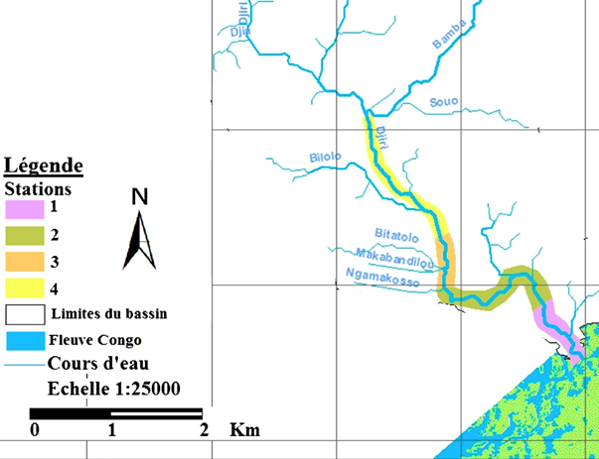
Figure 1: Map of Study area (Mikia et al., 2018)
The climate is of the Lower Congo type and corresponds to Aw4 according to the Köppen classification (Beck and Mahony, 2018). The main characteristic is the alternation of a long rainy season, marked by heavy rainfall and high data, and a dry season (from June to September), with almost no rainfall and mild temperatures (Figure 2). The wettest months are March, April, November, and December.
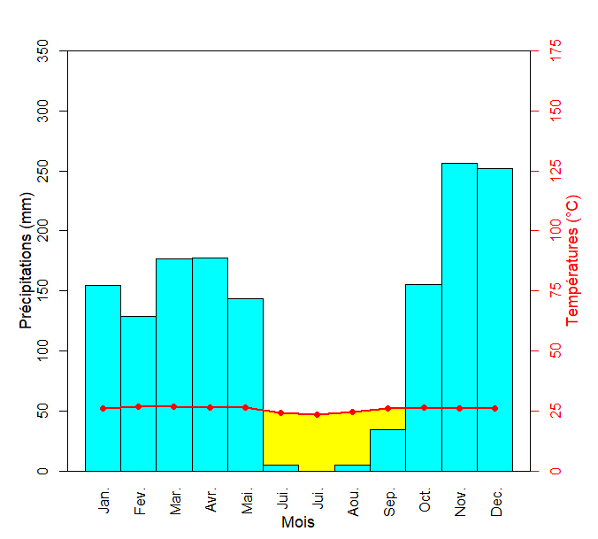
Figure 2: Ombrothermic diagram of Brazzaville (data source: ANAC, 2022)
According to local chorology, the Djiri flora develops in the Léfini district, the Congo-Zambezian transition zone, the Lower Guinea region, and the regional center of Guinea-Congo endemism (Kimpouni et al., 1992). The geological substrate is represented by (i) the Mesozoic Stanley Pool series and (ii) the Cenozoic polymorphic sandstone or Batéké sandstone series. The soils are (i) moderately organic hydromorphic to acidic anmoor soils on sandy material and (ii) highly desaturated yellow psammitic ferralitic soils found on plateau and hill slopes (Denis, 1974).
2.2 Biological Material
The biological material consists of fish and tracheophytes recorded in the Djiri River's main channel and bed. For the flora, the classification adopted is based on APG IV (2016) for spermatophytes and PPG I (2016) for pteridophytes. The taxonomic nomenclature is in accordance with Lebrun and Stork (1991-2015).
The different fish species are presented according to the evolutionary order (from least evolved to most evolved) proposed by Lévêque and Paugy (2006) and updated by FishBase (2025).
Plant taxa have been classified according to diaspore types (TD) and biological types. The diaspore types are those defined by Dansereau and Lems (1957), namely: Ballochore [(Ballo): diaspores expelled by the plant itself]; Barochore [(Baro): dry or fleshy, heavy diaspores]; Desmochore [(Desmo): clinging or adhesive diaspores]; Pogonochore [(Pogono): diaspores with feathery or silky appendages, pappus-like hairs]; Pleochore [(Pleo): diaspores equipped with a flotation device]; Pterochore [(Ptero): diaspores with wing-like appendages]; Sarcochore [(Sarco): diaspores totally or partially fleshy]; Sclerochores [(Sclero): relatively light, non-fleshy diaspores]; Sporochores [(Sporo): very small diaspores].
The biological types (BT) are those of Raunkiaer (1934), adapted by Lebrun (1947) for tropical regions, namely: Phanerophytes (Ph: trees, shrubs and bushes, lianas), Chamaephytes (Ch: subshrubs), Hemicryptophytes (Hc: perennial herbaceous plants), Geophytes (Ge: plants with tubers, rhizomes or bulbs), Therophytes (Th: annual plants), and Hydrophytes (Hydro: aquatic plants).
2.3 Data Collection
2.3.1 Sampling Device
Data collection was carried out within a sampling design consisting of three contiguous stations of varying sizes, located on the lower reaches of the Djiri River (Figure 1). The stations were delineated according to vegetation type. Thus, following the definition of Descoings (1969, 1975), station 1 is characterized by an aquatic grassland, station 2 by a forest-savanna mosaic, and station 3 by a riparian forest.
2.3.2 Site Descriptions
- Station 1
Station 1 is located in an area of ​​aquatic grassland formation where the following communities are found:
- an aquatic meadow with Echinochloa stagnina, followed by communities of Vossia cuspidata and Cyperus papyrus.
- a free-floating grassland composed of a community of Salvinia nymphellula, associated with Azolla pinnata subsp. africana and Eicchornia crassipes;
- a fixed floating grassland composed of a community of Nymphaea lotus and Ipomoea aquatica.
- Station 2
Station 2 is located in a forest-savannah mosaic where, on the edge, Vossia cuspidata, Hyparrhenia diplandra and Imperata cylindrica dominate with companion species Alchornea cordifolia, Anthocleista liebrechtsiana, Raphia vinifera, Bridelia ripicola, Dupineta brazzae. The herbaceous layer is made up of Vossia cuspidata, Acroceras zizanioides, Aframomum giganteum, Nephrolepis biserrata, Scleria racemosa and Lasimorpha senegalensis.
- Station 3
Station 3 is located in a riparian forest area dominated by a community of Symphonia globulifera, with the following companion species: Pentachletra eetveldeana, Anthocleista liebrechtsiana, and Millettia laurentii. The shrub layer is composed of Maprounea africana, Alchornea cordifolia, Bridelia ripicola, and Eremospatha laurentii. The herbaceous layer is composed of Acroceras zizanioides, Aframomum giganteum, Nephrolepis bisserata, Scleria racemosa, and Lasimorpha senegalensis.
2.3.3 Floristic and Faunistic Inventory
The floristic inventory followed a qualitative method in which only the presence of a species at each site was recorded (Miabangana et al., 2016). Species were identified in situ for the most common species, and a reference herbarium, deposited at the National Herbarium (IEC) located at National Institute for Research in Exact and Natural Sciences 5IRSEN) in Brazzaville, was created for the authentication and identification of specimens of species that could not be identified in the field.
Fish populations were sampled using various methods such as and fishing gear: cast nets, gillnets, longlines, and dip nets. Captured fish were immediately placed in a jar containing 10% formalin for fixation and then transferred the following day to 5% formalin or 70% alcohol for preservation. Specimens were identified the next day in the laboratory using identification keys appropriate for each species.
2.3.4 Physicochemical Parameters of the Water
The choice of environmental descriptors is based on existing knowledge of the relationship between the environment and fish populations (Samba Diouf, 1996).
During each fishing campaign, the following parameters were measured in situ: water temperature, using a thermometer integrated into a conductivity meter; conductivity, using an Eutech conductivity meter; pH, using an Eutech pH meter; dissolved oxygen, using an Eutech oxygen meter; turbidity and TDS, using a Hanna turbidimeter; and transparency, using a 30 cm diameter Secchi disk.
2.4 Data Processing
- Floristic and Ecological Spectra
A spectrum is a description of the elementary syntaxon based on various classifications. The raw spectrum (RS) takes into account the number of species belonging to a given category or classification. The raw spectrum is given in the followed formula (De Foucault, 1995):
$$\text{SB (\%) =}\frac{Number of species per category}{Total number of species}\text{ × 100}$$ | (1)
Szymkiewicz Specific Quotient (I)
The Szymkiewicz specific quotient is given as formula by Evrard (1968).
$$\text{I = }\frac{\text{Sp}}{\text{G}}$$ | (2)
where Sp = number of species and G = number of genera.
Pteridophyte Quotient (PQt)
$$\text{QPt = }\frac{Number of Pteridophytes}{Number of Spermatophytes}\text{ × 100}$$ | (3)
Jaccard Dissimilarity (Legendre and Legendre, 1998)
Knowledge of the Jaccard dissimilarity (Dj) allows us to verify whether two groups belong to the same large set. When Dj is less than 50%, the two groups belong to the same plant community, and if applicable (less than 50%), the two samples belong to the same community.
$$\text{Dj (\%) = }\left[1 - \left(\frac{\text{C}}{\text{A + B - C}}\right)\right]\text{ × 100}$$ | (4)
with A = number of species in the first group, B = number of species in the second group,
C = number of species common to both groups.
Hierarchical cluster analysis (HCA) based on Jaccard dissimilarity was performed using the R software (Vegan package 2.6-4) for the different sites to identify similarities in their floristic composition.
- Relationship between plant communities and fish distribution
To assess the relationship between plant communities and fish distribution, a Venn diagram was first created. Next, a list of species specific to each plant community was compiled. Finally, this link was evaluated using a Multiple Factor Analysis (MFA) of plant functional traits and the diversity of fish exclusive to certain communities.
3. RESULTS
3.1 Characteristics of Plant Communities
3.1.1 Taxonomic and Floristic Data
The floristic inventory identified 63 species distributed across 60 genera, 31 families, 20 orders, and 2 classes (Tables 1 and 2).
Table 1: Synopsis of taxonomic data
Stations | Orders | Families | Genera | Species
Station 1 | 8 | 12 | 21 | 22
Station 2 | 15 | 21 | 45 | 46
Station 3 | 13 | 20 | 26 | 27
Mean ± SE | 12 ± 3,61 | 17,67 ± 4,93 | 30,67 ± 12,66 | 31,67 ± 12,66
Total | 20 | 31 | 60 | 63
Table 2: Floristic and ecological data of the Djiri
BT: Biological types; Ph: Phanerophytes; Ch: Chamaephytes; Hc: Hemicryptophytes; Ge: Geophytes; Th: Therophytes; Hydro: Hydrophytes; DT: Diasporas types
Taxa |  |  |  | BT | DT | Stations
Classes | Orders | Families | Genera and species | BT | DT | 1 | 2 | 3
Equisetopsida | Alismatales | Araceae | Cercestis congensis Engl. | Ph | Sarco |  | ++
Equisetopsida | Alismatales | Araceae | Lasimorpha senegalensis Schott | Ge | Sarco |  | ++ | ++
Equisetopsida | Arecales | Arecaceae | Elaeis guineensis Jacq. | Ph | Sarco |  | ++ | ++
Equisetopsida | Arecales | Arecaceae | Eremospatha laurentii De Wild. | Ph | Sarco |  | ++ | ++
Equisetopsida | Arecales | Arecaceae | Raphia vinifera P.Beauv. | Ph | Sarco |  | ++
Equisetopsida | Asterales | Asteraceae | Bidens pilosa L. | Th | Desmo |  | ++
Equisetopsida | Asterales | Asteraceae | Chromolaena odorata (L.) R.M.King & H.Rob. | Ch | Pogono |  | ++ | ++
Equisetopsida | Asterales | Asteraceae | Erigeron floribundus (Kunth) Sch.Bip. | Th | Pogono |  | ++
Equisetopsida | Asterales | Asteraceae | Vernonia perrottetii Sch.Bip. | Th | Pogono |  | ++
Equisetopsida | Brassicales | Caricaceae | Carica papaya L. | Ph | Sarco |  | ++
Equisetopsida | Caryophyllales | Polygonaceae | Polygonum lanigerum R.Br. | Th | Pléo | ++
Equisetopsida | Caryophyllales | Polygonaceae | Persicaria sp. | Th | Pléo | ++
Equisetopsida | Commelinales | Commelinaceae | Commelina diffusa Burm.f. | Hc | Scléro | ++ | ++ | ++
Equisetopsida | Commelinales | Pontederiaceae | Eichhornia crassipes (Mart.) Solms | Hydro | Pléo | ++
Equisetopsida | Fabales | Fabaceae | Millettia laurentii De Wild. | Ph | Ballo |  |  | ++
Equisetopsida | Fabales | Fabaceae | Pentaclethra eetveldeana De Wild. & T.Durand | Ph | Ballo |  |  | ++
Equisetopsida | Gentianales | Apocynaceae | Alstonia boonei De Wild. | Ph | Pogono |  |  | ++
Equisetopsida | Gentianales | Gentianaceae | Anthocleista liebrechtsiana De Wild. & T.Durand | Ph | Sarco | ++ | ++ | ++
Equisetopsida | Gentianales | Rubiaceae | Mitragyna stipulosa (DC.) Kuntze | Ph | Sarco |  | ++ | ++
Equisetopsida | Laurales | Lauraceae | Persea americana Mill. | Ph | Sarco |  |  | ++
Equisetopsida | Magnioliales | Annonaceae | Annona senegalensis Pers. | Ph | Sarco |  | ++
Equisetopsida | Malpighiales | Clusiaceae | Symphonia globulifera L.f. | Ph | Sarco |  |  | ++
Equisetopsida | Malpighiales | Euphorbiaceae | Alchornea cordifolia (Schumach. & Thonn.) Müll.Arg. | Ph | Sarco |  | ++ | ++
Equisetopsida | Malpighiales | Euphorbiaceae | Manihot esculenta Crantz | Ph | Ballo |  | ++ | ++
Equisetopsida | Malpighiales | Euphorbiaceae | Manihot glaziovii Müll.Arg. | Ph | Ballo |  | ++ | ++
Equisetopsida | Malpighiales | Euphorbiaceae | Maprounea africana Müll.Arg. | Ph | Ptéro |  |  | ++
Equisetopsida |  | Passifloraceae | Passiflora foetida L. | Ph | Sarco |  | ++
Equisetopsida |  | Phyllanthaceae | Bridelia ripicola J.Léonard | Ph | Sarco |  | ++ | ++
Equisetopsida |  | Phyllanthaceae | Hymenocardia acida Tul. | Ph | Ptéro |  | ++
Equisetopsida |  | Phyllanthaceae | Uapaca heudelotii Baill. | Ph | Sarco |  | ++
Equisetopsida | Malvales | Malvaceae | Clappertonia ficifolia (Willd.) Decne. | Ph | Sarco |  | ++ | ++
Equisetopsida | Malvales | Malvaceae | Triumfetta cordifolia A.Rich. | Ph | Desmo |  | ++ | ++
Equisetopsida | Malvales | Malvaceae | Urena lobata L. | Ch | Desmo |  | ++
Equisetopsida | Myrtales | Melastomataceae | Dupineta brazzae (Cogn.) Veranso-Libalah & G. Kadereit | Ch | Sarco |  | ++
Equisetopsida | Myrtales | Onagraceae | Ludwigia sp. | Ch | Scléro |  |  | ++
Equisetopsida | Nymphaeales | Ceratophyllaceae | Ceratophyllum submersum L. | Hydro | Pléo | ++
Equisetopsida | Nymphaeales | Nymphaeaceae | Nymphaea lotus L. | Hydro | Pléo | ++
Equisetopsida | Poales | Cyperaceae | Cyperus papyrus L. | Ge | Scléro | ++
Equisetopsida | Poales | Cyperaceae | Kyllinga erecta Schumach. | Ge | Scléro | ++ | ++ | ++
Equisetopsida | Poales | Cyperaceae | Rhynchospora corymbosa (L.) Britton | Ge | Scléro |  | ++
Equisetopsida | Poales | Cyperaceae | Scleria racemosa Poir. | Hc | Scléro | ++ | ++
Equisetopsida | Poales | Poaceae | Acroceras zizanioides (Kunth) Dandy | Hc | Scléro | ++ | ++ | ++
Equisetopsida | Poales | Poaceae | Bambusa vulgaris Schrad. ex J.C.Wendl. | Ph | Scléro |  | ++
Equisetopsida | Poales | Poaceae | Brachiaria sp. | Th | Scléro | ++ | ++
Equisetopsida | Poales | Poaceae | Digitaria brazzae (Franch.) Stapf | Ch | Sarco | ++ | ++
Equisetopsida | Poales | Poaceae | Echinochloa stagnina (Retz.) P.Beauv. | Ge | Scléro | ++ | ++
Equisetopsida | Poales | Poaceae | Hyparrhenia diplandra (Hack.) Stapf | Hc | Scléro |  | ++
Equisetopsida | Poales | Poaceae | Imperata cylindrica (L.) Raeusch. | Ge | Pogono |  | ++
Equisetopsida | Poales | Poaceae | Loudetia arundinacea (Hochst. ex A.Rich.) Steud. | Hc | Scléro |  | ++
Equisetopsida | Poales | Poaceae | Panicum maximum Jacq. | Hc | Scléro |  | ++
Equisetopsida | Poales | Poaceae | Paspalum vaginatum Sw. | Ge | Scléro | ++ | ++ | ++
Equisetopsida | Poales | Poaceae | Setaria sulcata Raddi | Hc | Scléro | ++
Equisetopsida |  |  | Trachypogon spicatus (L.f.) Kuntze | Hc | Scléro |  | ++
Equisetopsida |  |  | Vossia cuspidata (Roxb.) Griff. | Hc | Scléro | ++ | ++
Equisetopsida | Sapindales | Anacardiaceae | Mangifera indica L. | Ph | Sarco |  | ++
Equisetopsida | Solanales | Convolvulaceae | Ipomoea aquatica Forssk. | Hydro | Sarco | ++
Equisetopsida | Solanales | Convolvulaceae | Ipomoea mauritiana Jacq. | Ge | Sarco |  | ++
Equisetopsida | Zingiberales | Zingiberaceae | Aframomum giganteum (Oliv. & D.Hanb.) K.Schum. | Ge | Sarco |  | ++ | ++
Polypodiopsida | Polypodiales | Nephrolepidaceae | Nephrolepis biserrata (Sw.) Schott | Ge | Sporo | ++ | ++ | ++
Polypodiopsida | Polypodiales | Polypodiaceae | Microsorum scolopendria (Burm.f.) Copel. | Ge | Sporo |  | ++ | ++
Polypodiopsida | Polypodiales | Thelypteridaceae | Cyclosorus striatus (Schumach.) Ching | Ge | Sporo | ++ | ++ | ++
Polypodiopsida | Salviniales | Salviniaceae | Azolla pinnata subsp. africana (Desv.) R.M.K.Saunders & K.Fowler | Hydro | Sporo | ++
Polypodiopsida | Salviniales | Salviniaceae | Salvinia nymphellula Desv. | Hydro | Sporo | ++
3.1.3 Floristic Spectra and Diaspores
Within Station 1 (Figure 3A), the Poaceae family represents 31.82% of the species richness. This family is followed by the Cyperaceae (13.63%), and the Polygonaceae and Salviniaceae (9.09% each). The other families each account for less than 5% of the species richness.
In Station 2 (Figure 3B), the predominant family is the Poaceae, with 26.09% of the species. The Poaceae are followed by the Asteraceae (8.70%), then the Arecaceae, Cyperaceae, Euphorbiaceae, Malvaceae, and Phyllanthaceae, each representing 6.52% of the recorded species. The remaining families each represent less than 5% of the species richness.
In station 3 (Figure 3C), Euphorbiaceae dominate, representing 14.81% of the recorded species. Fabaceae, Malvaceae, Arecaceae, and Poaceae follow, each accounting for 7.41% of the species richness. The remaining families each contribute less than 4%.
Figure 3: Spectra of plant families in the flora
A: Station 1; B: Station 2; C: Station 3
The biological spectrum of the vascular flora of the Djiri River (Figure 4) highlights a relative dominance of phanerophytes (39.68%) in the study area. Phanerophytes are followed by geophytes (19.05%), hemicryptophytes (14.29%), hydrophytes and therophytes (9.52% each), and chamaephytes (7.94%). Within the stations, phanerophytes remain dominant in the second and third stations, while hydrophytes are the dominant species in the first station.

Figure 4: Biological Spectra
The diaspore spectrum of the Djiri River flora (Figure 5) highlights a relative dominance of sarcochores (34.72%) in the study area. This indicates a primarily endozoochoric dispersal of diaspores. Sarcochores are followed by sclerochores (26.98%), as well as pleochores, pogonochores, and sporochores (7.94% each). The other diaspore types represented less than 7% of the species richness. Sarcochores remain dominant in stations 2 and 3, while sclerochores dominated station 1.

Figure 5: Diaspore Spectra
3.1.4 Pteridophyte and Szymkiewicz Quotients
Between stations, the pteridophyte quotient varied from 6.98 to 22.22%, while the Szymkiewicz quotient varies from 1.02 to 1.05 (Table 3).
Table 3: Values ​​of the pteridophyte and Szymkiewicz quotients
Quotients | S1 | S2 | S3 | Average ± ET | Study area
Pteridophyte (%) | 22,22 | 06,98 | 12,50 | 13,90 ± 7,72 | 08,62
Szymkiewicz | 01,05 | 01,02 | 01,04 | 01,04 ± 0,01 | 01,05
3.1.5 β Diversity
Analysis of the dendrogram based on Jaccard dissimilarity (Figure 8) revealed a strong floristic dissimilarity among the different surveyed sites. This indicates a diversity of plant communities within the study area.
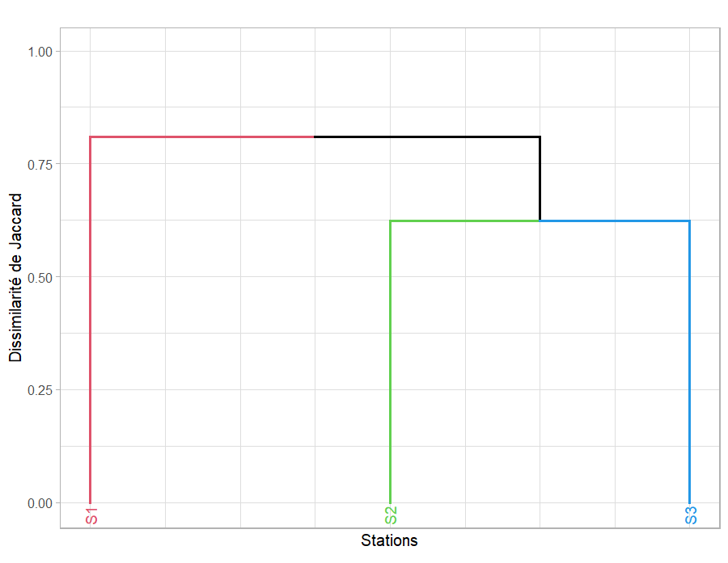
Figure 8: Dendrogram of affinity of the different stations
3.2 Fish diversity
The fish inventory identified 99 species belonging to 57 genera and 23 families. The results of this inventory are recorded in Table 4.
Table 4: List of fish species recorded in the Djiri River
Families | Genera and species | Habitat | Feeding regime
PROTOPTERIDAE | Protopterus dolloï Boulenger, 1900 | Forest areas | Omnivorous
POLYPTERIDAE | Polypterus ansorgii Boulenger, 1910 | Flooded forest areas | Entomophagous
POLYPTERIDAE | Polypterus mokelembembe Schliewen & Schafer, 2006 | Flooded forest areas | Entomophagous
POLYPTERIDAE | Polypterus congicus Poll, 1954 | Flooded forest areas | Entomophagous
ARAPAIMIDAE | Heterotis niloticus (Cuvier, 1829) | Forest areas | Omnivorous
PANTODONTIDAE | Pantodon buchholzi Peters, 1877 | Flooded forest areas | Entomophagous
NOTOPTERIDAE | Xenomystus nigri (Gunther, 1862) | Flooded forest areas | Entomophagous
MORMYRIDAE | Cyphomyrus macrops (Boulenger, 1909) | Flooded forest areas | Larvivore
MORMYRIDAE | Gnathonemus petersii (Günther, 1862) | Flooded forest areas | Larvivore
MORMYRIDAE | Hippopotamyrus weeksii (Boulenger, 1902) | Flooded forest areas | Larvivore
MORMYRIDAE | Marcusenius greshoffii (Schilthuis, 1891) | Main course | Bottom feeder
MORMYRIDAE | Marcusenius kutuensis (Boulenger, 1899) | Main course | Bottom feeder
MORMYRIDAE | Marcusenius macrolepidotus (Boulenger, 1905) | Main course | Bottom feeder
MORMYRIDAE | Marcusenius moorii (Gunther, 1867) | Main course | Bottom feeder
MORMYRIDAE | Marcusenius schilthuisae (Boulenger, 1899) | Main course | Bottom feeder
MORMYRIDAE | Marcusenius stanleyanus (Boulenger, 1897) | Main course | Bottom feeder
MORMYRIDAE | Mormyrus ovis Boulenger, 1898 | Main course | Entomophagous
MORMYRIDAE | Petrocephalus balayi Sauvage, 1898 | Main course | Entomophagous
MORMYRIDAE | Petrocephalus christyi Boulenger, 1920 | Main course | Entomophagous
MORMYRIDAE | Petrocephaus microphthalmus Pellegrin, 1908 | Main course | Entomophagous
MORMYRIDAE | Petrocephaus simus Sauvage, 1879 | Main course | Larvivore
MORMYRIDAE | Petrocephalus sp. | Main course | Larvivore
MORMYRIDAE | Pollimyrus nigripinnis (Boulenger, 1899) | Main course | Larvivore
DOROSOMATIDAE | Odaxothrissa losera Boulenger, 1899 | Main course | Entomophagous
DOROSOMATIDAE | Pellonula leonensis Boulenger, 1916 | Main course | Entomophagous
DOROSOMATIDAE | Pellonula vorax Günther, 1868 | Main course | Entomophagous
PHRACTOLAEMIDAE | Phractolaemus ansorgii (Boulenger, 1901) | Main course | Detritivore
CYPRINIDAE | Clypeobarbus matthesi Poll & Gosse, 1962 | Main course | Omnivorous
CYPRINIDAE | Enteromius stanleyi Poll & Gosse, 1974 | Main course | Omnivorous
CYPRINIDAE | Enteromius sp. | Main course | Omnivorous
CYPRINIDAE | Labeo lineatus Boulenger, 1898 | Forest areas | Detritivore
CYPRINIDAE | Labeo sp. | Forest areas | Detritivore
CYPRINIDAE | Leptocypris weeksii (Boulenger, 1899) | Main course | Planktophagous
CYPRINIDAE | Raïmas buchholzi (Peters, 1877) | Main course | Planktophagous
CYPRINIDAE | Raïmas christyi Boulenger, 1920 | Main course | Planktophagous

Table 4: List of fish species recorded in the Djiri (continued 1)
Families | Genera and species | Habitat | Feeding regime
HEPSETIDAE | Hepsetus odoe (Bloch, 1794) | Forest areas | Ichtyophage
ALESTIDAE | Alestes liebrechtsii Boulenger, 1898 | Main course | Eclectic
ALESTIDAE | Bathyaethiops caudomaculatus (Pellegrin, 1925) | Main course
ALESTIDAE | Bathyaethiops greeni Fowler, 1949 | Main course
ALESTIDAE | Brachypetersius altus (Boulenger, 1899) | Main course
ALESTIDAE | Brachyalestes comptus (Roberts & Stewart, 1976) | Main course
ALESTIDAE | Brachyalestes imberi Peters, 1852 | Main course | Eclectic
ALESTIDAE | Brycinus macrolepidotus (Valenciennes, 1849) | Main course | Eclectic
ALESTIDAE | Brycinus poptae Pellegrin, 1906 | Main course | Eclectic
ALESTIDAE | Bryconaethiops boulengeri Pellegrin, 1900 | Flooded forest areas | Eclectic
ALESTIDAE | Bryconaethiops microstoma Günther, 1873 | Flooded forest areas | Eclectic
ALESTIDAE | Alestopetersius tumbensis (Hoedeman, 1951) | Flooded forest areas | Zooplancto-phagous
ALESTIDAE | Hydrocinus vittatus (Castelnau, 1861) | Main course | Ichtyophage
ALESTIDAE | Micralestes acutidens (Peters, 1852) | Flooded forest areas | Zooplancto-phagous
ALESTIDAE | Micralestes stormsi Boulenger, 1902 | Flooded forest areas | Zooplancto-phagous
ALESTIDAE | Phenacogrammus interruptus (Boulenger, 1899) | Flooded forest areas | Entomo-phagous
CITHARINIDAE | Citharinus gibbosus Boulenger, 1899 | Flooded meadow | Plankto-phagous
CITHARINIDAE | Citharinus latus Müller & Troschel, 1845 | Flooded meadow | Plankto-phagous
CITHARINIDAE | Citharinus macrolepis Boulenger, 1899 | Flooded meadow | Plankto-phagous
DISTICHODONTIDAE | Belonophago hutsebauti Giltay, 1929 | Flooded forest areas | Ichtyophage
DISTICHODONTIDAE | Distichodus affinis Günther, 1873 | Flooded forest areas | Phytopha-gous
DISTICHODONTIDAE | Distichodus altus Boulenger, 1899 | Flooded forest areas | Phytopha-gous
DISTICHODONTIDAE | Distichodus antonii Schilthuis, 1891 | Flooded forest areas | Phytopha-gous
DISTICHODONTIDAE | Distichodus atroventralis Boulenger, 1898 | Flooded forest areas | Phytopha-gous
DISTICHODONTIDAE | Distichodus lusosso Schilthuis, 1891 | Flooded forest areas | Phytopha-gous
DISTICHODONTIDAE | Distichodus noboli Boulenger, 1899 | Flooded forest areas | Phytopha-gous
DISTICHODONTIDAE | Distichodus sexfasciatus Boulenger, 1897 | Flooded forest areas | Phytopha-gous
DISTICHODONTIDAE | Eugnathichthys macroterolepis Boulenger, 1899 | Forest areas | Entomo-phagous
DISTICHODONTIDAE | Ichtyborus ornatus (Boulenger, 1899) | Forest areas | Ichtyophage
DISTICHODONTIDAE | Mesoborus crocodilus Pellegrin, 1900 | Forest areas | Ichtyophage
DISTICHODONTIDAE | Nannocharax schoutedeni Poll, 1939 | Forest areas | Entomo-phagous
DISTICHODONTIDAE | Phago boulengeri Schilthuis, 1891 | Forest areas | Entomo-phagous

Table 4: List of fish species recorded in the Djiri (end)
Families | Genera and species |  | Habitat | Feeding regime
CLAROTEIDAE | Auchenoglanis occidentalis (Valenciennes, 1840) |  | Shallow areas | Omnivorous
CLAROTEIDAE | Chrysichthys ornatus Boulenger, 1902 |  | Flooded forest areas | Omnivorous
CLAROTEIDAE | Chrysichthys punctatus Boulenger, 1899 |  | Flooded forest areas | Omnivorous
CLAROTEIDAE | Chrysichthys thonneri Steindachner, 1912 |  | Flooded forest areas | Omnivorous
CLAROTEIDAE | Parauchenoglanis punctatus (Sauvage, 1879) |  | Flooded forest areas | Detritivore
SCHILBEIDAE | Parailia congica Boulenger, 1899 |  | Main course | Entomophagous
SCHILBEIDAE | Pareutropius debauwi (Boulenger, 1900) |  | Main course | Eclectic
SCHILBEIDAE | Schilbe intermedius Rüppell, 1832 |  | Main course | Eclectic
SCHILBEIDAE | Schilbe mystus (Linnaeus, 1758) |  | Main course | Eclectic
SCHILBEIDAE | Schilbe marmoratus Boulenger, 1911 |  | Forest areas | Eclectic
CLARIIDAE | Channallabes apus (Gunther, 1873) |  | Flooded forest areas | Omnivorous
CLARIIDAE | Clarias gariepinus (Buchell, 1822) |  | Flooded forest areas | Omnivorous
CLARIIDAE | Clarias sp. |  | Flooded forest areas | Omnivorous
MALAPTERURIDAE |  | Malapterurus electricus Lacépède, 1803 | Forest areas | Ichtyophage
MOCHOKIDAE |  | Synodontis alberti, Schilthuis, 1891 | Flooded forest areas | Detritivore
 |  | Synodontis congicus Poll, 1971 | Flooded forest areas | Detritivore
 |  | Synodontis contractus Vinciguerra, 1928 | Flooded forest areas | Detritivore
 |  | Synodontis flavitaeniatus Boulenger, 1919 | Flooded forest areas | Detritivore
 |  | Synodontis nigriventris David, 1936 | Flooded forest areas | Detritivore
 |  | Synodontis nummifer Boulenger, 1899 | Flooded forest areas | Detritivore
 |  | Synodontis schoutedeni David, 1936 | Flooded forest areas | Detritivore
 |  | Synodontis sp. | Flooded forest areas | Detritivore
MASTACEMBELIDAE |  | Mastacembellus congicus Boulenger, 1916 | Main course | Larvivore
CICHLIDAE |  | Hemichromis elongatus (Guichenot, 1859) | Flooded meadow | Malacophagus
 |  | Hemichromis stellifer Loiselle, 1979 | Flooded meadow | Malacophagus
 |  | Pelmatochromis nigrofasciatus (Pellegrin, 1900) | Flooded meadow | Malacophagus
 |  | Coptodon tholloni (Sauvage, 1884) | Flooded meadow | Phytophagous
 |  | Coptodon zillii (Gervais, 1848) | Flooded meadow | Phytophagous
 |  | Tylochromis lateralis (Boulenger, 1898) | Flooded meadow | Omnivorous
ANABANTIDAE |  | Ctenopoma nebulosum (Norris & Teugels, 1990) | Shaded forest areas | Insectivorous
CHANNIDAE |  | Parachanna insignis (Günther, 1861) | Forest areas | Ichtyophage
TETRAODONTIDAE |  | Tetraodon miurus Boulenger, 1902 | Main course | Malacophagus
3.3 Relationship between plant communities and fish distribution
Figure 6 shows that out of a total of 99 fish species, 22 are specific to the aquatic meadow, 5 to the forest-savanna mosaic, and 3 to the riparian forest. The aquatic meadow and the forest-savanna mosaic share 15 species. This figure is 7 and 4 respectively between the riparian forest and the aquatic meadow, and then between the riparian forest and the forest-savanna mosaic. The three communities share 42.86% of the species richness. The species specific to the riparian forest are Clarias sp., Distichodus altus and Distichodus atroventralis. Belonophago hutsebauti, Cytharinus macrolepis, Duboisalestes tumbensis, Ponthodon buccholzi and Synodontis schoutedeni are specific to the forest-savannah mosaic. Auchenoglanis occidentalis, Barbus stanleyi, Citharinus latus, Ctenopoma nebulosum, Clypeobarbus sp., Cyphomyrus macrops, Distichodus antonii, Distichodus notospilus, Distichodus sexfasciatus, Eugnathichthys macroterolepis, Heterotis niloticus, Labeo lineatus, Labeo sp., Polypterus ansorgei, Polypterus palmas, Petrocephalus simus, Synodontis alberti, Synodontis congicus, Synodontis flavitaeniatus, Schilbe mystus, Synodontis nummifer and Synodontis sp. are specific to aquatic meadows.
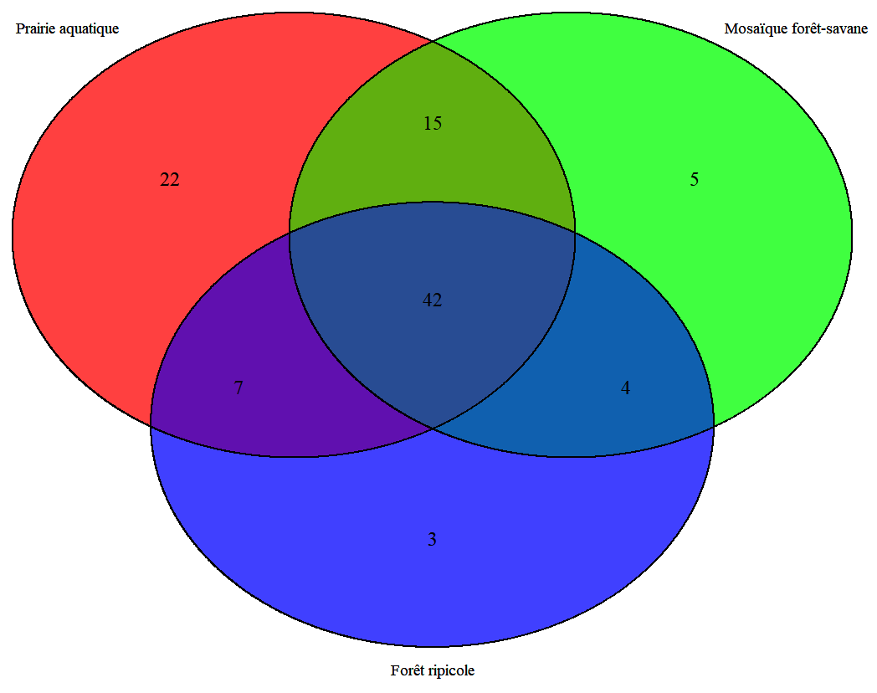
Figure 6: Venn diagram of fish species richness as a function of plant communities
Figure 7 shows that environmental parameters and fish diversity allow us to classify the different plant communities studied.
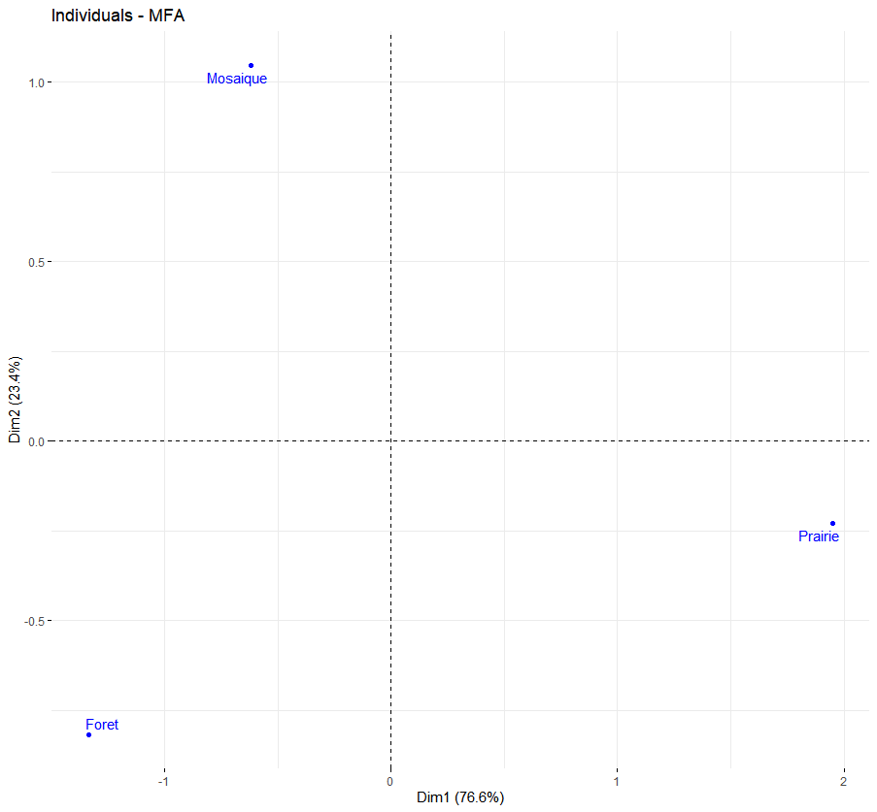
Figure 7: Multiple factor analysis of plant communities
Thus, the additional analysis provided by Figure 8 allows us to distinguish three groups of fish. The group with the highest number of species is primarily associated with the aquatic meadow where turbidity, temperature, pH, and oxygen levels appear to be significantly higher. The second group, associated with the forest-savanna mosaic, is linked to varying TDS values ​​and consists of species such as Ponthodon buccholzi, Belonophago hutsebauti, Brycinus imberi, Brycinus poptae, Barbus sp., Cytharinus macrolepis, Duboisalestes tumbensis, Hemichromis bimaculatus, Hepsetus odoe, Malapterurus electricus, Schilbe marmoratus, Synodontis schoutedeni, and Tilapia tholloni. The third group, linked to the riparian forest, consists of species associated with slightly higher conductivity values, such as Bathyaethiops greeni, Barbus matthesi, Clarias sp., Distichodus altus, Distichodus atroventralis, Parachanna insignis, Parauchenoglanis punctatus, Sarotherodon boulengeri and Tetraodon miurus.
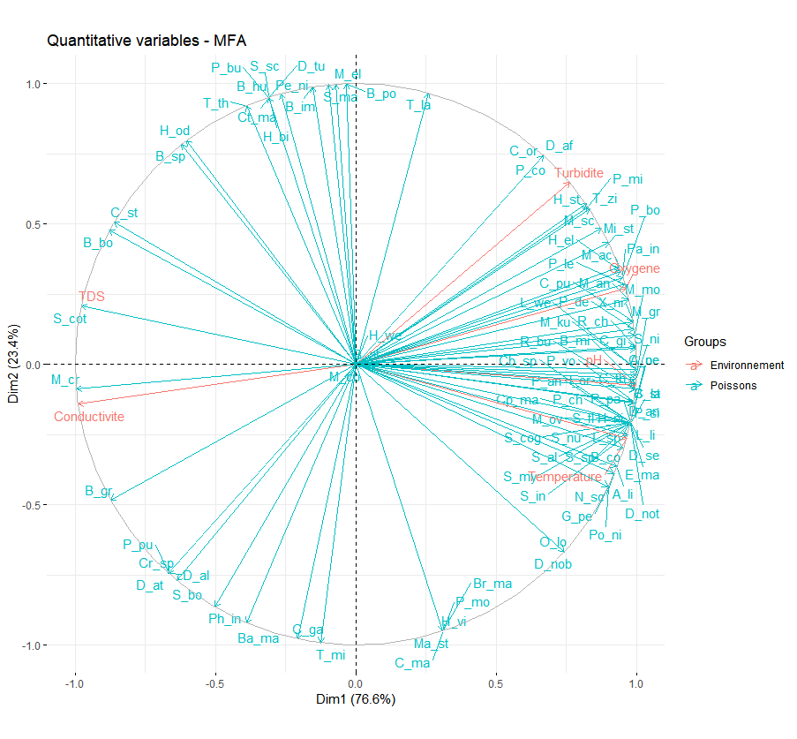
Figure 8: Multiple Factor Analysis of Variables
4. DISCUSSION
4.1 Floristic Diversity
The floristic data link the lower reaches of the Djiri River to other lotic ecosystems in the Guinea-Congo region (Ouattara et al., 2017; Tchinda et al., 2018). Regarding station 3, characterized by a riparian woodland, the dominance of Euphorbiaceae, Fabaceae, and Malvaceae suggests similarities to the forests of the Congo Basin (Kimpouni et al., 2018). The sites investigated in the Djiri region exhibit different floristic compositions, thus highlighting the existence of more than one plant community. Since the climate is likely the same across the study area, the differences in floristic composition could be due to edaphic factors.
The Szymkiewicz quotient highlights the degree of isolation and the conditions under which a plant community has evolved (Sonké, 1998). The values ​​of this quotient allow us to conclude that the Djiri flora has reached edaphic equilibrium and is no longer undergoing speciation (Miabangana et al., 2016). The dominance of Spermatophytes over Pteridophytes is consistent with studies conducted in Congo (Sita, 1980; Miabangana et al., 2016). Compared to the aforementioned studies, the pteridophyte quotient (PQt) was relatively higher in the Djiri River. The PQt value obtained indicates a good occurrence of spore-bearing tracheophytes in the study area. Being a river, the study area benefits from high humidity and moisture levels (Miabangana., 2016). et al This characteristic confirms the distribution of PQt within the stations.
The vascular flora of the Djiri River includes species linked to agricultural practices (Carica papaya, Persea americana, Manihot esculenta, M. glaziovii, and Mangifera indica) and ruderal species (Bidens pilosa, Chromolaena odorata, Triumfetta cordifolia, Urena lobata, and Paspalum vaginatum). The presence of these species is likely the result of deliberate or accidental anthropochory (Kimpouni et al., 2017).
Within the Djiri flora, biological spectra reveal three types of physiognomy. In station 1, the vegetation is herbaceous, while in station 3 it is woody. Station 2, a forest-savanna mosaic, is intermediate between the two other inventoried stations.
The regeneration of taxa or their diaspore dispersal is strongly linked to animals, and to a lesser extent, to wind and water. From a faunal perspective, dispersal is primarily carried out by fish in the aquatic meadow and along the banks (Mikia et al., 2018). Within the exposed wooded and herbaceous formations, zoochorous dispersal is linked to avian and mammalian fauna (Kimpouni et al., 2017). The high representation of pleochores and sporochores, although counterbalanced by sclerochores, within station 1 highlights a very pronounced hydrochory within this flora.
4.2 Diversity of the ichthyofauna
The study of the ichthyofauna showed that biodiversity is very high with 99 species of fish recorded, the ratio of the number of species to the number of families as defined by Whitfield (1994), which gave an idea of ​​the level of diversification reached within the families is also high (4.39). The Mormyridae family is the most diverse, representing 17% of all recorded species; it is followed by the Alestidae (14.9%), the Distichodontidae (10.7%), the Cyprinidae (8.5%), and the Mochokidae (7.5%). Since biological diversity was highly dependent on the prevailing ecological conditions in the studied systems, the species pool observed in an ecosystem is closely linked to current abiotic and biotic factors (Teugels et al., 1994). Biological diversity is also the legacy of a long evolutionary history of species and populations, within a climatic and geomorphological context that has also evolved (Teugels et al., 1994). According to Myers' classification (1951), of all these recorded fish species, three (3) belong to the group of peripheral fish, marine fish that have colonized continental waters (Odaxothrissa losera, Pellonula leonensis, Pellonula vorax); five (5) belong to the group of secondary fish, fish present in fresh water but which may occasionally spend some time in salt water (Hemichromis elongatus, Hemichromis stellifer, Tilapia tholloni, Tilapia sp, Tylochromis lateralis) and the other eighty-four to the group of so-called primary fish, fish strictly confined to fresh water.
4.3 Flora-fish fauna ecological relationship
The observed floristic heterogeneity between the aquatic meadow, the forest-savanna mosaic, and the riparian forest produces a mosaic of habitats and food webs that profoundly structures fish communities (Lévêque, 1999). Furthermore, aquatic plants also influence predator protection and the physicochemical conditions of the water (Thomaz and Cunha, 2010). In the Djiri, the aquatic meadow, dominated by macrophytes such as Echinochloa stagnina, Vossia cuspidata, Cyperus papyrus, Salvinia nymphellula and Eichhornia crassipes, is home to the greatest diversity of fish in the ecosystem. Macrophytes play a major structuring role by (i) increasing habitat complexity and creating micro-niches (Aloo et al., 2013), (ii) promoting the presence of aquatic invertebrates that serve as food for species such as Polypterus ansorgii, Polypterus congicus, Clarias gariepinus, Labeo lineatus, Synodontis alberti and Heterotis niloticus (Howard-Williams and Junk, 1976), (iii) providing spawning substrates for phytophilic fish such as Tilapia tholloni, Coptodon tholloni and Distichodus antonii (Aloo et al., 2013), and (iv) providing essential refuges for juveniles of Brycinus spp., Petrocephalus spp. and Marcusenius spp. (Welcomme, 1979). These facts explain the dominance of limnophilic species and species dependent on aquatic vegetation, confirming the role of the aquatic meadow as a hub of fish biodiversity. This phenomenon is consistent with observations made in African floodplains (Aloo et al., 2013).
The riparian forest, although floristically rich with species such as Symphonia globulifera, Pentaclethra eetveldeana, Anthocleista liebrechtsiana, and Millettia laurentii, exhibits lower fish diversity. This trend reflects shaded conditions where primary productivity is low. The fish observed, notably Clarias sp., Distichodus altus, and Distichodus atroventralis, demonstrate a specialization for low-light environments, as reported in other tropical forest systems (Daget et al., 1984–1991).
The forest-savanna mosaic occupies an intermediate position, both in terms of its vegetation structure, combining stands of Vossia cuspidata, Acroceras zizanioides, and Aframomum giganteum with woody plants such as Alchornea cordifolia and Bridelia ripicola, and in terms of its fish community. It supports generalist and transitional species, such as Belonophago hutsebauti, Citharinus macrolepis, Pantodon buchholzi, and Synodontis schoutedeni, characteristic of areas where open and semi-forest habitats overlap (Welcomme, 1979; Daget et al., 1984-1991). These intermediate habitats offer both structural niches and a diverse range of food sources, promoting the coexistence of limnophilic and semi-forest species.
CONCLUSION
This study identified 63 species distributed across 60 genera, 31 families, 20 orders, and 2 classes. Within this flora, the Poaceae, Asteraceae, Cyperaceae, and Euphorbiaceae families demonstrate an affinity with the riparian forests of tropical Africa. Although mature, the Djiri flora is largely dominated by seed-bearing Tracheophytes. However, the significant occurrence of spore-bearing Tracheophytes suggests a particular microclimate linked to the site's humidity. The strong floristic dissimilarity of the inventoried sites confirms the diversity of the original vegetation types.
Although belonging to the Guinea-Congo regional center of endemism, the flora of Djiri is disturbed, as evidenced by the very low rate of endemism recorded and the presence of allochthonous and naturalized taxa. However, the forest sites, climax communities in terms of phytochory, exhibit higher endemism than the herbaceous sites. This duality is also noted with regard to biological types, both diaspore and foliar. However, for these latter syntaxa, the respective dominance of phanerophytes, sarcochores, and mesophylls highlights the superior species richness of woody formations compared to that of herbaceous formations. Overall, the fish fauna of the Djiri is rich and highly diverse, with the Mormyridae family being the most diverse, representing 17% of all recorded species; it is followed by the Alestidae (14.9%) and the Distichodontidae (10.7%). These three families alone account for 32.6% of the species. In addition to the sheer number of species, the Djiri's flora provides favorable conditions for the primary consumers that constitute most of the species belonging to these three families. Certain frugivorous fish play an important role in the dispersal of diaspores, which gives rise to the forest-savanna mosaic. The presence of hydrophytes offers ideal living conditions for thousands of species, providing nurseries and camouflage, thus attracting numerous predators and leading to silent competition and predation in this aquatic environment.

REFERENCES
Aloo, P., Ojwang, W., Omondi, R., Njiru, J. M. & Oyugi, D. (2013). A review of the impacts of invasive aquatic weeds on the biodiversity of some tropical water bodies with special reference to Lake Victoria (Kenya). Biodiversity Journal, 4 (4), 471‑482.
Angiosperm Phylogeny Group. (2016). An update of the Angiosperm Phylogeny Group classification for the orders and families of flowering plants: APG IV. Botanical Journal of the Linnean Society, 181(1), 1-20. https://doi.org/10.1111/boj.12385
Beck, S., & Mahony, M. (2018). The IPCC and the new map of science and politics. Wiley Interdisciplinary Reviews: Climate Change, 9(6), e547. https://doi.org/10.1002/wcc.547
Chatelain, C., Kadjo, B., Koné, I., & Refisch, J. (2001). Relations Faune - Flore dans le Parc National de Taï : une étude bibliographique. Tropenbos - Côte d’Ivoire Abidjan. https://eref.uni-bayreuth.de/id/eprint/18953
Daget J., Gosse J.-P., Teugels G.G. & Thys van den Audenaerde D.F.E. (1984–1991). Check-list of the freshwater fishes of Africa (CLOFFA). ORSTOM & MRAC, 4 volumes.
Dansereau P. & Lems K. (1957). The grading dispersal types in plant communities and their ecological significance. Contrib. Inst. Bot. Univ. Montréal, 71, 52p.
De Foucault, B. (1995). A propos des concepts de spectre et de série spectrale en phytosociologie et lichénosociologie. Documents mycologiques, 25(3), 98-100. https://www.smnf.fr/les-documents-mycologiques/
Denis, B. (1974). Carte pédologique Brazzaville-Kinkala. Notice explicative n° 52. République Populaire du Congo à 1/200.000. ORSTOM. https://horizon.documentation.ird.fr/exl-doc/pleins_textes/pleins_textes_6/fdi_07274.html
Descoings, B. (1969). Esquisse phytogéographique du Congo. In Atlas du Congo. ORSTOM. https://horizon.documentation.ird.fr/exl-doc/pleins_textes/pleins_textes_6/fdi_01001/05197.pdf
Descoings, B. (1975). Les grandes régions naturelles du Congo. Candollea, 30, 91-120. https://www.e-periodica.ch/digbib/referencelist?query=Candollea+30+1975#
Évrard, C. (1968). Recherches écologiques sur le peuplement forestier des sols hydromorphes de la Cuvette centrale congolaise. Institut National pour l’Étude Agronomique du Congo Belge. (Série Scientifique, No. 110) https://books.google.com/books/about/Recherches_%C3%A9cologiques_sur_le_peupleme.html?id=2_0fAQAAIAAJ
Grenouillet, G., Pont, D., & Seip, K. L. (2002). Abundance and species richness as a function of food resources and vegetation structure: juvenile fish assemblages in rivers. Ecography, 25(6), 641-650. https://doi.org/10.1034/j.1600-0587.2002.250601.x
Kimpouni V., Lejoly J. & Lisowski S. (1992). Les Eriocaulaceae du Congo. Fragmenta Flor. Geobot., 37, 127-145.
Kimpouni, V., Mbouba, S.D. & Motom, M. (2017): Study of the allochthonous arboreal flora and urban forestry in Brazzaville (Congo). Journal Botanique de la Société Botanique de France 79, 73-92. https://www.persee.fr/doc/jobot_1280-8202_2017_num_79_1_2109.
Kimpouni, V., Nzila, J. D., Massamba-Makanda, C. M., Salisou, Y. M., & Kampe, J. P. (2018). Phytodiversité et paramètres de structure de la forêt péri-urbaine de la Djoumouna (Brazzaville - Congo). *International Journal of Innovation and Scientific Research*, *37*(1), 90-110. http://www.ijisr.issr-journals.org/abstract.php?article=IJISR-18-118-02
Lebrun, J. (1947). La végétation de la plaine alluviale au Sud du lac Édouard. Institut des Parcs Nationaux du Congo Belge, Mission J. Lebrun (1937-1938), Fascicule 1. https://bibdigital.rjb.csic.es/idurl/1/1757417
Lebrun J. (1960). Studies on the flora and vegetation of the lava fields north of Lake Kivu (Belgian Congo). Institute of National Parks of the Belgian Congo, J. Lebrun Mission (1937-1938), Fascicle 2, 352 p.
Lebrun, J. P., & Stork, A. L. (1991-2015). Énumération des plantes à fleur d’Afrique tropicale. Éditions des conservatoires et jardin botaniques de Genève. https://africanplantdatabase.ch
Legendre, P., & Legendre, L. (1998). Numerical ecology. Elsevier Science B.V. https://books.google.com/books/about/Numerical_Ecology.html?id=240_AQAAIAAJ
Lévêque, C., & Paugy, D. (2006). Les poissons des eaux continentales africaines. Diversité, écologie, utilisation par l’homme. IRD Éditions. https://www.irdeditions.com/catalogue/9782709920421 .
Mady-Goma Dirat I., Mikia M., Tsoumou A., & Vouidibio J. (2016). Ichthyofaunal Diversity of Komo River, tributary of Alima River, Congo Brazzaville. International Research Journal of Environment Sciences. 5(9), 1-9.
Miabangana, E. S., Lubini Ayingweu, C., & Malaisse, F. (2016). Analyse floristique et phytogéographique de la forêt de la Djoumouna (République du Congo). Revue Internationale de Géologie, de Géographie et d’Écologie Tropicales, 40(2), 175-190. https://www.geoecotrop.be/Num%C3%A9ro%2040.html
Mikia, M., Mady-Goma Dirat, I., Tsoumou, A., & Vouidibio, J. (2018). Food habits of Bryconaethiops boulengeri Pellegrin, 1900 (Characiformes: Alestidae) of Djiri River Tributary of the Right Bank of Congo River. Open Journal of Ecology, 8, 510-521. https://doi.org/10.4236/oje.2018.89031
Moukolo, N., Laraque, A., Olivry, J. C., & Bricquet, J. P. (1993). Transport en solution et en suspension par le fleuve Congo (Zaïre) et ses principaux affluents de la rive droite. Hydrological Sciences Journal, 38(2), 133-145. https://doi.org/10.1080/02626669309492651
Muhlenberg, M., Slowik, J. & Waitkuwait, W.E. (1993). Rehabilitation of classified forests in eastern Côte d'Ivoire. SODEFOR-GTZ, Côte d’Ivoire
Ouattara, M., Tiébré, M.S., & N’Guessan, K.E. (2017). Étude de la végétation d’un canal artificiel de navigation soumis aux pressions anthropiques, la rivière Assinie, Côte d’Ivoire. Afrique Science, 13(5), 130-149. https://www.afriquescience.info/doc/AS135/130-149.pdf
The Pteridophyte Phylogeny Group. (2016). A community-derived classification for extant lycophytes and ferns. Journal of Systematics and Evolution, 54(6), 563-603 https://doi.org/10.1111/jse.12229
Raunkiaer C. (1934). The life forms of plants and statistical plant geography. Oxford Univ. Press, Oxford.
Diouf, P. S. (1996). Les peuplements de poissons des milieux estuariens de l’Afrique de l’Ouest : l’exemple de l’estuaire hyperhalin du Sine-Saloum. (Doctoral dissertation, Université de Montpellier II). https://www.documentation.ird.fr/hor/fdi:010008130
Sonké B. (1998). Floristic and structural studies of the forests of the Dja Wildlife Reserve (Cameroon). Doctoral thesis, Free University of Brussels, Faculty of Science, Brussels, 256 p.
Tchinda, M. C., Zapfack, L., Chimi, D. C., Essono, D. M., & Ntsomboh-Ntsefong, G. (2018). Influence of the Origin of Water Pollution on the Floristic Diversity of Macrophytes of the Mfoundi Lowlands in the City of Yaounde. International Journal of Current Research in Biosciences and Plant Biology, 5(8), 29-39. https://doi.org/10.20546/ijcrbp.2018.508.005
Teugels, G. G., Guégan, J.-F., & Albaret, J.-J. (Eds.). (1994). Diversité biologique des poissons des eaux douces et saumâtres d'Afrique : synthèses géographiques : symposium PARADI. Musée Royal de l'Afrique Centrale.
Thomaz, S. M., & Cunha, E. R. (2010). The role of macrophytes in habitat structuring in aquatic ecosystems: methods of measurement, causes and consequences on animal assemblages’ composition and biodiversity. Acta Limnologica Brasiliensia, 22(2), 218–236. https://doi.org/10.4322/actalb.02202011 .
Welcomme, R. L. (1979). Fisheries ecology of floodplain rivers. Longman. https://books.google.com/books/about/Fisheries_Ecology_of_Floodplain_Rivers.html?id=2_0NAQAAIAAJ

