Original Research Article

The Prevalence of Melasma Among Medical College Students in Sulaymaniyah City

ABSTRACT
Background: Melasma is a skin condition characterized by patches of brown discoloration that appear on sun-exposed areas, most commonly the face. Sun-light exposure and genetic predisposition are the two main causes of melasma.
The aim of this study
The aim of this study is to investigate the prevalence of melasma among medical students in Sulaymaniyah city and potential risk factors associated with its development.
Methods:
A cross-sectional (observational, analytic) study has been conducted in Sulaymaniyah city using a questionnaire. The sampling method was non-random convenience sampling via a self-administrative questionnaire that consisted of 15 questions, answered by 502 students.
Results and conclusion:
A total of 502 participants answered a questionnaire, with the prevalence of melasma found to be 3.6%. The female-to-male ratio was 2:1, and a positive family history of melasma was reported in 55.6% of cases with melasma. Malar distribution was the most common pattern of melasma, and no significant correlation was found between melasma and sunlight expo-sure, thyroid disorders, or oral contraceptive pill use. However, a significant relationship was found between family history and the development of melasma, with a p-value of 0.034.
Keywords: Melasma, prevalence, family history, medical students, skin condition

- Introduction
Melasma, which comes from the Greek word for "black spot," is a skin condition characterized by patches of light or dark brown discoloration that appear on sun-exposed areas, most commonly the face [1]. Sunlight exposure and genetic predisposition are the two main causes of melasma. Furthermore, etiologic variables that have been linked to the skin condition include the usage of natural and synthetic oestrogens, retinoids, anti-seizure medications, and cosmetics containing certain irritant ingredients [2]. Melasma overwhelmingly affects women, appearing nine times more frequently than in men. It rarely appears before puberty, suggesting a link to hormonal changes. It has a higher prevalence during reproductive years, especially in pregnancy, with up to 50% of patients experiencing it. Across the general population, its occurrence varies widely, ranging from 1.5% to 33%, depending on demographics [3]. There are three identified clinical patterns of melasma based on the distribution of lesions. The most prevalent pattern, known as the centrofacial pattern, affects the chin, upper lip, forehead, cheeks, and nose. The nose and cheeks are included in the malar pattern. The mandibular ramus is involved in the mandibular pattern [4]. Melasma skin contains increased melanin, melanocytes, and melanosomes. UV light increases the production of corticotropin, alpha-melanocyte-stimulating hormone, interleukin 1, and endothelin 1, which in turn increases the amount of melanin produced by intraepidermal melanocytes. However, its pathogenesis is still mostly unknown [3, 5]. Melasma occurs in all ethnicities and populations. However, epidemiological research has shown that more pigmented phenotypes, including those from East Asia (Japanese, Korean, and Chinese), India, Pakistan, the Middle East, and Mediterranean-Africa, have higher prevalences. In the Americas, it is more common among Hispanic-Americans and Brazilians who live in intertropical areas, where there is greater exposure to ultraviolet radiation [6, 7]. Since 50% of people with melasma report having a favorable family history of the ailment, genetic susceptibility is also thought to play a significant role in the development of the condition [8]. Thyroid issues and the illness may potentially be related [9]. Regarding the diagnoses, it’s usually based on clinical examination, examination with a wood lamp and dermatoscope, sometimes a skin biopsy might be necessary [10]. The differential diagnoses for melasma (as these disorders resemble melasma clinically) are post inflammatory hyperpigmentation, acquired dermal macular hyperpigmentation, and drug-induced hyperpigmentation [10]. As for the treatment of melasma, sometimes it resolves spontaneously after delivery and no treatment might be needed. As with other cases, sunscreens with high protection SPF (SPF of 30 or more), avoiding sun exposure, and cessation of contraceptives are advised [10]. The most effective combination has been a topical steroid with intermediate strength, tretinoin, and hydroquinone [10]. The condition is not infectious and is not associated with any mortality [8]. As for the prognosis, there have been no documented incidences of malignant transformation or correlation with a higher risk of melanoma or other cancers [8].

- Patient and method
A cross-sectional (observational, analytic) study has been conducted in Sulaymaniyah city from February to April 2024 by questionnaire, including 502 students, ages 18 to 29, from all stages of the college of medicine. The sampling method was non-random convenience sampling via a self-administrative questionnaire that consisted of 15 questions, prepared on Google Forms, and sent to all the medical students. In addition, physical copies of the questionnaire were prepared and distributed around the campus as well.
  - Sample size and participants:
The minimum sample size required for this survey was calculated. Based on this calculation, we needed at least [320] participants. However, we were able to recruit [502], which gives our analysis an even stronger basis.
  - Ethical considerations:
Permission was taken from the Department of Family and Community Medicine as well as informing the respondents about the questionnaire.
  - Study assessments (questionnaire)
A questionnaire was developed that included demographics including age and gender. In addition, thorough family and medical histories were taken from the participants including polycystic ovarian syndrome, thyroid diseases, diabetes, and others. Detailed history of the participants with melasma was taken, like their history of sun exposure, sunscreen use, and others like skincare, makeup, and perfume usage. The questionnaire was pretested for clarity and was provided in both English and Kurdish.
  - Data collection
The questionnaire was prepared on Google Forms and sent to all the medical students. In addition, physical copies of the questionnaire were prepared and distributed around the campus.
  - Statistical analysis
Microsoft Excel was used for data entry, and IBM SPSS Statistics 22 (statistical package for social science software) was used for finding relationships between different variables. Chi-square test was used at a significant level of 0.05.
- Results:
A total of 502 participants answered the questionnaire; 282 (56.2%) were female and 220 (43.8%) were male. The mean age was 21.07 ± 1.847 (range 18–29). The age and academic year distribution are shown in figures 2 and 3. The number of people with a positive family history for melasma was 108 (21.5%). The frequencies of sun exposure, sun screen, skin care products, makeup, and perfume use are shown in Table 3. Of the 282 females, 71 (25.7%) had irregular menstrual cycles, 10 (3.6%) were using oral contraceptives, and 37 (13.5%) had used them in the past.
The number of participants with melasma was 18, making the prevalence 3.6%. The number of females with melasma was 12 (66.7%), and the number of males was 6 (33.3%). Hence, the female-to-male ratio for melasma is 2:1. The most common distribution of patches was the malar distribution, which was 12 (66.7%), followed by centrofacial (22.2%), then mandibular (11.1%). The number of people with melasma who had a family history of melasma was 10 (55.6%). The average duration of sun exposure per day for the students with melasma was <2 hours in 10 (55.6%) of them, between 2-5 hours in 7 (38.9%) of them, and >5 hours in 1 (5.6%) of them. The frequencies of sun exposure, sun screen, skin care products, makeup, and perfume use are shown in the table below. Of the 12 females diagnosed with melasma, 1 (8.3%) had irregular menstrual cycles, and 11 (91.7%) had regular cycles. 1 (5.6%) was currently using oral contraceptives; 3 (16.7%) have used them in the past but not currently.
In the analysis, using the chi-square test, it was found that there’s a statistically significant correlation between the development of melasma and family history, as the p-value was 0.034, but for the other factors, there was no significant relationship, for example, PCOS and COCP (p-values 0.244 and 0,304, respectively). This can be found in table 6.

Table 1: Demographic data of all participants
 |  | Frequency | Percent
Gender | Male | 220 | 43.80%
Gender | Female | 282 | 56.10%
Academic year | 1st | 55 | 10.90%
Academic year | 2nd | 92 | 18.30%
Academic year | 3rd | 132 | 26.20%
Academic year | 4th | 117 | 23.30%
Academic year | 5th | 56 | 11.10%
Academic year | 6th | 50 | 9.90%

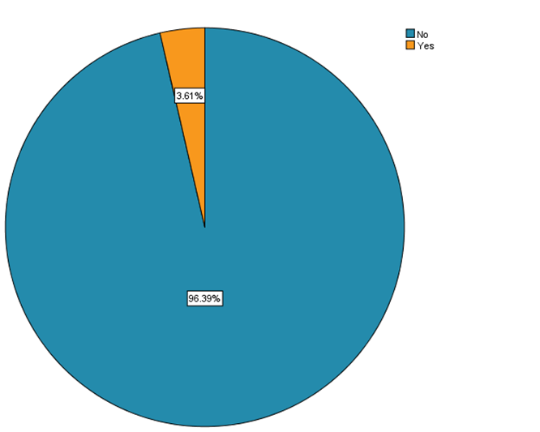

Figure 1: Prevalence of melasma in medical students

Table 2: Association of gender with melasma
 |  |  | Melasma
 |  |  | No | Yes | Total | P-value
Gender | Male | Count | 214 | 6 | 220 | 0.253
Gender | Male | % within melasma | 44.2% | 33.3% | 43.8% | 0.253
Gender | Female | Count | 270 | 12 | 282 | 0.253
Gender | Female | % within melasma | 55.8% | 66.7% | 56.2% | 0.253
Total |  | Count | 484 | 18 | 502
 |  | % within melasma | 100.0% | 100.0% | 100.0%

Table 3: Association between melasma with risk factors
 |  | Melasma |  | Total | p-value
 |  | No | Yes | Total | p-value
Family history | No | 384(97.5%) | 10(2.5%) | 394(100%) | 0.034
Family history | Yes | 100(92.6%) | 8(7.4%) | 108(100%) | 0.034
Sun exposure | <2 hours | 280(96.6%) | 10(3.4%) | 290(100%) | 0.942
Sun exposure | 2-5 hours | 171(96.1%) | 7(3.9%) | 178(100%) | 0.942
Sun exposure | >5 hours | 33(97.1%) | 1(2.9%) | 34(100%) | 0.942
Sunscreen | Never | 72(97.3%) | 2(2.7%) | 74(100%) | 0.742
Sunscreen | Rarely | 72(97.3%) | 2(2.7%) | 74(100%) | 0.742
Sunscreen | Sometimes | 132(95.0%) | 7(5.0%) | 139(100%) | 0.742
Sunscreen | Almost everyday | 208(96.7%) | 7(3.3%) | 215(100%) | 0.742
Makeup | Never | 241(97.6%) | 6(2.4%) | 247(100%) | 0.141
Makeup | Rarely | 33(91.7%) | 3(8.3%) | 36(100%) | 0.141
Makeup | Sometimes | 93(93.9%) | 6(6.1%) | 99(100%) | 0.141
Makeup | Almost everyday | 117(97.5%) | 3(2.5%) | 120(100%) | 0.141
Skin care | Never | 100(98.0%) | 2(2.0%) | 102(100%) | 0.411
Skin care | Rarely | 97(97.0%) | 3(3.0%) | 100(100%) | 0.411
Skin care | Sometimes | 131(94.2%) | 8(5.8%) | 139(100%) | 0.411
Skin care | Almost everyday | 156(96.9%) | 5(3.1%) | 161(100%) | 0.411
Perfume | Never | 39(100%) | 0(0%) | 39(100%) | 0.342
Perfume | Rarely | 58(98.3%) | 1(1.7%) | 59(100%) | 0.342
Perfume | Sometimes | 143(94.7%) | 8(5.3%) | 151(100%) | 0.342
Perfume | Almost everyday | 244(96.4%) | 9(3.6%) | 253(100%) | 0.342

Table 4: Association of some conditions with melasma
 |  |  | Melasma
 |  |  | No | Yes | Total | P-value
Thyroid disorders | No | Count | 474 | 17 | 491 | 0.308
Thyroid disorders | No | % within Melasma | 97.9% | 94.4% | 97.8% | 0.308
Thyroid disorders | Yes | Count | 10 | 1 | 11 | 0.308
Thyroid disorders | Yes | % within Melasma | 2.1% | 5.6% | 2.2% | 0.308
Vitamin B12 deficiency | No | Count | 472 | 18 | 490 | 0.499
Vitamin B12 deficiency | No | % within Melasma | 97.5% | 100.0% | 97.6% | 0.499
Vitamin B12 deficiency | Yes | Count | 12 | 0 | 12 | 0.499
Vitamin B12 deficiency | Yes | % within Melasma | 2.5% | 0.0% | 2.4% | 0.499
Vitamin D deficiency | No | Count | 356 | 16 | 372 | 0.145
Vitamin D deficiency | No | % within Melasma | 73.6% | 88.9% | 74.1% | 0.145
Vitamin D deficiency | Yes | Count | 128 | 2 | 130 | 0.145
Vitamin D deficiency | Yes | % within Melasma | 26.4% | 11.1% | 25.9% | 0.145
Diabetes | No | Count | 479 | 18 | 497 | 0.665
Diabetes | No | % within Melasma | 99.0% | 100.0% | 99.0% | 0.665
Diabetes | Yes | Count | 5 | 0 | 5 | 0.665
Diabetes | Yes | % within Melasma | 1.0% | 0.0% | 1.0% | 0.665

Table 5: Association of some drugs with melasma
 |  |  | Melasma
 |  |  | No | Yes | Total | P-value
Retinoids | No | Count | 402 | 18 | 420 | 0.056
Retinoids | No | % within Melasma | 83.1% | 100.0% | 83.7% | 0.056
Retinoids | Yes | Count | 82 | 0 | 82 | 0.056
Retinoids | Yes | % within Melasma | 16.9% | 0.0% | 16.3% | 0.056
Blood pressure meds | No | Count | 469 | 18 | 487 | 0.448
Blood pressure meds | No | % within Melasma | 96.9% | 100.0% | 97.0% | 0.448
Blood pressure meds | Yes | Count | 15 | 0 | 15 | 0.448
Blood pressure meds | Yes | % within Melasma | 3.1% | 0.0% | 3.0% | 0.448
Antiseizure meds | No | Count | 473 | 18 | 491 | 0.518
Antiseizure meds | No | % within Melasma | 97.7% | 100.0% | 97.8% | 0.518
Antiseizure meds | Yes | Count | 11 | 0 | 11 | 0.518
Antiseizure meds | Yes | % within Melasma | 2.3% | 0.0% | 2.2% | 0.518

Table 6: Association of some risk factors in females and melasma
 |  |  | Melasma
 |  |  | No | Yes | Total | P-values
Regular menstrual cycles | No | Count | 71 | 1 | 72 | 0.159
Regular menstrual cycles | No | % within patches | 26.3% | 8.3% | 25.5% | 0.159
Regular menstrual cycles | Yes | Count | 199 | 11 | 210 | 0.159
Regular menstrual cycles | Yes | % within patches | 73.7% | 91.7% | 74.5% | 0.159
COCP (combined oral contraceptives) | No | Count | 227 | 8 | 235 | 0.304
COCP (combined oral contraceptives) | No | % within patches | 84.1% | 66.7% | 83.3% | 0.304
COCP (combined oral contraceptives) | Yes, currently | Count | 9 | 1 | 10 | 0.304
COCP (combined oral contraceptives) | Yes, currently | % within patches | 3.3% | 8.3% | 3.5% | 0.304
COCP (combined oral contraceptives) | Yes, in the past | Count | 34 | 3 | 37 | 0.304
COCP (combined oral contraceptives) | Yes, in the past | % within patches | 12.6% | 25.0% | 13.1% | 0.304
PCOS (polycystic ovarian syndrome) | No | Count | 259 | 12 | 271 | 0.244
PCOS (polycystic ovarian syndrome) | No | % within Melasma | 95.9% | 100.0% | 96.1% | 0.244
PCOS (polycystic ovarian syndrome) | Yes | Count | 11 | 0 | 11 | 0.244
PCOS (polycystic ovarian syndrome) | Yes | % within Melasma | 4.1% | 0.0% | 3.9% | 0.244
Total |  | Count | 270 | 12 | 282
 |  | % within patches | 100.0% | 100.0% | 100.0%

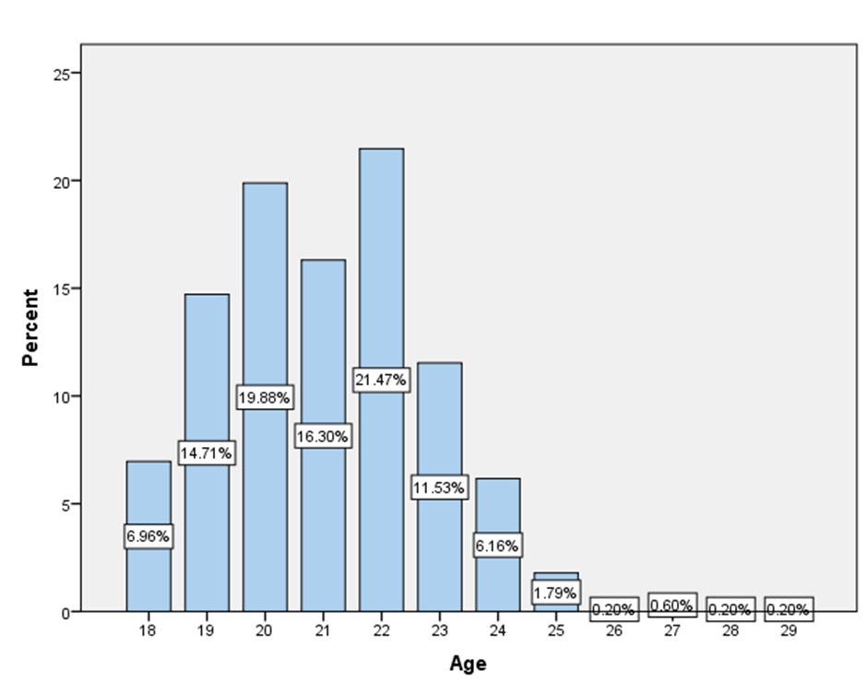
Figure 2: Age distribution of all participants

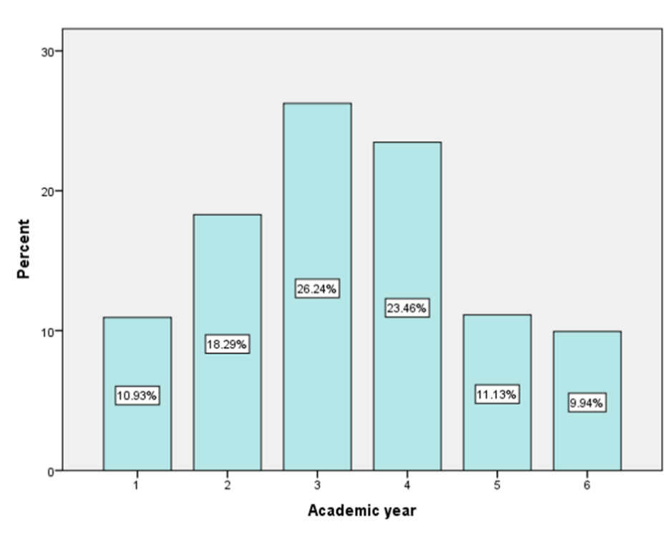
Figure 3: Academic year distribution of all participants

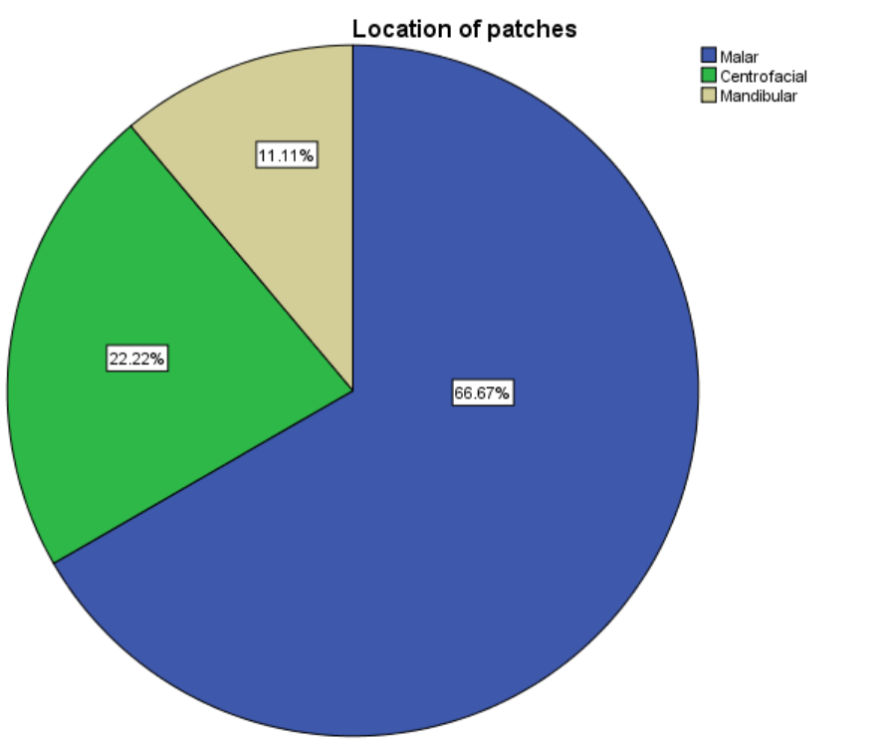
Figure 4: Location of patches

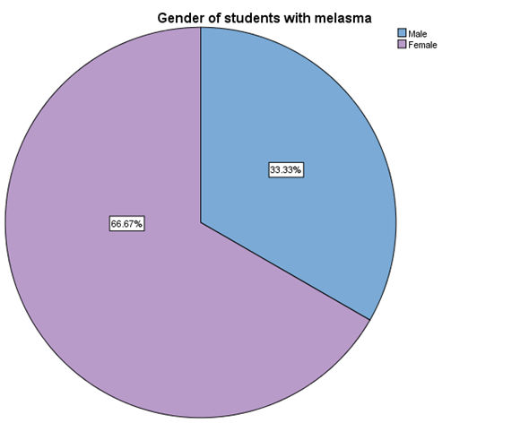
Figure 5: Gender of students with melasma

- Discussion
This is the first study on melasma that was conducted among medical students at the University of Sulaymaniyah. Melasma is a symmetrical, acquired facial discoloration [12].
Melasma is more common among women. The present study demonstrated a prevalence of 3.6% of melasma. The females were making 66.7% and the males were making 33.3%, consistent with the results of an Indian study [13] that showed melasma in 24.4% of male patients and in a study done in Erbil [12] that showed melasma in 16.66% of male patients. The female-to-male ratio in the present study was 2:1. Other studies that were done show a higher ratio [14], reporting a female-to-male ratio of 6:1 in the Malaysian population and 24:1 in the Indonesian population.

The present study demonstrated a positive family history of melasma in 55.6%; in addition, a positive family history was reported in 31.1% of melasma patients in the Indian study [13].

In the present study, malar distribution (66.7%) was the most common pattern of distribution, followed by centrofacial distribution (22.2%), whereas the study in Erbil [12] showed centrofacial distribution (70.95%) as the most common type of distribution.

UV light is the main factor that causes and aggravates melasma [15], and this has been shown in multiple studies. Pathack et al. [16], reporting that 100% of patients have exacerbations from UV lights, is one of them. However, no significant relationship was observed between melasma and sunlight in this study, as 55.6% of melasma patients had a daily exposure to sunlight of less than 2 hours.

When the thyroid gland is not working properly, it can cause other hormonal imbalances, such as elevated estrogen levels. This elevation in estrogen can lead to the development of melasma by promoting melanin formation in the skin [17]. This is in agreement with a study previously done [18] that showed 43.1% of melasma patients had high thyroid stimulating hormone. On the contrary, in our study, only 5.6% of melasma patients reported having thyroid disorders. In addition, studies have shown a correlation between melasma and diabetes [19], melasma and vitamin B12 deficiency [20], and melasma and vitamin D deficiency [21], but no correlation was found in this study between those and any other diseases with melasma, which might be due to the fact that our study is among younger people. In addition, the study done in Erbil [12] states that some disorders were observed with melasma, including acne, diffuse hair loss, and hirsutism; however, they were all considered to be accidental since these diseases are already common.

Any kind of skin-irritating cosmetic product has the potential to exacerbate melasma [22]. However, no significant correlation between cosmetic use, including perfume and makeup, with the occurrence of melasma was found in this study. In contrast, in a recent study, cosmetic usage was found to be the second most common factor that precipitates melasma in 67.9% of the patients [23].

Medications that increase skin sensitivity to sunlight, such as blood pressure, retinoid, and some antibiotics, as well as anti-seizure and oral contraceptive tablets, can cause melasma [24]. However, there was no significant association found in the study in Iraq [25] as the vast majority of patients (92%) who were included denied taking any medications that could cause melasma. In agreement with this, in the present study no association was found either.
In addition to enhancing the curative impact of melasma and lowering side effects and the recurrence rate, using skin care products alone or in conjunction with regular therapy can also increase patient satisfaction [26]. Michael Gold et al [27] reported that 100% of the melasma patients showed improvement and were satisfied with the overall effectiveness of their treatment (Skin care system with 4% hydroquinone and 0.05% tretinoin), opposite to this in the present study, no significant correlation was found.

Sunscreen usage: A key adjuvant therapy and the cornerstone of melasma treatment is the rational and efficient use of sunscreens, which can limit the synthesis of melanin, prevent skin irritation, maintain the skin barrier, and prevent the recurrence of melasma [26]. In agreement with this, in a study [28] aimed at evaluating the efficacy of broad-spectrum sunscreens in the management and prevention of chloasma in expectant mothers, only five new cases of the condition were identified among the 185 patients who finished the investigation. In the present study, no correlation was found.

Hormonal birth control works by boosting the body's levels of estrogen, high estrogen in the body enhances pigment production [29]. In agreement, a study in Nepal [30] found that most of the melasma patients had a history of oral contraceptive pill intake. However, an insignificant correlation was found in our study, mainly due to the fact that our study is on university students, meaning they don’t take contraceptive pills.

Menstrual problems can sometimes lead to melasma [31]. In the present study, 91.7% of the female melasma patients showed regular menstrual cycles and only 8.3% had irregular cycles, in comparison to the study in Erbil [12], which demonstrated 18.28% of the melasma patients to have menstrual irregularities.

  - Strengths and limitations:
Survey research has advantages in terms of low cost, dependability, and low data entry errors. The limitations of our study are the low age range and the fact that medical students may not represent the different sectors of the community.

- Conclusion
To the best of our knowledge, this is the first study about the prevalence (3.6 %) of melasma in the Sulaymaniyah medical college.
We found a significant relationship between family history and development of melasma (p-value = 0.034) other factors had no relation to the development of melasma as their p-values were more than 0.05.

Declarations:

Ethics approval and consent to participate:
The ethical committee at the University of Sulaimani, Iraq's College of Medicine, approved the study (number 101). The 2008 Declaration of Helsinki and international principles were followed in the implementation of the work.
Consent for publication:
The authors give permission for publishing the materials of the study
Availability of data:
The data used to support the findings of this study are included within the article.

References:
[1] Wolff, K., Johnson, R. A., Saavedra, A. P., & Roh, E. K. (2017). *Fitzpatrick's Color Atlas and Synopsis of Clinical Dermatology, Eighth Edition*. McGraw-Hill Education. https://accessmedicine.mhmedical.com/content.aspx?bookid=2043&sectionid=154893575
[2] Katsambas, A., & Antoniou, C. (1995). Melasma. Classification and treatment. Journal of the European Academy of Dermatology and Venereology, 4(3), 217–223. https://doi.org/10.1111/j.1468-3083.1995.tb00341.x
[3] Basit, H., Godse, K. V., & Al Aboud, A. M. (2024). Melasma. In StatPearls. StatPearls Publishing. http://www.ncbi.nlm.nih.gov/books/NBK459271/
[4] Wolff, K., Goldsmith, L. A., Katz, S. I., Gilchrest, B. A., Paller, A. S., & Leffell, D. J. (Eds.). (2008). *Fitzpatrick's dermatology in general medicine* (7th ed., Vol. 1). McGraw-Hill. https://www.vitalsource.com/products/fitzpatrick-s-dermatology-in-general-medicine-wolff-goldsmith-katz-gilchrest-v9780071466905
[5] Victor, F. C., Gelber, J., & Rao, B. (2004). Melasma: a review. J Cutan Med Surg, 8(2), 97–102. https://doi.org/10.1007/s10227-004-0158-9

[6] M. Perez, J Luke, A. Rossi, Melasma in Latin Americans. Journal of drugs in dermatology: JDD [Internet], vol. 10 no. 5, pp. 517–23, May. 2011, [PubMed]
[7] Sheth, V. M., & Pandya, A. G. (2011). Melasma: A comprehensive update: Part I. Journal of the American Academy of Dermatology, 65(4), 689–697. https://doi.org/10.1016/j.jaad.2010.12.046
[8] Handel, A. C., Miot, L. D. B., & Miot, H. A. (2014). Melasma: a clinical and epidemiological review. Anais Brasileiros de Dermatologia, 89(5), 771–782. https://doi.org/10.1590/abd1806-4841.20143063

[9] Ludmann, P. (2022). Melasma: Diagnosis and treatment. American Academy of Dermatology. https://www.aad.org/public/diseases/a-z/melasma-treatment

[10] Oakley, A. (2020). Melasma. DermNet. https://dermnetnz.org/topics/melasma
[11] Achar, A., & Rathi, S. K. (2011). Melasma: a clinico-epidemiological study of 312 cases. Indian Journal of Dermatology, 56(4), 380–382. https://doi.org/10.4103/0019-5154.84722 .
[12] I. M. Almosuly and R. O. Butros, “Clinical Assessment Of Melasma In Patients Attending The Department Of Dermatology And Venereology At Rizgary Teaching Hospital In Erbil City,” Zanco Journal of Medical Sciences (Zanco J Med Sci), vol. 14, no. 2, p. 55_60-55_60, Aug. 2010, doi: 10.15218/zjms.2010.023.
[13] KrupaShankar, D. S. R., Somani, V. K., Kohli, M., Sharad, J., Ganjoo, A., Kandhari, S., Mysore, V. R., Aurangabadkar, S., Malakar, S., Vedamurthy, M., Kadhe, G., Motlekar, S., & Ahirrao, P. (2014). A Cross-Sectional, Multicentric Clinico-Epidemiological Study of Melasma in India. *Dermatology and Therapy (Heidelberg)*, *4*(1), 71–81. https://doi.org/10.1007/s13555-014-0046-1

[14] Sivayathorn, A. (1995). Melasma in Orientals. Clinical Drug Investigation, 10(2), 34–40. https://doi.org/10.2165/00044011-199500102-00006
[15] Yang, J., Zeng, J., & Lu, J. (2022). Mechanisms of ultraviolet-induced melasma formation: A review. J Dermatol, 49(12), 1201–1210. https://doi.org/10.1111/1346-8138.16542 .
[16] Achar, A., & Rathi, S. K. (2011). Melasma: a clinico-epidemiological study of 312 cases. Indian Journal of Dermatology, 56(4), 380–382. https://doi.org/10.4103/0019-5154.84722
[17] D. D. Chavan, “Thyroid and Melasma: Causes, Treatment, and Solutions | Clear Skin Clinics Pune,” Skin Clinic in Pune | Best Skin Specialist in Pune | Clear Skin. Accessed: May 04, 2024. [Online]. Available: https://www.clearskin.in/blog/how-thyroid-causes-melasma/
[18] Kamal, Z. A., & Elethawi, A. M. D. (2022). Evaluation of serum thyroid hormones in female patients with melasma. Advanced Medical Journal, 7(1), 1-4. https://doi.org/10.56056/amj.2022.151

[19] Morav, V. (2020). Treating Hormonally Induced Melasma. Skin Inc. https://www.skininc.com/science/physiology/article/21879658/treating-hormonally-induced-melasma

[20] P. Thakri, “Understanding Melasma: Causes and Treatments.” Accessed: May 04, 2024. [Online]. Available: https://evaskinclinicpune.com/blogs/melasma-causes-and-treatments/

[21] Ramírez, L. (2024). Does Vitamin D Have Anything To Do With Melasma? Navamd.com Face Forward Blog. https://navamd.com/face-forward-blog/vitamin-d-and-melasma/

[22] Rucoba, R. J. (2023). What are some common melasma causes? https://blog.walgreens.com/health/skin-health-conditions/melasma-causes.html

[23] Viorizka, P. B. B., Setyaningrum, T., Qurnianingsih, E., & Damayanti. (2023). The Profile and Triggering Factors of Melasma Patients: A Retrospective Study. Berkala Ilmu Kesehatan Kulit dan Kelamin, 35(2), 142-147. https://doi.org/10.20473/bikk.V35.2.2023.142-147

[24] Glinski, S. (2023, September 14). 8 ways to treat melasma, according to dermatologists. Forbes Health. https://www.forbes.com/health/conditions/best-treatment-for-melasma/

[25] Abdulrazak, Z. H., & Alkhazrajy, L. A. (2024). Melasma assessment of quality of life among Iraqi women during 2023. International Journal of Dermatology Sciences, 6(1), 01–08. https://doi.org/10.33545/26649772.2024.v6.i1a.27 .
[26] Wang, Y., Zhao, J., Jiang, L., & Mu, Y. (2021). The Application of Skin Care Product in Melasma Treatment. Clin Cosmet Investig Dermatol, 14, 1165–1171. https://doi.org/10.2147/CCID.S323748
[27] Gold, M., Rendon, M., Dibernardo, B., Bruce, S., Lucas-Anthony, C., & Watson, J. (2013). Open-Label Treatment of Moderate or Marked Melasma with a 4% Hydroquinone Skin Care System Plus 0.05% Tretinoin Cream. J Clin Aesthet Dermatol, 6(11), 32–38. https://pubmed.ncbi.nlm.nih.gov/24307923/
[28] Lakhdar, H., Zouhair, K., Khadir, K., Essari, A., Richard, A., Seité, S., & Rougier, A. (2007). Evaluation of the effectiveness of a broad-spectrum sunscreen in the prevention of chloasma in pregnant women. Journal of the European Academy of Dermatology and Venereology, 21(6), 738–742. https://doi.org/10.1111/j.1468-3083.2007.02185.x
[29] Kirsch, D. B. (2024). The Connection Between Your Birth Control And Melasma. Kirsch Dermatology. https://www.kirschderm.com/the-connection-between-your-birth-control-and-melasma/
[30] Pudasaini, P., & Neupane, S. (2021). An Observational Study to Evaluate Quality of Life in Patients with Melasma in A Tertiary Level Hospital of Pokhara. Nepal Journal of Dermatology, Venereology & Leprology. https://doi.org/10.3126/njdvl.v19i1.35047
[31] Sài, G. (2024). Distinguishing hormonal melasma from common melasma. Vinmec. https://www.vinmec.com/en/news/health-news/distinguishing-melasma-caused-by-hormonal-disorders-from-normal-melasma/

