Epidemiological Study of Respiratory Tract Diseases in Dogs at Jabalpur, India

ABSTRACT
The present study was undertaken to investigate the epidemiological prevalence of respiratory tract diseases in dogs presented to the Veterinary Clinical Complex (VCC), College of Veterinary Science and Animal Husbandry, Nanaji Deshmukh Veterinary Science University (NDVSU), Jabalpur, Madhya Pradesh. A total of 2397 dogs of either sex, breed and age, were screened over a period of six months from June to November 2025. Among these, 117 dogs were found to be affected with respiratory tract diseases, resulting in an overall incidence of 4.88 per cent. The highest distribution was recorded in dogs above six years of age, gender wise distribution revealed that male dogs were more commonly affected, and breed wise distribution showed that the highest number of affected dogs belonged to non-descript breeds, followed by Labrador Retrievers. The most common clinical abnormalities observed were cough (76.07%), inappetence (58.12%), nasal discharge (54.70%), lethargy (40.17%) and fever (37.61%).
1. INTRODUCTION
Respiratory tract diseases are among the most frequently encountered disorders in canine clinical practice and constitute a major cause of morbidity in dogs across different age groups and breeds. The close association between dogs and humans further emphasizes the importance of maintaining optimal respiratory health in companion animals. Respiratory diseases not only compromise the quality of life of affected dogs but also lead to repeated veterinary visits and increased economic burden on pet owners.
Anatomically, the canine respiratory system is divided into the upper and lower respiratory tracts. The upper respiratory tract comprises the nasal cavity, paranasal sinuses, pharynx and larynx, while the lower respiratory tract includes the trachea, bronchi, bronchioles, alveoli and lungs (Bichot and Bienzle, 2020). Diseases affecting the upper respiratory tract often present with nasal discharge, sneezing and stertor, whereas lower respiratory tract diseases are commonly associated with cough, dyspnea, abnormal lung sounds, presence of tracheal sensitivity and exercise intolerance. The etiology of respiratory tract diseases in dogs is multifactorial and may involve infectious agents, environmental factors, anatomical abnormalities, age-related immune changes and concurrent systemic diseases. Common signs associated with respiratory disorders include nasal discharge, coughing, exercise intolerance, dyspnea, sneezing, abnormal respiratory sounds and adventitious lung sounds on auscultation (Vieson and LeRoith, 2012). Epidemiological studies play a vital role in understanding the distribution and determinants of diseases within a population. Such studies provide baseline data regarding incidence, age, sex and breed predisposition, as well as common clinical manifestations, which are essential for early diagnosis, rational clinical decision-making and formulation of preventive strategies. Despite the clinical importance of respiratory tract diseases, region-specific epidemiological data in dogs, particularly from central India, remain limited. Therefore, the present study was undertaken to investigate the prevalence and epidemiological characteristics of respiratory tract diseases in dogs presented to a veterinary care hospital at Jabalpur.
2. MATERIALS AND METHODS
The study was conducted at the Veterinary Clinical Complex (VCC), Department of Veterinary Medicine, College of Veterinary Science and Animal Husbandry, NDVSU, Jabalpur, Madhya Pradesh, over a period of six months from June to November 2025. A total of 2397 dogs were screened based on history and clinical signs viz. nasal discharge, lacrimation, coughing, exercise intolerance, dyspnea, sneezing, epistaxis, haemoptysis, tracheal sensitivity etc., which were suggestive of respiratory tract diseases. Dogs suspected on the basis of clinical findings were further subjected to thoracic radiographic examination to support clinical diagnosis and to confirm lower respiratory tract diseases. For statistical analysis, chi-square test of significance was applied for the qualitative data.
3. RESULTS AND DISCUSSION
3.1 Overall incidence
Among 2397 screened dogs, 117 were affected with respiratory tract diseases. Therefore, the overall incidence of respiratory tract diseases in dogs at Jabalpur was 4.88 per cent The results of this study are in close agreement with the findings of Jain et al. (2015) and Uddin et al. (2021) who reported a prevalence and proportional incidence of respiratory tract infections in dogs as 5.12 per cent and 5.5 per cent, respectively (Table 01).
On the contrary slightly lower prevalence of respiratory tract diseases was observed by Ayodhya et al. (2013), Sanchez-Vizcaino et al. (2016), Tagorti (2019) and Bali (2024) which ranges from 0.97 to 1.85 per cent. However, Rose et al. (2024) documented a markedly higher overall incidence of canine respiratory tract infections, accounting for 18.2 per cent.
Different scientists have documented varying rates of incidence of respiratory tract diseases in dogs. The variations observed between the present study and earlier reports may be attributed to the differences in study population, duration of the study and different management practices opted for the dog population studied.

Table 01: Overall incidence of respiratory tract diseases in dogs
Particulars | No. screened | No. affected | Incidence (%)
Total dog population studied | 2397 | 117 | 4.88
3.2 Age wise distribution of respiratory tract diseases
The dogs of varying ages included in the study were classified into four age groups. The age wise distribution of respiratory tract diseases was highest in dogs of more than 6 years of age, accounting for 39.32 per cent, followed by dogs in the age group of 3-6 years with 23.93 per cent. Dogs aged 0-1 year showed a distribution of 20.51 per cent, while the lowest distribution was observed in 1-3 years of age group with 16.24 per cent. Age wise distribution of respiratory tract diseases varied significantly, indicating a higher susceptibility in older dogs (Table 02).
The results of the present study, which showed a higher distribution of respiratory tract diseases in dogs aged more than six years, are in close agreement with Savitha (2017) who observed greater susceptibility of pulmonary disorders in older dogs and Dimopoulou et al. (2023), who reported respiratory tract diseases in dogs with median age of 7.81 years. On the contrary Ayodhya et al. (2013) and Canonne et al. (2020) reported the highest occurrence of respiratory tract diseases in puppies aged 0-6 months, while Qekwana et al. (2020) and Rose et al. (2024) observed greater susceptibility in dogs below 2 years of age, indicating a predominance of respiratory tract diseases in younger dogs in their respective studies.
The higher distribution of respiratory tract diseases in dogs of more than six years of age might be due to age-related physiological and immunological changes in the respiratory system, along with a general decline in immune competence.
Table 02: Age wise distribution of respiratory tract diseases in dogs
Age(years) | No. affected (n=117) | Per cent (%)
0-1 | 24 | 20.51
1-3 | 19 | 16.24
3-6 | 28 | 23.93
>6 | 46 | 39.32
χ²=14.17* *Significant at p < 0.05

3.3 Gender-wise Distribution of Respiratory Tract Diseases
The gender wise distribution of respiratory tract diseases revealed a higher distribution in male dogs, accounting for 67.52 per cent (79/117), whereas female dogs constituted 32.48 per cent (38/117) of the affected dogs. The gender-wise distribution of respiratory tract diseases in dogs varied significantly, with a significantly higher proportion of affected cases observed in male dogs as compared to female dogs (Table 03).
The results of the present study, which showed a higher distribution of respiratory tract diseases in male dogs, are in close agreement with Kogan et al. (2008), Dey et al. (2013), Jain et al. (2015), Darcy et al. (2018), Nakazawa et al. (2023), Sarkar et al. (2023) and Rose et al. (2024) who also reported higher prevalence of respiratory tract diseases in males. However, on the contrary Ayodhya et al. (2013) and Qekwana et al. (2020) reported a slightly higher occurrence of respiratory tract infections in female dogs.
The higher distribution observed in male dogs in the present study may be due to a reason that a greater number of male dogs were presented to veterinary clinics, as well as the preferential selection of male dogs as companion animals by owners.
Table 03: Gender wise distribution of respiratory tract diseases in dogs
Gender | No. affected (n=117) | Per cent (%)
Male | 79 | 67.52
Female | 38 | 32.48
χ²=14.38* *Significant at p < 0.05

3.4 Breed wise distribution of respiratory tract diseases
The breed wise distribution of respiratory tract diseases varied significantly, with the highest distribution recorded in non-descript dogs accounting for 32.48 per cent, followed by Labrador Retrievers with 24.79 per cent. Pugs constituted 9.40 per cent of the affected dogs, while German Spitz and German Shepherd dogs accounted for 8.54 per cent and 6.84 per cent, respectively. Other breeds also accounted for 6.84 per cent, followed by Saint Bernard with 5.98 per cent and Beagle with 5.13 per cent (Table 04).
The findings of the present study are in close agreement with the findings of Savitha (2017) and Naveen (2022) who also reported that non-descript dogs as the most commonly affected breed, followed by Labrador Retrievers in canine respiratory tract disorders. However, Tagorti (2019), Lo et al. (2021) and Rose et al. (2024) reported Labrador Retrievers as the most commonly affected breed among dogs with respiratory tract infections and Ayodhya et al. (2013) reported a higher prevalence of respiratory diseases in Pugs followed by Labrador Retrievers.
Non-descript dogs constituted the most frequently affected breed, which may be attributed to their higher population density in the study area and consequently, greater presentation to the veterinary clinical complex. In addition, inadequate management practices, lack of balanced nutrition and irregular or absent routine vaccination may have contributed to their increased susceptibility.
Table 04: Breed wise distribution of respiratory tract diseases in dogs
Breed | No. affected (n=117) | Per cent (%)
Non-descript | 38 | 32.48
Labrador Retriever | 29 | 24.79
Pug | 11 | 09.40
German Spitz | 10 | 08.54
German Shepherd | 08 | 06.84
Other breeds | 08 | 06.84
Saint Bernard | 07 | 05.98
Beagle | 06 | 05.13
χ²=69.65* *Significant at p < 0.05

3.5 Clinical Abnormalities Observed in Respiratory Tract Diseases
Among the dogs affected with respiratory tract diseases, a variety of clinical signs and symptoms were observed. Cough was the most common clinical sign, recorded in 76.07 per cent of dogs, followed by inappetence in 58.12 per cent and nasal discharge in 54.70 per cent of dogs. Lethargy was observed in 40.17 per cent of dogs, followed by fever in 37.61 per cent. Harsh lung sounds were recorded in 28.20 per cent of dogs, while sneezing and congested mucous membranes were each observed in 27.35 per cent of dogs. Dyspnea or open-mouth breathing was noted in 23.93 per cent of dogs, followed by exercise intolerance in 23.08 per cent. Abnormal respiratory sounds were present in 20.51 per cent, lacrimation in 19.66 per cent, tracheal sensitivity in 15.38 per cent and retching in 13.67 per cent of dogs. Crackles were observed in 9.40 per cent, dysphagia in 8.54 per cent, wheezing in 5.98 per cent, epistaxis in 5.12 per cent and muffled heart and lung sounds in 3.42 per cent of dogs (Table 05).
The findings of current study correlates well with the findings of Sanchez-Vizcaino et al. (2016), Arsevska et al. (2018), Singleton et al. (2019), Sariga et al. (2022) and Kose et al. (2021) who also reported cough as the most common clinical sign, followed by nasal discharge, sneezing, dyspnea, fever and lethargy. Similarly, Elgalfy et al. (2022) observed anorexia, dullness, cough and nasal discharge in respiratory affections in dogs.
Table 05: Clinical abnormalities in respiratory tract diseases in dogs
Clinical abnormality | Frequency (n=117) | Per cent (%)
Cough | 89 | 76.07
Inappetence | 68 | 58.12
Nasal discharge | 64 | 54.70
Lethargy | 47 | 40.17
Fever | 44 | 37.61
Harsh lung sounds | 33 | 28.20
Sneezing | 32 | 27.35
Congested mucous membrane | 32 | 27.35
Dyspnea/open mouth breathing | 28 | 23.93
Exercise intolerance | 27 | 23.08
Abnormal respiratory sound | 24 | 20.51
Lacrimation | 23 | 19.66
Tracheal sensitivity | 18 | 15.38
Retching | 16 | 13.67
Crackles | 11 | 09.40
Dysphagia | 10 | 08.54
wheezing | 7 | 05.98
Epistaxis | 6 | 05.12
Muffled heart and lung sound | 4 | 03.42
Cough results from mechanical or chemical irritation and inflammation of the respiratory mucosa involving the pharynx, larynx, trachea and bronchi. The release of inflammatory mediators, accumulation of mucus, airway narrowing and activation of cough receptors trigger a protective reflex that facilitates clearance of secretions or foreign material. Inappetence occurs due to systemic inflammatory responses, cytokine release, hypoxia and reduced olfaction associated with nasal obstruction.
Nasal discharge arises from inflammation of the nasal mucosa and increased glandular secretions and impaired mucociliary clearance due to desquamation of respiratory epithelium. Lethargy is a consequence of systemic illness, hypoxemia, fever and increased metabolic demands, resulting in reduced activity levels. Fever develops due to the action of endogenous pyrogens released during infection or inflammation on the hypothalamic thermoregulatory center.
Abnormal lung sounds such as wheezes and crackles occur due to airway narrowing, accumulation of exudate and alveolar collapse or consolidation associated with bronchial or pulmonary pathology. Sneezing occurs due to stimulation of nasal sensory receptors by inflammation, mucosal oedema or foreign body and serves as a protective reflex to expel chemical and physical irritants from the nasal epithelial surface. Dyspnea may be attributed to hypoxia or hypercarbia sensed by peripheral and central chemoreceptors, resulting from severe inflammation of airway that interferes with normal gas exchange.
4. CONCLUSION
The present study documented an overall incidence of respiratory tract diseases in dogs as 4.88 per cent among the total dogs presented to the Veterinary Clinical Complex, Jabalpur. A significantly higher distribution of respiratory tract diseases was observed in dogs above six years of age (39.32%), suggesting increased susceptibility in older dogs. Male dogs (67.52%) were affected more commonly than females and non-descript dogs (32.48%), followed by Labrador Retrievers (24.79%), constituted the majority of affected breeds. Clinically, cough (76.07%) was the most predominant abnormality, followed by inappetence (58.12%), nasal discharge (54.70%), lethargy (40.17%) and fever (37.61%). Other clinical signs such as dyspnoea, sneezing, abnormal lung sounds and exercise intolerance further emphasized the diverse clinical presentation of respiratory tract diseases in dogs.
DISCLAIMER(ARTIFICIALINTELLIGENCE)
Author(s) hereby declares that no AI technologies such as Large Language Models (ChatGPT, COPILOT, etc.) and text-to-image generators have been used during the writing or editing of this manuscript.

REFERENCES:
- Bichot, A.D. and Bienzle, D. (2020). Lower respiratory tract of the dog and cat. In: Sharkey, L.C., Radin, M.J. and Seelig, D.(ed.). Veterinary Cytology, 1st Edn., John Wiley and Sons, Inc., Hoboken, New Jersey, USA, pp 281-301.
- Vieson, M.D. and LeRoith, T. (2012). A review of the pathology and treatment of canine respiratory infections. Veterinary Medicine: Research and Reports, 3(1): 25-39.
- Jain, S., Patel, P.R. and Raval, S.K. (2015). A study of diseases in geriatric dogs. Indian Journal of Animal Research, 49(6): 866-868.
- Uddin, M.M., Talukder, H., Islam, O., Asaduzzaman, M., Das, M., Ahsan, M. I. and Islam, S. (2021). Magnitudes of diseases in dogs vary among different levels of age, gender, breed and season: a hospital-based, retrospective cross-sectional study. Heliyon, 7(11): e08287 https://doi.org/10.1016/j.heliyon.2021.e08287.
- Ayodhya, S., Rao, D.T., Reddy, Y.N., Sundar, N.S. and Kumar, V.G. (2013). Epidemiological, clinical and haematological studies on canine respiratory diseases in and around Hyderabad city, Andhra Pradesh, India. International Journal of Current Microbiology and Applied Sciences, 2(11): 453-462.
- Sanchez-Vizcaino, F., Daly, J.M., Jones, P.H., Dawson, S., Gaskell, R., Menacere, T., Heayns, B., Wardeh, M., Newman, J., Everitt, S., Day, M.J., McConnell, K., Noble, P.J.M. and Radford, A.D. (2016). Small animal disease surveillance: respiratory disease. Veterinary Record, 178(15): 361-364.
- Tagorti, G. (2019). Disease prevalence among young dogs in Grand Tunis, Tunisia: a retrospective study. Veterinary World, 12(4): 489-495.
- Bali, S.D.K. (2024). Diagnostic evaluation and therapeutic management of bacterial respiratory tract infections in dogs. M.V.Sc thesis (Veterinary Medicine), Sher-e-Kashmir University of Agricultural Sciences and Technology, Jammu (J&K).
- Rose, T.K., Rajesh, J.B., Marwein, S.C., Kar, P., Behera, S.K., Chethan, G.E., Rao, J.M., Roychoudhary, P., Dutta, T.K., Tolenkhomba, T.C., Sarma, K. and Prasad, H. (2024). Hospital based incidence of Bordetella bronchiseptica in canines in Mizoram. Journal of Animal Research, 14(1): 95-97.
- Savitha, J. (2017). Studies on occurrence of pulmonary disorders in dogs. M.V.Sc. thesis (Veterinary Pathology), Karnataka Veterinary, Animal and Fisheries Sciences University, Bidar.
- Dimopoulou, M., Engdahl, K., Ladlow, J., Andersson, G., Hedhammar, A., Skioldebrand, E. and Ljungvall, I. (2023). The epidemiology of upper respiratory tract disorders in a population of insured Swedish dogs (2011–2014) and its association to brachycephaly. Scientific Reports, 13(1): 8765 https://doi.org/10.1038/s41598-023-35466-0.
- Canonne, A.M., Roels, E., Menard, M., Desquilbet, L., Billen, F. and Clercx, C. (2020). Clinical response to 2 protocols of aerosolized gentamicin in 46 dogs with Bordetella bronchiseptica infection (2012‐2018). Journal of Veterinary Internal Medicine, 34(5): 2078-2085.
- Qekwana, D.N., Naidoo, V., Oguttu, J.W. and Odoi, A. (2020). Occurrence and predictors of bacterial respiratory tract infections and antimicrobial resistance among isolates from dogs presented with lower respiratory tract infections at a referral veterinary hospital in South Africa. Frontiers in Veterinary Science, 7(1): 304 https://doi.org/10.3389/fvets.2020.00304.
- Kogan, D.A., Johnson, L.R., Jandrey, K.E. and Pollard, R.E. (2008). Clinical, clinicopathologic and radiographic findings in dogs with aspiration pneumonia: 88 cases (2004–2006). Journal of the American Veterinary Medical Association, 233(11): 1742-1747.
- Dey, S., Singh, L.B.J.L., Prasad, S. and Rajora, V.S. (2013). Prevalence status of canine lower respiratory tract infections in selected areas of Uttarakhand and Uttar Pradesh. The Indian Veterinary Journal, 90(9): 31-32.
- Darcy, H.P., Humm, K. and Haar, G.T. (2018). Retrospective analysis of incidence, clinical features, potential risk factors and prognostic indicators for aspiration pneumonia in three brachycephalic dog breeds. Journal of the American Veterinary Medical Association, 253(7): 869-876.
- Nakazawa, Y., Ohshima, T., Fujita, M. and Fujiwara‐Igarashi, A. (2023). Retrospective study of 1050 dogs with respiratory symptoms in Japan (2005–2020). Veterinary Medicine and Science, 9(2): 638-644.
- Sarkar, B.D., Barman, D., Phukan, A., Baishya, B.C., Nath, M.K. Kachari, J., Hazorika, M., Chetia, P.B. and Ghosh, T. (2023). Prevalence studies of bacteria associated respiratory tract infection in dog. The Pharma Innovation Journal, 12(9): 2703-2707.
- Naveen (2022). Clinico-therapeutic investigations in canine respiratory tract disorders. M.V.Sc. thesis (Veterinary Medicine), Sher-e-Kashmir University of Agricultural Sciences and Technology, Jammu (J&K).
- Lo, E.J.Y., Schwarz, T. and Corcoran, B.M. (2021). Topographical distribution and radiographic pattern of lung lesions in canine eosinophilic bronchopneumopathy. Journal of Small Animal Practice, 62(8): 655-661.
- Arsevska, E., Priestnall, S.L., Singleton, D.A., Jones, P.H., Smyth, S., Brant, B., Dawson, S., Saanchez-Vizcaino, F., Noble, P. J. M. and Radford, A.D. (2018). Small animal disease surveillance: respiratory disease 2017. Veterinary Record, 182(13): 369-373.
- Singleton, D.A., Stavisky, J., Jewell, C., Smyth, S., Brant, B., Sanchez-Vizcaino, F., Dawson, S., Pinchbeck, G.L., Noble, P. and Radford, A.D. (2019). Small animal disease surveillance 2019: respiratory disease, antibiotic prescription and canine infectious respiratory disease complex. The Veterinary Record, 184(21): 640–645.
- Sariga, K., Bipin, K.C., Deepa, P.M., Rateesh, R.L. and Dinesh, P.T. (2022). Molecular identification and occurrence of bordetellosis among dogs in northern Kerala. Journal of Veterinary and Animal Sciences, 53(4): 541-544.
- Kose, S.I., Maden, M. and Sayin, Z. (2021). Clinical and bacteriological analysis of respiratory tract infections in sheltered dogs and determination of antibacterial treatment options. Journal of the Hellenic Veterinary Medical Society, 72(4): 3491-3502.
- Elgalfy, G.E., Abd El-Raof, Y.M., Ghanem, M.M. and El-khaiat, H.M. (2022). Clinical, hematological, acute phase proteins and radiographic changes in different respiratory affections in dogs and cats. Benha Veterinary Medical Journal, 42(1): 80-85.

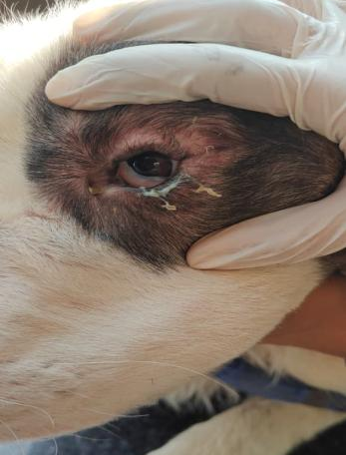
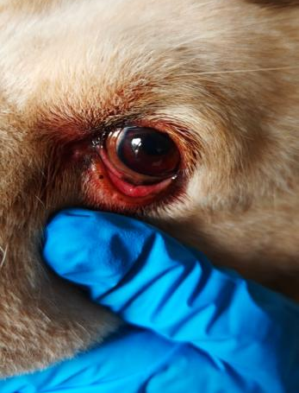

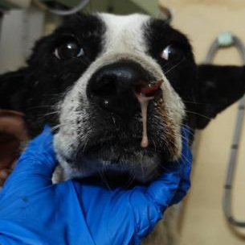
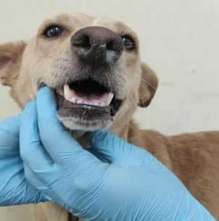
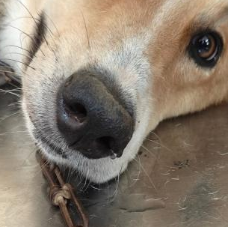
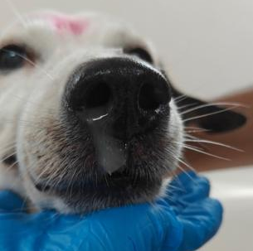


(a)

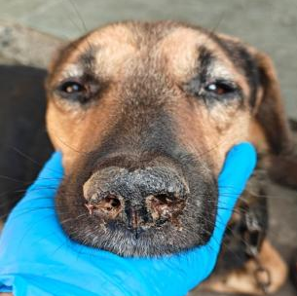

(c)









